COS30008 Semester 1, 2024 Dr. Ky Trung Pham

**Swinburne University of Technology**

Faculty of Science, Engineering and Technology

**ASSIGNMENT COVER SHEET**

**Subject Code:** COS30008

**Subject Title:** Data Structures and Patterns

**Assignment number and title:** 2, Indexers, Method Overriding, and Lambdas

**Due date:** October 21, 2024, 3:59

**Lecturer:** Dr. Ky Trung Pham

**StudentName:** Lau Ngoc Quyen

**StudentID:** 104198996

|  |  |  |  |  |  |  |  |  |  |  |  |
| --- | --- | --- | --- | --- | --- | --- | --- | --- | --- | --- | --- |
| Check  Tutorial | Mon 10:30 | Mon 14:30 | Tues 08:30 | Tues 10:30 | Tues 12:30 | Tues 14:30 | Tues 16:30 | Wed  08:30 | Wed  10:30 | Wed  12:30 | Wed  14:30 |
| **X** |  |  |  |  |  |  |  |  |  |  |

Marker's comments:

|  |  |  |
| --- | --- | --- |
| Problem | Marks | Obtained |
| 1 | 48 |  |
| 2 | 30+10= 40 |  |
| 3 | 58 |  |
| Total | 146 |  |

**Extension certification:**

This assignment has been given an extension and is now due on 21th October 2024

Signature of Convener:

1

1. **InVector.cpp**

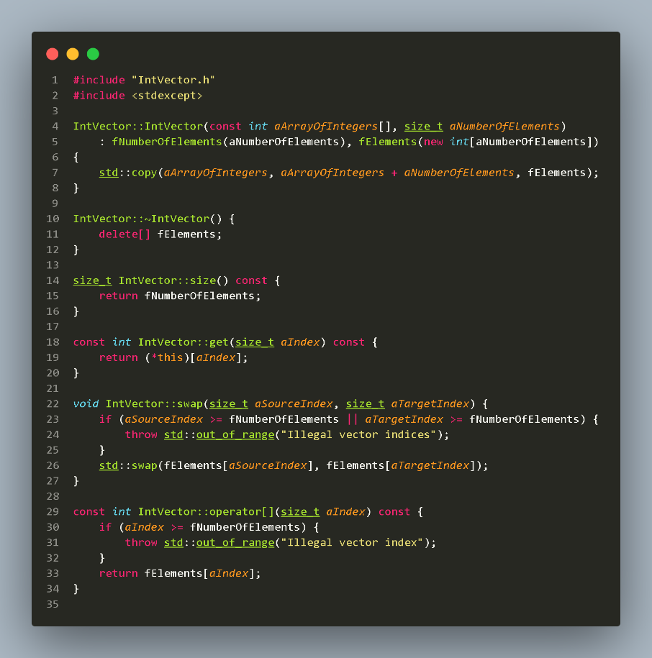

1. **Main.cpp**

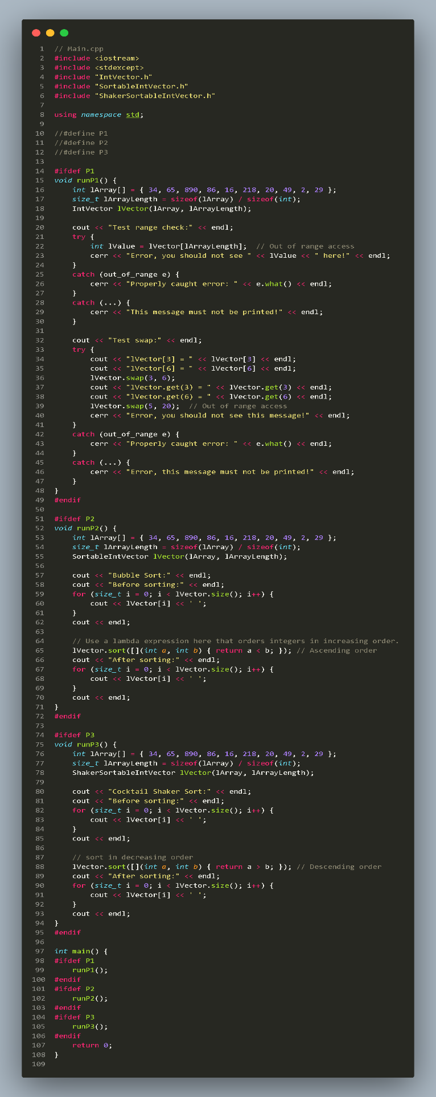

1. **SortableIntVector.cpp**

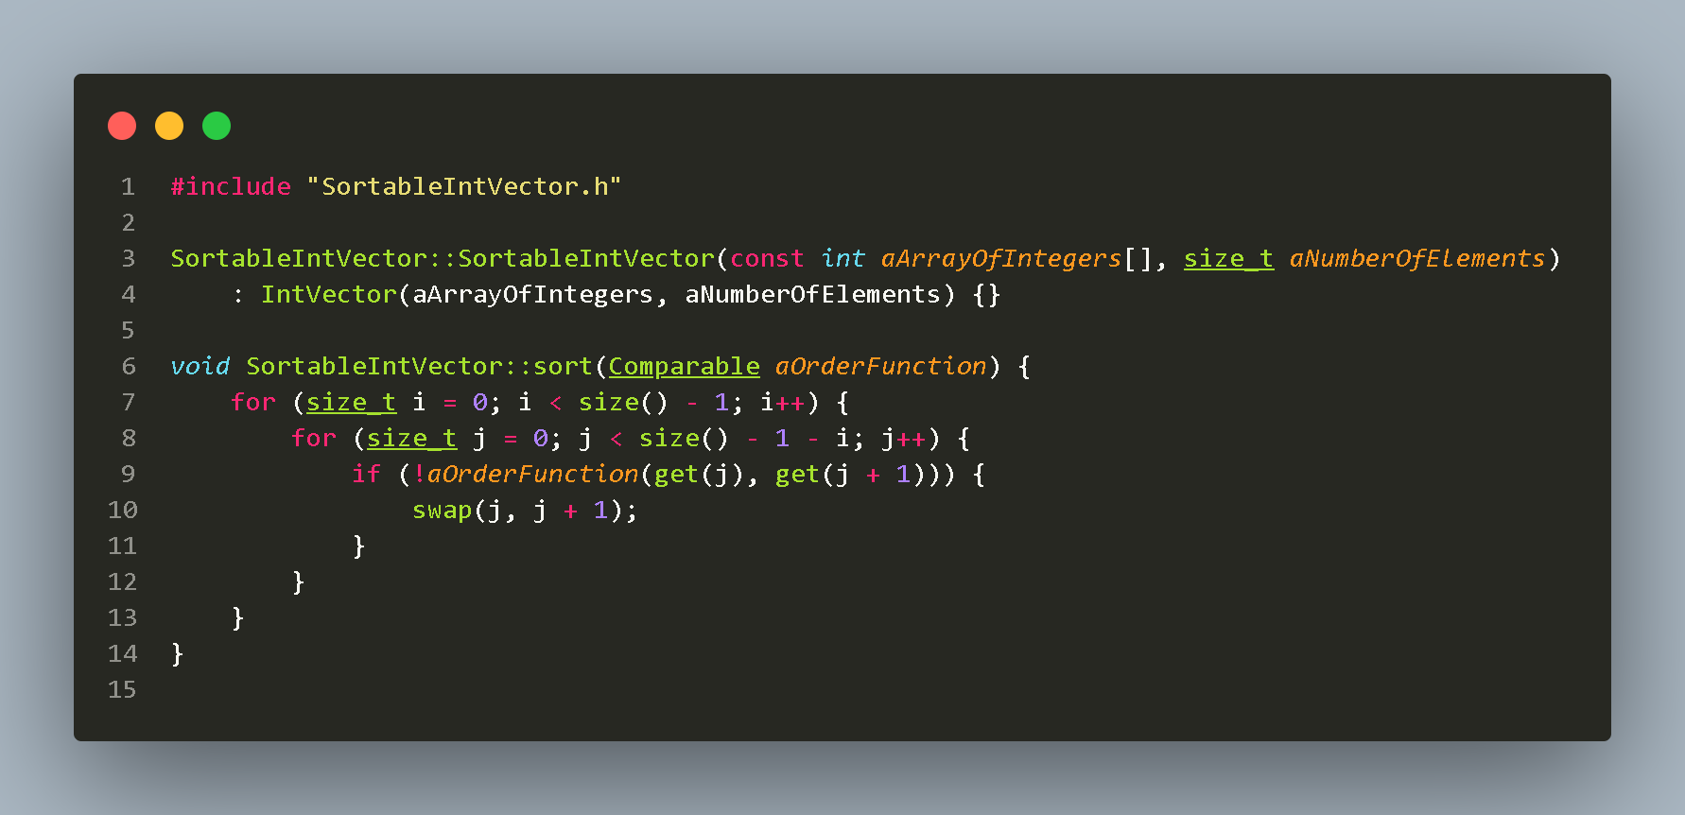

1. **ShakerSortableIntVector.cpp**

