HANOI UNIVERSITY OF SCIENCE AND TECHNOLOGY

School of Information and Communications Technology

Software Design Document

Version 1.1

AIMS: An Internet Media Store

Software Design and Construction

Group 02

Trần Xuân Bách 20204634

Nguyễn Ngọc Quỳnh Anh 20204631

Nguyễn Vũ Thục Anh 20204631

Vũ Đức Anh 20193985

*Hanoi,* *1/2024*

Table of contents

Table of contents 1

1. Use Case Analysis 2

1.1. Use Case “Refund” 2

***1.1.1.*** ***Sequence Diagram for UC “Refund”*** 2

***1.1.2.*** ***Analysis Class Diagram for UC “Refund”*** 2

1.2. Use Case “Search Products” 3

***1.2.1.*** ***Sequence Diagram for UC “Search Products”*** 3

***1.2.2.*** ***Analysis Class Diagram for UC "Search Products”*** 3

1.3. Use Case “Filter Products” 4

***1.3.1.*** ***Sequence Diagram for UC “Filter Products”*** 4

***1.3.2.*** ***Analysis Class Diagram for UC "Filter Products”*** 5

1.4. Use Case “Detail Products” 5

***1.4.1.*** ***Sequence Diagram for UC “Detail Products”*** 5

***1.4.2.*** ***Analysis Class Diagram for UC "Detail Products”*** 5

2. Class Design 8

2.1. General Class Diagram 8

2.2. Relationship Class Diagram 9

2.3. Class Design 9

2.3.1. HomeScreenHandler 9

# Use Case Analysis

## Use Case “Refund”

### ***Sequence Diagram for UC “Refund”***

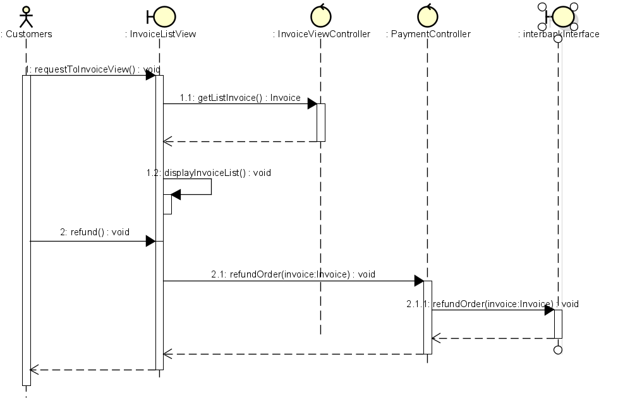

### ***Analysis Class Diagram for UC “Refund”***

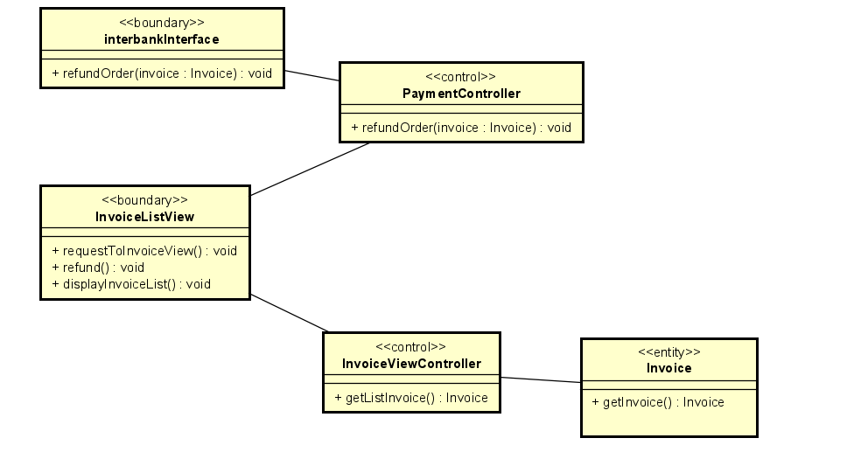

## Use Case “Search Products”

### ***Sequence Diagram for UC “Search Products”***

### ***Analysis Class Diagram for UC "Search Products”***

## Use Case “Filter Products”

### ***Sequence Diagram for UC “Filter Products”***

### ***Analysis Class Diagram for UC "Filter Products”***

## Use Case “Detail Products”

### ***Sequence Diagram for UC “Detail Products”***

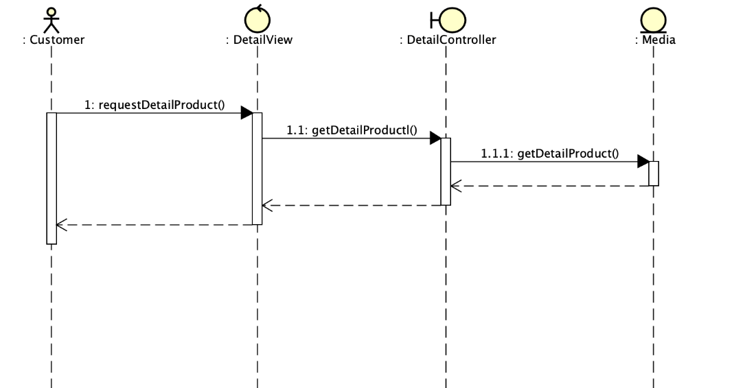

### ***Analysis Class Diagram for UC "Detail Products”***

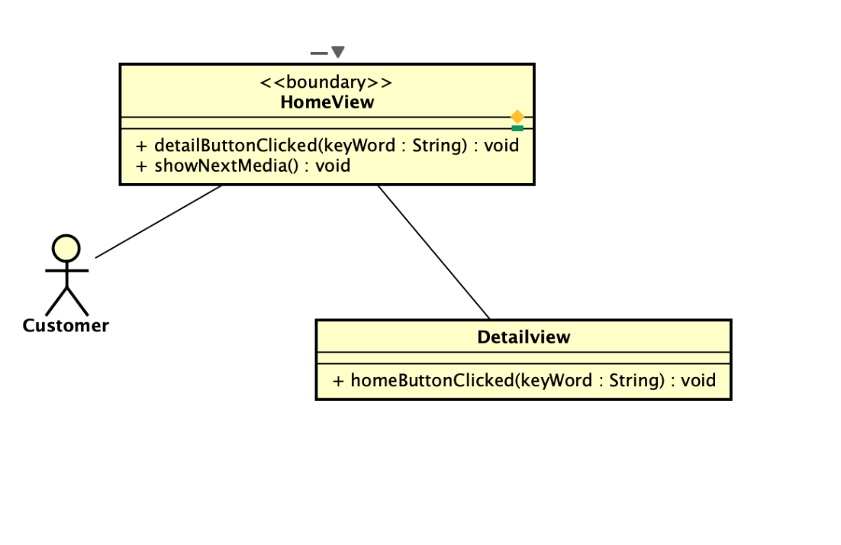

# Class Design

## General Class Diagram

## Relationship Class Diagram

## Class Design

### HomeScreenHandler

**Attribute**

|  |  |  |  |  |
| --- | --- | --- | --- | --- |
| # | Name | Data type | Default value | Description |
| 1 | homeItems | List | NULL | Holds the media items fetched from the controller. |
| 2 | displayedItems | List | NULL | Holds the currently displayed media items |
|  | curentPage | int | 0 | Tracks the current page number |
|  | itemsPerPage | int | 12 | Represents the number of items to display per page |

**Operation**

|  |  |  |  |
| --- | --- | --- | --- |
| # | Name | Return type | Description (purpose) |
| 1 | filterMediaByKeyWord | List<MediaHandler> | Filters media items based on a given keyword. |
| 2 | checkEmpty | Void | Checks if the filtered media items list is empty and handles displaying a message accordingly |
| 3 | updateMediaDisplay | Void | Update and manage the display of media items on the home screen based on the current page |
| 4 | showNextMedia | Void | Displays the next set of media items on the screen based on pagination |
| 5 | showPreviousMedia | Void | Displays the previous set of media items on the screen based on pagination |
| 6 | addMediaHome | Void | Populates the home screen with media items passed as a list. |
| 7 | addMenuItems | Void | Adds menu items based on specified text and position to the given menu button |