HANOI UNIVERSITY OF SCIENCE AND TECHNOLOGY

School of Information and Communications Technology

Software Requirement Specification

Version 1.1

AIMS: An Internet Media Store

Software Design and Construction

Group 02

Trần Xuân Bách 20204634

Nguyễn Ngọc Quỳnh Anh 20204631

Nguyễn Vũ Thục Anh 20204631

Vũ Đức Anh 20193985

*Hanoi,* *1/2024*

Table of contents

Table of contents 1

1 Introduction 2

1.1 Objective 2

1.2 Scope 2

2 Overall requirements 3

2.1 Actors 3

2.2 General use case diagram 3

2.3 Lower-level use case diagrams 4

2.3.1 Manage Orders 4

2.3.2 Manage Customers 4

2.4 Business processes 5

2.4.1 Activity Diagram of customer's software usage process 5

3 Detail requirements 6

3.1 Specification of Use case UC001 - “Refund ” 6

3.2 Specification of Use case UC002 - “Search Products” 7

3.3 Specification of Use case UC003 - “Filter Products” 9

3.4 Specification of Use case UC004 - “View detail Products” 10

# Introduction

## Objective

This document presents the detailed description for User management subsystem, user group and their usable function at run time. This document also describes the objectives and features of the system, interfaces and constraints of the system in response to external action.

This document is for stakeholders and related software developers.

## Scope

Industrial Revolution 4.0, has opened new opportunities for all of us: AIMS Project, an E commerce system for buying media products.

In this course, we will focus on features for customers, which are related to view products, placing orders, paying orders and refunding orders, instead of features such as account authentication or user management.

**In this project, our group will focus on refund, search and filter products function, pagination and view detail products for customers.**

AIMS Project is a 24/7 platform-independent system, which allows new customers to use with ease. It is expected to serve 1000 customers at the same time without the noticeable loss of performance and to operate in an average of 300 hours without failure. The AIMS Software also can be repaired within 1 hour after any typical failure. The response time for the AIMS Software is 1 second at normal or 2 seconds during a peak load if it is not explicitly stated

# Overall requirements

## Actors

3 Actors: Customer, Administrator, PayPalSanbox

## General use case diagram

Figure : General Use Case Diagram of AIMS Project

## Lower-level use case diagrams

### Manage Orders

Figure 2: Lower-level Use Case Diagram for UC Manage Orders

### Manage Customers

Figure 3: Lower-level Use Case Diagram for UC Manage Customers

## Business processes

### Activity Diagram of customer's software usage process

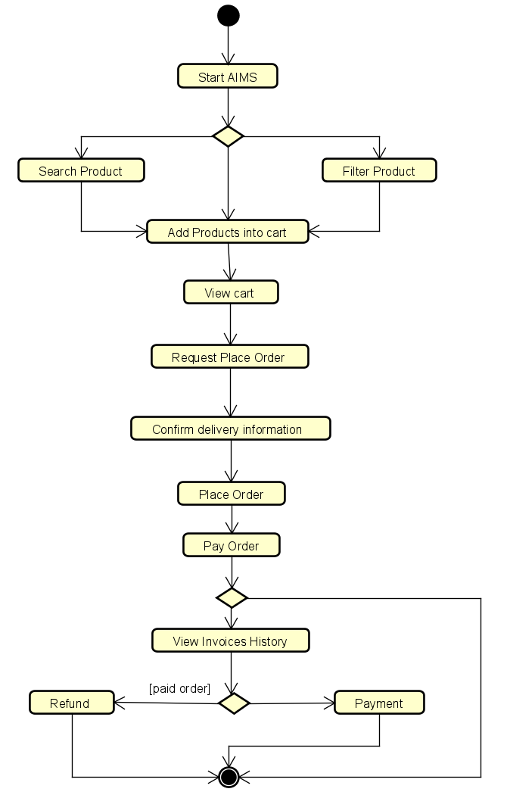

Figure 4: Activity Diagram of customer's software usage process

# Detail requirements

Details of the use cases given in following sections are specified below.

## Specification of Use case UC001 - “Refund ”

1. **Use case code**

UC001

1. **Brief Description**

This use case describes the interaction between Customer and AIMS system when Customer perform order refund.

1. **Actors**

**Customer**

1. **Preconditions**

The customer has viewed invoice

1. **Basic Flow of Events**
2. The system displays list invoice information
3. The customer selects the invoice that needs a refund
4. The system processing the refund
5. The system displays successful refund results
6. **Alternative flows**

Table N-Alternative flows of events for UC Place order

|  |  |  |  |  |
| --- | --- | --- | --- | --- |
| **No** | **Location** | **Condition** | **Action** | **Resume location** |
|  | 4 | If the invoice has expired for a refund | * The system displays an error message screen |  |
|  |  | If refund processing fails | * The system displays the message: Refund failed |  |

1. **Activity Diagram**

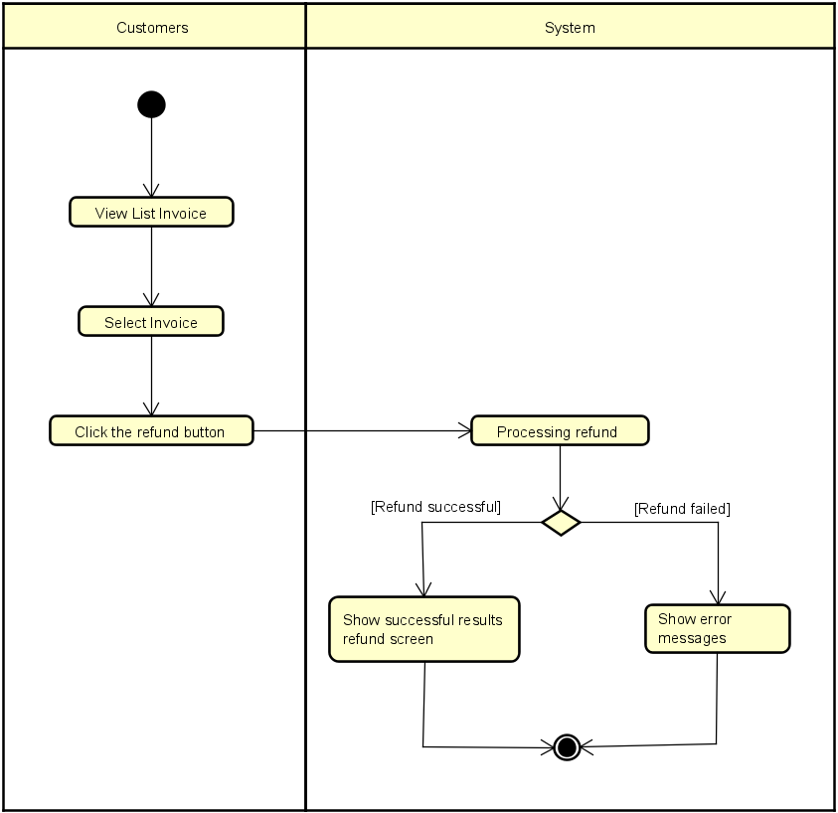

## Specification of Use case UC002 - “Search Products”

1. **Use case code**

UC002

1. **Brief Description**

This use case describes the interaction between Customer and AIMS system when Customer wishes to search products

1. **Actors**

**Customer**

1. **Preconditions**

The customer has viewed the product list

1. **Basic Flow of Events**
2. Customer enters search keywords in the search box
3. Customer clicks the search button
4. The system gets products suitable for keywords
5. The system checks the number of products matching the keyword
6. The system displays a list of at most 12 products on one page matching the keyword
7. **Alternative Flows**

Table 4 -Alternative Flow of Use case "Search Products"

|  |  |  |  |  |
| --- | --- | --- | --- | --- |
| **No** | **Location** | **Condition** | **Action** | **Resume Location** |
| 1. | 5 | If there are no products matching the keyword | * The system displays the message: There are no matching products |  |
| 2. |  | If there are more than 12 products matching the keyword | * Customer clicks the next or pre button to see the full product list | 5 |

1. **Activity Diagram**

## Specification of Use case UC003 - “Filter Products”

1. **Use Case code**

UC003

1. **Brief Description**

This use case describes the interaction between Customer and AIMS system when Customer wishes to filter products

1. **Actors**

**Customer**

1. **Preconditions**

The customer has viewed the product list

1. **Basic Flow of Events**
2. Customer chooses 1 criteria to filter products
3. The system gets products suitable
4. The system checks the number of products matching
5. The system displays a list of at most 12 products on one page matching
6. **Alternative Flows**

Table 4 -Alternative Flow of Use case "Filter Products"

|  |  |  |  |  |
| --- | --- | --- | --- | --- |
| **No** | **Location** | **Condition** | **Action** | **Resume Location** |
| 1. | 5 | If there are no products matching | * The system displays the message: There are no matching products |  |
| 2. |  | If there are more than 12 products matching | * Customer clicks the next or pre button to see the full product list | 4 |

1. **Activity Diagram**

## Specification of Use case UC004 - “View detail Products”

1. **Use Case code**

UC005

1. **Brief Description**

This use case describes viewing product details

1. **Actors**

**Customer**

1. **Preconditions**
2. **Basic Flow of Events**
3. The customer chooses to view product details
4. The system displays product details
5. Customer chooses to display the main screen
6. The system displays the main screen
7. **Alternative Flows**
8. **Activity Diagram**

