DMA
MICRO-ARCHITECTURE SPECIFICATION – V3.0
QUY NHON SEMICONDUCTORS – QNSC

Table of Contents

Table of Tables
Table 3-1. Sub-blocks
Table 4-1. Upstream IP used
Table 5-1. DMA interface
Table 5-2. Configuration, fixed at the instances in m_qnsc_wrap_dma
Table 6-1. Memory map, regions behind APB_M13
Table 6-2. Register map, idma_reg32_2d
Table 6-3. CONF fields
Table 7-1. Examples
Table 9-1. Functions this block does not provide
Table 10-1. Tie-offs inside m_qnsc_wrap_dma
Table 11-1. Requirements on other owners
Table 11-2. HAS text this specification departs from
Table A-1. Acronyms
Table B-1. First review

Table of Figures
Figure 3-1. DMA in QSOC
Figure 6-1. CONF and STATUS fields
Figure 7-1. One DMA job, firmware view
Figure 7-2. A 1D job of four words, memory to memory

Revision history
The reasoning behind each change, the V1.0–V2.0 history, the V2.0 text and the research report it was based on are in QNSC_DMA_DECISIONS.md.
Version | Date | Author | Reviewer | Description of change
V3.0 | 2026-09-28 | Nghia VT (lead), for Ong Bao Vinh | – | Upstream iDMA used unmodified (frontend reg, 32-bit, 2D, APB), per the mentor: open-source 32-bit DMA, IP not redesigned. In-house frontend, descriptor engine and peripheral channels of V2.0 removed; APB_M13; idle interrupt

1. Overview
The DMA copies blocks of data between any two addresses of QSOC without the CPU executing a load and a store per word. Firmware writes a source, a destination and a length, launches the job, and continues or sleeps until the DMA interrupt.
The fact that shapes it: it is pulp-platform/iDMA used as released. Frontend, midend and backend are upstream; this block is a wrapper that joins them and connects them to APB_M13 and AXI_S2.
Every transfer is started by software. There is no hardware request from peripherals: a peripheral is reached as an ordinary address through S_BUS, AXI2APB and P_BUS.
Block directory design/dma, wrapper m_qnsc_wrap_dma, owner Ong Bao Vinh.

2. Features
- Memory-to-memory, memory-to-peripheral and peripheral-to-memory copies at any byte address and length – 7.1.
- 2D jobs: REPS repetitions with independent source and destination strides; a stride of 0 reaches a FIFO data register – 7.3.
- AXI4 bursts on AXI_S2, 32-bit data – 7.2.
- Configuration on APB_M13, upstream register file – 6.
- One level interrupt while the DMA is idle – 7.4.
Use in QSOC: block copies between memories and buffers, and SPI host and SPI Device data at high rates. UART and I2C are served by the CPU: at 113 636 baud a 16-byte FIFO needs one interrupt every 1.4 ms.

3. Block diagram
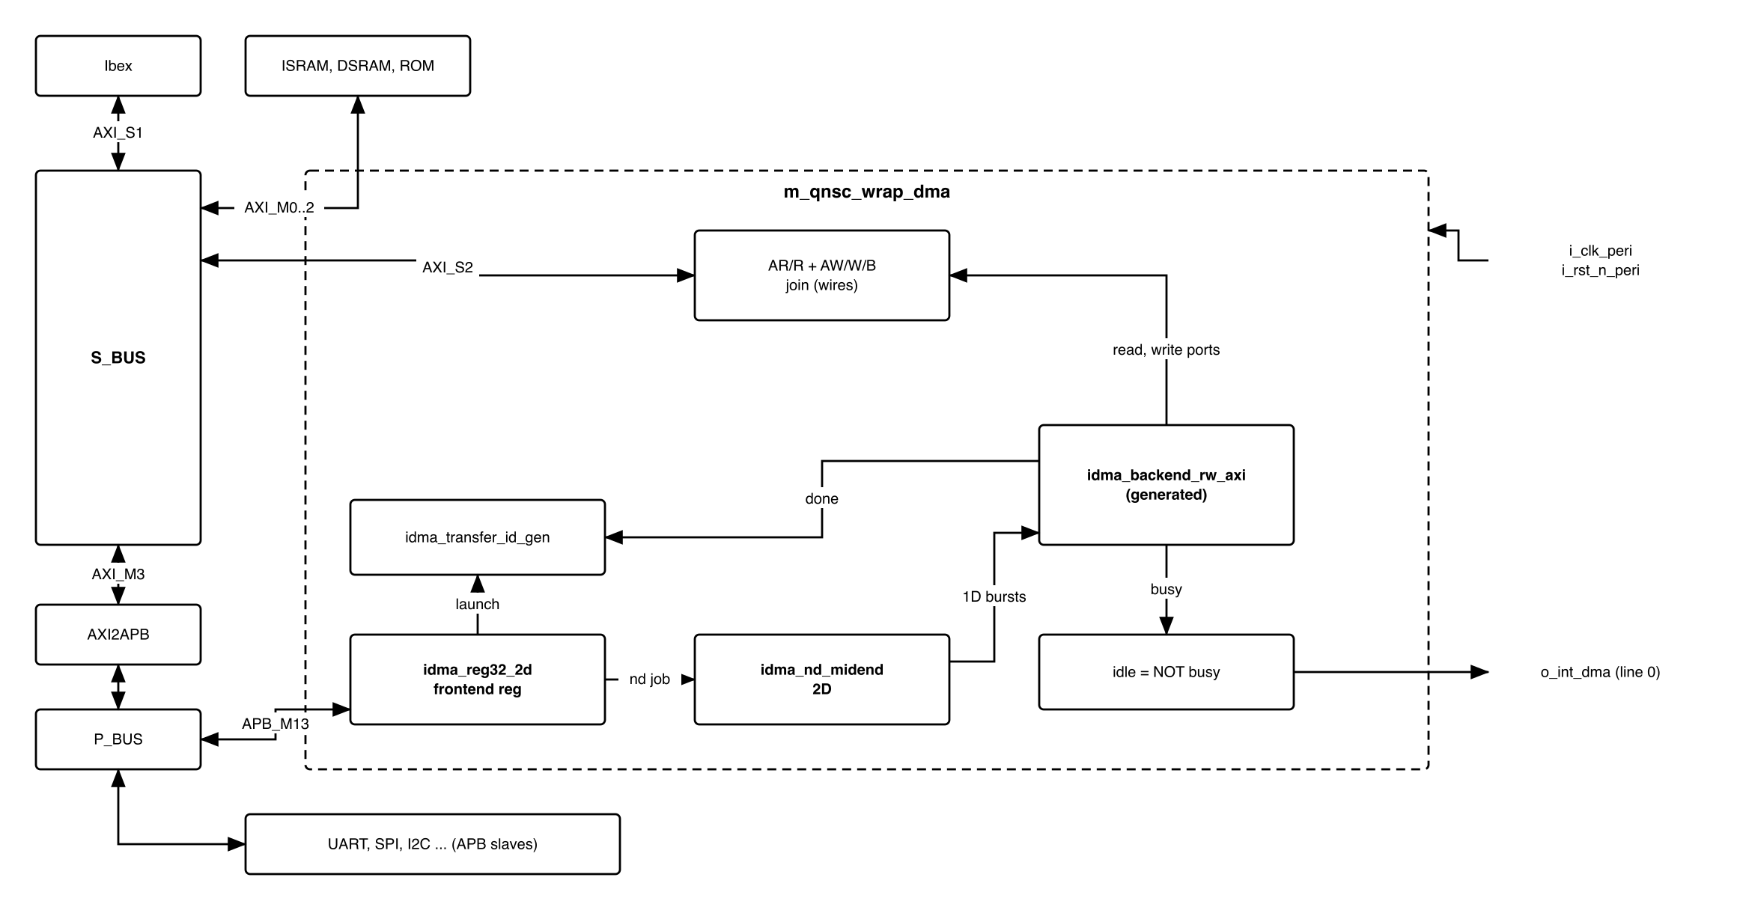
Figure 3-1. DMA in QSOC
Table 3-1. Sub-blocks
Block | Module | Source | Function
Frontend | idma_reg32_2d | upstream, generated (7.6) | APB register file; builds a 2D job; launches it on a read of NEXT_ID
Transfer IDs | idma_transfer_id_gen | upstream | Issues the job ID returned by NEXT_ID; counts completed jobs into DONE_ID
Midend | idma_nd_midend | upstream | Splits a 2D job into REPS 1D transfers
Backend | idma_backend_rw_axi | upstream, generated (7.6) | Executes a 1D transfer as AXI4 read and write bursts
Port join | in m_qnsc_wrap_dma | wires | Read port AR/R and write port AW/W/B onto one AXI port, AXI_S2
Idle | in m_qnsc_wrap_dma | one NOR | o_int_dma = no unit busy
The block is in the peri clock cluster, SCRC CLK_EN[10].

4. IP used
Table 4-1. Upstream IP used
From | Module | Commit | Licence
pulp-platform/iDMA | idma_reg.sv.tpl, idma_reg.rdl (frontend), idma_nd_midend, idma_transfer_id_gen, backend templates, idma_pkg | 2e0b0fe5 | SHL-0.51
Facts this specification relies on, read at that commit:
- Backend protocols: AXI4, AXI4-Lite, AXI4-Stream, OBI, TileLink, Init (src/db). No APB, which QSOC does not need: the configuration port is the frontend’s.
- The frontend template has an APB4 configuration port (--cpuif apb4-flat, the idma.mk default) and a 32-bit variant. It has no interrupt and no hardware request input.
- A read of NEXT_ID launches the job and returns the next transfer ID; one launch is held until the midend accepts it (idma_reg.sv.tpl, launch_pending_q).
- The frontend drives burst = INCR for source and destination (idma_reg.sv.tpl).
- idma_rt_midend launches on a time counter, not on a peripheral event; it is not used.

5. Interface
Table 5-1. DMA interface
Signal | Dir | Width | Description
i_clk_peri, i_rst_n_peri | in | 1 | SCRC o_clk_dma, o_rst_n_dma
i_bus_apb_psel, i_bus_apb_penable, i_bus_apb_pwrite | in | 1 | P_BUS APB_M13
i_bus_apb_paddr | in | 12 | Offset in the window (contract meta.apb_paddr_width)
i_bus_apb_pwdata, i_bus_apb_pstrb, i_bus_apb_pprot | in | 32, 4, 3 | APB4
o_bus_apb_prdata, o_bus_apb_pready, o_bus_apb_pslverr | out | 32, 1, 1 | APB4 response
o_bus_axi_ar_*, i_bus_axi_r_* | – | AXI4 | Read channels to S_BUS AXI_S2, from the backend read port
o_bus_axi_aw_*, o_bus_axi_w_*, i_bus_axi_b_* | – | AXI4 | Write channels to AXI_S2, from the backend write port
o_int_dma | out | 1 | 1 while the DMA is idle – 7.4. To INTMAP i_int_dma, line 0

Table 5-2. Configuration, fixed at the instances in m_qnsc_wrap_dma
Parameter | Value | Why
Frontend | reg32_2d, apb4-flat, 1 register port, 1 stream | 32-bit system, 2D for the stride-0 case; one job stream
DataWidth, AddrWidth | 32, 32 | QSOC bus widths
AxiIdWidth | 5 | AXI_S2 ID width assumed by S_BUS (QNSC_BUS_MAS 11)
TFLenWidth | 32 | LENGTH is a 32-bit register
NumAxInFlight, BufferDepth | 2, 2 | Backend template defaults
ErrorCap | NO_ERROR_HANDLING | No error-handler port – 7.5
HardwareLegalizer, RejectZeroTransfers | 1, 1 | Bursts split at 4 KiB and to legal lengths; a zero-length job is dropped
EnableCompute | 0 | No on-the-fly compute; COMPUTE_CFG has no effect

6. Register map
Table 6-1. Memory map, regions behind APB_M13
Base | Size | Region | Port | Kind | Note
0x80034000 | 16 KiB | dma_cfg | APB_M13 | peripheral | Register interface of the DMA
The frontend decodes offset bits 7:0, so the map repeats every 256 bytes in the window. All registers are 32-bit; an offset with no register reads 0.
Table 6-2. Register map, idma_reg32_2d
Offset | Register | Access | Reset | Description
0x00 | CONF | RW | 0 | Job options, Figure 6-1
0x04 | STATUS | RO | 0 | busy: bit 8 midend, bits 7:0 the eight backend units of idma_busy_t; bit 9 reads 0
0x08–0x40 | STATUS of streams 1–15 | RO | 0 | Not present; read 0
0x44 | NEXT_ID | RO, read has effect | 0 | Read launches the job and returns its ID
0x48–0x80 | NEXT_ID of streams 1–15 | RO | 0 | Not present; read 0, launch nothing
0x84 | DONE_ID | RO | 0 | ID of the last completed job
0x88–0xC0 | DONE_ID of streams 1–15 | RO | 0 | Not present
0xD0 | DST_ADDR | RW | 0 | Destination byte address
0xD4 | SRC_ADDR | RW | 0 | Source byte address
0xD8 | LENGTH | RW | 0 | Bytes per 1D transfer
0xDC | DST_STRIDE | RW | 0 | Destination address step between repetitions
0xE0 | SRC_STRIDE | RW | 0 | Source address step between repetitions
0xE4 | REPS | RW | 0 | Number of repetitions (2D)
0xE8 | COMPUTE_CFG | RW | 0 | No effect (EnableCompute = 0)
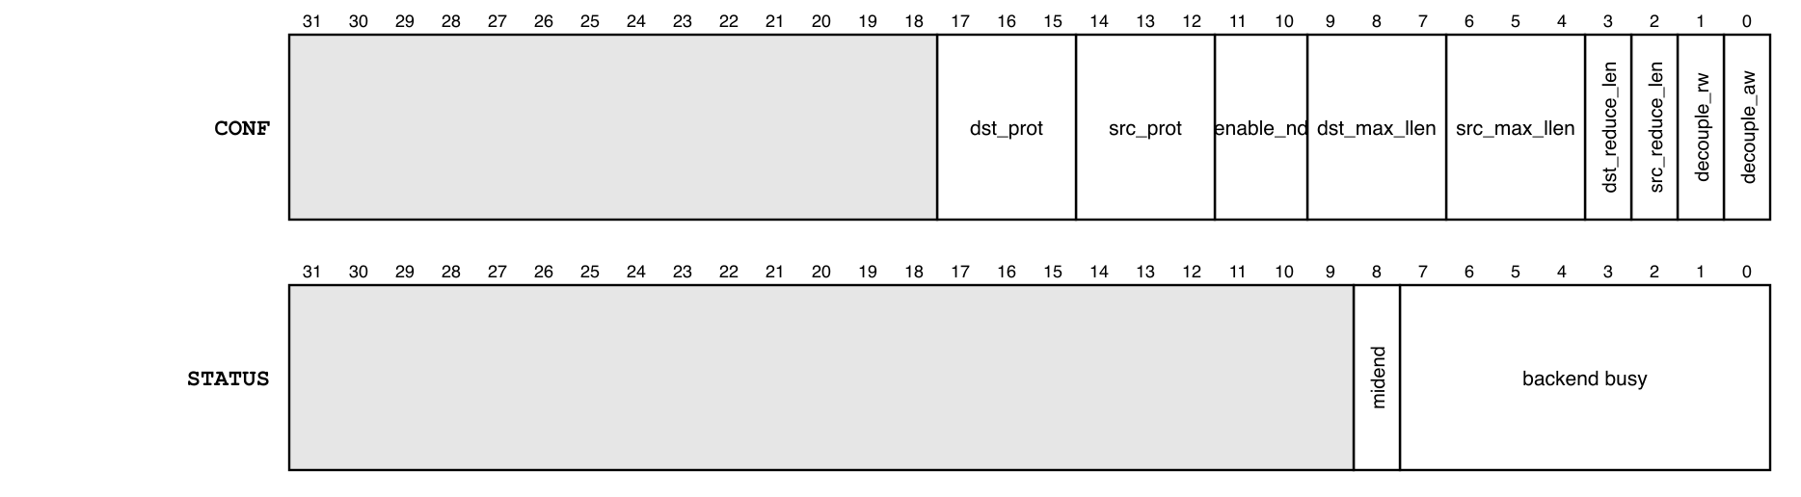
Figure 6-1. CONF and STATUS fields
Table 6-3. CONF fields
Bits | Field | QSOC value | Meaning
0 | decouple_aw | 0 | Write address may be issued before read data; 0 = coupled
1 | decouple_rw | 0 | Read and write decoupled; 0 = coupled
2, 3 | src_reduce_len, dst_reduce_len | 0 | 1 limits the burst to 2^max_llen beats
6:4, 9:7 | src_max_llen, dst_max_llen | 0 | Log2 of the maximum burst length when reduced
11:10 | enable_nd | 0 or 1 | 1 = 2D job (REPS, strides used)
14:12, 17:15 | src_protocol, dst_protocol | 0 | 0 = AXI, the only backend protocol
31:18 | – | 0 | Reserved

7. Functional behaviour

7.1 Job
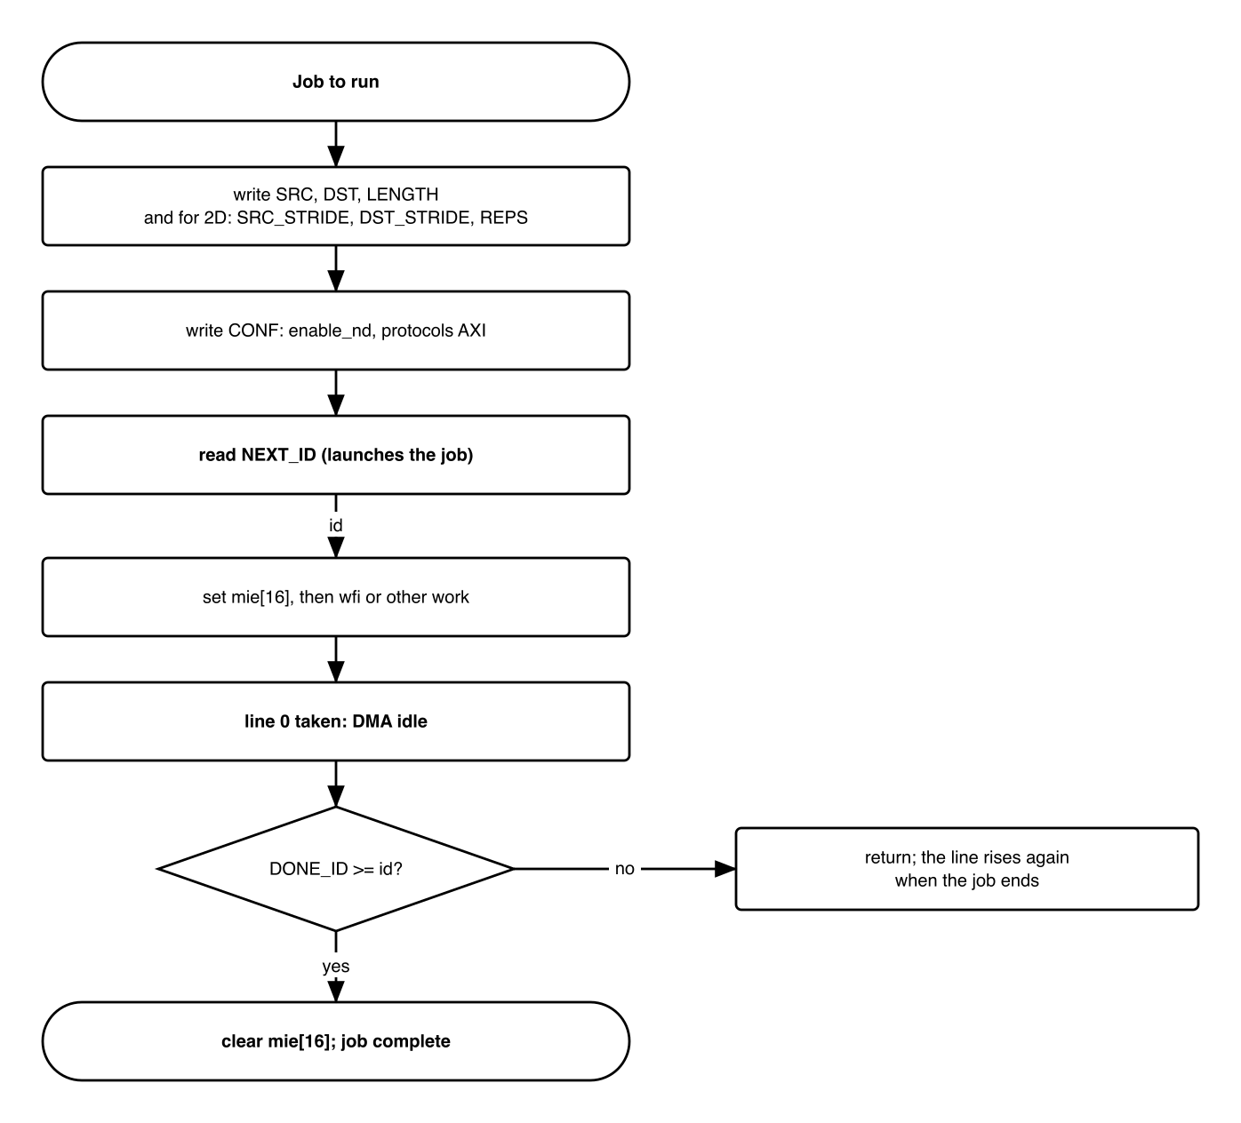
Figure 7-1. One DMA job, firmware view
- A 1D job copies LENGTH bytes from SRC_ADDR to DST_ADDR, both incrementing. Addresses and length need no alignment; the backend handles the byte offsets.
- A 2D job (enable_nd = 1) copies REPS blocks of LENGTH bytes; block k starts at SRC_ADDR + k x SRC_STRIDE and DST_ADDR + k x DST_STRIDE.
- Reading NEXT_ID samples the registers and launches the job; the registers may be rewritten at once.
- The frontend holds one launch until the midend accepts it; a second read of NEXT_ID before that is lost. Firmware runs one job at a time: it launches the next job after DONE_ID has reached the previous ID.
- DONE_ID is the ID of the last job completed. A job with ID i is complete when DONE_ID >= i, modulo 2^32.

7.2 Bus traffic
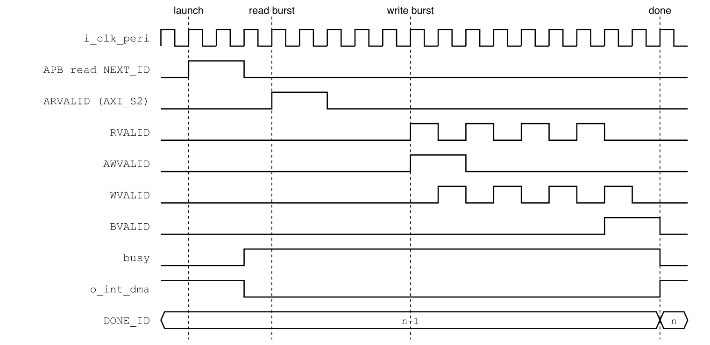
Figure 7-2. A 1D job of four words, memory to memory
- Reads and writes use INCR bursts on AXI_S2, split at 4 KiB boundaries.
- With the ISRAM/DSRAM controller, a read burst returns one beat every 2 cycles and a write burst takes one beat per cycle (QNSC_RAM_MAS 7.1): about 2 cycles per word, against about 10 for a CPU copy loop (estimate, not simulated).
- A peripheral address goes through AXI_M3, AXI2APB and P_BUS: one APB access per beat.
- The DMA and Ibex share S_BUS; the crossbar arbitrates between them.

7.3 Peripheral FIFO: stride 0
A FIFO data register is reached with a 2D job whose peripheral-side stride is 0:
Table 7-1. Examples
Job | SRC_ADDR | DST_ADDR | LENGTH | REPS | SRC_STRIDE | DST_STRIDE
16 bytes to UART0 THR | buffer | 0x8002_0000 | 1 | 16 | 1 | 0
16 bytes from UART0 RBR | 0x8002_0000 | buffer | 1 | 16 | 0 | 1
4 KiB memory copy (1D) | source | destination | 4096 | – | – | –
Firmware starts a FIFO job only when the FIFO has room or data for all REPS entries, for example from the peripheral’s FIFO interrupt. Nothing paces the DMA by the peripheral.

7.4 Interrupt
- o_int_dma = 1 while neither the midend nor any backend unit is busy (STATUS = 0). It is a level, 1 out of reset.
- Firmware enables mie bit 16 after launching, and the handler compares DONE_ID with the launched ID: equal or later, the job is done and the handler clears mie[16]; earlier, the line was sampled before the job became busy and the handler returns.
- Line 0 is the highest-priority fast line (QNSC_Interrupt_Map_MAS 7.2).

7.5 Errors
- LENGTH = 0 is not a job: firmware does not launch one.
- With ErrorCap = NO_ERROR_HANDLING, an AXI error response on AXI_S2 (decode error, SLVERR from the ROM or a blocked peripheral) is not reported: the job completes and DONE_ID advances.

7.6 Generated files
The frontend and the backend are generated once, at the pinned commit, and committed with the command that made them in util/gen/idma/:
- idma_reg32_2d_reg_top.sv, idma_reg32_2d_reg_pkg.sv: PeakRDL regblock on idma_reg.rdl, SysAddrWidth=32 NumDims=2 Log2NumDims=1, --cpuif apb4-flat.
- idma_reg32_2d_top.sv: gen_idma.py on idma_reg.sv.tpl.
- idma_backend_rw_axi.sv, idma_legalizer_rw_axi.sv, idma_transport_layer_rw_axi.sv: gen_idma.py on the backend templates, --ids rw_axi.
None is edited by hand. design/dma/rtl/ holds the wrapper only.

7.7 Clock and reset
- Clock o_clk_dma, gateable by CLK_EN[10]; reset o_rst_n_dma, released with the other domains (QNSC_SCRC_MAS 7.5).
- The SCRC APB guard covers APB_M13 only. Before gating the DMA, firmware waits until STATUS = 0, so no burst is cut on S_BUS (QNSC_SCRC_MAS 7.10).

8. Instances
One m_qnsc_wrap_dma in design/top.

9. What is not provided here, and who provides it
Table 9-1. Functions this block does not provide
Function | Where it lives
Hardware request from a peripheral | not provided; firmware starts every job from the peripheral’s interrupt (7.3)
Descriptor chains, circular buffers | not provided; firmware launches the next job
Reporting an AXI error | not provided (7.5)
Memory fill without a source | not provided; copy from a zero buffer
Routing AXI_S2 to memories and AXI_M3 | S_BUS

10. Tie-offs
Table 10-1. Tie-offs inside m_qnsc_wrap_dma
Port | Tied to | Why
Frontend midend_busy_i | midend busy_o | Reported in STATUS[9]
Backend error-handler request | none (NO_ERROR_HANDLING has no port) | 7.5
AXI user on every channel | 0 | Not used on S_BUS
AXI ar_prot, aw_prot | as driven by the backend | Not checked by any QSOC slave

11. Requirements on others, and open items
Table 11-1. Requirements on other owners
Item | Owner | What it blocks
AXI_S2 ID width 5; AXI_S2 reaches AXI_M0–AXI_M3 | bus owner | 7.2
UART wrapper drops o_dma_tx_req, o_dma_rx_req and the patch 0001-add-dma-request-lines | UART owner | a vendor patch that nothing uses
Contract: close tbd “DMA peripheral channel for each requester”; interrupt line 0 note: idle level | lead | contract matching this block

Table 11-2. HAS text this specification departs from
QSOC_HAS_Report_EN_v4_final Table 10-1/10-2 says | This specification | Why
Three modes: register job, descriptor chain, eight peripheral channels | upstream frontend reg only | Mentor: open-source DMA, IP not redesigned; QSOC peripherals are slow enough for CPU-paced jobs
Configuration port APB_M14 at 0x8003_8000 | APB_M13 at 0x8003_4000 | Contract since GPIO3 was dropped
DMA_ISR write-1-to-clear flags, IRQ_MODE | idle level from STATUS | The upstream frontend has no interrupt; an idle level needs no register
axi_mux 3:1 onto AXI_S2 | wires | Without a descriptor fetch port only the read and write ports remain, on disjoint channels
Open items, DMA owner:
- Generate the files of 7.6 and commit them with the commands.
- Run the upstream rw_axi backend jobs and a wrapper test in simulation.
Accepted limits:
- No AXI error is visible to software (7.5).
- A FIFO job is paced by firmware, not by the peripheral (7.3).
- One job at a time (7.1).

12. Verification
- DMA_001 Register reset values, access and the 256-byte alias of section 6.
- DMA_002 A 1D job copies LENGTH bytes for unaligned addresses and lengths 1, 3, 4, 5, 4096 and across a 4 KiB boundary.
- DMA_003 A 2D job with DST_STRIDE = 0 writes one address REPS times, in order.
- DMA_004 Two jobs, each launched after DONE_ID reached the previous ID, complete in order and DONE_ID reaches each ID.
- DMA_005 A read of NEXT_ID while a launch is still held changes nothing (documents the limit of 7.1).
- DMA_006 o_int_dma is 1 exactly while STATUS = 0.
- DMA_007 A job to UART0 at 0x8002_0000 through S_BUS and P_BUS (SoC test).
- DMA_008 Ibex and the DMA both reach ISRAM during a job; both complete (SoC test).
- DMA_009 The generated files match a regeneration from the pinned commit (CI).

Appendix A. Acronyms
Table A-1. Acronyms
Acronym | Description
DMA | Direct Memory Access
iDMA | pulp-platform’s modular DMA engine
INCR | AXI incrementing burst
ND | N-dimensional (here 2D) transfer

Appendix B. First review
Table B-1. First review
Item | Reviewer | Response
Use an open-source 32-bit DMA; do not redesign the IP | Quan (mentor) | Upstream iDMA unmodified, 3, 4
iDMA has no hardware request from peripherals | Vinh (research) | Correct; QSOC does not need it, 1, 9
Is an APB backend needed to reach the peripherals? | Vinh | No: peripherals are addresses behind S_BUS, 1
What is the DMA for if the CPU starts every job? | Vinh | Block copies and fast SPI without a CPU load/store per word; one interrupt per job, 2, 7.2
APB_M14 against contract APB_M13 | lead, V3.0 | 6

