Table of Contents

QNSC_Interrupt_Map_MAS
Block intmap · Owner Nghia Van Trong · Version 2.0 · 2026-09-23
Twenty-seven interrupt sources reach the CPU as twelve wires. INTMAP is the combinational OR tree that does the reduction.
Why the specification says what it says — the two designs that were dropped, the evidence read out of Ibex, the questions that closed — is in QNSC_Interrupt_Map_DECISIONS.md. This file is the contract.

1. Scope
INTMAP groups the interrupt sources of fourteen blocks onto the CPU’s fast interrupt lines, one line per peripheral, and passes the watchdog bark straight through to the non-maskable input.
It does not: hold state, decode an address, appear on any bus, prioritise (the core does that), or latch a pulse. It has no clock and no reset.

2. Block diagram
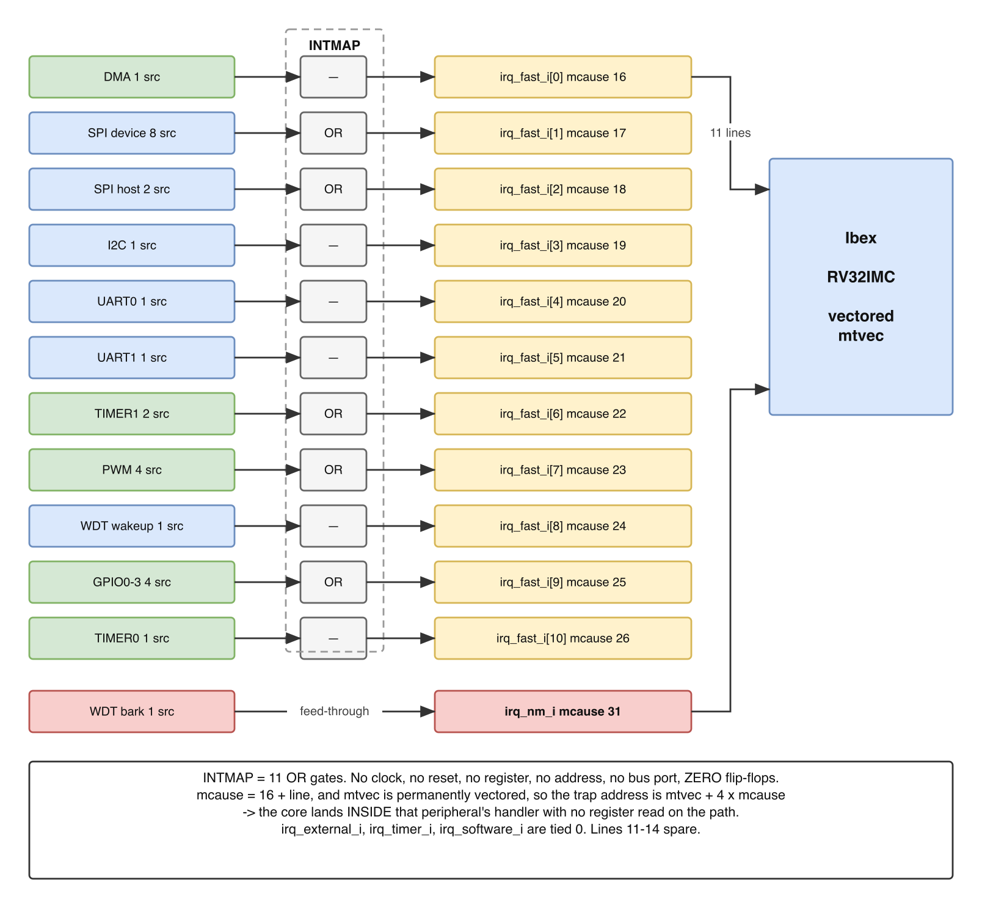
INTMAP — 27 sources, one OR per peripheral, 12 wires to the CPU
One combinational layer. No sub-blocks, no clock domain, no reset domain.

3. IP used
From | Module | Commit
— | — | —
Designed in house. The block instantiates nothing; it is assign statements.

4. Interface
Every port. Naming follows QNSC_RTL_Design_Naming_Rule V1.0 section 3.6, i_int_<source> / o_int_<source>.
Signal | Dir | Width | Description
i_int_dma | in | 1 | DMA completion. Level, held by DMA_ISR
i_int_spi_dev | in | 8 | spi_device intr_*_o, in declaration order
i_int_spi_host | in | 2 | spi_host error, event
i_int_i2c | in | 1 | I²C
i_int_uart_0 | in | 1 | UART0. Driven by the IP’s INT port
i_int_uart_1 | in | 1 | UART1
i_int_timer_1 | in | 2 | TIMER1 irq_lo_o, irq_hi_o
i_int_pwm | in | 4 | PWM events_o
i_int_wdt_wkup | in | 1 | aon_timer wake-up expiry
i_int_gpio | in | 4 | one per GPIO instance
i_int_timer_0 | in | 1 | TIMER0 irq_lo_o only — 64-bit mode
i_int_wdt_bark | in | 1 | aon_timer nmi_wdog_timer_bark_o
o_int_fast | out | 11 | to Ibex irq_fast_i[10:0]
o_int_nm | out | 1 | to Ibex irq_nm_i
27 inputs, 12 outputs, and no other ports. No i_clk_*, no i_rst_n_*.

5. Register map
None. The block has no address and is not a bus slave, so there is nothing for software to read or write.
Enabling and masking is done in the core: mie bits 16–26 for the fast lines. Acknowledging is done at each peripheral’s own status register.

6. Functional behaviour

6.1 One OR gate per peripheral
assign o_int_fast[0] = i_int_dma;
assign o_int_fast[1] = |i_int_spi_dev;
assign o_int_fast[2] = |i_int_spi_host;
assign o_int_fast[3] = i_int_i2c;
assign o_int_fast[4] = i_int_uart_0;
assign o_int_fast[5] = i_int_uart_1;
assign o_int_fast[6] = |i_int_timer_1;
assign o_int_fast[7] = |i_int_pwm;
assign o_int_fast[8] = i_int_wdt_wkup;
assign o_int_fast[9] = |i_int_gpio;
assign o_int_fast[10] = i_int_timer_0;
assign o_int_nm = i_int_wdt_bark;
A peripheral with one source is wired straight through; one with several is OR-reduced. Zero flip-flops, so the delay from a source asserting to the core seeing it is combinational.

6.2 Line assignment
The line index is the priority: Ibex resolves the lowest index first. This table therefore fixes the default priority order as well as the wiring, and changing it requires re-synthesis.
Line | mcause | Vector | Peripheral | Sources | Shape
0 | 16 | mtvec + 0x40 | DMA | 1 | level
1 | 17 | mtvec + 0x44 | SPI device | 8 | level
2 | 18 | mtvec + 0x48 | SPI host | 2 | level
3 | 19 | mtvec + 0x4C | I²C | 1 | level
4 | 20 | mtvec + 0x50 | UART0 | 1 | level
5 | 21 | mtvec + 0x54 | UART1 | 1 | level
6 | 22 | mtvec + 0x58 | TIMER1 | 2 | pulse
7 | 23 | mtvec + 0x5C | PWM | 4 | pulse
8 | 24 | mtvec + 0x60 | WDT wake-up | 1 | level
9 | 25 | mtvec + 0x64 | GPIO0–3 | 4 | pulse
10 | 26 | mtvec + 0x68 | TIMER0 | 1 | pulse
11–14 | 27–30 | — | spare, tied to 0 | 0 | —
— | 31 | mtvec + 0x7C | WDT bark, on irq_nm_i | 1 | level
26 sources on 11 lines, plus the NMI: 27. Ibex provides 15 fast lines, so four are spare.
Order follows one rule: data loss first, human time last. A missed SPI or UART event loses a byte that cannot be recovered; a missed timer tick arrives again next period. DMA takes line 0 because the rest of the system waits on a transfer completing.

6.3 The core identifies the source, not a register
Fast line n raises mcause 16 + n, and Ibex is permanently in vectored mode, so the trap address is mtvec + 4 × mcause. The core therefore enters the peripheral’s own handler directly. No claim register is read and no bus transaction occurs on the interrupt path.
mcause 16 and above is platform-use space in the RISC-V privileged specification, so this numbering is a local convention the specification permits.

6.4 The NMI bypasses this block
i_int_wdt_bark goes to o_int_nm unmodified. The bark must reach the core even if firmware has hung with interrupts disabled, and irq_nm_i is outside mstatus.MIE and mie.
Ibex ignores the NMI in Debug Mode. A bark raised while SYSDBG has the core halted therefore traps on resume, not when it occurs — and only because aon_timer holds the bark as a level.

6.5 A pulse can be missed, and what that costs
mip in Ibex is combinational: assign mip.irq_fast = irq_fast_i. The core latches nothing, and neither does this block. A one-cycle pulse arriving while mstatus.MIE is clear is therefore not seen.
That costs an interrupt but not information, because every source either holds its line or keeps a record:
Source | Shape | Recovery
DMA | level | held by DMA_ISR, write-1-to-clear
SPI ×2, I²C, UART ×2, WDT wake-up | level | held until the handler clears it
GPIO | pulse | which pin fired is in the instance’s own INTSTATUS
TIMER0, TIMER1, PWM | pulse | the event repeats next period
No source destroys information. This is the condition the design depends on.

7. Instances
One. It is instantiated in design/top and has no parameters.

8. What is not provided here, and who provides it
Function | Where it lives
Pending latch | the peripheral’s status register, or nowhere — 6.5
Which event fired | the peripheral’s status register
Which peripheral fired | mcause, via the vectored trap address
Priority resolution | Ibex, by fast-line index
Per-source enable | mie bits 16–26, in the core
Acknowledge | writing the peripheral’s status register

9. Tie-offs
Port | Tied to | Why
irq_fast_i[14:11] | 4'b0 | QSOC drives 11 of the 15 lines
irq_external_i | 0 | nothing aggregates onto it; there is no external controller
irq_timer_i | 0 | no CLINT, so mip.MTIP is never set. TIMER0 is an ordinary fast line
irq_software_i | 0 | permitted on a single-hart system
Consequence for firmware: an RTOS ported to QSOC must supply its own timer driver rather than the standard mtime/mtimecmp one.

10. Requirements on others, and open items
Item | Owner | What it blocks
APB-to-TL-UL wrapper for aon_timer | WDT owner | two of the 27 sources, one being the NMI. Its enable is in WDOG_CTRL offset 0x1C, so without a bus path the watchdog cannot be enabled and never barks
Watchdog stoppable while debug_mode is asserted, or firmware told to disable it | WDT owner | a long debug session otherwise ends in a reset with nothing recording why
Vector table at mtvec + 0x40 … +0x68, plus +0x7C; mie bits 16–26 | firmware owner | —
Handlers installed before mstatus.MIE is set | firmware owner | the block is transparent out of reset, so every source is live from the first cycle
Accepted limits, stated rather than hidden:
- A pulse arriving while mstatus.MIE is clear is lost. Recoverable for every source — 6.5.
- Priority is fixed at elaboration. Changing it is a re-synthesis.
- mcause 16–30 is platform-use space, so the numbering is a local convention rather than a portable one.

Verification
Ten checks, none requiring a bus model:
- Each single-source input raises exactly its own line.
- Each OR group raises its line for every member, individually.
- No input raises a line other than its own.
- Spare lines [14:11] are always 0.
- i_int_wdt_bark reaches o_int_nm and no fast line.
- Simultaneous inputs on one group raise the line once.
- Simultaneous inputs on different groups raise both lines.
- Output follows input combinationally, with no cycle of delay.
- mcause/vector mapping matches section 6.2 against qnsc_pkg.
- Lint check: the module contains no i_clk_, no i_rst_n_, and no always_ff. If any appears, the design has drifted back into being a controller.

