ROM
MICRO-ARCHITECTURE SPECIFICATION – V3.0
QUY NHON SEMICONDUCTORS – QNSC

Table of Contents

Table of Tables
Table 3-1. Sub-blocks
Table 4-1. Upstream IP used
Table 5-1. m_qnsc_wrap_rom interface
Table 5-2. m_qnsc_rom_image interface
Table 5-3. Controller parameters
Table 6-1. Memory map, regions behind AXI_M0
Table 6-2. ROM layout
Table 9-1. Functions this block does not provide
Table 10-1. Controller ports tied inside m_qnsc_wrap_rom
Table 11-1. Requirements on other owners
Table 11-2. HAS text this specification departs from
Table A-1. Acronyms
Table B-1. First review

Table of Figures
Figure 3-1. ROM wrapper, read and write paths
Figure 6-1. ROM layout
Figure 7-1. Single-beat read at the AXI port
Figure 7-2. Image port
Figure 7-3. A single-beat write answered with SLVERR

Revision history
The reasoning behind each change, the V1.0–V2.1 history and the V2.1 text are in QNSC_ROM_DECISIONS.md.
Version | Date | Author | Reviewer | Description of change
V3.0 | 2026-09-28 | Nghia VT (lead), for Nguyen Hao Nam | – | V2.1 moved onto the MAS template: generated constant image instead of $readmemh, ports as QNSC_RAM_MAS, controller behaviour referenced, timing diagrams, monochrome figures

1. Overview
The boot ROM is 2 KiB of read-only memory at 0x0000_0000 on S_BUS port AXI_M0. QSOC has no Flash, so the ROM holds the only code present at reset: Ibex fetches its first instruction from it.
The fact that shapes it: the libraries have no mask ROM and no OTP. The ROM is the RAM’s AXI controller in front of a constant array generated from the bootloader image, with every write answered by an error.
This document is the ROM hardware and the layout Ibex forces on its contents. What the bootloader does is QNSC_BOOT_SPEC.
Block directory design/rom, wrapper m_qnsc_wrap_rom, owner Nguyen Hao Nam.

2. Features
- 512 words of 32 bits at 0x0000_0000–0x0000_07FF – 6.
- Reads by the vendored AXI controller, INCR bursts up to 256 beats – 7.1.
- Contents fixed at build time, as synthesisable constant logic – 7.2.
- Every write answered with SLVERR, bursts of any length drained – 7.3.
- Layout forced by Ibex: 128-byte trap vector table, first fetch at 0x80 – 6.

3. Block diagram
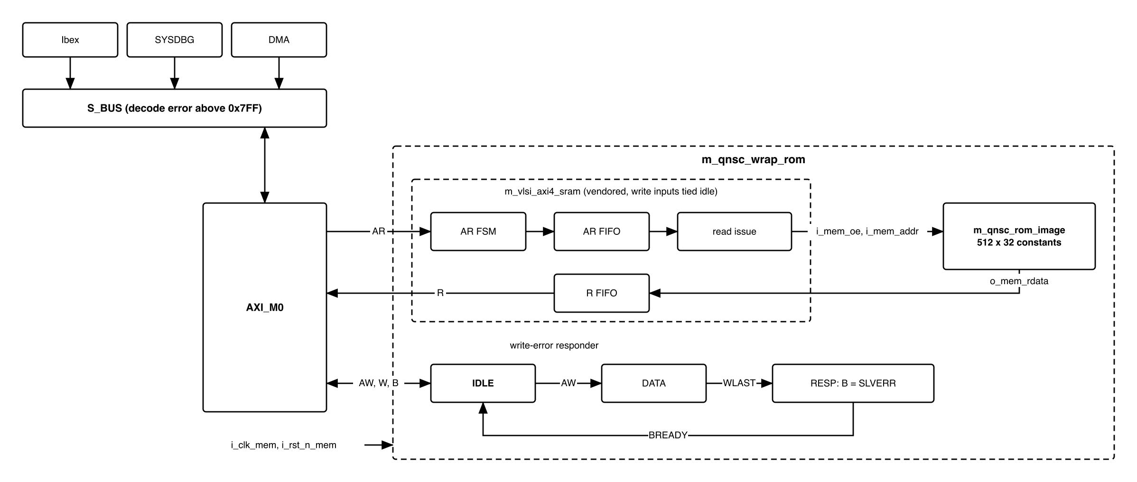
Figure 3-1. ROM wrapper, read and write paths
Table 3-1. Sub-blocks
Block | Module | Function
AXI controller | m_vlsi_axi4_sram, vendored, not modified | AR/R handshake, burst addresses, read issue. Its write channel is tied idle
Image | m_qnsc_rom_image, generated | 512 x 32 constants, one-cycle read
Write-error responder | in m_qnsc_wrap_rom | Accepts AW and W, answers B with SLVERR
The controller is the one ISRAM and DSRAM use, with the same parameters, so QNSC_RAM_MAS 7.1, 7.2, 7.4 and 7.6 apply to the read path unchanged. The block is in the mem clock cluster: clock never gated.

4. IP used
Table 4-1. Upstream IP used
From | Module | Commit | Licence
nguyenquanicd/AXI4-SRAM-CONTROLLER | m_vlsi_axi4_sram and its sub-modules | 503d7cd9 | MentorProvided-QNSC-Course
Controller facts relied on, at that commit: o_sram_addr is a byte address; i_sram_rdata is sampled in the cycle after o_sram_oe; RRESP is always OKAY; there is no AxSIZE, every beat is a full word.

5. Interface
Table 5-1. m_qnsc_wrap_rom interface
Signal | Dir | Width | Description
i_clk_mem, i_rst_n_mem | in | 1 | SCRC o_clk_rom, o_rst_n_rom
i_bus_axi_ar_*, o_bus_axi_r_* | – | as QNSC_RAM_MAS Table 5-1 | To the controller
i_bus_axi_aw_*, i_bus_axi_w_*, o_bus_axi_b_* | – | as QNSC_RAM_MAS Table 5-1 | To the responder. w_strb and w_data not used; b_resp always 2'b10
The RAM’s macro ports o_mem_*, i_mem_rdata are internal here, to the image.
Table 5-2. m_qnsc_rom_image interface
Signal | Dir | Width | Description
i_clk_mem | in | 1 | Wrapper clock
i_mem_oe | in | 1 | Controller o_sram_oe
i_mem_addr | in | 9 | Word index, controller o_sram_addr[10:2]
o_mem_rdata | out | 32 | Word i_mem_addr, in the cycle after i_mem_oe = 1

Table 5-3. Controller parameters
Parameter | Value
PARA_DATA_WD, PARA_ADDR_WD | 32
PARA_ID_WD | 7, as ISRAM and DSRAM
PARA_LEN_WD, PARA_FIFO_DEPTH | 8

6. Address map and layout
Table 6-1. Memory map, regions behind AXI_M0
Base | Size | Region | Port | Kind | Note
0x00000000 | 2 KiB | rom | AXI_M0 | memory | Boot code, read-only, executable
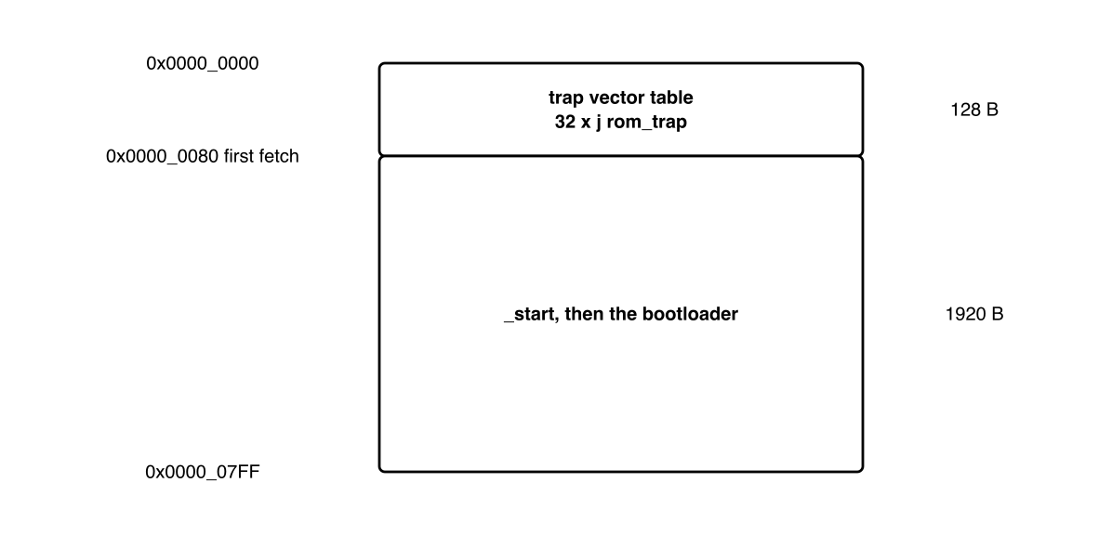
Figure 6-1. ROM layout
Table 6-2. ROM layout
Offset | Size | Contents | Forced by
0x000–0x07F | 128 B | 32 x j rom_trap, each a 4-byte instruction | mtvec resets to boot_addr_i in vectored mode; causes 16–30 are the fast interrupts, 31 the NMI
0x080–0x7FF | 1920 B | _start, then the rest of the bootloader | Ibex fetches first from {boot_addr_i[31:8], 8'h80}
Ibex boot_addr_i = 0x0000_0000 in normal boot. A trap while the bootloader runs enters rom_trap, a loop left only by a reset.

7. Functional behaviour

7.1 Read
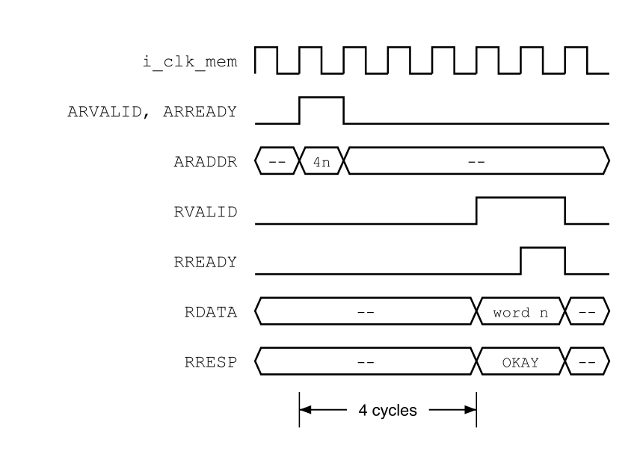
Figure 7-1. Single-beat read at the AXI port
- RVALID 4 cycles after the AR handshake; one beat every 2 cycles in a burst; one read in flight (QNSC_RAM_MAS 7.1). RRESP = OKAY.
- Burst addresses as QNSC_RAM_MAS 7.2 and 7.4.
- Address bits above [10:2] are ignored. S_BUS decodes the start address only, so an INCR burst that runs past 0x7FF continues from word 0.

7.2 Image
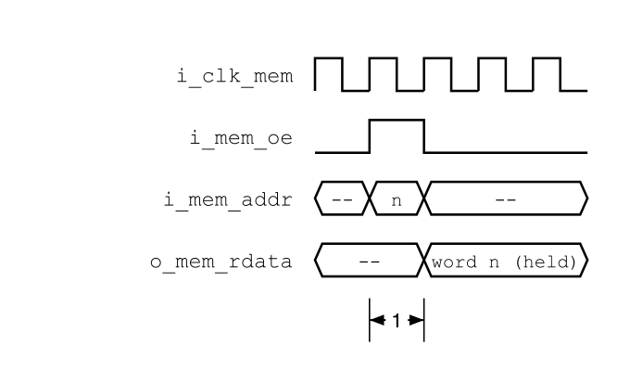
Figure 7-2. Image port
- util/gen_rom.py writes m_qnsc_rom_image.sv from rom_image.hex: a case over the 512 indices into an output register loaded when i_mem_oe = 1. No reset, no initial, no memory array: synthesis maps it to constant logic.
- rom_image.hex holds 512 words, one per line; word n is bytes 4n to 4n+3 of the bootloader binary, byte 4n in bits 7:0. Words past the binary are 0.
- The generator fails if the binary exceeds 2048 bytes. CI regenerates the module from the committed hex and fails on a difference.

7.3 Write-error responder
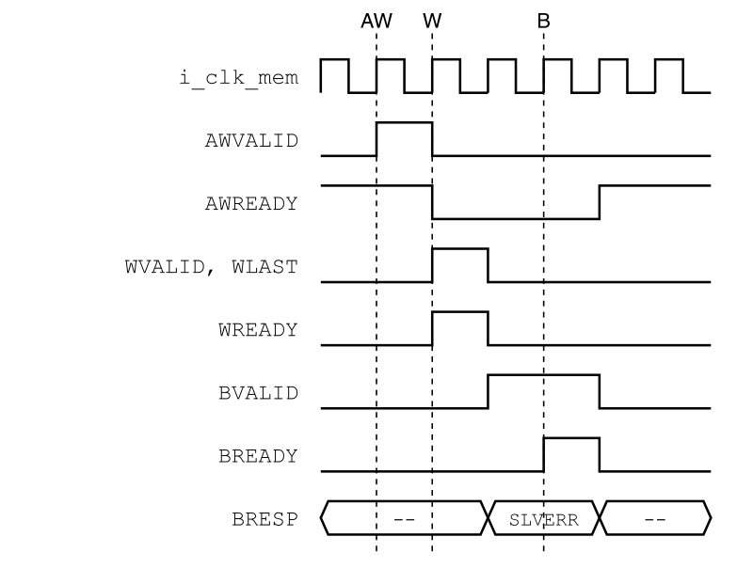
Figure 7-3. A single-beat write answered with SLVERR
The controller’s write inputs are tied idle, so no write reaches the image. A write to the ROM must still be answered, or its master waits forever.
- IDLE: AWREADY = 1. On the AW handshake, store AWID.
- DATA: WREADY = 1. Discard beats up to the one with WLAST.
- RESP: BVALID = 1, BID = stored ID, BRESP = SLVERR, until BREADY.
W is accepted only after AW, which AXI allows. Reads continue meanwhile. A stray write ends as a store access fault in Ibex, or an error at SYSDBG or DMA.

7.4 Reset
i_rst_n_mem asserts with every chip reset and releases with S_BUS, before the CPU (QNSC_SCRC_MAS 7.5). Every S_BUS master is in reset whenever the ROM is, so no access reaches it in reset. The responder resets to IDLE.

8. Instances
One m_qnsc_wrap_rom at AXI_M0.

9. What is not provided here, and who provides it
Table 9-1. Functions this block does not provide
Function | Where it lives
Bootloader behaviour, its size budget and its build | QNSC_BOOT_SPEC; source design/rom/boot/
Decode error above 0x0000_07FF | S_BUS
boot_addr_i and its debug-boot mux | CPU owner, QNSC_SYSDBG_MAS 11
Debugging the bootloader from its first instruction | QNSC_SYSDBG_MAS 7.1

10. Tie-offs
Table 10-1. Controller ports tied inside m_qnsc_wrap_rom
Port | Tied to | Why
i_awvalid, i_wvalid | 0 | No write reaches the image
i_awaddr, i_awburst, i_awlen, i_awid, i_wdata, i_wlast | 0 | Unused while the valids are 0
i_bready | 1 | No B response is produced
o_awready, o_wready, o_bid, o_bresp, o_bvalid, o_sram_wdata, o_sram_we | open | Write path replaced by the responder

11. Requirements on others, and open items
Table 11-1. Requirements on other owners
Item | Owner | What it blocks
AXI_M0 window exactly 0x0000_0000–0x0000_07FF, no aliasing | bus owner | 6
boot_addr_i = 0x0000_0000 in normal boot | CPU owner | 6

Table 11-2. HAS text this specification departs from
QSOC_HAS_Report_EN_v4_final says | This specification | Why
Read-only by tying the write channel to the idle state | also a responder answering writes with SLVERR | A tied write channel never answers, so a stray write would hang its master
Open items: util/gen_rom.py and the bootloader source design/rom/boot/ are not yet in the repository. ROM owner.
Accepted limit: an INCR read burst past 0x7FF wraps to word 0 (7.1). Ibex, SYSDBG and a correctly programmed DMA never issue one.

12. Verification
- ROM_001 After reset, every word reads as the matching word of rom_image.hex.
- ROM_002 INCR bursts of 1–16 beats return consecutive words, RLAST on the last, RRESP = OKAY.
- ROM_003 The first Ibex fetch after reset is at 0x0000_0080 and returns the first instruction of _start.
- ROM_004 Writes of 1, 2, 16 and 256 beats change no word and complete with BRESP = SLVERR and BID = AWID.
- ROM_005 Reads issued while a write is being answered complete normally.
- ROM_006 util/gen_rom.py fails on a binary above 2048 bytes; CI fails when the committed m_qnsc_rom_image.sv differs from its regeneration.
- ROM_007 SYSDBG (AXI_S0) reads every ROM word through S_BUS.
- ROM_008 m_qnsc_rom_image.sv contains no initial and no memory array; SYN reports no memory and no latch.

Appendix A. Acronyms
Table A-1. Acronyms
Acronym | Description
NMI | Non-Maskable Interrupt
OTP | One-Time Programmable memory
SLVERR | AXI slave error response, 2'b10

Appendix B. First review
Table B-1. First review
Item | Reviewer | Response
Reset vector is boot_addr_i + 0x80 | Sinh | 6
ROM is 2 KiB; crossbar window must match | Sinh | 6, 11
o_sram_addr is a byte address; the index belongs to the wrapper | Nam | 5
All domains released together, CPU last | Quan (mentor) | 7.4
PARA_ID_WD = 7 | RAM owner | 5
A write to the ROM must not hang its master | Nam | 7.3
Licence of AXI4-SRAM-CONTROLLER | mentor | 4
Can the debugger read the ROM? | SYSDBG owner | yes, ROM_007
initial $readmemh does not synthesise to ASIC logic | lead, V3.0 | generated image, 7.2, ROM_008
Port names differed from QNSC_RAM_MAS for the same controller | lead, V3.0 | 5
A burst past 0x7FF wraps | lead, V3.0 | 7.1, accepted limit

