SYSCSR
MICRO-ARCHITECTURE SPECIFICATION – V3.0
QUY NHON SEMICONDUCTORS – QNSC

Table of Contents

Table of Tables
Table 4-1. Upstream IP used
Table 5-1. SYSCSR interface
Table 6-1. Memory map, regions behind APB_M1
Table 6-2. Register map
Table 6-3. RESET_CAUSE fields
Table 6-4. DOMAIN_RST_STATUS fields, all RO; the bit map is QNSC_SCRC_MAS Table 6-3
Table 6-5. CHIP_ID_REV fields
Table 7-1. Values read in the states firmware and the debugger meet
Table 7-2. Access results
Table 9-1. Functions this block does not provide
Table 10-1. Tie-offs inside m_qnsc_syscsr
Table 11-1. Requirements on other owners
Table 11-2. HAS text this specification departs from
Table A-1. Acronyms
Table B-1. First review

Table of Figures
Figure 3-1. SYSCSR in the system: who writes and who reads each register
Figure 6-1. Register fields; shaded bits are reserved and read 0
Figure 7-1. RESET_CAUSE across power-on, a firmware clear and a watchdog bite

Revision history
The reasoning behind each change, the V1.0–V2.2 history and the V2.2 text are in QNSC_SYSCSR_DECISIONS.md.
Version | Date | Author | Reviewer | Description of change
V3.0 | 2026-09-28 | Nghia VT (lead), for Nguyen Hao Nam | – | V2.2 moved onto the MAS template and aligned with QNSC_SCRC_MAS V3.0: APB_M1, Naming Rule wrapper, bit 13 reserved, CHIP_ID from the contract, reset-cause write race closed, access timing and post-boot values stated

1. Overview
SYSCSR (System Control and Status Registers) is the status half of the clock and reset subsystem. Three read-only registers answer three questions firmware cannot answer any other way: why the chip last reset (RESET_CAUSE), which domains are in reset now (DOMAIN_RST_STATUS), and which chip this is (CHIP_ID_REV).
The fact that shapes it: SYSCSR is reset by power-on only, so a watchdog or software reset leaves RESET_CAUSE for the code that runs after it.
SYSCSR controls nothing; every control bit is in SCRC (QNSC_SCRC_MAS).
Block directory design/scrc, wrapper m_qnsc_syscsr, owner Nguyen Hao Nam.

2. Features
- Three 32-bit registers on APB_M1 – 6.
- RESET_CAUSE: one sticky bit per reset source, set by hardware, write 1 to clear – 7.2.
- DOMAIN_RST_STATUS: live reset state of every SCRC domain – 7.3.
- CHIP_ID_REV: the contract constant C_CHIP_ID, ASCII ‘QSOC’ – 6.
- Reset by power-on only, on a clock that is never gated – 7.1.
- Generated by APB-CSR-Generator; one wait state per completed access – 7.4.

3. Block diagram
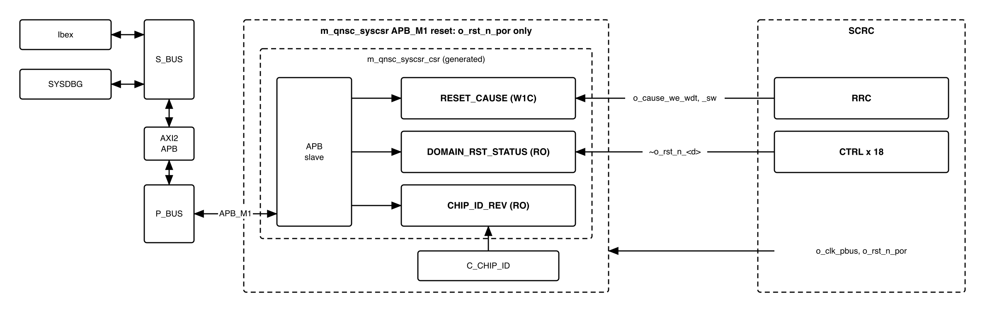
Figure 3-1. SYSCSR in the system: who writes and who reads each register
m_qnsc_syscsr wraps the generated m_qnsc_syscsr_csr. It renames the ports to the Naming Rule and drives the generator’s option and constant inputs (section 10); it adds no logic.
SYSCSR is in the cpu clock cluster of the contract, hence i_clk_cpu; the clock is SCRC o_clk_pbus, the P_BUS clock.

4. IP used
Table 4-1. Upstream IP used
From | Module | Commit | Licence
nguyenquanicd/APB-CSR-Generator | generator; output m_qnsc_syscsr_csr | ee80ff54 | MentorProvided-QNSC-Course
Generator behaviour this specification relies on, read in CSR_Generation.py at that commit, with i_slverr_en = 1, i_protect_en = 0 and the synchronous option:
- PSLVERR = 1 when PADDR[1:0] != 0, or PWRITE = 1 and PSTRB != 4'hF. Such an access changes no register.
- An access is captured in the SETUP cycle and completes with PREADY in the second ACCESS cycle; an access answered with PSLVERR completes in the first.
- A ro field is a live input with no storage; a write to it is ignored.
- A w1c field: an APB write clears the bits written 1; otherwise i_hw_we loads i_hw_wdata. The APB write wins when both occur in the same cycle – 7.2.
- An offset with no register reads 0 and ignores writes, without error.
Workbook register names are resetcause, domainrststatus, chipidrev; field names are those of Tables 6-3 to 6-5. The workbook and the generated file are kept in util/gen/syscsr/, because the generated port names (i_bus_rstn, i_paddr) do not follow the Naming Rule and design/scrc/rtl/ holds only code written here.

5. Interface
Table 5-1. SYSCSR interface
Signal | Dir | Width | Connected to, in design/top | Description
i_clk_cpu | in | 1 | SCRC o_clk_pbus | 20 MHz, never gated
i_rst_n_por | in | 1 | SCRC o_rst_n_por | Power-on only. Never o_rst_n_pbus
i_bus_apb_psel, i_bus_apb_penable, i_bus_apb_pwrite | in | 1 | P_BUS APB_M1 | APB control. Reached by Ibex and by SYSDBG
i_bus_apb_paddr | in | 12 | P_BUS APB_M1 | Offset in the window (contract meta.apb_paddr_width)
i_bus_apb_pwdata | in | 32 | P_BUS APB_M1 | Write data
i_bus_apb_pstrb | in | 4 | P_BUS APB_M1 | 4'hF on a write, else PSLVERR
i_bus_apb_pprot | in | 3 | P_BUS APB_M1 | Not used
o_bus_apb_prdata, o_bus_apb_pready, o_bus_apb_pslverr | out | 32, 1, 1 | P_BUS APB_M1 | APB response – 7.4
i_cause_we_wdt, i_cause_we_sw | in | 1 | SCRC o_cause_we_wdt, o_cause_we_sw | 1 for the whole WDT / SW chip reset – 7.2
i_domain_rst_stat | in | 32 | bit n = ~o_rst_n_<d> of SCRC domain n; bits 13, 30:18 tied 0 | 1 = domain n in reset. Reserved bits are not read

6. Register map
Table 6-1. Memory map, regions behind APB_M1
Base | Size | Region | Port | Kind | Note
0x80004000 | 16 KiB | syscsr | APB_M1 | peripheral
Only offset bits 11:0 reach SYSCSR, so the map repeats every 4 KiB in the window: 0x8000_5000 is RESET_CAUSE.
Table 6-2. Register map
Offset | Register | Access | Reset | Description
0x00 | RESET_CAUSE | W1C | 0x0000_0001 | Sticky cause of the resets since last cleared
0x04 | DOMAIN_RST_STATUS | RO | live | 1 = domain in reset
0x08 | CHIP_ID_REV | RO | 0x5153_4F43 | Chip identifier
0x0C–0xFFF | – | RSVD | 0 | Read 0, writes ignored, no error
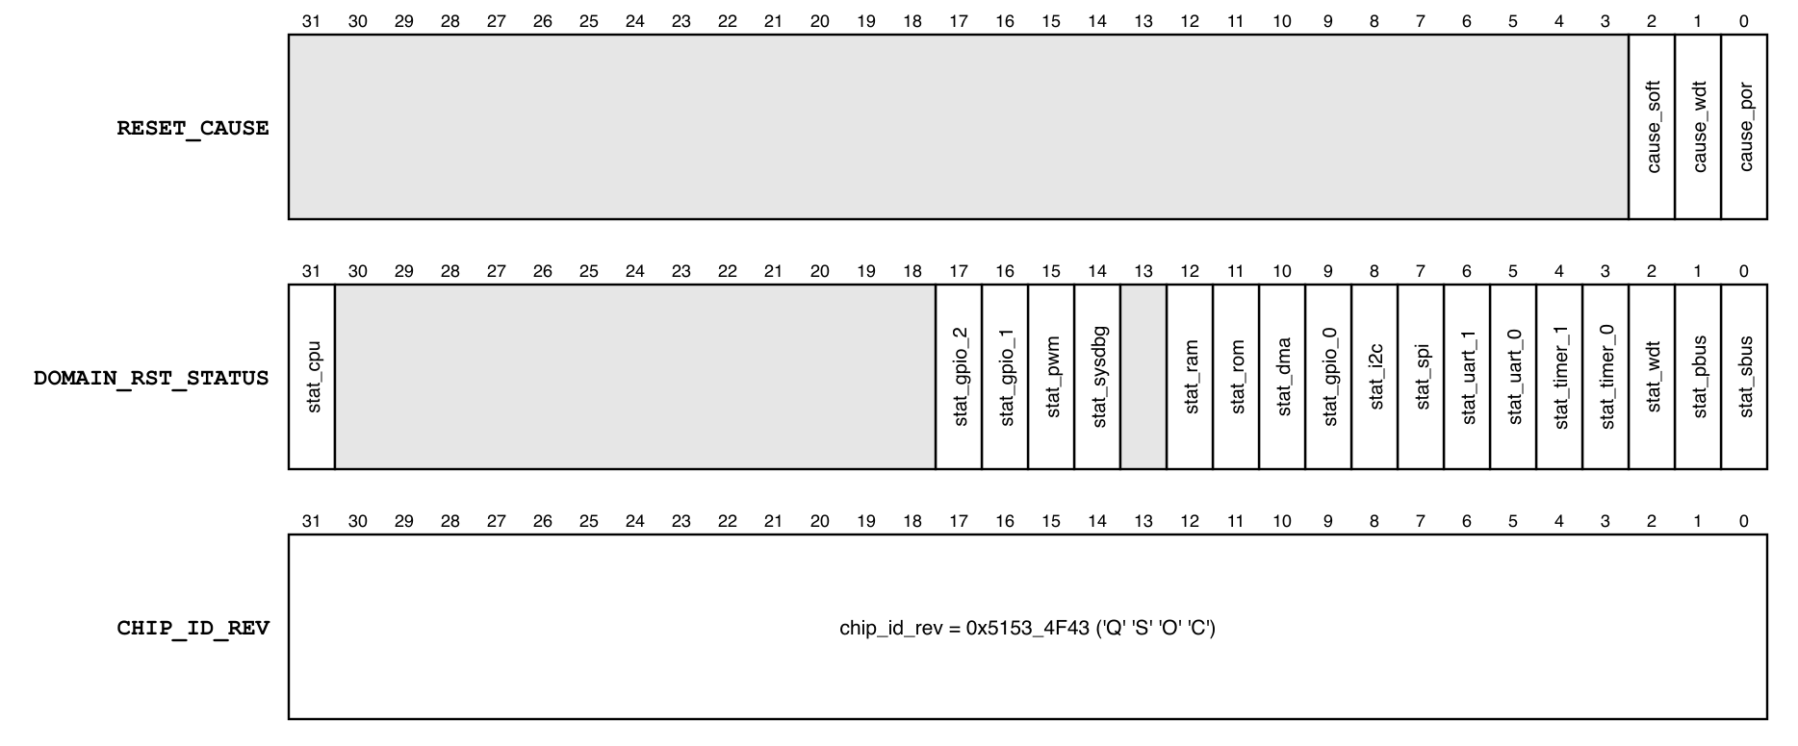
Figure 6-1. Register fields; shaded bits are reserved and read 0
Table 6-3. RESET_CAUSE fields
Bits | Field | Access | Reset | Set by | Meaning when 1
0 | cause_por | W1C | 1 | power-on, by reset value | A power-on reset occurred
1 | cause_wdt | W1C | 0 | i_cause_we_wdt | A watchdog reset occurred
2 | cause_soft | W1C | 0 | i_cause_we_sw | A software reset (SCRC SW_RST) occurred
31:3 | – | RSVD | 0 | – | –

Table 6-4. DOMAIN_RST_STATUS fields, all RO; the bit map is QNSC_SCRC_MAS Table 6-3
Bit | Field | Domain
0 | stat_sbus | S_BUS
1 | stat_pbus | P_BUS
2 | stat_wdt | WDT
3 | stat_timer_0 | TIMER0
4 | stat_timer_1 | TIMER1
5 | stat_uart_0 | UART0
6 | stat_uart_1 | UART1
7 | stat_spi | SPI Host and SPI Device
8 | stat_i2c | I2C
9 | stat_gpio_0 | GPIO0
10 | stat_dma | DMA
11 | stat_rom | ROM
12 | stat_ram | ISRAM and DSRAM
13 | – | reserved
14 | stat_sysdbg | SYSDBG
15 | stat_pwm | PWM
16 | stat_gpio_1 | GPIO1
17 | stat_gpio_2 | GPIO2
30:18 | – | reserved
31 | stat_cpu | CPU

Table 6-5. CHIP_ID_REV fields
Bits | Field | Access | Value | Description
31:0 | chip_id_rev | RO | 0x5153_4F43 | C_CHIP_ID: ‘Q’, ‘S’, ‘O’, ‘C’, most significant byte first. No revision field

7. Functional behaviour

7.1 Clock and reset
- SYSCSR runs on o_clk_pbus, which SCRC never gates, including during a chip reset, and is reset by o_rst_n_por, which only power-on asserts.
- After power-on RESET_CAUSE = 0x1.
- A WDT or SW reset changes nothing in SYSCSR except the cause bit it sets.
- No initialisation is needed. SYSCSR is readable as soon as P_BUS and the reading master leave reset.

7.2 Reset cause
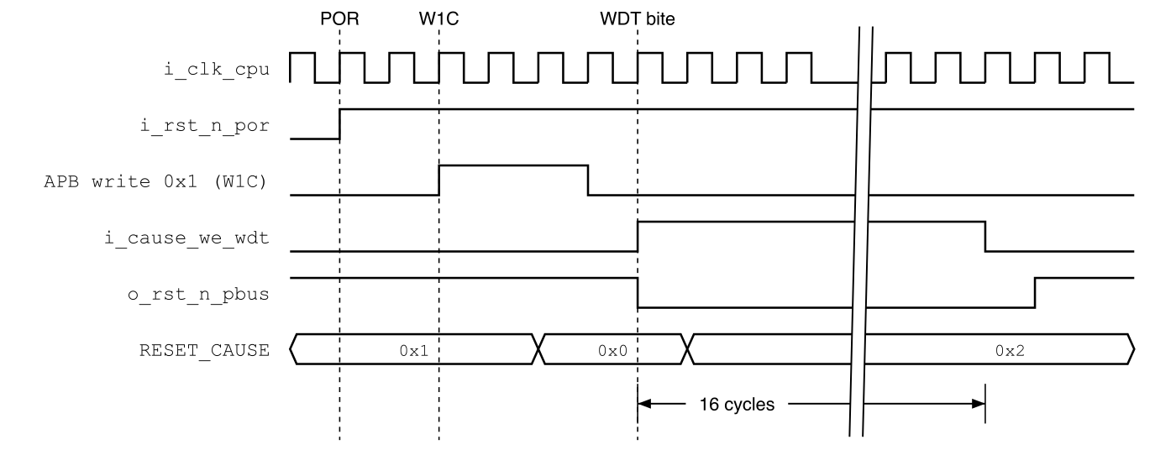
Figure 7-1. RESET_CAUSE across power-on, a firmware clear and a watchdog bite
- Power-on leaves cause_por = 1 by its reset value.
- Watchdog, software: i_cause_we_wdt or i_cause_we_sw is 1 for the 16 cycles of the chip reset (QNSC_SCRC_MAS 7.3), and sets its bit.
- A bit stays 1 until written 1. Several bits can be 1: each means its source has caused at least one reset since the bit was last cleared.
- Write race. An APB write to RESET_CAUSE is applied at the clock edge that ends the cycle after its SETUP cycle, and wins over a hardware set at that edge. P_BUS enters reset in the first cycle of the chip reset and starts no transfer while in reset, so at most one write lands inside the chip reset, at its first edge. The set enable lasts 16 edges, so the bit is set at the next.

7.3 Domain reset status
- DOMAIN_RST_STATUS[n] is i_domain_rst_stat[n], captured when the register is read. It is not stored: every SCRC output is synchronous to o_clk_pbus.
- A bit is 1 while its domain is in reset: during a chip reset, for timer_1 until its clock first runs, and for the CPU while SYSDBG holds it.
Table 7-1. Values read in the states firmware and the debugger meet
State | DOMAIN_RST_STATUS | Reason
After any reset, normal boot | 0x0000_0010 | timer_1 is gated after reset, so still in reset
Debug boot, CPU held, read by SYSDBG | 0x8000_0010 | also stat_cpu: o_dbg_cpu_hold = 1
After firmware sets SCRC CLK_EN[4] | 0x0000_0000 | timer_1 clocked and released
Ibex reads stat_cpu = 0 whenever it can read at all; the bit is for SYSDBG.

7.4 Bus access
Table 7-2. Access results
Access | PREADY in | PSLVERR | Effect
Aligned read | 2nd ACCESS cycle | 0 | Register value; 0 at an offset with no register
Aligned write, PSTRB = 4'hF, to RESET_CAUSE | 2nd ACCESS cycle | 0 | Clears the bits written 1
Aligned write, PSTRB = 4'hF, to any other offset | 2nd ACCESS cycle | 0 | None
PADDR[1:0] != 0 | 1st ACCESS cycle | 1 | None
Write with PSTRB != 4'hF | 1st ACCESS cycle | 1 | None
A byte or halfword store to SYSCSR is therefore an access fault in Ibex.

7.5 Firmware use
- At start-up, read RESET_CAUSE, keep the value, and write it back to clear the bits that were set.
- Read CHIP_ID_REV to check the program, or the host through SYSDBG, is on a QSOC.

8. Instances
One m_qnsc_syscsr in design/top, containing one m_qnsc_syscsr_csr.

9. What is not provided here, and who provides it
Table 9-1. Functions this block does not provide
Function | Where it lives
Clock gating, SW_RST | SCRC, APB_M0
The reset-cause set enables and the domain resets | SCRC RRC and CTRLs
An interrupt on a reset cause | none; firmware reads RESET_CAUSE at start-up

10. Tie-offs
Table 10-1. Tie-offs inside m_qnsc_syscsr
Generated port | Tied to | Why
i_protect_en | 0 | No privilege check; all code runs in machine mode
i_slverr_en | 1 | Misaligned and partial-strobe accesses answered with PSLVERR
i_hw_we_resetcause_cause_por | 0 | cause_por is set by its reset value
i_hw_wdata_resetcause_cause_* | 1 | An enable always sets the bit
i_chipidrev_chip_id_rev | qnsc_pkg::C_CHIP_ID | One source; hardcode_check rejects the literal
i_paddr[15:12] | 0 | P_BUS carries 12 address bits
o_resetcause_cause_* | unconnected | Generated for w1c fields; not needed

11. Requirements on others, and open items
Table 11-1. Requirements on other owners
Item | Owner | What it blocks
i_rst_n_por = o_rst_n_por | top (lead) | RESET_CAUSE surviving WDT and SW
i_domain_rst_stat wired as in section 5 | top (lead) | 7.3
o_cause_we_wdt, o_cause_we_sw held for the whole chip reset; P_BUS reset in its first cycle | SCRC (same owner) | 7.2

Table 11-2. HAS text this specification departs from
QSOC_HAS_Report_EN_v4_final Table 9-1, 9-2 | This specification | Why
Clock and reset: the peripheral bus domain | reset by power-on only | A WDT or SW reset would clear RESET_CAUSE. The HAS feature list already requires “SYSCSR only reset by Power-on reset”
cause_por reset 0, set by a hardware write | reset 1, hardware write tied 0 | The register is held in reset during power-on, so it cannot be written then
domainrststatus bits 0–13; one stat_gpio for 4 GPIO; bit 13 spi_device proposed | bits 0–12, 14–17, 31; one bit per GPIO; bit 13 reserved | QNSC_SCRC_MAS domain map: 3 GPIO, one SPI domain, SYSDBG, PWM and CPU added
Open items: none.

12. Verification
- SYSCSR_001 After power-on: RESET_CAUSE = 0x1, CHIP_ID_REV = 0x5153_4F43.
- SYSCSR_002 A watchdog reset sets cause_wdt and leaves the other bits unchanged.
- SYSCSR_003 A software reset sets cause_soft and leaves the other bits unchanged.
- SYSCSR_004 Writing 1 to a RESET_CAUSE bit clears only that bit; writing 0 changes nothing.
- SYSCSR_005 DOMAIN_RST_STATUS[n] = ~o_rst_n_<d> for the 18 implemented bits, in every cycle a read samples it; reserved bits read 0.
- SYSCSR_006 Writes to DOMAIN_RST_STATUS, CHIP_ID_REV and offsets with no register change nothing and complete without PSLVERR.
- SYSCSR_007 Each row of Table 7-2 gives the stated PREADY cycle, PSLVERR and effect.
- SYSCSR_008 A W1C write of 0x7 whose SETUP cycle is the last before a watchdog chip reset leaves cause_wdt = 1 after the reset.
- SYSCSR_009 Table 7-1 values after a normal boot and a debug boot (SoC test).
- SYSCSR_010 Every SYSCSR flip-flop is reset by i_rst_n_por only (netlist check).

Appendix A. Acronyms
Table A-1. Acronyms
Acronym | Description
POR | Power-On Reset
RRC | Reset Request Controller, in SCRC
SCRC | System Clock and Reset Controller
SYSCSR | System Control and Status Registers
W1C | Write 1 to clear
WDT | Watchdog Timer

Appendix B. First review
Table B-1. First review
Item | Reviewer | Response
CHIP_ID_REV misspelled ‘QCOS’; separate REV field | Sinh | V1.1; now C_CHIP_ID in the contract, 6
MRV_BUSY premature | Sinh | Removed in V1.1
RESET_CAUSE must survive WDT/SW | Nam, V2.0 | POR-only reset, 7.1
SYSDBG reads SYSCSR while it holds the CPU | SYSDBG MAS V3.0 | stat_cpu, 7.3
APB_S1 against contract APB_M1 | lead, V3.0 | 5, 6
spi_device and GPIO3 domains removed | lead, V3.0 | bits 13 and 18 reserved
One-cycle cause pulse lost against a W1C write in the same cycle | lead, V3.0 | set held for the whole reset, 7.2, SYSCSR_008
Generated names fail the Naming Rule | lead, V3.0 | wrapper m_qnsc_syscsr; generated file in util/gen/syscsr, 4
Post-boot DOMAIN_RST_STATUS not stated | lead, V3.0 | 7.3

