SCRC
MICRO-ARCHITECTURE SPECIFICATION – V3.2
QUY NHON SEMICONDUCTORS – QNSC

Table of Contents

Table of Tables
Table 3-1. Sub-blocks
Table 3-2. Names in VLSI_SCRC.drawio against this specification
Table 4-1. Upstream IP used
Table 5-1. SCRC interface
Table 5-2. Domain clock and reset outputs
Table 6-1. Memory map, regions behind APB_M0 and APB_M1
Table 6-2. Register map
Table 6-3. Domain bit map
Table 7-1. What each reset clears
Table 7-2. PSLVERR sources on APB_M0
Table 7-3. MCPU actions, per changed bit n
Table 7-4. SCRC timing, w_clk_root cycles
Table 7-5. What firmware does
Table 8-1. RTL modules and instance counts
Table 9-1. Functions this block does not provide
Table 10-1. Tie-offs
Table 11-1. Requirements on other owners
Table 11-2. HAS text this specification departs from
Table A-1. Acronyms
Table B-1. First review

Table of Figures
Figure 3-1. SCRC top level
Figure 3-2. SCRC operation, from any reset source to the runtime loop
Figure 6-1. Domains and their bit, shared by every register above and by SYSCSR
Figure 7-1. One domain controller
Figure 7-2. Reset Filter, after the mentor’s diagram
Figure 7-3. Reset Request Controller
Figure 7-4. Watchdog bite through RRC
Figure 7-5. Reset tree
Figure 7-6. Power-up sequence; numbers are the steps above, one gap compresses step 4
Figure 7-7. Clock stop, then start, of domain n
Figure 7-8. APB guard
Figure 7-9. One blocked and one forwarded transfer; the IP adds one wait state

Revision history
The reasoning behind each change, the V1.0–V2.3 history and the V2.3 text are in QNSC_SCRC_DECISIONS.md.
Version | Date | Author | Reviewer | Description of change
V3.0 | 2026-09-27 | Nghia VT (lead), for Nguyen Hao Nam | – | V2.3 moved onto the MAS template; Naming Rule ports; APB_M0/APB_M1; one SPI domain (bit 13 reserved); per-peripheral soft reset removed; WDT never gated; monochrome figures after the mentor’s VLSI_SCRC.drawio; timing diagrams; deviations from the HAS listed
V3.1 | 2026-09-28 | Nghia VT (lead), for Nguyen Hao Nam | – | Owner decisions on the two proposals: no stretch after POR, adopted (7.3, SCRC_RST_001); two CSRs, rejected, the mentor’s APB BUS and WFs stay. Open item on the APB BUS name narrowed to renaming the generated module
V3.2 | 2026-09-29 | Nghia VT (lead) | – | 7.10: before gating dma, wait for DONE_ID, not idle (QNSC_DMA_MAS V3.2)

1. Overview
SCRC (System Clock and Reset Controller) turns the two dedicated pads CLKIN and PORSTN into one gated clock and one synchronised reset for each of the 18 domains of QSOC, and turns the three reset sources – power-on, watchdog bite, software – into one chip reset.
The fact that shapes it: sequencing is software. A mini RISC-V core, MCPU (MRV-CPU), runs a program from its own ROM and is the only agent that opens a clock gate, releases a reset or opens an APB guard. Ibex only writes requests. No register field has two writers.
SCRC does not divide or switch frequency (no PLL; one 20 MHz clock, contract meta.clock_mhz), does not hold the status registers (SYSCSR, APB_M1, a separate specification), and does not capture DBG_EN (SYSDBG).
Block directory design/scrc, top module m_qnsc_scrc, owner Nguyen Hao Nam.

2. Features
- One root clock, 18 domain outputs: 7 always-on, 11 gateable – 7.1.
- Glitch filter and synchroniser on PORSTN, from library cells – 7.2.
- Three reset sources merged by the Reset Request Controller (RRC) into a chip reset, 16 cycles after a WDT bite or SW_RST, with the cause reported to SYSCSR – 7.3.
- Register access rights enforced in hardware per master – 7.4.
- Power-up sequence after every chip reset: all domains together, APB guards opened, CPU released last – 7.5.
- Runtime clock gating on request from Ibex – 7.6.
- Two recovery levels only: chip reset and CPU hold; no per-peripheral reset – 7.3.
- APB guard per gateable slave: an access to a stopped peripheral ends in PSLVERR instead of hanging the bus – 7.7.
- CPU held in reset by SYSDBG; SYSDBG reset by power-on only – 7.8.

3. Block diagram
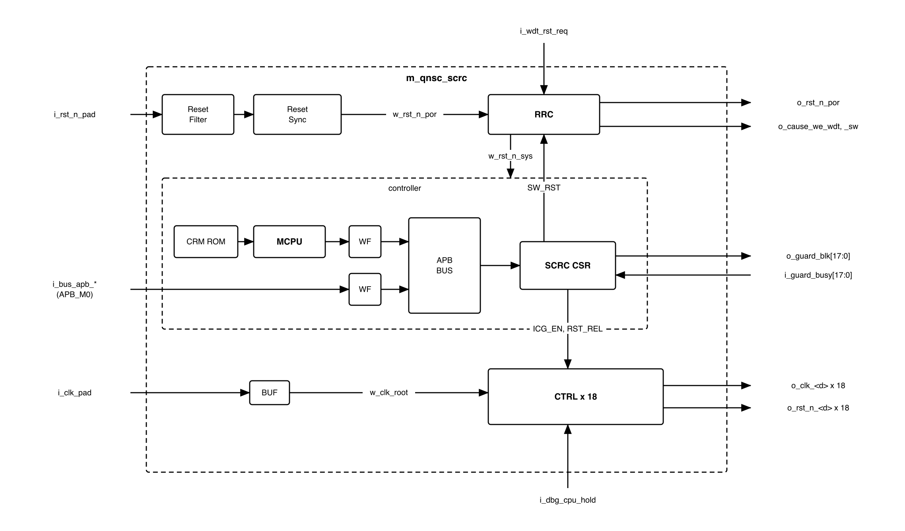
Figure 3-1. SCRC top level
The structure is the mentor’s (doc/reference/VLSI_SCRC.drawio): input stage above, controller below, one CTRL per domain. Two blocks are added to it:
- RRC, because the watchdog and software requests would otherwise be cleared by the reset they cause – 7.3.
- WF, a write filter per master, because the CSR generator sees one slave and cannot tell the masters apart – 7.4.
The APB guards are designed and delivered with SCRC but instantiated in design/top – 7.7.
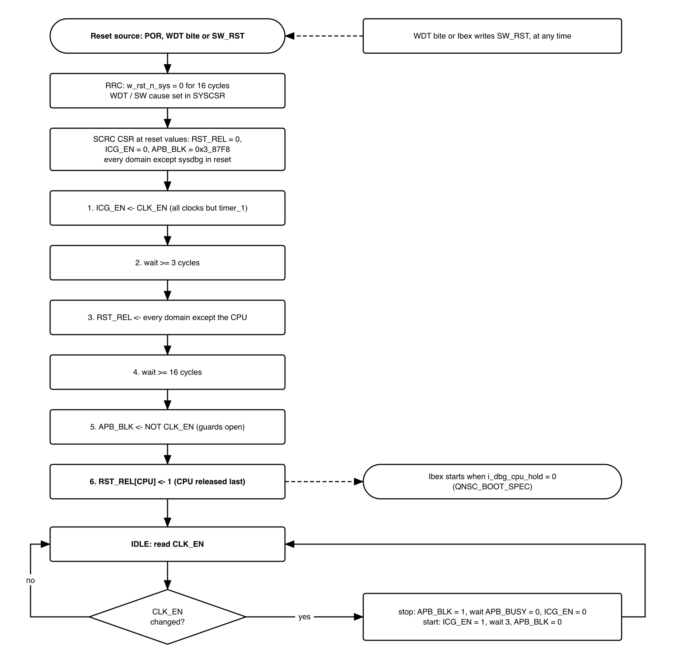
Figure 3-2. SCRC operation, from any reset source to the runtime loop
The figure is the whole behaviour of SCRC: sections 7.3, 7.5 and 7.6 specify each box.
Table 3-1. Sub-blocks
Block | Module | Function | Clock | Reset
Reset Filter | m_qnsc_scrc_rst_filter | Rejects glitches on PORSTN | none | none
Reset Sync | m_qnsc_scrc_rst_sync | Asynchronous assert, synchronous release of w_rst_n_por | w_clk_root | filter output
RRC | m_qnsc_scrc_rrc | Merges WDT and SW requests; 16-cycle w_rst_n_sys; cause enables | w_clk_root | w_rst_n_por
MCPU | m_vlsit_mrv_cpu | Runs the CRM ROM program – 7.5, 7.6 | w_clk_root | w_rst_n_sys
CRM ROM | m_qnsc_scrc_crm_rom | MCPU program, combinational read | – | –
WF x 2 | m_qnsc_scrc_apb_wfilter | Drops writes a master may not make – 7.4 | w_clk_root | w_rst_n_sys
APB BUS | generated – 11 | 2 masters, 1 slave | w_clk_root | w_rst_n_sys
SCRC CSR | m_qnsc_scrc_csr | Registers of section 6 | w_clk_root | w_rst_n_sys
BUF | library root buffer | Root of every clock | – | –
CTRL x 18 | m_qnsc_scrc_ctrl | Clock gate + reset synchroniser per domain – 7.1 | w_clk_root | RST_REL[n]

Table 3-2. Names in VLSI_SCRC.drawio against this specification
Mentor’s diagram | This specification
i_clkin, i_porstn | i_clk_pad, i_rst_n_pad
i_int_clkin, i_int_porstn | w_clk_root, w_rst_n_por; i_int_ is the interrupt prefix
Small CPU / MCPU, RISC-V CPU(MRV) + BIU | MCPU (m_vlsit_mrv_cpu, BIU inside)
ROM | CRM ROM
APB BUS, “APB Decoder Generator” | APB BUS, from APB-BUS-Generator
CPU CTRL, UART, SPI, System CTRL | CTRL x 18
CTRL i_clkin_en, i_rst_n, o_clk, o_clk_rstn | ICG_EN[n], RST_REL[n], o_clk_<d>, o_rst_n_<d>
RST SYNC i_scan_en, o_sync_rst_n; 2-FF Synchronizer | m_qnsc_scrc_rst_sync; m_qnsc_scrc_sync
Interrupt into the Small CPU | tied 0 – 10

4. IP used
Table 4-1. Upstream IP used
From | Module | Commit | Licence
nguyenquanicd/MRV-CPU | m_vlsit_mrv_cpu and its sub-modules | eea0028c | MentorProvided-QNSC-Course
nguyenquanicd/APB-CSR-Generator | generator; output m_qnsc_scrc_csr | ee80ff54 | MentorProvided-QNSC-Course
nguyenquanicd/APB-BUS-Generator | generator; output the APB BUS | 5661aecf | MentorProvided-QNSC-Course
Upstream facts this specification relies on, read at those commits:
- m_vlsit_mrv_cpu: 13 instructions (add sub and or addi andi ori lw sw jal jalr beq lui, docs/MRV-CPU-SPEC.md): no xor, no shift. PARA_RESET_VECTOR = 0x1000. APB master ports o_psel o_penable o_pwrite o_paddr o_pwdata i_prdata i_pready only: no PSTRB, PPROT or PSLVERR. The BIU goes IDLE, SETUP, ACCESS, DONE, so every lw/sw takes at least 3 cycles and stalls the core.
- APB-CSR-Generator (CSR_Generation.py): module name from the workbook Module Name cell. With i_slverr_en = 1 and i_protect_en = 0, PSLVERR = 1 exactly when PADDR[1:0] != 0, or PWRITE = 1 and PSTRB != 4'hF. An unused offset reads 0 without error.

5. Interface
All resets are active low, asserted asynchronously and released on the clock of their own domain.
Table 5-1. SCRC interface
Signal | Dir | Width | Description
i_clk_pad | in | 1 | CLKIN pad, dedicated, not through IO MUX. Root clock
i_rst_n_pad | in | 1 | PORSTN pad, dedicated. Power-on reset, asynchronous – 7.2
i_wdt_rst_req | in | 1 | WDT aon_timer_rst_req_o. Active high, sticky, WDT domain – 7.3
i_dbg_cpu_hold | in | 1 | SYSDBG o_dbg_cpu_hold. 1 holds the CPU in reset – 7.8
i_bus_apb_psel, i_bus_apb_penable, i_bus_apb_pwrite | in | 1 | P_BUS APB_M0 control
i_bus_apb_paddr | in | 12 | Offset in the window (contract meta.apb_paddr_width)
i_bus_apb_pwdata | in | 32 | Write data
i_bus_apb_pstrb, i_bus_apb_pprot | in | 4, 3 | APB4 strobe, protection
o_bus_apb_prdata, o_bus_apb_pready, o_bus_apb_pslverr | out | 32, 1, 1 | APB response – 7.4
i_guard_busy | in | 18 | Bit n = 1 while the guard of domain n has a transfer in progress
o_guard_blk | out | 18 | APB_BLK[17:0]. Bit n = 1 blocks the APB slave of domain n
o_clk_<d>, o_rst_n_<d> | out | 1 each | 18 pairs, Table 5-2
o_rst_n_por | out | 1 | Synchronised power-on reset, not affected by WDT or SW
o_cause_we_wdt, o_cause_we_sw | out | 1 | From a flip-flop, 1 while a WDT / SW chip reset lasts: set RESET_CAUSE.cause_wdt / .cause_soft in SYSCSR – 7.3

Table 5-2. Domain clock and reset outputs
<d> | Drives, in design/top
cpu | Ibex wrapper i_clk_cpu, i_rst_n_cpu
sbus | S_BUS; reset also to SYSDBG i_rst_n_sysbus
pbus | P_BUS; clock also to SYSCSR and the 11 guards
rom | ROM i_clk_mem, i_rst_n_mem
ram | ISRAM and DSRAM i_clk_mem, i_rst_n_mem
sysdbg | SYSDBG i_clk_cpu, i_rst_n_por
wdt | WDT wrapper i_clk_wdt, i_rst_n_wdt, and aon_timer clk_aon_i, rst_aon_ni. Never gated
timer_0, timer_1, uart_0, uart_1, spi, i2c, gpio_0, gpio_1, gpio_2, pwm, dma | the wrapper’s i_clk_peri, i_rst_n_peri. The SPI wrapper feeds SPI Host and SPI Device from its one pair
SYSCSR DOMAIN_RST_STATUS[n] is ~o_rst_n_<d>, wired in design/top.

6. Register map
Table 6-1. Memory map, regions behind APB_M0 and APB_M1
Base | Size | Region | Port | Kind | Note
0x80000000 | 16 KiB | scrc | APB_M0 | peripheral | System clock and reset control registers
0x80004000 | 16 KiB | syscsr | APB_M1 | peripheral
Ibex reaches SCRC CSR through APB_M0, MCPU through the APB BUS, at the same offsets. Only offset bits 11:0 reach SCRC, so the map repeats every 4 KiB in the window: 0x8000_1000 is SW_RST. Reserved bits read 0 and ignore writes.
Table 6-2. Register map
Offset | Register | Bits | Ibex | MCPU | Reset | Description
0x00 | SW_RST | 0 | RW | RO | 0 | Write 1: chip reset, cause SOFT – 7.3
0x04 | CLK_EN | 17:0 | RW | RO | 0x0003_87E8 | Requested clock state, 1 = run
0x08 | – | – | RSVD | RSVD | 0 | Reads 0, writes ignored
0x0C | ICG_EN | 17:0 | RO | RW | 0 | Clock-gate enable of each gateable CTRL
0x10 | RST_REL | 31, 17:0 | RO | RW | 0 | Reset release of each CTRL, 1 = released
0x14 | APB_BLK | 17:0 | RO | RW | 0x0003_87F8 | Guard block, 1 = block. To o_guard_blk
0x18 | APB_BUSY | 17:0 | RO | RO | live | i_guard_busy
0x1C–0xFFF | – | – | RSVD | RSVD | – | PSLVERR – 7.4
Implemented bits: 0x0003_87F8 (gateable) in CLK_EN, ICG_EN, APB_BLK, APB_BUSY; 0x8003_9FFF in RST_REL; bit 0 in SW_RST.
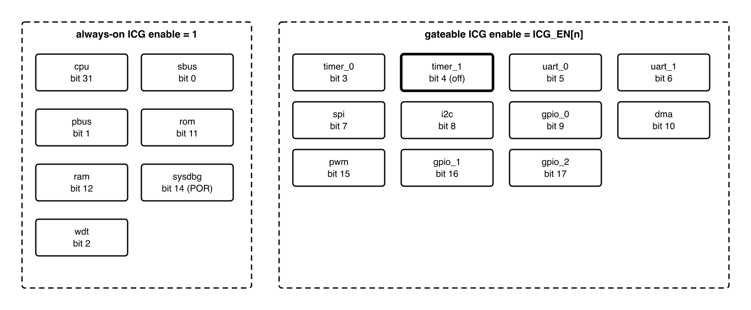
Figure 6-1. Domains and their bit, shared by every register above and by SYSCSR
Table 6-3. Domain bit map
Bit | <d> | Type | CLK_EN reset | Guard
0 | sbus | always-on | – | –
1 | pbus | always-on | – | –
2 | wdt | always-on | – | –
3 | timer_0 | gateable | 1 | own
4 | timer_1 | gateable | 0 | own
5 | uart_0 | gateable | 1 | own
6 | uart_1 | gateable | 1 | own
7 | spi | gateable | 1 | own; SPI Host and SPI Device
8 | i2c | gateable | 1 | own
9 | gpio_0 | gateable | 1 | own
10 | dma | gateable | 1 | configuration port only
11 | rom | always-on | – | –
12 | ram | always-on | – | –
13 | – | reserved | – | –
14 | sysdbg | always-on, POR only | – | –
15 | pwm | gateable | 1 | own
16 | gpio_1 | gateable | 1 | own
17 | gpio_2 | gateable | 1 | own
30:18 | – | reserved | – | –
31 | cpu | always-on | – | –
Bit 18 was GPIO3, removed with the 40-pin package. Bit 13 was spi_device: the SPI wrapper runs both SPI blocks on one clock and reset (SPI MAS V1.3).

7. Functional behaviour

7.1 Clocks
- i_clk_pad drives one root buffer, w_clk_root, and 18 CTRLs. The only cell on a clock path after the root buffer is the library ICG cell of each CTRL.
- The seven always-on domains and the SCRC logic have their ICG enable tied 1. No register value stops them. wdt is among them so that no firmware can stop the watchdog that supervises it.
- A gateable domain’s ICG enable is ICG_EN[n].
- All outputs are synchronous to each other (skew closed by clock-tree synthesis); nothing in SCRC crosses a clock domain except i_wdt_rst_req.
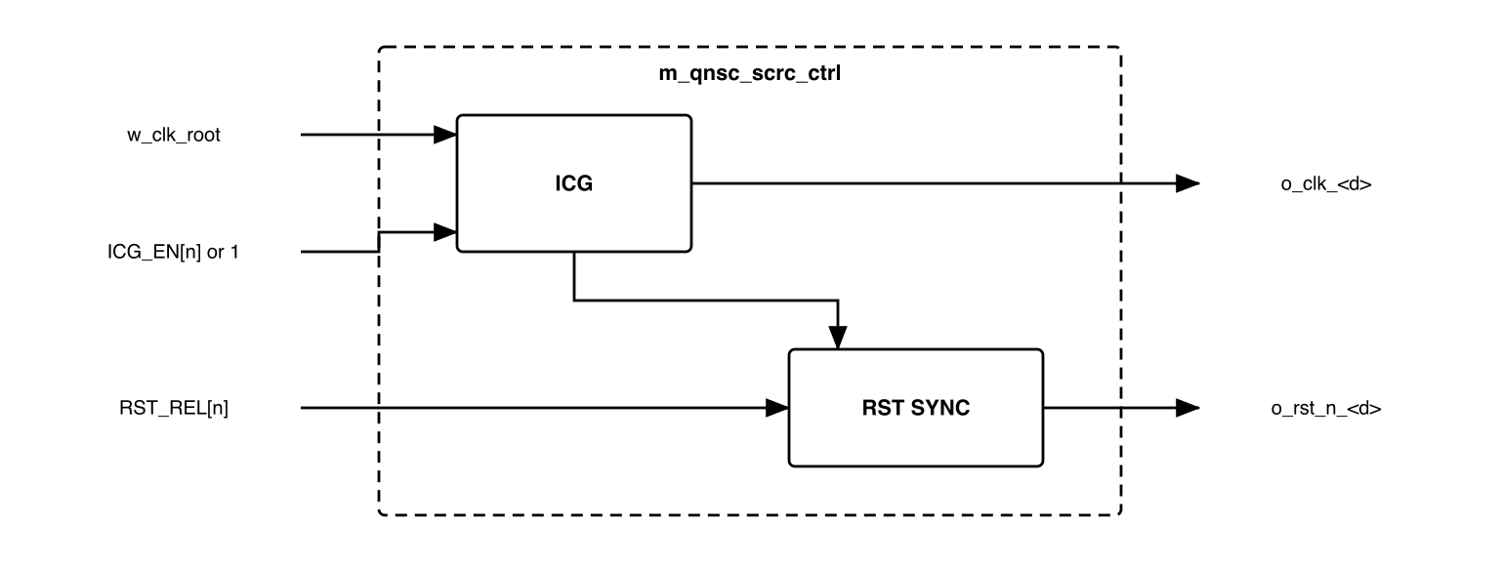
Figure 7-1. One domain controller
The reset synchroniser of a CTRL runs on the gated clock. A release written while the clock is stopped completes when the clock runs again.

7.2 Power-on input stage
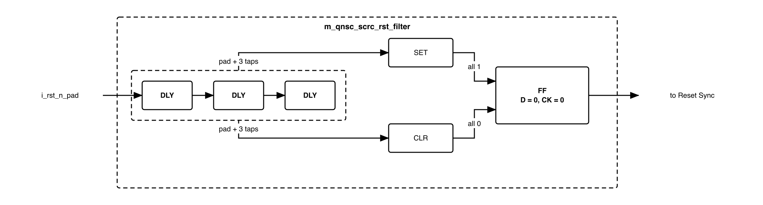
Figure 7-2. Reset Filter, after the mentor’s diagram
- Three library delay cells in series. SET drives the flip-flop’s asynchronous set when the pad and all three taps are 1; CLR drives its asynchronous clear when all four are 0. The output therefore changes only after the pad has been stable for the whole chain; a shorter pulse changes nothing. Gate-level detail: doc/reference/VLSI_SCRC.drawio.
- The Reset Sync asserts w_rst_n_por asynchronously and releases it on the second rising edge of w_clk_root after the filter output rises.
- Every cell of this stage is an instantiated library cell, none is inferred – 11.

7.3 Reset Request Controller
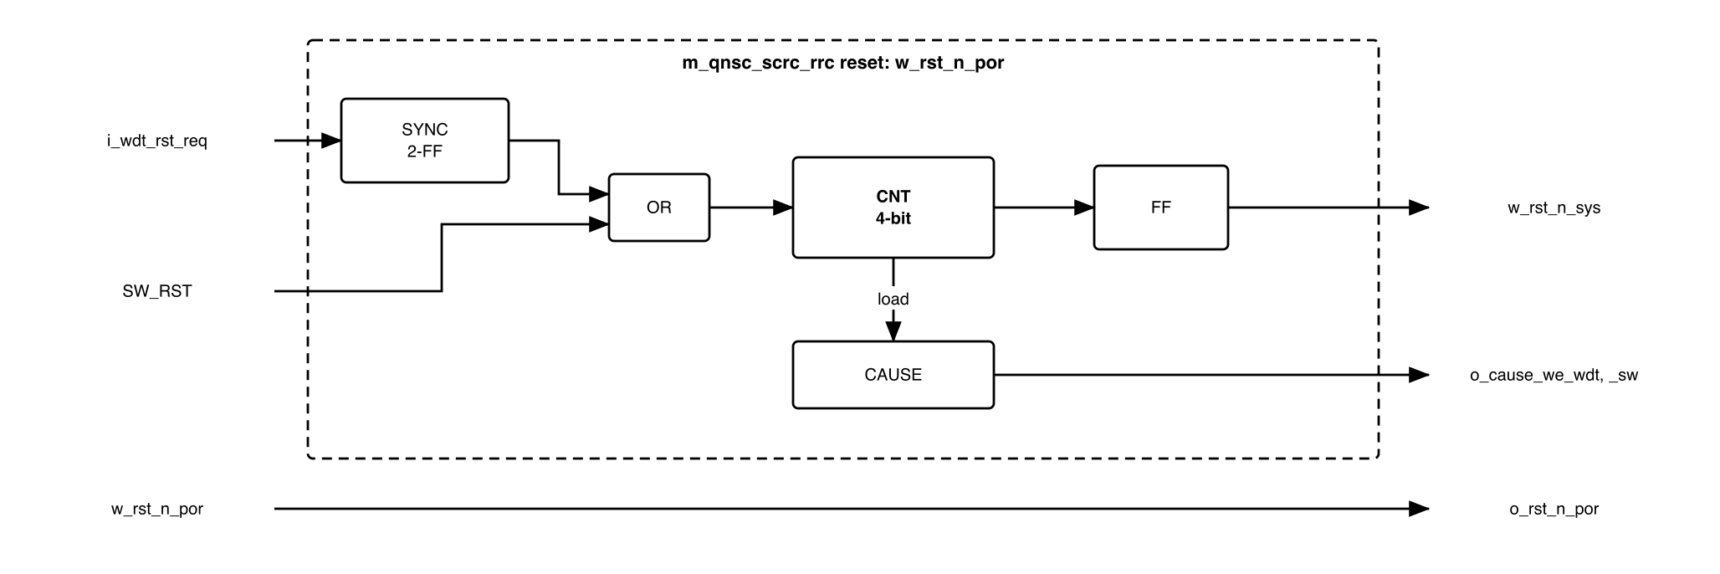
Figure 7-3. Reset Request Controller
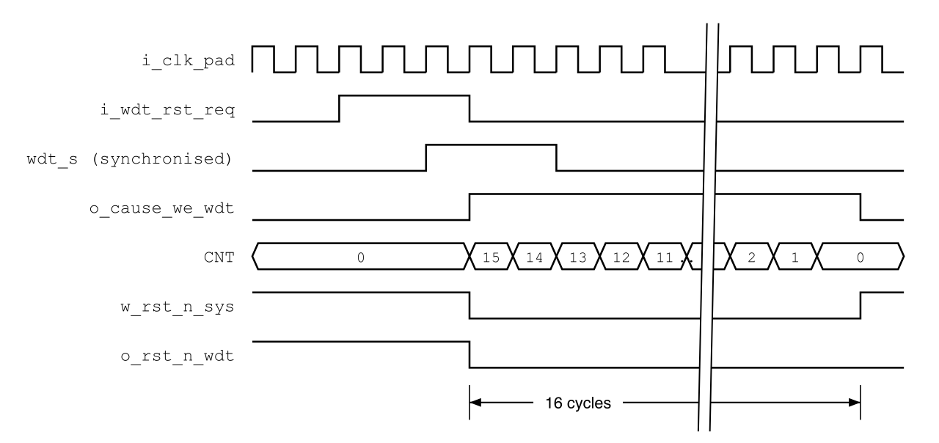
Figure 7-4. Watchdog bite through RRC
- Every RRC flip-flop, CNT included, is reset to 0 by w_rst_n_por only.
- i_wdt_rst_req passes a 2-FF synchroniser (m_qnsc_scrc_sync). SW_RST is already on w_clk_root.
- A request while CNT = 0 loads CNT = 15 and asserts w_rst_n_sys from the flip-flop. w_rst_n_sys stays 0 while CNT != 0 or a request is held.
- In the load cycle CAUSE captures the synchronised WDT request and SW_RST. o_cause_we_wdt and o_cause_we_sw are those flip-flops, held while w_rst_n_sys = 0 and cleared when it releases. A level, not a one-cycle pulse: the generated SYSCSR lets an APB write win over a hardware set in the same cycle, and P_BUS is in reset for the later cycles, so the set cannot be lost (QNSC_SYSCSR_MAS 7.2). Power-on sets neither: RESET_CAUSE.cause_por resets to 1 in SYSCSR.
- w_rst_n_sys resets MCPU, the WFs, the APB BUS and SCRC CSR, which clears SW_RST and RST_REL. RST_REL = 0 asserts every domain reset except sysdbg, wdt included, and the WDT reset clears i_wdt_rst_req. Both requests drop inside the 16 cycles, so a WDT or SW reset lasts exactly 16 cycles.
- On power-on there is no stretch: w_rst_n_sys releases one cycle after w_rst_n_por. None is needed, because every domain stays in reset through RST_REL = 0 until the program of 7.5 releases it.
- The APB write of SW_RST = 1 completes before w_rst_n_sys asserts. Its response may not reach Ibex, which is reset with the rest of the chip.
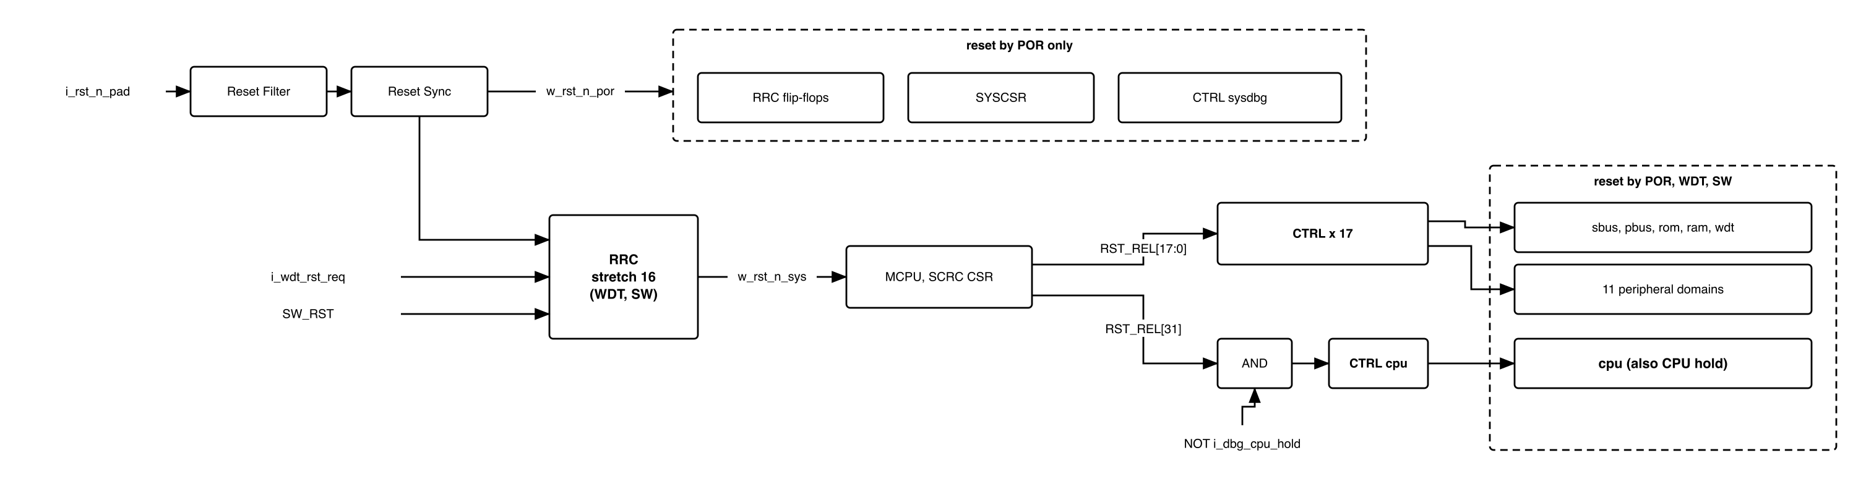
Figure 7-5. Reset tree
Table 7-1. What each reset clears
Logic | POR | WDT, SW | CPU hold
RRC, o_rst_n_por, SYSCSR | yes | no | no
sysdbg (synchroniser input w_rst_n_por) | yes | no | no
MCPU, WFs, APB BUS, SCRC CSR | yes | yes | no
cpu (input RST_REL[31] AND NOT i_dbg_cpu_hold) | yes | yes | yes
sbus, pbus, rom, ram | yes | yes | no
wdt, 11 gateable domains | yes | yes | no
There is no per-peripheral reset. No IP can report that it is hung, so a hang is recovered by a chip reset: the watchdog bite, or firmware writing SW_RST. The only partial reset is the CPU hold, from SYSDBG (7.8).

7.4 Register access
Table 7-2. PSLVERR sources on APB_M0
Access | Result | Produced by
Ibex write to 0x0C–0x18 | dropped, PSLVERR | Ibex WF
MCPU write to 0x00, 0x04, 0x18 | dropped, silently: MCPU has no PSLVERR | MCPU WF
any access to 0x1C | PSLVERR | WFs
any access to 0x20–0xFFF | PSLVERR | APB BUS
PADDR[1:0] != 0, or write with PSTRB != 4'hF | PSLVERR | SCRC CSR
A byte or halfword store to SCRC therefore faults: firmware uses word accesses. A dropped write changes no register.

7.5 Power-up sequence
MCPU starts at 0x1000 when w_rst_n_sys releases, and after every chip reset runs:
- ICG_EN <- CLK_EN.
- Wait at least 3 cycles.
- RST_REL <- 0x0003_9FFF: every domain except the CPU, in one write.
- Wait at least 16 cycles.
- APB_BLK <- NOT CLK_EN AND 0x0003_87F8: guards of running peripherals open.
- RST_REL <- 0x8003_9FFF: the CPU is released last.
- Take CLK_EN as the applied clock state; enter IDLE (7.6).
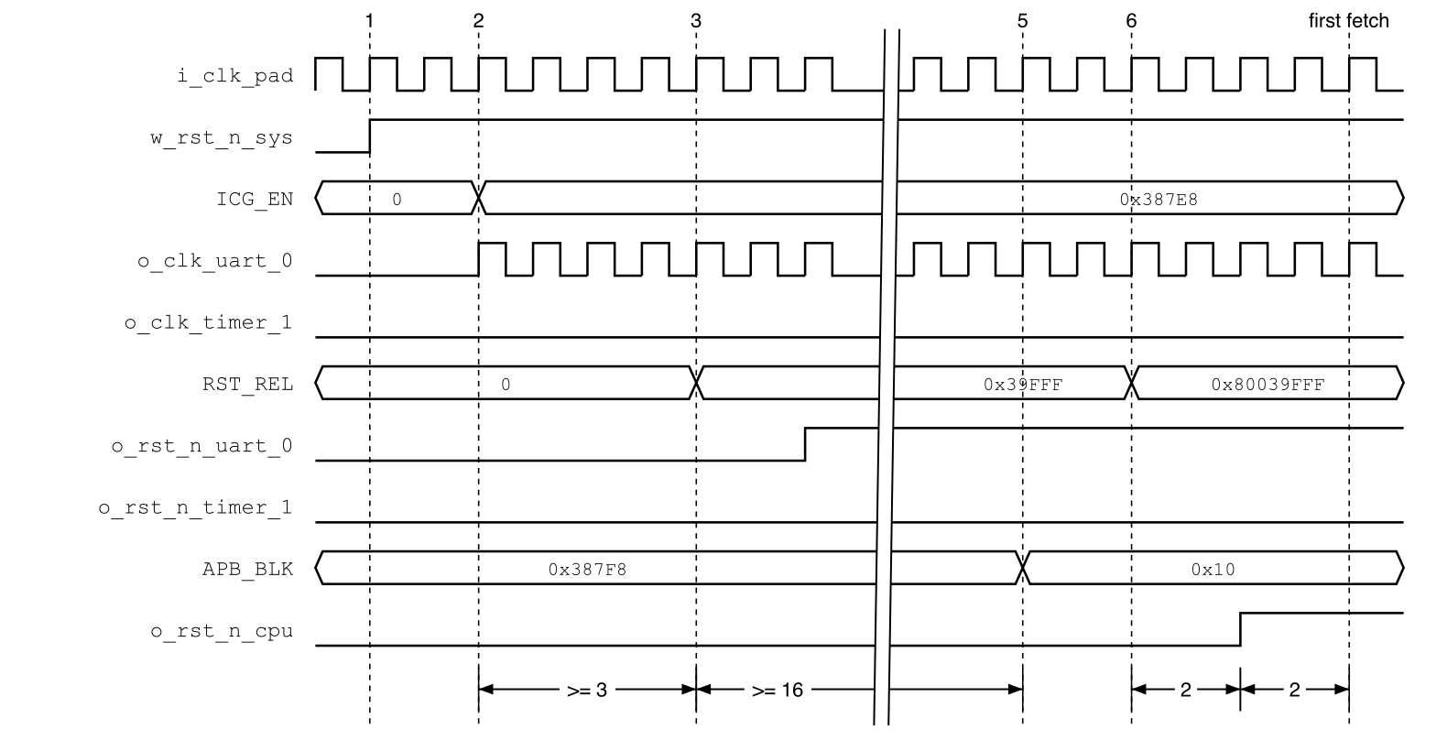
Figure 7-6. Power-up sequence; numbers are the steps above, one gap compresses step 4
- Step 5 precedes step 6, so the boot ROM’s first UART0 access is not blocked.
- The order is the CRM ROM program: changing it changes no RTL.
- After step 6, timer_1 is gated, blocked and still in reset: its synchroniser input is 1 but it has no clock edge. DOMAIN_RST_STATUS[4] reads 1 until CLK_EN[4] is written 1.

7.6 Runtime requests
In IDLE (Figure 3-2), MCPU polls CLK_EN and compares it with the state it has applied. Only the last value written matters, so Ibex may write it back to back.
Table 7-3. MCPU actions, per changed bit n
Request | Step 1 | Step 2 | Step 3
Clock stop | APB_BLK[n] <- 1 | wait APB_BUSY[n] = 0 | ICG_EN[n] <- 0
Clock start | ICG_EN[n] <- 1 | wait 3 cycles | APB_BLK[n] <- 0
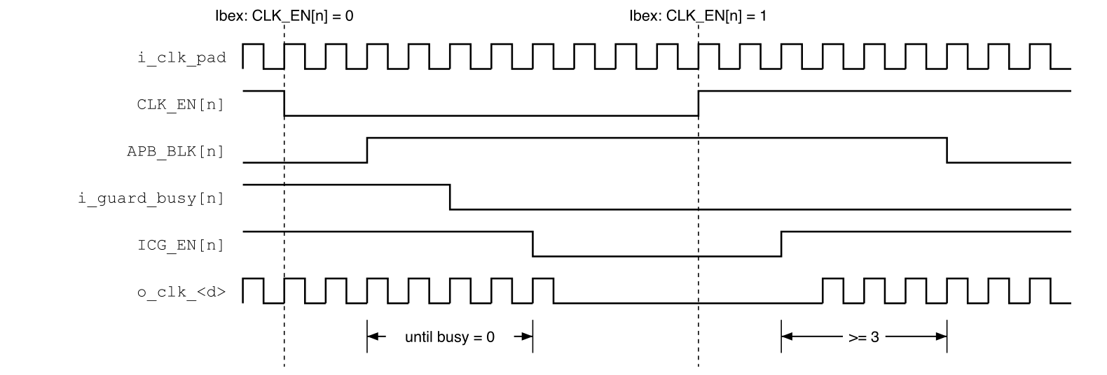
Figure 7-7. Clock stop, then start, of domain n
- Invariant, in every cycle: APB_BLK[n] = 0 only if domain n’s clock runs.
- RST_REL changes only in the power-up sequence; at runtime MCPU writes ICG_EN and APB_BLK only.

7.7 APB guard
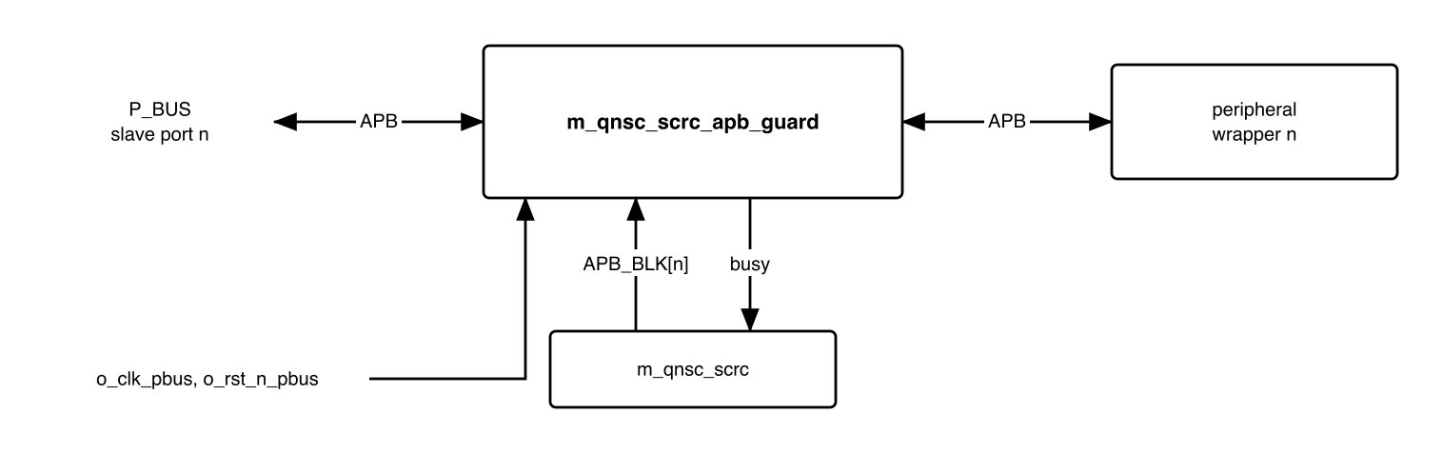
Figure 7-8. APB guard
m_qnsc_scrc_apb_guard, on o_clk_pbus and o_rst_n_pbus:
- Samples APB_BLK[n] in the SETUP phase (PSEL AND NOT PENABLE); a change during a transfer does not affect that transfer.
- Blocked: completes in the ACCESS phase with PREADY = 1, PSLVERR = 1, PRDATA = 0, and holds PSEL to the IP at 0.
- Not blocked: pass-through, busy = 1 from SETUP until the IP completes the transfer (PENABLE AND PREADY).
- One guard per gateable domain: 11 guards, 11 bits of APB_BLK.
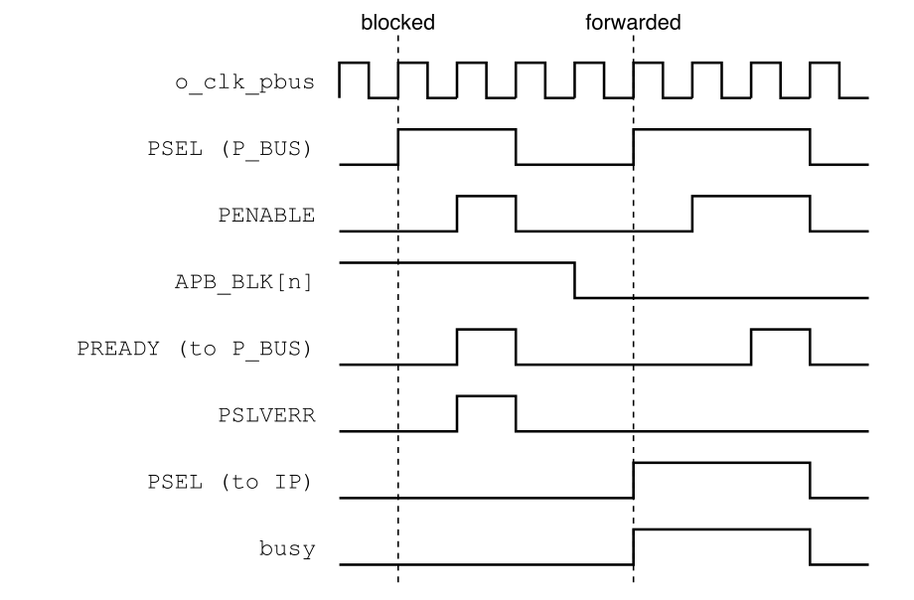
Figure 7-9. One blocked and one forwarded transfer; the IP adds one wait state
The error reaches Ibex as a load or store access fault, through P_BUS PSLVERR and AXI2APB SLVERR. There is no automatic clock restart and no retry.

7.8 CPU hold and SYSDBG
- cpu synchroniser input = RST_REL[31] AND NOT i_dbg_cpu_hold. The hold is not a reset source and sets no cause bit.
- sysdbg synchroniser input = w_rst_n_por; its clock never stops.
- o_rst_n_sbus also resets SYSDBG’s bus side, so a WDT or SW reset leaves no half-finished SYSDBG bus handshake.
What SYSDBG does with the hold: QNSC_SYSDBG_MAS 7.1.

7.9 Timing summary
Table 7-4. SCRC timing, w_clk_root cycles
Quantity | Value
WDT or SW chip reset | 16
w_rst_n_por release to w_rst_n_sys release | 16
Domain reset release after its input rises | 2 domain-clock edges
ICG_EN[n] = 1 before RST_REL[n] = 1 | >= 3
Non-CPU release to CPU release | >= 16, plus the APB_BLK write
CPU reset release to first Ibex fetch | 2 (Ibex)
MCPU APB access | >= 3
APB_BLK[n] = 1 to clock stop | until APB_BUSY[n] = 0, unbounded
Clock start to APB_BLK[n] = 0 | >= 3

7.10 Firmware sequences
Table 7-5. What firmware does
To | Write | Then | Done when
Stop a peripheral clock | mask its interrupts; CLK_EN[n] = 0 | – | ICG_EN[n] = 0
Start a peripheral clock | CLK_EN[n] = 1 | – | APB_BLK[n] = 0
Use TIMER1 | CLK_EN[4] = 1 | – | APB_BLK[4] = 0
Reset the chip | SW_RST = 1 | – | restart; RESET_CAUSE.SOFT = 1
Recover from an access fault at a gated peripheral | CLK_EN[n] = 1 | – | retry the access
Recover from a hung peripheral | SW_RST = 1, or let the watchdog bite | – | restart
Before stopping pwm, write PWM CMD = STOP | RST (QNSC_PWM_MAS 7.7). Before stopping dma, wait until DONE_ID reaches the last launched job: the DMA reports idle before its last write response (QNSC_DMA_MAS 7.4).

8. Instances
Table 8-1. RTL modules and instance counts
Module | Count | Where | Source
m_qnsc_scrc | 1 | design/top | in house
m_qnsc_scrc_apb_guard | 11 | design/top, one per gateable APB slave | in house
m_qnsc_scrc_rst_filter | 1 | m_qnsc_scrc | in house, library cells
m_qnsc_scrc_rst_sync | 19 | power-on stage, 18 CTRLs | library cell wrapper
m_qnsc_scrc_sync | 1 | RRC, i_wdt_rst_req | library cell wrapper
m_qnsc_scrc_rrc | 1 | m_qnsc_scrc | in house
m_vlsit_mrv_cpu | 1 | m_qnsc_scrc | MRV-CPU
m_qnsc_scrc_crm_rom | 1 | m_qnsc_scrc | in house
m_qnsc_scrc_apb_wfilter | 2 | one per master; a parameter selects the read-only offsets | in house
APB BUS | 1 | m_qnsc_scrc | APB-BUS-Generator – 11
m_qnsc_scrc_csr | 1 | m_qnsc_scrc | APB-CSR-Generator
m_qnsc_scrc_ctrl | 18 | m_qnsc_scrc; ICG enable tied 1 in seven | in house, library ICG
The eleven guards: timer_0, timer_1, uart_0, uart_1, gpio_0, gpio_1, gpio_2, spi, i2c, pwm, dma configuration port.

9. What is not provided here, and who provides it
Table 9-1. Functions this block does not provide
Function | Where it lives
RESET_CAUSE, DOMAIN_RST_STATUS, CHIP_ID_REV | SYSCSR, APB_M1, RTL in design/scrc
DBG_EN capture, o_dbg_cpu_hold | QNSC_SYSDBG_MAS 7.1
Ibex boot_addr_i mux, fetch_enable_i tie | CPU owner, QNSC_SYSDBG_MAS 11
Decode error on an unmapped address | S_BUS, P_BUS
Masking interrupts, PWM safe stop, DMA idle before gating | firmware, 7.10
Boot download, image format | QNSC_BOOT_SPEC

10. Tie-offs
Table 10-1. Tie-offs
Port | Tied to | Why
MCPU i_interrupt | 0 | Polling. The MRV interrupt is an unmasked edge that overwrites x1; a request during a BIU stall is lost – DECISIONS
MCPU master PSTRB, PPROT into its WF | 4'hF, 0 | MCPU has neither port; any other strobe is rejected by SCRC CSR
SCRC CSR i_protect_en | 0 | No privilege check; the rights are the WFs
SCRC CSR i_slverr_en | 1 | Misaligned and partial-strobe accesses answered with PSLVERR
ICG enable of the seven always-on CTRLs | 1 | Never gated – 7.1
m_qnsc_scrc_rst_sync i_scan_en | 0 | No scan in QSOC v1

11. Requirements on others, and open items
Table 11-1. Requirements on other owners
Item | Owner | What it blocks
WDT rst_aon_ni = o_rst_n_wdt, aon_timer_rst_req_o to i_wdt_rst_req | WDT owner | 7.3: the request dropping inside 16 cycles
SYSCSR bus reset = o_rst_n_por, not o_rst_n_pbus | SYSCSR (same owner) | RESET_CAUSE surviving WDT and SW
Eleven guards between P_BUS and the wrappers; i_guard_busy bits 0, 1, 2, 11, 12, 13, 14 tied 0; DOMAIN_RST_STATUS[n] = ~o_rst_n_<d> | top (lead) | 7.7, SYSCSR
P_BUS forwards each slave’s PSLVERR; AXI2APB turns it into SLVERR | bus owner | access fault on a blocked peripheral
SPI MAS: APB_S11 is APB_M10 (contract); wrapper PCLK/PRESETn = o_clk_spi/o_rst_n_spi, as i_clk_peri/i_rst_n_peri | SPI owner | the SPI wrapper’s connection
IO MUX has registers (QNSC_SYSDBG_MAS 7.1) but no clock domain, bit or address in the contract | top, IO MUX owner | IO MUX integration

Table 11-2. HAS text this specification departs from
QSOC_HAS_Report_EN_v4_final says | This specification | Why, in DECISIONS
Software reset resets every domain except the CPU | resets the whole chip, CPU included | one bit, one behaviour; firmware reads RESET_CAUSE after restart
Tier-1 reset is a plain OR of the sources | RRC latches, stretches to 16 cycles | the WDT and SW requests are cleared by the reset they cause
MCPU handler entered by interrupt; do not write back to back | polling; back-to-back writes allowed | the MRV interrupt loses requests
Responder inside SCRC watches CLK_EN | guards at the top follow APB_BLK, written by MCPU | the guard must close before the clock stops, not after the request
Open items:
- APB BUS name clash. APB-BUS-Generator always names its top m_vlsi_apb_router, as for P_BUS, so both cannot be compiled into one design, and the name fails Naming Rule 2.1. The generator stays (the mentor’s design); the generated module is renamed when it is committed to util/gen, with the command. SCRC owner with the bus owner.
- Library cells. DLY, ICG, the synchronisers and the filter flip-flop are library cells. Their SMIC 28 nm names are not known yet; Verilator needs a behavioural model of each, and SYN needs them instantiated, not inferred. SCRC owner, with the lead for the flow.
- CRM ROM depth. Not fixed; the program is a few dozen words. SCRC owner.
Accepted limits:
- One domain serves both SPI blocks: gating spi stops SPI Host and SPI Device together.
- Gating spi while an external host drives SPI Device SCK loses that transfer: SPI Device needs its core clock at >= 1/4 of SCK.
- The dma guard covers the configuration port only, not DMA transfers already issued on S_BUS.
- A peripheral that holds PREADY low while not blocked stalls Ibex; only the watchdog recovers it.

12. Verification
- SCRC_CLK_001 Every output clock equals the root clock while its CTRL is enabled.
- SCRC_CLK_002 The seven always-on clocks, wdt included, never stop, for any register value.
- SCRC_CLK_003 After any chip reset every gateable clock runs except timer_1.
- SCRC_RST_001 A WDT bite and SW_RST each hold w_rst_n_sys low for exactly 16 cycles; after POR it releases one cycle after w_rst_n_por. Each asserts every domain reset except sysdbg (WDT, SW).
- SCRC_RST_002 Each domain reset releases 2 domain-clock edges after its input rises.
- SCRC_RST_003 All non-CPU domains release in the same cycle; the CPU releases >= 16 cycles later and after APB_BLK is written.
- SCRC_RST_004 With i_dbg_cpu_hold = 1, o_rst_n_cpu stays 0 for any RST_REL[31].
- SCRC_RST_005 WDT and SW resets do not change RRC, o_rst_n_por or o_rst_n_sysdbg.
- SCRC_RST_007 Before the CPU reset releases, APB_BLK = NOT CLK_EN on the gateable bits; the boot ROM’s first UART0 access completes without PSLVERR.
- SCRC_RST_008 After a chip reset, o_rst_n_timer_1 = 0 until CLK_EN[4] is set, then releases.
- SCRC_RRC_001 A WDT request cleared by the reset it causes still gives one 16-cycle reset, with o_cause_we_wdt = 1 for exactly those 16 cycles and o_cause_we_sw = 0.
- SCRC_FLT_001 A pulse on i_rst_n_pad shorter than the three-cell delay does not change w_rst_n_por (gate-level simulation with library delays).
- SCRC_CSR_001 Every row of the PSLVERR table (7.4) gives the stated result, and a dropped write changes no register.
- SCRC_CSR_002 Reset value, implemented bits and access of every register match section 6, per master.
- SCRC_SEQ_001 Any sequence of CLK_EN writes, back to back included, ends with ICG_EN = the last value written.
- SCRC_SEQ_002 The invariant of 7.6 holds in every cycle (assertion).
- SCRC_BUS_001 An access to a blocked peripheral ends in one transfer with PSLVERR = 1 and never asserts PSEL at the IP.
- SCRC_BUS_002 A change of APB_BLK during a transfer does not change its response.
- SCRC_BUS_003 With an IP holding PREADY low for N cycles, its clock stops only after the transfer completes, for any N.
- SCRC_DBG_001 With DBG_EN = 0 the CPU releases as without SYSDBG; with DBG_EN = 1 it stays in reset until CPUHOLD = 0.
- SCRC_IMP_001 No o_clk_<d> path contains a cell other than the root buffer and one library ICG (netlist check), and no RRC flip-flop has a reset other than w_rst_n_por.

Appendix A. Acronyms
Table A-1. Acronyms
Acronym | Description
BUF | Clock root buffer
CNT | RRC stretch counter
CRM ROM | Clock/Reset Manager ROM, the MCPU program memory
CTRL | Domain controller: clock gate + reset synchroniser
DLY | Library delay cell
ICG | Integrated Clock Gating cell
MCPU / MRV-CPU | Mini RISC-V CPU, the SCRC controller
POR | Power-On Reset
RRC | Reset Request Controller
SCRC | System Clock and Reset Controller
SYSCSR | System Control and Status Registers
WF | Write filter

Appendix B. First review
Table B-1. First review
Item | Reviewer | Response
Release all domains together, CPU last | Quan (mentor) | 7.5
Per-peripheral soft reset | Quan (mentor) | first allowed, then removed in a later lesson: no IP can report a hang, so recovery is chip reset or CPU hold, 7.3
SYSDBG survives WDT/SW, never gated; CPU holdable | SYSDBG owner | 7.3, 7.8
TIMER0 runs after reset, TIMER1 may start gated | TIMER owner | 6
PWM stopped before its clock is gated | PWM owner | 7.10
CPU release raced the guard opening | review, V2.3 | 7.5 step 5 before 6
CSR generator cannot enforce per-master rights | RTL check, V2.2 | WFs, 7.4
APB_S0/APB_S1 against contract APB_M0/APB_M1 | lead, V3.0 | 3, 5, 6
Ports did not follow the Naming Rule | lead, V3.0 | 3, 5, 8
Figures had colour and drifted from the text | lead, V3.0 | redrawn; timing diagrams added
timer_1 status after boot not stated | lead, V3.0 | 7.5, SCRC_RST_008
No stretch after POR | lead proposal, adopted by the owner | 7.3, SCRC_RST_001
Two CSRs instead of APB BUS + WFs | lead proposal | Rejected by the owner: the mentor’s design stays, DECISIONS 4
Guard reset o_rst_n_pbus | lead, V3.0 | 7.7; owner to confirm
Generated bus top name clashes with P_BUS | lead, V3.0 | 11, open
spi and spi_device were two domains; the SPI wrapper takes one PCLK/PRESETn for both IPs | SPI MAS V1.3, lead | one domain, bit 13 reserved
Earlier review items (V1.x) | Sinh, Quan | DECISIONS

