UART
MICRO-ARCHITECTURE SPECIFICATION – V3.0
QUY NHON SEMICONDUCTORS – QNSC

Table of Contents

Table of Tables
Table 1-1. Memory map, regions behind APB_M8 and APB_M9
Table 1-2. Instances
Table 3-1. Sub-blocks
Table 4-1. Upstream IP used
Table 5-1. m_qnsc_wrap_uart interface
Table 6-1. Register map
Table 6-2. Fields firmware uses
Table 7-1. Common divisors at 20 MHz
Table 9-1. Functions this block does not provide
Table 10-1. Tie-offs inside m_qnsc_wrap_uart
Table 11-1. Requirements on other owners
Table 11-2. HAS text this specification departs from
Table A-1. Acronyms
Table B-1. First review

Table of Figures
Figure 3-1. One UART instance in QSOC
Figure 6-1. Register fields
Figure 7-1. One 8N1 frame, character 0x4D

Revision history
The reasoning behind each change, and the research report this specification is built on, are in QNSC_UART_DECISIONS.md.
Version | Date | Author | Reviewer | Description of change
V3.0 | 2026-09-28 | Nghia VT (lead), for Ong Bao Vinh | – | Specification written from the research report (V2.x): addresses and interrupt lines from the contract, wrapper m_qnsc_wrap_uart around upstream apb_uart unmodified, no DMA request ports, no parameter

1. Overview
UART0 and UART1 are two instances of pulp-platform/apb_uart, a 16550A-compatible serial port with 16-byte transmit and receive FIFOs. UART0 carries the boot download (QNSC_BOOT_SPEC); UART1 is a general-purpose port.
The fact that shapes it: QSOC has one 20 MHz clock, so the baud rate is set only by the divisor, and the reset divisor stops the baud generator until firmware writes one (7.2).
The block has no hardware flow control and no DMA request: modem inputs are tied inactive, and every transfer is made by the CPU or by a software-started DMA job.
Block directory design/uart, wrapper m_qnsc_wrap_uart, owner Ong Bao Vinh.
Table 1-1. Memory map, regions behind APB_M8 and APB_M9
Base | Size | Region | Port | Kind | Note
0x80020000 | 16 KiB | uart_0 | APB_M8 | peripheral | Carries the boot download
0x80024000 | 16 KiB | uart_1 | APB_M9 | peripheral

Table 1-2. Instances
Instance | APB port | Interrupt | SCRC domain | Use
UART0 | APB_M8 | fast line 4, mcause 20 | uart_0, CLK_EN[5] | Boot download, console
UART1 | APB_M9 | fast line 5, mcause 21 | uart_1, CLK_EN[6] | General purpose

2. Features
- 16550A register map at byte offset 4 x n; 8 registers, DLAB banking – 6.
- 5 to 8 data bits, 1 or 2 stop bits, none, odd, even or stick parity, break – 7.1.
- 16-bit divisor: baud = 20 MHz / (16 x divisor) – 7.2.
- 16-byte TX and RX FIFOs, RX trigger at 1, 4, 8 or 14 bytes, character timeout – 7.3.
- One level interrupt from four prioritised sources – 7.4.
- Zero-wait-state APB; register errors answered with PSLVERR – 7.5.

3. Block diagram
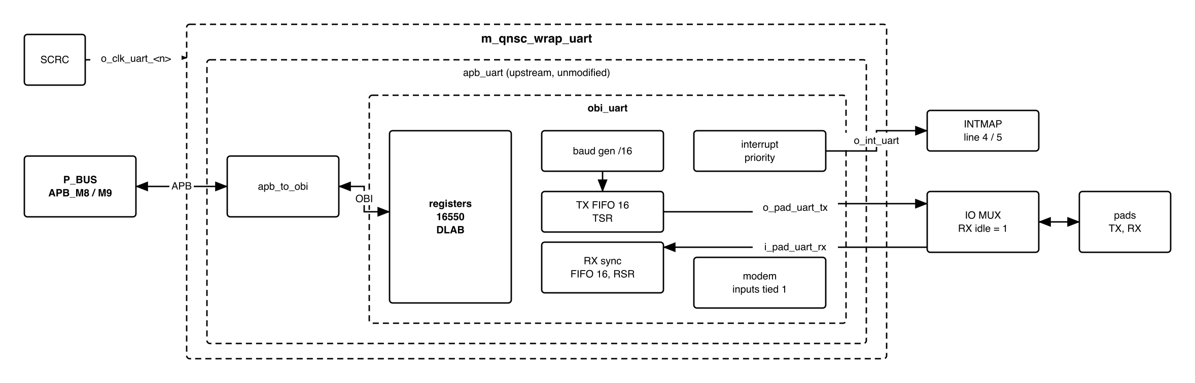
Figure 3-1. One UART instance in QSOC
Table 3-1. Sub-blocks
Block | Module | Function
APB to OBI | apb_to_obi (in apb_uart) | APB4 slave; the register offset is PADDR[4:2]
Registers | obi_uart_register | 16550 registers, DLAB decode, PSLVERR on unmapped access
Baud generator | obi_uart_baudgen | Divides i_clk_peri by the divisor; 16 ticks per bit
Transmitter | obi_uart_tx | THR, 16-byte FIFO, shift register, frame generation
Receiver | obi_uart_rx | 2-FF input synchroniser, majority sampling, 16-byte FIFO, timeout
Interrupts | obi_uart_interrupts | Four sources, priority encoder, ISR
Modem | obi_uart_modem | Inputs tied inactive in the wrapper
The block is in the peri clock cluster: i_clk_peri is gated by SCRC.

4. IP used
Table 4-1. Upstream IP used
From | Module | Commit | Licence
pulp-platform/apb_uart | apb_uart, apb_uart_wrap | 8182a85d | SHL-0.51
pulp-platform/obi_peripherals | obi_uart and its sub-modules | 079894a6 (v0.1.1) | SHL-0.51
pulp-platform/obi | apb_to_obi, obi_pkg | v0.1.7, as apb_uart pins | SHL-0.51
pulp-platform/apb | apb/typedef.svh | 6ae8bf8d (v0.2.4+6), as iDMA pins; apb_uart asks for 0.2.4 | SHL-0.51
pulp-platform/common_cells | fifo_v3, counter, delta_counter, sync, cf_math_pkg (the src/deprecated shims onto cc_*) | db427693 (v2.0.0-beta.3+3), the copy design/bus uses | SHL-0.51
pulp-platform/tech_cells_generic | tc_sync, called by the sync shim | v0.2.14, as common_cells pins | SHL-0.51
Facts this specification relies on, read at those commits:
- apb_uart has a 3-bit PADDR and forms {PADDR, 2'b00}, ties PSTRB to '1 and PPROT to 0. Its ports have no DMA request.
- The reset value of DLL is 1 and of DLM 0; the baud generator counts only when {DLM, DLL} - 1 is not 0 (obi_uart_baudgen.sv), so it is stopped out of reset.
- irq_o = 1 while any enabled source is pending (obi_uart_interrupts.sv).
- In non-FIFO mode the receiver reports LSR.BI = 1 for every character (obi_uart_rx.sv line 462, which overrides the computed value).

5. Interface
Table 5-1. m_qnsc_wrap_uart interface
Signal | Dir | Width | Description
i_clk_peri, i_rst_n_peri | in | 1 | SCRC o_clk_uart_<n>, o_rst_n_uart_<n>
i_bus_apb_psel, i_bus_apb_penable, i_bus_apb_pwrite | in | 1 | P_BUS APB_M8 / APB_M9
i_bus_apb_paddr | in | 12 | Offset in the window (contract meta.apb_paddr_width); bits 4:2 used
i_bus_apb_pwdata | in | 32 | Bits 7:0 used
i_bus_apb_pstrb, i_bus_apb_pprot | in | 4, 3 | Not used
o_bus_apb_prdata, o_bus_apb_pready, o_bus_apb_pslverr | out | 32, 1, 1 | Bits 31:8 read 0
o_int_uart | out | 1 | irq_o, level – 7.4. To INTMAP i_int_uart_<n>
i_pad_uart_rx | in | 1 | Serial input through IO MUX. Idle 1
o_pad_uart_tx | out | 1 | Serial output through IO MUX. Idle 1

6. Register map
The UART decodes offset bits 4:2 only, so its 32-byte map repeats every 32 bytes in the window: base + 0x20 is RBR. Registers are 8 bits wide in bits 7:0.
Table 6-1. Register map
Offset | DLAB = 0 read | DLAB = 0 write | DLAB = 1 read | DLAB = 1 write | Reset
0x00 | RBR | THR | DLL | DLL | DLL 0x01
0x04 | IER | IER | DLM | DLM | 0x00
0x08 | ISR | FCR | PSLVERR | FCR | ISR 0xC1, FCR 0x00
0x0C | LCR | LCR | PSLVERR | LCR | 0x00
0x10 | MCR | MCR | PSLVERR | MCR | 0x00
0x14 | LSR | PSLVERR | PSLVERR | PSLVERR | 0x60
0x18 | MSR | PSLVERR | PSLVERR | PSLVERR | 0x00
0x1C | SPR, reads 0 | ignored | PSLVERR | ignored | 0x00
With DLAB = 1 only DLL and DLM can be read: firmware clears DLAB before it reads LSR. LCR is writable in both banks, so DLAB can always be cleared.
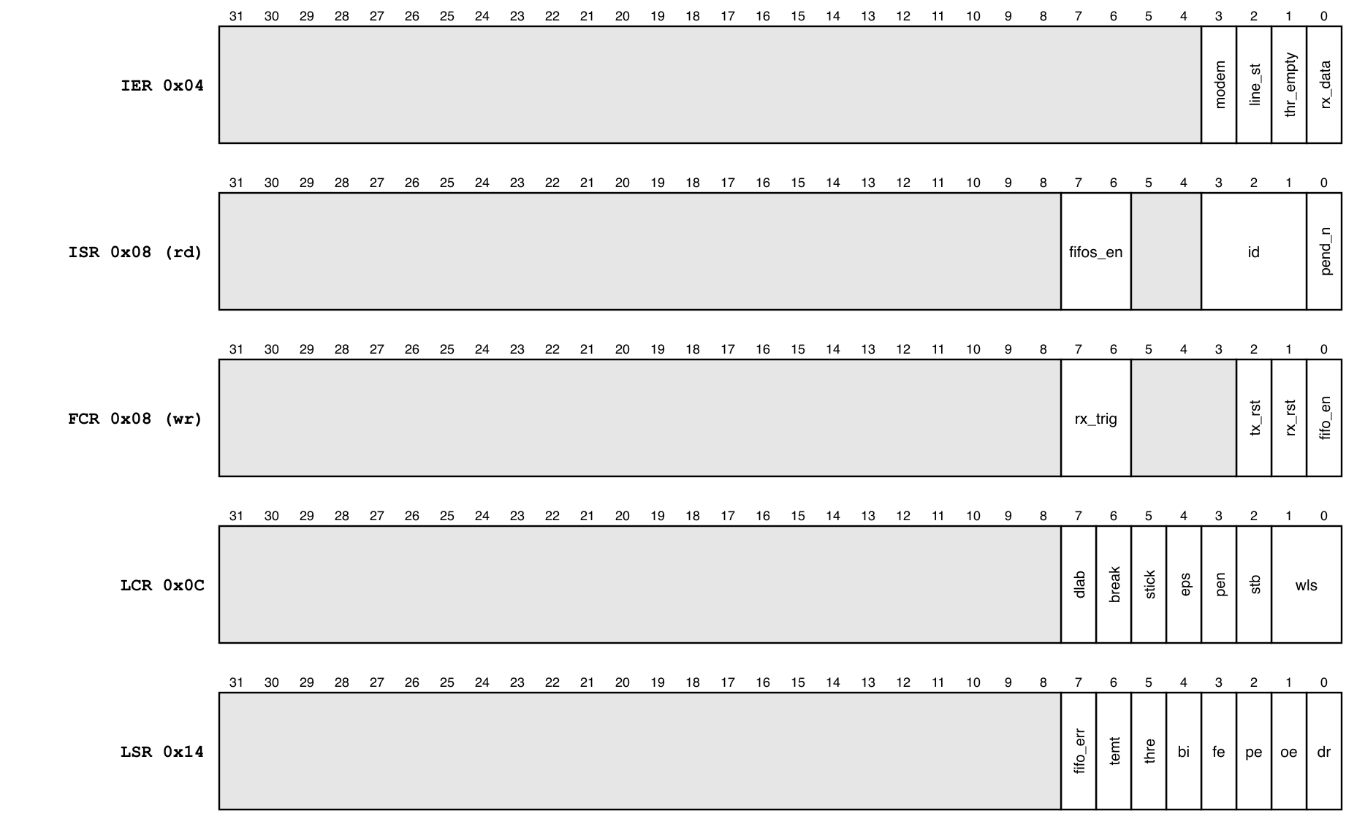
Figure 6-1. Register fields
Table 6-2. Fields firmware uses
Register | Bits | Meaning
IER | 0 / 1 / 2 / 3 | Enable: RX data or timeout / THR empty / line status (not used, 7.4) / modem status (not used)
ISR | 0 | 0 = an interrupt is pending
ISR | 3:1 | 011 line status, 010 RX data, 110 timeout, 001 THR empty, 000 modem
ISR | 7:6 | Always 11 (16550A FIFOs)
FCR | 0 / 1 / 2 | FIFO enable / clear RX FIFO / clear TX FIFO
FCR | 7:6 | RX trigger level: 1, 4, 8, 14 bytes
LCR | 1:0 | Data bits: 5, 6, 7, 8
LCR | 2 / 3 / 4 / 5 | 2 stop bits / parity enable / even parity / stick parity
LCR | 6 / 7 | Send break / DLAB
LSR | 0 / 1 / 2 / 3 / 4 | Data ready / overrun / parity / framing / break
LSR | 5 / 6 / 7 | THR empty / transmitter empty / error in RX FIFO

7. Functional behaviour

7.1 Frame
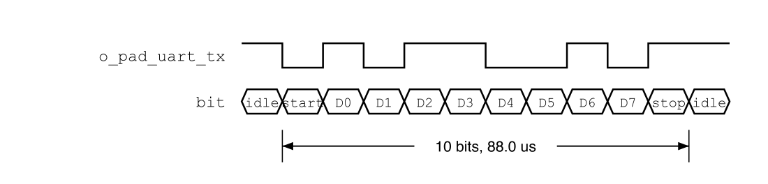
Figure 7-1. One 8N1 frame, character 0x4D
A frame is a start bit (0), 5 to 8 data bits least significant first, an optional parity bit and 1 or 2 stop bits (1). The line idles at 1.

7.2 Baud rate
- baud = 20 MHz / (16 x {DLM, DLL}). Divisor 11 gives 113 636 baud, 1.36 % below 115 200, inside the 8N1 tolerance.
- Out of reset the divisor is 1 and the baud generator does not run: nothing is sent or received until firmware writes the divisor.
- Writing DLL or DLM restarts the baud counter.
Table 7-1. Common divisors at 20 MHz
Target baud | Divisor | Actual | Error
9 600 | 130 | 9 615 | +0.16 %
19 200 | 65 | 19 231 | +0.16 %
57 600 | 22 | 56 818 | -1.36 %
115 200 | 11 | 113 636 | -1.36 %

7.3 FIFOs
- Firmware sets FCR = 0x07 (FIFOs on, both cleared) before use. Without FIFOs the receiver reports LSR.BI = 1 for every character (section 4), so the non-FIFO mode is not used.
- The RX interrupt fires when the RX FIFO reaches the FCR[7:6] trigger level, or when data waits without a new character for 4 character times (timeout).
- A 16-byte FIFO at 113 636 baud holds 1.4 ms of data.

7.4 Interrupt
- o_int_uart is 1 while any source enabled in IER is pending. ISR[3:1] names the highest-priority one: line status, RX data, timeout, THR empty, modem.
- RX data is a level while the RX FIFO is at or above its trigger level; timeout clears on a read of RBR; THR empty is a level while the THR is empty and clears when THR is written.
- The line-status source is computed from the error events of the character being received, so it may last one cycle (obi_uart_interrupts.sv), and INTMAP does not latch. Firmware leaves IER[2] = 0 and reads the errors in LSR with each character; UART_008 settles it.
- Modem status is not used: IER[3] stays 0.

7.5 Bus access
- Every access completes with no wait state.
- An access the table of section 6 marks PSLVERR completes with PSLVERR = 1 and changes nothing. It reaches Ibex as a load or store access fault.
- PSTRB is ignored: a byte, halfword or word store writes bits 7:0.

7.6 Firmware initialisation
The order QNSC_BOOT_SPEC 5 uses, and every driver follows:
- LCR = 0x80 (DLAB = 1).
- DLL = divisor low byte, DLM = divisor high byte.
- LCR = 0x03 (8N1, DLAB = 0), written as a value, not read-modify-write.
- FCR = 0x07.
- IER as required; 0 for polling.

8. Instances
Two instances of one wrapper, UART0 and UART1 (section 1). They differ only in their connections in design/top.

9. What is not provided here, and who provides it
Table 9-1. Functions this block does not provide
Function | Where it lives
Pin selection, RX idle level when the pin is not selected | IO MUX
Hardware flow control (RTS/CTS) | not provided; modem inputs tied inactive
DMA request | not provided; a DMA job is started by firmware (QNSC_DMA_MAS 7.3)
Clock gating, reset | SCRC
Boot download protocol | QNSC_BOOT_SPEC

10. Tie-offs
Table 10-1. Tie-offs inside m_qnsc_wrap_uart
Port of apb_uart | Tied to | Why
CTSN, DSRN, DCDN, RIN | 1 | Inactive; equals the reset value of the modem synchronisers, so no modem-status change is seen after reset
RTSN, DTRN, OUT1N, OUT2N | open | No flow control, no modem outputs
PADDR[2:0] | i_bus_apb_paddr[4:2] | Register index

11. Requirements on others, and open items
Table 11-1. Requirements on other owners
Item | Owner | What it blocks
RX input driven 1 when the pad is not selected for the UART | IO MUX owner | A 0 is a continuous break: framing errors and interrupts
UART0 pins selected out of reset | IO MUX owner | Boot download

Table 11-2. HAS text this specification departs from
QSOC_HAS_Report_EN_v4_final says | This specification | Why
(research report V2.x) UART0 at APB_M9 0x8002_4000, UART1 at APB_M10 | APB_M8 0x8002_0000, APB_M9 0x8002_4000 | Contract since GPIO3 was dropped
(research report V2.x) interrupts to PLIC sources 13, 14 | INTMAP fast lines 4, 5 | QSOC has no PLIC
Open items, UART owner:
- Vendor obi_peripherals, obi, apb and tech_cells_generic at the commits of section 4, without the DMA-request patch, and add the src/deprecated shims to the one common_cells copy. obi_peripherals asks for common_cells 1.37; the shims keep the old ports, and this set was linted together with Verilator 5.
- Lint waiver: Verilator reports a latch on character_length (obi_uart_rx.sv line 200). It is a temporary, read only in the branch that assigns it.
- Wrapper RTL, lint, and the tests of section 12.
Accepted limits:
- The 32-byte register map aliases across the 16 KiB window without an error.
- LCR[2] (2 stop bits) is not yet confirmed in simulation (UART_007).
- The line-status interrupt is not used (7.4) until UART_008 shows it is a level.

12. Verification
- UART_001 Reset values of every register; the baud generator does not run until the divisor is written.
- UART_002 Every cell of the section 6 table: result and PSLVERR, in both banks.
- UART_003 Internal loopback (MCR[4] = 1), 8N1, divisor 11: every byte sent is received.
- UART_004 FIFO mode, a 60 KiB stream at 113 636 baud against a peer 2 % off: no overrun, framing or parity error.
- UART_005 RX trigger levels 1, 4, 8, 14 and the timeout interrupt with 3 bytes.
- UART_006 Interrupt priority and clearing actions of 7.4.
- UART_007 Stop-bit count on o_pad_uart_tx with LCR[2] = 0 and 1.
- UART_008 Parity, framing and break with IER[2] = 1: width of the o_int_uart pulse, recorded; the result decides whether IER[2] may be used.
- UART_009 Boot: QNSC_BOOT_SPEC initialisation and frame reception on UART0 (SoC test).

Appendix A. Acronyms
Table A-1. Acronyms
Acronym | Description
DLAB | Divisor Latch Access Bit, LCR[7]
FIFO | First-in, first-out buffer
OBI | Open Bus Interface
RBR, THR | Receiver buffer, transmit holding register
TSR, RSR | Transmit, receive shift register

Appendix B. First review
Table B-1. First review
Item | Reviewer | Response
Why apb_uart: APB, 16550 map, polling, no subsystem | Vinh (research) | 4; DECISIONS
Non-FIFO mode reports BI for every character | Vinh (research, F1) | 7.3: FCR = 0x07 always
With DLAB = 1 most reads fault | Vinh (research, F2) | 6, 7.6
Reset divisor stops the baud generator | Vinh (research, F5) | 7.2
512 aliases in the 16 KiB window | Vinh (research, F6) | accepted limit, as the other APB IP
Wrapper name, parameters, DMA ports | lead, V3.0 | m_qnsc_wrap_uart, no parameter (Naming Rule V1.1, design/README.md); DMA ports dropped (QNSC_DMA_MAS V3.0)
Addresses and interrupt from HAS v1.3 | lead, V3.0 | contract, section 1

