TIMER
MICRO-ARCHITECTURE SPECIFICATION – V2.0
QUY NHON SEMICONDUCTORS – QNSC

Table of Contents

Table of Tables
Table 1-1. Instance assignment
Table 3-1. TIMER sub-modules
Table 4-1. Upstream IP used
Table 4-2. Why the PWM IP cannot serve as the timer
Table 5-1. Block interface
Table 6-1. Register map of one instance
Table 6-2. CFG_REG_LO and CFG_REG_HI bit fields
Table 7-1. Counting rate options
Table 7-2. Interrupt shape by mode
Table 7-3. Address decode against region size
Table 9-1. Functions this block does not provide
Table 10-1. Constraints on firmware and integration
Table 11-1. Requirements on other owners
Table 12-1. Verification QSOC must add
Table A-1. Acronyms
Table B-1. First review

Table of Figures
Figure 3-1. The timer block and its two counters

Revision history
V2.0 is a rewrite. The reasoning behind each decision, and how every open question closed, is in QNSC_TIMER_DECISIONS.md.
Version | Date | Author | Reviewer | Description of change
V2.0 | 2026-09-23 | Nghia VT | – | Rewritten as specification only, onto the template the other blocks follow. Tables and figures are numbered by the build

1. Overview
TIMER0 and TIMER1 are the two general-purpose timers of QSOC, each an integration of pulp-platform/apb_timer_unit behind an APB4 slave. One instance holds two 32-bit counters that can be chained into one 64-bit counter.
QSOC has no CLINT, so there is no mtime. TIMER0 is the chip’s timebase, and firmware reaches it through these registers rather than through the RISC-V standard machine timer – section 11.
Block directory design/timer, module m_qnsc_wrap_apb_timer_unit, owner Nghia Van Trong.
Table 1-1. Instance assignment
Instance | Region | APB port | Mode | Interrupt lines
TIMER0 | 0x8001C000 | APB_M7 | 64-bit, both counters chained | 1 – irq_lo_o only
TIMER1 | 0x80020000 | APB_M8 | two independent 32-bit | 2 – irq_lo_o, irq_hi_o

2. Features
- Two 32-bit counters per instance, chainable into one 64-bit counter.
- 8-bit prescaler ahead of each counter, and an optional reference-clock input sampled as data.
- Periodic or one-shot at the compare, selected per counter.
- Hardware start from an event input, with no CPU action.
- No status register and no interrupt flag – section 6, and the fact QNSC_Interrupt_Map_MAS depends on.

3. Block diagram
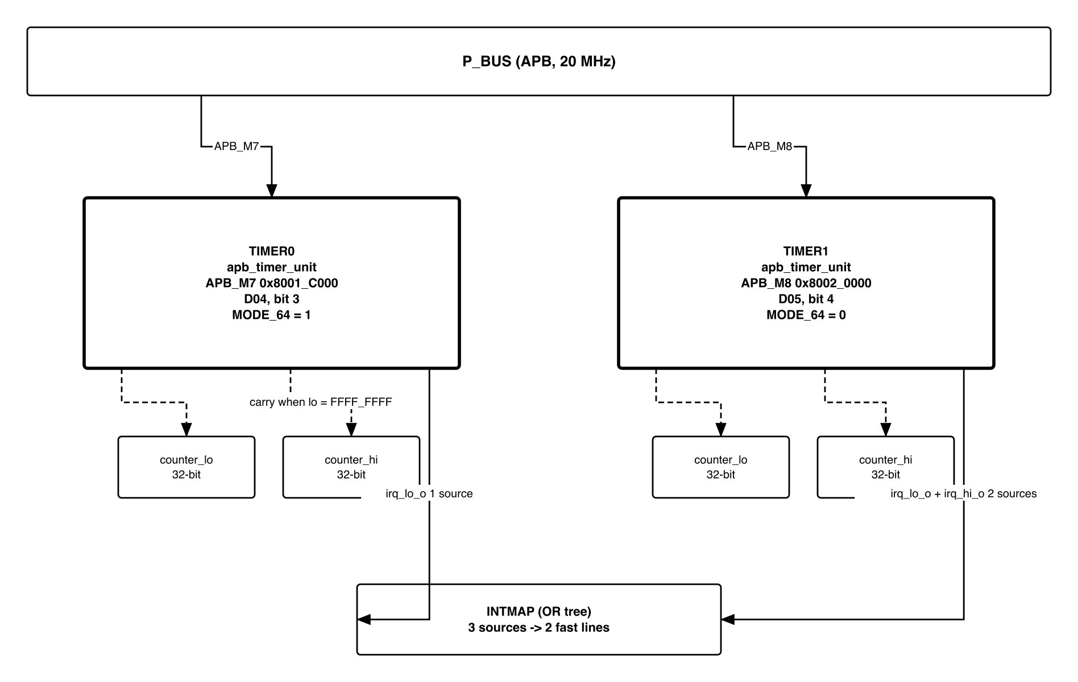
Figure 3-1. The timer block and its two counters
Table 3-1. TIMER sub-modules
Sub-module | Count | Function
timer_unit_counter | 2 | the 32-bit counters, lo and hi
timer_unit_counter_presc | 2 | 8-bit prescaler ahead of each counter
APB register file | 1 | ten addresses, section 6
Interrupt logic | 1 | combinational, section 7.3
In 64-bit mode the two counters are chained, and the RTL raises the carry explicitly:
s_enable_count_hi = ( s_timer_val_lo == 32'hFFFFFFFF );
so counter_hi advances exactly once per wrap of counter_lo – a true 64-bit count, not two loosely coupled halves.

4. IP used
Table 4-1. Upstream IP used
From | Module | Commit | Licence
pulp-platform/apb_timer_unit | apb_timer_unit and three sub-modules | pinned in vendor/manifest.yml | SolderPad 0.51
Why not the PWM IP, which QSOC also instantiates. An earlier revision specified apb_adv_timer for this role; it cannot perform it, and the reason is arithmetic:
Table 4-2. Why the PWM IP cannot serve as the timer
 | apb_adv_timer (PWM) | apb_timer_unit (this block)
Counter width | 16-bit | 32-bit, or 64-bit combined
Wrap at 20 MHz, no prescaler | 3.2768 ms | 214.7 s, or ~29 000 years at 64-bit
Channel output pins | 16 | none
Suited to | short repeating waveforms | a timebase that must not wrap
A timebase wrapping every 3.28 ms forces firmware to count wraps continuously, and one missed wrap corrupts every later measurement. A PWM block never needs a long count. The two roles want opposite counter widths, which is why QSOC instantiates both IPs.

5. Interface
Table 5-1. Block interface
Signal | Dir | Width | Note
HCLK | in | 1 | peri cluster clock – section 7.5
HRESETn | in | 1 | active low
PADDR | in | 12 | only PADDR[5:0] is decoded – section 7.6
PWDATA | in | 32
PWRITE, PSEL, PENABLE | in | 1 each
PRDATA | out | 32
PREADY | out | 1 | tied to PSEL & PENABLE inside the IP
PSLVERR | out | 1 | tied 0 inside the IP
ref_clk_i | in | 1 | sampled as data, not used as a clock
event_lo_i, event_hi_i | in | 1 each | start a counter without CPU action
irq_lo_o, irq_hi_o | out | 1 each | to INTMAP
busy_o | out | 1 | either counter enabled
PREADY tied and PSLVERR tied pull in opposite directions:
- The block can never stall P_BUS. No access can hang the bus, which removes it from the list of blocks a watchdog must protect against.
- The block can never report an error. A write to an unimplemented offset is accepted silently and a read returns zero, so firmware gets no signal that it addressed the block wrongly.

6. Register map
Ten addresses per instance, at the region base.
Table 6-1. Register map of one instance
Offset | Name | Access | Function
0x00 | CFG_REG_LO | RW | configuration of lo; also holds the 64-bit mode bit
0x04 | CFG_REG_HI | RW | configuration of hi
0x08 | TIMER_VAL_LO | RW | current count of lo; a write loads it
0x0C | TIMER_VAL_HI | RW | current count of hi; a write loads it
0x10 | TIMER_CMP_LO | RW | compare target for lo
0x14 | TIMER_CMP_HI | RW | compare target for hi
0x18 | TIMER_START_LO | WO | any write starts lo
0x1C | TIMER_START_HI | WO | any write starts hi
0x20 | TIMER_RESET_LO | WO | any write clears lo
0x24 | TIMER_RESET_HI | WO | any write clears hi
Reads return only six of the ten – the two CFG, the two VAL, the two CMP. The four command addresses are write-only and read as zero.
There is no status register and no interrupt flag. This is the fact section 11 and QNSC_Interrupt_Map_MAS both depend on: nothing in this block records that an interrupt happened, so nothing here can acknowledge one either.
Table 6-2. CFG_REG_LO and CFG_REG_HI bit fields
Bit | Name | Function
0 | ENABLE | counter runs
1 | RESET | clears the counter; self-clearing
2 | IRQ_EN | allows the compare to raise the interrupt
3 | IEM | lets event_*_i set ENABLE
4 | CMP_CLR | on compare, clear the counter – this is what makes it periodic
5 | ONE_SHOT | on compare, clear ENABLE
6 | PRESC_EN | insert the prescaler
7 | REF_CLK_EN | count ref_clk_i edges instead of every core clock
15:8 | PRESC | 8-bit prescaler divisor
31 | MODE_64 | CFG_REG_LO only: chain both counters into one 64-bit timer
MODE_64 is read from CFG_REG_LO everywhere the RTL uses it, including the paths controlling the hi counter. Writing bit 31 of CFG_REG_HI has no effect and must not be relied on.

7. Functional behaviour

7.1 Counting rate
Table 7-1. Counting rate options
REF_CLK_EN | PRESC_EN | Counter advances | Wrap of 32 bits at 20 MHz
0 | 0 | every core clock | 214.7 s
0 | 1 | every PRESC+1 core clocks | up to 256 x that
1 | 0 | on each rising edge of ref_clk_i | set by ref_clk_i
1 | 1 | prescaled ref_clk_i edges | set by both
ref_clk_i passes through a four-stage shift register and an edge detector inside the IP. It is sampled as data, never used as a clock, so it creates no second clock domain and needs no CDC constraint.

7.2 One counting tick is the interrupt pulse width
One counting tick is one HCLK cycle with no prescaler and no reference clock, PRESC+1 cycles with the prescaler, or one ref_clk_i period with REF_CLK_EN set. The narrowest case is one core clock, and that is the case INTMAP must assume.

7.3 The interrupt is combinational, and 64-bit mode drives only one line
if ( s_cfg_lo_reg[`MODE_64_BIT] == 1'b0 ) begin // 32-bit mode
irq_lo_o = s_target_reached_lo & s_cfg_lo_reg[`IRQ_BIT];
irq_hi_o = s_target_reached_hi & s_cfg_hi_reg[`IRQ_BIT];
end else begin // 64-bit mode
irq_lo_o = s_target_reached_lo & s_target_reached_hi & s_cfg_lo_reg[`IRQ_BIT];
end
In 64-bit mode irq_hi_o is never driven, so the instance contributes one source, not two. That is why TIMER0 contributes one line and TIMER1 two.
The 64-bit compare is correct, and it is worth showing why, because the expression looks as though two unrelated events must coincide. target_reached_hi is high for the whole epoch in which counter_hi equals its target, and that epoch lasts one full wrap of counter_lo. Within it, counter_lo passes through every value exactly once, so it equals its own target for exactly one tick. The AND therefore produces exactly one pulse, at the intended 64-bit value.

7.4 The compare is equality, not greater-or-equal
target_reached is asserted when the counter equals the compare value. The standard RISC-V machine timer is specified the other way – pending while mtime >= mtimecmp – specifically so that a target already passed still fires.
This block has no such protection, and the failure is silent:
Mode | If firmware writes a target the counter has just passed
32-bit at 20 MHz | next hit after a full wrap, 214.7 s late
64-bit at 20 MHz | next hit after a 64-bit wrap, ~29 000 years – never
Firmware must compute the next target from the current count with enough margin to cover its own interrupt latency, and must not write a target derived from a count it read earlier. In 64-bit mode this is a correctness matter, not a performance one. Section 12 turns it into a test.

7.5 One-shot mode holds the interrupt as a level
The comparator is a flop not gated by the counter enable:
// timer_unit_counter.sv -- COMPARATOR
always_ff@(posedge clk_i, negedge rst_ni)
if ( s_count == compare_value_i ) target_reached_o <= 1'b1;
else target_reached_o <= 1'b0;
and when the counter is stopped, s_count holds its value. So a mode that stops the counter on the compare leaves s_count == compare_value_i true indefinitely, and the interrupt is held rather than pulsed.
Table 7-2. Interrupt shape by mode
CMP_CLR | ONE_SHOT | What happens at the target | Shape | Width
1 | 0 | counter clears and runs on – periodic | pulse | 1 counting tick
0 | 0 | counter runs past the target | pulse | 1 tick; next hit after a full wrap
x | 1 | ENABLE cleared, counter stops on the target | held level | until firmware clears or restarts it
The held level is useful rather than awkward. One-shot is exactly the mode in which “the event repeats next period” is not available as a recovery mechanism. Because the IP holds the line, a one-shot alarm missed while mstatus.MIE was clear is still pending when interrupts are re-enabled. QNSC_Interrupt_Map_MAS classifies the two modes separately for this reason.
Firmware must clear a one-shot interrupt by acting on the block – writing TIMER_RESET_*, moving TIMER_CMP_*, or clearing IRQ_EN. Returning from the handler without doing so re-enters it immediately.

7.6 The register file aliases 256 times across its region
Table 7-3. Address decode against region size
Item | Value
Registers implemented | 10 addresses, 0x00 to 0x24
Address bits decoded | PADDR[5:0]
Span actually decoded | 64 bytes
Region assigned | 16 KiB
Consequence | the 64 bytes alias 256 times across the region
So 0x80020000 and 0x80020040 are the same register. Harmless if firmware uses the base address, and a trap if anyone assumes an access above the first 64 bytes will fault – it will not, PSLVERR being tied low.
The recommendation is to accept the aliasing and document it, rather than narrow the decode in the wrapper: narrowing costs logic and buys only a fault firmware has no way to observe.

8. Instances
Two, differing in the mode firmware selects rather than in any parameter – see the table in section 1. TIMER0 is configured 64-bit as the chip timebase; TIMER1 is left as two independent 32-bit counters.

9. What is not provided here, and who provides it
Table 9-1. Functions this block does not provide
Function | Where it lives
Interrupt status or flag | Nowhere. The block has none – section 6
Interrupt acknowledge | Firmware acting on the block: TIMER_RESET_*, TIMER_CMP_* or IRQ_EN – 7.5
Error response on a bad offset | Nowhere. PSLVERR is tied 0 – section 5
Greater-or-equal compare | Nowhere. Firmware must add the margin – 7.4
mtime and mtimecmp | Nowhere. QSOC has no CLINT – section 11
Aggregation onto a CPU interrupt line | INTMAP

10. Constraints this block imposes
Table 10-1. Constraints on firmware and integration
On | Constraint | Consequence if missed
Firmware | Compute the next compare target from the current count, with margin | A target just passed is missed for a full wrap – 214.7 s, or never in 64-bit mode
Firmware | Clear a one-shot interrupt by acting on the block | The handler re-enters immediately – 7.5
Firmware | Do not write MODE_64 in CFG_REG_HI | Silently ignored – section 6
Firmware | Use the region base; do not rely on a fault above 0x24 | Aliasing, silent – 7.6
SCRC | Do not gate peri while a timer interrupt is asserted | The handler cannot clear its own source

11. Requirements on others, and open items
Table 11-1. Requirements on other owners
Item | Owner | What it blocks
APB paddr width for the wrapper | bus owner | The wrapper’s port list. The IP declares 12 bits; the region is 16 KiB, so 14
CLK_EN bit position for this block | SCRC owner | The wrapper’s clock port
TIMER0 on line 10, TIMER1 on line 6 of irq_fast_i | INTMAP owner (this author) | Settled in util/qsoc_contract.yml
What drives event_lo_i and event_hi_i, if anything | top-level owner | Hardware start. Tied 0 if nothing drives them
What drives ref_clk_i, if anything | top-level owner | The reference-clock counting modes of 7.1
Timer driver in place of the standard mtime one | firmware owner | Any RTOS port – see below
What QSOC gives up by having no mtime. The RISC-V privileged specification puts the machine timer at mtime/mtimecmp in a CLINT, and every RTOS port and most bare metal examples assume it. QSOC has no CLINT, so mip.MTIP is never set and irq_timer_i is tied off. The consequence is confined to software: firmware drives TIMER0 through the registers of section 6 instead, and an RTOS port must supply its own timer driver. Nothing in hardware is missing – a 64-bit counter with a compare is exactly what mtime is – but the interface is this block’s, not the standard one.
Accepted limits, stated rather than hidden:
- Equality compare, with no catch-up – 7.4. The most serious limit in the block.
- No interrupt status anywhere – section 6.
- No error response – section 5.
- 64 bytes aliasing across 16 KiB – 7.6.
- irq_hi_o unused in 64-bit mode – 7.3.
Open on this block: whether event_*_i and ref_clk_i are driven at all, and the gate count, which waits on synthesis.

12. Verification
The IP arrives with no testbench, so all of this is QSOC’s to write.
Table 12-1. Verification QSOC must add
What is checked | Why it matters
A target written just after the counter passed it is missed, and the documented margin rule avoids it | The block’s most serious limit – 7.4. The test exists to prove the rule is necessary, not that the hardware is wrong
64-bit chaining: counter_hi advances exactly once per wrap of counter_lo | The carry of section 3
64-bit mode raises one pulse at the intended value, and irq_hi_o stays low | 7.3
One-shot holds the line until firmware acts; periodic pulses for one tick | 7.5, and the shape INTMAP assumes
Pulse width is one counting tick in each of the four rate modes | 7.1, 7.2
MODE_64 in CFG_REG_HI has no effect | Section 6
Reads of the four command offsets return zero | Section 6
0x00 and 0x40 are the same register | 7.6
No APB access can stall P_BUS, for any offset in the 16 KiB region | Section 5
Acceptance criterion: TIMER0 in 64-bit mode raises exactly one interrupt at a programmed 64-bit target, and a target written late is proven to be missed – because a timebase that silently stops being a timebase is the failure this block can cause.

Appendix A. Acronyms
Table A-1. Acronyms
Acronym | Description
APB | Advanced Peripheral Bus, AMBA APB4
CLINT | Core Local Interruptor – the RISC-V standard timer block. Not present in QSOC
CMP_CLR | Clear the counter on compare, making it periodic
IEM | Interrupt Event Mask: lets event_*_i start the counter
MODE_64 | CFG_REG_LO bit 31: chain both counters
mtime, mtimecmp | The RISC-V standard machine timer registers, in a CLINT
ONE_SHOT | Clear ENABLE on compare, stopping the counter
PRESC | Prescaler divisor
PSLVERR | APB slave error response. Tied 0 by this IP

Appendix B. First review
Table B-1. First review
Item | Reviewer | Response
Too long, and the redundancy causes wrong information | Teacher, 2026-09-23 | V2.0: 571 lines to this, with the record kept whole in _DECISIONS
Why two different timer IPs in one chip? | – | Section 4: 16-bit wraps in 3.28 ms, which cannot be a timebase. The roles want opposite counter widths
Is the 64-bit compare expression correct? | – | Yes, and 7.3 shows why the AND of two conditions still gives exactly one pulse
Does the block need an interrupt status register? | – | It has none and cannot be given one – it is IP. Section 9 says where acknowledgement happens instead

