PWM
MICRO-ARCHITECTURE SPECIFICATION – V2.7
QUY NHON SEMICONDUCTORS – QNSC

Table of Contents

Table of Tables
Table 4-1. Upstream IP used
Table 5-1. PWM interface
Table 6-1. Register map
Table 7-1. Channel output action, CHn_TH.MODE
Table 7-2. Channel outputs against pad functions
Table 7-3. Input pool index, CFG.IN_SEL
Table 7-4. Count source qualifier, CFG.IN_MODE
Table 9-1. Functions this block does not provide
Table 10-1. Tie-offs
Table 11-1. Requirements on other owners
Table A-1. Acronyms
Table B-1. First review

Table of Figures
Figure 3-1. PWM block: register file, clock gates, four timer modules, event multiplexer

Revision history
The reasoning behind each change is in QNSC_PWM_DECISIONS.md.
Version | Date | Author | Reviewer | Description of change
V2.0 | 2026-09-23 | Nghia VT | – | Rewritten as specification only, onto the template
V2.1 | 2026-09-24 | Nghia VT | – | Corrected against the RTL (CH_EN, output MODE, events, input stage, decode); full register fields; tie-off table; new block diagram
V2.2 | 2026-09-25 | Nghia VT | – | Pad ports named o_pad_pwm, i_pad_tim_ext (was o_pwm, i_tim_ext), per QNSC_RTL_Design_Naming_Rule 3.8
V2.3 | 2026-09-25 | Nghia VT | – | 7.2: an unconfigured channel goes to 1 at CMD.START (reset MODE 0 is SET, reset TH 0 matches at once), seen in simulation of the wrapper. TIM_EXT synchronised by the shared qnsc_sync cell. Moved to APB_M12 at 0x8003_0000 with the peripherals after the dropped GPIO3
V2.4 | 2026-09-28 | Nghia VT | Tâm | Module m_qnsc_wrap_pwm (Naming Rule V1.1). APB_ADDR_WIDTH fixed at 12 in the wrapper (no package, no parameter). Review answers: one clock domain and why low_speed_clk_i is 0 (section 3); TIM_EXT bits independent, minimum pulse (7.4); four event lines on one INTMAP line (7.5)
V2.5 | 2026-09-28 | Nghia VT | – | SCRC bit from QNSC_SCRC_MAS V3.0: CLK_EN[15]; requirement on SCRC closed
V2.6 | 2026-09-30 | Nghia VT | – | Section 12: every check carries an ID (PWM_NNN), for traceability to tests. No change in behaviour
V2.7 | 2026-10-09 | Nghia VT | – | pulp_clock_gating maps onto qnsc_clk_gate, the chip’s one clock gate (4). Word writes only: the IP has no PSTRB or PPROT (7.6). No dead time, complementary output or break input (11). No change in behaviour

1. Overview
PWM is one instance of pulp-platform/apb_adv_timer on APB_M12, at 0x80030000, 16 KiB. It has four timer modules of four channels each, so sixteen channel outputs. The eight channels of modules 0 and 1 drive pads PWM_0 to PWM_7. Four event lines drive INTMAP fast line 7.
The block has no event status register, no period-end interrupt and no DMA request.
Block directory design/pwm, module m_qnsc_wrap_pwm, owner Nghia Van Trong.

2. Features
- Four timer modules, each with a 16-bit up or up-down counter, 16-bit start and end values and an 8-bit prescaler – 7.1.
- Four channels per module, each with a 16-bit compare value and a 3-bit output action – 7.2.
- Eight channel outputs at pads, modules 0 and 1 – 7.3.
- Per-module count source selected from 48 signals: four TIM_EXT pads, 28 constant zeros and the sixteen channel outputs – 7.4.
- Four event lines, each the rising edge of one selected channel – 7.5.
- A clock gate per module under CH_EN, all four closed out of reset – 7.7.

3. Block diagram
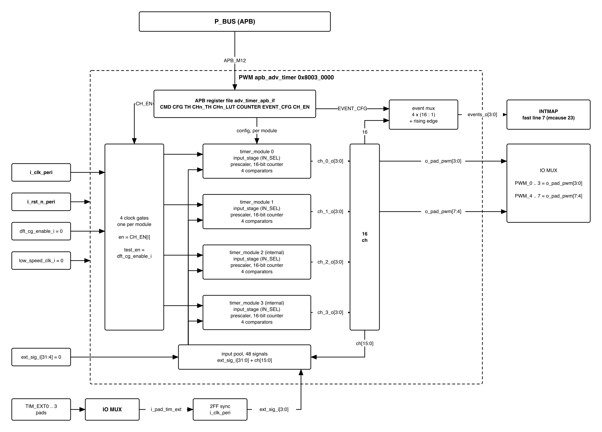
Figure 3-1. PWM block: register file, clock gates, four timer modules, event multiplexer
Clock i_clk_peri (peri cluster, gated by SCRC CLK_EN[15]), reset i_rst_n_peri. The register file and the event multiplexer run on i_clk_peri. Timer module i runs on i_clk_peri gated by CH_EN[i].
The block has one clock domain, i_clk_peri. The four module clocks are gated branches of it, not other frequencies. The IP’s second clock input, low_speed_clk_i, is tied 0: QSOC has one frequency and no slow clock source (contract, clock_domains). A slower count comes from the prescaler (7.1).

4. IP used
Table 4-1. Upstream IP used
From | Module | Commit | Licence
pulp-platform/apb_adv_timer | apb_adv_timer, adv_timer_apb_if, timer_module, timer_cntrl, input_stage, prescaler, up_down_counter, comparator | c8faec1e | SolderPad 0.51
lut_4x4.sv and out_filter.sv are in the vendor directory and are not instantiated. pulp_clock_gating is supplied in design/pwm/rtl. It instantiates qnsc_clk_gate, the one clock gate of QSOC (design/common/tech/, Naming Rule 2.8), so the technology selected with TECH supplies the cell here as in every other block.

5. Interface
Names follow QNSC_RTL_Design_Naming_Rule V1.1. o_pad_pwm and o_int_pwm are 0 in reset.
Table 5-1. PWM interface
Signal | Dir | Width | Description
i_clk_peri | in | 1 | peri cluster clock, to HCLK
i_rst_n_peri | in | 1 | asynchronous active-low reset, to HRESETn
i_bus_apb_paddr | in | 12 | only [9:2] decoded – 7.6
i_bus_apb_pwdata | in | 32 | write data
i_bus_apb_pwrite, i_bus_apb_psel, i_bus_apb_penable | in | 1 each | APB4 control
o_bus_apb_prdata | out | 32 | read data; 0 at unimplemented offsets
o_bus_apb_pready | out | 1 | constant 1, zero wait states
o_bus_apb_pslverr | out | 1 | constant 0
i_pad_tim_ext | in | 4 | pads TIM_EXT0-3 through IO MUX. Two flip-flops in the wrapper (qnsc_sync, design/common) synchronise it to i_clk_peri, then ext_sig_i[3:0]
o_pad_pwm | out | 8 | [3:0] = ch_0_o[3:0], [7:4] = ch_1_o[3:0], to IO MUX – 7.3
o_int_pwm | out | 4 | events_o[3:0], one-cycle pulses, to INTMAP line 7 – 7.5

6. Register map
M is the module base: 0x000, 0x040, 0x080 or 0x0C0 for modules 0 to 3. n is the channel, 0 to 3. Reserved bits read 0 and ignore writes.
Table 6-1. Register map
Offset | Register | Field | Bits | Access | Reset | Description
M+0x00 | CMD | START | 0 | WO | 0 | load START, END, SAW into the counter and run
 |  | STOP | 1 | WO | 0 | stop; outputs hold their level
 |  | UPDATE | 2 | WO | 0 | load START, END, SAW into the counter
 |  | RST | 3 | WO | 0 | counter to START, prescaler to 0, all four outputs to 0
 |  | ARM | 4 | WO | 0 | arm the input stage for IN_MODE 6 and 7
M+0x04 | CFG | IN_SEL | 7:0 | RW | 0 | count source index – 7.4
 |  | IN_MODE | 10:8 | RW | 0 | count source qualifier – 7.4
 |  | CLK_SEL | 11 | RW | 0 | 1: count only on rising edges of low_speed_clk_i
 |  | SAW | 12 | RW | 1 | 1: up (sawtooth); 0: up-down
 |  | PRESC | 23:16 | RW | 0 | prescaler; divide by PRESC + 1
M+0x08 | TH | START | 15:0 | RW | 0 | counter start value
 |  | END | 31:16 | RW | 0 | counter end value
M+0x0C+4n | CHn_TH | TH | 15:0 | RW | 0 | compare value of channel n
 |  | MODE | 18:16 | RW | 0 | output action of channel n – 7.2
M+0x1C+4n | CHn_LUT | LUT, FLT | 15:0, 17:16 | RW | 0 | stored and read back; no effect on any output
M+0x2C | COUNTER | COUNT | 15:0 | RO | 0 | current counter value
0x100 | EVENT_CFG | SEL0 .. SEL3 | 15:0 | RW | 0 | 4 bits per event line k at [4k+3:4k]: channel index 4 x module + n
 |  | EN | 19:16 | RW | 0 | EN[k] enables event line k
0x104 | CH_EN | CLK_EN | 3:0 | RW | 0 | CLK_EN[i] opens the clock gate of module i
CMD bits are held for the duration of the write and clear on the next cycle without a write. CMD reads 0.

7. Functional behaviour

7.1 Counter and period
The counter advances once per prescaler output event.
- SAW = 1: counts START, START+1, … END, then reloads START. Period = (END - START + 1) x (PRESC + 1) count events.
- SAW = 0: counts START up to END, then down to START, then up. Period = 2 x (END - START) x (PRESC + 1) count events.
With IN_MODE = 0 there is one count event per i_clk_peri cycle. At 20 MHz the sawtooth period ranges from 100 ns (END - START = 1, PRESC = 0) to 838.9 ms (65 536 x 256 cycles).

7.2 Output action
Each channel output is a flip-flop in its comparator. A match is COUNTER equal to CHn_TH.TH on a count event. The “second event” is the counter reaching END when SAW = 1, and the next match when SAW = 0.
Table 7-1. Channel output action, CHn_TH.MODE
MODE | Name | On match | On second event
0 | SET | set | –
1 | TOGRST | toggle | clear
2 | SETRST | set | clear
3 | TOG | toggle | –
4 | RST | clear | –
5 | TOGSET | toggle | set
6 | RSTSET | clear | set
7 | – | hold | hold
MODE 2 with SAW = 1 gives an edge-aligned output; MODE 2 with SAW = 0 gives a centre-aligned output. CMD.RST drives the output to 0 in every MODE.
Unconfigured channels. Out of reset every channel has MODE 0 (SET) and TH 0, so CMD.START drives each channel firmware did not configure to 1 at the first count of 0, and it stays 1. Before CMD.START, set every channel of the module: MODE 4 (RST) keeps an unused output at 0.

7.3 Channel outputs and pads
ch_i_o[n] is channel n of module i. Modules 0 and 1 drive the pads, so the pads carry two independent periods with four channels under each.
Table 7-2. Channel outputs against pad functions
Pad function | Wrapper output | Channel
PWM_0..PWM_3 | o_pad_pwm[3:0] | ch_0_o[3:0], module 0
PWM_4..PWM_7 | o_pad_pwm[7:4] | ch_1_o[3:0], module 1
The IO MUX sees only o_pad_pwm[7:0]. Which package pin carries each function is the pad owner’s table.
ch_2_o and ch_3_o reach only the event multiplexer and the input pool.

7.4 Input stage and external triggers
Each module’s input_stage picks one signal from a 48-signal pool with CFG.IN_SEL and qualifies it with CFG.IN_MODE. Start and stop come only from CMD.
Table 7-3. Input pool index, CFG.IN_SEL
IN_SEL | Signal
0 – 3 | ext_sig_i[3:0] = TIM_EXT0-3
4 – 31 | ext_sig_i[31:4], tied 0
32 + 4 x module + n | ch_<module>_o[n]
48 – 255 | constant 0

Table 7-4. Count source qualifier, CFG.IN_MODE
IN_MODE | A count event occurs
0 | every cycle; the selected signal is ignored
1 | every cycle the signal is 0
2 | every cycle the signal is 1
3 | on each rising edge
4 | on each falling edge
5 | on each rising or falling edge
6 | after CMD.ARM, every cycle from the first rising edge until the counter reaches END
7 | as 6, from the first falling edge
CFG.CLK_SEL = 1 additionally requires a rising edge of low_speed_clk_i, which is tied 0, so a module with CLK_SEL = 1 does not count.
The four TIM_EXT bits are independent signals: each is its own external trigger, and each module selects one of them with IN_SEL. No module reads them as a multi-bit value, so synchronising each bit on its own with qnsc_sync (two flip-flops to i_clk_peri) is correct. A level or pulse on TIM_EXTn must last at least two i_clk_peri cycles (100 ns at 20 MHz) to be seen.

7.5 Event lines
Event line k is EN[k] & new & ~old, where new and old are two successive i_clk_peri samples of channel SELk of {ch_3_o, ch_2_o, ch_1_o, ch_0_o}.
- Each event is a pulse of exactly one i_clk_peri cycle.
- A falling edge of the selected channel produces no event.
- EVENT_CFG resets to 0, so no event occurs until firmware sets a selection and EN[k].
- The edge detector samples only while EN[k] = 1. Enabling a line whose selected channel is 1, when the last sample taken was 0, produces one event; this applies to every enable, not only the first.
- The event does not identify the module or channel; firmware knows which it selected.
The block has no software-readable event status. timer_module.status_o is not connected to the register file. An event that the core does not take is not recorded anywhere.
The four event lines are not one per module: each selects any of the sixteen channels. INTMAP ORs all four onto one core interrupt, fast line 7, so the core sees one PWM interrupt whether one or four lines are enabled. Because nothing records which line fired, firmware that must know the source enables one event line at a time.

7.6 Address decode
The register index is PADDR[9:2], so the decoded window is 1 KiB and repeats every 0x400 across the 16 KiB region. Offsets with no register – M+0x30 to M+0x3C and 0x108 to 0x3FC – read 0 and ignore writes. No access returns an error: PSLVERR is 0 and PREADY is 1.
The IP has no PSTRB and no PPROT, and the wrapper takes neither from P_BUS. Every write writes all 32 bits of the register: firmware accesses this block with word stores (sw) only. A byte or halfword store writes the other bytes with whatever the bus carries in those lanes.

7.7 Clock gating and safe stop
Two gates are in series: SCRC CLK_EN[15] gates i_clk_peri for the whole block, and CH_EN[i] gates module i.
- CH_EN resets to 0: every module is stopped and unclocked out of reset.
- While CH_EN[i] = 0, module i holds its counter and outputs, and a CMD write to it has no effect.
- A gated module freezes its outputs at their current level.
- Safe stop: with CH_EN[i] = 1, write CMD = STOP | RST (0x0A). All four outputs of module i go to 0; the clock may then be gated.

8. Instances
One, on APB_M12, with APB_ADDR_WIDTH = 12, EXTSIG_NUM = 32 and TIMER_NBITS = 16. The four timer modules are internal to the IP.

9. What is not provided here, and who provides it
Table 9-1. Functions this block does not provide
Function | Where it lives
Event status, flag or acknowledge | Nowhere – 7.5
Period-end interrupt | Nowhere; events are channel rising edges – 7.5
Merging the four events onto one core line | INTMAP, fast line 7
Pad multiplexing of PWM_n and TIM_EXTn with GPIO | IO MUX

10. Tie-offs
Table 10-1. Tie-offs
Port | Tied to | Why
dft_cg_enable_i | 0 | no test-mode source in the pad ring; the four clock gates follow CH_EN only
low_speed_clk_i | 0 | no slow clock source; CFG.CLK_SEL = 1 stops the module counting
ext_sig_i[31:4] | 0 | four TIM_EXT pads exist; IN_SEL 4-31 select 0
ch_2_o, ch_3_o | unconnected at the wrapper boundary | modules 2 and 3 have no pads

11. Requirements on others, and open items
Table 11-1. Requirements on other owners
Item | Owner | What it blocks
i_bus_apb_paddr[11:0] = the low 12 bits of the offset (P_BUS subtracts the base; offset bits 13:12 are not used) | bus owner | register decode
SCRC closes the PWM clock only after firmware’s safe stop – 7.7 | firmware owner | outputs frozen at a non-zero level at a power stage
Pins for PWM_0..7 and TIM_EXT0..3, and their IO MUX default after reset | IO pad / IO MUX owner | pin owner out of reset
Accepted limits:
- No event status; a missed event is not recorded – 7.5.
- Events are rising edges of one selected channel, not period ends – 7.5.
- The 1 KiB register window aliases across 16 KiB without an error – 7.6.
- Pads carry modules 0 and 1 only: two independent periods – 7.3.
- CHn_LUT has no effect – section 6.
- No dead-time insertion, no complementary output pair and no break (fault) input: a half bridge driven from two channels gets no hardware protection against shoot-through.
- Word writes only – 7.6.
Open: gate count, after synthesis.

12. Verification
The IP has no testbench.
- PWM_001 ch_i_o[n] is channel n of module i; o_pad_pwm[3:0] = ch_0_o, o_pad_pwm[7:4] = ch_1_o.
- PWM_002 Every register field resets to the value in section 6; reserved bits and CMD read 0.
- PWM_003 Out of reset, CMD.START has no effect until CH_EN[i] = 1.
- PWM_004 SAW = 1 period is (END - START + 1) x (PRESC + 1); SAW = 0 period is 2 x (END - START) x (PRESC + 1).
- PWM_005 Each CHn_TH.MODE value 0-7 gives the action of the MODE table, in both SAW settings; MODE 2 with SAW = 0 is centre-aligned.
- PWM_006 Changing one CHn_TH changes no other channel and not TH; CHn_LUT writes read back and change no output.
- PWM_007 CMD.STOP holds all four outputs; CMD = STOP | RST drives them to 0.
- PWM_008 An event fires on a rising edge of the selected channel only, is one i_clk_peri cycle wide, and never fires while EN[k] = 0.
- PWM_009 Each IN_MODE 0-7 with ext_sig_i[3:0] and with a channel feedback source; IN_SEL 4-31 and 48-255 never count except in IN_MODE 0 and 1.
- PWM_010 Holes read 0 and ignore writes; offset +0x400 aliases offset 0; PSLVERR = 0.
- PWM_011 Confirm in simulation: when a new TH takes effect (at CMD.START, at CMD.UPDATE while stopped, at the period end after CMD.UPDATE while running), and when new CHn_TH, IN_SEL, IN_MODE and PRESC values take effect while running.
Acceptance criterion: eight pads carry two independent periods with four independently set compare values under each, and each event arrives one i_clk_peri cycle wide on a rising edge of the channel firmware selected.

Appendix A. Acronyms
Table A-1. Acronyms
Acronym | Description
APB | Advanced Peripheral Bus, AMBA APB4
DFT | Design For Test
ICG | Integrated Clock Gating cell
PWM | Pulse Width Modulation

Appendix B. First review
Table B-1. First review
Item | Reviewer | Response
Too long; redundancy causes wrong information | Teacher, 2026-09-23 | Rewritten to the template; reasoning in _DECISIONS
Do the four event lines mean four periods elapsed? | – | No: each is a rising edge of one selected channel – 7.5
Is 16 bits enough? | – | Period range at 20 MHz in 7.1
ch_i_o mapping | RTL | All four channels of module i – 7.3

