SYSDBG
MICRO-ARCHITECTURE SPECIFICATION – V3.2
QUY NHON SEMICONDUCTORS – QNSC

Table of Contents

Table of Tables
Table 4-1. Upstream IP used
Table 5-1. SYSDBG interface
Table 5-2. SYSDBG parameters
Table 6-1. JTAG instructions and data registers
Table 7-1. Effect of DBG_EN
Table 7-2. What each reset does
Table 7-3. AXI manager behaviour
Table 7-4. Crossing signals and constraints
Table 7-5. Debug window layout
Table 9-1. Functions this block does not provide
Table 10-1. Tie-offs
Table 11-1. Requirements on other owners
Table A-1. Acronyms
Table B-1. First review

Table of Figures
Figure 3-1. SYSDBG block diagram
Figure 7-1. Debug boot wiring
Figure 7-2. Read handshake

Revision history
The reasoning behind each change, and every version before V3.0, is in QNSC_SYSDBG_DECISIONS.md.
Version | Date | Author | Reviewer | Description of change
V3.0 | 2026-09-23 | Nghia VT | – | Rewritten after the teacher’s reference design: JTAG data registers, native AXI4 manager, 4-phase handshake. Adds the DBG_EN pin and CPU hold
V3.1 | 2026-09-25 | Nghia VT | – | Port names to QNSC_RTL_Design_Naming_Rule V1.0: o_dbg_req, o_dbg_cpu_hold, AXI named per channel (o_bus_axi_ar_valid, …). No change in behaviour
V3.2 | 2026-09-30 | Nghia VT | – | Section 12: every check carries an ID (<BLOCK>_NNN), for traceability to tests. No change in behaviour

1. Overview
SYSDBG is the QSOC debugger. A JTAG TAP takes commands from the host. An AXI4 manager on AXI_S0 reads and writes memory. A 4-phase handshake links the two. It also drives the Ibex debug_req input.
One external pin, DBG_EN, decides who starts the CPU after power-on:
- DBG_EN = 0, normal boot: SCRC releases the CPU, which runs the ROM bootloader. The debugger can attach later.
- DBG_EN = 1, debug boot: the CPU stays in reset until the host has loaded the debug window and the program into ISRAM over JTAG, and then released it.
SYSDBG does not reset the chip, gate a clock, or hold a debug ROM. It has no memory-mapped registers: everything is reached through JTAG.
Block directory design/sysdbg, module m_qnsc_sysdbg, owner Nghia Van Trong.

2. Features
- JTAG TAP to IEEE 1149.1, 4-bit IR, seven data registers.
- AXI4 manager: one-beat, 32-bit word reads and writes to any address, including while the CPU runs. One transaction at a time.
- 4-phase request/acknowledge handshake between the TCK and AXI clock domains.
- Halt through debug_req, set and cleared by the host.
- Debug boot: DBG_EN pin; CPU held in reset until the host clears CPUHOLD.

3. Block diagram
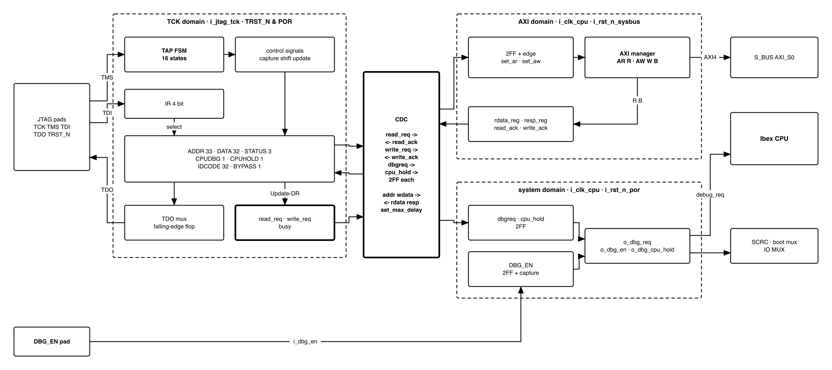
Figure 3-1. SYSDBG block diagram
Three domains, as labelled in the figure: TCK (i_jtag_tck, reset i_jtag_trst_n AND i_rst_n_por), AXI (i_clk_cpu, reset i_rst_n_sysbus) and system (i_clk_cpu, reset i_rst_n_por). i_clk_cpu is the cpu cluster clock, the same clock as S_BUS, and is never gated.

4. IP used
Table 4-1. Upstream IP used
From | Module | Commit | Licence
– | – | – | –
In house. Nothing is instantiated.

5. Interface
Table 5-1. SYSDBG interface
Signal | Dir | Width | Description
i_clk_cpu | in | 1 | System and AXI clock, 20 MHz
i_rst_n_por | in | 1 | Power-on reset only
i_rst_n_sysbus | in | 1 | S_BUS domain reset. Resets the AXI domain
i_jtag_tck | in | 1 | JTAG clock. Asynchronous to i_clk_cpu, may stop at any time
i_jtag_tms, i_jtag_tdi | in | 1 | Sampled on rising TCK
i_jtag_trst_n | in | 1 | JTAG reset
o_jtag_tdo | out | 1 | Changes on falling TCK
o_jtag_tdo_oe | out | 1 | 1 in Shift-IR and Shift-DR only
i_dbg_en | in | 1 | From the DBG_EN pad. Asynchronous, captured once – 7.1
o_dbg_en | out | 1 | Captured DBG_EN. Selects the Ibex boot address and forces the JTAG pins
o_dbg_cpu_hold | out | 1 | 1 holds the CPU in reset. From a flip-flop, reset 1. Into the SCRC CPU reset synchroniser
o_dbg_req | out | 1 | To Ibex debug_req_i. Level, from a flip-flop
o_bus_axi_ar_valid, i_bus_axi_ar_ready | out, in | 1 | AR handshake
o_bus_axi_ar_addr | out | 32 | Read address, [1:0] = 0
i_bus_axi_r_valid, o_bus_axi_r_ready | in, out | 1 | R handshake
i_bus_axi_r_data | in | 32 | Read data
i_bus_axi_r_resp | in | 2 | Read response
o_bus_axi_aw_valid, i_bus_axi_aw_ready | out, in | 1 | AW handshake
o_bus_axi_aw_addr | out | 32 | Write address, [1:0] = 0
o_bus_axi_w_valid, i_bus_axi_w_ready | out, in | 1 | W handshake
o_bus_axi_w_data | out | 32 | Write data
i_bus_axi_b_valid, o_bus_axi_b_ready | in, out | 1 | B handshake
i_bus_axi_b_resp | in | 2 | Write response
Other AXI4 signals | – | – | Constant outputs or unused inputs – section 10

Table 5-2. SYSDBG parameters
Parameter | Default | Meaning
IdcodeValue | 0x0515_3001 | Part 0x5153 (“QS”), manufacturer 0x000, bit 0 = 1
AxiIdWidth | 5 | S_BUS slave-port ID width
SyncStages | 2 | Flip-flops per synchroniser

6. Register map
No memory-mapped registers. The registers below are JTAG data registers, selected by the IR and shifted LSB first.
Table 6-1. JTAG instructions and data registers
IR | Name | Bits | Capture-DR loads | Update-DR does | Reset
0100 | ADDR | 33 | addr_reg | Load addr_reg. If bit 32 = 0 and not busy: start a read | 0
0101 | DATA | 32 | rdata_hold, the last read data | Load wdata_reg. If addr_reg[32] = 1 and not busy: start a write | 0
0110 | STATUS | 3 | {busy, resp[1:0]} | Nothing | 0
0111 | CPUDBG | 1 | dbgreq | Load dbgreq | 0
1000 | CPUHOLD | 1 | cpu_hold | Load cpu_hold | 1
1110 | IDCODE | 32 | IdcodeValue | Nothing | –
1111 | BYPASS | 1 | 0 | Nothing | –
others | as BYPASS | 1 | 0 | Nothing | –
- addr_reg[32] is the direction: 0 read, 1 write. addr_reg[1:0] are ignored.
- resp is the AXI response of the last completed transaction: 00 OKAY, 10 SLVERR, 11 DECERR.
- IR is 4 bits. Capture-IR loads 0001. Test-Logic-Reset loads IDCODE.

7. Functional behaviour

7.1 Debug enable and CPU hold
The system domain synchronises i_dbg_en and captures it once, SyncStages + 1 cycles after i_rst_n_por releases. The captured value is o_dbg_en. It holds until the next power-on reset. The cpu_hold data register reaches the system domain through a synchroniser whose reset value is 1.
captured = 0 from i_rst_n_por, 1 once DBG_EN has been captured
o_dbg_cpu_hold = !captured | (o_dbg_en & cpu_hold_sync) -- registered, reset 1
- Until the capture, o_dbg_cpu_hold = 1.
- DBG_EN = 0: after the capture, o_dbg_cpu_hold = 0 permanently. CPUHOLD has no effect.
- DBG_EN = 1: o_dbg_cpu_hold follows CPUHOLD, which is 1 at reset. The host writes 0 to start the CPU. Writing 1 puts it back in reset, with ISRAM untouched.
o_dbg_cpu_hold holds the CPU only. It is not a reset source and sets no bit in RESET_CAUSE.

7.2 Boot flows
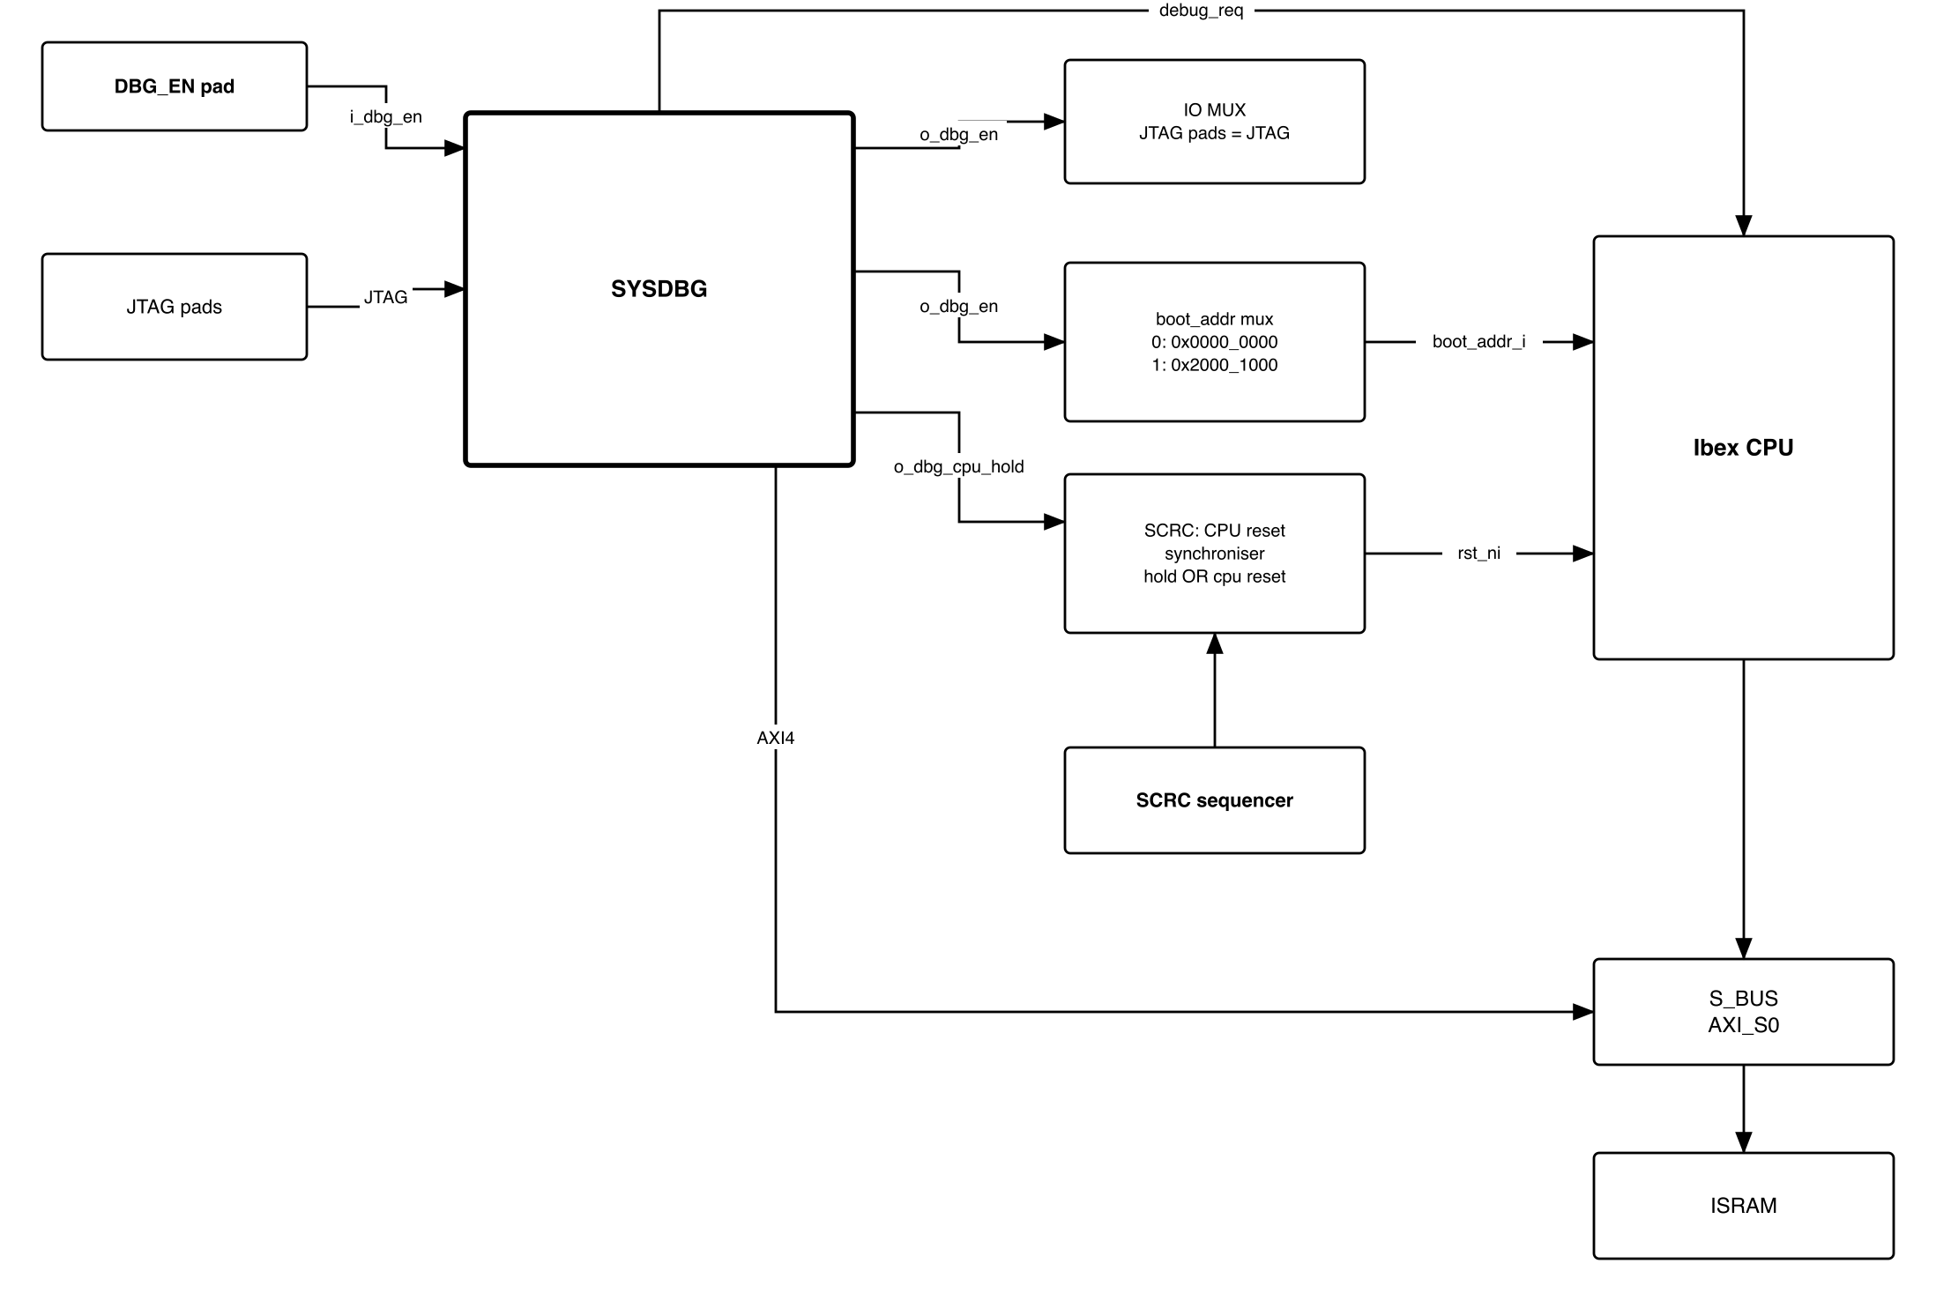
Figure 7-1. Debug boot wiring
Table 7-1. Effect of DBG_EN
 | DBG_EN = 0, normal boot | DBG_EN = 1, debug boot
CPU leaves reset | When SCRC releases it | When SCRC releases it and CPUHOLD = 0
Ibex boot_addr_i | 0x0000_0000, ROM | 0x2000_1000, ISRAM
First instruction | 0x0000_0080, bootloader | 0x2000_1080, loaded image
JTAG pads (TCK, TMS, TDI, TDO, TRST_N) | IO MUX register, default JTAG | Forced to JTAG
Normal boot. To attach, the host writes the debug window (7.8) while the CPU runs, then halts it (7.7).
Debug boot. The host takes these steps, in order:
- Power on. SCRC releases the bus, ROM, RAM and peripherals. The CPU stays in reset.
- Write the debug window, 0x2000_0000–0x2000_0FFF (7.8).
- Write the program image from 0x2000_1000.
- Optional: CPUDBG = 1. The core then halts before its first instruction, with dpc = 0x2000_1080.
- CPUHOLD = 0. The CPU starts.
- Halt, resume, single-step, ebreak in RAM, read and write.
- To run again: CPUHOLD = 1, change the image, CPUHOLD = 0.
To debug the ROM bootloader from its first instruction: debug boot, halt before the first instruction (step 4), write dpc = 0x0000_0080 with a sequence, then single-step (dcsr.step) or resume. No hardware trigger is needed.

7.3 Reset behaviour
Table 7-2. What each reset does
Event | TCK domain | AXI domain | System domain | CPU
Power-on | Reset | Reset | Reset | Reset, then 7.1
Watchdog bite, software reset | – | Reset. A request still held is issued again on release | – | Per SCRC, then 7.1
i_jtag_trst_n | Reset: dbgreq = 0, cpu_hold = 1 | – | – | Held again in debug boot

7.4 Reading and writing memory
Read of address A:
- IR = ADDR, DR = {0, A}. Update-DR starts the read.
- IR = STATUS, scan until busy = 0. Check resp.
- IR = DATA, scan. The captured value is the read data.
Write of D to address A:
- IR = ADDR, DR = {1, A}. Nothing is issued.
- IR = DATA, DR = D. Update-DR starts the write.
- IR = STATUS, scan until busy = 0. Check resp.
Rules:
- While busy = 1, Update-DR of ADDR and DATA is ignored: no register changes and no transaction starts.
- While addr_reg[32] = 1, every Update-DR of DATA starts another write, to the same address.
busy = read_req OR synchronised read_ack OR write_req OR synchronised write_ack, all on the TCK side.

7.5 AXI manager
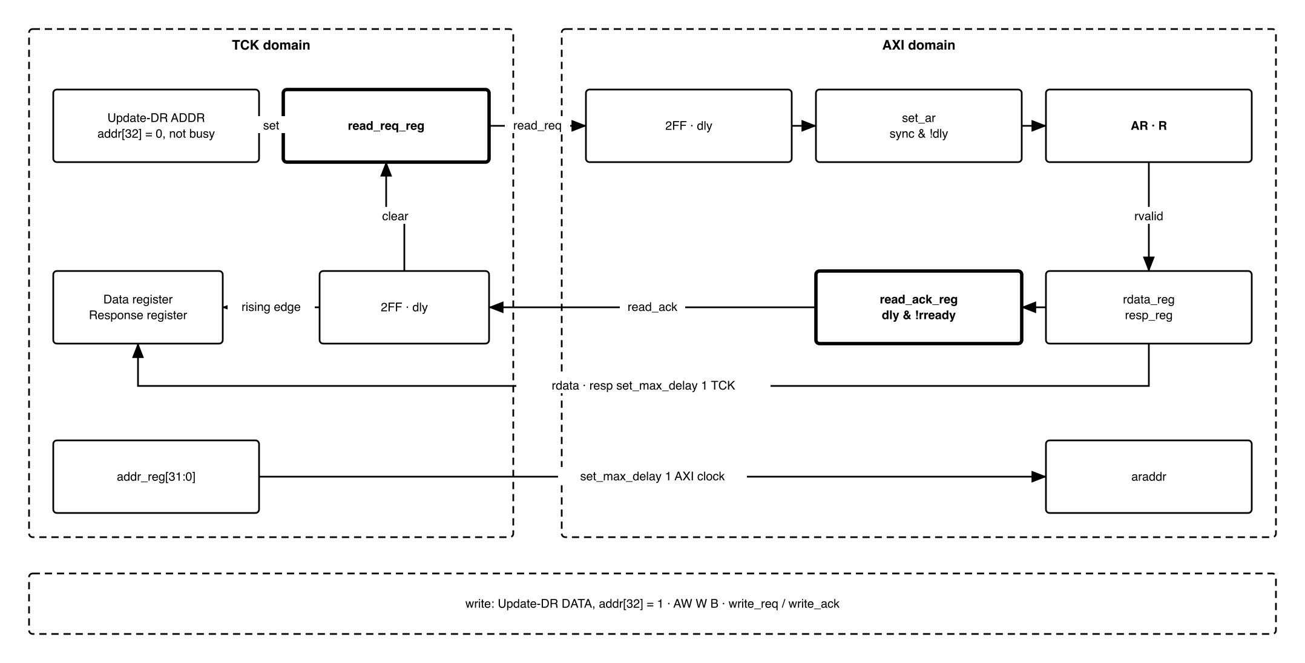
Figure 7-2. Read handshake
set_ar is the rising edge of the synchronised read_req. set_aw is the same for write_req.
Table 7-3. AXI manager behaviour
Event | Read | Write
set_ar / set_aw | arvalid = 1, araddr = addr_reg, rready = 1 | awvalid = 1, awaddr = addr_reg, wvalid = 1, wdata = wdata_reg, bready = 1
Address handshake | arvalid = 0 | awvalid = 0
Data handshake | rdata_reg = rdata, resp_reg = rresp, rready = 0 | wvalid = 0
Response handshake | – | resp_reg = bresp, bready = 0
Acknowledge | read_ack = synchronised read_req after the delay flip-flop, AND NOT rready | write_ack = synchronised write_req after the delay flip-flop, AND NOT bready
At most one transaction is outstanding.

7.6 Clock domain crossing
Each transaction is one 4-phase handshake:
- TCK side sets req.
- AXI side sees req rise and runs the transaction.
- AXI side raises ack and holds it while req = 1.
- TCK side sees ack rise, captures resp_reg into resp (and, for a read, rdata_reg into rdata_hold), then clears req.
- AXI side sees req fall and drops ack.
- TCK side sees ack fall and is no longer busy.
Table 7-4. Crossing signals and constraints
Signal | Direction | How it crosses | Constraint
read_req, write_req | TCK to AXI | SyncStages flip-flops, then one delay flip-flop for the edge | set_max_delay -datapath_only, one i_clk_cpu period, to the first flip-flop
read_ack, write_ack | AXI to TCK | SyncStages flip-flops, then one delay flip-flop for the edge | the same, one TCK period
addr_reg, wdata_reg | TCK to AXI | No synchroniser. Stable from req rising until ack falls | set_max_delay -datapath_only, one i_clk_cpu period
rdata_reg, resp_reg | AXI to TCK | No synchroniser. Stable from ack rising until the next req | set_max_delay -datapath_only, one TCK period
dbgreq, cpu_hold | TCK to system | SyncStages flip-flops | set_max_delay -datapath_only, one i_clk_cpu period, to the first flip-flop

7.7 Halt and resume
- Halt. CPUDBG = 1 drives o_dbg_req high. Ibex saves the PC in dpc and jumps to DmHaltAddr = 0x2000_0800. The window code sets HALTED = 1; the host reads it to confirm the halt.
- Halt before starting. CPUDBG = 1 while the CPU is held, or across a watchdog reset, makes the core halt before its first instruction.
- Resume. The host writes CPUDBG = 0 first, then RESUME = 1 in the debug window. The loop executes dret. If debug_req were still high, the core would halt again at the next instruction.

7.8 Debug window
The first 4 KiB of ISRAM. The host writes all of it through SYSDBG: - in debug boot, while the CPU is held (7.2 step 2); - in normal boot, at any time before the first halt.
Firmware places nothing here.
Table 7-5. Debug window layout
Address | Content
0x2000_0000–0x2000_07FF | Command sequences and flags (RESUME, HALTED), written and read by the host
0x2000_0800 | DmHaltAddr: entry on every halt
0x2000_0810 | DmExceptionAddr: entry on an exception in Debug Mode
0x2000_0820–0x2000_0FFF | Dispatch loop
The exact layout and code are host software, in _DECISIONS, “Debug window code”.

8. Instances
One, in design/top, with the default parameters.

9. What is not provided here, and who provides it
Table 9-1. Functions this block does not provide
Function | Where it lives
Reset of the chip or of any domain | Nowhere. o_dbg_cpu_hold holds the CPU only
CPU clock control | Not needed. The cpu cluster is never gated
Byte and halfword access, bursts | Nowhere. Word only; the host does read-modify-write
Debug ROM, program buffer | Nowhere. The debug window in ISRAM, 7.8
dret, stepping, ebreak | Ibex, driven by code in the debug window. No hardware triggers (DbgTriggerEn = 0)

10. Tie-offs
Table 10-1. Tie-offs
Port | Tied to | Why
o_bus_axi_ar_len, o_bus_axi_aw_len | 0 | One beat
o_bus_axi_ar_size, o_bus_axi_aw_size | 3'b010 | 4 bytes, word only
o_bus_axi_ar_burst, o_bus_axi_aw_burst | 2'b01, INCR | Legal for one beat
o_bus_axi_ar_id, o_bus_axi_aw_id | 0 | One transaction outstanding
o_bus_axi_{ar,aw}_lock, _prot, _cache, _qos, _region | 0 | No exclusive access, protection, cache hints or QoS
o_bus_axi_w_strb | 4'b1111 | Word only
o_bus_axi_w_last | 1 | One beat
i_bus_axi_r_id, i_bus_axi_r_last, i_bus_axi_b_id | Unused | One beat, one ID

11. Requirements on others, and open items
Table 11-1. Requirements on other owners
Item | Owner | What it blocks
DBG_EN on a dedicated input pad, pull-down on the board. If no pad is free, it may share a pad whose IO MUX default is an input, since it is sampled only after power-on | Top, pad owner | Debug boot
i_rst_n_por from power-on only, not from the watchdog | SCRC | DBG_EN capture and hold surviving a watchdog bite
CPU reset = SCRC CPU reset OR o_dbg_cpu_hold, through the CPU reset synchroniser | SCRC | Debug boot
boot_addr_i = o_dbg_en ? 0x2000_1000 : 0x0000_0000 | CPU owner | Debug boot running the loaded image
DmHaltAddr = 0x2000_0800, DmExceptionAddr = 0x2000_0810. DmBaseAddr/DmAddrMask act only with PMP, which is off | CPU owner | 7.8
fetch_enable_i tied to IbexMuBiOn. The CPU is held by reset (o_dbg_cpu_hold), not by fetch enable | CPU owner | Debug boot; a second hold would need its own release
AXI_S0 connected to SYSDBG directly, AXI4, ID width AxiIdWidth. No axi_from_mem | Bus owner | Every bus access
Remove the 0xF000_0000 SYSDBG register region from HAS Table 7-1 (already gone from qsoc_contract.yml) | HAS owner | Consistency. There are no memory-mapped registers
The five JTAG pads forced to JTAG while o_dbg_en = 1 | IO MUX owner | Debug boot with firmware that remaps pins
ISRAM array has no reset and no clear-on-reset | RAM owner | Image surviving a watchdog or software reset
Image linked at 0x2000_1000, reset entry 0x2000_1080; bootloader jumps to 0x2000_1080 | Firmware owner | The same image in both boot modes
Accepted limits:
- No timeout: a slave that never answers keeps busy = 1 until an S_BUS reset or power-on.
- In normal boot, firmware can take the JTAG pins. Use debug boot.

12. Verification
- SYSDBG_001 TAP: all 16 states from every state; IDCODE after reset; BYPASS and unused IR codes are 1 bit; IR changes only at Update-IR; Capture-IR loads 0001.
- SYSDBG_002 Each data register of section 6: length, capture value, update effect, reset value.
- SYSDBG_003 Read and write sequences of 7.4 against an AXI slave model with random ready/valid delays. Every transaction issued exactly once, with the fixed fields of section 10.
- SYSDBG_004 Update-DR of ADDR or DATA while busy changes nothing.
- SYSDBG_005 SLVERR and DECERR reach STATUS.resp.
- SYSDBG_006 AXI protocol checker on the manager port for every test.
- SYSDBG_007 CDC: TCK from 10x slower to 10x faster than i_clk_cpu, and TCK stopped mid-handshake for 10,000 cycles. CDC lint: only the signals of the crossing table cross.
- SYSDBG_008 i_rst_n_sysbus asserted during a transaction: the transaction is issued again after release, and completes.
- SYSDBG_009 DBG_EN: o_dbg_cpu_hold = 1 until the capture, then 0 for DBG_EN = 0, or CPUHOLD for DBG_EN = 1. Toggling the pad afterwards changes nothing. o_dbg_cpu_hold never glitches (it is a flip-flop output).
- SYSDBG_010 With Ibex, debug boot: load the window and image, CPUDBG = 1, CPUHOLD = 0. HALTED = 1 and dpc = 0x2000_1080. CPUDBG = 0, RESUME = 1: HALTED = 0 and the core runs without halting again.
- SYSDBG_011 With Ibex, normal boot: attach while running, halt, resume.
Acceptance: in debug boot, load an image that toggles a GPIO, release the CPU, halt it, read dpc, resume it, and see the GPIO toggle again.

Appendix A. Acronyms
Table A-1. Acronyms
Acronym | Description
CDC | Clock Domain Crossing
DR, IR | JTAG Data and Instruction Register
dpc | Debug PC: where dret returns
dret | Instruction that leaves Debug Mode
POR | Power-On Reset
SCRC | System Clock Reset Control
TAP | Test Access Port, IEEE 1149.1

Appendix B. First review
Table B-1. First review
Item | Reviewer | Response
The block diagram does not show where the FSM and the CDC are | Teacher, 2026-09-23 | Section 3 separates the three domains. 7.6 gives the handshake, its signals and its constraints
Too long, and the repetition causes errors | Teacher, 2026-09-23 | Rewritten as V3.0. The reasoning moved to _DECISIONS
Who loads the 4 KiB debug program, and when? | Teacher, 2026-09-23 | The host, over JTAG. In debug boot, while the CPU is held; in normal boot, before the first halt – 7.2, 7.8
The debugger must control the CPU reset, selected by an external pin | Teacher, 2026-09-23 | DBG_EN and CPUHOLD – 7.1
Reference design VLSI_SYSDBG.drawio | Teacher, 2026-09-23 | Used as the pattern and adapted to QSOC – _DECISIONS D18
CPU clock under debugger control | Teacher, 2026-09-23 | Not needed: the cpu cluster is never gated, and holding reset stops the CPU
IP list names axi_from_mem for the debugger | Owner, 2026-09-25 | An early pick from the V1.x memory-style port. The block is self-designed, as the teacher asks: its own AXI4 manager (7.5) connects to AXI_S0 directly, and no IP is instantiated – _DECISIONS D21

