TIMER
MICRO-ARCHITECTURE SPECIFICATION – V2.6
QUY NHON SEMICONDUCTORS – QNSC

Table of Contents

Table of Tables
Table 1-1. Instance assignment
Table 4-1. Upstream IP used
Table 5-1. TIMER interface
Table 6-1. Register map
Table 7-1. Tick source
Table 7-2. Interrupt equations
Table 7-3. Interrupt shape by mode
Table 7-4. Interrupt period, CMP &gt;= 1
Table 9-1. Functions this block does not provide
Table 10-1. Tie-offs
Table 11-1. Requirements on other owners
Table A-1. Acronyms
Table B-1. First review

Table of Figures
Figure 3-1. TIMER0 and TIMER1 in QSOC
Figure 3-2. Inside one TIMER instance

Revision history
The reasoning behind each change is in QNSC_TIMER_DECISIONS.md.
Version | Date | Author | Reviewer | Description of change
V2.0 | 2026-09-23 | Nghia VT | – | Rewritten as specification only, on the MAS template
V2.1 | 2026-09-24 | Nghia VT | – | One-shot and CFG_REG_HI[31] behaviour corrected from the RTL; wrapper interface, full register map, tie-offs and two figures added
V2.2 | 2026-09-25 | Nghia VT | – | SCRC reset outputs named o_rst_n_timer_0, o_rst_n_timer_1 (was o_rst_timer0_n), per QNSC_RTL_Design_Naming_Rule 1.3 and 1.4
V2.3 | 2026-09-25 | Nghia VT | – | Ports and addresses moved up one slot after GPIO3 was dropped: TIMER0 on APB_M6 at 0x8001_8000, TIMER1 on APB_M7 at 0x8001_C000
V2.4 | 2026-09-28 | Nghia VT | – | SCRC bits from QNSC_SCRC_MAS V3.0: CLK_EN[3], CLK_EN[4]; the error response is the SCRC APB guard; two requirements on SCRC closed
V2.5 | 2026-09-28 | Nghia VT | – | Wrapper m_qnsc_wrap_timer (Naming Rule V1.1 rule 2.1; was m_qnsc_wrap_apb_timer_unit). No change in behaviour
V2.6 | 2026-09-30 | Nghia VT | – | Section 12: every check carries an ID (<BLOCK>_NNN), for traceability to tests. No change in behaviour

1. Overview
TIMER0 and TIMER1 are two instances of apb_timer_unit from pulp-platform/timer_unit, each an APB slave with two 32-bit counters that can be chained into one 64-bit counter. Each counter compares on equality and can raise one interrupt. The block has no pad connection and no interrupt status register.
Block directory design/timer, wrapper module m_qnsc_wrap_timer, owner Nghia Van Trong.
Table 1-1. Instance assignment
Instance | Base | APB port | Mode | Clock gate out of reset | Interrupt
TIMER0 | 0x8001_8000 | APB_M6 | 64-bit: firmware writes MODE_64 = 1 | open | irq_lo_o to irq_fast_i[10] (mcause 26); irq_hi_o not connected
TIMER1 | 0x8001_C000 | APB_M7 | two 32-bit: MODE_64 stays 0 | closed | irq_lo_o and irq_hi_o to irq_fast_i[6] (mcause 22)

2. Features
- Two 32-bit counters per instance, chainable into one 64-bit counter – 7.2.
- 8-bit prescaler ahead of each counter – 7.1.
- Periodic, free-running or one-shot operation, selected per counter – 7.3.
- Equality compare, one interrupt output per counter – 7.3, 7.4.
- Zero-wait-state APB slave that never returns an error – 7.6.

3. Block diagram
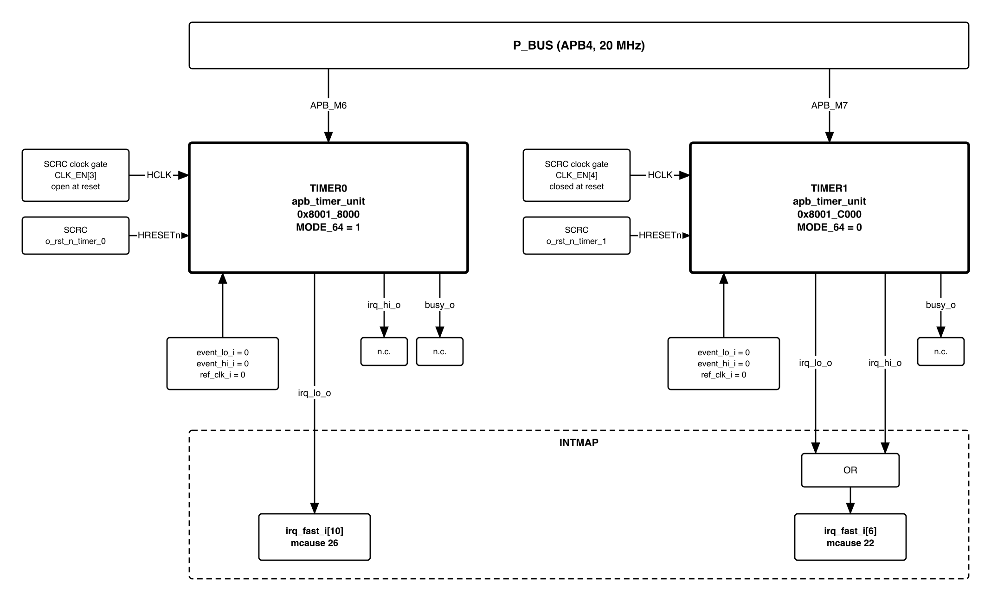
Figure 3-1. TIMER0 and TIMER1 in QSOC
Both instances are in the peri clock cluster. Each has its own clock gate, CLK_EN[3] or CLK_EN[4] in SCRC, and its own reset, o_rst_n_timer_0 or o_rst_n_timer_1 from SCRC.
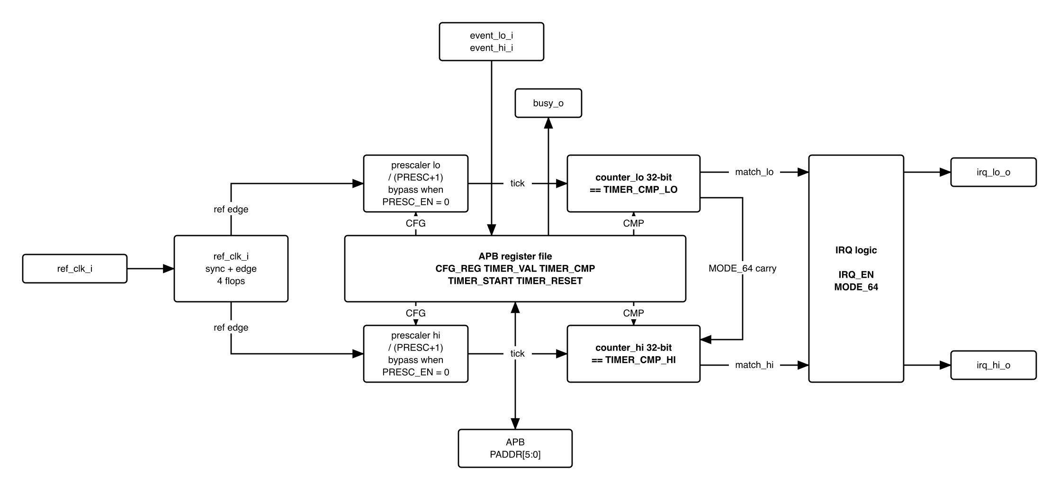
Figure 3-2. Inside one TIMER instance

4. IP used
Table 4-1. Upstream IP used
From | Module | Commit | Licence
pulp-platform/timer_unit | apb_timer_unit, timer_unit_counter, timer_unit_counter_presc | 4c69615c | SolderPad 0.51

5. Interface
Names follow QNSC_RTL_Design_Naming_Rule V1.1. The IP port each wrapper port drives is named in the description.
Table 5-1. TIMER interface
Signal | Dir | Width | Description
i_clk_peri | in | 1 | gated peri clock, to HCLK
i_rst_n_peri | in | 1 | asynchronous active-low reset from o_rst_n_timer_0 / o_rst_n_timer_1, to HRESETn
i_bus_apb_paddr | in | 12 | to PADDR; only [5:0] decoded – 7.6
i_bus_apb_pwdata | in | 32 | to PWDATA
i_bus_apb_pwrite, i_bus_apb_psel, i_bus_apb_penable | in | 1 each | to PWRITE, PSEL, PENABLE
i_bus_apb_pstrb | in | 4 | not connected; every write stores all 32 bits
i_bus_apb_pprot | in | 3 | not connected
o_bus_apb_prdata | out | 32 | from PRDATA; 0 at unimplemented offsets
o_bus_apb_pready | out | 1 | from PREADY = PSEL & PENABLE, zero wait states
o_bus_apb_pslverr | out | 1 | from PSLVERR, constant 0
o_int_timer | out | 2 | [0] = irq_lo_o, [1] = irq_hi_o, to INTMAP – 7.3

6. Register map
All registers reset to 0. lo and hi registers are identical except MODE_64.
Table 6-1. Register map
Offset | Register | Field | Bits | Access | Reset | Description
0x00 | CFG_REG_LO | ENABLE | 0 | RW | 0 | 1 = counter lo runs
 |  | RESET | 1 | RW | 0 | 1 = clear counter and prescaler lo; returns to 0 the next cycle
 |  | IRQ_EN | 2 | RW | 0 | 1 = compare drives irq_lo_o
 |  | IEM | 3 | RW | 0 | 1 = event_lo_i sets ENABLE; no effect in QSOC – section 10
 |  | CMP_CLR | 4 | RW | 0 | 1 = clear the counter at the compare
 |  | ONE_SHOT | 5 | RW | 0 | 1 = clear ENABLE at the compare
 |  | PRESC_EN | 6 | RW | 0 | 1 = count prescaler ticks
 |  | REF_CLK_EN | 7 | RW | 0 | 1 = count ref_clk_i rising edges; counter stops in QSOC – section 10
 |  | PRESC | 15:8 | RW | 0 | prescaler divisor, tick every PRESC+1 cycles
 |  | – | 30:16 | RW | 0 | stored and read back, no function
 |  | MODE_64 | 31 | RW | 0 | 1 = chain lo and hi into one 64-bit counter
0x04 | CFG_REG_HI | bits 0-15 | 15:0 | RW | 0 | as CFG_REG_LO, for counter hi
 |  | – | 30:16 | RW | 0 | stored and read back, no function
 |  | – | 31 | RW | 0 | must be 0 – 7.3
0x08 | TIMER_VAL_LO | VAL | 31:0 | RW | 0 | count of lo; a write loads it
0x0C | TIMER_VAL_HI | VAL | 31:0 | RW | 0 | count of hi; a write loads it
0x10 | TIMER_CMP_LO | CMP | 31:0 | RW | 0 | compare value of lo
0x14 | TIMER_CMP_HI | CMP | 31:0 | RW | 0 | compare value of hi
0x18 | TIMER_START_LO | – | 31:0 | WO | 0 | any write sets CFG_REG_LO.ENABLE; reads 0
0x1C | TIMER_START_HI | – | 31:0 | WO | 0 | any write sets CFG_REG_HI.ENABLE; reads 0
0x20 | TIMER_RESET_LO | – | 31:0 | WO | 0 | any write clears counter and prescaler lo; reads 0
0x24 | TIMER_RESET_HI | – | 31:0 | WO | 0 | any write clears counter and prescaler hi; reads 0
0x28-0x3C | – | – | 31:0 | RSVD | 0 | writes ignored, reads 0
In 64-bit mode with CFG_REG_LO.ENABLE = 1, CFG_REG_LO alone controls the count and the interrupt; of CFG_REG_HI only RESET acts. Firmware keeps CFG_REG_HI = 0 in 64-bit mode: with CFG_REG_LO.ENABLE = 0, CFG_REG_HI.ENABLE = 1 runs counter hi alone.

7. Functional behaviour

7.1 Counting rate
The counter advances once per tick.
Table 7-1. Tick source
REF_CLK_EN | PRESC_EN | Tick | 32-bit wrap at 20 MHz
0 | 0 | every HCLK cycle | 214.7 s
0 | 1 | every PRESC+1 HCLK cycles | 214.7 s x (PRESC+1), 15.3 h at most
1 | 0 or 1 | each, or every PRESC+1, rising edge of ref_clk_i | never: ref_clk_i = 0 in QSOC
“The counter advances every cycle” below means REF_CLK_EN = 0 and either PRESC_EN = 0 or PRESC = 0.

7.2 64-bit mode
With CFG_REG_LO.MODE_64 = 1, counter hi advances only on a tick in which TIMER_VAL_LO = 0xFFFF_FFFF, so {TIMER_VAL_HI, TIMER_VAL_LO} is one 64-bit count. The 64-bit value matches when TIMER_VAL_HI = TIMER_CMP_HI and TIMER_VAL_LO = TIMER_CMP_LO, and 7.3 applies to it as to a 32-bit counter. irq_hi_o is 0 in this mode.

7.3 Compare and interrupt
The match flag of each counter is a flop: it is 1 in the cycle after each cycle in which the count equals TIMER_CMP, whether or not ENABLE is set. The interrupt is combinational:
Table 7-2. Interrupt equations
Mode | irq_lo_o | irq_hi_o
32-bit | match_lo & CFG_REG_LO.IRQ_EN | match_hi & CFG_REG_HI.IRQ_EN
64-bit | match_lo & match_hi & CFG_REG_LO.IRQ_EN | 0

Table 7-3. Interrupt shape by mode
CMP_CLR | ONE_SHOT | Counter advances | At the match | Interrupt
1 | 0 | any | clears to 0, keeps running – periodic | 1-cycle pulse
0 | 0 | every cycle | runs on – free-running | 1-cycle pulse
0 | 0 | prescaled or ref_clk_i | runs on – free-running | pulse of one tick
0 | 1 | every cycle | ENABLE cleared, stops at CMP+1 | 1-cycle pulse
0 | 1 | prescaled or ref_clk_i | ENABLE cleared, stops at CMP | level, held until cleared – 7.5
1 | 1 | any | clears to 0 and stops | 1-cycle pulse
Periodic operation gives a pulse. One-shot gives a level held until cleared when the counter is prescaled or counts ref_clk_i, and a 1-cycle pulse when it is not.
Table 7-4. Interrupt period, CMP >= 1
Mode | Period
Periodic, counter advances every cycle | CMP+1 HCLK cycles
Periodic, PRESC_EN = 1 and PRESC >= 1 | CMP x (PRESC+1) HCLK cycles
Free-running | 2^32 ticks, or 2^64 ticks in 64-bit mode
Writing 1 to CFG_REG_HI[31] in 32-bit mode stops counter hi from clearing its own ENABLE at its match in one-shot mode. Firmware keeps that bit 0.

7.4 Equality compare
A match requires the count to equal TIMER_CMP. A compare value that the count has already passed matches only after the counter wraps: 2^32 ticks later, 214.7 s at 20 MHz, or 2^64 ticks in 64-bit mode.

7.5 Clearing the interrupt
A held one-shot level falls on any of: a write to TIMER_RESET_x or CFG_REG_x.RESET = 1; a TIMER_CMP_x or TIMER_VAL_x write that makes count and compare differ; CFG_REG_x.IRQ_EN = 0.
A write to TIMER_START_x alone does not restart a counter held at its match: the one-shot condition clears ENABLE again.
No register records which TIMER1 counter raised irq_fast_i[6]. In one-shot mode a counter that was started and reads ENABLE = 0 has matched; in periodic and free-running mode no register identifies the source.

7.6 APB response and address decode
- PREADY = PSEL & PENABLE: every access completes with zero wait states.
- PSLVERR = 0 for every offset.
- Only PADDR[5:0] is decoded, so the 64-byte map repeats 256 times in the 16 KiB region: base + 0x40 is CFG_REG_LO.
- PSTRB is not connected: a byte or halfword store writes all 32 bits of PWDATA.
- While the clock gate is closed, the counters and compare flags hold their value, so o_int_timer holds its value. While the clock is stopped, the SCRC APB guard answers accesses to the region with an error (QNSC_SCRC_MAS 7.7).

8. Instances
Two instances of one wrapper with identical parameters. They differ only in MODE_64 as written by firmware, the clock gate reset state and the INTMAP line – section 1.

9. What is not provided here, and who provides it
Table 9-1. Functions this block does not provide
Function | Where it lives
Interrupt status or flag | nowhere
Interrupt acknowledge | firmware writes to the block – 7.5
Source of irq_fast_i[6] between TIMER1 lo and hi | nowhere in periodic or free-running mode – 7.5
Error response | SCRC APB guard, while the clock is stopped (QNSC_SCRC_MAS 7.7)
Greater-or-equal compare | nowhere – 7.4
mtime and mtimecmp | nowhere; irq_timer_i is tied 0 at the core
Aggregation onto a CPU interrupt line | INTMAP

10. Tie-offs
Table 10-1. Tie-offs
Port | Tied to | Why
event_lo_i, event_hi_i | 0 | no hardware start source in QSOC; IEM has no effect
ref_clk_i | 0 | no reference clock in QSOC; REF_CLK_EN = 1 stops the counter
busy_o | open | no consumer in QSOC
irq_hi_o of TIMER0 | open at INTMAP | 0 in 64-bit mode – 7.2
i_bus_apb_pstrb, i_bus_apb_pprot | open | the IP has no such inputs

11. Requirements on others, and open items
Table 11-1. Requirements on other owners
Item | Owner | What it blocks
i_bus_apb_paddr[11:0] = the low 12 bits of the offset (P_BUS subtracts the base; offset bits 13:12 are not used) | bus owner | register decode
Accepted limits and firmware rules:
- Compute each compare value from a fresh read of the count, with margin for interrupt latency; a passed value is missed for a full wrap – 7.4.
- Clear a held one-shot level by one of the writes in 7.5 before mret, or the handler is re-entered.
- Keep CFG_REG_HI[31] = 0 – 7.3; use word stores only – 7.6.
- Do not close a timer’s clock gate while its interrupt is asserted: the level holds and the block cannot be written to clear it – 7.6.
- Closing TIMER0’s clock gate stops the timebase without any record.
- Read the 64-bit count as HI, LO, HI; if the two HI values differ, read again.
- Restart a one-shot with TIMER_RESET_x, then TIMER_START_x – 7.5.
Open: gate count, from synthesis.

12. Verification
The IP has no testbench. Each check below is added by QSOC.
- TIMER_001 Register reset values and access types match section 6, including reads of 0 from 0x18-0x3C and read-back of CFG bits 30:16.
- TIMER_002 base + 0x40 accesses CFG_REG_LO; every access in the 16 KiB region completes with zero wait states and PSLVERR = 0; a byte store writes all 32 bits.
- TIMER_003 Tick rate for each row of 7.1, including PRESC = 0 and 255.
- TIMER_004 64-bit mode: TIMER_VAL_HI advances exactly once per lo wrap, with and without the prescaler; irq_hi_o stays 0; one pulse at the programmed 64-bit value.
- TIMER_005 Every row of the interrupt shape table in 7.3, in 32-bit and 64-bit mode. Confirm in simulation the one-shot rows: 1-cycle pulse and stop at CMP+1 when the counter advances every cycle; held level and stop at CMP when prescaled.
- TIMER_006 Periodic period equals the 7.3 formula, with and without the prescaler; confirm in simulation.
- TIMER_007 Each clearing action of 7.5 drops a held level; TIMER_START_x alone does not restart it – confirm in simulation.
- TIMER_008 A compare value written one tick behind the count is missed until the wrap.
- TIMER_009 CFG_REG_HI[31] = 1 in 32-bit mode changes counter hi one-shot behaviour – 7.3.
- TIMER_010 Tie-offs of section 10 present; IEM = 1 and REF_CLK_EN = 1 act as stated there.
- TIMER_011 Integration: TIMER0 irq_lo_o reaches irq_fast_i[10], both TIMER1 outputs reach irq_fast_i[6], and the gate reset values match section 1.
Acceptance: TIMER0 in 64-bit mode raises exactly one interrupt at a programmed 64-bit value, and a value written behind the count is missed.

Appendix A. Acronyms
Table A-1. Acronyms
Acronym | Description
APB | AMBA Advanced Peripheral Bus
mtime, mtimecmp | RISC-V machine timer registers
SCRC | System clock and reset controller

Appendix B. First review
Table B-1. First review
Item | Reviewer | Response
Too long, and the redundancy causes wrong information | Teacher, 2026-09-23 | V2.0 rewrite; V2.1 cuts the remaining reasoning to _DECISIONS

