WDT
MICRO-ARCHITECTURE SPECIFICATION – V1.1
QUY NHON SEMICONDUCTORS – QNSC

Table of Contents

Table of Tables
Table 1-1. Memory map, regions behind APB_M2
Table 3-1. Sub-blocks
Table 4-1. Upstream IP used
Table 5-1. m_qnsc_wrap_wdt interface
Table 6-1. Register map
Table 7-1. Thresholds at 20 MHz
Table 9-1. Functions this block does not provide
Table 10-1. Tie-offs inside m_qnsc_wrap_wdt
Table 11-1. Requirements on other owners
Table A-1. Acronyms
Table B-1. First review

Table of Figures
Figure 3-1. WDT in QSOC
Figure 6-1. Register fields
Figure 7-1. Petted once, then hung: bark, bite and the chip reset

Revision history
The reasoning behind each change, and the research draft this specification is built on, are in QNSC_WDT_DECISIONS.md.
Version | Date | Author | Reviewer | Description of change
V1.0 | 2026-09-28 | Nghia VT (lead), for Vu Bui Minh Hieu | – | Specification written from Quach Huynh Huu Tai’s research draft V0.1: upstream aon_timer unmodified, one 20 MHz clock, bark to the NMI and bite to SCRC, APB bridge on the upstream tlul_adapter_host, tie-offs, missing OpenTitan packages
V1.1 | 2026-09-30 | Nghia VT | – | INTR_STATE access written W1C, the template name (OpenTitan calls it rw1c)

1. Overview
WDT is one instance of lowRISC OpenTitan aon_timer: a 32-bit watchdog with two thresholds and a 64-bit wake-up timer, behind one register block.
The fact that shapes it: the watchdog is the only recovery from a hung chip. Its bark is the non-maskable interrupt; its bite is a chip reset through SCRC. Nothing else in QSOC resets a hung peripheral (QNSC_SCRC_MAS 7.3), so the block is never clock-gated and firmware cannot stop it by gating.
The IP speaks TL-UL; the wrapper adds an APB bridge built on the upstream tlul_adapter_host.
Block directory design/wdt, wrapper m_qnsc_wrap_wdt, owner Vu Bui Minh Hieu.
Table 1-1. Memory map, regions behind APB_M2
Base | Size | Region | Port | Kind | Note
0x80008000 | 16 KiB | wdt | APB_M2 | peripheral
Interrupts: bark to irq_nm_i, mcause 31; wake-up to fast line 8, mcause 24 (QNSC_Interrupt_Map_MAS 7.2, 7.3). SCRC domain wdt, bit 2, always on.

2. Features
- Watchdog: 32-bit counter at 20 MHz, bark and bite thresholds, up to 214.7 s – 7.1.
- Bark: a level on the NMI until firmware pets the counter and clears it – 7.2.
- Bite: a sticky reset request, cleared by the chip reset it causes – 7.3.
- Configuration lock WDOG_REGWEN until the next reset – 6.
- Wake-up timer: 12-bit prescaler, 64-bit counter, one level interrupt – 7.4.
- APB access with 2 wait states; PSLVERR on an unused offset or a partial write – 7.5.

3. Block diagram
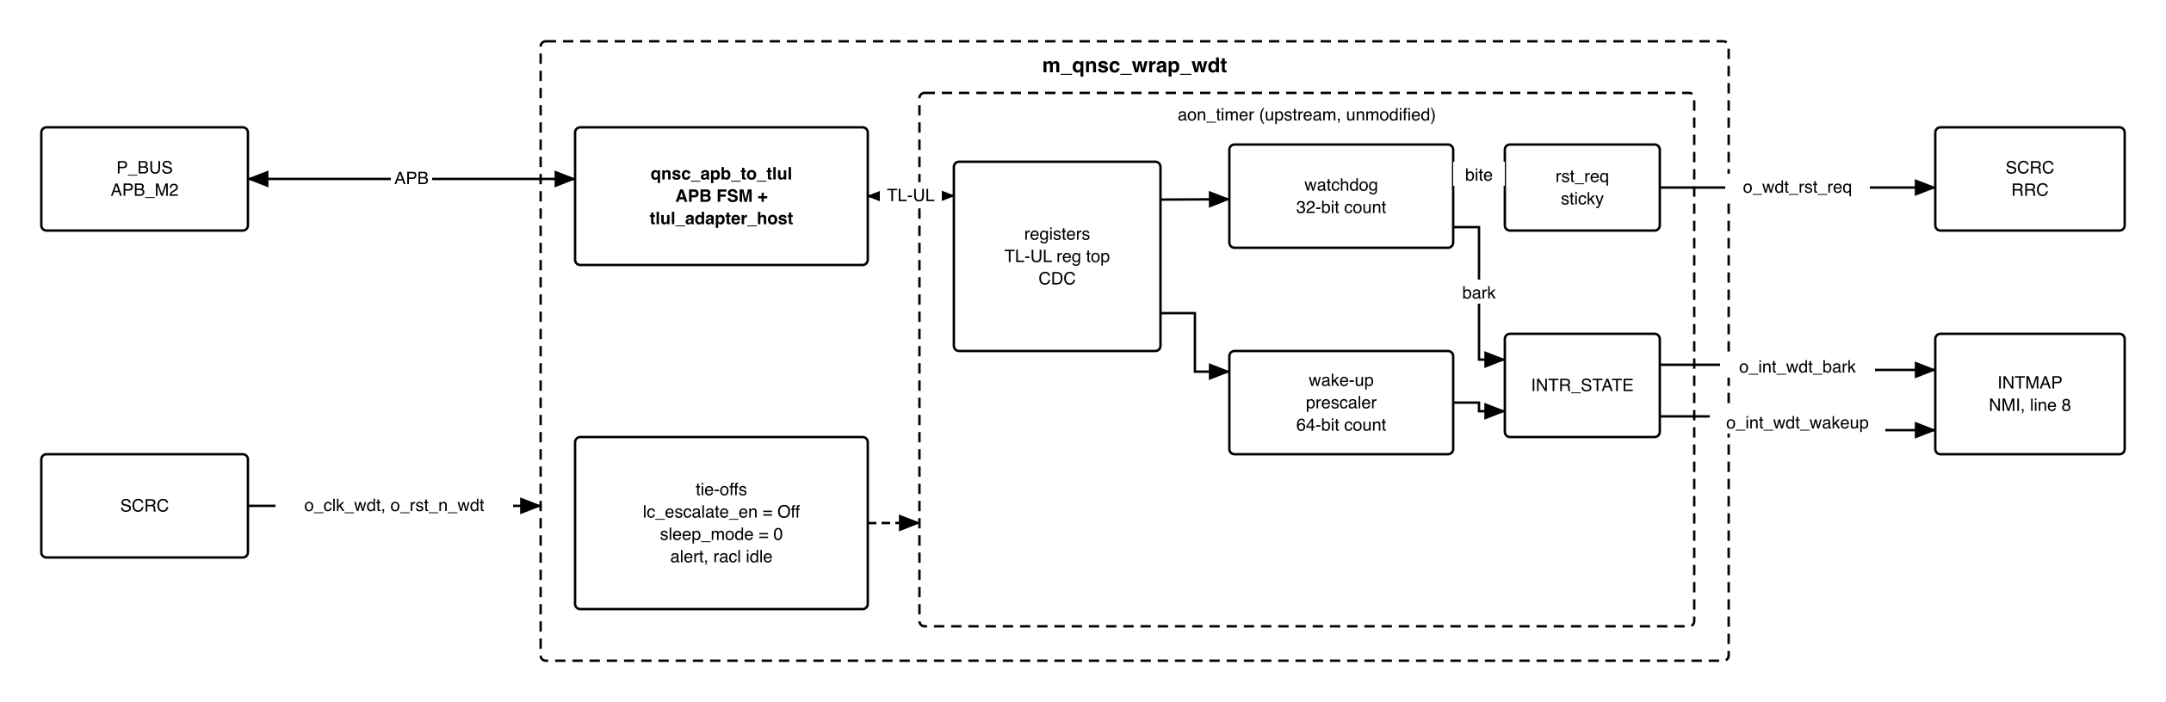
Figure 3-1. WDT in QSOC
Table 3-1. Sub-blocks
Block | Module | Function
APB bridge | qnsc_apb_to_tlul (in house) around tlul_adapter_host (upstream) | One APB transfer to one TL-UL request; integrity bits generated by the adapter – 7.5
Registers | aon_timer_reg_top | TL-UL register block; prim_reg_cdc to the always-on side
Watchdog | aon_timer_core | Counter, bark and bite comparators
Wake-up timer | aon_timer_core | Prescaler, 64-bit counter, comparator
Interrupts | prim_intr_hw | INTR_STATE, both enables fixed to 1
Reset request | flip-flop in aon_timer | Set by the bite, cleared only by rst_aon_ni
Tie-offs | in m_qnsc_wrap_wdt | Section 10
The block is the only member of the wdt clock cluster, never gated. clk_i and clk_aon_i are the same clock, so the IP’s CDC is a fixed few-cycle delay.

4. IP used
Table 4-1. Upstream IP used
From | Module | Commit | Licence
lowRISC/opentitan | aon_timer, aon_timer_core, aon_timer_reg_top, tlul_adapter_host, prim_* | aecc39ba | Apache-2.0
lowRISC/opentitan, not yet vendored | lc_ctrl_pkg, lc_ctrl_state_pkg, lc_ctrl_reg_pkg (hw/ip/lc_ctrl/rtl); top_pkg, top_racl_pkg (hw/top_earlgrey/rtl) | aecc39ba | Apache-2.0
Facts this specification relies on, read at that commit and checked in an RTL simulation of this configuration (Verilator 5):
- The counters run only while lc_escalate_en_i = lc_ctrl_pkg::Off (4'b1010); tied to 0 they never count (aon_timer_core.sv, lc_tx_test_false_strict).
- Bark sets INTR_STATE[1] on every count while WDOG_COUNT >= WDOG_BARK_THOLD; nmi_wdog_timer_bark_o = intr_wdog_timer_bark_o (aon_timer.sv).
- The bite sets aon_timer_rst_req_o while WDOG_COUNT >= WDOG_BITE_THOLD; it stays 1 until rst_aon_ni (aon_timer.sv, “Reset Request”).
- aon_timer_reg_top checks TL-UL command and data integrity on every request; tlul_adapter_host with EnableDataIntgGen = 1 generates both.
- The register block decodes address bits 5:0 (BlockAw = 6).

5. Interface
Table 5-1. m_qnsc_wrap_wdt interface
Signal | Dir | Width | Description
i_clk_wdt, i_rst_n_wdt | in | 1 | SCRC o_clk_wdt, o_rst_n_wdt. Drive clk_i, clk_aon_i, rst_ni, rst_aon_ni
i_bus_apb_psel, i_bus_apb_penable, i_bus_apb_pwrite | in | 1 | P_BUS APB_M2
i_bus_apb_paddr | in | 12 | Offset in the window (contract meta.apb_paddr_width); bits 5:2 used
i_bus_apb_pwdata | in | 32 | Write data
i_bus_apb_pstrb | in | 4 | Byte enables, to the TL-UL mask
i_bus_apb_pprot | in | 3 | Not used
o_bus_apb_prdata, o_bus_apb_pready, o_bus_apb_pslverr | out | 32, 1, 1 | 7.5
o_int_wdt_bark | out | 1 | nmi_wdog_timer_bark_o, level. To INTMAP i_int_wdt_bark
o_int_wdt_wakeup | out | 1 | intr_wkup_timer_expired_o, level. To INTMAP i_int_wdt_wakeup
o_wdt_rst_req | out | 1 | aon_timer_rst_req_o, sticky. To SCRC i_wdt_rst_req

6. Register map
The block decodes offset bits 5:0: the 64-byte map repeats every 64 bytes in the window. Offsets 0x38 and 0x3C answer PSLVERR.
Table 6-1. Register map
Offset | Register | Access | Reset | Description
0x00 | ALERT_TEST | WO | 0 | Bit 0 fires the fatal alert; no effect in QSOC
0x04 | WKUP_CTRL | RW | 0 | Wake-up enable and prescaler, Figure 6-1
0x08, 0x0C | WKUP_THOLD_HI, _LO | RW | 0 | Wake-up threshold, bits 63:32 and 31:0
0x10, 0x14 | WKUP_COUNT_HI, _LO | RW | 0 | Wake-up counter, bits 63:32 and 31:0
0x18 | WDOG_REGWEN | RW0C | 1 | Write 0 to lock WDOG_CTRL, WDOG_BARK_THOLD, WDOG_BITE_THOLD until reset
0x1C | WDOG_CTRL | RW | 0 | Watchdog enable, Figure 6-1
0x20 | WDOG_BARK_THOLD | RW | 0 | Bark threshold, in cycles of 50 ns
0x24 | WDOG_BITE_THOLD | RW | 0 | Bite threshold, in cycles of 50 ns
0x28 | WDOG_COUNT | RW | 0 | Watchdog counter; write 0 to pet
0x2C | INTR_STATE | W1C | 0 | Interrupt state, Figure 6-1
0x30 | INTR_TEST | WO | 0 | Write 1 to set the matching INTR_STATE bit
0x34 | WKUP_CAUSE | RW0C | 0 | Set by a wake-up or bark event; drives wkup_req_o, unused
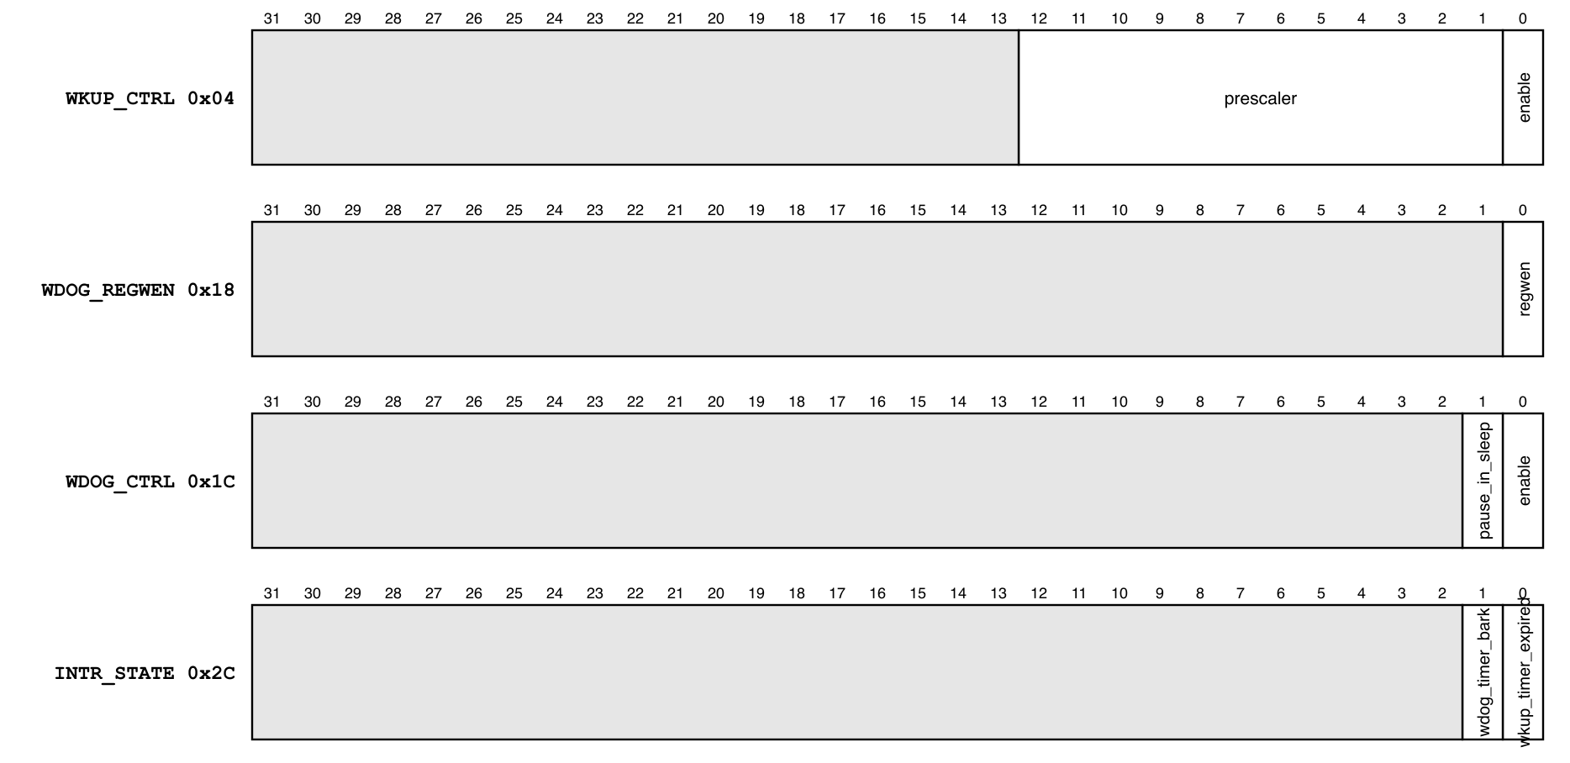
Figure 6-1. Register fields
WDOG_CTRL.pause_in_sleep has no effect: sleep_mode_i is 0 (section 10).

7. Functional behaviour

7.1 Watchdog timing
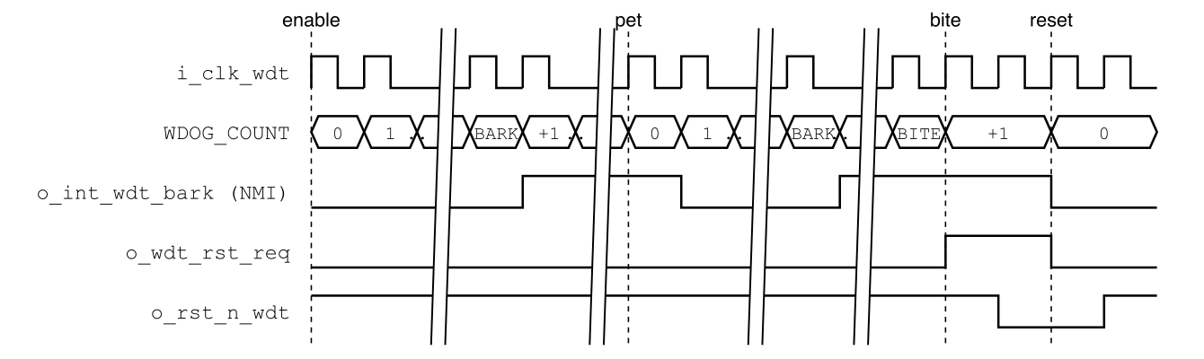
Figure 7-1. Petted once, then hung: bark, bite and the chip reset
- With WDOG_CTRL.enable = 1, WDOG_COUNT increments every cycle of i_clk_wdt (50 ns). Bark comes at WDOG_BARK_THOLD x 50 ns, bite at WDOG_BITE_THOLD x 50 ns, plus a few cycles of CDC (simulated: 7 after the enable write).
- Rule: WDOG_BARK_THOLD < WDOG_BITE_THOLD, so the NMI handler runs before the reset.
- The watchdog is off after every reset; firmware enables it. QNSC_BOOT_SPEC 7.2 relies on it being off during the download.
Table 7-1. Thresholds at 20 MHz
Time | Value
1 ms | 20 000 (0x0000_4E20)
1 s | 20 000 000 (0x0131_2D00)
2 s | 40 000 000 (0x0262_5A00)
Maximum | 2^32 - 1, 214.7 s
Enable sequence: install the NMI entry at mtvec + 0x7C, write WDOG_BARK_THOLD, WDOG_BITE_THOLD, WDOG_COUNT = 0, then WDOG_CTRL = 1. Writing WDOG_REGWEN = 0 afterwards makes the settings permanent until the next reset.

7.2 Bark
- INTR_STATE[1] is set on every count while WDOG_COUNT >= WDOG_BARK_THOLD. o_int_wdt_bark is that bit: a level on irq_nm_i, not maskable.
- The handler pets, then clears: WDOG_COUNT = 0, then INTR_STATE = 0x2. The other order sets the bit again at the next count.

7.3 Bite
- At WDOG_COUNT >= WDOG_BITE_THOLD, o_wdt_rst_req rises and stays 1.
- SCRC makes a 16-cycle chip reset, sets RESET_CAUSE.cause_wdt, and asserts o_rst_n_wdt, which clears the request and every register of this block (QNSC_SCRC_MAS 7.3). The watchdog is then off again.

7.4 Wake-up timer
- With WKUP_CTRL.enable = 1 the counter increments every prescaler + 1 cycles (50 ns to 204.8 us).
- INTR_STATE[0] is set on every increment while {WKUP_COUNT_HI, _LO} >= {WKUP_THOLD_HI, _LO}: before clearing it, the handler moves the threshold or the counter, or disables the timer.
- There is no power manager: the timer is a general-purpose interrupt source.
- Each write of WKUP_CTRL restarts the prescaler.

7.5 APB bridge and access
- qnsc_apb_to_tlul issues one TL-UL request in the ACCESS phase, holds it until the adapter grants it, and ends the transfer when the response arrives: PREADY = response valid, PRDATA = response data, PSLVERR = response error. One request is outstanding at a time (MAX_REQS = 1).
- Every access takes 4 cycles: 2 wait states (simulated).
- PSLVERR answers an offset of 0x38–0x3C, and a write whose PSTRB misses a byte the register uses. Word stores are always accepted; firmware uses them.
- The module is shared with SPI (design/common); its owner is the maintainers.

8. Instances
One m_qnsc_wrap_wdt in design/top.

9. What is not provided here, and who provides it
Table 9-1. Functions this block does not provide
Function | Where it lives
Chip reset, reset cause | QNSC_SCRC_MAS 7.3, QNSC_SYSCSR_MAS 7.2
NMI and line 8 routing | QNSC_Interrupt_Map_MAS 7.2, 7.3
Pausing the watchdog in debug mode | not provided; 11
Power manager, sleep, life-cycle escalation, alert handler | not in QSOC; tied off, section 10

10. Tie-offs
Table 10-1. Tie-offs inside m_qnsc_wrap_wdt
Port | Tied to | Why
lc_escalate_en_i | lc_ctrl_pkg::Off | Any other value stops both counters
sleep_mode_i | 0 | QSOC has no sleep mode
alert_rx_i | prim_alert_pkg::ALERT_RX_DEFAULT | No alert handler
racl_policies_i | 0 | EnableRacl = 0, the default
alert_tx_o, racl_error_o, wkup_req_o, intr_wdog_timer_bark_o | open | No receiver; the bark leaves as the NMI copy
tlul_adapter_host MAX_REQS, EnableDataIntgGen | 1, 1 | One outstanding request; integrity generated
tlul_adapter_host wdata_intg_i, user_rsvd_i, instr_type_i | 0, 0, MuBi4False | Integrity generated inside; data access
tlul_adapter_host rdata_intg_o, intg_err_o | open | APB has no integrity

11. Requirements on others, and open items
Table 11-1. Requirements on other owners
Item | Owner | What it blocks
o_rst_n_wdt asserted by every chip reset | SCRC (QNSC_SCRC_MAS 7.3) | Clearing the bite request
NMI entry at mtvec + 0x7C before the watchdog is enabled | firmware | Bark handling
Vendor the five OpenTitan packages of section 4 (also needed by SPI) | WDT owner | Compiling aon_timer and tlul_adapter_host
Write qnsc_apb_to_tlul in design/common | maintainers, with the WDT and SPI owners | Every access
Open items, WDT owner: wrapper RTL, lint, and the tests of section 12.
Accepted limits:
- The watchdog keeps counting while the CPU is halted by SYSDBG: before a long halt, the debugger writes WDOG_CTRL = 0 through memory access, or the bite resets the chip.
- WDOG_REGWEN = 0 also blocks that write until the next reset.

12. Verification
- WDT_001 Reset values of section 6; the watchdog does not count after reset.
- WDT_002 Bark at WDOG_BARK_THOLD: o_int_wdt_bark = 1; petting, then clearing INTR_STATE[1], drops it.
- WDT_003 Bite at WDOG_BITE_THOLD: o_wdt_rst_req = 1 and stays 1 until i_rst_n_wdt = 0.
- WDT_004 WDOG_REGWEN = 0 blocks writes to WDOG_CTRL and both thresholds until reset.
- WDT_005 Wake-up interrupt after (THOLD + 1) x (prescaler + 1) cycles.
- WDT_006 APB: 2 wait states; PSLVERR at 0x38, 0x3C and for a byte write to WDOG_BARK_THOLD; alias at offset + 0x40.
- WDT_007 Integration with SCRC: a bite gives one chip reset with RESET_CAUSE.cause_wdt = 1.

Appendix A. Acronyms
Table A-1. Acronyms
Acronym | Description
AON | Always on, OpenTitan’s name for the slow timer domain
CDC | Clock-domain crossing
NMI | Non-maskable interrupt
TL-UL | TileLink Uncached Lightweight
WDT | Watchdog timer

Appendix B. First review
Table B-1. First review
Item | Reviewer | Response
Clock of about 200 kHz, timeout up to 6 hours | lead, V1.0 | One 20 MHz clock; up to 214.7 s, 7.1
Interrupts to a PLIC, reset to rstmgr, wake-up to pwrmgr | lead, V1.0 | INTMAP NMI and line 8; SCRC; wake-up request unused
Hand-written TL-UL mapping and integrity | lead, V1.0 | Upstream tlul_adapter_host generates both, 7.5
lc_escalate_en_i driven by the life-cycle controller | lead, V1.0 | Tied to Off; 0 would stop the counters
OpenTitan packages missing from vendor/ | lead, V1.0 | Section 4, 11
Watchdog counts during a debug halt | lead, V1.0 | Accepted limit, 11
Owner | lead, V1.0 | Vu Bui Minh Hieu, after Quach Huynh Huu Tai

