QUY NHON SEMICONDUCTORS – QNSC

<IP NAME>
MICRO-ARCHITECTURE SPECIFICATION

V1.0

Contents
Contents 2
Reversion and History 3
Table of Tables 4
Table of Figures 5
1. Overview 6
2. Feature 6
2.1. Feature 1 6
2.2. Feature 2 6
3. Block Diagram 6
Appendix A. Acronyms 7
Appendix B. First Review 8

Reversion and History
Version | Date (mm/dd/yyyy) | Author | Reviewer | Description of Change
V0.1 | 03/17/2026 | A | - | First version
V0.2
V0.3
V0.4

Table of Tables
Table 2-2. Table 6

Table of Figures
Figure 3-1. Diagram 6

Overview
Overview

Feature

Feature 1
This is feature 1

Feature 2
Table 2-1. Table
No. | Instruction | Opcode | Description
1
2
3
4
5

Block Diagram

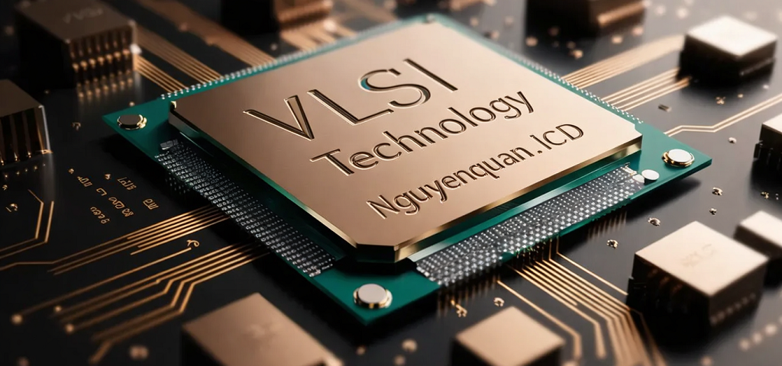
Figure 3-1. Diagram

- Acronyms
Acronyms | Description
CPU | Center Processor Unit

- First Review
Acronyms | Reviewer | Response

