I2C
MICRO-ARCHITECTURE SPECIFICATION – V3.0
QUY NHON SEMICONDUCTORS – QNSC

Table of Contents

Table of Tables
Table 1-1. Memory map, regions behind APB_M11
Table 3-1. Sub-blocks
Table 4-1. Upstream IP used
Table 5-1. m_qnsc_wrap_i2c interface
Table 6-1. Register map
Table 6-2. STATUS and CMD fields
Table 7-1. Command sequences
Table 7-2. Prescaler at 20 MHz (estimate without rise time)
Table 9-1. Functions this block does not provide
Table 11-1. Requirements on other owners
Table A-1. Acronyms
Table B-1. First review

Table of Figures
Figure 3-1. I2C in QSOC
Figure 6-1. Register fields
Figure 7-1. Writing one data byte: two commands

Revision history
The reasoning behind each change, and the research report this specification is built on, are in QNSC_I2C_DECISIONS.md.
Version | Date | Author | Reviewer | Description of change
V3.0 | 2026-09-28 | Nghia VT (lead), for Ong Bao Vinh | – | Specification written from the research report: upstream apb_i2c unmodified (the DMA registers TXCMD/RXCMD dropped), wrapper m_qnsc_wrap_i2c, open-drain as output enables to the IO MUX, 20 MHz prescaler values

1. Overview
I2C is one instance of pulp-platform/apb_i2c, an I2C master built on the OpenCores I2C core: START, repeated START, STOP, ACK and NACK, clock stretching, multi-master clock synchronisation and arbitration-loss detection.
The fact that shapes it: firmware drives the bus one byte per command. It writes a byte and a command, waits for the interrupt flag, and issues the next; the core has no FIFO.
The block is not an I2C slave, and has no DMA request.
Block directory design/i2c, wrapper m_qnsc_wrap_i2c, owner Ong Bao Vinh.
Table 1-1. Memory map, regions behind APB_M11
Base | Size | Region | Port | Kind | Note
0x8002C000 | 16 KiB | i2c | APB_M11 | peripheral
Interrupt: fast line 3, mcause 19. SCRC domain i2c, CLK_EN[8].

2. Features
- Standard mode (100 kHz) and fast mode (400 kHz) from a 16-bit prescaler – 7.2.
- One command per byte: START, STOP, read, write, ACK or NACK – 7.1.
- Clock stretching by the slave; SCL synchronisation with another master – 7.3.
- Arbitration loss and bus-busy status – 7.3.
- One level interrupt, set on every completed command and on arbitration loss – 7.4.
- Zero-wait-state APB, never an error – 6.

3. Block diagram
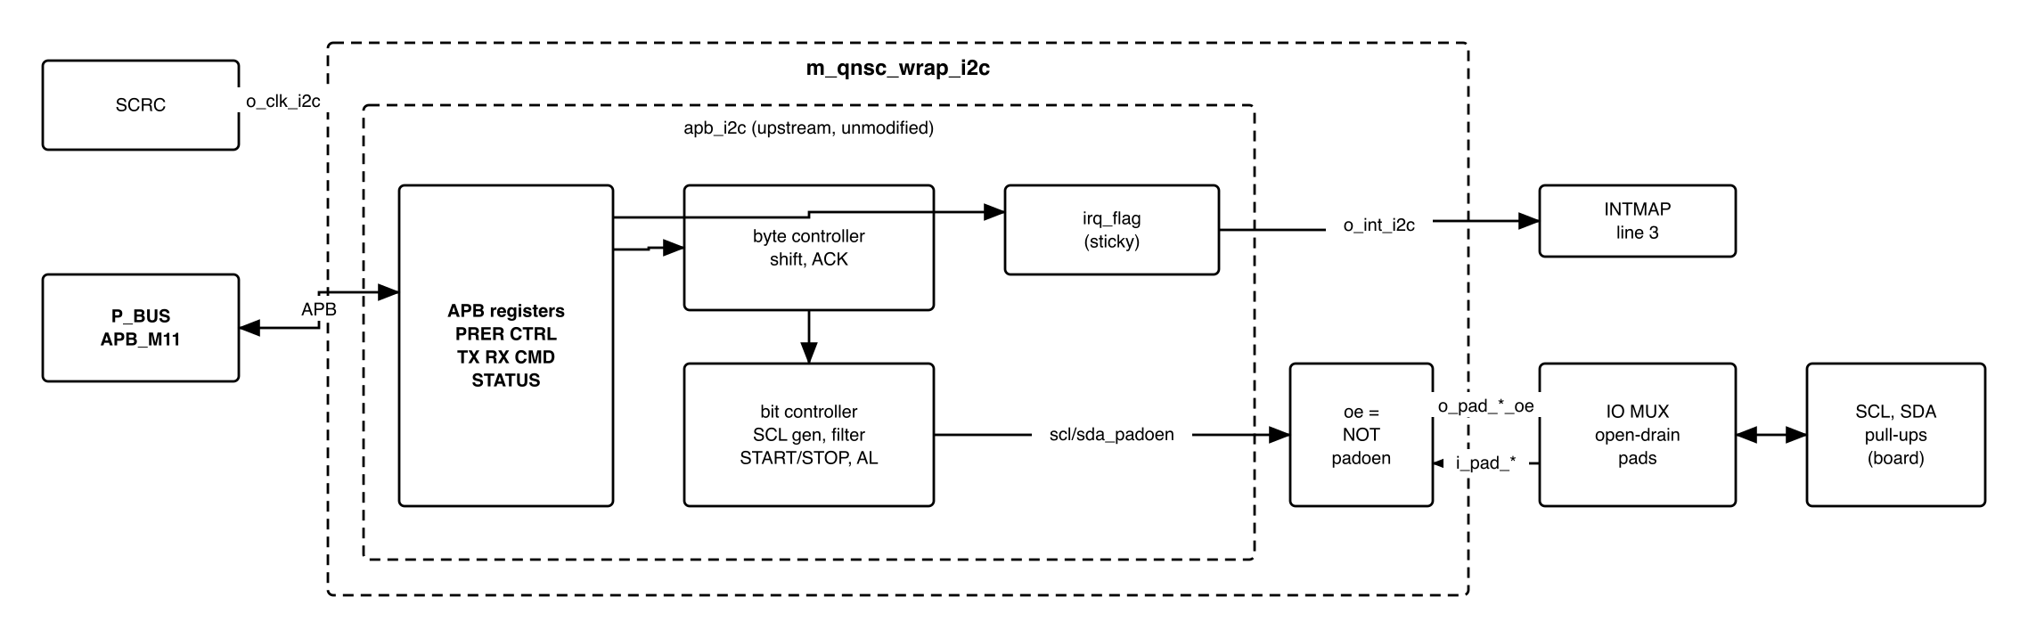
Figure 3-1. I2C in QSOC
Table 3-1. Sub-blocks
Block | Module | Function
Registers | apb_i2c | APB slave, 6 registers, interrupt flag
Byte controller | i2c_master_byte_ctrl | Executes one command: shifts a byte, handles ACK
Bit controller | i2c_master_bit_ctrl | SCL generation, input filter, START/STOP detection, stretching, arbitration
Output enables | in m_qnsc_wrap_i2c | o_pad_i2c_*_oe = NOT *_padoen_o: 1 drives the line low
The block is in the peri clock cluster.

4. IP used
Table 4-1. Upstream IP used
From | Module | Commit | Licence
pulp-platform/apb_i2c | apb_i2c, i2c_master_byte_ctrl, i2c_master_bit_ctrl | 84855413 | OpenCores notice in the controller files; no LICENSE file upstream
Facts this specification relies on, read in the vendored source:
- PADDR[5:2] is decoded; PREADY = 1 and PSLVERR = 0 always (apb_i2c.sv).
- scl_pad_o and sda_pad_o are constant 0 (i2c_master_bit_ctrl.sv): a line is either driven low or released.
- The interrupt flag is sticky: set by a completed command or arbitration loss, cleared by CMD.IACK; interrupt_o = flag AND CTRL.IEN, from a flip-flop.
- CMD is written only while CTRL.EN = 1.

5. Interface
Table 5-1. m_qnsc_wrap_i2c interface
Signal | Dir | Width | Description
i_clk_peri, i_rst_n_peri | in | 1 | SCRC o_clk_i2c, o_rst_n_i2c
i_bus_apb_psel, i_bus_apb_penable, i_bus_apb_pwrite | in | 1 | P_BUS APB_M11
i_bus_apb_paddr | in | 12 | Offset in the window (contract meta.apb_paddr_width)
i_bus_apb_pwdata | in | 32 | Write data
i_bus_apb_pstrb, i_bus_apb_pprot | in | 4, 3 | Not used
o_bus_apb_prdata, o_bus_apb_pready, o_bus_apb_pslverr | out | 32, 1, 1 | pready = 1, pslverr = 0
o_int_i2c | out | 1 | interrupt_o, level – 7.4. To INTMAP i_int_i2c
i_pad_i2c_scl, i_pad_i2c_sda | in | 1 | Line level, from the pad
o_pad_i2c_scl_oe, o_pad_i2c_sda_oe | out | 1 | 1 = drive the line low; 0 = release. The pad drives 0 when enabled

6. Register map
The core decodes offset bits 5:2: offsets 0x18–0x3C read 0 and ignore writes, and the 64-byte map repeats every 64 bytes in the window. No access returns an error.
Table 6-1. Register map
Offset | Register | Access | Reset | Description
0x00 | PRER | RW | 0 | Prescaler, bits 15:0 – 7.2
0x04 | CTRL | RW | 0 | Bit 7 EN core enable, bit 6 IEN interrupt enable
0x08 | RX | RO | 0 | Last byte received
0x0C | STATUS | RO | 0 | Figure 6-1
0x10 | TX | RW | 0 | Byte to send: data, or address and R/W bit
0x14 | CMD | RW | 0 | Command, Figure 6-1. Writable only while EN = 1
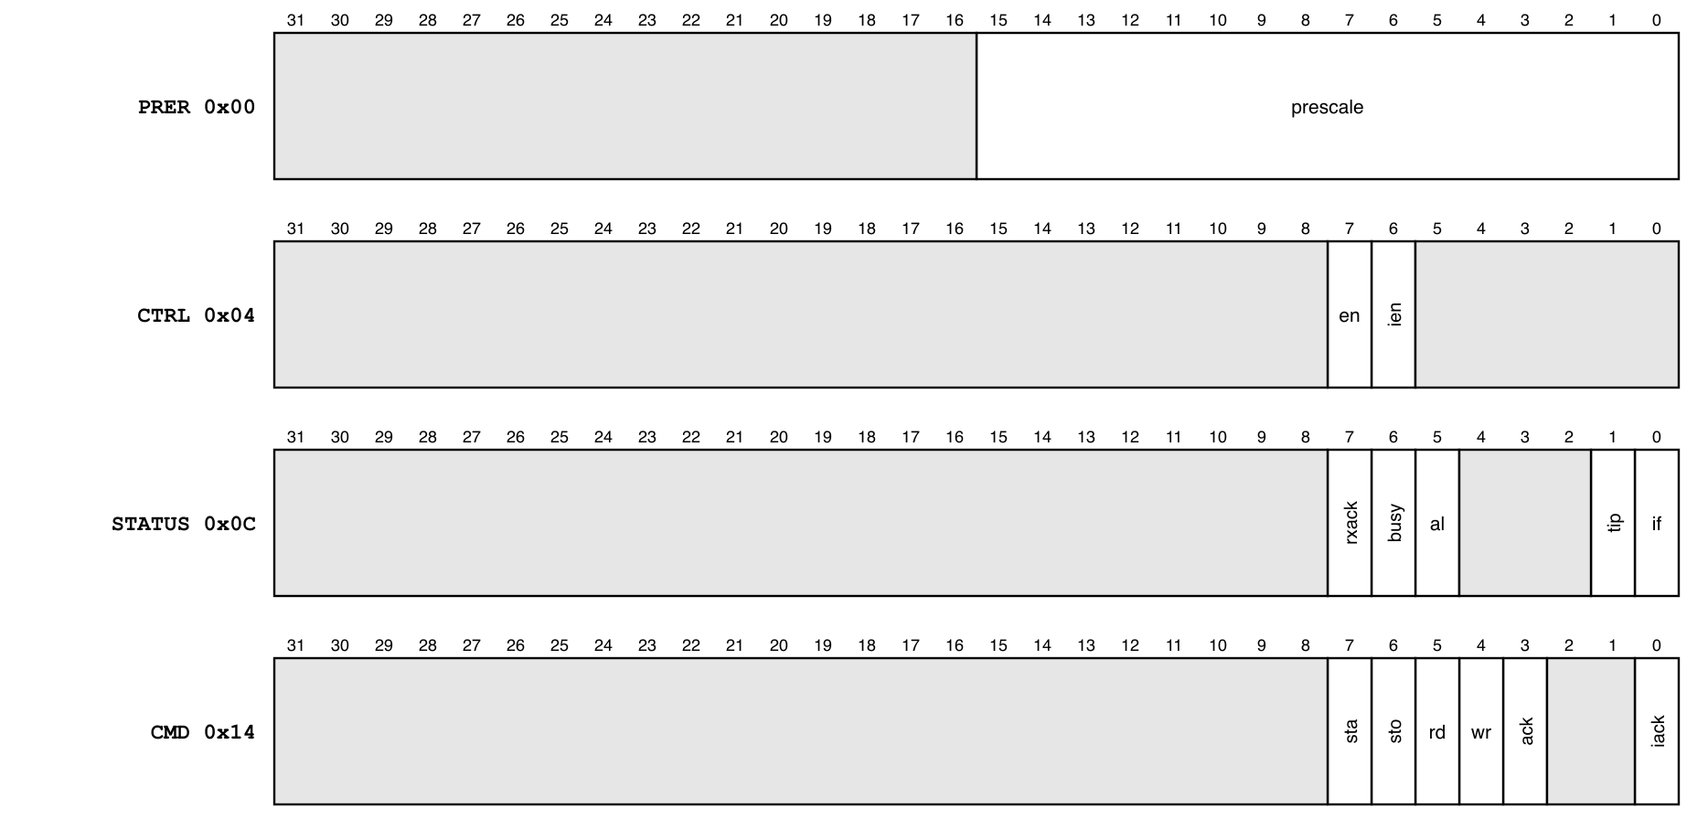
Figure 6-1. Register fields
Table 6-2. STATUS and CMD fields
Register | Bit | Name | Meaning
STATUS | 7 | RXACK | 1 = the slave did not acknowledge (NACK)
STATUS | 6 | BUSY | A START has been seen on the bus and no STOP yet, from any master
STATUS | 5 | AL | Arbitration lost; held until the next START
STATUS | 1 | TIP | A transfer is in progress
STATUS | 0 | IF | Interrupt flag
CMD | 7 / 6 | STA / STO | Generate START (or repeated START) / STOP
CMD | 5 / 4 | RD / WR | Read / write one byte
CMD | 3 | ACK | When reading: 0 = send ACK, 1 = send NACK
CMD | 0 | IACK | Write 1 to clear IF
CMD bits 7:4 clear themselves when the command ends or arbitration is lost; IACK clears after one cycle.

7. Functional behaviour

7.1 Commands
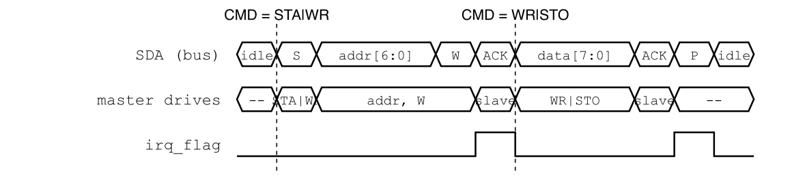
Figure 7-1. Writing one data byte: two commands
Each command moves one byte and ends by setting IF. START and STOP travel with the byte command they belong to.
Table 7-1. Command sequences
Transaction | Writes, each followed by waiting for IF and writing CMD = IACK
Write register r of slave a with d | TX = a<<1, CMD = STA|WR – TX = r, CMD = WR – TX = d, CMD = WR|STO
Read register r of slave a | TX = a<<1, CMD = STA|WR – TX = r, CMD = WR – TX = (a<<1)|1, CMD = STA|WR – CMD = RD|ACK|STO, then read RX
After each write command firmware checks STATUS.RXACK = 0; after each command it checks STATUS.AL = 0.

7.2 SCL frequency
- A bit takes 4 phases of (PRER + 1) cycles, plus the input filter delay and the rise time of the line: T_{SCL} ≈ [4 (PRER + 1) + 2 ((PRER >> 2) + 1) + 3] x 50 ns + t_{rise}.
- The OpenCores rule PRER = f / (5 f_{SCL}) - 1 overshoots: at 100 kHz it gives about 109 kHz.
Table 7-2. Prescaler at 20 MHz (estimate without rise time)
Mode | PRER | f_{SCL}, estimated
Standard, 100 kHz | 44 | 96.6 kHz
Fast, 400 kHz | 10 | 377 kHz
The rise time only lowers the frequency; I2C_003 measures it.

7.3 Bus conditions
- Clock stretching: after releasing SCL the core waits until the line is high.
- Multi-master: a falling SCL driven by another master restarts the local phase, so both masters share one SCL.
- Arbitration: releasing SDA for a 1 and reading 0, or an unexpected STOP, sets AL and IF; the core releases both lines and ends the command.
- Busy: BUSY follows START and STOP on the bus, whoever sends them.

7.4 Interrupt
- o_int_i2c = IF AND IEN, a level from a flip-flop. IF is set by the end of every command and by arbitration loss, and is cleared only by CMD.IACK.
- With IEN = 0 firmware polls STATUS.IF.

7.5 Pads
- Each line is open drain: o_pad_i2c_*_oe = 1 pulls it low, 0 releases it; the board pull-up makes it high. i_pad_i2c_* is the line level, so the core sees the wired-AND of every device.
- The inputs pass the core’s own synchroniser and filter.

8. Instances
One m_qnsc_wrap_i2c in design/top.

9. What is not provided here, and who provides it
Table 9-1. Functions this block does not provide
Function | Where it lives
I2C slave mode | not provided
FIFO, DMA request | not provided; one command per byte
Open-drain pad cells, pull-ups | IO MUX and pads; board
10-bit addressing | firmware: two address bytes

10. Tie-offs
None. Every core port reaches a wrapper port; the wrapper inverts the two output enables.

11. Requirements on others, and open items
Table 11-1. Requirements on other owners
Item | Owner | What it blocks
Open-drain pads for SCL and SDA: drive 0 when oe = 1, high impedance otherwise; line level back on the input | IO MUX, pad owner | Every transfer
Pull-up resistors on SCL and SDA | board | Every transfer
Open items, I2C owner: wrapper RTL, lint, and the tests of section 12.
Accepted limits:
- An access to an unused offset returns 0 without PSLVERR; the map aliases every 64 bytes.
- The register layout differs from the original OpenCores map (separate RX/TX and STATUS/CMD); OpenCores drivers need new offsets.

12. Verification
- I2C_001 Reset values; CMD ignores writes while EN = 0.
- I2C_002 Write and read sequences of 7.1 against an I2C slave model, with ACK and NACK.
- I2C_003 SCL frequency for PRER = 44 and 10 with a modelled rise time.
- I2C_004 A slave stretching SCL delays the bit without error.
- I2C_005 Arbitration against a second master: AL and IF set, both lines released.
- I2C_006 o_int_i2c follows IF AND IEN; IACK clears it.
- I2C_007 o_pad_i2c_*_oe is never 1 while the core releases the line (open-drain rule).

Appendix A. Acronyms
Table A-1. Acronyms
Acronym | Description
AL | Arbitration Lost
NACK | Not acknowledged
SCL, SDA | Serial clock, serial data

Appendix B. First review
Table B-1. First review
Item | Reviewer | Response
dma_last_i floating in the wrapper | Vinh (research, F1) | DMA registers dropped with the patch
DMA request ports not brought out | Vinh (research, F2) | Not needed: QNSC_DMA_MAS V3.0 has no hardware request
OpenCores prescaler rule overshoots | Vinh (research, F3) | 7.2
1'bz in the wrapper is not synthesisable | Vinh (research, F5) | Output enables to the IO MUX, 7.5
Alias every 64 B, no PSLVERR | Vinh (research, F7) | Accepted limit
Register map differs from OpenCores | Vinh (research, F9) | Accepted limit
Wrapper name, clock names, address width | lead, V3.0 | m_qnsc_wrap_i2c, i_clk_peri, 12-bit PADDR

