SYSDBG – Debugger
MICRO-ARCHITECTURE SPECIFICATION – V1.14
QUY NHON SEMICONDUCTORS – QNSC

Table of Contents

Table of Figures
Figure 1-1. Figure 1 – Where the debugger sits in QSOC
Figure 3-1. Figure 2 – The SYSDBG block
Figure 4-1. Figure 3 – Internal structure, and the two clock domains
Figure 4-2. Figure 4 – The ACCESS register, bit by bit
Figure 4-3. Figure 5 – Command FSM
Figure 4-4. Figure 6 – Halting the CPU, end to end
Figure 4-5. Figure 7 – What one bus port can and cannot reach
Figure 4-6. Figure 8 – Host software stack

Reversion and History
Version | Date | Author/Owner | Description of Change
V1.0 | 2026-09-16 | Nghia VT | First issue as a standalone document. Supersedes the Debugger half of QNSC_RAM_Debugger_MAS V1.2. Content is unchanged from that issue: SYSDBG is an in-house block converting JTAG to AXI and controlling the CPU’s debug_req, with riscv-dbg used as reference material only.
V1.1 | 2026-09-17 | Nghia VT | Follows the instructor’s ruling of 2026-09-17: the debug program lives inside ISRAM rather than on a dedicated slave port, so no port is added to S_BUS for it and none to this block in either stage. Table 11 gains the debug memory window and the four Dm* values derived from it; Table 12 restated so the two stages differ in software and memory contents, not in ports. All four Dm* values are unchanged from V1.0.
V1.2 | 2026-09-17 | Nghia VT | Follows the agreed memory map: the debug window moves to 0x2000_0000 – 0x2000_0FFF and all four Dm* values follow (Table 11), which also now reserves a 256 B debug data scratch for Stage 2. Stage 2 confirmed in scope; section 4.12 restated, and section 5.2 rewritten around the questions that only arise once it is. Two Stage 2 dependencies resolved by reading the core rather than by request: dscratch0/dscratch1 are unconditional in ibex_cs_registers.sv, and Ibex forces its instruction cache off in Debug Mode. Table of Tables rebuilt – the V1.1 list was misnumbered from Table 11 onward.
V1.3 | 2026-09-18 | Nghia VT | Aligned with QSOC_HAS, which had already answered two of this document’s open questions. Nothing in the design changes; two questions close and one rationale is added. The AXI4-Lite to AXI4 conversion at AXI_S0 is settled and mandatory: the HAS lists it in Table 5-5 among the project’s required protocol conversions, because S_BUS is AXI4 full while this block is an AXI4-Lite master, so a direct connection fails at elaboration. The adapter named is now axi_lite_to_axi from pulp-platform/axi – the library already chosen for S_BUS – in place of the third-party axi_axil_adapter V1.2 suggested. Section 4.1 also now answers why AXI4-Lite was chosen at all, since the adapter makes it a fair question: this block moves one word per JTAG scan and never bursts, so full AXI4 would mean writing and verifying burst length, size and type, IDs with response ordering, WLAST alignment and the 4 KiB boundary rule – all dead logic in the one block that must be trustworthy when nothing else is. The adapter costs nothing: it is pure combinational wiring with no flip-flops, so no latency and no area. Hardware triggers are confirmed: DbgTriggerEn = 1'b1 with DbgHwBreakNum = 1, which the HAS specifies for read-only memory where a software breakpoint cannot be written. That answer is now stronger than V1.2’s reasoning, because the corrected boot flow (QNSC_RAM_MAS V1.3) puts a real serial bootloader in ROM – frame parsing, CRC32, a copy loop – and it is the program most likely to need a breakpoint during bring-up, since nothing else runs until it works. Halt-on-reset remains open; the HAS records it as TBD for the same reset-ordering reason given here.
V1.4 | 2026-09-18 | Nghia VT | Bus master changed from AXI4-Lite to a memory-style req/gnt/rsp_valid port with byte enables, section 4.1, after reading the System Bus Access port of pulp-platform/riscv-dbg and finding that neither it nor OpenTitan’s rv_dm emits AXI, and that axi_from_mem contains the same axi_lite_to_axi this document already cited – so the AXI4-Lite layer is not avoided, only moved out of this block’s state machine. Two defects fixed at the same time. The timeout abandoned a granted request, which on a bus with no cancel would deliver its response to the next command as a silent wrong answer; it now reports and drains, section 4.8, with STATUS.bus_timeout added. And the ACCESS register claimed byte writes while carrying no way to express them; a 2-bit size field is added, 66 to 68 bits, with lane alignment done in hardware and misaligned access rejected before any request is issued
V1.5 | 2026-09-18 | Nghia VT | Cross-checked against QSOC_HAS EN v1.1 and signed off the two items that document marks as pending this author. Halt-on-reset is accepted as mandatory and open question 2 closes, the deciding reason being that the ROM holds a real bootloader rather than a spin loop. The D15 clock gate rule is confirmed and, more importantly, the gap it exposed in this document is filled: section 4.2 had never said anything about clock gating, and gating clk_i while the TAP keeps running on tck_i is a silent way to disable the debugger, so the gate must be open out of reset and not closable by software
V1.6 | 2026-09-18 | Nghia VT | Stage 2 is committed and specified here rather than deferred, so both stages are now complete in this document. Section 4.12 adds the mechanism: a dispatch loop at DmHaltAddr polling a command word, instruction sequences written into the window through the master port that already exists, results published before the command word is cleared, and returns by jump rather than ebreak so that the first sequence needs nothing configured. Verified from Ibex RTL that dscratch0 and dscratch1 exist, which is what lets a sequence read a register without destroying it. Table 11 now fixes one window layout for both stages. Two open questions close: the debug window is enforced by a PMP region, which QSOC_HAS settles, and SYSDBG writes the dispatch loop itself
V1.7 | 2026-09-18 | Nghia VT | The two-stage framing is removed. Both stages were committed, so the staging had become scaffolding that made a single design read as two. Everything is now one feature set: section 4.12 is Reading a CPU register rather than Staged scope, and Table 12 lists capability against “does it need an extra port” – where every row reads no, which is the architectural point the staging used to carry. The technical content is unchanged; 26 places stopped saying Stage 1 or Stage 2
V1.8 | 2026-09-19 | Nghia VT | A defect in the resume path is fixed. Section 4.7 claimed that writing resumereq released the core; it does not. Reading ibex_controller.sv shows debug_mode_d is cleared in exactly one place, the dret branch, so a core in Debug Mode stays there until it executes dret – and since the halted core is running the dispatch loop, nothing in the previous revision ever told that loop to do so. As written, resume could never have happened. A resume flag is added to the window at 0x2000_0F0C, the dispatch loop now polls it as well as the command word, and section 4.12 specifies the order of the two host writes with the reason: setting the flag while debug_req_o is still high makes the core dret and then halt again at the next instruction boundary, which from the host looks like resume being ignored
V1.9 | 2026-09-21 | Nghia VT | ndmreset removed. The Day005 review of 2026-09-18 fixed the chip’s reset sources at three – POR, watchdog, software – and removed debug reset explicitly; SCRC confirms two global sources and three reset causes with no DEBUG. CTRL[2], the ndmreset_o port and the fan-out exclusion are all gone, and section 4.2 now publishes the cost: with the core wedged, recovery falls to the watchdog or to power cycling. CTRL[2] is left reserved rather than reassigned so an older host cannot silently trigger a different function. Also renames the clock and reset owner from SYSCTL to SCRC, since SYSCTL and SYSCSR are now register files inside it.
V1.10 | 2026-09-21 | Nghia VT | ROM range corrected to 0x0000_0000 – 0x0000_07FF, 2 KiB, following the Day005 review of 2026-09-18 and the ROM owner’s own specification. Earlier revisions carried 8 KiB from QSOC_HAS. Only the read-only-memory argument of section 4.11 depends on the range, and it is unchanged: a smaller ROM is still ROM.
V1.11 | 2026-09-21 | Nghia VT | JTAG pads confirmed, and a second silent way to lose the debugger recorded. The team’s IOPAD_Pin_Summary of 2026-09-20 gives all five JTAG signals pads on PIN_8–PIN_12 with b00 as the reset default and carries tdo_oe_o, so the pad row of section 5.1 is closed. But all five share their pads with GPIO0[7:3] through a firmware-writable IO MUX, so one register write disconnects the debug adapter – the same silent failure as gating the debug clock, and now unrecoverable without power cycling because section 4.2 removed the debug reset. New section 4.3.1 states the hazard and asks for one of three rules, the weakest of which costs nothing.
V1.12 | 2026-09-21 | Nghia VT | Four open questions closed now that QSOC is confirmed a training device with no external acceptance criterion. Host-side debug: the custom 68-bit ACCESS register stands and the in-house host software is the deliverable; stock OpenOCD cannot drive this block and that is now recorded as a consequence, together with the GDB stub as optional work and the exact sections that would change if the criterion ever appeared. Production debug lockout closed as not applicable. Peripherals keep running while halted – gating them would cost every other owner a gate – with the watchdog named as the one exception the watchdog owner must resolve. IDCODE: a shape is proposed and riscv-dbg’s own default is explicitly not reused, since this is a self-designed module.
V1.13 | 2026-09-21 | Nghia VT | Two integration rows closed against the bus owner’s specification. The system bus is axi_xbar, fully connected – every slave port reaches every master port through one shared address map – so the bus master on AXI_S0 reaches ROM on AXI_M0, which answers the ROM-readback item the ROM owner’s document raised as unconfirmed. And each slave port has a private decode-error slave returning 32'hBADCAB1E, so an out-of-map access is reported rather than hung – the behaviour STATUS[1] and the bus timeout of section 4.8 already assumed but could not cite.
V1.14 | 2026-09-21 | Nghia VT | The last two items that did not need anyone else are closed by deciding. The linker boundary was never a question: QNSC_RAM_MAS reserves the first 4 KiB of ISRAM, so 0x2000_1000 is a consequence, and it moves to the integration checklist as a firmware obligation. IDCODE is decided as 0x0515_3001 – part number 0x5153 reading hex-ASCII "QS", version as the silicon revision, manufacturer honestly 0x000 since QSOC has no JEDEC ID, and bit 0 set as the standard requires. riscv-dbg’s default is explicitly not borrowed.

Table of Tables
Table | Title
Table 1 | Sourcing decision
Table 2 | SYSDBG sub-blocks
Table 3 | SYSDBG clock and reset domains
Table 4 | SYSDBG port list
Table 5 | SYSDBG parameters
Table 6 | JTAG instruction registers
Table 7 | ACCESS data register fields
Table 8 | SYSDBG register map
Table 9 | Command FSM states
Table 10 | Core debug CSRs and parameters required from the CPU
Table 11 | Debug memory window, and the CPU parameters derived from it
Table 12 | What each part of the block delivers
Table 13 | Host software deliverables
Table 14 | SYSDBG verification plan
Table 15 | Interfaces to agree with the team
Table 16 | Acronyms

Table of Figures
Figure | Title
Figure 1 | Where the debugger sits in QSOC
Figure 2 | The SYSDBG block
Figure 3 | Internal structure, and the two clock domains
Figure 4 | The ACCESS register, bit by bit
Figure 5 | Command FSM
Figure 6 | Halting the CPU, end to end
Figure 7 | What one bus port can and cannot reach
Figure 8 | Host software stack

1. Overview

1.1 Scope
This document specifies SYSDBG, the debugger of QSOC, the MCU built in this training project. In the QSOC block diagram it is a master on AXI_S0.
The RAM is the author’s second block and is specified separately in QNSC_RAM_MAS. The two are described apart because they are different kinds of work, and the difference is the point of this document: the RAM is an integration of an existing IP, while SYSDBG is designed in house.
Table 1 – Sourcing decision
Item | Source | Why
SYSDBG | Designed in house. pulp-platform/riscv-dbg is read as a reference, not instantiated. | The block is specified as a custom design: JTAG to AXI, plus control of the CPU’s debug_req. riscv-dbg shows what a spec-compliant debug module must do and supplies the address constants the CPU needs, but its full feature set – abstract commands, a program buffer, system bus access, a spec-compliant DMI – is far larger than QSOC requires, and building none of it would leave nothing to design.
Host software | Written in house – section 4.13 | A debugger cannot be demonstrated without the program that drives it.
Nothing is reused. The RISC-V Debug Specification 0.13 and the riscv-dbg RTL are reference material: read to learn what a debug module must be able to do, and to take the address constants that the Ibex integration must declare.

1.2 Position in the system
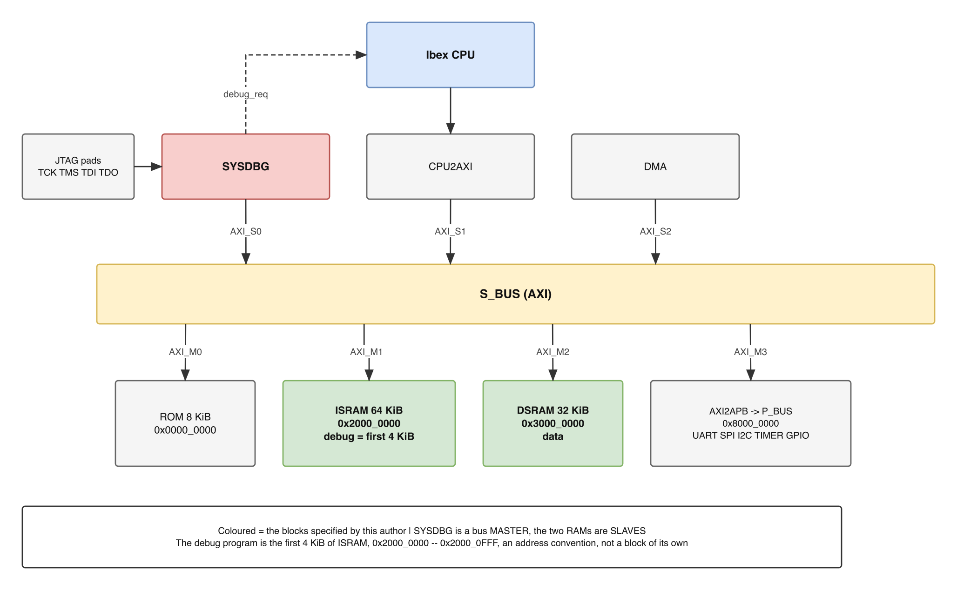
Figure 1-1. Figure 1 – Where the debugger sits in QSOC
Three blocks issue transactions on S_BUS: CPU2AXI on AXI_S1, SYSDBG on AXI_S0, and DMA on AXI_S2. Three memories answer them: ROM on AXI_M0, ISRAM on AXI_M1 and DSRAM on AXI_M2. Peripherals sit behind the AXI2APB bridge on AXI_M3.
Three consequences for this specification:
- SYSDBG is a bus master. It reads and writes memory and peripherals without the CPU being involved – which is how firmware is loaded, and which also makes this block security-relevant (section 5.2).
- It has one bus port, and it is a master. Nothing in this specification gives SYSDBG a slave port. Register access adds content in the debug memory and software on the host, not a new port – section 4.12.
- The CPU is not reachable over the bus at all. Ibex has only master interfaces (instr_* and data_* are all requests going out), so no master can address it. SYSDBG and the CPU are both masters, and two masters cannot talk to each other – they can only share a slave. That is why reading a CPU register means making the CPU write the value into memory itself, and why section 4.11 asks for a memory the CPU can fetch from.
SYSDBG also carries a connection that belongs to no bus at all: a dedicated wire, debug_req, into the CPU, and a status wire, debug_mode, coming back.

2. Feature

2.1 Feature – SYSDBG
SYSDBG is an in-house block. Its purpose, stated minimally: terminate a JTAG connection from the PC, turn the commands arriving on it into bus transactions on AXI_S0, drive the CPU’s debug_req input, and report status back.
Features:
- JTAG Test Access Port to IEEE 1149.1, with IDCODE, BYPASS and one command register.
- A single 68-bit command register, so one JTAG scan is one read or write.
- Run control: halt, resume and non-debug-module reset of the Ibex hart, through debug_req and a status input.
- Memory-style bus master on AXI_S0: read and write any address in the system memory map, including while the CPU is running.
- CPU register access: read a GPR or a CSR by having the halted core execute a short instruction sequence, section 4.12. This needs no additional port.
- Host software on the PC over USB, section 4.13.
Why a memory interface and not AXI, given that S_BUS is full AXI4 and an adapter is therefore mandatory. This block moves one word per JTAG scan and never bursts, section 4.6. Driving full AXI4 would mean generating and verifying burst length, size and type, transaction IDs with response ordering, WLAST alignment with AWLEN, and the rule that a burst may not cross a 4 KiB boundary. AXI4-Lite removes the bursts but still requires three independent channel handshakes for a write – AW, W, then B – and a compliant master may not assume an order between AW and W, so the state machine has to tolerate either. All of that is machinery this block never exploits, in the one block whose whole purpose is to be trusted when nothing else is.
A req/gnt/rsp_valid port with byte enables is the exact shape of the work: one address, one direction, one word, one error bit back, and the same sequence for a read as for a write. The adapter is axi_from_mem from pulp-platform/axi, and the point that settles the choice is what that module is made of – axi_lite_from_mem followed by axi_lite_to_axi. The AXI4-Lite layer still exists either way. The only question was whether this block’s own state machine generates it or a verified library module does, and there is no reason to prefer the hand-written one.
The reference implementations agree. The System Bus Access port of pulp-platform/riscv-dbg, the module this document reads as its reference in Table 1, is exactly this interface: master_req_o, master_add_o, master_we_o, master_wdata_o, master_be_o, master_gnt_i, master_r_valid_i, master_r_err_i, master_r_rdata_i. That project also ships an OBI wrapper, which is another request/response protocol, and no AXI wrapper at all. OpenTitan’s rv_dm uses TL-UL for the same port. Neither reference debug module emits AXI, and the reason is the one above. QSOC_HAS Table 5-5 records the conversion at AXI_S0 as mandatory and describes this block’s master as a handshake interface of the same kind as the CPU’s memory port, section 5.1.
Two things a standard debug module has are deliberately not built: an abstract command engine and a Program Buffer. Both live inside the debug module and require the core to fetch from it, which is what forces a slave port onto the debug block. QSOC puts the same instructions in ISRAM instead – the core fetches from a slave that already exists, and SYSDBG writes them through the master port it already has. The function is the same; the port is not needed, and no Dm* parameter moves because the window does not move.

3. Block Diagram
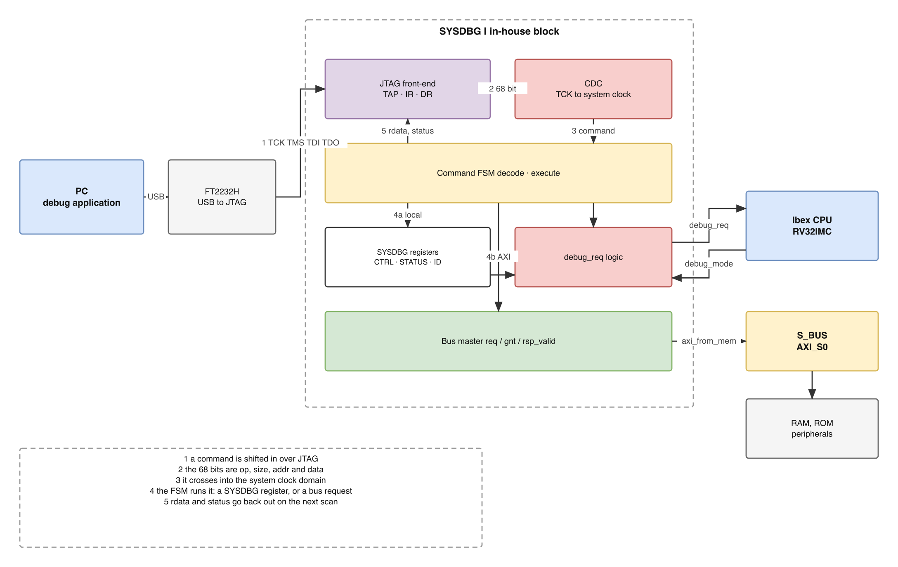
Figure 3-1. Figure 2 – The SYSDBG block

4. Micro-architecture Details

4.1 Structure
SYSDBG splits into two clock domains, described in section 4.2. The boundary between them is the part of the design most likely to be got wrong.
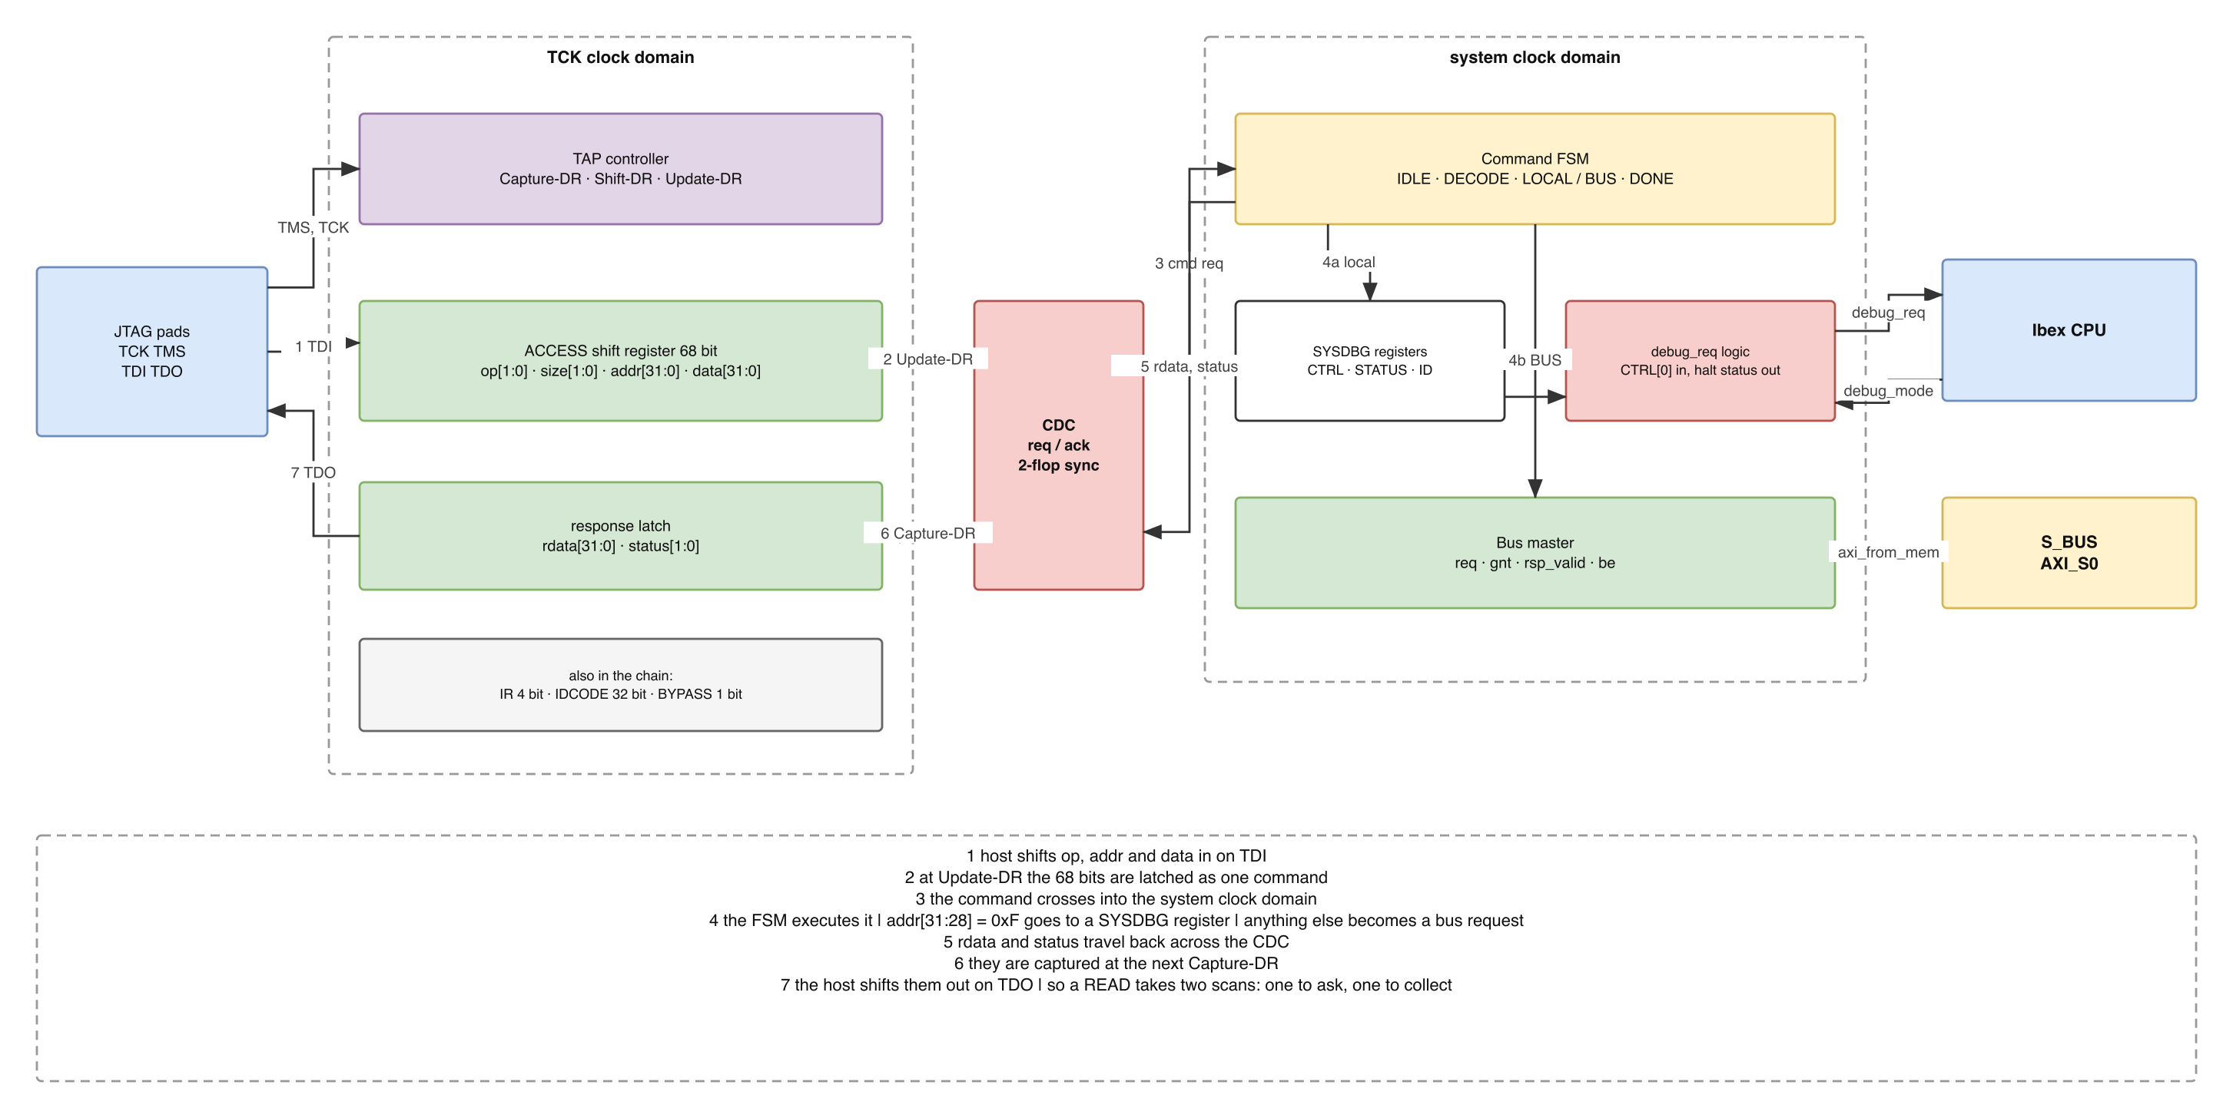
Figure 4-1. Figure 3 – Internal structure, and the two clock domains
Figure 3 is the same design as Table 2, drawn as a loop: a command travels left to right along the top, the answer returns right to left along the bottom. The numbered steps are walked through in section 4.9.
Table 2 – SYSDBG sub-blocks
Domain | Sub-block | Role
TCK | TAP controller | The IEEE 1149.1 state machine, driven by TMS
TCK | IR, 4 bit | Selects which data register is in the scan chain
TCK | IDCODE, 32 bit | Identifies QSOC to the host
TCK | BYPASS, 1 bit | Required by the standard
TCK | ACCESS, 68 bit | The command register, section 4.6
– | CDC | Request/acknowledge handshake, section 4.10
system | Command FSM | Decodes and executes one command, section 4.8
system | Register file | CTRL, STATUS, ID, section 4.7
system | debug_req logic | Drives the CPU input, samples debug_mode
system | Bus master | Issues bus transactions on AXI_S0, through axi_from_mem

4.2 Clock and reset domains
The block spans two clocks and three reset domains, and the third is the one easiest to get wrong.
Table 3 – SYSDBG clock and reset domains
Domain | Clocked by | Reset by
JTAG | tck_i, supplied by the debug adapter, and free to stop | trst_ni, plus the TAP’s own Test-Logic-Reset state
System | clk_i, the chip clock, always running | rst_ni, the chip’s power-on reset
The crossing | both | neither – the handshake of section 4.10 survives either reset asserting alone
Table 2 says which sub-block sits in which domain.
QSOC has no debug reset, and this block therefore cannot restart the chip. The Day005 review of 2026-09-18 fixed the chip’s reset sources at three – power-on reset, watchdog, and software reset – and removed debug reset explicitly, to keep the reset tree simple. The team’s clock and reset block confirms it: its global combine has two inputs, POR and the watchdog request, and its reset-cause register has three causes with no DEBUG among them.
(That block is SCRC, System Clock and Reset Control. Earlier revisions of this document called it SYSCTL after the QSOC block diagram. The current name is SCRC, and it is the control half at APB_M0; SYSCSR is the separate status half at APB_M1 – two APB slaves rather than two register files inside one block.)
What this costs, stated plainly. A non-debug-module reset exists in the RISC-V Debug Specification so that a host can restart a target while keeping its JTAG connection. Without it, the only ways to restart QSOC are power cycling, the watchdog, or a software reset written by the CPU. The last of those requires the CPU to be running: if the core is wedged with interrupts disabled, no software reset can be issued, so recovery falls to the watchdog or to removing power.
What survives. The debugger can still halt the core, resume it, read and write any address while the core runs, and load firmware – see Table 12. Only the restart capability is absent, and nothing in this block depends on it.
tck_i may stop between commands, so no system-side logic may wait on a TCK edge, and no JTAG-side logic may wait on a system edge. Each side must make progress on its own clock alone.
The system-side clock gate must default on and must not be closable by software. QSOC_HAS gives this block its own domain, D15, with clock-enable bit 14, and proposes exactly that rule; this document confirms it, and states the failure it prevents. Because the TAP runs on tck_i, gating clk_i does not stop the JTAG side: the host would still shift commands in successfully, they would be latched at Update-DR, and then nothing would execute. The FSM would be frozen mid-command, busy would read 1 forever, and every scan would return BUSY. The host cannot distinguish that from a slave that is not answering, so software able to close this gate is software able to disable the debugger silently. The gate must therefore be open out of reset – a debugger has to be able to attach before any software has run – and writes that would close it must be ignored. Whether the bit is readable is not important; whether it is writable is.
The project has settled on a single clock frequency for the whole IC, and that decision does not reach this block. It governs the clocks QSOC generates: one divided system clock, no per-domain frequencies, no PLL. tck_i is not generated by QSOC at all – it is an input pin driven by the debug adapter, at whatever rate the host chooses, starting and stopping whenever the host likes. So the two domains in Table 3 are not an exception to the decision; they are outside its scope, and the crossing of section 4.10 is required regardless of how many clocks the chip makes for itself. SYSDBG is the only block in QSOC with a genuinely asynchronous input clock.

4.3 Block interface
Table 4 – SYSDBG port list
Group | Signal | Dir | Width | Notes
Clock, reset | clk_i, rst_ni | in | 1 | System domain
JTAG | tck_i, tms_i, tdi_i | in | 1 | From the pads
 | tdo_o | out | 1 | Driven only in a Shift state
 | tdo_oe_o | out | 1 | Output enable for the pad
 | trst_ni | in | 1 | Optional by the standard; provided
CPU | debug_req_o | out | 1 | Level-sensitive, held until resume
 | debug_mode_i | in | 1 | From ibex_top, section 4.11
Bus master | mem_req_o, mem_addr_o, mem_we_o | out | 1 / 32 / 1 | Request, address, and direction
 | mem_wdata_o, mem_be_o | out | 32 / 4 | Write data and its byte enables
 | mem_gnt_i | in | 1 | Request accepted
 | mem_rsp_valid_i | in | 1 | Response, once per request, read or write
 | mem_rsp_rdata_i, mem_rsp_error_i | in | 32 / 1 | Read data, and the bus error flag
tdo_oe_o exists because the JTAG standard requires TDO to be tri-stated outside the Shift-DR and Shift-IR states, so that several devices can share one chain. QSOC has a single TAP today, but omitting the enable would make adding a second device a change to this block rather than to the pad ring.
The nine signals above replace the eighteen an AXI4-Lite master would need, and the names are those of axi_from_mem with the directions flipped, so the instantiation is a straight connection with no renaming table to get wrong.
Byte enables, and who aligns the data. mem_be_o is derived from the size field of the command and the low address bits, exactly as dm_sba derives its be_mask: a byte access sets one bit chosen by addr[1:0], a halfword sets two chosen by addr[1], a word sets all four. Sub-word access is not a luxury here – QSOC is RV32IMC, so planting a software breakpoint over a compressed instruction is a halfword write. This block also does the lane alignment in hardware: on a write the payload is taken from the low bits of data and shifted into the addressed lane, and on a read the addressed lane is shifted back down into the low bits of rdata. The host therefore always puts the value in the low bits and never has to know the shift, which is stated explicitly because a silent disagreement about it is a bug that looks like corrupted memory.

4.3.1 The JTAG pins are shared with GPIO, and that is a hazard
The team’s IOPAD_Pin_Summary of 2026-09-20 settles the pad question in this block’s favour: all five JTAG signals have pads, and b00 – the JTAG function – is the reset default, so the debugger works before firmware runs.
Pad | Pin | b00 | b01
TCK | PIN_8 | TCK | GPIO0_7
TMS | PIN_9 | TMS | GPIO0_6
TDI | PIN_10 | TDI | GPIO0_5
TDO | PIN_11 | TDO | GPIO0_4
TRSTN | PIN_12 | TRSTN | GPIO0_3
But every one of them is shared with a GPIO function, and the selection is a register firmware can write. A single write that moves PIN_8 to PIN_12 into b01 disconnects the debug adapter.
The failure is silent, and it is the same shape as the clock-gate failure of section 4.2. The host keeps shifting; nothing reports an error; TDO simply stops answering, and a dead adapter is indistinguishable from a dead chip. Section 4.2 required that the debug clock gate cannot be closed by software for exactly this reason. The IO MUX is a second route to the same outcome and needs the same rule.
Recovery is worse than it was. QSOC has no debug reset, section 4.2, so a host that loses the pins cannot reset the chip to get them back. The only ways out are the watchdog – which does not restore the IO MUX unless its reset reaches that register – or power cycling the board.
What this document asks for, in order of preference:
 | Rule
Preferred | The IO MUX ignores writes that would move PIN_8–PIN_12 out of b00
Acceptable | Those five fields are writable only after a lock bit is cleared, and the lock is set at reset
Minimum | The five fields are returned to b00 by any reset that reaches the IO MUX register, so a watchdog bite restores debug access
The minimum is worth stating separately because it costs nothing at design time and it is the difference between a recoverable board and one that needs its power removed.
This is a constraint on the IO MUX, not on this block, and it belongs in the integration checklist of section 5.1 alongside the clock-gate rule.

4.4 Parameters
Table 5 – SYSDBG parameters
Parameter | Default | Meaning
IdcodeValue | to be assigned | The 32-bit IDCODE. Project-level decision, section 5.1
AddrWidth | 32 | System bus address width; must match S_BUS
DataWidth | 32 | System bus data width; the ACCESS register width follows from it
RegBaseAddr | 0xF000_0000 | Base of the SYSDBG register window
RegAddrMatch | addr[31:28] == 4'hF | The decode rule of section 4.8
SyncStages | 2 | Flip-flops in each CDC synchroniser. Raise to 3 only if a timing analysis asks for it
BusTimeout | 1024 | System-clock cycles before an unanswered bus request is reported; it is never abandoned, section 4.8

4.5 JTAG instruction registers
Table 6 – JTAG instruction registers
IR value | Name | DR width | Purpose
0x1 | IDCODE | 32 | Target identification; read first after reset
0x2 | ACCESS | 68 | Read or write a system address, section 4.6
0xf | BYPASS | 1 | Standard-mandated pass-through

4.6 The ACCESS data register
One data register carries a whole command, so one scan is one operation.
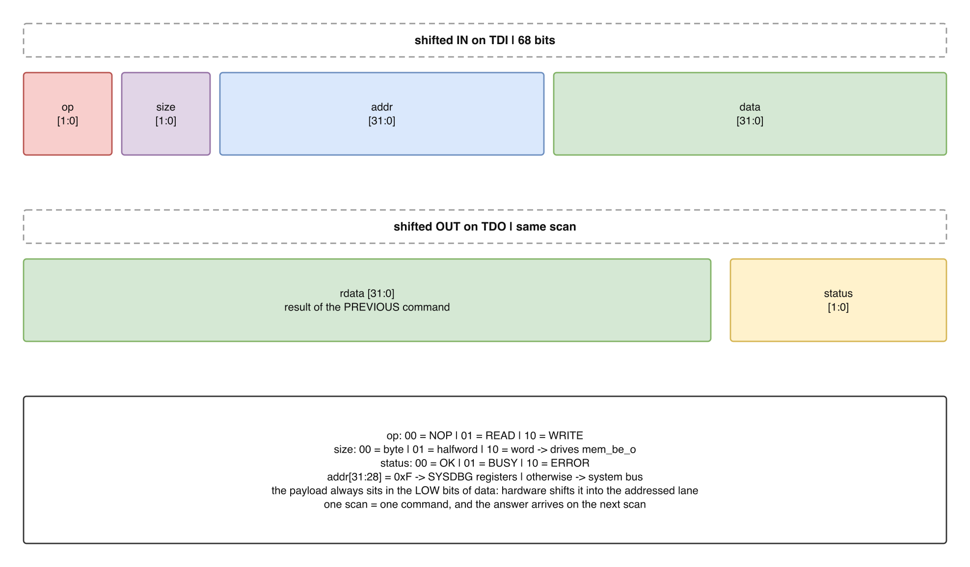
Figure 4-2. Figure 4 – The ACCESS register, bit by bit
Table 7 – ACCESS data register fields
Direction | Field | Width | Meaning
in, on TDI | op | 2 | 00 NOP · 01 READ · 10 WRITE
in | size | 2 | 00 byte · 01 halfword · 10 word · 11 reserved
in | addr | 32 | Target address
in | data | 32 | Write data; ignored for READ
out, on TDO | rdata | 32 | Result of the previous command
out | status | 2 | 00 OK · 01 BUSY · 10 ERROR
The value shifted out is the previous command’s result, not this one’s. That is not a defect to work around: in a scan chain the shift out happens at the same time as the shift in, before the new command has had a chance to run. A host therefore reads a location with two scans – one to issue the READ, one to collect it. The DMI defined by the RISC-V Debug Specification behaves the same way, which is good evidence that the shape is right.
Address decode. addr[31:28] = 0xF selects the SYSDBG register file. Every other address is handed to the bus master unchanged, so the whole system memory map is reachable with no special cases.

4.7 Register map
Table 8 – SYSDBG register map
Address | Name | Access | Bits
0xF000_0000 | CTRL | RW | [0] haltreq · [1] resumereq · [2] reserved, reads 0
0xF000_0004 | STATUS | RO | [0] busy · [1] error · [2] cpu_halted · [3] bus_timeout
0xF000_0008 | ID | RO | Version and build identifier
Three registers is deliberately the whole of it. Halting the CPU is write(0xF000_0000, 1); confirming it halted is read(0xF000_0004) and testing bit 2.
The three CTRL bits do not all behave the same way, and the difference has to be stated because a driver written against the wrong assumption fails in a way that looks like the CPU ignoring the debugger.
Bit | Behaviour | Why
[0] haltreq | Held. Written 1, stays 1, and is cleared only by writing resumereq | debug_req_o is level-sensitive: the core samples a level, not an edge, so the request must persist. A self-clearing haltreq would drop debug_req before the core had acted on it
[1] resumereq | Write 1, self-clearing. Reads back 0 | It is an event, not a state. Its effect is to clear haltreq, and once that has happened there is nothing left for the bit to mean
[2] reserved | Reads 0, writes ignored | QSOC has no debug reset – section 4.2. The bit position is kept unused rather than reassigned, so a host written against an earlier revision cannot silently trigger something else
Writing resumereq lowers debug_req_o; it does not by itself restart the core. Once the core is in Debug Mode it stays there until it executes a dret instruction – ibex_controller.sv clears debug_mode_d in exactly one place, the dret branch, and nowhere else. Since the halted core is executing the dispatch loop, the loop is what has to run dret, so it has to be told. Section 4.12 gives the mechanism and the order the two steps must be taken in.
These registers are reachable only over JTAG. They are deliberately not placed on the system bus: software running on the CPU must not be able to halt itself or grant itself debug access.

4.8 Command FSM
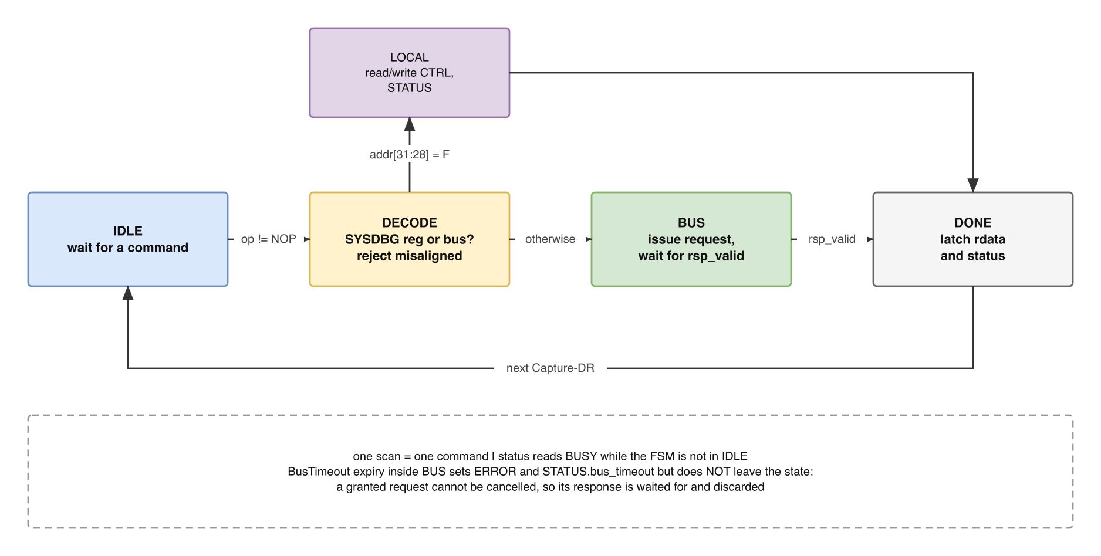
Figure 4-3. Figure 5 – Command FSM
Table 9 – Command FSM states
State | What happens
IDLE | Wait for the TAP to reach Update-DR with op != NOP
DECODE | Inspect addr[31:28]: local register file or system bus. Reject a misaligned or reserved size here, without issuing a request
LOCAL | Read or write CTRL / STATUS / ID; completes in one cycle
BUS | Drive mem_req_o; wait for mem_gnt_i, then for mem_rsp_valid_i. BusTimeout expiry is flagged here but does not leave the state
DONE | Latch rdata and status for the next scan to collect
While the FSM is not in IDLE, status reads back as BUSY. A host that issues a command before the previous one has finished receives BUSY rather than a corrupted result, which makes the protocol safe to drive from a simple program with no timing model of the target.
A slave that never answers is reported, not abandoned. An unmapped address, or a block whose clock is not running, would otherwise leave the FSM waiting forever, and a debugger that hangs takes with it the only tool available for finding out why. The tempting fix – give up after BusTimeout cycles and return status = ERROR – is wrong, and quietly so. Neither AXI, nor TL-UL, nor a req/gnt bus has any way to cancel a request that has already been granted. A block that stops waiting still has a response coming, and that response would be delivered to the next command: the host would receive data from an address it never asked about, together with status = OK. A silent wrong answer from the debugger is worse than a visible stall, because every conclusion drawn after it is also wrong.
So on expiry the FSM latches status = ERROR and sets STATUS.bus_timeout, and then keeps waiting. busy stays high, so a host that issues another command is told BUSY and is never handed a mismatched result. If the response eventually arrives it is discarded and the FSM returns to IDLE. If it never arrives, busy and bus_timeout both stay set, and that pair is a diagnosis rather than a hang: the host reads STATUS over JTAG – a path that does not depend on the system bus at all – and knows a slave is not answering. dm_sba in pulp-platform/riscv-dbg takes the same position, exposing sbbusy_o = (state_q != Idle) and never cancelling.

4.9 One command, end to end
The sections above describe the blocks. This is the same design followed as a single path, and it exercises every one of them.
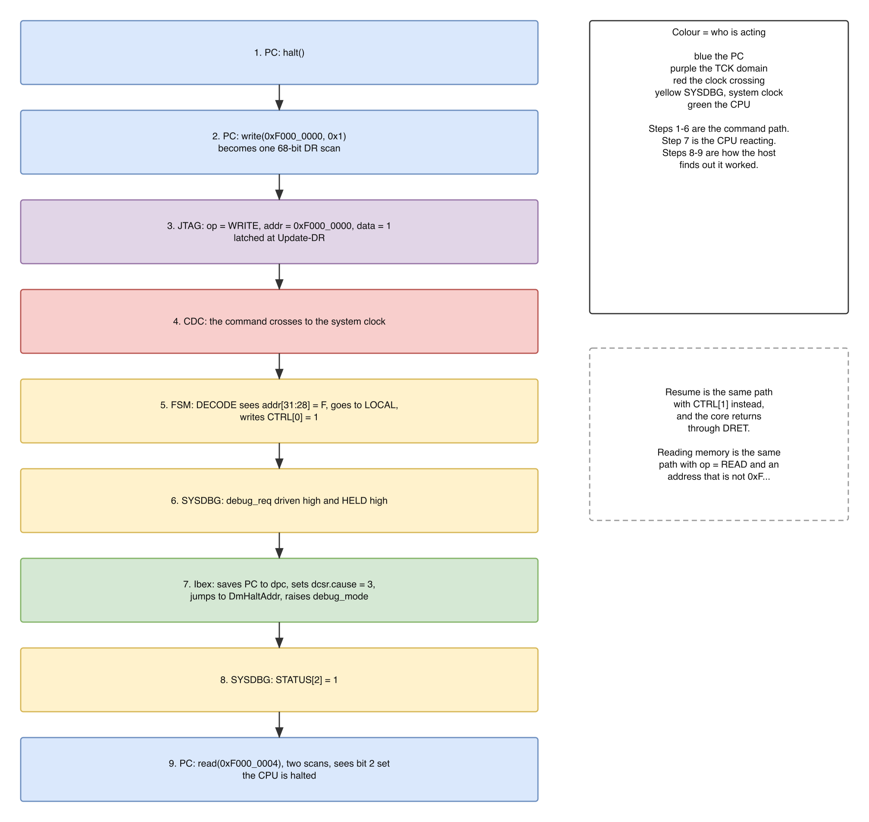
Figure 4-4. Figure 6 – Halting the CPU, end to end
Reading a memory word is the same path with op = READ and an address that is not 0xF..., so that step 5 enters BUS rather than LOCAL. Resuming is the same path with CTRL[1].

4.10 Clock domain crossing
Three rules, and nothing else crosses the boundary:
- The 68-bit command is captured once, at Update-DR, and passed across as a single unit with a request/acknowledge pair. The shift register itself is never sampled from the system side; it is moving.
- rdata and status cross back the same way and are captured at Capture-DR, so the value the host shifts out is stable for the whole scan.
- Two-flop synchronisers on the request and acknowledge lines.
This is the classic slow-to-fast handshake and is implemented as a small separate module, m_sysdbg_cdc, so that it can be verified on its own (section 4.14). The four signals that cross are named here so that the figures and the testbench agree: cmd_req and cmd_ack for the command going in, rsp_req and rsp_ack for the result coming back. Each is a single bit and each is toggled, not pulsed, so that a level-change detector on the far side works regardless of how long TCK stays stopped.
A timing constraint must accompany it. The 68-bit command register is read by the system domain but is never timed against it, so synthesis must be told:
set_false_path -from [get_clocks tck] -to [get_clocks clk]
set_false_path -from [get_clocks clk] -to [get_clocks tck]
Without it the tool will try to close timing between two unrelated clocks and report failures that mean nothing. With it, the handshake is what guarantees correctness, which is the reason only two single-bit signals are allowed to cross.

4.11 Requirements on the CPU side
SYSDBG cannot be specified independently of the core. Five items must be agreed with the owner of the Ibex integration.
Table 10 – Core debug CSRs and parameters required from the CPU
Item | Where it lives | Why SYSDBG cares
debug_req_i | ibex_top.sv | The wire SYSDBG drives; level-sensitive, must be held until the core halts
debug_mode | exists as debug_mode_q in ibex_controller.sv; not currently a port | Requested as a new output. It makes STATUS[2] a direct observation instead of an inference
DmHaltAddr, DmExceptionAddr | Ibex parameters | The core jumps to DmHaltAddr on every halt, so it must point at valid code
DmBaseAddr, DmAddrMask | Ibex parameters, feed the PMP | If PMP is enabled these must cover the debug memory or the core cannot fetch it
dcsr 0x7b0, dpc 0x7b1, dscratch0/1 0x7b2/0x7b3 | core CSRs | Nothing to request – all four are unconditional flops in ibex_cs_registers.sv; see below
ICache | ibex_top.sv parameter, default 1'b0 | SYSDBG writes instructions into ISRAM and the core must fetch them, not a cached copy. Nothing to request either – see below
On debug_mode. The RISC-V Debug Specification gives the core no output announcing that it has entered Debug Mode; riscv-dbg infers it from the core writing to a Halted location in the debug ROM, which requires a slave port on the debug module itself so that it can observe the write. Because SYSDBG is designed in house alongside the core, a direct signal is available instead, and it removes the need for a debug ROM entirely. The signal already exists inside the core and is already exported for verification as rvfi_ext_debug_mode. This is the clearest illustration of the difference between integrating a standard block and designing one: the standard must work with every core, so it cannot assume such a signal exists.
Two things that would normally have to be asked of the CPU owner turn out to need nothing at all. Both were settled by reading the core rather than by asking, and both are recorded because their absence would have been expensive to discover late.
dscratch0 and dscratch1 are always present. An instruction sequence has a bootstrap problem: to store a register to memory it needs a second register to hold the address, and clobbering that one loses the value it was sent to fetch. The two scratch CSRs exist to break exactly that cycle – csrw dscratch0, s0 parks a register without touching memory. ibex_pkg.sv annotates them // optional, which reads like a warning but is the RISC-V Debug Specification’s word, not Ibex’s: ibex_cs_registers.sv instantiates u_dscratch0_csr and u_dscratch1_csr as ordinary flops, outside any generate block and behind no parameter. There is nothing to request.
The core disables its own instruction cache in Debug Mode. The design depends on SYSDBG writing instructions into ISRAM over the bus and the core then fetching them; a cached copy of whatever was previously at that address would break it silently. Ibex closes this itself:
// ibex_cs_registers.sv
assign icache_enable_o =
cpuctrlsts_part_q.icache_enable & ~(debug_mode_i | debug_mode_entering_i);
and with icache_enable_i low, ibex_icache.sv never performs a lookup (lookup_actual_ic0 = lookup_grant_ic0 & icache_enable_i & ...), so every fetch goes to the bus. Instructions written while the core is halted are therefore always seen. One case is left over: if SYSDBG loads a new main image into ISRAM and then resumes, the cache may still hold the old one. That is handled in software – the sequence ends with fence.i before the resume – or avoided entirely by leaving ICache at its default 1'b0.

The debug memory window
The four Dm* parameters are not free choices – they are derived from one base address, and Ibex’s own PMP fixes the rule. ibex_pmp.sv matches the debug region as
debug_mode_allowed_access = debug_mode_i &
((pmp_req_addr[31:0] & ~DmAddrMask) == DmBaseAddr);
so the window must be a power of two and its base must be aligned to its own size. DmAddrMask is the size minus one. Ibex’s default mask, 0x0000_0FFF, makes that 4 KiB, which is also comfortably more than the offsets riscv-dbg uses inside the region (the debug ROM begins at 0x800).
Table 11 – Debug memory window, and the CPU parameters derived from it
Parameter | Value | Where it comes from
Window | 0x2000_0000 – 0x2000_0FFF, 4 KiB | The first 4 KiB of ISRAM, QNSC_RAM_MAS section 5.1
DmBaseAddr | 0x2000_0000 | The base itself; low 12 bits must be zero
DmAddrMask | 0x0000_0FFF | Size minus one
DmHaltAddr | 0x2000_0800 | base + dm_pkg::HaltAddress
DmExceptionAddr | 0x2000_0810 | base + dm_pkg::ExceptionAddress, which is HaltAddress + 16
Inside those 4 KiB the layout is fixed:
Offset | Address | Size | Contents
0x000 – 0x7FF | 0x2000_0000 | 2 KiB | Instruction sequence area, where SYSDBG writes the sequence the core is to execute
0x800 | 0x2000_0800 | – | DmHaltAddr, the dispatch loop of section 4.12
0x810 | 0x2000_0810 | – | DmExceptionAddr. A fault raised while in Debug Mode lands here; it records the fault and re-enters the dispatch loop
0x820 – 0xEFF | 0x2000_0820 | ~1.7 KiB | Free
0xF00 – 0xF07 | 0x2000_0F00 | 8 B | Result words, where a sequence writes the value it was sent to fetch
0xF08 | 0x2000_0F08 | 4 B | Command word. Non-zero means a sequence is ready at 0x2000_0000; the sequence clears it when finished
0xF0C | 0x2000_0F0C | 4 B | Resume flag. Non-zero tells the dispatch loop to execute dret; the loop clears it first
0xF10 – 0xFFF | 0x2000_0F10 | 240 B | Reserved scratch
The window is part of ISRAM, not a port on this block and not a block of its own. The instructor’s ruling was to keep the debug program inside a RAM rather than give it dedicated hardware, so it is the first 4 KiB of the instruction RAM and nothing more – an address convention. The CPU reaches it by fetching, and SYSDBG writes into it through the bus master port it already has. Nothing is added to SYSDBG and no new master appears anywhere.
It is the first 4 KiB and not the last, and that is a decision rather than a default. All four parameters in Table 11 are compile-time parameters of ibex_top; changing one means re-elaborating the CPU. Anchored to the bottom of ISRAM they depend on the base address alone, which does not move. Anchored to the top they would be base + size - 0x1000, so every change to ISRAM’s capacity – a single PARA_SRAM_DEPTH edit, and the cheapest change in the RAM specification – would drag all four with it and force a CPU rebuild. QNSC_RAM_MAS section 5.1 records the same reasoning from the RAM’s side.
The arrangement is safe because the same ruling split the RAM in two: a stray data pointer writes into DSRAM and cannot reach ISRAM unless it deliberately addresses that range. QNSC_RAM_MAS section 5.1 records the options and why this one was taken.
The window is placed inside ISRAM rather than borrowing an address in the main ROM, and that matters because DmBaseAddr is a compile-time parameter: moving it is not a local change, it moves the CPU parameters, the memory map and the PMP region together.
A defect to avoid. Ibex’s default DmExceptionAddr is DmHaltAddr + 8. In riscv-dbg that offset is the resume entry point, not the exception entry point; the exception entry is at +0x10. Leaving the defaults in place means an exception inside debug mode jumps into the resume path. OpenTitan derives all four parameters explicitly rather than relying on the defaults, and QSOC must do the same.

4.12 Reading a CPU register
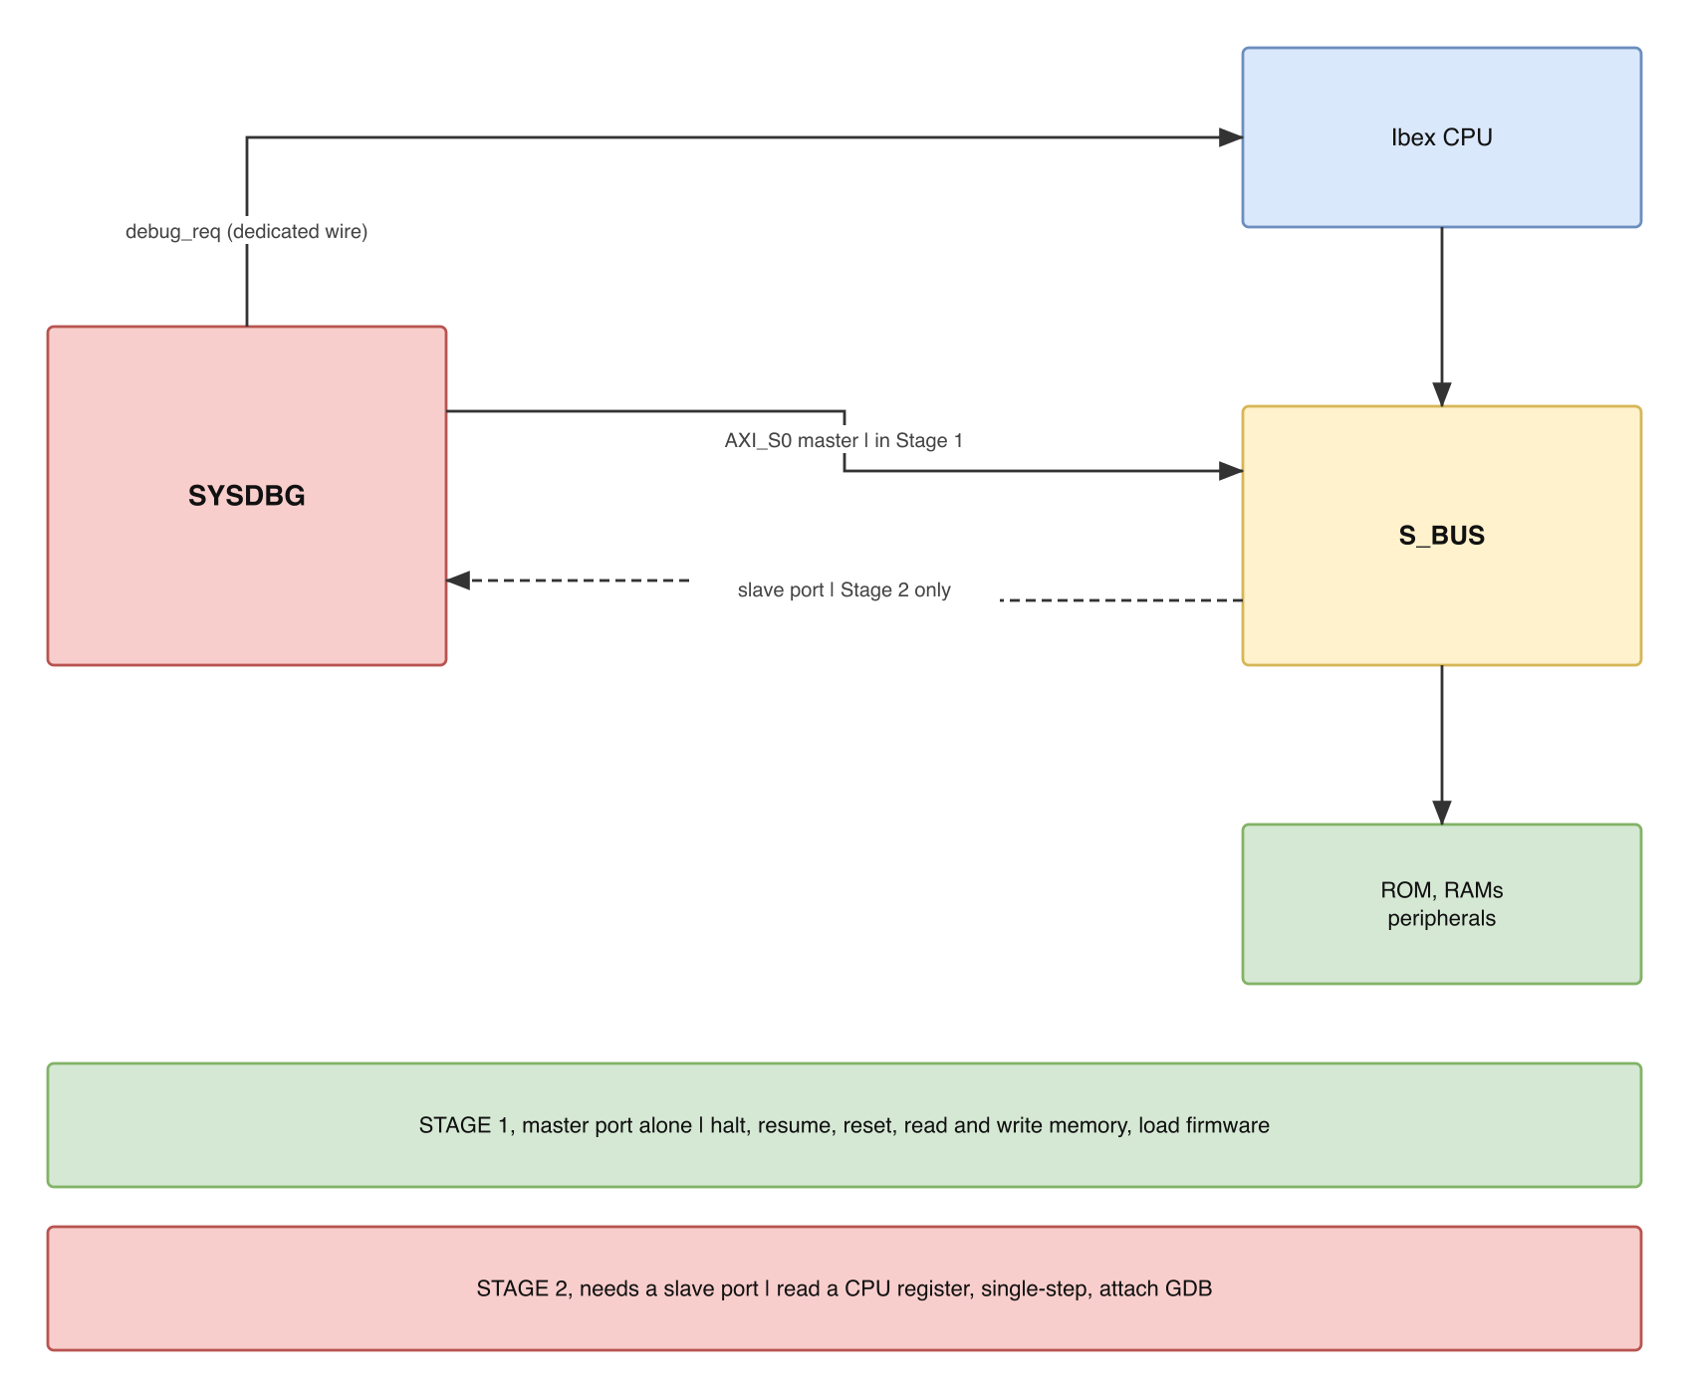
Figure 4-5. Figure 7 – What one bus port can and cannot reach
Table 12 – What each part of the block delivers
Capability | What it needs | Extra port?
Halt, resume, non-debug-module reset | debug_req, debug_mode, three JTAG registers | no
Read and write any address, including while the CPU runs | The bus master on AXI_S0 | no
Load firmware and run it | The same master, then resumereq | no
Read a GPR or a CSR | The halted core executes a sequence from the debug window | no
OpenOCD and GDB | Host software on top of the above | no
Every row reads “no”, and that is the result worth drawing attention to. The block has exactly one bus port and it is a master. Register access is the row that looks as though it must need a slave port – a standard debug module would put a Program Buffer inside itself and let the core fetch from it – and it does not, because the instructions go in ISRAM instead.
The rest of this section is how that row works.
A CPU register has no bus address, so no amount of bus mastering reaches it. The only defined route is to make the core execute a store, then read the address it stored to.
The dispatch loop at DmHaltAddr. Whatever sits at DmHaltAddr runs on every halt, so what goes there is a loop that polls two words: the command word at 0x2000_0F08 and the resume flag at 0x2000_0F0C. A non-zero command word means a sequence is waiting at 0x2000_0000, so the loop jumps there. A non-zero resume flag means the host wants the program to continue, so the loop clears the flag and executes dret, which restores the PC from dpc and leaves Debug Mode. If both are zero it keeps spinning.
Register discipline, and why two debug CSRs are needed. A sequence that reads x5 must not destroy anything – including the register it needs to hold an address. Ibex implements dscratch0 at 0x7b2 and dscratch1 at 0x7b3, two CSRs that exist for exactly this purpose and that ordinary firmware never touches. A sequence saves the working registers there first and restores them last, so the machine state the host sees is the state the program had:
csrw dscratch0, t0 # park t0 where firmware cannot see it
csrw dscratch1, t1
lui t0, 0x20000 # t0 = 0x2000_0000, the window base
csrr t1, dpc # the value being fetched; a GPR needs no csrr
sw t1, 0xF00(t0) # publish the result
sw zero, 0xF08(t0) # clear the command word LAST
csrr t1, dscratch1 # restore, in reverse order
csrr t0, dscratch0
j 0x2000_0800 # back to the dispatch loop
The result is written before the command word is cleared, and that order is a requirement, not a style. The host detects completion by polling the command word; if the flag cleared first, the host could read a stale result and believe it.
Sequences return by a jump, not by ebreak, and that is deliberate. An ebreak re-enters Debug Mode and lands on DmHaltAddr, which would also work – but only once dcsr.ebreakm is set, and setting a CSR requires a sequence, which would require the return path to already work. Returning by an ordinary jump breaks that circle: the first sequence ever executed needs nothing configured. dcsr.ebreakm is still set later, because it is what makes a software breakpoint planted in application code enter Debug Mode instead of trapping.
What SYSDBG does, in order. Write the sequence into 0x2000_0000 through the bus master; write the command word non-zero; poll the command word until it reads zero; read the result from 0x2000_0F00. Four ordinary bus accesses, each one JTAG scan, using only the master port.
Why SYSDBG also writes the dispatch loop itself. ISRAM is volatile, so after power-on the window holds garbage and something valid has to be at DmHaltAddr before the first halt. SYSDBG writes it over JTAG as the first thing a session does, which depends on nobody: not on the ROM bootloader having run, not on reset ordering, and not on a firmware image being present. This is the answer to what was open question 7.

Resume, and why the order of the two steps matters
Resume is two host writes, and they are not interchangeable:
- Write resumereq to CTRL[1]. This clears haltreq, so debug_req_o goes low.
- Then write a non-zero value to the resume flag at 0x2000_0F0C.
Doing it the other way round produces a fault that looks like resume being ignored. If the flag is set while debug_req_o is still high, the loop executes dret, the core leaves Debug Mode – and then at the very next instruction boundary it sees debug_req_i still asserted and halts again immediately. From the host the program appears never to start, and STATUS[2] goes back to 1 with no explanation. Lowering the request first removes the race entirely.
Why this is in software rather than hardware. SYSDBG could write the resume flag itself as a side effect of the resumereq write, but that would put a bus transaction inside a register write in the command FSM – more states, for something the host can do with an ordinary write() it already has. The hardware stays at three registers and the ordering rule lives in one place, the resume() function of section 4.13.
The one limit worth stating plainly. Everything above requires the core to be halted, because it works by borrowing the core’s own pipeline. Reading memory needs no halt; reading a register always does.

4.13 Host software
A debugger cannot be demonstrated without software on the host side. This is a deliverable of the block, not an afterthought.
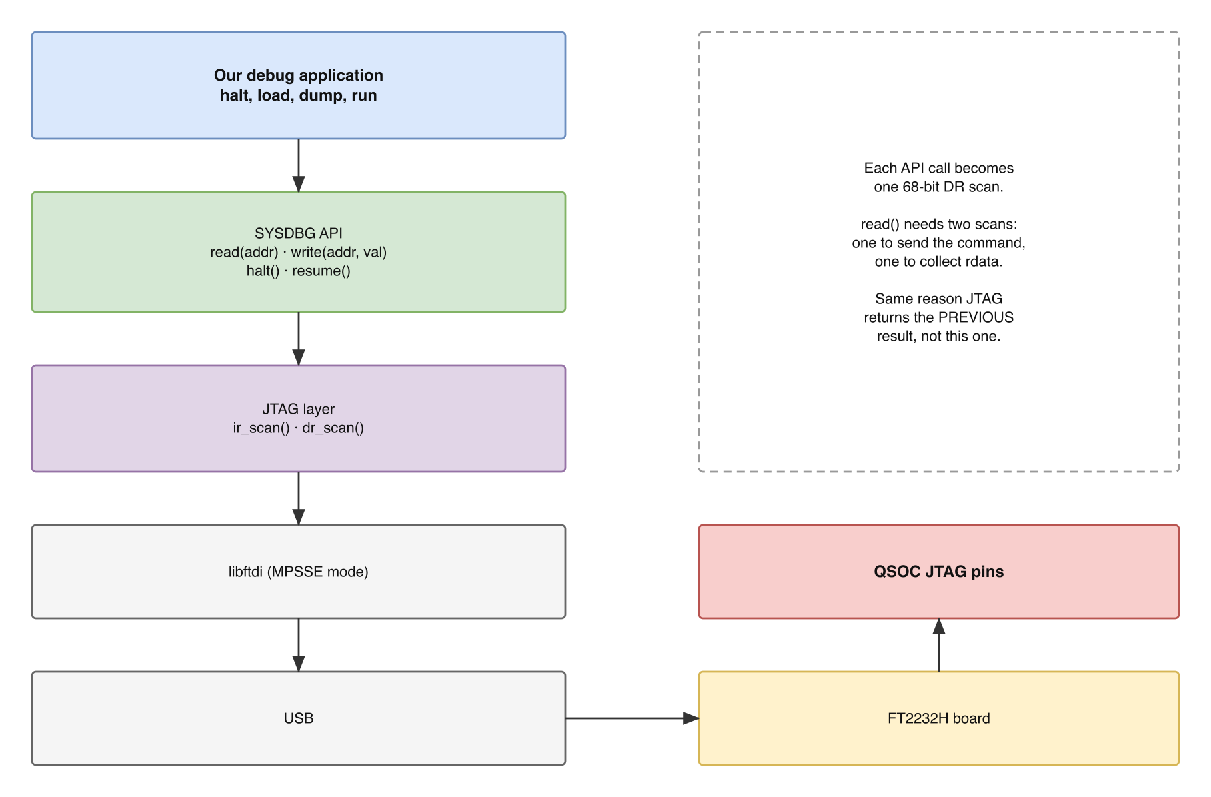
Figure 4-6. Figure 8 – Host software stack
Table 13 – Host software deliverables
Layer or item | Contents
JTAG layer | ir_scan(), dr_scan() over the 68-bit ACCESS register, on libftdi in MPSSE mode
SYSDBG API | read(addr), write(addr, val), halt(), resume(), reset(). resume() is two writes in a fixed order: resumereq first, then the resume flag, section 4.12
Firmware loader | Writes an image into the RAM over the bus master, then releases the core
Debug window initialiser | Writes the dispatch loop to DmHaltAddr and the fault handler to DmExceptionAddr at the start of every session, section 4.12
Sequence generator | Emits the instruction sequences for read_gpr(n) and read_csr(addr), then polls the command word and returns the result word
Smoke test | Read IDCODE; write CTRL and read STATUS back; halt and confirm STATUS[2]; write and read back a RAM word; load a program and watch it run; halt and read dpc
Each API call is one 68-bit DR scan; read() is two, for the reason in section 4.6. The five steps of the smoke test are ordered so that each proves exactly one thing and a failure localises immediately: the JTAG chain, then the CDC and FSM, then debug_req reaching the core, then the bus master, then the whole path.
The third step is the acceptance criterion for the block as a whole – it is the point at which debug_req becomes observable from the host.

4.14 Verification plan
The RAM arrives with 46 tests already written (QNSC_RAM_MAS, section 4.9). SYSDBG arrives with none, because nobody has written it yet – so the verification plan is part of the design rather than an afterthought.
Table 14 – SYSDBG verification plan
Level | What is checked | How
m_sysdbg_cdc alone | No data is sampled while moving; the handshake completes; behaviour when TCK stops mid-sequence | Directed testbench with two independent, deliberately unrelated clocks, including a TCK that stops after Update-DR
TAP alone | The 16-state walk from every state; IDCODE reads correctly after reset; BYPASS is one bit; IR update takes effect only at Update-IR | Directed JTAG stimulus driving TMS patterns
Command FSM alone | Every state transition; BUSY while not IDLE; misaligned and reserved size rejected in DECODE | Directed, with a stub slave whose grant and response latency is programmable
BusTimeout behaviour | On expiry: ERROR and bus_timeout set, busy stays high, no new command accepted; a response arriving after expiry is discarded and never returned as a result | Stub slave told to answer only after BusTimeout cycles. This is the test that proves the hazard of section 4.8 is closed
Bus master port | req held until gnt; exactly one mem_rsp_valid_i per granted request; no second request while one is outstanding; mem_be_o never zero on a write, and equal to the size-and-address decode | Four SVA properties, modelled on sva/dm_sba_sva.sv in pulp-platform/riscv-dbg
The pair with its adapter | Protocol legality of the AXI4 that reaches AXI_S0; SLVERR and DECERR both arrive as mem_rsp_error_i and become status = ERROR | An AXI checker or the Synopsys VIP already used for the RAM, applied to SYSDBG + axi_from_mem together, since that pair is what the crossbar sees
Resume ordering | Setting the resume flag before lowering debug_req makes the core re-halt immediately; doing it in the specified order resumes once and stays running | Directed test driving both orders and checking debug_mode and STATUS[2]
Block level | A scan in produces the right transaction out; a read needs two scans; byte and halfword accesses land in the right lane both ways; debug_req rises and is held | Behavioural JTAG driver plus a memory model
System level | The five bring-up steps of section 4.13, against Ibex | RTL simulation of the whole SoC, then the FPGA
Two properties deserve an assertion rather than a test case, because they are invariants and a directed test can only sample them:
- debug_req_o never falls while CTRL[0] is set.
- The system side never reads the ACCESS register while shift_dr is active.
The acceptance criterion for the whole block is the third bring-up step: write CTRL.haltreq over JTAG, poll STATUS[2], and see it go high. Everything before it proves a piece; that step is the first that proves the block.

5. Integration into QSOC

5.1 Interfaces to agree with the team
Table 15 – Interfaces to agree with the team
Item | Owner of the other side | Why it matters
S_BUS geometry: data width, address width | bus owner | Parameters of the bus master, section 4.4. QSOC_HAS fixes both at 32 bits
Conversion to AXI4 at AXI_S0: settled, and required | bus owner | QSOC_HAS Table 5-5 lists this among the mandatory protocol conversions and describes this block’s master as a handshake interface of the same kind as the CPU’s memory port – which is what section 4.1 specifies. Use axi_from_mem from pulp-platform/axi, the library already chosen for S_BUS and already used for CPU2AXI, with MaxRequests = 1, because this block has exactly one command outstanding at a time. The adapter is not delivered by this block: it belongs with the other conversions at the crossbar, so that all bus-protocol adaptation is owned and verified by one person. This block’s own testbench instantiates it in order to check the AXI4 side, section 8
D15 clock gate: bit 14, open out of reset, not closable by software | clock and reset owner | Section 4.2. QSOC_HAS proposes it and this document confirms it. Software able to close this gate can disable the debugger silently, because the TAP keeps working on tck_i while the command FSM is frozen
The memory map | memory map owner | QNSC_RAM_MAS Table 10: 0x2000_0000 for the debug window, 0xF000_0000 for these registers
JTAG IDCODE for QSOC | project level | Hard-coded in the TAP and checked by the host software
Export of debug_mode from ibex_top | CPU owner | Removes the need for a debug ROM, and is how SYSDBG knows an instruction sequence has finished, section 4.11
All four Dm* parameters | CPU owner | Derived in Table 11; not the Ibex defaults
4 KiB reserved at 0x2000_0000 | memory map owner | Table 11 – so the parameters never have to move
0xF000_0000 left unmapped on S_BUS, answering DECERR | bus owner | Section 4.7 – these registers live in the JTAG command space only; a bus slave claiming that region would shadow them
ISRAM reserving its first 4 KiB for the debug program | RAM owner (this author) and the firmware linker script | Table 11 – the main image must start at 0x2000_1000
SYSDBG released from reset before the CPU | SCRC owner | Section 4.2 and open question 3 – halt-on-reset fails if debug_req is not already high when the core leaves reset. SCRC’s own boot flow now states this requirementebug connection
Firmware links the main image at 0x2000_1000 | firmware owner | Section 5.2 item 6 – forced by the 4 KiB debug window in QNSC_RAM_MAS, and enforced by a PMP region
Reach of the bus master: settled | bus owner | The system bus is axi_xbar from pulp-platform/axi, fully connected – “every slave port has a direct wired datapath to every master port” – with one shared address map, so AXI_S0 reaches every subordinate including ROM on AXI_M0. This answers the ROM-readback item the ROM owner’s specification raised. QuachHuynhHuuTai_AXI4_System_Bus_Crossbar section 2.1
Decode errors are observable: settled | bus owner | Each slave port owns a private decode-error slave returning 32'hBADCAB1E per beat, so an out-of-map access reports rather than hangs – which is what STATUS[1] error and the timeout of section 4.8 assume. Same document, section 2.3
JTAG pins in the pad ring, and tdo_oe: settled | pad owner | IOPAD_Pin_Summary of 2026-09-20 places all five on PIN_8–PIN_12 with b00 as the default, and carries tdo_oe_o. Section 4.3
IO MUX must not be able to steal the JTAG pins | pad / IO MUX owner | Section 4.3.1 – the five pads are shared with GPIO0[7:3], and a write that switches them disconnects the debugger silently

5.2 Open questions
They are grouped by who has to answer.
For the CPU owner:
- Hardware triggers: QSOC_HAS has answered this, and the answer is yes — DbgTriggerEn = 1'b1 with DbgHwBreakNum = 1. The reasoning this document arrived at independently is the reasoning the HAS gives: for code in ISRAM a breakpoint costs nothing, because the program is in writable RAM and a software breakpoint – an ebreak patched over the instruction and restored afterwards – works. ROM is the exception. 0x0000_0000 – 0x0000_07FF cannot be written, so no breakpoint can be set there unless a hardware trigger does it, and the HAS specifies exactly one trigger for that purpose: “1 hardware breakpoint trigger, usable in read-only memory where a software breakpoint cannot be written”.
- The boot flow makes this necessary rather than merely nice. With the application loaded by a serial bootloader in ROM (QNSC_RAM_MAS section 5.1), the ROM holds a real program – frame parsing, CRC32, a copy loop into ISRAM – and it is exactly the program most likely to need a breakpoint during bring-up, because nothing else can run until it works. An earlier revision of this document left the question open on the grounds that the ROM might hold little more than a spin loop; that premise was wrong.
- What remains for the CPU owner is only to set the parameter before elaboration, since DbgTriggerEn is a compile-time parameter of ibex_top and not a register.
- Halt-on-reset: settled as required, and this document agrees. Stopping the core before it executes the first ROM instruction is a standard expectation of a GDB session. It is not a feature of SYSDBG so much as a reset-ordering requirement: debug_req must already be high when the core leaves reset, which means SCRC releases SYSDBG from reset before the core, and there is no handshake to wait on – a request that arrives late arrives after the core has already run. Section 4.2 records that QSOC has no debug reset at all, so this ordering requirement is the only reset-tree constraint this block places on SCRC. QSOC_HAS now marks halt-on-reset mandatory, pending this author’s sign-off, and the sign-off is given here: the ROM holds a serial bootloader, not a spin loop (QNSC_RAM_MAS section 5.1), so a fault in the ROM is a fault in real code, and without halt-on-reset the core has already run into it before the debugger can attach. This is the same premise that makes the hardware trigger necessary, section 4.11. What remains is sequencing, and it belongs to the SCRC owner, not to this block.
For the instructor, or the project:
- Closed: there is no external acceptance criterion, because QSOC is a training device. The question was whether a standard tool must work unmodified, since stock OpenOCD drives a DMI-compatible register and this block uses the custom 68-bit ACCESS register of section 4.6. With no acceptance criterion to meet, the custom register stands and the host software of section 4.13 is the deliverable.
- The consequence is recorded rather than hidden. Stock OpenOCD cannot drive this block, so no tool built on it – GDB through OpenOCD, or an IDE through either – attaches without work. What is reachable, and costs no RTL: GDB speaks the Remote Serial Protocol to a stub on the host, and a stub over the SYSDBG API of Table 13 would give x1–x31 and dpc in a real GDB session. That is optional future work, not a requirement of this block.
- What would force an architecture change, if the criterion ever appears: a requirement that stock OpenOCD work. The ACCESS register would have to be replaced by a DMI-shaped one, which is a change to sections 4.6, 4.8 and 4.13. Recording it here means the cost is known before anyone promises it.
- Decided: peripherals keep running while the core is halted, with one exception to settle. Nothing in this design stops them, and adding a debug-halt gate would mean a new signal from this block to every peripheral plus a gate inside each one – a cost spread across other people’s blocks for a convenience this device does not need.
- The consequence, so nobody debugs against a wrong model: single-stepping a loop that reads a timer sees it jump by thousands of ticks between steps, a UART transmission completes on its own, and a PWM channel keeps switching. Any timing measured while halted is meaningless. This is normal for small MCUs and is stated here only because the opposite is often assumed.
- The exception is the watchdog, and it is not this block’s to fix. Ibex ignores the NMI in Debug Mode, so a watchdog left running during a halt barks unheard and resets the chip the moment the core resumes, with nothing recording why. Since QSOC also has no debug reset, section 4.2, the host sees the target vanish. This document asks the watchdog owner for one of two things: a way to stop the watchdog while debug_mode is asserted, or an explicit instruction that firmware must disable it before a debug session. QNSC_Interrupt_Map_MAS raises the same point from the interrupt side.
- Closed as not applicable to this device. QSOC is a training chip with no life cycle controller, so today SYSDBG is always reachable, and it is a bus master that can write anywhere. For an FPGA demonstration that is acceptable, but it should be stated rather than left unsaid.
For the firmware or ROM owner:
- Closed: the boundary is fixed by this author’s own two documents, so there is nothing to confirm. QNSC_RAM_MAS reserves the first 4 KiB of ISRAM for the debug window, so the main image must start at 0x2000_1000 – that is a consequence, not a request. QSOC_HAS settles the enforcement: the CPU runs with PMP enabled, four regions and granularity 0, so a region can end exactly at 0x2000_0FFF and a stray pointer is stopped in hardware rather than discovered at the next halt. The linker script honouring the same boundary is therefore a firmware obligation recorded in section 5.1, not an open question: a correct program never provokes the PMP region in the first place.
- Closed. The core executes the dispatch loop of section 4.12, and SYSDBG writes it over JTAG at the start of a session rather than depending on the ROM bootloader or on reset ordering, section 4.12.
- Decided: IDCODE = 0x0515_3001. IEEE 1149.1 fixes the shape – bit 0 must read 1, bits 11:1 are a manufacturer ID, bits 27:12 a part number and bits 31:28 a version. QSOC has no JEDEC manufacturer ID, so any value is a local convention and there is nothing to wait for. The value chosen is self-describing:
Field | Bits | Value | Meaning
Version | 31:28 | 0x0 | silicon revision; increments per tape-out
Part number | 27:12 | 0x5153 | hex-ASCII “QS”, for QSOC
Manufacturer | 11:1 | 0x000 | no JEDEC ID assigned – stated honestly rather than borrowed
Required 1 | 0 | 1 | mandated by IEEE 1149.1
- pulp-platform/riscv-dbg’s own default, 32'h0000_0DB3, is deliberately not reused. This is a self-designed debug module, and answering a host with another project’s IDCODE would tell it something untrue. If QSOC ever obtains a real manufacturer ID, only bits 11:1 change and nothing else in this document moves.

6. Observations
- The CPU offers one wire, and the block is everything built around it. debug_req_i is the entire debug interface of the core. It is a trigger, not a debugger; everything in section 4.1 exists to get a command from a PC to that one wire and an answer back.
- The most valuable finding came from reading the core, not the spec. Section 4.11 works it through: debug_mode exists inside Ibex as debug_mode_q but is not exported, and asking for it removes both the debug ROM and the slave port that riscv-dbg needs in order to infer the same fact. A standard block could not have asked, because a standard must work with every core.
- The one real limit is stated rather than hidden. A register can only be read while the core is halted, because the mechanism borrows the core’s own pipeline. Memory needs no halt; a register always does, and section 4.12 says so plainly instead of leaving it to be discovered.
- The host software is the part most likely to be underestimated. Without it, nothing about this block can be demonstrated, which is why it is specified here (section 4.13) rather than assumed.
- This block and the RAM are specified from opposite directions, deliberately. SYSDBG is a design: nothing is instantiated, riscv-dbg is read only to learn what a debug module must do, and every block inside Figure 2 is written for QSOC. Both, in the end, came down to the same activity – reading somebody else’s RTL closely enough to know exactly where it stops.

Appendix A. Acronyms
Table 16 – Acronyms
Acronym | Description
AXI | Advanced eXtensible Interface
CDC | Clock Domain Crossing
CSR | Control and Status Register
DM | Debug Module
DMI | Debug Module Interface
DTM | Debug Transport Module
FSM | Finite State Machine
GDB | GNU Debugger
IP | Intellectual Property block
JTAG | Joint Test Action Group, IEEE 1149.1
QSOC | The MCU built in this training project
RTL | Register Transfer Level
SBA | System Bus Access
TAP | Test Access Port
BE | Byte enable, one bit per data byte, selecting which bytes a write updates

Appendix B. First Review
Item | Reviewer | Response

Appendix C. References
- RISC-V Foundation, RISC-V External Debug Support, Version 0.13
- PULP Platform, riscv-dbg, https://github.com/pulp-platform/riscv-dbg – reference only, not instantiated
- PULP Platform, RISC-V Debug System Documentation, doc/debug-system.md
- lowRISC, Ibex Documentation and RTL, ibex_top.sv, ibex_controller.sv
- IEEE 1149.1, Standard Test Access Port and Boundary-Scan Architecture
- ARM, AMBA AXI and ACE Protocol Specification, IHI 0022
- QSOC block diagram and IP assignment sheet, VLSIT_DeepTraining_20260908
- QSOC_HAS – the system architecture specification. Authority for the mandatory conversion to AXI4 at AXI_S0 and for the hardware breakpoint trigger
- PULP Platform, axi: axi_from_mem.sv, which instantiates axi_lite_from_mem.sv and axi_lite_to_axi.sv, https://github.com/pulp-platform/axi
- PULP Platform, riscv-dbg: src/dm_sba.sv for the System Bus Access port this document’s master follows, src/dm_obi_top.sv, and sva/dm_sba_sva.sv for the assertions of section 8
- QNSC_RAM_MAS – the companion specification for the author’s second block

