Interrupt Map
MICRO-ARCHITECTURE SPECIFICATION – V2.4
QUY NHON SEMICONDUCTORS – QNSC

Table of Contents

Table of Tables
Table 4-1. Upstream IP used
Table 5-1. Interrupt map interface
Table 7-1. Interrupt line assignment
Table 7-2. Interrupt source totals
Table 7-3. How each source is cleared, and what a missed pulse costs
Table 9-1. Functions this block does not provide
Table 10-1. Every interrupt input on the core
Table 11-1. Requirements on other owners
Table A-1. Acronyms
Table B-1. First review

Table of Figures
Figure 3-1. INTMAP: 5 OR gates and 6 wires onto irq_fast_i[10:0], one wire onto irq_nm_i

Revision history
The reasoning behind each change, and the versions before V2.0, are in QNSC_Interrupt_Map_DECISIONS.md.
Version | Date | Author | Reviewer | Description of change
V2.0 | 2026-09-23 | Nghia VT | – | Rewritten as specification only. History and reasoning moved to _DECISIONS; tables in 7.2 and 10 generated from util/qsoc_contract.yml
V2.1 | 2026-09-24 | Nghia VT | – | NMI stated as a wire through the block; source ports, widths and timer shape added; figure redrawn; reasoning moved to _DECISIONS
V2.2 | 2026-09-24 | Nghia VT | – | GPIO3 dropped with the 40-pin package: 26 sources, i_int_gpio 3 bits
V2.3 | 2026-09-26 | Nghia VT | – | Decisions from the RTL generation: line indices from qnsc_pkg (7.1); open item 2 closed by a simulation-only X check per input (7.6)
V2.4 | 2026-09-28 | Nghia VT | – | Watchdog rule added: WDOG_BARK_THOLD < WDOG_BITE_THOLD, so the NMI runs before the chip reset; 7.5 excludes the WDT, which is never gated

1. Overview
INTMAP is a combinational block that connects 26 interrupt sources from 8 blocks to 12 interrupt inputs of the Ibex core. The 25 maskable sources form 11 source groups; each group drives one fast line irq_fast_i[n], through an OR gate when the group has several sources and a wire when it has one. The watchdog bark is a wire to the non-maskable input irq_nm_i.
It does not: hold state, decode an address, appear on any bus, prioritise (the core does that), or latch a pulse. It has no clock and no reset.
Block directory design/intmap, module m_qnsc_intmap, owner Nghia Van Trong.

2. Features
- 26 sources onto 11 fast lines plus one NMI; 4 fast lines spare, tied 0
- One source group per line: no line carries sources from two groups
- Combinational: no clock, no reset, no flip-flop, no bus port, no register on any path from input to output
- Priority is the line index, resolved by the core, lowest index first
- The watchdog bark is a wire from i_int_wdt_bark to o_int_nm, never ORed

3. Block diagram
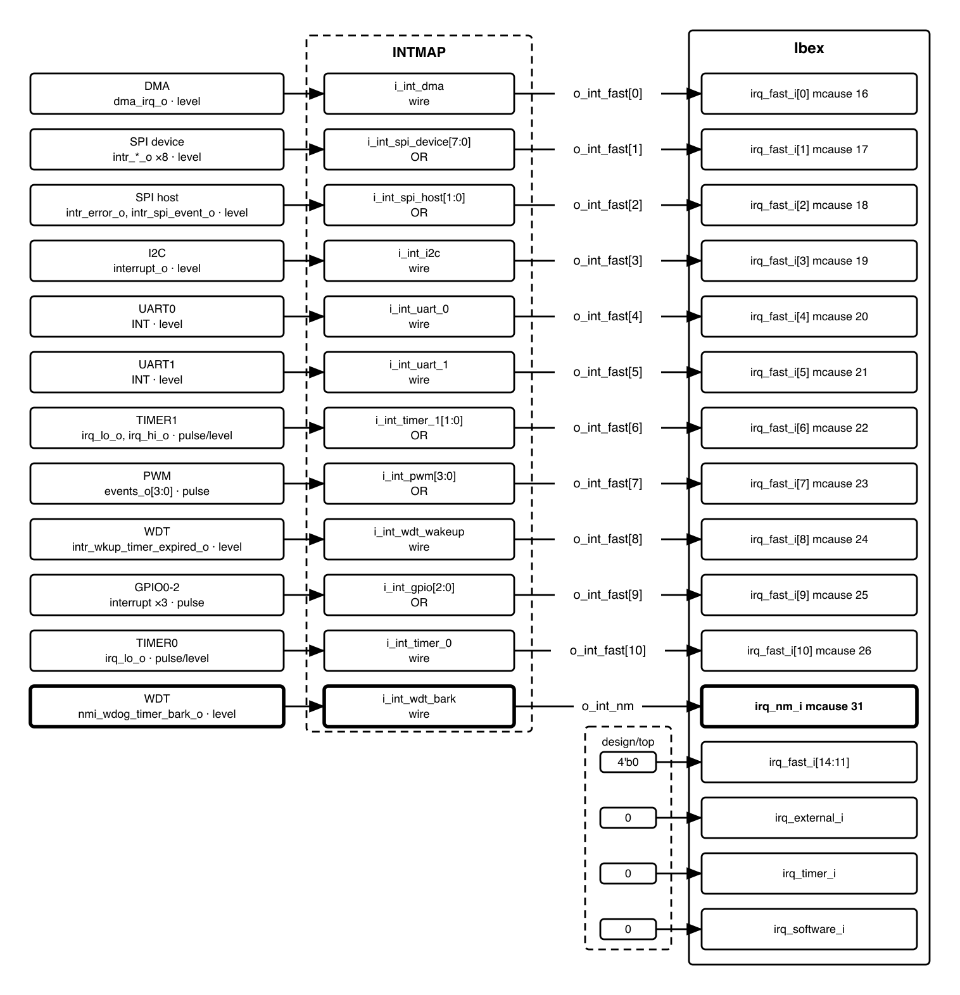
Figure 3-1. INTMAP: 5 OR gates and 6 wires onto irq_fast_i[10:0], one wire onto irq_nm_i
One combinational layer, no clock, reset or bus port. The tie-offs are in design/top.

4. IP used
Table 4-1. Upstream IP used
From | Module | Commit | Licence
– | – | – | –
Designed in house. The block instantiates nothing; it is assign statements.

5. Interface
Every port, named per QNSC_RTL_Design_Naming_Rule V1.0 section 3.6. The vendor port behind each input is in the table in 7.2.
Table 5-1. Interrupt map interface
Signal | Dir | Width | Description
i_int_dma | in | 1 | from DMA
i_int_spi_device | in | 8 | from SPI device, bits in port declaration order
i_int_spi_host | in | 2 | from SPI host, bit 0 error, bit 1 event
i_int_i2c | in | 1 | from I2C
i_int_uart_0 | in | 1 | from UART0
i_int_uart_1 | in | 1 | from UART1
i_int_timer_1 | in | 2 | from TIMER1, bit 0 irq_lo_o, bit 1 irq_hi_o
i_int_pwm | in | 4 | from PWM, bit n = events_o[n]
i_int_wdt_wakeup | in | 1 | from WDT, wake-up timer
i_int_gpio | in | 3 | from GPIO0-2, bit n = GPIOn
i_int_timer_0 | in | 1 | from TIMER0, 64-bit mode
i_int_wdt_bark | in | 1 | from WDT, bark
o_int_fast | out | 11 | to Ibex irq_fast_i[10:0]
o_int_nm | out | 1 | to Ibex irq_nm_i
26 input bits, 12 output bits, and no other ports. No i_clk_*, no i_rst_n_*.

6. Register map
None. The block has no address and is not a bus slave. Enabling is in the core (mie bits 16-26, mstatus.MIE); clearing is at each source (7.4).

7. Functional behaviour

7.1 One OR gate per multi-source group
assign o_int_fast[C_INT_LINE_DMA] = i_int_dma; // line 0
assign o_int_fast[C_INT_LINE_SPI_DEVICE] = |i_int_spi_device; // line 1
assign o_int_fast[C_INT_LINE_SPI_HOST] = |i_int_spi_host; // line 2
assign o_int_fast[C_INT_LINE_I2C] = i_int_i2c; // line 3
assign o_int_fast[C_INT_LINE_UART_0] = i_int_uart_0; // line 4
assign o_int_fast[C_INT_LINE_UART_1] = i_int_uart_1; // line 5
assign o_int_fast[C_INT_LINE_TIMER_1] = |i_int_timer_1; // line 6
assign o_int_fast[C_INT_LINE_PWM] = |i_int_pwm; // line 7
assign o_int_fast[C_INT_LINE_WDT_WAKEUP] = i_int_wdt_wakeup; // line 8
assign o_int_fast[C_INT_LINE_GPIO] = |i_int_gpio; // line 9
assign o_int_fast[C_INT_LINE_TIMER_0] = i_int_timer_0; // line 10
assign o_int_nm = i_int_wdt_bark;
Five outputs are OR reductions and seven are wires. Zero flip-flops: every output follows its inputs combinationally, with no cycle of delay. The line indices and the width of o_int_fast (C_INT_FAST_LINES_USED) come from qnsc_pkg, so the line order has one source, the contract.

7.2 Line assignment
Line n is the wire irq_fast_i[n]. Ibex takes the lowest pending index first, so the line order is the priority order; changing it is a re-synthesis. For line n, mcause = 16 + n, equal to the mie bit that enables it (ibex_pkg.sv, CSR_MFIX_BIT_LOW = 16). mtvec is always in vectored mode, so the core jumps to mtvec + 4 * mcause. No register is read and no bus transaction occurs on the interrupt path.
Table 7-1. Interrupt line assignment
Line | CPU port | mcause | Vector | INTMAP input | Source port | Width | Shape
0 | irq_fast_i[0] | 16 | mtvec + 0x40 | i_int_dma | o_int_dma | 1 | level
1 | irq_fast_i[1] | 17 | mtvec + 0x44 | i_int_spi_device | intr_*_o ×8 | 8 | level
2 | irq_fast_i[2] | 18 | mtvec + 0x48 | i_int_spi_host | intr_error_o, intr_spi_event_o | 2 | level
3 | irq_fast_i[3] | 19 | mtvec + 0x4C | i_int_i2c | interrupt_o | 1 | level
4 | irq_fast_i[4] | 20 | mtvec + 0x50 | i_int_uart_0 | INT | 1 | level
5 | irq_fast_i[5] | 21 | mtvec + 0x54 | i_int_uart_1 | INT | 1 | level
6 | irq_fast_i[6] | 22 | mtvec + 0x58 | i_int_timer_1 | irq_lo_o, irq_hi_o | 2 | pulse; level in one-shot with prescaler or ref clock
7 | irq_fast_i[7] | 23 | mtvec + 0x5C | i_int_pwm | events_o[3:0] | 4 | pulse
8 | irq_fast_i[8] | 24 | mtvec + 0x60 | i_int_wdt_wakeup | intr_wkup_timer_expired_o | 1 | level
9 | irq_fast_i[9] | 25 | mtvec + 0x64 | i_int_gpio | interrupt ×3 | 3 | pulse
10 | irq_fast_i[10] | 26 | mtvec + 0x68 | i_int_timer_0 | irq_lo_o | 1 | pulse; level in one-shot with prescaler or ref clock
11-14 | irq_fast_i[14:11] | 27-30 | – | tied 0 in design/top | – | 0 | –
– | irq_nm_i | 31 | mtvec + 0x7C | i_int_wdt_bark | nmi_wdog_timer_bark_o | 1 | level

Table 7-2. Interrupt source totals
 | Count
Sources onto fast lines | 25
Sources on the non-maskable input | 1
Total interrupt sources | 26
Source blocks (DMA, SPI, I2C, UART, TIMER, PWM, WDT, GPIO) | 8
Sources that pulse | 10
Fast lines driven | 11
Fast lines Ibex provides | 15
Fast lines spare | 4

7.3 The NMI is a wire through this block
o_int_nm equals i_int_wdt_bark and depends on no other input; no fast line depends on i_int_wdt_bark. irq_nm_i is not masked by mstatus.MIE or mie. Ibex ignores irq_nm_i in Debug Mode; the bark is a held level, so it traps after the core resumes.

7.4 A missed pulse, and how each source is cleared
Ibex’s mip is combinational (assign mip.irq_fast = irq_fast_i) and this block latches nothing, so a pulse that ends while mstatus.MIE (clear inside any handler) or the mie bit is clear, or in Debug Mode, raises no trap.
Table 7-3. How each source is cleared, and what a missed pulse costs
Source | Shape | Cleared by | A missed pulse
DMA | level | W1C DMA_ISR | –
SPI device, SPI host | level | W1C INTR_STATE | –
I2C | level | IACK, bit 0 of CMD | –
UART0, UART1 | level | the 16550 register read that IIR names | –
WDT wake-up, WDT bark | level | W1C INTR_STATE | –
GPIO0-2 | pulse | nothing; INTSTATUS clears on read | lost; the pin stays recorded in INTSTATUS
TIMER0, TIMER1 | pulse; level in one-shot with prescaler or ref clock | a held level ends on the writes in QNSC_TIMER_MAS 7.5 | lost; periodic mode raises it again next period, one-shot does not
PWM | pulse | nothing | lost; the next period raises it again

7.5 A gated peripheral holds its line
Every interrupt source except the WDT is in the peri cluster, whose clocks SCRC stops through CLK_EN; the WDT clock is never stopped. A stopped clock retains flip-flop state, so a peripheral gated with its interrupt asserted keeps its line high, and this block passes it on. Clearing it needs a register write to the gated peripheral, which cannot complete, so the core re-enters that handler while the mie bit is set. Firmware clears a peripheral’s interrupt before gating it (11).

7.6 An unknown input is reported in simulation
Inside `ifndef SYNTHESIS, one deferred assertion per input (assert final) checks that the input is 0 or 1 and names it when it is X or Z. It adds no hardware. An X would otherwise pass an OR gate silently, and Ibex checks only the whole bundle (IbexIrqX). A 4-state simulator is needed to see it; Verilator is 2-state.

8. Instances
One. It is instantiated in design/top and has no parameters.

9. What is not provided here, and who provides it
Table 9-1. Functions this block does not provide
Function | Where it lives
Pending latch | the source’s status register, or none (7.4)
Which event fired | the source’s status register; TIMER1 (lo/hi) and PWM have none, see their MAS
Which group fired | mcause, via the vectored trap address
Priority resolution | Ibex, by fast-line index
Per-line enable | mie bits 16-26, in the core
Acknowledge | the source’s own clear (7.4)

10. Every interrupt input on the core
Table 10-1. Every interrupt input on the core
Core input | Width | Driven by | Note
irq_fast_i[10:0] | 11 | o_int_fast, this block | 11 source groups, one per line, mcause 16-26
irq_fast_i[14:11] | 4 | tied 4'b0 in design/top | spare; mcause 27-30 never raised
irq_nm_i | 1 | o_int_nm, this block | wdt_bark wire, mcause 31, outside mie and mstatus.MIE
irq_external_i | 1 | tied 0 in design/top | no PLIC; mcause 11 never raised
irq_timer_i | 1 | tied 0 in design/top | no CLINT mtime/mtimecmp; mip.MTIP stays 0
irq_software_i | 1 | tied 0 in design/top | no CLINT msip; mip.MSIP stays 0

11. Requirements on others, and open items
Table 11-1. Requirements on other owners
Item | Owner | What it blocks
Vector table entries at mtvec + 0x40 to +0x68 and +0x7C; mtvec 256-byte aligned, because Ibex ignores mtvec[7:0] | firmware owner | every interrupt
Handlers installed before mstatus.MIE is set, and the NMI entry at mtvec + 0x7C before the watchdog is enabled | firmware owner | every source is live from the first cycle out of reset; the NMI ignores mstatus.MIE
aon_timer WDOG_BARK_THOLD < WDOG_BITE_THOLD: the bark (NMI, first timeout) must come before the bite (chip reset, second timeout) | firmware owner | the NMI handler running before the reset
Firmware clears a peripheral’s interrupt before closing its CLK_EN gate (7.5); written in the programming guide. SCRC needs no change | firmware owner | a handler that cannot clear its own source
Align HAS lines 69 and 155 with 7.3: the bark passes through INTMAP as a wire, so INTMAP takes 26 sources (25 maskable + the NMI). The HAS also still counts four GPIO instances; QSOC has three | HAS owner | consistency between HAS and MAS
Open on this block, blocking nobody:
- Timing and area. Deepest path: the 8-input OR on spi_device. The numbers come from the first synthesis run.
- X on an input. Closed in V2.3: a simulation-only check per input (7.6).

12. Verification
Eleven checks, none needing a bus model:
- Each single-source input raises exactly its own line.
- Each OR group raises its line for every member, individually.
- No input raises a line other than its own.
- irq_fast_i[14:11], irq_external_i, irq_timer_i, irq_software_i are always 0 at the core boundary.
- i_int_wdt_bark reaches o_int_nm and no fast line; no other input reaches o_int_nm.
- Simultaneous inputs raise each affected line once.
- Output follows input combinationally, with no cycle of delay.
- mcause and vector mapping match the table in 7.2 against qnsc_pkg.
- A held input keeps its line asserted for as long as it is held (7.5).
- Lint check: the module contains no i_clk_, no i_rst_n_, and no always_ff.
- An X on any input raises that input’s 7.6 assertion (4-state simulator).

Appendix A. Acronyms
Table A-1. Acronyms
Acronym | Description
CLINT | Core Local Interruptor – RISC-V timer and software interrupt block. Not present in QSOC
INTMAP | Interrupt Map – this block
mcause | Machine Cause register: why the core trapped
mie | Machine Interrupt Enable register: per-line mask
mip | Machine Interrupt Pending register
mstatus.MIE | The global interrupt enable bit
mtvec | Machine Trap Vector: base of the trap table
NMI | Non-Maskable Interrupt – irq_nm_i on Ibex
PLIC | Platform Level Interrupt Controller. Not present in QSOC
SCRC | System Clock Reset Control
W1C | Write-1-to-Clear
WDT | Watchdog Timer (aon_timer)

Appendix B. First review
Table B-1. First review
Item | Reviewer | Response
GPIO: one line for the three instances, or three lines? | Day005, 2026-09-18 | One line. Which pin fired is in the instance’s INTSTATUS (7.4)
Is the DMA interrupt a pulse or a level? | DMA owner | Level, held by W1C DMA_ISR (7.4)
Does this block need to latch pending? | – | No. Every level source holds its line; a missed pulse is recorded or repeats (7.4)
Is the non-maskable interrupt in the totals and the core-input table? | Teacher, 2026-09-23 | Yes: it is counted in the 26 (7.2) and listed in section 10
What happens to a line whose peripheral is clock-gated? | – | It stays asserted (7.5). Firmware clears the source before gating it; SCRC needs no change (11)

