BOOT
BOOT FLOW SPECIFICATION – V3.2
QUY NHON SEMICONDUCTORS – QNSC

Table of Contents

Table of Tables
Table 3-1. Memory map, regions behind APB_M8 and AXI_M0 and AXI_M1 and AXI_M2
Table 4-1. Boot stages
Table 4-2. Steps of Figure 4-1
Table 5-1. UART0 registers used, base 0x8002_0000
Table 6-1. Frame fields
Table 7-1. Steps of Figure 7-1
Table 7-2. Tokens, 4 ASCII bytes, sent by the ROM
Table 7-3. Timeouts
Table 8-1. Limits, enforced by the build
Table 8-2. Source, design/rom/boot/
Table 10-1. Requirements on other owners
Table A-1. Acronyms
Table B-1. First review

Table of Figures
Figure 3-1. Blocks on the boot path
Figure 4-1. Reset to application
Figure 6-1. Boot frame; every field little-endian
Figure 7-1. Bootloader flow
Figure 7-2. PC loader and boot ROM

Revision history
The reasoning behind each change, the V1.0–V2.2 history and the V2.2 text are in QNSC_BOOT_DECISIONS.md.
Version | Date | Author | Reviewer | Description of change
V3.2 | 2026-10-09 | Nguyen Hao Nam | – | Mentor review of V3.1 (Appendix B): ENTRY dropped from the header, for the same entry as debug boot; LOAD_ADDR dropped with it, so the payload always goes to 0x2000_1000 and the ROM jumps to 0x2000_1080; header 12 bytes; LENGTH 132 to 61 440; FUAR dropped and the UART error bits no longer read, since a CRC or the timeout catches every UART error; Figure 4-1 redrawn (two SCRC steps, the DBG_EN pin, no CRC test) and Table 4-2 with it
V3.1 | 2026-09-30 | Nguyen Hao Nam | – | Mentor review 29/09 (Appendix B): no QRDY after reset, only after a failure; 19 200 baud; Figure 4-1 shows the CPU release and tests CRC pass; debug boot explained by the boot address mux; steps of Figures 4-1 and 7-1 described (Tables 4-2, 7-1); how each failure is detected; timeouts given as minimums; UART errors before MAGIC get no reply; Figure 7-1 redrawn with one decision per check; the PC stops on a failure token; RX_TIMEOUT and DRAIN_IDLE raised
V3.0 | 2026-09-28 | Nghia VT (lead), for Nguyen Hao Nam | – | V2.2 moved onto the template: UART0 address corrected to 0x8002_0000, hardware sequencing referenced to SCRC/SYSDBG, bootloader image limits moved here from the ROM, timing recomputed, monochrome figures

1. Overview
QSOC has no Flash. After every reset the boot ROM downloads the application from a PC into ISRAM over UART0, checks it, and jumps to it. This specification is the bootloader, the frame and handshake between it and the PC loader, and what the application can rely on.
It is not a block and has no RTL. The hardware it runs on is QNSC_ROM_MAS, QNSC_SCRC_MAS (reset and release order) and QNSC_SYSDBG_MAS (debug boot).
Source design/rom/boot/, output rom_image.hex; owner Nguyen Hao Nam.

2. Features
- The same flow after every reset: power-on, watchdog, software – 4.
- UART0 at 19 231 baud (19 200 nominal) 8N1, polled – 5.
- Frame: 12-byte header with its own CRC, payload, payload CRC – 6.
- A 4-byte token answers every step; any failure returns to QRDY – 7.
- Nothing written to RAM before the header is checked – 7.1.
- Application up to 60 KiB, loaded at 0x2000_1000 and entered at 0x2000_1080, the same as in debug boot – 9.

3. Boot path
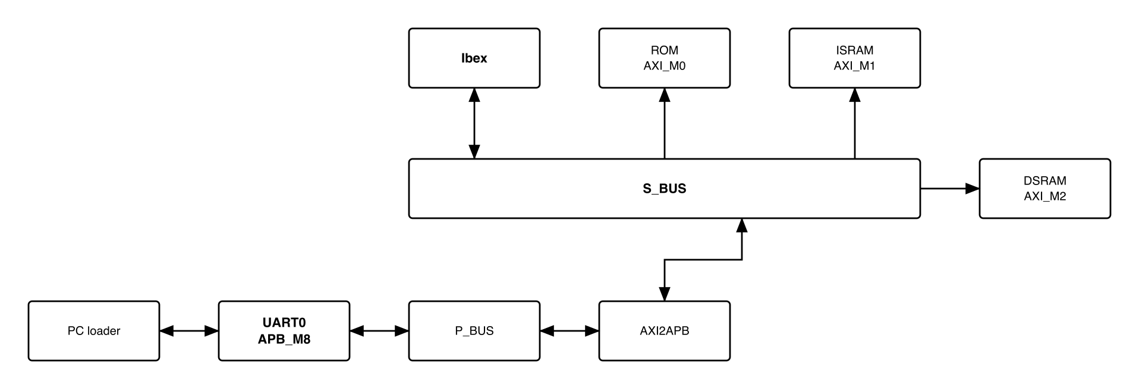
Figure 3-1. Blocks on the boot path
Table 3-1. Memory map, regions behind APB_M8 and AXI_M0 and AXI_M1 and AXI_M2
Base | Size | Region | Port | Kind | Note
0x00000000 | 2 KiB | rom | AXI_M0 | memory | Boot code, read-only, executable
0x20000000 | 4 KiB | isram_dbg | AXI_M1 | memory | The debug window: the first 4 KiB of ISRAM, not a block of its own
0x20001000 | 60 KiB | isram | AXI_M1 | memory | The downloaded application
0x30000000 | 32 KiB | dsram | AXI_M2 | memory | Stack, heap and variables
0x80020000 | 16 KiB | uart_0 | APB_M8 | peripheral | Carries the boot download
The bootloader runs from the ROM, keeps its stack in DSRAM, writes ISRAM only from 0x2000_1000, and accesses no peripheral other than UART0.

4. Sequence
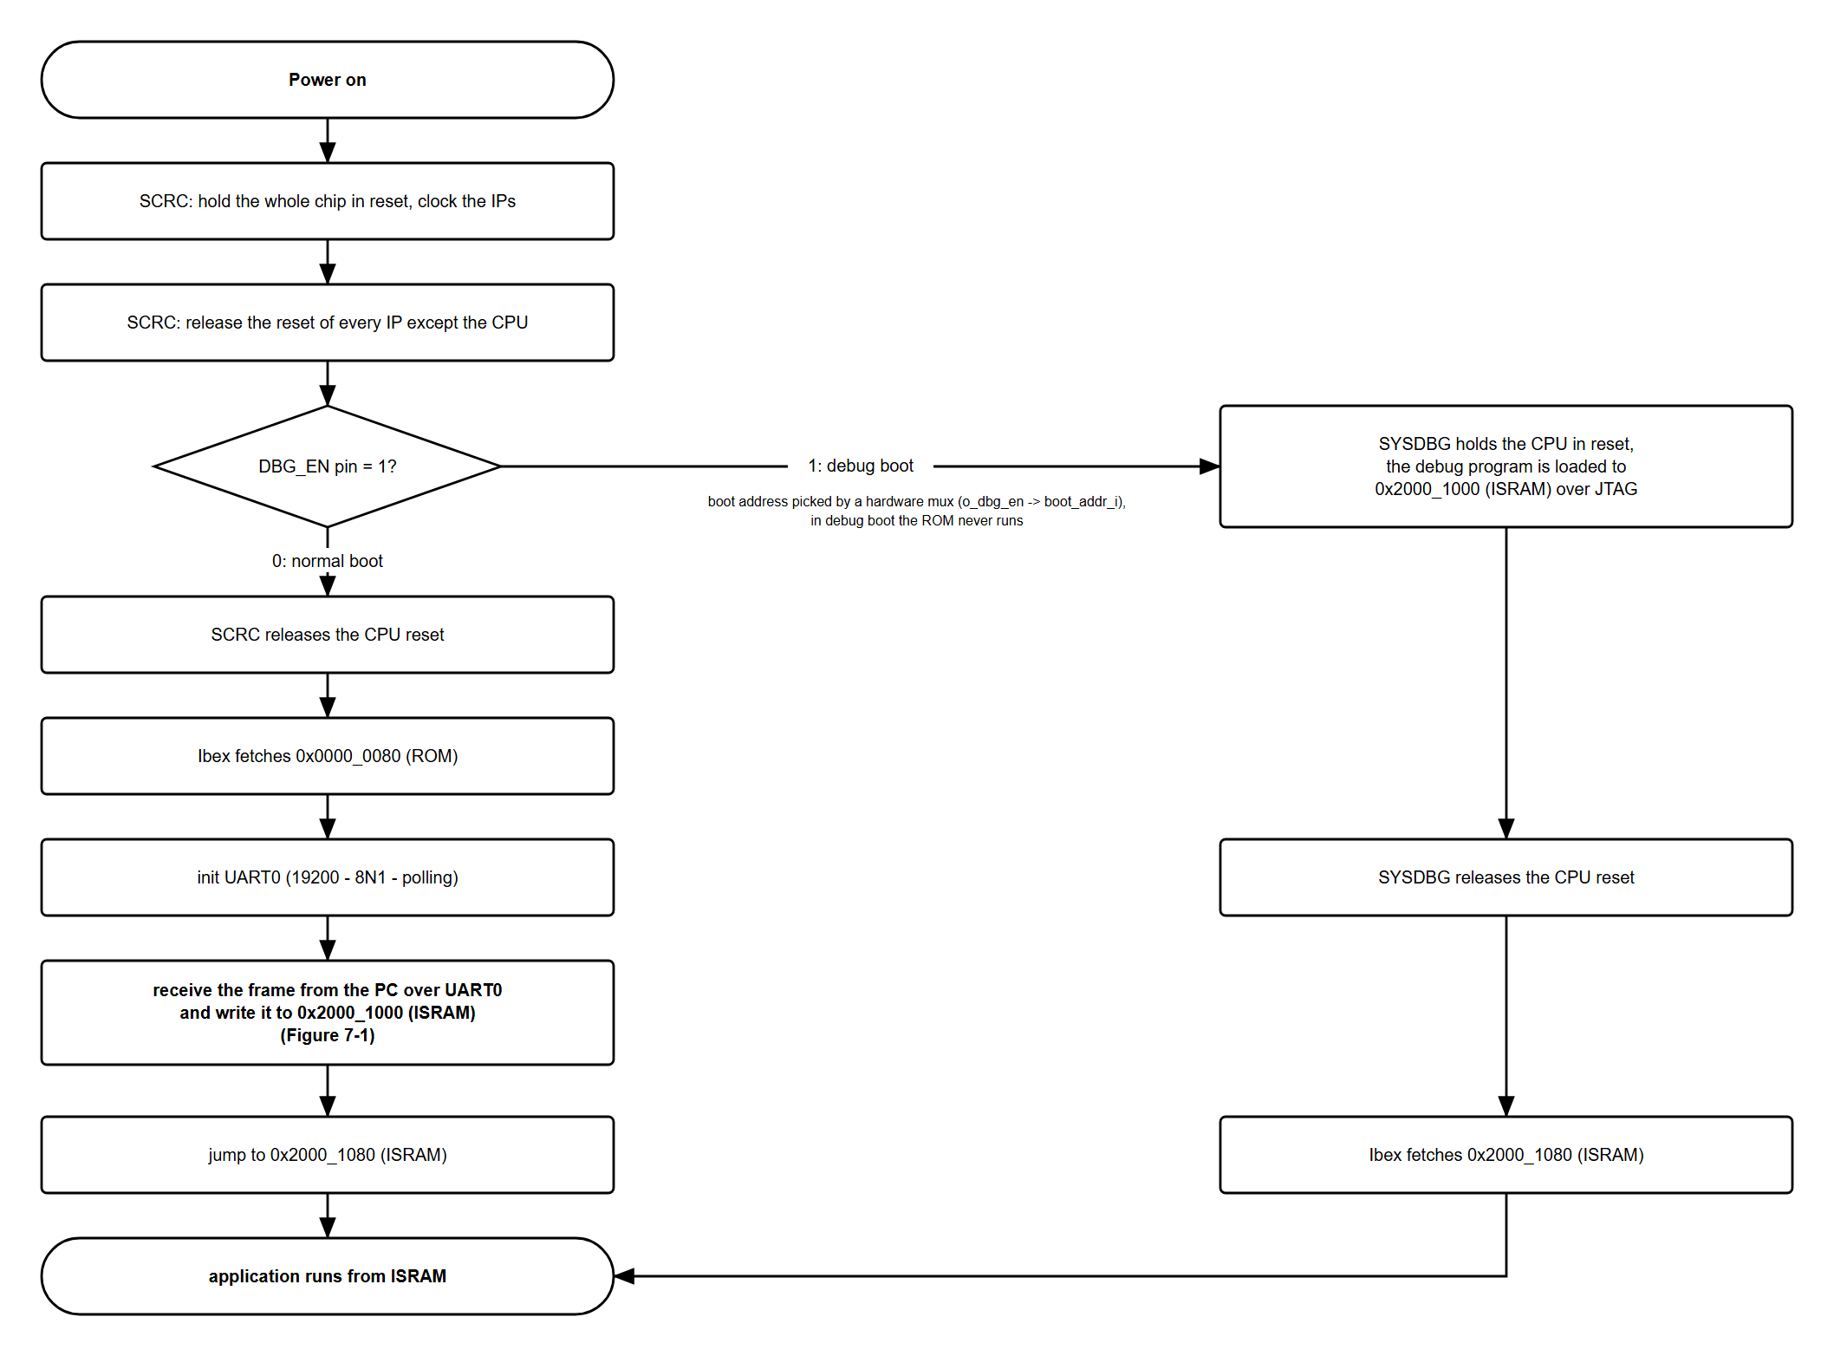
Figure 4-1. Reset to application
Table 4-1. Boot stages
Stage | Done by | Specified in | Ends when
1. Chip reset | SCRC RRC | QNSC_SCRC_MAS 7.3 | chip reset releases
2. Power-up | SCRC MCPU | QNSC_SCRC_MAS 7.5 | CPU released; UART0 clocked and reachable
3. Mode | SYSDBG | QNSC_SYSDBG_MAS 7.1 | o_dbg_cpu_hold = 0
4. ROM start | Ibex, crt0.S | QNSC_ROM_MAS 6, section 8 | boot_main called
5. Download | bootloader | section 7 | both CRCs pass, ACKP sent
6. Jump | bootloader | 7.5 | first instruction at 0x2000_1080
With DBG_EN = 1 stages 4 to 6 do not run. SYSDBG captures DBG_EN once after power-on, and the captured o_dbg_en switches the Ibex boot_addr_i from 0x0000_0000 to 0x2000_1000 in hardware. The ROM never reads DBG_EN; in debug boot it executes no instruction. The host loads the image through SYSDBG, releases the CPU, and the CPU starts at 0x2000_1080 (QNSC_SYSDBG_MAS 7.1, 7.2). The layout of section 9 is the same in both modes, so one image serves both.
Table 4-2. Steps of Figure 4-1
Step of Figure 4-1 | What happens | Specified in
Power on | The power-on reset. A WDT bite or SW_RST resets the chip too and enters at the next step; only POR makes SYSDBG read the DBG_EN pin again and put the CPU hold back on. | QNSC_SCRC_MAS 7.3
SCRC: hold the whole chip in reset, clock the IPs | The RRC holds the chip in reset: 16 cycles after a WDT bite or SW_RST; after POR it releases one cycle later. Then MCPU runs the CRM program, which first starts the clocks of the peripherals that CLK_EN asks for: after reset, every peripheral except TIMER1. | QNSC_SCRC_MAS 7.3, 7.5
SCRC: release the reset of every IP except the CPU | At least 3 cycles later MCPU releases the reset of every domain except the CPU. At least 16 cycles after that it opens the APB guards of the peripherals whose clock runs, the TIMER1 guard staying closed, so UART0 is reachable before the CPU runs. Register values: QNSC_SCRC_MAS 7.5. | QNSC_SCRC_MAS 7.5
DBG_EN pin = 1? | Decided by hardware, not by the ROM. SYSDBG reads the DBG_EN pin once after power-on. The value decides whether the CPU starts in the ROM (0) or in ISRAM (1), and whether the debugger may hold the CPU in reset. A WDT bite or SW_RST does not read the pin again. | QNSC_SYSDBG_MAS 7.1
SCRC releases the CPU reset (DBG_EN = 0) | Last, MCPU releases the CPU reset. The CPU leaves reset only when SCRC has released it and SYSDBG no longer holds it. With DBG_EN = 0, SYSDBG lets go as soon as it has captured DBG_EN, so the CPU starts when SCRC releases it, with the boot address already pointing at the ROM. | QNSC_SCRC_MAS 7.5, 7.8, QNSC_SYSDBG_MAS 7.1
Ibex fetches 0x0000_0080 (ROM) | Ibex starts at its boot address + 0x80: 0x0000_0080 in the ROM. The start-up code points the stack at the top of DSRAM, 0x3000_8000, and calls the bootloader, boot_main. | QNSC_ROM_MAS 6, section 8
init UART0 | Sets 19 200 baud, 8 data bits, no parity and 1 stop bit, turns the FIFOs on and the interrupts off (section 5). The ROM starts listening for MAGIC at once. | 5
receive the frame from the PC over UART0 and write it to 0x2000_1000 (ISRAM) | Receive and check the frame, Figure 7-1 and Table 7-1. The step ends when the header CRC, LENGTH and the payload CRC all pass. On any failure the ROM sends a failure token, empties the line and sends QRDY, and the PC resends the whole frame. | 7
jump to 0x2000_1080 (ISRAM) | The ROM sends ACKP, waits until the token has fully left UART0, clears the instruction prefetch and jumps to 0x2000_1080, where Ibex starts in debug boot too. | 7.5
application runs from ISRAM | Section 9. | 9
SYSDBG holds the CPU in reset, the debug program is loaded to 0x2000_1000 (ISRAM) over JTAG (DBG_EN = 1) | CPUHOLD is 1 after power-on, so SYSDBG keeps the CPU in reset while SCRC releases everything else, the CPU reset included. Meanwhile the host writes, over JTAG, the debug window 0x2000_0000–0x2000_0FFF and the program image from 0x2000_1000. | QNSC_SYSDBG_MAS 7.1, 7.2, 7.8
SYSDBG releases the CPU reset | The host writes 0 to the CPUHOLD register. SCRC has already released the CPU, so it leaves reset at once. | QNSC_SYSDBG_MAS 7.2
Ibex fetches 0x2000_1080 (ISRAM) | The boot address now points at ISRAM, so Ibex starts at 0x2000_1080, just after the image’s vector table. | QNSC_SYSDBG_MAS 7.2
In debug boot a WDT bite or SW_RST neither captures DBG_EN again nor sets CPUHOLD: with CPUHOLD = 0 the CPU restarts at 0x2000_1080 on the image already in ISRAM.

5. UART0 configuration
UART0 is pulp-platform/apb_uart around obi_uart: 16550 registers at byte offset 4 x n, 16-byte RX FIFO.
Table 5-1. UART0 registers used, base 0x8002_0000
Offset | Register | Use
0x00 | RBR / THR / DLL | receive, transmit; DLL = 65 while DLAB = 1
0x04 | IER / DLM | IER = 0; DLM = 0 while DLAB = 1
0x08 | FCR | 0x07: FIFOs on, both cleared
0x0C | LCR | 0x80 (DLAB) while writing the divisor, then 0x03: 8 bits, no parity, 1 stop
0x14 | LSR | bit 0 data ready; bit 5 THRE; bit 6 TEMT. Bits 1–3, the line errors, are not read
Divisor 65: 20 MHz / (16 x 65) = 19 231 baud, 0.16 % above 19 200, a standard rate on the PC. One byte takes 520 µs, 10 400 cycles. The low rate keeps a wide margin against framing errors on the link.
The ROM polls UART0 and uses no interrupt. To receive, it reads LSR in a loop: bit 0 set means a byte waits in RBR, which it then reads; otherwise it reads LSR again. While it hunts MAGIC the loop has no limit; after MAGIC it counts the polls against RX_TIMEOUT (7.3). To send, it waits for LSR.THRE = 1 and writes THR.
The ROM ignores the line error bits. With 8N1 there is no parity error. A byte received with a framing error is kept as it is and fails a CRC (FHCR or FPCR). A byte lost to an overrun leaves the frame one byte short, so the ROM waits for a byte that never comes and sends FTMO. Either way the PC resends the frame.

6. Frame format
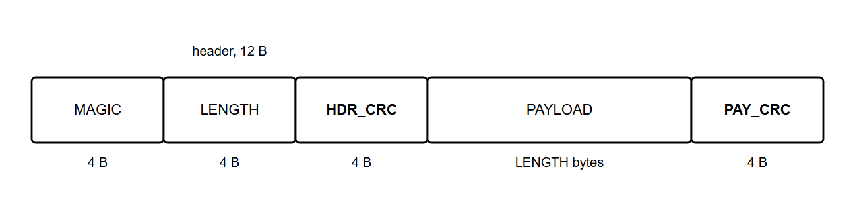
Figure 6-1. Boot frame; every field little-endian
Table 6-1. Frame fields
Offset | Field | ROM check
0x00 | MAGIC | the bytes ‘Q’, ‘S’, ‘O’, ‘C’ in that order
0x04 | LENGTH | multiple of 4, 132 to 61 440
0x08 | HDR_CRC | CRC32 of bytes 0x00–0x07
0x0C | PAYLOAD | LENGTH bytes of the application binary, zero-padded by the PC; written to ISRAM from 0x2000_1000
0x0C + LENGTH | PAY_CRC | CRC32 of PAYLOAD
The frame carries no address. The payload always goes to 0x2000_1000 and the ROM always jumps to 0x2000_1080: the addresses at which debug boot loads and starts an image (QNSC_SYSDBG_MAS 7.2), so one image serves both modes. LENGTH is at least 132 so that the image reaches the first instruction at 0x2000_1080, and at most 61 440 so that it ends inside ISRAM, at 0x2001_0000.
CRC32 is the zlib variant: reflected polynomial 0xEDB88320, initial value and final XOR 0xFFFF_FFFF. The ROM computes it bitwise.

7. Bootloader behaviour
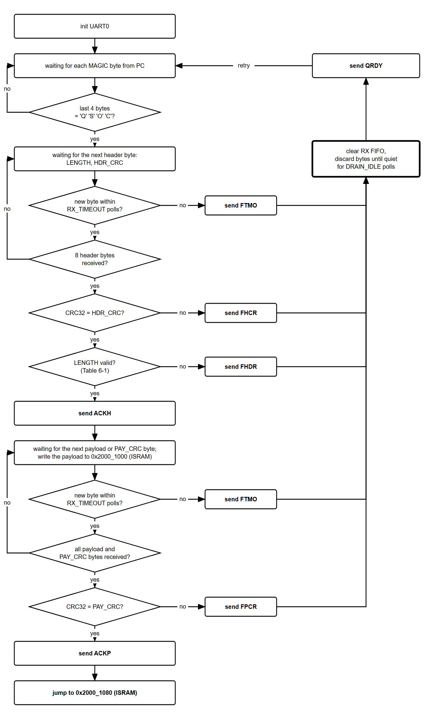
Figure 7-1. Bootloader flow
Table 7-1 describes each step of Figure 7-1 and how each failure is found. Every check is done by the bootloader in software.
Table 7-1. Steps of Figure 7-1
Step of Figure 7-1 | What the ROM does | Failure detected, token
init UART0 | Section 5. | –
waiting for each MAGIC byte from PC; last 4 bytes = ‘Q’ ‘S’ ‘O’ ‘C’? | Poll LSR with no time limit and shift each byte through a 4-byte window until it holds MAGIC. Nothing is sent. | none
waiting for the next header byte: LENGTH, HDR_CRC | Poll LSR for the 8 bytes of LENGTH and HDR_CRC. A CRC32 runs over MAGIC and LENGTH as they arrive. | –
new byte within RX_TIMEOUT polls? | The poll count restarts at every byte (7.3). | no: FTMO
8 header bytes received? | No: wait for the next header byte. | –
CRC32 = HDR_CRC? | Checked before LENGTH: with a wrong CRC its value means nothing. | no: FHCR
LENGTH valid? | The CRC only shows that the bytes arrived as the PC sent them, not that the value makes sense. LENGTH must be a multiple of 4 and 132 to 61 440 (Table 6-1), so the payload reaches 0x2000_1080 and stays inside ISRAM. | no: FHDR
send ACKH | ISRAM is written only after this token. | –
waiting for the next payload or PAY_CRC byte; write the payload to 0x2000_1000 (ISRAM) | Every 4 payload bytes are written as one word to ISRAM, the first at 0x2000_1000, and fed to a second CRC32. The 4 bytes of PAY_CRC are neither written nor fed. | –
new byte within RX_TIMEOUT polls? | As for the header. | no: FTMO
all payload and PAY_CRC bytes received? | The loop bound only: LENGTH payload bytes, then 4 bytes of PAY_CRC. No: wait for the next byte. | –
CRC32 = PAY_CRC? | PAY_CRC is the CRC32 the PC computed over the payload; the ROM compares it with its own. | no: FPCR, no jump
send ACKP, jump to 0x2000_1080 (ISRAM) | 7.5. | –
send failure token, clear RX FIFO, discard bytes until quiet for DRAIN_IDLE polls, send QRDY | The token is sent in full first. Then the RX FIFO is cleared, bytes are discarded until the line has been quiet for DRAIN_IDLE, QRDY is sent, and the ROM waits for MAGIC again (7.2). | –

7.1 Handshake
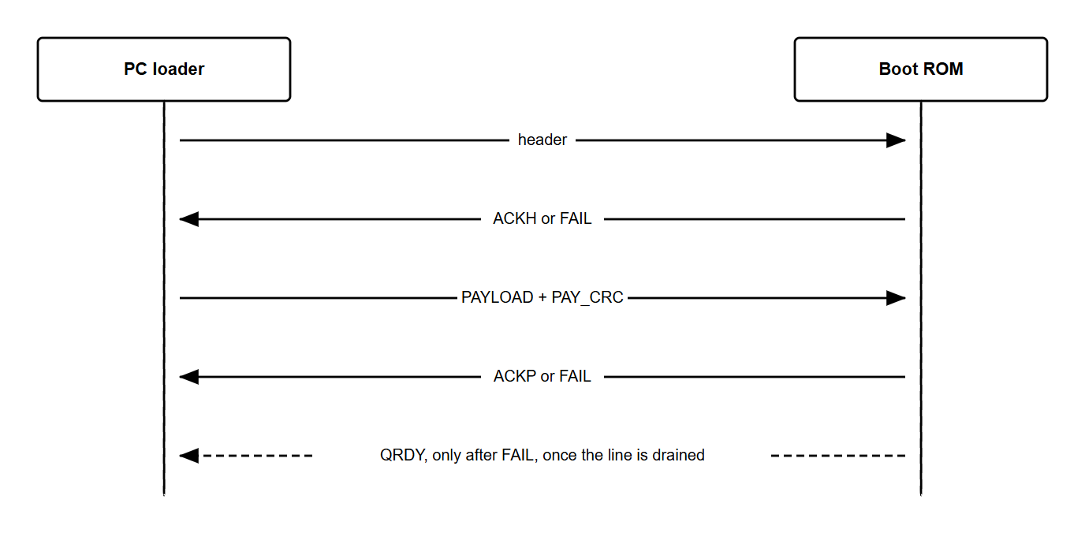
Figure 7-2. PC loader and boot ROM
Table 7-2. Tokens, 4 ASCII bytes, sent by the ROM
Token | Sent when
QRDY | after every failure, once the line is drained; not after reset
ACKH | header received, HDR_CRC correct, LENGTH in range
ACKP | PAY_CRC correct
FHCR | HDR_CRC wrong
FHDR | LENGTH out of range
FPCR | PAY_CRC wrong
FTMO | more than RX_TIMEOUT between two bytes after MAGIC
- FAIL in Figure 7-2 is any failure token; Figure 7-1 shows which step sends which.
- Bytes before MAGIC get no reply, so line noise is harmless. No token is sent after reset: the PC sends its frame without waiting. If the frame starts before UART0 is configured, MAGIC is missed, no ACKH comes back, and the PC resends after its 2 s wait.
- Nothing is written to ISRAM before ACKH.
- No token reports a UART error: a CRC failure or FTMO reports it (5).

7.2 Failure and retry
After a failure token the ROM clears its RX FIFO, discards bytes until the line has been quiet for DRAIN_IDLE, sends QRDY and waits for a new frame; the PC resends the whole frame. Words already in ISRAM are overwritten by the next one. The watchdog is off after reset (aon_timer WDOG_CTRL resets to 0), so a download that never completes waits for the PC or a reset. The PC waits for QRDY before it resends, so no byte of the new frame is lost in the drain. The PC stops sending as soon as it reads a failure token: it sends the payload in chunks and checks for a token between them, so the ROM does not drain the rest of a bad frame.

7.3 Timeouts
The bootloader uses no timer: a timeout is a count of LSR polls. A poll is at least one APB read, and an APB transfer takes at least 2 cycles, so Table 7-3 gives minimum times only. The exact time per poll depends on the bus path and is not specified.
Table 7-3. Timeouts
Constant | Polls | Minimum, at 2 cycles per poll | Meaning
RX_TIMEOUT | 1 000 000 | 100 ms, 192 byte times | between two bytes of a frame, after MAGIC
DRAIN_IDLE | 500 000 | 50 ms, 96 byte times | quiet line that ends a drain
MAGIC hunt | – | – | no limit
A slower poll only lengthens a timeout. The PC waits 2 s for each token, plus the payload time for ACKP, so the counts need no tuning. The margins cover gaps in the PC stream from the operating system and the USB-serial adapter. RX_TIMEOUT must stay below the PC’s 2 s wait, so a poll must take fewer than 40 cycles; the time per poll is measured in simulation (10).

7.4 Writing ISRAM
The payload is written one 32-bit word per four received bytes.

7.5 Jump
After ACKP the ROM waits for LSR.TEMT = 1, so the token has left UART0, executes fence.i, and jumps to 0x2000_1080. It does not return.

8. Bootloader image
Table 8-1. Limits, enforced by the build
Limit | Value | Enforced by
Image | 2048 bytes, vector table included (QNSC_ROM_MAS 6) | link.ld, util/gen_rom.py
Code | 1 KiB after the vector table (Day005 review) | make size
Sections | .text only: no .data, .bss or .rodata | link.ld
- crt0.S holds the 32 vectors and _start at 0x80: sp = 0x3000_8000, the top of DSRAM, then boot_main.
- Built with -march=rv32imc_zicsr_zifencei, which fence.i needs.
Table 8-2. Source, design/rom/boot/
File | Content
boot.h | Frame, tokens, timeouts; addresses from the generated qnsc_map.h
crt0.S, boot.c | Vectors and _start; the bootloader
link.ld | Layout and the limits above
Makefile | make, make size, make test, make test-serial; output rom_image.hex
tools/qsoc_image.py | Packs an application binary into a frame: pads it to a multiple of 4 and sets LENGTH
tools/qsoc_loader.py | Sends a frame over a serial port at 19 200 baud and follows the handshake: the payload in chunks, stopped at a failure token, then a retry
tools/rom_model.py, tools/test_protocol.py | Python model of boot.c, and the loader run against it for every token (make test)
tools/test_serial_link.py | The loader command line through pyserial (socket://) against the model (make test-serial)

9. Application contract
- Link at 0x2000_1000, 132 bytes to 60 KiB.
- Put a 128-byte vector table at 0x2000_1000 and set mtvec to it; put _start at 0x2000_1080. The same image then runs in debug boot.
- Set up its own stack and data in DSRAM.
- Find UART0 configured (19 231 baud 8N1, FIFOs on, interrupts off, transmitter empty), every peripheral clock running except TIMER1, and the watchdog off.
- Read and clear SYSCSR RESET_CAUSE (QNSC_SYSCSR_MAS 7.5).
Download time at 19 231 baud: 60 KiB in about 32 s, 22 KiB in about 11.7 s.

10. Requirements on others, and open items
Table 10-1. Requirements on other owners
Item | Owner | What it blocks
qnsc_map.h generated from the contract, as qnsc_pkg.sv is | lead | boot.h without typed addresses
Open items: design/rom/boot/ is in PR #51 (feat/rom-wrapper), not yet merged. ROM owner. Time per LSR poll, measured in simulation, to replace the minimums of Table 7-3. ROM owner.

11. Verification
- BOOT_001 After each reset source the ROM sends no token and accepts a correct frame: ACKH, ACKP, then execution at 0x2000_1080.
- BOOT_002 Bytes before MAGIC get no reply.
- BOOT_003 A wrong HDR_CRC gives FHCR, a LENGTH out of range gives FHDR; neither writes ISRAM.
- BOOT_004 A wrong PAY_CRC gives FPCR and no jump.
- BOOT_005 A gap longer than RX_TIMEOUT after MAGIC gives FTMO; a byte changed on the line gives FHCR or FPCR, a byte lost gives FTMO.
- BOOT_006 After every failure the ROM sends QRDY and accepts a resent frame.
- BOOT_007 After ACKP, ISRAM from 0x2000_1000 equals the payload word for word.
- BOOT_008 The build fails when a limit of Table 8-1 is broken.
- BOOT_009 make test passes against rom_model.py for every token.

Appendix A. Acronyms
Table A-1. Acronyms
Acronym | Description
CRC | Cyclic Redundancy Check
DLAB | Divisor Latch Access Bit, LCR[7]
LSR | Line Status Register
THRE, TEMT | Transmit holding register empty, transmitter empty

Appendix B. First review
Table B-1. First review
Item | Reviewer | Response
Handshake mandatory: ACK or failure per step | Quan (mentor), Day006 | 7.1
Header checked separately from payload | Quan (mentor), Day006 | 6, HDR_CRC
Why LOAD_ADDR and ENTRY are separate | Quan (mentor) | DECISIONS; both removed in V3.2
First fetch is ROM base + 0x80 | Sinh | QNSC_ROM_MAS 6
UART0 at 0x8002_4000, “APB slave 9” | lead, V3.0 | 0x8002_0000, APB_M8, map generated in 3
Byte time 86.8 µs, 1736 cycles | lead, V3.0 | 88.0 µs, 1760 cycles at the real baud rate
Word writes justified by “no byte-strobe path” | lead, V3.0 | ISRAM has byte strobes (QNSC_RAM_MAS 7.3); reason removed
Figure 4-1: show the CPU release | Quan (mentor), 29/09 | Figure 4-1, Table 4-2
Leave out of the MAS any parameter or step that is not known | Quan (mentor), 29/09 | 7.3: timeouts as minimums
Polling for the PC data not defined; QRDY after reset not needed | Quan (mentor), 29/09 | 5: polling; 7.1: no QRDY after reset, kept after a failure
“ACKP sent?” should test the CRC | Quan (mentor), 29/09 | Figure 7-1: CRC32 = PAY_CRC? before ACKP; V3.2 Figure 4-1 no longer repeats it
How does the CPU run the image loaded over JTAG if it starts in the ROM? | Quan (mentor), 29/09 | 4: hardware boot address mux; the ROM does not run
Baud rate down to about 10 000–20 000 | Quan (mentor), 29/09 | 5: 19 200
Figure 7-1: how each failure is detected and reported | Quan (mentor), 29/09 | Table 7-1
Describe every step of Figures 4-1 and 7-1 | Quan (mentor), 29/09 | Tables 4-2, 7-1
Drop ENTRY from the header, to match debug boot | Quan (mentor), V3.1 review | 6: no ENTRY, no LOAD_ADDR; the ROM jumps to 0x2000_1080

