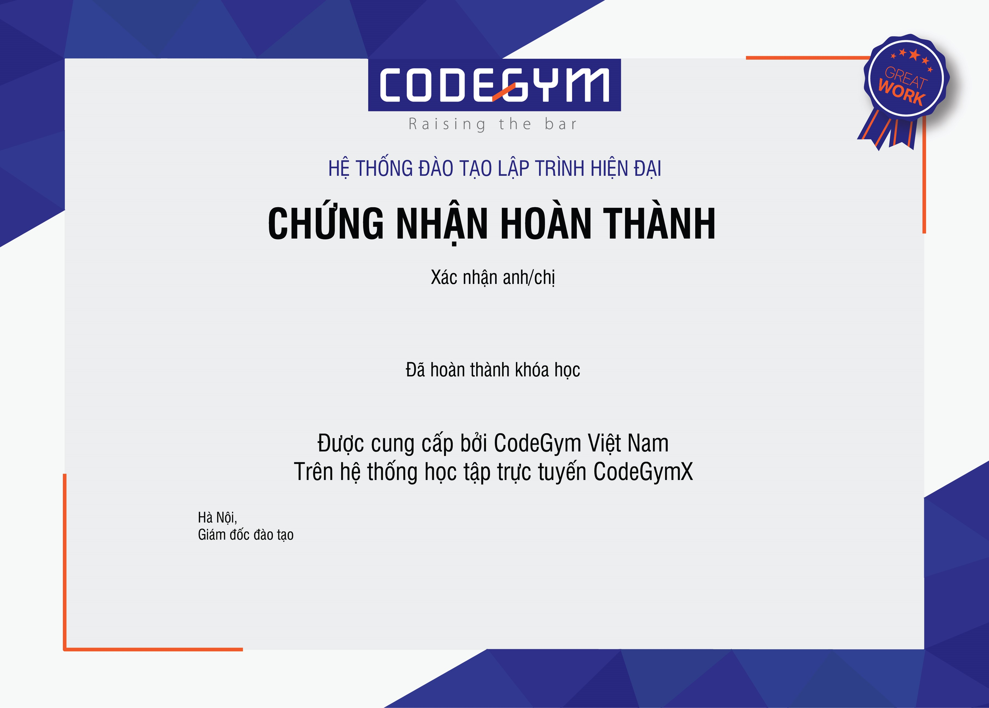

SCX - Scrum Essence

Trần Xuân Quỳnh

21

/11/

22

Powered by TCPDF (www.tcpdf.org

[)](http://www.tcpdf.org/)