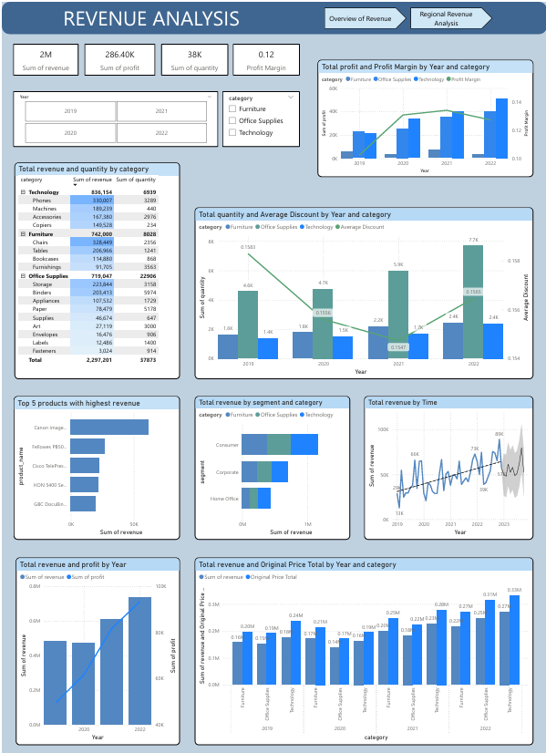
ONLINE RETAIL SALES PERFORMANCE ANALYSIS
Business Performance Analysis of U.S. Online Retail (2019 - 2022)

Data Analytics & Business Intelligence Project
Submitted for Data Analyst / Business Analyst Internship Application

Prepared by
TO LE QUYNH TRANG
Data Analyst / Business Analyst Intern Applicant

Tools & Technologies
Power BI

Project Date
December 2025

Contact
Email: toquynhtrang13@gmail.com

CONTENTS

I. INTRODUCTION 3
1.1. Reason for choosing the topic 3
1.2. Research objectives 3
1.2.1. General objective 3
1.2.2. Specific objectives 3
1.3. Scope of research 4
II. DATA PREPROCESSING 5
2.1. Load data in Power Query and perform preprocessing 5
2.2. Measure 6
III. ANALYSIS RESULTS 7
3.1. Dashboard 7
3.2. Online retail analysis 8
3.2.1. Overview of revenue 8
3.2.2. Analyze revenue by year and category 9
3.2.3. Revenue by time 12
3.2.4. Revenue Structure by Category 14
3.2.5. Revenue by segment and category 17
3.2.6. Impact of Discounts on Profitability by Year 18
3.2.7. Relationship Between Quantity and Discount 20
3.3. Regional Revenue Analysis 22
3.3.1. Revenue by region and time 22
3.3.2. Top 5 state with highest revenue 24
3.3.3. Total profit and profit margin by region 25
3.3.4. Total profit by region and category 27
IV. CONCLUSIONS AND GENERAL RECOMMENDATIONS 28
4.1. Conclusions 28
4.2. General Recommendations 29
REFERENCES 31

LIST OF FIGURES

Figure1. Overview of revenue Page 8
Figure 2. Regional revenue Page 8
Figure 3. Key Business Performance Indicators 8
Figure 4. Total revenue and profit by Year 9
Figure 5. Total profit and profit Margin by Year and Category 9
Figure 6. Total revenue by time 12
Figure 7. Total revenue and quantity by category 14
Figure 8. Top 5 products with highest revenue 15
Figure 9. Total Revenue by segment and category 17
Figure 10. Total revenue and original price total bu year and category 18
Figure 11. Total quantity and Average Discount by year and category 20
Figure 12. Total revenue by region 22
Figure 13. Top 5 state with highest revenue 24
Figure 14. Total profit and profit margin by region 25
Figure 15. Total profit by region and category 27

I. INTRODUCTION

1.1. Reason for choosing the topic
The period from 2019 to 2022 was a time of significant fluctuations for online retail activities in the United States, particularly under the impact of the COVID-19 pandemic and the subsequent economic recovery. In this context, e-commerce not only expanded rapidly in scale but also profoundly changed consumer behavior, product structure, shipping strategies, and the profitability of businesses.
Choosing the topic of analyzing the USA Online Retail Store from 2019 to 2022 allows for a comprehensive assessment of the effectiveness of online retail operations in the U.S. market during this turbulent period, thereby drawing valuable practical insights for business management and economic analysis.

1.2. Research objectives

1.2.1. General objective
To analyze data from the USA Online Retail Store during the period from 2019 to 2022 to assess the effectiveness of online retail business and identify factors affecting revenue and profit of businesses. Additionally, to identify regions with high or low revenue, profit, and profit margins, thereby clarifying the differences in business effectiveness across geographical areas in the U.S. market and drawing appropriate management implications.

1.2.2. Specific objectives
- Analyze the situation of revenue, profit, and profit margin of online retail stores over time.
- Evaluate business effectiveness by product, category, and subcategory.
- Compare business results among customer segments.
- Analyze differences in revenue and profit by geographical area (region, city, state).
- Examine the impact of discounts and quantity on revenue and profit.
- Propose some management implications to improve the effectiveness of online retail operations.

1.3. Scope of research
- Time scope:
The research is conducted on online retail transaction data during the period from 2019 to 2022, reflecting the fluctuations of business activities before, during, and after the COVID-19 pandemic.
- Spatial scope:
The analysis focuses on the online retail market in the United States, with data classified by regions (region), states (state), and cities (city).
- Data scope:
The USA Online Retail Store dataset from 2019 to 2022 includes information about:
- Orders and transaction times (order_id, order_date, ship_date);
- Products and manufacturers (product_name, manufactory);
- Customer segments and product categories (segment, category, subcategory);
- Geographical information (region, city, state, zip, country);
- Business indicators (sales, quantity, discount, profit, profit_margin).
- Content scope of the research:
The research focuses on analyzing and processing data from the USA Online Retail Store during the period from 2019 to 2022 through statistical data and visual charts, aiming to describe, compare, and evaluate the effectiveness of business operations over time, by region (region), product, and customer segment. Based on the analysis results, the research synthesizes and draws conclusions, while also proposing some recommendations and solutions to contribute to enhancing the effectiveness of online retail operations within the research scope.

II. DATA PREPROCESSING

2.1. Load data in Power Query and perform preprocessing
Go to the View menu, check the boxes for Formula Bar, Show whitespace, Column distribution, Column quality, Column profile. The information appears as below; we see that both Error and Empty are 0%, so we do not need to remove empty and duplicate columns.
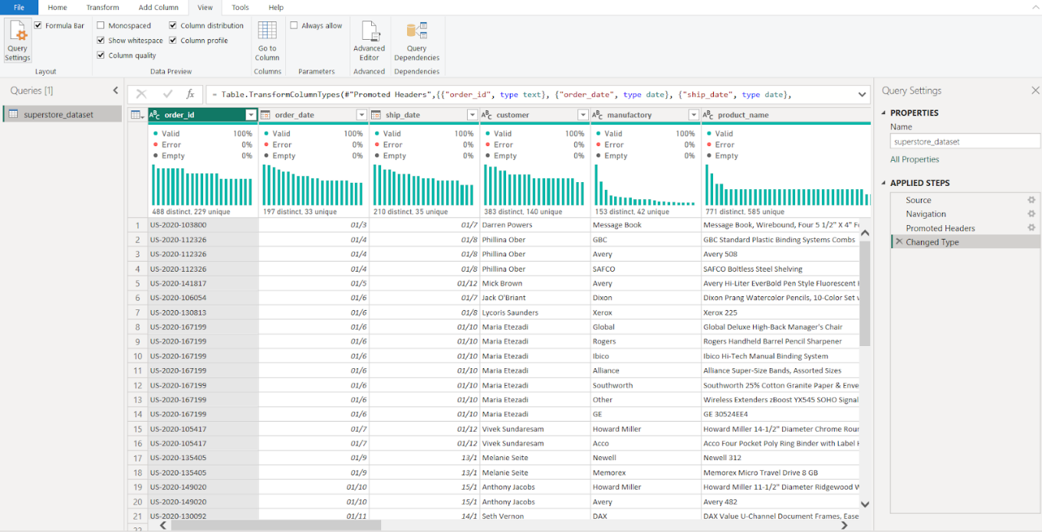
Split the order_date column and then merge it back into the correct date format. Rename the column to Date and adjust the format of the Date column.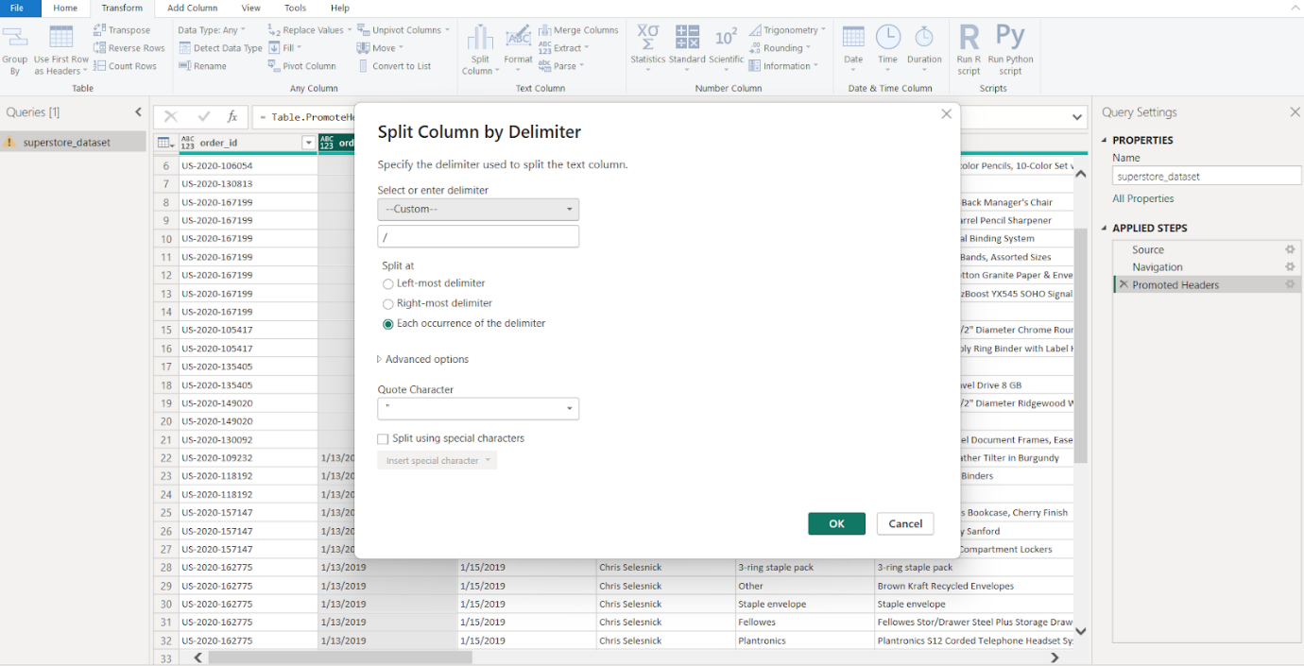
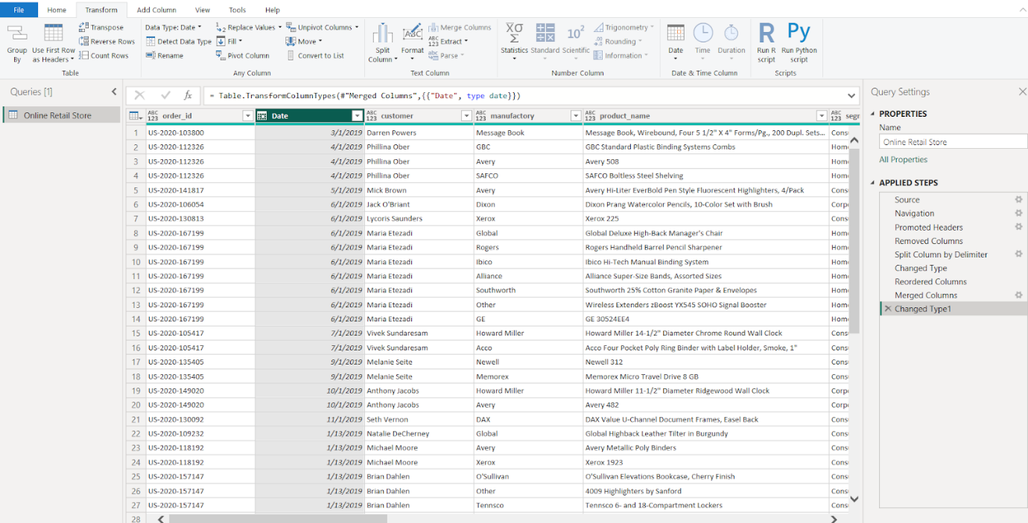
Adjust the formatting of the columns discount, profit, revenue, and profit_margin to Decimal number. Set the format of the quantity column to Whole number.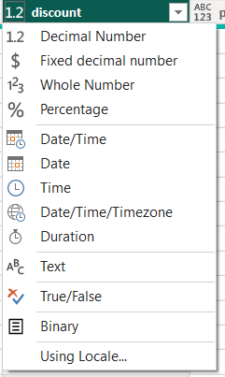 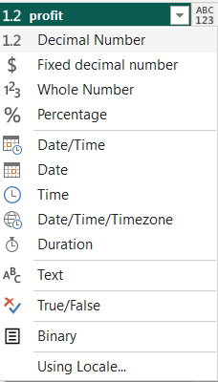 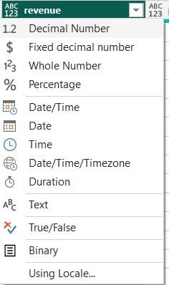 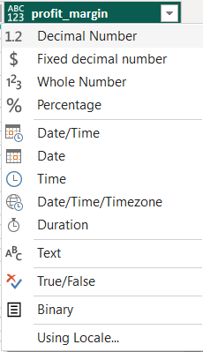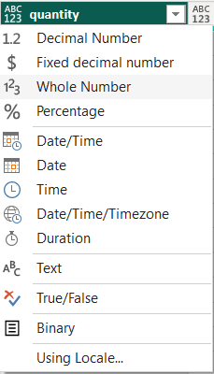

2.2. Measure
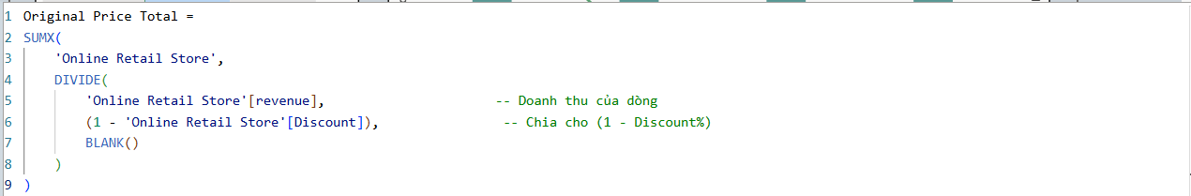

III. ANALYSIS RESULTS

3.1. Dashboard
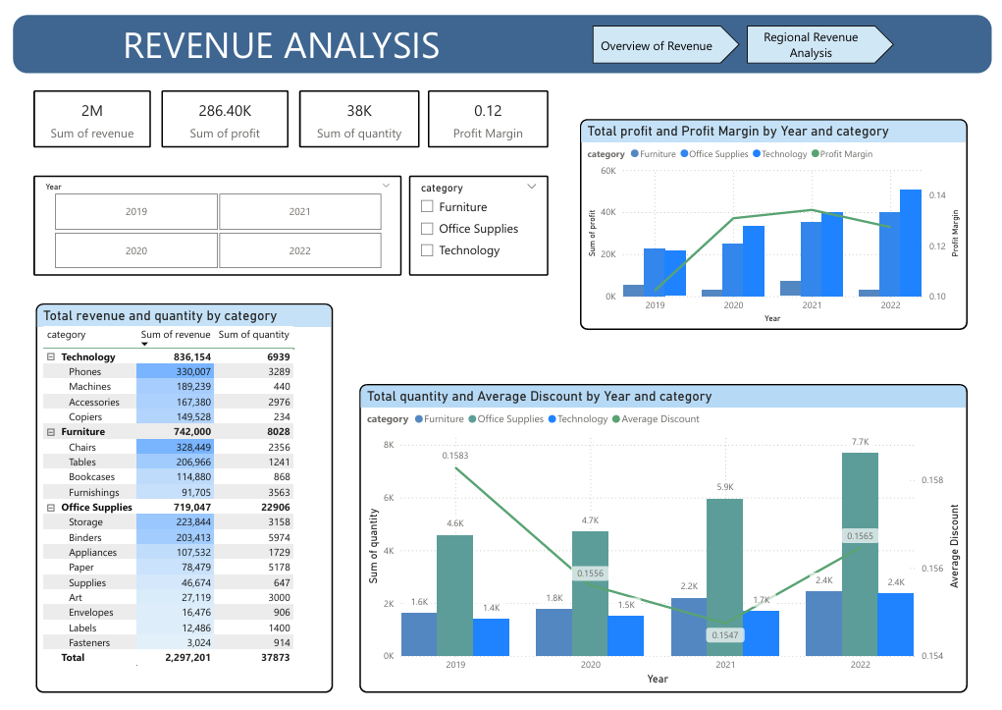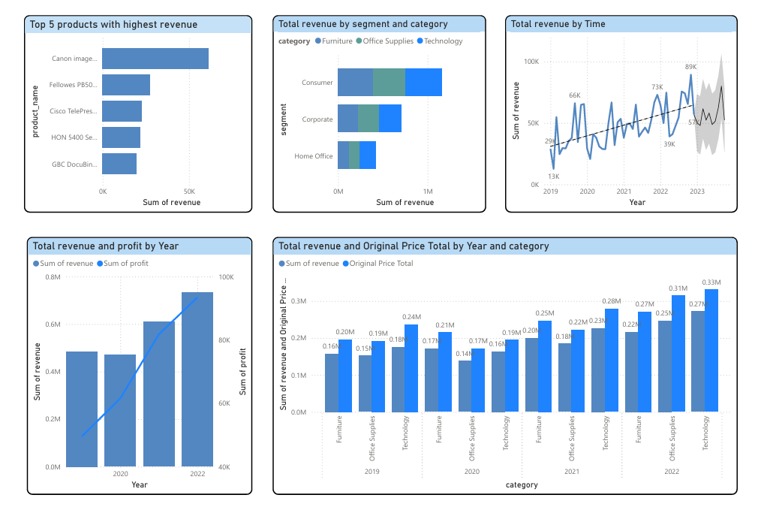
Figure1. Overview of revenue Page

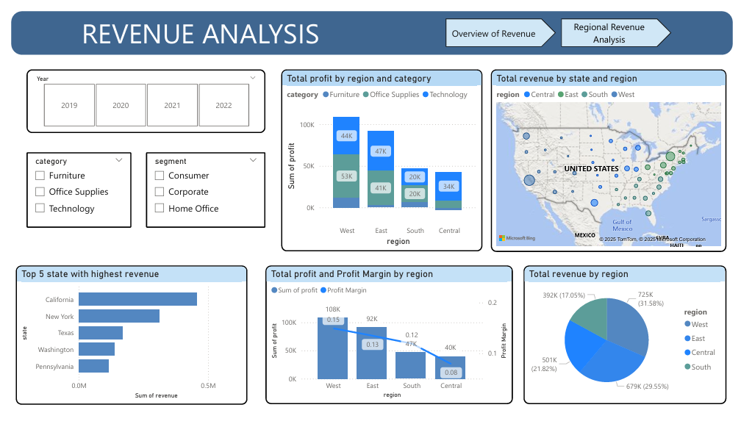
Figure 2. Regional revenue Page

3.2. Online retail analysis

3.2.1. Overview of revenue
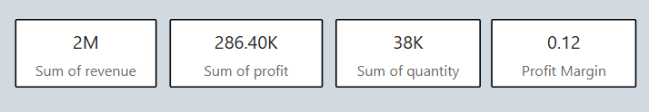
Figure 3. Key Business Performance Indicators
The company operates in the online retail sector in the U.S. market, offering products in three main categories: furniture, stationery, and technology. Sales activities are conducted on a nationwide scale, covering 4 regions and 49 states, reflecting the distribution capacity and broad market access.
During the period from 2019 to 2022, the business recorded revenue of approximately 2 million USD, with 38 thousand products sold. Total profit reached 286.4 thousand USD, equivalent to a profit margin of about 12%. Revenue is generated from three main customer groups: Consumer, Corporate, and Home Office, indicating a business model aimed at various segments that helps the company mitigate risks in the U.S. online retail market.

3.2.2. Analyze revenue by year and category
3.2.2.1. Revenue and category each year
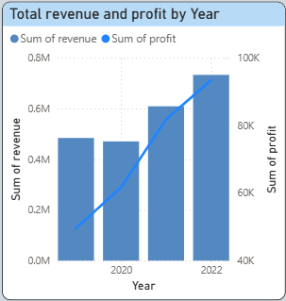
Figure 4. Total revenue and profit by Year
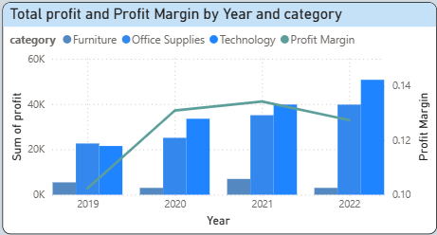
Figure 5. Total profit and profit Margin by Year and Category
In 2019, the base year
Total revenue reached 0.48 million USD, profit was 50 thousand USD, and profit margin was 10.2%, reflecting relatively stable business operations but low profitability. Technology and Office showed better profitability due to a high margin of over 12%, while the profit margin of Furniture was only about 3%, indicating lower efficiency and reducing the overall effectiveness of the business during this initial phase. This shows that the profitability of the categories differed from the very beginning.
In 2020: revenue declined, but efficiency improved
This was a period when the business adapted to the impact of Covid-19. Revenue slightly decreased to 0.47 million USD; however, profit increased to 62 thousand USD, and profit margin improved significantly to 13.1%. The contrast between revenue and profit indicates that the rate of cost increase was lower than the rate of profit generation. In other words, the business generated more profit per unit of revenue. This reflects improved business efficiency, despite the revenue scale being reduced in a challenging context. Technology and Office continued to maintain increasing profits and higher profit margins compared to the previous year, reflecting stable profit generation even in a difficult market environment. In contrast, Furniture continued to show unstable profitability, with profits and profit margins decreasing compared to 2019 and significantly lower than the other two categories.
In 2021: a period of strong growth and high efficiency
This marked a phase of strong growth in both scale and efficiency, with revenue increasing to 0.61 million USD, profit reaching 82 thousand USD, and profit margin at 13.4% – the highest level during this period. The simultaneous increase in revenue and profit margin indicates that yields were maintained while expanding scale, reflecting optimal and sustainable business efficiency in this recovery year. Category analysis shows that Technology and Office continued to have gradually increasing and stable profits, reflecting sustainable profitability, while Furniture, despite improvements compared to the previous year, still maintained a "wave-like" trend, lacking long-term stability.
In 2022, a phase of scale growth and declining profit margins
This was a period when the business expanded its scale to the highest level, with revenue reaching 0.73 million USD and profit increasing to 93 thousand USD. However, profit margin slightly decreased to 12.7%, indicating that costs began to rise faster than revenue as operational scale expanded. This result reflects a phase of growth in scale but relatively reduced efficiency. Although Technology and Office recorded significant profit increases compared to previous years at around 40 thousand USD and 50 thousand USD, Furniture had very low profits, almost the lowest in the four-year period, with a profit margin of only about 1% – the lowest throughout the period, indicating limited profitability.
3.2.2.2. General observations
The period 2019 - 2020 (Adaptation & Performance Improvement): Revenue slightly decreased by 2% (from 0.48 to 0.47 million USD), but profit increased significantly by 24% (from 50 to 62 thousand USD). Profit margin improved markedly from 10.2% to 13.1%.
The period 2021 - 2022 (Scale Expansion): Revenue grew strongly, reaching the highest level (0.73 million USD). However, profit margin showed a slight downward trend from the peak of 13.4% (in 2021) to 12.7% (in 2022).
Regarding product categories: There is a significant disparity in profitability. Technology and Office consistently maintained high profit margins (>12%), while Furniture had low and volatile profit margins (dropping to 1% in 2022).
3.2.2.3. Recommendations
Analyze the reasons for the profit margin decline in 2022: it may be due to the impact of operating costs rising faster than revenue during scale expansion, inflation increasing the cost of goods sold, or ineffective cost management strategies for the Furniture group when this group's profit margin hit a low of 1%.
Propose solutions to address this: Strengthen marketing strategies for high-profit and high-margin product groups (Technology, Office), optimize processes, and review the Furniture product portfolio to improve profit margins or eliminate ineffective items.
Set growth targets for 2023: Focus on maintaining and enhancing the successful cost optimization strategies from the 2019 - 2021 period, ensuring sustainable growth in both scale and efficiency.

3.2.3. Revenue by time
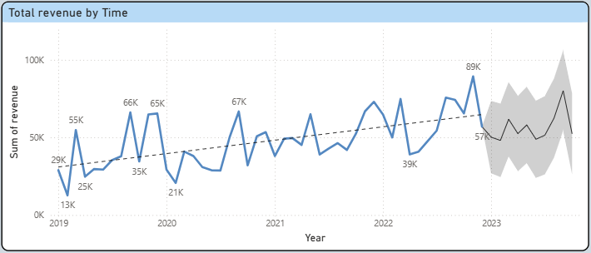
Figure 6. Total revenue by time
3.2.3.1. Revenue by quarter
Overview of Long-Term Growth Trends: Looking at the overall picture from 2019 to early 2023, the unit's revenue is in a positive growth cycle. The upward trendline clearly indicates that the business scale has significantly expanded year by year. If at the beginning of 2019, the average revenue only fluctuated around the threshold of 30K, by the end of 2022, this figure had been pushed up to a new baseline above 60K. This demonstrates that long-term business effectiveness is on the right track despite short-term fluctuations.
Characteristics of Fluctuations and Annual Cyclicality: Data shows a clear recurring pattern of seasonality. Most years begin with a sharp decline in the first quarter (with extreme lows of 13K in 2019 and 21K in 2020), before accelerating and peaking in the last months of the year. Notably, the "low point" of the following year is always higher than the previous year (for example, the low point of 2022 is 39K, significantly higher than the lows of previous years). This indicates that the financial health of the business is improving, and its ability to withstand downturns has strengthened over time.
+ Quarter 1: The "Trench" and Accumulation Phase at the Beginning of the Year
This is the most challenging time of the year when revenue often hits rock bottom. Specifically, the chart shows that the historical lows all fall in Q1, such as 13K (2019) or 21K (2020). By 2022, although the low point had risen to 39K, this still remains the quarter with the lowest performance compared to the rest of that year.
+ Quarter 2: Recovery and Mild Growth Phase
After hitting the bottom at the beginning of the year, Q2 usually records stable recovery. The chart shows clear upward slopes from the Q1 low. For example, from the 13K at the beginning of 2019, it bounced back to 55K, or from 21K in 2020, it surged to above 40K. This is the phase when the business begins to regain growth momentum, creating an important sales cushion in preparation for larger campaigns in the middle of the year.
+ Quarter 3: Strong Fluctuation Phase and Establishing Mid-Term Peaks
Q3 is often the time when there is strong contention between the upward trend and corrective phases. We see the emergence of high peaks such as 66K (2019), 67K (2020), and 73K (2022) typically occurring in the middle and late Q3. However, after each of these peaks, there is often a sudden deep drop (such as the fall to 35K in 2019 or 50K in 2022). This indicates that Q3 is highly seasonal, with revenue spiking but not maintaining long-term stability.
+ Quarter 4: Explosive Phase and Achieving the Highest Peak of the Year
Q4 is the "golden" time for the business when all indicators point towards record highs. The highest peak on the entire chart (89K) occurred in Q4 of 2022, and a similar trend has been observed in previous years when year-end revenue is usually higher than the annual average. This is the phase of maximizing market demand.
Forecast and Prospects for Early 2023: Entering early 2023, revenue recorded at 57K, beginning to enter the forecast zone (gray area). According to the forecasting model, revenue is likely to continue fluctuating strongly within a range of 50K to 80K. The gray area widening towards the end of the chart indicates the instability and unpredictability of the market in the near future.
3.2.3.2. Recommendation
Quarter 1 - "Overcoming the Trench": Revenue always hits rock bottom, but the baseline is gradually rising over the years. It is necessary to implement customer appreciation programs or "early year" promotions to stimulate demand early, leveraging the 39K low point (in 2022) as a springboard to maintain stable cash flow right from the beginning of the year.
Quarter 2 - Accelerating Recovery: Take advantage of the strong recovery momentum after Q1 to ramp up mid-scale marketing campaigns. This is an ideal time to introduce new products or key product lines to create a sustainable sales cushion before entering the volatile phase of Q3.
Quarter 3 - Managing Fluctuations: Although it often sets high peaks (66K - 73K), Q3 is prone to sudden drops. There needs to be a contingency plan for inventory and finances to cope with deep corrections, while also focusing on short-term contracts that can close quickly to maintain mid-term peaks.
Quarter 4 - Maximizing Revenue Drop Exploitation: This is the most explosive time of the year (peak 89K). The business needs to focus all efforts on advertising, large promotional programs, and optimizing logistics to meet market demand at record levels, ensuring that operational processes are not hindered during this "golden" period.

3.2.4. Revenue Structure by Category
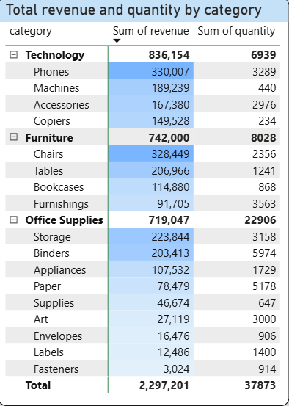

Figure 7. Total revenue and quantity by category
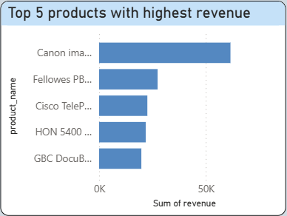

Figure 8. Top 5 products with highest revenue

3.2.4.1. Revenue by Category
At the category level, Technology leads in revenue with 836,154, despite only accounting for 18.4% of total output. Among the subcategories, Phones are a pillar as they lead in both revenue and volume, reflecting stable demand. Machines and Copiers stand out despite lower sales, generating high revenue, indicating the important role of high-value technology products in optimizing revenue. Accessories mainly support in terms of quantity, helping to expand the customer base and increase cross-selling. Additionally, 2 out of the top 5 highest revenue products belong to Technology, specifically the products ranked 1st and 3rd in the ranking. This shows that Technology's revenue is strongly driven by high-value products, independent of large volume sales.
In contrast, Office Supplies is the category with the largest volume (22,906 units, ~60.6%). Binders and Paper stand out with very large quantities, reflecting the frequent repeat purchase demand. Storage generates the highest revenue in the group, indicating better unit value than typical office items. The remaining subcategories mainly serve a supplementary role, helping to diversify the category but contributing little to revenue, with only 2 products appearing in the Top 5 revenue, specifically the products ranked 2nd and 5th. The fact that Office Supplies products still make it into the Top 5 despite being characterized by low prices indicates that some key items (such as storage devices and specialized office supplies) accumulate significant revenue due to very high sales frequency, rather than high unit prices.
For Furniture, only 1 product ranks 4th in the top 5 highest revenue products. This accurately reflects the intermediary role of this category: Furniture generates relatively large revenue (742,000) but lacks many standout products with exceptional revenue. Chairs are the leading subcategory, leading in both revenue and quantity. Tables stand out due to their high value per product despite low volume. In contrast, Furnishings mainly contribute in terms of quantity with low unit value, while Bookcases have limited demand and a smaller role.
3.2.4.2. Recommendations
Dominant group (Technology): Maximize resources on high-value products such as Phones, Machines, and Copiers to maintain the leading revenue position. Use the Accessories group as "bait" for cross-selling, helping to increase order value without relying on a race for sales volume.
Potential group and maintain cash flow (Office Supplies): Leverage the large volume advantage from Binders and Paper through bulk sales policies or subscription packages to ensure stable cash flow. Special emphasis should be placed on boosting the Storage line as this is the item with the best balance between unit value and purchasing frequency in the office supplies group.
Group needing optimization (Furniture): Focus on improving efficiency for the Chairs (core) and Tables (high value) lines by optimizing shipping costs for bulky items. Review and streamline low-demand groups like Bookcases to avoid wasting resources, shifting focus to products with better revenue breakthrough potential.

3.2.5. Revenue by segment and category
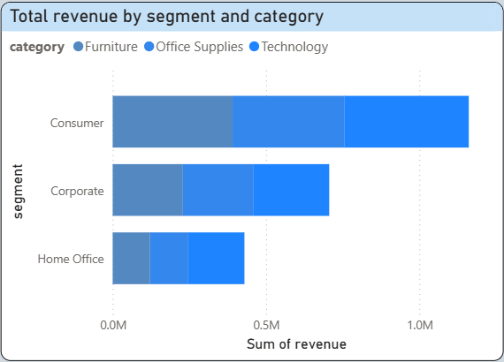
Figure 9. Total Revenue by segment and category
3.2.5.1. Revenue by each segment
According to customer segments, Consumer is the main revenue driver, generating about 1.2 million USD, accounting for nearly 50% of total revenue. Among them, Technology is the highest with 406K, followed by Furniture at 391K and Office Supplies at 364K. The revenue structure is quite balanced, indicating that Consumer has diverse needs and is not dependent on a single category.
Corporate is the second largest segment with revenue of about 0.7 million USD. The revenue structure here is relatively balanced between Furniture and Office Supplies (around 230K), with Technology leading at 246K; however, the difference is not too significant. This reflects the dual needs of corporate customers: investing in technology equipment while maintaining daily operations with office supplies.
In the Home Office segment, Technology generates the highest revenue at around 180K, while Office Supplies and Furniture are both above 120K and quite similar. This structure shows that the primary need is for technology equipment to support working from home, while the other two categories play a supplementary role.
3.2.5.2. Recommendations
Firstly, continue to prioritize the Consumer segment as the core revenue growth driver. With a share of nearly 50% of total revenue and a balanced revenue structure among Technology, Furniture, and Office Supplies, the business should maintain a diverse product portfolio strategy while enhancing cross-selling and product bundling programs to tap into the multifaceted needs of this customer group, rather than overly focusing on a single category.
Secondly, for the Corporate segment, it is necessary to apply a solution-based selling strategy. Due to the parallel demand between Technology and products that support daily operations, the business can design combined product packages (technology equipment + office supplies + basic furniture) to increase the average order value and strengthen long-term relationships with corporate customers.
Thirdly, for the Home Office segment, Technology should be seen as the development focus. The business can concentrate on technology products that support working from home, while using Furniture and Office Supplies as supplementary products to increase revenue per customer, rather than expanding a sprawling product portfolio.

3.2.6. Impact of Discounts on Profitability by Year
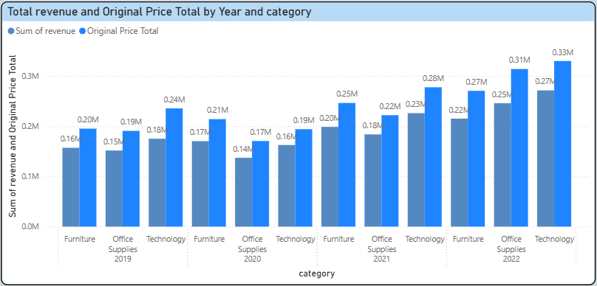
Figure 10. Total revenue and original price total by year and category
3.2.6.1. Revenue of category by year
In 2019: All three categories had revenue lower than the original price, indicating that discounting activities were widespread. Technology had the largest gap (0.24M → 0.18M), reflecting higher demand pressure compared to Furniture (0.20M → 0.16M) and Office Supplies (0.19M → 0.15M). However, Technology still generated the highest revenue among the three groups, demonstrating the ability to sell high-value products even when discounts were necessary.
In 2020: Furniture's revenue slightly increased to 0.17M while Office Supplies decreased to 0.14M, reflecting a shift in demand. Technology saw a decrease in both original price and revenue (0.19M → 0.16M), indicating a contraction in market size. The gap between revenue and original price in all three categories narrowed compared to 2019, implying that businesses began to control discounts more tightly.
In 2021: All categories showed a clear recovery. Technology led with revenue of 0.23M on an original price of 0.28M, while Furniture reached 0.20M / 0.25M and Office Supplies 0.18M / 0.22M. Although there was still a gap due to discounts, the increase in revenue indicated improved market demand, allowing businesses to expand sales without significantly increasing discount levels.
In 2022: This was the year of the strongest growth. Technology continued to lead (0.27M / 0.33M), but Office Supplies grew the fastest, reaching 0.25M on an original price of 0.31M, coming close to Technology. Furniture also showed steady growth (0.22M / 0.27M). Despite a significant increase in original prices across all three categories, the gap with revenue did not widen correspondingly, indicating that revenue growth was driven by real demand rather than deep discounts.
3.2.6.2. Objective conclusion
During the period from 2019 to 2022, all three categories recovered and showed significant growth after the decline in 2020. Technology maintained its leading role in revenue, while Office Supplies demonstrated the fastest growth rate during 2021–2022. More importantly, the gap between Original Price and Revenue did not widen over time, reflecting that revenue growth primarily came from expanding market demand and better discount control, rather than relying on aggressive discounting strategies.
3.2.6.3. Recommendation
Technology: Currently, the level of discounting has been better controlled since 2020 but still creates a large gap between Original Price and Revenue. Businesses should reduce reliance on widespread discounts, shifting to conditional discounts (seasonal, on old products, or bundled) to preserve revenue on high-value products.
Office Supplies: The gap between Original Price and Revenue is gradually narrowing while revenue is increasing rapidly, indicating that discounts are no longer the main determining factor. Businesses can maintain low or moderate discount levels, focusing on selling in volume and long-term contracts to expand revenue without sacrificing price.
Furniture: The current discount strategy helps maintain stable growth but has not created a significant breakthrough. Businesses should apply selective discounts for slow-moving product lines while limiting deep discounts on core products to avoid eroding revenue.

3.2.7. Relationship Between Quantity and Discount
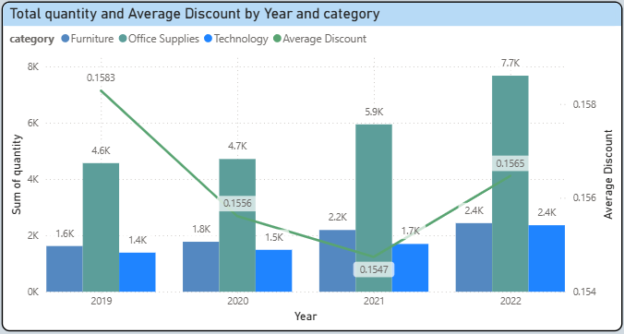
Figure 11. Total quantity and Average Discount by year and category
3.2.7.1. Quantity and Discount Analysis by Category
Office Supplies is the category with the highest and fastest-growing quantity, increasing from 4.6K in 2019 to 7.7K in 2022. The average discount remained relatively stable, ranging between 15.2% and 16% throughout the period. This indicates that the growth of Office Supplies was primarily driven by repeat purchases and high purchase frequency, rather than by increasing discount levels, thereby allowing the category to maintain profitability despite large quantity.
Technology recorded a lower quantity but exhibited steady growth, rising from 1.4K to 2.4K. Notably, this category maintained the lowest average discount among the three, fluctuating only between 12.7% and 13.7% (0.137 → 0.127 → 0.137 → 0.13). The simultaneous increase in quantity and consistently low, stable discounts suggests strong pricing power, implying that Technology’s growth is of higher quality and carries stronger profit potential compared to the other categories.
Furniture experienced moderate growth in quantity, increasing from 1.6K to 2.4K, but consistently recorded the highest average discount, ranging from 16.9% to 18.2% (0.182 → 0.169 → 0.177 → 0.17). This pattern indicates that Furniture relies more heavily on discount-driven demand to stimulate quantity. Although quantity increased, such a strategy poses a risk of profit margin erosion, particularly if higher discounts do not generate proportionate growth.
3.2.7.2. General comments
The combined analysis of Total Quantity and Average Discount over the period 2019–2022 reveals substantial differences in growth mechanisms across categories. Technology achieved volume growth from 1.4K to 2.4K while maintaining the lowest discount levels (approximately 12.7%–13.7%), reflecting its ability to expand sales at effective price points. Office Supplies recorded the largest increase in volume, from 4.6K to 7.7K, while sustaining a stable average discount of 15%–16%, indicating growth driven mainly by scale expansion at established discount levels. In contrast, Furniture’s volume growth from 1.6K to 2.4K was accompanied by the highest discount levels (16.9%–18.2%), suggesting that its growth is closely tied to discount policies.
3.2.7.3. Recommendation
The company should shift from a discount-led quantity growth strategy to a category-specific quantity optimization strategy. For Technology, maintaining low discount levels is recommended, as sales volume continues to grow steadily, indicating relatively low price sensitivity. For Office Supplies, discounts should remain stable while the company focuses on leveraging repeat purchasing behavior to further expand sales volume without compromising profit margins. Conversely, for Furniture, broad-based discounting should be reduced and replaced with targeted discount strategies, in order to prevent situations where quantity growth is not proportional to high discount levels.

3.3. Regional Revenue Analysis

3.3.1. Revenue by region and time
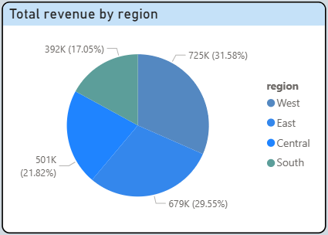
Figure 12. Total revenue by region
3.3.1.1. Revenue by time of each region
In 2019: Revenue reached approximately 484K. The West region led with 30.54% (147.88K), closely followed by the East with 26.57%. The South and Central regions had equal shares, both at 21.44%.
In 2020: Total revenue slightly decreased to 471K. A notable point was the East region rising to the number one position with a share of 33.22% (156.33K), pushing the West region down to second place with 29.75%. The South region shrank significantly to only 15.17%.
In 2021: A strong recovery was recorded with revenue soaring to 609K. The West region regained its leading position with 30.77%. The Central region experienced strong growth in share, accounting for 24.11%, while the South continued to be the smallest region with 15.37%.
In 2022: Revenue reached a record high of 733K. The West region exploded in strength, accounting for 34.11% of revenue (250.13K). The East region maintained its second position with 29.06%, while the South and Central held 16.76% and 20.07%, respectively.
3.3.1.2. General comments
Overall, the West region leads the strategy with the largest scale and the most stable growth, contributing 31.58% of total revenue (725.46K). Following is the East region, a key market playing a significant counterbalance role with nearly 30% of revenue (678.78K). Meanwhile, the Central region, despite maintaining a share of 21.8% (501K), has yet to show a breakthrough in scale. Finally, the South region, a niche market, has the lowest contribution at 17.05% (391.72K) and is showing a slight upward trend in recent years.
3.3.1.3. Recommendation
The business should maintain and strengthen the West region as the core market, prioritizing resources to protect its leading position and further tap into growth potential. The East region should be viewed as the second strategic market, suitable for scaling up and creating a balance with the West in the long term. For the Central region, the business should focus on depth (optimizing sales channels and product portfolio) rather than rapid expansion, to create a foundation for sustainable growth. As for the South, a selective strategy should be applied, experimenting with initiatives suitable for the niche market to improve revenue without increasing risk.

3.3.2. Top 5 state with highest revenue
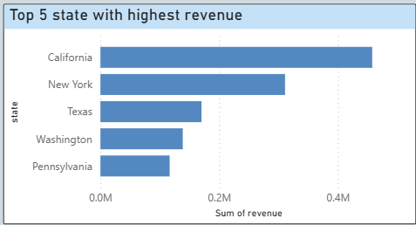
Figure 13. Top 5 state with highest revenue
3.3.2.1. Revenue by state in Top 5
California (Leading Position): As the state with the highest revenue in the entire system, surpassing other states with a value approaching 0.5M. Being part of the West region, California plays a key role as the main "economic hub" helping this area maintain its leading position.
New York (Eastern Hub): Ranking second with revenue exceeding 0.3M. This is the main growth driver of the East region.
Texas (Central Representative): Ranking third with revenue fluctuating around 0.18M. This is the only state from the Central region to make it onto this list.
Washington and Pennsylvania rank at the bottom with revenue of just over 0.1M, only about 1/5 of the leading state. The significant gap indicates that revenue is not evenly distributed but concentrated in key "supermarkets."
3.3.2.2. General comments
The dominance of coastal economic poles: 4 out of the 5 states with the highest revenue belong to the West (California, Washington) and East (New York, Pennsylvania) regions. This shows the imbalance in market scale between coastal states and inland states.
Revenue Gap: There is a large discrepancy between the leading state (California) and the fifth state (Pennsylvania). California's revenue is approximately 3-4 times higher than Pennsylvania's, indicating a significant concentration of economic resources in the Western market.
The absence of the South region: The chart confirms that the South region has no representatives in the Top 5 states with the highest revenue. This reflects the characteristic of the South as a more fragmented or smaller market.
3.3.2.3. Recommendation
Businesses should strengthen the West and East regions by continuing to invest strategically in California and New York – the two states that play a leading role in driving most of the revenue growth in each region. At the same time, Texas needs to be positioned as a strategic pillar of the Central region to reduce the imbalance between regions and expand presence into the inland area. For Washington and Pennsylvania, the focus should be on optimizing efficiency within the existing region rather than rapid expansion. As for the South, since no state is currently in the leading group, businesses should adopt a cautious approach at the regional level, experimenting by state and segment to gradually improve revenue contributions.

3.3.3. Total profit and profit margin by region
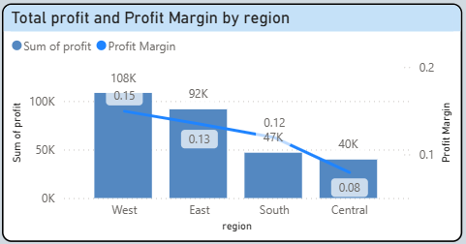
Figure 14. Total profit and profit margin by region
3.3.3.1. Total Profit and Profit Margin by each Region
West Region (Efficiency Leader): The West is the most optimized region, leading in both total profit (108K) and profit margin (0.15). This indicates that the West not only benefits from a large market size but also demonstrates strong cost control and effective pricing management.
East Region (Stable Performer): Ranking second, the East records a total profit of 92K with a profit margin of 0.13. The region serves as a stable profit pillar for the overall business.
South Region (Efficient Niche Market): Although total profit in the South is relatively low at 47K, significantly below West and East, its profit margin of 0.12 suggests that the region operates efficiently at its current scale, generating higher profitability per unit of revenue compared to the Central region.
Central Region: Despite achieving a total profit of 40K, which is not substantially lower than that of the South, the Central region records the lowest profit margin in the system at 0.08.
Overall, the profit margin trend declines sharply from West to Central. The margin gap from 0.15 to 0.08 (a reduction of nearly 50%) highlights a significant imbalance in cost control and pricing strategies across regions.
3.3.3.2. Recommendation
The company should continue to implement a region-differentiated strategy, maintaining the West as the benchmark for profitability by preserving its high margins through disciplined cost management and pricing, rather than pursuing expansion at any cost. The East should continue to play its role as a stable profit backbone, aligning with a selective growth strategy aimed at gradually improving profit margins on the existing scale.
For the South, the relatively strong profit margin supports the previously recommended cautious expansion strategy, whereby the company can incrementally scale operations to increase absolute profit while prioritizing efficiency per unit of revenue. In contrast, the Central region should be designated as a priority area for internal optimization, focusing on improving cost structures and product mix rather than aggressively expanding revenue, in order to narrow the profit margin gap relative to other regions.

3.3.4. Total profit by region and category
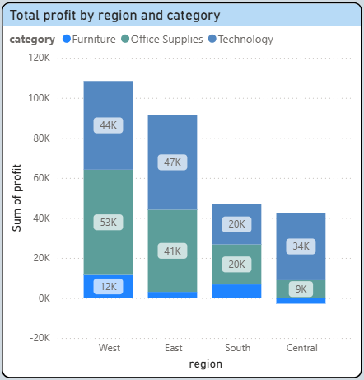
Figure 15. Total profit by region and category
3.3.4.1. Profit by Category across Four Regions
Technology is the largest contributor to profit in the East (47K) and, notably, in the Central region (34K). In the West, although it is not the top-performing category, Technology still generates a substantial profit of 44K. In the South, the category records 20K, equal to Office Supplies. Overall, Technology demonstrates strong stability and high profitability regardless of regional characteristics, serving as a key profit stabilizer, particularly for the Central region.
Office Supplies exhibits significant variation in performance across regions. The West region exploits this category extremely effectively, generating profits of up to 53K, the highest profit recorded for any single category in the chart. Profit levels are moderate in the East (41K) and South (20K). However, in the Central region, profit is only 9K, the lowest among all regions, indicating that Office Supplies is not a competitive strength in Central.
Furniture is the weakest-performing category and presents the most evident business risk. It generates only marginal profits in the West, East, and South, with the highest profit reaching just 12K in the West. In the East and South, Furniture profits are minimal, amounting to only a few thousand units. Most critically, the Central region records a negative profit of approximately –3K. As a result, Furniture acts as a profit drag on the overall system, particularly in the Central region, where it directly offsets the gains generated by other categories.
3.3.4.2. Recommendation
The company should restructure its category strategy on a region-specific basis, positioning Technology as the core profit driver across all regions. Given its stable profitability in the West, East, South, and especially Central, Technology should receive priority resource allocation in lower-performing regions to mitigate profit risk and stabilize overall regional performance.
For Office Supplies, the strategy should focus on deepening market penetration in regions with established advantages, particularly the West and East, where the category delivers strong profits and contributes meaningfully to overall performance. Conversely, in the Central region, Office Supplies should be maintained only in a supporting role, avoiding aggressive expansion until operational efficiency improves.
Regarding Furniture, weak profitability and losses in the Central region indicate a need for strict regional control. The company should scale back or reposition Furniture in Central, while maintaining it only as a complementary category in the West and East. Expansion driven purely by revenue growth should be avoided to prevent further erosion of overall profitability.

IV. CONCLUSIONS AND GENERAL RECOMMENDATIONS

4.1. Conclusions
Based on the business results achieved during the 2019–2022 period, the company possesses a solid foundation for future growth, particularly supported by the high profitability of the Technology category and the strong performance of the West region. These advantages provide favorable conditions for further expansion. However, declining profit margins amid rapid revenue growth, uneven performance across categories, and significant regional disparities indicate that the company faces notable challenges. Therefore, the company should pursue selective and efficiency-driven growth, strengthen cost control, optimize discount strategies by category and region, and restructure underperforming segments such as Furniture in order to sustain its competitive advantage and ensure long-term, sustainable growth.

4.2. General Recommendations
Adopt a differentiated growth strategy balancing scale expansion and efficiency optimization: The analysis shows that while revenue growth accelerated significantly during 2021–2022, profit margins began to decline as scale expanded. Therefore, future growth should prioritize a balanced strategy that simultaneously pursues revenue expansion and cost efficiency, rather than emphasizing scale alone. This is particularly critical to ensure that growth remains sustainable and does not erode profitability, especially in categories and regions with structurally low margins.
Position Technology as the core profit anchor across all dimensions (time, segment, and region): Technology consistently demonstrates superior profitability, low price sensitivity, and stable performance across years, customer segments, and regions. The company should reinforce Technology as the strategic profit anchor by prioritizing resource allocation, protecting pricing discipline, and focusing on high-value products. This approach can help stabilize overall business performance and offset risks arising from weaker categories such as Furniture.
Optimize discount strategies by category to protect profit margins:
Evidence from the relationship between quantity and discount indicates that sales growth is not primarily driven by deeper discounts, particularly for Technology and Office Supplies. The company should therefore shift from broad-based discounting toward category-specific and targeted discount policies. Maintaining low and stable discounts for Technology, stable discounts for Office Supplies, and selective, performance-based discounts for Furniture will help preserve margins while supporting sustainable volume growth.
Leverage Office Supplies as a cash-flow stabilizer rather than a margin driver:
Office Supplies contributes the largest sales volume and shows strong growth driven by repeat purchases rather than aggressive discounting. The firm should continue to leverage this category to ensure stable cash flow through volume-based strategies, long-term contracts, and bundling, while avoiding excessive price competition. This role complements the profit-driven strategy of Technology and supports overall financial resilience.
Implement region-specific strategies reflecting structural differences in profitability:
The sharp disparity in profit margins across regions—particularly between West and Central—highlights the need for differentiated regional strategies. The West should be maintained as the benchmark region for profitability and operational efficiency, while the East serves as a stable secondary pillar. The South should follow a cautious, efficiency-first expansion path, whereas the Central region should prioritize internal optimization of cost structures and product mix over rapid revenue growth.
Reassess the role of Furniture to minimize system-wide profit erosion:
Furniture exhibits weak and volatile profitability, with losses in the Central region and consistently low margins elsewhere. The company should reposition Furniture as a complementary category rather than a growth engine, scaling back underperforming product lines and regions, and focusing on operational improvements for core items. This will help prevent Furniture from undermining the gains generated by more profitable categories.

REFERENCES
tQchant. (2023). SuperStore Dataset 2019–2022: USA Online Retail Store [Data set]. https://www.kaggle.com/datasets/timchant/supstore-dataset-2019-2022?resource=download

