- Inside Schedule :
Please add text below create button
this text will contain information about schedule types APK ,reboot and MD5,We will get final text later from customer please add this temporary text for now

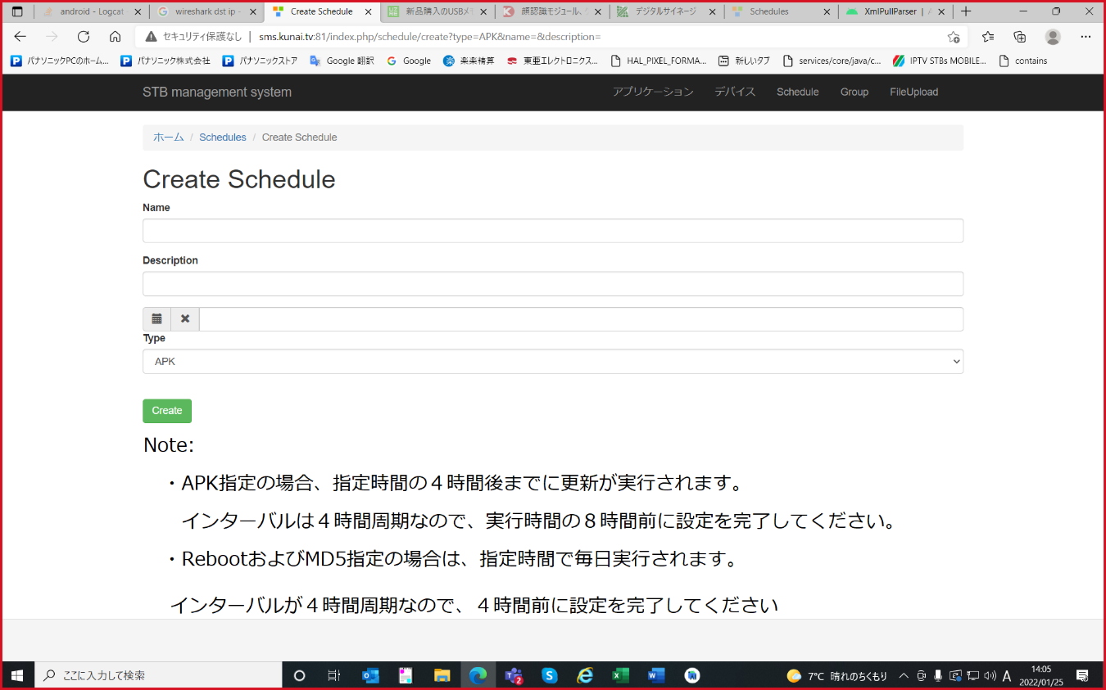

- Inside PUU App
Please follow schedule,
- PUU should update apk on only scheduled time
- reboot should not update the pcschool apk it should update only if the scheduled time is passed
Below is example
- SMS Schedule setting: 2022/1/26 20:00
- If stb reboot before 2022/1/26 20:00 => not update apk
- at 2022/1/26 20:00~24:00, => update apk
- If stb reboot after 2022/1/26 20:00 => update apk

