- Địa chỉ mac
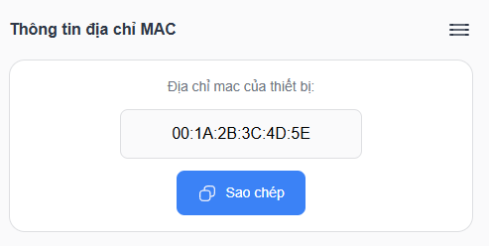
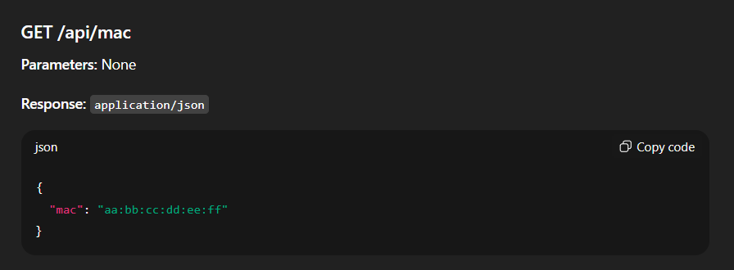
- Khai báo vòi bơm
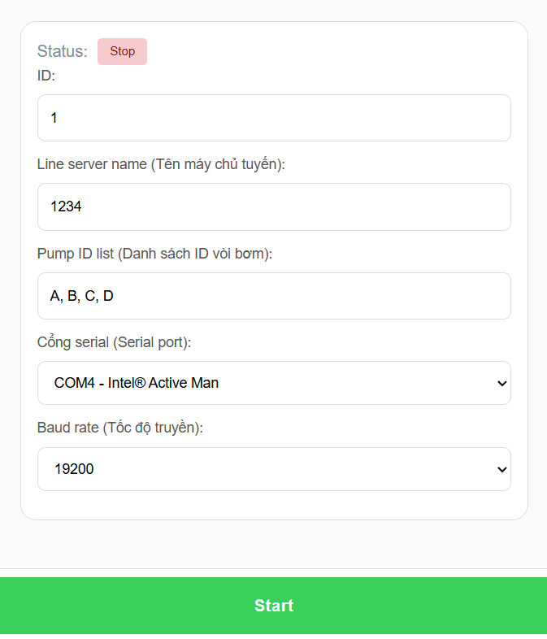
GET /api/ pump_status
Parameters: No parameters
Response: application/json
{"id":1,"line_server_name":"abc","pump_id_list":"A, B, C, D","serial_port":"COM1","baud_rate":9600,"status":"running|stop" }
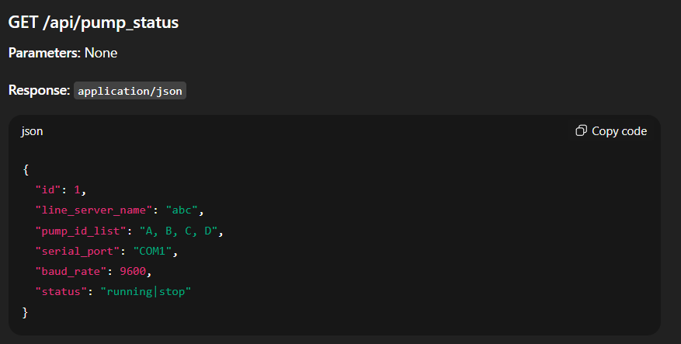
POST /api/ pump_status
Parameters: No parameters

Request body:
{"id":1,"line_server_name":"abc","pump_id_list":"A, B, C, D","serial_port":"COM1","baud_rate":9600,"status":"running|stop" }
Response: application/json
{“status:”success|error”}
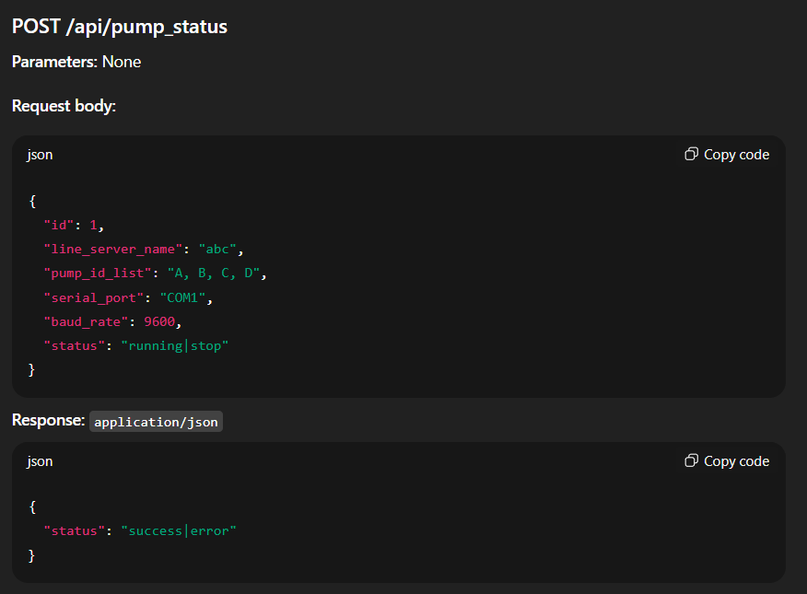
- Cấu hình nhiên liệu

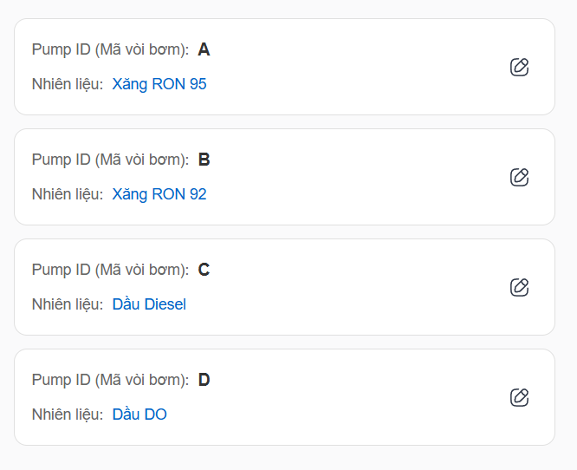

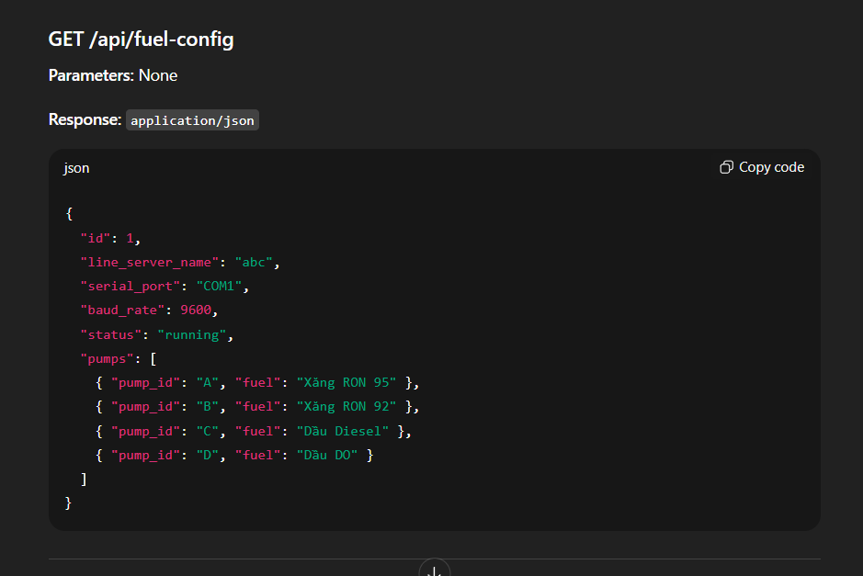

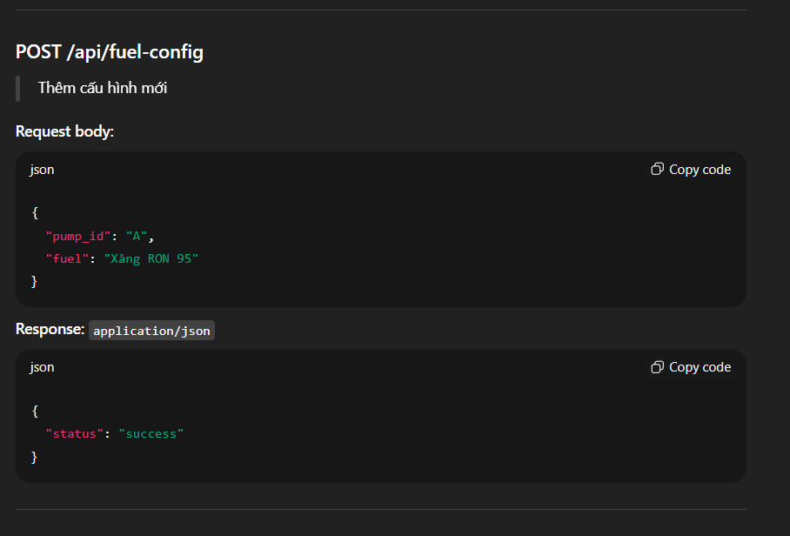

- Cấu hình giá nhiên liệu

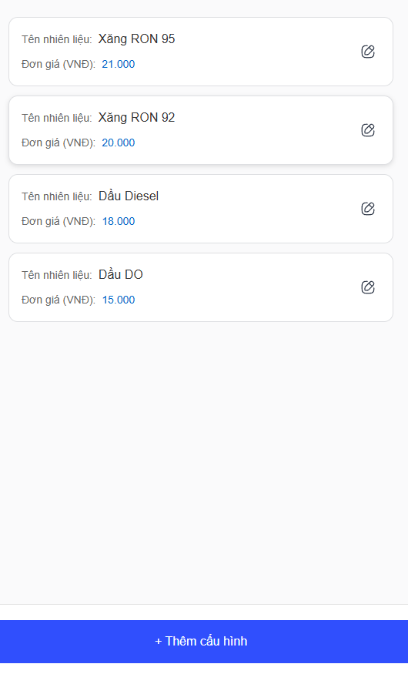

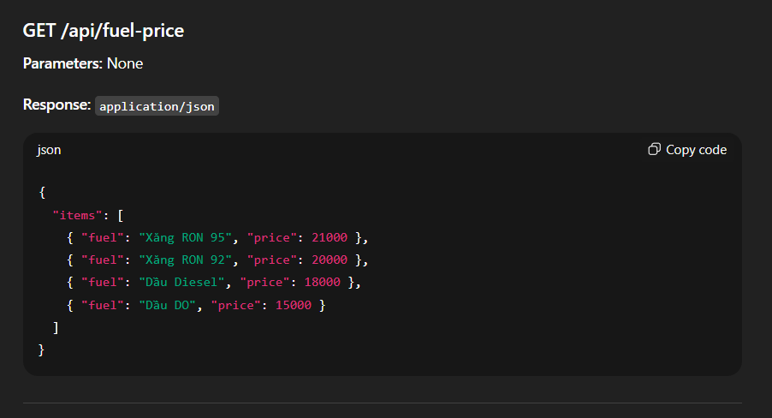

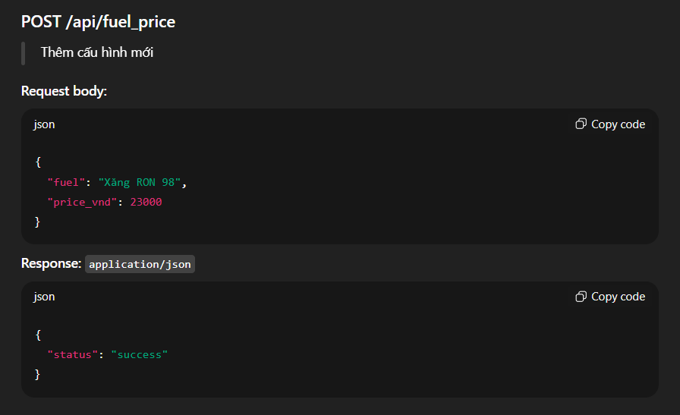

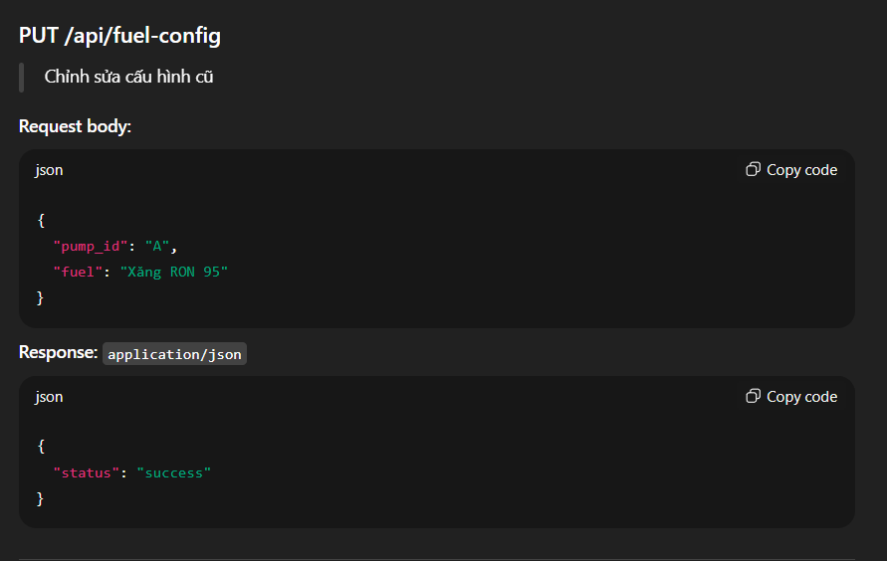

- Thông tin pump

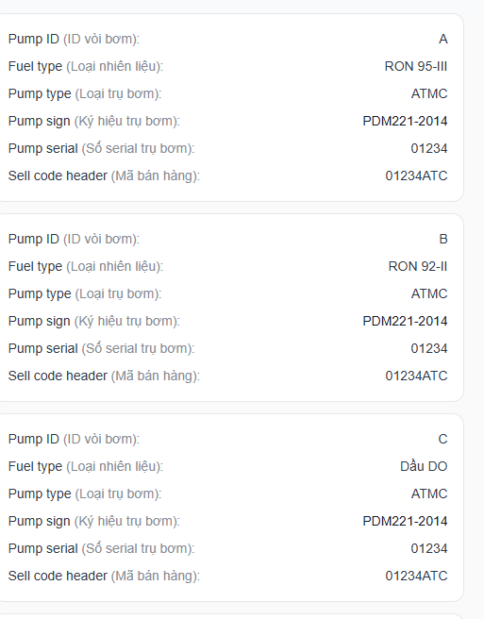

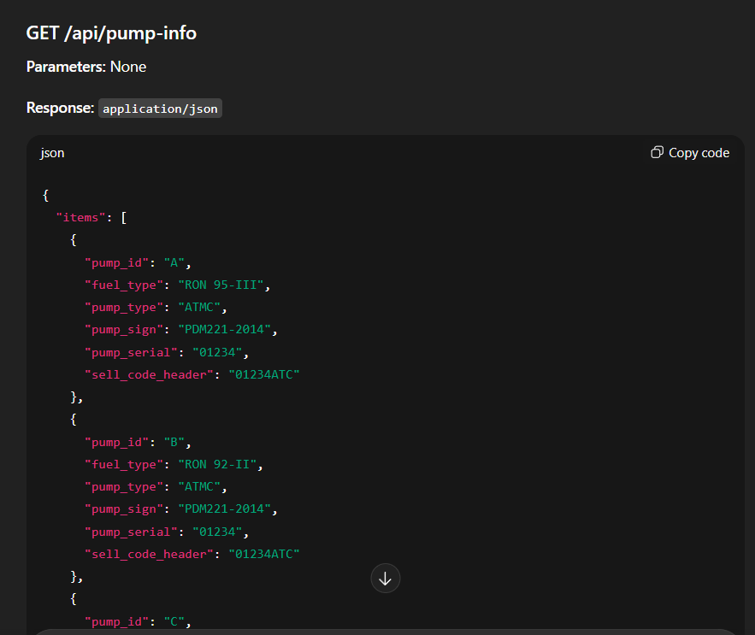
- Danh sách log bơm

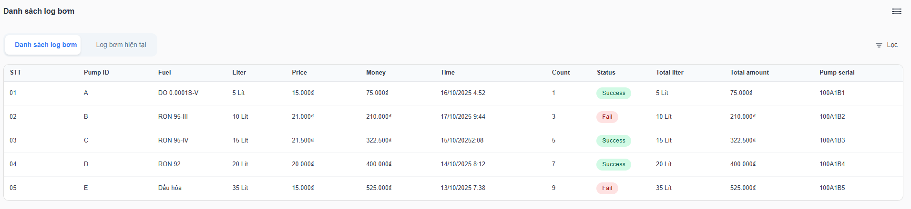

GET /api/pump-log

Parameters: None
Response: application/json

{

"logs": [

{ "stt": "01", "pump_id": "A", "fuel": "DO 0.0001S-V", "liter": 5, "price_vnd": 15000, "money_vnd": 75000, "time": "16/10/2025 4:52", "count": 1, "status": "Success", "total_liter": 5, "total_amount_vnd": 75000, "pump_serial": "100A1B1" },

{ "stt": "02", "pump_id": "B", "fuel": "RON 95-III", "liter": 10, "price_vnd": 21000, "money_vnd": 210000, "time": "17/10/2025 9:44", "count": 3, "status": "Fail", "total_liter": 10, "total_amount_vnd": 210000, "pump_serial": "100A1B2" },

{ "stt": "03", "pump_id": "C", "fuel": "RON 95-IV", "liter": 15, "price_vnd": 21500, "money_vnd": 322500, "time": "15/10/2025 2:08", "count": 5, "status": "Success", "total_liter": 15, "total_amount_vnd": 322500, "pump_serial": "100A1B3" },

{ "stt": "04", "pump_id": "D", "fuel": "RON 92", "liter": 20, "price_vnd": 20000, "money_vnd": 400000, "time": "14/10/2025 8:12", "count": 7, "status": "Success", "total_liter": 20, "total_amount_vnd": 400000, "pump_serial": "100A1B4" },

{ "stt": "05", "pump_id": "E", "fuel": "Dầu hỏa", "liter": 35, "price_vnd": 15000, "money_vnd": 525000, "time": "13/10/2025 7:38", "count": 9, "status": "Fail", "total_liter": 35, "total_amount_vnd": 525000, "pump_serial": "100A1B5" }

]

}

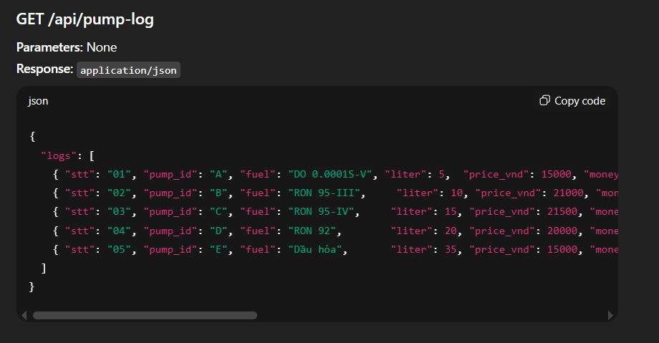

- Log bơm hiện tại

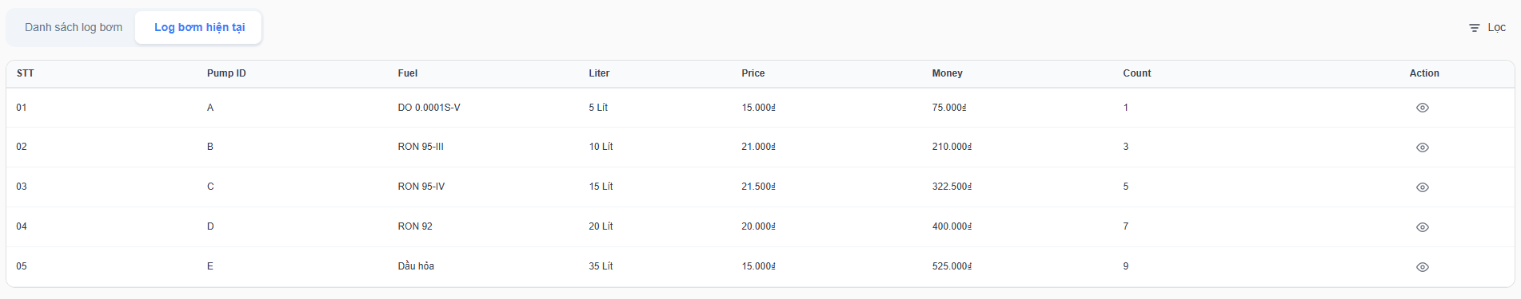

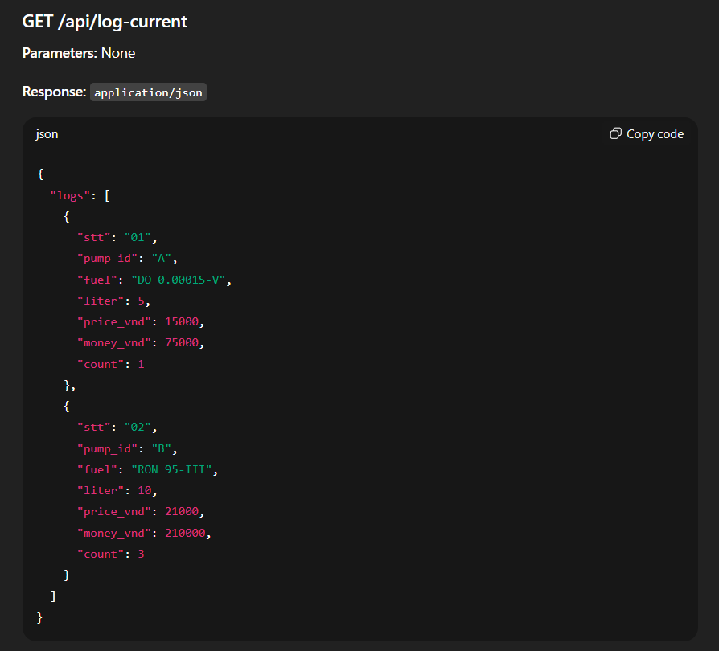

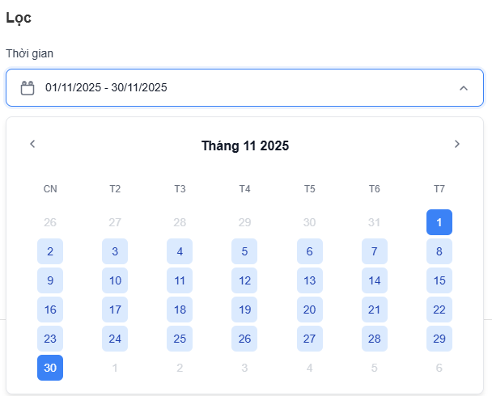

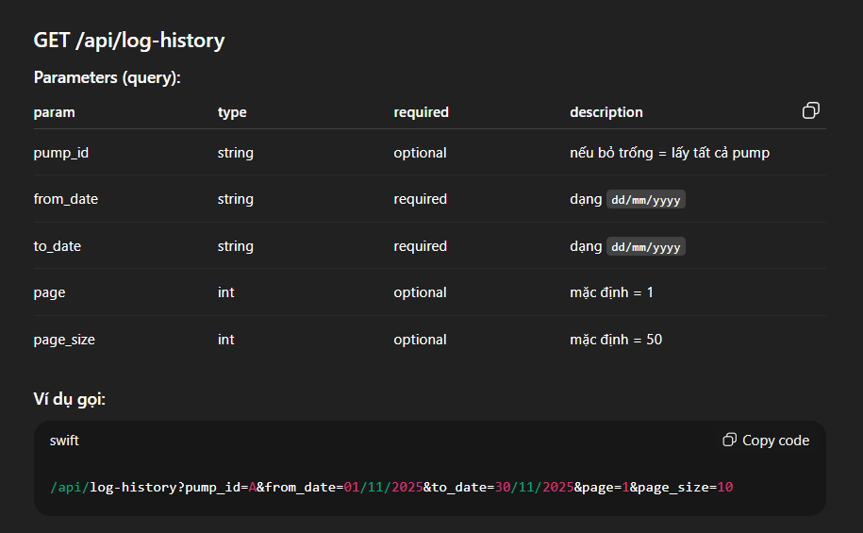

Response: application/json

{

"page": 1,

"page_size": 10,

"total_records": 359,

"items": [

{

"pump_id": "A",

"fuel_name": "RON 95-III",

"money_vnd": 210000,

"liter": 10,

"price_vnd": 21000,

"status": "success",

"timestamp": "17/11/2025 09:44:00",

"counter": 901

},

{

"pump_id": "A",

"fuel_name": "RON 92-II",

"money_vnd": 75000,

"liter": 5,

"price_vnd": 15000,

"status": "fail",

"timestamp": "16/11/2025 04:52:00",

"counter": 900

}

]

}

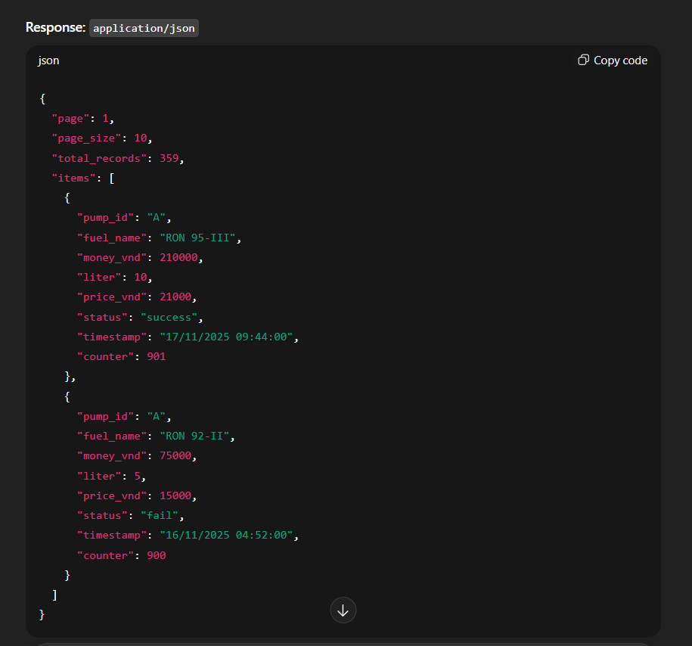

8.Chi tiết vòi bơm

