Contents

**1.** **Install JRE Instruction** 3

**2.** **Install JDK Instruction (Optional)** 3

**3.** **Install Apache NetBeans IDE (Optional)** 3

**4.** **Compiling and installation without Apache NetBeans IDE** 4

**5.** **Compiling and installation with Apache NetBeans IDE (Optional)** 5

**6.** **Test instruction** 6

**7.** **The key issues of upgrading a client and a server to a peer** 17

# **Install JRE Instruction**

Go to website <https://www.java.com/ES/download/> and stall the software by following the instructions.

# **Install JDK Instruction (Optional)**

Go to website <https://www.oracle.com/technetwork/java/javase/overview/index.html>

Download the suitable version, this project uses JDK 1.8.0_261 but it can be compiled on higher JDK version as well.

**Setting up the system by accessing the link** <https://docs.oracle.com/cd/E19182-01/821-0917/inst_jdk_javahome_t/index.html>

**Check JDK by using the command line window:**

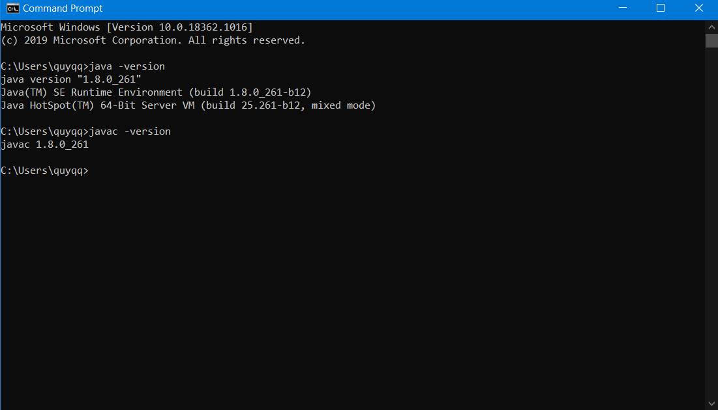

**Java version and Javac version have to be the same.**

# **Install Apache NetBeans IDE (Optional)**

Download NetBeans IDE <https://netbeans.org/downloads/8.2/rc/>

Download and install follow the instructions.

This project uses Apache NetBeans IDE 8.2 RC.

# **Compiling and installation without Apache NetBeans IDE**

*Unzip the file*: **COIT20257_Assignment_2PPFS.zip**

There are 4 folders below:

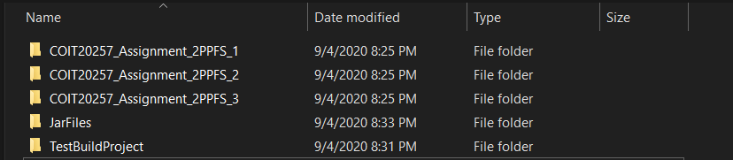

*Open folder* ***TestBuildProject*** *as shown below:*

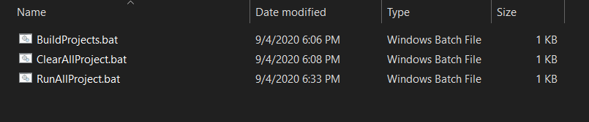

To compiling project run **BuildProjects.bat** file. The result is shown below:

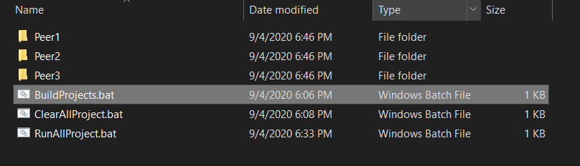

There are 3 folders which contain all compiled files. To run three peers, just double click on **RunAllProject.bat**. The result is shown below:

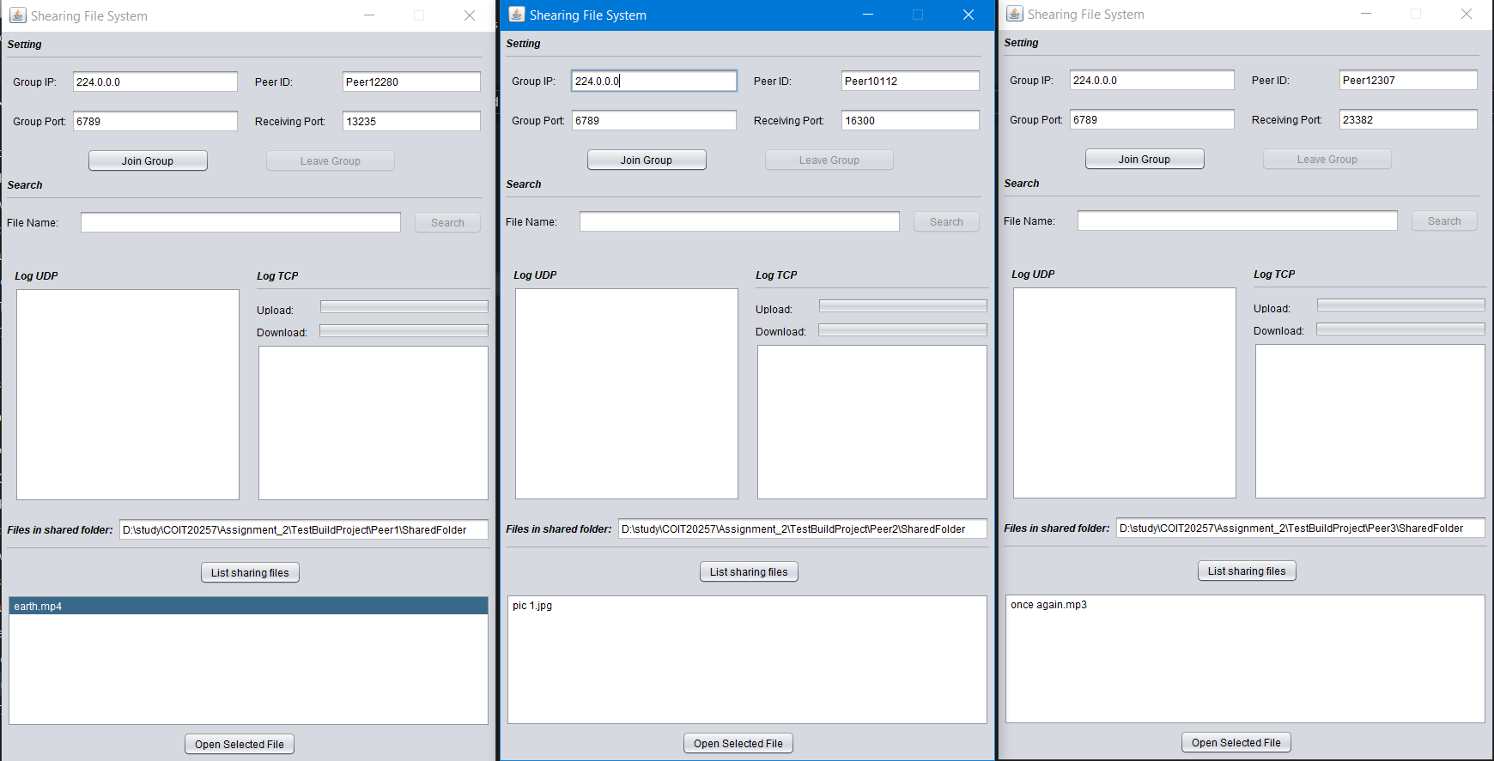

To clear out the project, just double click on **ClearAllProject.bat**

# **Compiling and installation with Apache NetBeans IDE (Optional)**

After unzipping the file **COIT20257_Assignment_2PPFS.zip,** open the projects on Apache NetBeans IDE 8.2 RC as below:

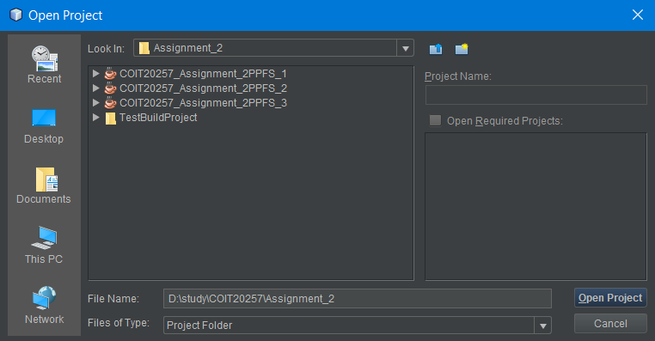

Select the projects and right click and compile the projects:

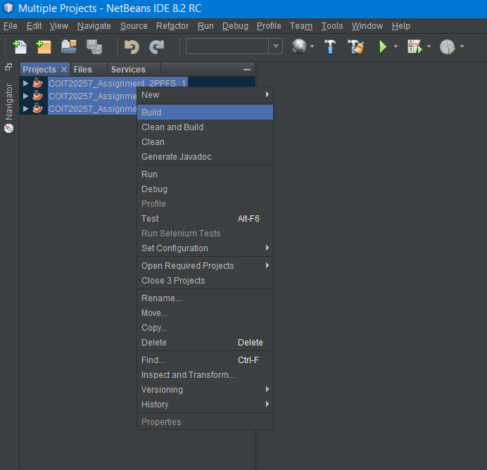

# **Test instruction**

Run three peer by using **RunAllProject.bat** after compiling the projects **BuildProjects.bat** by or open folder **JarFiles** as shown below:

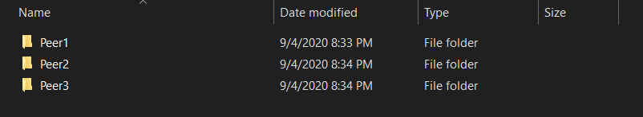

If run peers by jar files, the software will automatically create **SharedFolder**. To share the file, sharing files have to be copied to **SharedFolder** in each peer from **COIT20257_Assignment_2PPFS_1\SharedFolder COIT20257_Assignment_2PPFS_2\SharedFolder COIT20257_Assignment_2PPFS_3\SharedFolder**

After run three peers the result is shown below:

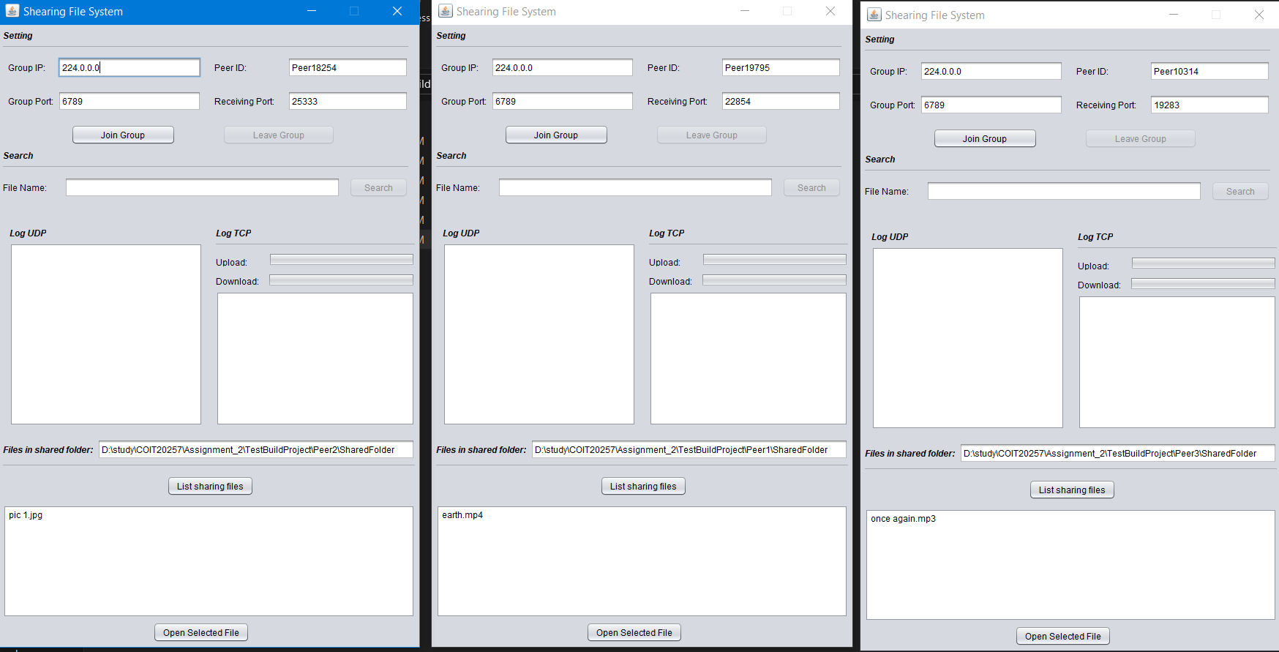

Each peer will have random PeerID and port of receiving files; however, it can be changed.

Each peer has a list box that shows sharing files as shown below:

**The first peer:**

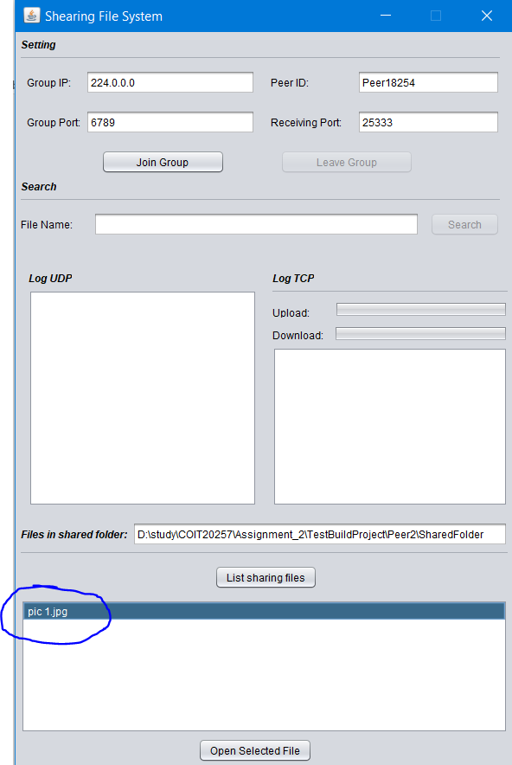

**The second peer:**

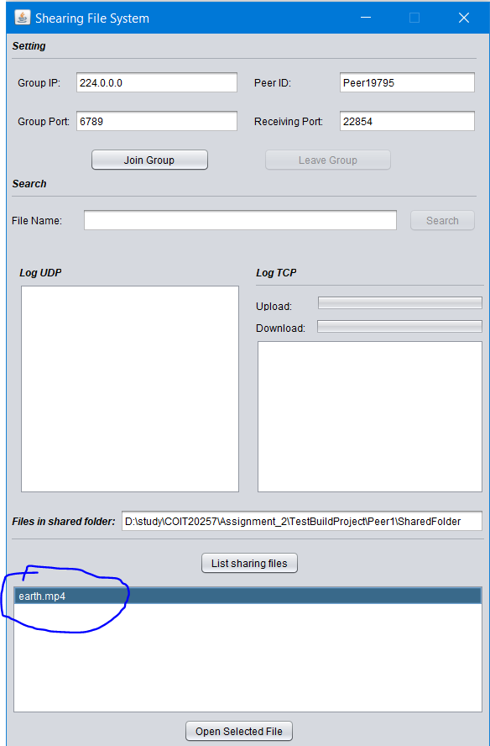

**The third peer:**

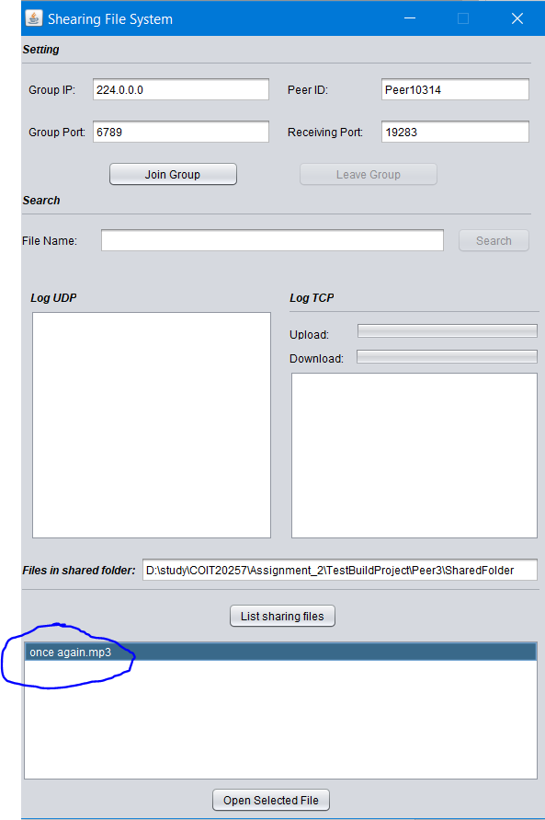

To open to check the folder, just follow the file path in the text field as shown below:

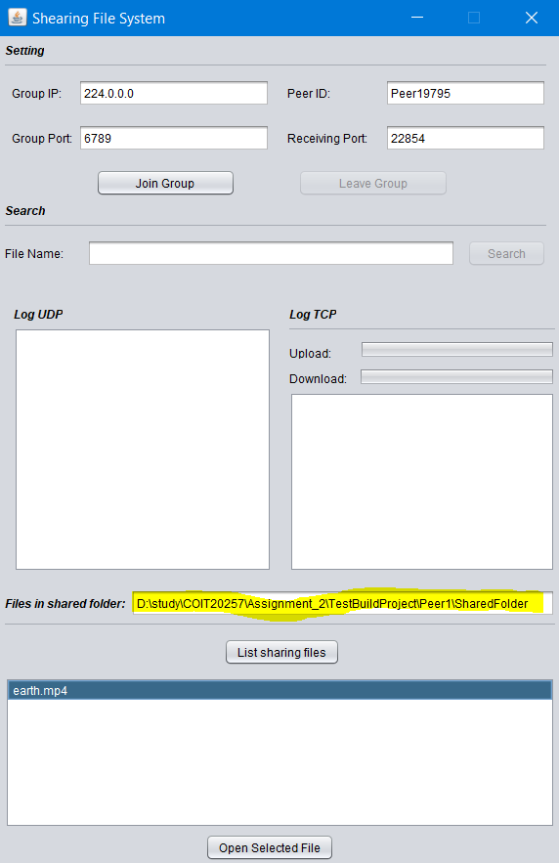

**For example, in peer 2 shared folder:**

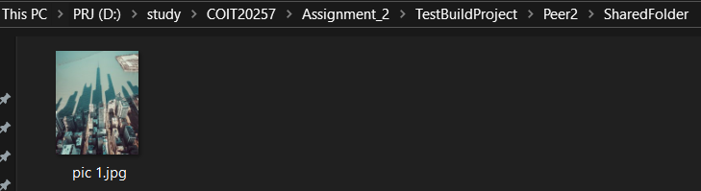

*To join the group, just click on button* ***Join Group*** *on the interface as shown below:*

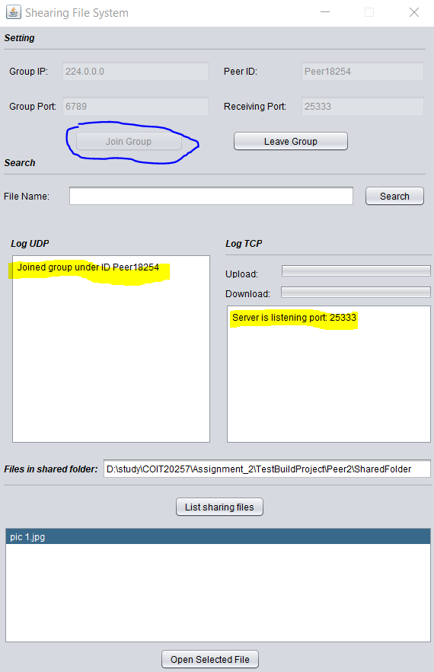

*Searching file in the group by entering the file name text box then click search button as shown below:*

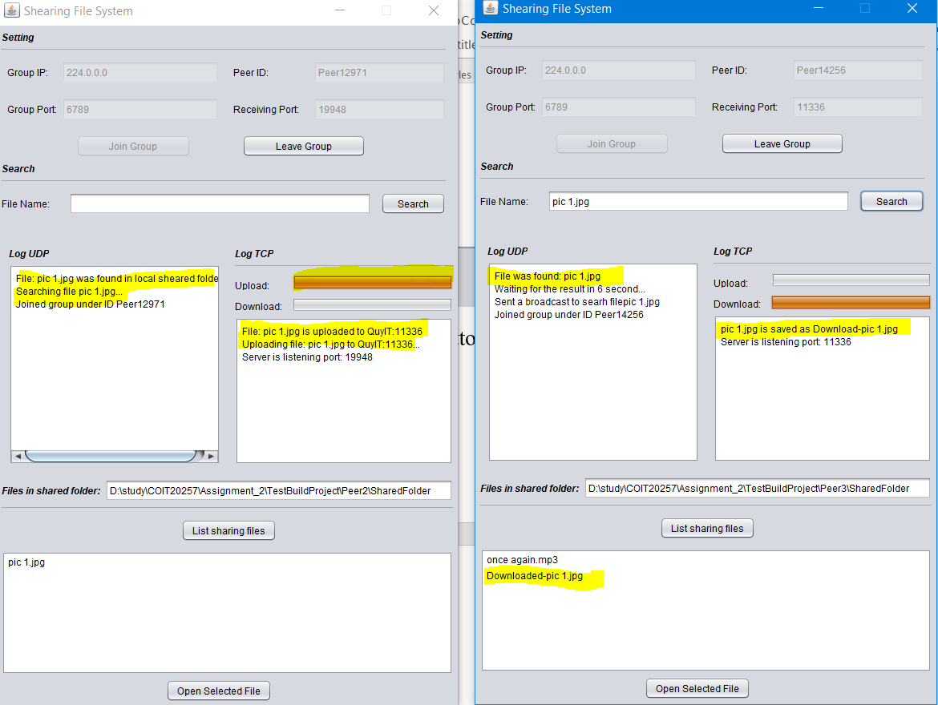

*Open the* ***downloaded-pic 1.jpg*** *and compare with original file*:

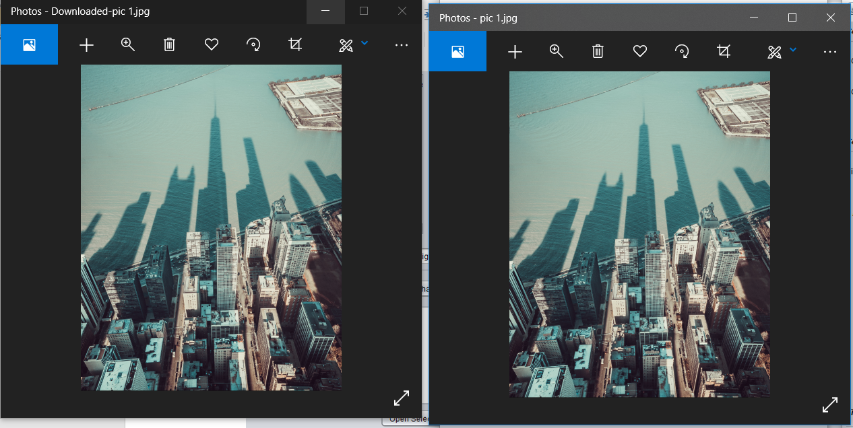

**First example:**

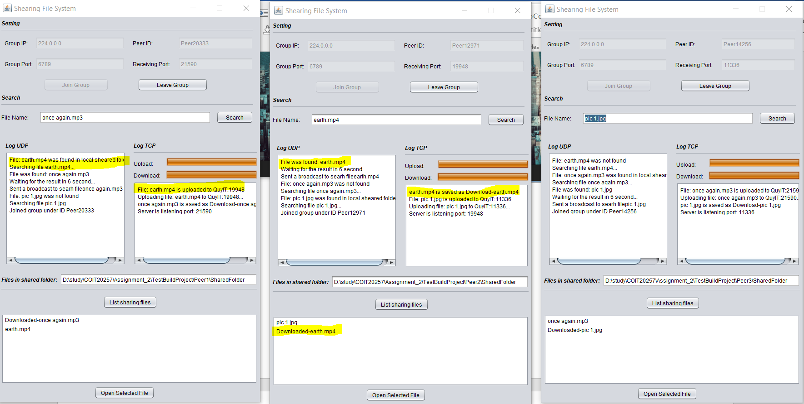

**Second example**:

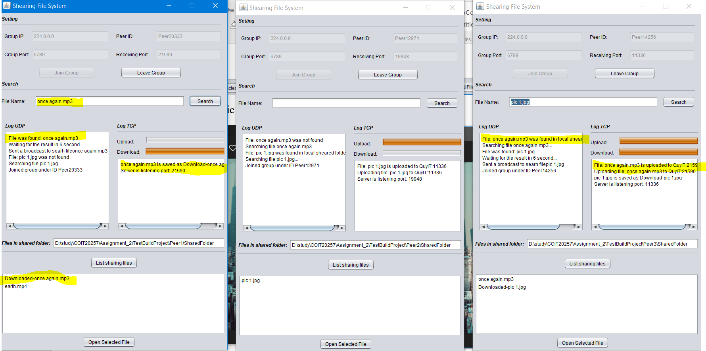

**File not found:**

The system will show the message find not found after 6 seconds if there is no file upload.

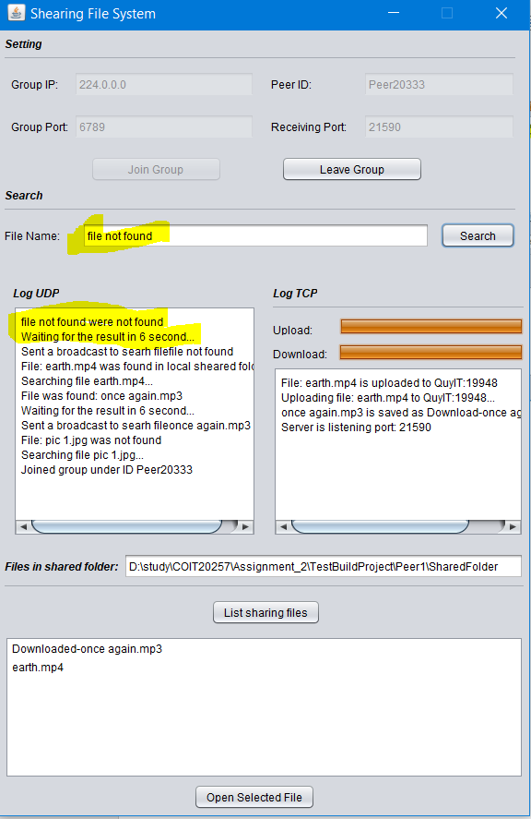

# **The key issues of upgrading a client and a server to a peer**

There are some key issues when TCP server and client are updated is listed below:

* Threads management is the big challenging in the first step because multi-threads is hard to predict and it works separately. Moreover, memory sharing between threads is another issue.
* Sending huge file over the network is complex to implement. The reason for this issue is that the biggest size can transfer over the network is 64KB. To overcome this problem, a large file will be broken in many small packets and sent over the network.