**Push Docker Images into Private AWS ECR**

Create Private ECR Repository

1. Log in to the AWS portal, find the ECR Service by searching for ECR and click on Get Started A screenshot of a computer

   Description automatically generated

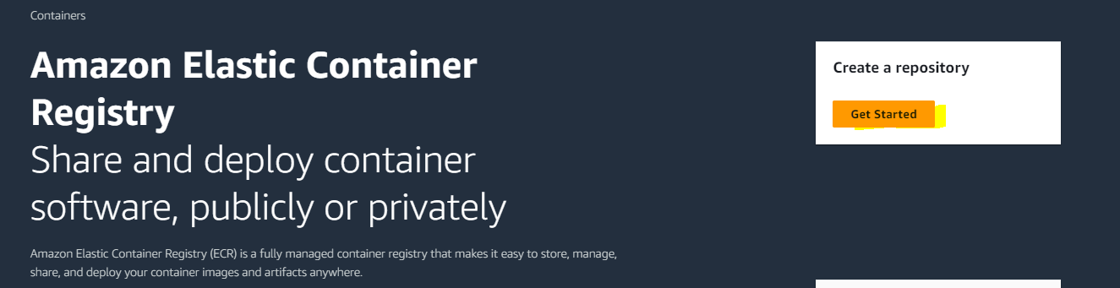

1. Do settings.

Push Image to the ECR

1. Select practical-devops and the click on View push commands button.  
   A screenshot of a computer

   Description automatically generated
2. Retrieve an authentication token and authenticate your Docker client to your registry.

Use the AWS CLI:



If you haven’t configured credentials yet you need to run “aws configure” command

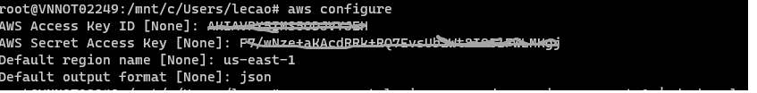

Re-run push image command. It should work now

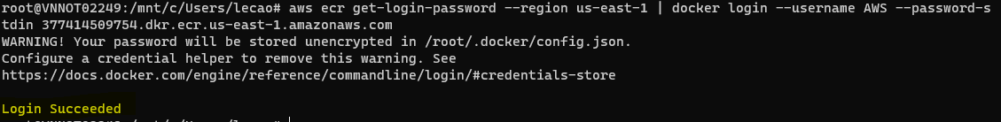

1. Build your Docker image using the following command.

Go to your directory that contains Dockerfile and run

docker build -t practical-devops .

1. After the build completes, tag your image so you can push the image to this repository:

1. Run the following command to push this image to your newly created AWS repository:

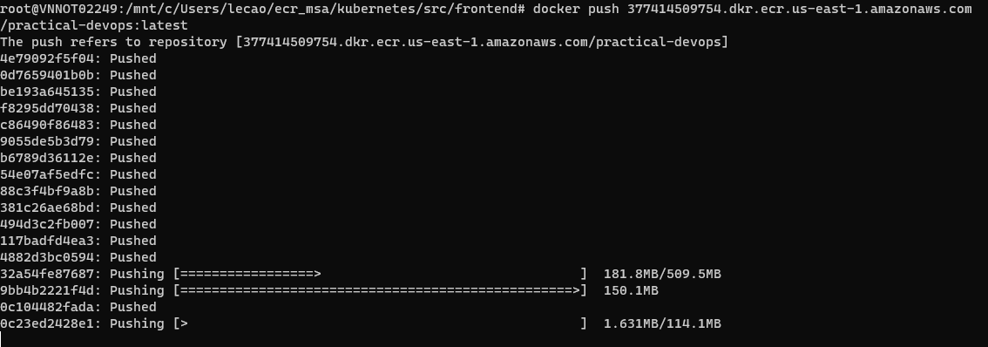

After pushing finished you can see Image display in the repository.

You can click on number Vulnerabilities to see the details.

