**Create EKS Using GUI**

Create Master Node

1. Log in to the AWS portal, find the Kubernetes Service by searching for EKS and click on Create Kubernetes Cluster and then specify the name for the Cluster.

The role allows Kubernetes cluster can go and provision worker nodes or can have access to the underlying storage or networking or load balancer what all things that are required to for Kubernetes cluster to run successfully.

1. Next is to create the role, click on “Create role” -> AWS Service -> EKS (from AWS Services) -> Select EKS Cluster -> Next Permissions.  
   A screenshot of a computer

   Description automatically generated with medium confidence

1. Enter a name for the role (e.g. eksClusterRole) and hit the Create role button at the bottom of the page to create the IAM role. The IAM role is created.

1. Back to EKS cluster page, and select the role created.

1. Specify networking – You can create your new VPC and subnets or you can use the default VPC and subnets. Here we will use the default VPC.  
   A screenshot of a computer

   Description automatically generated

Kubernetes master node will need a network on which it will create these machines or the master node or the server where master node running and that master node must be running inside a network

Cluster endpoint access

If the kube-api-server is public which means, we can access it over the internet. Now if we want to access it from our laptop and hence it public but in your production environment, we might want to keep it internal or private.

1. Configure logging.

Leave everything as default and click Next.

1. Select add-ons.

1. Configure selected add-ons settings.

1. Review and create.

Now Master node will be created in approximately 15-20 minutes.

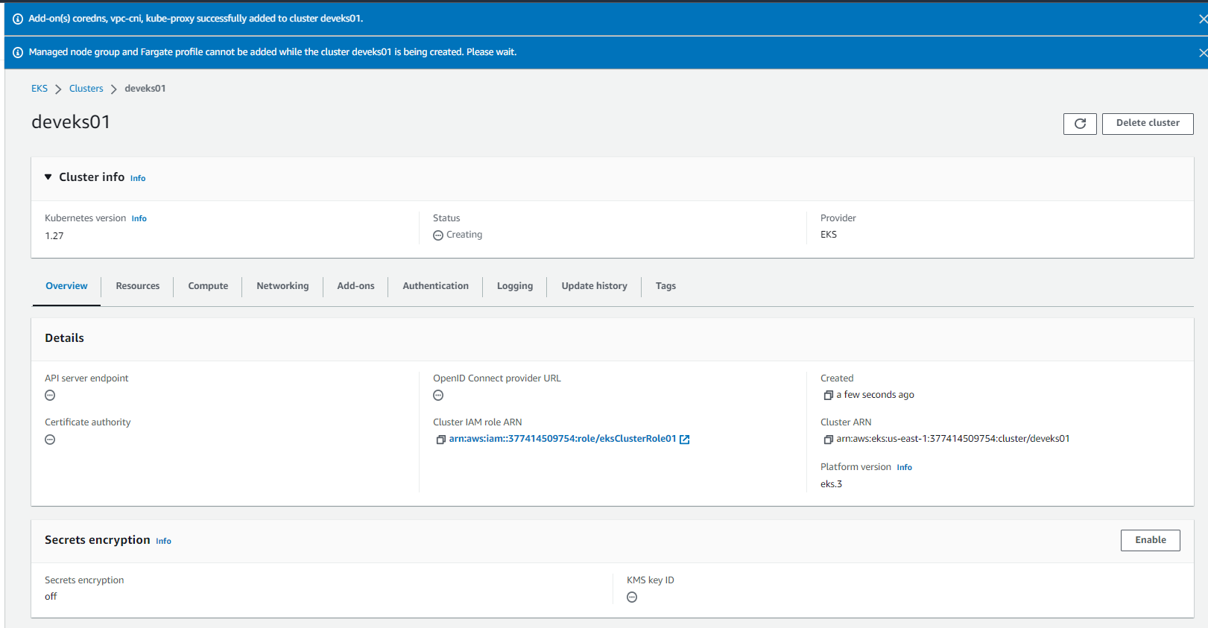

Create Worker Node

1. On the cluster page, select the Compute tab, and then choose Add Node Group.  
   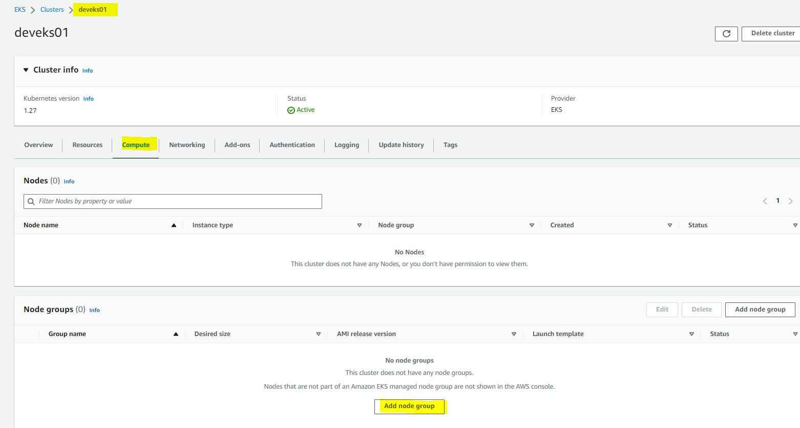
2. On the Configure node group page, fill out the parameters accordingly, and then choose Next.

1. Create IAM role for worker node  
   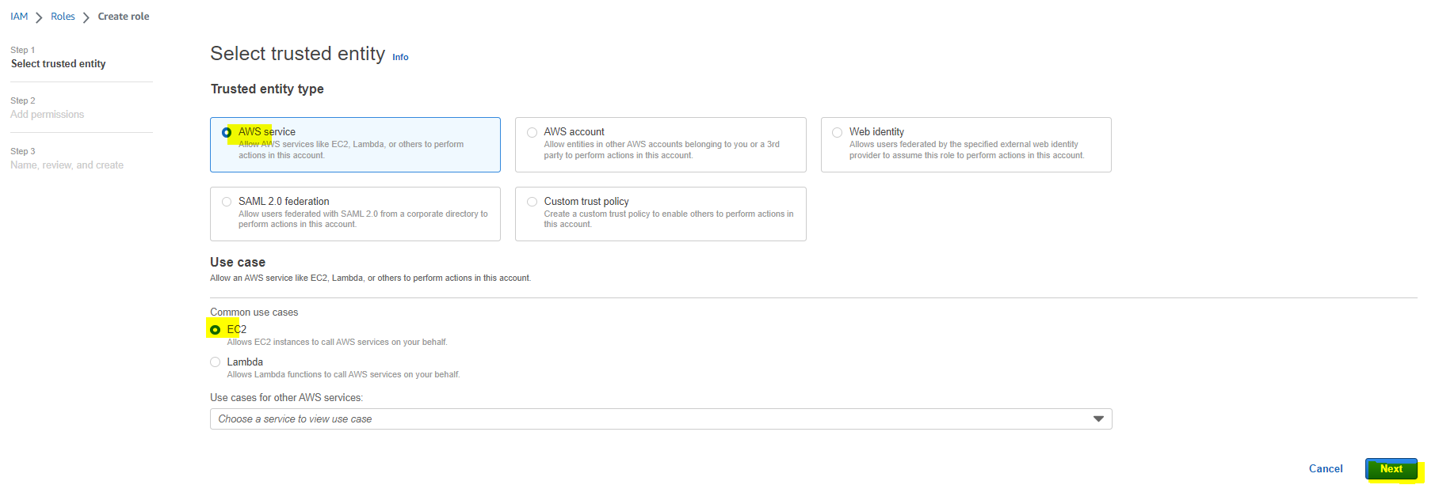

1. Back to Configure node group page and select role and click on Next.

1. Set compute and scaling configuration  
   A screenshot of a computer

   Description automatically generated with medium confidence

1. Specify networking  
   A screenshot of a computer

   Description automatically generated

Worker nodes will be created inside a network so if you have your master node and worker node to be in a different network which you should be then you create a separate VPC here for this. Here we will use same VPC for worker nodes and master node

Go back to Specify networking and select the key pair and click on Next.

Wait for several minutes for creating worker node finished.

Now if you go to the Cluster, you will see the nodes and node groups.

You can go to EC2 page to see the two worker nodes.

**Create EKS Fargate using eksctl**

When you deploy an eksctl YAML file or execute a cluster create command, it deploys Cloudformation templates at the backend. Ideally, the Cloudformation templates deploy the clusters and eksctl is just a wrapper for Cloudformation.

You can launch an EKS cluster using eksctl in two ways.

* + Using eksctl CLI and parameters
    - eksctl create cluster --name eksargocd --region us-east-1 --nodes 1 --nodes-max 2 --zones us-east-1a, us-east-1b, us-east-1c

Using eksctl CLI and YAML config

# An example of ClusterConfig with a normal nodegroup and a Fargate profile.

---

apiVersion: eksctl.io/v1alpha5

kind: ClusterConfig

metadata:

name: fargate-cluster

region: ap-northeast-1

nodeGroups:

- name: ng-1

instanceType: m5.large

desiredCapacity: 1

fargateProfiles:

- name: fp-default

selectors:

# All workloads in the "default" Kubernetes namespace will be

# scheduled onto Fargate:

- namespace: default

# All workloads in the "kube-system" Kubernetes namespace will be

# scheduled onto Fargate:

- namespace: kube-system

- name: fp-dev

selectors:

# All workloads in the "dev" Kubernetes namespace matching the following

# label selectors will be scheduled onto Fargate:

- namespace: dev

labels:

env: dev

checks: passed

Run command eksctl create cluster -f cluster-fargate.yaml

**Setup the kubectl configuration**

1. Installing AWS CLI

Refer to [https://docs.aws.amazon.com/cli/latest/userguide/getting-started-install.html#getting-started-install-instructions](https://docs.aws.amazon.com/cli/latest/userguide/getting-started-install.html%23getting-started-install-instructions)

1. Installing kubectl

Refer to <https://docs.aws.amazon.com/eks/latest/userguide/install-kubectl.html>

1. Configure AWS CLI credentials  
   The AWS CLI requires that you have AWS credentials configured in your environment. The *aws configured* command is the fastest way to set up your AWS CLI installation for general use.

Check status of Cluster as

*aws eks --region us-east-1 describe-cluster --name deveks01 --query cluster.status*



1. Configure kubectl with EKS API Server credentials.

*aws eks --region us-east-1 update-kubeconfig --name deveks01*



Validate kubectl configuration master node.

**Deploy Microservices to EKS**

Refer to Application_deployed_EKS.pdf file