Chapter 5
Opium Auction
Saran and Patna in Bihar, the Calcutta sale, the Lintin anchorage, and Canton
The money came before the seed. In the districts of Bihar and Benares, a cultivator who agreed to grow poppy for the East India Company was handed cash in the autumn, months before anything green showed in his field, and from that day the crop had an owner and the owner was not him. The Company called the payment an advance. Rolf Bauer, who spent years in the records of the Opium Department, found that the advance arrived when the landlord's rent fell due, and that the whole sum was frequently paid by the Department straight to the landlord. The cultivator's household got a receipt and a debt.
The arrangement had a long paper history behind it. Company servants at Patna had squeezed the opium trade for themselves after the Company took the revenue rights of Bengal, Bihar, and Orissa in 1765. In 1773, under Warren Hastings, the Calcutta government turned that private grip into a monopoly and farmed it out to a single contractor, who delivered opium at a fixed price for sale in Calcutta. The contract became a thing to be traded. In 1781 Hastings gave it to Stephen Sulivan, son of the Company's chairman, for four years, and young Sulivan sold it on to John Benn for 350,000 rupees a year, and Benn sold it again. The 11th Article of the charges against Hastings at his impeachment was about that contract. By the 1790s the contractors' opium had grown so bad that buyers abroad were turning it away, and in 1797 the Company dropped them. Two Opium Agents, salaried Company officers, took over: one for Bihar, based at Patna, and one for Benares, whose factory stood at Ghazipur on the Ganges. Regulation VI of 1799 made it illegal to grow poppy for anyone else.
Bihar had grown opium long before any Company servant arrived. The Company brought the counting.
* * *
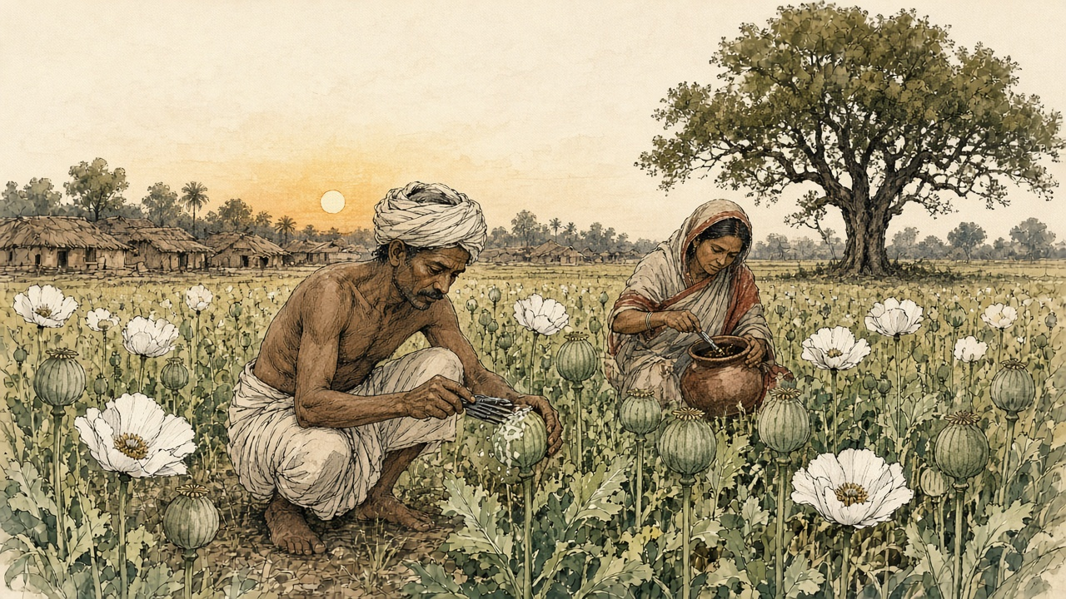
A village in Saran district, Bihar, the cold weather of 1836
Ram Ram. The gomastah babu came to the village when the rice was cut, and sat on the cot in front of the house of the headman, and the paper on his knee he opened. Paper-vaper, everything with them is paper. One by one he called us. My name also he called. Bhola, son of Ramdin, two bighas by the tank. The two bighas, they are not mine. The zamindar's they are. My father's father ploughed them, and his name also is in the zamindar's book, and the rent in that book never gets smaller.
Silver he counted into my hand. Warm it was, from his box in the sun. For one breath, Ma kasam, I felt rich. Then the zamindar's man stepped out from behind the cot and held out his own hand, and the silver from my palm went to his, all of it, the whole advance, for the rent. The gomastah wrote something. The zamindar's man wrote something. I put my thumb in the ink. My hand when I walked home was empty and black at the thumb, and the field was not mine anymore even in my father's way of speaking, because now in the Sarkar's book also, it was written.
My wife asked, how much? I showed her the thumb. She said nothing. She went in and banged the pots, bang-bang, and the little one started crying.
In Kartik we sowed. The field needs water, water-shater, every few days, from the tank by the lever, my back and my brother's back, up and down, up and down, the bucket and the rope cutting into the hands. The neighbour planted wheat. His wheat was knee high when our poppy still was small, and he laughed and said, Bhola, your field the Company's garden has become.
Phagun. The flowers came white, and the whole tank side was white like a wedding, and then they dropped, and the heads stood up green and hard, size of a hen's egg. Now it starts.
Evening, in the cool, out we go with the knives. Little hooked blades, three, four together tied, and you pull them round the head of the poppy, so, not too deep. Too deep and the juice runs out on the ground and is lost. Too shallow and nothing comes. My son also, eleven years, I gave him a knife, and he cut his own finger the first night and sucked it and did not cry, because his mother was watching.
Out of the cut comes milk. White, white, it beads up and hangs. All night it sits, and all the next day the sun cooks it brown and sticky, and in the evening back we come with the scoop, scraping, scraping, every head, the field is long and the sun even at that hour still heavy on the neck. The smell gets into everything. Sour, heavy, like something in the back of the cowshed, and sweet under it, so that your head is thick by noon. The stuff sticks to the scoop and to the fingers and dries black in the lines of the hand. My wife scrubs my hands with ash at night and still the next morning the smell is on the roti.
Then the gomastah's men came walking the fields. They looked. They did not weigh anything. They looked at the heads and talked to each other, and one of them said a number, and the other wrote it. So many seers from Bhola's two bighas. By guess they made it. And I knew, Ram, I knew looking at that number, my field could not give that number, not if every head bled twice.
That night I did not sleep. I lay on the cot and I could hear the jackals out past the tank, and I did sums. The number they wrote. The advance, already gone to the zamindar. The price the Sarkar pays per seer, that the babu said, and minus for the wet, minus if the opium is bad, minus, minus. If it comes short, they say embezzled. Bhola hid it, Bhola sold it to some bania. Then the court. My brother's wife's uncle in Chhapra, they took him to the court. The cow they took. The cot also.
Ramdin's son does not go to court. I said this to myself in the dark like a mantra.
My wife came and sat by me. She said, in the next village, they put cow dung in it. They put the mud of the tank in it, and gur, to make it heavy. I said, and the factory? They test. In the factory they know. She said, then what? I said, then we scrape harder.
We scraped harder. Again and again we cut those heads, every evening, until they gave nothing and were scarred all over like the face of an old man after smallpox. My son's fingers bled and healed and bled. At the end there was a pot, an earthen pot, heavy, black at the top and brown inside like jaggery, and I carried it on my head to the weighing at the kothi, and the whole way I prayed, Ram, let the scale be kind.
The scale was not kind. Short. The babu wrote it. Next year, he said, you will do better. Next year. The advance for next year also, he said, you will take.
* * *
Bihar and Benares, 1797 to 1839
What Bhola feared was in print. In February 1837 the Chinese Repository, the English-language monthly printed in Canton, ran a long article on the Bengal system, and Nathan Allen copied its core into his study of the trade in 1853. A European collector stood at the top. Under him came the gomastahs, Indian agents of better education and caste, then the sudder mattus, the landholders, then the village mattus, and at the bottom the ryots who did the work. Just before the juice was drawn, the gomastah and his establishment made a circuit of the country and formed, "by guess," an estimate of each field. The ryot then engaged to deliver that quantity "and as much more as the field will yield, at the price previously fixed." If he fell short and the collector suspected embezzlement, the collector could sue him in the civil court. A man who planted poppy without an engagement had his property attached and was "compelled either to destroy his poppies, or give security."
Allen added what his own informants, men who had lived in the opium districts, told him. The cultivators and the landholders were "from policy, kept constantly in debt to the government agents." Every native agent took a commission on the produce of his beat. Each chest obtained in this way, Allen wrote, cost the government about 300 rupees.
The cultivators knew the scale's appetite and some tried to feed it. Allen lists what the factory chemists found in the pots: sugar, catechu, molasses, cow-dung, soft clayey mud, pounded poppy seed, the juice of other plants. The factory caught most of it.
The violence in the system shows best in records written later, when people were finally asked. Before the Royal Commission on Opium in 1893 and 1894, witnesses from Bihar described the minor officers of the Department, zilladars paid by commission, threatening cultivators in Shahabad with fines and imprisonment to make them sow. A Patna district cultivator named Poonit Singh testified that a zilladar had torn up other crops a man had planted on land licensed for poppy. Bauer, reading the Department's own files, found peasants kidnapped and crops destroyed. His arithmetic of the costs and returns of a poppy field reached the conclusion the Department never printed: Bihar's peasants grew the crop at a loss.
Each spring the pots came in from the districts by river and by cart, numbered and labelled, to the two sudder factories.
* * *
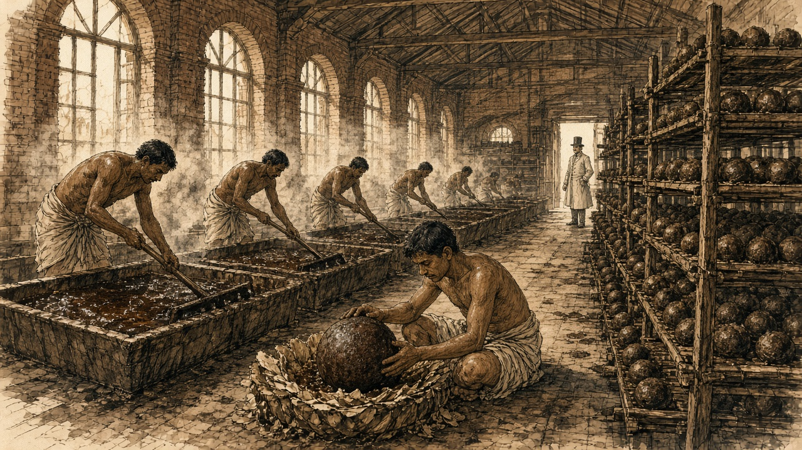
The opium factory at Patna, the hot weather
Bismillah. Before the sun comes over the wall we are already inside, and inside the sun does not matter, because the heat in the godowns of this factory, it lives there. It sits in the bricks. By the third hour the sweat runs from the head into the eyes and you cannot wipe it, your hands are full of the stuff.
First is the long hall. The pots stand in rows on the floor, a hundred, two hundred, earthen, each one with its number. The examiner sahib walks, and the tester walks with him, and he pushes the scoop down into the pot, deep, and turns it and pulls it out and looks, and sometimes only with the fingers he presses it, feeling, and calls out. A number. A class. The writer writes. From each pot a little goes in a box for the chemical room. If that room says sugar, says mud, the man whose pot it is, Allah help him.
Me, they put in the mixing room, where the pots are tipped into the vats and we stand at the edge with the rakes. Blind rakes, wood, no teeth, a flat blade on a long pole, and you push and pull and push through it until the whole vat is one paste, one colour, no lumps of this village and that village, all the same. It does not want to move. It is like pushing a rake through wet clay that wants to keep your rake. The shoulders burn first, then the back, then something in the back of the neck. The fumes come up off it warm and sour, and after an hour the head floats, a little, like before fever. My brother-in-law says you get used to it. Fifteen years he is here. His eyes are always red.
At noon we wash at the tank. The water turns brown off our arms. I put my face in my hands and smell them and it is still there, under the nails.
Some days they send me to the balling room to carry. That room is quiet. Each ball-maker has his little table, his stool, the brass cup. He wets the cup, he lays in the petal-cakes, torn, pressed, pasted down with the thin opium they call lewa, layer on layer, and the opium lump goes inside, weighed already, and he closes the petals round it with his thumbs until it is round as a child's head. A good man makes more than a hundred in a day. All the same weight. If not the same weight, the sahib's scale will tell, and his pay will tell.
Then the drying room, the balls in little earthen cups in rows to the roof, and men going along with a sharp needle, a style, poking any ball that swells, letting the gas out, a soft hiss, a smell like a rotten mango. And the stacking room, and there the boys. Small ones, climbing up the racks, turning the balls, turning, turning, rubbing them with poppy dust so the mildew does not come and the insects do not eat them. My Karim also, Ammi says, next year he can go to the stacking room. A little more money in the house.
I said nothing to her. What can I say. I have seen the boys come out at evening with the dust in their hair and the dust in their eyelashes, and the little ones asleep standing up, ya Allah, asleep standing.
Forty of those balls go in one chest. The carpenters make the chests from the timber they bring down from Nepal on the river. Nail-nail-nail, all day, a sound like rain on a roof. Then the chests go down to the ghat and onto the boats. Where they go after Calcutta, nobody in this factory knows. China, they say. What is China. Somewhere the opium goes and somebody's money comes back, and none of it comes here.
* * *
The Ganges and Calcutta, 1798 to 1830
Walter Sherwill, a Company revenue surveyor, drew the Patna factory around 1850 for a set of lithographs printed in London in 1851, the examining hall, the mixing room, the balling room, the drying room, the stacking room, and then the river. His last plate shows the opium fleet coming down the Ganges past the Monghyr hills. Small canoes run ahead, their crews sounding the channel and beating drums to warn other boats aside, because the government boats claimed the river. Beside the fleet a timber raft floats down from the Nepal forests, wood for more chests.
A full chest held forty balls. William Hunter, an American who worked in Canton from 1825, gives its weight as one picul, 133⅓ pounds.
At Calcutta the chests went to public auction, and the Company sold to whoever bid. It was particular about what it sold. In January 1798 the Board of Trade had 900 chests from Bhagalpur, Patna, and Rangpur burned at Calcutta, under a new rule that opium failing to reach 200 sicca rupees a chest at auction would be destroyed so the brand would keep its name in the Eastern markets. The speculators welcomed the burning, the Asiatic Mirror reported, because it would raise prices further east. At the first sale of the season on 15 December 1800 the average was 725 sicca rupees a chest. At the December sale of 1804 it was 1,687 for Bihar and 1,761 for Benares.
Allen, writing around 1850, put what a chest cost the Company to obtain at about 300.
* * *
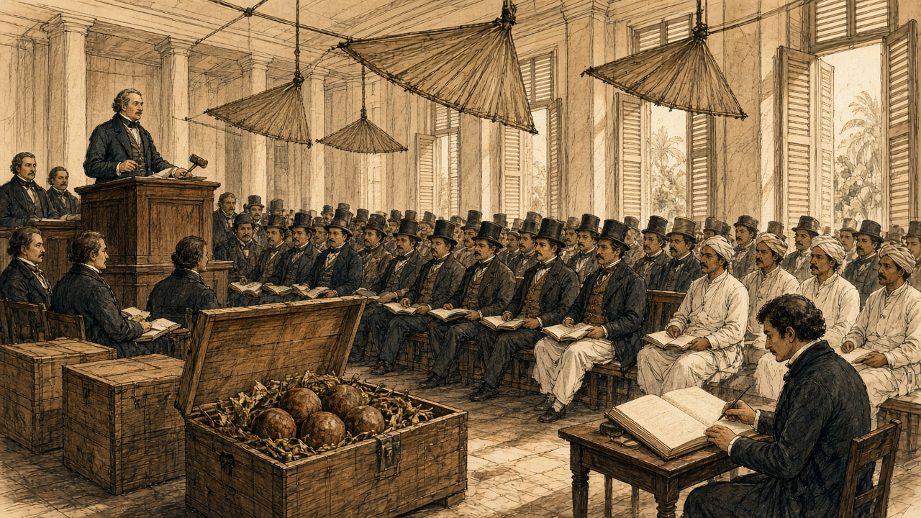
Calcutta, the Company's opium sale, 20 December 1830
Monday, the 20th. The first Sale of the season; and a most fatiguing day, the room being close beyond bearing by ten o'clock, the punkahs doing nothing but stir the heat about, and every gentleman of the agency houses present, or his banian, or both. I had the Patna lots and young H. the Benares. Ink dried on the nib between bids.
The bidding was brisk from the first lot, and there was a feeling in the room, which I cannot well describe, as of men at a race-course who have money laid on the issue and have heard something of the horses. Word had come that prices at Lintin were firm. When the hammer fell on the last of the Patna I cast up my column twice to be sure of it, and the average stood at 1,608 Sicca Rupees the chest. The Benares came to 1,605. Mr. —— leaned across to see my figures and said only, "Well, that is the China market," as though he were reading the weather.
I had the Agents' provision charges by me in a bundle from the Board, and for my own satisfaction set the cost of a chest against its price, and did the subtraction, and did it again. The product of that sum against the number of chests I shall not write down, for it is not my business, and the Board has clerks enough to admire it.
What struck me most was that not a man in the room had seen a poppy. Nor had I. The chests are a figure in the Patna Agent's invoice, and a figure in my column, and tomorrow they will be a figure in some house's books, and in six weeks a figure at Macao; and the opium itself lies all the while in the godown at the ghat, smelling, they tell me, like a cow-house in the rains.
The Red Rover, Clifton's new vessel, built sharp to work against the monsoon, is taking on Bengal opium from this sale. The old hands say no ship can beat up the China Sea at this season. I have put down five rupees with H. that she does it.
* * *
The Bay of Bengal, the Lintin anchorage, and Canton, 1830 to 1839
He did it. The Canton Register reported that the Red Rover, Captain William Clifton, reached Macao on 6 February 1831, thirty-nine days out of Calcutta, a record, with 538 chests of Bengal opium from the Company's first sale on 20 December. A year later she and the Water Witch came in together with 1,500 chests from the first Calcutta auction. By 1833 the paper reported the passage against the winter monsoon as regularly achieved, and Dent and Company were advertising for freight of treasure on the Red Rover's run back to Calcutta.
The Company could not carry the chests into China itself. The Jiaqing Emperor had banned the import, and the Company's tea trade at Canton depended on the goodwill of the officials who enforced the ban. So the Company sold in Calcutta and let the country traders take the chests and the risk. Jardine, Matheson and Company, founded at Canton in 1832, and Dent and Company were the most prominent. Malwa opium from western India, shipped through Bombay, grew into a rival larger than Bengal's own. In the season of 1832 to 1833 the Canton Register counted 6,410 chests of Patna sold at Lintin and Macao, 1,880 of Benares, and 15,402 of Malwa.
By Michael Greenberg's count, Indian opium sent to China ran to about four thousand chests a year around 1800. Bengal and Malwa together came to 21,885 chests in 1834–35. By 1838–39 the figure was 40,200.
Most of it went first to Lintin, 伶仃 Língdīng, an island in the mouth of the Pearl River, where old hulks lay at anchor as floating warehouses, beyond the reach of the officials and on the route of every ship bound for Canton.
* * *
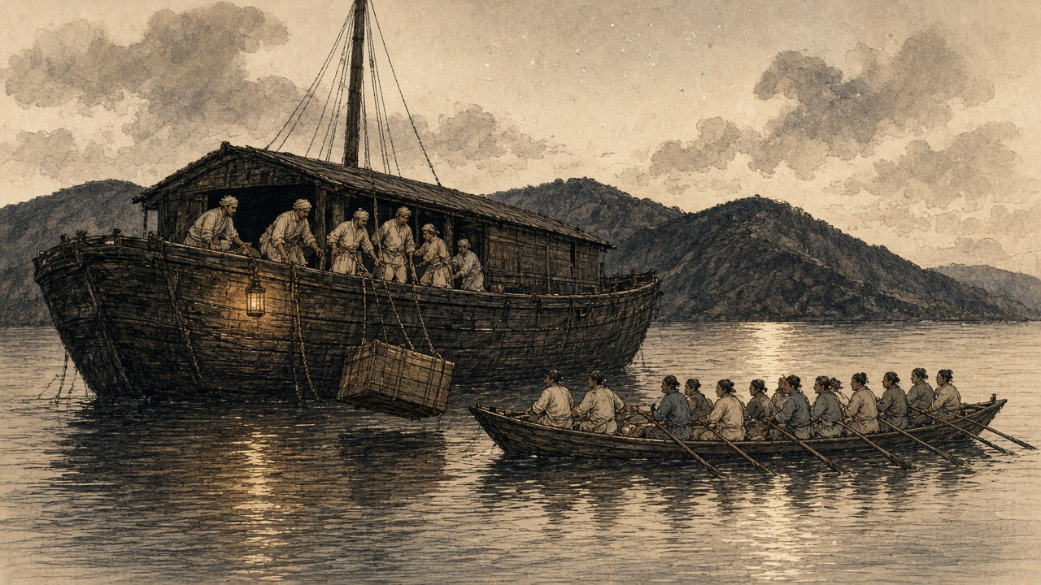
A receiving ship at Lintin, the southwest monsoon
Allah, the heat on that deck. No shade on a receiving ship, only the old awning that has holes in it like a fishing net, and the sun coming through the holes making spots on the planks that move when the ship swings.
From Chittagong side I am. My uncle brought me first on a country ship to Calcutta, then this one, and this one does not go anywhere. Sits. Three years she sits at Lintin, chained to the bottom, belly full of opium. The Manila men and we, the few Bengali, we are the crew. The cooks Chinese, the carpenters Chinese, the shroff who weighs the silver, Chinese. The captain, a sahib from Scotland side. His Hindustani is bad and his temper is worse.
Morning, a clipper comes in. All hands then. The chests come over the side on the tackle, swinging, and one wrong swing and a chest goes in the water, and then the captain's mouth, an hour of it, and the money cut from all of us. We lower them into the hold. The hold, bhai, the hold. It is a box of hot air with a smell inside that the nose stops telling you about after a while, but the head does not stop. Sweet and rotten, like a dead rat in a jar of gur. The Chinese call it foreign mud. Mud it is not. Mud does not make your head heavy like this.
Then the boats come. Not every day, but in the selling season always, at night more. Long, long boats, varnished bright, sixty, seventy men at the oars, thirty a side, the oars going up and down together like the legs of one big insect, and a mat sail as big as a house. A gun in the front. The broker's man sits in the back with the paper. The order, from Canton, so many chests, this mark, this number.
Then we break open the chests. The balls come out, brown, dusty, the petals cracking, and we weigh them and the broker's man watches the scale like a cat watches a hole, and then all of it into mat bags, the merchant's sign painted on and the weight, and over the side into the long boat. Four hours, five, and the hold of the long boat is full and the oars go down and she is gone into the dark toward the river, and nobody stops her. The mandarin boats that should stop her, they also have been paid. Everybody knows this. The captain says the ship gets five dollars a chest for the delivery.
Five dollars a chest. In my whole life, in my village, nobody holds five dollars.
At night sometimes I lie on deck and look at the lights of the Chinese boats on the water and think about the man at the end of that long boat. Who is he. Somebody in Canton is going to put this mud in a pipe and smoke it. A man with a mother. In Chittagong we have opium also, old men in the bazaar who eat a little and sleep in the shade. I saw one once, in Calcutta, by the ghat, a Chinese, a carpenter off a ship, smoking. His arms like two sticks of cane. His eyes sunk so deep in the head, like two stones at the bottom of a well. He did not see me. He did not see anything.
Money, the ship is full of it. Silver-tilver, boxes of it, up the ladder it comes after the boats, and into the captain's room, and in the morning the shroff sits with his copper scales and pours it, ring, ring, ring, the whole forenoon. Down in the hold I lie in the smell and count the rings, and lose count, and start again.
* * *
Canton, the Thirteen Factories, 1823 to 1838
At Canton foreigners could trade only through the 公行 Gōngháng, the Cohong, a guild of licensed Chinese merchants whose warehouses and the foreigners' rented quarters stood together on the riverbank at the 十三行 Shísān Háng, the Thirteen Factories. Each foreign ship needed a Hong merchant as its security, and a merchant who stood security answered with his own fortune for duties and for whatever the foreigners did. Hunter recorded the system biting in 1823. A compradore at one of the American houses had borrowed his employer's cash for speculation, and the theft came out by accident. The American chief went directly to Houqua, 伍秉鉴 Wǔ Bǐngjiàn of the 怡和行 Yíhé Háng, who was the compradore's guarantor. "Houqua sent the deficiency to the firm the same evening. It was over $50,000."
The guarantee could ruin a man. 蔡世文 Cài Shìwén, called Munqua by the foreigners, head of the 万和行 Wànhé Háng and senior merchant of the guild from 1788, killed himself in 1796 when his business failed under its debts. When Jardine and Matheson needed a Chinese name for their firm, they took two characters from Houqua's: 怡和洋行 Yíhé Yángháng.
Silver moved through the factories all day. Opium was always sold for cash, Hunter wrote, and in the arched passages between the buildings "one could never move without seeing heaps of silver being examined and hearing its metallic ring as successive quantities were poured in and out of copper scales." Once weighed, the coins stopped being coins. Spanish and Mexican dollars went into the treasuries by weight, at 717 thousandths of a tael each, and became bullion.
A great deal of that silver ended up in one place. As early as 1803 the Company advertised in Bombay that merchants trading to China could pay their sale proceeds into its treasury at Canton and take twelve-month bills on London at five shillings and six pence the dollar. In 1830 the Canton treasury was open for thirty-day bills on Bengal at 202 sicca rupees per hundred Spanish dollars. The country trader got paper that could be cashed in London or Calcutta. The Company got the silver at Canton, where it bought its tea, without shipping an ounce out from England. In 1811 it had sixty thousand chests of tea lying in its Canton warehouse and not enough ships to carry them home.
The Qing state saw the same silver moving in the other direction. In 1830 an imperial edict on the Viceroy's report complained that foreigners used their dollars to buy up sycee, the empire's silver, so that "our silver diminishes and foreign money increases," and called the spread of opium smoking "damage like a great fire." On 1 January 1831 a servant in the Viceroy's own yamen fell asleep over his opium lamp and set the building on fire. In 1832 a new law set the punishment for smoking at a hundred blows, the cangue, and transportation.
The far end of the chain shows in a petition the Canton Register printed in 1830, from a widow named Wai Ping, sixty-three, whose son Ah Keen Soo had taken up the pipe. He had stolen everything in the house to pay for it, she wrote, and dunned her daily for more, and when she reproved him he looked ready to strike her. Foreign doctors described the bodies. James Hill, an English ship's surgeon in China in 1839, wrote of "the sallow and shrivelled countenance, the dim and sunken eye, and the general emaciated and withered appearance." G. H. Smith, a surgeon at Penang, recorded what happened when a confirmed smoker went without: great prostration, water streaming from the eyes, then cold over the whole body, aching in every part, diarrhoea, "the most horrid feelings of wretchedness," and, if the drug was withheld long enough, death. Five-sixths of the sixty inmates a day in the poorhouse he ran were opium smokers.
In the autumn of 1838 林则徐 Lín Zéxú, governor-general of Hubei and Hunan, sent the Daoguang Emperor a memorial on the silver and the pipe. If the court went on treating opium lightly, he wrote, then in a few decades "中原几无可以御敌之兵，且无可以充饷之银," the central plain would have almost no soldiers left to resist an enemy, and no silver left to pay them. The emperor sent him to Canton.
* * *
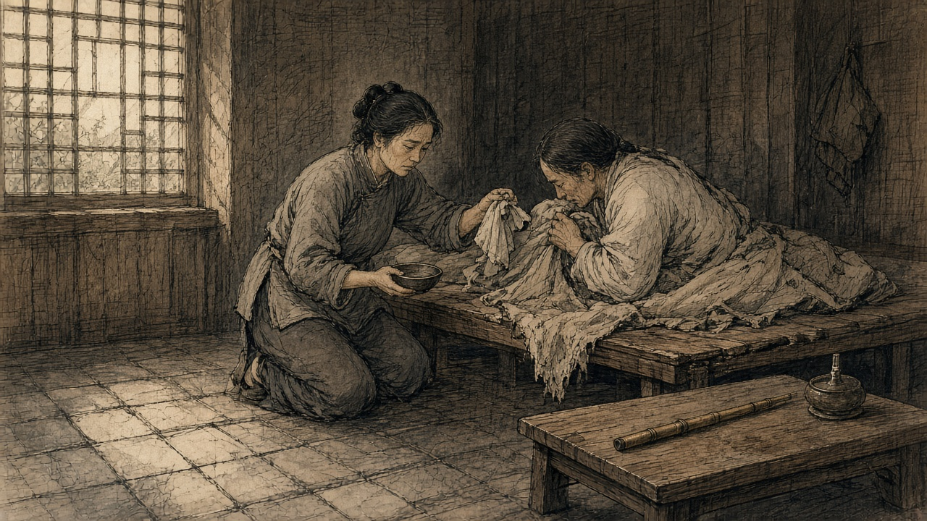
Canton, the western suburbs, March to June 1839
That morning, the whole river, nobody moving. Boats all pulled to the bank, every one. The people on both banks thick, thick, on the roofs also, on the walls. No noise. So many people, and you could hear the water.
The Imperial Commissioner's boat came up from downriver, big, red and black, flags behind. Him, sitting. A heavy man, a big beard. Did not look left, did not look right. Behind came more boats, the Viceroy, all the great officials, the crews in new red clothes. Nobody spoke. My neighbour's wife put her hand on my arm and pressed. I knew what she meant. Both our husbands, the same pipe.
Ah-Sing, my husband, carried for the hongs. Bales, chests, tea, from the boats to the godowns, twelve years. The pipe, started from the shoulder. The shoulder hurt, a friend gave him one pipe, the shoulder stopped hurting. One pipe at night. Then two. Then morning also. Then the wages before they came home already were in the smoke-house. The bracelet from my mother, gone. The good jacket, gone. Rice, some days, the children ate, I didn't. Some days nobody.
At night, the lamp. The little flame, the needle, the brown bead turning on the needle over the flame, swelling, and that smell, sweet like burnt sugar, coming into the whole room, into the quilts, into the children's hair. He would lie on his side with his knees up and pull and pull on the pipe and his face would go smooth, smooth, like a boy's again. That face, I hated it, because it was the only time he looked at peace and the peace was not for us.
Then the Commissioner's notices went up. Pipes, hand in. Lamps, hand in. The smoke-houses, shut. The sellers they took away in chains, and some of them, we heard, strangled. Ah-Sing, the night after the notice, cried. A grown man. He held the pipe in both hands like a baby. Then the next day, himself, he carried it to the yamen and gave it up. I followed behind him in the street and he did not know.
Three days, he shook. Cold, he said, cold, in the third month, sweat pouring off him. His eyes ran water all the time, his nose ran, he could not hold anything in, front or back, the smell of it in that one room. He lay on the boards and curled up and his bones I could count through the skin. Every joint, he said, somebody is twisting. He begged me. Go to Ah-Fook, Ah-Fook still has some, just a little, just one bead. I said no. He cursed me, cursed my mother, cursed the Commissioner, cursed Heaven. Then he cried again and said sorry, sorry.
Fourth night, I thought he was dying. His hands, ice. Breathing like an old dog. I sat by him the whole night with the children asleep against the wall and held the lamp close to his mouth to see the breath move the flame. Moved. Still moved. Near morning, a little sleep, him. Me, none.
Then the news came that the foreigners had been shut inside their factories, and the servants all called out, and the foreign mud, the Commissioner made them give it up, all of it, more than twenty thousand chests. Twenty thousand. A chest, I had seen them, my husband carried them. Heavy as a man. Twenty thousand men's weight of that stuff.
Ah-Sing, sitting up by then. Thin as a bamboo. Ate a little congee. He said, they will burn it. I said, good, burn it. He said nothing for a long time. Then he said, where the smoke goes, there I will go and stand.
Fifth month, I found the new pipe under the floorboard. Small, cheap, bamboo. I held it in my hand. Still warm. I put it back under the board where it was, and went and washed the rice.
* * *
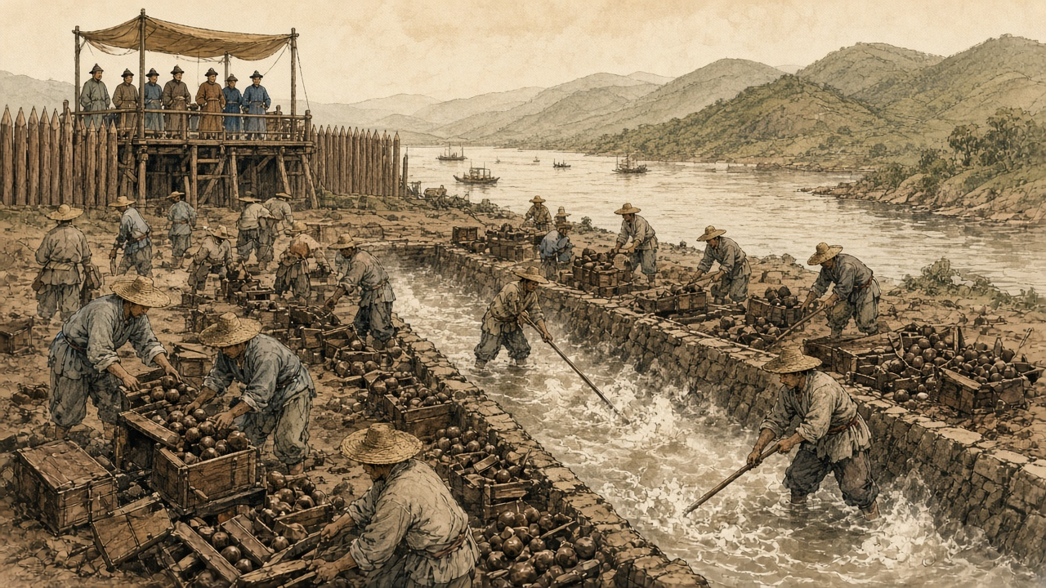
Humen, June 1839
The new imperial regulations of June 1839 gave smokers eighteen months to break the habit. After that, any smoker, official or commoner, faced strangulation.
At Canton the foreigners had been held in their factories since late March, their Chinese servants withdrawn, until the British superintendent of trade, Captain Charles Elliot, promised to surrender every chest held by British merchants. Hunter counted the total at 20,283 chests, delivered at the Bogue by 21 May. There were, he wrote, 15,000 chests on board the receiving ships at Lintin when Lin's orders arrived and 5,000 at the coast stations, worth together more than twelve million dollars. Elliot wrote to London that this was "the first time, in our intercourse with this Empire, that its Government has taken the unprovoked initiative in aggressive measures against British life, liberty, and property." Hunter, who had sold the drug himself, set his own judgment beside it. The despatch "contained not a word of the provocation given by foreigners in continuing the condemned traffic." Of himself and the other merchants he wrote: "We disregarded local orders, as well as those from Pekin, and really became confident that we should enjoy perpetual impunity."
Lin had the opium destroyed with water. On the shore at 虎门 Hǔmén, the Bogue, workmen dug trenches lined with stone and timber and let in water from a creek. They broke the balls apart by hand, threw the pieces in, and stirred until they dissolved, then added salt and lime, and the mixture boiled up in stinking clouds. When it was done they opened the trenches and let the mass run out on the tide. About five hundred men worked for twenty-three days. Lin and some sixty officials watched from a pavilion built for the purpose, and foreigners were allowed to watch with them.
Before it began, Jonathan Spence found, Lin composed a prayer to the spirit of the sea. He apologized for the poison about to flow into its waters and asked the god to tell the creatures that lived there to move away for a time, so they would not be harmed.
* * *
London, April 1840
William Jardine left Canton in January 1839 and was in London by the autumn, with charts of the China coast and a plan for what a naval force could take. The Melbourne government had decided on war before Parliament discussed it. On 7 April 1840 Sir James Graham opened a Tory motion censuring ministers over their handling of China. On the second night William Ewart Gladstone, thirty years old, Tory member for Newark, spoke about the opium.
"A war more unjust in its origin, a war more calculated in its progress to cover this country with permanent disgrace, I do not know, and I have not read of."
He went on to ask whether the minister knew that the opium smuggled into China came exclusively from British ports, from Bengal and through Bombay, and said the British flag had become "a pirate flag to protect an infamous traffic."
Palmerston answered him. The Chinese, he told the House, were "disposed to buy what other people were disposed to sell them."
On 9 April the House divided. Two hundred and seventy-one voted with the government and two hundred and sixty-two against. The warships the motion might have stopped were already at sea, bound for the Pearl River.
In 1846, by Allen's count, the Company sold 21,649 chests of Bengal opium at Calcutta for a clear profit of over two million pounds sterling.

Sources
First-person passages are reconstructions; named and dated events follow the sources below.
The original volume carries no in-text markers. These are the sources grouped to this chapter.
• India Office Records, British Library, London. Bengal Opium Proceedings, Opium Department Correspondence, and Patna/Ghazipur Opium Agency Records.
• Jardine Matheson Archive, Cambridge University Library. Canton Correspondence and Opium Consignment Accounts, 1830s-1840.
• Chouban Yiwu Shimo 籌辦夷務始末 [Complete Account of the Management of Barbarian Affairs]. Daoguang chao. Beijing: Palace Museum edition.
• Hansard, House of Commons Debates. 7 April 1840.
• Hunter, W. C. The "Fan Kwae" at Canton Before Treaty Days, 1825-1844. London: Kegan Paul, Trench, & Co., 1882. Source for the smug boats, receiving-ship crews and cumsha, the shroffs and the 717/1000 tael dollar, Houqua and the 1823 compradore deficit, Lin's arrival on 10 March 1839, the 20,283 chests, and Elliot's despatch of 30 March 1839.
• Lin Zexu 林則徐. Lin Zexu ji 林則徐集 [Collected Works of Lin Zexu]. Beijing: Zhonghua Shuju. Memorial of 1838, 钱票无甚关碍宜重禁吃烟以杜弊源片.
• Qing shilu 清實錄 [Veritable Records of the Qing]. Daoguang chao, 1839-1840 entries.
• Fairbank, John King. Trade and Diplomacy on the China Coast: The Opening of the Treaty Ports, 1842-1854. Cambridge, MA: Harvard University Press, 1953.
• Fay, Peter Ward. The Opium War, 1840-1842. Chapel Hill: University of North Carolina Press, 1975.
• Greenberg, Michael. British Trade and the Opening of China, 1800-1842. Cambridge: Cambridge University Press, 1951.
• Lin, Man-houng. China Upside Down: Currency, Silver, and the Opium Trade, 1797-1900. Cambridge, MA: Harvard University Asia Center, 2006.
• Platt, Stephen R. Imperial Twilight: The Opium War and the End of China's Last Golden Age. New York: Alfred A. Knopf, 2018.
• Trocki, Carl A. Opium, Empire and the Global Political Economy. London: Routledge, 1999.
• Zheng Yangwen. The Social Life of Opium in China. Cambridge: Cambridge University Press, 2005.
• Cheong, Weng Eang. The Hong Merchants of Canton: Chinese Merchants in Sino-Western Trade, 1684-1798. Richmond: Curzon Press, 1997.
• Van Dyke, Paul A. Merchants of Canton and Macao: Politics and Strategies in Eighteenth-Century Chinese Trade. Hong Kong: Hong Kong University Press, 2011.
• Hansard, HC Deb 8 April 1840, vol. 53. Gladstone on the China expedition. Division of 9 April 1840: 271 to 262.
• Lin, Man-houng. China Upside Down: Currency, Society, and Ideologies, 1808–1856.
• Farooqui, Amar. Opium City: The Making of Early Victorian Bombay. New Delhi: Three Essays Collective, 2006.
• IOR opium proceedings and Jardine Matheson Canton correspondence: collection level.
• Allen, Nathan. The Opium Trade; Including a Sketch of Its History, Extent, Effects, etc., as Carried on in India and China. Lowell, MA, 1853. Quotes the Chinese Repository (February 1837) on the Bengal agency system; source for the 300-rupee chest cost, the adulterants, the 1846 Calcutta sales, and the medical testimony of James Hill (Lancet, 1841) and G. H. Smith (Medico-Chirurgical Review, April 1842).
• Bauer, Rolf. The Peasant Production of Opium in Nineteenth-Century India. Leiden: Brill, 2019. Advances paid at rent time and passed to landlords; documented coercion; cultivation at a loss.
• Betteridge, Samuel R. "Rethinking the Bengal Connection: Opium Monopoly and Fiscal Capacity in British India, 1862–1908." PhD thesis, London School of Economics, 2021. The 1773 contract monopoly and the 1797 agency system; Royal Commission on Opium evidence (Babu Rasik Lal Ghosh; Poonit Singh, cultivator of Patna district), vol. III.
• Kranton, Rachel, and Anand V. Swamy. "Contracts, Hold-Up, and Exports: Textiles and Opium in Colonial India." American Economic Review 98, no. 3 (2008). Regulation VI of 1799 and payment net of advances and quality deductions.
• Sherwill, Walter S. Illustrations of the Mode of Preparing the Indian Opium Intended for the Chinese Market. London: James Madden, 1851. Plate texts as reprinted in Benjamin Broomhall, The Truth about Opium Smoking (London, 1882), and in Peter C. Perdue, "The First Opium War," MIT Visualizing Cultures.
• Perdue, Peter C. "The First Opium War: The Anglo-Chinese War of 1839–1842." MIT Visualizing Cultures. Source for the Humen trenches, the workforce and duration of the destruction, Lin's prayer to the sea spirit as recorded by Jonathan Spence, and Palmerston's reply to Gladstone.
• The Canton Register and the India Gazette, Asiatic Mirror and other Calcutta and Bombay papers, 1798–1835, as abstracted in Roger Houghton, A Peoples' History 1793–1844 from the Newspapers, "Opium" parts 1 and 2 (houghton.hk). Source for the 1798 burning of 900 chests, Calcutta sale averages of 1800, 1804, and December 1830, the Red Rover's voyages, the 1803 and 1830 Canton treasury bills, the 1811 tea stock, the 1830 edict, the 1832 smoking law, the 1831 yamen fire, Wai Ping's petition, and the 1832–33 Lintin and Macao sales by brand.
• Farooqui, Amar. "The Global Career of Indian Opium and Local Destinies." Almanack 14 (2016). Greenberg's figures of 21,885 chests in 1834–35 and 40,200 in 1838–39.
• "Bulletin on Narcotics" 1956, issue 2 (UNODC): history of the Ghazipur factory, operating since 1789, on its present site from 1820.
• 《钦定严禁鸦片烟条例》 (June 1839), the eighteen-month grace period for smokers, as summarized in 王宏斌, 试论中国禁止鸦片烟毒的经验与教训, 近代中國網.
• 蔡世文 and the 万和行: 乾隆时期广州公行首商蔡世文家族事迹考述——清代广州十三行行商研究之六, 华南师范大学学报 (Journal of South China Normal University).

