Chapter 2
Boats at Canton, 1839
The Pearl River from Lintin to the Canton suburbs, 1826 to 1839, and the City of London
The chests left the receiving ships in long varnished boats that Canton officials called 快蟹 kuàixiè, fast crabs, and 扒龙 pálóng, scrambling dragons. A report the Canton authorities sent the throne in 1832 counted between one and two hundred of them running opium from Lintin to the money-changers' shops of the province, firing on the coast guard when they met it. William Hunter, the American who worked at Canton from 1825, describes them as long and broad in the beam, wider abaft, so that there was room in the stern for the brokers' agents who always rode with the cargo. Sixty to seventy men pulled from low benches along both sides of the deck under a mainsail and foresail of matting, bamboo, and rattan. They carried a large gun in the bow, swivels, spears, and flintlocks bought off foreign ships. Government cruisers were painted black and red. The smuggling boats were varnished bright.
The censor 冯赞勋 Féng Zànxūn told the emperor about the iron netting hung along both sides against shot, and the fifty or sixty oars that sent the boats along so fast that people called them 插翼 chāyì, boats with wings stuck on. In 1836 the official 许乃济 Xǔ Nǎijì, who had served in Guangdong, wrote that when a government cruiser did close with one, the crab fought back, and men were wounded and killed.
The river had its own people. The 疍家 Dànjiā, Tanka in the foreigners' spelling, were born on boats, fished and ferried from them, and married on them. In May 1729 the Yongzheng Emperor wrote in an edict the Guangdong gazetteers copied out in full that the people of the province looked on the boat households as a base sort and would not let them ashore, and the boat people, not daring to resist, stayed cramped in their boats all their lives, though they paid the fish tax like anyone. "蛋户本属良民," he wrote, the boat households are by origin good people. Those who could build a house might live in the villages near the water and be registered with everyone else, and local bullies were forbidden to drive them off. The edict gave the Tanka the law on paper.
The officials' reports call the smuggling crews desperate men and runaways. Whoever they were, the syndicates paid them by the run.
* * *
The Canton River, half a mile below the Factories, June 1833
Fourth bench from the bow, left side, that one is my place. Three years I pull from it. The man beside me, Ah-Kau, also Tanka, from the Honam side. His wife and my wife, sisters. Under the bench my sandals, my rice tin, a rag for the hands. The hands, after three years, you could scale a fish with them.
Leaving Lintin, dusk. The receiving ship's men already put the balls in mat bags, the broker's agent already checked his paper. He sits in the stern under the little roof, tea, abacus, bags stacked round him, a hen on eggs. Him we don't talk to. He talks to the steersman, the steersman shouts, we pull.
Sixty oars, all one breath. Lean forward, the blade in, lean back, the whole body, the heels hard against the bench in front. Out. Again. The first hour the shoulders complain. Second hour they stop complaining, they just burn. After that, no man anymore, a part of the boat, like a nail. The boat-master beats the time with his heel on the deck and the sound comes up through the planks into your bottom. Water runs off the oar handles down the arms into the armpits. Salt in the cracks of the hands. The mat sail cracks over our heads when the wind takes it and then the boat jumps, and everybody laughs a little, because when the sail works, the oars get a breath.
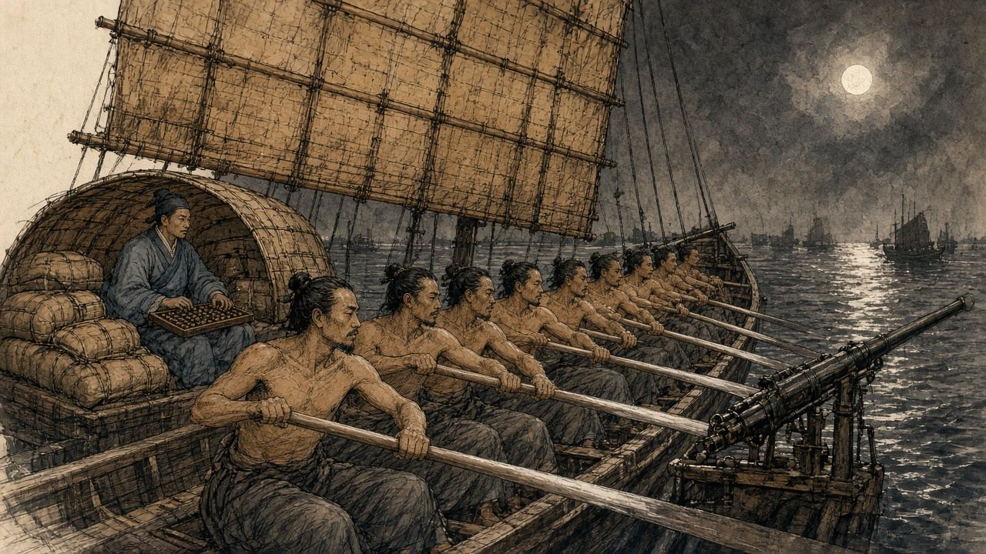
One night's run, more than a month of nets. My mother's coffin, paid already, from this oar. My son in the old scholar's school on the Honam bank, also this oar. The shore children throw mud at him on the road. He goes anyway.
Most nights, nothing. A mandarin boat comes out, black and red, lantern up. Our steersman shouts, their side shouts. Some stones go over, ours and theirs, thump on the deck, splash. One time a stone took the ear of the boy on the seventh bench, he bled all down his neck and kept pulling. Then the mandarin boat turns back and writes its paper, and we go on up. Opera, Ah-Kau calls it. Both sides paid for their seats.
This night, different.
A new commander on the river, the broker's agent said that afternoon, one not yet fed. Nobody listened. Every new one, one month later he also eats.
Half a mile below the Factories, the foreigners' lamps already showing on the bank, out of the dark on both sides come boats. Not one. Five. Gongs. Torches. Men on the bows with long hooks. The steersman pulls us hard over and shouts, and we pull, we pull until the bench creaks. The boat-master has stopped beating time. Nobody needs time now.
They stay with us. A mile, they stay with us. The big gun in our bow fires once, and the noise of it goes into my teeth, and the smoke comes back over all of us so that I pull blind, coughing, the oar handle wet and slipping. Their muskets. A sound on the planks like somebody throwing gravel. The swivel at the stern goes, and someone in the stern is screaming, high, like a pig.
Then Ah-Kau's oar stops.
Mine hits it, wood on wood, the shock up into my elbow. I turn my head. He sits there, still holding the handle. A ball has gone into him under the arm, the side toward the bank, and he looks at me like he wants to ask something, the price of rice maybe, what time it is. His mouth opens and what comes out is blood, black in the torchlight, a great deal of it, over his chin, over his chest, over my hand where I have grabbed his shirt. He is warm. The blood is warm. He tries to stand up and his legs do not hear him. He sits down again on the bench, slowly, like an old man sitting down, and then he goes over against me, his head on my shoulder, heavy, heavy, and he does not get up.
All around us, the hooks. One catches the gunwale by my bench. Someone is up on the side shouting jump, jump, and the bench in front of me is empty already.
I put Ah-Kau down on the deck. I don't know why I did this. There was no time to do it and I did it, laid him down flat with his face up, the way you lay a man down, and then I went over the side.
The river at night, warm like soup on top, cold below. Down into the cold, eyes open, nothing to see, only the torchlight above turning the water brown-gold. I held my breath until fire came into my chest and swam along the bottom with my hands in the mud. A Tanka child swims before it walks, the shore people say, laughing. That night my body knew it without me.
When I came up, far off, by the mud of the bank among the reeds, our boat was already stopped in the river with their boats all around it like ants on a dropped cake. Torches. Shouting. I lay in the reeds with only my nose up and the mosquitoes eating my face, and I heard them break open the bags.
Ah-Kau's wife, my wife's sister. Who goes and tells her. Me.
* * *
Canton and the delta, 1826 to 1837
The Canton Register, the British free traders' weekly, reported the fight on 17 June 1833. A new naval commander had ordered all fast crabs destroyed. Five government boats caught a crab coming up about half a mile below the factories, chased her a mile, and hemmed her in. One crew member was killed, the rest abandoned the boat, and many were wounded. Some three hundred men had been in the fight. The officers found two chests of opium on board and a book listing everyone to whom the cargo was consigned. The book, the paper added, "was fortunately repurchased from the officers at the scene."
The opium came out of the receiving ships against a chit, a delivery order written by a foreign house in the Factories after a Chinese broker had paid in silver. Xu Naiji named the brokers: "有省城包买户，谓之窑口," wholesale buyers in the provincial city, called 窑口 yáokǒu, furnace mouths. The 1832 report put them among the money-changers and silversmiths, whose furnaces for assaying sycee could refine raw opium too, some in a street beside the Thirteen Factories. Between furnace mouth and receiving ship ran the boat, and along the boat's route stood a line of men with their hands out.
The navy's share was organized early. The 防海纪略 Fánghǎi jìlüè, a late-Qing history that follows the scholar 魏源 Wèi Yuán closely, says that after the governor-general 李鸿宾 Lǐ Hóngbīn set up anti-smuggling patrol boats in 1826, the patrols took 规银 guīyín, customary silver, of thirty-six thousand taels a month and let the opium through. 卢坤 Lú Kūn abolished them in 1832, too late to pull the navy's habits back. The Canton Register of December 1832 reported that bribes to escape the ban on building fast crabs had grown so steep that delta boatyards could no longer afford to build them, and two new crabs had been built at Lintin itself, on a raft moored between two foreign ships, where no Chinese official had jurisdiction. The bigger carried sixty men, small swivels, pikes, knives, and plenty of round stones. The run to Canton went at a fixed fee, so well managed that officials seldom came near. The occasional skirmishes, the editor wrote, were "forms of opera." Some of the opium, he added, went up to Canton in the coast guard boats themselves.
Inland, the customs houses ran on fees. In January 1837 the paper passed on what the tea men from the Wuyi hills said: since early 1835 the dealers carrying opium north to trade for tea had paid the customs houses at Shaoguan and Ganzhou a fixed sum on every ball of Patna let through, half a dollar at Shaoguan, and both houses had grown rich. Hunter, who sold the drug through brokers, describes what happened when a new magistrate arrived. The question of fees arose and was soon settled, "unless the new-comer was exorbitant in his demands," and then the brokers came back with beaming faces and immunity reigned again.
In 1837 the governor-general 邓廷桢 Dèng Tíngzhēn restored the patrol boats. Wei Yuan, writing in the 1840s, recorded what one of his officers did with them. The deputy commander of the Guangdong navy, 韩肇庆 Hán Zhàoqìng, made his money protecting the smugglers. He made an agreement with the foreign ships: out of every ten thousand chests, a few hundred would be handed over to the navy so that it could report seizures. Sometimes navy boats carried the opium into port themselves. On the strength of his seizures Han was promoted to brigade general, 总兵 zǒngbīng, and awarded the right to wear the peacock feather. "水师兵丁，人人充橐," every man in the navy filled his purse, and the opium coming in each year rose to forty and fifty thousand chests.
* * *
A customs station of the Hoppo on the river below Canton, autumn 1838
The papers on the table, the brush, the ink stone. Wet the stone a little, grind. Ledger, very neat. Every boat that stops, its name, its cargo, its master's name, the duty paid. Boats that do not stop, the ledger does not know.
Before dawn they come. The broker's runner, a boy in a good blue jacket, hands always cold, bows very low on the plank, says Uncle, the weather is cold, Uncle should take care of himself, and puts the paper packet on the corner of the table under the ink stone. Very correct. Myself, I also say very correct things back. Ask after his master's mother. The boy says the old lady is well, thanks Uncle for remembering. Then he goes. Inside the packet, the dollars, chopped and weighed. Never do we say the word.
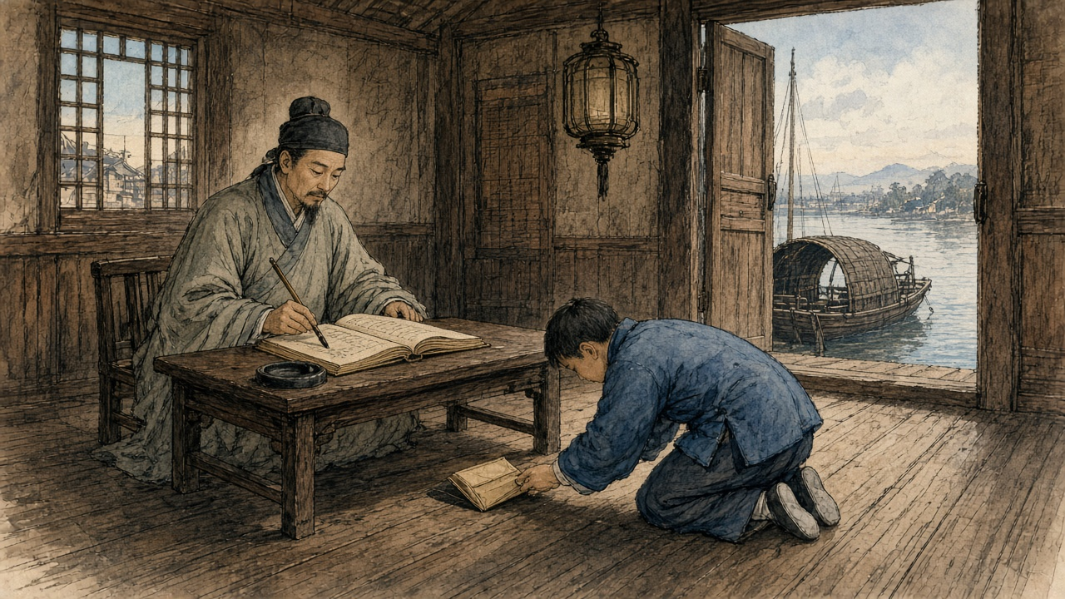
My salary from the Hoppo, written down, would not keep my mother in rice. The superintendent above me knows it, and he has a superintendent above him. The packet, it goes up, a part, a part, a part, like water up a wick. What stays with me, my son's teacher, my mother's medicine, the New Year.
And the pipe. That also.
The pipe started for the cough. Winter on the river, the wet gets into the chest. A colleague said, one pipe, the cough stops. It stopped. Six years ago, that. Now in the afternoon, at the hour of the monkey, the body asks. Not politely. It begins in the eyes, they water. Then the nose. Yawning, yawning, the jaw cracks with it. Something cold walks up the back. If the boat with the runner is late, the hands shake on the brush, and the characters in the ledger come out like a drunk wrote them. Then home, the lamp, the needle, the little bead swelling and darkening over the flame, the pull, the long pull. Warm comes back into the hands. The world goes soft at the edges, kind, like an old quilt.
My wife sits in the next room with the sewing and does not come in. My son is eleven. He knows his Four Books better than I did at fifteen. The teacher says, this one, the provincial examination, maybe.
This autumn a copy of a memorial went hand to hand along the river, and I read it at this table with the shutter closed. Huang Juezi, of the Court of State Ceremonial. Smokers, one year to stop. After the year, death. Officials who smoke, punished heavier than common people. And their sons and grandsons not permitted to sit the examinations.
That line, I read once. Then again. The candle guttering, the smoke going straight up and then bending.
My son, his name on the list at the examination hall. My son, his name never on the list.
That night I did not light the lamp. Lay on the bed in the dark with my hands under my arms. At midnight the cold came. Came up from the feet like water filling a boat. The bones of the knees, someone twisting them. Sweat came out all over and was cold at once. In the next room my wife's breathing, I could hear she was not asleep. Hour of the ox, I got up, went to the box, lit the lamp. Hands shaking so the needle could not hold the bead, it fell, and I got down and found it with my fingers in the dust and put it back on the needle, kneeling.
In the morning the runner came, bowed, said Uncle looks tired, Uncle should take care of himself. Put the packet under the ink stone.
* * *
Peking and Canton, 1836 to 1838
The court argued about the boats and the pipe in writing. In 1836 Xu Naiji proposed giving up the ban, taxing opium as a medicine, and allowing it only by barter so that no silver would leave. 朱嶟 Zhū Zūn and 许球 Xǔ Qiú answered him. Zhu's memorial, which the Canton Register translated that November, asked why, if the export of silver could be stopped as the legalizers claimed, the import of opium could not. Prostitution, gambling, robbery and treason were all forbidden and still committed, he wrote. Should those laws go too?
In June 1838 黄爵滋 Huáng Juézī, of the Court of State Ceremonial, sent up the memorial the customs clerk read with his shutter closed. Silver had grown so dear, he wrote, that a tael now cost "一千六百有零," sixteen hundred copper cash and more. Lin Man-houng, who has reconstructed the rates, puts it at about a thousand cash around 1800. A farmer paid his land tax in silver and sold his rice for copper, and Huang named the leak in plain words: "粤省奸商勾通巡海兵弁，用扒龙、快蟹等船，运银出洋，运烟入口." The treacherous merchants of Guangdong, in league with the coastal patrol soldiers, used the scrambling dragons and the fast crabs to carry the silver out and the opium in. Smokers made the market, so he proposed a year's grace and then death. The emperor sent it to the provinces for comment. 林则徐 Lín Zéxú, governor-general at Wuchang, answered with a programme and attached the withdrawal prescriptions he had been collecting for more than ten years, "目击鸦片烟流毒无穷，心焉如捣," having watched the endless poison of opium with a heart pounded as in a mortar. In Hubei he had paid out of his own salary for a thousand courses of pills to be made up for smokers.
Deng Tingzhen was already squeezing the river. In January 1838 he reported to the throne that between March and December of the previous year his officers had made thirty seizures and arrested a hundred and fourteen people, and taken 8,661 taels of sycee and 3,848 catties of opium. A ball from the foreign ships, he wrote, that used to cost forty dollars now went for sixteen to eighteen.
In April 1838 Kwok Sze Ping, in the Register's spelling, who had smuggled for five years and kept a shop where customers came to smoke, was strangled at Macao on the emperor's order. That month the Friend of India at Serampore reported that the Guangdong police had broken up the fast crabs and scattered the brokers. On 13 July the broker the foreigners knew as Ko Kwan was arrested.
The foreigners had a replacement ready. In February 1838 Deng complained in an edict that they were bringing opium up to Canton in their own decked boats: "It is just like the old 'fast crabs'." The crabs had Chinese crews that Chinese officers could catch. The new boats flew foreign flags.
In early December 1838 chests were seized as they were landed at the house of the British merchant James Innes, and the Hong merchant who had stood security for the ship was set out in public in a heavy wooden collar. On 12 December officers brought a convicted dealer into the square in front of the Factories and began to set up the cross to strangle him there. Hunter, writing forty years later, misdates the scene to February, but his picture is sharp: the victim stood by the cross with a chain about his neck, held by two gaolers, while the presiding mandarin sat by his tent and his servants kept bringing him fresh pipes. Foreign merchants poured out to protest, and a boat's crew off the British ship Orwell smashed the cross and laid the pieces over the executioners' heads. A crowd Hunter put at eight or ten thousand stoned the factories until officers came with whips at dusk. The prisoner was taken off and strangled at the regular execution ground.
On 26 February 1839 the officers came back.
* * *
A sampan off the Factory Square, Canton, 26 February 1839
Afternoon, the foreigners all out on the river in their little boats, rowing for sport. Pulling an oar for nothing, only foreigners. My sampan, by the steps below the square, waiting for a fare. Ah-Shui at home with the children, his back still bad, no work since the crabs were finished. The boat that is my house, that is also my work. Mine, the oar, now.
Soldiers came into the square. Many. Not running, walking, the way men walk who have done this before. Behind them, a chair. Behind the chair, a man on foot with the chain.
They did it at the corner of the street, not in front of the foreigners' doors. A cross of wood, two men drove it into the ground with mallets, tok, tok, tok, the sound came over the water to me clear. The man, they stood him against it. His back to the wood. His arms they pulled out wide along the crosspiece and tied, and his neck they tied to the upright, a cord round it. Young, this one. Thin. His queue had come loose.
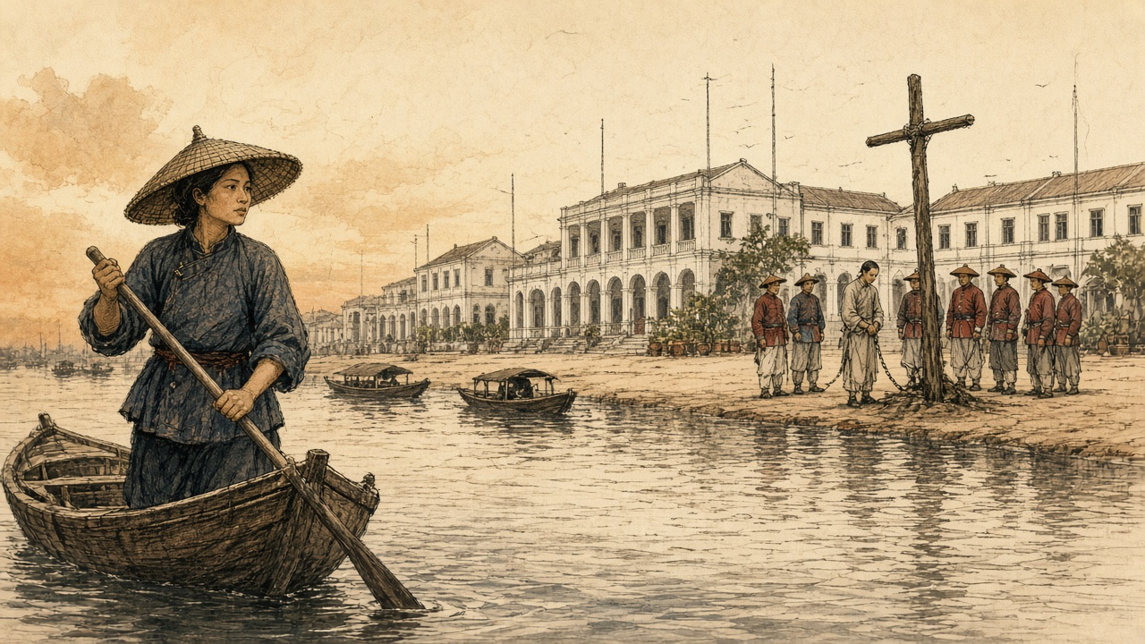
He did not shout. His feet, I watched his feet. Bare, and the toes moving on the stones, gripping, like a man trying to stand on a deck in a swell.
The executioner went behind the cross. He put a stick into the cord at the back of the neck, and he turned it.
Look at the water, I told myself. My eyes stayed. The man's face went dark, red then dark, purple like a bruise on a plum. His mouth opened wide and the tongue came out of it. The fingers on the crosspiece opened, closed, opened, scratched at the wood. His whole body jumped against the cords, jumped again, the legs kicking out in front, and a dark stain spread down the front of his trousers. The executioner turned the stick once more. Leaned on it with his weight, like a man wringing a heavy net.
The feet stopped. Then a long time, I don't know how long, the toes still moving a little, by themselves.
Quick, the foreigners said afterward, the ones not out on the river. From the water, not quick.
They untied him and he fell forward onto the stones, his face on the stones, and two of them took his arms and two his legs and carried him off up Old China Street. The soldiers walked after. The square was empty. A dog came to sniff the place where the cross had stood.
Then a foreigner came down the steps, red-faced from his rowing, climbed into my sampan, pointed across the river, said something angry, and I rowed him. What else.
That night Ah-Shui asked what I saw today. I said nothing. Rice, I said, eat.
Opium dealer, the soldiers said. Big or small, nobody on the water knew. Ah-Shui, three years at the oar. By that word, him also.
After, the foreign flags in front of the factories came down and stayed down. For him, people said. No. For their square.
* * *
The Gongyuan examination hall and the Yuehua Academy, Canton, March 1839
The Imperial Commissioner came on the twenty-fifth day of the first month and made the Yuehua Academy his headquarters. A couplet there, people said, in his own hand. Within the week every student in the city could recite it:
海纳百川，有容乃大；壁立千仞，无欲则刚。
The sea takes in a hundred rivers; it is great because it holds them. A cliff stands ten thousand feet; it is hard because it wants nothing.
A new high official, by custom, examines the students to see the quality of the place. The 观风试. Myself, Yuexiu Academy, twenty-six years, twice failed the provincial examination, my father a schoolmaster in Panyu, his father also. We were called, from Yuexiu, from Yuehua, from Yangcheng, six hundred and forty-five of us. Into the cells of the examination hall, best gowns, ink stones, brushes, the way our fathers went. Sat. Waited for the theme.
Inside the paper, a second slip.
The questions on it, not from the classics. Where are the furnace mouths, and the names of the men who keep them. Who sells retail. What was wrong with the bans before. How to end it. No name to be written on the answer. The paper to go straight to the Commissioner's own hand.
The hall went very quiet. Six hundred men, nobody coughed. I heard the man in the cell next to me put his brush down on the stone. Then pick it up. Then put it down.
My cousin's husband, a clerk in the Panyu yamen. My mother's brother, a shopkeeper in the western suburb, who buys from whom, I know. Pull one string of a family, the whole house comes down. My father taught me Mencius before I could hold the brush properly: a man who sees a child about to fall into a well. His heart moves first. Then the reasoning.
I thought of the smoke houses behind the Xiguan, the men coming out at dawn with faces grey as ash. Of the old schoolmaster on our street who sold his books one at a time, first the commentaries and then the classics themselves, until there was only the pipe. Of the boat people's children, with mud on their backs, sitting at the back of his schoolroom while he still taught.
I ground the ink fresh. Wrote small and clear. The first question I answered with the furnaces I knew. The third question, what was wrong with the bans before, I answered in one line.
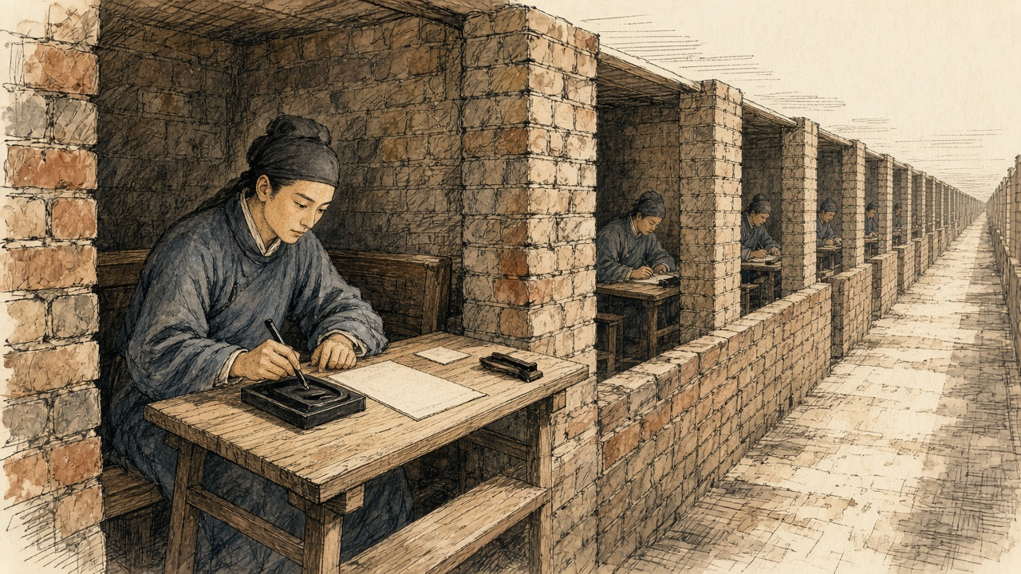
The navy protects the smuggling.
When the papers reached the Commissioner, the clerks said afterward, nearly every one gave him the same answer.
* * *
Canton, the spring of 1839
Wei Yuan records that the students all answered with the navy's protection of the smugglers, "皆以水师包庇贩私对," and that Lin then memorialized to have the brigade general Han Zhaoqing dismissed. Lin's joint report with Deng Tingzhen and the provincial governor 怡良 Yíliáng, sent up in the spring, opens with a sentence about who dies of opium: "吸食者病于瘾而死，兴贩者罹于法而亦死." The smoker sickens of the craving and dies, and the dealer falls under the law and dies too. By the end of the third month, the report counted, Deng and the governor had arrested 1,600 people and taken 461,526 taels' weight of raw and prepared opium, 42,741 pipes, and 212 pans for boiling it down. After that, gentry chosen village by village kept the 保甲 bǎojiǎ registers and handed offenders over, and by the eighteenth day of the fifth month the officers reported a hundred and ninety-two more prisoners.
Under the Qing code as the Register summarized it in 1838, a man convicted of dealing in opium was punished under the law for smuggling gunpowder and saltpetre: a month in the cangue, then banishment to the frontier as a slave to the soldiers. The cangue was a square board of heavy wood locked around the neck, broad enough that a man in it could not reach his own mouth with his hands.
* * *
The gate of a ward in the western suburbs of Canton, the fourth month, 1839
The wood, heavier than an oar. Heavier than a chest. The two halves, they put them round my neck at the yamen and fixed them, and it came down on the bones of my shoulders, and from that moment, the shoulders carry it, day and night, no putting down. Twenty-eight days more. Ah-Mui counts them for me. I lose count. She does not.
The neck rubs on the hole. First day, red. Third day, the skin broke. Now it weeps, a wet sore all round like a collar under the collar, and the flies come. Hands, I cannot get them up past the edge of the board to brush them. Shake the head, the board swings, the board pulls the sore. So the flies stay. They walk in it.
Sleep, sitting against the wall of the gate. The board's corner on the ground, my head hanging from it. Sleep, wake. Sleep, wake. Neck breaking. Every night, the same dream, I am in the water at the bottom of the river and cannot come up because something is holding my neck.
People walk past. The shore people, mostly they don't look. Some look. A boy spat once. His mother pulled him away, not because of the spitting, because I am a boat man and smell of it.
Ah-Mui comes twice a day with the congee. She kneels in the dirt, holds the bowl up, under the edge of the board, and feeds me with the chopsticks, a little, a little, like feeding a baby bird, and wipes my chin with her sleeve. In front of everybody. Her face, all the time, no expression. Only once, wiping, her hand stopped on my cheek for a moment and stayed there.
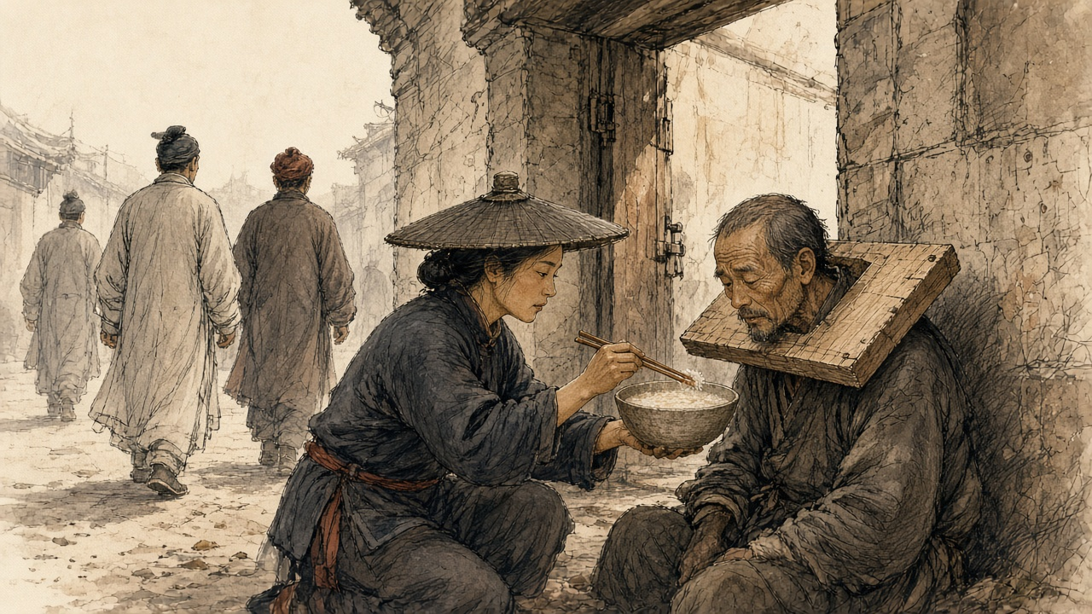
This time, not even the oar. Carrying. Two bags, a friend of a friend, up from a foreign boat at Whampoa to a door in an alley, a night's pay. The crabs all finished, broken up, the men scattered, and children must still eat. That door in the alley, the ward headman knew it. The ward headman's list, my name on it.
After the twenty-eight days, the frontier. Slave to the soldiers. Where, nobody tells me. A Tanka man, in some place with no river.
Ah-Mui says, when you come back. She says it every day. When you come back, the boy will be big.
I say yes. I don't say the other thing, she doesn't say it. Between us that thing sits on the board like a fly.
* * *
The customs station below Canton, the fifth month, 1839
No more runner. No more packet under the ink stone. The broker's shop, the board up over the door, the master fled to his village or arrested, nobody says. The ledger, now very neat and very true, and the boats that stop are few.
My wife's brother copied the prescription out of a book from Hubei, the one the Commissioner had made for the smokers there, and the druggist made it up. Paper twists, two kinds. 忌酸丸: ginseng, atractylodes, angelica, coptis, many things, and a little opium ash in the paste so the body does not scream all at once. Each day, one fewer of these, two of the other pills instead. Down, down, until none. She laid them out on the table in a row and counted them for me, like a merchant counting coins, and wrote the days on a slip of red paper. Her characters, I had not seen her write in years. Small and firm.
First days, not so bad. The ash in the pill, the body thinks it is fed. Then each day one fewer, and the body understands it is being cheated.
Seventh day, the eyes run water and will not stop, the nose also, the water falling on the ledger, blot, blot. Yawning, every breath a yawn, the jaw aches. Ninth day, the bowels. Water. Again and again to the bucket behind the screen, the stink of it in the station, the boatmen outside looking at each other. Cold, though the fifth month is hot, I sit in my winter gown shaking and the sweat runs off me. Every joint, someone is in there with a knife, the knees, the elbows, the small bones of the hands. The skin crawls, as if ants are under it.
Eleventh day, at the hour of the monkey, I stood up from the table and went to the door, and the lamp and the needle and the box were at home under the bed, I knew exactly where, and my feet were already walking.
At the door my son stood. Home from the teacher early. Book under his arm. He looked at my face, he looked at the winter gown, and he said, Father, is it the pills?
He knew. Of course he knew. A boy of eleven, a house of three rooms.
I said, yes. It is the pills. I said, go home and study. He bowed, the proper bow, and went.
I went back to the table and sat. I held the edge of the table with both hands until the knuckles went white, and I held it, and the hour of the monkey went past, and the hour of the rooster. My wife came at dark with the lamp and the rice and saw me there, and put down the rice, and took one of my hands off the table edge and held it in both of hers. Cold, she said. So cold.
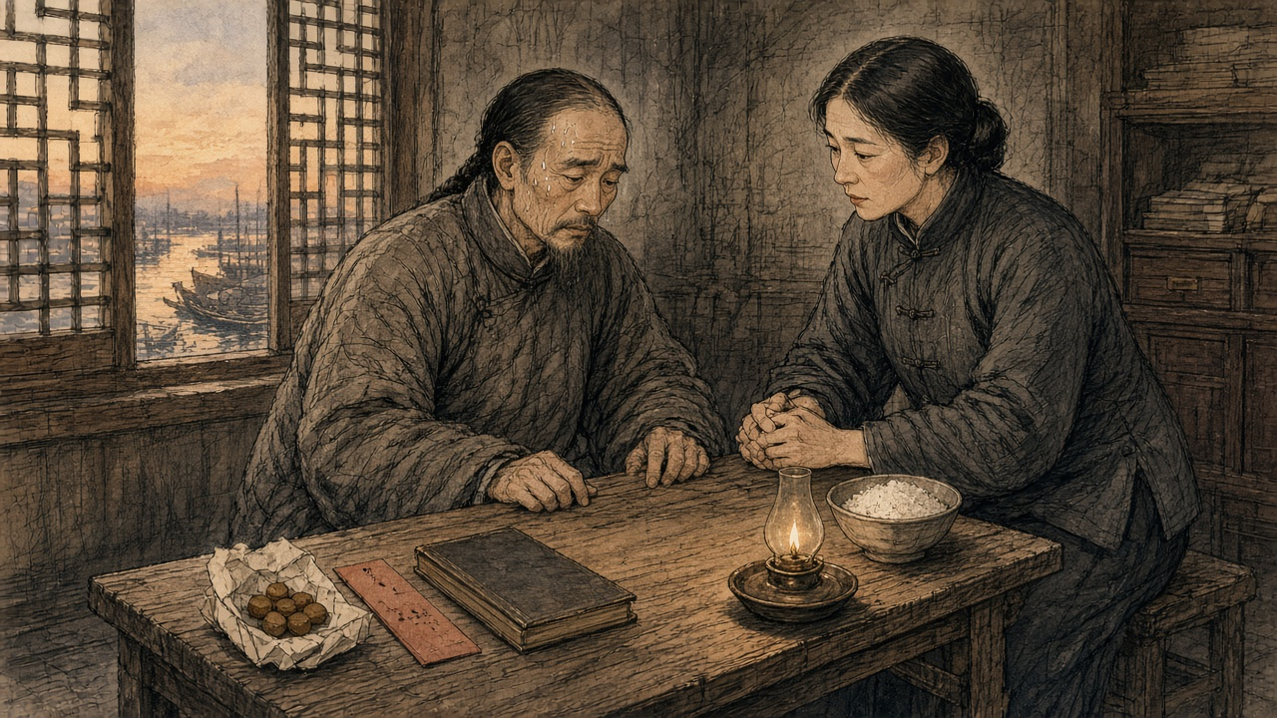
Fourteenth day, I slept.
* * *
The City of London, the autumn of 1839
The China houses had partners at home who never sailed. In 1834 Hollingworth Magniac, back from Canton, joined the banker John Abel Smith and his cousin Oswald Smith in Magniac, Smith & Co., London correspondents of Jardine, Matheson & Co. Smith sat in the Commons for Chichester. When William Jardine came home in 1839, Smith introduced him to Lord Palmerston, who later acknowledged how valuable their information had been in planning the China expedition. The Canton accounts came home as account sales and accounts current, volumes now in the Jardine Matheson Archive at Cambridge. The man below belongs to no named firm.
Tuesday. Fog at eight, so thick in Cornhill the lamps were still lit, then a cold thin drizzle which has not stopped. Boz has us exactly: "Middle-aged men, whose salaries have by no means increased in the same proportion as their families, plod steadily along, apparently with no object in view but the counting-house." My salary has increased very well, but in every other particular I plod.
Coal bad this month; it smokes, and my eyes have smarted since ten.
The Canton accounts by the overland mail. I spent the forenoon upon them with young P., who reads the figures while I tick. Each consignment its own sheet of good rag paper, ruled by hand in red: the ship's name, her captain, the marks, the number of chests, Patna, Benares, or Malwa, the rate per chest obtained, the gross; then down the right hand, the charges, freight, insurance, landing, boat hire, the receiving-ship charge of five dollars the chest, commission, and below a double rule the net proceeds; and lastly how remitted, by what bills, drawn on what house, at what exchange, at what usance. P. writes a good round hand and uses the steel pen, which I dislike; it scratches, and the ink takes on it unevenly. The ink in the older books has gone the colour of weak tea.
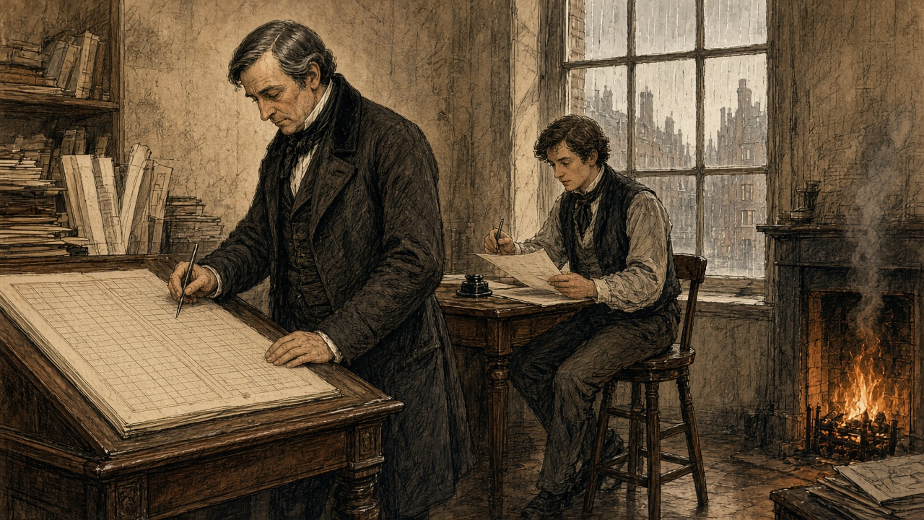
The season's figures run very well until March and then stop. After March, a fresh sheet: chests delivered up to the Chinese Commissioner on Captain Elliot's order, against his certificates, Her Majesty's Superintendent promising in effect that the Crown will answer for them. Twenty thousand two hundred and eighty-three chests in all, the Canton papers say, across every house. Ours is not the largest share. I made P. read me the column twice.
The opium itself, the letter says, went into pits of brine and lime and out with the tide in June. A copy of one of Captain Elliot's certificates came with the letter. Good thick paper.
Mr. J. is in town and has been with the Foreign Secretary, they say. The senior partner says all will come right; the certificates are the Government's paper and the Government must pay. He said it while looking out of the window at the rain coming down Lombard Street.
Bills on London from Canton fell due today to the amount of — I need not write it. They were met.
Home by six. Rain steady. A boy selling hot chestnuts at the corner of Gracechurch Street, his hands in rags, and some poor fellow face down in the gutter by the Monument, drunk or ill; I did not stop to discover which. The fog coming up again off the river. Tomorrow the Calcutta letters.
* * *
Canton, 1839 to 1840
The regulations that reached Canton in the summer of 1839 gave smokers eighteen months to break the habit before strangulation. Lin's later memorials, added up by the historian 茅海建 Máo Hǎijiàn, report 890 more cases and 1,432 more prisoners between May 1839 and the end of June 1840. When the British ships came, Lin went to the river for men. He had learned from translated foreign newspapers, the 防海纪略 says, that the British despised the Qing navy and feared the coastal smugglers, the fishing boats, and the 蛋户, the Tanka. He enrolled five thousand able-bodied men at six dollars a month, with six more for their families.
Han Zhaoqing lost his post. Wei Yuan gives the rest in one clause after Lin's memorial for his dismissal, "终以邓廷桢所保，不能尽正其罪": in the end, because Deng Tingzhen had vouched for him, his crime could not be punished in full.

Sources
First-person passages are reconstructions; named and dated events follow the sources below.
The original volume carries no in-text markers. These are the sources grouped to this chapter.
• The Chinese Repository 中國叢報. Canton: 1832-1851. Especially the 1837-1839 issues for descriptions of receiving ships, fast crabs, centipede boats, and the Pearl River smuggling routes; vol. VII, no. 8 (December 1838), on the Innes seizure and the attempted execution of 12 December 1838.
• Qing shilu 清實錄 [Veritable Records of the Qing]. Daoguang chao. Entries concerning the opium trade at Lintin and the conduct of Guangdong naval commander Han Zhaoqing 韓肇慶.
• Chouban Yiwu Shimo 籌辦夷務始末 [Complete Account of the Management of Barbarian Affairs]. Daoguang chao. Beijing: Palace Museum edition. Huang Juezi's memorial of 1838 is printed in juan 2.
• Guangdong local gazetteers for Pearl River delta counties. Especially entries on waterways and the Tanka 疍家 boat population; (Yongzheng) Guangdong tongzhi 廣東通志, juan 7 and juan 64, and the Dingli leichao 定例類抄, juan 7, for the edict of the fifth month of Yongzheng 7 (1729), 粤東蛋户准於近水村莊居住.
• Hunter, W. C. The "Fan Kwae" at Canton Before Treaty Days, 1825-1844. London: Kegan Paul, Trench, & Co., 1882. Source for the smug boats ("scrambling dragons" and "fast crabs"), their build, crews, sails, armament and varnished hulls, the brokers' agents, the five-dollar cumsha, magistrates' fees, the river as "a city afloat," the strangling cross, the square riot (misdated by Hunter to February 1839), and the execution of 26 February 1839.
• Antony, Robert J. Unruly People: Crime, Community, and State in Late Imperial South China. Hong Kong: Hong Kong University Press, 2016.
• Brook, Timothy, and Bob Tadashi Wakabayashi, eds. Opium Regimes: China, Britain, and Japan, 1839-1952. Berkeley: University of California Press, 2000.
• Fay, Peter Ward. The Opium War, 1840-1842. Chapel Hill: University of North Carolina Press, 1975.
• Siu, Helen F. Merchants' Daughters: Women, Commerce, and Regional Culture in South China. Hong Kong: Hong Kong University Press, 2010.
• Van Dyke, Paul A. The Canton Trade: Life and Enterprise on the China Coast, 1700-1845. Hong Kong: Hong Kong University Press, 2005.
• Van Dyke, Paul A. Merchants of Canton and Macao: Politics and Strategies in Eighteenth-Century Chinese Trade. Hong Kong: Hong Kong University Press, 2011.
• Murray, Dian H. Pirates of the South China Coast, 1790-1810. Stanford: Stanford University Press, 1987.
• Wakeman, Frederic, Jr. Strangers at the Gate: Social Disorder in South China, 1839-1861. Berkeley: University of California Press, 1966.
• Polachek, James M. The Inner Opium War. Cambridge, MA: Harvard University Press, 1992.
• Chen, Song-Chuan. Merchants of War and Peace: British Knowledge of China in the Making of the Opium War. Hong Kong: Hong Kong University Press, 2017.
• Qing shilu and Chouban yiwu shimo: series-level only until juan/folio confirmed.
• 魏源 Wei Yuan. 夷艘寇海記 (appendix to 聖武記) and 道光洋艘征撫記. Source for Han Zhaoqing's arrangement ("每萬箱許送數百箱與水師報功"), his promotion and peacock feather, the academy students' answers ("皆以水師包庇販私對"), and his dismissal ("終以鄧廷楨所保，不能盡正其罪").
• 防海紀略 Fanghai jilüe (late Qing; Chinese Wikisource text). Follows Wei Yuan; source for the 36,000 taels a month taken by the patrol boats after 1826, Lu Kun's abolition of the patrols in 1832, Deng Tingzhen's restoration in 1837, "水師兵丁，人人充橐," and Lin's recruitment of five thousand men, in a passage on the smugglers, fishermen and 蛋户 the British feared, at six dollars a month plus six for their families.
• 沈渭濱 Shen Weibin. 道光十九年：從禁煙到戰爭. Quotes the memorial of the censor 馮贊勳 on the fast crabs' iron netting, fifty to sixty oars and the name 插翼, and Xu Naiji's 有省城包買戶，謂之窰口.
• 黃爵滋 Huang Juezi. 請嚴塞漏卮以培國本疏, Daoguang 18 (1838), as printed in 中國通史參考資料·近代部分 and in Qing shigao, biography of Huang Juezi. Source for the silver rate of 1,600 cash and more, the scrambling dragons and fast crabs, the year's grace, and the exclusion of smoking officials' sons and grandsons from the examinations.
• 林則徐 Lin Zexu, 鄧廷楨 Deng Tingzhen, 怡良 Yiliang. 會奏續獲人烟槍具摺, in 林文忠公政書, 使粵奏稿 juan 4. Source for "吸食者病於癮而死，興販者罹於法而亦死," the arrest of 1,600 people, 461,526 taels of opium, 42,741 pipes and 212 pans by the end of the third month of 1839, and the later 140 cases and 192 prisoners.
• 林則徐 Lin Zexu. 籌議嚴禁鴉片章程摺 (1838), with the withdrawal prescriptions 忌酸丸 and 補正丸, in 林文忠公政書, 湖廣奏稿 juan 4; the prescriptions as collected by 何其偉 He Qiwei in 救迷良方. Lin's a thousand courses of pills paid from his salary as summarized by 中華文史網 (Qing History Project, historychina.net).
• 茅海建 Mao Haijian. 天朝的崩潰：鴉片戰爭再研究 (Beijing: Sanlian, 1995), ch. 2. Lin's later arrest totals, May 1839 to June 1840.
• "林則徐在高第街的日子," 羊城網 (gznf.net), which also records that Liang Tingnan organized the examination at Lin's request; and 人民周刊, 4 May 2016. The 觀風試 of 645 students from the Yuehua, Yuexiu and Yangcheng academies and its four questions; Lin's couplet at the Yuehua Academy.
• The Canton Register, as abstracted in Roger Houghton, A Peoples' History 1793–1844 from the Newspapers, "Opium" parts 2 and 3 (houghton.hk). Source for the 1832 memorial on 100 to 200 fast crabs, the crabs built at Lintin (December 1832), the fight of June 1833 and the repurchased book, Xu Naiji's description of the boats and the yaokou (1836), Zhu Zun's memorial (8 November 1836), the Shaoguan customs fees (January 1837), Deng Tingzhen's report on the 1837 seizures and the price of a ball, his edict on the foreigners' decked boats (February 1838), the strangling of Kwok Sze Ping at Macao (April 1838), the arrest of Ko Kwan (13 July 1838), the penal code on dealers, the cangue, and the Friend of India editorial of 19 April 1838.
• Eitel, E. J. Europe in China: The History of Hongkong from the Beginning to the Year 1882. London and Hong Kong, 1895, ch. 8. The Innes seizure and the security merchant in the wooden collar, December 1838.
• Merchants and Mandarins: China Trade Era (online flipbuilder edition, pp. 246, 265), citing the Chinese Repository VII, no. 8 (December 1838), the Canton Press Extra, and the consular despatch of P. W. Snow, 6 March 1839, for the dating of the attempted execution to 12 December 1838 and the execution of 26 February 1839; Elliot's address as abstracted in Houghton, "China 1839–1840, part 10" (houghton.hk), gives the same two dates.
• Lin, Man-houng. China Upside Down: Currency, Society, and Ideologies, 1808–1856. Cambridge, MA: Harvard University Asia Center, 2006. Silver-copper exchange rates.
• Greenberg, Michael. British Trade and the Opening of China, 1800-1842. Cambridge: Cambridge University Press, 1951. The agency houses, their London correspondents, and remittance by bills on London.
• "Smith, John Abel (1802–1871)." Oxford Dictionary of National Biography. Magniac, Smith & Co. (1834) as London correspondents of Jardine, Matheson & Co.; Smith's introduction of Jardine to Palmerston.
• Jardine Matheson Archive, Cambridge University Library, MS JM/A5 (Account sales, 1810–1886), the accounts current series (including the London volumes), and the ledgers series A1, as described in the ArchiveSearch catalogue.
• Dickens, Charles ("Boz"). Sketches by Boz. London, 1836. "The Streets—Morning" and "The Streets—Night."

