Chapter 10
Poppies Inland, 1839
Yunnan, Sichuan, Hubei, and Peking, 1831 to 1848
In the summer of 1831 the governor-general of Yunnan and Guizhou, the scholar 阮元 Ruǎn Yuán, sent the Daoguang Emperor his rules for stopping the poppy in the Southwest. The emperor's reply of 3 August, kept in the Veritable Records, repeats what Ruan had told him. Along Yunnan's frontier the 夷民, the non-Han peoples of the border, had long grown the poppy, collected the juice of the flower, and boiled it into a paste they called 芙蓉 fúróng, the lotus, and sold it as opium. People of the interior grew it too, saying they wanted the seed for pressing oil. Ruan explained why. "费工少而获利多": it took little labor and paid a great deal. The province was all deep mountains and remote valleys, and the habit was old.
Ruan proposed two inspections a year. In winter, when the poppy came up out of the ground, the local official and an officer of the garrison would walk the fields and hoe the plants out. In late spring, when it flowered and set its buds, they would walk them again. Clerks and runners of proven honesty would watch the passes and the tax stations for carriers.
The emperor answered the plan point by point. The valleys were too many, he wrote, and to trust the growing households to dig out their own plants "是必不可信之事," was a thing that could never be believed. Then the runners. "试思胥役之中。焉有诚妥可信者": think it over, among clerks and runners, where is there one honest and trustworthy? Add more of them and you add one more abuse. "所议皆不过纸上空谈。于事何济": everything proposed is empty talk on paper, and what use is that to the matter? He ordered the officials to inspect without fixed dates, to arrive when no one expected them, and to report at the end of every year. If poppy they had not found turned up later in some other case, they would be impeached.
For the border domains he left the work to the 土司 tǔsī, the hereditary native chiefs who governed them for the throne. Each winter the chief was to inspect in person. Any plot grown in secret, his headmen and militia were to pull up, and the grower was to be put in the cangue according to the statute. The field went to the chief, to be worked by his militiamen as militia land.
The same summer the emperor approved rules for Hunan, where poppy growers were to be sent into military exile and their land confiscated. From Canton the viceroy reported poppy only in the prefecture of Chaozhou, and the emperor answered that he doubted it stopped there. In Guangdong the field would be forfeit and the grower punished as an opium dealer, and the ward headmen, village elders, and lineage heads who had kept quiet would be cangued or beaten. The governor-general of Sichuan, 鄂山 È Shān, reported poppy still grown around Huili and Pingwu, where the province met the non-Han country. In Hunan and Guangdong the officials were to sign a sealed bond every year that their districts grew none.
* * *
A valley near Mengzi, southern Yunnan, the winter of 1838 to the spring of 1839
That field, my grandfather's. Beans, wheat, in the cold season, every year. Beans to the market at Mengzi, wheat for us. A good year, the beans pay the tax and a little over. A bad year, not.
Five years now, poppy. My wife's brother started first, then the man across the ditch, then me. Same field, same water, same winter. The seed so small, a whole year's seed in one bowl. Sow it thin, keep the birds off it. The rest the plant does.
Winter, the green comes up. Low, grey-green, leaves like a cabbage gone wrong. This winter a proclamation came down from the provincial city, red seal, and the headman read it out at the temple. Planting the poppy, boiling the paste, opening a smoking-house, carrying it out of the province, all to be seized and punished, no favour. He read it, folded it, put it back in his sleeve, and went home.
Spring, the flowers. Whole valley, white, some red, so bright in the sun it hurts the eyes. Then the petals drop, and the head stands up on the stalk, green, hard, the size of a hen's egg. That is when the work starts.
Prick the head. A little blade, a few strokes, shallow, the skin only. The juice comes out white, a bead, a line, slow, and sits there and goes brown. Then scrape it off with the edge of the knife into a bowl. Every head, every plant, the whole field, bent over, the back, the neck, my wife on the next row. The juice on the fingers goes black and sticky and will not wash.
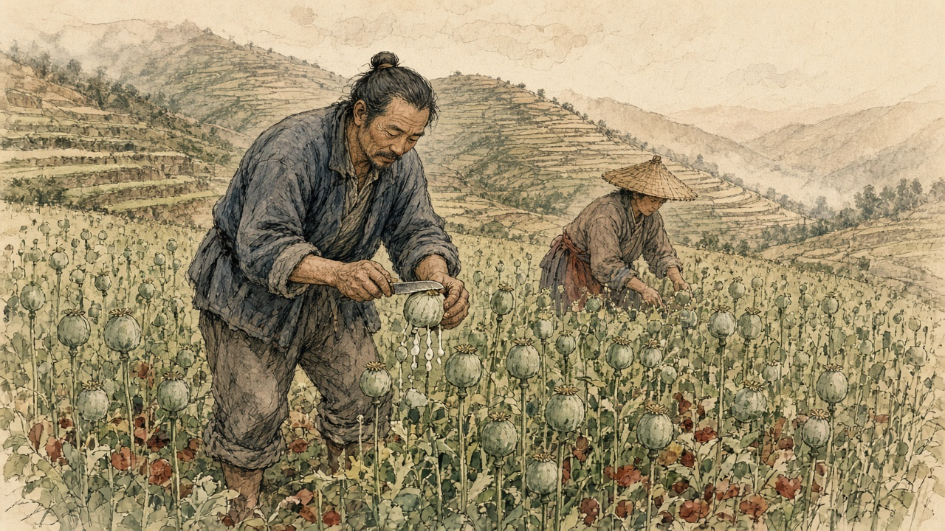
Then the pot. Boil it, strain it, boil it down, until it is the paste, thick and dark. The smell, sweet and rotten together, in the walls, in the quilts. Neighbours say nothing. Their houses smell the same.
A man from Sichuan comes for it. He pays silver. Ten times what rice pays, people say. Ten times, I don't know. More than beans, much more. This year the tax paid, and more over.
In the towns the paste is cheap, cheaper than anywhere, the Sichuan man says. In Mengzi the smoking-houses open in the street, doors wide. The yamen people go, the clerks, the runners, the officials' relatives and servants. Students, shopkeepers, soldiers from the garrison, ordinary people. Five, six men in ten, people say.
My wife's brother smokes now. In the evening his hand starts to shake before the lamp is lit, and his eyes go somewhere, and he is not at the table any more even when he sits at it. His wife came to my wife, crying. Their rice money, gone into his pipe. The paste he boiled himself, gone into his own pipe. Grows it, boils it, smokes it, and still owes.
Summer, more news from the provincial city. A new law from Peking. Anyone growing poppy, gathering the juice, making the paste and selling it, the chief offender, strangled. Not at once, after the autumn assizes. The helpers, exile to the fever country at the far frontier. A year and a half to stop.
That night, no sleep. Lay there, eyes open in the dark. A rope round a neck, I thought of a rope round a neck, the knot under the ear. Got up, went out, stood at the edge of the field. Stalks, dry now, rattling a little in the wind. My own hands, black in the creases still, I could feel them without seeing. Stood a long time. Then back in and lay down beside my wife, and she was awake too, and neither of us said a word.
Next winter, the seed in the ground again, same as the man across the ditch.
* * *
Peking, 1836 to 1838
The court argued over the poppy at home before it argued over the ships at sea. On 10 June 1836 the vice-president of the Court of Sacrificial Worship, 许乃济 Xǔ Nǎijì, who had served in Guangdong, proposed taxing foreign opium as a medicine and, on a separate slip, letting Chinese farmers grow their own. Opium came from the juice pricked out of the poppy as it set its buds, he wrote, boiled down. Fujian, Guangdong, eastern Zhejiang, and Yunnan had all grown it, until the censors had it banned, and since then nobody in the interior dared, and the foreigners kept all the profit. Native opium was cheap and weak, he wrote, did a man little harm, and was easy to give up. "今若宽内地民人栽种罂粟之禁，则烟性平淡，既无大害，且内地之种日多，夷人之利日减，迨至无利可牟，外洋之来者自不禁而绝." If the ban on the people of the interior planting the poppy were relaxed, the smoke would be mild and do no great harm, home growing would increase day by day, the foreigners' profit would shrink day by day, and when there was no profit left to seek, the foreign supply would stop without being banned.
He knew the danger to the grain, and answered it from Guangdong. There the poppy went in after the late rice was cut in the ninth month, flowered and fruited by the second or third, and once the juice was taken the early rice went in, so the land lost nothing and the farmer gained a great deal. The officials at Canton, answering the emperor, suggested allowing it on hilltops and field corners too broken to be farmed in proper plots, and nowhere on good fields.
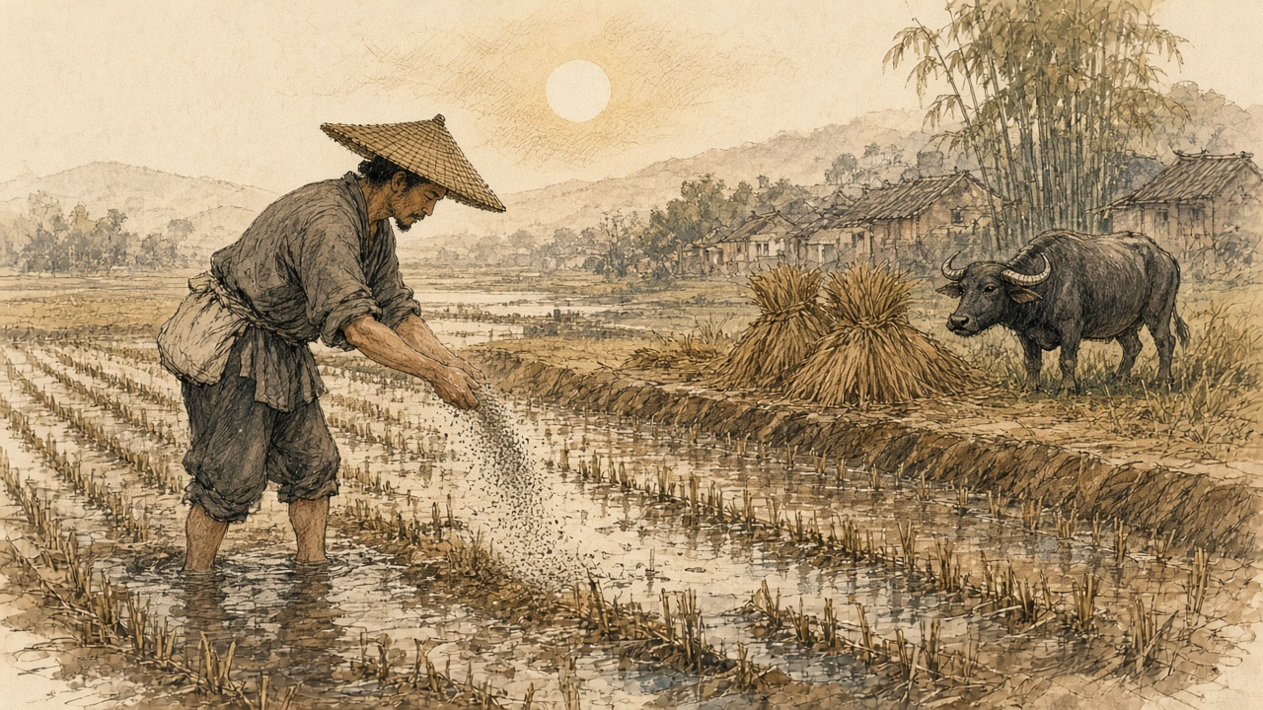
Xu argued for the people as he saw them. Only the stupid and lowly with no office would be left free to buy and smoke, he wrote; officials, scholars, and soldiers would still be forbidden. Did the habit shorten lives? Not always, and "今海内生齿日众，断无减耗户口之虞": the empire's people were growing more numerous by the day, and there was no danger at all of the population being reduced. That autumn two officials answered him. One was the supervising censor 许球 Xǔ Qiú. The other was the sub-chancellor of the Grand Secretariat 朱嶟 Zhū Zūn, a Yunnan man from Tonghai, who would not have the poppy ban in the interior loosened and would not have the law punish officers and soldiers while it let the common people buy and smoke. "民贫尚可变富，民弱不可救药," he wrote: a people grown poor can still grow rich again, but a people grown weak has no medicine that will save it.
Huang Juezi's memorial of 1838, with its year of grace and death for the smokers, won the argument at court. On 28 October 1838 Xu Naiji was demoted to the sixth rank and retired for having recklessly asked for the ban to be relaxed.
On 20 December 1838 the emperor wrote to the governor-general of Yunnan and Guizhou, 伊里布 Yīlǐbù, and the governor of Yunnan, 颜伯焘 Yán Bótāo, about a memorial on their province. In the deep mountains and remote valleys, it said, the poppy was grown and its juice boiled into smoke, "其利十倍于种稻," the profit ten times that of growing rice. In the yamens, from officials' relatives, private secretaries, and servants down to clerks and runners, and in the towns, among students, merchants, soldiers, and ordinary people, "吸烟者十居五六," smokers were five or six in ten. Dens opened in plain view. The paste sold cheaper than in any other province and was now being carried out of it for the profit. The opium that came by sea had to be dealt with strictly, the emperor wrote, and what grew at home had to be cut out.
* * *
Hanyang and Hankou, the summer of 1838
Hankou sat where the Han River runs into the Yangzi, across the water from the provincial capital at Wuchang, a town of markets and warehouses. In the summer of 1838 the governor-general of Hubei and Hunan, 林则徐 Lín Zéxú, did not wait for the court to settle the new penalties. He and the two governors set up bureaus in the provincial city and at Hankou to take in pipes, bowls, implements, and leftover opium, and he paid out of his own allowance for a thousand courses of pills to break the craving, for men who handed in their pipes and truly meant to stop.
The magistrate of Hanyang, 郭觐辰 Guō Jìnchén, went down to the boats. In the cargo boxes of a dealer named 朱运升 Zhū Yùnshēng his men found more than 1,200 taels of raw opium and more than 800 of prepared paste hidden among the goods. In the warehouse of Qiu Dixiang they took two more dealers. Two others had already gone home to Guangdong, and in the leather trunk of one and the wooden chest of the other the searchers found 2,070 and 980 taels. In another warehouse they took two more, and in the double bottom of a bed belonging to a man who had run, 850 taels. Three dealers walked into the prefecture and county offices and gave theirs up. In all, more than twelve thousand taels.
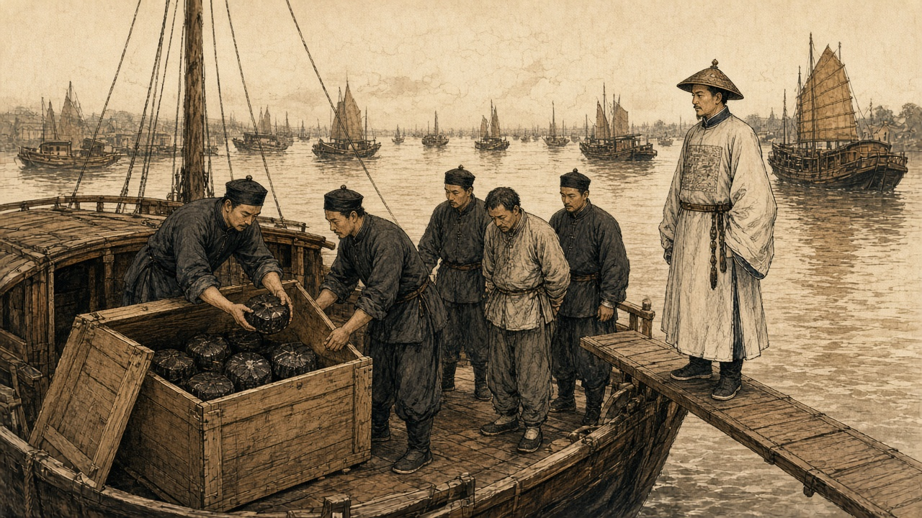
By the end of the sixth month the bureaus had 1,264 pipes. Lin's officials checked them one by one, split each with a knife, and burned them. Pipes with paste still caked inside were soaked with tung oil and burned again until nothing was left, and the ash was thrown into the middle of the river. The carved and ornamented pipes and bowls, Lin wrote, were too many to list.
He had been asking the merchants about trade, at Hankou and before that in the Nanhao quarter of Suzhou. They told him that goods which twenty or thirty years before had done ten thousand taels of business now did half that. He asked where the other half had gone. "一言以蔽之，曰鸦片烟而已矣." In a word, opium.
He did the sum for the emperor. A poor man in a fair year could live on four or five hundredths of a tael of silver a day, and on a tenth of a tael he lived comfortably. A smoker spent at least a tenth of a tael a day on top of food and clothes, thirty-six taels a year. If only one in a hundred people smoked, the drain was more than a hundred million taels a year, and far more than one in a hundred smoked. Smokers called their friends in, he wrote, and took pride in drawing others into the habit.
The dealers, he reported, had heard there might be a death penalty, "莫不魄悸魂惊," and every one of them was shaken to the soul. Many had already fled. He wanted the smokers punished as hard as the sellers, and quoted the proverb: in a market of men whose feet have been cut off, nobody sells shoes, and beside the monks' quarters nobody sells combs.
He named who protected the trade. In the yamens, he wrote, among private secretaries, officials' relatives, personal servants, clerks, and runners, "嗜鸦片者十之八九," eight or nine in ten were addicted, and all of them were in a position to shield the sellers. The statute had long prescribed strangulation for keeping an opium den. "而历年未闻绞过一人，办过一案": yet in all those years no one had heard of a single man strangled, or a single case tried.
* * *
A roadside in Wuchang, the summer of 1838
The chair came along the road with the runners in front calling to clear the way, and I went down on my knees in the dust at the side, and put my forehead to the ground, and stayed. Old Mrs Wang from our lane next to me, also. Others, further along. Nobody told us to. We came.
Twelve years his habit. A clerk in a cloth shop by the river, a good hand, he could write. Trade got bad, the shop cut his pay, then a friend took him along one evening to smoke, for company. After that, every evening. The friend brought other friends. Then the shop let him go.
A day's eating, our house, five mouths, never more than a few coppers. His pipe, every day, more than all of us. The pawnshop, my wedding hairpins, the winter quilt, his good gown. Borrowed from my sister, borrowed from his cousin. Every New Year the debts called in, people at the door, and him on the bed with his face to the wall.
Then the notices went up. A death law coming. The yamen giving out pills. I took him by the sleeve to the bureau myself, him carrying his pipe wrapped in a cloth, and he handed it over, and they gave him the paper packets.
Then the days after.
His face shrank. The skin pulled in tight over the bones, and the lips drew back off the teeth, and the teeth showed all the time, even sleeping. Water streaming from the eyes. Cold, cold over the whole body in the summer heat, shaking under every cover we had left, and we did not have many. Aching, every part of him. The bowels, water, many times in a night, the stink of it, and him too weak to get up, me cleaning him like a baby. No strength even to lift the head. And always begging. One pipe, only one. He called me by my childhood name, the one only his mother used.
The druggist said ginseng helps. The druggist's price for ginseng, Korean, foreign, all of it, up and up since the notices, several times what it was. Everybody in the city buying. I sold my last good jacket for one packet of it.
Then one morning he ate rice. Half a bowl. Some days after, he sat in the doorway in the sun. Now he goes to the docks for work, any work, comes home tired and sleeps at night. His face, filling out a little.
What I could not do in twelve years, what his own father could not, the death law did.
So I knelt. Dust in my mouth. The chair went by, I heard the poles creak, I did not look up. I said into the ground, my husband, the habit, broken, he is getting stronger. Said it again. Whether anybody heard, I don't know.
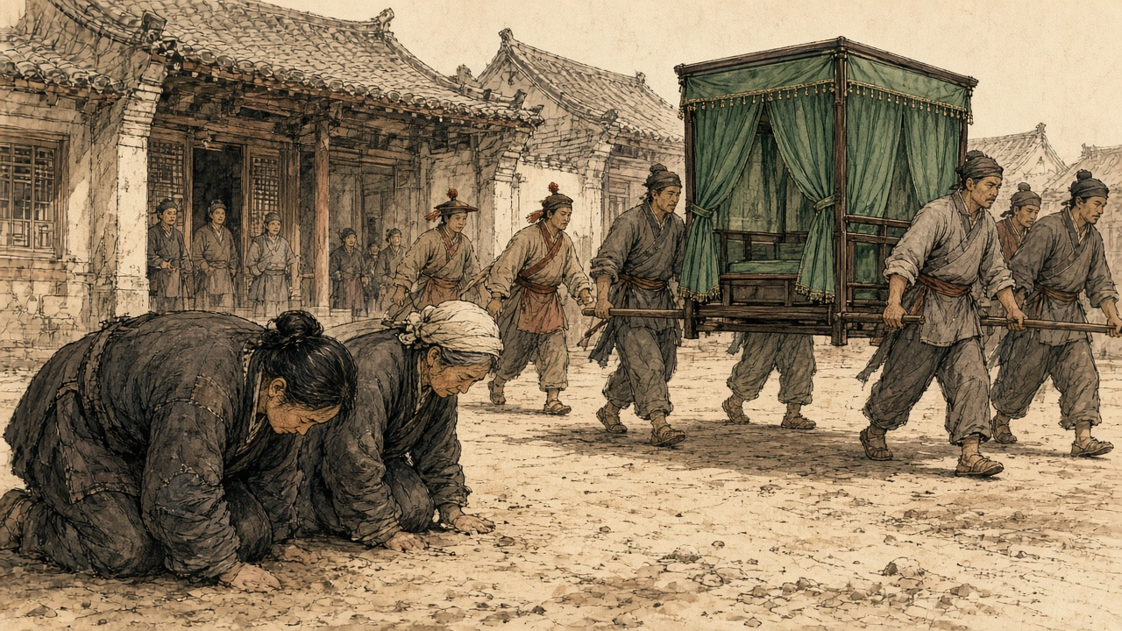
Lin wrote to the emperor that old people and women were kneeling at the roadside in Hubei and knocking their heads on the ground in thanks, saying their husbands and sons had long been sick with the craving and now, by the medicine, had broken it, and their bodies were growing stronger. "是其父子家人平日所不能断者，皆恃国法有以断之": what fathers, sons, and families could not break on their own, they relied on the law of the state to break for them.
* * *
The parade ground at Wuchang, the tenth day of the ninth month, 1838
Morning. The parade ground flat and grey, the dust packed hard by the soldiers' feet. The Governor-General himself was there, and the Governor. We runners at the tables.
Pipes, a mountain of them. Sacks and bundles tied with string, from all over the province. Plain pipes black with years. Pipes carved and fitted so fine, so many kinds, nobody could count them. Bowls in heaps. All the little tools. The clerk calls the count, I hand, the other one writes. At the end, one thousand seven hundred and fifty-four, pipes.
My job, the knife. Lay the pipe on the block, set the blade along the stem, hit the back of the blade with the mallet. Crack. Split open, two halves. Inside, black. Old oil, thick, shining, all down the bore. That is how you tell an old pipe from a new one, the clerk says, a new one is clean inside. These, none clean.
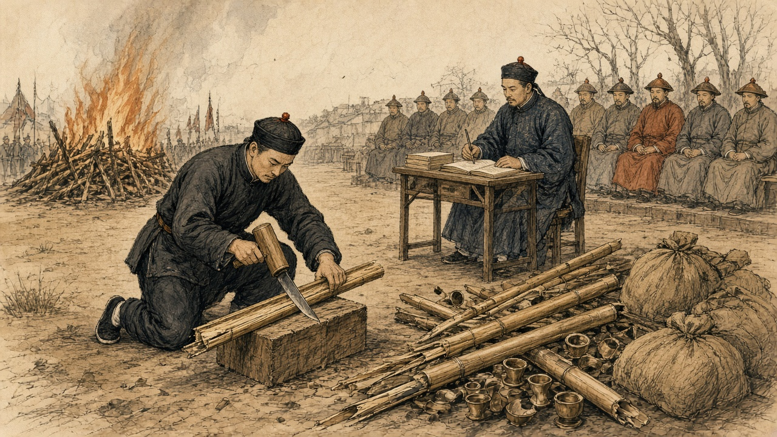
And the smell comes up out of the wood when it splits.
My hands, the first hour, steady. After that, not. Every crack it comes up again, into the nose, into the back of the throat, and the stomach turns over and the mouth fills with water. Spit, wipe the mouth on the sleeve, next pipe. Since the summer I have not been to the place behind the dyer's. Since the summer, fifty-odd days. The eyes streaming, the cold in the bones in the heat, the aching, the bowels, that is over now, almost over. And now this, a whole morning of it, the whole parade ground.
The runner next to me, same thing, I can see it. Lips wet. Neither of us looks at the other.
Then the scales. Raw opium, paste, weighed out in front of the great men, the clerk calling it. Sixteen thousand seven hundred and sixty-eight taels. The Jiangxia lot, thrown into the middle of the river. Gone, all that money, under the brown water. The Hanyang lot, sealed up for the provincial treasury.
The pipes, smashed, onto the fire. Oil in them, they go up fast, spitting, and the smoke is that smoke, sweet and heavy, rolling across the ground. I keep my eyes on the fire, and pinch the inside of my wrist with my nails until the skin breaks, and keep pinching.
The new law, people say, will be death for smoking. In the yamen everybody knows who smokes. Eight of ten, nine of ten. Our own Governor-General wrote it to the Emperor, the clerk says. If it comes, who arrests whom.
End of the day, my hands black to the wrist. Washed them at the bank. The smell on them still, going home. In the dark, at the alley by the dyer's, I stopped. Stood there. My feet knew the way. Then walked on.
That winter the emperor called Lin to Peking and sent him on to Canton as imperial commissioner.
* * *
The roads between Yunnan and Sichuan, 1839 to January 1841
In 1839 the censor 陆应谷 Lù Yìnggǔ, himself from Mengzi, reported that the poppy in Yunnan was no longer a matter of a few border valleys. In Fumin, Chenggong, and Luquan, counties just outside the provincial capital, people were planting it in secret. And in the wide districts toward the frontier, Mengzi, Guangnan, Kaihua, Jingdong, Zhaozhou, Menghua, "昔种豆麦之田今成罂粟之地": the fields that once grew beans and wheat had become poppy land.
The capital added up the provincial reports. Across 1838 and 1839, the archives of the campaign record, the provinces outside Guangdong seized 588,179 taels of opium and paste and 39,468 pipes and implements, and took 4,111 dealers and smokers. In March 1839 the Sichuan governor-general 宝兴 Bǎoxīng reported 32,630 taels, more than 3,340 implements, and 33 cases. The poppy uprooted in those two years came to something over 230 mu, under forty acres, and Zhejiang alone reported that much. Yilibu reported to the throne that the poppy in Yunnan had been dug out completely.
The regulations of June 1839 reached the provinces that summer: strangulation after the assizes for the chief offenders who grew the poppy and made and sold the paste, exile to the malarial far frontier for their accomplices, eighteen months for the country to comply.
On 22 January 1841, the last day of the twentieth year of Daoguang, with a British fleet already on the coast, the emperor answered a memorial from the border. Opium bands from Yongchang in western Yunnan, it said, were moving in parties of several hundred men at a time, carrying guns and cannon. Each band carried red flags, and on the flags was written:
将本求利，舍命取财
Jiāng běn qiú lì, shě mìng qǔ cái
Put up the capital, seek the profit. Stake your life, take the wealth.
They traveled freely between Shunqing and Ningyuan in Sichuan. The people there grew poppy and boiled it into raw opium under the new name of 芙蓉膏, lotus paste, and went about selling it in gangs. The authorities at Huili had caught one opium criminal, who confessed that in Yunnan he had resisted arrest and killed soldiers, and the case had been closed with a muddled verdict. The censor 杜彦士 Dù Yànshì, writing on the same border that month, reported that the people there lived mainly by growing poppy and that half the sellers were Sichuan men.
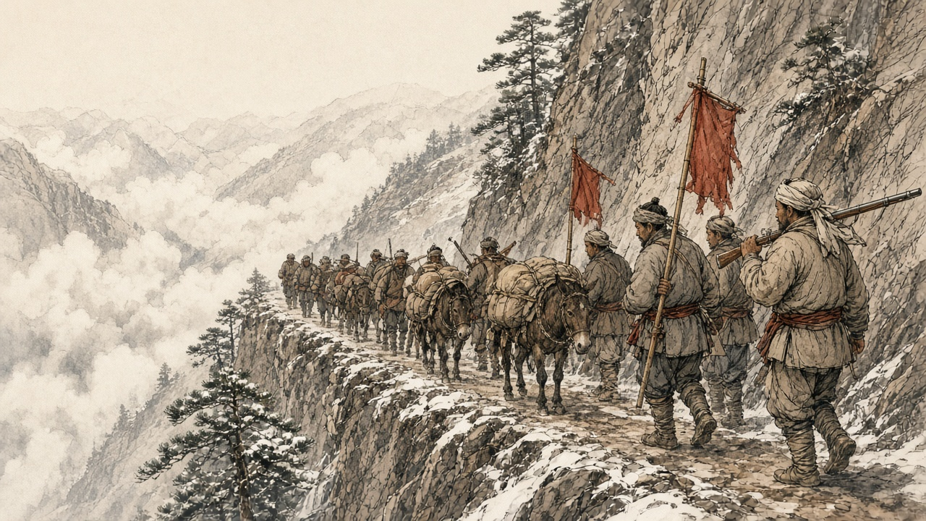
The emperor asked how this could be. Yilibu had reported the Yunnan poppy destroyed, cleared completely. How then was lotus paste still sold? The new governor-general and governor were to make their subordinates investigate and arrest in earnest and to uproot every plant, "不准稍留根株," not the smallest root left behind; and the Sichuan governor-general was to seize any opium bandit who crossed into his province, "毋许姑息养奸," with no indulgence that would feed the evil.
Lin had been dismissed from Canton the October before and was waiting there for the emperor's pleasure. Sixty years later, when 严复 Yán Fù put The Wealth of Nations into Chinese, he chose 母财 mǔcái, mother-wealth, for capital.
吴其濬 Wú Qíjùn, first in the palace examination of 1817, served in the 1840s as governor of Yunnan and then governor-general of Yunnan and Guizhou, and spent years on a botany of the empire's plants, most of them drawn from life. He put the poppy among the flowers. "近来阿芙蓉流毒天下，与断肠草无异，然其罪不在花也": these days opium poisons the whole empire, no different from the heartbreak herb, yet the crime is not the flower's. He died early in 1847, governor of Shanxi. His manuscripts were edited and printed at Taiyuan in 1848 by 陆应谷 Lu Yinggu, a native of Mengzi, who dated his preface from the Taiyuan prefectural office in the spring of that year. Nine years before, as a censor, Lu had told the emperor about the bean and wheat fields of Mengzi.

Sources
First-person passages are reconstructions; named and dated events follow the sources below.
The original volume carries no in-text markers. These are the sources grouped to this chapter.
• Qing shilu 清實錄 [Veritable Records of the Qing]. Daoguang chao. Entry of 丙戌, the last day of the 12th month of Daoguang 20 (22 January 1841), relaying a memorial on the Yongchang opium bands, their red flags and the slogan jiang ben qiu li, she ming qu cai 將本求利，捨命取財, their movement between Shunqing and Ningyuan, the name 芙蓉膏, the Huili confession and the muddled verdict, and the order to Guiliang, Zhang Lizhong and Baoxing; read in the transcription at baike.ytso.com (文脈國學). Entry of 壬寅, 20 December 1838, to Yilibu and Yan Botao on Yunnan cultivation, the tenfold profit over rice, and smokers "十居五六"; same transcription. Daoguang 11, 6th month (juan 191): the reply of 3 August 1831 to Ruan Yuan on Yunnan, the tusi and militia land; the Hunan rules on Su Cheng'e's memorial; the Guangdong rules on Li Hongbin's memorial; read in the transcription at 39017.com.
• Yunnan and Sichuan local gazetteers. Especially entries using the formula fei liang zhong yan 廢糧種煙, "abandon grain, plant smoke." (Not located for this draft; see corrections.)
• Qing administrative records on native-drug likin and local prohibition-office fees. Tuyao li 土藥釐. (Post-1853; not used for 1839.)
• Lin Zexu 林則徐. Lin Zexu ji 林則徐集 [Collected Works of Lin Zexu]. Beijing: Zhonghua Shuju. Especially memorials and letters from 1839-1841 on opium suppression in the interior.
• 林則徐 Lin Zexu. 查挐煙販收繳煙具情形摺 and 錢票無甚關礙宜重禁吃煙以杜弊源片 (Daoguang 18, 1838), in 林文忠公政書, 湖廣奏稿 juan 5 (read at shidianguji.com). Source for the bureaus at Wuchang and Hankou, the thousand courses of pills, Guo Jinchen's seizures from Zhu Yunsheng and the other dealers, the 1,264 pipes split, burned with tung oil and thrown into the river, the ginseng prices, the kneeling women and old people, "是其父子家人平日所不能斷者，皆恃國法有以斷之," "莫不魄悸魂驚," the Hankou and Suzhou merchants and "鴉片煙而已矣," the daily cost of living and of smoking, "嗜鴉片者十之八九," "歷年未聞絞過一人，辦過一案," and the proverb of the shoes and the combs.
• 來新夏 Lai Xinxia. 林則徐年譜, entry for Daoguang 18, 9th month, 10th day (27 October 1838), as given at guoxuedashi.com; and 林則徐全集 vol. 9, 日記, p. 352, as cited there: 1,754 pipes and other implements destroyed on the Wuchang parade ground and 16,768 taels of opium weighed, the Jiangxia lot thrown into the river and the Hanyang lot held in the provincial treasury.
• 許乃濟 Xu Naiji. 鴉片例禁愈嚴流弊愈大亟請變通辦理摺 and 請弛內地民人栽種罌粟之禁片 (Daoguang 16/4/27, 10 June 1836), in 籌辦夷務始末 juan 1 and 鴉片戰爭檔案史料 vol. 1. The reply from Canton allowing poppy on 山頭地角 is in the same juan of 籌辦夷務始末. The edict retiring Xu, Daoguang 18/9/11 (28 October 1838), is in 鴉片戰爭檔案史料 vol. 1, no. 71.
• 朱嶟 Zhu Zun. 申嚴例禁以彰國法而除民害摺 (1836), as quoted in 雲南法制報, "廉吏故事 | 朱嶟：學粹品端 克盡厥職," reprinted by the Baoshan municipal discipline commission, 16 September 2025.
• 中國第一歷史檔案館 summary of the 1838–1839 campaign, "中華文史網 · 檔案利用" (historychina.net, item 352445): provincial totals of 588,179 taels, 39,468 pipes and implements, 4,111 offenders and some 230 mu of poppy uprooted; Baoxing's Sichuan report of March 1839; the Zhejiang report of 230 mu.
• 陸應穀 Lu Yinggu, memorial of Daoguang 19 (1839) on Yunnan cultivation, "昔種豆麥之田今成罌粟之地," as quoted in 中國歷史研究院 (hrczh.cass.cn), February 2025.
• 杜彥士 Du Yanshi, memorial of January 1841; 阮元 Ruan Yuan's 1831 memorial; and 鄂山 E Shan's 1831 report on Huili and Pingwu, as quoted in "晚清民初土藥的自行生產與銷售," 天山醫學院 禁戒毒品 series (tsu.tw, item 12607), which also notes that cultivation remained local and scattered before 1859.
• 《欽定嚴禁鴉片煙條例》 (June 1839), clauses on cultivators, as summarized at historychina.net (清史參考) and tsu.tw (item 12602): strangulation after the assizes for chief offenders, exile to the malarial frontier for accomplices, and the eighteen-month limit.
• 藍鼎元 Lan Dingyuan, on withdrawal ("一日輟飲則面皮頓縮，唇齒齞露，脫神欲斃，復飲乃愈"), as quoted in 近代史研究 2020 no. 6, p. 121; and G. H. Smith, Medico-Chirurgical Review, April 1842, as in chapter 05, for the other signs of withdrawal in the first-person passages.
• 吳其濬 Wu Qijun. 植物名實圖考, juan 26, 罌子粟 ("然其罪不在花也"), Taiyuan, 1848, with the preface by 陸應穀 dated 道光二十八年 from the Taiyuan prefectural office; Naikaku Bunko copy as described at shuge.org (書格), which also gives Wu's offices and Lu's native place of Mengzi.
• Bello, David Anthony. Opium and the Limits of Empire: Drug Prohibition in the Chinese Interior, 1729-1850. Cambridge, MA: Harvard University Asia Center, 2005.
• Dikötter, Frank, Lars Laamann, and Zhou Xun. Narcotic Culture: A History of Drugs in China. Chicago: University of Chicago Press, 2004.
• Li, Xiaoxiong. Poppies and Politics in China: Sichuan Province, 1840s to 1940s. Newark: University of Delaware Press, 2009.
• Schwartz, Benjamin I. In Search of Wealth and Power: Yan Fu and the West. Cambridge, MA: Harvard University Press, 1964. For Yan Fu's translation of Adam Smith and the term mu cai 母財.
• Zheng Yangwen. The Social Life of Opium in China. Cambridge: Cambridge University Press, 2005.
• Baumler, Alan, ed. Modern China and Opium: A Reader. Ann Arbor: University of Michigan Press, 2001.
• Perdue, Peter C. Exhausting the Earth: State and Peasant in Hunan, 1500-1850. Cambridge, MA: Harvard University Press, 1987. For comparison of inland agricultural production and state extraction.
• 徐珂 Xu Ke, comp. 清稗類鈔 (1917), on 籠頭水 and 土皮 (consulted to correct the source chapter; not used in the prose).

