Smoke on the Mediterranean
MJF

Contents
Part I
01. Opium Auction
02. Boats at Canton, 1839
03. Poppies Inland, 1839
04. Canal Shares, 1875
05. Occupation of Egypt, 1882
Part II
06. Dublin Weavers, 1801–1824
07. Crotty's House, 1832
08. Indian Meal at a Penny a Pound, 1845–1846
09. Twelve O'Clock Precisely, 1846–1847
10. A Fair Face for the Doctor, 1847–1848
11. Valid Against the World, 1849–1856
12. Church Wells, 1850–1878
13. A Shilling a Turnip, 1879–1880
14. Big Bugs about Athy, 1903–1909
15. Banana Skins at the Metal Bridge, 1913–1915
16. Fifty Proxies at Dundalk, 1892–1915
17. Second Volley at Portobello, 1915–1916
18. Candles from the Staff Sergeant's Store, 1911–1921
19. Thirty Revolvers on the Field, 1920
20. Two Letters for Craig, 1921–1922
21. Ten Shillings a Day for Palestine, 1922
Part III
22. Ledger and Mob, Galilee, 1831–1840
23. Gaslight at Dolmabahçe, 1855–1873
24. Fifty Thousand Pounds in Gold for Mecca, 1915–1917
25. Screen at the Wailing Wall, 1922–1938
26. Milk Cans at the King David, 1935–1947
27. A Pinch of Salt at Dandi, 1907–1938
28. Full and Final Settlement, 1943–1958

Part I

Chapter 1
Opium Auction
Saran and Patna in Bihar, the Calcutta sale, the Lintin anchorage, and Canton
The money came before the seed. In the districts of Bihar and Benares, a cultivator who agreed to grow poppy for the East India Company was handed cash in the autumn, months before anything green showed in his field, and from that day the crop had an owner and the owner was not him. The Company called the payment an advance. Rolf Bauer, who spent years in the records of the Opium Department, found that the advance arrived when the landlord's rent fell due, and that the whole sum was frequently paid by the Department straight to the landlord. The cultivator's household got a receipt and a debt.
The arrangement had a long paper history behind it. Company servants at Patna had squeezed the opium trade for themselves after the Company took the revenue rights of Bengal, Bihar, and Orissa in 1765. In 1773, under Warren Hastings, the Calcutta government turned that private grip into a monopoly and farmed it out to a single contractor, who delivered opium at a fixed price for sale in Calcutta. The contract became a thing to be traded. In 1781 Hastings gave it to Stephen Sulivan, son of the Company's chairman, for four years, and young Sulivan sold it on to John Benn for 350,000 rupees a year, and Benn sold it again. The 11th Article of the charges against Hastings at his impeachment was about that contract. By the 1790s the contractors' opium had grown so bad that buyers abroad were turning it away, and in 1797 the Company dropped them. Two Opium Agents, salaried Company officers, took over: one for Bihar, based at Patna, and one for Benares, whose factory stood at Ghazipur on the Ganges. Regulation VI of 1799 made it illegal to grow poppy for anyone else.
Bihar had grown opium long before any Company servant arrived. The Company brought the counting.
* * *
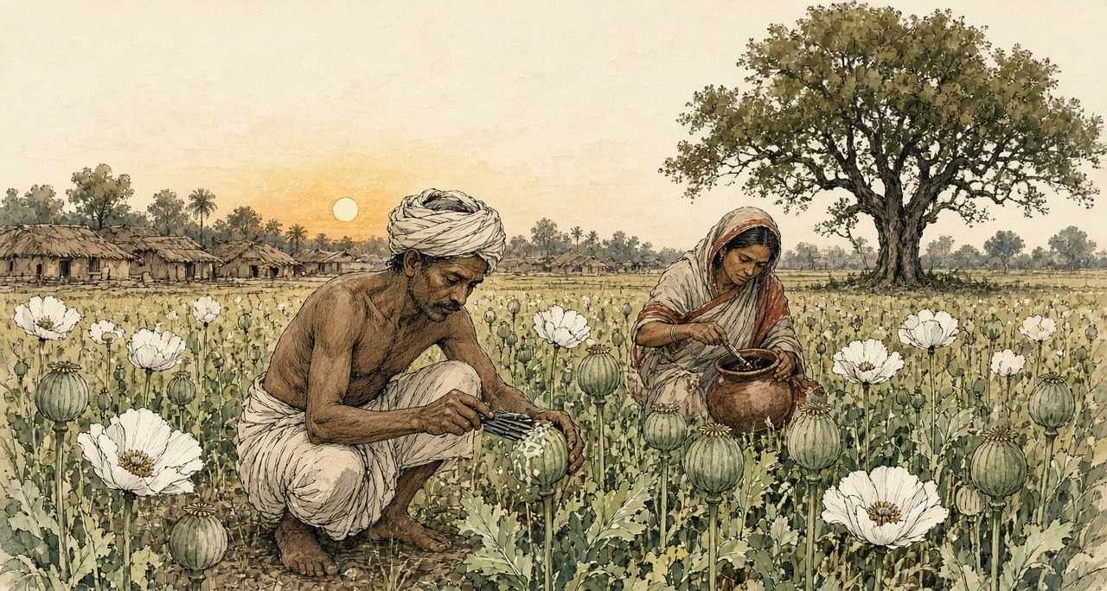
A village in Saran district, Bihar, the cold weather of 1836
Kartik, 1836. Saran district village.
Ram-Ram. I this my father's left-behind bahi back-side blank pages on writing am, because gomastah babu says man his own account himself keep should, only zamindar's book on not. My writing good is-not, but name and account write can, and my son me-after this read-will.
Cutting time, gomastah babu came. Headman's house in-front cot on sat-down, knee on paper opened. All paper only is with them. One-by-one called. My name also — Bhola, Ramdin's son, two bighas. But those two bighas mine are-not, zamindar's are. My father's father ploughed-had, his name also zamindar's book in is, and rent book small becomes-not.
Silver count-having my hand in gave. Warm is, box from, sun-heat in. One breath for, I rich seemed. After-that, zamindar's man cot behind-from came-out, hand forward did, and my palm's silver his hand into went-already — whole advance, rent for. Gomastah something wrote, zamindar's man something wrote. I thumb ink in put. House-to walked then hand empty, thumb black, and field now father's saying-by also mine is-not, because now Sarkar's book in also written-went.
Wife asked, how much? I thumb showed. She nothing spoke. Inside went, pots banged-down, and little-one crying started.
We sowed. Field-to water needed every few days, tank from, lever by — my back and brother's back, up-down, up-down, bucket and rope hands cut. Neighbour wheat sowed. His wheat knee-full is when our poppy small is, and he laughed, spoke, Bhola, your field Company's garden become-went.
Phagun in, flowers come white, tank edge all white, wedding like, after-that drop-went, and pods stand-up green and hard, hen's egg size. Now work starts. Evening at, cold in, knife take-having go-out. Small crooked blades, three-four tie-having, pod's four-sides around pull, too deep not. Too deep then juice ground on flows-away, useless. Less deep then nothing comes. My son also, eleven years of, him-to also knife gave, first night finger cut-took, sucked-took, cried not, because mother watching is.
Juice comes-out white, pearl like hangs. Night-full lies-staying, next day sun-heat in cook-having brown and sticky, evening at we scrape, every pod. Field long is, evening at also neck on load. Smell everything into enters. Sour, heavy, cowshed behind like, and underneath sweet, noon by head heavy. Stuff scraper and fingers-to sticks, hand lines in black dries. Wife night at ash with hands rubs, still morning at roti on smell comes.
After-that, gomastah's men field in walking come. Looked. Anything weighed not. Pods looked, among-themselves talk did, one a number said, other wrote. Bhola's two bighas from so-many seers. Guess-by made. And I know-went, Ram, that number look-having know-went — my field that number give cannot, even-if every pod two times blood bleeds.
That night slept not. Cot on lying stayed, tank across jackals heard, account calculated. What number they wrote. Advance, which zamindar to gone-already. Sarkar's rate per seer, what babu said, and wet for minus, opium bad be then minus, minus, minus. Short fell then say embezzled-did. Bhola hid, Bhola bania-to sold-gave. After-that, court. My brother's wife's uncle-to Chhapra in court took-went. Cow took-went. Cot also. Ramdin's son court goes-not. This I dark in myself-to said, mantra like.
Wife came, me-near sat. Spoke, next village in cow-dung put-they, tank mud, jaggery, heavy making for. I said, and factory? They test. Factory in to-them known is. She spoke, then what? I said, then more force-with scrape-will.
We more force-with scraped. Again-again those pods cut, every evening, until nothing gave and all on scars fell, smallpox after old-man's face like. Son's fingers cut, healed, again cut. One pot is, clay of, heavy, top black, inside jaggery like brown, and I it head on take-having kothi weighing-for went, whole road praying stayed, Ram, scale-to mercy do let.
Scale mercy did-not. Babu wrote-gave. Next year, they said, better do-will. Next year. Next year's advance also, they said, you take-will.
I this all therefore written-have that my son know what given-went and what taken-went, and this not think that his father fool was, only Company's book in one man is.
* * *
Bihar and Benares, 1797 to 1839
What Bhola feared was in print. In February 1837 the Chinese Repository, the English-language monthly printed in Canton, ran a long article on the Bengal system, and Nathan Allen copied its core into his study of the trade in 1853. A European collector stood at the top. Under him came the gomastahs, Indian agents of better education and caste, then the sudder mattus, the landholders, then the village mattus, and at the bottom the ryots who did the work. Just before the juice was drawn, the gomastah and his establishment made a circuit of the country and formed, "by guess," an estimate of each field. The ryot then engaged to deliver that quantity "and as much more as the field will yield, at the price previously fixed." If he fell short and the collector suspected embezzlement, the collector could sue him in the civil court. A man who planted poppy without an engagement had his property attached and was "compelled either to destroy his poppies, or give security."
Allen added what his own informants, men who had lived in the opium districts, told him. The cultivators and the landholders were "from policy, kept constantly in debt to the government agents." Every native agent took a commission on the produce of his beat. Each chest obtained in this way, Allen wrote, cost the government about 300 rupees.
The cultivators knew the scale's appetite and some tried to feed it. Allen lists what the factory chemists found in the pots: sugar, catechu, molasses, cow-dung, soft clayey mud, pounded poppy seed, the juice of other plants. The factory caught most of it.
The violence in the system shows best in records written later, when people were finally asked. Before the Royal Commission on Opium in 1893 and 1894, witnesses from Bihar described the minor officers of the Department, zilladars paid by commission, threatening cultivators in Shahabad with fines and imprisonment to make them sow. A Patna district cultivator named Poonit Singh testified that a zilladar had torn up other crops a man had planted on land licensed for poppy. Bauer, reading the Department's own files, found peasants kidnapped and crops destroyed. His arithmetic of the costs and returns of a poppy field reached the conclusion the Department never printed: Bihar's peasants grew the crop at a loss.
Each spring the pots came in from the districts by river and by cart, numbered and labelled, to the two sudder factories.
* * *
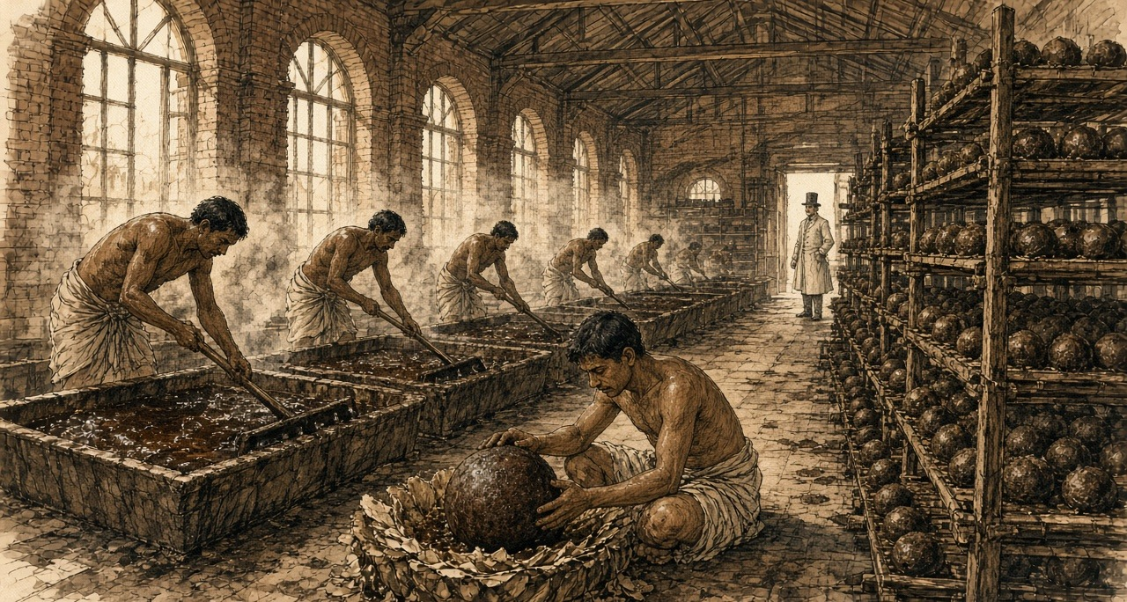
The opium factory at Patna, the hot weather
Patna kothi, hot weather season.
Bismillah. I this my own bahi in writing am, because now fingers ink hold can, and my son Karim me-after this read-will. I here kothi in wage-work do. Sun wall over coming before, we inside are. Inside, sun of talk is-not, because this kothi's godowns' heat right-there stays, bricks in sitting stays. Third watch by, sweat head from eyes into comes, wipe cannot, hands stuff with full stay.
First, long hall. Pots ground on line in, hundred, two hundred, clay of, each one on number. Examiner sahib walks, tester with walks, pot in scoop push-they, deep, turn-having pull-out, look, sometimes only fingers with press-having depth-take, speak. One number. One class. Writer writes. Every pot from a-little chemical room to goes. If that room say sugar is, mud is, then whose pot is, Allah his help do.
Me mixing room in kept-have, where pots vats into tip-they and we edge on rake take-having standing stay. Blind rake, wood of, without teeth, long pole on flat blade — push give, pull, push give, until whole vat one paste not be, one colour, this village and that village of any lump not remain, all one-like. That moves even not. Like wet clay in rake pushing are which rake-to hold-staying wants. Shoulders first burn, after-that back, after-that neck behind something breaks. Steam up comes, warm, sour, one hour after head light floating starts, fever before like. My brother-in-law says habit becomes. Fifteen years from here is. Eyes always red.
Noon at, tank on hands-mouth wash. Water arms from brown becomes. Face hands in put-having smell, smell nails under-from still comes.
Some days ball-making room in load-carrying send-give. That room quiet stays. Every ball-maker's small table, stool, brass cup. Cup wet makes, poppy flowers' cake puts, tear-having, press-having, thin opium with stick-having which lewa call-they, layer on layer, and opium lump inside goes, before-from weighed-already, and thumbs with petals lump's four-sides around closes until child's head like round not become. Good man day in hundred from more makes. All of weight one-like. Otherwise sahib's scale tell-will, pay tell-will.
After-that, drying room, balls small clay cups in roof up-to, men sharp needle take-having walk, which ball swelling be it prick-they, gas let-out, soft hiss, rotten mango like smell. After-that, stacking room, at-there boys. Small-small, rack on climbing, balls turning, turning, poppy dust with rubbing, so mildew not stick, insects not eat. My Karim also, Ammi says, next year stacking room in go can, house in a-little more money come-will. I nothing said. What say. I those boys evening at outside coming seen-have, hair in dust, eyelashes in dust, small-ones then standing-standing only sleep-go, ya Allah, standing-standing sleep-go.
Forty balls one chest in. Carpenters chest Nepal from river road-by brought wood from make. Thok-thok-thok day-full, roof on rain like sound. After-that, chest ghat on, boats on. Calcutta after where go, this kothi in nobody knows. China, say-they. China what is. Somewhere opium goes, somebody's money back comes, and that in-from anything here comes-not.
* * *
The Ganges and Calcutta, 1798 to 1830
Walter Sherwill, a Company revenue surveyor, drew the Patna factory around 1850 for a set of lithographs printed in London in 1851, the examining hall, the mixing room, the balling room, the drying room, the stacking room, and then the river. His last plate shows the opium fleet coming down the Ganges past the Monghyr hills. Small canoes run ahead, their crews sounding the channel and beating drums to warn other boats aside, because the government boats claimed the river. Beside the fleet a timber raft floats down from the Nepal forests, wood for more chests.
A full chest held forty balls. William Hunter, an American who worked in Canton from 1825, gives its weight as one picul, 133⅓ pounds.
At Calcutta the chests went to public auction, and the Company sold to whoever bid. It was particular about what it sold. In January 1798 the Board of Trade had 900 chests from Bhagalpur, Patna, and Rangpur burned at Calcutta, under a new rule that opium failing to reach 200 sicca rupees a chest at auction would be destroyed so the brand would keep its name in the Eastern markets. The speculators welcomed the burning, the Asiatic Mirror reported, because it would raise prices further east. At the first sale of the season on 15 December 1800 the average was 725 sicca rupees a chest. At the December sale of 1804 it was 1,687 for Bihar and 1,761 for Benares.
Allen, writing around 1850, put what a chest cost the Company to obtain at about 300.
* * *
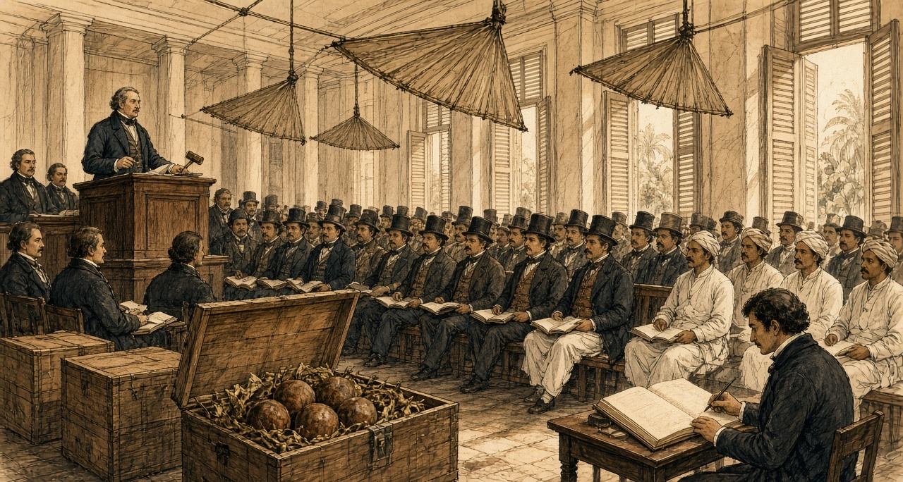
Calcutta, the Company's opium sale, 20 December 1830
Monday, the 20th. The first Sale of the season; and a most fatiguing day, the room being close beyond bearing by ten o'clock, the punkahs doing nothing but stir the heat about, and every gentleman of the agency houses present, or his banian, or both. I had the Patna lots and young H. the Benares. Ink dried on the nib between bids.
The bidding was brisk from the first lot, and there was a feeling in the room, which I cannot well describe, as of men at a race-course who have money laid on the issue and have heard something of the horses. Word had come that prices at Lintin were firm. When the hammer fell on the last of the Patna I cast up my column twice to be sure of it, and the average stood at 1,608 Sicca Rupees the chest. The Benares came to 1,605. Mr. —— leaned across to see my figures and said only, "Well, that is the China market," as though he were reading the weather.
I had the Agents' provision charges by me in a bundle from the Board, and for my own satisfaction set the cost of a chest against its price, and did the subtraction, and did it again. The product of that sum against the number of chests I shall not write down, for it is not my business, and the Board has clerks enough to admire it.
What struck me most was that not a man in the room had seen a poppy. Nor had I. The chests are a figure in the Patna Agent's invoice, and a figure in my column, and tomorrow they will be a figure in some house's books, and in six weeks a figure at Macao; and the opium itself lies all the while in the godown at the ghat, smelling, they tell me, like a cow-house in the rains.
The Red Rover, Clifton's new vessel, built sharp to work against the monsoon, is taking on Bengal opium from this sale. The old hands say no ship can beat up the China Sea at this season. I have put down five rupees with H. that she does it.
* * *
The Bay of Bengal, the Lintin anchorage, and Canton, 1830 to 1839
He did it. The Canton Register reported that the Red Rover, Captain William Clifton, reached Macao on 6 February 1831, thirty-nine days out of Calcutta, a record, with 538 chests of Bengal opium from the Company's first sale on 20 December. A year later she and the Water Witch came in together with 1,500 chests from the first Calcutta auction. By 1833 the paper reported the passage against the winter monsoon as regularly achieved, and Dent and Company were advertising for freight of treasure on the Red Rover's run back to Calcutta.
The Company could not carry the chests into China itself. The Jiaqing Emperor had banned the import, and the Company's tea trade at Canton depended on the goodwill of the officials who enforced the ban. So the Company sold in Calcutta and let the country traders take the chests and the risk. Jardine, Matheson and Company, founded at Canton in 1832, and Dent and Company were the most prominent. Malwa opium from western India, shipped through Bombay, grew into a rival larger than Bengal's own. In the season of 1832 to 1833 the Canton Register counted 6,410 chests of Patna sold at Lintin and Macao, 1,880 of Benares, and 15,402 of Malwa.
By Michael Greenberg's count, Indian opium sent to China ran to about four thousand chests a year around 1800. Bengal and Malwa together came to 21,885 chests in 1834–35. By 1838–39 the figure was 40,200.
Most of it went first to Lintin, 伶仃 Língdīng, an island in the mouth of the Pearl River, where old hulks lay at anchor as floating warehouses, beyond the reach of the officials and on the route of every ship bound for Canton.
* * *
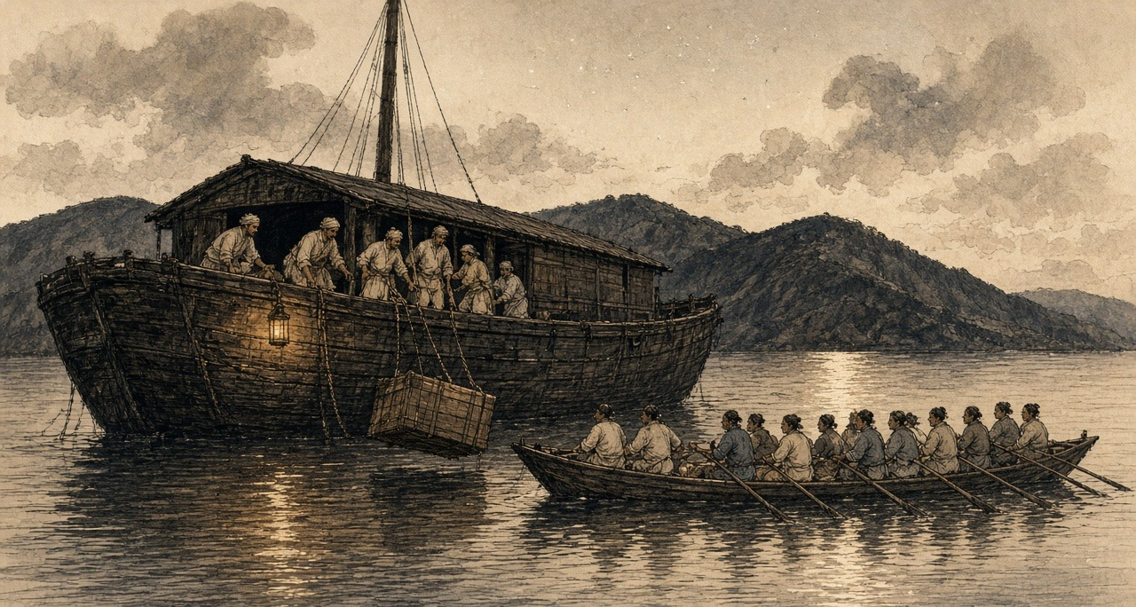
A receiving ship at Lintin, the southwest monsoon
Lintin, floating ship. Southwest monsoon wind.
Allah, that deck's heat. Floating ship on shade is-not, only old one pulled-tight awning, in-which net like holes, and sun those holes through comes, planks on drop-drop light falls, ship swings-when drops-also move.
I Chittagong side's man. Uncle me before one country ship-on take-having Calcutta came, after-that this ship-on, and this ship anywhere goes not. Sitting stays. Three years holding Lintin-at sitting is, at-bottom chain with tied, belly-full opium. Manila men and we, few Bengali, this ship's crew. Cook Chinese, carpenter Chinese, who money weighs he-also Chinese. Captain, Scotland side's sahib. His Hindustani bad, temper more bad.
Morning-at, one clipper comes. That-time everybody work-at. Tackle rope-on chest up comes, swings, one swing wrong happens-if chest water-in falls, after-that captain's mouth, one hour scolding, and our everybody's pay cut. Chests at-bottom lower-we. Bottom, bhai, bottom. Hot air's box, inside such smell that nose little-while after telling stops, but head telling goes-on. Sweet, rotten, gur jar-in dead rat like. Chinese call foreign mud. Mud is-not. Mud-in head so heavy becomes not.
After-that, boat comes. Daily not, but selling season-in always, night-at more. Long-long boat, shining-bright, sixty-seventy men oar pull, one side thirty, oars together rise-fall, as-if one big insect's legs, and house-equal big mat sail. Front-at one cannon. Back-at broker's man paper take-having sits. Order, Canton from, so-many chests, this mark, this number.
After-that, we chest break-open. Balls come-out, brown, dust-smeared, petals cracked, we weight do, broker's man scale toward looking stays cat as-if hole toward looks, after-that all mat bags-in, merchant's mark and weight painted, and ship's side over long boat-in. Four hours, five hours, long boat's bottom full becomes, oar goes-down, dark-in river toward goes-away, nobody stops. Mandarin's boat who stopping ought, they-also bribe eaten-have. Everybody knows. Captain says each chest for ship gets five dollar.
Five dollar each chest. My whole life-in, my village-in, five dollar nobody hand-in holds.
Night-at sometimes deck-on lying water above Chinese boat's light see, and think that long boat's end-at which man is, he who. Canton-at somebody this mud pipe-in give-having eat-will. One man, whose mother is. Chittagong-at our-also opium is, bazaar's old-men a-little eat, shade-in sleep. One-time Calcutta-at ghat edge-by one Chinese carpenter seen-have, ship's man, smoking. Arms two cane sticks like. Eyes two head's so deep-in sunk-gone, as-if well's bottom-at two stones. He me saw-not. Anything saw-not.
Money, ship-full money. Silver-silver, box-box, boat after ladder climb-having up comes, captain's room-to goes, and morning-at money-weighing man his copper scale take-having sits, pours, thong, thong, thong, whole forenoon. At-bottom I smell-inside lying thong hear, count lose, again start.
* * *
Canton, the Thirteen Factories, 1823 to 1838
At Canton foreigners could trade only through the 公行 Gōngháng, the Cohong, a guild of licensed Chinese merchants whose warehouses and the foreigners' rented quarters stood together on the riverbank at the 十三行 Shísān Háng, the Thirteen Factories. Each foreign ship needed a Hong merchant as its security, and a merchant who stood security answered with his own fortune for duties and for whatever the foreigners did. Hunter recorded the system biting in 1823. A compradore at one of the American houses had borrowed his employer's cash for speculation, and the theft came out by accident. The American chief went directly to Houqua, 伍秉鉴 Wǔ Bǐngjiàn of the 怡和行 Yíhé Háng, who was the compradore's guarantor. "Houqua sent the deficiency to the firm the same evening. It was over $50,000."
The guarantee could ruin a man. 蔡世文 Cài Shìwén, called Munqua by the foreigners, head of the 万和行 Wànhé Háng and senior merchant of the guild from 1788, killed himself in 1796 when his business failed under its debts. When Jardine and Matheson needed a Chinese name for their firm, they took two characters from Houqua's: 怡和洋行 Yíhé Yángháng.
Silver moved through the factories all day. Opium was always sold for cash, Hunter wrote, and in the arched passages between the buildings "one could never move without seeing heaps of silver being examined and hearing its metallic ring as successive quantities were poured in and out of copper scales." Once weighed, the coins stopped being coins. Spanish and Mexican dollars went into the treasuries by weight, at 717 thousandths of a tael each, and became bullion.
A great deal of that silver ended up in one place. As early as 1803 the Company advertised in Bombay that merchants trading to China could pay their sale proceeds into its treasury at Canton and take twelve-month bills on London at five shillings and six pence the dollar. In 1830 the Canton treasury was open for thirty-day bills on Bengal at 202 sicca rupees per hundred Spanish dollars. The country trader got paper that could be cashed in London or Calcutta. The Company got the silver at Canton, where it bought its tea, without shipping an ounce out from England. In 1811 it had sixty thousand chests of tea lying in its Canton warehouse and not enough ships to carry them home.
The Qing state saw the same silver moving in the other direction. In 1830 an imperial edict on the Viceroy's report complained that foreigners used their dollars to buy up sycee, the empire's silver, so that "our silver diminishes and foreign money increases," and called the spread of opium smoking "damage like a great fire." On 1 January 1831 a servant in the Viceroy's own yamen fell asleep over his opium lamp and set the building on fire. In 1832 a new law set the punishment for smoking at a hundred blows, the cangue, and transportation.
The far end of the chain shows in a petition the Canton Register printed in 1830, from a widow named Wai Ping, sixty-three, whose son Ah Keen Soo had taken up the pipe. He had stolen everything in the house to pay for it, she wrote, and dunned her daily for more, and when she reproved him he looked ready to strike her. Foreign doctors described the bodies. James Hill, an English ship's surgeon in China in 1839, wrote of "the sallow and shrivelled countenance, the dim and sunken eye, and the general emaciated and withered appearance." G. H. Smith, a surgeon at Penang, recorded what happened when a confirmed smoker went without: great prostration, water streaming from the eyes, then cold over the whole body, aching in every part, diarrhoea, "the most horrid feelings of wretchedness," and, if the drug was withheld long enough, death. Five-sixths of the sixty inmates a day in the poorhouse he ran were opium smokers.
In the autumn of 1838 林则徐 Lín Zéxú, governor-general of Hubei and Hunan, sent the Daoguang Emperor a memorial on the silver and the pipe. If the court went on treating opium lightly, he wrote, then in a few decades "中原几无可以御敌之兵，且无可以充饷之银," the central plain would have almost no soldiers left to resist an enemy, and no silver left to pay them. The emperor sent him to Canton.
* * *
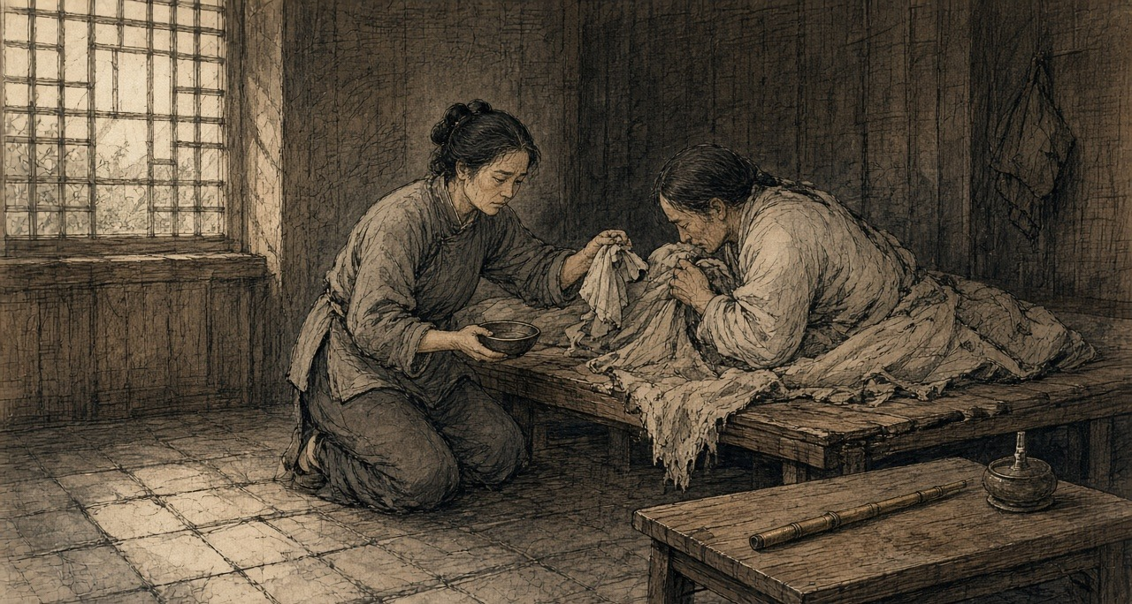
Canton, the western suburbs, March to June 1839
Daoguang 19th year, 3rd month, Guangzhou West Gate.
That morning, whole river all have-no move. The boats all pulled-to bank, one also have-no left. Two banks the people dense-dense, roof top also is people, wall top also is people. A little sound also have-none. So many people, but hear water sound.
Imperial Commissioner's boat from downriver come up, big big red red black black, behind follow the flags. He sit at there. One fat guy, big beard. Have-not look toward left, have-not look toward right. Behind still have boats, Viceroy, all big officials, the boatmen wear-all new red shirts. No person make sound. Next-door house the woman her hand press-hold my arm, press until tight-tight. I know her what meaning. We two families the men, eating-together same one pipe.
Ah-Sing, my husband, help foreign hongs carry goods. Cloth bale, wooden box, tea leaf, from boat carry to godown, twelve years already. The pipe is from shoulder start. Shoulder hurt, friend gave one pipe, shoulder then not hurt already. Night one pipe. Then two pipes. Then morning also eat. Then the wages, not-yet return home, already in smoke-house inside. My mother the bracelet, have-none already. Good shirt, have-none already. Rice, sometimes the children eat, I not eat. Sometimes no person eat.
Night, that lamp. Tiny-tiny the fire, the needle, the brown-colored pill at fire on-top turn, swell big, that smell, sweet until like burnt-already sugar, enter until whole room, enter until quilt, enter until the children their hair inside. He will side-body lie at there, knee shrink-up, one pipe connect one pipe so eat, the face then slowly flat-all, flat-all, like change-return a young-boy so. That face, I hate-dead it, because only that time he look-down peaceful, and that kind peaceful not for us.
After-that, Commissioner the notices paste-out already. Pipe, hand-over. Lamp, hand-over. Smoke-house, shut. Sell-smoke those people use iron chain lock-away, some, we hear, strangle-die already. Ah-Sing, notice come-out second night, cry already. One big man. He two hands hold-hold pipe, like hold-hold a baby so. After-that, second day, himself, take pipe go yamen hand-over already. I follow at his back walk street, he not know.
Three days, he shiver. Cold, he say, cold, third month day, sweat so pour. The eyes so flow eye-water, the nose so flow, front back all cannot hold, that one room full smell. He lie at wooden board on-top shrink-close, the bones I through a layer skin all can count. Every joint, he say, someone at there twist. He beg me. Go find Ah-Fook, Ah-Fook still have, only little-little, only one pill. I say cannot. He scold me, scold my mother, scold Commissioner, scold Heaven. After-that, again cry, say sorry, sorry.
Fourth night, I think he about-to die. His hands, ice. Breathe like an old dog so. I whole-night sit at his beside, the children lean-on wall sleep-already, I take the lamp place-near his mouth, see the breath have-not blow-move the fire. Moved. Still have move. Daybreak-before, he sleep a-while. I, have-not.
After-that, have news come, say foreigners were shut inside the hongs, the servants all withdraw, the foreign mud, Commissioner call them hand-over-all out, twenty-thousand-something chest. Twenty-thousand-something. The chests I seen, my husband carried. Heavy until like one person so. Twenty thousand people's weight, all is that stuff.
Ah-Sing, that time stand-up able already. Thin until like a bamboo so. Eat-already little-little congee. He say, they will burn-already it. I say, good, burn-already it. He long-time have-not make sound. After-that, he say, the smoke goes where, I go that place stand.
Fifth month, I at floor board under find-reached new pipe. Tiny-tiny, cheap, bamboo made. I hold at hand. Still is warm. I put-return it at floor board under original place, then go wash rice.
* * *
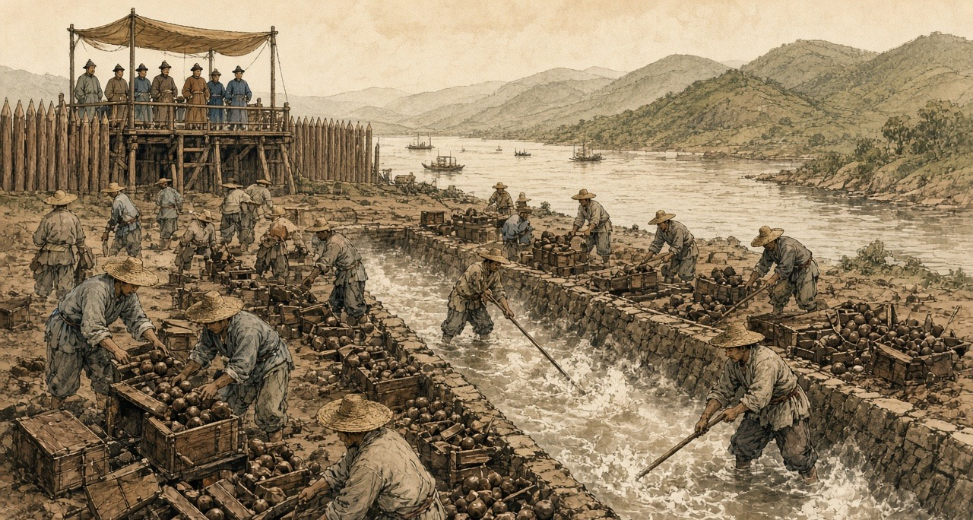
Humen, June 1839
The new imperial regulations of June 1839 gave smokers eighteen months to break the habit. After that, any smoker, official or commoner, faced strangulation.
At Canton the foreigners had been held in their factories since late March, their Chinese servants withdrawn, until the British superintendent of trade, Captain Charles Elliot, promised to surrender every chest held by British merchants. Hunter counted the total at 20,283 chests, delivered at the Bogue by 21 May. There were, he wrote, 15,000 chests on board the receiving ships at Lintin when Lin's orders arrived and 5,000 at the coast stations, worth together more than twelve million dollars. Elliot wrote to London that this was "the first time, in our intercourse with this Empire, that its Government has taken the unprovoked initiative in aggressive measures against British life, liberty, and property." Hunter, who had sold the drug himself, set his own judgment beside it. The despatch "contained not a word of the provocation given by foreigners in continuing the condemned traffic." Of himself and the other merchants he wrote: "We disregarded local orders, as well as those from Pekin, and really became confident that we should enjoy perpetual impunity."
Lin had the opium destroyed with water. On the shore at 虎门 Hǔmén, the Bogue, workmen dug trenches lined with stone and timber and let in water from a creek. They broke the balls apart by hand, threw the pieces in, and stirred until they dissolved, then added salt and lime, and the mixture boiled up in stinking clouds. When it was done they opened the trenches and let the mass run out on the tide. About five hundred men worked for twenty-three days. Lin and some sixty officials watched from a pavilion built for the purpose, and foreigners were allowed to watch with them.
Before it began, Jonathan Spence found, Lin composed a prayer to the spirit of the sea. He apologized for the poison about to flow into its waters and asked the god to tell the creatures that lived there to move away for a time, so they would not be harmed.
* * *
London, April 1840
William Jardine left Canton in January 1839 and was in London by the autumn, with charts of the China coast and a plan for what a naval force could take. The Melbourne government had decided on war before Parliament discussed it. On 7 April 1840 Sir James Graham opened a Tory motion censuring ministers over their handling of China. On the second night William Ewart Gladstone, thirty years old, Tory member for Newark, spoke about the opium.
"A war more unjust in its origin, a war more calculated in its progress to cover this country with permanent disgrace, I do not know, and I have not read of."
He went on to ask whether the minister knew that the opium smuggled into China came exclusively from British ports, from Bengal and through Bombay, and said the British flag had become "a pirate flag to protect an infamous traffic."
Palmerston answered him. The Chinese, he told the House, were "disposed to buy what other people were disposed to sell them."
On 9 April the House divided. Two hundred and seventy-one voted with the government and two hundred and sixty-two against. The warships the motion might have stopped were already at sea, bound for the Pearl River.
In 1846, by Allen's count, the Company sold 21,649 chests of Bengal opium at Calcutta for a clear profit of over two million pounds sterling.
Chapter 1 Mini-Glossary
• Bigha (3 occurrences in this chapter): Traditional unit of land area in northern India; in Bihar and Bengal, used by the Opium Department to measure licensed poppy holdings.
• Cangue (1 occurrences in this chapter): Heavy square wooden collar locked around a prisoner's neck as a public corporal punishment in Qing China.
• Cohong (1 occurrences in this chapter): The Gonghang guild of licensed Chinese security merchants at the Thirteen Factories in Canton holding the monopoly on Western trade before 1842.
• Compradore (2 occurrences in this chapter): Chinese treasury manager and intermediary employed by foreign trading houses in Canton and the treaty ports to handle silver, brokers, and local staff.
• Gomastah (5 occurrences in this chapter): Salaried Indian native agent of the East India Company's Opium Department who distributed cash advances to cultivators and estimated field yields.
• Humen (1 occurrences in this chapter): The Bogue, at the mouth of the Pearl River, where Imperial Commissioner Lin Zexu destroyed 20,283 chests of surrendered British opium in lime-and-salt trenches in June 1839.
• Kothi (1 occurrences in this chapter): Rural sub-agency weighing station and treasury house of the Bengal Opium Department where cultivators delivered raw opium pots.
• Lewa (1 occurrences in this chapter): Thin, sticky liquid opium paste used in the Patna and Ghazipur factories to glue poppy-petal cakes around spherical opium balls.
• Lintin (7 occurrences in this chapter): Lingding Island in the outer Pearl River estuary, where foreign receiving hulks anchored year-round to store and transship smuggled Indian opium.
• Picul (1 occurrences in this chapter): Traditional East Asian commercial weight (dan) used in the China trade, equal to 100 catties or 133.33 pounds (the weight of one chest of Bengal opium).
• Ryot (2 occurrences in this chapter): Indian peasant cultivator or tenant farmer; also applied by British officials with Indian service experience to Irish and Egyptian peasants.
• Seer (2 occurrences in this chapter): Indian unit of weight equal to one-fortieth of a maund (approximately 2.05 pounds).
• Shroff (2 occurrences in this chapter): Chinese silver assayer and money-changer who weighed, tested, and stamped Spanish and Mexican silver dollars in Canton and Hong Kong.
• Sicca Rupee (4 occurrences in this chapter): High-purity silver rupee of the Bengal Presidency used in East India Company opium auctions prior to the uniform coinage of 1835.
• Sycee (1 occurrences in this chapter): Fine Chinese silver bullion cast into boat-shaped ingots (yuanbao) and measured by weight in taels; drained outward to pay for imported opium.
• Tael (1 occurrences in this chapter): Chinese ounce of silver (liang), approximately 1.33 ounces avoirdupois (37.8 grams), serving as the standard unit of account in Qing state finance.
• Yamen (2 occurrences in this chapter): The official headquarters, residence, and courtroom of a Chinese mandarin or magistrate.
• Zamindar (5 occurrences in this chapter): Landholder in Bengal and Bihar responsible for paying fixed land revenue to the British colonial state and collecting rent from peasant cultivators.
• Zilladar (2 occurrences in this chapter): Subordinate field officer of the Opium Department in Bihar paid by commission to enforce poppy cultivation quotas.
Chapter 1 Appendix of Important Names
• Elliot, Charles (2 mentions in this chapter): British Chief Superintendent of Trade in China who surrendered the British merchants' opium to Lin Zexu at Humen in 1839.
• Gladstone, William Ewart (1 mentions in this chapter): British Prime Minister and Chancellor of the Exchequer whose career spanned the 1840 Opium War debate, Irish land and Home Rule legislation, and the 1882 occupation of Egypt.
• Hastings, Warren (3 mentions in this chapter): First Governor-General of Bengal, who formalized the East India Company's opium monopoly in 1773.
• Houqua (Wu Bingjian) (3 mentions in this chapter): Senior Cohong security merchant of the Yihe Hang in Canton and principal Chinese commercial partner of Western firms.
• Jardine, William (3 mentions in this chapter): Scottish surgeon and co-founder of Jardine, Matheson & Co., who advised Lord Palmerston on the First Opium War.
• Matheson, James (2 mentions in this chapter): Scottish merchant and co-founder of Jardine, Matheson & Co. in Canton.
• Palmerston, Lord (Henry John Temple) (1 mentions in this chapter): British Foreign Secretary and Prime Minister who directed British policy in the First Opium War and the 1840 Levant crisis.
Sources
• India Office Records, British Library, London. Bengal Opium Proceedings, Opium Department Correspondence, and Patna/Ghazipur Opium Agency Records.
• Jardine Matheson Archive, Cambridge University Library. Canton Correspondence and Opium Consignment Accounts, 1830s-1840.
• Chouban Yiwu Shimo 籌辦夷務始末 [Complete Account of the Management of Barbarian Affairs]. Daoguang chao. Beijing: Palace Museum edition.
• Hansard, House of Commons Debates. 7 April 1840.
• Hunter, W. C. The "Fan Kwae" at Canton Before Treaty Days, 1825-1844. London: Kegan Paul, Trench, & Co., 1882. Source for the smug boats, receiving-ship crews and cumsha, the shroffs and the 717/1000 tael dollar, Houqua and the 1823 compradore deficit, Lin's arrival on 10 March 1839, the 20,283 chests, and Elliot's despatch of 30 March 1839.
• Lin Zexu 林則徐. Lin Zexu ji 林則徐集 [Collected Works of Lin Zexu]. Beijing: Zhonghua Shuju. Memorial of 1838, 钱票无甚关碍宜重禁吃烟以杜弊源片.
• Qing shilu 清實錄 [Veritable Records of the Qing]. Daoguang chao, 1839-1840 entries.
• Fairbank, John King. Trade and Diplomacy on the China Coast: The Opening of the Treaty Ports, 1842-1854. Cambridge, MA: Harvard University Press, 1953.
• Fay, Peter Ward. The Opium War, 1840-1842. Chapel Hill: University of North Carolina Press, 1975.
• Greenberg, Michael. British Trade and the Opening of China, 1800-1842. Cambridge: Cambridge University Press, 1951.
• Lin, Man-houng. China Upside Down: Currency, Silver, and the Opium Trade, 1797-1900. Cambridge, MA: Harvard University Asia Center, 2006.
• Platt, Stephen R. Imperial Twilight: The Opium War and the End of China's Last Golden Age. New York: Alfred A. Knopf, 2018.
• Trocki, Carl A. Opium, Empire and the Global Political Economy. London: Routledge, 1999.
• Zheng Yangwen. The Social Life of Opium in China. Cambridge: Cambridge University Press, 2005.
• Cheong, Weng Eang. The Hong Merchants of Canton: Chinese Merchants in Sino-Western Trade, 1684-1798. Richmond: Curzon Press, 1997.
• Van Dyke, Paul A. Merchants of Canton and Macao: Politics and Strategies in Eighteenth-Century Chinese Trade. Hong Kong: Hong Kong University Press, 2011.
• Hansard, HC Deb 8 April 1840, vol. 53. Gladstone on the China expedition. Division of 9 April 1840: 271 to 262.
• Lin, Man-houng. China Upside Down: Currency, Society, and Ideologies, 1808–1856.
• Farooqui, Amar. Opium City: The Making of Early Victorian Bombay. New Delhi: Three Essays Collective, 2006.
• IOR opium proceedings and Jardine Matheson Canton correspondence: collection level.
• Allen, Nathan. The Opium Trade; Including a Sketch of Its History, Extent, Effects, etc., as Carried on in India and China. Lowell, MA, 1853. Quotes the Chinese Repository (February 1837) on the Bengal agency system; source for the 300-rupee chest cost, the adulterants, the 1846 Calcutta sales, and the medical testimony of James Hill (Lancet, 1841) and G. H. Smith (Medico-Chirurgical Review, April 1842).
• Bauer, Rolf. The Peasant Production of Opium in Nineteenth-Century India. Leiden: Brill, 2019. Advances paid at rent time and passed to landlords; documented coercion; cultivation at a loss.
• Betteridge, Samuel R. "Rethinking the Bengal Connection: Opium Monopoly and Fiscal Capacity in British India, 1862–1908." PhD thesis, London School of Economics, 2021. The 1773 contract monopoly and the 1797 agency system; Royal Commission on Opium evidence (Babu Rasik Lal Ghosh; Poonit Singh, cultivator of Patna district), vol. III.
• Kranton, Rachel, and Anand V. Swamy. "Contracts, Hold-Up, and Exports: Textiles and Opium in Colonial India." American Economic Review 98, no. 3 (2008). Regulation VI of 1799 and payment net of advances and quality deductions.
• Sherwill, Walter S. Illustrations of the Mode of Preparing the Indian Opium Intended for the Chinese Market. London: James Madden, 1851. Plate texts as reprinted in Benjamin Broomhall, The Truth about Opium Smoking (London, 1882), and in Peter C. Perdue, "The First Opium War," MIT Visualizing Cultures.
• Perdue, Peter C. "The First Opium War: The Anglo-Chinese War of 1839–1842." MIT Visualizing Cultures. Source for the Humen trenches, the workforce and duration of the destruction, Lin's prayer to the sea spirit as recorded by Jonathan Spence, and Palmerston's reply to Gladstone.
• The Canton Register and the India Gazette, Asiatic Mirror and other Calcutta and Bombay papers, 1798–1835, as abstracted in Roger Houghton, A Peoples' History 1793–1844 from the Newspapers, "Opium" parts 1 and 2 (houghton.hk). Source for the 1798 burning of 900 chests, Calcutta sale averages of 1800, 1804, and December 1830, the Red Rover's voyages, the 1803 and 1830 Canton treasury bills, the 1811 tea stock, the 1830 edict, the 1832 smoking law, the 1831 yamen fire, Wai Ping's petition, and the 1832–33 Lintin and Macao sales by brand.
• Farooqui, Amar. "The Global Career of Indian Opium and Local Destinies." Almanack 14 (2016). Greenberg's figures of 21,885 chests in 1834–35 and 40,200 in 1838–39.
• "Bulletin on Narcotics" 1956, issue 2 (UNODC): history of the Ghazipur factory, operating since 1789, on its present site from 1820.
• 《钦定严禁鸦片烟条例》 (June 1839), the eighteen-month grace period for smokers, as summarized in 王宏斌, 试论中国禁止鸦片烟毒的经验与教训, 近代中國網.
• 蔡世文 and the 万和行: 乾隆时期广州公行首商蔡世文家族事迹考述——清代广州十三行行商研究之六, 华南师范大学学报 (Journal of South China Normal University).

Chapter 2
Boats at Canton, 1839
The Pearl River from Lintin to the Canton suburbs, 1826 to 1839, and the City of London
The chests left the receiving ships in long varnished boats that Canton officials called 快蟹 kuàixiè, fast crabs, and 扒龙 pálóng, scrambling dragons. A report the Canton authorities sent the throne in 1832 counted between one and two hundred of them running opium from Lintin to the money-changers' shops of the province, firing on the coast guard when they met it. William Hunter, the American who worked at Canton from 1825, describes them as long and broad in the beam, wider abaft, so that there was room in the stern for the brokers' agents who always rode with the cargo. Sixty to seventy men pulled from low benches along both sides of the deck under a mainsail and foresail of matting, bamboo, and rattan. They carried a large gun in the bow, swivels, spears, and flintlocks bought off foreign ships. Government cruisers were painted black and red. The smuggling boats were varnished bright.
The censor 冯赞勋 Féng Zànxūn told the emperor about the iron netting hung along both sides against shot, and the fifty or sixty oars that sent the boats along so fast that people called them 插翼 chāyì, boats with wings stuck on. In 1836 the official 许乃济 Xǔ Nǎijì, who had served in Guangdong, wrote that when a government cruiser did close with one, the crab fought back, and men were wounded and killed.
The river had its own people. The 疍家 Dànjiā, Tanka in the foreigners' spelling, were born on boats, fished and ferried from them, and married on them. In May 1729 the Yongzheng Emperor wrote in an edict the Guangdong gazetteers copied out in full that the people of the province looked on the boat households as a base sort and would not let them ashore, and the boat people, not daring to resist, stayed cramped in their boats all their lives, though they paid the fish tax like anyone. "蛋户本属良民," he wrote, the boat households are by origin good people. Those who could build a house might live in the villages near the water and be registered with everyone else, and local bullies were forbidden to drive them off. The edict gave the Tanka the law on paper.
The officials' reports call the smuggling crews desperate men and runaways. Whoever they were, the syndicates paid them by the run.
* * *
The Canton River, half a mile below the Factories, June 1833
Bow-from count-down fourth bench, left side, that-one is my place. Three years I pull-already. Beside that-one, Ah-Kau, also is Tanka, Honam side those people. His woman and my woman, two sisters. Bench underneath, my grass-sandals, my rice-tin, one hand-wiping rag. The two hands, three years come-down, take-go scrape fish-scales also can.
Leave Lintin, dusk-close. Receiving-ship the men already take the smoke-balls put-all mat bags, furnace-mouth the agent already check-good the paper. He sit at stern the little roof underneath, tea, abacus, the bags stack until surround-all him, like a sit-egg hen so. Him, we not with him talk. He with the steersman talk, steersman shout-one-sound, we then pull.
Sixty oars, same one breath. Body toward-front lean, blade drop water, body toward-back bend, whole person, heels dead-press-hold front the bench. Up. Again come. First hour, the shoulders complain. Second hour, not complain already, only fire-like burn. Pass-already that time, not is man anymore, is the boat's one piece, like an iron nail so. Boat-master use heel at deck on-top beat time, the sound from board underneath pass-up come, shake until enter the bottom inside. The water from oar-handle flow-down arms, flow-enter armpits. Hand split-cracks those places, soak-all salt. Head-top the mat-sail eat-straight wind that time, paak one sound ring, the boat then jump-one-jump, everybody then laugh a-little, because the sail do work, the oar then breathe-get a breath.
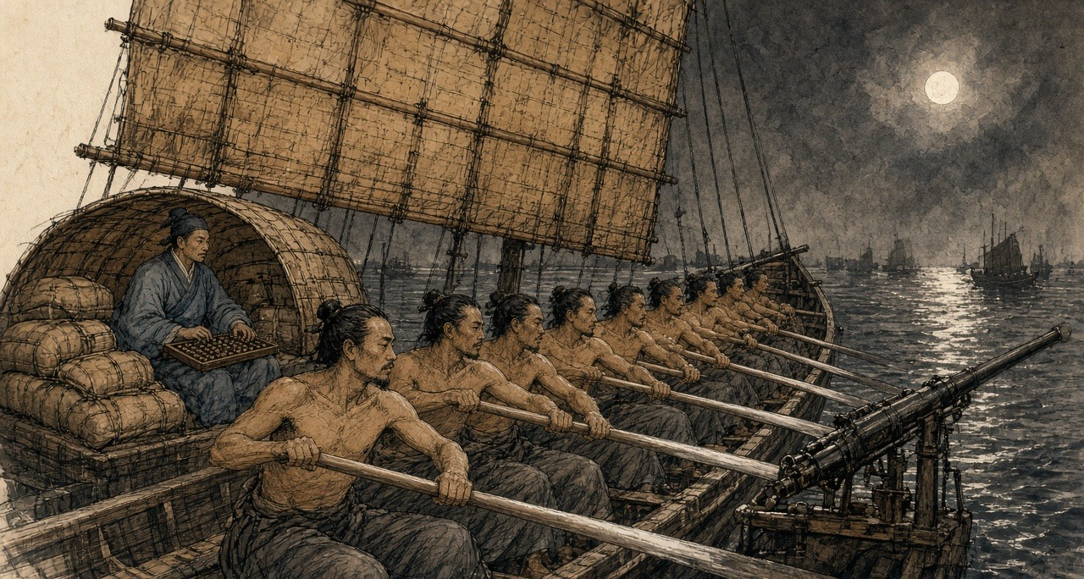
Run one night water, better-than cast one month net. My mother's coffin, already pay-all count, rely-on this oar. My son at Honam bank on-top the old scholar's school-room read book, also is rely-on this oar. Bank on-top the children at road on-top throw mud-lumps drop his body. He still go.
Most nights, anything have-none. Mandarin-boat come-out, black and red, hang-up a lantern. Our steersman shout, their that-side also shout. Throw few stones cross-come, we throw, they throw, thump-drop deck on-top, splash-drop water. Have one time a stone scrape-off-already seventh bench the young-boy's ear, the blood along the neck flow-down come, he same-way pull. After-that, the mandarin-boat turn-head go, return-go write its report-paper, we continue up. Do big-opera, Ah-Kau say-so. Two sides all buy-all ticket already.
Tonight, not-same.
River on-top change-already a new official, furnace-mouth the agent afternoon that-time say, this-one not-yet feed-full. No person listen. Every-every new official, pass one month then also is same-way eat.
Thirteen Factories underneath half-mile water, bank on-top foreign-ghosts the lamps already look-get-to, two sides pitch-black inside rush the boats out-come. Not is one. Five. Gong-sound. Torches. Bow stand-all men, hold-hold long hooks. Steersman take the boat dead-pull cross-go, big-shout one sound, we pull, pull until the bench also creak-creak ring. Boat-master have-no again beat time. Now no-need time already.
They bite-hold not let-go. Full one mile water, bite-hold not let-go. Our bow the big-gun fire-already one shot, the sound shake until enter my teeth inside, the smoke roll-back come cover-all us, make until I blind-rush so pull, all-way cough, the oar-handle both wet and slip. Their fowling-guns. Hit-drop deck on-top, like someone scatter broken-gravel so sound. Stern the swivel-gun again ring, stern at-there someone at-there scream, very sharp, like slaughter-pig so.
After-that, Ah-Kau's oar stop-already.
My oar hit-into it, wood hit wood, shake until my elbow also numb. I turn-around head. He sit at there, the hand still hold-hold the handle. One bullet from his armpit-under hit-already enter-go, toward-bank that side, he look-hold me, like want ask me something so, ask rice-price maybe, or is ask now what time-hour. His mouth open-big,吐-out come is blood, torch-light shine-hold black-black, one big mouthful, flow-pass his chin, flow-pass his chest, flow-also drop my grab-hold his shirt the hand on-top. He is warm. The blood is warm. He want stand-up body, the two legs not hear him use. He again sit-return drop the bench on-top, slowly so, like an old-man sit-down so, after-that he whole-person lean-drop me on-top, the head rest-hold my shoulder, heavy-until-die, heavy-until-die, have-no again stand-up.
Four-sides all is hooks. Have one hook-hold my bench beside the gunwale. Someone stand at boat-side big-shout jump ah, jump ah, my front the bench already empty-already.
I take Ah-Kau put-flat at deck on-top. I not know myself why want so do. Simply have-no time do, but I do-already, put-flat him, face toward-up, like usual lay-down a man so, after-that I then turn-pass gunwale jump-down go.
Night the river, top warm until like soup so, bottom cold. Sink-down go cold water inside, open-big eyes, anything all see-not, only see top the torches take the water shine-until brown-mud colour so. I shut-hold the breath, shut until the chest like fire-burn so, two hands claw-hold river-bottom the mud swim-cross go. Tanka child not-yet learn walk first learn swim, bank on-top the people always laugh-hold so say. That night, my body itself know swim, no-need me mind.
Wait I float-return up-come, far-far, at bank-side the reeds and mud inside, our boat already stop-already at river middle, their boats surround-hold-all, like the ants surround-hold a fall-drop-ground cake so. Torches. Shout-sound. I lie-flat at reeds inside, only stick the nose out-come, the mosquitoes bite until my whole face all is, I listen-hold them cut-open the mat bags.
Ah-Kau's woman, my woman's older-sister. Who go with her say. Me.
* * *
Canton and the delta, 1826 to 1837
The Canton Register, the British free traders' weekly, reported the fight on 17 June 1833. A new naval commander had ordered all fast crabs destroyed. Five government boats caught a crab coming up about half a mile below the factories, chased her a mile, and hemmed her in. One crew member was killed, the rest abandoned the boat, and many were wounded. Some three hundred men had been in the fight. The officers found two chests of opium on board and a book listing everyone to whom the cargo was consigned. The book, the paper added, "was fortunately repurchased from the officers at the scene."
The opium came out of the receiving ships against a chit, a delivery order written by a foreign house in the Factories after a Chinese broker had paid in silver. Xu Naiji named the brokers: "有省城包买户，谓之窑口," wholesale buyers in the provincial city, called 窑口 yáokǒu, furnace mouths. The 1832 report put them among the money-changers and silversmiths, whose furnaces for assaying sycee could refine raw opium too, some in a street beside the Thirteen Factories. Between furnace mouth and receiving ship ran the boat, and along the boat's route stood a line of men with their hands out.
The navy's share was organized early. The 防海纪略 Fánghǎi jìlüè, a late-Qing history that follows the scholar 魏源 Wèi Yuán closely, says that after the governor-general 李鸿宾 Lǐ Hóngbīn set up anti-smuggling patrol boats in 1826, the patrols took 规银 guīyín, customary silver, of thirty-six thousand taels a month and let the opium through. 卢坤 Lú Kūn abolished them in 1832, too late to pull the navy's habits back. The Canton Register of December 1832 reported that bribes to escape the ban on building fast crabs had grown so steep that delta boatyards could no longer afford to build them, and two new crabs had been built at Lintin itself, on a raft moored between two foreign ships, where no Chinese official had jurisdiction. The bigger carried sixty men, small swivels, pikes, knives, and plenty of round stones. The run to Canton went at a fixed fee, so well managed that officials seldom came near. The occasional skirmishes, the editor wrote, were "forms of opera." Some of the opium, he added, went up to Canton in the coast guard boats themselves.
Inland, the customs houses ran on fees. In January 1837 the paper passed on what the tea men from the Wuyi hills said: since early 1835 the dealers carrying opium north to trade for tea had paid the customs houses at Shaoguan and Ganzhou a fixed sum on every ball of Patna let through, half a dollar at Shaoguan, and both houses had grown rich. Hunter, who sold the drug through brokers, describes what happened when a new magistrate arrived. The question of fees arose and was soon settled, "unless the new-comer was exorbitant in his demands," and then the brokers came back with beaming faces and immunity reigned again.
In 1837 the governor-general 邓廷桢 Dèng Tíngzhēn restored the patrol boats. Wei Yuan, writing in the 1840s, recorded what one of his officers did with them. The deputy commander of the Guangdong navy, 韩肇庆 Hán Zhàoqìng, made his money protecting the smugglers. He made an agreement with the foreign ships: out of every ten thousand chests, a few hundred would be handed over to the navy so that it could report seizures. Sometimes navy boats carried the opium into port themselves. On the strength of his seizures Han was promoted to brigade general, 总兵 zǒngbīng, and awarded the right to wear the peacock feather. "水师兵丁，人人充橐," every man in the navy filled his purse, and the opium coming in each year rose to forty and fifty thousand chests.
* * *
A customs station of the Hoppo on the river below Canton, autumn 1838
Table-face the papers, the brush, the ink-stone. Drip little-little water drop the ink-stone on-top, grind. The ledger, neat-neat tidy-tidy. Every one stop-stay boat, boat name, load what cargo, boat-master's name, hand-over-already how-much duty. Not stop-stay those boats, the ledger not know.
Sky not-yet bright they then come. Furnace-mouth the runner-boy, wear a good tidy blue jacket, two hands always cold-ice-ice, at gangplank on-top bow until very low, call-sound Uncle, weather cold ah, Uncle himself take-care body, after-that take the paper packet put at table-corner the ink-stone underneath. Very proper-rule. Myself, also speak-return some very proper-rule words. Ask-after his master's old-mother. The boy say old-lady very good-spirit, thank Uncle hang-heart. After-that, he then go. The paper packet inside, is foreign-silver, chop-mark and weigh-pass all. From head to tail, we all not speak that one word.
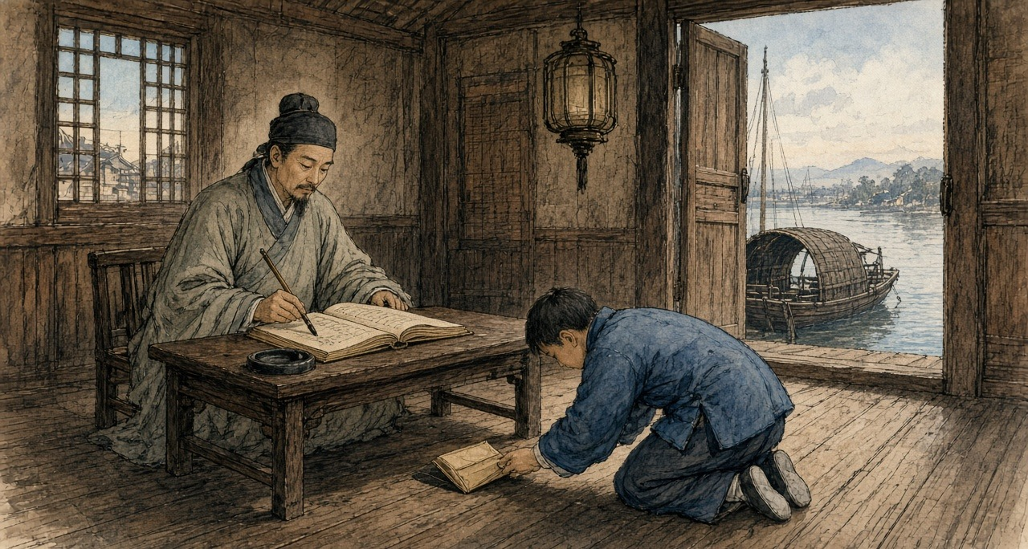
Hoppo send-down come that salary, write at paper on-top that share, even keep my mother eat rice also not enough. My on-top the superintendent know, his on-top still have a big-official. The paper packet, one layer one layer so go-up, one piece, one piece, one piece, like lamp-wick suck water so. Stay-return at my place those, my son's teacher, my mother's medicine, pass-New-Year.
Still have the pipe. That thing also is.
The pipe is from cough start. Winter at river on-top, the wet-air enter-already the chest inside. A colleague say, eat one pipe la, eat one pipe then not cough already. Really stop-already. Six years before matter already, that-time. Now once reach afternoon, monkey-hour, the body then ask you take. Not polite. From the two eyes start, flow eye-water. After-that, the nose. Yawn, one connect one, yawn until jaw-bone also crack-crack sound. Have a cold-air from spine-back underneath walk-up come. If send-packet the boat late-already, hold-brush the hand then shake, the ledger on-top write-out come the characters, like drunk-man write so. After-that, return home, the lamp, the needle, the tiny-tiny bead at fire on-top swell-big, turn-black, one pull, long-long one pull. The warm-air return-back enter two hands inside. This world four-sides the edges change until soft-ripe all, very kind, like an old quilt so.
My woman sit at next-room sew clothes, not enter-come. My son eleven years. He read Four Books, familiar-pass me fifteen years that-time. Teacher say, this boy, provincial examination, maybe can.
This year autumn-between, have one memorial's copy-book at the river on-top one pass one, I shut-close the shutter, at this table on-top look. Court of State Ceremonial, Huang Juezi. Eat-smoke people, give one year time break. One year after, death-crime. Do-official who eat-smoke, crime heavy-pass common-people. And-also sons and grandsons not-allow sit examination.
That one line characters, I look-already one time. Again look one time. The candle at-there jump, the smoke straight-straight go-up, after-that bend-already.
My son, his name write at examination-hall the list on-top. My son, his name never will at the list on-top.
That night I have-not light the lamp. Pitch-dark lie at the bed on-top, two hands tuck at armpits underneath. Midnight, the cold come-already. From foot-sole underneath well-up come, like a boat enter-water so. Knee-cap the bones, someone at inside twist-hold. Whole body pour-all cold-sweat, once come-out then cold-ice-ice. Next-room my woman breathe-air the sound, I hear-out-can she have-not sleep-hold. Ox-hour, I stand-up body, walk-go the box at-there, light-hold the lamp. Two hands shake until the needle hold-not-steady the bead, fall-already drop ground, I kneel-drop ground-under, use fingers at the dust inside feel-return it out-come, kneel at-there take it put-return up the needle on-top.
Morning the boy again come, do a bow, say Uncle look-down like very tired, Uncle himself take-care body. Take the paper packet put at the ink-stone underneath.
* * *
Peking and Canton, 1836 to 1838
The court argued about the boats and the pipe in writing. In 1836 Xu Naiji proposed giving up the ban, taxing opium as a medicine, and allowing it only by barter so that no silver would leave. 朱嶟 Zhū Zūn and 许球 Xǔ Qiú answered him. Zhu's memorial, which the Canton Register translated that November, asked why, if the export of silver could be stopped as the legalizers claimed, the import of opium could not. Prostitution, gambling, robbery and treason were all forbidden and still committed, he wrote. Should those laws go too?
In June 1838 黄爵滋 Huáng Juézī, of the Court of State Ceremonial, sent up the memorial the customs clerk read with his shutter closed. Silver had grown so dear, he wrote, that a tael now cost "一千六百有零," sixteen hundred copper cash and more. Lin Man-houng, who has reconstructed the rates, puts it at about a thousand cash around 1800. A farmer paid his land tax in silver and sold his rice for copper, and Huang named the leak in plain words: "粤省奸商勾通巡海兵弁，用扒龙、快蟹等船，运银出洋，运烟入口." The treacherous merchants of Guangdong, in league with the coastal patrol soldiers, used the scrambling dragons and the fast crabs to carry the silver out and the opium in. Smokers made the market, so he proposed a year's grace and then death. The emperor sent it to the provinces for comment. 林则徐 Lín Zéxú, governor-general at Wuchang, answered with a programme and attached the withdrawal prescriptions he had been collecting for more than ten years, "目击鸦片烟流毒无穷，心焉如捣," having watched the endless poison of opium with a heart pounded as in a mortar. In Hubei he had paid out of his own salary for a thousand courses of pills to be made up for smokers.
Deng Tingzhen was already squeezing the river. In January 1838 he reported to the throne that between March and December of the previous year his officers had made thirty seizures and arrested a hundred and fourteen people, and taken 8,661 taels of sycee and 3,848 catties of opium. A ball from the foreign ships, he wrote, that used to cost forty dollars now went for sixteen to eighteen.
In April 1838 Kwok Sze Ping, in the Register's spelling, who had smuggled for five years and kept a shop where customers came to smoke, was strangled at Macao on the emperor's order. That month the Friend of India at Serampore reported that the Guangdong police had broken up the fast crabs and scattered the brokers. On 13 July the broker the foreigners knew as Ko Kwan was arrested.
The foreigners had a replacement ready. In February 1838 Deng complained in an edict that they were bringing opium up to Canton in their own decked boats: "It is just like the old 'fast crabs'." The crabs had Chinese crews that Chinese officers could catch. The new boats flew foreign flags.
In early December 1838 chests were seized as they were landed at the house of the British merchant James Innes, and the Hong merchant who had stood security for the ship was set out in public in a heavy wooden collar. On 12 December officers brought a convicted dealer into the square in front of the Factories and began to set up the cross to strangle him there. Hunter, writing forty years later, misdates the scene to February, but his picture is sharp: the victim stood by the cross with a chain about his neck, held by two gaolers, while the presiding mandarin sat by his tent and his servants kept bringing him fresh pipes. Foreign merchants poured out to protest, and a boat's crew off the British ship Orwell smashed the cross and laid the pieces over the executioners' heads. A crowd Hunter put at eight or ten thousand stoned the factories until officers came with whips at dusk. The prisoner was taken off and strangled at the regular execution ground.
On 26 February 1839 the officers came back.
* * *
A sampan off the Factory Square, Canton, 26 February 1839
Afternoon, the foreign-ghosts all go-out-all river-face, sit-hold their little boats, at-there sport-pull oar. Have-no money take also put-out strength pull an oar, only foreign-ghosts first will. My sampan, moor at square underneath the stone-steps side, wait guest. Ah-Shui at home watch-hold the children, his waist-back still is not-good, since the fast-crabs scatter-all after then have-no work open. This boat is my house, also is my work. Now, the oar belong-to me hold.
Have soldiers walk-enter the square inside. Very many. Not is run, is walk, like usual do-used-to these things people so walk. Their behind, one sedan-chair. The chair behind, one man walk-road, the neck lock-hold iron chain.
They at street-mouth corner at-there do, not is straight-face-hold foreign-ghosts the big doors. One wooden cross-frame, two men use big wood-mallets drive-drop ground-under, duk, duk, duk, the sound cross water-face pass-reach come my place, clear-clear. That man, they push him stand-close go. Spine-back stick-hold the wood. His two arms, they toward two-sides pull-open, tie-tight at the cross-wood on-top, the neck then tie-hold the upright-wood, use a cord loop-hold. Young, this-one. Very thin. The queue loosen-open-already.
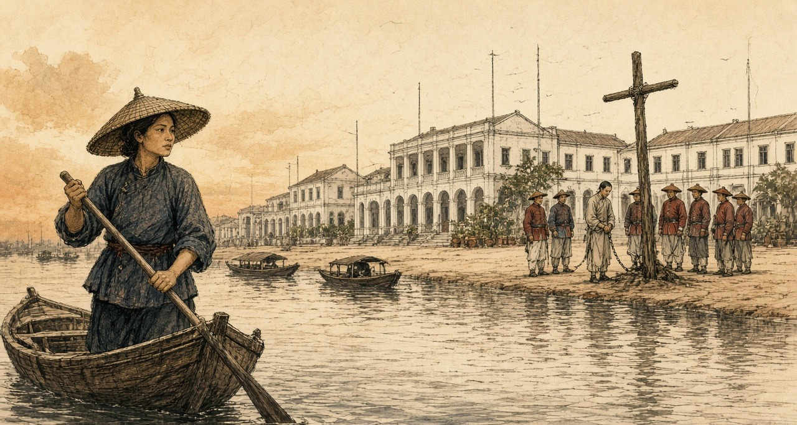
He have-no shout. His two feet, I look-hold his two feet. Bare-feet, the toes at stone-slabs on-top move-down move-down, dead-grip-hold, like a man at big-swell inside want at deck on-top stand-steady so.
The executioner walk-go cross-frame behind. He take a wood-stick stick-drop the neck behind the cord inside, after-that turn.
Look-hold the water la, I with myself say. My two eyes have-no move-away. That man's face turn-black, first is red, after-that turn-black, purple-black, like a bruised-already plum so. His mouth open until very big, the tongue stick-already out-come. Cross-wood on-top those fingers open-wide, close-tight, open-wide, at the wood on-top scratch. He whole-person at the cords on-top jump-up, again jump-up, the two legs toward front kick-wild, the trousers front soak-out one big dark-stain come. The executioner take the stick again turn-more one circle. Whole-person lean-press drop the stick on-top, like a man wring-hold a very heavy fish-net so.
The two feet stop-already. After-that, very long-time, I not know have how long, the toes themselves still at-there move little-little.
Very quick only, the foreign-ghosts afterward say, those have-not go-out river-face foreign-ghosts. From water-face look-cross go, not quick.
They untie-open him, he whole-person toward-front fall-drop the stone-slabs on-top, the face stick-hold stone-slabs, two men grab-hold his two arms, two men grab-hold his two legs, carry-hold him enter-already Old China Street. The soldiers follow-hold behind walk. The square empty-all. Have a dog walk-cross come, smell-down stand-pass cross-frame that place.
After-that, have a foreign-ghost from stone-steps walk-down come, pull-finish boat the face red-flushed, climb-up my sampan, point-one-point opposite bank, mutter-already few sentences not-know-what angry words, I then pull-cross go. Otherwise still can how.
That night Ah-Shui ask me today see-reached what. I say anything have-none. Eat rice la, I say, eat la.
Sell-smoke man, the soldiers say. Big or is small, water on-top no person know. Ah-Shui, pull-already three years fast-crab. According-to that word count, he also is.
After, Thirteen Factories front those foreign-ghost flags drop-all down-come, have-no again raise-return up-go. For that man, the people say. Not is. Is for their square.
* * *
The Gongyuan examination hall and the Yuehua Academy, Canton, March 1839
Imperial Commissioner at first-month twenty-fifth day arrive-step, take Yuehua Academy make-already his headquarters. At-there have a couplet, the people say, is his own-brush write. Not-enough one week, whole provincial-city the book-reading men all recite-out-can:
Sea takes-in hundred rivers, have capacity then great; Cliff stands-up ten-thousand fathoms, have-no desire then hard.
Big official newly arrive, according-to custom must examine-down the students, look-down this place's literary-wind. Guanfeng examination. Myself, Yuexiu Academy, twenty-six years, provincial-examination fail-rank two times, my father is Panyu one teach-book master, his father also is. We by-them summon-called, from Yuexiu, from Yuehua, from Yangcheng, six-hundred forty-five men. Walk-enter examination-hall the cells inside, wear-hold best that long-gown, bring-along ink-stone, hair-brush, with our fathers that-year walk-enter go same-like. Sit-down. Wait give-out theme.
The paper inside, tuck-hold second slip paper.
On-top the questions, not is come-from Four Books Five Classics. Ask furnace-mouths at where, open furnace-mouths those men call what name. Who do retail-selling. Before the prohibitions why not see effect. How-way first can cut-off-completely. Answer-paper on-top no-need write name. The paper straight-hand go Imperial Commissioner's own hand inside.
Whole examination-hall quiet-all. Six-hundred-more men, no person cough one sound. I hear-reached next-door cell the man take the brush put-drop the ink-stone on-top. After-that, again pick-up. After-that, again put-down.
My cousin's husband, is Panyu county-yamen one clerk. My mother's-brother, at West Gate open shop, who with who take goods, I know. Pull-up one family's one string, whole house all will collapse-down come. My father at I not-yet hold-steady the brush that-time then teach me read Mencius: now a man suddenly-sees a child about-to fall-into a well. The heart move first. After-that first is calculation.
I think-up West Gate behind those smoke-houses, daybreak that-time walk-out come those men, the face grey until like stove-ash so. Think-up our street the old schoolmaster, one-book one-book so sell-all his books, first sell commentaries, after-that even classics also sell-all, sell until last only remain-return the pipe. Think-up Tanka those children, spine-back still stick-hold mud, while the old master still teach-hold book that-time, sit at his school-room back-most that row.
I fresh-again grind-pass the ink. The characters write until very small, very clear. First question, I write-already I know those few furnace-mouths down-go. Third question, before the prohibitions why not see effect, I only answer-already one line characters.
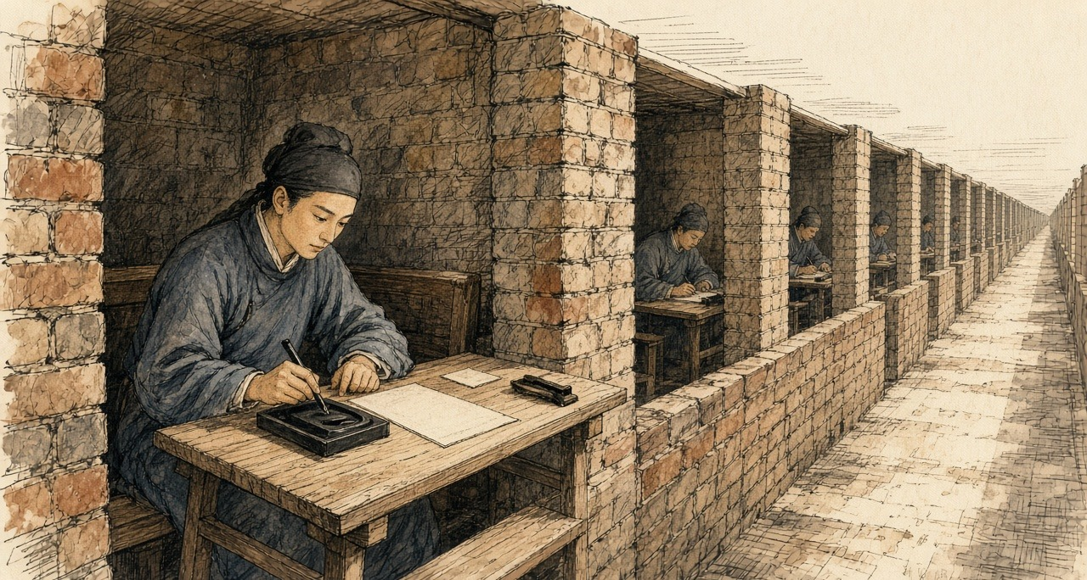
Navy protects smuggling.
Wait the papers hand-reach up Commissioner's place, the clerks afterward say, almost sheet-sheet paper all is give same one answer him.
* * *
Canton, the spring of 1839
Wei Yuan records that the students all answered with the navy's protection of the smugglers, "皆以水师包庇贩私对," and that Lin then memorialized to have the brigade general Han Zhaoqing dismissed. Lin's joint report with Deng Tingzhen and the provincial governor 怡良 Yíliáng, sent up in the spring, opens with a sentence about who dies of opium: "吸食者病于瘾而死，兴贩者罹于法而亦死." The smoker sickens of the craving and dies, and the dealer falls under the law and dies too. By the end of the third month, the report counted, Deng and the governor had arrested 1,600 people and taken 461,526 taels' weight of raw and prepared opium, 42,741 pipes, and 212 pans for boiling it down. After that, gentry chosen village by village kept the 保甲 bǎojiǎ registers and handed offenders over, and by the eighteenth day of the fifth month the officers reported a hundred and ninety-two more prisoners.
Under the Qing code as the Register summarized it in 1838, a man convicted of dealing in opium was punished under the law for smuggling gunpowder and saltpetre: a month in the cangue, then banishment to the frontier as a slave to the soldiers. The cangue was a square board of heavy wood locked around the neck, broad enough that a man in it could not reach his own mouth with his hands.
* * *
The gate of a ward in the western suburbs of Canton, the fourth month, 1839
The wood, heavy-pass an oar. Heavy-pass one chest. Two-sides wood-board, they at yamen inside clamp-hold my neck, lock-tight-already, the board then press-drop my shoulders the bones on-top, from that one moment start, the two shoulders then carry-hold it, day also carry, night also carry, have-no put-down. Still have twenty-eight days. Ah-Mui help me count-hold. I count-confused-all. She have-no confused.
The neck at the hole inside rub. First day, red. Third day, the layer skin break-already. Now flow-hold yellow-water, whole neck raw-all, like at wood-collar underneath again wear-more one wet collar so, after-that the flies then come. Two hands, I reach-not-pass the board's edge go brush them. Once shake the head, the board then swing, once swing then pull-hold the raw-flesh. So the flies stay at-there. At the sore on-top walk.
Sleep, lean-hold ward-gate the wall sit at-there. The board's corner prop-hold ground, my head hang at inside. Sleep-down, wake-down. Sleep-down, wake-down. The neck like break so. Night-night all dream same one dream, I sink-already at river-bottom the water inside, float-not-return up-come, because have something press-hold my neck.
The people walk-pass. Bank on-top the people, mostly not look. Have some look. Have a boy spit-already a mouthful spittle. His mother pull-away him, not is because he spit, is because I is boat-man, body on-top have a smell.
Ah-Mui one day come two times, bring bowl congee come. She kneel at dirt-ground on-top, hold-high the bowl, from the board's edge underneath pass-up come, use the pair chopsticks feed me, one mouthful, one mouthful, like feed baby-bird so, after-that use her sleeve help me wipe chin. Face-hold all people's face. Her face, from head to tail, a-little expression also have-none. Only have one time, wipe-hold that-time, her hand at my cheek on-top stop-already a while, have-not pull-away.
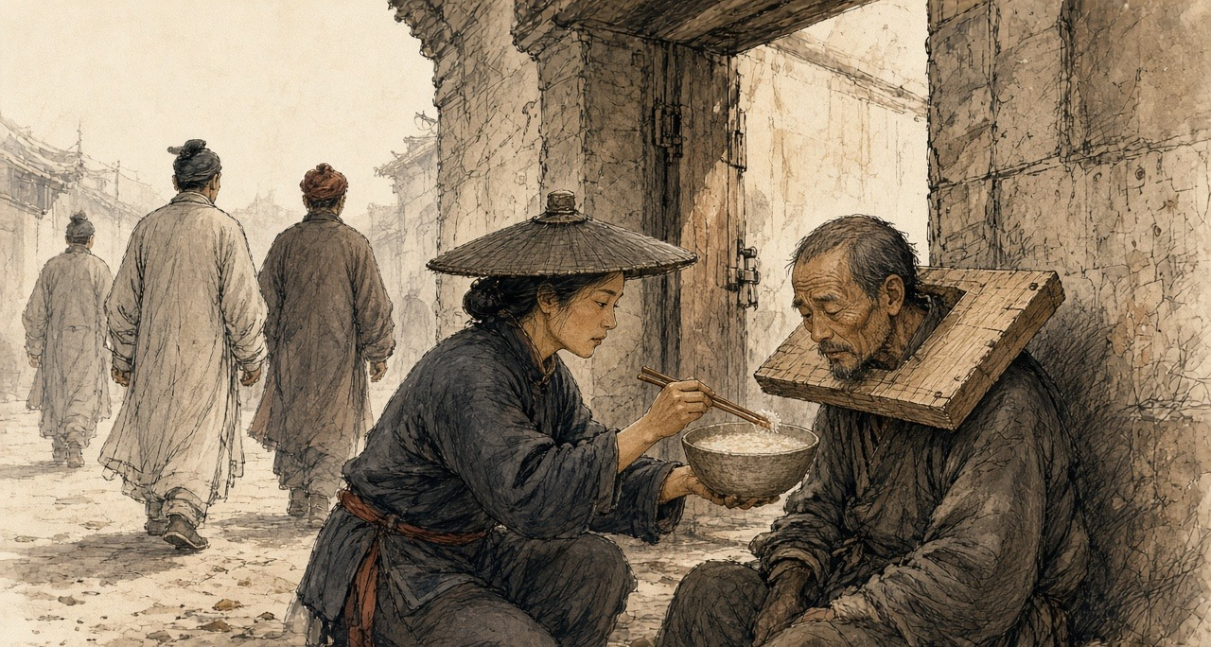
This one time, even pull-oar also not is. Is carry-load. Two bags stuff, friend connect friend, from Whampoa the foreign-ghost boat carry-up come, send-go side-alley one door-mouth, one night wage. The fast-crabs all scatter-all, break-all, the men run-all, but the children still must eat rice. Side-alley that door-mouth, the ward-headman know. Ward-headman's name-list, have my name at on-top.
Pass-finish these twenty-eight days, banish frontier. Give the soldiers do slave. Go where-place, no person tell me know. One Tanka man, go one have-no river place.
Ah-Mui say, wait you return-come that-time. She day-day all so say. Wait you return-come that-time, the boy all big-grown already.
I say yes. I have-no speak other that sentence, she also have-no speak. At us two middle, that sentence sit at the cangue-board on-top, like a fly so.
* * *
The customs station below Canton, the fifth month, 1839
Have-no again see the boy. The ink-stone underneath have-no again have paper packet. Furnace-mouth the shop, door on-top nail-already seal-board, the master run-already return village or is arrest-already, no person say. The ledger, now neat-neat tidy-tidy, true-true exact-exact, stop-stay boats few-and-fewer.
My wife's-brother from Hubei pass-cross come a book inside copy-already a prescription, is Imperial Commissioner at that-side help the eat-smoke people make that-one, take-go druggist-shop make-up-already return-come. Paper twists, two kinds. Jisuan pills: ginseng, atractylodes, angelica, coptis, many things, inside still mix-already little-little smoke-ash, let the body not-good all-at-once scream-all save-life. Every day, this kind eat fewer one pill, change other that kind pill two pills. All-way reduce, all-way reduce, reduce until none stop. She take the pills at table-face line-into one row, help me count-good, like a shopkeeper count silver-coins so, also at a red paper-slip on-top write-down-all the days. Her characters, I very many years have-not see her write-pass. Tiny-tiny, very firm.
First those few days, not count too hard-bear. The pill inside have smoke-ash, the body think itself eat-full-already. After-that, day-day fewer one pill, the body start know itself by-someone cheat-hold.
Seventh day, the two eyes flow eye-water, flow until stop-not-able, the nose also is, the water drip-drop the ledger on-top, one blot, one blot. Yawn, breathe one breath then do one yawn, jaw-bone also ache-all. Ninth day, the bowels. Flow-water. One time again one time so walk-go screen behind the bucket at-there, whole customs-station all is that stink-smell, outside the boatmen your eye look my eye. Cold, clearly fifth-month weather so hot, I wear-hold a winter-padded-gown sit at-there shake, the sweat so pour-down come. Every one joint, all have someone hold-hold a knife at inside pry, knee-cap, elbow, fingers those small bones. The layer skin like have ants at inside crawl-hold so.
Eleventh day, monkey-hour, I from the table at-there stand-up body, walk-go door-mouth, the lamp, the needle and the box right at home the bed underneath, I clear-clear know at which place, my two feet already themselves walk-hold cross-go.
Door-mouth at-there, my son stand at-there. From teacher's place early leave-school return-come. Armpit underneath tuck-hold the book. He look-down my face, look-down the winter-gown, after-that he say, Father, is-not-is because the medicine-pills ah?
He know. He of-course know la. Eleven years boy, three rooms house.
I say, is. Is because the medicine-pills. I say, return home read-book la. He do-already a bow, proper-proper one bow, after-that walk-away-already.
I walk-return go the table at-there, sit-down. I two hands dead-grab-hold the table's edge, grab until knuckle-bones all white-all, all-way grab-hold, monkey-hour pass-already, rooster-hour again pass-already. Enter-dark that-time, my woman hold-hold the lamp and rice cross-come, see-reached me sit at-there, then put-down bowl rice, take my grab-hold table-edge that hand pull-open, use her two hands wrap-hold. Very cold ah, she say. Cold until like-this.
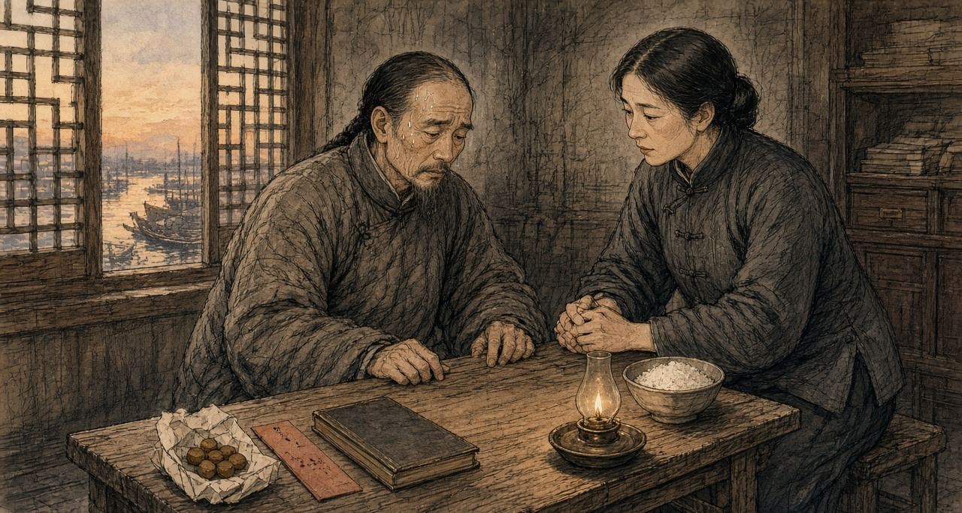
Fourteenth day, I sleep-hold-already.
* * *
The City of London, the autumn of 1839
The China houses had partners at home who never sailed. In 1834 Hollingworth Magniac, back from Canton, joined the banker John Abel Smith and his cousin Oswald Smith in Magniac, Smith & Co., London correspondents of Jardine, Matheson & Co. Smith sat in the Commons for Chichester. When William Jardine came home in 1839, Smith introduced him to Lord Palmerston, who later acknowledged how valuable their information had been in planning the China expedition. The Canton accounts came home as account sales and accounts current, volumes now in the Jardine Matheson Archive at Cambridge. The man below belongs to no named firm.
Tuesday. Fog at eight, so thick in Cornhill the lamps were still lit, then a cold thin drizzle which has not stopped. Boz has us exactly: "Middle-aged men, whose salaries have by no means increased in the same proportion as their families, plod steadily along, apparently with no object in view but the counting-house." My salary has increased very well, but in every other particular I plod.
Coal bad this month; it smokes, and my eyes have smarted since ten.
The Canton accounts by the overland mail. I spent the forenoon upon them with young P., who reads the figures while I tick. Each consignment its own sheet of good rag paper, ruled by hand in red: the ship's name, her captain, the marks, the number of chests, Patna, Benares, or Malwa, the rate per chest obtained, the gross; then down the right hand, the charges, freight, insurance, landing, boat hire, the receiving-ship charge of five dollars the chest, commission, and below a double rule the net proceeds; and lastly how remitted, by what bills, drawn on what house, at what exchange, at what usance. P. writes a good round hand and uses the steel pen, which I dislike; it scratches, and the ink takes on it unevenly. The ink in the older books has gone the colour of weak tea.
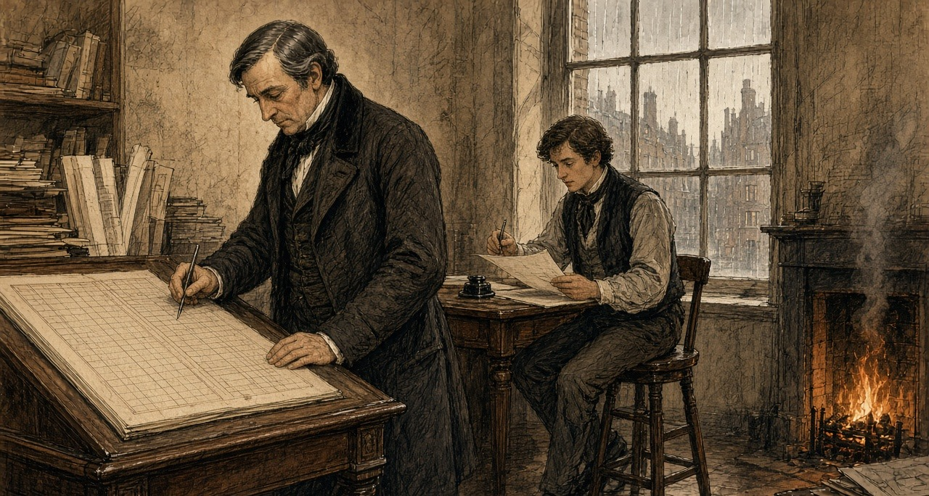
The season's figures run very well until March and then stop. After March, a fresh sheet: chests delivered up to the Chinese Commissioner on Captain Elliot's order, against his certificates, Her Majesty's Superintendent promising in effect that the Crown will answer for them. Twenty thousand two hundred and eighty-three chests in all, the Canton papers say, across every house. Ours is not the largest share. I made P. read me the column twice.
The opium itself, the letter says, went into pits of brine and lime and out with the tide in June. A copy of one of Captain Elliot's certificates came with the letter. Good thick paper.
Mr. J. is in town and has been with the Foreign Secretary, they say. The senior partner says all will come right; the certificates are the Government's paper and the Government must pay. He said it while looking out of the window at the rain coming down Lombard Street.
Bills on London from Canton fell due today to the amount of — I need not write it. They were met.
Home by six. Rain steady. A boy selling hot chestnuts at the corner of Gracechurch Street, his hands in rags, and some poor fellow face down in the gutter by the Monument, drunk or ill; I did not stop to discover which. The fog coming up again off the river. Tomorrow the Calcutta letters.
* * *
Canton, 1839 to 1840
The regulations that reached Canton in the summer of 1839 gave smokers eighteen months to break the habit before strangulation. Lin's later memorials, added up by the historian 茅海建 Máo Hǎijiàn, report 890 more cases and 1,432 more prisoners between May 1839 and the end of June 1840. When the British ships came, Lin went to the river for men. He had learned from translated foreign newspapers, the 防海纪略 says, that the British despised the Qing navy and feared the coastal smugglers, the fishing boats, and the 蛋户, the Tanka. He enrolled five thousand able-bodied men at six dollars a month, with six more for their families.
Han Zhaoqing lost his post. Wei Yuan gives the rest in one clause after Lin's memorial for his dismissal, "终以邓廷桢所保，不能尽正其罪": in the end, because Deng Tingzhen had vouched for him, his crime could not be punished in full.
Chapter 2 Mini-Glossary
• Cangue (2 occurrences in this chapter): Heavy square wooden collar locked around a prisoner's neck as a public corporal punishment in Qing China.
• Fast crabs (6 occurrences in this chapter): Kuaixie ('fast crabs') and Palong ('scrambling dragons'); heavily armed, fifty-to-seventy-oar smuggling galleys that ran opium from Lintin into the Pearl River delta.
• Hoppo (2 occurrences in this chapter): Western name for the Imperial Superintendent of Maritime Customs at Canton, appointed by the Qing court to collect trade duties.
• Lintin (3 occurrences in this chapter): Lingding Island in the outer Pearl River estuary, where foreign receiving hulks anchored year-round to store and transship smuggled Indian opium.
• Sycee (2 occurrences in this chapter): Fine Chinese silver bullion cast into boat-shaped ingots (yuanbao) and measured by weight in taels; drained outward to pay for imported opium.
• Tael (4 occurrences in this chapter): Chinese ounce of silver (liang), approximately 1.33 ounces avoirdupois (37.8 grams), serving as the standard unit of account in Qing state finance.
• Tanka (6 occurrences in this chapter): Danjia boat-dwelling people of the Pearl River delta in Guangdong, historically barred from living ashore and heavily recruited by both opium boats and Lin Zexu's river forces.
• Yamen (2 occurrences in this chapter): The official headquarters, residence, and courtroom of a Chinese mandarin or magistrate.
Chapter 2 Appendix of Important Names
• Deng Tingzhen (3 mentions in this chapter): Viceroy of Liangguang who collaborated with Imperial Commissioner Lin Zexu in the 1838–1839 Canton opium suppression.
• Elliot, Charles (2 mentions in this chapter): British Chief Superintendent of Trade in China who surrendered the British merchants' opium to Lin Zexu at Humen in 1839.
• Han Zhaoqing (2 mentions in this chapter): Qing naval officer in Guangdong promoted for staged opium seizures while running protection for the fast-crab smugglers.
• Huang Juezi (1 mentions in this chapter): Qing official whose 1838 memorial on silver drain and mandatory capital punishment for opium smokers precipitated Lin Zexu's mission.
• Jardine, William (3 mentions in this chapter): Scottish surgeon and co-founder of Jardine, Matheson & Co., who advised Lord Palmerston on the First Opium War.
• Matheson, James (2 mentions in this chapter): Scottish merchant and co-founder of Jardine, Matheson & Co. in Canton.
• Palmerston, Lord (Henry John Temple) (1 mentions in this chapter): British Foreign Secretary and Prime Minister who directed British policy in the First Opium War and the 1840 Levant crisis.
• Wei Yuan (3 mentions in this chapter): Qing scholar and historian of the Opium War and maritime geography.
• Xu Naiji (2 mentions in this chapter): Qing official who proposed legalizing and taxing opium in 1836 and was subsequently demoted.
Sources
• The Chinese Repository 中國叢報. Canton: 1832-1851. Especially the 1837-1839 issues for descriptions of receiving ships, fast crabs, centipede boats, and the Pearl River smuggling routes; vol. VII, no. 8 (December 1838), on the Innes seizure and the attempted execution of 12 December 1838.
• Qing shilu 清實錄 [Veritable Records of the Qing]. Daoguang chao. Entries concerning the opium trade at Lintin and the conduct of Guangdong naval commander Han Zhaoqing 韓肇慶.
• Chouban Yiwu Shimo 籌辦夷務始末 [Complete Account of the Management of Barbarian Affairs]. Daoguang chao. Beijing: Palace Museum edition. Huang Juezi's memorial of 1838 is printed in juan 2.
• Guangdong local gazetteers for Pearl River delta counties. Especially entries on waterways and the Tanka 疍家 boat population; (Yongzheng) Guangdong tongzhi 廣東通志, juan 7 and juan 64, and the Dingli leichao 定例類抄, juan 7, for the edict of the fifth month of Yongzheng 7 (1729), 粤東蛋户准於近水村莊居住.
• Hunter, W. C. The "Fan Kwae" at Canton Before Treaty Days, 1825-1844. London: Kegan Paul, Trench, & Co., 1882. Source for the smug boats ("scrambling dragons" and "fast crabs"), their build, crews, sails, armament and varnished hulls, the brokers' agents, the five-dollar cumsha, magistrates' fees, the river as "a city afloat," the strangling cross, the square riot (misdated by Hunter to February 1839), and the execution of 26 February 1839.
• Antony, Robert J. Unruly People: Crime, Community, and State in Late Imperial South China. Hong Kong: Hong Kong University Press, 2016.
• Brook, Timothy, and Bob Tadashi Wakabayashi, eds. Opium Regimes: China, Britain, and Japan, 1839-1952. Berkeley: University of California Press, 2000.
• Fay, Peter Ward. The Opium War, 1840-1842. Chapel Hill: University of North Carolina Press, 1975.
• Siu, Helen F. Merchants' Daughters: Women, Commerce, and Regional Culture in South China. Hong Kong: Hong Kong University Press, 2010.
• Van Dyke, Paul A. The Canton Trade: Life and Enterprise on the China Coast, 1700-1845. Hong Kong: Hong Kong University Press, 2005.
• Van Dyke, Paul A. Merchants of Canton and Macao: Politics and Strategies in Eighteenth-Century Chinese Trade. Hong Kong: Hong Kong University Press, 2011.
• Murray, Dian H. Pirates of the South China Coast, 1790-1810. Stanford: Stanford University Press, 1987.
• Wakeman, Frederic, Jr. Strangers at the Gate: Social Disorder in South China, 1839-1861. Berkeley: University of California Press, 1966.
• Polachek, James M. The Inner Opium War. Cambridge, MA: Harvard University Press, 1992.
• Chen, Song-Chuan. Merchants of War and Peace: British Knowledge of China in the Making of the Opium War. Hong Kong: Hong Kong University Press, 2017.
• Qing shilu and Chouban yiwu shimo: series-level only until juan/folio confirmed.
• 魏源 Wei Yuan. 夷艘寇海記 (appendix to 聖武記) and 道光洋艘征撫記. Source for Han Zhaoqing's arrangement ("每萬箱許送數百箱與水師報功"), his promotion and peacock feather, the academy students' answers ("皆以水師包庇販私對"), and his dismissal ("終以鄧廷楨所保，不能盡正其罪").
• 防海紀略 Fanghai jilüe (late Qing; Chinese Wikisource text). Follows Wei Yuan; source for the 36,000 taels a month taken by the patrol boats after 1826, Lu Kun's abolition of the patrols in 1832, Deng Tingzhen's restoration in 1837, "水師兵丁，人人充橐," and Lin's recruitment of five thousand men, in a passage on the smugglers, fishermen and 蛋户 the British feared, at six dollars a month plus six for their families.
• 沈渭濱 Shen Weibin. 道光十九年：從禁煙到戰爭. Quotes the memorial of the censor 馮贊勳 on the fast crabs' iron netting, fifty to sixty oars and the name 插翼, and Xu Naiji's 有省城包買戶，謂之窰口.
• 黃爵滋 Huang Juezi. 請嚴塞漏卮以培國本疏, Daoguang 18 (1838), as printed in 中國通史參考資料·近代部分 and in Qing shigao, biography of Huang Juezi. Source for the silver rate of 1,600 cash and more, the scrambling dragons and fast crabs, the year's grace, and the exclusion of smoking officials' sons and grandsons from the examinations.
• 林則徐 Lin Zexu, 鄧廷楨 Deng Tingzhen, 怡良 Yiliang. 會奏續獲人烟槍具摺, in 林文忠公政書, 使粵奏稿 juan 4. Source for "吸食者病於癮而死，興販者罹於法而亦死," the arrest of 1,600 people, 461,526 taels of opium, 42,741 pipes and 212 pans by the end of the third month of 1839, and the later 140 cases and 192 prisoners.
• 林則徐 Lin Zexu. 籌議嚴禁鴉片章程摺 (1838), with the withdrawal prescriptions 忌酸丸 and 補正丸, in 林文忠公政書, 湖廣奏稿 juan 4; the prescriptions as collected by 何其偉 He Qiwei in 救迷良方. Lin's a thousand courses of pills paid from his salary as summarized by 中華文史網 (Qing History Project, historychina.net).
• 茅海建 Mao Haijian. 天朝的崩潰：鴉片戰爭再研究 (Beijing: Sanlian, 1995), ch. 2. Lin's later arrest totals, May 1839 to June 1840.
• "林則徐在高第街的日子," 羊城網 (gznf.net), which also records that Liang Tingnan organized the examination at Lin's request; and 人民周刊, 4 May 2016. The 觀風試 of 645 students from the Yuehua, Yuexiu and Yangcheng academies and its four questions; Lin's couplet at the Yuehua Academy.
• The Canton Register, as abstracted in Roger Houghton, A Peoples' History 1793–1844 from the Newspapers, "Opium" parts 2 and 3 (houghton.hk). Source for the 1832 memorial on 100 to 200 fast crabs, the crabs built at Lintin (December 1832), the fight of June 1833 and the repurchased book, Xu Naiji's description of the boats and the yaokou (1836), Zhu Zun's memorial (8 November 1836), the Shaoguan customs fees (January 1837), Deng Tingzhen's report on the 1837 seizures and the price of a ball, his edict on the foreigners' decked boats (February 1838), the strangling of Kwok Sze Ping at Macao (April 1838), the arrest of Ko Kwan (13 July 1838), the penal code on dealers, the cangue, and the Friend of India editorial of 19 April 1838.
• Eitel, E. J. Europe in China: The History of Hongkong from the Beginning to the Year 1882. London and Hong Kong, 1895, ch. 8. The Innes seizure and the security merchant in the wooden collar, December 1838.
• Merchants and Mandarins: China Trade Era (online flipbuilder edition, pp. 246, 265), citing the Chinese Repository VII, no. 8 (December 1838), the Canton Press Extra, and the consular despatch of P. W. Snow, 6 March 1839, for the dating of the attempted execution to 12 December 1838 and the execution of 26 February 1839; Elliot's address as abstracted in Houghton, "China 1839–1840, part 10" (houghton.hk), gives the same two dates.
• Lin, Man-houng. China Upside Down: Currency, Society, and Ideologies, 1808–1856. Cambridge, MA: Harvard University Asia Center, 2006. Silver-copper exchange rates.
• Greenberg, Michael. British Trade and the Opening of China, 1800-1842. Cambridge: Cambridge University Press, 1951. The agency houses, their London correspondents, and remittance by bills on London.
• "Smith, John Abel (1802–1871)." Oxford Dictionary of National Biography. Magniac, Smith & Co. (1834) as London correspondents of Jardine, Matheson & Co.; Smith's introduction of Jardine to Palmerston.
• Jardine Matheson Archive, Cambridge University Library, MS JM/A5 (Account sales, 1810–1886), the accounts current series (including the London volumes), and the ledgers series A1, as described in the ArchiveSearch catalogue.
• Dickens, Charles ("Boz"). Sketches by Boz. London, 1836. "The Streets—Morning" and "The Streets—Night."

Chapter 3
Poppies Inland, 1839
Yunnan, Sichuan, Hubei, and Peking, 1831 to 1848
In the summer of 1831 the governor-general of Yunnan and Guizhou, the scholar 阮元 Ruǎn Yuán, sent the Daoguang Emperor his rules for stopping the poppy in the Southwest. The emperor's reply of 3 August, kept in the Veritable Records, repeats what Ruan had told him. Along Yunnan's frontier the 夷民, the non-Han peoples of the border, had long grown the poppy, collected the juice of the flower, and boiled it into a paste they called 芙蓉 fúróng, the lotus, and sold it as opium. People of the interior grew it too, saying they wanted the seed for pressing oil. Ruan explained why. "费工少而获利多": it took little labor and paid a great deal. The province was all deep mountains and remote valleys, and the habit was old.
Ruan proposed two inspections a year. In winter, when the poppy came up out of the ground, the local official and an officer of the garrison would walk the fields and hoe the plants out. In late spring, when it flowered and set its buds, they would walk them again. Clerks and runners of proven honesty would watch the passes and the tax stations for carriers.
The emperor answered the plan point by point. The valleys were too many, he wrote, and to trust the growing households to dig out their own plants "是必不可信之事," was a thing that could never be believed. Then the runners. "试思胥役之中。焉有诚妥可信者": think it over, among clerks and runners, where is there one honest and trustworthy? Add more of them and you add one more abuse. "所议皆不过纸上空谈。于事何济": everything proposed is empty talk on paper, and what use is that to the matter? He ordered the officials to inspect without fixed dates, to arrive when no one expected them, and to report at the end of every year. If poppy they had not found turned up later in some other case, they would be impeached.
For the border domains he left the work to the 土司 tǔsī, the hereditary native chiefs who governed them for the throne. Each winter the chief was to inspect in person. Any plot grown in secret, his headmen and militia were to pull up, and the grower was to be put in the cangue according to the statute. The field went to the chief, to be worked by his militiamen as militia land.
The same summer the emperor approved rules for Hunan, where poppy growers were to be sent into military exile and their land confiscated. From Canton the viceroy reported poppy only in the prefecture of Chaozhou, and the emperor answered that he doubted it stopped there. In Guangdong the field would be forfeit and the grower punished as an opium dealer, and the ward headmen, village elders, and lineage heads who had kept quiet would be cangued or beaten. The governor-general of Sichuan, 鄂山 È Shān, reported poppy still grown around Huili and Pingwu, where the province met the non-Han country. In Hunan and Guangdong the officials were to sign a sealed bond every year that their districts grew none.
* * *
A valley near Mengzi, southern Yunnan, the winter of 1838 to the spring of 1839
That field, my grandfather left-behind. Beans, wheat, cold-season plant, year-year plant. Beans carry-go Mengzi street on-top sell, wheat keep-give us ourselves eat. Good year, the beans hand-over-already grain-tax, still remain-get-down little-over. Bad year, not-enough.
Five years already, plant poppy. My wife's-brother first plant, across-ditch that house follow-hold plant, follow-hold is me. Same one field, same one water, same one winter. The seed tiny-very, one whole year's seed, hold at one bowl inside. Sow thin-little, do-not let birds peck-already. The rest, the plant itself grow.
Winter, the green-shoots come-up-already. Low-low, grey-green grey-green, leaves like grow-bad-already cabbage. This winter, provincial-city send-down proclamation come, stamp-up big red seal, the headman at temple door-mouth read-out. Plant poppy, boil paste, open smoke-house, carry-out province sell, all-all must seize must punish, no favour. He read-finish, fold-up come, stuff-return sleeve-tube inside, return-home go-already.
Spring, open-flower. Whole valley, white, also have red, sun-underneath hurt-eyes-very. After-that, the petals drop-already, the head at stalk on-top stand-up come, green, hard, hen's-egg so big. This time, the work start-already.
Prick the head. One small blade, stroke few lines, shallow-shallow, only break skin. The white-juice come-out, one bead, one line, slow-slow, hang at that-place turn-into brown-colour. After-that, use knife-edge scrape-enter bowl inside. Every one head, every one plant, whole field, bend-up waist-back, the back, the neck, my woman at next-door that row. Fingers on-top the juice turn-black-already, sticky-hand-very, wash also wash-not-off.

After-that, is enter-pot. Boil, strain, again boil-dry, until boil-into paste, both thick and dark. That smell, both sweet and rotten mix-together, bore-enter earth-walls inside, bore-enter quilts inside. Left-right neighbours anything all not say. Their houses inside also is same smell.
Sichuan merchant-man come take. Give silver. Compare-to plant rice ten-times more, people say. Ten-times, I not know. Compare-to beans more, much more. This year grain-tax hand-over-clear-already, still have over.
Towns inside the paste cheap, compare-to anywhere all cheap, the Sichuan man say. Mengzi street on-top, the smoke-houses big-doors wide-open. Yamen inside the people go, clerks, runners, officials' relatives and servants. Book-reading men, shopkeepers, garrison-camp inside the soldiers, ordinary people. Ten men inside, have five-six, people say.
My wife's-brother now also eat-up-already. Once reach evening, the lamp not-yet light, his that hand then start shake, the eyes look-reach other-place go, the person sit at table-side, the soul already not at table-side. His woman run-come find my woman, cry. Their house's buy-rice money, enter-already his that pipe. Himself boil-out the paste, enter-already his own pipe. Himself grow, himself boil, himself smoke, still owe-debt.
Summer, provincial-city again pass-down news come. Peking come new law. Whoever grow poppy, gather juice, make paste go sell, the chief-offender, strangle-die. Not is at-once strangle, wait autumn-assizes pass-after. The helpers, banish-go fever-country at far-frontier. Give one year and half time stop-completely.
That night, sleep-not-able. Lie at bed on-top, pitch-dark open-hold eyes. One rope loop at neck on-top, I think-up one rope loop at neck on-top, the knot at ear underneath. Climb-up come, walk-out go, stand at field-edge. The stalks, now dry-already, wind blow-pass, rattle-rattle sound. My own two hands, finger-creases inside still is black, no-need look all feel-get-to. Stand-already very long-time. After-that, walk-return house, at my woman beside lie-down, she also wake-hold at-there, we two, one word all have-not say.
Next winter, the seed still is enter-ground again, with across-ditch that house same-like.
* * *
Peking, 1836 to 1838
The court argued over the poppy at home before it argued over the ships at sea. On 10 June 1836 the vice-president of the Court of Sacrificial Worship, 许乃济 Xǔ Nǎijì, who had served in Guangdong, proposed taxing foreign opium as a medicine and, on a separate slip, letting Chinese farmers grow their own. Opium came from the juice pricked out of the poppy as it set its buds, he wrote, boiled down. Fujian, Guangdong, eastern Zhejiang, and Yunnan had all grown it, until the censors had it banned, and since then nobody in the interior dared, and the foreigners kept all the profit. Native opium was cheap and weak, he wrote, did a man little harm, and was easy to give up. "今若宽内地民人栽种罂粟之禁，则烟性平淡，既无大害，且内地之种日多，夷人之利日减，迨至无利可牟，外洋之来者自不禁而绝." If the ban on the people of the interior planting the poppy were relaxed, the smoke would be mild and do no great harm, home growing would increase day by day, the foreigners' profit would shrink day by day, and when there was no profit left to seek, the foreign supply would stop without being banned.
He knew the danger to the grain, and answered it from Guangdong. There the poppy went in after the late rice was cut in the ninth month, flowered and fruited by the second or third, and once the juice was taken the early rice went in, so the land lost nothing and the farmer gained a great deal. The officials at Canton, answering the emperor, suggested allowing it on hilltops and field corners too broken to be farmed in proper plots, and nowhere on good fields.

Xu argued for the people as he saw them. Only the stupid and lowly with no office would be left free to buy and smoke, he wrote; officials, scholars, and soldiers would still be forbidden. Did the habit shorten lives? Not always, and "今海内生齿日众，断无减耗户口之虞": the empire's people were growing more numerous by the day, and there was no danger at all of the population being reduced. That autumn two officials answered him. One was the supervising censor 许球 Xǔ Qiú. The other was the sub-chancellor of the Grand Secretariat 朱嶟 Zhū Zūn, a Yunnan man from Tonghai, who would not have the poppy ban in the interior loosened and would not have the law punish officers and soldiers while it let the common people buy and smoke. "民贫尚可变富，民弱不可救药," he wrote: a people grown poor can still grow rich again, but a people grown weak has no medicine that will save it.
Huang Juezi's memorial of 1838, with its year of grace and death for the smokers, won the argument at court. On 28 October 1838 Xu Naiji was demoted to the sixth rank and retired for having recklessly asked for the ban to be relaxed.
On 20 December 1838 the emperor wrote to the governor-general of Yunnan and Guizhou, 伊里布 Yīlǐbù, and the governor of Yunnan, 颜伯焘 Yán Bótāo, about a memorial on their province. In the deep mountains and remote valleys, it said, the poppy was grown and its juice boiled into smoke, "其利十倍于种稻," the profit ten times that of growing rice. In the yamens, from officials' relatives, private secretaries, and servants down to clerks and runners, and in the towns, among students, merchants, soldiers, and ordinary people, "吸烟者十居五六," smokers were five or six in ten. Dens opened in plain view. The paste sold cheaper than in any other province and was now being carried out of it for the profit. The opium that came by sea had to be dealt with strictly, the emperor wrote, and what grew at home had to be cut out.
* * *
Hanyang and Hankou, the summer of 1838
Hankou sat where the Han River runs into the Yangzi, across the water from the provincial capital at Wuchang, a town of markets and warehouses. In the summer of 1838 the governor-general of Hubei and Hunan, 林则徐 Lín Zéxú, did not wait for the court to settle the new penalties. He and the two governors set up bureaus in the provincial city and at Hankou to take in pipes, bowls, implements, and leftover opium, and he paid out of his own allowance for a thousand courses of pills to break the craving, for men who handed in their pipes and truly meant to stop.
The magistrate of Hanyang, 郭觐辰 Guō Jìnchén, went down to the boats. In the cargo boxes of a dealer named 朱运升 Zhū Yùnshēng his men found more than 1,200 taels of raw opium and more than 800 of prepared paste hidden among the goods. In the warehouse of Qiu Dixiang they took two more dealers. Two others had already gone home to Guangdong, and in the leather trunk of one and the wooden chest of the other the searchers found 2,070 and 980 taels. In another warehouse they took two more, and in the double bottom of a bed belonging to a man who had run, 850 taels. Three dealers walked into the prefecture and county offices and gave theirs up. In all, more than twelve thousand taels.
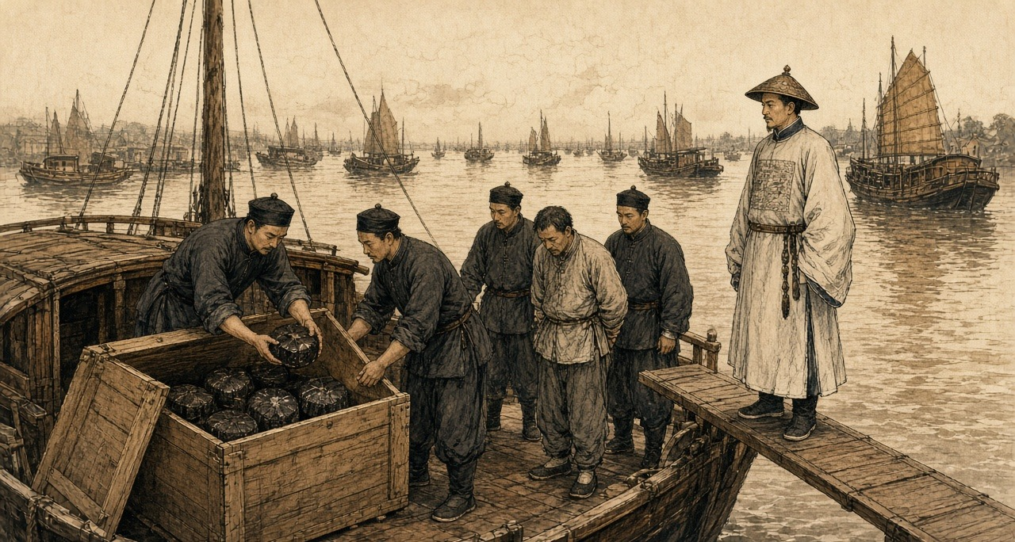
By the end of the sixth month the bureaus had 1,264 pipes. Lin's officials checked them one by one, split each with a knife, and burned them. Pipes with paste still caked inside were soaked with tung oil and burned again until nothing was left, and the ash was thrown into the middle of the river. The carved and ornamented pipes and bowls, Lin wrote, were too many to list.
He had been asking the merchants about trade, at Hankou and before that in the Nanhao quarter of Suzhou. They told him that goods which twenty or thirty years before had done ten thousand taels of business now did half that. He asked where the other half had gone. "一言以蔽之，曰鸦片烟而已矣." In a word, opium.
He did the sum for the emperor. A poor man in a fair year could live on four or five hundredths of a tael of silver a day, and on a tenth of a tael he lived comfortably. A smoker spent at least a tenth of a tael a day on top of food and clothes, thirty-six taels a year. If only one in a hundred people smoked, the drain was more than a hundred million taels a year, and far more than one in a hundred smoked. Smokers called their friends in, he wrote, and took pride in drawing others into the habit.
The dealers, he reported, had heard there might be a death penalty, "莫不魄悸魂惊," and every one of them was shaken to the soul. Many had already fled. He wanted the smokers punished as hard as the sellers, and quoted the proverb: in a market of men whose feet have been cut off, nobody sells shoes, and beside the monks' quarters nobody sells combs.
He named who protected the trade. In the yamens, he wrote, among private secretaries, officials' relatives, personal servants, clerks, and runners, "嗜鸦片者十之八九," eight or nine in ten were addicted, and all of them were in a position to shield the sellers. The statute had long prescribed strangulation for keeping an opium den. "而历年未闻绞过一人，办过一案": yet in all those years no one had heard of a single man strangled, or a single case tried.
* * *
A roadside in Wuchang, the summer of 1838
The chair along the road come-pass, front the runners all-way call-clear road, I right at road-side the dust inside kneel-down go, forehead press-hold ground, stay. Our lane inside Old Mrs Wang at my beside, also kneel-hold. Further-along, still have other-people. Have-no anyone tell us come. We ourselves come.
Twelve years already, his craving. River-side cloth-shop inside one clerk, a good hand, can write. Trade turn-bad-already, the shop cut his pay, after-that have one evening, a friend take him along go eat-smoke, say for company. From that after, evening-evening all go. The friend again bring other friends come. After-that, the shop then let him go.
One day's eating, our house, five mouths, never pass few coppers. His that pipe, every day, eat-away more-than all of us. The pawnshop, my wedding hairpins, winter quilt, his good long-gown. Toward my sister borrow, toward his cousin borrow. Year-year New Year, the debts call-in, people at door-mouth, and him lie at bed on-top, face turn-toward wall.
After-that, the notices paste-out-already. A death-law come-hold. The yamen give-out medicine-pills. I myself pull-hold his sleeve take him go the bureau inside, him hand-inside hold-hold use cloth wrap-up the pipe, hand-over go, they then give him the paper packets.
After-that, is the days after.
His face shrink-already. The layer skin pull-tight at bones on-top, the lips draw-back off the teeth, the teeth all-time show at outside, even sleep-hold also show. Water stream-down from the eyes. Cold, cold over whole body at summer-heat inside, shake under every cover we have left, and we have-not remain many. Ache, every part of him. The bowels, flow-water, one night many times, the stink of it at that one room, him too weak stand-up-not-able, me clean him like a baby so. Have-no strength even lift the head. And always beg-hold. One pipe, only one. He call me my childhood small-name, only his mother use that-one.
Druggist say ginseng help. Druggist's price for ginseng, Korean, foreign, all of it, since the notices come-out, up and up, several times what it was. Whole city the people all buy-hold. I sell-already my last good jacket for one packet of it.
After-that, have one morning, he eat-down rice. Half a bowl. Pass-already few days, he sit at doorway inside in the sun. Now he go the docks for work, any work, come-home tired and sleep at night. His face, fill-out a-little.
What I twelve years do-not-able, what his own father do-not-able, the death-law do-already.
So I kneel. Dust at my mouth inside. The chair go-by, I hear the poles creak, I have-not look-up. I toward the ground say, my husband, the habit, break-already, he is get-stronger-hold. Say-already again. Whether anybody hear-reached, I not know.
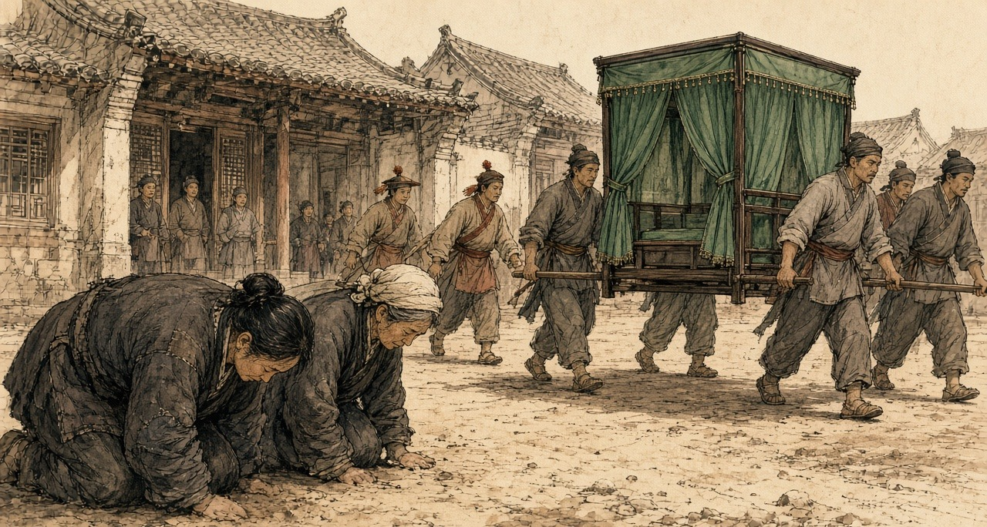
Lin wrote to the emperor that old people and women were kneeling at the roadside in Hubei and knocking their heads on the ground in thanks, saying their husbands and sons had long been sick with the craving and now, by the medicine, had broken it, and their bodies were growing stronger. "是其父子家人平日所不能断者，皆恃国法有以断之": what fathers, sons, and families could not break on their own, they relied on the law of the state to break for them.
* * *
The parade ground at Wuchang, the tenth day of the ninth month, 1838
Morning. The parade-ground flat and grey, the dust pack-hard by the soldiers' feet. Governor-General himself at-there, and the Governor. We runners at the tables.
Pipes, one mountain of them. Sacks and bundles tie-hold with string, from all-over the province. Plain pipes black with years. Pipes carve and fit so fine, so many kinds, no person count-clear-able. Bowls in heaps. All the little tools. The clerk call the count, I hand, the other-one write. At the end, one-thousand seven-hundred fifty-four, pipes.
My job, the knife. Lay the pipe at the block on-top, set the blade along the stem, hit the back of the blade with the mallet. Crack. Split-open, two halves. Inside, black. Old oil, thick, shining, all down the bore. That is how you tell an old pipe from a new one, the clerk say, a new one is clean inside. These, none clean.
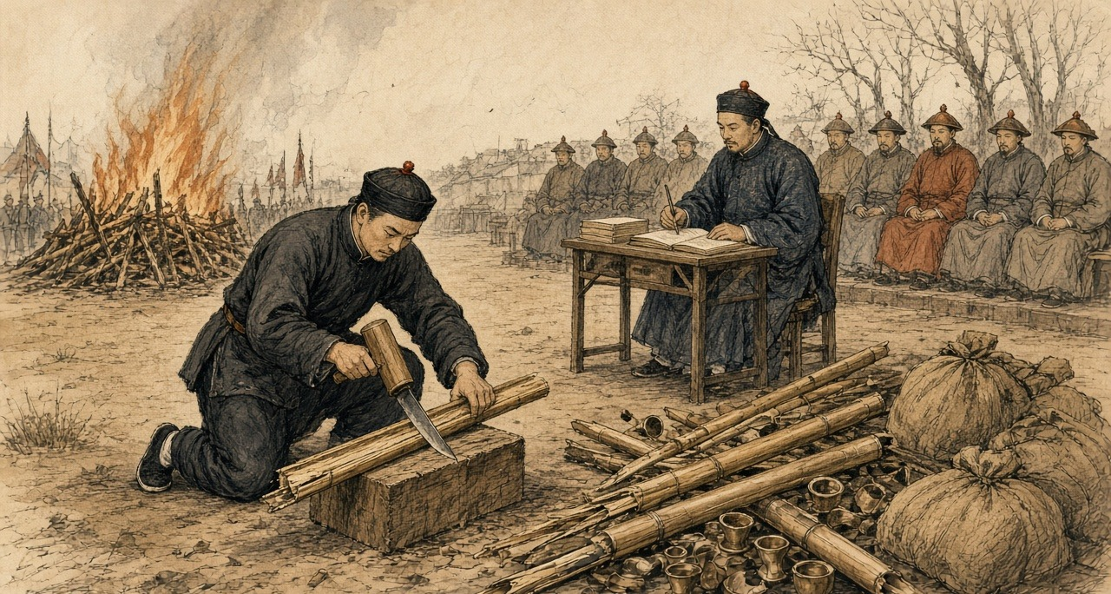
And the smell come-up out of the wood when it split.
My hands, the first hour, steady. After-that, not. Every crack it come-up again, enter the nose inside, enter the throat back, and the stomach turn-over and the mouth fill with water. Spit, wipe the mouth at the sleeve on-top, next pipe. Since the summer I have-not go to the place behind the dyer's. Since the summer, fifty-odd days. The eyes stream-water, the cold at the bones inside at the heat, the aching, the bowels, that is pass-already now, almost pass-already. And now this, a whole morning of it, the whole parade-ground.
The runner next to me, same thing, I see-out-can. Lips wet. Neither of us look at the other.
After-that, the scales. Raw opium, paste, weigh-out at the great-men in-front, the clerk call-hold it. Sixteen-thousand seven-hundred sixty-eight taels. The Jiangxia lot, throw-enter the middle of the river. Gone, all that money, under the brown water. The Hanyang lot, seal-up for the provincial treasury.
The pipes, smash-broken, onto the fire. Oil at inside, they go-up fast, spit-hold, and the smoke is that smoke, sweet and heavy, roll-cross the ground. I keep my eyes at the fire on-top, and pinch the inside of my wrist with my nails until the skin break, and keep pinch-hold.
The new law, people say, will be death for smoking. At the yamen inside everybody know who smoke. Eight of ten, nine of ten. Our own Governor-General write-already it to the Emperor, the clerk say. If it come, who arrest whom.
End of the day, my hands black to the wrist. Wash-already them at the bank. The smell at them on-top still, walk-return home. At the dark inside, at the alley by the dyer's, I stop-already. Stand at-there. My feet know the way. After-that, walk-on.
That winter the emperor called Lin to Peking and sent him on to Canton as imperial commissioner.
* * *
The roads between Yunnan and Sichuan, 1839 to January 1841
In 1839 the censor 陆应谷 Lù Yìnggǔ, himself from Mengzi, reported that the poppy in Yunnan was no longer a matter of a few border valleys. In Fumin, Chenggong, and Luquan, counties just outside the provincial capital, people were planting it in secret. And in the wide districts toward the frontier, Mengzi, Guangnan, Kaihua, Jingdong, Zhaozhou, Menghua, "昔种豆麦之田今成罂粟之地": the fields that once grew beans and wheat had become poppy land.
The capital added up the provincial reports. Across 1838 and 1839, the archives of the campaign record, the provinces outside Guangdong seized 588,179 taels of opium and paste and 39,468 pipes and implements, and took 4,111 dealers and smokers. In March 1839 the Sichuan governor-general 宝兴 Bǎoxīng reported 32,630 taels, more than 3,340 implements, and 33 cases. The poppy uprooted in those two years came to something over 230 mu, under forty acres, and Zhejiang alone reported that much. Yilibu reported to the throne that the poppy in Yunnan had been dug out completely.
The regulations of June 1839 reached the provinces that summer: strangulation after the assizes for the chief offenders who grew the poppy and made and sold the paste, exile to the malarial far frontier for their accomplices, eighteen months for the country to comply.
On 22 January 1841, the last day of the twentieth year of Daoguang, with a British fleet already on the coast, the emperor answered a memorial from the border. Opium bands from Yongchang in western Yunnan, it said, were moving in parties of several hundred men at a time, carrying guns and cannon. Each band carried red flags, and on the flags was written:
将本求利，舍命取财
Jiāng běn qiú lì, shě mìng qǔ cái
Put up the capital, seek the profit. Stake your life, take the wealth.
They traveled freely between Shunqing and Ningyuan in Sichuan. The people there grew poppy and boiled it into raw opium under the new name of 芙蓉膏, lotus paste, and went about selling it in gangs. The authorities at Huili had caught one opium criminal, who confessed that in Yunnan he had resisted arrest and killed soldiers, and the case had been closed with a muddled verdict. The censor 杜彦士 Dù Yànshì, writing on the same border that month, reported that the people there lived mainly by growing poppy and that half the sellers were Sichuan men.
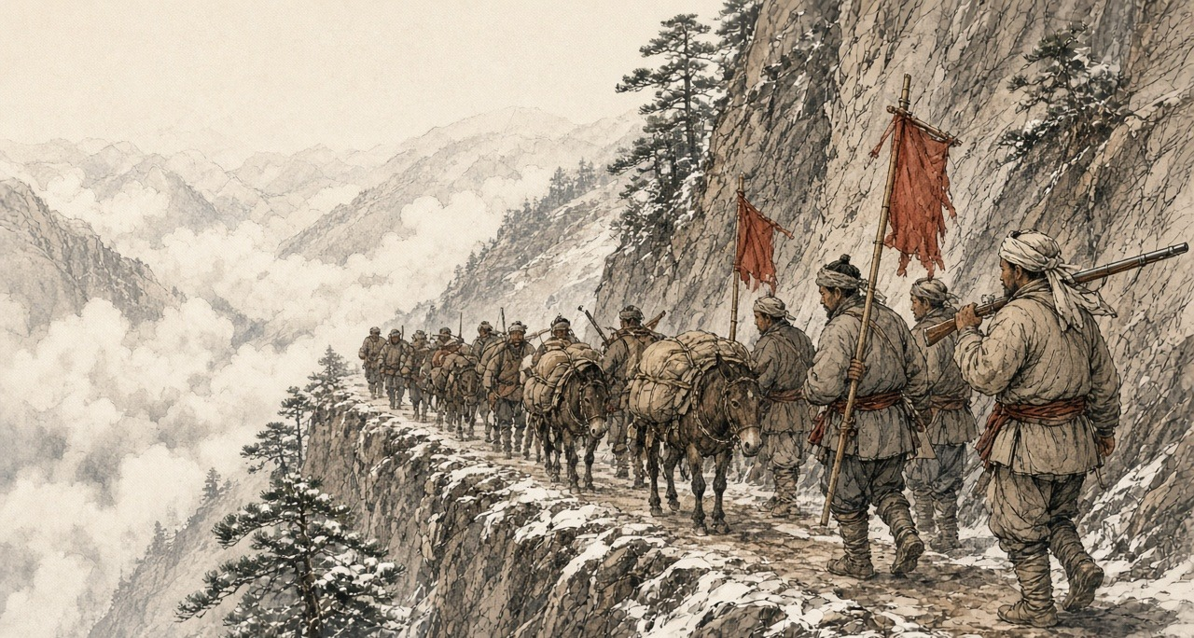
The emperor asked how this could be. Yilibu had reported the Yunnan poppy destroyed, cleared completely. How then was lotus paste still sold? The new governor-general and governor were to make their subordinates investigate and arrest in earnest and to uproot every plant, "不准稍留根株," not the smallest root left behind; and the Sichuan governor-general was to seize any opium bandit who crossed into his province, "毋许姑息养奸," with no indulgence that would feed the evil.
Lin had been dismissed from Canton the October before and was waiting there for the emperor's pleasure. Sixty years later, when 严复 Yán Fù put The Wealth of Nations into Chinese, he chose 母财 mǔcái, mother-wealth, for capital.
吴其濬 Wú Qíjùn, first in the palace examination of 1817, served in the 1840s as governor of Yunnan and then governor-general of Yunnan and Guizhou, and spent years on a botany of the empire's plants, most of them drawn from life. He put the poppy among the flowers. "近来阿芙蓉流毒天下，与断肠草无异，然其罪不在花也": these days opium poisons the whole empire, no different from the heartbreak herb, yet the crime is not the flower's. He died early in 1847, governor of Shanxi. His manuscripts were edited and printed at Taiyuan in 1848 by 陆应谷 Lu Yinggu, a native of Mengzi, who dated his preface from the Taiyuan prefectural office in the spring of that year. Nine years before, as a censor, Lu had told the emperor about the bean and wheat fields of Mengzi.
Chapter 3 Mini-Glossary
• Cangue (1 occurrences in this chapter): Heavy square wooden collar locked around a prisoner's neck as a public corporal punishment in Qing China.
• Tael (13 occurrences in this chapter): Chinese ounce of silver (liang), approximately 1.33 ounces avoirdupois (37.8 grams), serving as the standard unit of account in Qing state finance.
• Yamen (5 occurrences in this chapter): The official headquarters, residence, and courtroom of a Chinese mandarin or magistrate.
Chapter 3 Appendix of Important Names
• Huang Juezi (1 mentions in this chapter): Qing official whose 1838 memorial on silver drain and mandatory capital punishment for opium smokers precipitated Lin Zexu's mission.
• Xu Naiji (1 mentions in this chapter): Qing official who proposed legalizing and taxing opium in 1836 and was subsequently demoted.
Sources
• Qing shilu 清實錄 [Veritable Records of the Qing]. Daoguang chao. Entry of 丙戌, the last day of the 12th month of Daoguang 20 (22 January 1841), relaying a memorial on the Yongchang opium bands, their red flags and the slogan jiang ben qiu li, she ming qu cai 將本求利，捨命取財, their movement between Shunqing and Ningyuan, the name 芙蓉膏, the Huili confession and the muddled verdict, and the order to Guiliang, Zhang Lizhong and Baoxing; read in the transcription at baike.ytso.com (文脈國學). Entry of 壬寅, 20 December 1838, to Yilibu and Yan Botao on Yunnan cultivation, the tenfold profit over rice, and smokers "十居五六"; same transcription. Daoguang 11, 6th month (juan 191): the reply of 3 August 1831 to Ruan Yuan on Yunnan, the tusi and militia land; the Hunan rules on Su Cheng'e's memorial; the Guangdong rules on Li Hongbin's memorial; read in the transcription at 39017.com.
• Yunnan and Sichuan local gazetteers. Especially entries using the formula fei liang zhong yan 廢糧種煙, "abandon grain, plant smoke."
• Qing administrative records on native-drug likin and local prohibition-office fees. Tuyao li 土藥釐. (Post-1853; not used for 1839.)
• Lin Zexu 林則徐. Lin Zexu ji 林則徐集 [Collected Works of Lin Zexu]. Beijing: Zhonghua Shuju. Especially memorials and letters from 1839-1841 on opium suppression in the interior.
• 林則徐 Lin Zexu. 查挐煙販收繳煙具情形摺 and 錢票無甚關礙宜重禁吃煙以杜弊源片 (Daoguang 18, 1838), in 林文忠公政書, 湖廣奏稿 juan 5 (read at shidianguji.com). Source for the bureaus at Wuchang and Hankou, the thousand courses of pills, Guo Jinchen's seizures from Zhu Yunsheng and the other dealers, the 1,264 pipes split, burned with tung oil and thrown into the river, the ginseng prices, the kneeling women and old people, "是其父子家人平日所不能斷者，皆恃國法有以斷之," "莫不魄悸魂驚," the Hankou and Suzhou merchants and "鴉片煙而已矣," the daily cost of living and of smoking, "嗜鴉片者十之八九," "歷年未聞絞過一人，辦過一案," and the proverb of the shoes and the combs.
• 來新夏 Lai Xinxia. 林則徐年譜, entry for Daoguang 18, 9th month, 10th day (27 October 1838), as given at guoxuedashi.com; and 林則徐全集 vol. 9, 日記, p. 352, as cited there: 1,754 pipes and other implements destroyed on the Wuchang parade ground and 16,768 taels of opium weighed, the Jiangxia lot thrown into the river and the Hanyang lot held in the provincial treasury.
• 許乃濟 Xu Naiji. 鴉片例禁愈嚴流弊愈大亟請變通辦理摺 and 請弛內地民人栽種罌粟之禁片 (Daoguang 16/4/27, 10 June 1836), in 籌辦夷務始末 juan 1 and 鴉片戰爭檔案史料 vol. 1. The reply from Canton allowing poppy on 山頭地角 is in the same juan of 籌辦夷務始末. The edict retiring Xu, Daoguang 18/9/11 (28 October 1838), is in 鴉片戰爭檔案史料 vol. 1, no. 71.
• 朱嶟 Zhu Zun. 申嚴例禁以彰國法而除民害摺 (1836), as quoted in 雲南法制報, "廉吏故事 | 朱嶟：學粹品端 克盡厥職," reprinted by the Baoshan municipal discipline commission, 16 September 2025.
• 中國第一歷史檔案館 summary of the 1838–1839 campaign, "中華文史網 · 檔案利用" (historychina.net, item 352445): provincial totals of 588,179 taels, 39,468 pipes and implements, 4,111 offenders and some 230 mu of poppy uprooted; Baoxing's Sichuan report of March 1839; the Zhejiang report of 230 mu.
• 陸應穀 Lu Yinggu, memorial of Daoguang 19 (1839) on Yunnan cultivation, "昔種豆麥之田今成罌粟之地," as quoted in 中國歷史研究院 (hrczh.cass.cn), February 2025.
• 杜彥士 Du Yanshi, memorial of January 1841; 阮元 Ruan Yuan's 1831 memorial; and 鄂山 E Shan's 1831 report on Huili and Pingwu, as quoted in "晚清民初土藥的自行生產與銷售," 天山醫學院 禁戒毒品 series (tsu.tw, item 12607), which also notes that cultivation remained local and scattered before 1859.
• 《欽定嚴禁鴉片煙條例》 (June 1839), clauses on cultivators, as summarized at historychina.net (清史參考) and tsu.tw (item 12602): strangulation after the assizes for chief offenders, exile to the malarial frontier for accomplices, and the eighteen-month limit.
• 藍鼎元 Lan Dingyuan, on withdrawal ("一日輟飲則面皮頓縮，唇齒齞露，脫神欲斃，復飲乃愈"), as quoted in 近代史研究 2020 no. 6, p. 121; and G. H. Smith, Medico-Chirurgical Review, April 1842, as in chapter 05, for the other signs of withdrawal in the first-person passages.
• 吳其濬 Wu Qijun. 植物名實圖考, juan 26, 罌子粟 ("然其罪不在花也"), Taiyuan, 1848, with the preface by 陸應穀 dated 道光二十八年 from the Taiyuan prefectural office; Naikaku Bunko copy as described at shuge.org (書格), which also gives Wu's offices and Lu's native place of Mengzi.
• Bello, David Anthony. Opium and the Limits of Empire: Drug Prohibition in the Chinese Interior, 1729-1850. Cambridge, MA: Harvard University Asia Center, 2005.
• Dikötter, Frank, Lars Laamann, and Zhou Xun. Narcotic Culture: A History of Drugs in China. Chicago: University of Chicago Press, 2004.
• Li, Xiaoxiong. Poppies and Politics in China: Sichuan Province, 1840s to 1940s. Newark: University of Delaware Press, 2009.
• Schwartz, Benjamin I. In Search of Wealth and Power: Yan Fu and the West. Cambridge, MA: Harvard University Press, 1964. For Yan Fu's translation of Adam Smith and the term mu cai 母財.
• Zheng Yangwen. The Social Life of Opium in China. Cambridge: Cambridge University Press, 2005.
• Baumler, Alan, ed. Modern China and Opium: A Reader. Ann Arbor: University of Michigan Press, 2001.
• Perdue, Peter C. Exhausting the Earth: State and Peasant in Hunan, 1500-1850. Cambridge, MA: Harvard University Press, 1987. For comparison of inland agricultural production and state extraction.
• 徐珂 Xu Ke, comp. 清稗類鈔 (1917), on 籠頭水 and 土皮 (consulted to correct the source chapter; not used in the prose).

Chapter 4
Canal Shares, 1875
Alexandria, the Isthmus of Suez, Upper Egypt, London, and Cairo, 1856 to 1878
On 20 July 1856, at Alexandria, the viceroy of Egypt, Mohammed Said Pasha, set his name to a regulation for the fellah workmen whom the Suez company would employ. He had drawn it up, the preamble says, together with Ferdinand de Lesseps, president and founder of the Universal Company of the Maritime Canal of Suez. Its first article settled who would supply the men. The Egyptian government would furnish them on the demand of the company's chief engineers, as the work required.
The second article put a price on them. Two and a half to three piastres a day for a grown man, and rations in kind worth one piastre more. A worker under twelve years old got one piastre, with a full ration. Pay was to be counted out weekly, except in the first month, when the company would hand over only half until it had built up a reserve of fifteen days' wages for each man. The company would provide drinking water. In the copy printed at Paris in 1870 the next two words stand in capitals: EN ABONDANCE.
The rest followed on. The daily task would not exceed the one set by the Egyptian department of bridges and roads for its own canal works, and the number of men called up would take account of the seasons in the fields. Police on the workings would be government officers acting under the engineers' orders. A man who fell short of his task lost up to a third of his pay. A man who deserted forfeited the fifteen days held back, and the money went into the hospital fund. The company would shelter the workers under tents or in sheds, keep a hospital at its own cost, pay a sick man a piastre and a half a day while he could not work, and meet the travelling costs of the workmen and their families from home to the workings.
Six months earlier the concession had fixed the proportion. At least four-fifths of the workers employed on the canal would be Egyptians. The company's capital was two hundred million francs in four hundred thousand shares of five hundred francs each, and the viceroy came to hold 177,642 of them. He was also promised fifteen per cent of the company's future net profits. When Lesseps struck the first blow of the pick on the beach of Pelusium on 25 April 1859, at the place that would be named Port Said, a hundred and fifty workmen and employees stood around him.
* * *
The ridge of El-Guisr, between Lake Ballah and Lake Timsah, the autumn of 1862
Came the sheikh el-beled to the threshing-floor after the dawn prayer, and in his hand a paper from the mudir. Read-he the names. My name in it, and the name of Abdallah, son of my brother, and the sons of Mahmoud the miller, the three of them. A month, said the sheikh. A month only, inshallah, and you come-back and the money in your hand.
Went-out my mother to the door and stood. Said-not a thing. My wife put the bread in the cloth and tied-it, and untied-it, and put-in an onion, and tied-it again.
Walked-we. Days of-it, the road of the Sharqiya, after-that no road, the sand only. The feet of Abdallah, the skin came-off from-them the second day. Fourteen, the boy, not-yet become a man, and the paper wrote-him a man.
El-Guisr, they call-on it, the embankment, a hill of sand between two lakes, and on-it men. Wallah, not I-saw people by-this-number in one place, not at the mulid of Tanta. All Egypt at-there. Men of the Buhaira, men of the Saʿid. Twenty thousand, said the clerk. And in our-midst boys, small-ones, and the couffe on their backs like the men.
The couffe, plaited from the straw, a basket. You fill-it with your hands, the sand, the mud under the sand, wet and heavy when the digging goes deep. You lift-it on your back and climb. The slope, soft, the foot sinks in-it up-to the ankle, and the man in-front-of-you, his heels in your face. At-top you tip-it, and the sand runs out-of-it on the other side, and you go-down again bring another. From the rising of the sun until the sun goes-down. The neck, third day I-could-not turn-it. The shoulders, skinned-raw place-where the couffe sits, and the sweat runs into-them and burns.
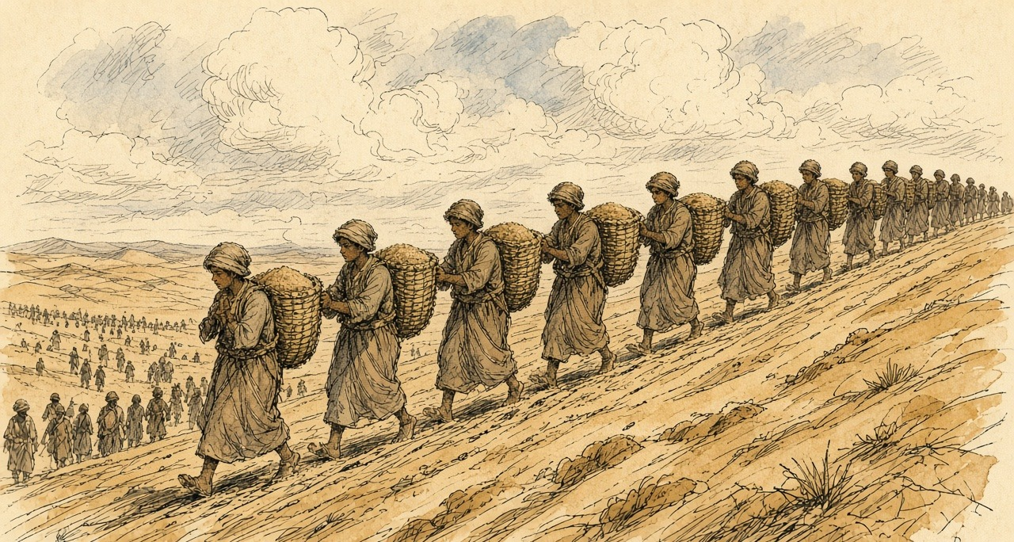
Water, there-was. Dug-they a canal from the Nile to the two-lakes, the sweet canal, and the water came to-us in-it, water of the Nile, taste of the village in the desert. Alhamdulillah for this. The ration, bread dry, hard like the tile. You wet-it in the water and eat.
Day of Saturday, the pay. The clerk the Frankish on a table, and the man who speaks for-him beside-him, calling the names. The half, he-gave-to-us. The half the second stays with the company, said the speaker, fifteen days, until the month finishes. Who runs-away, is-lost on-him. Ran-away a man from Mit Ghamr second week, and his-half, went, they-said, to the hospital. Abdallah counted his piastres in his palm, time after time, until the clerk called the name that after-him.
Near end of our-month the engineers opened the cut from seaward, and came the water of the salt-sea into bed of Lake Timsah the dry. Stood the men on the bank watching on-it. Spread-it on floor of the lake, slowly, and the floor went-dark under-it. Ya Rabb. All that sand, our backs carried-it, and the sea entered place-where it-was. Me, I-looked on Abdallah. His lips cracked, and he-was laughing.

Gave-they-us the rest last day. Counted-it, the clerk, and the speaker counted-it after-him, and I counted-it after the speaker. Walked-we to the village. My mother put the bread in-front-of-us and sat, and her hand on the head of Abdallah, and she-lifted-it-not.
* * *
The Nile in Upper Egypt, December 1862 to May 1864
Lucie Duff Gordon, an Englishwoman with consumption who had come to Egypt for the dry air, wrote from her boat near Gebel Sheykh Embarak in the first days of December 1862. "The other day four huge barges passed us towed by a steamer and crammed with hundreds of the poor souls torn from their homes to work at the Isthmus of Suez, or some palace of the Pasha's, for a nominal piastre a day, and find their own bread and water and cloak." One of her crew, a boatman she calls Andrasool, recognized relatives of his from a village near Aswan on the barges. "There was much shouting and poor Andrasool looked very mournful all day. It may be his turn next."
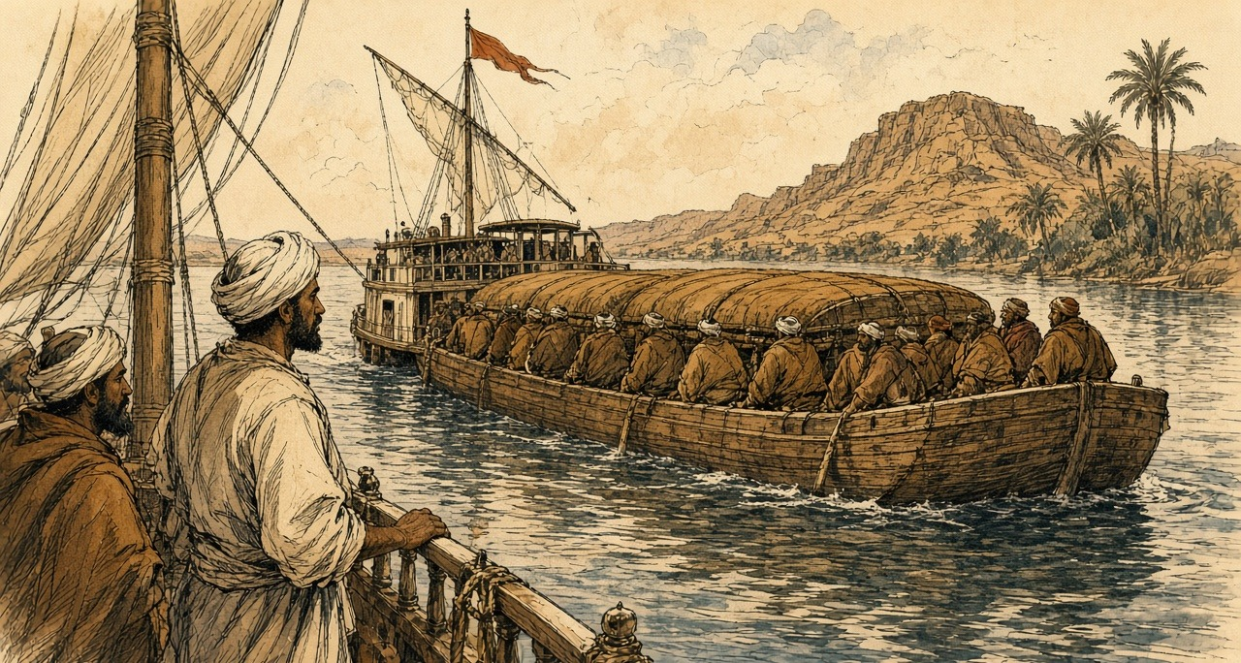
On 18 January 1863 Said Pasha died, and his nephew Ismail succeeded him. On 11 February, from farther up the river, she wrote: "Everyone is cursing the French here. Forty thousand men always at work at the Suez Canal at starvation-point, does not endear them to the Arabs." Then: "If he ceases to give forced labour, the Canal, I suppose, must be given up."
That spring Constantinople sent a note to Paris, printed in every paper, saying that the corvée had been abolished throughout the empire, Egypt included, and that the canal was still being dug by it. In late May 1864, at Luxor, Duff Gordon was dosing her neighbours through an epidemic. "Two poor fellows have just come home from the Suez Canal work with gastric fever, I think. I hope it won't spread." The wife of one of them asked her whether there were more ladies like her in her own village. Duff Gordon told her there were many better, and good doctors. "'Alhamdullillah,' said she, 'then the poor people don't want you so much, and by God you must stay here for we can't do without you, so write to your family to say so, and don't go away and leave us.'" A few days later she added: "The cattle are all dead; perhaps five are left in all Luxor."
* * *
Fontainebleau, 6 July 1864, and the Isthmus, 1864 to 1869
The dispute between the company and Ismail went to Napoleon III to settle, and he signed his award at Fontainebleau on 6 July 1864. The regulation of 20 July 1856, he found, had the character of a contract between the viceroy and the company, with undertakings on both sides. Its cancellation entitled the company to compensation, and he set it at thirty-eight million francs. A convention of 30 January 1866 repealed the regulation outright, with the article of the concession that required four-fifths of the workmen to be Egyptian. From then on the company would find its labour under the common law, "sans privilèges comme sans entraves," without privileges and without hindrance.
The award ran on. Thirty million francs to the company for land it handed back. Six million for its rights over the fresh-water canal, and ten million for the work it had done on that canal and had still to do. Eighty-four million francs in all, owed by the Egyptian government to the company and set out in a table of instalments. The first fell due on 1 November 1864. The last fell due on 1 November 1879.
Egypt was paying the company for the loss of its own people's labour. Twelve years later, in the House of Commons, the Chancellor of the Exchequer would put a rough figure on that labour before the award. "This amount, on a rough calculation, may be taken at £400,000."
With the corvée gone the company turned to steam. The contractors Borel and Lavalley brought out dredges. Alfred Roussin, writing in the Revue des Deux Mondes in 1867, found railway trucks run under the shovels of the workmen at El-Guisr and drawn up the bank by locomotives coupled in pairs, the whistle and breath of the engines echoing off the cut. The first trenches along the line, he noted, were the work of the old fellah contingents.
Ismail kept paying. In 1869, short of the money to buy back further rights from the company, he detached from his shares the dividend coupons for twenty-five years, from 1 January 1870, and handed them over. The company issued paper against them and sold it. On 17 November 1869 the Empress Eugénie's yacht L'Aigle led the procession of ships into the canal. The shares the Khedive still held would earn him nothing until 1894.
When Said died in 1863, the public debt of Egypt had stood at £3,293,000. By 1876 the funded debt, with the Khedive's estate loans, stood at £68,110,000, and there was a floating debt of about £26,000,000 more. The American agent in Cairo wrote home in December 1875 that seventeen million pounds was a low estimate of what the canal had cost Egypt from first to last.
* * *
London and Cairo, 15 to 26 November 1875
On Monday 15 November 1875 Frederick Greenwood, editor of the Pall Mall Gazette, called on the Foreign Secretary, Lord Derby, to tell him that the Khedive was negotiating to transfer his canal shares to a group of French capitalists. Turkey had gone bankrupt in October. The coupons on the Egyptian public debt fell due on 1 December, and Ismail needed three or four millions sterling to meet them. The previous Friday he had agreed to sell the shares for ninety-two million francs, £3,680,000, paying the buyers eight per cent on them, raised later to eleven, until 1894, when the dividends came back. The Paris houses could not raise the money in time.
The Cabinet met on Wednesday 17 November and decided in principle that England should have them. Disraeli wrote to the Queen at Balmoral the next day.
"The Khedive, on the eve of bankruptcy, appears desirous of parting with his shares in the Suez Canal, and has communicated, confidentially, with General Stanton. There is a French company in negotiation with His Highness, but they purpose only to make an advance with complicated stipulations. 'Tis an affair of millions; about four at least; but would give the possessor an immense, not to say preponderating, influence in the management of the Canal."
Further down: "The Khedive now says, that it is absolutely necessary that he should have between three and four millions sterling by the 30th of this month! Scarcely breathing time! But the thing must be done." He added a note at the foot, that in his hurry he had not written according to etiquette. "There is no time to rewrite it. The messenger for Balmoral is waiting."
The Queen telegraphed her approval and wrote on the 19th that she feared it would be difficult to arrange. In Cairo the Khedive signed a fresh contract with the French group: eighty-five million francs, £3,400,000, for three months at eighteen per cent a year, against the shares and his fifteen per cent of the canal's profits. If he failed to repay, both were forfeit. On Saturday 20 November Derby told the French chargé d'affaires that Britain would be opposed to the shares "falling into the hands of another French company, so as to make the property in the Canal more French than it already was." The Paris money did not come. On Tuesday the 23rd Ismail offered his shares to the British government for £4,000,000, with interest at five per cent until the coupons were freed.
Parliament was not sitting. On 22 November the Chancellor of the Exchequer, Sir Stafford Northcote, wrote to Disraeli: "I am sure that there is no way by which we can raise the money without the consent of Parliament, and that the utmost we could do would be to enter into a treaty engaging to ask Parliament for the money, and then let the K[hedive] get it in advance from some capitalist who is willing to trust to our power of getting Parliamentary authority."
The capitalist was Baron Lionel de Rothschild at New Court. Disraeli's private secretary, Montagu Corry, used to tell the story afterward. He had waited outside the Cabinet room, and when his chief put out his head and said "Yes," he went to New Court and told Rothschild that the Prime Minister wanted £4,000,000 "to-morrow." Rothschild, as Corry told it, picked up a muscatel grape, ate it, threw out the skin, and said, "What is your security?" "The British Government." "You shall have it." Disraeli's official biographers, who printed the story, warned that it need not be taken as gospel. They were sure that Corry had gone to Rothschild on the 17th or 18th and come back with a promise.
The terms were settled at the Treasury at the start of the next week. On 24 November Northcote wrote again: "I find Smith and Welby a good deal startled by the largeness of Rothschild's commission. It will, I suppose, be criticised, but, if the business goes right, a matter of that kind will not signify much." The Cabinet had sat on it for more than four hours the day before, and it met again that day. Disraeli wrote to the Queen from Whitehall Gardens.
"It is just settled: you have it, Madam. The French Government has been out-generaled. They tried too much, offering loans at an usurious rate, and with conditions, which would have virtually given them the government of Egypt. The Khedive, in despair and disgust, offered your Majesty's Government to purchase his shares outright. He never would listen to such a proposition before. Four millions sterling! and almost immediately. There was only one firm that could do it—Rothschilds. They behaved admirably; advanced the money at a low rate, and the entire interest of the Khedive is now yours, Madam."
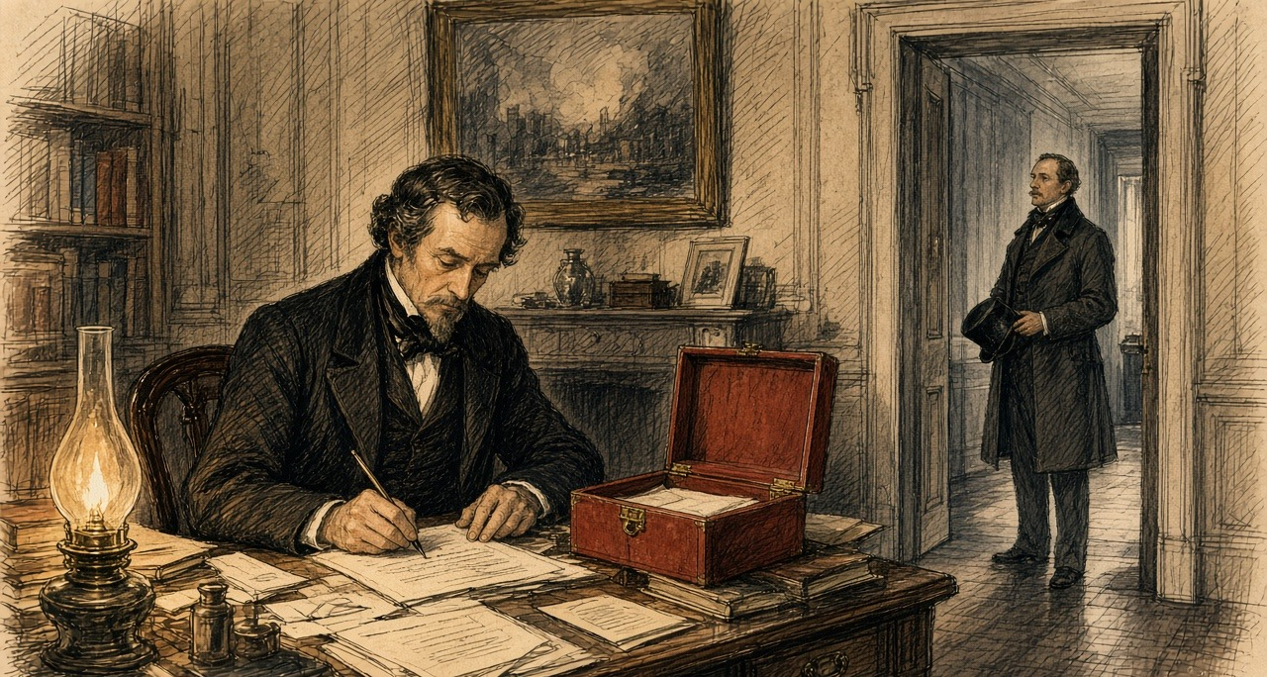
At Windsor the Queen wrote in her journal that she had "Received a box from Mr. Disraeli, with the very important news that the Government has purchased the Viceroy of Egypt's shares in the Suez Canal for four millions, which gives us complete security for India, and altogether places us in a very safe position! An immense thing." Her letter of the next morning added: "The great sum is the only disadvantage."
On 25 November, in Cairo, General Edward Stanton, the British agent and consul-general, and Ismail Sadek Pasha, the Egyptian Minister of Finance, signed the agreement. The British had believed they were buying 177,642 shares. The Khedive had sold some, and the number was 176,602. The price came down by the value of the 1,040 that were missing, to £3,976,582. On 1 December, once the shares were deposited with the consul-general, one million pounds would be held at Egypt's disposal by the Rothschild house in London. The rest would follow in December and January. Then the clause on interest:
"The Egyptian Government undertakes to pay to Her Britannic Majesty's Government interest at the rate of 5 per cent. per annum on the whole amount of the purchase money of the said 176,602 shares, in equal half-yearly payments,—the said payments to be made in London on the 1st of June and the 1st of December in each year, until such time as the coupons of the said shares shall be liberated from the engagement now existing with the Suez Canal Company; and the Egyptian Government further engages that the amount of the said interest shall be charged on the revenues of Egypt."
Britain had bought shares that would pay nothing for nineteen years. Egypt, which had sold them, would pay Britain their interest in the meantime, out of what it could raise in the country. On 26 November the shares were deposited at the British consulate in Cairo. When the House met in February, Gladstone told it that, by his information, they were in seven zinc boxes.
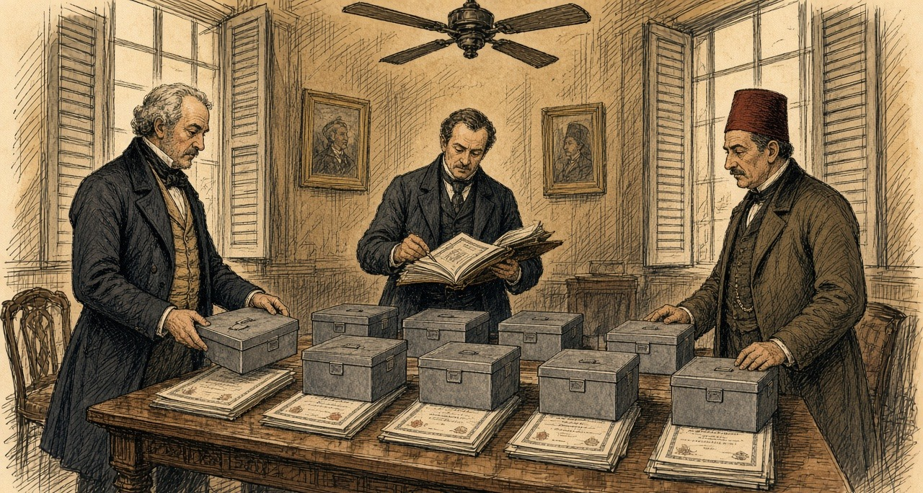
On the 25th Disraeli had written to Lady Bradford: "We have had all the gamblers, capitalists, financiers of the world, organised and platooned in bands of plunderers, arrayed against us, and secret emissaries in every corner, and have baffled them all, and have never been suspected." On the 26th Northcote recorded a protest against what he thought a policy wanting in magnanimity. "I don't like it."
* * *
The House of Commons, February to June 1876
On 14 February 1876 Northcote laid the figures before the Committee of Supply. "The Messrs. Rothschild undertook to pay this sum to the Khedive, and in consideration of their trouble and risk it is agreed that the Government will pay them 2½ per cent commission on the purchase-money, or £99,414." He meant to borrow the money from the Commissioners of the National Debt and to pay off the loan with the Khedive's interest. Within about thirty-six years, he said, "we shall be entirely free of the payment, and shall have our property in the Canal for nothing. This will, of course, be conditional upon two things—firstly, that the Khedive continues regularly to pay his £200,000 a-year." The reporter marked the response from the benches opposite: "Hear, hear!"
He also told the House how far Egypt had carried the company. The difference between what the company had raised and what it had spent was £5,160,000, "a sum which was almost entirely provided in one shape or another by the Viceroy of Egypt." He counted the forced labour, and the discount on the award paid early, and put the Khedive's total contribution at "nearly £10,000,000 of money or money's worth." Then the coupons. Ismail had cut them off to raise thirty million francs, and the paper issued against them was now worth upward of seventy million.
The adjourned debate came on 21 February. Gladstone took up the commission. "I want to know what was their risk. I want to know whether their risk was not a risk any rational man would have taken at the cost of one brass farthing." He reckoned the Rothschilds had been out of their money for three months at most, so that two and a half per cent for three months came to ten per cent a year, and with the Khedive's five per cent, fifteen. "I must say if we pay 15 per cent for our money in the British market for the purpose of accommodation, it seems to prove that we are an Oriental Potentate indeed."
Later that night Sir George Campbell, who had governed in India, asked where the £200,000 would come from. He read out the Khedive's revenue as published: £10,542,000, of which £6,300,000 went to the interest on the debt and £688,000 to the tribute owed the Sultan. Of what was left, two-thirds was land tax paid in advance under a law that would stop bringing anything in six years from its start. "The serious view of this matter was that the Government having identified themselves with the credit of the Khedive, he would be bound to raise the revenue to meet his engagements, and the result of that would be that a terribly-increased pressure would be brought to bear against the already unhappy ryots of Egypt." He had heard that the Khedive had devised a new poll tax. "Let us take our chance, but not allow ourselves to become a cause of oppression, and a source of stock jobbing and intrigue."
Disraeli answered the argument that the navy could always get satisfaction if the French company stood in the way. "The world is governed by conciliation, compromise, influence, varied interests, the recognition of the rights of others, coupled with the assertion of one's own." The vote passed without a division. On 23 February the House granted a sum not exceeding £4,080,000, and the money was raised by Exchequer bonds.
On 1 June 1876, in the Commons, Evelyn Ashley asked whether the half-yearly interest on the canal shares had been paid. Northcote answered that he believed it had. Then, after a word from W. H. Smith beside him: "The money has been paid to-day."
Each half-yearly payment, five per cent of £3,976,582 divided by two, came to £99,414, the same sum to the pound as the Rothschild commission.
* * *
Cairo, April 1876 to December 1876
By then the Khedive had stopped paying his Treasury bills. He suspended them on 8 April 1876. On 2 May a decree of the Khedive set up a Commission of the Public Debt, the Caisse de la Dette, whose commissioners would act as representatives of the bondholders. On 7 May another decree consolidated the debt of Egypt, which then stood at £91,000,000. France, Austria, and Italy named commissioners. The British government declined.
Stephen Cave, the minister Disraeli had sent to Cairo, had made a balance sheet of Egypt's finances from 1864 to 1875. Revenue raised in those years was £94,281,401, and the spending ran to £97,240,966. "For the present large amount of indebtedness," Cave wrote, "there is absolutely nothing to show but the Suez Canal, the whole proceeds of the loans and floating debt having been absorbed in payment of interest and sinking funds, with the exception of the sum debited to that great work." He singled out the law of the Moukabala of 1872, under which landowners could redeem half their land tax for ever by paying six years of it in advance, in one sum or in instalments over twelve years. It was, he wrote, "perhaps the most striking instance of the reckless manner in which the means of the future have been sacrificed to meet the pressing needs of the present."
That autumn George Goschen came out for the British bondholders, with Edmond Joubert for the French, and their arrangement became a decree on 18 November 1876. The unified debt was set at £59,000,000 at six per cent, with one per cent more for a sinking fund. The customs revenue was to be paid straight to the commissioners of the debt, and no receipt but theirs was valid.
Hussey Vivian, the British agent, reported on 8 December that it was impossible to account for the money the government had handled that year. "£4,000,000 for the Suez Canal shares, £5,000,000 advance from the French, and nearly a year's revenue have disappeared, while the payment of the coupon of the Unified Debt has been deferred, all the public employes are in arrears of pay, and heavy debts remain unsettled."
* * *
The roads of Suez, 5 January 1877
On the twenty-first day of the eleventh month of the second year of Guangxu, 5 January 1877, the steamer carrying 郭嵩焘 Guō Sōngtāo, the first resident minister the Qing sent to Britain, came up the Red Sea to the mouth of the gulf at Suez. He kept a daily record for the Zongli Yamen and wrote the canal into it.
In the third year of Tongzhi, he wrote, a Frenchman, 赖赛朴, Lesseps, had opened the waterway "以机器开河," cutting it with machines. It took seven years, cost seventy or eighty million, and the merchants of many countries had put up the money. Egypt, owning the land, had been given a third. Then: "埃及以千二百万金鬻之英人." Egypt sold it to the English for twelve million in gold. "于是英人合官民所出公费约得全股之半." So the English, between their government and their people, now held about half of all the shares. He dated the sale a year early. His account of the canal begins in 1864, the year the machines came, and has no levies in it.
He went ashore by rail to the town of Suez. The houses were mostly built of earth with flat roofs, nothing like the trading ports of the West. The women covered their heads and drew the cloth across the face, fastened at the nose by a cane piece, so that only the two eyes showed, "even the beggars." For drinking water there was "仅一井," only a single well. Going back to the anchorage in a hired boat he climbed onto two of the company's dredges. On one, between a pair of hulls, an iron frame three zhang high carried more than thirty iron buckets for lifting mud, turning on its wheel "如水车之龙骨," like the dragon-bone chain of a Chinese water-lift, tipping the mud into an iron trough and out along an iron chute five or six zhang long.
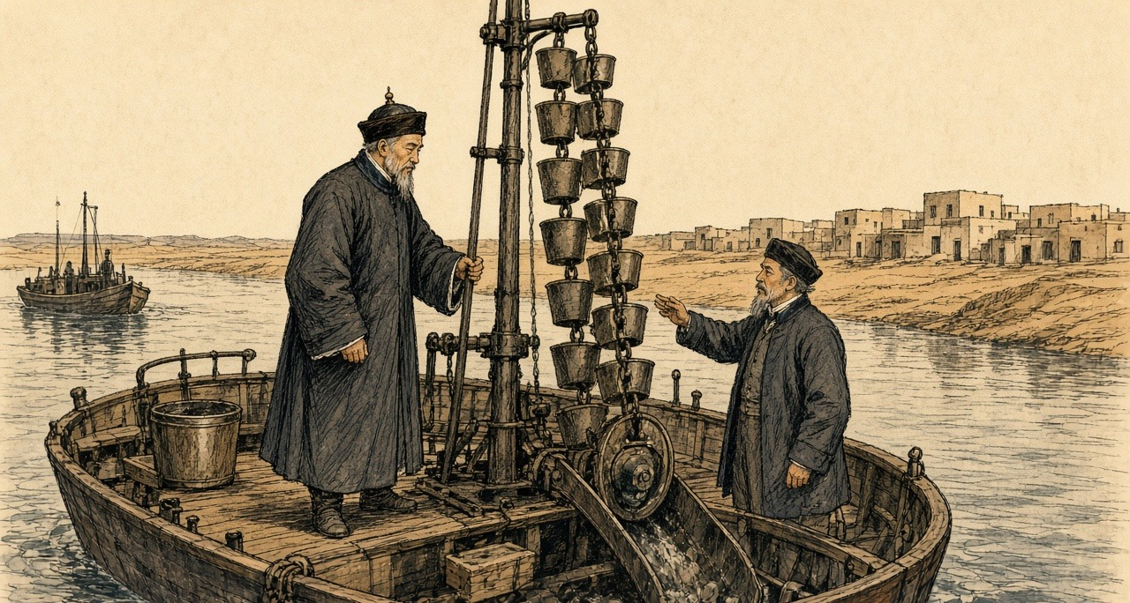
The steamer entered the canal on the 22nd. Guo noted the telegraph posted along the bank and a wooden hut every ten li or so for the men who worked it. At Aden, a few days before, he had written down the garrison: two thousand men, mostly Indians, holding a rock the English had taken as a stopping place on the sea road. On New Year's Day, in the Red Sea, an English passenger who grew tea in Assam had told him that India now produced thirty million pounds of tea a year. As the ship neared Southampton he wrote out a list of the British possessions it had passed. Hong Kong, Labuan, Singapore, Malacca, Province Wellesley, Penang. Bengal, Madras, Bombay, Ceylon, Socotra. Aden and Perim in the Red Sea. Malta and Gibraltar.
The Zongli Yamen printed the record in Peking that year. In June the Hanlin compiler 何金寿 Hé Jīnshòu impeached it, "立言悖谬，失体辱国": perverse in what it said, a loss of dignity and a shame to the country. The court ordered the printing blocks destroyed.
* * *
A village in Upper Egypt, the spring of 1878
The Nile, low the year that passed. Rose-not the water to the fields the high, and the fields stood dry and cracked. What we-gathered, a-little. Half of the half.
Came the collector before the cutting. Came he, and with-him the soldiers and the courbash, and a merchant from the town, and a scribe. The tax, of this year, and the year that after-it. Said my husband, ya effendim, the crop not-yet cut. Said the merchant, then sell-it-to-me now. Fifty piastres for the ardeb, pay I the tax, and you-bring-to-me the grain after a month.
Does-he what. Put-he his thumb on the paper.
After a month, the grain went to boat of the merchant. In market of the town that day the ardeb was-sold for a hundred and twenty. Stood my husband in the market and heard the price. Returned-he the house and sat beside the wall and his hands, trembling on his knees, and he-stood-not for prayer of the maghrib.
The tax finished-not. Fifty for the ardeb, sufficed-not. Came the sheikh el-beled with the collector second time and stood-they at our door. Who with-him-is, gives. Who with-him-is-not, the courbash.
Umm Hassan, next-to-us, her son took-they-him to the threshing-floor. Heard-it the village all-of-it. One, two. Counted-I until I-could-not count. After-it carried-they-him to the house, and she walking behind-him and her hands on her head.
My coins. Of my mother before-me, and her mother before-her, on a string, and tied-she-it on my neck night of my wedding, and wore-I-it since that-day. The cow, sold-we-her the year that passed, and the donkey. Remained the coins.
Took the scissors, I, and cut the string. My fingers obeyed-me-not first time. Put-I the coins in palm of my husband, and closed-he his hand on-them and opened-it, and closed-it. Went he to the scribe. The scribe counted-them on the table, and wrote, and turned to the-one after-him.
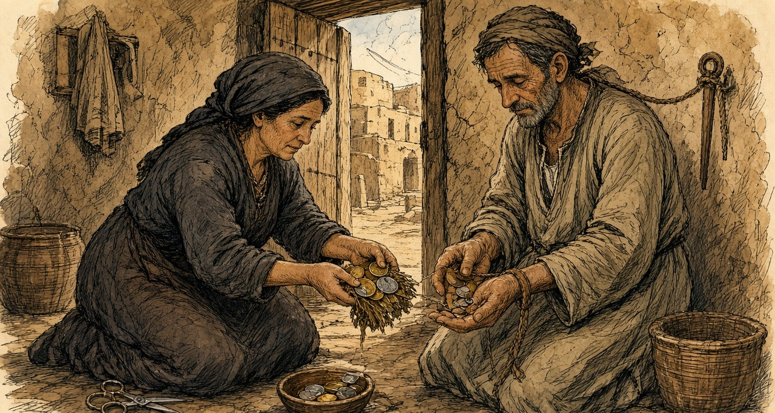
On the road, women from the villages that southward, walking, and with-them children, from door to door. Bread, lillah. Gave-we what with-us-was, first days. After-it remained-not a thing we-give-it, and they stayed walking, and we closed the door. Our-Lord forgive-us. Our-Lord forgive who was the cause.
* * *
Cairo and the provinces, the spring of 1878
On 1 May 1878 about £2,000,000 fell due as interest on the unified debt. On 31 March the commissioners of the debt held about £500,000. Evelyn Baring, by then the British commissioner, later wrote that he and his colleagues would have preferred not to pay, knowing the money could not be found without taking the taxes in advance, "a course to which we were opposed as being oppressive to the peasantry." The French government held that the Khedive could pay if he chose. On 16 April it asked London to join in pressing him, and Vivian was instructed to act with his French colleague.
"Two of the most iron-fisted Pashas who could be found were sent into the provinces," Baring wrote. "They were accompanied by a staff of money-lenders who were prepared to buy in advance the crops of the cultivators." The year before, the Khedive had admitted to Vivian that to pay the coupon the taxes were being collected "for nine months, and in some places for a year in advance." In Upper Egypt there was famine. Sir Alexander Baird, asked by the government to help with relief, reported: "It is almost incredible the distances travelled by women and children, begging from village to village." He added that the death register in no case showed a death from starvation, but that he was satisfied the excess deaths had come from dysentery and other diseases brought on by insufficient and unwholesome food. "In some cases, perfectly authenticated, corn was sold to the merchants for 50 piastres an ardeb, which was delivered in one month's time when it was worth 120 piastres an ardeb."
The last instalment reached the commissioners of the debt a few hours before the coupon fell due. Baring wrote of the money that came in: "The great diversity of currency, and the fact that many of the coins were strung together to be used as ornaments, bore testimony to the pressure which had been used in the collection of the taxes."
Chapter 4 Mini-Glossary
• Ardeb (5 occurrences in this chapter): Standard Egyptian dry measure of grain capacity, approximately equivalent to 5.44 imperial bushels or 198 litres.
• Caisse de la Dette (1 occurrences in this chapter): International Commission of the Public Debt established in Egypt in May 1876 to collect assigned state revenues for European bondholders.
• Corvée (2 occurrences in this chapter): Unpaid or nominally paid compulsory state labour, particularly the mass drafts of Egyptian fellahin used to dig the Suez Canal between 1859 and 1864.
• Couffe (3 occurrences in this chapter): Plaited straw basket carried on the back by Egyptian fellahin to haul sand and wet earth out of the Suez Canal excavations.
• Courbash (2 occurrences in this chapter): Heavy whip of hippopotamus hide used by tax collectors and village officials in 19th-century Egypt to enforce payment and labour.
• Fellah (2 occurrences in this chapter): Plural fellahin; Egyptian peasant cultivator or agricultural labourer whose crops and corvée labour underwrote the Khedive's debt and canal works.
• Khedive (21 occurrences in this chapter): Title of the autonomous Ottoman viceroys of Egypt, formally granted by the Sultan to Ismail Pasha in 1867 and held by his successors until 1914.
• Moukabala (1 occurrences in this chapter): Egyptian tax law of 1872 allowing landholders to redeem half their future land tax in perpetuity by paying six years' tax in advance to the Khedive.
• Mudir (1 occurrences in this chapter): Provincial governor in 19th-century Egypt responsible for tax collection and corvée labour quotas.
• Ryot (1 occurrences in this chapter): Indian peasant cultivator or tenant farmer; also applied by British officials with Indian service experience to Irish and Egyptian peasants.
• Sheikh el-beled (2 occurrences in this chapter): Village headman in Egypt responsible for naming men to the corvée and assisting state tax collectors.
• Yamen (2 occurrences in this chapter): The official headquarters, residence, and courtroom of a Chinese mandarin or magistrate.
Chapter 4 Appendix of Important Names
• Baring, Evelyn (Lord Cromer) (3 mentions in this chapter): British Commissioner of the Public Debt and long-serving Consul-General in Egypt (1883–1907).
• Disraeli, Benjamin (9 mentions in this chapter): British Prime Minister who arranged the 1875 purchase of Khedive Ismail's Suez Canal shares with Rothschild financing.
• Duff, Douglas V. (3 mentions in this chapter): Former Black and Tan in Ireland who served as an officer in the British Gendarmerie and Palestine Police in Jerusalem.
• Gladstone, William Ewart (2 mentions in this chapter): British Prime Minister and Chancellor of the Exchequer whose career spanned the 1840 Opium War debate, Irish land and Home Rule legislation, and the 1882 occupation of Egypt.
• Gordon, Lucie Duff (3 mentions in this chapter): English writer resident in Upper Egypt during the 1860s who recorded the impact of the Suez Canal corvée and taxation on the fellahin.
• Lesseps, Ferdinand de (3 mentions in this chapter): French diplomat and promoter of the Universal Company of the Maritime Canal of Suez.
• Northcote, Stafford (5 mentions in this chapter): British Chancellor of the Exchequer during the 1875–1876 Suez Canal share purchase.
• Rothschild, Lionel de (8 mentions in this chapter): Head of N. M. Rothschild & Sons in London who advanced the £4,000,000 for the British government's purchase of the Suez Canal shares in 1875.
• Said Pasha (2 mentions in this chapter): Viceroy of Egypt (1854–1863) who granted Ferdinand de Lesseps the Suez Canal concessions and the 1856 corvée labour regulation.
Sources
• Rothschild Archive, London. Lionel de Rothschild correspondence and loan documents for the £4,000,000 advance, November 1875.
• Hansard, House of Commons Debates and Parliamentary Papers. Suez Canal share purchase, November 1875. Especially HC Deb 14 February 1876, vol. 227 (Supply: The Suez Canal Shares), for Northcote's figures: 176,602 shares, £3,976,582, the 2½ per cent commission of £99,414, the £200,000 a year, the "Hear, hear!", the £5,160,000, the £400,000 of labour and "nearly £10,000,000 of money or money's worth," and the délégations; HC Deb 21 February 1876, vol. 227, cc. 562-661 (Supply: £4,080,000 Suez Canal Shares, adjourned debate), for Gladstone on the "one brass farthing," the 15 per cent and the "Oriental Potentate," and the seven zinc boxes, and for Sir George Campbell on the Khedive's revenue, the poll tax and "the already unhappy ryots of Egypt"; HC Deb 1 June 1876, vol. 229, c. 1521, for "The money has been paid to-day"; HC Deb 19 July 1883 (Childers on the 5 per cent paid by Egypt until 1894 against borrowing at 3½ per cent), consulted for the interest arrangement.
• The Suez Canal (Shares) Act 1876 (39 & 40 Vict. c. 67), legislation.gov.uk, reciting the Agreement of 25 November 1875 between Stanton and Ismail Sadek Pasha and the Commons resolution of 23 February 1876 for £4,080,000.
• Bin Chun 斌椿. Chengcha Biji 乘槎筆記 [Notes from a Raft]. 1866. Collected in Zhong Shuhe 鍾叔河, ed., Zou xiang shijie congshu 走向世界叢書 [The World from Within: Chinese Travel Writing to the West]. Changsha: Yuelu Shushe, 1985. (Consulted for the source chapter's claim; the quoted line could not be verified and is not used.)
• Guo Songtao 郭嵩燾. Shi Xi Jicheng 使西紀程 [Record of a Mission to the West]. 1877. Collected in Zou xiang shijie congshu 走向世界叢書. Read in the National Library of China scan transcribed at zh.wikisource.org: entries for Guangxu 2, 11th month, days 15 to 22 (30 December 1876 to 6 January 1877) on Aden, the Assam tea talk, Suez, the dredges, and the canal telegraph, and the closing list of British possessions. English translation: J. D. Frodsham, trans., The First Chinese Embassy to the West: The Journals of Kuo Sung-tao, Liu Hsi-hung and Chang Te-yi. Oxford: Clarendon Press, 1974.
• He Jinshou 何金壽, memorial of Guangxu 3, 5th month, 6th day (1877) impeaching Shi Xi Jicheng, as summarized by the Hunan Provincial Research Institute of Culture and History (css.hunan.gov.cn) and Hunan Today (hunantoday.cn).
• Monypenny, William Flavelle, and George Earle Buckle. The Life of Benjamin Disraeli, Earl of Beaconsfield. Vol. 5, 1868-1876. London: John Murray, 1920. Chapter 12, for Greenwood's call, the French option and mortgage, Disraeli's letters to the Queen of 18, 19, 20 and 24 November 1875 ("It is just settled: you have it, Madam"), the Queen's replies, Northcote's letters of 22, 24 and 26 November, Corry's grape story and the biographers' caveat, the letters to Lady Bradford, and the Commons speech on "conciliation, compromise, influence."
• Buckle, George Earle, ed. The Letters of Queen Victoria, Second Series. Vol. 2, 1870-1878. London: John Murray, 1926. For the Queen's journal of 24 and 25 November 1875.
• Wei Yuan 魏源. Haiguo Tuzhi 海國圖志 [Illustrated Gazetteer of the Maritime Kingdoms]. 1842. Modern edition: Changsha: Yuelu Shushe. (Consulted; the isthmus appears in juan 24 as 蘇爾士麥, not 苏夷士. Not used in the prose.)
• Règlement pour les ouvriers fellahs qu'emploiera la Compagnie de l'isthme de Suez, Alexandria, 20 July 1856, as printed in Drohojowska, Antoinette-Joséphine-Françoise-Anne. L'Égypte et le canal de Suez. Paris: A. Laporte, 1870, pp. 118-123 (fr.wikisource.org).
• Napoléon III. Sentence arbitrale, Fontainebleau, 6 July 1864, and the Convention of 30 January 1866 between the viceroy and the company, as reproduced by the Fondation Napoléon (napoleon.org, Suez dossier, historique 16 and 17).
• Roussin, Alfred. "L'Isthme de Suez et les travaux du canal maritime." Revue des Deux Mondes, 2e période, tome 70 (1867), pp. 369-405 (fr.wikisource.org). For El-Guisr in September 1862, the twenty thousand fellahs, the month-long contingents, the fresh-water canal reaching Lake Timsah on 10 January 1862, the opening of Lake Timsah to the sea on 18 November 1862, the first blow of the pick on 25 April 1859, the note from Constantinople of 6 April 1863, and the machines.
• Duff Gordon, Lucie. Letters from Egypt, 1863-1865. London: Macmillan, 1865; read in the Project Gutenberg edition (no. 17816). Letters of early December 1862 (the barges), 11 February 1863 ("Forty thousand men"), and late May and 2 June 1864 (the men home from the canal work, the cattle).
• Beardsley, Richard, U.S. Agent and Consul-General at Cairo, to Hamilton Fish, 13 December 1875. Papers Relating to the Foreign Relations of the United States, 1876, no. 322 (history.state.gov).
• Cromer, Evelyn Baring, Earl of. Modern Egypt. Vol. 1. London: Macmillan, 1908. Chapters 2 and 3, for the debt of 1863 and 1876, the suspension of 8 April 1876, the decrees of 2 and 7 May and 18 November 1876, Cave's balance sheet and his words on the Moukabala, Vivian's despatches, the famine and Baird's report, the coupon of 1 May 1878, and the strung coins.
• Blake, Robert. Disraeli. London: Eyre & Spottiswoode, 1966.
• Farnie, D. A. East and West of Suez: The Suez Canal in History, 1854-1956. Oxford: Clarendon Press, 1969.
• Ferguson, Niall. The House of Rothschild: The World's Banker, 1849-1999. New York: Viking, 1998.
• Karabell, Zachary. Parting the Desert: The Creation of the Suez Canal. New York: Alfred A. Knopf, 2003.
• Landes, David S. Bankers and Pashas: International Finance and Economic Imperialism in Egypt. Cambridge, MA: Harvard University Press, 1958.
• Day, Jenny Huangfu. Qing Travelers to the Far West: Diplomacy and the Information Order in Late Imperial China. Cambridge: Cambridge University Press, 2018.
• Leonard, Jane Kate. Wei Yuan and China's Rediscovery of the Maritime World. Cambridge, MA: Council on East Asian Studies, Harvard University, 1984.
• Lubbock, Basil. The China Clippers. Glasgow: Brown, Son & Ferguson, 1914.
• MacGregor, David R. The Tea Clippers: Their History and Development, 1833-1875. London: Conway Maritime Press, 1952.
• The National Archives, Kew. Foreign Office Suez share papers and Rothschild loan correspondence: series cited; piece numbers not assumed.

Chapter 5
Occupation of Egypt, 1882
Cairo, Alexandria, London, Tel el-Kebir, and Suez, 1879 to 1885
The coupon of May 1878 was paid. That summer Ismail Pasha took a ministry with two Europeans in it, Nubar Pasha presiding and the Englishman Charles Rivers Wilson at the Ministry of Finance. Wilfrid Scawen Blunt, who knew the men, wrote that "the nine millions advanced by the Rothschilds went mostly in paying the more urgently immediate calls, and not a tax was reduced or a demand remitted." Wilson began cutting the native officials. "What made it the more easy for him," Blunt wrote of the Khedive's chance to turn the anger on his Christian ministers, "was that in these retrenchments no European salaries were cut down."
The army was cut too. The officers' pay was in arrears. The new ministry paid part of what was owed and put a large number of officers on half-pay. Evelyn Baring, then a commissioner of the debt in Cairo, called it "especially harsh and impolitic" to dismiss so many men "without, in the first place, fully liquidating the arrears of pay due to them," and wrote that "many officers and their families were reduced to a state of complete destitution." The British consul-general, Lord Vivian, reported what came next: "by an unparalleled act of folly, the Minister of War summoned the remaining 2000 officers up to Cairo from various parts of the country to receive a portion of their arrears of pay and to deposit their arms with the authorities. He thus grouped together a seething mass of 2500 discontented officers, the garrison of Cairo consisting only of 2600 troops, a large proportion of whom had undoubted sympathy with the grievances of the mutineers."
* * *
Abbassiyeh and the Ministry of Finance, Cairo, 18 February 1879
Said the officer to us, go home. Home, with what. In my belt nothing, and the pay of the months they owe it to me. Said he, the new ministers, no money they have. Said I to myself, the money for the Franks, it they have.
Slept we in the barracks without bread. In the morning came the students of the military school, walking in one body to the Ministry of Finance, and with them officers in their swords. Walked we behind them, some of us. Not many. Some.
At the Ministry, a carriage at the door, and getting into it Nubar Pasha. Ran the young men at him and seized him. Pulled one his moustache. Struck another his ear, then the other ear. Stood I behind, and my heart, it beat in my throat. Then took they him inside, him and the Englishman, and shut the doors on them.
After a time came the Effendina himself in his carriage, and with him the colonel of his guard. Opened the crowd for the carriage, and men cried his name. Went he up into the building and came down, and ordered us to go home. We did not go. Said a man, let us settle our accounts ourselves. Ordered the Effendina the soldiers to fire. Raised they their rifles and the sound came, and I fell on my face in the street with my hands over my head. Then lifted I my head. Above us they fired, over the heads. The colonel, our blood he did not want it.
Went I back to Abbassiyeh that night. The arrears, a part of them they paid it. The rest, God knows it.
* * *
Cairo and Constantinople, February to June 1879
Two accounts of that morning survive. Vivian's, which Baring printed, says Nubar and Wilson were "mobbed by a crowd of officers armed with swords," dragged into the Ministry of Finance and shut in while the mutineers cut the telegraph wires. The Khedive came and ordered the rioters out. "If," he said, "you are my officers, you are bound by your oath to obey me; if you refuse, I will have you swept away." There were cries of "Death to the dogs of Christians." When the crowd at the gates would not disperse he ordered up the troops. "They fired in the air," Vivian wrote, "but a few soldiers were wounded by the mutineers' revolvers, and a few of the rioters received bayonet wounds."
The other account is Ahmed Urabi's, given to Blunt in Arabic twenty-four years later. Urabi was a lieutenant-colonel at Rosetta, called to Cairo the day before "to deal with the case of a number of soldiers that had been disbanded by the new Ministers without their arrears of pay or even bread to eat, and who were at Abbassiyeh." He said the Khedive's own servants got up the demonstration among the students of the military college. "They were joined on the way by some of the disbanded soldiers and officers, not many, but some. At the Ministry they found Nubar getting into his carriage, and they assaulted him, pulled his moustache, and boxed his ears." Ismail ordered Ali Bey Fehmy, the colonel of his guard, to fire on the students, "but Ali Fehmy ordered his men to fire over their heads and nobody was hurt."
Nubar resigned. Urabi was blamed and sent away from his regiment to Alexandria, where his duty was to act for the sheikhs of Upper Egypt, "whose arrears of taxes in the shape of beans and other produce were to be collected and sent to Alexandria in security for money advanced to Ismail" by lenders there.
In April Ismail dismissed his European ministers. They found out, Charles Royle wrote, only "when, on going to their offices, they found their places already occupied by their successors." The Khedive's senior officers swore "to bear true allegiance to the Khedive, and to resist all the enemies of the country, of himself, and of his family." London and Paris pressed the Sultan. On 26 June 1879 a telegram came to Cairo addressed "to the ex-Khedive Ismail Pasha": "Il est prouvé que votre maintien au poste de Khédive ne pouvait avoir d'autre résultat que de multiplier et d'aggraver les difficultés présentes." His son Tewfik was named in his place. Many of Ismail's valuables, Baring noted, were already aboard his yacht.
* * *
Cairo, November 1879 to July 1880
With Tewfik the Control came back, Baring for England and M. de Blignières for France. Before they reached Egypt the government asked them by telegraph whether it should borrow to meet its payments. Baring set down their answer: "If the Tribute could not be paid, so much the worse for the Tribute." Government servants would be paid first, and the taxes "should on no account be taken in advance." On 1 November 1879 the interest due on the Unified Debt was £1,989,000. The commissioners of the debt held £1,147,000. The bondholders got 4 per cent.
On 1 January 1880 the Controllers proposed 4 per cent as the fixed rate. "So far from producing a bad effect," Baring wrote, "Unified Stock rose from 51 to 56." Of the £1,684,000 still owing on coupons only partly paid, "We cannot," they wrote, "hold out the least hope that these sums will ever be paid." They put the year's revenue at £8,562,000. Tribute and administration would take £4,323,000, "thus leaving £4,239,000 available for the creditors of the Egyptian Government."
Some of the weight came off the fellah. The law of the Moukabala was repealed on 6 January, and on 17 January the poll tax of £205,000 a year was abolished. Every taxpayer was handed an extract from the village register showing what he owed and the days he would be called to pay. That summer the British consuls reported "a general feeling of satisfaction." The village money-lenders' rates had fallen by 50 per cent, and "the use of the courbash was greatly diminished."
Then the settlement. On the international Commission of Liquidation, Baring wrote, some members wanted a margin left for the country, "whilst others took a more optimistic view of the revenue and endeavoured, in the bondholding interest, to keep the administrative expenditure down to the lowest possible figure." The Khedive signed the Law of Liquidation on 17 July 1880. Revenue was taken at £E8,362,000. The whole administration of Egypt was fixed at £E4,520,000 a year. Interest stayed at 4 per cent, and £E5,600,000 of new Preference Stock went to pay the floating debt. Baring judged it fair but for one defect: "too large a proportion of revenue (66 per cent) was mortgaged to the bondholders, whilst the balance left at the disposal of the Government was insufficient."
A petition was going round the officers' messes. "It concluded with a threat that the petitioners might have recourse to the sword to attain their ends." In June 1880 Baring left for India, and Sir Auckland Colvin of the Indian Civil Service took his chair as Controller-General.
* * *
Kasr el-Nil and the Abdin Square, Cairo, 1 February and 9 September 1881
Urabi now had a regiment at Abbassiyeh. "I was especially in ill favour," he said, "because I had refused to allow my men to be taken from their military duty and put to dig the Tewfikieh Canal, which it was the practice to make them do without extra pay." In January 1881 he and two other colonels petitioned the prime minister, Riaz Pasha, against a Minister of War who was raising Circassians over native officers. Riaz read it in an inner room and came out. "Your petition," he said, "is muhlik," a hanging matter. Urabi answered: "Ye saat le Basha, is Egypt then a woman who has borne but eight sons and then been barren?"
On 1 February the colonels were called to the Ministry of War at Kasr el-Nil, arrested, and put before a court-martial. "Whilst the trial was proceeding," Baring wrote, "the officers and men of their regiments arrived, and broke into the room where the Court was sitting. They treated the Minister of War roughly, destroyed the furniture, and delivered the Colonels." The minister was dismissed that day.
On 9 September, believing they were marked for murder, the colonels marched. Urabi sent the Khedive word that the army would come to the Abdin Palace at the afternoon prayer for his answer.
The man at the Khedive's side that afternoon was the Controller-General. Colvin's account, which Baring printed, says he urged Tewfik to arrest Urabi himself. "Arabi Bey approached on horseback; the Viceroy called out to him to dismount. He did so, and came forward on foot, with several others and a guard with fixed bayonets, and saluted. I said to the Viceroy, 'Now is your moment.' He replied, 'We are between four fires.' I said, 'Have courage.'" Tewfik turned to a native officer and then back: "What can I do? We are between four fires. We shall be killed." He told Urabi to sheathe his sword. Urabi gave three points. The ministry must go, a parliament must be called, and the army must be raised to 18,000 men. He said the army had come on the part of the Egyptian people and would not retire until they were granted.
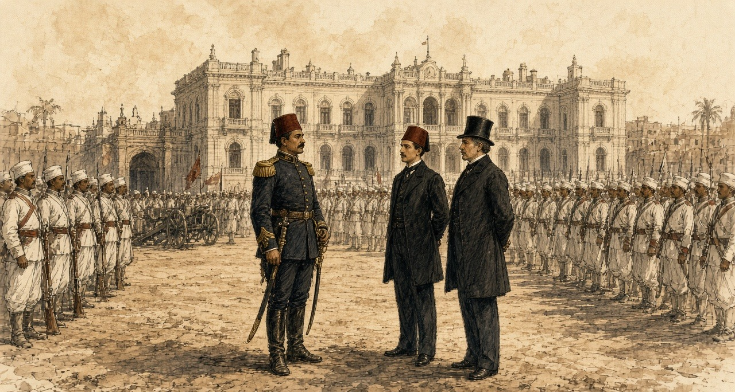
Urabi remembered other words. When he had made his three demands, the Khedive said, "I am Khedive of the country and shall do as I like." Urabi replied, "We are not slaves, and we shall never more be inherited from this day forth." Blunt took down the Arabic: Nahnu ma abid wa la nurithu ba'd el yom. Then the acting British consul, Sir Charles Cookson, came out and asked why a soldier demanded a parliament. "I said that it was to put an end to arbitrary rule, and pointed to the crowd of citizens supporting us behind the soldiers. He threatened me, saying, 'We shall bring a British army.'"
* * *
The Abdin Square, the same afternoon
From Abbassiyeh marched we, through the Hassaneyn quarter, the colonel on his horse in front. Came the people out of the shops and walked behind us. The cannons, to the west gate they went.
Stood we in the square in the sun with our rifles. Came out the Effendina, and with him the generals and a Frank. Said he something, and got down the colonel from his horse. Said my officer, steady, steady. My hands on the rifle, they ran with sweat.
This colonel, when they wanted to take us to dig the Tewfikieh canal, refused he. Other regiments, to the digging they took them, and the pay of the digging, none. For this they hate him in the palace. For this we stand.
Went the Effendina back inside. Went the Englishman in and came out, and went in, and came out. Behind us the crowd, more and more. At the end came the word down the ranks, the ministry gone, and from the front the shout, long live the Effendina. Shouted the men. Shouted I. Then marched we back to Abbassiyeh in the dark, quiet.
* * *
Cairo and London, January to May 1882
Ten days before Abdin, Sheikh Mohammed Abdu, who edited the official journal, had warned Urabi: "I foresee that a foreign occupation will come and that a malediction will rest for ever on him who provokes it." That winter a Chamber of Notables met, landholders and village headmen from the provinces, and asked to vote the budget.
The budget had two parts, the revenues assigned to the debt and the rest. The Notables asked only for the rest. Blunt put their case: since the Control stood in the country as guardian of the foreign obligations, "and as the interest on the debt amounted only to one-half of the revenue, the remaining half ought to be at the disposal of the nation." Baring's own figure for the bondholders' share was 66 per cent.
On 8 January 1882 Britain and France sent the Khedive a Joint Note. They called his rule the only guarantee of "the good order and development of general prosperity in Egypt, in which France and Great Britain are equally interested," and said they would "guard by their united efforts against all cause of complication, internal or external, which might menace the order of things established in Egypt." Colvin had written to London days before: "In fact, the Egyptian administration is a partnership of three."
On 17 January Malet and Colvin gave Blunt a brief to carry to the Notables. He kept the paper. "The control of the Budget was an international matter. Therefore it should be left untouched by them." Sultan Pasha, the Chamber's president and a cautious man, said the ministry's draft law was "like a drum; it made a great sound but was hollow inside." Lord Granville wired Malet that caution was needed, "regard being had to the pecuniary interests on behalf of which Her Majesty's Government have been acting." On 20 January Malet wired back: "Armed intervention will become a necessity if we adhere to the refusal to allow the Budget to be voted by the Chamber."
The two consuls-general told the prime minister that "the Chamber could not vote the Budget without infringing the Decrees establishing the Control." On 2 February a deputation told the Khedive "that the right to vote the Budget was not one for discussion with foreign Powers." Tewfik told Malet he "had no force to resist." Within days Mahmoud Sami was prime minister and Urabi was Minister of War.
That spring, walking through St James's Park, Blunt asked Lord Rosebery his views on Egypt. "I have no views at all but those of a bondholder," Rosebery said. His wife was a Rothschild.
* * *
Alexandria, 11 June 1882
By late May English and French ironclads lay off Alexandria. Baring quoted a report that Urabi's return to power was taken by the natives as a sign that the Christians would be expelled, "that they were to recover the land bought by Europeans or mortgaged to them, and that the National Debt would be cancelled." On 30 May Cookson wired: "Every day's delay increases the dangerous temper of the soldiery, and their growing defiance of discipline."
On Sunday 11 June, about one in the afternoon, a fight broke out near the Café Crystal in the Rue des Soeurs. Royle gives the story as it was told. A Maltese and a native coachman or donkey-boy quarrelled, the Maltese was beaten with a stick, he answered with a knife, and by one account he killed the other man. The riot broke out in three places almost at once. Crowds came up the streets with naboots, the heavy sticks of the town, crying "Death to the Christians!" Near the police headquarters, whenever a European came in sight, the cry went up in Arabic: "Oh, Moslems! Kill him! Kill the Christian!" Police and soldiers joined in. A Greek ship's master was pulled from his carriage and bayoneted. In the Rue des Soeurs three European bodies lay in a heap. Cookson was clubbed down with a naboot. A missionary, Mr. Ribton, was beaten to the ground three times trying to shield his daughter, and when his body was found his head was too battered to be known. The dead were dragged into back streets, stripped and thrown into the sea. About 7,000 troops waited in barracks under arms until after six.
The hospitals received forty-nine bodies, forty-four of them European, and seventy-one wounded, thirty-six European, two Turkish and thirty-three native. Estimates of the dead ran to 150 Europeans, "besides natives," and fewer than half could be proved. Natives were buried in secret. In the Commons the Irish member F. H. O'Donnell called it "a desperate riot between Arabs, Greeks, and Maltese, in which European roughs were aggressors, and in which four Arab lives were taken for every one European," and cited a foreign writer who put the Arab dead at 600 or 700. The governor arrested two or three hundred natives. By 17 June about 14,000 Christians had left the country.
* * *
Alexandria, 11 July 1882
On 10 July Admiral Sir Beauchamp Seymour gave the military commandant until sunrise "to-morrow, the 11th instant," to hand over, "for the purpose of disarming, the batteries on the isthmus of Ras-el-Tin and the southern shore of the harbour of Alexandria." The French squadron would not join and left. By dark the British warships were alone.
"At 7 a.m., on the 11th," Seymour reported, "signalled from the Invincible to the Alexandra to fire a shell into the recently armed earthworks termed the Hospital Battery, and followed this by a general signal to the fleet 'Attack the enemy's batteries.'" The Alexandra, Superb, Sultan, Temeraire, Inflexible, Monarch, Invincible and Penelope opened together, about two discharges a minute. The Inflexible's shells weighed 1,700 lb. When they struck the Lighthouse Fort under an embrasure, Royle wrote, they threw dust and broken stone as high as the lighthouse, and when it cleared the gun's crew sent another shell back.
About 2,000 Egyptian artillerymen manned the forts under Toulba Pasha. At Mex an adjutant-major held the works with four officers and 150 men. Fifty were killed and forty-eight wounded. Along the inner line, sixty-five were killed and 150 to 200 wounded. At Ras el-Tin and Fort Adda at least fifty were believed killed and 150 wounded. The chief of police reported that stray shell had killed and wounded between 150 and 200 citizens. One shell at the Moharrem Bey Gate killed two police officers and six of their men. Toward five o'clock the mosque inside Fort Pharos fell in on the wounded sheltering behind its walls.
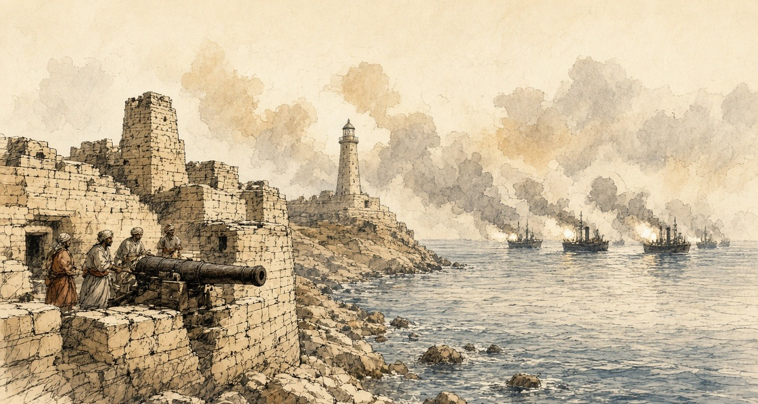
The British lost five killed and twenty-eight wounded. For the Egyptian dead, the Frenchman John Ninet gave 680 and General Stone, the Khedive's American chief of staff, 700. The Cairo paper El Taif printed: "No soldiers ever stood so firmly to their posts under a heavy fire as did the Egyptians under the fire of twenty-eight ships during ten hours."
* * *
The Boulevard de Rosette, Alexandria, the same day
Before the sun, went my husband to the fort of Ras el-Tin. Said he, sit in the house, you and the children, and do not go out. Then the guns, and the house, it shook, and from the ceiling the dust came down on the children's heads. Put I my hands over the ears of the little one, and she cried, and I could not hear her.
In the middle of the morning came the carts up from the sea. Went I out. On the carts the dead, the soldiers, their clothes taken off them, the bodies tied in with ropes. Ran the women after the carts, and I ran. Struck they their faces and cried out, and I cried out with them. Looked I in every cart for his face. This one, no. This one, I could not see it.
After the dead came the wounded, in carriages and in carts, and their wounds I could not look at them. Went the carts to the native hospital, and there buried they the dead at once, as they came. Asked I a man, from Ras el-Tin, who. Said he, sister, go home. God is merciful.
At the noon hour small boys went by with a green flag, beating on petroleum tins and calling on God and the Prophet. The guns did not stop.
When the guns stopped, took I the children and a bundle, and the rest I left it. On the bank of the Mahmoudieh, the people, a river of them, walking out of the city. No one spoke. Walked we until the night came down. Sat I by the water with the children asleep on my knees, and looked back, and in the city no light at all. Him I did not find. La hawla wa la quwwata illa billah.
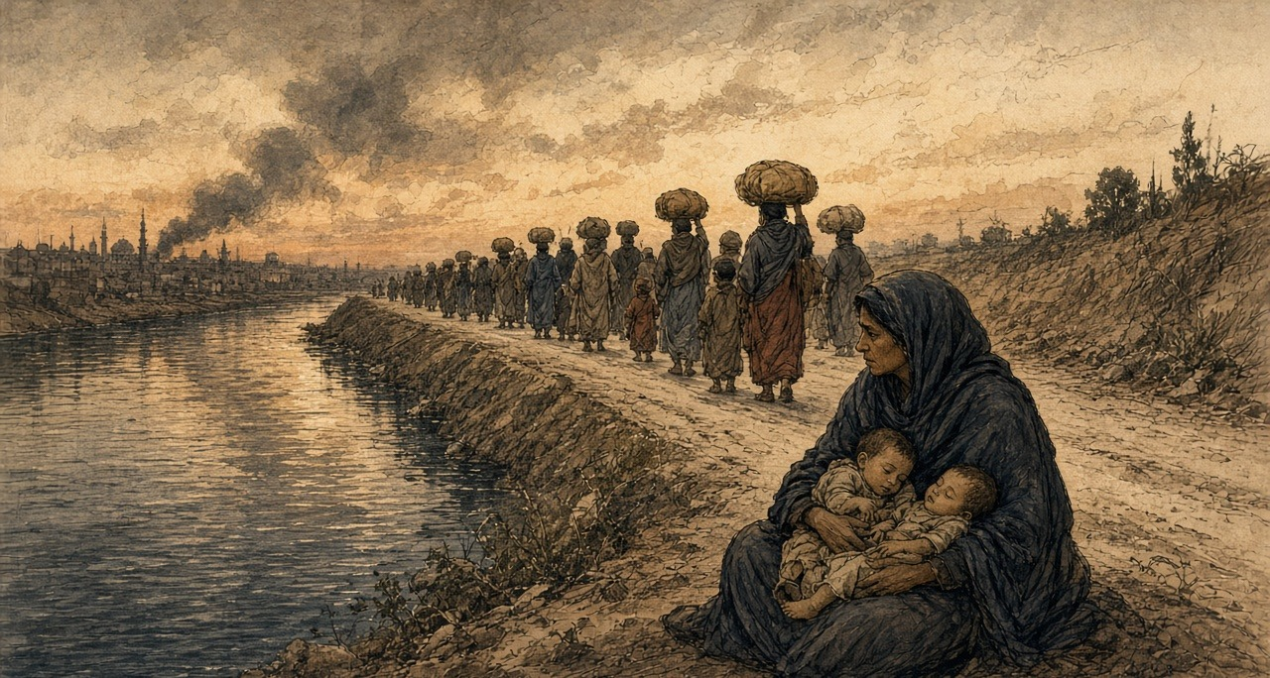
* * *
Alexandria, 12 to 23 July 1882
The leaving went on through the night and into the morning. The trains from Moharrem Bey station carried people inside, "but on the roof, the steps, and even the buffers of the carriages." On the 12th, Baring wrote, "the Egyptian garrison retreated, having first set fire to the town, which was pillaged by the mob." Cotton soaked in petroleum was thrown into houses, paraffin poured over furniture and lit, bedding soaked in petroleum piled against doors that would not open. "On every side the smell of petroleum was distinguishable." At the gates the looters set on the women leaving the harems, and in their haste for the jewellery "even cut their ears and wrists, and to silence their cries stunned them with blows from their sticks." By the morning of the 13th Alexandria "presented the appearance of a vast bonfire." The Place Mehemet Ali burned, and all the streets from it to the sea. In the middle of the square, Royle wrote, "the statue of Mehemet Ali on horseback in the centre alone remained untouched."
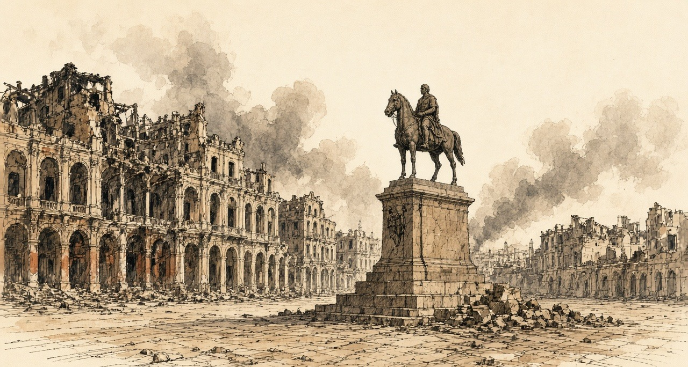
Who set the first fire was argued from that week. Royle held that apart from the harem buildings of the Ras el-Tin palace, which a shell set alight a little after ten on the 11th, "the British missiles did not create a single conflagration." O'Donnell told the Commons he "was perfectly certain of this, that the shells from the English Fleet originally set fire to Alexandria before a single incendiary extended the conflagration," and members cried "No, no!" The War Office and the Admiralty had wanted to land troops as soon as the firing stopped. The Cabinet refused. Gladstone told the House a landing would have been "grossly disloyal in the face of Europe and the Conference."
Seamen and marines went ashore with Gatling guns from the 13th. Lord Charles Beresford was made chief of police. "Those guilty of pillaging were flogged, and incendiaries were sentenced to be shot." A Black man caught setting fire to houses was court-martialled, tied to a tree in the Place Mehemet Ali, and shot by a party of sailors, the first public execution, on the first day of clearing the streets. A proclamation of 20 July ordered the shooting of anyone taken in the act of incendiarism, or taken a second time for pillage. On the 23rd three natives and one Greek were shot.
Inland the killing ran the other way. At Tanta, by the count of the prefect of police, fifty-one Europeans were murdered and buried, and about as many again killed and thrown into the canal. At Benha ten Greeks and three Jews were murdered. At Galioub a family was taken off a train and put under the wheels.
An international commission later weighed what Alexandria had lost. It awarded 106,820,236 francs, £4,341,011: £1,070,007 for houses, £1,385,402 for furniture, £1,735,806 for merchandise. The bill went to the Egyptian treasury.
* * *
The House of Commons, 17 July to 8 August 1882
On 17 July John Bright explained why he had left the Cabinet. "For 40 years at least I have endeavoured, from time to time, to teach my countrymen an opinion and doctrine which I hold—namely, that the moral law is intended not only for individual life, but for the life and practice of States in their dealings with one another. I think that in the present case there has been a manifest violation both of International Law and of the moral law." Gladstone replied: "Agreeing with him in the principle, we disagree in the application."
On 24 July Gladstone asked for £2,300,000, £1,400,000 for the Navy, most of it for transports, and £900,000 for the Army. To pay for it he proposed "an addition of 3 d. to the second half-year of the Income Tax of 1882–3, which would be equal to an addition of 1½ d. for the tax of the whole year, making the tax of the whole year 6½ d." He told the House: "The insecurity of the Canal is a symptom only, and the seat of the disease is in the interior of Egypt, in its disturbed and its anarchical condition." Of the aim he said: "We hope to put down that tyranny which now reigns in Egypt, and when that preliminary step may have been achieved—and God grant it may be soon—we hope to promote a settlement of Egyptian affairs, based upon the maintenance of international right, based upon the avoidance of every selfish purpose and design."
On 25 July the Speaker read the Queen's message calling out the Army Reserve "for the protection of the interests of the Empire." On 31 July the House voted to charge the Indian troops sent to Egypt on the revenues of India, "subject to any future decision of Parliament," by 140 to 28. On 8 August Sir Wilfrid Lawson asked which international engagements made "the voting of the unassigned portion of the Budget by the Egyptian Chamber of Delegates" a breach. Sir Charles Dilke answered that the English and French governments had agreed "that it would be unadvisable to publish at present the Papers relating to it."
Gladstone kept his own accounts. At the end of 1881, as H. C. G. Matthew printed them, he held £51,500 nominal of the Egyptian Tribute loan of 1871, entered at £40,567, about 37 per cent of his investments. In the summer of 1882 that stock stood at 57. By December it stood at 82.
* * *
Tel el-Kebir, 12 and 13 September 1882
Wolseley landed at Ismailia, on the canal, and came west along the railway and the Sweet Water Canal toward the lines Urabi had dug across the desert at Tel el-Kebir. Urabi had called for one-sixth of the men of every province, and every old soldier back to the ranks. On 12 September 25,000 rations were served out inside the lines.
Came the sheikh el-beled to our door with the paper. Said he, you were a soldier, go back. Said I to my son, the buffalo, the water, the land, on you now. Kissed I my mother's hand and went.
At Tel el-Kebir the earth thrown up in a long wall, and behind it we. Gave they each of us a Remington, and along the trench the boxes of cartridges open, every three or four steps a box. Said the sergeant, a thousand and fifty in each one. Counted I the boxes and stopped counting.
The night of the twelfth ate we the rations sitting against the wall. Said the man beside me, from a village by Belbeis, the English, by day they will come, and from far we will see them on the plain. Lay we down on our rifles behind the wall, and I slept.
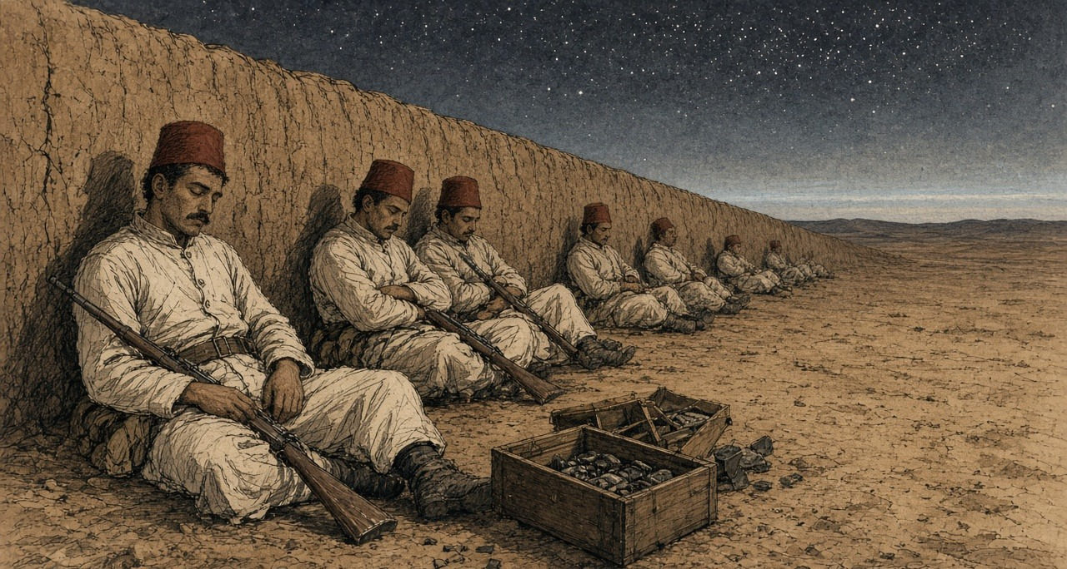
Woke I and still dark, and the gun of the picket firing. Then all the guns, ours, and in front of us shouting, a sound I had not heard in my life. Stood I and fired into the dark, at what I do not know. Came men over the wall in the grey light, Scots in their skirts, with the bayonets. One of ours stood up before me, and the bayonet went into him, and he sat down. In the trench fought the men with the bayonet and the butt and the hands. The Sudanese, they did not run. Body to body they fought them.
Ran I. God forgive me, I ran. Threw I the rifle. Behind us came the horsemen with the swords, and I heard them before I saw them, and a man running beside me, they cut him down. Stopped I and put up my hands and cried, aman, aman. Looked the horseman at me and went past.
Walked I. Along the canal walked we, many, and none with a rifle. In the villages they gave me bread. When came I to our door my mother did not know me, and then she knew me, and she put her hands on my face and did not let go.
* * *
Tel el-Kebir and Cairo, 13 to 15 September 1882
The first shots came at 4.55 a.m., from an Egyptian picket 150 yards out, at the Highland Brigade. The defence, Royle wrote, "had been sleeping on their arms behind the parapets." The Highlanders' attack "was made entirely with the bayonet, not a shot being fired until the men were within the enemy's lines." Urabi's headquarters and the canal bridge were taken at 6.45 a.m.
Urabi was a mile and a half to the rear. "I was still asleep when we heard the firing close to the lines," he told Blunt. "I said my prayer and galloped to where we had a reserve of volunteers, and called to them to follow me to support the front line. But they were only peasants, not soldiers, and the shells were falling among them and they ran away. I then rode forward alone with only my servant Mohammed with me, who, seeing that there was no one with me and that I was going to certain death, caught hold of my horse by the bridle and implored me to go back." They rode along the Ismailia Canal to Belbeis.
"The trenches, after the battle, were found to be filled with dead, mostly bayoneted, and the ground in rear as far as the railway station was dotted with the bodies of those shot down in retreat." The cavalry "cut down the fugitives by scores." Most runaways "threw away their arms, and, begging for mercy, were left unmolested," because prisoners would have slowed the ride to Cairo. A naval officer who went into one redoubt next day called it "a perfect charnel-house." The Egyptian dead were "not far from 2,000." Their wounded were never counted. In the four days after the battle 534 were treated at Tel el-Kebir, with twenty-seven capital operations. The British lost fifty-seven killed, 380 wounded and twenty-two missing.
The cavalry reached Cairo at sunset on the 14th. At half past one that night the prefect of police told Urabi that General Drury Lowe wished to see him at Abbassiyeh. He went with Toulba Pasha. "We thereupon took off our swords and delivered them to General Lowe," Urabi stated, "telling him at the same time that we only gave ourselves up to the English Government because we were confident England would deal with us justly."
* * *
The Daira Saniya prison, Cairo, October to December 1882
On 5 October Urabi was moved to the Khedive's prison. He wrote out what followed for his English counsel, A. M. Broadley. He was searched four times by the palace servants, "even to the length of taking off my boots from my feet." On the night of the 9th, after he had fallen asleep, about ten men came into his cell. "One of them said, 'Arabi, do you know me?' I said 'No; who are you, and what do you want from me at such a time?' He said, 'I am Ibrahim Agha, whom you were searching for. You dog! You pig!' and he spat upon me three times." It went on for about eight minutes. Urabi believed the man had been sent to kill him.
To Broadley he said: "all Egypt was with me—the Khedivial family—the old men of Mehemet Ali's time, the Ulemas, the army, and the peasants, but in the presence of prison, arrest, torture, and threats, who will own me now?"
Lord Dufferin, sent from Constantinople, settled the ending. Urabi would plead guilty to rebellion and be sentenced to death, and the sentence would be commuted at once to exile. On the morning of 3 December 1882, dressed in his military trousers, a light drab overcoat and a white silk scarf, he signed and sealed the plea: "Of my own free will, and by the advice of my Counsel, I plead guilty to the charges now read over to me." Under a second paper, his word to Dufferin to stay where England sent him, he wrote: "AHMED ARABI, the Egyptian." The court sentenced him to death. The Khedive's decree commuted it to perpetual exile from Egypt and its dependencies. The 570 feddans he had built up from his father's eight and a half were confiscated.
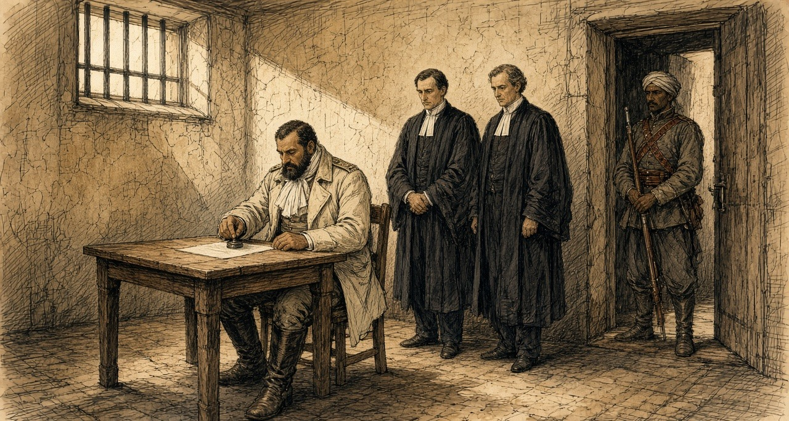
On 23 November he had written to Blunt: "I care nothing for the position I am in—for prison, for insults, or for what may happen after, since I have offered myself a legacy (wakf) to the freedom of my country." When an agent brought the exiles a letter thanking the Khedive "for his handsome treatment towards us," Urabi asked Yacoub Sami whether he had signed it. "I would rather be cut in pieces first. I have said, and say, that Tewfik is unfit to reign over us. How then can I lie and promise to pray for his prosperity?"
On Christmas Day the seven were driven by back streets to the Kasr el-Nil barracks, one or two without time to put on their boots. Egyptian troops stood in a square, and British soldiers watched from the galleries and cheered at intervals. An officer read the decree striking them from the army. As Urabi got back into his carriage a captain named Elfi cried out: "Oh Arabi, you have brought the English to Egypt!" Broadley's man Hasan said afterward: "God is great! You see even the Khedive dare not touch Arabi."
Some of the exiles were penniless. Broadley got each an advance of £30 on the allowance they would draw in Ceylon. Ladies of Cairo, quietly, for fear of Tewfik, sent Urabi portmanteaus and clothes. The Egyptian government had chartered a large steamer, the Mareotis, "wholly regardless of expense." Urabi gave Broadley his little black rosary and his carpet. On 26 December 1882 he and his six companions sailed from Suez.
* * *
Cairo and London, 1883 to 1885
Suleiman Sami, an officer charged with the burning of Alexandria, was hanged. Lord Randolph Churchill called it in the Commons "the grossest and vilest judicial murder that has ever stained the annals of Oriental justice." The Dual Control was abolished. On 3 January 1883 Granville told the Powers that Her Majesty's Government were "desirous of withdrawing" the British force "as soon as the state of the country and the organisation of proper means for the maintenance of the Khedive's authority will admit of it."
Baring came back to Cairo as consul-general on 11 September 1883. He found "the Government Treasury was well-nigh bankrupt," and the Europeans discontented "because the indemnities due to them for their losses during and after the Alexandria bombardment had not yet been paid."
The money was raised in 1885. By a convention of 18 March, Britain, Germany, Austria-Hungary, France, Italy and Russia undertook to guarantee "the regular payment of the annuity of £315,000" on a loan of £9,000,000 issued by the Egyptian government. On 17 July Mr. Ruston asked in the Commons whether the delay meant "very grave inconvenience" to the Egyptian Treasury, "and much suffering to those entitled to receive the Alexandrian indemnities." Messrs. N. M. Rothschild were agents for the issue in London, the Chancellor of the Exchequer said, at "£500 per £1,000,000, and reasonable incidental expenses." The loan was issued on Tuesday, 28 July 1885.
Chapter 5 Mini-Glossary
• Abdin (4 occurrences in this chapter): Palace and square in Cairo where Colonel Ahmed Urabi and the Egyptian army confronted Khedive Tewfik on 9 September 1881.
• Courbash (1 occurrences in this chapter): Heavy whip of hippopotamus hide used by tax collectors and village officials in 19th-century Egypt to enforce payment and labour.
• Effendina (5 occurrences in this chapter): Honorific Turkish-Arabic title ('Our Lord') used in Egypt to address the Viceroy or Khedive.
• Feddan (1 occurrences in this chapter): Egyptian unit of agricultural land area, slightly larger than an English acre (approximately 1.038 acres or 4,200 square metres).
• Fellah (1 occurrences in this chapter): Plural fellahin; Egyptian peasant cultivator or agricultural labourer whose crops and corvée labour underwrote the Khedive's debt and canal works.
• Khedive (19 occurrences in this chapter): Title of the autonomous Ottoman viceroys of Egypt, formally granted by the Sultan to Ismail Pasha in 1867 and held by his successors until 1914.
• Moukabala (1 occurrences in this chapter): Egyptian tax law of 1872 allowing landholders to redeem half their future land tax in perpetuity by paying six years' tax in advance to the Khedive.
• Naboot (2 occurrences in this chapter): Long, heavy quarterstaff of hard wood carried by Egyptian townsmen and watchmen.
• Sheikh el-beled (1 occurrences in this chapter): Village headman in Egypt responsible for naming men to the corvée and assisting state tax collectors.
• Wakf (1 occurrences in this chapter): In Islamic law, an inalienable charitable or religious endowment of property.
Chapter 5 Appendix of Important Names
• Baring, Evelyn (Lord Cromer) (15 mentions in this chapter): British Commissioner of the Public Debt and long-serving Consul-General in Egypt (1883–1907).
• Blunt, Wilfrid Scawen (9 mentions in this chapter): English poet, anti-imperialist writer, and supporter of Ahmed Urabi and Egyptian nationalism.
• Churchill, Winston (1 mentions in this chapter): British cabinet minister (Home Secretary, First Lord of the Admiralty, War and Colonial Secretary, and Prime Minister) recurring across the Irish, Middle Eastern, and Indian settlements.
• Colvin, Auckland (4 mentions in this chapter): Indian Civil Service official and British Controller-General in Egypt during the 1881–1882 Urabi confrontation.
• Gladstone, William Ewart (4 mentions in this chapter): British Prime Minister and Chancellor of the Exchequer whose career spanned the 1840 Opium War debate, Irish land and Home Rule legislation, and the 1882 occupation of Egypt.
• Ismail Pasha (Khedive) (2 mentions in this chapter): Ruler of Egypt (1863–1879) whose foreign loans and canal expenditures led to the 1875 sale of Egypt's Suez Canal shares and European financial control.
• Nubar Pasha (2 mentions in this chapter): Armenian-Egyptian statesman and three-time Prime Minister of Egypt.
• Rothschild, Lionel de (2 mentions in this chapter): Head of N. M. Rothschild & Sons in London who advanced the £4,000,000 for the British government's purchase of the Suez Canal shares in 1875.
• Seymour, Beauchamp (2 mentions in this chapter): British admiral who commanded the bombardment of Alexandria on 11 July 1882.
• Urabi, Ahmed (27 mentions in this chapter): Egyptian army colonel and nationalist Minister of War who led the 1881–1882 movement against Khedivial autocracy and European financial control.
• Wolseley, Garnet (1 mentions in this chapter): British general who commanded the 1882 expeditionary force that defeated Ahmed Urabi's army at Tel el-Kebir.
Sources
• Cromer, Evelyn Baring, Earl of. Modern Egypt. Vol. 1. London: Macmillan, 1908. Chapter 5 (Vivian's despatch on the half-pay officers and the riot of 18 February 1879, the Khedive's words, "Death to the dogs of Christians," the shots in the air and the bayonet wounds); chapter 8 (the oath of April 1879, the Sultan's telegram of 26 June 1879, the yacht); chapter 10 (the Controllers' advice from Paris, the coupon of 1 November 1879, the report of 1 January 1880, the rise from 51 to 56, the £1,684,000, the 1880 budget, the repeal of the Moukabala, the poll tax, the register extract, the consuls' reports, the Law of Liquidation of 17 July 1880 and the 66 per cent, the officers' petition, Colvin's appointment); chapter 11 (the petition of January 1881, the court-martial of 1 February, Malet on 9 September, Colvin's account of Abdin, the three demands); chapters 13 and 14 (Colvin's memorandum, the Joint Note of 8 January 1882, Granville's and Malet's telegrams, Gambetta, the consuls' letter to Cherif, the deputation of 2 February); chapter 16 (Malet on the National Debt, Cookson on 30 May, Seymour's report (he was later Lord Alcester), the incendiaries, Gladstone's "grossly disloyal"); chapter 18 (Dufferin's arrangement of the plea, the exile from Suez on 26 December, Suleiman Sami and Lord Randolph Churchill, Granville's circular of 3 January 1883); and the opening of Part III (the Treasury and the unpaid indemnities in September 1883).
• Blunt, Wilfrid Scawen. Secret History of the English Occupation of Egypt. London: T. Fisher Unwin, 1907. For the Rothschild advance and the retrenchments of 1878; the Notables and the "one-half of the revenue"; the notes of 17 January 1882 on the budget as "an international matter"; Sultan Pasha's drum; Rosebery's "views of a bondholder." Appendix I, "Arabi's Account of his Life and of the Events of 1881-1882," told to Blunt in Arabic on 16 March 1903 at Sheykh Obeyd: his birth and land, the riot against Nubar, the disbanded soldiers at Abbassiyeh, the beans sent to Alexandria, the Tewfikieh Canal, Riaz and "muhlik," Abdin and "Nahnu ma abid wa la nurithu ba'd el yom," Cookson's threat, the morning at Tel el-Kebir, his servant Mohammed; and Sheikh Mohammed Abdu's account of his warning before Abdin.
• Broadley, A. M. How We Defended Arábi and His Friends: A Story of Egypt and the Egyptians. London: Chapman and Hall, 1884. For Urabi's written statement of 29 October 1882 on the prison and Ibrahim Agha; "who will own me now?"; the plea and the undertaking to Dufferin of 3 December 1882; the letter to Blunt of late November 1882 and the wakf; the refusal of the letter of thanks; the ceremony at Kasr el-Nil on 25 December 1882 and Captain Elfi; the £30 advances; the Mareotis; the rosary and the prayer carpet; the Khedivial decree of 21 December 1882.
• Royle, Charles. The Egyptian Campaigns, 1882 to 1885. New and revised edition. London: Hurst and Blackett, 1900. For the riot of 11 June 1882 and its casualty figures; the ultimatum of 10 July; the ships and the bombardment of 11 July, the Inflexible's shells, the Egyptian garrisons and losses at Mex, the inner line, Ras el-Tin and Adda, the police chief's figure for citizens, the Moharrem Bey Gate, the mosque in Fort Pharos, Ninet's and Stone's figures and the El Taif account; the carts of dead artillerymen, the wounded, the green flag and the petroleum tins, the Boulevard de Rosette and the native hospital, the fugitives on the Mahmoudieh Canal and the trains; the fire, the petroleum, the women at the gates; Beresford, the floggings, the execution in the Place Mehemet Ali, the proclamation of 20 July and the shootings of the 23rd; Tanta, Benha and Galioub; the Alexandria indemnity awards; Urabi's levy; and Tel el-Kebir: the rations, the cartridges, the hour of the first shots, the bayonet, the trenches, the cavalry, the redoubt, the Egyptian and British losses, and Urabi's statement on his surrender to Drury Lowe.
• Hansard, House of Commons Debates. HC Deb 17 July 1882, vol. 272, cc. 722-4 (Bright's personal explanation and Gladstone's reply); HC Deb 24 July 1882, vol. 272, cc. 1574-619 (Gladstone on the vote of credit, the income tax, the canal "a symptom only," and the war's object; O'Donnell on the riot and the fire); HC Deb 25 July 1882, vol. 272, c. 1682 (the Queen's message on the Army Reserve); HC Deb 31 July 1882, vol. 273, cc. 255-307 (the Indian revenues resolution and division); HC Deb 8 August 1882, vol. 273, c. 1145 (Lawson and Dilke on the Egyptian budget); HC Deb 17 July 1885, vol. 299, c. 1060 (Ruston on the guarantee and the Alexandrian indemnities); HC Deb 30 July 1885 (the Chancellor of the Exchequer on the Rothschild commission); HC Deb 31 July 1885, vol. 300, cc. 670-1 (Bourke on the Convention of 18 March 1885, the £315,000 annuity, and the issue of the loan).
• Matthew, H. C. G., ed. The Gladstone Diaries. Vol. 10, January 1881-June 1883. Oxford: Clarendon Press, 1990. Introduction, for Gladstone's own annual accounts: his holding of Egyptian Tribute loan stock at the end of 1881, its book value, its share of his portfolio, and its prices in 1882.

Part II

Chapter 6
Dublin Weavers, 1801–1824
The Liberty of Dublin, Westminster, and Lancashire, 1798 to 1838
A room in the Liberty of Dublin cost a shilling a week, or two. James Whitelaw, vicar of St Catharine's, who counted the city house by house in 1798, gave the price before he described anything else. "A single apartment, in one of these truly wretched habitations, rates from one to two shillings per week; and, to lighten this rent, two, three, and even four families, become joint tenants."
The people who paid it were, in his list, "working manufacturers, by petty shop-keepers, the labouring poor, and beggars, crowded together, to a degree distressing to humanity." The working manufacturers were the weavers and the trades around the loom: the winders, warpers, dyers and throwsters of a district that made silk, wool and cotton cloth. Their streets had been built for richer people. The Coombe, Pimlico, Spitalfields and the Weaver's Square, the city's historians wrote in 1818, were laid out after 1688 for English clothiers who came over with their capital, and the district was "the residence of all that was opulent and respectable in the city." Then the woollen trade was shut out of foreign markets by law in 1699, and "many wealthy employers immediately left the country, and brought their capitals and assistants with them." The houses stayed. The money went.
* * *
Plunket-street, Braithwaite-street and Joseph's-lane, summer 1798
Whitelaw went out early. "As I was usually out at very early hours on the survey, I have frequently surprized from ten to sixteen persons, of all ages and sexes, in a room, not fifteen feet square, stretched on a wad of filthy straw, swarming with vermin, and without any covering, save the wretched rags that constituted their wearing apparel."
He counted. Plunket-street held 1,804 people in 92 houses. Weaver's-square held 261 in 19. Cork-street held 1,620 in 126. On one stretch of Plunket-street "thirty-two contiguous houses contained 917 souls, which gives an average of 28.7 to a house; and the entire Liberty averages from about twelve to sixteen persons to each house." A priest told him that No. 6 Braithwaite-street had once held one hundred and eight souls. In 1797 it held 97. On the day of the survey, 56.
In the back-yards, often not ten feet deep, the waste of every room was thrown from the windows, and he had "seen it nearly on a level with the windows of the first floor." Near Castle-market, in Joseph's-lane, in the summer of 1798, he found a house where a slaughter-yard had burst the back door and filled the hall, and where the rain came "through every floor, from the garret to the ground." In the garret he found "the entire family of a poor working shoemaker, seven in number, lying in a fever." Their room had no door. The landlord, "finding him not able to pay the week's rent, in consequence of his sickness, had, the preceding Saturday, taken it away."
Whitelaw counted thirty-seven people in that house. He worked out what it paid. Its owner drew "a profit rent of above 30l. per annum, which he exacted, every Saturday night, with unfeeling severity." The owners of these houses, he wrote, were generally men who "lived in affluence, in, perhaps, a distant part of the city," and who never troubled their tenants "except to collect his rents, generally weekly; in which, indeed, he betrayed no remissness whatever."
When he told the tenants to clear the yards, they gave him one answer, and he wrote it down: "It is not my business; if I remove it, who will pay me?"
Whitelaw could be hard on the poor in print. The question he recorded was a fair one. In the Liberty everything was paid for by the week, in shillings, and a family that lost a week's work lost its door.
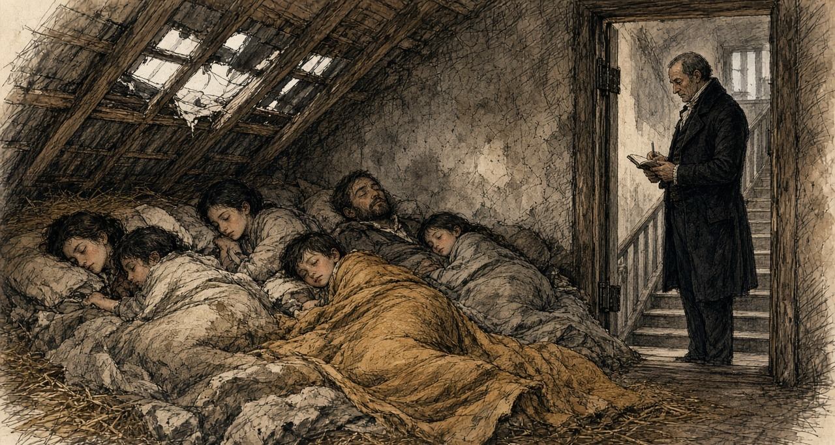
* * *
Dublin and Westminster, 1800
The Union of Great Britain and Ireland took effect on 1 January 1801. Its sixth article dealt with trade, and the money in it was set out in a schedule.
Most goods were to pass between the two islands free. A list of manufactures was not. "For the period of Twenty years from the Union," the article ran, "the articles enumerated in the Schedule Number Two, hereunto annexed, shall be subject on importation into each country from the other to the duties specified in the said Schedule Number Two." The schedule set the duty at "Ten Pounds per Cent. on the true Value," and named what it covered: apparel, wrought brass, cabinet ware, coaches, wrought copper, cottons other than calicoes and muslins, glass, haberdashery, hats, hardware, gold and silver lace and thread, millinery, stained paper, pottery, saddlery and leather, stockings, and "Silk Manufacture."
Woollens were handled apart. "The woollen manufactures, known by the names of Old and New Drapery, shall pay, on importation into each country from the other, the duties now payable on importation into Ireland." Calicoes and muslins kept their old Irish duties until 1808, and then "the said duties shall be annually reduced, by equal proportions as near as may be in each year, so as that the said duties shall stand at Ten per centum from and after the Fifth day of January One thousand Eight hundred and Sixteen, until the Fifth day of January One thousand Eight hundred and Twenty-one." On cotton yarn and twist, "all duties shall cease on the said articles from and after the Fifth day of January One thousand Eight hundred and Sixteen."
So the Union did not set one ten per cent duty on manufactured goods. It set ten per cent on a list, kept the old duties on woollens, stepped calicoes and muslins down to ten per cent by 1816, and took the duty off spun cotton altogether in 1816. Each date was a date on which an English price would come nearer to a Dublin one.
The seventh article dealt with the other side of the account. Each kingdom kept its own debt. "For the Space of Twenty Years after the Union shall take place, the Contribution of Great Britain and Ireland respectively, towards the Expenditure of the United Kingdom in each Year, shall be defrayed in the Proportion of Fifteen Parts for Great Britain and Two Parts for Ireland." Two parts in seventeen of the joint expenditure would be raised in Ireland, and the Parliament that voted it would sit in London.
* * *
Dublin, Kildare and Ulster, 1801 to 1816
Cotton went first. In 1802 the inspectors of yarn reported to the Linen Board 20,500 looms in Ireland "engaged solely in the manufacture of cotton," 3,500 of them in the counties of Dublin and Kildare. "Since that period," the historians of Dublin wrote in 1818, "the business in Ireland has rapidly declined." When the enemy shut British goods out of the Continent and America laid its embargo, English cotton goods that could find no buyer abroad came across the Irish Sea, "against which a small duty of 10 per cent. on heavy goods, and 2d. per lb. on spun cotton, afforded a feeble protection. Some of the most respectable manufacturers withdrew their capital from the business, and others failed altogether."
By 1816 there were "not more than 300 looms in the cotton manufacture in the metropolis, and of these 100 only are in the employ of masters." The rest had done something new. With small sums from a loan fund known as the Meath loan, a number of poor weavers had bought their own yarn, woven it, and sold the cloth themselves, so that "the profit of an intermediate person is saved." They kept a depot and a market in the Liberty, where country shopkeepers came to buy, and "above 200 working manufacturers are concerned in it." Their masters' capital had gone. They had put in their own.
Wool went in a crash. Weavers who gave evidence years later remembered it by a name. "In 1810 Mr. Hoskins," they said, failed, "which caused such an effect as to stop 22 employers." The commissioner who took their evidence wrote that the failure "was followed by the bankruptcy of almost the entire woollen trade of Dublin," and that "the banks throughout the country refused to discount their bills."
New money came in behind it. William Willans and his partners built the Hibernian Mills at Kilmainham in 1811. They did it, he said, because of "the high duties on many articles of English manufacture, which we, in common with others, then imported for sale. On some goods these duties were so high as 25 per cent." The duty made it worth building in Dublin. It did not make it cheap. The buildings cost more than in England, the machinery cost more to bring in and keep, and there was "the high price of coal." Willans brought his overlookers and his best workmen from England, at better wages than they could get in Yorkshire.
Coal was the cost that would not come down. Sir John Newport told the Commons in 1821 that pottery had never been made in Ireland and never could be, "because coal could not be had but at a heavy price."
* * *
The Weaver's Square, the wet season, before 1815
The warp is sized since tuesday, and hanging out on the tenters in the open air yet. Not a dry thread in it. Days it hangs there, and weeks, dripping into the nettles, and wool that has the wet it cannot go onto the beam.
When the loom stands idle, the winder is idle, and the warper, and the draw-boy besides. Eight of us live off the one frame, near enough, in the broad woollen. Let the sky hold clear and you will have five hundred and fifty looms clacking across the liberty. Let the rain set off in the bay and the whole trade waits on the clouds.
We drew up our petition to the Dublin Society, and to the Farming Society after, praying them to build a stove-house where a man could dry his chain by fire in the bad months. We wrote it out plain what a wet winter does to the trade: it sends one part of us out begging in the streets, another part to the debtors' marshal, and the third to the fever hospital. That was no lie. The gentlemen read the paper and laid it on the table. Then there was talk of a joint-stock company putting one up on debentures, for the dividend. No dividend came of it, so no brick was laid.
When the beam stops, you till the irons so the damp won't rust them, and you walk down past Thomas street into the flagged streets where the quality shops are, and you hold out your hat.
* * *
Brown-street, at the rere of the Weaver's Square, 1815
The weavers' own words are in the History of 1818. Their petitions, it says, described the wet seasons as calamities "which often sent, as their petition truly states, 'one portion of them to the streets, another to the jails, and a third to the hospitals.'" The same historians put a number on the waiting. In an ordinary year 550 woollen looms were at work in the district, each giving work to eight people, and with five in a family depending on each worker, "it will follow that 22,000 individuals are deprived of the means of support, as long as the weather continues unfavourable."
The house the societies would not build was built in 1815 by one man, Mr. Pleasants, "at his own expense, and without hope of remuneration." He did, the historians wrote, "what neither petitions or debentures could accomplish." It stood in Brown-street, behind the Weaver's Square, three stories high, "with the weavers' arms emblazoned in the front, and the centre surmounted with a cupola and spire." On the ground floor were four furnaces. Metal tubes ran from them to either end of the building, and every floor was made of iron bars "through which the heat permeates." The cloth was stretched on tenters worked by machinery across the heated floors. The warps were dried on the top floor, farthest from the stoves.
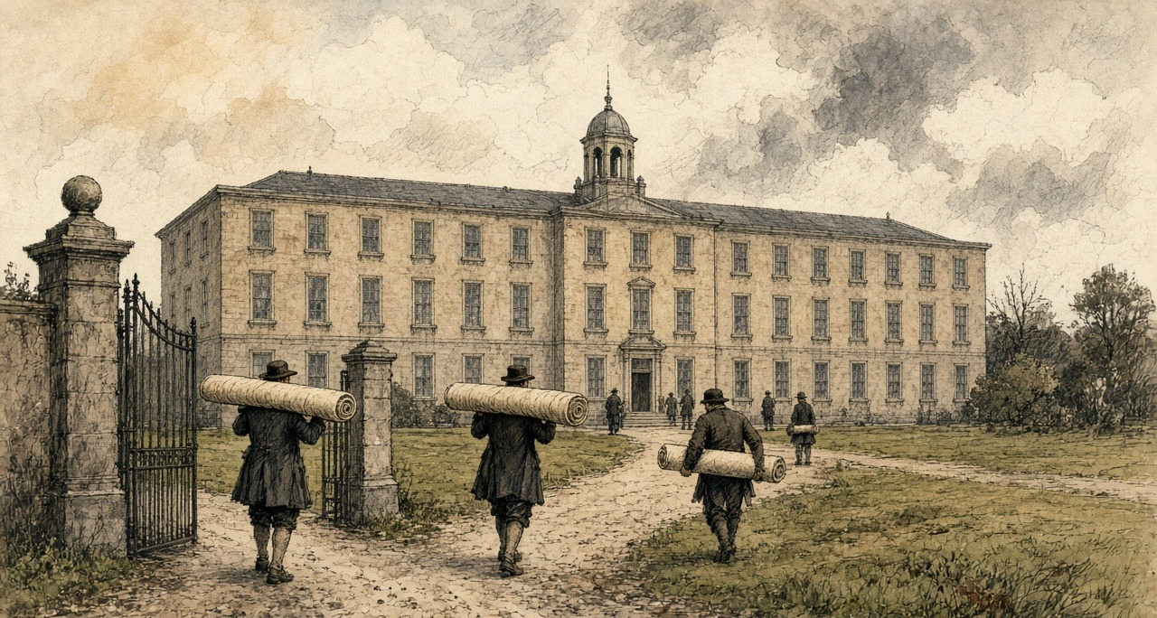
It cost £12,964 12s. 10d. The weaver paid only what covered the coals and the running costs: "2s. 6d. for every piece of cloth, and 5d. for every chain of warp. In winter it is always filled."
It was a coal fire under a weaving district, and it came as a gift. Nobody had found it worth building for profit.
* * *
The Liberty and the Weavers' Hall, 1809 to December 1816
Silk was the Liberty's own trade. It "never extended to any other part of Ireland." It was "generally supposed to have been introduced by the French refugees," and it lived on silk bought in London. "The silks imported are not brought direct from Italy, but purchased in London of the agents of the Italian houses, and the raw silks are bought at the sales at the East India House."
The war cut that line. A committee of silk weavers set down their history in their own words for the hand-loom commission in 1838. In 1805, they said, came "the last rise in wages." In 1809 "they suffered much by the Berlin decrees, which had the effect of raising the price of raw silk to an enormous height, so as to prevent the manufacturer from purchasing it." The weavers "were thrown out of employment and enlisted."
The Union's terms still gave Dublin something. The Irish silk manufacturer paid "a less duty on organized silk than the London merchant." The historians of 1818 knew how long it would last: "as that was one of the commercial regulations made at the Union, it will cease in 1821, when the duties will be equalized." They thought "the trade, in all probability, will be totally annihilated." Even with the advantage, "there is about as much English silk goods at present imported, as are manufactured at home."
1816 was a year of general distress. "The general distress, and failure of markets which have arrived at the lowest depression this year (1816), have completed the ruin of the silk manufacture in Dublin, and thrown out of employment and left destitute almost all those who were maintained and subsisted by it." The woollen survey made for the relief of the poor found "170 looms only were employed out of 700, which once were kept in motion in this district."
In December 1816 the manufacturers met at the Weavers' Hall on the Coombe and drew up a report. The silk goods imported and worn in Ireland, they reckoned, would employ 1,600 looms, "while 500 were idle in the Liberties." They pointed to the civil list laid before Parliament in 1815, which showed £143,000 paid to silk mercers for silks for Carlton House, the Prince Regent's palace in London, while the Irish silk trade for the same time "did not receive £20." They did not ask for alms. "We ask not for charity for our starving manufacturers," the report said, "but to give them employment by using the work of their hands."
When the looms stopped, the people of the Liberty came down into the city. A visitor, the historians wrote, would find himself "surrounded by groups of strange figures, remarkably different from those to which his eye has been accustomed. Their greasy and squalid dress, and pallid faces strikingly distinguish them, and a certain cast of countenance on which sickness and famine stamp a ghastly expression, often excites surprise and alarm." Then they added: "It is much to the credit of the poor people that the alarm is unfounded. Their distresses often render them importunate, but they never behave with incivility, much less with outrage."
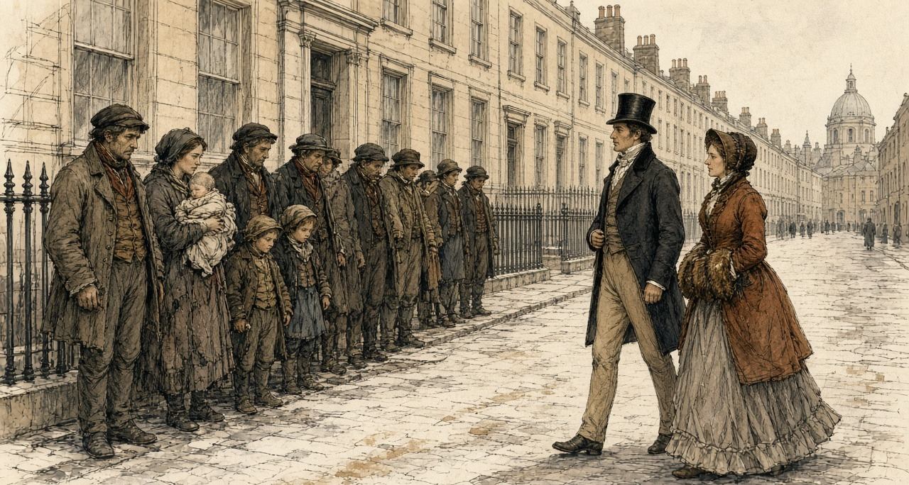
* * *
The House of Commons, 14 June 1820 to 3 April 1821
The twenty years were nearly up. In 1820 the Chancellor of the Exchequer brought in a bill to continue the Union duties, and on 14 June Sir Henry Parnell moved for a committee to examine them first.
Parnell argued from the buyer's side. The duties, he said, took "out of the pockets of the Irish consumer of English goods 200,000l. a year." They shut the Irish maker out of England. "It was utterly impossible that much capital could be invested under these circumstances in Ireland in manufactures." He held that the Union had meant them to end: "The Irish parliament, when they passed the Act of Union, understood these duties were to cease in twenty years, and prepared their plans accordingly." The Chancellor's bill, he said, "proposed an indiscriminate renewal of ten per cent on seventeen great branches of manufacture, and to allow twenty years more for the gradual extinction of the duties."
Mr. Vesey Fitzgerald opposed the motion. "The state of Ireland at the present moment was so deplorable, that any attempt to agitate this question would produce a feeling of a most distressing nature throughout the whole country." The Chancellor said the duties "must cease some time or other," but not without notice, or without "causing great injury." Mr. Shaw said that the manufacturers, at least in Dublin, did feel "great anxiety that the protecting duties should be continued." Castlereagh warned of alarm "when commercial credit was so deeply shaken." Irish banks had been failing that summer. The committee was refused by 66 votes to 30.
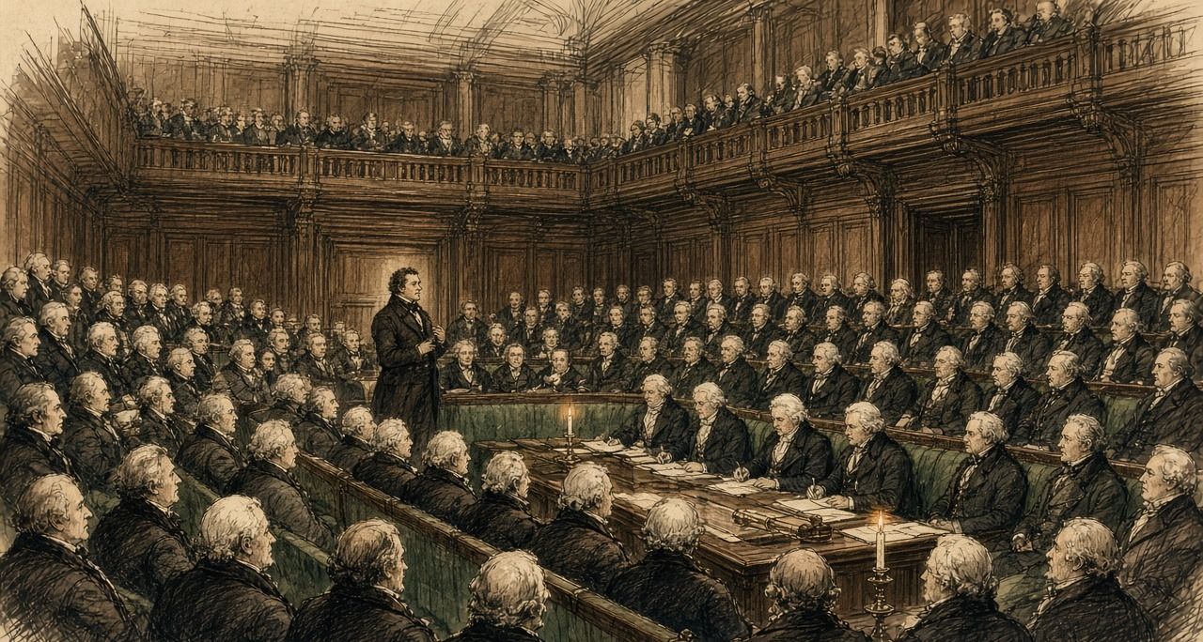
On 7 July, in committee on the bill, Parnell named the items one by one. The duty on wrought brass was "nothing more or less than a tax of ten per cent upon British machinery going into Ireland." The duty on apparel was "rather a subject of ridicule," since he had never heard of any going into Ireland "unless of old clothes from Liverpool and Bristol." Only "cottons, calicoes, silk, and glass" needed protection, he said, and he moved to end the remaining duties in 1830 rather than 1840. The words stood. The bill passed with 1840 in it.
In 1821 the petitions came the other way, from Keswick in February and from the merchants and traders of Liverpool in April, English towns that wanted Ireland open. Mr. Hutchinson said that if the duties went "it would throw a great number of persons out of bread." Peel called them "merely a tax upon her commercial industry." In April the Chancellor told the House he had heard from the Dublin chamber of commerce that "it would be more agreeable" to put the matter off for that session. He promised to bring it forward again "at as early a period as possible."
* * *
The Chancellor's office, before the repeal
Barrett Wadden made silk in Dublin for fourteen years and then moved to Spitalfields. In June 1832 he told a committee of the Commons what he had gone to London to say, when the government was making up its mind.
He started with the ten per cent. Dublin's mercers and milliners, he said, crossed to London "three, four and in some instances, I believe, six times a year, in search of British goods and London fashions," and the Dublin makers copied what they brought back. However fine the work, "it had no sale in our market unless it was stamped with British origin." So "we were constantly a season behind-hand, London taking the lead," and they needed the ten per cent to stay in business at all.
When he learned that the duties were to be repealed, he went with a deputation to the Chancellor of the Irish Exchequer, with Sir Henry Parnell present. They said the Dublin silk trade would be destroyed. Wadden said he would never forget the answer. "You are wrong; the repeal of those duties will be to you a source of very considerable employment; for while there is a duty of 10 per cent. on British manufactures coming to Ireland, and a duty of 10 per cent. on your Irish poplins or tabinets going to England, so long you will be shut out from that market; but take away those duties, and for every ten weavers that you now employ in the production of Irish poplins or tabinets, you will in my judgment," the Chancellor told him, "be enabled to give employment a hundred fold."
"We begged leave to differ from him," Wadden said; "however it was no great importance; they had it all their own way; the duties were repealed; and I have lived to see some of my best, my oldest and my most valued friends sent to prison, their families scattered East, West, North and South."
* * *
Lancashire and the West of Scotland, 1813 to 1833
What was coming across the water was being made a new way.
The power loom, Edward Baines wrote in his history of the cotton trade, "came very slowly into favour. In 1813, there were not more than one hundred of the latter machines" for dressing the warp, "and 2400 of the former in use." Hand-loom weavers broke some of them. They kept coming. On figures given in the Commons in 1830, there were 12,150 power looms in England and 2,000 in Scotland in 1820, and 45,500 and 10,000 in 1829. "In England the great increase took place during the years of speculation, 1824 and 1825." They ran on steam and water. By 1833, Baines reckoned, the cotton factories of Britain were moved by 33,000 horse-power of steam and 11,000 of water. The steam was raised from coal, the fuel Newport said Ireland could get only at a heavy price.
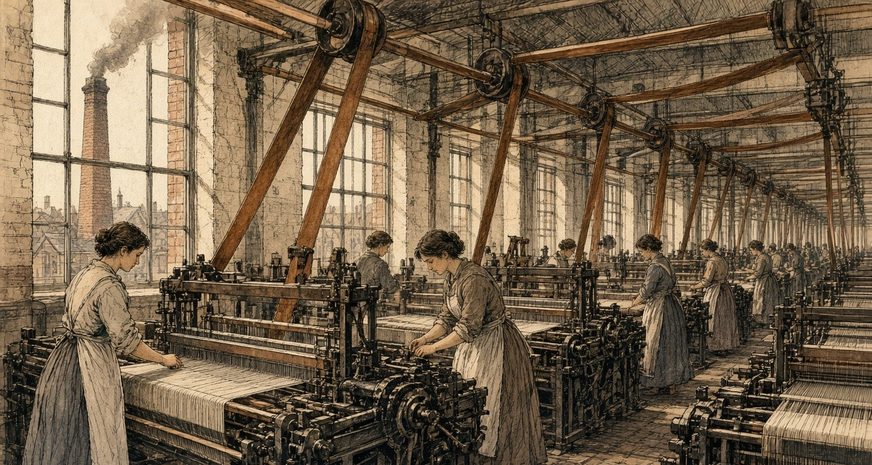
Willans, who employed hand-loom weavers and expected the power loom to follow him to Dublin, put the difference in money. "A web will take 16 to 18 days to weave by hand, at a cost of 33s. to 36s. A similar web will be done by a power-loom in six days, perhaps five days, at 8s. or 10s. expense for labour."
No power looms wove silk in Dublin. They did not have to. A tabinet weaver named Becket told the commission in 1838 that the power loom, "though not used in weaving silks in Dublin, yet caused an increase of hands at the silk weaving, and was one of the causes of the withdrawal of the trade in whole silks from Dublin." A ribbon weaver named Flood, as the commissioner set down his evidence, put the decline down to power looms, and said that "ribbons are now made by steam so cheap, that to make them at the same price by hand would not be worth any one's while; he could not live by it."
* * *
Westminster, Dublin Castle, and the Liberty, 1823 to 1824
In his budget statement of 2 July 1823 the Chancellor of the Exchequer counted the repeal of the Union duties among the year's reductions. "It could not be denied that the repeal of those duties would be prejudicial to the interests of some persons, but it would enable the people of Ireland to obtain some articles of British produce 10 per cent below the price which they at present paid for them." The cotton duties went first. In May 1824 Parnell told the Commons that the duties on woollens and silks had been repealed "in the course of this session."
In the same session Parliament took away the law that had fixed silk weavers' wages. In London magistrates had set them. In Dublin the power belonged to the Dublin Society. Lord Lauderdale, speaking for the repeal in the Lords on 14 May 1824, described that body as "a mixed company of ladies and gentlemen, who met as a board of trade, to settle the rate of wages." He said that fixed wages hurt the weaver they were meant to protect, because when trade was slack the master "could not afford to pay the fixed price; he, therefore, withdrew his capital, and the journeyman was thrown out of employment."
The silk weavers of Dublin wrote to Dublin Castle against the repeal of their protection. The Castle's register records their letter, and the cause they gave for the trade's decline: "The Union and its fatal consequences to Ireland, the want of a Resident Nobility and Gentry on whose patronage the prosperity of the silk trade principally depended." With it went a certificate from the magistrates of the police office in James's Street to the "good order and regularity" of the silk weavers of the city.
In 1824 the trade was busy. Jonathan Sisson, who imported raw and thrown silk into Dublin and sat on the city's Common Council for the Corporation of Weavers, counted the looms that year and brought the figures to London: "1,200 broad silk looms of different kinds, and there were 996 ribbon machines." About ten silk mills were throwing in the city. "The trade was rapidly increasing in 1824," he said, and besides the mills at work "a great number of silk mills were erected that have never come into use."
On 11 May 1824 Parnell told the Commons where the money was going now. "Since the Union duties have been repealed on cotton goods, very large quantities of cotton yarn have been sent from Manchester and Glasgow to Ireland to be wove into cloth, and in that shape returned to the owners of the yarn. In this way a considerable English capital provided employment for a number of Irish weavers." He expected the same in silk and worsted, which would be "sent to Ireland to be wove, and returned to England." Irish shopkeepers were getting English goods from Liverpool on credit long enough to sell them before the bills came due, and "English capitalists have opened large wholesale and retail commission houses in Dublin and other large towns in Ireland, for the sale of all descriptions of English goods."
He meant it as good news. In his account the yarn belonged to Manchester and Glasgow before the weaving and the cloth belonged to them after it. What stayed in Dublin was the weaver's wage.
* * *
The Liberty, November 1825 to the summer of 1826
They took the duty off the thrown silk in November by an order out of the Treasury, without a week's warning to the trade. Seven and sixpence the pound weight it stood at, and down to five shillings on the stroke of a pen. Any master in the Coombe who had silk lying in his cellar at the old duty was broke before he threw a shuttle.
Then came word of the English banks smashing, and on the heels of it came the steamers into the river, loaded to the hatches. Whole silks and velvets from the Macclesfield and Spitalfields houses that had to turn their stock into ready cash or go under, knocked down in the Dublin auction rooms for less than the price of the raw organzine. Our masters locked their counting-houses and gave out no more cane.
We went down to the meeting with the Lord Mayor in the chair, the whole trade of us, and we voted of our own free will to knock fifteen shillings in the hundred off the price of weaving. While the Dublin Society had the fixing of the wages, we stood by the book. When the law went, we cut our own bread to keep the looms going in the city. It never brought back a yard of work.
They got up a charity subscription at the Exchange, and put sixteen hundred men breaking stones on the roads. A silk weaver's hands on a stone-hammer—two days of it and a man could never tie a broken thread again. Then the spotted fever got into the tenements in Skinner's Alley, and the Castle had to pitch tents in the fields to hold the raving. Half the young lads took the boat for Manchester to weave at starvation rates. The old men you see at the bridge, selling the penny papers or sweeping the horse-mucus off the crossing—those are whole-silk men.
* * *
The Liberty, 1826, and a committee room at Westminster, 1832
Sisson said the silk weavers, "fearful of the importation of French silks, broke through all these former arrangements, and at a public meeting, where the Lord Mayor presided, of their own accord, agreed to reduce 15 per cent. on the prices then existing." Later cuts took weaving prices down a further 30 to 40 per cent, "about the same as Macclesfield and Manchester."
Of 1826 he said: "it was indeed an awful thing to go through the Liberties of Dublin." A subscription was raised at a meeting called by requisition to the Lord Mayor. The people were "huddled together as they were, without any thing to support them." Fever followed, "and Government was obliged at the end of that year to erect hospitals even in the fields to receive these people." "What became of them it is difficult to say," he told the committee; "great numbers fell a sacrifice to a premature death." He had seen others "as news vendors and sweeping the streets."
By 1832, of all the broad, narrow and ribbon looms he had counted in 1824, "there were only 150." Of the ten silk mills, about two were left. A mill that cost something like £2,000 "was sold in the year 1829 for under 50l." Machinery that cost about £4,000 "was sold for 62l." In Fordham's Alley and Skinner's Alley, where the silk trade had lived, "most of the houses are down or falling." A man who owned property in the Liberty went up lately to look for it, and "he could find no vestige of houses whatever."
The houses Whitelaw had counted in 1798, at a shilling or two a room, had paid their owners every Saturday night. Now there was nobody in them to pay.
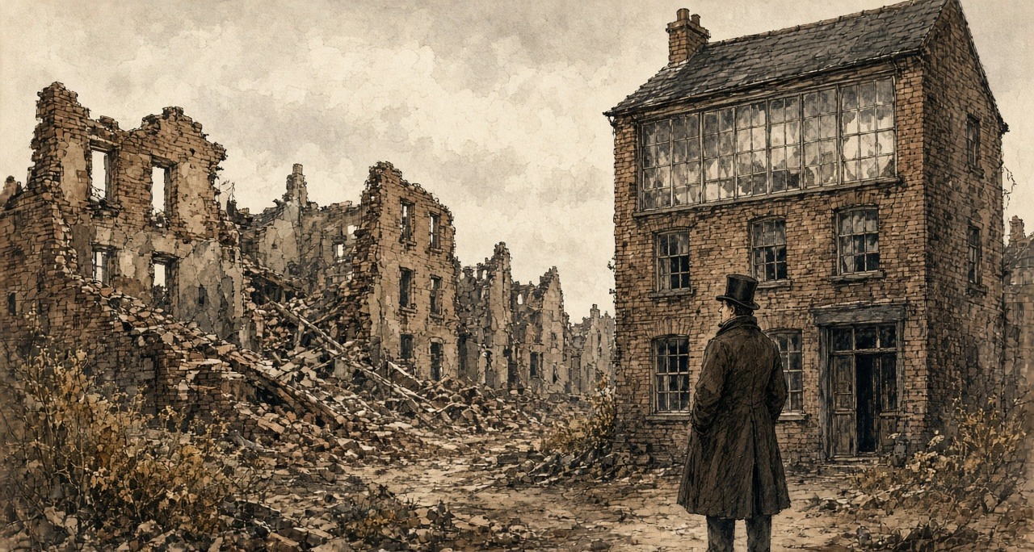
* * *
Dublin, May 1838
In 1838 the hand-loom commission sent an assistant commissioner, C. G. Otway, to Ireland. He was not sympathetic to the weavers' case. He blamed the protecting duties, the old wage rules and the weavers' combinations, and he quoted masters who said the same. He also found 400 silk weavers left in the city, most of them on poplins, the one Dublin fabric that still sold. Of the old trade in whole silks he wrote, "There can be no doubt that the trade in weaving whole silk is extinct." He thought the silk weavers "the best educated class of weavers I have met," and recorded that he had received no evidence of embezzlement against them, "although the temptation to this crime, from the value and portability of the raw material committed to their charge, is, I need not state, one to which they are peculiarly liable."
The woollen weavers told him there were not more than 300 looms at work in Dublin and around it, and gave him their own word for the weeks without work. "When we are waiting for work, it is called walking as we have nothing to do but walk, spinning street-yarn, wearing out our shoes."
The duties of the Union had been a wall, mostly of ten per cent, around a trade that needed coal, credit and silk from across the water to live. When the wall came down the coal stayed dear, the credit was English, and the cloth came in by steam.
Chapter 6 Appendix of Important Names
• Parnell, Charles Stewart (6 mentions in this chapter): Leader of the Irish Parliamentary Party and president of the Irish National Land League.
• Parnell, Henry (6 mentions in this chapter): Irish MP and financial reformer who advocated the repeal of the 1800 Union protective duties.
• Peel, Robert (1 mentions in this chapter): British Chief Secretary for Ireland and Prime Minister who repealed the Corn Laws during the Great Famine in 1846.
Sources
• An Act for the Union of Great Britain and Ireland, 39 & 40 Geo. III c. 67 (1800), original print, Articles Sixth and Seventh and Schedule Number Two ("Ten Pounds per Cent. on the true Value"; the list of manufactures; Old and New Drapery; calicoes and muslins; cotton yarn and twist; the fifteen and two parts).
• Whitelaw, James. An Essay on the Population of Dublin. Being the Result of an Actual Survey Taken in 1798. Dublin, 1805. For the rent of a room, the joint tenancies, the early-morning rooms, the street and house counts for Plunket-street, Weaver's-square, Cork-street and Braithwaite-street, the back-yards, the house in Joseph's-lane and the shoemaker's door, the profit rent, the landlords, and "who will pay me?"
• Warburton, J., J. Whitelaw and R. Walsh. History of the City of Dublin. 2 vols. London, 1818. Vol. 2, the chapters on the cotton, silk and woollen manufactures and the Tenter House: the building of the Liberties after 1688 and the departure of capital after 1699; the cotton looms of 1802, the "feeble protection," the 300 looms of 1816 and the Meath loan weavers; the silk trade's dependence on London, the organzine duty to cease in 1821, the distress of 1816, the Weavers' Hall report of December 1816 and the Carlton House silks; the 170 woollen looms out of 700; the weavers' petitions, the 550 looms and 22,000 dependants, Mr. Pleasants's Tenter House in Brown-street, its furnaces, cost and charges; the people of the Liberties in the streets.
• Hansard, House of Commons Debates. HC Deb 14 June 1820, vol. 1, cc. 1066-72 (Parnell's motion on the Irish ten per cent Union duties; Fitzgerald, the Chancellor of the Exchequer, Shaw, Castlereagh; the division); HC Deb 7 July 1820, vol. 2, cc. 300-3 (the Union Duties Bill in committee; Parnell on brass, apparel, and 1830 against 1840); HC Deb 16 February 1821, vol. 4, cc. 720-3 (the Keswick petition; Hutchinson, Newport on coal, Peel, the Chancellor); HC Deb 3 April 1821, vol. 5, cc. 5-6 (Canning's Liverpool petition and the Dublin chamber of commerce); HC Deb 2 July 1823, vol. 9, cc. 1412-22 (the budget and the repeal of the Union duties); HC Deb 11 May 1824, vol. 11, cc. 654-723 (Parnell on the state of Ireland, the yarn from Manchester and Glasgow, and the commission houses).
• Hansard, House of Lords Debates. HL Deb 14 May 1824, vol. 11, cc. 750-3 (Lauderdale on the Silk Manufacture Bill and the Dublin Society).
• Report from the Select Committee on the Silk Trade, with the Minutes of Evidence. House of Commons, ordered to be printed 2 August 1832. Evidence of Barrett Wadden (the Dublin trade and London fashion, the deputation to the Chancellor of the Irish Exchequer, "a hundred fold") and of Jonathan Sisson (the looms and mills of 1824 and 1832, the Treasury order of November 1825, the auctions, the 15 per cent reduction, 1826 in the Liberties, the hospitals in the fields, the sale of the mills, Fordham's Alley and Skinner's Alley).
• Hand-Loom Weavers. Reports from Assistant Hand-Loom Weavers' Commissioners, Part III. House of Commons, 1840. Report of C. G. Otway on Ireland: the silk trade in 1838, the statement of the committee of silk weavers (1805, the Berlin decrees, enlistment, steam communication, the panic of 1825), Becket and Flood on the power loom and steam, the evidence of the woollen weavers (Hoskins's failure, "walking") and of William Willans (the Hibernian Mills, the duties, coal, 1821 to 1826, the power-loom web).
• Baines, Edward. History of the Cotton Manufacture in Great Britain. London, 1835. For the power looms of 1813, 1820 and 1829, the speculation of 1824 and 1825, and the steam and water power of the cotton factories in 1833.
• Chief Secretary's Office Registered Papers, National Archives of Ireland, CSO/RP/1824/1501 (the letter of the silk weavers of Dublin against the repeal of protective duties, as calendared); CSO/RP/1826 (the Royal Exchange relief fund and the road works, as calendared).

Chapter 7
Crotty's House, 1832
Moyarta, Kilrush, Ennis, Scariff, Limerick and Westminster, 1831 to 1844
The question put to the parish priest of Moyarta was about money. The commissioners reminded him that, by his own account, tenancy at will lowered the rent the people would be willing to give. What did it do to the tenant's condition, and to his farm? The Reverend Malachi Duggan answered that it "paralyses the industry of the tenantry," and then he told them about a house.
"A poor man built a nice dwelling-house; he had no lease. The farm was given to a middleman, and he took a fancy to the house, and he picked a quarrel with the man, and threw him out on the highway. He built himself the house, and his wife died, and the man himself died."
They asked him the man's name. "Crotty." They asked how long ago. "About twelve years." It was Friday, the 23rd of August 1844, at Kilrush in the county of Clare, and the printed minutes of Her Majesty's Commissioners of Inquiry into the State of the Law and Practice in respect to the Occupation of Land in Ireland number the answers 13 and 14 of witness No. 608. Twelve years back from that August is 1832.
The priest had more to say about the house than about the man. "There was no improvement made in my parish for eight or nine years afterwards, for everybody liked the house; it was a pretty thing, and paved all round, and back offices built next to it."
A paved yard and back offices are things a man pays for. The house had been the best argument in the parish for spending money on a holding, and then it became the best argument against it.
* * *
The parishes of Moyarta and Kilballyowen, the years after
Duggan's parishes, by his own account, held 22,000 English acres, "principally tillage." The general run of farms was from three acres to fifteen. "There are not many farmers in it who hold forty acres of land—not more than three or four." Leases were few. "From year to year. We have not many leases at all."
Is knowledge of that house at every soul in the parish. A fine neat thing to look upon. flags laid flat around the door of it, and the out-offices built snug against the gable, and is it not Martin Crotty himself that raised it with his own hands, and is he not out on the road from it today?
Are the few acres at me from year to year, the way they are at the whole townland. Is the strength in my arms yet to quarry the flags and pave the middle of my own door, and the stones lying idle in the ditch. Do not lay to hand a stone. Does no man in Moyarta lay a stone on a wall. Should a stranger ask what sloth on us, I would only point my finger down the boreen at the roof of Crotty.
Were a lease at me. would credit be at me. Says the priest the truth of it from the altar. Walks a man with a lease into the bank in Kirush, and is the bank straight with him and he straight with the bank, at six and the hundred. Is there no mercy on the pound that breaks the back depends under the usury so heavy on the pound that breaks the break undergoes the bitterest before a penny of the principal is touched. And when the breath goes out of a tenant it will, and is the mould not earth before the man in the nail comes on. So stays the shilling seen in the freeze coat, and stays the green puddle before the threshold, and is no covetousness put into the eye of the middleman riding past.
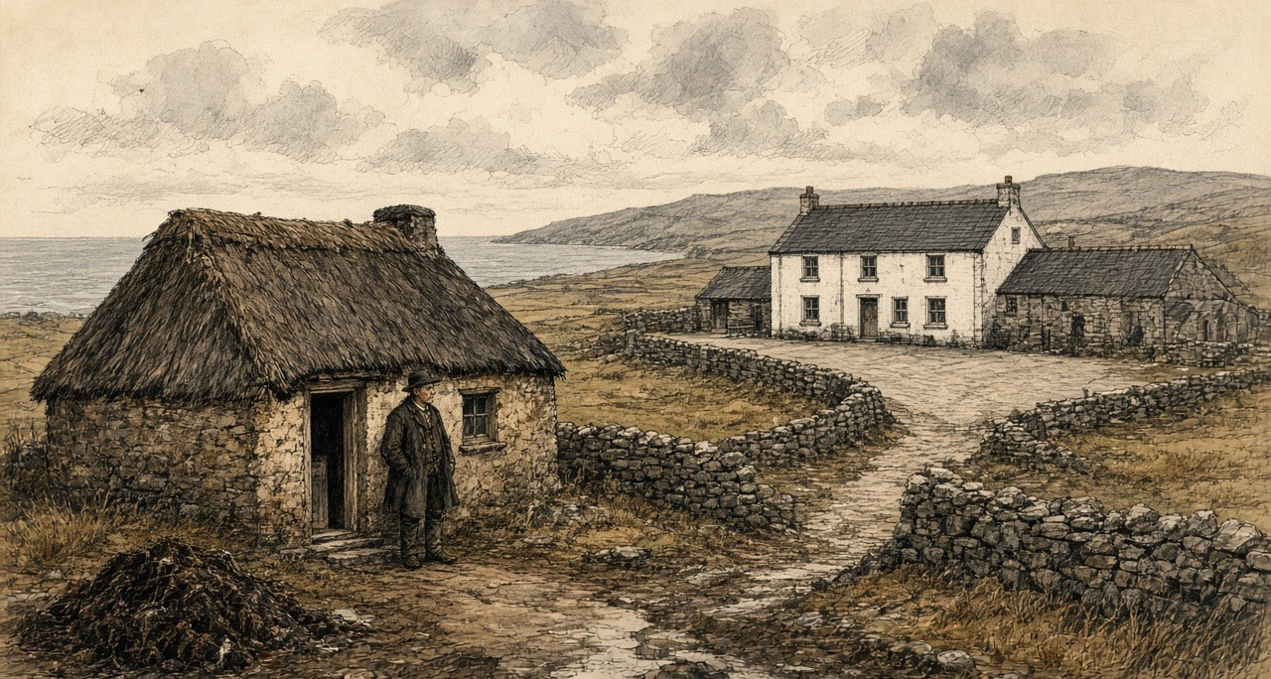
Duggan gave the money side of it in his own words before he ever came to Crotty. Asked whether the people wanted leases at the present rents, he said they "would rather have leases and pay a high rent, than have the land without a lease at a low rent. The reason is, when they have leases they have credit, they have a stake in the country, and can get money from the banks; but when they have no lease they have no credit in the country, and when they die their widow is likely to be turned out. I think it much better for the people to get the money from the banks rather than the country usurers. In dealing with the banks they are very punctual, but in dealing with the usurers, the interest is so high they cannot pay interest and principal; the interest is often fifty per cent."
A lease was not only a right to stay. It was the paper a bank would lend against. Without it, a family's borrowing was done at fifty per cent, and a family's improvements were done at the risk of the house itself.
* * *
The House of Lords, Westminster, 8 March 1832
In the year the priest's reckoning puts Crotty on the highway, the money that left the small farms of Ireland was being argued over in Parliament under another name. On the 8th of March 1832 the Marquis of Lansdown moved the first report of the Lords' committee on tithes in Ireland. Tithe was the Established clergy's share of the produce of the land.
Lansdown wanted it commuted into a fixed charge. He described what the clergyman did under the old system: "making ten or twelve collections in the course of a year: raising one part of his income by the tithe on potatoes, another by the tithe on flax, and so on through the different articles of agricultural produce." He spoke of "the collision between the clergyman and his flock—always recollecting that the flock do not receive, or do not think they receive, any benefit from the services of the clergyman."
The committee had found the payment of tithes resisted in many parts of the country, "sometimes by illegal acts and outrages, more frequently by combinations among the people, by which they availed themselves of such legal difficulties as enabled them to delay or prevent the payment." Lansdown read their lordships the evidence of the Archbishop of Dublin. "But as for the continuance of the tithe system, it seems to me that it must be at the point of the bayonet—that it must be through a sort of chronic civil war."
The committee's remedy for the clergy was money from the Treasury. It recommended that the Government be empowered to grant them assistance "out of the Consolidated Fund, in respect of the tithes due for one year," and that it have the power "to levy arrears in the districts where the resistance has been most effectually organized" to get its advances back. A clergyman who could not collect his tithe would be paid by the Government, and the Government would collect the arrears.
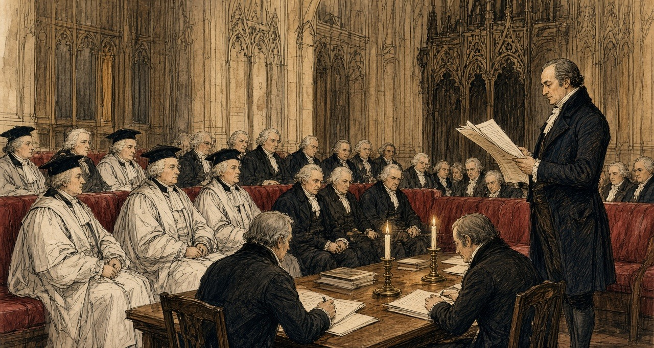
In the west of Clare, the disturbances of that time had another name. Duggan told the commissioners in 1844 that his parishes had not had many outrages "for forty years. In the year 1831 only one—a house was broken belonging to a middleman. None of those who had land or any stake in the country joined the Terryalts; they were persons who had no interest and no tie in the country."
No interest and no tie: the priest meant men with no land. In the east of the county a magistrate gave the commissioners a reason for 1831 that was a matter of rent.
* * *
Mock ground, the half barony of Tulla, 1831 to 1844
James Molony of Kiltanon, near Tulla, landed proprietor, magistrate and deputy lieutenant of the county of Clare, gave evidence at Scariff on Tuesday, the 20th of August 1844. He described a kind of letting that had no lease and, in his opinion, no law.
"The con-acre system, known in this country by the name of mock ground (whence the denomination comes I do not know), prevails extensively, but from various causes the ground applicable to con-acre has become so scarce as not to meet the demand. I must say for myself, the origin of agrarian outrages very much arises from the want of the con-acre land, and the lower orders of people conceive that the farmers and landed proprietors ought to make sacrifices to give them the means of subsistence, for which they are unable to pay, because their labour is not required on the farms, the farmer having the usual set of labourers sufficient for his purpose."
Then he gave the price. "The price of con-acre land varies from £3 10s. to £8 per Irish acre, from £2 to £5 the English acre; the high rate is where permission is given to burn, or where the farmer furnishes the manure." Stubble ground fetched "£2 10s. an acre ready money. This description of land used to be given rent free, and ready ploughed, to persons who had dung to put upon it." Payment was "recovered by distress and sale of the potatoes, or by civil bill process." The usual wage was eightpence a day. The outrages of 1831 in his district, he said, "then originated in the want of con-acre land."
Medium land in the same district, Molony said, let to farmers at about twelve and sixpence the statute acre, "being £1 Irish." The labourer's potato ground, taken by the season, cost three and a half times that at the lowest, and eight times it at the highest.
For the one crop only is the mock ground set to me, and not an hour beyond the digging. Is silver from my hand for the former, or the sweat of my back in the harvest, or a share of the two. Eightpence is the wage of the long day when a day's hire is in it, and his own servant-boys at him for the constant work, so is the hiring scarce.
If he gives leave to pare the sod and burn the baitin for the ashes, is the rent heavier on me. If it is his own dung that goes out on the ridge, is it heavier again. Cheaper is the oat-stubble, ach is it silver down on the nail before the spade goes in. In the old days, what was ground given free, and the plough run through it, to any poor man that had the scraping of the road-mud gathered at his cabin door to spread on it.
Are the potatoes at me while they are under the clay and no debt on my head. if there is a shilling wanting on the gale day, they are at the farmer. Can he put the padlock on the pit, or cant them to strangers at the edge of the ridge, or drag me before the bench at the sessions. Is there neither lease nor parchment between the you of us, only the stalk in the night.
In the year of the Terrayts, when the mock ground was denied to the boys and the grass-bullocks put to walk the good land, did we go in the night with the spades and turn the sods upside down before the moon set. Testifies the magistrate himself that the hunger for the potato-ridge was the mother of that work.
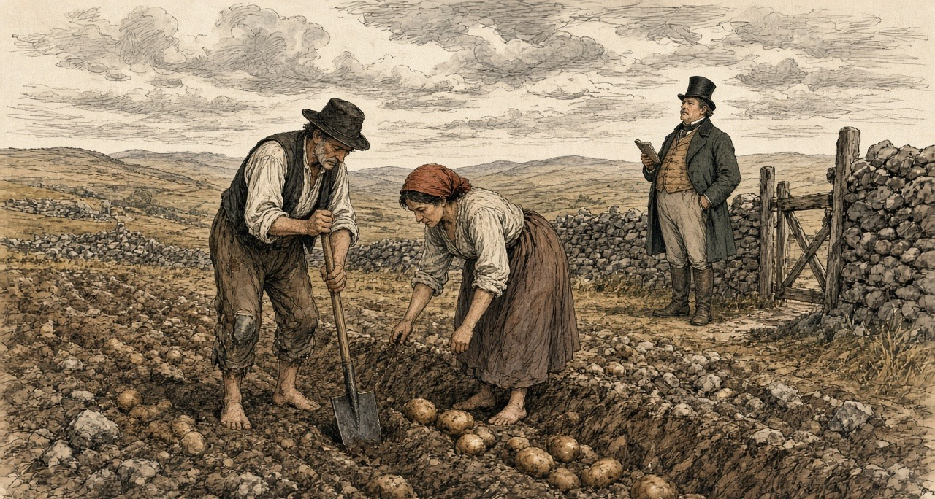
Molony closed with a recommendation. "I think the law of landlord and tenant does not apply to con-acre, consequently there is no law that applies strictly to that kind of tenure, and I think a blank form of letting would be very desirable."
* * *
Ennis, Wednesday, 21 August 1844
William Daxon lived at Kilmorane, two miles and a half from Ennis. He was "a farmer and land agent," and the district he knew best ran "from this to Kilrush, and the western part of the county." He gave the commissioners the rents of the ordinary land: "the average of good land is from 30s. to £3 10s. an acre," wheat land from forty shillings to two guineas. Then they asked him about con-acre.
"Does the con-acre system prevail in the district?—Yes, very much." The usual rent? "From £8 to £10, and in some cases £12." Wages? "Eightpence a day if you have standing labourers through the year; and if not, if you bring in labourers, it is 10d. to 1s. for a man casually employed."
So a farmer paid thirty shillings to three pounds ten for an acre of good land, and a labourer paid eight to twelve pounds for an acre of potato ground, by the season, on eightpence a day.
Daxon told them how the rent came in. An agent "will come into Kilrush for two days; he receives rent the fifth of July, and thirtieth of December; that rent becomes due in the November and May previous: that man cannot spend his time there to wait the convenience of an immense number of cottier tenants; they are obliged to pay it on a certain day to him." If they could not, the remedy was distress, "distraining them and putting on keepers." The keeper "gets 1s. for a day, and 1s. for the night." A man in arrear paid a shilling a day and a shilling a night for the man set to watch his goods.
He told them also what credit cost a small tenant who had been given more land. The new holders had not capital enough. "They are obliged to go to the banks at the recommendation of some gentleman, who will represent them as honest and proper people: they get £15 or £20 at six per cent." Six per cent, with a gentleman's word. Fifty per cent, Duggan would say two days later, without it.
* * *
The courthouse at Kilrush, Friday, 23 August 1844
Fourteen witnesses were heard at Kilrush that day, numbers 599 to 612. Before the priest came in, the commissioners had already heard what a distress cost in the barony. Mr. Patrick Slattery, a corn dealer and poor law guardian, told them that "lately they have had recourse to putting a keeper over the crop, and another in the house, and charging 2s. for each for every twenty-four hours, and in some instances I believe more." Asked whether the tenant should be held to a fixed rent if prices fell, he put the value of a lease into shillings. "I would rather pay 25s. with fixity of tenure than 15s. without it, for when there is fixity of tenure a man will raise capital, or by industry, and improve the land, and make it more worth 20s. than 10s., but now he may do it and then be turned out."
Mr. Robert Fitzgerald, who lived near Kilkee, a lieutenant in the Clare militia, complained that his landlord's people had kept him from the sea-weed his lease gave him. "My neighbours get £5 an acre for the sea-weed on the shore; and in consequence of my right being denied, my land is not worth one-third of it." He gave the reason he had been given for the sea sand: "the sea shore at Kilkee is very much frequented by bathers; and if the sand was removed, they have found out that it would not be so smooth and pleasant for the bathers."
Then Duggan was sworn. He told them that the tenants on the two properties in his district under the management of the courts were "miserably distressed," and blamed "the avarice and rapacity of those who take the land under the courts, and not the courts." He gave them the wages: sixpence a day with food for a man in permanent employment, eightpence from a farmer, tenpence in the hurried period of spring. "There is no person in my district to employ them, except casually."
He gave them the one agrarian crime of the past year, and it was about land and arrears. "There was a poor widow who got in arrear to the amount of £20, holding under middlemen." She was ejected and "got a little hut on the other side of the road." When the land was handed over to another man and he built a new house on it, "they tumbled the house to the ground at night." The priest called a public meeting the next day. When the man went to rebuild, "they got out again another night, and took out four guns, and broke in the door of his brother, and then he was discouraged making any improvements upon the land." In the end there was a compromise. The widow "got back six acres, and she is living upon it; and the other man has got the other six, and they are living in amity, the animosity died away."
He told them that on the Westby land there was now "a better order of things established. Mr. Nicholas Westby, of London, divided the land of the tenantry into divisions, and put each man's division by itself, and reduced the rent so low that they could not complain if they got leases at the present moment." He had listened to Westby speaking to his agent: "Let all things be as they are; let in no more tenants, and we will turn out no man: but there are no more sub-divisions to take place."
Asked whether the land of the country was held by absentee landlords, he said: "All of it." The agents? "No; except one man, all the agents of the landlords are absentees." He told them whom the people feared. "Unfortunately in this country the tenantry are more afraid of the under-agent than they are of the landlord. They expect always generosity from a gentleman, but they expect nothing but perfidy from those persons in the employment of an absentee landlord."
What he wanted was simple. "I mean a long lease. I mean some system, as in England, that the tenant would not be turned out when he paid his rent; or if he was turned out for the sake of any domestic improvements of the landlord, that he should get some remuneration for his improvements."
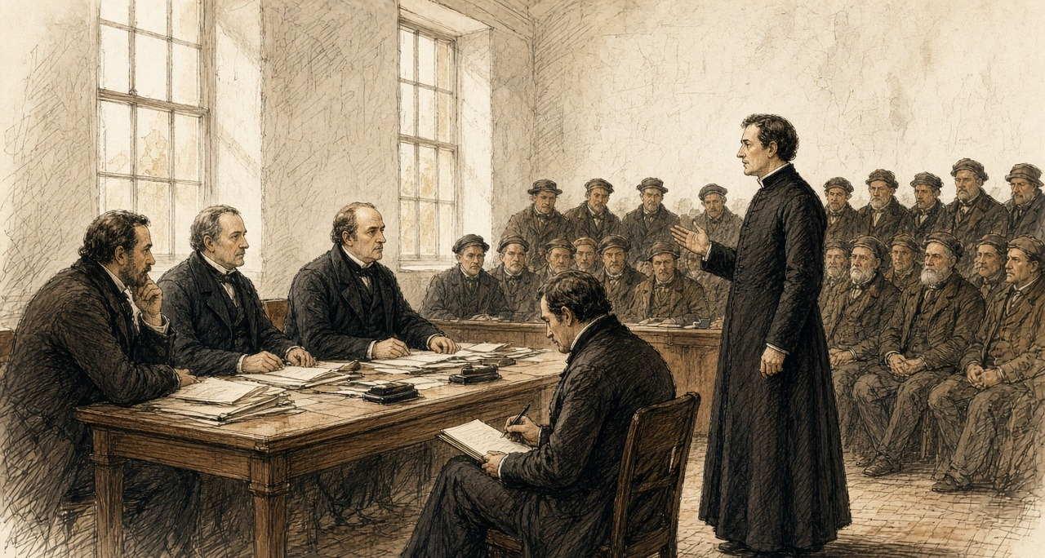
* * *
The same room, the same afternoon
The next witness was John Lynch, who gave his address as "Newbridge, by the side of the road." He had held four acres at Moydalla under Colonel Wyndham, one of upwards of thirty in the same holding, all bound "one security for the other." Fifteen were turned out. He owed nothing. "Some days afterwards he gave me £8, after my house was thrown down." It did not carry the family through: "the compensation did not buy provision for myself and family for the year following." Had he any land now? "No, not the breadth of this table."
Then the clerk wrote: "Patrick Crotty, sworn, and examined through an interpreter, who was also sworn."
The questions went to him through the interpreter, and his answers came back the same way. The minutes keep only the English.
He had lived on land belonging to Mr. Westby. He was removed from it "about eight years ago." He had been living with his father and mother. "My father built five houses, and he was one of the most settled tenants upon the farm." They were dispossessed "by Tom Pilkington." Had Pilkington taken a lease of the lands from Mr. Westby? "He said he got a lease." Were the Crottys' lands in it? "Yes."
Did he allow them anything for the house or the improvements? "No. My father paid £36; and after paying him that sum, he ejected him."
"Did Thomas Pilkington allow your father any thing for the house?—No; and after he was ejected, he gave £7 to be allowed to stay in the house a limited time; and after the winter quarter, he was thrown out, and went into a shed on the side of the road, by which my mother got cold and died."
Was Pilkington any relation to the agent? "The agent was father-in-law to Thomas Pilkington."
After the ejectment was served, the son said, "he proceeded as rapidly as he could, and he brought the habere and ejected them under it." Possession was taken "in or about the month of September. The harvest was cut and down." No application had been made to the present Mr. Westby. "Some application was made to the former Mr. Westby by the tenants, and he made a promise to let them have the land; but he broke his promise, and gave them to a middleman."
The family went to another little tenement of two acres. "Mr. Keane became landlord of it, and gave us four acres in addition to that." Patrick Crotty still held the six acres, at Caharsavaun. His last answer was about the rest of the family. "I have a brother and four sisters, who are actually paupers."
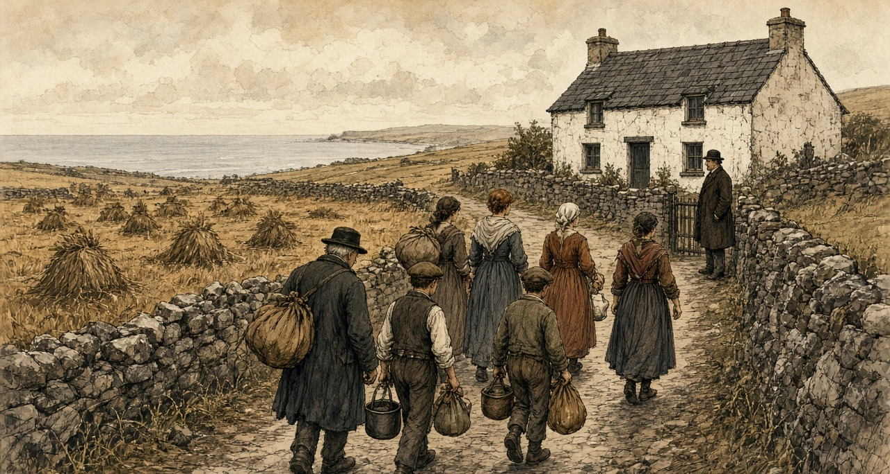
The minutes do not say that the priest's Crotty and this witness's father were the same man. They put the two accounts one page apart, on the same afternoon, both turning on a middleman. The priest put the eviction about twelve years back. The son put it about eight.
The man after him, Patrick Fitzgerald, had held about three acres under Mr. Vandeleur. He had built a house and spent "upwards of £700 about my own farm," on a promise and without a lease, and paid the masons "3s. 6d. a day." His rent was one pound a year. He was put out "seven years last May, with ten in family," by "a Dublin ejectment." "It was for non-title they put me out." He owed nothing, "only £1, and they would not take that in consequence of a point of law." The compensation was "only £5 he gave my wife, who fell ill of the fever and erysipelas in the leg." "I took away the windows and doors." The Vandeleur agent, Francis John Fitzgerald, told the commissioners next that the estate was "over 20,000 statute acres altogether, and the population is very great."
* * *
Appendix B, No. 73
The appendix to the volume prints statements from gentlemen named in the evidence, in reply to it. The answer to Patrick Crotty came from Marcus Keane, esq., who wrote that he had heard the particulars at the time "from the persons concerned, most of whom have since died."
"The facts are these:—The farm of Kiltrellig was held by Richard Pilkington, as middleman, under a lease of lives, at the expiration of which the late Mr. Westby agreed to re-let to Thomas Pilkington, to whom a lease was made in 1834. Much factious opposition was raised at the time by the tenants in possession, and Martin Crotty (the father of Pat. Crotty, the witness), with others of his family, were amongst Mr. Pilkington's most strenuous opposers. Not satisfied with using the most provoking and abusive language, his son on one occasion openly threatened Mr. Pilkington's life, who, to prevent the spread of such disaffection, was compelled to serve an ejectment, and the eviction of the party from the land subsequently followed."
On the money, he wrote: "I believe that Crotty's statement, with regard to having paid £7 for the use of his house for a limited period, to be wholly untrue. Had it been otherwise, it could not have escaped me, as I was perfectly conversant with Mr. Pilkington's affairs at the time. A short time after Crotty was dispossessed he got another farm of nearly equal value, at Clohanesevau, which adjoins Kiltrellig."
Keane did not answer the £36. He did not mention the five houses, or the shed by the road, or the mother. He gave the farm a name, Kiltrellig, and the father a name, Martin, and the new lease a year, 1834. Between the priest's twelve years, the son's eight and the agent's lease, the eviction falls somewhere from 1832 to 1836. The record does not fix it closer than that.
The priest had said the middleman took a fancy to the house. The gentleman said the family were put out for their tongues. Neither denied that Thomas Pilkington got the lease and the farm, or that Martin Crotty's family left it.
* * *
Limerick, Monday, 26 August 1844
Three days later the commission sat at Limerick, across the Shannon from Clare, and the Clare money came up again.
Mr. Daniel Cullen was a grocer at Thomond Gate and a farmer in the barony of Bunratty, and a poor law guardian. He had counted the people who came into three streets of his parish in the previous three years from the country: 126 to the High-road, fifty-six to Mass-lane, 230 to the New-road, "making a total of 412 persons in that part of the parish." From where? "Some from Limerick, but most generally from the county of Clare."
"They generally come in suffering under the greatest possible poverty. So great is their poverty, that they generally occupy the most wretched hovels that can be found." He had found "in some cases as many as twelve persons living in a few square yards." Their diet was potatoes. "At this season of the year they get a little milk, and in the winter season they may get a few herrings." Wages in the city were "about 10d. a day without food, when it can be obtained." He had taken one of the city members into one of the houses, "and he felt that he was self-degraded after leaving the miserable hovel he had visited."
Across the bridge from the Clare side came we in onto the new-road, and is the whole street packed with our own countrypeople. Was no day's highre to be got west in the parishes, and is there little better inside the walls of the town, for so many of the banished crowded in at the gates that one man's hunger is eating another man's wage.
Are twelve of us lying down together in the four paces of this cellar. The wet potato on the board. A sup of sour milk in the summer. In the dead of winter, a salt tail of a herring to give a taste to the mouth. Go the men out in the grey of the morning to stand in the rain at the hiring-cross, and come they back at nightfall with the wet soaked into the bone, and goes the cold into the joints of them, and the pains, until they are stretched on the straw asking for the dispensary ticket.
Came a big gentleman from the Parliament in through the low door the other day, and Mr. Cullen the grocer showing him the way. Stood he in the middle of the floor with his hat touching the rafters, looking at the rags on the children. Went the blood from his cheeks with the stink of the place, and went he out into the air again as fast as his legs could carry him.
Cullen told the commissioners what a distress could cost: "I have known a case of a tenant's property being seized for rent, and there were two men upon the premises for fourteen days, and he was charged 2s. 4d. a head for each man for twenty-four hours, whereas the usual wages for men at that time was only 8d. a day." He told them what a farm cost, before the rent. "In many cases you have very little chance of a farm without being first able to bribe the agent." The commissioners asked for an instance. "In the county of Clare, on the lands of Quinpool, on the property of Benjamin Finch White. I had occasion to make application to the landlord to take up ten acres of land from him. I had to give the agent £20; it was never introduced into the receipt or into the deed I received." He had a lease of twenty-one years. The agent "was a brother to Mr. White, the landlord."
Benjamin Finch White answered in the appendix, as No. 74. "In 1838 I set a farm to Mr. D. Cullen, which contained about 124 Irish acres; but that I never was aware that he, or two other tenants who took similar farms from me at that time, had paid any money to my agent, or had given any thing to him for his interest with me to get them the land. I beg further to say that I am very much opposed to such a system, and also, that I have collected my own rents since 1838." He did not say the twenty pounds had not been paid. The landlord's acreage and the tenant's do not agree, and the printed record leaves them so.
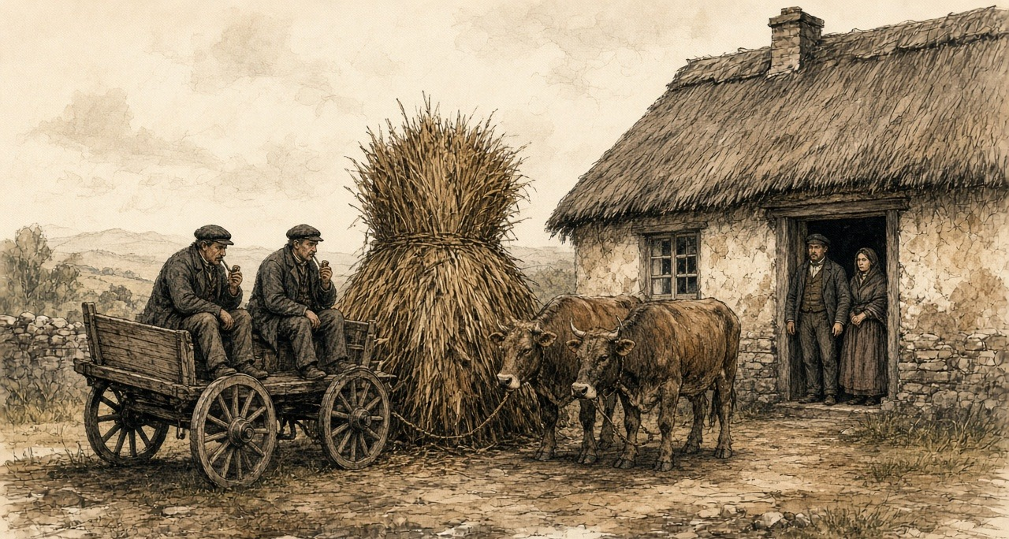
The same day the commissioners heard David John Wilson of Belvoir, near Sixmilebridge, in the county of Clare: "a small proprietor of very poor land, a very poor tenantry." "The tenant too often resorts to the loan fund, the pawnbroker, and local usurer, and the interest is enormous," Wilson said, and he gave the sums. "About May, 1842, A B bought potatoes at £1 per barrel ready money (that being then the current price), and without removing them from the pit (and though the price had fallen) re-sold them at £1 10s. per barrel, to be paid the following Christmas, and if not paid at Christmas, or, at the farthest, on twelfth day, the price was to be £1 15s. per barrel, which was the sum entered in the note that was passed." The buyer was processed at the April sessions of 1843, paid part, was processed again, paid part again with the costs. "A day's work was required and agreed to for each renewal of the note passed. The original agreement was at the rate of 150 per cent."
He went on. "Oats only worth 8d. per stone are often sold in spring at 13d. a stone, to be paid in harvest, being at the rate of 125 per cent. Meal bought at 15s. per cwt. has been frequently sold for £1 4s. per cwt. on six months' time, being 120 per cent. per annum." He had found that "as the grades descend the rents increase," and he had known tenants "distrained, and their stock (in three or four instances) impounded by five several claimants within the course of ten or fifteen days."
Wilson had also drawn a house. In December 1843 he had written to the Farmer's Gazette with "my plan of a cheap cottage for a cottier," and the letter was printed in the appendix among the papers he delivered in. He wanted "separate sleeping-places for the family, instead of having all its members crowded into one room, sometimes into one bed—a warm pig-sty, to prevent the custom of bringing the sow into the house at the time of farrowing," a hen-house, a dairy, a store-room, a place for two cows, and, at a northern gentleman's suggestion, a room for a loom, ten feet by eight. He had contracted with a mason to build the walls "at the cost of £2 15s. for both house and linney. The tenant finds stones, attendance, and diets the mason and his assistant." He expected to be about ten pounds out of pocket on each house, "but the occupiers being tenants-at-will, I purpose making them allowances for their labour, by instalments out of their accruing rents."
His tenants were all at will, and he meant them to stay so. "I have found, by experience, that leases are positive bars to improvement, however low the rent; and I hand in several cases as proving my assertion. I now give no leases." "I collect the tenantry, and read out the reports made of each person." "To those favourably reported, I extend any favour or accommodation in my power to bestow; from the others it is withheld."
Wilson's tenants were to build the houses with their own stones and their own labour, and be paid back out of their rents, and hold them at will. Crotty too had built at will.
* * *
Caharsavaun, 1844
The sums in the minutes add up only one way. Martin Crotty built five houses, by his son's account, and was allowed nothing for them. His son said he paid £36 and, after the ejectment, £7 more to stay a limited time. The agent called the £7 wholly untrue and said nothing of the £36. The family that had been "one of the most settled" on Kiltrellig went to two acres, then to six, and in 1844 the son held the six and said his brother and four sisters were paupers.
In the parish around them, by the priest's account, money that might have gone into stone and paving and back offices was not spent for eight or nine years, because everybody had seen what a pretty house was worth to the man who built it. Credit for men without leases ran at fifty per cent, or at a hundred and fifty per cent on a barrel of potatoes. A keeper on the crop cost two shillings for a day and a night. Potato ground cost eight pounds an acre, or ten, or twelve. A labourer earned eightpence, when anyone would hire him.
The commissioners' last question to the priest was what he meant by fixity of tenure. He said a long lease, or compensation for improvements. In Moyarta that would have meant a price for Crotty's house, paid to the man who built it.
Chapter 7 Mini-Glossary
• Con-acre (8 occurrences in this chapter): Also called 'mock ground' in County Clare; season-only subletting of small patches of manured potato land to landless Irish labourers at high cash or labour rents.
• Habere (1 occurrences in this chapter): Writ of habere facias possessionem; legal court order directing the sheriff to evict tenants and deliver physical possession of land to a landlord.
Sources
• Evidence taken before Her Majesty's Commissioners of Inquiry into the State of the Law and Practice in respect to the Occupation of Land in Ireland. Part II. Dublin: Alexander Thom for HM Stationery Office, 1845 (HC 1845 [616] XX). Scariff, 20 August 1844: James Molony, No. 579 (mock ground, the price of con-acre, stubble ground, distress and civil bill, wages, 1831, the want of a law for con-acre, medium land at 12s. 6d.). Ennis, 21 August 1844: William Daxon, No. 590 (rents of good land, con-acre at £8 to £12, wages, the agent's two days at Kilrush, keepers, bank credit at six per cent). Kilrush, 23 August 1844: Patrick Slattery, No. 606; Robert Fitzgerald, No. 607; Rev. Malachi Duggan, No. 608 (the parishes, leases and credit, usurers, wages, the widow's arrear and the tumbled house, the Terryalts, Crotty's house, Mr. Westby, absentees and under-agents, fixity of tenure); John Lynch, No. 609; Patrick Crotty, No. 610, examined through an interpreter; Patrick Fitzgerald, No. 611; Francis John Fitzgerald, No. 612. Limerick, 26 August 1844: Daniel Cullen, No. 618 (the 412 persons, the hovels, diet and wages, keepers at 2s. 4d., the £20 to the agent at Quinpool); David John Wilson, No. 625 (usury, rents by grade, leases as "positive bars to improvement").
• Appendix to the same Part II: Appendix B, No. 73, Statement of Marcus Keane, esq., in reply to the evidence of Patrick Crotty (Kiltrellig, Richard and Thomas Pilkington, the lease of 1834, Martin Crotty, the £7, Clohanesevau); No. 74, Statement of Benjamin Finch White, esq., in reply to the evidence of Daniel Cullen; Appendix No. 29, "Cottiers' Cottages," D. J. Wilson's letter to the Farmer's Gazette, December 1843, with the plan, the mason's contract and the cost.
• Hansard, House of Lords Debates. HL Deb 8 March 1832, vol. 10, cc. 1269-305, "Tithes (Ireland)": the Marquis of Lansdown on the first report of the Lords' committee on tithes in Ireland, the tithe on potatoes and flax, the resistance, the evidence of the Archbishop of Dublin ("the point of the bayonet"), and the advance out of the Consolidated Fund.

Chapter 8
Indian Meal at a Penny a Pound, 1845–1846
London, Dublin, Cork, the county of Clare and Killarney, August 1845 to August 1846
On Saturday, 23 August 1845, the Gardeners' Chronicle, the London weekly that John Lindley edited, opened its leading column with a disease. "A FATAL malady has broken out among the Potato Crop. On all sides we hear of the destruction that has overtaken this valuable product, excepting in the north of England. In Belgium the fields are said to have been entirely desolated. There is hardly a sound sample in Covent Garden Market." The paper reached for the language of the cattle plague. "In fact the murrain seems to have been transferred from cattle to Potatoes."
It described what a grower would see. "The first obvious sign is the appearance on the edge of the leaf of a black spot, which gradually spreads; then gangrene attacks the haulm, and in a few days the latter is decayed, emitting a peculiar and rather offensive odour. When it is severe the tubers also decay." Lindley blamed the weather, the cold and the incessant rain of that summer and the want of sun. "The cause of this calamity is, we think, clearly traceable to the season."
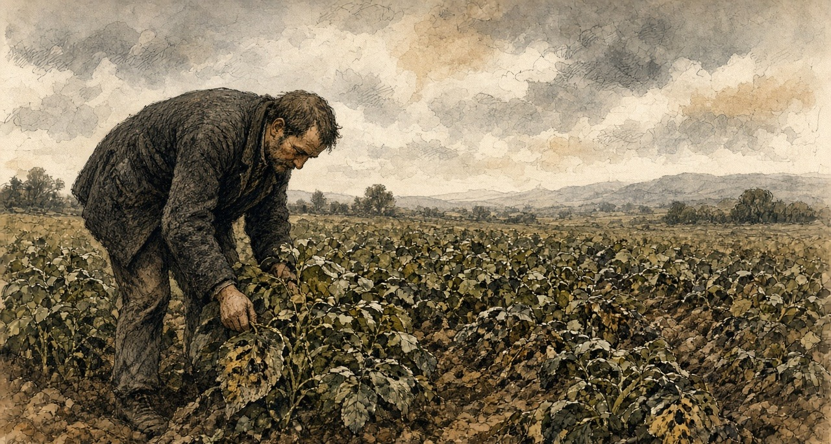
Three weeks later the presses were held for a late notice. "We stop the Press, with very great regret, to announce that the Potato Murrain has unequivocally declared itself in Ireland. The crops about Dublin are suddenly perishing." The same issue printed methods for turning potatoes into flour, and the notice ended on that. The conversion, the editor wrote, "becomes then a process of the first national importance; for where will Ireland be, in the event of a universal Potato rot?"
In Ireland the potato was the crop that was eaten. Sir Randolph Routh, the Commissary-General who would run the Government's food depots there, explained the other crops to the Treasury in January. "Oats and wheat and barley are not considered as food by the people; they are usually grown as means of payment for rent."
* * *
Whitehall, Netherby and Dublin Castle, October 1845
Sir Robert Peel wrote to the Home Secretary, Sir James Graham, from Whitehall on 13 October. He had the Irish reports in front of him and he gave his rule for them first. "There is such a tendency to exaggeration and inaccuracy in Irish reports that delay in acting upon them is always desirable." In the same letter he wrote down where his mind was going. "The removal of impediments to import is the only effectual remedy." The impediments were the Corn Laws, the duties that kept foreign grain out of the United Kingdom and kept the price of home-grown grain up for the men who owned the land.
Graham answered the same day from Netherby. Indian corn could be had from the United States cheaply, he wrote, if the people would eat it, "but unfortunately it is an acquired taste."
In Dublin the Lord Lieutenant, Lord Heytesbury, had Robert Kane of the Royal Dublin Society at work, and two professors sent over from England, Lindley himself and the chemist Lyon Playfair. On 24 October Heytesbury told Peel what made the counting impossible. "We constantly receive satisfactory reports of the state of the potatoes when dug, and learn a few days after that they have all rotted in the pits."
The three commissioners signed their first report the same day, in the Board Room of the Royal Dublin Society. The Irish Government printed it and sent it out through the constabulary to every part of the country. Moisture, they wrote, hastened the disease, and it passed from potato to potato by contact. People were not to pit the crop "in the usual way." They were to dry the potatoes, sort them, and lay them in single layers about two inches apart, with turf ashes or dry turf mould or sand or burned clay between, no more than four layers deep, and cover the heap with clay, straw or heath. "We particularly recommend that Potatoes should not be removed into inhabited rooms." They called the disease "an enemy whose history and habits are yet but imperfectly known."
Their second report, of 29 October, went further. Chloride of lime and salt, which people had been trying, only hastened the rot. Potatoes slightly diseased could be boiled and eaten. When "the tubers have acquired a disagreeable smell, their influence on the system is more questionable." The starch could be grated and washed out of a bad potato, a thing they found "already practised in most parts of the country," and they warned what starch alone would do. "An animal fed merely on starch dies of starvation, nearly, if not quite so soon, as if totally deprived of food." The rest of the potato could be cut in two or three and dried on a corn kiln, or on hurdles laid over a lime kiln, or on hurdles set on stones two or three feet high over a slow turf fire.
* * *
West Clare, near Kilkee, November and December 1845
Before the sun was over the hill on the Tuesday morning, smelled I it through the chink of the window-shutter. Not like a beast dead in the furze—for a heavy greasy stink is on a dead sheep—ach a sweet, cold, cellar-like smell, like cabbage-water that stood a month in a wooden tub. Put I not my brogues on me. Out over the ditch into the two-acre garden went I in my bare feet. And the stalks that were standing up to my waistband on the Sunday, purple in the blossom, were lying flat along the drills as if someone had gone over them with a boiling kettle. When I put my toe under a stalk to lift it, parted the stem from the root with a wet slip, and stayed the black slime of it between my toes. Dug we them in the rain and the police paper stuck inside the band of my hat. Read a sergeant of the constabulary it out at the chapel gate after last Mass—three gentlemen in Dublin that never handled a loy in their lives telling the parish of Querrin how to pit potatoes. Two inches apart, says the paper, and dry turf-mould between them, and bring them not into the dwelling-house. Where was dry turf-mould to be got at me in the November when the bog-holes were lipping over the road, unless I took the dry turf off the loft that was saved at us for the winter's fire? And where was I to sort forty barrels of Minions and the sleet driving level off the Atlantic, if not on the kitchen floor between the dresser and the bed? On our hams in the firelight sat we for three nights, the woman and the four childer and myself, and the rushlight stuck in a cleft stick in the wall. Takes a man a potato that looks as sound as a pebble on the strand, and presses he his thumb against the rose-end of it. Gives the skin with a little creak under the nail, is the brown in it. Got my little Mary, that is seven, the knack of it before any of us. Good, bad, good, bad—flinging the soft ones into the skib by the door until the small wrists were cramping on her, and the stink of the bruised pulp had the dog whining under the settle. Grated we twenty stone of the spotted ones on a piece of tin that I punched full of holes with a tenpenny nail and nailed to a board. Rubs a man the raw tuber up and down on the jagged tin until the skin is grated off his own knuckles, and run the bloody water and the black potato-juice down into the tub together. After three washings is a cake of white starch on the bottom, as hard and cold as a flagstone. Baked my wife a griddle-cake of it on the Thursday. White as a gentleman's biscuit was it, and chewed it like wet leather between the teeth. An hour after we ate it, was the little boy rolling on the hearthstone and his two hands knotted in the wool of his belly, roaring with the wind that was swelling him up like a blown calf, and his belly as empty of nourishment as a drum. Out in the haggard, stacked high on stone staddles and the clean straw rope networked over them to keep the wind off, stand six stacks of white oats that I reaped with my own hook. Took I a sheaf of them down and shelled I the grain into the quern to make a fist of meal for the child, would the driver have the keeper in my kitchen before dark at two shillings a day to watch the other five stacks for Mr. Westby's rent.
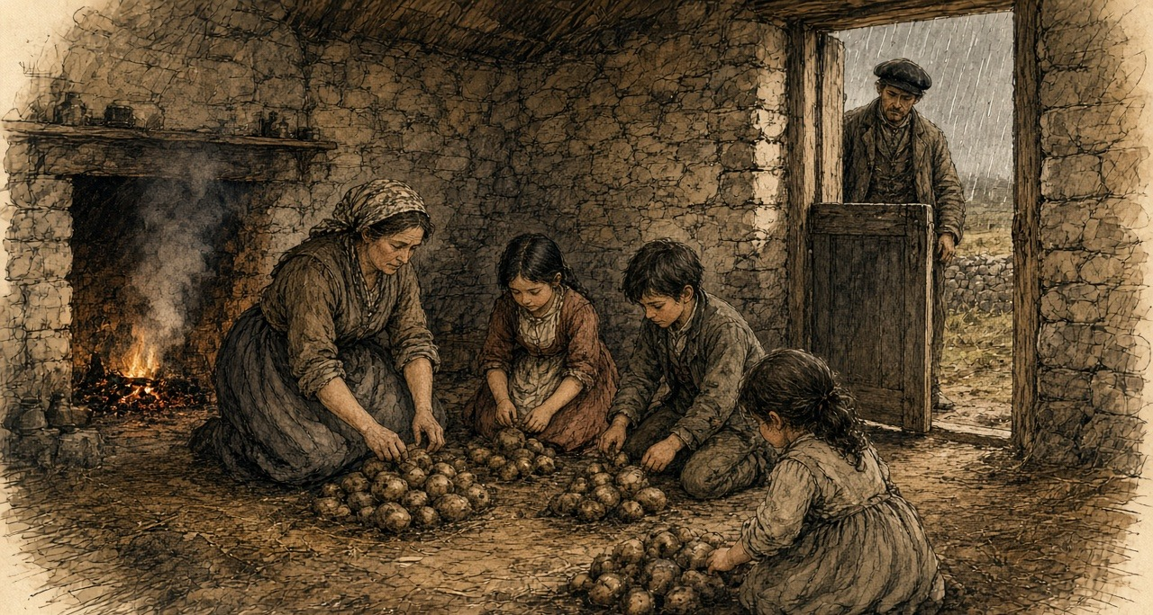
* * *
London and the Isle of Wight, November and December 1845
Lindley and Playfair went back to London and on 15 November wrote to Graham. They had been through the country between Dublin and Drogheda, through the counties of Dublin, Louth, Meath and Westmeath and part of Kildare. They gave him a number. "One-half of the actual Potato crop of Ireland is either destroyed or remains in a state unfit for the food of man. We moreover feel it our duty to apprize you, that we fear this to be a low estimate."
They named places. They had seen "a large field at Skerries, where not more than one Potato in twenty was found lying in a state which would admit of preservation; and another, near Oldbridge, in which, from the want of skill in the owner, all appeared to be perishing in the pits; and we have proof that these are not rare examples." An eighth of the crop had to be held back for seed. That left, they wrote, "only three-eighths of the crop" that could "be at this moment assumed to be available as food." On the question every official wanted answered, when the hunger would begin, they declined to guess. "We are not sufficiently acquainted with the habits of the Irish peasantry to be able to state at what time the want of food from the failure of their Potatoes may be first expected."
Heytesbury wrote again two days later. "How rely upon any calculation when the potatoes are perishing in the pits?"
The Cabinet had broken up on 6 November without agreeing to open the ports. Peel had put a sum before it on 31 October. A vote of credit for Ireland, "for instance, for 100,000l.," would raise the question of the Corn Laws the moment it was asked for. He then spent a sum of that size without asking Parliament for it at all. "Some days after the separation of the Cabinet on the 6th of November," he wrote afterwards, "I resolved (acting in concert with Sir James Graham and Mr. Goulburn) to take the unusual step of authorising a very large purchase of Indian corn in the United States on account of the Government." Goulburn was Chancellor of the Exchequer. The order went "secretly," through Barings, the London bank, "acting on behalf of the Treasury, that department undertaking the whole pecuniary responsibility." Among his purposes, he wrote, was "to habituate the Irish people to the consumption of a novel species of food."
The suggestion had come in on 5 November from Commissary-General Hewetson at Southampton. He wrote to Peel of his "long residence in North America as a public officer," and said that Indian corn meal, "by prompt and secret measures," could "be cheaply and readily purchased to any extent." Peel thanked him four days later.
The Treasury put it on paper on 9 December. The First Lord and the Chancellor of the Exchequer had "entered into an arrangement with the house of Messrs. Baring to provide a supply of Indian corn and meal to the extent of 100,000l., to be shipped from the United States and transmitted to Cork." The money was to come out of the Commissariat Chest, the army's own account for supply. The corn was to be stored in the naval storehouses at Cork. Hewetson was sent there to receive it.
Routh, who had been put on the Relief Commission in Dublin at the end of November, took no office. He worked from his hotel, he explained, because an office would tell people that relief was coming. On 20 December he wrote that he was glad to have kept the Indian corn secret, "of which no one has any idea or expectation."
In those same weeks Peel lost his government and got it back. Lord John Russell, the Whig leader, wrote from Edinburgh on 22 November that the Corn Law was "the blight of commerce and the bane of agriculture." Peel went to the Queen at Osborne on 5 December and resigned. Lord Stanley, in his own Cabinet, would not follow him on the corn duties. Russell tried to form a ministry and could not. On 20 December the Queen saw Peel at Windsor. "So far from taking leave of you, Sir Robert, I must require you to withdraw your resignation, and to remain in my service." He went back to work the same day. On 26 December he wrote to the Princess Lieven, "I feel like a man restored to life after his funeral service had been preached."
* * *
The Billiard Room, Kilkee, Saturday, 10 January 1846
The Relief Commission wanted its first local meeting to set the pattern for the rest. The pattern was money from the district first and help from the Government after. Kilkee was chosen, and the meeting was put off to Saturday, 10 January, so that more of the public could come. It was held in the Billiard Room.
Mr. H. Burton of Carrigaholt Castle took the chair. Robert Fitzgerald of Kilkee was vice-chairman. The Reverend M. Comyn, the parish priest, was there, and Dr. Tuite. The people of the parishes came in such numbers that few of the proprietors could get into the room. In the printed account the name of the man who brought them is a blank. "—— succeeded in filling the room assigned for the meeting with so large a body of the people, that very few of the proprietors could obtain access to it."
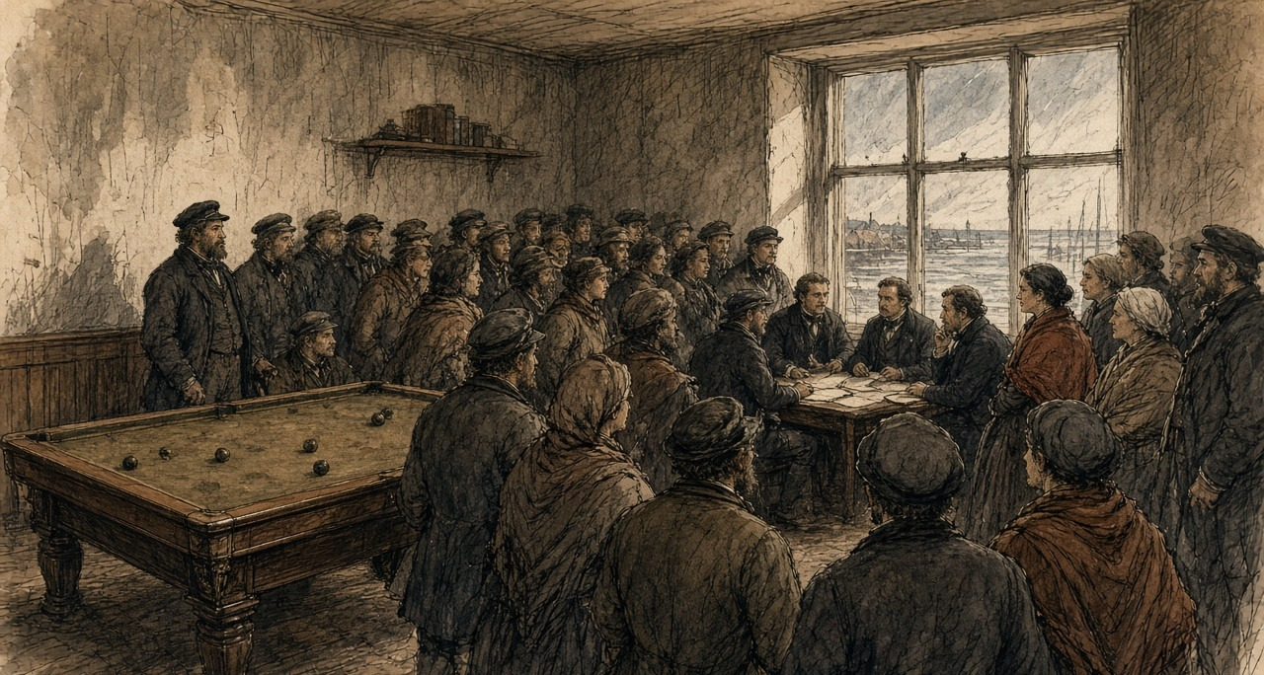
The meeting passed its resolutions. One was about the food. "The potatoes having now become so unfit for human use, that even the cattle are beginning to loathe them," the people were to be advised to stop eating them. Another was about the animals they had been feeding the rot to. "Pigs and fowl fed on diseased potatoes are found, on being slaughtered, to have their livers and intestines so singularly affected and rotten as to be convertible to no human use whatever."
The memorial for public works asked for a safe harbour in the bay of Doonbeg, for the bogs of the parishes to be drained, for roads along the cliffs, for a landing for the Kilkee fishermen's canoes and a pier at Movasta. It spoke for the labourers of the coast, who "have no objection or fear of cold from working in salt water in the most inclement weather." The memorialists were afraid to plant potatoes again in the old ground, "fearing it retains the malaria that has been so fatal the last season." A second memorial, from the proprietors, covered the parishes of Moyarta and Kilballyowen, the parishes of the Reverend Malachi Duggan. It said "that there are numbers now in actual want of food, and without the means of purchasing it."
Nobody offered money. Routh reported to the Treasury on 15 January that the meeting "has in a great measure failed." The labourers of the coast had offered to work in salt water in January. Hamilton, the agent, told Routh that the proprietors could neither advance funds nor give security for a loan.
* * *
Haulbowline and the Lee Mills, Cork, January to March 1846
Hewetson reached Cork in the first days of January and took the naval stores on Haulbowline Island in the harbour. On 12 January he was waiting on ships. The wind was "blowing hard from the south-east." He hired weighers at a guinea to twenty-five shillings a week. A Cork labourer, he noted, earned one shilling and threepence a day.
The Treasury sent its rules to Routh on 26 January. They were long and they came down to a few points. The landowners and ratepayers of a district were answerable, in law and in morals, for its poor. The Government would only help. Food was to be sold at cost and for ready money. Work was to be paid by the task, and no more than would buy enough food. Free relief was for those who could not work, and only when the workhouse was full. Every work was to be one that could be shut down at once.
The corn came in. Hewetson took the Lee Mills on the river and set every pair of stones to it. On 24 February he wrote that fourteen pairs were grinding, with one pair always with the dresser, and that he expected a thousand sacks a week, "each sack 20 stone, or 280 pounds." "Four extensive kilns are at work night and day." The ship Atlas had come into Cove with her corn heated in the hold, "in a bad state from heat, even to germinating." He meant to save what he could of it. The quartern loaf in Cork was eightpence.
He reported on the men who carried the sacks. "We have worked the people employed so hard, that they struck three times, to the great dismay of our contractor for unloading and lofting the corn: it is severe labour; 1100 sacks per day occasionally, each 280 lbs. in weight. The Cork merchants are quite astonished at our dispatch; they think 600 per day heavy work."
* * *
The stores, Cork harbour, February 1846
Two hundred and eighty pound is in the sack, and woven so thin and hard is the jute of the American bag that the seam of it cuts through a frieze shoulder-cape in three hours and saws straight into the meat of your neck. Lift you it not with your arms; if you put your arms to it, is the rupture on you before the dinner-bell. Under the hatch-coaming of the Atlas stand you while swings the winch-man the sling over, and tip two of the hold-gang the mouth of the sack onto the pad of straw that is tied behind your neck, and take you the twenty stone on the seventh bone of your spine and your chin driven down into your breastbone. Up the plank you go—eighteen inches wide, slick with the harbour drizzle and the yellow dust—up out of the ship and across the quay and up the two-and-thirty wooden steps to the third loft of the Lee Mills. Alive was that corn in the Atlas. When they took the main hatches off her at Haulbowline, came a steam up out of her belly like the steam off a dunghill in the frost, and when you went down the ladder into the hold, took the heat the breath out of your throat. Had the grain at the bottom got the bilge-water in the gale off the Banks, and was it fermented together into cakes the size of millstones, and white roots sprouted three inches long matted through the yellow maize, and the smell of it like sour whiskey-wash in a still-house. Had we to take the iron shovels and the pickaxes to quarry it out of the ribs of the ship before we could bag it. Rose the green mould-dust up in the lantern-light so thick that when we came up on deck at six o'clock, were we coughing green gobs into the tide. A thousand sacks a day wanted Hewetson out of us, and the kiln-fires roaring night and day under the perforated tiles to bake the sprout out of the rotten corn before it went between the French burrs. The third time we threw the sacks down on the quay and stood with our arms folded, came the contractor out of the counting-house and his watch in his hand, and pointed he down the river road to where two hundred countrymen from Kerry and West Cork were standing outside the iron gate in the rain, their faces the colour of tallow, watching the bread-crusts in our coat pockets. One-and-threepence a day, says he, and five hundred men are at the gate that will carry those sacks for tenpence. Back up the plank went we. By four in the afternoon had the sweat and the yellow meal-dust worked into the raw galls on my neck and set like plaster-of-Paris, so that every time I tipped a sack at the hopper, tore it the scab off the flesh. At the gate that night took I my fifteenpence and bought I two quartern loaves at eightpence the piece. A penny out of yesterday's wage on top of today's was that. When I took my shirt off by the candle at home, had my wife to soak the linen over my shoulder with warm water from the kettle before she could peel it off the blood.
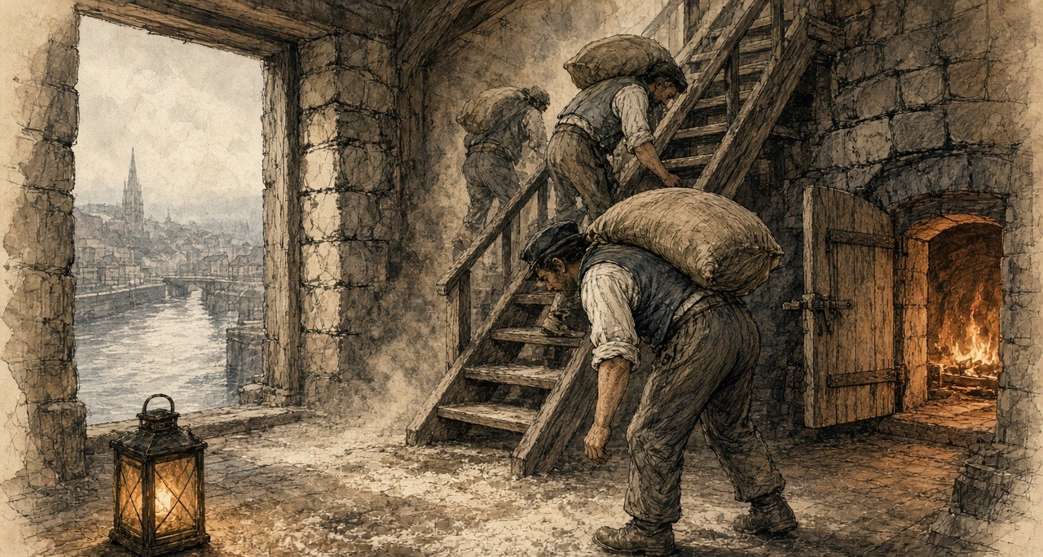
* * *
Dublin, Limerick and Carrigaholt, March and April 1846
On 6 March Routh, by then in an office at the Castle, wrote down a sum. "The price of labour is 8d. per diem; the price of the meal 1d., or thereabouts, per lb." A day's ration of the meal would cost twopence to twopence-halfpenny. He warned against paying a man in meal at that rate when his work was worth eightpence in money. The people were used to potatoes, he wrote, "which satisfy by repletion, and a more nourishing substance, which does not fill the stomach, leaves a craving sensation, a want of support and strength, as if they had not eaten enough."
The Treasury had already put the difficulty to him on 4 March. Pitched above oatmeal, the meal would earn the Government no thanks. Pitched much below, it would draw the custom of the whole country to the depots and damage the private trade.
On 13 March the Treasury fixed it. Their Lordships set the price at which the Indian corn meal was to be disposed of "at 1d. per pound," and desired "that all issues to Local Committees and others may be made at that price." "Prompt payment may invariably be required." Routh put the Adirondack's meal at ten shillings and sixpence the hundredweight, a little over a penny a pound. Hewetson had asked for the penny himself, from the Lee Mills, as one fixed rate for the whole country, and he had written down what it would cost. At that rate, with the steamers and the rest, "the balance sheet at the close of this service will be much against the public." In Sligo, the commissary there found Indian meal from Armagh selling at eleven shillings to eleven and sixpence the hundredweight, and oatmeal at sixteen.
A large issue went out at Limerick at the penny. By 2 April Routh wanted it back. "The demands on our depots are increasing fast, and the inconvenient precedent of the large issue at Limerick, at 1d. per lb. holds out an invitation to them, which I find it difficult to combat." "I must raise the price to 11s. per cwt., otherwise the whole country will be on us." The dealers, he wrote, were holding back their stocks for May, June, July and August. The printer had been told to stop giving out the Indian Corn Pamphlet, the instructions for cooking the meal, and sell it at a halfpenny. "The demand is beyond credibility."
Captain Mann, R.N., the Commission's officer at Kilrush, went down the peninsula in April. At Kilbaha seed potatoes were sixpence a stone, two pounds a barrel of ninety-six stone. At Carrigaholt he found the distress among the tenants and labourers of Knock "fully borne out," and ordered four more barrels of Indian meal sold there at one shilling and threepence a stone, fourteen pounds for fifteen pence. Mr. Burton and Mr. Duggin were willing to buy meal for the poor, but there was "Not a person but themselves resident who could contribute, and I am sorry to say that positive refusals to contribute from landlords non-resident were shown to me." "It is the general opinion of respectable persons," he wrote, "that but for the Indian corn meal that is in, and daily arriving in the river, potatoes would be 12d. per stone."
In some parts of Clare, "such as Kilkee and Kilrush," Routh reported in March, there seemed to be "a determination to subscribe nothing." The Board of Works then had 1,600 men at work in the county. On 31 March he wrote that it had 5,487. In Ennis two hundred pounds had been raised in one day. At Kilrush they were beginning to subscribe. "Colonel Vandeleur sent down 50l. yesterday."
Commissary-General Coffin wrote from Limerick on 11 April that he was "so thoroughly persuaded of the general truth of the principles laid down by Burke, in his Thoughts and Details on Scarcity," that he excused the Government's interference rather than praised it. Burke's maxims worked, Coffin went on, only for those who had an interest in the struggle of the market, "and the unfortunate Irish cottier has none. His condition excludes him from the circle in which commerce revolves, and as his labour avails him only for the direct production of the food on which he depends for subsistence, the failure of that food leaves him incapable of profiting by the resources of the market, and consequently liable to starve in the midst of plenty."
In Tipperary that month food was seized around Clonmel and Carrick-on-Suir. Deputy Commissary-General Dobree wrote from Waterford on 24 April that the crowds "confined their outrages to the robbery of food, and dispersed immediately on the arrival of the military." The magistrates ordered the soldiers to fire. The commanding officer "declined complying with the magistrates' order to fire, as he felt he had force to quell the riot, and seize the ringleaders, without bloodshed." After that, Dobree wrote, no one tried to move food through the country "without a strong escort." Clonmel subscribed five hundred pounds, Routh reported, and the Lord Lieutenant matched it. At Carrick-on-Suir a crowd attacked the men on a Board of Works road, carried off their tools, and told them not to work for less than one shilling and sixpence a day. The Board paid tenpence. Lieutenant-Colonel Jones, the chairman of the Board of Works, wrote to the Treasury on 18 April. The disturbances "were not famine riots, but a regular set to for plunder. I understand the women were all provided with bags, and as soon as they filled them with meal, off they started."
* * *
A relief road in the west, May to July 1846
Parliament had passed the Act on 5 March. Half the cost of a relief road was to come from the Treasury as a grant. The other half was to be presented on the barony and paid back by the ratepayers.
Put your eye on that road going up into the red bog behind Knock. Forty feet wide between the gripes, boxed with broken limestone, leading from the crossroads where lives no soul to the turf-bank where goes no foot, and stops it dead against a face of black peat six feet high, like a wall built across a doorway. Six weeks were we cutting down the hill at Caherlean to fill the hollow, and when rode the new engineer out from Ennis on the Wednesday, looked he at his paper and said he the gradient was wrong, and set he the two hundred of us to wheeling the same stones back up the hill to fill the cutting we had just made. Has a man that ate fourteen pound of boiled Lumpers a day since he was weaned a stomach on him the size of a three-gallon firkin; needs the bulk of the potato to press against the ribs until the brain thinks the work is done. Now take you a pound of this yellow American dust—Peel's brimstone, the boys call it—that we buy at the store for a penny. Because the woman has no knowledge of the nature of the foreign grain, boils she it twenty minutes in the pot, the way she would boil oatmeal, instead of the two hours it wants. Swallow you it down at dark. In the bottom of your belly lies it like a fistful of wet sea-sand, heavy and small, and grates every sharp, unburst flint corner of the maize against the lining of your guts as it goes through you. By the midnight begins the griping, and before the sky is grey are you out behind the cabin in the nettles three times, passing blood and raw yellow grit. When you lift the fourteen-pound sledge on the rock at seven, is a hollow under your breastbone big enough to put your hat in, and black spots dancing like midges between your eyes and the stone. In April, when we started, could Pat Sullivan wheel three hundredweight of quarry spalls up a greased plank at a trot and tip it without laying his handles down. Yesterday watched I him at the barrow. Bent he his knees to the shafts, and stood the tendons in his wrists out like cords under the loose brown skin, and stirred the barrow never from the rut. Stood he up and looked he at his two hands as if to a stranger they belonged, and sat he down on the upturned wheel and wept he like a weaning child while the check-clerk was calling the roll. Every other May since I was sixteen, was the reaping-hook wrapped in straw under my arm and the brogues tied round my neck, walking to Dublin for the fourpenny deck-passage to Liverpool and the hay-harvest in Cheshire. Four gold sovereigns sewed in your waistband would you bring home at Michaelmas to clear the rent. This year could I not leave the doorstep. Walks a man two miles from the parish, strikes the committee his name off the ticket-list, and gives the meal-dealer not a pound of meal on trust to the wife. Come you back from England in the October, would you find the door hasped on the inside and the four of them dead on the floor. Tenpence a day get we for moving a hill into a bog-hole, and gone up to two shillings the stone is the meal in the huckster's barrel because the Government shut the depot.
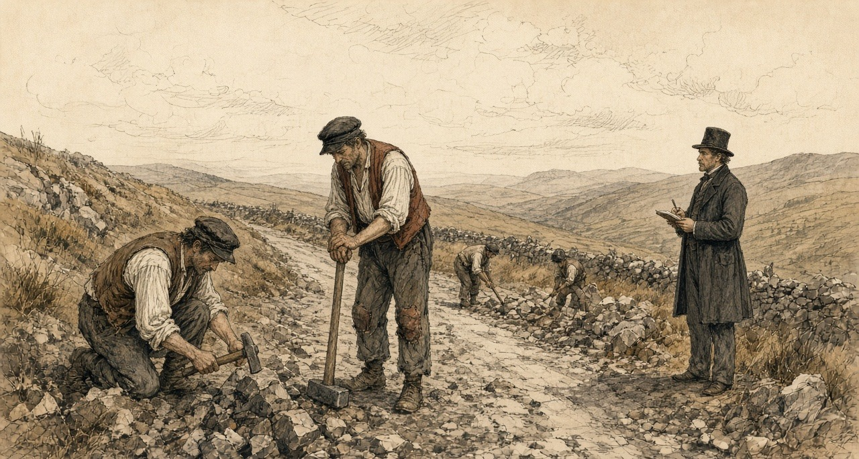
* * *
The House of Commons and the House of Lords, May and June 1846
The Corn Importation Bill had its third reading in the Commons at the sitting of 15 May. Benjamin Disraeli spoke against it, and against the use of Irish hunger as its reason. "The population is reduced to the lowest sources of subsistence. Admitted; but how do they gain even their potatoes except by cultivating the soil, and by producing that wheat and those oats which they send to England? I should be very glad if that wheat and those oats remained in Ireland."
Mr. Hudson, a protectionist, gave the House the price of wheat at Burlington, thirty-eight shillings and tenpence, and said it was "so far from any sign of famine manifesting itself." Peel answered for November. "I did feel in November last that there was just cause for apprehension of scarcity and famine in Ireland." The House divided. Ayes, 327. Noes, 229. Majority, 98.
In the Lords the Duke of Wellington, who had stayed in the Cabinet with Peel, told the peers on 28 May what would happen to them if they threw the Bill out against the Crown and the Commons. "Without the Crown or the House of Commons you can do nothing." The second reading carried, 211 to 164.
Both Houses voted on 25 June. In the Lords the Corn Importation Bill was "read a third time, and passed," with cries of "Not-content." In the Commons, the same night, the question was the Protection of Life (Ireland) Bill, the Government's measure against outrage. Richard Cobden told the House what Lord George Bentinck, the leader of the protectionists, had said the vote was for, as Cobden heard him: "it must be the object of every honest man to inflict summary punishment upon the traitor." Bentinck went into the lobby against the Bill. So did Disraeli, Lord John Russell, Daniel O'Connell and William Smith O'Brien. Ayes, 219. Noes, 292. Majority against the Government, 73.
On 29 June Peel told the Commons that he had resigned. The House had defeated him, he said, by "refusing to give to Her Majesty's servants those powers which they deemed necessary for the repression of outrage and the protection of life in Ireland." He gave the credit for repeal to one name, "RICHARD COBDEN." He ended on bread. "It may be that I shall leave a name sometimes remembered with expressions of good will in the abodes of those whose lot it is to labour, and to earn their daily bread by the sweat of their brow, when they shall recruit their exhausted strength with abundant and untaxed food, the sweeter because it is no longer leavened by a sense of injustice."
Under the Act the duties on wheat, barley and oats came down by stages, to a shilling a quarter from February 1849.
* * *
The meal stores, Killarney, Friday and Saturday, 10 and 11 July 1846
There were five carts of potatoes in the market at Killarney on the Saturday. Five carts with one horse each, for the town and all the country around it. The price on them was a price for the gentry.
Nine miles from the Gap of Dunloe walked I it, and the sixpenny-bit under my tongue so could no hand pick it out of my pocket in the press. When I came into the Kenmare road at three in the morning, was the street before the Market House solid with heads from wall to wall. Saw you not the cobblestones—ach the grey shawls of the women and the caubeens of the men packed together in the mist, and a low, steady humming noise coming out of four thousand throats. No shouting yet, ach the breath and the muttering of people that had no sleep on them. By ten o'clock was the July sun blazing down between the slates, and so tight was the crush that my two arms were pinned flat against my ribs. Could I not lift my hand to wipe the sweat out of my eyes. Had a woman from Glenflesk in front of me a dead child under her shawl. Knowledge was at me that dead it was by the way rolled the little head loose against my chest when the crowd surged, and the cold of its foot through the cloth against my wrist. And she would not let on nor work her way out, for lost she her place at the barrier, would the other three at home be dead before the Monday. The smell of us in that sun was the smell of unwashed wool soaked in famine-sweat, and sour breath, and the filth running down the legs of old men that stood twelve hours in their breeches without room to step aside. When threw the peelers the half-door open at the ticket-window, gave the street a heave like a wave hitting a rock, and was I carried twelve feet forward without my brogues touching the ground. Went my ribs crack against the oak post of the door. Spat I the sixpence into my palm, slimy with the blood where the edge of the silver had cut the inside of my cheek, and slapped I it down on the sill, and shoved a gentleman with his coat off and the sweat dripping off his whiskers a bit of blue pasteboard into my fist. Six pound, shouts he at me, and get out by the back lane. Six pound of dry meal tied in the tail of my shirt, to last seven mouths from the Saturday night to the Tuesday morning. Coming out through the archway by the shambles, made three ragged lads from the mountain a rush at the knot in my shirt with a clasp-knife, to slit the linen and catch the spill in their hats. Struck I the foremost one square in the mouth with my elbow, and felt I his loose teeth give under the bone of my arm, and ran I the three miles to the Flesk bridge with my two hands locked over my belly like a dog carrying a bone out of a fair.
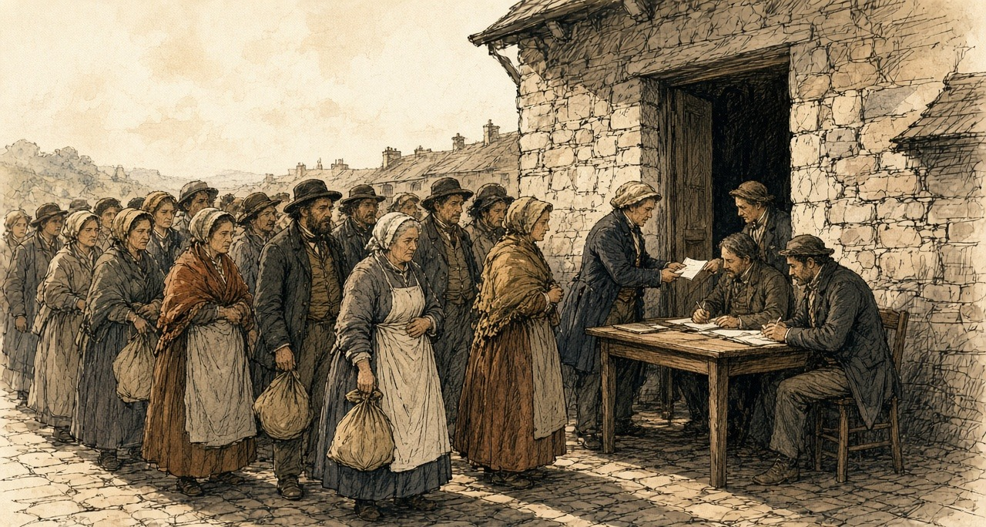
The Killarney committee sent the Government a cheque for two hundred pounds that day, for twenty tons more. It had sold three thousand four hundred tickets the day before. On the Saturday it sold four thousand seven hundred and eighty-two. Mr. Saunders, writing for the committee, put the people who came to the store at about fifty thousand.
* * *
Banagher, the Killeries and Dublin Castle, June to August 1846
Captain Pole kept the depot at Banagher, on the Shannon. On 22 June he wrote to the Treasury in praise of the rules. They had said to the rich, "You shall have no cheap food, or help in money, unless you yourselves subscribe." Consenting, the rich had turned to the poor and said, "You, too, shall have no food unless you labour for it." He sold about a thousand pounds of meal a day over his own counter in small lots, to people who came twelve miles. July, he wrote, "bears the name of 'the meal month.'"
A small farmer walked twelve miles to Pole's room with a letter from his priest. Pole asked him why he did not go to the committee near his home. The man said he would sooner starve. "By going to the Committee I proclaim myself a pauper — by coming to you I purchase from the Government, what the Government have provided for those who have suffered loss." Pole sold him a sack. On 13 July Pole wrote again. "My mighty storehouse, which once seemed to defy the appetite of whole counties, has been nearly emptied."
At Westport, Captain Perceval loaded twenty tons of meal on the steamer Vulcan at two in the morning of 22 June and sent fifty-five tons that day to Belmullet, Achill Bay, Dugort and Bull's Mouth. The commander of the revenue cutter Eliza called on him the same day. On his last trip to the Killeries a boat had pulled alongside and the men in it had begged food for one of their crew, who lay "stretched out half dead, and was unable to eat the bread" the commander gave him. He described the others in the boat, the "emaciated countenance and prominent eye-balls."
Lord John Russell was Prime Minister from the end of June. On 21 July his new Board of Treasury issued a Minute on the relief works. Their Lordships were "deeply sensible" that the measures of the past months were "at variance with the principles by which the well-being of society is ordinarily regulated," and that "great and permanent evils would be the result of any portion of the people becoming habituated to depend upon the Government for support." They had heard that the men on the roads were "preferring the receipt of an eleemosynary allowance under the name of wages, to higher wages proportioned to the labour performed." The inspectors were to cut the lists to those with "no other means of subsistence." "Secondly. The wages to be paid are also, in every case, according to the rule which has been repeatedly enjoined, to be fixed below the usual rate of wages in the neighbourhood." Works were to be closed, and each given a date to end.
On the day of the Minute, Jones sent the Treasury his weekly return. "What I foresaw early in the year is now verified; every man in the country who wants work, is forced upon us; we cannot help ourselves." In the week ended 18 July the Board had paid for 109,052 days' labour in Clare alone, more than in any other county. In the week ended 25 July the count for Ireland was 502,689 days, an average of 83,781 men on the works each working day.
The new Chancellor of the Exchequer would not refill the stores at Cork. The merchants' own cargoes had sat unsold, the Treasury said, because of the Government's sales. Committees were to buy from the private holders. Free donations stopped on 10 August. The depots stopped issuing meal on 15 August. In early August Routh cut the depot price from ten pounds a ton to nine, because the dealers were selling at nine and some at eight pounds ten.
The Treasury drew up the account. Indian corn and oatmeal, with freight, grinding and the rest, £185,432 7s. 7d. Against that stood the sales to 15 July, £70,171 6s. 5d., a further £60,000 of sales expected by 15 August, and the insurance recovered on the cargo of the Arab, lost at sea. The balance left on the public was £50,481 5s. 5d. The works under the first Act of the session had cost £452,727 14s. 8d., and half of that was to be paid back by the baronies. Of £852,481 9s. 7d. spent on relief in Ireland since November 1845, £494,851 7s. 9d. was to be repaid. The food bought came to 44,121,574½ pounds. At a pound a person a day, the statement reckoned, that would feed 490,240 people for three months. The census of 1841 had counted 8,175,124 people in Ireland.
* * *
The road from Cork to Dublin, 27 July to 3 August 1846
Father Theobald Mathew made the journey to Dublin and back that summer, and on 7 August he wrote to the Treasury from Cork. "On the 27th of last month I passed from Cork to Dublin, and this doomed plant bloomed in all the luxuriance of an abundant harvest. Returning on the 3rd instant, I beheld, with sorrow, one wide waste of putrifying vegetation. In many places the wretched people were seated on the fences of their decaying gardens, wringing their hands and wailing bitterly the destruction that had left them foodless."
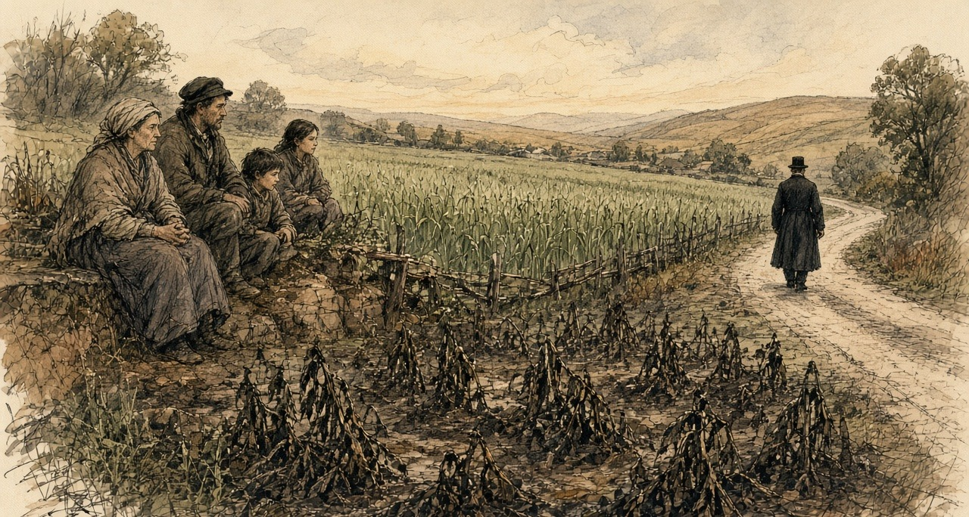
At Limerick on 4 August Major Simmonds reported on the grain. "Nothing can be finer than the corn crops now being cut."
The stalks are black again. A week ago they were green and high and in flower. Then the spots on the leaves, and the smell coming up off the field in the morning, and the stalks lying down.
I am sitting on the ditch. My wife is beside me. Below us the field is the field from last year.
The oats are coming ripe in the next field. The meal store is to shut on the fifteenth. The road is to shut on a day the inspector will name.
Chapter 8 Appendix of Important Names
• Baring, Evelyn (Lord Cromer) (1 mentions in this chapter): British Commissioner of the Public Debt and long-serving Consul-General in Egypt (1883–1907).
• Begin, Menachem (1 mentions in this chapter): Commander of the revisionist Zionist underground organization Irgun Zvai Leumi in Mandate Palestine.
• Disraeli, Benjamin (2 mentions in this chapter): British Prime Minister who arranged the 1875 purchase of Khedive Ismail's Suez Canal shares with Rothschild financing.
• O'Connell, Daniel (1 mentions in this chapter): Irish political leader who led the campaigns for Catholic Emancipation and the Repeal of the Union.
• Peel, Robert (11 mentions in this chapter): British Chief Secretary for Ireland and Prime Minister who repealed the Corn Laws during the Great Famine in 1846.
• Russell, Lord John (4 mentions in this chapter): British Whig Prime Minister during the height of the Irish Famine (1846–1852).
Sources
• The Gardeners' Chronicle and Agricultural Gazette, London, 1845: leading article of 23 August (the "fatal malady," the black spot, the haulm, the "offensive odour," Covent Garden, the cause "traceable to the season"); 13 September ("We stop the Press," the crops about Dublin, "where will Ireland be"); 1 November (the Commissioners Kane, Playfair and Lindley, and their first report, Board Room of the Royal Dublin Society, 24 October 1845, distributed by the constabulary: drying, sorting and layering in turf ashes, potatoes not to be taken into inhabited rooms); 8 November (second report, 29 October 1845: chloride of lime and salt, boiled diseased potatoes, the "disagreeable smell," starch extraction, the animal fed on starch, kiln-drying on corn kilns, lime kilns and hurdles over turf fires).
• Potatoes (Ireland). Copy of the Report of Dr. Playfair and Mr. Lindley on the present state of the Irish Potato Crop, and on the Prospect of Approaching Scarcity, London, 15 November 1845, addressed to Sir James Graham; presented to the House of Commons, February 1846, HC 1846 (28) (the counties visited, "one-half," Skerries and Oldbridge, three-eighths available as food, the habits of the Irish peasantry).
• Memoirs by the Right Honourable Sir Robert Peel, published by the trustees of his papers, Lord Mahon and Edward Cardwell. Part III, The New Government, 1841; Repeal of the Corn Laws, 1845-6. London: John Murray, 1857 (Peel to Graham, 13 October 1845; Graham to Peel, 13 October 1845; Heytesbury to Peel, 24 October and 17 November 1845; Peel's memorandum read to the Cabinet, 31 October 1845, on a vote of credit "for instance, for 100,000l."; the purchase of Indian corn through Barings after 6 November; Russell's Edinburgh letter, 22 November 1845; Peel's resignation at Osborne, 5 December 1845; Lord Stanley; the Queen's words at Windsor and the resumption of office, 20 December 1845; Peel to the Princess Lieven, 26 December 1845).
• Correspondence explanatory of the Measures adopted by Her Majesty's Government for the Relief of Distress arising from the Failure of the Potato Crop in Ireland. Commissariat Series and Board of Works Series. London: HMSO, 1846 (HC 1846 [735] XXXVII). Commissariat: Hewetson to Peel, Southampton, 5 November 1845, and reply, 9 November (p. 1); Treasury to Routh, 27 November 1845; Treasury Minute, 9 December 1845 (Barings, 100,000l., Cork, the Commissariat Chest); Routh, 3 and 20 December 1845 (the hotel; the secret corn); Routh, 1 January 1846 (oats and barley grown for rent); Hewetson, Cork, 12 January 1846 (Haulbowline, weighers' and labourers' wages, the wind); Routh, 15 January 1846, with the resolutions and memorials of the Kilkee meeting of 10 January (pp. 9-13); Treasury instructions to Routh, 26 January 1846; Hewetson on the price and the balance sheet (p. 64); Hewetson, Cork, 24 February 1846 (the Lee Mills, the kilns, the Atlas, the quartern loaf, the strikes, 1,100 sacks of 280 lbs.); Treasury to Routh, 4 March 1846, on the price to be fixed (p. 54); Routh, 6 March 1846 (the price of labour and of meal, the ration, the "craving sensation," p. 56); Routh, 9 March 1846 (the Adirondack's meal at 10s. 6d. per cwt.), with Sligo prices; Treasury Minute, 13 March 1846 (1d. per pound, prompt payment, p. 64); Routh, 2 April 1846 (Limerick, 11s. per cwt., the Indian Corn Pamphlet, p. 88); Routh on Kilkee and Kilrush and the 1,600 men (p. 79) and, 31 March 1846, on the 5,487 men in Clare, Ennis and Colonel Vandeleur (p. 84); Captain Mann, Kilrush, 11 April 1846 (Kilbaha, Carrigaholt, 1s. 3d. per stone, Mr. Burton and Mr. Duggin, the refusals of non-resident landlords, p. 98); Coffin, Limerick, 11 April 1846 (Burke's Thoughts and Details on Scarcity, "starve in the midst of plenty," p. 99); Jones, 18 April 1846 (Tipperary, Carrick-on-Suir, 10d. a day, p. 109); Routh, 17 April 1846 (the Clonmel subscription); Dobree, Waterford, 24 April 1846 (Clonmel, the order to fire, the escorts, p. 122); Captain Perceval, Westport, 19 June 1846 (Cong, Mr. Moore and Mr. Waldron, the enfeebled men, the "cheap diet," pp. 167-8) and 22 June 1846 (the Vulcan, the Eliza and the Killeries, p. 171); Captain Pole, Banagher, 22 June 1846 (pp. 170-1) and 13 July 1846 (the small farmer, the "mighty storehouse," pp. 205-6); Saunders, Flesk, Killarney, 11 July 1846 (p. 204), with the ticket returns for 10 and 11 July; Routh, 5 August 1846 (the price reduced to 9l. a ton); Major Simmonds, Limerick, 4 August 1846; the account of the Indian corn and oatmeal, with the balance of £50,481 5s. 5d.; the Statement of the Total Expenditure for Purposes of Relief in Ireland since November 1845 (p. iv). Board of Works: the Act 9 Vict. c. 1 and the half-grant; returns of men employed for the weeks ended 4, 11, 18 and 25 July 1846 and the county abstract for the week ended 18 July; Treasury Minute of 21 July 1846 (pp. 341-2); Jones to Trevelyan, 21 July 1846.
• Correspondence from July 1846 to January 1847, relating to the Measures adopted for the Relief of the Distress in Ireland. Commissariat Series. London: HMSO, 1847: the Rev. Theobald Mathew to Trevelyan, Cork, 7 August 1846.
• Hansard, House of Commons Debates. HC Deb 15 May 1846, vol. 86, Corn Importation Bill, third reading: Disraeli, Hudson, Peel; division, Ayes 327, Noes 229. HC Deb 25 June 1846, vol. 87, Protection of Life (Ireland) Bill, second reading: Cobden; division, Ayes 219, Noes 292. HC Deb 29 June 1846, vol. 87, Ministerial Explanations: Peel's statement of resignation.
• The Corn Importation Act, 9 & 10 Vict. c. 22 (26 June 1846), schedule of duties.
• Hansard, House of Lords Debates. HL Deb 28 May 1846, vol. 86, Corn Importation Bill, adjourned debate on the second reading: the Duke of Wellington; division, Contents 211, Non-Contents 164. HL Deb 25 June 1846, vol. 87, Corn Importation Bill, third reading.
• Report of the Commissioners appointed to take the Census of Ireland for the year 1841. Dublin: Alexander Thom for HMSO, 1843 (HC 1843 [504] XXIV): total population 8,175,124.

Chapter 9
Twelve O'Clock Precisely, 1846–1847
Foynes, Cork, London, West Carbery, the county of Clare and the House of Commons, September 1846 to September 1847
Lord Monteagle wrote his letters at Mount Trenchard, the family house above the Shannon near Foynes, in the county of Limerick. As Thomas Spring Rice he had been Chancellor of the Exchequer from 1835 to 1839. In the autumn of 1846 he was the chairman of the relief sessions at Shanagolden, a village a few miles inland, and the new public works for his district were not yet begun.
On 27 September he wrote to Henry Labouchere, the Chief Secretary for Ireland, against a county meeting to demand an early session of Parliament. "We have … more than enough to do organising our committees of our public works and we should not be taken off from this pressing duty to the excitement of hustings speaking."
Three days later he wrote to Richard Griffith of the Board of Works, and he wrote faster. "Do not think me impatient but the pressure which is likely to come upon us is something very formidable indeed. Hitherto the confidence which the people place in me and in mine has preserved tranquillity and we have been ably seconded by the R.C. clergy who are acting cordially with us. But this cannot last very long." He wanted the Foynes works hurried on, "for at present we have no kind of employment along that district N. of Shanagolden and extending between your road and the river."
On 1 October he wrote to the Treasury.
* * *
The Treasury, Whitehall, Friday, 9 October 1846
Charles Trevelyan was Assistant Secretary to the Treasury, and he kept copies of his letters in bound books. His answer to Monteagle ran to thirty-five pages. It opened on the receipt of the post.
"My dear Lord, I have had the pleasure of receiving your letters dated 1st instant, and before proceeding to the subjects more particularly treated in it, I must beg of you to dismiss all doubt from your mind of the magnitude of the existing calamity and its danger not being fully known and appreciated in Downing Street."
The government establishments, he went on, were "strained to the utmost to alleviate this great calamity and avert this danger."
Further on he set out what government was for. "It forms no part of the functions of government to provide supplies of food or to increase the productive powers of the land." The landlords had their part, and he wrote what he thought of the way they were playing it. "The nobility and gentry have met in their respective baronies … calling upon the government to do everything, as if they have themselves no part to perform in this great crisis of the country."
Then he wrote about Providence.
"I think I see a bright light shining in the distance through the dark cloud which at present hangs over Ireland. A remedy has already been applied to that portion of the maladies of Ireland which was traceable to political causes, and the morbid habits which still to a certain extent survive are gradually giving way to more healthy action. The deep and inveterate root of social evil remains, and I hope I am not guilty of irreverence in thinking that, this being altogether beyond the power of man, the cure has been applied by the direct stroke of an all-wise Providence in a manner as unexpected and unthought of as it is likely to be effectual. God grant that we may rightly perform our part and not turn into a curse what was intended for a blessing."
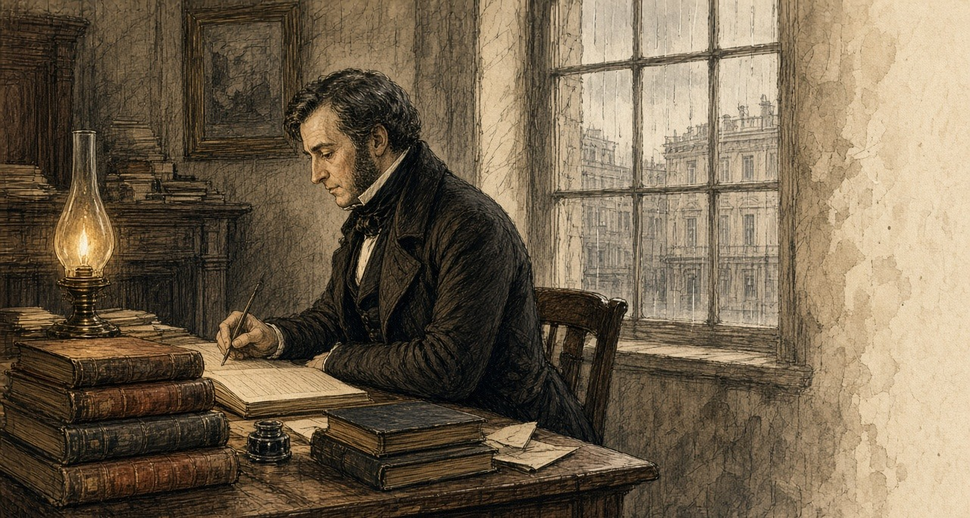
The law the works ran under had passed at the end of August, the Act 9 & 10 Vict. c. 107. Under it the gentlemen and ratepayers of each barony met at extraordinary presentment sessions and voted the works, and the money was advanced from the Treasury and charged back on the barony. Trevelyan described the sessions himself, in print, a year and a quarter later. In the southern and western counties roads were "presented in the mass," at a cost which "in some cases, much exceeded the annual rental of the barony."
* * *
Anderson's Quay, Cork, Friday, 9 October 1846
The same day, in Cork, a merchant named Nicholas Cummins sat down to his own letter to Trevelyan. He was the managing partner of the house of N. and J. Cummins, on Anderson's Quay, and the Cork correspondent of Barings, the London bank through which Sir Robert Peel had bought his Indian corn the winter before. In September Commissary-General Hewetson had commended him to the Treasury as "an intelligent and upright man." He sent Trevelyan the Cork markets by letter, at Trevelyan's own desire.
"My last respects were of the 1st instant; since when our corn markets have continued to be largely supplied with home produce, prices of which have been receding for the last few days; Indian corn is unchanged in value; shipments of oats from this port are beginning to take place: during the week they have amounted to about 12,000 barrels of 14 stone; there has also been some small export of flour and oatmeal."
Twelve thousand barrels of fourteen stone is a hundred and sixty-eight thousand stone of oats, the grain that in Routh's words of the January before was grown "as means of payment for rent." It went out of Cork harbour in a week.
Cummins had better news from the coast. "A most abundant and providential take of fish, especially herrings, has greatly contributed to relieve the distress during the last 10 days in the coast districts; the supply of herrings, when salted, enables the people to make use of the remnant of the potato crop, which could scarcely be eaten without them."
Some of the county's presentment sessions, he reported, had voted works "in many cases exceeding the entire annual valuation." And he noted a price. The farmers wanted bere, the barley that ripens a month before any other grain, for seed, and it had "run up from 12s. to 25s. the barrel of 16 stone."
* * *
The relief road, west Clare, November 1846
Shut they the summer road on us in the month of August, and opened they the new line when the gentlemen sat at the presentment sessions. Is the same rule in it: the ticket. Takes a man the ticket from the committee, and shows he it to the steward, and writes the check-the clerk name down in the book.
Is task-work that is on us now. Is no penny given for the length of the day, ach for the weight of the rock you break. Walks the steward down the drain in the dusk with the measuring-rod in his hand, and measures he the perch of bank you out and the heap of stones you sledged, and is that your wage on the Saturday—if pleases the pay-clerk to ride out on the Saturday.
Came he not at all the last week. Until the Tuesday after were we fasting on the ditches waiting for him.
Are the palms of my two hands gone soft as a child's with the want of the solid food. Peels the skin off them on the shaft of the wheel-barrow, and goes the blood soaking into the timber, and in the frost of the morning is the hand stiffened into a claw, so that it is slow you pry the fingers open.
Are hundreds of us crowded on this one cutting. Men out of the red bogs, men up from the strands. The poor wandering people that came in from Kerry and Cork in the old years to cut the red wrack on the rocks and threw up their scalpeens in the sand-hills—are they besides us too. Says the Board's officer that the list is too heavy. Walks he down the line with the book and strikes he the names out with his pencil, one after another, and stand the men he strikes by the gripe of the ditch with the loy still in their hands, looking at him.
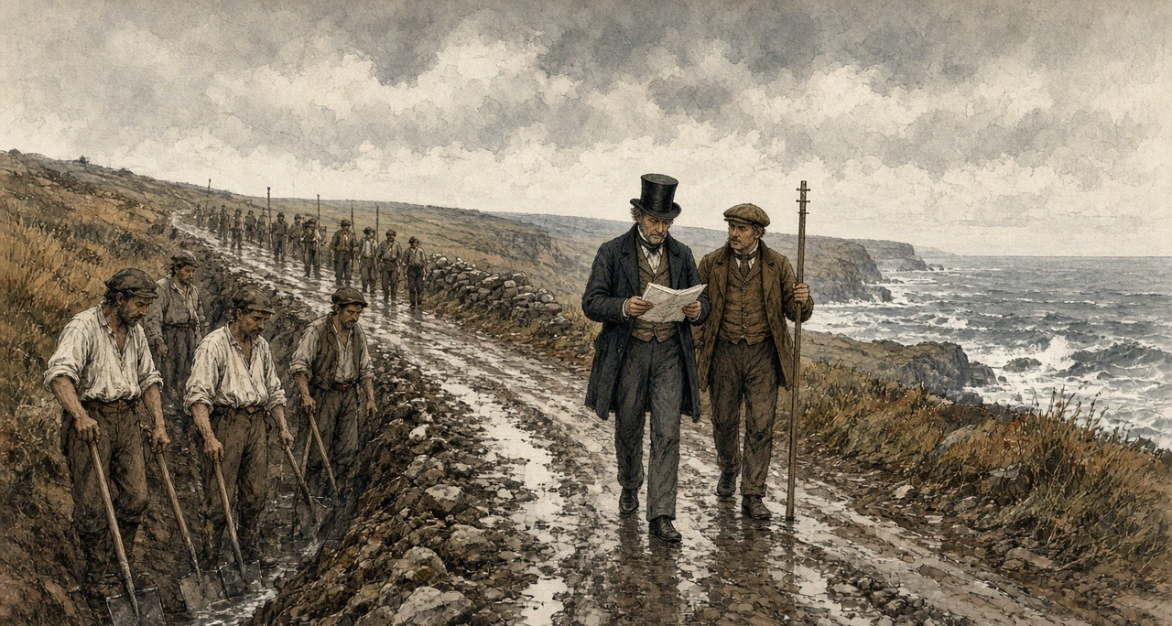
Left he my name in the book.
Rises the Indian meal at the huckster's every market-days. Buys the Saturday's silver less on the Monday than it bought the week before. Boils the woman of the house the yellow dust in the big water so it will stretch round the children, and lades she the thick setting off the iron bottom into my noggin, for is it on my two legs the road depends. I put no question to her on what goes into her own mouth.
Went her good shawl to the dawn in Kilrush first, and went my freeze coat after it. Stands a man in his linen shirt on the hill now, in the black month of November, over the sea. Bionn the gale off the great ocean driving in over Kilkee and the rain flat as a slate in it. In the dark of the night is the little one wedged between the two of us in the bracket, and not a thread of a blanket over our bones.
* * *
Ennis and Clare Castle, Saturday, 5 December 1846
Captain Edmund Wynne was an inspecting officer of the Board of Works, at Ennis. In the barony of Moyarta, the barony of Kilkee and Carrigaholt, he had a Mr. Marcus Keane look into the state of the townlands, and on 5 December he gave the Board the answer. "Including the remnant of the potato crop, there are not provisions for three weeks, and these, too, in the hands of a few individuals. Now, at the expiration of this period, all the money in the Treasury cannot meet the wants of the frightful population in that district without importing provisions."
Along the coast, he believed, the people were a third more than the census of 1841 had counted. "Squatters from all the southern counties have settled down, and converted the country into one monster cottier farm."
He was still writing when the news came in.
"I have just received, while writing, an account of one of the stewards being shot this evening, about 5 o'clock, between this town and Clare Castle." The steward was Hennessy, the principal overseer of the works in the parish of Clare Abbey. He was walking with two friends, one of them a pay clerk of the Board. Three soldiers were about twenty yards in front of him and two about the same distance behind. "A man stood on the ditch, within two yards of Hennessy (the steward), and fired at him, lodging the contents of the blunderbuss in his hip; he then stopped to explain that he did not intend to shoot anybody but Hennessy, and walked off quietly, without the slightest effort being made to stop him."
Hennessy had been carrying out orders Wynne and the engineer Gamble had given him the Saturday before. "And for this he has been shot." About forty slugs and large shot were taken out of him. In a private letter two days afterwards Wynne wrote that the blunderbuss "was badly loaded with some of our blasting powder." The man was well known, he wrote, and there was not a chance of his being brought to justice.
The rule was that a work on which an outrage was committed stopped until the man who committed it was given up. On 7 December Wynne and Gamble signed a public notice. The works in the parish of Clare Abbey were discontinued, "In consequence of the outrage committed on Mr. Hennessy, the principal Overseer." If information was given that led to the arrest, the works would be resumed. "Whereby 900 men are sent adrift," Wynne wrote. The people of Clare village, Gamble reported to Dublin, had gathered round Hennessy's house, "hooting and joking on the subject," and refused to go for a doctor.
Nobody gave information.
* * *
Caheragh and Skibbereen, county Cork, November and December 1846
Denis M'Kennedy worked on a road in the West Division of West Carbery, in the parish of Caheragh, north of Skibbereen. The arrears of the pay clerks in that barony had been the subject of letters for weeks. The Board had remitted £1,700 to its man, Mr. J. H. Love, on 10 October, for both divisions of the barony. Some of it was paid out in the wrong division. The pay clerk, Mr. Gibbs Ross, did not act on his instructions, and candidates for the post of pay clerk did not want to go to the far west of the district at all.
M'Kennedy worked a fortnight without pay. Then he died.
Dr. Patrick Dore saw the body on the Monday after the death and made an external examination. There was no injury on it. Then he and Dr. Daniel Donovan opened it. They opened the abdomen and they opened the chest. They looked for food in the stomach and there was none. They followed the gut down, and there was none in the small intestines either. In the large bowel they found what was left. "A portion of undigested raw cabbage, mixed with excrement, that appeared to be the residue of some raw vegetable substance." There was no sign of any disease that would have killed him.
The coroner's jury gave its verdict. "Died of starvation, caused by the gross neglect of the Board of Works."
George Pinchin, the sub-inspector of constabulary, sent the verdict and the doctors' evidence to the Inspector-General with one line of his own. "The deceased, Denis M'Kennedy, was working on the road for a fortnight without receiving any pay." The Board answered in a memorandum that the £1,700 had been "ample provision for all the works then in progress," that Mr. Ross's conduct "appears to have been very improper," and that another person would be appointed in his stead.
There were more inquests at Skibbereen. On 4 December Trevelyan wrote to Colonel Jones, the chairman of the Board of Works. "I enclose another police notice of two more inquests at Skibbereen, on men who are alleged to have died of hunger on the Relief Works. How do you account for these repeated deaths at Skibbereen?" None of Jones's officers might be to blame, he allowed, "but we shall be expected to show that every possible precaution has been taken, and inquiry made."
Two days before, on 2 December, he had written to Jones of the people. "The great evil with which we have to contend" was "not the physical evil of the famine, but the moral evil of the selfish, perverse and turbulent character of the people."
* * *
South Reen, parish of Myross, Tuesday, 15 December 1846
N. M. Cummins, a justice of the peace who lived at Ann Mount, in Cork, had held some small property in the west of the county for many years. Lamentable accounts of the coast had reached him, and he thought it right to investigate their truth himself. On 15 December he went to Skibbereen, and out to one townland on the eastern side of Castlehaven Harbour, called South Reen. He knew what he was likely to find. He took as much bread as five men could carry.
The hamlet looked deserted.
He went into the cabins to find out why. In the first, in a corner, on some filthy straw, lay six bodies under what looked like a ragged horse-cloth. Their legs hung out from under it, bare, naked above the knees. He took them for dead.
He went closer. From the heap on the straw there came a low moaning, and he understood they were alive. They were in fever. He counted them as what they were. Four children. A woman. And, in his words, "what had once been a man."
Within a few minutes he was not alone in the townland. At least two hundred people were round him. Most of them were delirious, with hunger or with fever, and they were yelling. Hands took hold of his clothes and pulled at them, and the clothes came near to tearing off him. He tried to get clear of them. Something seized his neck-cloth from behind and held it with a grip that turned him round.
It was a woman. In her arms she had an infant just born. Round her loins she had the remains of a filthy sack, and that sack was the only thing covering either of them.
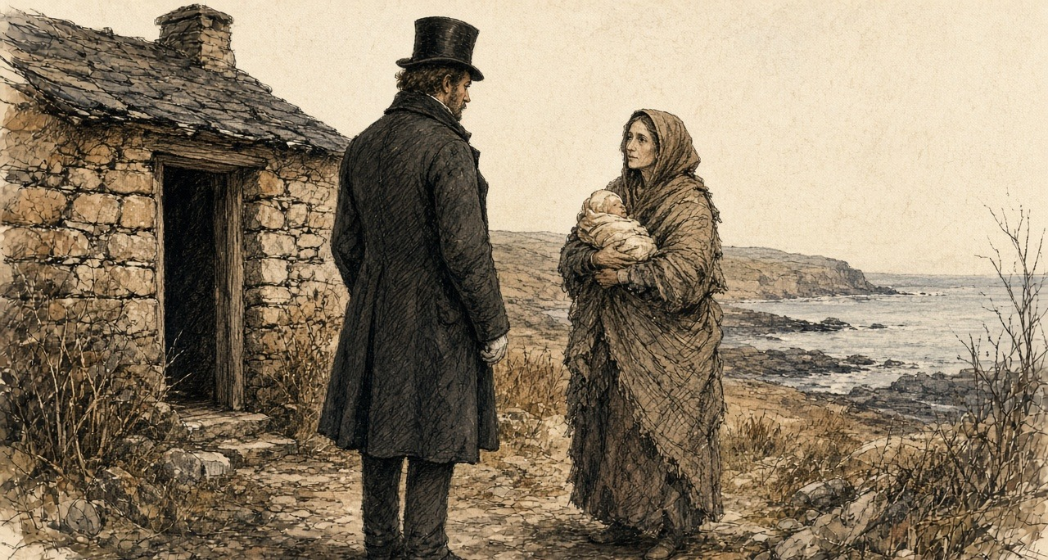
That morning the police opened a house on the next lands that had been seen shut up for days. Inside, on the mud floor, there were two frozen corpses. The rats had eaten half of them. The same day a mother, herself in fever, was seen dragging out the body of her daughter, a girl of about twelve, naked, and leaving it half covered with stones. Within five hundred yards of the cavalry station at Skibbereen the dispensary doctor found seven people lying under one cloak who could not move. One had been dead for many hours. The others could not move themselves, or him.
On 17 December, at Ann Mount, Cummins wrote it all down in a letter to the Duke of Wellington, and sent it to The Times. "Without apology or preface, I presume so far to trespass on your Grace as to state to you, and, by the use of your illustrious name, to present to the British public the following statement of what I have myself seen within the last three days." He wrote what he had seen at South Reen. "Their demoniac yells are still ringing in my ears, and their horrible images are fixed upon my brain. My heart sickens at the recital, but I must go on."
He did not spare the men in office. "To what purpose should I multiply such cases? If these be not sufficient, neither would they hear who have the power to send relief, and do not, even 'though one came from the dead.'" He told the Duke what to do with it. "You have access to our young and gracious Queen, lay these things before her. She is a woman, she will not allow decency to be outraged." And at the end: "Once more, my Lord Duke, in the name of starving thousands, I implore you, break the frigid and flimsy chain of official etiquette, and save the land of your birth."
The Times printed the letter on Thursday, 24 December 1846.
* * *
Cork and Limerick, 30 December 1846
Nicholas Cummins of Anderson's Quay wrote to Trevelyan again on 30 December, and enclosed the letter from The Times. "A near relative of my own, to whose published statement (sent herein) I refer you, has been but one of many credible witnesses who have actually seen the extent of the misery." Two Quakers had been through West Carbery the week before, and their account was "even more distressing, if indeed, that can be, than the report of Mr. Cummins."
Then the merchant gave the market. "Although several cargoes of maize have come to hand here during the past ten days, no impression worth notice has been made upon prices, which stand at, for Indian corn, 17l. 5s. per ton in ship." Food, he wrote, "is not to be had for money in many places." The flour mills of Messrs. Allen at Shannon Vale, near Clonakilty, had burned down the week before.
Hewetson wrote to Trevelyan from Limerick the same day with the same Cork price. Shipped direct from the States, he wrote, it stood the consignee at no more than £9 or £10 a ton. "These are really famine prices." The captain of the American ship Isabella, up and down the Shannon on the public steamers, made no secret of "the enormous profits the English and Irish houses are making by their dealings with the States." "One house in Cork alone, it is affirmed, will clear 40,000l. by corn speculation." He called the prices extortionate and then took the word back, "but as they are according to the spirit of trade, and therefore legitimate I will qualify the term to famine rates."
On 7 January Sir Randolph Routh, at Dublin Castle, answered a report on the parish of Schull, west of Skibbereen. A Cork house, George and Co., had two large mills at Skibbereen, and its agent, Mr. Swanton, was "retailing meal in any quantity required; and our store is also open. So that food is not wanting, but rather the money to buy it."
In the same letter Routh gave the Treasury an estimate of the rents. The proprietors of the Skibbereen district, he wrote, drew an annual income of £50,000 from it. He listed them. Lord Carbery, £15,000. "Sir Wm. Rixon Beecher (on whose estate stands the town of Skibbereen)," £10,000. Richard H. H. Beecher, £4,000. Mr. Newman, £4,000. The O'Donovan, £2,500. Smaller names followed. "Ought such destitution to prevail with such resources, allowing that I am misinformed in some of the points." On 8 January a Treasury Minute asked who the principal landowners were, "and what sums of money they have contributed."
The rector of Creagh, near Skibbereen, Mr. Caulfield, wrote to the Home Secretary in the first days of January. The workhouse, built for 800, held 960. Deaths in it in November, 83. In December to the 28th, 135. In the same two months of the year before, 7. "In the small burying-ground near Skibbereen, eight bodies were interred within an hour. Very few now attend funerals, which is strange in this country."
* * *
Clare Abbey, Thursday, 24 December 1846
The works at Clare Abbey had been stopped since 7 December. On Christmas Eve Wynne went through the parish himself.
He wrote to Colonel Jones from Ennis that night.
"I must, however, again call your attention to the appalling state in which Clare Abbey is at present; I ventured through that parish this day, to ascertain the condition of the inhabitants, and although a man not easily moved, I confess myself unmanned by the extent and intensity of suffering I witnessed, more especially amongst the women and little children, crowds of whom were to be seen scattered over the turnip fields, like a flock of famishing crows, devouring the raw turnips, mothers half naked, shivering in the snow and sleet, uttering exclamations of despair, whilst their children were screaming with hunger; I am a match for any thing else I may meet with here, but this I cannot stand."
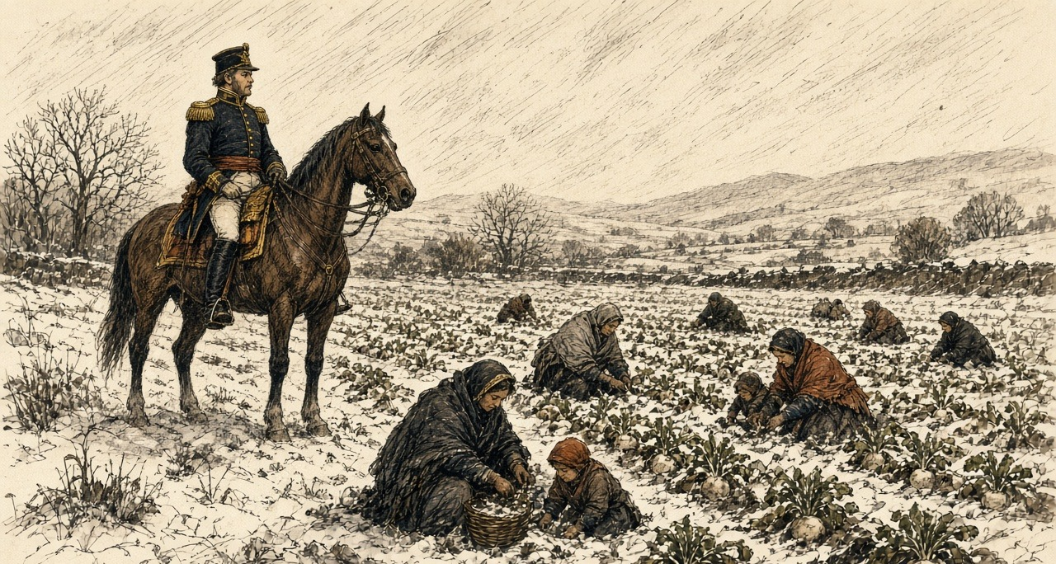
"When may we expect to resume the works? Nothing but dire necessity would make me advocate this step, feeling as I do, that I thereby throw away the only armour we possess against the bullet of the assassin; but it cannot be helped."
In the same letter he reported prices. "Provisions are all but exhausted; and the holders of the remnant demand such exorbitant prices as place more than one meal a day quite beyond the reach of the labourer with a family, even though in constant employment." In Ennis that day he could not get a loaf of bread for himself, because his servant had not ordered it in the morning.
Wynne wrote again on 29 December, about the people who from age, infirmity or exhaustion could not work, and were "beyond the reach of Relief Works." "Already several deaths have occurred, I fear, too, from starvation; they must increase daily." "Such is their state of alarm and despair at the prospect before them that they cannot be induced to look beyond to-morrow; thousands never expect to see the harvest." And he described the country around Ennis. "The effects of famine are discernible everywhere, not a domestic animal to be seen, pigs and poultry have quite disappeared." The dogs were gone, "except here and there the ghost of one buried in the skeleton of one of those victims of cruelty and barbarity which have been so numerous here within the last two months." He meant the horses and donkeys that had been shot. "It is an alarming fact, that this day, in the town of Ennis, there was not a stone of bread stuff of any description to be had on any terms, nor a loaf of bread."
* * *
The Treasury, Tuesday, 5 January 1847
The new year brought a report from Hugh Parker, an officer of the Board, written on 31 December after a tour west of Skibbereen. Of the 18,000 people of the parish of Schull, he reckoned, 16,000 were "in a state of utter destitution." The rector, Dr. Traill, kept soup kitchens at work. "The people now drop off very fast, and deaths increase daily." "Death seems stamped on the faces of thousands; in many places I could with difficulty move, I was so beset with hundreds imploring assistance."
Trevelyan sent it on to Routh on 5 January.
"The accompanying description by Mr. Hugh Parker, of the state of the population in the remote districts to the west of Skibbereen, is the most awful I have yet seen, and it makes me, as well as you, anxious to hear what progress Mr. Bishop is making in his mission to that quarter, for the extension of soup-kitchens. I lament to have to express my opinion that this rude expedient of the public kitchen, is the only thing which stands between multitudes of our fellow countrymen and death, and we are very anxious that it should be carried to the utmost possible extent in the districts in which it is required."
Routh had already written out the method for Clare. On 30 December, with Wynne's letter of the 29th in front of him, he sent it to Hewetson, copied from Skibbereen. One or two kitchens to a village, with cauldrons enough. A policeman appointed by the constabulary officer to stand over the issue, "to see that the articles purchased for the soup are actually put into it, that it is distributed at twelve o'clock precisely, and that good order is preserved."
* * *
Kilkee, January and February 1847
The Commissariat officer at Kilrush, Captain Mann, came over to Kilkee on Thursday, 14 January, and the gentlemen agreed there would be a soup kitchen. There was no boiler. One was coming from Dublin. Until it came they were to use the boilers from the baths, the ones that heat the sea water. The contracts for the meat were to be taken on the Saturday. At Kilrush they began the soup on the Monday, the 18th. Mann asked the Government to put a pound to every pound the people of Kilrush subscribed.
On the first day of January a deputation from our district waited on Mr. Labouchere: Mr. Burton of Carrigaholt Castle, the Protestant rector Mr. Martin, and the two priests, Father Comyn and Father Duggan. The Clare Journal printed the account on 7 January. They told him that the men on the works in the district were not more than one in seven and a half of the destitute. "The men are actually seen to stagger on the works, and the stewards state that hundreds of them are never seen to taste food from the time they come upon the works in the morning until they depart at nightfall." They said two hundred persons and upwards had died of the destitution in the parishes of Kilferagh and Killard. Oatmeal had sold at Kilkee on the Saturday before at five shillings the stone. To give one meal in the day to the destitute of the district would take £1,500 a week. "The people have pledged their day-clothes and night covering, and they have, after a hard day's work, to lie down at night on a bed of straw, without a blanket or coverlet of any kind."
At the salt-water boilers down by the bath-house is the soup. Stands a man in the crush with his tin can in his fist. Comes the smell of it floating out over the heads of the people—the boil of the beef-heads and the meal in the steam—and runs the water from your teeth, and is there a gripe like a knife twisting in under the short ribs with the fierceness of it.
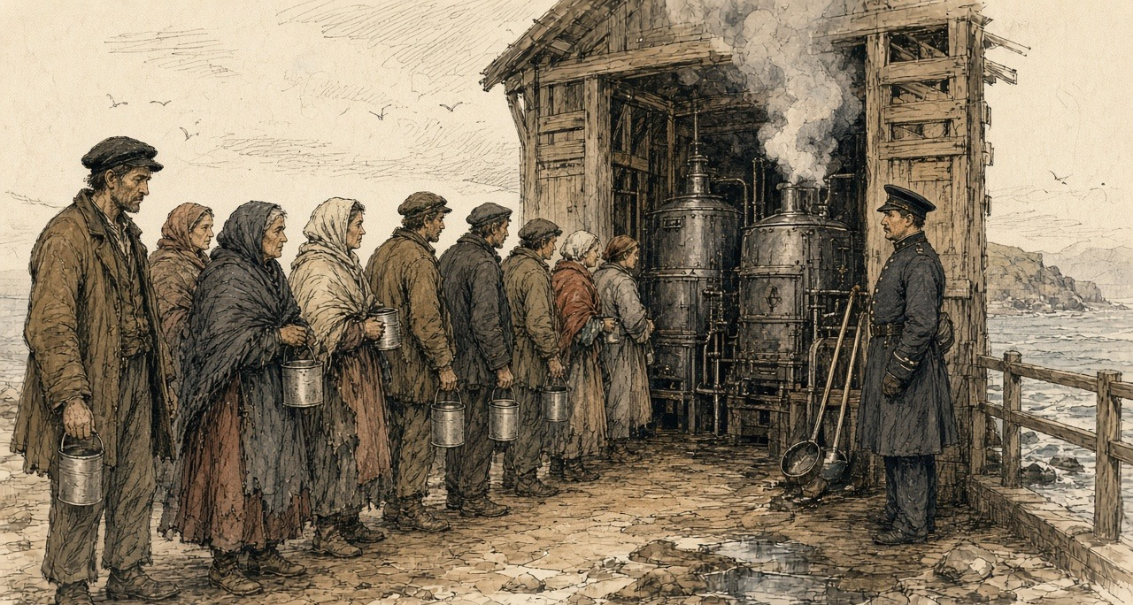
On the stroke of the twelve cries the peeler the word, and dip they the great ladles.
Is my mother's ticket is that in my hand. Is the walk of the road gone out of her legs since the Little Christmas. Stretched in the dark of the corner by the hearth is she. Past the age of the shovel is she, so put the gentlemen her name down on the free list.
Carry I the can home against my breast with my two hands locked round up into my nostrils, and walk I on.
When I cross the threshold site the road not her head from the sop. Props my wife her shoulders up from behind, and tip I the lip of the can to her teeth. Runs the yellow trickle down the side of her chin and into the hollows of her throat, and wipes my wife it clean with her forefinger, and puts she that finger into her own mouth.
Are the eyes of the children glued to the tin can.
Is fish in plenty in the bay of Kilkee. Great ling on the slabs for a shilling a head. Fresh herrings at four-and-six the hundred. Is not a penny piece at me, nor a line, nor a hook, and the curragh rotting on the bank since we pawned the nets.
Captain Gordon of the Board saw the ling for sale at Kilkee in the first week of February, and put the price in his journal. In the same week he wrote that throughout west Clare the farm work had stopped, "as also the fisheries."
* * *
The Treasury and the Relief Commission, Dublin, February to April 1847
When Parliament met at the end of January the Government announced that the public works would end, and that food would be given instead, cooked, under a new Act. The Act was the 10 Vict. c. 7, "for the temporary Relief of Destitute Persons in Ireland." A Relief Commission sat in Dublin under Sir John Burgoyne. In every electoral division a committee of magistrates, clergy, the Poor Law guardian and the three highest ratepayers was to draw up a list, and the ratepayers of the union would pay, with Government loans until the rates came in.
After the Act passed, the numbers on the works went on rising. Trevelyan's own figures for the daily average on them ran: in October 114,000; in November 285,000; in December 440,000; in January 570,000; in February 708,000. In March, 734,000. The heaviest month was March, at £1,050,772. The Board of Works, in its report for February, wrote of overseers "unable, perhaps sometimes unwilling, to enforce regularity or system in works executed by a mass of unskilful, and frequently weak and even dying creatures."
An officer of the Board looked at the men on his works that winter and wrote to his superiors that, as an engineer, he was ashamed of allotting so little task work for a day's wages, and, as a man, he was ashamed of requiring so much. Trevelyan printed that in a footnote. In some districts, he added, the men were paid for turning up.
On 10 March the Treasury put a date on the end. "Their Lordships direct that notice be immediately given, that from Saturday, the 20th March, the number of persons employed on the Relief Works will be reduced by not less than 20 per cent." The first to go were to be those holding ten acres and upwards. After them, those who held the most land, "although less than ten acres," or the most of any other property. Where soup or other rations could be had for all the destitute of a district, the works there were to stop altogether.
* * *
The House of Commons, Monday, 29 March 1847
Lord George Bentinck rose early in the sitting to ask, again, how many people were dying in Ireland. He wanted a return comparing the deaths of 1847 with former years. He read the House a letter from Dr. M'Hale, the Catholic Archbishop of Tuam. The clergy could supply the return, the Archbishop wrote, signed by the medical attendant in each locality. "But, alas! contrasted with the number of deaths that occurred within the same period of other years, it will show 20 to 1, at the least, this year, more than in any preceding it. The names of the persons can also be given."
Labouchere, the Chief Secretary, did not deny "the unfortunate fact, that a great mortality had occurred in Ireland." He doubted that returns from the clergy of either church could be relied on. Lord John Russell complained of the labour that returns put on the public offices. Benjamin Disraeli answered him. If returns were moved "of the quantities of pigs and poultry consumed within a given time, there would not be the least objection raised to any such return. Now there was, however, a remarkable and unprecedented mortality afflicting the sister kingdom, and the difficulties placed in the way of obtaining an exact statement of the deaths appeared to be insuperable."
Later that night the House went into committee on the Poor Relief (Ireland) Bill, which would put the destitute on the rates once the soup ended. William Gregory, the Member for Dublin, rose to move a clause.
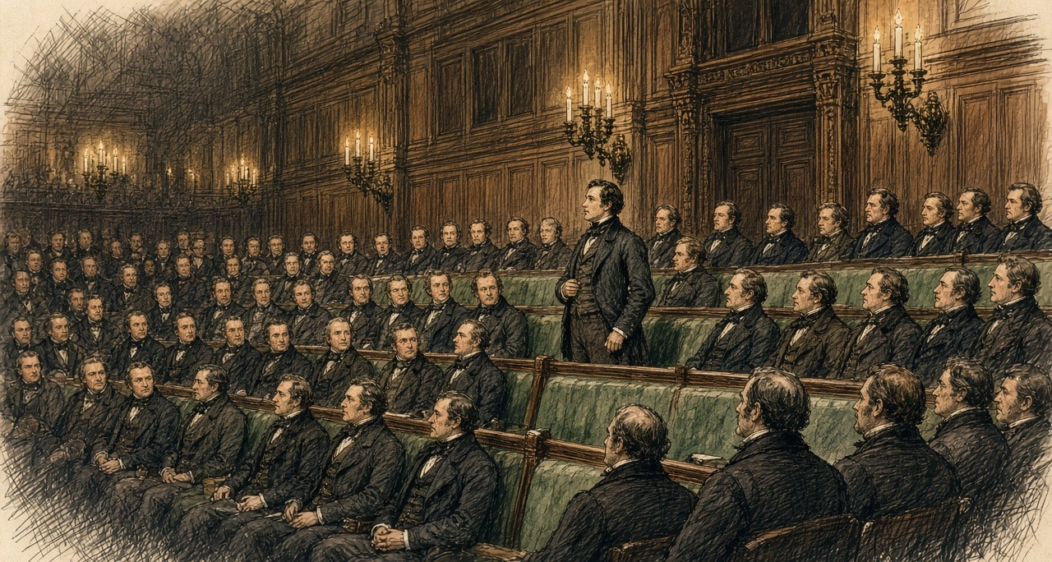
"That no person who shall be in the occupation, whether under lease or agreement, or as tenant-at-will, or from year to year, or in any other manner whatsoever, of any land of greater extent than the quarter of a statute acre, shall be deemed and taken to be a destitute poor person under the provisions of this Act, or of any former Act of Parliament; nor shall it be lawful for any board of guardians to grant any relief whatever in or out of the workhouse to any such occupier, his wife, or children." Nor could the guardians relieve a man who had been such an occupier until they were satisfied that he had "bonâ fide, and without collusion, absolutely parted with and surrendered" his right to any land over the quarter acre.
He had meant half an acre, he said. He had been in Ireland since he gave notice, and the most intelligent persons had told him that half an acre was far too much. Men should not "exercise the double vocation of pauper and farmer."
William Smith O'Brien, the Member for Limerick, understood that the Government meant to accept it, and spoke anyway. "If a man was only to have a right to out-door relief upon condition of his giving up his land, a person might receive relief for a few weeks, and become a beggar for ever. He thought this was a cruel enactment."
Mr. Curteis, an English member, asked the House what a quarter of an acre was. "The peasant grew potatoes on it. Suppose his crop failed him; he must, in such case, give it up and go into the workhouse, or starve. It might be that the poor man, having a lease, would not surrender it. What then, must he hold it and starve?"
Sir George Grey, the Home Secretary, had always understood that the small holdings were the bane of Ireland. Holders of small farms, he said, had given up the cultivation of their own holdings "in order to earn 6s. a week under the Government system." He would support the clause, with words to give it a prospective operation, "say, for instance, from the 1st of November next."
Poulett Scrope warned that its consequence "would be a complete clearance of the small farmers in Ireland." Sharman Crawford said that in Ireland the tenant built his own cottage, and the clause "would be to enable the landlord, if he chose, to take possession of the poor man's property."
Gregory answered them. "Many hon. Members insisted that the operation of a clause of this kind would destroy all the small farmers. If it could have such an effect, he did not see of what use such small farmers could possibly be."
Scrope asked Grey how many people now on relief would be left destitute if they kept their holdings. Grey had not made any such estimate.
The committee divided. Ayes, 117. Noes, 7.
* * *
Dublin, June and July 1847
The Relief Commission's accountant made the return for Saturday, 3 July 1847. On that day 2,643,128 rations were being issued, "equal to the support of 3,020,712 persons daily." In the union of Kilrush the return was 43,317 a day. The average cost of a ration, with the committees' staff and the carriage, was about twopence. It had come down by a fifth since June, because the price of provisions had fallen.
The Act for the relief of the destitute poor in Ireland, 10 & 11 Vict. c. 31, passed on 8 June 1847. Trevelyan summarised its terms. "After the 1st November, 1847, no person is to be relieved either in or out of a workhouse, who is in the occupation of more than a quarter of an acre of land."
Six months later Trevelyan wrote the history of the year himself, anonymously, in the Edinburgh Review for January 1848, under the title "The Irish Crisis," and Longmans reprinted it as a book with his name. The Temporary Relief Act had cost £1,557,212. Of the soup, he wrote, "The famine was stayed." The "affecting and heart-rending crowds of destitutes," in a phrase he took from Count Strzelecki, had "disappeared from the streets," and "deaths from starvation ceased."
He closed the essay on the theme of his letter to Monteagle. "The deep and inveterate root of social evil remained, and this has been laid bare by a direct stroke of an all-wise and all-merciful Providence, as if this part of the case were beyond the unassisted power of man."
* * *
The soup kitchen, Kilkee, May to September 1847
Put they us off the road works in the spring. Went the first batch on the twentieth day of March—every man that had a bit of ground to his name—and went the rest of us after, until the steward laid down his measuring-rod and left the road half-cut in the bog.
Then was it the boiler rations for the whole parish, whoever had his name written in the division book. Made they the rule that every Christian must walk to the boiler on his own two feet—the man of the house and the woman of the house both—and stand in the crush to be seen. Only the bed-rid and the childer under nine years had leave to stay within.
Was it no liquid soup they gave us at the end, ach the stribout—the Indian meal and the rice steamed together in the sea-boilers until it was stiff as turf-mud. One pound dry was the law's allowance, swelled out with the water to three-pound weight or four. With the wooden spoon stand upright in the middle of it. Cooked they it in the town, so no man could trade a handful of the raw meal for a candle or a grain of salt. By the sunrise of the next day, would a sour ferment be working in it, and was there not a beggar in the Seven Parishes would give you a brass farthing for sour stirabout.
The first day I brought the weight of it home in the bucket, went the childer at it with such madness that the little lad threw it all back up on the clay floor. Held his mother his forehead until the retching left him, and fed she him again, by grain, off the tip of her finger.
In the month of August, when the oats whitened in the big farmers' fields, shut they the boilers down, union by union. By the twelfth day of September was the fire quenched under every cauldron in Ireland.
Now is there nothing between us and the grave ach the workhouse in Kilrush. And is the talk in every ditch about the new law Mr. Gregory put in the book in London: from the first day of November, will neither bite nor sup, inside the house or outside it, be given to the man or the wife or the child of a man that holds above the quarter of a statute acre of ground—until he signs the paper giving his title and his roof up forever to the landlord.
Is my own bit of ground the long garden you see from the gripe of the road. Three quarters of an acre, near enough, and the cabin standing on the corner of it.
Have I the measure of it paced out in my head since the boiler shut. Every evening, when the dark comes down, go I out the door and walk the four bounds of it with my feet.
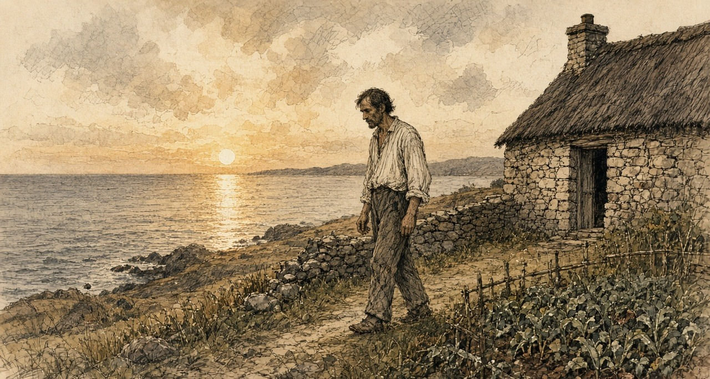
Chapter 9 Appendix of Important Names
• Begin, Menachem (1 mentions in this chapter): Commander of the revisionist Zionist underground organization Irgun Zvai Leumi in Mandate Palestine.
• Disraeli, Benjamin (1 mentions in this chapter): British Prime Minister who arranged the 1875 purchase of Khedive Ismail's Suez Canal shares with Rothschild financing.
• Gordon, Lucie Duff (1 mentions in this chapter): English writer resident in Upper Egypt during the 1860s who recorded the impact of the Suez Canal corvée and taxation on the fellahin.
• Griffith, Arthur (1 mentions in this chapter): Founder of Sinn Féin and signatory of the 1921 Anglo-Irish Treaty.
• Peel, Robert (1 mentions in this chapter): British Chief Secretary for Ireland and Prime Minister who repealed the Corn Laws during the Great Famine in 1846.
• Russell, Lord John (1 mentions in this chapter): British Whig Prime Minister during the height of the Irish Famine (1846–1852).
• Trevelyan, Charles (13 mentions in this chapter): Assistant Secretary to the British Treasury who administered Irish famine relief operations between 1845 and 1847.
Sources
• National Library of Ireland, Monteagle Papers, Collection List No. 122 (finding aid, with transcriptions): Monteagle to Henry Labouchere, Mount Trenchard, Foynes, 27 September 1846 (copy, MS 13,396/7); Monteagle to Richard Griffith, Mount Trenchard, 30 September 1846 (copy, MS 13,396/8); Monteagle's papers as chairman of the Shanagolden relief sessions (MS 13,396/9, /11); the opening of C. E. Trevelyan to Lord Monteagle, Treasury, 9 October 1846, 35 pp. (MS 13,397/1); Thomas Spring Rice's tenure as Chancellor of the Exchequer, 1835–9.
• C. E. Trevelyan to Lord Monteagle, 9 October 1846: the passages on the functions of government, the nobility and gentry, and the "direct stroke of an all-wise Providence," as given in the verified-quotation file (research/trevelyan-quotes.md), from the transcriptions printed in Noel Kissane, The Irish Famine: A Documentary History (NLI, 1995), p. 51, and Peter Gray, "Ideology and the Famine" (1995), p. 93, citing the NLI manuscript. Wording follows the majority of transcriptions ("unthought of as it is likely to be effectual")
• C. E. Trevelyan to Lieut.-Colonel H. D. Jones, 2 December 1846, Trevelyan's out-letter books (Private Letter Books, vol. X; now Newcastle University Special Collections, CET/1). Wording as in the verified-quotation file
• [C. E. Trevelyan], "The Irish Crisis," Edinburgh Review 87, no. 175 (January 1848), pp. 229–320; reprinted as C. E. Trevelyan, The Irish Crisis (London: Longman, Brown, Green & Longmans, 1848): extraordinary presentment sessions under 9 & 10 Vict. c. 107, roads "presented in the mass" (pp. 56–7); the monthly averages on the Relief Works, 114,000 to 734,000, and the March expenditure of £1,050,772 (pp. 61, 64); the officer "ashamed" of the task work, attendance as proof for wages (p. 63 n.); the announcement at the meeting of Parliament (p. 64); the Temporary Relief Act, the committees, the cooked-food test, personal attendance, the ration and stirabout swelling to three or four pounds, the sour stirabout (pp. 84–8); 3,020,712 rations in July 1847, the end of issues on 15 August and 12 September (pp. 88–9); "The famine was stayed" (p. 89); £1,557,212 (p. 91); the summary of the Poor Relief Acts of 1847, "10 Vic. cap. 31 [Passed 8th June, 1847]," and the quarter-acre rule from 1 November 1847 (pp. 153–4); the closing Providence passage (p. 201, scan-verified).
• Correspondence from July 1846 to January 1847, relating to the Measures adopted for the Relief of the Distress in Ireland. Commissariat Series [First Part]. London: HMSO, 1847: Routh to Trevelyan, 3 September 1846, with Hewetson to Routh, Lee Mills Depot, Cork, 1 September 1846, on Nicholas Cummins, and Treasury Minute of 8 September 1846; N. Cummins to Trevelyan, Cork, 9 October 1846 (oats exported, herrings, the presentment sessions, bere seed, pp. 135–6); N. Cummins to Trevelyan, 12 December 1846; Wynne to Jones, Ennis, 29 December 1846 (pp. 438–9), and Routh to Hewetson, Dublin Castle, 30 December 1846, enclosing it, with the method for soup kitchens in Clare on the Skibbereen precedent, distribution "at twelve o'clock precisely"; N. Cummins to Trevelyan, Cork, 30 December 1846 (p. 439); Hewetson to Trevelyan, Limerick, 30 December 1846; Hugh Parker to Jones, 31 December 1846, enclosed in Trevelyan to Routh, 5 January 1847 (pp. 454–5); Routh to Trevelyan, 7 January 1847 (George and Co., "food is not wanting," the proprietors' incomes, p. 458); Treasury Minute, 8 January 1847, with the Rev. Mr. Caulfield to Sir G. Grey, Creagh Rectory, Skibbereen, dated "January 4, 1846" in print, a misprint for 1847 (p. 459).
• Correspondence from January to March 1847, relating to the Measures adopted for the Relief of the Distress in Ireland. Commissariat Series, Second Part. London: HMSO, 1847: Routh to Trevelyan, 27 January 1847, enclosing Captain Mann to Hewetson, Limerick, 22 January 1847 (the Kilrush soup kitchen from 18 January; Kilkee, 14 January, the bath boilers, p. 53).
• Correspondence from July 1846 to January 1847, relating to the Measures adopted for the Relief of the Distress in Ireland. Board of Works Series [First Part]. London: HMSO, 1847 (HC 1847 [764] L): police report of Sub-Inspector George Pinchin, verdict and evidence of Drs. Daniel Donovan and Patrick Dore at the inquest on Denis M'Kennedy, Caheragh, West Carbery, with the Board's memorandum (p. 252 and contents); Trevelyan to Jones, 4 December 1846 (pp. 300–1); Wynne to the Secretary of the Board of Works, Ennis, 5 December 1846 (Moyarta, Clondegad, the shooting of Hennessy, pp. 308–9); extracts of a private letter of Wynne, Ennis, 7 December 1846 ("900 men are sent adrift," the blasting powder); report of 8 December 1846 and the public notice of 7 December 1846, signed by Edmund Wynne and Samuel Gamble; Wynne to Jones, Ennis, 24 December 1846 (Clare Abbey, the turnip fields, prices, pp. 434–5). The Board's printed correspondence gives 5 December for the shooting ("this evening"); Wynne's private letter of 7 December says "yesterday evening." The chapter follows the official letter.
• Correspondence from January to March 1847 … Board of Works Series, Second Part. London: HMSO, 1847: extract from the Clare Journal, Thursday, 7 January 1847 (the Kilkee deputation to Labouchere, Burton, Martin, Comyn and Duggan, the men staggering on the works, Kilferagh and Killard, oatmeal at 5s. a stone, the pledged clothes); journal of Captain Gordon, West District, County Clare, week ending 6 February 1847 (ling and herrings at Kilkee).
• Treasury Minute, dated 10th March, 1847, and First Report of the Relief Commissioners, constituted under the Act 10th Vic., cap. 7. London: HMSO, 1847 (the February returns, the Board's "weak and even dying creatures," the reduction of 20 per cent. from 20 March, holders of ten acres first; first monthly report, 10 April 1847).
• Fourth Report of the Relief Commissioners, constituted under the Act 10th Vic., cap. 7. London: HMSO, 1847: report of 19 July 1847; accountant's statement of daily rations for Saturday, 3 July 1847 (2,643,128 rations, 3,020,712 persons, cost about 2d., the fall by one-fifth); Kilrush union, 43,317.
• Bill for the temporary Relief of Destitute Persons in Ireland, 28 January 1847; the Act 10 Vict. c. 7.
• Hansard, House of Commons Debates, HC Deb 29 March 1847, vol. 91: "Mortality in Ireland," cc. 571–5 (Lord George Bentinck, the Archbishop of Tuam's letter, Labouchere, Lord John Russell, Disraeli); "Poor Relief (Ireland) Bill," committee (Gregory's clause, cc. 585–92: Gregory, Smith O'Brien, Curteis, Sir G. Grey, Scrope, Sharman Crawford, Gregory's reply; division, Ayes 117, Noes 7).
• Act for the Relief of the Destitute Poor in Ireland, 10 & 11 Vict. c. 31, passed 8 June 1847.
• N. M. Cummins, J.P., Ann Mount, Cork, to the Duke of Wellington, 17 December 1846, published in The Times, 24 December 1846. Text checked against two independent transcriptions (University College Cork, Multitext Project in Irish History; the Southern Star reprint at failteromhat.com), which differ in small points; the chapter follows the Multitext wording ("their wretched legs hanging about, naked above the knees"

Chapter 10
A Fair Face for the Doctor, 1847–1848
Gravesend, the North Atlantic, the St. Lawrence, Canada West, St. John, the Kilrush union and Westminster, April 1847 to April 1848
When the public works stopped in the spring of 1847, Stephen de Vere had men on his hands. He was a younger son of the de Veres of Curragh Chase, in the county of Limerick, and through the winter a number of labourers had been employed on the public works under his supervision. His brother Aubrey set the order of events down fifty years later. "On the sudden cessation of the public works, he took passage for Canada with a considerable number of those who had been employed on them."
The diary he carried was bound in red leather. On the first page he wrote the names of his party: "S. De. V. P. O'Neill & wife J. Hanly Roger Kennedy J. Fitzgerald Johnny McDonagh."
They came up from Bristol by railway on the evening of Thursday, 29 April, and went straight aboard a barque in the Thames, the Birman. She went down the river to Gravesend that night. Hanly was ill before they had left the river.
The next day the Birman lay at Gravesend taking in cargo. It was gunpowder, Government powder, for the garrison of Quebec. De Vere went ashore and dined with Stephen S. Rice. Hanly was still ill.
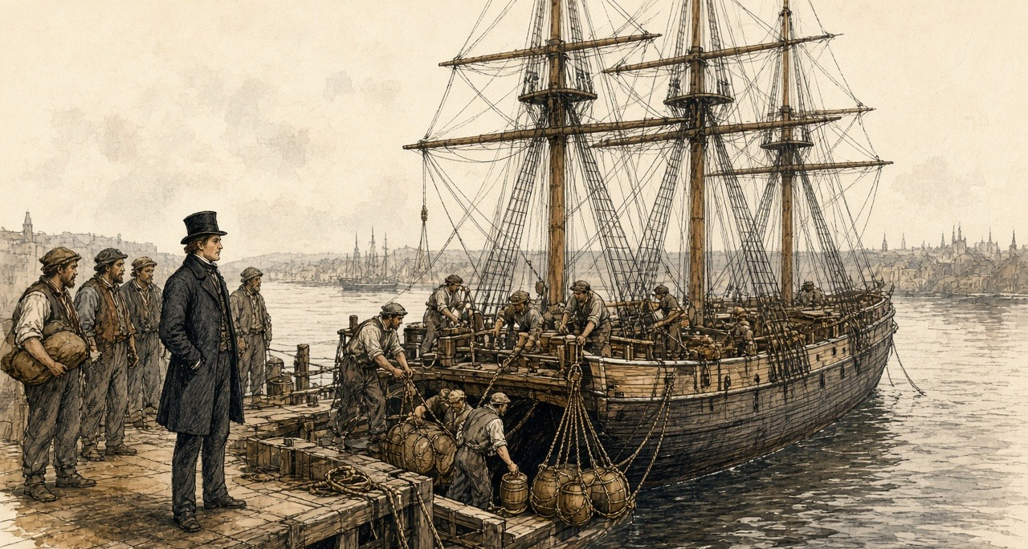
On Saturday, 1 May, he wrote one word. "Sailed."
He had £1,300 lodged with a bank in London. He went in the steerage.
* * *
The steerage of the Birman, May and June 1847
The diary has nothing between the first of May and the ninth of June. What the voyage was he put down afterwards, from Canada West, in a letter to a Government man in London, and he wrote it as a man who had lain in the berths.
Before the emigrant had been a week at sea, he wrote, he was an altered man.
The passengers on the Birman were found in provisions by the owners, under a contract and a printed scale of dietary. The meat was of the worst quality. There was water enough in the casks. What reached the passengers was a different quantity. It was served out in a measure called a gallon, and de Vere tested the measure, and it held three quarts.
The ration was salt meat and rice, and both had to be boiled. There was not water for the pot and for the mouth as well. The passengers carried their salt provisions and their rice up the ladder and threw them over the side, because they had not water enough both for the cooking and for "the satisfying of their raging thirst afterwards."
There was no water left for washing. A passenger could wash only by taking it from the pot.
Some of them gave up getting out of the berths. "I have known persons to remain for days together in their dark close berths, because they thus suffered less from hunger, though compelled, at the same time, by want of water to heave overboard their salt provisions and rice."
The berths were dark because lights were forbidden. The ship had open fire-grates on deck for the cooking, and men lit lucifer matches and pipes in secret down in the sleeping places, and under them all, in the hold, was the powder for Quebec.
Nobody aired the beds. The master never once came down into the steerage in the whole voyage, and he would listen to no complaints. Once or twice a week spirits were sold to anyone who would pay for them, and the grog was the captain's profit. De Vere called what followed "scenes of unchecked blackguardism beyond description."
He lay among it in the dark. Between the berths and the piles of boxes there was a narrow space that was never washed or scraped, and it "breathes up a damp fetid stench." In many ships, he wrote, the filthy beds, "teeming with all abominations," were never brought up and aired. The fevered lay in among the sound, in sleeping places so narrow that a sick man could hardly turn over, and their ravings went on beside the ones who were trying to sleep.
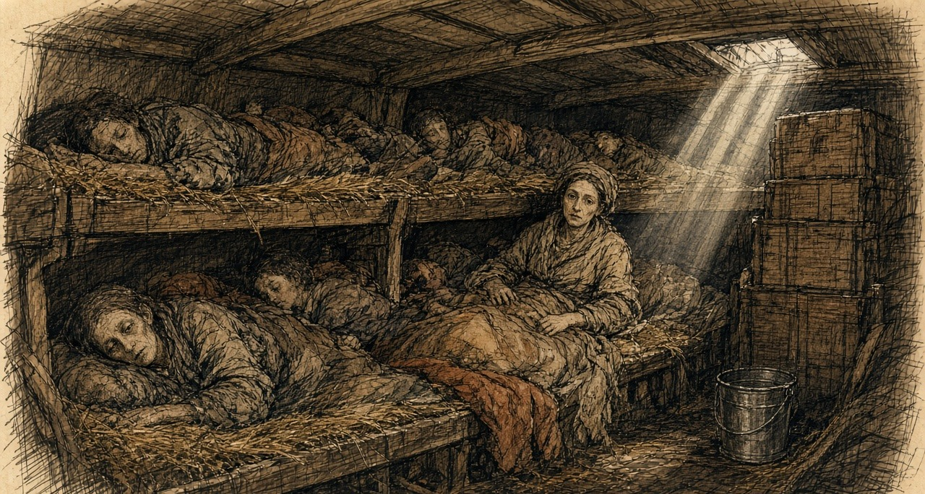
On the third of June the Birman was on the Banks of Newfoundland. On the ninth she was off Cape Breton with land in sight. On the twelfth, west of Cape Gaspé and about 250 miles below Quebec, she lay in a dead calm, in thick fog. A squall came down from the north without warning and laid her over. She had the main royal set and all her studding sails. "Ship in great Danger." It lasted about five minutes. She came up slowly.
Then, the day before quarantine, came the cleaning. All hands were ordered to "scrub up," he wrote, "and put on a fair face for the doctor and government inspector."
On Sunday, 13 June, they took a pilot aboard, and the river began to narrow. He wrote down the woods running from the mountain tops to the shore, white rocks, gleams of snow. On the water were crowds of ships, outward bound. They were "taking out cargoes Of corn for Europe."
* * *
Grosse Isle, Wednesday, 16 June 1847
The quarantine station was on an island in the river below Quebec, and its medical superintendent was Dr. G. M. Douglas. He had been writing to the Government since May.
On 24 May he had reported "a state of illness and distress among the newly arrived emigrants, unprecedented in this country even during the prevalence of cholera in 1832 and 1834." Seventeen vessels with Irish passengers had come in since his last letter, from Cork and Liverpool, Sligo, Limerick, Belfast, Londonderry and New Ross. They had sailed with 5,607 people. Two hundred and sixty had died on the passage. Upwards of 700 were in hospital or lying sick on board, waiting for beds. He was turning the passengers' sheds into hospitals. A postscript: "Twelve vessels have arrived this morning, all more or less sickly." The Miriam, from Limerick, had buried twenty-four.
On 31 May the chief emigrant agent at Quebec, A. C. Buchanan, made a return. Thirty-six vessels at Grosse Isle, with 12,450 passengers. Six hundred and sixty-two deaths on the voyage. A naval officer had come up from the island that morning to tell him the people detained there were in the greatest want of food.
Douglas wrote again on 8 June, and Buchanan copied it out for the Governor-General. "I never saw people so indifferent to life; they would continue in the same berth with a dead person until the seamen or captain dragged out the corpse with boat-hooks."
The Birman came to anchor off the island at about seven in the morning of 16 June.
The doctor did not come. They waited for him all day. De Vere counted the ships waiting with them, about forty, and on shore he could see what looked like villages, white tents, for the sick. He heard that the daily mortality was about 150.
The Birman lay alongside a ship called the Jessy, in which many were ill. The water between the ships was not clean water. "Water covered with beds Cooking utensils refuse of the dead."
From the ships that had been inspected, the sick were going ashore in boats. He watched the boats go in. "Ghastly appearance of boats full of sick going ashore never to return. Several died between ship and shore."
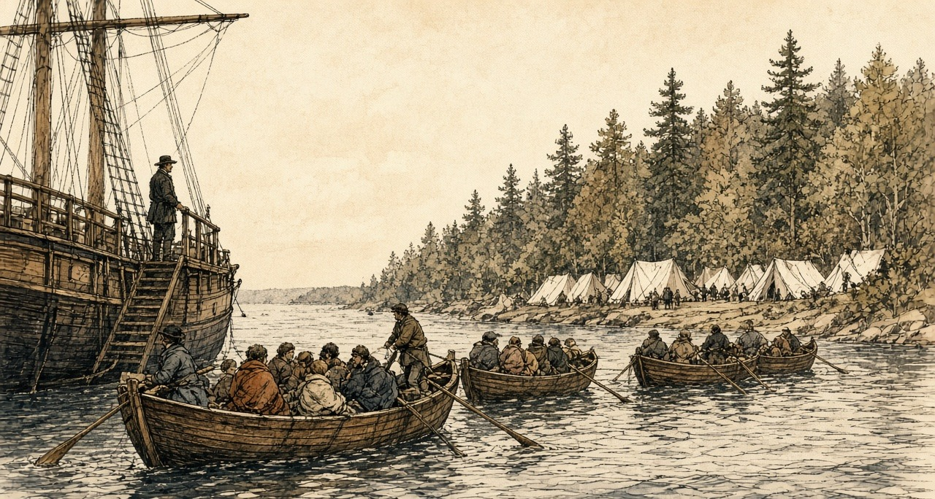
In the boats wives went without their husbands, and children without their parents, because the doctor took the sick and left the well, and the well stayed aboard. One of the ships there was the Sisters, from Liverpool. Every passenger in her and every man of her crew had come in with fever. He wrote down afterwards that all of them died but the captain and one girl.
In the evening the doctor came aboard. The Birman's passengers stood on deck in a file, washed. "The medical inspections on board were slight and hasty – hardly any questions were asked – but as the doctor walked down the file on deck, he selected those for hospital who did not look well, and, after a very slight examination, ordered them ashore." Some were kept back who were not ill. Many were let go who were in fever.
The Birman got a clean bill of health.
The funds in the agent's hands, he found, were "altogether insufficient for care." The medical attendance was bad.
Dr. Douglas kept the figures for the whole season, and de Vere copied his tables into the diary the next winter. Between May and the beginning of November 98,106 emigrants arrived at Quebec. The quarantine hospital admitted 8,691 of them, and 3,238 died in it, 1,361 men, 969 women and 908 children. In August, at the height of it, the hospital held an average of 2,021 sick every day.
Douglas counted his own people too. Of twenty-six medical men, twenty-two took the fever and four died. Of 186 nurses, orderlies and cooks, many of them emigrants taken on when they recovered, twenty-two died. Two of the six carters hired to move "the sick, dying, and dead" died.
* * *
Quebec, June 1847
A steamer towed the Birman up to Quebec on 17 June, and de Vere kept his party on board until the Saturday, when he took lodgings for them at the O'Connells' in Champlain Street, in the lower town.
He went before Buchanan with a complaint against the master of the Birman, Captain Guthrie, for false measures of water. The captain wanted to settle it quietly. De Vere refused to settle except in Buchanan's presence, took the captain before him, and made him pay £10. He handed the £10 to the parish priest, the Rev. Mr. McMahon, for the destitute emigrants, and the priest acknowledged it in the newspapers.
In Quebec he met men he knew. They were "Persons who had been working Under my orders last winter," and they were all in work, at about five shillings a day. There was better money to be had. He wrote it down without comment. "Enormous wages offered for Loading infected ships. 8 to 10/ per day."
* * *
Montreal and Toronto, July to September 1847
At Montreal, on 4 July, John Hanly fell ill. The doctor declared it a cold. On the evening of the 5th Hanly was much worse, with a dreadful headache and pains in the neck and back, and de Vere wrote the word he had been holding off. "Dreaded fever."
He sent the rest of the party on to Toronto and stayed with Hanly alone. He told Roger Kennedy what to tell the others in case it was fever, and he did not let Roger see the patient. He wrote a codicil to his will. The thermometer in the shade stood at 100. The next day the mercury in the sun went to the top of the tube at 135, "& then Rapidly rising – no air."
Hanly came through.
In Toronto, on Saturday, 24 July, Roger Kennedy took the fever. De Vere sat up with him through the nights. He gave him half a glass of port wine every four hours, and later wine or broth every two hours. On 31 July Roger was so weak that he sent for the priest, who gave him the rites of the Church after confession. Roger rallied in the evening. On 2 August the doctor said the fever was going off, and de Vere sat up again all night with him, reading Amelia. On the 3rd Hanly went down again with the bowels.
On Sunday, 25 July, he had written: "My birthday, my only Pleasure writing a long letter To my mother, Roger's fever heavy."
The Government sent its emigrants up the river by steamer, and in Toronto the emigrant agent, Edward McElderry, received them. Through September de Vere's diary has one line almost every day: "Watch wharf." He went down to the steamers with McElderry when they came in, and he described them afterwards.
They were small, incommodious and ill-ventilated, and they came in after forty-eight hours from Montreal "freighted with fetid cargoes of 1,100 and 1,200 Government emigrants of all ages and sexes." The healthy who had just arrived from Europe were mixed in with half-recovered convalescents from the hospitals. For two days they had not been able to lie down. They had hardly been able to sit. In almost every boat there was plain fever. In some there were deaths, and the dead and the living lay together.
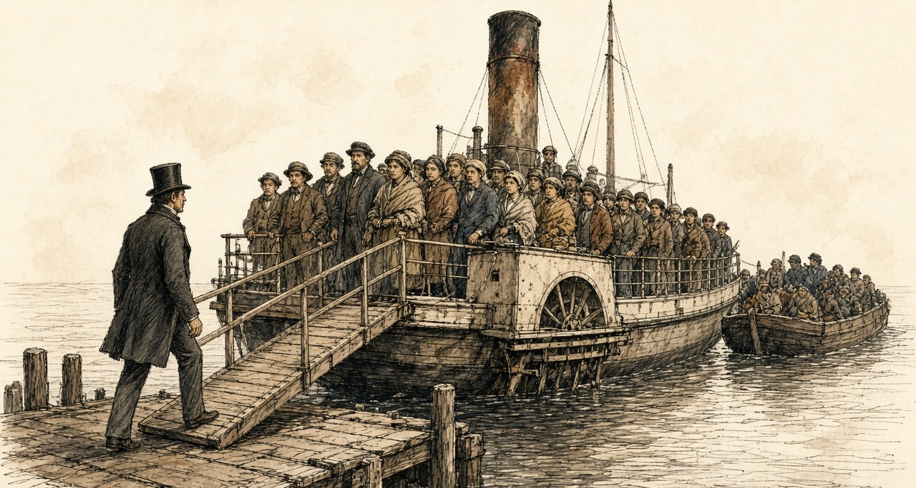
When there was no room on board, the people were put on open barges towed behind the steamer, standing, he wrote, "like pigs upon the deck of a Cork and Bristol packet." A woman died in the Toronto hospital after she had been trodden down in one of those barges, when she was weak and fainting.
"I have, myself, when accompanying the emigrant agent on his visit to inspect the steamer on her arrival, seen him stagger back like one struck, when first meeting the current of fetid infection, exhaled from between her decks."
The Catholic Bishop of Toronto, Michael Power, had been visiting the sick emigrants himself since so many of his clergy were down. He died of typhus on 1 October. De Vere wrote him an obituary in the diary. "He did not spare himself."
On 6 November, at London, in Canada West, he heard that McElderry was dead of fever.
* * *
The Kilrush workhouse, county Clare, Wednesday, 17 November 1847
Since the first day of November is the quarter-acre law in force upon us. Gets me that holds the grass of the goat neither meal nor ticket nor shelter of the house—neither herself, nor the woman, nor the childer—while his grip is on the sod.
Is not a sod of ground at my mother. So is it my mother I take upon my shoulders.
Long and heavy is the road into Kilrush. Is no step in her feet, and carry her the seven miles between my two shoulders. Light is the burden of her necking and the fowl i the bare bones of her wrists knocking together on my collarbone, and every mile or two breathes she a small word in Irish into my ear, and is the voice so thin in her that I know not what she says.
At the far edge of the town stands the great workhouse. Built hard up against the wall of it is the fever shed, and is the strait that kept her in the chimney corner until-today was every mouth in Kilkee that that cross to gate that is to lie down in the winding-sheet.
Is the multitude wedged before the gate ahead of us. Sits the Board of Guardians on the Wednesday, is a new officer from Dublin among them—Captain Kennedy, they call him—and is he within since the break of day.
Stand i the press of the crowd for three hours and her weight hanging from my neck. Is no order or rank in it, an each soul shoving for the one narrow elbow, and a crying and a keening out of a hundred throats. Beside my elbow is a woman with a child hosted on her shoulder, and is the black collar on my mother's shawl. At my boots is a grown man stretched in the mud, rattling his teeth with the rigors of the relapsing fever.
The stench of that gate. is the smell of my own dark cabin at me, and the smell of the sour boilers, ach is the breath of the open grave itself.
Comes the Captain out into the yard, and has he the wanders drag the spotted ones and the raving ones apart to the side of the wall, and leaves the rest of us standing. Call the Guardians us through in the wicket then, and name they. Draw not back from the rags on the vermin on us—i will leave no le on them, they stood close to their work.
Took they her in. Spoke her name, and the townland, and asked the clerk what holding of land was at me, and told the straight truth of the three-quarters of an acre, and wrote he her down for the house, and shut he the book against myself.
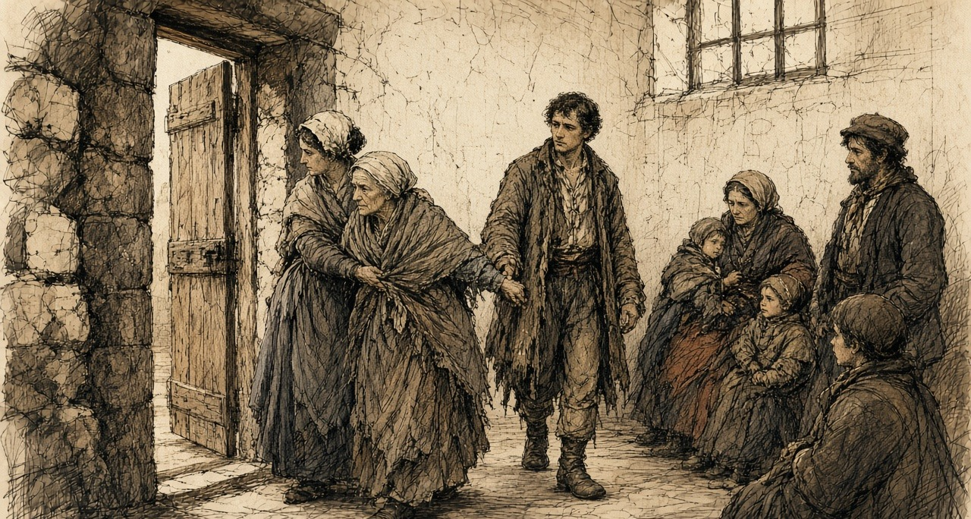
Was the grip of her fingers still twisted in the wool of my sleeve when the porter loosed her hand to lead her within.
Walked I back to the town on the Sunday to get a sight of her face. Was there a small wicket-gate in the side wall of the fever yard where the country people used to slip in to look on their own. Was the iron bolt shot through the panes in the door, and stood out on the road for an hour, looking at the top of the wall.
Is the Indian meal cheaper in the shops of Kilrush this winter than it was in the summer. Are the sacks of it stacked in the rafters in every merchant's store, are the hovels at the cross.
* * *
Kilrush, November 1847
Captain Kennedy had arrived in Kilrush as temporary inspector for the Poor Law Commissioners on 9 November. His reports went to Dublin every few days, and the Commissioners printed them.
On 11 November he reported that 6,000 notices to quit had been served in the union. The rate warrant had gone out late. "A month earlier would have been a great matter, before the crops were swept by landlords or realized by tenants." Twenty-one had died in the workhouse the week before. "The contractor for coffins is unpaid, and threatens to 'stop the supplies.'" The hospital adjoined the workhouse, and "popular terror attributes all deaths in the house to fever," and the nearness of the one to the other kept people out.
On 18 November he described the board day.
"The admissions to the workhouse amounted to nearly 200. Such a tangled mass of poverty, filth, and disease, as the applicants presented, I have never seen. Numbers in all stages of fever and small-pox mingling indiscriminately with the crowd, and all clamouring for admission. I had them separated as quickly as possible." The Chairman and Guardians, "regardless of personal danger, examined and admitted them to the house or hospital. I was in the house from 11 o'clock a.m. till 6½ o'clock p.m., and returned to my lodgings covered with vermin!"
The contractor had supplied 535 coffins for the house alone in six months, "besides the large number given out of doors." Kennedy had seen "healthy children lying with and fondling those in the worst stages of small-pox and fever." On the last visiting day he had found a side gate open, and the friends of fever patients passing in and out of the hospital, and he had got an order to forbid it.
He went through the rate collectors' books. "All the lands under ejectment are literally bare of all stock or produce. Empty walls, an iron pot, and children in swarms, are all I can see or the collector find." He had got an order to proceed against two gentlemen, Messrs. John and Ralph Westropp, for arrears of rates. He hoped for the countenance of the Catholic clergy "in the collection of this most righteous impost."
"Provisions are cheap and plentiful."
That month an inspector in another union asked the Commissioners in Dublin what exactly counted as giving up land under the new Act. On 26 November they answered him. They could lay down no general rule. "All that is requisite is, that a party receiving relief should bonâ fide have ceased to occupy more than a quarter of an acre of land." As to the hardships of the clause, "the Commissioners are not insensible to them; but the Commissioners presume that the hardships were foreseen by the legislature, and on the whole, a less evil than the permitting any one to receive relief from poor rates, who occupies more than a quarter of an acre."
* * *
St. John, New Brunswick, November 1847
In the first days of November the ship Aeolus lay at St. John with emigrants from Lord Palmerston's estate in Sligo. That week the Mayor asked the health officer of the quarantine station, Dr. William Harding, for a report on them. Harding sent it on 4 November.
Words, he said, would not convey it. "These peculiarities are strikingly apparent by inspection, which will at once inform the beholder that 99 of every 100 must be supported by the charity of this community." There were "many superannuated people, and others of broken-down constitutions, and subjects of chronic disease, lame, widows with very helpless families, feeble men (through chronic disease, &c.) with large helpless families; in fact, all those causes which rendered them paupers upon the hands of their landlords are now in existence, with added force from recent disease." Nearly four hundred, he wrote, "so glaring paupers are thus sent out. Who so tame as would not feel indignant at the outrage?"
The Common Council met on 10 November. The almshouses were already full of Irish pauper immigrants. The council could not shelter "such an unheard-of mass of misery thus heartlessly thrown upon our shores at this inclement season of the year," and offered a free passage back to Ireland to any who would take it. It recorded its regret that one of Her Majesty's Ministers, "either by himself or his authorized agent, should have exposed such a numerous and distressed portion of his tenantry to the severity and privations of a New Brunswick winter, unprovided as they are with the common means of support, with broken-down constitutions, and nearly all in almost a state of nudity."
Palmerston's agents, Stewarts and Kincaid, answered for him. They gave their opinion of the scheme plainly. "We think the emigration was eminently calculated to be of the greatest use to your Lordship's estate, to the colonies, and above all, to the poor people themselves; and we hope that means may be provided for continuing it next season upon a scale equally large."
The man who had seen the Palmerston people aboard another of the estate's ships, the Eliza Liddell, wrote from Roscommon on 27 November with his accounts. "I paid 3l. 15s. per adult passenger." It included the usual allowance of bread and water and the head-money on the other side.
In the summer M. H. Perley, the emigration officer at St. John, had reported on an earlier voyage of the Aeolus from Sligo. Her 600 passengers said they had been "exported" by their landlord, Sir Robert Gore Booth, "who paid their passage-money, in order to disencumber his estate." Perley called it "this 'shovelling out' of helpless paupers."
* * *
London, Canada West, October and November 1847
De Vere had a cottage now, with a garden, a stable and a well, for £12 10s. the six months. The £1,300 he had lodged in London had become, by interest and exchange, £1,583 in Canadian currency. He bought a pony, a cow with a calf, and in November a sleigh with a bearskin.
On 2 October his "adopted brother" Michael had come up from Quebec, with Stephen, and the little girl Catharine, and Biddy and the baby. They had sailed from Limerick in the Anne on 9 August. A passenger off the Jane Black had told him in Toronto that the Anne passed them at Kilrush.
On 13 October Catharine was very feverish. On the 16th the doctor declared Michael's illness emigrant fever. De Vere was up every night. On the 20th the child went into a stupor, and he sent for the doctor, who thought her in very imminent danger, and for the priest. Mustard plasters were laid on her. Michael's pulse climbed to 116, his skin hot and dry, his memory going. On the 26th the priest came in the morning, and in two hours Michael's pulse fell from 116 to 104 and his head cleared, and the doctor said the crisis was over. De Vere wrote, "I care not what may be my own fate, if my dear brother be spared. Up all night."
They recovered. On 5 November the doctor told him the Government had closed the Board of Health and the hospital would take no new cases. A Dr. Lee, paid $5 a day by the Government to attend it, had died of typhus the week before.
On 20 November he wrote down a story about a family from Mayo. They had come out that year "apparently in the most abject poverty," a father, a mother, an uncle and a boy of about twelve, and had been sent up to Toronto at the Government's expense. In Toronto the mother was taken into hospital with a rapid cancer of the breast and soon died. The father, the uncle and the boy took a poor lodging near him. He used to meet them. The father complained of dysentery, and de Vere told him to send for a doctor, and the father said he was too poor. In the end he went into the hospital and died "from want of care in the early stage of the disease, leaving his little son in possession of 300 sovereigns tied up in an old rag, which had, during the voyage, been tied under the mother's breast and had produced the cancer of which she died."
The men he had brought out were working on the railway at three shillings and something a day, and he told them he would expect a dollar a week each from them towards the house. On 23 November Pat O'Neill told him he had hired himself to a farmer, to drive his teams and live in, at $10 a month, and was going in the morning. De Vere told him it was most disrespectful. "He replies with cool impertinence." The men, he wrote, had told others they would never work for him under $10 a month. "It is fortunate for me that I did not purchase a farm in the expectation of their performing their contract." On the 26th the railway discharged Roger, Hanly and Fitzgerald for the winter.
On Tuesday, 30 November, he told the boys they must look out for employment, and refused to keep Pat O'Neill's wife in the house at a dollar a week. He spent the rest of the day "Preparing dispatch for Elliot."
The letter was to Thomas Frederick Elliot, of the Colonial Land and Emigration Office in London, who had asked him to write. It ran to four printed pages. He set down the Birman and Grosse Isle and the sheds and the steamers, and then what he wanted done. Separate quarters for the married, for single men and for single women. A hospital ward. Cooking stoves, and "decent privies." A surgeon paid by the Government on every ship carrying more than fifty passengers, with power to hear complaints at sea and prosecute on arrival. No spirits sold except as medicine. The water raised from three quarts to four.
The emigrant who reached Canada through all of it, he wrote, "has lost his self-respect, his elasticity of spirit – he no longer stands erect – he throws himself listlessly upon the daily dole of Government, and, in order to earn it, carelessly lies for weeks upon the contaminated straw of a fever lazaretto."
He sent it off on 1 December, with a copy to his mother.
* * *
Moyarta, county Clare, February and March 1848
Are the roofs coming down across the whole barony of Moyarta. Ag leagan na aithe—tumbling, the bailiffs call it. Stand the people out in the middle of the road with the three-legged pot and the bundle of rags, and before the stars are out they are burrowed in the back of the ditch with the stitches of bog-deal laid across the bank and the sleet beating in on their heads.
Over beyond on the Carrighatool road levelled the crowbar brigade six score houses on the one estate inside of three weeks. Crawl the banished souls on the one estate inside of three weeks. Crawl the banished locksmith is the black fever burning in that cabin to, and then must the man of that house drag them out by the heels and lay them on the roadside, for will no Christian keep the plague under his rafters.
Was the notice to quit served on my own door in November. Was it served on the whole townland.
Came the under-agent riding down the boereen yesterday. Stood he on the stepping-stones outside the threshold; would he not bend his head to come under the lintel. Said he that I took the spade to my own roof and gave the land up without warrant on the sheriff, would five shillings of white silver be put into my palm. And with the land surrendered, said he, would the Gregory law be off my neck, and would the relieving officer put our names down on the outdoor meal list before nightfall.
Spoke the woman of the house not a word. Were her two eyes fixed on the corner where the childer lay.
Was neither stool nor dresser nor pot left within. Were the three childer lying flat in the rotten straw, and no cry coming out of them. Had they given over crying a fortnight back. By that silence did I know the end was in it.
Held I out my hand for the silver.
Is the roof of bog-scrows and old blackened reed-thatch laid over the couples, and are those couples the crooked oak timber my father's father dragged out of the red bog before I was born. Climb I up on the stone fingers, sodden in the heat of my loom. Rotten thatch soft away in my fingers, sodden in the heat of my loom. Comes the rotten thatch soft away in my fingers, sodden in the heat of my loom. Comes the rotten thatch soft away in my fingers, sodden in the heat of my loom. Comes the rotten thatch soft away in my fingers, sodden in the heat of my loom. Comes the rotten thatch soft away in my fingers, sodden in the heat of my loom.
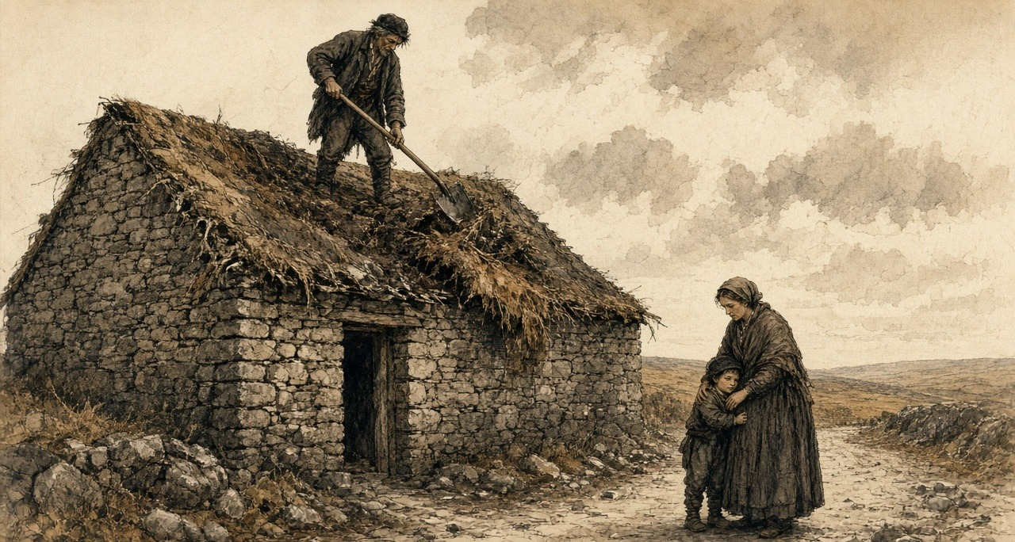
My wife has the children out in the road. She is holding the small boy's face into her skirt so he won't see.
I come down off the wall. I stand inside the gable in the light. The sky is over the hearth.
The relieving officer is the one man for the whole district. There are hundreds on his book. When I find him at last he takes the name, and the name of the townland, and he says he will see.
I have the shillings in my fist. I don't open my hand for fear one will fall.
* * *
Moyarta and Kilrush, February to April 1848
Captain Kennedy was in the barony of Moyarta in February. "There is a concentration of misery and suffering in Moyarta almost beyond the possibility of grappling with, and daily on the increase. Some idea of this may be formed from the fact that upwards of 120 houses have been 'tumbled' on one property within a few weeks, containing families to a greater number; many of whom are burrowing behind the ditches, without the means of procuring a shelter. The relieving officer is intelligent and active, but his duties cannot possibly be performed by any one individual."
At Carrigaholt he went down a list of 575 families and saw every person on it. "On one estate alone, little short of 200 houses have been 'tumbled' within three months, and 120 of this number, I believe, within three weeks!"
On 16 March he wrote of the paupers admitted the day before. "When driven from their cabins they betake themselves to the ditches or the shelter of some bank, and there exist like animals, till starvation or the inclemency of the weather drives them to the workhouse. There were three cart-loads of these creatures, who could not walk, brought for admission yesterday, some in fever, some suffering from dysentery, and all from want of food."
A week later he named the purpose. "Whole districts are being cleared and re-let in larger holdings. These measures, though productive of immediate suffering, will eventually aid the working of the law, and facilitate the collection of rates." Many of the men evicted were deserting their families, "some going to America, some in search of employment."
On 30 March: "I state my conviction, that 1000 cabins have been levelled in this Union within a very few months. The occupants of many of these were induced to give them up on receipt of a small sum of money, and that once spent they must seek the workhouse or starve."
On 13 April: The occupiers "are too often deluded by the specious promises of under-agents and bailiffs, and induced to throw down their own cabin for a paltry consideration of a few shillings, and an assurance of out-door relief." Why did they submit? "The great mass are tenants-at-will and dare not resist."
In the week ending 8 April the union gave out-door relief to 14,292 people. It cost £296 7s. 11d. That is about fivepence a head for the week.
Kennedy had already set down what land was worth there. There were hundreds of instances, he wrote, where an acre worth fifteen shillings was let for £3, and the occupier who could not pay in full was bound to give 140 days' labour to his landlord in spring and harvest, when he most needed the days himself. At eightpence a day, Kennedy reckoned, that came to £4 13s. A cabin "worth perhaps 7s. 6d. a-year" was let for 100 or 120 days' labour.
On 8 April he gave the Commissioners a count. "I calculate that 6,000 houses have been levelled since November, and expect 500 more before July."
* * *
The House of Commons, Monday, 21 February 1848
Henry Labouchere, Chief Secretary for Ireland the year before, moved the second reading of a Passengers' Bill on 21 February.
In former years, he told the House, the deaths among emigrants to Canada had not been more than half of one per cent. Last year they had been seventeen per cent, at sea, in quarantine, and in the hospitals after landing. (The Emigration Commissioners, reporting in November, had put the deaths on the voyage alone at fifty-five in every thousand, against five before.) The Bill would give each passenger twelve superficial feet instead of ten. It would make the ships carry enough food to keep the passengers alive. It would put a Government superintendent aboard, a warrant officer of the Navy, to see the rules kept.
It would not put a surgeon on every ship. The Colonial Secretary had wanted that, Labouchere said, but the Commissioners had concluded that surgeons could not be found for so many ships.
Before he sat down, he read the House a private letter. It was from "an Irish gentleman of station and family, Mr. Stephen De Vere," who had gone out as a steerage passenger "that he might make himself personally acquainted with the condition of the steerage passengers when crossing the Atlantic." He read the water, the salt provisions and rice thrown overboard, the people lying "for four days together in their dark close berths," the gallon that held three quarts, the grog, the powder. He read the line about the voice of prayer. "It was fortunate," he said, "that the House was able to have the testimony of so competent a witness as this gentleman."
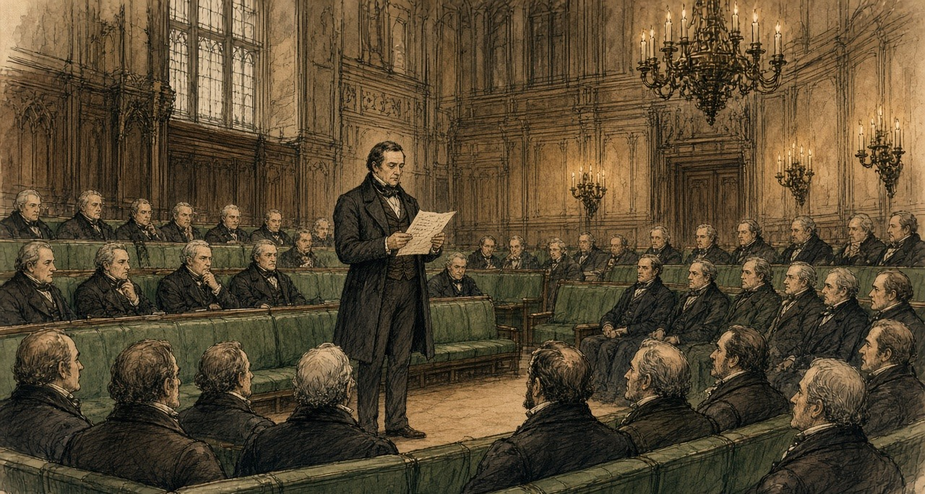
Mr. Wakley, the Member for Finsbury, said a surgeon was to get twenty pounds for seven weeks out and seven weeks home. "Why, it was preposterous to suppose that competent medical men could be obtained for so paltry a pittance." The doctors in the Irish fever hospitals had been paid five shillings a day, and one in fifteen of them had died.
Mr. W. Brown pleaded guilty to being a shipowner and welcomed the Bill. Something else needed attention, he said. "It was well known to every shipowner that the greater part of the ships employed in the Quebec trade in carrying out emigrants would never return with the weight of cargo they brought from Quebec, if it were not that the cargo carried the ship instead of the ship carrying the cargo."
The Bill was sent upstairs to a select committee.
That day, at London in Canada West, a farmer from the Huron Tract came to de Vere's door and asked him for a loan of £70, to pay the Canada Company for land he had worked seven years.
* * *
The House of Lords, March 1848
A select committee of the Lords on colonization from Ireland had been sitting since the session before. Its chairman was Lord Monteagle of Brandon, who as Thomas Spring Rice had been Chancellor of the Exchequer, and who wrote his letters from Mount Trenchard, above the Shannon.
On 9 March 1848 Elliot gave evidence before it. He was asked whether any passenger had reported to him on the trade. "One of the most important Pieces of Evidence upon Emigration which I have ever seen in my Life was contained in a Letter which I received from Mr. Stephen De Vere." De Vere had gone, Elliot said, "wishing to judge for himself whether it was a good Place to which to encourage his poorer Neighbours to proceed," and had "voluntarily exposed himself to the Inconvenience and Hazard of taking his own Passage in the Steerage." He had laid the letter before Lord Grey, who had sent it to the Governor-General of Canada. He was asked for a copy. "I will do so." The letter was delivered in and read, and printed in the committee's minutes.
Elliot explained what the Bill could not do. If the Government listened only to those who wanted more safeguards, "we might perhaps do more Harm than Good to our poorer Fellow Subjects by keeping them to starve at home." "We could not therefore act on all the Suggestions which have occurred in Mr. De Vere's Letter; some must lie over till a more favourable Moment." He put a figure on what the new rules would cost an emigrant. Not more than fifteen shillings, he conjectured, or with an extra colonial tax, "1l. in all for adult Passengers."
A short Act passed the session before, he said, had already forbidden passenger ships to carry gunpowder.
On 14 March Earl Grey, the Colonial Secretary, moved the second reading of the Passengers' Bill in the Lords. A copy of the regulations was to be stuck up on board every ship, he said, a necessary provision, "for when Mr. De Vere went out in one of these ships, he saw great reason to complain of the indiscriminate sale of ardent spirits, but was not aware that heavy penalties could on arrival have been inflicted for such a practice."
Lord Monteagle spoke later in the debate. If he thought the Bill would discourage emigration, he would not support it. He was glad its provisions would run only for a limited time, because "it was probable that the circumstances which had rendered the measure necessary would not continue to exist for any long period." He was glad that arrangements were proposed to find the emigrants employment on arrival, "for the points of debarcation would thus be relieved from the burden of an emigrant population." It was most important, he said, to prevent emigration becoming burdensome to the colonies.
The Bill was read a second time.
That winter de Vere wrote to Monteagle from Canada West. On 12 February, in the same post, a letter went to his elder brother, Vere, telling him he had become a Catholic. "My principal reason for leaving my own country was to save my mother the pain which I feared the avowal of my convictions would have caused to her."
On 2 March, in snow, a letter came from Elliot. De Vere called it "most satisfactory," Elliot "asserting now that it will produce important practical results." Elliot sent him the papers on emigration laid before Parliament as well.
Chapter 10 Appendix of Important Names
• Elliot, Charles (8 mentions in this chapter): British Chief Superintendent of Trade in China who surrendered the British merchants' opium to Lin Zexu at Humen in 1839.
• McMahon, Henry (1 mentions in this chapter): British High Commissioner in Egypt who exchanged the 1915–1916 correspondence with Sharif Hussein of Mecca.
• Palmerston, Lord (Henry John Temple) (3 mentions in this chapter): British Foreign Secretary and Prime Minister who directed British policy in the First Opium War and the 1840 Levant crisis.
Sources
• Diary of Stephen E. De Vere, 1847–1848, two volumes, Manuscripts and Archives Research Library, Trinity College Dublin. Cited from the full transcriptions published in the online exhibition "Bearing Witness: Stephen De Vere's Famine Diary (1847–1848)," Irish Famine Stories in Ontario (Canada Ireland Foundation). Vol. 1: the list of the party; Bristol, London and the Birman, 29 April 1847; Gravesend, the powder, dinner with Stephen S. Rice; "Sailed," 1 May; the Banks, 3 June; Cape Breton, 9 June; the squall west of Gaspé, 12 June; the pilot and the corn ships, 13 June; Grosse Isle, 16 June (about forty ships, the tents, the daily mortality about 150, the Sisters of Liverpool, the Jessy, "Water covered with beds," the boats of sick, the separations, the agent's funds, the medical attendance); Quebec, 17–24 June (the O'Connells' lodgings, the complaint against Captain Guthrie before Buchanan, the £10 to the Rev. Mr. McMahon, the men at 5s. a day, 8s. to 10s. for loading infected ships); Hanly's illness and the codicil at Montreal, 4–11 July, and the temperatures; Toronto, Roger Kennedy's fever, 24 July to 2 August, and the birthday entry of 25 July; "Watch wharf," 14–17 September; Bishop Power, 29 September and 1 October; the arrival of Michael, Stephen, Catharine, Biddy and the baby by the Anne, 2 October, and the report that the Anne passed the Jane Black at Kilrush, 20 September; the London cottage, 6 October; the £1,300 become £1,583, 15 July; the fevers of Catharine and Michael, 13–31 October; Dr. Lee and the Board of Health, 5 November; McElderry's death, 6 November; the Mayo family, 20 November; Pat O'Neill and the men, 23–30 November; the dispatch for Elliot, 30 November and 1 December. Vol. 2: Dr. Douglas's four tables for the season of 1847, copied into the diary (98,106 arrived; 8,691 admitted; 3,238 died, by sex and age; the clergy, medical men and attendants; the daily averages by month); 11 and 12 February 1848 (letters to Lord Monteagle and to Vere; the "important disclosure"); 21 February 1848 (the Huron Tract farmer and the £70); 28–29 February and 4 March 1848 (letters to Monteagle).
• Stephen E. De Vere to T. F. Elliot, London, Canada West, 30 November 1847, delivered in by Elliot and printed in First Report from the Select Committee of the House of Lords on Colonization from Ireland; together with the Minutes of Evidence. Session 1848. Ordered to be printed 2 June 1848 (HL 1848 (46-I)), pp. 45–8. Text from the transcription published by Irish Famine Stories in Ontario, checked against the extracts in Hansard (below). The committee transcription reads "for days together"; Hansard prints "for four days together." The chapter quotes each where it is quoted.
• First Report from the Select Committee of the House of Lords on Colonization from Ireland (as above), evidence of T. F. Elliot, Esq., 9 March 1848, Lord Monteagle of Brandon in the chair: Qq. 459–61 (the letter, Lord Grey, the Governor-General), 463–7 (the suggestions that "must lie over," the Act of the last session prohibiting gunpowder, the proposed amendments), 470 (the cost, 15s. or 1l.).
• Papers relative to Emigration to the British Provinces in North America. London: HMSO, 1848 (Canada and New Brunswick): Elgin to Grey, 28 May 1847, enclosing Dr. G. M. Douglas to the Hon. D. Daly, Quarantine Station, 24 May 1847 (the cholera comparison, seventeen vessels, 5,607 passengers, 260 deaths, the Miriam from Limerick), and Douglas's extract of 21 May 1847 (the Jane Black from Limerick, 425 passengers, 13 deaths); A. C. Buchanan to Major Campbell, Quebec, 31 May 1847 (the return of 36 vessels, 12,450 passengers, 662 deaths; the provisions sent down) and 9 June 1847, enclosing Douglas's letter of 8 June ("dragged out the corpse with boat-hooks"); the report of the Colonial Land and Emigration Office, 20 November 1847, signed by T. F. Elliot and others (deaths on the voyage from 5 to 55 in the 1,000); M. H. Perley's report for the quarter ending 30 June 1847, on the Aeolus from Sligo and Sir Robert Gore Booth ("exported," "shovelling out"); Dr. W. S. Harding to the Mayor of St. John, 4 November 1847, and the resolutions of the Common Council of St. John, 10 November 1847; Stewarts and Kincaid to Viscount Palmerston ("the greatest use to your Lordship's estate"); the letter from Roscommon, 27 November 1847, on the Eliza Liddell (3l. 15s. per adult passenger).
• Papers relating to Proceedings for the Relief of the Distress, and State of the Unions and Workhouses in Ireland. Fourth Series, 1847. London: HMSO, 1848: Captain Kennedy, Temporary Inspector, to the Poor Law Commissioners, Kilrush, 11 November 1847 (arrival 9 November; 6,000 notices to quit; the late rate warrant; 21 deaths; the coffin contractor; the hospital beside the house; no out-door relief yet), pp. 155–6; the Commissioners to Kennedy, 15 November 1847; Kennedy to the Commissioners, 18 November 1847 (nearly 200 admissions, fever and small-pox in the crowd, the Guardians, "covered with vermin," 535 coffins in six months, the children, the side gate, the rate collectors, the Westropps, "this most righteous impost," "Provisions are cheap and plentiful"), pp. 156–7; the Poor Law Commissioners to Lieut.-Col. Clarke, 26 November 1847, on surrender of land under 10 Vict. c. 31 and the hardships "foreseen by the legislature."
• Reports (from Captain Kennedy) and Returns relating to Evictions in the Kilrush Union. London: HMSO, 1849: extracts of 25 November 1847, 11 February 1848 (Moyarta, 120 houses "tumbled," the relieving officer; Carrigaholt, 575 families, nearly 200 houses), 16 March, 23 March, 28 March and 30 March 1848 (1,000 cabins, the "small sum of money"); 6 April 1848 (the acre at 15s. let for 3l., 140 days' labour, 4l. 13s.; the cabin and 100 or 120 days; Killard, 23 houses on 27 March); 8 April 1848 (6,000 houses since November); 13 April 1848 ("a paltry consideration of a few shillings"; tenants-at-will); 16 April 1848 (14,292 souls on out-door relief in the week ending 8 April, at 296l. 7s. 11d.). The fivepence a head is the chapter's arithmetic from Kennedy's figures.
• Hansard, House of Commons Debates, HC Deb 21 February 1848, vol. 96, cc. 1024–35, "Passengers' Bill – Emigrant Vessels": Labouchere (the half per cent and the seventeen per cent; twelve feet for ten; food; the Government superintendent; the surgeon not required; the reading of De Vere's letter, cc. 1029–30); Wakley (20l., the Irish fever hospitals); W. Brown ("the cargo carried the ship"); the Bill referred to a select committee.
• Hansard, House of Lords Debates, HL Deb 14 March 1848, vol. 97, cc. 536–7, "Passengers' Bill": Earl Grey (the regulations to be posted; Mr. De Vere and the spirits); Lord Monteagle; the Bill read a second time.
• Aubrey de Vere, Recollections of Aubrey De Vere (London: Edward Arnold, 1897), pp. 252–3 (the cessation of the public works; "those who had been employed on them under his supervision").
• Stephen E. De Vere to Vere E. De Vere, 11 February 1848, Trinity College Dublin MS 5075a, ff. 81–2, quoted from the transcription in the same exhibition (the conversion; "an exile for conscience sake").

Chapter 11
Valid Against the World, 1849–1856
Whitehall, Westminster, Connemara, 14 Henrietta Street, the parish of Ballynakill in county Galway, Eyrecourt and Hampstead Heath, 1848 to 1856
In the first weeks of 1848 Charles Trevelyan published his account of the famine relief, The Irish Crisis, and near the end of it he turned from food to land. Quoting two pamphlets at length, he described the men who held much of the soil of Ireland and could neither improve it nor sell it. They were owners for life under settlements and entails, with jointures to widows and portions to younger children charged on the rents, and judgments and mortgages on top. Behind them, when the interest went unpaid, came a receiver of the Court of Chancery.
He gave his remedy in one sentence. "The remedy for this state of things is simply the sale of the encumbered estate, or of a sufficient portion of it to enable the owner to discharge his encumbrances and to place him in a position to do his duty towards the remainder."
He went on. "This is the master-key to unlock the field of industry in Ireland. The seller, in all such cases, is incapable of making a proper use of the land. The purchaser, on the other hand, may safely be assumed to be an improver."
A Bill to make such sales easier had passed the Lords in 1847 and been withdrawn in the Commons. The insurance companies, Trevelyan noted, "who are the principal lenders on Irish mortgages," had objected "to having their investments disturbed." An Act of 1848 followed it.
* * *
The House of Commons, Friday, 11 May 1849
The Solicitor-General moved the second reading of the Government's new Bill. It took the sale of encumbered land out of Chancery altogether. A commission of three would sit in Dublin. Either the owner or any creditor could petition it for a sale, and the commissioners would sell, pay the creditors out of the money in their order, and give the buyer a conveyance that no earlier claim could disturb. The lawyers called it a parliamentary title.
Member after member rose to approve it. Two of them told the House what the market was like.
Mr. Grogan said there were "already more estates in the market than could find purchasers." He knew of one lately sold "for between ten and eleven years' purchase, although the title was perfectly clear." Sir Henry Winston Barron said that within the last few days three estates had been offered for sale in Dublin. Two had found no purchasers. The third "was sold at 60 per cent under what was considered by the best judges as its real value."
Colonel Dunne thought the Bill a faulty measure. Any man, from spite or political enmity, could force the sale of an estate "by merely buying up some small debt upon it." Six million pounds a year already went out of Ireland to absentee proprietors. He did not believe many Irishmen would be found able to buy, and he said where the land would go. "He thought the Irish estates would be bought up by speculators, and persons anxious to seize upon Irish property; and the result would be, unless some timely precautions were taken, that the land would get into the hands of non-residents, and the evils to the population would be increased."
Mr. Sadleir, the member for Carlow, had practised as a solicitor in Dublin. The Act of 1848 was useless, he said: under it "every practical man knew it was impossible to sell incumbered estates." He had moved for a return of the Chancery decrees for sale. In the year to March 1848 the Court of Chancery alone had decreed fifty-one estates to be sold, and in the year to March 1849 sixty-nine. In one Master's office there had been fifteen sales in the first of those years and six in the second. In another, seven, and then one. The new Bill had for its object, he said, "an economical, speedy, facile, and advantageous sale of incumbered estates," and the commissioners ought to have "most extensive and summary powers." He wanted the middlemen's leases cleared away too, so that land could be offered "in such a form as would be most likely to attract the English capitalist."
He wanted one more power. Arrears of poor-rate owed by landlords should be recovered from them by the most summary means. Of the three millions sterling collected the year before in poor-rates and county cess, he reminded the House, the tenantry in actual occupation had paid it, "the majority of whom paid less than 15 l. a year rent."
The Bill was read a second time.
* * *
The House of Lords, June and July 1849
Lord Campbell moved the second reading in the Lords on 11 June. In Ireland, he explained, a man could borrow on a judgment, and the judgment then lay as a charge not on one farm but on everything he owned or would ever own, and it could be sold on from hand to hand until "nobody could tell who was the actual owner of any particular judgment." He told the House a story he had from Sir Edward Sugden, who had been Lord Chancellor of Ireland. When an encumbered estate was called on in Chancery, every judgment creditor was entitled to be a party, and counsel rose one after another, said whom they appeared for, and threw the brief towards the bench. So many briefs came at him, Sugden had said, "that it actually resembled the bombarding of a town." Every fee marked on the back of them came out of the estate.
As soon as a creditor had a judgment he could have a receiver, "so that almost all Ireland was under receivers, and the only thriving trade was that of a receiver." In 1807 the receivers of the courts had collected £200,000 a year in Irish rents. They now collected upwards of £2,000,000.
On 26 July the Lords and Commons settled their last differences. In a clause about estates under a receiver the Commons had put "net" where the Lords had written "gross," and Lord Campbell asked their Lordships to accept it. "As the clause was framed by their Lordships, an estate might produce nothing, and yet it could not be sold."
The Incumbered Estates (Ireland) Act received the Royal Assent on Saturday, 28 July 1849. It went through in a list of more than thirty Bills. Alongside it went the Relief of Distress (Ireland) (No. 2) Bill, the Labouring Poor Act Amendment (Ireland) Bill, and the Advance of Money (Athlone to Galway Railway) Bill.
* * *
Connemara, Wednesday, 17 to Friday, 19 October 1849
James Caird farmed at Baldoon, in Wigtownshire, and he went to Ireland that autumn to look at land. Sir Robert Peel had put forward what was called the Plantation Scheme for the west of Ireland, and in Scotland, Caird wrote, the competition for farms had pushed rents so high that the scheme "was, therefore, hailed as possibly an advantageous outlet for our agricultural capital and skill." Peel offered him an introduction. The Lord Lieutenant, Caird wrote, was "considerately pleased to countenance the Author's object." He left Dublin by railway on 4 October.
On the 17th he took the Clifden mail west from Galway, into the Martin estate. It was "now for sale, about which so much has been said." The road ran seventeen miles through it, and the day was wet. He could see no stock on the moors at all. Most of the small patches of ground that had once been dug were deserted and gone back to waste.
Ballynahinch, the Martins' house, stood on a river between the lakes and the sea. He walked five miles over the hills behind it and found heathy mountain, fit, he thought, for small blackfaced sheep and West Highland cattle.
He had the printed plan of the estate with him, and he went over it by its numbers. Lots 83, 84, 85 and 86 were the Cleggan division, on a peninsula between two bays, and he walked carefully over every part of it. Several hundred acres of light arable land. Seaweed and coral-sand on the shore. In a lake behind the beach a hundred and forty salmon had once been taken at two draughts of the net. Lots 80 and 81, across the bay, were inferior, "but the estate would be more complete by getting the whole together."
South of Clifden the road crossed the necks of the sea inlets on bridges, and the tide was rushing in under them with great velocity as they passed.
Lot 65 was Derrygimlagh. It ran two miles along the shore, 2,700 acres, 350 of them lakes, rocky and level. Enclosed and drained, he thought, and dressed with seaweed and sand, it would make good grazing. He set down what he was told about it in the same paragraph. "There seemed to be a considerable population still on this property, although the mortality during the famine was dreadful, not fewer than eight hundred persons, young and old, as I was informed, having died on this lot alone."
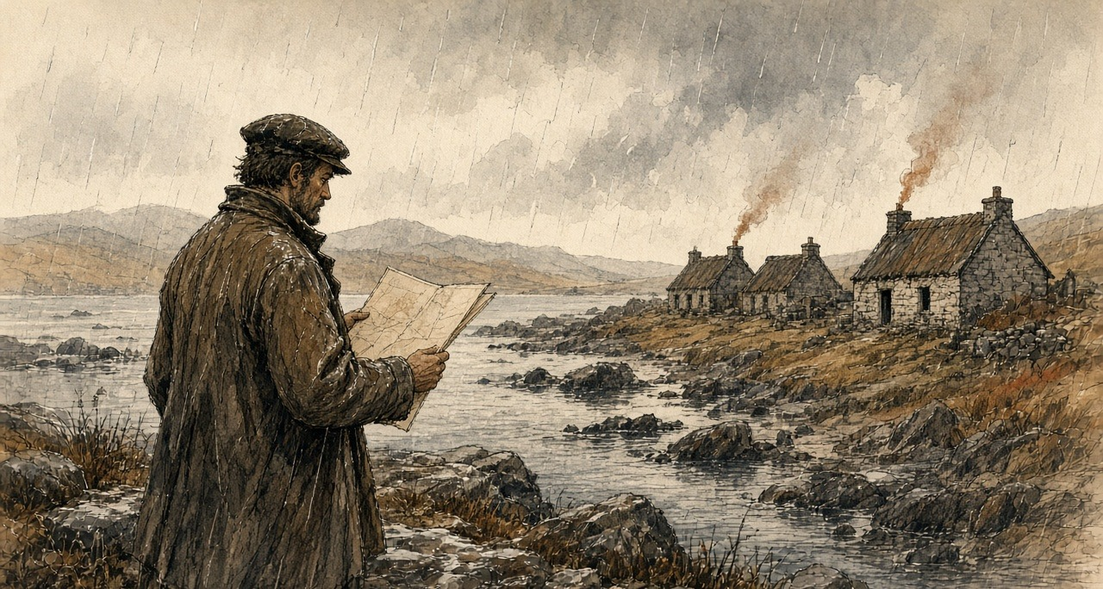
Night came on before Roundstone, and they reached Ballynahinch again drenched.
On the 19th, on the way back, he looked at lots 35, 36, 38 and 39, 4,350 acres fronting Lough Corrib. These were the lots he liked. Dry light land for green crops, a clean white gravel beach where a boat could touch anywhere, beautiful sites to build on. "Care must be taken to ascertain exactly how the existing leases stand, for on the length of these will greatly depend the value of the purchase." A farmer who held a large part of the land walked him over it and, when the rain came down heavily, asked him into his house. It looked neat from outside. Inside, Caird wrote, "it is impossible to describe the dirt and confusion."
He went on south through Clare. He had no time for the west of the county. Kilrush, he wrote, was "noted for its evictions and its poverty," and stood on the coal formation, which was not favourable for farming, "but the whole of the north bank of the Shannon, from Limerick to Kilrush, is well worth the inspection of persons in quest of land."
His book came out in 1850, the preface dated January, for farmers from England and Scotland thinking of going over. A farmer taking land in the west, he advised them, would be "welcomed as a benefactor by the labouring population. He will of course wisely avoid any interference with the parties still in possession of land, as there is plenty of land in the country unoccupied."
* * *
14 Henrietta Street, Dublin, 1849 to 1853
The commissioners were John Richards, a baron of the Exchequer, Dr. Mountifort Longfield and Charles James Hargreave. They were sworn and met for the first time on 28 August 1849. On Thursday, 25 October, the court opened for business.
The Government had taken a house in Henrietta Street, No. 14, for the court. An architect of the Board of Works went through it in 1853 and wrote down each room. The housekeeper lived in the basement. On the ground floor the Chief Commissioner had his public office, twenty-five feet by twenty, with a private room behind it for himself and a clerk, and beside it was the examiners' office. Each of the other two commissioners had the same on the floors above, and the third had a large extra room for the auction clerk.
In the rear, the stable and coach-house had been turned into a court for conducting the sales, thirty feet by twenty-nine. There was a private room for the commissioners and a small room for the bar, a covered passage for the public and a private passage for the commissioners.
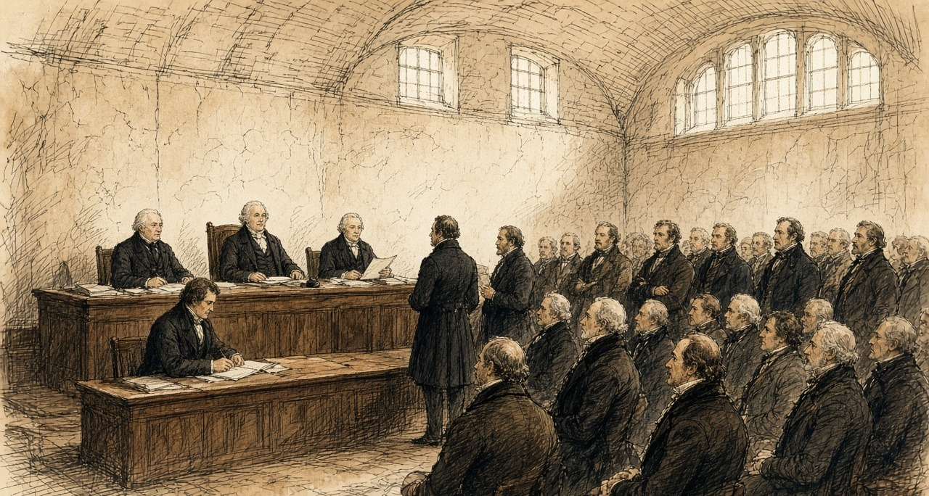
The first estate was sold by auction there on Monday, 21 January 1850. By the end of July the court had held sales in eighty-seven estates and sold 257 lots, and 64,802 acres had changed owners. For seventy-seven of those lots the purchase money did not exceed £1,000. The petitions alone had already put £12,400,348 of encumbrances on the record of the court.
The house filled, and the Government took No. 4, a very large house on the other side of the street, for the secretary, the registrar and the accountant. Its stables were fitted up at great expense, the basement made fireproof for the title deeds. The architect noted "the number of vehicles constantly attending this office."
In April 1853 the court made a return of its staff and their pay. Stephen Woulfe Flanagan, the Master, had £1,000 a year. The auction clerk, John Locke, had £180. James Woulfe, the crier, had £70. There were three porters at £50 each, and the housekeeper, Frances Gumley, had £50, with Lucy Greaves to help her at £30.
By 31 January 1852 the court had sold 559 estates, in 2,698 lots, to 1,640 buyers. A Dublin pamphleteer counted where they came from. Sixty-seven were from England, one from the Isle of Man, one from India, and one from Scotland.
By 1 April 1853 the sales came to £8,790,917 17s. 8d. No county had sold more than Galway. Its estates had brought £1,004,535 11s. 8d. Clare's came to £149,710.
* * *
The House of Commons, Thursday, 7 March 1850
Six weeks after the first auction in Henrietta Street, George Poulett Scrope, the member for Stroud, moved for a special commission to inquire into the union of Kilrush. In six months of 1847, he told the House, the relief works in that one union had cost £110,000, nearly double its rental.
Edward Horsman, the member for Cockermouth, had been there in the recess. "If any person had travelled through Europe during his whole lifetime, he would never have witnessed so much misery arising from the same cause as he (Mr. Horsman) saw concentrated there in the course of a single week." It was all very well, he said, "to speak of the 'rights of property,' but were there no rights of humanity or rights of life?" There was "no law which told human beings they should die in hundreds."
Lord John Russell answered for the Government. He would not make an exception of Kilrush and farm it at the public expense. There were duties of landlords and tenants that no legislature could perform for them. And there was a change now going on. "If the operations of that Act were to extend to the Kilrush union—if it should so happen that the estates of the union were to be sold, and persons would buy them, I believe there is no superabundant population in that union." He believed "that by means of the Incumbered Estates Act that union must be greatly improved."
Sir George Grey trusted they would rely upon the operation of the Act "at present to see what effect would be produced." Under it, he believed, "there would be a transfer of property from proprietors who were unable to perform their duties to those who were both able and willing to do so."
Mr. Herbert read the House a letter about the Clifden union in Connemara. Three estates made up about three-fourths of it. The principal one was part of the Martin estate, "lately offered for sale in London." It was in the hands of the Law Life Insurance Company. "The nominal proprietor does not derive any income whatsoever from it, it continues for sale."
In his reply Scrope said one more thing. "As to the Incumbered Estates Bill, he did not think there was an estate in the district that would come under it."
The House divided. Sixty-three for the commission, seventy-six against.
* * *
14 Henrietta Street, December 1853 to March 1854
John Sadleir had stopped being a solicitor in 1846. By the winter of 1853 he was a junior Lord of the Treasury, chairman of a London bank, and the founder of the Tipperary Joint Stock Bank, which his brother James managed. He was buying land in the court.
In the matter of the Earl of Glengall, owner and petitioner, he bought lots in the town of Cahir and the manor of Cahir. One lot of the manor alone went at £30,000. His purchase money in the Glengall estate came to £67,970. It came in slowly.
On 20 December 1853 Mr. Commissioner Hargreave made an order. An attachment had been sought against Sadleir to compel him to lodge the money, and Hargreave held it back on condition that money was lodged by the 30th. On 18 January Sadleir proposed to pay the balance in pieces, £19,000 that month, £10,000 in each of February, March and April, the rest in May. Hargreave allowed it. On 11 February, Sadleir undertaking to lodge £2,000 more within a week, Hargreave let him take the conveyance of Lot No. 1 of the manor of Cahir, the deed to stay in court until the £2,000 came in. On 9 March Sadleir applied for provisional credit. It was refused with costs, and he was ordered to lodge £2,200 by Monday.
The court executed twenty conveyances to him or to men buying in trust for him. Across the estates of Wall, Glengall, Kingston, Darcy, Hyde and Portarlington the books of the court held fifty declarations of trust made by him or for him.
That December a Scotsman named Allan Pollok bought an estate in the county of Galway in the court, in the parishes of Ballynakill and Kilbegnet: about 7,414 statute acres, with some five hundred tenants and twenty-five hundred people. In the advertisement issued by the commissioners, it was stated that there were no leases, "and that the greatest portion of the land was held by tenants from year to year." He was told, one of his friends said afterwards in the Commons, "that this would be a great advantage, as it would enable him to settle the estates as he pleased."
* * *
The parish of Ballynakill, county Galway, 1854 to 1856
Was the white paper nailed fast to the timber of the door when I came up from the path. Driven through the middle of it was a bright new iron nail, and the boards of the door black with the turf-smoke of three generations.
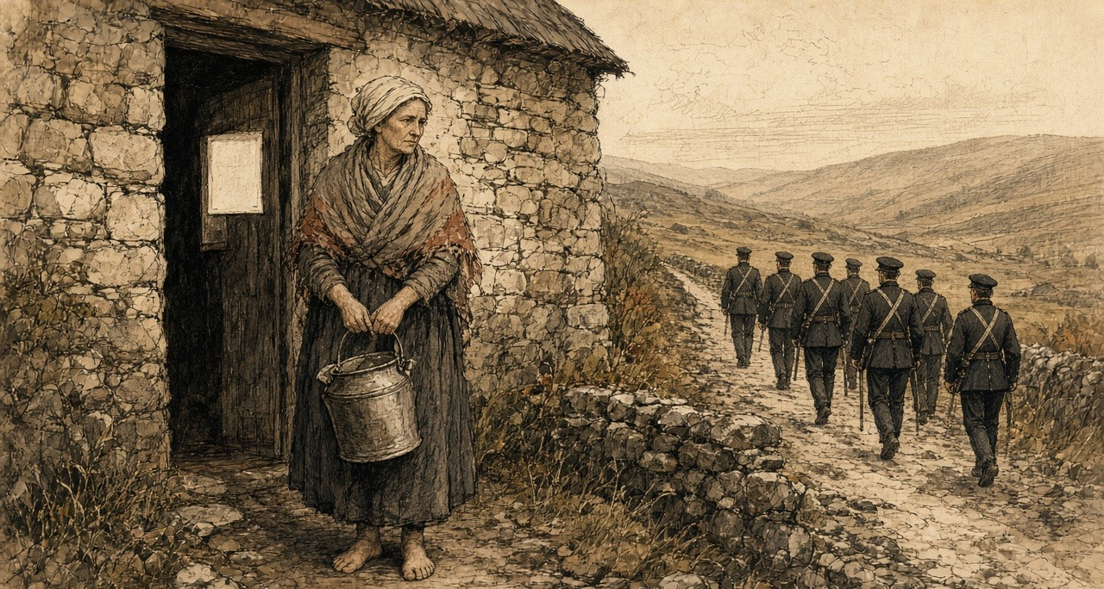
Was the man of the house away cutting turf in the high bog. Stood I on the threshold with the water-bucket in my hand, and the cold spring water spilling over the rim into my bare instep, and I set it down. Is no letter of the English at me, nor reading of any book under heaven.
Down on the high-road were the peelers marching. More of the green coats together in the troop one than ever my eyes beheld since the day I was christened, and two chief officers riding before with the silver braid on their breasts, and a process-server trotting at their stirrup with a sheaf of the white papers under his oxter. Going from cabin to cabin the length of the baile were they, and every door they left behind them had the white blister nailed to the wood.
In the time of the old master, were but five peelers in the barracks at the cross. Now are ten in it, and a new stone barracks raised beside the bog. And is it a Scotch bailiff of the Albannach's own bringing that gives the law to the parish: Are the Albannach's watchers walking the ditches by night and by day. Lifted no man of our parish a stone or a kippen against them yet, nor will.
Was not a penny of arrears on our head, is that the thing that will not lie quiet in my mind. Paid to the last May gale was the rent, and the receipt for it tucked in the dresser. When the word came that a stranger from Scotland had bought the seven townlands in the great Court below in Dublin, and held they out the November rent to him before the gale day came, and who they out the November rent to him before the gale day came. When they out the November rent to him before the gale day came. When they out the November rent to him before the gale day came. When they out the November rent to him before the gale day came.
Himself went to the office with the half-year's rent the week after the paper. They would not take it off him. He stood there with it in his hand held out, and no one would put a hand to it. He came home and put it back in the stocking and the stocking back in the thatch, and he sat at the fire and said nothing at all the whole night, and his two hands hanging.
Some went. The people beyond us went, and the Albanach's men paid them for everything, the value of the crop in the ground, the value of the hens. They got something over that again. They went off down the road with the cart and the hens' money, and the house is standing yet with nobody in it. The children go past it on the far side of the road.
We did not go.
There was a lawyer's word for what was on the door, and it was to be tried at the assizes. The women of the townland walked to the assize town to hear it. We walked it together, a crowd of us, and the men stayed with the cattle. My feet were split on the road. The town was full of carts and gentlemen and police, and the courthouse was full, and the talk inside it was all in English, and fast, and we stood at the back with our shawls up and could not follow it.
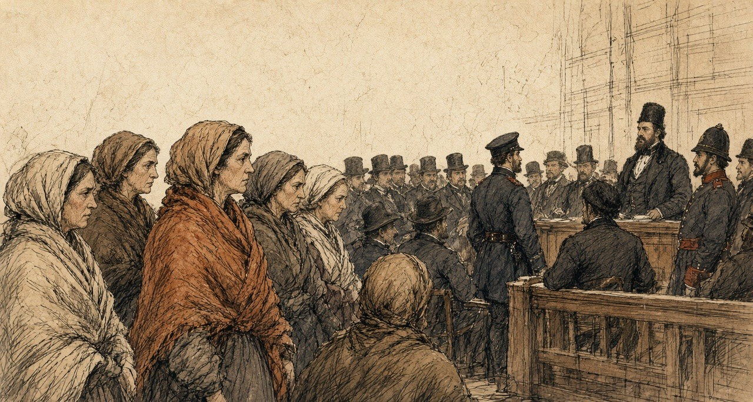
A man of our parish that had English came out to us at last. It was not gone on with. Something was wrong in the papers, he said. It would be put back to the next assizes.
Six months.
The woman next to me sat down on the step of a house in the street. Just sat down. I took hold of the wall.
Six months of a roof, and then the summer assizes, and the walk again.
When I came home I put my hand flat on the door where the nail was. The paper is gone off it. The hole is there.
* * *
The West and Cornborough estates, county Galway, 1853 to 1856
Pollok held two more estates in Galway, called the West estate and Cornborough. There were 246 tenants on them when he took possession, and he set about getting the land into his own hands.
He offered compensation to every tenant who would give up his holding. All but nine agreed. The nine were evicted. Then, his friend told the Commons, "they were immediately replaced in their houses as 'care-takers,'" and they were in his employment, all but two, who had left of their own accord.
The tenants of the West estate were not paupers, M'Mahon told the Commons later. Even through the famine they had paid their rents, and when they were put out none of them went into the poorhouse. By Pollok's own admission he now held the whole of the land, about 1,200 acres, except some 200 acres on leases for lives. On it he built nine farmsteadings, twenty cottages, a corn-mill and a mansion-house. The parish priest of Eyrecourt, Father Derry, wrote to M'Mahon in May 1856 that two-thirds of the houses had been levelled at once.
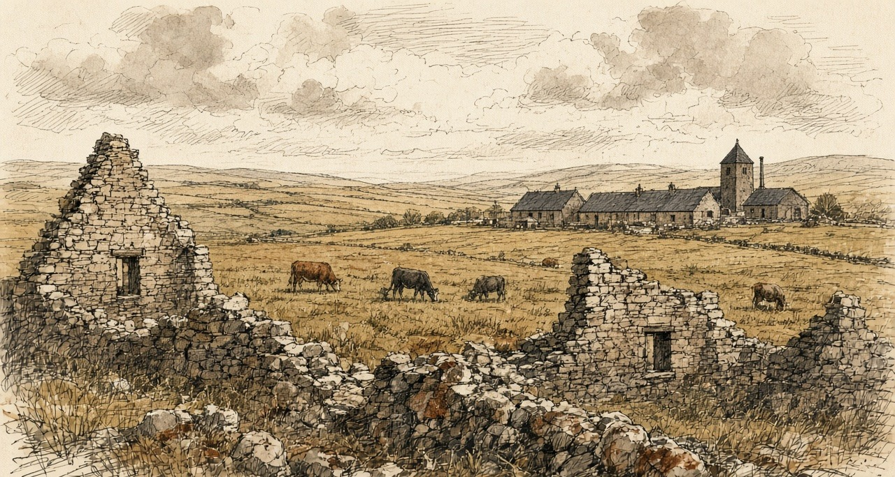
"Instead of the 246 tenants, there were now only a number of labourers."
In 1856 a memorial went to Pollok from the West estate. It was agreed to, his friend said, by 742 persons. It regretted "so many false statements made in London as to your conduct towards us," and went on.
"Most of us were tenants of yours at the time you became proprietor of the West estate. When we gave up our holdings you dealt liberally with us, and have found us liberal employment, at higher wages, and more regularly paid, than we have experienced before. We are all comfortable, contented, and happy, and should be very sorry if a stop were put to the present system of management. We return you thanks for your regular and good employment of our labour, and remain your humble servants."
* * *
Gloucester Square and Hampstead Heath, London, Saturday, 16 and Sunday, 17 February 1856
Anthony Norris was a solicitor of Bedford Row. He had known John Sadleir since 1843 and frequently transacted business with him. On the afternoon of Saturday, 16 February, Sadleir told him not to call that evening. "I would rather that you would not come to see me to-night as I want to get my papers together, but come to-morrow at 11 o'clock."
That day Sadleir had gone to the firm of Wilkinson, Gurney and Stevens, in Nicholas Lane, in a very excited state, to raise a large sum for the Tipperary Bank. The firm had advanced him large sums for years, and six weeks before, when the balances grew too big, they had asked for security. He had given them a deed. It purported to be the conveyance of an estate bought in the Encumbered Estates Court. Josiah Wilkinson refused him on the Saturday, and that very evening, alarmed, he sent his partner, Stevens, to Dublin to register the deed, which the firm had neglected to do.
A letter came to Norris from Ireland that concerned Sadleir, and he went to Gloucester Square anyway. Sadleir was walking about the room, which was very unusual. He appeared surprised to see him. Norris stayed about half an hour and left shortly before eleven. Sadleir talked about his affairs and the money he had lost suddenly the week before. "I noticed, as I was leaving the house, that his eyes were blood-shot, and that he was restless, and not in his usual temperament. I had never seen him in the same state before. He was always cool and collected." There was something about the eyes, Norris said, "as though he had been weeping."
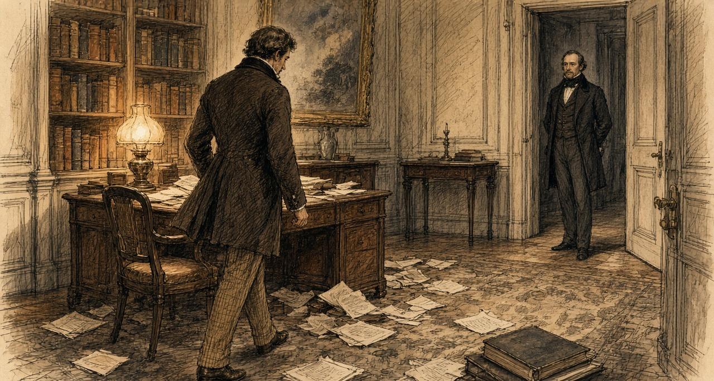
Sadleir had come home to dine about seven, which was unusual. He gave his butler a note for a chemist in the neighbourhood saying the groom wanted essential oil of bitter almonds, a pound's worth. At nine he asked whether it had come and had it sent for. At half-past nine the butler brought it up and set it by his side, about half a pint. He was looking over papers. Later the butler brought the tea-tray, with a silver cream-ewer on it. At half-past eleven the butler saw him for the last time. When he went up at one o'clock the room was empty, and the hat and coat were gone. Sadleir had a latch-key. The servants went to bed.
In the hall he had left three letters, with a note that they were to be delivered on Sunday morning if he was not home by nine.
At half-past eight on Sunday morning a labourer looking for a strayed donkey on Hampstead Heath found him behind Jack Straw's Castle, on his back on a small rise, his head against a furze bush. He was cold and stiff. His hat had fallen a little way off. Beside him lay the bottle, marked in several places "Essential Oil of Almonds" and "Poison," with a little left in it, the silver cream-ewer smelling strongly of prussic acid, and a case of razors. In his pockets were a £5 note, £8 in gold, some silver and halfpence, some pieces of lump sugar, his latch-key, and a slip of paper on which he had written "John Sadleir, Gloucester Square, Hyde Park." They carried him to the Hampstead workhouse.
In Dublin Stevens found at once that the deed was a forgery. It bore the signatures of two of the commissioners and of two attesting witnesses, and every one of them was forged. The seal on it was the genuine seal of the commissioners, taken off some other document and put on this one.
One of the letters in the hall was to Robert Keating, the member for Waterford. "To what infamy have I come step by step—heaping crime upon crime—and now I find myself the author of numberless crimes of a diabolical character and the cause of ruin and misery and disgrace to thousands—ay, to tens of thousands." Stevens and Norris, he wrote, had no knowledge "of the fabrication of deeds and forgeries by me, and by which I have sought to go on in the horrid hope of retrieving." Norris produced another. "I cannot live—I have ruined too many—I could not live and see their agony."
On 1 February the Tipperary Bank had published a balance sheet, declared a dividend of six per cent with a bonus, and carried £3,000 to its reserve. Within a month it had stopped payment. James Sadleir, the manager, had let his brother overdraw more than £200,000. The deficit was over £400,000. The depositors in the south of Ireland, the Annual Register reported that year, were "chiefly small farmers and tradesmen," and they lost their whole savings.
The coroner's jury found that John Sadleir had died by his own hand in a perfectly sound state of mind.
On 4 April Mr. Deasy, the member for Cork, moved in the Commons for a return of everything the late Mr. Sadleir had bought in the Incumbered Estates Court. It was widely believed in Ireland, he said, that the commissioners had treated Sadleir "as an influential Member of that House, and as a good customer to the Court." He spoke of "the system of land jobbing which prevailed to a great extent in the Incumbered Estates Court." The return was signed at Henrietta Street on 23 April. It listed the Glengall orders, the extensions of time, and the twenty conveyances.
* * *
The House of Commons, Tuesday, 29 April 1856
The Galway petition had been in the House for more than a year. Mr. M'Mahon, a barrister and the member for Wexford, had presented it in March 1855 for the inhabitants of Kilbegnet and Ballynakill, and twice put off his motion on it. He brought it on in the evening of 29 April, between the nights of a debate on the fall of Kars, before a House that wanted to get back to it. He would not have pressed it then, he said, "had not the dwellings of upwards of 500 families depended upon the result."
He read the petition's case. The tenants were remarkable "for their punctuality and sobriety, and for the total absence of agrarian outrage." They owed no rent and had offered to pay in advance. Pollok had promised none would be evicted and had then proceeded against all of them. Before he bought there had been five police in the district; now there were ten, and on his application another station had been set up, "wholly under the control of one of the servants of Mr. Pollok." Lately "a large body of police, under the command of two chief inspectors, were going about, scattering about processes of ejectment, on behalf of Mr. Pollok, in the most illegal and irregular manner, in some instances by nailing them to the doors of the houses."
He read from a statement that Pollok's brother had published. Pollok had bought "under the direct inducement that he was to have possession of the leases on whatever conditions he thought proper." He had calculated, "not on the present rental, but on an estimated rental." He had found the tenants without capital, and his arrangements required tenants with capital.
When a district was laid waste in Ireland, M'Mahon said, the people went into a distant workhouse "and the evictor did not pay a sixpence of poor-rate." When an English manufacturer wanted police to guard his mill he paid for them. In Ireland the police were paid out of the national revenue. And he quoted the Chief Secretary for Ireland, who was now Edward Horsman. M'Mahon read the House his speech on Kilrush of 1850, the misery of a single week, the rights of humanity, the law that told no one to die in hundreds.
Mr. Bellew, a Galway member and a landlord, seconded. Pollok, he said, was not a hard-hearted man so much as "the victim, so to speak, of a misconceived passion for evictions, for Mr. Pollok evicted all alike, rich and poor, and not only allowed them the full value of everything upon their land, even to the poultry, but gave them something additional upon quitting." "He could not forget the anxious faces of wives and mothers, who had walked twenty or thirty miles to the assize town to obtain a few hours' earlier possession of the fact as to whether they were destitute before heaven, or for six months longer had a roof to cover them."
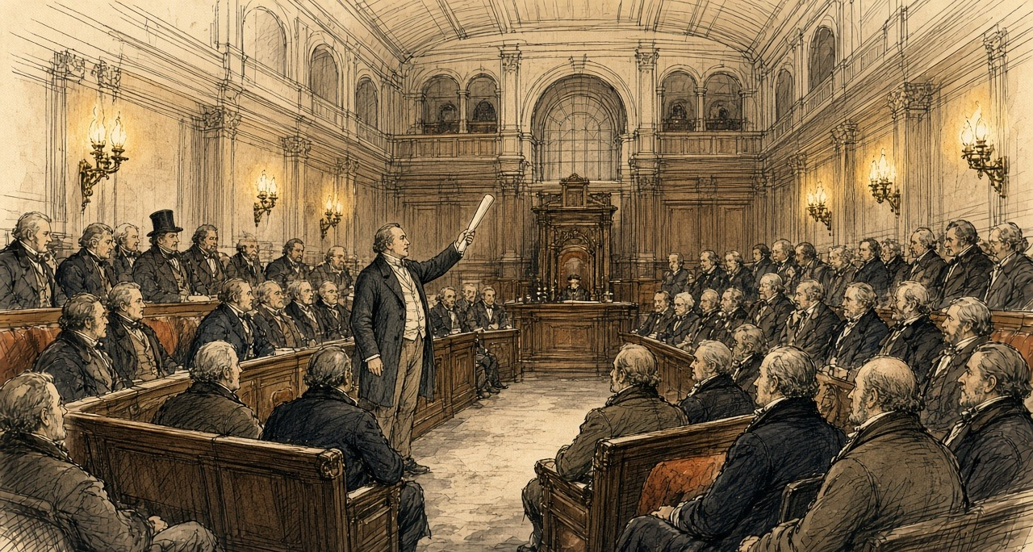
Lord Palmerston would not grant a committee. It was hard to say what remedy a landlord had against tenants who paid no rent if not the law. But "the too frequent resort to this practice of 'clearing estates' by Irish landowners, through process of eviction, except under very extreme circumstances, was one ill-calculated indeed to advance the prosperity of their common country." He moved that the House pass to the orders of the day. The vote of censure over Kars was waiting.
Edward Ellice, a Scottish member, regretted that the man was a Scotchman, and that the system "had long been known in Scotland, and was a curse to the country." Disraeli said that no one could have listened "to so painful a history" without concluding that "the exercise of rights under the law as described was most intolerable in a Christian nation." He had always thought the court beneficial on the whole, "but if there was anything which could raise a prejudice against that court it would be, that it gave to strangers who might even be non-resident the opportunity, if they thought fit, for depopulating large districts." The catastrophe, he understood, might come next July.
Sir Michael Shaw Stewart, the member for Renfrewshire, said Pollok was a friend of his and a highly honourable man. He did not know whether the petition was true.
M'Mahon withdrew his motion. The House went back to Kars.
* * *
The House of Commons, Tuesday, 27 May 1856
Four weeks later Shaw Stewart rose to present a petition of Pollok's own. Pollok had been "held up to execration by the public press," in Ireland and in Scotland. He was possessed of vast wealth, honourably acquired, and of an estate in Renfrewshire that had been in his family for many years. On the West estate the population had risen since he bought it, from 1,200 to 1,500 souls. Not one person there had been driven to the poorhouse. He read the memorial of the 742. The farm buildings, he had been told by persons well qualified to judge, "were superior to anything in Ireland or Scotland," and would be useless if the land were turned to grass. On the other estate Pollok had tried to make the same arrangements, and the tenants were at first ready, and afterwards refused. He had then gone to law, "not to eject the tenants from the country, but to show that he was legal owner." Owing to informalities, the proceedings had not been carried out.
M'Mahon answered that he was a stranger to Galway and had stated nothing of his own knowledge. He had a letter, received on the Saturday, from Father Derry. Pollok had bought in December 1853 and begun his ejectments in the spring of 1854, when no rent was due, and the tenants were ready to pay now. If Pollok took the rent he would waive his ejectments. "Mr. Pollok wanted the land and not the rent."
Mr. Hastie read from the report of Michael Kelly, the receiver of the Court of Chancery on the estate before the sale. "The great bulk of the tenantry are persons in a humble rank of life, and for the most part persons in doubtful and in very many instances insolvent circumstances." Henry Drummond, the member for West Surrey, protested against the whole discussion, and said the owner who had managed the estate so well before Pollok had ended in the Insolvent Debtors' Court.
Sir John Pakington said Pollok "deserved to be ranked amongst the greatest benefactors of Ireland." Palmerston said he had expressed no opinion about Pollok whatever, only about the system with which he was charged.
John Francis Maguire took Pollok's own figures. From one estate of 12,000 acres he had removed 240 tenants, and made most of them day-labourers. The system meant "converting the farmer, who enjoys at least a position of comparative independence, into a day-labourer, who is not only in a position of complete and total dependence, but whose means of existence depend upon the chance of accident or the calamity of sickness." He had a figure for the court. Of £17,000,000 of property bought in it, not much more than £2,000,000 or £3,000,000 had been bought by strangers.
George Henry Moore, the member for Mayo, had been to see Pollok. Pollok had "converted the inhabitants into farm labourers; but he paid them well and treated them handsomely." And now, Moore said, "like most other gentlemen who had tried high farming, he was becoming tired of the system, and was about to relet this property in large farms." If the land went to grass, what would become of the people who had been dispossessed?
Bellew said Pollok did not deny the main fact. "He admitted that he had ejected 177 tenants from their holdings on the estate to which the petition referred." The new labourers had no security. "They might have work this year and next; but what would be their condition five years hence?" They might be employed today, and "this day fortnight they might be houseless and penniless."
The House adjourned till Friday.
* * *
The House of Commons, June and July 1856
On 16 June Colonel Higgins asked the Chief Secretary about a judgment of the Queen's Bench in Ireland, Errington v. Rorke. The judges had held that a man who bought from the Incumbered Estates Court was bound by an earlier lease that was not mentioned in his conveyance. Horsman answered him. "Hitherto it had been supposed that an estate purchased in the Incumbered Estates Court brought with it a title good and valid against the world. It certainly was the intention of the Legislature and the understanding of the public that such should be the case; and on the faith of that understanding large purchases were made in that Court." The decision was "calculated to create apprehension and alarm amongst those purchasers," and the Government meant to obviate the alarm.
On 4 July, on the second reading of an Incumbered Estates Bill, Sir James Graham raised it again. There had been about 5,000 sales through the court, he said, and probably twenty or thirty old title-deeds brought in with each estate. Dr. Longfield, he was informed, had recommended that the old deeds be destroyed, so that no one could go behind the parliamentary title. If they had not been destroyed, Graham said, they had been "stowed in a cellar into which nothing ever entered except the River Liffey, which did penetrate this deep recess, he was given to understand, from time to time, and bid fair to destroy them."
The Bill was read a second time.
Chapter 11 Appendix of Important Names
• Disraeli, Benjamin (1 mentions in this chapter): British Prime Minister who arranged the 1875 purchase of Khedive Ismail's Suez Canal shares with Rothschild financing.
• Palmerston, Lord (Henry John Temple) (2 mentions in this chapter): British Foreign Secretary and Prime Minister who directed British policy in the First Opium War and the 1840 Levant crisis.
• Peel, Robert (2 mentions in this chapter): British Chief Secretary for Ireland and Prime Minister who repealed the Corn Laws during the Great Famine in 1846.
• Russell, Lord John (1 mentions in this chapter): British Whig Prime Minister during the height of the Irish Famine (1846–1852).
• Trevelyan, Charles (2 mentions in this chapter): Assistant Secretary to the British Treasury who administered Irish famine relief operations between 1845 and 1847.
Sources
• [C. E. Trevelyan], The Irish Crisis (London: Longman, Brown, Green & Longmans, 1848; first printed in the Edinburgh Review, January 1848), the section on encumbered estates (owners for life, receivers; "The remedy for this state of things is simply the sale"; "the master-key"; "may safely be assumed to be an improver"; the Bill of 1847 and the insurance companies). Text from Project Gutenberg no. 56727.
• Hansard, HC Deb 11 May 1849, vol. 105, cc. 344–61, "Incumbered Estates (Ireland) Bill": the Solicitor-General's motion; Grogan (more estates than purchasers; ten and eleven years' purchase); Sir H. W. Barron (three estates, 60 per cent under value); Colonel Dunne (the small debt, £6,000,000 to absentees, "bought up by speculators"); Sadleir (the Chancery returns, 51 and 69 decrees, 15 and 6 sales, 7 and 1; "economical, speedy, facile"; "summary powers"; "the English capitalist"; poor-rates, three millions, tenants under £15). Second reading.
• Hansard, HL Deb 11 June 1849, vol. 105, cc. 1336–67: Lord Campbell (judgments; Sugden's briefs, "the bombarding of a town"; receivers, £200,000 in 1807, upwards of £2,000,000). HL Deb 26 July 1849, vol. 107, cc. 960–2 (net and gross; "an estate might produce nothing"). HL Deb 28 July 1849, vol. 107, cc. 1071–2, Minutes (Royal Assent: Incumbered Estates (Ireland); Relief of Distress (Ireland) (No. 2); Labouring Poor Act Amendment (Ireland); Advance of Money (Athlone to Galway Railway)). The outline of the Bill (petition by owner or creditor, sale and distribution by the commissioners, the parliamentary title) is taken from Sadleir's speech, the commissioners' report of August 1850 and the 1856 debates below; Hansard prints no text of the Solicitor-General's opening.
• James Caird, The Plantation Scheme; or, The West of Ireland as a Field for Investment (Edinburgh and London: Blackwood, 1850), preface dated Baldoon, Wigtown, January 1850 (Peel's scheme; rents in Scotland; the introduction from Peel; the Lord Lieutenant), pp. 1–2; p. 3 (Dublin, 4 October); pp. 47–53 (the Clifden mail, 17 October; the wet day; no stock; deserted patches; Ballynahinch; five miles of hills; lots 83–86 and 80–81 at Cleggan; the salmon; the bridges and the tide; Derrygimlagh, lot 65, 2,700 acres, "not fewer than eight hundred persons"; drenched; 19 October, lots 35, 36, 38, 39 on Lough Corrib; "Care must be taken"; the farmer's house, "the dirt and confusion"); p. 70 (Kilrush "noted for its evictions and its poverty"; "persons in quest of land"); p. 122 ("welcomed as a benefactor"; "plenty of land in the country unoccupied"). Text from the Internet Archive copy plantationscheme00cairrich.
• Report of the Commissioners for the Sale of Encumbered Estates in Ireland, as to their Progress, &c., S. Woulfe Flanagan to T. N. Redington, 5 August 1850, presented to Parliament 1850: first meeting 28 August 1849; court opened 25 October; first sale by auction 21 January 1850; 87 estates, 257 lots, 77 under £1,000; 64,802 acres; encumbrances in petitions £12,400,348.
• Papers relating to the Removal of the Offices of the Incumbered Estates Court from Henrietta-street to the Four Courts, HC 1854 (184): memorandum of J. Owen, Architect's Office, 30 June 1853 (No. 14 room by room; the stable and coach-house converted into a court for sales, 30 by 29 feet; passages; No. 4 opposite; the fireproof basement for title deeds; "the number of vehicles constantly attending"); Treasury minute of 21 March 1854 (the commission to terminate about August 1858).
• Return from the Incumbered Estates Court to 1 April 1853, HC 1853 (390): produce of sales by county (Galway £1,004,535 11s. 8d.; Clare £149,710; total £8,790,917 17s. 8d.); staff and salaries, signed Henry Carey, 19 April 1853.
• Ireland: Observations on the People, the Land, and the Law, in 1851, with especial reference to the Incumbered Estates Court, 3rd edn (Dublin: Hodges & Smith, 1852), pp. 67–8 (sales to 31 January 1852: 559 estates, 2,698 lots, 1,640 purchasers; 67 from England, one each from Scotland, the Isle of Man and India). The author is anonymous on the title page.
• Hansard, HC Deb 7 March 1850, vol. 109, cc. 465–96, "Kilrush Union": Poulett Scrope (£110,000 in six months; the motion; "As to the Incumbered Estates Bill"); Horsman (the single week; "rights of humanity"; "die in hundreds"); Lord John Russell ("If the operations of that Act were to extend to the Kilrush union"; "must be greatly improved"); Sir G. Grey ("a transfer of property"); H. A. Herbert reading the letter on the Clifden union (the Martin estate, the Law Life Insurance Company); division, 63 to 76.
• Return of Purchases made in the Incumbered Estates Court by the late John Sadleir, HC 1856, signed Henry Carey, 23 April 1856: the Glengall lots and the £30,000 lot; £67,970; the orders of Mr. Commissioner Hargreave of 20 December 1853, 18 January, 11 February and 9 March 1854; the declarations of trust by or for him (7, 22, 9, 8, 2 and 2, fifty in all); twenty conveyances. Hansard, HC Deb 4 April 1856, vol. 141, cc. 543–7 (Deasy; "a good customer to the Court"; "land jobbing").
• The Annual Register ... of the Year 1856 (London, 1857), Chronicle, 17 February, "Suicide of Mr. John Sadleir, M.P." (the career; the inquest; the evidence of the butler as summarised; the deposition of Anthony Norris quoted in the first person; the evidence of Josiah Wilkinson; the forged deed and the transferred seal; the letters to Keating and the unaddressed letter; the balance sheet of 1 February; the overdraft and deficit; the depositors; the verdict). Hansard's people index (Mr John Sadleir, 1813–1856) gives his seats: Carlow, 29 July 1847 to 20 January 1853; Sligo, 8 July 1853 to 17 February 1856.
• Hansard, HC Deb 29 April 1856, vol. 141, cc. 1707–18, "Constabulary Force (Ireland)—Evictions in Galway": M'Mahon (the petition of Kilbegnet and Ballynakill, presented 25 March 1855; 7,414 acres, 500 tenants, 2,500 souls; the police; the processes nailed to doors; Pollok's brother's statement; poor-rate and police; Horsman quoted); Bellew ("misconceived passion for evictions"; "even to the poultry"; the wives and mothers); Palmerston; Ellice; Disraeli; Shaw Stewart; Maguire; the motion withdrawn.
• Hansard, HC Deb 27 May 1856, vol. 142, cc. 697–712, "Alleged Evictions in Ireland—Case of Mr. Pollok": Shaw Stewart (Pollok's petition; the West estate; the nine evicted and replaced as caretakers; the advertisement, "no leases"; the informalities; 1,200 to 1,500 souls; the memorial of 742; the farm buildings; the Renfrewshire estate); M'Mahon (Father Derry's letter; 246 tenants; 1,200 acres, 200 on leases for lives; two-thirds of the houses levelled; nine farmsteadings, twenty cottages, a corn-mill, a mansion-house; no tenants to the poorhouse; December 1853 and the spring of 1854; "wanted the land and not the rent"); Hastie (Kelly's report, as receiver of the Court of Chancery); Drummond; Pakington; Palmerston; Maguire (12,000 acres, 240 tenants; the day-labourer; £17,000,000 and £2,000,000 or £3,000,000); Moore; Bellew (177 tenants; "this day fortnight"); the adjournment.
• Hansard, HC Deb 16 June 1856, vol. 142, c. 1495 (Higgins; Horsman, "a title good and valid against the world"); HC Deb 4 July 1856, vol. 143, cc. 374–80, "Incumbered Estates (Ireland) Bill" (Graham: about 5,000 sales, the old deeds, Longfield's recommendation, the cellar and the Liffey; second reading).

Chapter 12
Church Wells, 1850–1878
Castleconnell, Thurles, Tralee, Kilkenny, Errismore in Connemara, the Aran Islands and Dublin, 1834 to 1878
In the hay season of 1834 a travel writer named Henry Inglis hired a rowing boat at Castleconnell to take him up the Shannon to Killaloe. Before he went he walked out as far as a holy well dedicated to St. Senanus. He judged from what he saw that it was in high repute. Hundreds of little wooden vessels lay heaped in it and above it, left by the people who had come to drink. The trees that hung over the well were entirely covered with shreds of every colour, bits and clippings of gowns and handkerchiefs and petticoats. Among them he noticed some strings of beads, and a few locks of hair.
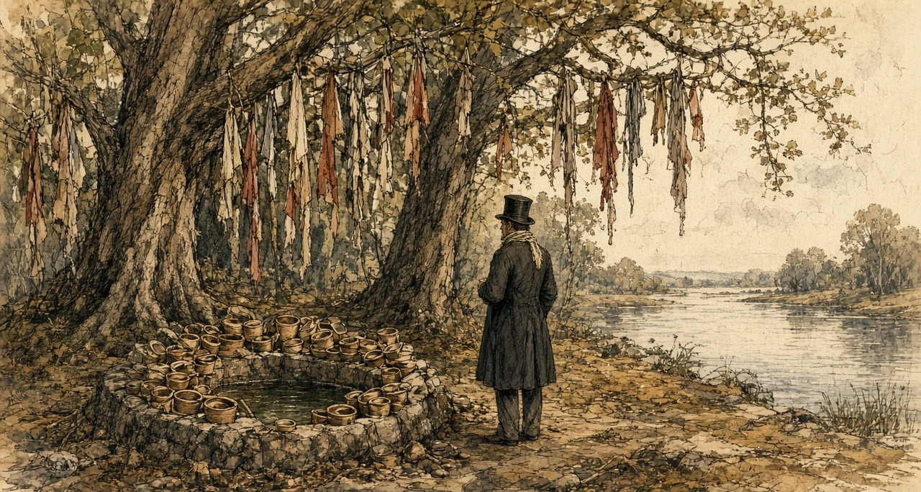
He thought he understood what they were for. "These, I believe, are the title-deeds to certain exemptions, or benefits, claimed by those who thus deposit them in the keeping of the patron saint, who is supposed to be thus reminded of the individuals whose penances might otherwise have been overlooked."
The inn at Castleconnell was beautifully placed and very moderate in its charges. For a very small house there, £10 a month was asked.
* * *
Thurles, county Tipperary, Wednesday, 21 and Thursday, 22 August 1850
The letter of convocation had been dated at Drogheda on 30 May, the feast of Corpus Christi, in Latin, over the name of Paul, Archbishop of Armagh, Primate of all Ireland and Delegate of the Apostolic See. He summoned every archbishop and bishop in Ireland to a national council at Thurles, in the buildings of the seminary, on the feast of the Assumption. On 6 August, from Drogheda again, he put it back a week, "ob graves causas," for grave reasons, to the 22nd.
The town filled. Every house in it and around it, the Illustrated London News reported, was occupied with visitors, and in many cases the barns had been turned into lodgings. On the Wednesday night it was almost impossible to find a place to lay one's head except at prices that, "in times like these, seem exorbitant." The paper counted the clergy of the surrounding dioceses, the priests who had come from the most remote parts of the country and the strangers from every direction, and put the applicants for a bed at not fewer than six hundred. The streets were crowded besides with people from the towns around and the peasantry of the neighbourhood.
By eight o'clock on Thursday morning groups of soberly dressed clergymen were walking towards the College. It was faced in cut stone. Inside, its halls and broad stone staircases were full of priests in surplice and soutane, some wearing the stole, and now and then a bishop went by in his robes with his train-bearers. When a great man came near, his name passed from group to group in a whisper.
Charles Bianconi had lent pictures from his collection, which the paper called one of the best in the country, to hang in the hall and on the walls of the cathedral. One was The Death of St. Francis of Assisi. The other was The Visitation. There were busts on pedestals, two of them of O'Connell.
At ten o'clock exactly the prelates gathered in the College oratory and the Veni Creator was sung. Then the procession came down the great stairs, out through the hall and along the broad path to the door of the cathedral, about five hundred yards. Police stood at intervals along the avenue and the road and in the cathedral yard to keep the crowd off. The bell in the cathedral tower tolled, and the choristers chanted the Litany of the Blessed Virgin.
A cross-bearer led, in crimson and gold. Behind him at least three hundred clergy walked two and two. Then the notaries and secretaries of the council, the archiepiscopal cross, the promoters, the procurators of absent bishops, the provincials of the religious orders, the mitred abbot of Mount Melleray, and the bishops in order of promotion, each with a chaplain and a mitre-bearer. Their vestments were velvet, brocade and cloth of gold. The mitres glittered with jewels. The laity came last.
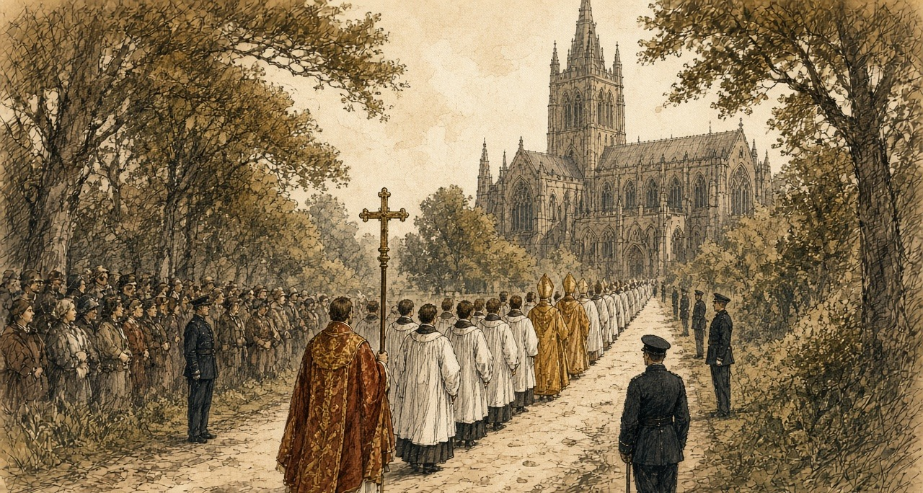
All eyes went to the Primate. To the reporter Dr. Cullen seemed "the lowliest and meekest of that glittering crowd of dignitaries." His face was pale. His eyes were mostly cast down, the lids almost covering them. He was said to be not more than forty-five.
A throne had been built on the Gospel side of the sanctuary and covered in crimson damask and brocade. Cullen sang the High Mass of the Holy Ghost. The deacon sang the Gospel: "And at that time Jesus, calling together the twelve apostles, he gave them power and authority over all devils, and to cure diseases." Cullen read his allocution in Latin from his seat. The decree opening the council was read, and the bishops said it was agreeable to them. Cullen knelt towards the altar with his hand on the Gospels and made the profession of faith while everyone stood bareheaded, and then each prelate, and only a prelate, knelt before him, said the same words, and kissed the book.
The proceedings themselves were to be secret. No member would communicate with anyone outside while they lasted.
In the same column in which it announced the opening of the synod, the Illustrated London News printed a paragraph from the Limerick Reporter. "Nineteen houses were levelled, and 148 persons turned out roofless, last week, in a village called Ballagh, near Clonoulty, not far from Thurles."
* * *
A small farm in the parish of Thurles, August 1850
Strangers had the barn off us for the week of the Synod—two northern curates out of Armagh and the car-man that drove them—and they paid down what we asked without a word of bargaining, and threw in two shillings over the third morning came.
I scoured the place out myself on the Monday. I lifted the hens' roost down off the rafters and scattered two buckets of hot lime over the flags where the cow stood in the winter, and the sharp burn of the lime was up in my nostrils the whole week after. We gave them the clean wheatestraw on the Thursday, and I kept good rows of it, and the children and the two good blankets off our own bed, and himself and the childer and myself settled on the settle in the kitchen turf-turn.
I had the silver tied safe in the corner of my check apron going into Thurles on the Thursday, and I kept my fist closed round through the cloth, feeling the solid knock of it against my thigh at every step.
You could not stir a foot in Liberty Square for the crush. Outside-cars and gigs hub-to-hub from every parish in Munster, and the stallions rearing and roaring, and the horse-dung trodden into a butter underfoot, and balloiled-singers bawling, and gentlemen come over from the London papers. I, hoised myself up on the coping of the college yard wall with my sister's girl beside me, and a double line of the constabulary standing below with their broad backs pressed against our boots.
Then the great bell in the tower began to toll. You could feel the iron stroke of it jarring in your teeth. Out from under the lime-trees came the Latin singing, and then they came walking, two and two down the gravel—the white surplices over the black soutanes, more priests together than I think was in the four corners of Ireland—and then the bishops in their hem of train up off the gravel.
Gold. Solid cloth of gold on the backs of them. One old prelate passed right under the wall where my feet were hanging, and the cape on his shoulders was that crusted with gold bullion it swung stiff as a barn-door, and the kids in the jewells let off their wink firing in the sun, and a little acolyte in red holding the hem of his train up off the gravel.
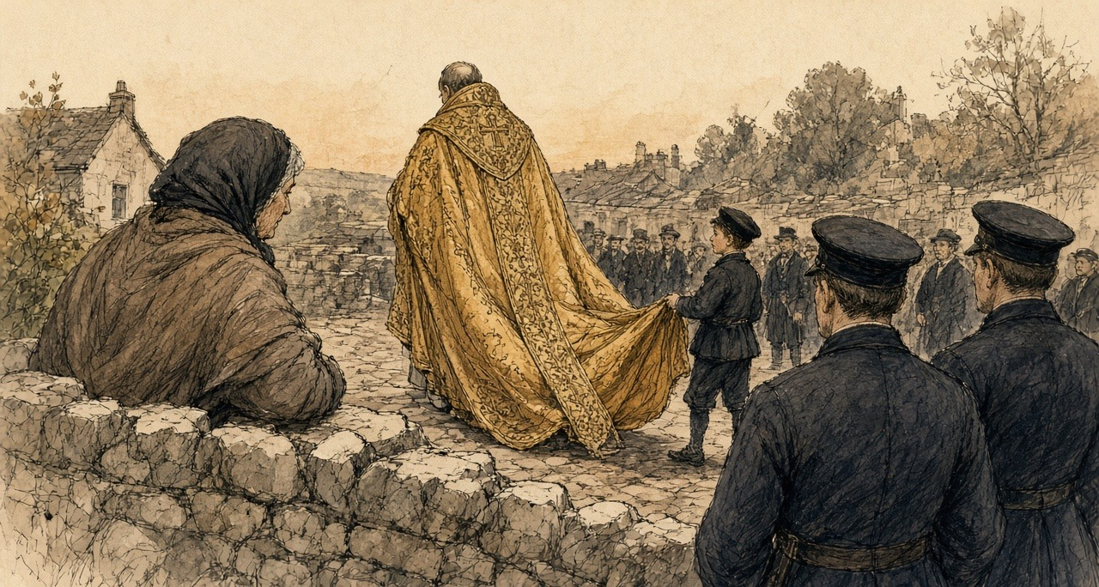
My niece whispered that the small, dark-faced one at the end was Dr. Cullen, the new Primate that was forty years in Rome. I never got a sight of yes in his facial kit winking fine in the cathedral, the road to the cathedral door.
And while we were crushed there waiting on the blessing, a cattle-drover in the crowd behind was telling how the sheriff levelled nineteen cabins at Balilagh, out Clonclty, the week before, and turned seven score souls out into the gip of the ditch. A townsman in a good freeze coat turned round and told to him what hisMonth, today was not the day for it.
When I got back to the yard, the northern curates' driver was at the pump slicing the white road-dust off the wheels of the car, and he pitched each of the childer a bright copper halfpenny. Himself took the apron off me at the door, and took the counted and the silver shillings on the scrub-board twice over.
* * *
Thurles, August and September 1850
The council sat for three public sessions in the cathedral, and between them in private congregations. On the 29th MacHale, the Archbishop of Tuam, preached. The next day there was a requiem for the dead pastors of the church. The third and last session was on Monday, 9 September, before what the paper called an immense multitude of country-people round the cathedral. Three secretaries stood by the altar to witness the signing: Dr. O'Brien of Waterford, Dr. Cooper of Dublin and Dr. Leahy of Thurles. Cullen signed first. At the end it was announced that it was the wish and command of the Primate that none but the ecclesiastics taking part should leave the chapel before the procession.
The decrees were sent to Rome. The Congregation of Propaganda considered them at a general meeting on 28 April 1851, and the Pope confirmed them on 4 May, with some amendments, which the printed text set in italics. They were printed in Dublin in 1851, in Latin.
The decree on baptism said this. Because of the calamities of past times, the practice of baptizing in private houses had come into the country. In many places the custom could now be abolished without great inconvenience, and in those places, the bishops commanded, the sacrament was to be given in the churches from now on. Where an infant was in danger of death, or lived so far from a church that it could not safely be carried there, necessity did not allow the custom to be changed. Fonts were to be put up and kept in the parish churches as soon as possible.
At a baptism, by ancient and received custom, an offering was made to the priest. The custom was to stay. But no parish priest or curate was to strike a bargain over the offering before he baptized, and any priest who refused to baptize an infant because the offering was short or withheld was suspended by that act. No sacrament was ever to be refused because the offering had not been given. When the last anointing was given to the dying, no offering was to be asked at all.
Marriages, except in necessity or for some grave cause the bishop would define, were always to be made in the church. In each diocese where there was no such law already, the bishop was to make one by which the offerings customary at marriages were to be taken away altogether, or at least kept within just limits.
The priests were to keep regular days and hours every week to hear confessions in the public church. Besides the customary stations, they were urged to hold others, at least twice a year, in the parish church. The Eucharist could still be carried to the sick in their houses.
The priests were to flee public dances altogether, neither getting them up nor encouraging them in any way, and never to dance in private with women or in front of them. They were to keep away from public horse races and from any hunt carried on with great clamour, with horses and dogs. They were never to be seen at the theatre. They were to guard themselves against cards, at which much time was wasted and idleness fostered.
On holy days the people were to come to Mass, and to stop servile work. But the fairs that by old usage were held on feast days, the decree said, could not be prevented. The parish priest was to see that people busy at other business did not miss Mass.
He was to take particular care of the poor and the wretched of his parish. With those who oppressed them he was to deal with prudence and charity, and try to dissuade them from harassing the poor.
The bishops also knew of certain abandoned men, enemies of the Catholic Church, who in some districts of the kingdom were trying "pecunia, elargitionibus," with money, with handouts and with every kind of corruption, to draw away from the faith of their fathers the poorer Catholics who were afflicted by hunger and other calamities, and make them apostates, hypocrites, and sons of hell.
The decree on church property began with a definition. The goods of the church were nothing other than the vows of the faithful and the patrimony of the poor. Every parish priest was to make an inventory, at once, of everything movable and immovable that belonged to his church: the sacred vessels and furniture, any land, any parochial house or school, any permanent rent, and every charge on them. One copy went to the bishop's archive. Gold and silver vessels were to have the name of their church engraved on them. And lest for want of law the church's goods pass into other hands, the bishop was to see that their titles and deeds were drawn up accurately according to the civil law, in the names of three or four trustees, who were to meet once a year. Every bishop and priest was to keep a properly made and signed will. A priest who neglected it was to be deprived of the public prayers customarily said for him after his death, unless the bishop judged otherwise.
Two more matters came out of Thurles before the decrees did. The Cork Examiner's correspondent reported that the synod had passed a decree to found a Catholic university, and that every ecclesiastic in Ireland would be called on to pay two per cent of his income a year towards it. And the Austrian Government had placed £3,200 at the disposal of the synod for the relief of the distressed poor of Ireland. It was divided £1,200 to Munster, £1,200 to Connaught, and £800 between Leinster and Ulster.
On 7 September, at Thurles College, the Archbishop of Cashel, Michael Slattery, answered a letter from the Under-Secretary, Sir Thomas Redington, telling him that the Queen had appointed him a Visitor of the new Queen's College at Cork. "It is obviously impossible for me, as a Catholic bishop, to accept of any situation whatsoever in connexion with those institutions."
* * *
The chapel, Thurles, the spring of 1851
The others were christened at the fire. The priest came to the house for the station and the neighbours came in, and the child was done there on the table with the cloth on it, and the water warm out of the kettle.
This one had to go to the chapel.
She was four days old. There was a frost on the ruts. I had her inside my shawl against my skin, and the godmother walking beside me, and every step the cold coming up through my feet and into the bad place where she came out of me. I was bleeding yet. I could feel it warm and then cold.
I kept my mouth on the top of her head the whole road. The smell of her. I was counting her breaths against my neck, to know they were there.
The chapel was colder than outside. Stone. You could see your breath in it. They had a font now inside the door, new, and the water in it was not warmed. When he poured it on her she opened her mouth and nothing came out of it at first, and then she roared, and her whole body went stiff in my arms like a board, and blue at the lips.
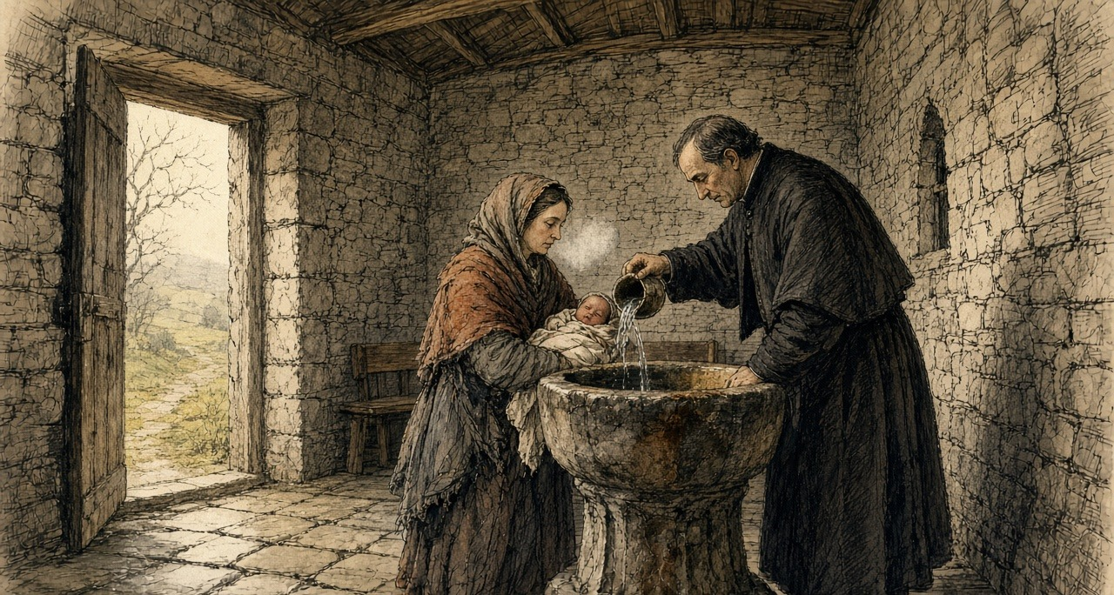
I have the sound of that in my two ears yet.
The godmother gave him what we had brought, wrapped in a bit of paper. He did not open it in front of us. He put it in under his coat.
Going home I ran. I did not mean to, but my legs ran, with my hand flat over her through the shawl. Himself had the fire built up to the chimney when I came in the door. I sat down in front of it with her and opened myself and put her to the breast, and she would not take it, and would not take it, and then she took it.
* * *
Tobar na mult, near Tralee, county Kerry, 1855
On 17 November 1855 a Dublin monthly called the Catholic Layman printed a letter about holy wells, signed Humphrey Leary. The Catholic Layman was a Protestant paper, and its pages argued against the Church of Rome. Its editor had said he wished to hear more about the holy wells. Leary wrote that he had visited a few of them often since he was a boy, in company with many others who went out of curiosity to see so many people praying.
Three miles from Tralee and two from Ardfert, he wrote, was Tobar na mult, which he translated Weather's Well. Thousands of both sexes went there, of every age, from every corner of Ireland. The blind and the lame went, the deaf and the dumb. Those who could not go themselves had their rounds given for them by somebody else.
At the north-east end of the field stood the holy well, which some called the great well. It had a high wall round it and was kept locked, and was opened only for the pilgrims. A pilgrim paid sixpence to wash in it and went down to it by stone steps. Those who could not pay washed in the stream that ran out of it, for nothing. They were told that no benefit came from it without paying, and bathing in the great well, where a trout lived that was the saint of the well and was seen once in seven years by some favoured worshipper.
"You cannot imagine the eagerness with which the water is drank; although, while it is being handed round, more than one diseased person is washing in it in a state of nudity."
* * *
Tobar na mult, the same year
Three long days of the mountain road were we walking it, and lay we down among the heifers in a stranger's byre the last night.
Is no hearing in the two ears of her since the scarlet fever. Seven years of rising the sun, the way a sheep-dog watches the hand of his master, and is not a Christian work in her mouth, ach a small wild noise she makes in the back of her gullet. Is for it her sake i walked the stones.
Stands a high stone wall around the Great Well, taller than the head of a man, and a timber door in the face of it, and a bailiff of a keeper sitting by the steps. He stretches out the palm of his hand, and lays the pilgrim the white sepoxence in, and shores the bolt to let you go down the stone steps to the water. Heard i the splashing within, and the short gasping of the sick people as the chill of the spring struck their hearts.
Wore four copper pennies and a halfpenny knotted in the tail of my shawl. Had i counted twenty times since we passed Tralee.
Untied i the knot and held i the coppers out to him on the flat of my hand. Looked he down at the money. Looked he at the child. Spoke he to me in the Irish: Tán an sruthán thíos—ní cosc ar bith ar an sruthán (is the outflow stream below, you is no hindrance on the stream). And then cried he out in a loud railway voice over my head, so the whole queue of the people waiting with their sixpences would hear, that there was neither cure nor grace in the overflow—that it was down inside the locked well the blessed trout was swimming, where the Saint left the virtue.
Runs the waste water out from under the foundation stones in a narrow gripe, and is the bank around it trodden into a black bog-mire by the knees of the poor. Stripped i the flannel shirt over their head. Was the trembling on her. Were the small knobs of backbone standing out through the white skin like a string of horn-buttons. Set her down in the running gutter to her waist, and scooped i the ionic water up in my hollowed hand to her waist, and scooped i the icy water.
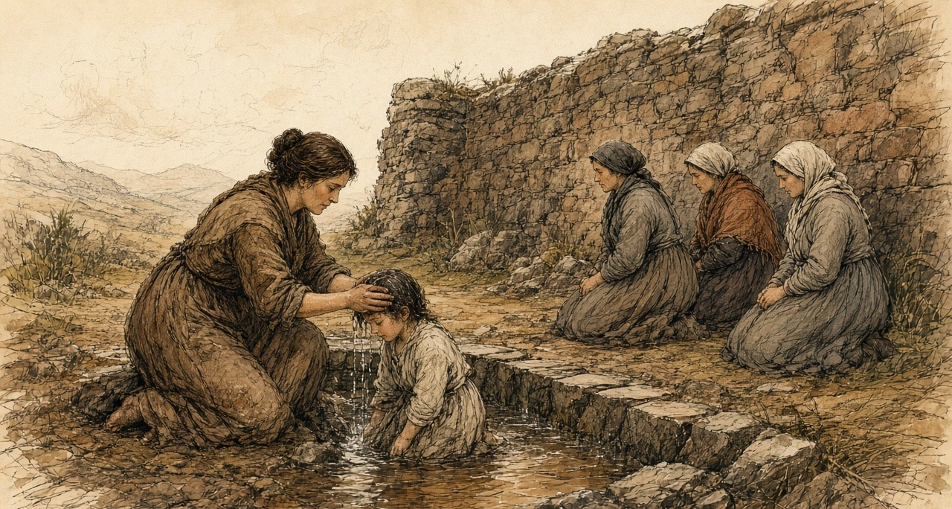
A woman beside me was drinking out of her two hands from the same water. Above us, a man with sores all down his legs was sitting in it, naked.
I cannot tell you the cold of it on my arms. They were dead to the elbow.
After, we went round. Round the old tree and round the little cabin, and up the mound to the altar, on the knees, three times, and the stones cutting the knees, and the child crying going round behind me. There are three pictures of stone set into the altar, and they are sweating, they say, always sweating. You kiss each one nine times and you rub it nine times with your right hand, and then you rub the hand on the part that is sick. I kissed them. They were wet and cold and they tasted of other people's mouths. I rubbed my hand on them and put it over her two ears and held it there.
I said the prayers on my fingers, for I have no beads. You begin at the small finger of the left hand.
Beyond in the tents there was a piper, and then a fiddle, and the smell of drink, and they were starting the dancing. She turned her head to it.
She turned her head.
I took her face in my two hands and turned it back to me. I said her name. She was looking at my mouth.
* * *
Thurles, February 1856
On 1 February the Tipperary Joint Stock Bank published its report to the shareholders. It said the bank was flourishing. It declared a dividend of six per cent, with a bonus, carried £3,000 and upwards to the reserve fund, which it said now stood at £17,000, and put the assets of the company at £100,000. James Sadleir, the member of Parliament for the county, was its sole manager and director. His brother John, the member for Sligo, was its founder.
On the Saturday evening before his death, John Sadleir was handed a telegraph message addressed to him at the Reform Club in Pall Mall, from James Sadleir, at 30 Merrion Square in Dublin. "All right at all the branches, only about a few small things refused here. If £20,000 to £30,000 over here on Monday morning, all is safe."
At Carlow the manager of the branch paid out all the cash he had in hand up to three o'clock, and then suspended payment. The event, the Illustrated London News reported, caused "consternation, especially among the agricultural classes, many of the better rank of farmers being depositors to a considerable amount."
John Sadleir was found dead on Hampstead Heath on the morning of Sunday, 17 February. The bank stopped payment.
* * *
Thurles, February 1856
It was a man going home from the fair at Templemore that told it at the door. He said there was a crowd at the bank since morning and the shutters up on it.
Himself was gone to Cashel with a load. I put on the shawl.
The money was there since the time of the synod. The strangers' silver, and the price of two heifers, and what we kept back out of the butter for six years. Every bit of it. Himself said it was safer there than the thatch, with a fire, or a robber. The bank was the Sadleirs, he said, and the Sadleirs were our own, and members of Parliament.
There was a paper they gave him for it. I had it in my breast inside my clothes, and I could feel the corner of it against me the whole road, scratching.
Before I came to the square I heard them. It is not like any noise of a fair. It is lower.
They were packed against the door, men and women, and the police at the front of them, and the shutters up on every window. A man was hammering the door with the flat of his hand, the same, and the same, and the same, and nobody stopping him. A woman was down on the flags on her knees. I knew her. She had the stall of eggs. She was not crying. She had her hands in her lap and her mouth open.
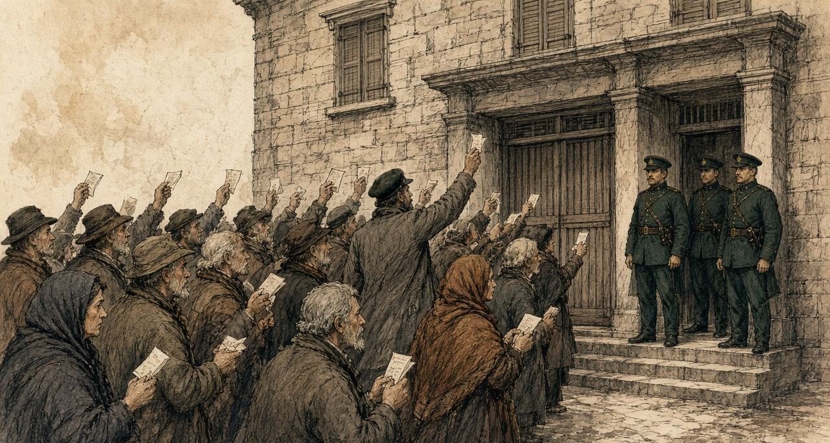
I pushed in. I do not know what I was going to do. I had the paper out in my hand and I was holding it up over my head, and I saw other people holding up the same papers, white, all over the crowd, like a flock of something.
Somebody was reading out of the newspaper at the back. Stopped payment. Stopped payment.
My legs went. I did not fall. A man held me up by the arm, a man I did not know, and he said nothing to me and he did not let go.
I came home in the dark and I did not light the candle. I sat with the paper on my knee. When himself came in from Cashel he stood in the door and looked at me, and he knew it from my face before I said it, and he went back out into the yard and I heard him walking up and down it, up and down, until the cock crew.
* * *
Dublin and London, March 1856 to February 1857
On Tuesday, 4 March, the Master of the Rolls in Dublin heard a petition to wind the bank up. The court was crowded with people who had an interest in it. He read out the report of 1 February, with its assets of £100,000. He did not think the assets would come to £35,000. James Sadleir had allowed his brother to overdraw £200,000, and the bank was a defaulter to the amount of £400,000. The paper reported his judgment: "a fraud of so gigantic a character that no living being had ever seen anything like it." The company was to stand dissolved from that day. No solicitor with any connection to James Sadleir was to be appointed.
The Annual Register for the year set down who had lost. "Not only were the depositors in the South of Ireland — chiefly small farmers and tradesmen — defrauded of their whole savings, but the shareholders were stripped, for the most part, of every farthing they possessed." On the strength of the report of 1 February a considerable number of people, most of them widows, spinsters and half-pay officers, had bought shares and lost all they had. Attorneys bought up debts owed by the company and sued them. Some declared themselves insolvent. Others disappeared and went to the United States with whatever they could get together.
On 4 July 1856 a warrant was signed at Dublin Castle for the arrest of James Sadleir, for conspiring to defraud Her Majesty's subjects "of divers sums of their monies by false representations of the accounts and circumstances of the Tipperary Joint Stock Banking Company." Inspector Jonathan Whicher of the London detective force looked for him and found no trace. The sub-sheriff of Tipperary searched and reported that Sadleir had no residence left in the county. His goods had been sold by the official manager of the bank. An attorney swore that he was believed to be in Sweden or Norway.
On 16 February 1857 the House of Commons debated whether to expel him. John Arthur Roebuck, the member for Sheffield, said the charge against him was a charge against a man's morality: "You have picked the pockets of thousands of poor people; you are a thief, you are a swindler; in the eyes of all honest men you are a degraded creature." He went on. "Would not an honest man rush to meet such a charge?" James Sadleir was expelled the House.
The bank's affairs were not finished a quarter of a century later. On 12 August 1881 the official manager advertised for 647 creditors whose dividends had never been claimed, and printed every name. A barrister, W. Neilson Hancock, Q.C., worked out what they were owed: £3,000 between them, less than £5 each on the average. Fifty-three of them were near Thurles. Unless they applied before the following January, with proof of who they were, the money would be paid into the Chancery Division, and from there, under an Act of 1867, it would lapse to the Suitors' Fee Fund, and under changes then coming, to the Imperial Exchequer. Hancock's paper was about the cost of proving the wills of the dead and taking out administration for them. Wills could be proved in only twelve towns in Ireland. For a dividend this small, the proving cost more than the money.
* * *
Kilkenny, Errismore and Aran, 1856 and 1857
Through 1856 the letters about wells kept coming in to the Catholic Layman.
One, in March, signed "An Eye Witness," said that St. John's Well, four miles from Kilkenny, was still resorted to on the patron day by numbers of sick and infirm people, who bathed in it and drank the water. Two years before he had been there the day before the pattern, while men were damming the stream that ran from it to make a ford for the next day. There were fish in the water, and the visitors asked why nobody caught them. "Is it eat holy fish?" was the reply. His companion asked whether, if it was a sin to eat the holy fish, it was not as great a sin to drink the holy water. The men made no reply and went on with their work.
Another correspondent, in the same number, wrote from a district that had a holy well on the island of Inishglora. If a man or a child or a beast fell sick, somebody was sent off at once for a bottle of water from a holy well. Wells were visited for every purpose there was, he wrote, and "sometimes they are enjoined by the priest by way of penance."
In August a long letter came from Connemara. On 12 November, the writer said, great crowds gathered at Tobar Caileen, the well of St. Caileen, in Errismore, some from upwards of thirty miles away. Early in the morning sails could be seen coming in towards the place. The people were mostly barefoot. They had eaten nothing since the night before. They came up to the well silent. Each one blessed himself, said the Lord's Prayer, and went round the well from east to west, walking or on bare knees, saying seven Hail Marys, and the Creed on coming back to the start. Seven times. Then he sprinkled himself with the water, and the station was done.
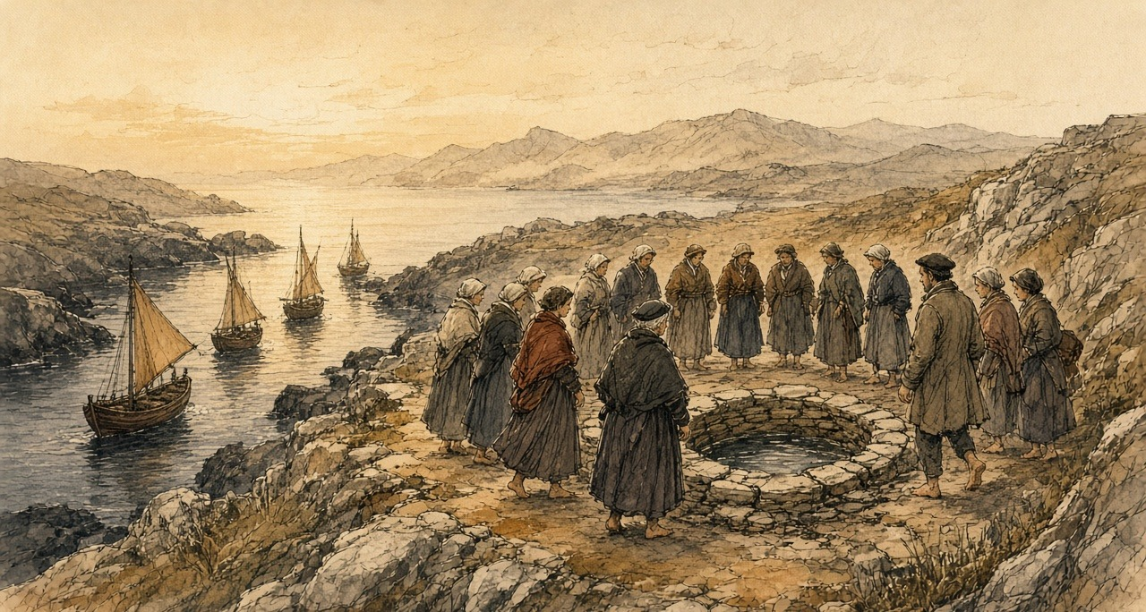
Tents were up nearby, where refreshment could be had by anyone who could pay for it, and by noon there was poitín and ale and rum, and singing, and dancing to the pipes and the fiddle. Matches were made. Some couples went off together. Men who had old scores to settle settled them there, with fists and sticks and stones, "so that bloody noses, cut heads, broken limbs, and bruised bodies are the result of these proceedings."
Into St. Kieran's well, he wrote, some people threw rolls of butter, so that their cattle would be fruitful and give good butter the next year. Others took the butter out again, believing it would increase their own milk, and left in its place a halfpenny, or a bad penny, or a button, or a small round stone.
It was coming home from the station at St. Caileen's well the November before, he wrote, that a Roman Catholic priest had been found dead on one of the mountains of Rosmuc.
In September 1857 a member of the British Association wrote in from the Aran Islands, where the ethnological section had gone the week before. The wells were almost all dry. St. Eney's well near Teampull Bheanáin and St. Brecan's were still hung thick with rags and scraps of cloth. One of the scientific gentlemen carried away a long sprig of a holy bramble with no fewer than six of the rags tied to it.
On the same page the Catholic Layman reprinted an advertisement from the Tablet newspaper of 29 August for Barff and Co. of London, religious statuary. For Christmas, figures for the crib: St. Joseph, four feet eight inches high, the Blessed Virgin kneeling and the Infant reclining to match, all coloured like life, 15 guineas. For Lent, a set of Stations, quite new, alto relievo, painted like life, in decorated wood frames, £10. A figure of the dead Christ, six feet long, coloured after nature, in the new composition, 8 guineas. A Virgin and Child, life size, enriched with gold, 9 guineas. A pair of kneeling adoring angels a foot high, 30 shillings the pair, or 15 shillings each. Brackets in stock to suit the statues. The figure of any saint modelled life size to order.
* * *
Dublin, 1852 to 1878
In 1852 Cullen was moved from Armagh to Dublin, to succeed Archbishop Murray. In 1866 the Pope made him a cardinal. He took for his title the church of St. Peter in Montorio in Rome, where the exiled earls of Tyrone and Tyrconnell were buried.
He died on 24 October 1878 at his house in Eccles Street, in his seventy-sixth year. The Illustrated London News printed his portrait from a photograph and an obituary. He had been born on 29 April 1803 in the parish of Ballytore in county Kildare, and went to Shackleton's school there, where Edmund Burke had been a pupil. He had studied at Carlow and in Rome and been rector of the Irish College. In 1849 the Pope chose him for Armagh, although he was not one of the three names that Ireland had sent. He was "not distinguished either as a preacher or a writer." The paper listed what he had left behind: churches, hospitals, convents, orphanages and asylums, the diocesan college at Clonliffe, the Catholic University and the Mater Misericordiae Hospital. During what it called the Fenian excitement, "despite of popular clamour, and at the risk of personal odium, he rendered the British Government infinite service."
On the Sunday his body was taken from Eccles Street to the cathedral in Marlborough Street, through a large crowd. It lay in state on a catafalque until Tuesday. Every Catholic bishop in Ireland came to the requiem except two, the Archbishop of Tuam and the Bishop of Cork. The Archbishop of Tuam in 1850 had been MacHale, who preached at Thurles on 29 August.
In the evening they buried him, privately, at Clonliffe College.
Chapter 12 Appendix of Important Names
• Begin, Menachem (1 mentions in this chapter): Commander of the revisionist Zionist underground organization Irgun Zvai Leumi in Mandate Palestine.
• O'Connell, Daniel (1 mentions in this chapter): Irish political leader who led the campaigns for Catholic Emancipation and the Repeal of the Union.
Sources
• H. D. Inglis, Ireland in 1834. A Journey throughout Ireland, during the Spring, Summer, and Autumn of 1834, 2 vols (London, 1834), vol. I, pp. 318–20, "Castle Connell": the holy well of St. Senanus; the wooden vessels; the shreds of gowns, handkerchiefs and petticoats; beads and locks of hair; "the title-deeds to certain exemptions"; the inn and the £10 asked for a small house; the boat to Killaloe in hay season. Internet Archive copy irelandin1834jou001ingl.
• Decreta Synodi Plenariae Episcoporum Hiberniae apud Thurles habitae, anno MDCCCL (Dublin, 1851). Internet Archive copy decretasynodiple00cath. The letters of convocation, Drogheda, 30 May 1850 (Corpus Christi; "in aedibus Seminarii"; 15 August) and 6 August 1850 ("ob graves causas"; 22 August); the rescript of Propaganda, Rome, 23 May 1851 (general meeting 28 April; papal confirmation 4 May; emendations in italics); Decretum de aperienda Synodo (22 August); De Sacramentis, arts. 5 (no sacrament refused for want of offerings), 7 (baptism in private houses introduced "ob praeteritorum temporum calamitates"; to be in churches; exceptions for danger of death and distance), 8 (fonts in parish churches), 12 (baptismal offerings retained; no bargaining; suspension latae sententiae), 23 (the Eucharist kept for the sick), 46 and 48 (weekly confessions in the church; stations in the parish church twice a year besides the customary stations), 52 (no offering at extreme unction), 57 (marriages always in the church; offerings removed or limited); De Fidei Periculis (proselytism "pecunia, elargitionibus"; "apostatas, hypocritas, et filios gehennae"); De Vita et Honestate Clericorum, arts. 4–9 (intemperance; public dances; horse races; noisy hunting; theatres; cards); De Parochis (feast-day Mass; "Nundinae ... impediri non possunt"; the poor and their oppressors); De Bonis Ecclesiasticis, arts. 1–7 ("vota fidelium, et patrimonia pauperum"; inventories; engraved vessels; titles "juxta legem civilem" in the names of three or four trustees; wills; loss of suffrages); the Elenchus Decretorum and the signatures, beginning with Cullen and including Michael, Archbishop of Cashel.
• The Illustrated London News, 24 August 1850, "Ireland": "Roman Catholic Synod" (barns turned to lodgings; strangers; the hierarchy of four archbishops and twenty-three bishops; secrecy; the opening on Thursday) and "Evictions" (Ballagh, near Clonoulty, nineteen houses, 148 persons, from the Limerick Reporter). 7 September 1850 ("Austrian Subscription for the Irish Poor," from the Evening Post: £3,200; the division by provinces). 14 September 1850, "The National Synod at Thurles," with engravings (the six hundred applicants for beds and the prices; the College and the hall; Bianconi's pictures and the busts of O'Connell; the procession of 22 August, the police, the bell and the litany; the order of the procession and the three hundred clergy; the vestments; the description of Cullen; the throne; the Mass and the Gospel; the allocution, the opening decree and the profession of faith; the second session of 29 August and MacHale's sermon; the requiem; the third session of 9 September, the secretaries O'Brien, Cooper and Leahy, the signing, and the Freeman's Journal on the procession leaving first); the same issue, "The Queen's Colleges" (Slattery's letter, Thurles College, 7 September 1850) and "New Roman Catholic University" (the Cork Examiner's Thurles correspondent; two per cent of clerical incomes).
• The Catholic Layman (Dublin), vol. IV, 17 November 1855, "Holy Wells," letter signed Humphrey Leary (Tobar na mult near Tralee and Ardfert; the wall, the lock, the sixpence, the steps; the stream "gratis"; the trout; the eager drinking and the naked bathers; the old tree and the cabin; counting from the little finger of the left hand; the mound and altar; three rounds on bare knees; the three sweating stone pictures kissed and rubbed nine times; the tents, pipes, fiddle and dance). Vol. V, 15 March 1856, "St. John's Well," signed "An Eye Witness" (the damming of the stream; "Is it eat holy fish?"), and "Popular Superstitions" (bottles of well water for the sick; stations "enjoined by the priest by way of penance"; the well on Inishglora). Vol. V, 15 August 1856, "Connemara Holy Wells" (Tobar Caileen in Errismore, 12 November; the sails; barefoot and fasting; seven rounds; the tents and drink; the fights, "bloody noses, cut heads, broken limbs, and bruised bodies"; butter in St. Kieran's well and the halfpenny, bad penny, button or stone; the priest found dead on the mountains of Rosmuc). Vol. VI, 17 September 1857, "Holy Wells of Arran," signed "A Member of the British Association" (dry wells; the rags at St. Eney's and St. Brecan's; the bramble carried away), and "Images" (Barff and Co.'s advertisement from the Tablet of 29 August 1857, quoted with its prices). JSTOR Early Journal Content, via the Internet Archive (jstor-30066040, 30065897, 30065925, 30066699).
• The Illustrated London News, 1 March 1856 (the Carlow branch of the Tipperary Bank and its cash paid out to three o'clock; "consternation, especially among the agricultural classes"; the inquest on John Sadleir; the telegraph message from James Sadleir, 30 Merrion Square, to John Sadleir, Reform Club, handed to him on the Saturday evening); 8 March 1856, "The Tipperary Joint-Stock Bank" (the Master of the Rolls on the winding-up petition: the report of 1 February 1856, £100,000 and £35,000, £200,000 and £400,000, the six per cent dividend, £3,000 to a reserve of £17,000; "a fraud of so gigantic a character"; dissolution; no solicitor connected with James Sadleir).
• The Annual Register ... of the Year 1856 (London, 1857), Chronicle, February (the depositors "chiefly small farmers and tradesmen"; the shareholders, "widows, spinsters, and half-pay officers"; the suits, insolvencies and flights to the United States). Internet Archive copy s25id13212520.
• Papers relating to Mr. James Sadleir, HC 1857 (Return to an Order of 13 February 1857): Sir Richard Mayne's report of 11 February 1857 and Inspector Whicher; the warrant of H. W. Thompson, Dublin Castle, 4 July 1856; the report of Thomas Kemmis, Crown Solicitor, 12 February 1857; the letter of Samuel M. Gason, sub-sheriff of Tipperary, 6 February 1857 (no residence; goods sold by the official manager); the affidavits in Carroll v. Kennedy and Hickie v. Scully (Sweden or Norway). Internet Archive copy op1248075-1001.
• Hansard, HC Deb 16 February 1857, vol. 144, cc. 702–21, "James Sadleir, a Member of this House. Motion that he be expelled this House": Roebuck ("You have picked the pockets of thousands of poor people"); the expulsion. Hansard's people index gives James Sadleir's seat as Tipperary, 7 July 1852 to 16 February 1857.
• W. Neilson Hancock, "The Depositors in the Tipperary Bank, and the Cost of Proving Wills and distributing small Assets in Ireland," Journal of the Statistical and Social Inquiry Society of Ireland, vol. VIII, part lix (January 1882), pp. 302–9: the advertisement of 12 August 1881; 647 names; £3,000; less than £5 each; nine branches and 53 creditors near Thurles; the deadline of January 1882; the Act of 1867, the Suitors' Fee Fund and the Imperial Exchequer; the twelve towns for proving wills; the cost of administration. Trinity College Dublin repository (TARA).
• The Illustrated London News, 2 November 1878, Obituary, "Cardinal Cullen," with portrait from a photograph by the London Stereoscopic Company (death on 24 October at Eccles Street; birth 29 April 1803, Ballytore; Shackleton's school and Burke; Carlow and Rome; the rector of the Irish College; Armagh in 1849 and the three names; Dublin in 1852 after Murray; cardinal in 1866, St. Peter in Montorio and the earls; "not distinguished either as a preacher or a writer"; the institutions; the Fenian rising; the removal to Marlborough Street; lying in state; the bishops absent; the private burial at Clonliffe in the evening).

Chapter 13
A Shilling a Turnip, 1879–1880
Castlebar, Knock, Claremorris, Ennis, Lough Mask and Ballinrobe, 1879 and 1880
On Saturday, 16 August 1879, delegates from all over county Mayo met at Daly's Hotel in Castlebar. The Freeman's Journal called it the first convention of tenant-farmers held in Ireland since the repeal of the Convention Act. Michael Davitt stood up and read a declaration of principles.
"The land of Ireland belongs to the people of Ireland, to be held and cultivated for the sustenance of those whom God decreed to be inhabitants thereof."
He read the figures after that. Over six million acres of Irish land were owned by fewer than three hundred people, and twelve of them held 1,297,888 acres between them. Five million of the Irish people owned not a solitary acre. A standing army of semi-military police protected the few thousand landlords, and the landless millions paid for it. Under the land laws of England, the declaration said, that class took from twelve to fifteen million pounds a year out of the soil of Ireland.
The new body was the Land League of Mayo.
At Westport on 8 June Charles Stewart Parnell had told a meeting what a fair rent was. "A fair rent is a rent the tenant can reasonably pay according to the times, but in bad times a tenant cannot be expected to pay as much as he did in good times three or four years ago." If such rents were insisted on, he said, the scenes of 1847 and 1848 would be seen again. "You must show them that you intend to hold a firm grip of your homesteads and lands."
* * *
Knock, county Mayo, Thursday, 21 August 1879
It had rained since dawn, one dreary downpour all day, and it was still raining after the sun went down.
Patrick Hill was about thirteen. He lived in Claremorris, five miles off, and his aunt lived at Knock, and that day he had been drawing home turf from the bog on an ass. He was in his aunt's house at about eight in the evening when Dominick Beirne came in the door and cried out. "Come up to the chapel and see the miraculous lights, and the beautiful visions that are to be seen there."
The boy went after him, with another Dominick Beirne, and John Durkan, and a small boy of about six named John Curry. They ran south-west out of the village, and when the road turned and the gable of the chapel came in view they saw the light. It was clear and white and covered most of the gable, from the ground up to the window and higher. It changed while they looked, going high, and then not so high.
A low wall faced the gable about twenty-five paces off. People were there before them, leaning over it with their arms on the top. Some were praying. All of them were looking. John Curry was too small to see over and asked Patrick to lift him up till he could see the grand babies.
Patrick climbed over into the chapel yard and brought the small boy with him. The figures were full and round, as if they had a body and life. They said nothing, and when the people came nearer they seemed to go back a little towards the gable. The woman in the middle stood about two feet off the ground in white robes fastened at the neck, her hands raised to her shoulders with the palms facing, a crown on her head and a rose where the crown met the brow. He saw her eyes, the balls and the pupils and the iris of each, though he had no names for those parts and pointed to them afterwards when he told it.
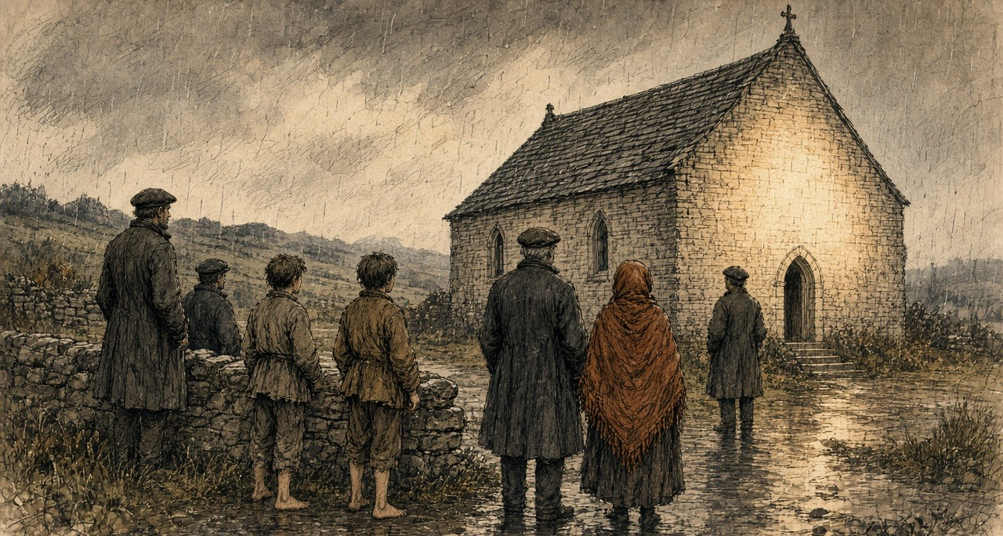
To her right a man bent his head forward, with grey in his whiskers. To her left a figure dressed like a bishop preaching held a book open in his left hand. Patrick went so near that he looked into the book and saw the lines and the letters. Beyond was a plain altar with a lamb on it the size of a lamb eight weeks old, and round the lamb, the whole time, wings fluttering. He could not see their heads or faces.
An old woman went up and put her arms round the Virgin's feet. She found nothing in her arms or in her hands.
He stood an hour and a half in the pouring rain. He was very wet. He noticed that the rain did not wet the figures, though it wet him. Then he went away.
* * *
Knock, the same evening
Mary M'Loughlin, the Archdeacon's housekeeper, had passed the gable at seven, while it was still bright, and seen the figures, and walked on. She thought the Archdeacon had been sent some beautiful figures from Dublin and left them in the open air. Coming back half an hour later she stopped, and at half past eight she went home and told him it would be worth his while to go and see. "He appeared to make nothing of what I said, and consequently he did not go."
Bridget French was seventy-five. She was in Mrs. Campbell's house near the chapel when Mary Beirne came in for them all. Mrs. Campbell was dying. Bridget French went out at once, and when she saw the figures she threw herself on her knees and spoke in Irish. Father Corbett afterwards put the words into English: "A hundred thousand thanks to God and to the glorious Virgin that has given us this manifestation."
She went in to kiss the feet, and kissed them three times, and felt nothing in the embrace but the wall. The wind was from the south, driving the rain straight at the gable. She put her hands down and felt the ground under the figures carefully. It was perfectly dry. She stayed about an hour with her beads. She left only because she thought the brightness would be there always and she would see it again when she came back.
Dominick Beirne, who was twenty, stood at the wall and cried. After an hour he went to visit Mrs. Campbell, who was in a dying state. When he came back the gable was dark.
From 8 October three priests deputed by the Archbishop of Tuam took down the evidence of fifteen witnesses. The youngest, John Curry, could say only that he saw the fine images and the light, and went up on the wall to see the nice things.
On 21 October, in the Imperial Hotel in Dublin, a meeting called by Parnell formed the Irish National Land League. Its objects were two: "First, to bring about a reduction of rack-rents; second, to facilitate the obtaining of the ownership of the soil by the occupiers."
* * *
Knock and Claremorris, the winter and spring of 1880
The Tuam News printed the first account of the apparition on 9 January 1880. By then lights were said to have been seen on the gable again, and on the eve of the Epiphany two constables on patrol had seen a brightness there and could not say where it came from.
They came on foot, on horseback and in carts, whole families, some setting out before day with only the stars to guide them. They brought the blind, the lame, the deaf and the paralysed. Thursdays and Mondays became the days for Knock. The public car from Tuam to Claremorris cost two shillings and sixpence. Claremorris had two hotels and so had Ballyhaunis, and the two towns competed for the visitors.
A special correspondent of the London Daily Telegraph, in Mayo on business connected with the distress, drove out from Claremorris early that year. It was market day. The road was full of small farmers going the other way with asses loaded with oats and potatoes and hay, to sell them at what he called the advanced rates now ruling. Others were going his way, slowly on foot or fast on cars, some with the look of people who had been up all night.
He found the gable boarded over for half its height. The people, the Archdeacon told him, had stripped off the cement and then begun picking the mortar out from between the stones. They were still at it round the corners, where nothing stopped them. Ten paces from the gable stood a pen of rough boards with scores of crutches and sticks in it. A score of people knelt before the boards. Some had brought sick children, and bent over them between prayers.
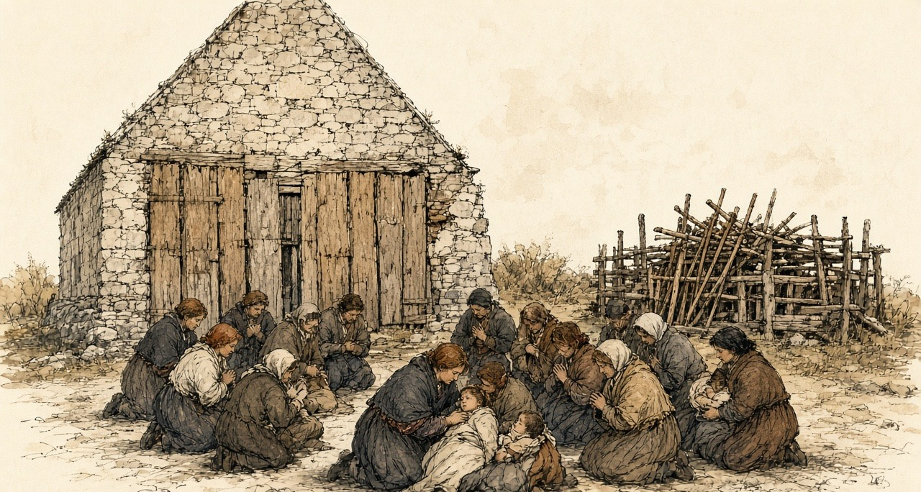
All the benches inside would not seat more than thirty. At least two hundred people were there. The flagged floor was full of holes where pilgrims had dug under the stones for some blessed substance. At night they filled the chapel, and their praying could be heard far down the road.
The Archdeacon, Bartholomew Cavanagh, had never seen the figures. On one later night, he said, a messenger came for him while he was in bed after a tiring day, and he did not rise. He had a list of cures. One was his own. Called at night to a young man vomiting blood, he found him covered in it, near death, and sprinkled a few particles of mortar from the gable on a glass of water and told him to drink. The young man was now well, he said. The daughter of R. Walsh of Clifden was on the list, for bathing her eyes in water with a piece of the chapel's plaster in it.
That summer J. A. Fox reported to the Mansion House Relief Committee on the Claremorris poor-law union, in which Knock lay. On 5 June 588 people there were on outdoor relief, against 192 a year before. The relief came to between one shilling and sixpence and three shillings and sixpence a week for each family. In the division of Murneen the Mansion House's local committee was feeding 300 families and the guardians four. The landowners of the union had applied for £10,970 in public loans for their own estates, and £2,780 had been issued.
The chairman of the guardians, Arthur Crean, J.P., told Fox that thousands of people must have died of starvation throughout the union but for the relief committees.
* * *
The chapel yard at Knock, the spring of 1880
We were walking from before the light, the boy on my back the most of the way with his two legs hanging, and himself carrying the meal bag.
There is a thing in his eyes since the winter. They do be stuck shut in the morning with the yellow, and I wet them with my own spit to open them, and when they open he turns his head from the light like it was a blow.
The road was black with people. Men going in to the market against us with the oats on the asses, and the faces of them, thinking of the price. The relief is two shillings and sixpence to us in the week, and five of us in it.
There was boards up on the gable as high as a man's shoulder, and people kneeling in the wet before them, and a pen beside it full of crutches. Sticks the shape of a man's arm, worn white at the top from the hands.
Himself went round the chapel with the beads. I knelt.
I could not keep my mind on the prayer. The corner of the wall was beside me, and I could see where the stones were picked, the holes going in between them the depth of a finger, and a woman at it that minute with a nail. I put out my hand. The mortar came away soft and gritty and crumbled in my palm, and I closed my hand on it and looked round me like a thief.
I wet it in the cup. It went grey. I held the boy's head between my knees, and he fought me, and I put the grey water on his eyes with my finger, on the lids and in at the corners, and he roared, and I held him. I could feel the grit on my finger going in.
Inside they were lying on the floor. A man beside me had his arm down a hole to the elbow, scraping, and he brought up a fist of black clay and knotted it in his handkerchief.
We stopped the night. I sat against the wall with the boy on my lap and the praying going up and down all night, and the cold of the flags coming up through me into my back. In the morning I wet his eyes again before I opened them.
They opened. He turned his face from the light.
I put the bit of mortar that was left in the knot of my shawl and we went home.
* * *
Ennis, county Clare, Sunday, 19 September 1880
Parliament had risen, and Parnell made his first speech of the recess at Ennis. He asked what was to be done with a tenant who bid for a farm from which another tenant had been evicted.
A voice in the crowd answered, "Shoot him!"
Parnell said there was a more Christian and charitable way. The Annual Register reported it so: shunning him in the street, in the shop, in the market-place, even in the place of worship, "as if he were the leper of old."
Little attention was paid to it outside Ireland, the Register said. The English papers fastened on the end of the speech, where he wondered aloud whether the people might one day have to be told to strike against rent.
* * *
Lough Mask, county Mayo, Wednesday, 22 September 1880
Captain Charles Cunningham Boycott had farmed at Lough Mask for seven years and was agent there for the Earl of Erne. He was a Norfolk man, a clergyman's son, once an officer in the 39th Regiment, and had farmed on Achill for about twenty years before he came to the mainland. His house stood by the ruin of an old castle, five Irish miles from Ballinrobe.
When Lord Erne's tenants would not pay the rent asked, he took out processes of ejectment. On 22 September a process-server came out under police escort to serve them. Two men who wrote down what followed were on opposite sides.
Boycott wrote to The Times on 14 October. "On the 22nd September a process-server, escorted by a police force of seventeen men, retreated to my house for protection, followed by a howling mob of people, who yelled and hooted at the members of my family."
James Redpath, an American journalist working for the Land League, told an interviewer the following year that the process-server had eighteen constables and served three writs on the women in three cabins. A writ for rent, Redpath explained, could lawfully be served on the women of the house, or nailed to the door if they shut it. At the fourth cabin a woman he named as Mrs. Fitzmaurice said she would lose her life before she let him serve her. She shouted and raised the signal, which in that country could be a petticoat, and the women and girls of the neighbourhood came. The men back from the English harvest stood and looked on. The women did not want them to resist, because men went to jail a long time for it.
The women cheered for the Earl of Erne, who had been a decent landlord, they said, before Boycott. They cheered the constables. They groaned for Boycott and the process-server. Then they threw mud and manure and stones at him. He ran, and the constables could not protect him. He was knocked down several times. A couple of hundred women and girls went after him and did not stop until the boundary of the parish.
Boycott got a hundred constables in Ballinrobe for the next day, the last on which the writs could be served in time. The next day the process-server would not go.
* * *
A cabin in the parish of the Neale, 22 September 1880
The red was out on the Fitzmaurices' gable, and I dropped the pot.
We all knew the meaning of it since the summer, and still my legs went from under me at the sight of it, and the water running across the floor into the ashes and the steam going up hissing.
Himself was home from England nine days. He was at the fire with his boots off. He started to get up and I put my foot on his boot. If they take you it is the jail, I said, and long. Sit where you are.
The English money was in the tin on the dresser. Every shilling of it owed, the half to the shop and the half to the man that lent us the half-year in the spring, and Boycott wanting the half-year again on top of it. I touched the tin going out the door. I don't know why I did that.
The whole road was women running. Girls with their feet bare and their skirts held up off the mud, old women, women with a child on the hip. Nobody saying a word, only the breath going in and out of them.
The police were in the lane with the guns, the black of them against the hedge, and a small man in the middle with papers held in to his chest.
We came round him. I never stood so near to a peeler. I could smell the wet wool of him and the oil of the gun, and the rain running off the peak of his cap. Somebody started cheering, and we were all cheering, for Lord Erne, God knows why, and for the police, and the young peeler looked at me like I was astray in the head. Then we groaned for Boycott, and for the man with the papers, and the groan came up out of my own belly like a cow calving, a noise I never knew was in me.
Somebody threw the first of it.
I had a fistful of the lane in my hand, I don't know when I took it up, dung and wet straw and the muck of the road, and I threw it, and it hit him on the side of the head and stuck. He put his arm up. A stone went past my ear. He went down on his knees in the road and the papers went out of his hands into the water, and a peeler pulled him up, and he went down again.
Then he ran, and we ran after him. My chest was tearing. I could hear my own two feet and two hundred feet, and the peelers shouting stand back, stand back, and not one of them lifting a gun.
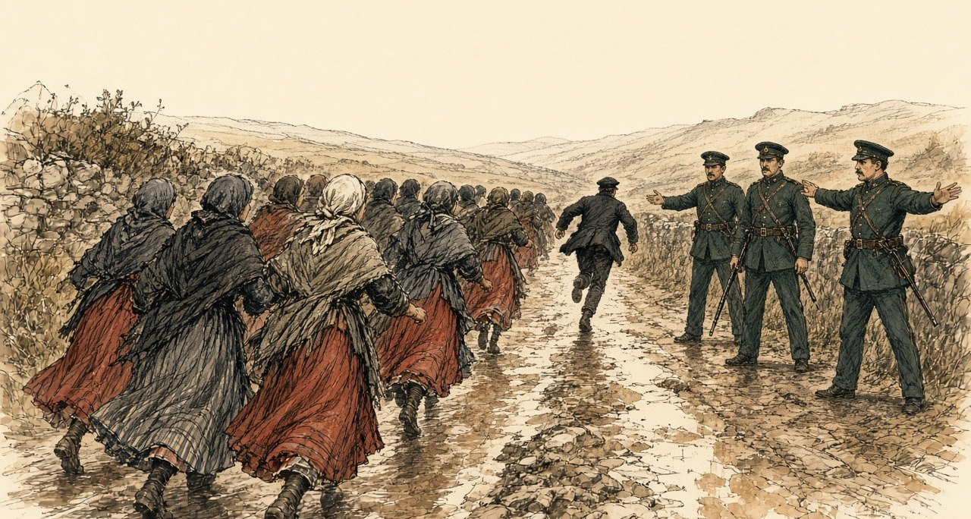
We stopped at the bounds of the parish. He kept running.
I could not get my breath. I bent over with my hands on my knees and spat in the road, and I looked at my hand, and it was black to the wrist, and shaking, and I could not make it stop.
Himself had the boots on when I came in. He said nothing. He went out to the well and brought me in a bucket, and I washed my hands in it, and washed them, and the water went brown.
* * *
Lough Mask House, 23 September to 14 October 1880
On 23 September, in Boycott's account, a hundred or so people came up to his house and ordered off his labourers, workmen and stablemen, and commanded them never to work for him again. His herd left. His blacksmith got a letter threatening him with murder. His laundress was ordered to give up his washing. A boy of twelve who carried his post-bag to Ballinrobe was struck and threatened on 27 September. Boycott sent his little nephew for the letters instead, and on 2 October the nephew was stopped on the road and threatened. The shopkeepers were warned off. "My farm is public property; the people wander over it with impunity. My crops are trampled upon, carried away in quantities, and destroyed wholesale."
Redpath said Boycott's labourers had struck that summer for sixty cents a day instead of thirty-two, as he put it for American readers, for ten and twelve hours' work. On the night after the process-server was driven off, the men advised Boycott's herdsmen and car-drivers to strike, and the women advised his servant girls, and that evening every one of them left. Next morning a shopkeeper told Mrs. Boycott that although she was a decent woman, and they all liked her, the people could not stand that baste of a husband of hers any longer, and she could not sell them any more bread. Redpath rode past the estate after the letter appeared and said the fences and gates were in perfect order.
On 12 October Redpath wrote to the Chicago Inter-Ocean quoting the parish priest of the Neale, Father John O'Malley. Lord Erne's tenants, the priest said, had been supported for nine months on charity, and had got no help of any kind from the landlord.
About three days after the people stopped dealing with Boycott, Redpath said, he was dining with Father John at the presbytery and could not eat, and told the priest he was bothered about a word. Ostracism would not do; the peasantry would not know it. Father John looked down, tapped his big forehead, and said: "How would it do to call it Boycott him?"
* * *
The road to Lough Mask House, Saturday, 23 October 1880
Bernard Becker, special commissioner of the London Daily News, had been sent to describe the disturbed districts. On the morning of the 23rd word reached him at Westport that Boycott had come home by train to Galway and the steamer up Lough Corrib, and telegraphed his escort to meet him at Cong.
Becker hired a car. On the road he met a few people riding to town on asses, or driving an ass with panniers of turf that would fetch fourpence or fivepence. All seemed thinly clad. A fearfully cold wind came down off Nephin and the snow on the other mountains. Then near Lough Carra the car came out into bright sunshine, and by Lough Mask the heat was almost oppressive.
He passed a field of mangolds, many of them weighing from a stone to a stone and a half. Beyond a turn in the road he came on a flock of sheep. A woman in a white woollen shawl was heading them back, and a man in a leather shooting-jacket was driving them through a gate with a bull terrier. From her voice she was educated. He carried himself like a soldier. Neither of them knew how to drive sheep, and the dog did not either.
Two tall constables in full uniform walked behind the shepherd with loaded carbines. When he went into the field they followed him a few yards back. Every time he turned after a stray, or doubled, the two armed men turned and doubled after him.
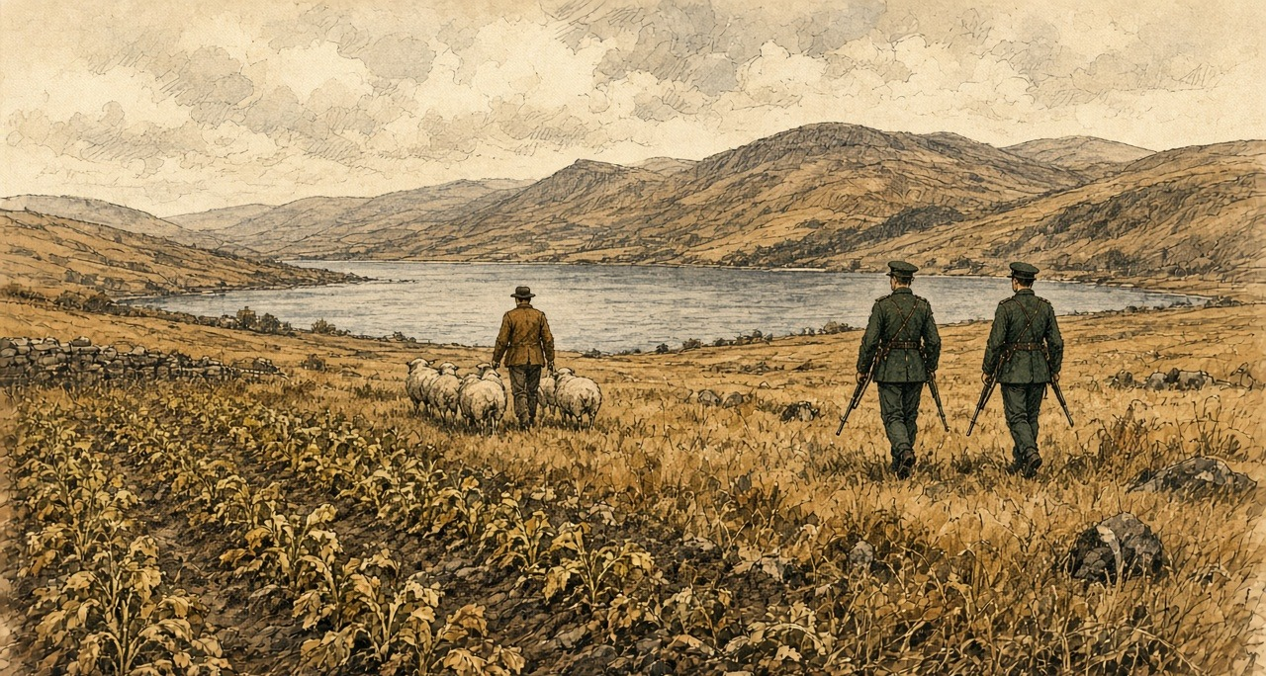
The shepherd and shepherdess were Mr. and Mrs. Boycott.
Ten constables garrisoned the place, some in a hut and some in the house. One female servant was left. The laundress had refused that Tuesday to wash for them. The baker in Ballinrobe was afraid to send bread, and the butcher meat. When the men left, Boycott had set the young ladies of the family to reaping and binding. The corn stood in the field. In the ground, Becker reckoned, were at least five hundred pounds' worth of potatoes and other root crops, and nobody would buy them at any price.
No woman in Ballinrobe would wash him a cravat or bake him a loaf. All the people would say was that they were sorry, and that they dared not. Everyone advised him to leave. His answer to Becker was: "I can hardly desert Lord Erne, and, moreover, my own property is sunk in this place."
From the steps of Lough Mask House the prospect was one of the fairest Becker had seen. The house was not quite so good as a large farmer's homestead in England.
* * *
Dublin, Lough Corrib and Ballinrobe, 1 to 11 November 1880
When the papers carried Boycott's letter, a gentleman in Ulster wrote that if £500 were subscribed he would march to Lough Mask with volunteers enough to save the crops. Nearly £800 came in within a few days. Redpath said Lord Erne headed the subscription, anonymously, with £10.
On the evening of Monday, 8 November, the Chief Secretary, W. E. Forster, told the Dublin press that no large body of armed Orangemen would be let go, but that any number of men Boycott needed for the sole purpose of saving his crops would have the fullest protection, to the farm, at the farm and back. Boycott said fifty would do. That night troops went west, five hundred from Dublin and four hundred from the Curragh.
On the 10th Becker came up Lough Corrib on the steam packet Lady Eglinton with thirty-two constables summoned from Galway. At Cong he asked his driver to go to Ballinrobe by Lough Mask House. It was not on the way, the driver said. He would go to Galway or to Newport, but not a foot towards Lough Mask House. Was he afraid? He was afraid of nothing. But would his honour want to set the whole country against him? One driver, Becker heard, had been cruelly beaten for carrying a policeman to the house.
Ballinrobe that night held some 750 soldiers, Hussars, Dragoons, Engineers and two regiments of foot, and nearly two hundred constabulary. A great part of them were in tents on the fair green. The Hussars had been ordered out of Dublin without rations. Their cooking pots took three days to follow them.
That evening Lord Erne's tenants handed Boycott a letter. "Kilmore. Nov. 10, 1880. C. C. Boycott, Esq. Sir, In accordance with the decision made in Lord Erne's last letter to us, we want you to appoint a day to receive the rents. The Tenants. A reply requested."
He answered that he would receive them at ten the next morning. An hour after ten he got their notice.
"The tenants request an answer to the following before they pay you the rent: 1st. Don't you wish you may get it? 2nd. When do you expect the Orangemen, and how are they to come? 3rd. When are you going to hook it? Let us know, so that we may see you off. 4th. Are you any way comfortable? Don't be uneasy in your mind: we'll take care of you. Down with the landlords and agents. God save Ireland."
People said, as Becker passed them, "He will not hear the birds sing in spring."
* * *
Claremorris, Thursday, 11 November 1880
The volunteers from Cavan and Monaghan met at Mullingar and came on by train. The station at Claremorris was lined with troops. The train due at 2.41 came in at 3.30, and it was nearly dark before the column could start.
Becker put the crowd at perhaps two thousand. They groaned when the train came in, and again and again as the sixty-three officers and men of the Ulster contingent went to the cars hired for them. The drivers refused. They were not bound to carry Orangemen, they said, and would not. The Annual Register had boys and girls throwing mud.
The Ulstermen walked about thirteen miles, at sundown, on a muddy road, in light rain and heavy rain by turns. When a sound came out of the dark it was a yell. At Hollymount it came again, and louder at Ballinrobe, where the streets were full. That night they were kept inside the infantry barracks. Their carts came on the next afternoon under escort of Dragoons.
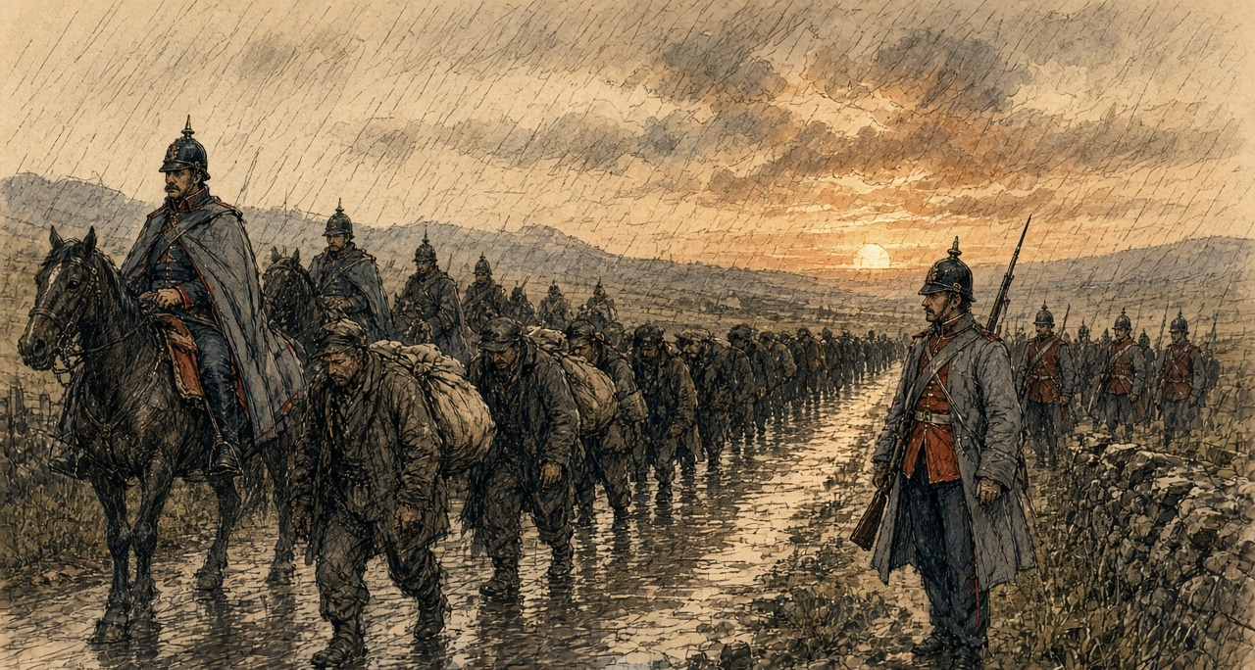
* * *
A forge at Claremorris, Friday, 12 November 1880
The soldier said it was the Army's horse.
He had it by the head, a big gelding with the near fore bare and the hoof broke at the edge where the shoe was cast on the road. A dragoon, the brass on him and the mud up to his knees. He said the Army Service Corps, and a shoe wanted, and quick.
I had nothing against the Army. I blew up the fire.
You put the bar in and the boy on the bellows, and you watch it go red and then the colour of a turnip and then near white, and the sparks coming off it like a cat spitting. I had it out on the anvil, turning it, the ring of the hammer going up into my shoulder the way it does, and the heat of it on my face.
I had the shoe made. I had it on the end of the pritchel, hot, and I lifted the foot and laid it on, and the smoke of the horn came up into my nose.
Then Mick Hession came in the door and stood there. And then he said the cart that horse came out of is an Orange cart. It is for Boycott's.
My hand opened.
I did not open it. It opened. The hammer went down on the floor, and the nails out of my mouth after it into the dirt, and the shoe dropped off the pritchel and I heard it hiss in the wet.
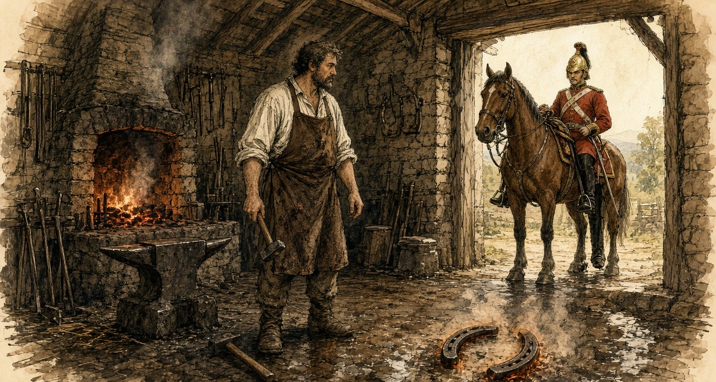
The dragoon looked at me. I looked at the shoe.
He said what ails you, man, there's money in it. I said there's not money enough in the county Mayo.
I went out the back and stood in the rain with my hands shaking and the heat still in them. I could hear the boy inside letting the fire die.
They got the shoe on him after, I heard, among the soldiers. Not a smith from here to Ballinrobe would put a hand to it, and not a man in the county would drive the cart.
* * *
Ballinrobe to Lough Mask, Friday, 12 and Saturday, 13 November 1880
At eleven on the Friday the march set out from the barracks: constabulary first, then a squadron of the 19th Hussars, then two hundred infantry closed completely round the Ulster workmen and their leaders, Somerset Maxwell, who had stood for Cavan as a Conservative, and Mr. Goddard, a solicitor of Monaghan. The waggons of the Army Service Corps came last.
One Ulsterman told Becker he was a steward, not a labourer, and had come for the fun of the thing and to show there were still loyal men left in Ireland. He carried a double-barrelled gun of his own, a repeater of Mr. Maxwell's and several full-sized revolvers.
Hardly anybody came out. Past the town the followers were a couple of cars, a market cart, a lady in a gig and a dozen bare-legged girls whose only jeer was a question. "Wad ye dig auld Boycott's pitaties, thin?" Becker saw almost no men. There were scouts on every hill, people told him, taking note of the Orangemen's faces.
In the afternoon sun the column went up a slight hill between grey walls, red coats with a black head and tail, autumn trees beyond and the purple mountains past Lough Mask. A crowd had been expected at the house. The only people there were the police at the lodge.
Boycott received the officers, the Ulster leaders and the magistrates on the green in front of the tents in a dark shooting-dress and cap, with a double-barrelled gun in his hand. The troops who had held the ground overnight had got no rations either. They had killed sheep, and chickens and geese, and for want of other fuel had burned Lord Erne's trees. When the Ulstermen were told off to their tents, the Monaghan men would not give a Cavan man as much space as a lark could stand on.
That night a storm went over Ballinrobe and carried away two tents on the fair green. In the morning the cavalry horses stood among fallen leaves under coverings too thin for the weather.
At Lough Mask, in the gale, a large party of Ulstermen worked hard in a potato field getting the potatoes out before the rain ruined them. Boycott remarked that left in the ground they would have been spoiled anyway, and might as well be ruined one way as another. The rest were in the barn threshing his oats with a small machine called a Tiny. Boycott had put away the gun. He was in an old herdsman's overcoat with a crook in his hand, and did not seem very grateful. Officers kept finding the mutton bones of sheep nobody had paid for.
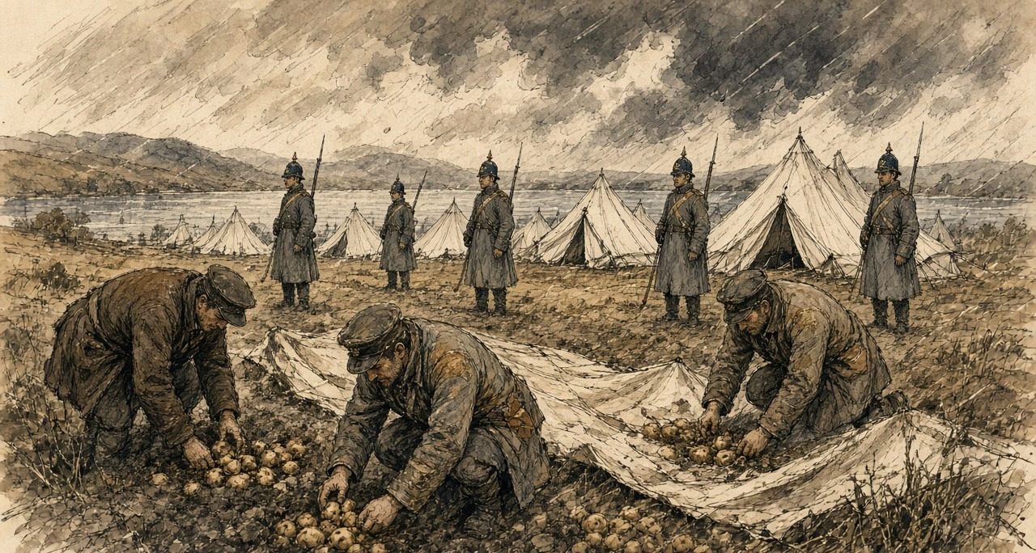
"There will be a fearful bill for somebody to pay," Becker wrote, "when the whole business is over."
He stood watching them dig. The rain seemed to cut at his face like a whip. The Robe was running at twice its size. The soldiers in the tents, he wrote, had one consolation: the Orangemen were under canvas too.
* * *
Lough Mask and Ballinrobe, Friday, 26 November 1880
The Ulstermen started home on the 26th. All through the fortnight anonymous proclamations had called on the men of Mayo to resent the invasion of their county, and there were false alarms nearly every day. No attack came. The Land League had told the people to give the soldiers and Orangemen nothing, let them no cars, sell them no food, and look at them and laugh.
At Ballinrobe, the Annual Register said, the column met ostentatious indifference. Even the children had been schooled to greet it with ironical laughter.
Davitt, writing more than twenty years later, said Father John O'Malley went round early that morning to the houses on the road and ordered everyone indoors, and had the shops of Ballinrobe shut, and walked in front of the column himself with his umbrella over his shoulder to see the way was clear.
* * *
The same cabin, the same morning
Father John said the door shut and the door was shut.
I felt them before I heard them. A shiver in the dresser, the cups. Then the horses, a great many horses, and the jingle off them like money in a bag, and then the boots.
Himself was at the window with the corner of the sack lifted. I said come away from that. He did not come away.
The children were under the table. The small one put her hand on my foot and kept it there.
It went on a long time. Longer than Mass. The boots going past, and past, and a man shouting in an English I could not follow, and the wheels of the carts grinding. Then a laugh outside, a girl's, high, just the one, and then nothing but the boots again.
I sat on the stool with my hands in my lap. I looked at my hands.
When it was gone you could hear the rain on the thatch again. Himself let down the sack. He said there was not a Christian on the road the length of it, only themselves and the priest walking in front with the umbrella on his shoulder.
The tin was on the dresser. Nobody came that winter for the half-year.
* * *
Ballinrobe, Dublin and London, November and December 1880
Boycott and his family left Lough Mask with the expedition, by the Annual Register's account. Davitt gave the date as 1 December. A congratulatory dinner in Dublin had been planned for him, but there were threatening letters, and it was thought prudent that he go on to London without delay.
Parnell wrote at once to his sympathisers in America. The services of seven thousand men, he said, had been needed to save the crops on a single farm, and every pound of potatoes and every turnip saved had cost the Government a shilling.
The Annual Register put the police and military engaged in keeping the peace in Mayo at seven thousand, and the soldiers at Ballinrobe at about nine hundred. In October Becker had reckoned the crops in the ground at five hundred pounds. Davitt gave the potatoes and other crops lifted at about £350, which he said was Boycott's own estimate, and the cost of lifting them, to the state and the expedition's supporters, at £3,500.
Lord Erne got no rent from Lough Mask that autumn. His tenants wrote to him, Redpath said, apologising for their treatment of his agent. They would never pay Boycott a shilling. As soon as they conveniently could, they would pay any other person the Earl appointed to receive it.
Chapter 13 Appendix of Important Names
• Boycott, Charles (30 mentions in this chapter): Land agent in County Mayo for Lord Erne whose ostracism in 1880 gave the English language the word 'boycott'.
• Davitt, Michael (4 mentions in this chapter): Mayo-born Fenian, convict prisoner, and founder of the Irish National Land League.
• Parnell, Charles Stewart (5 mentions in this chapter): Leader of the Irish Parliamentary Party and president of the Irish National Land League.
• Parnell, Henry (5 mentions in this chapter): Irish MP and financial reformer who advocated the repeal of the 1800 Union protective duties.
Sources
• The Freeman's Journal, 18 August 1879, "Land League Convention at Castlebar" (Daly's Hotel, Saturday 16 August 1879; "the first convention of tenant-farmers held in Ireland since the repeal of the Convention Act"; Daly, Judge and Louden; Davitt's declaration of principles: "The land of Ireland belongs to the people of Ireland"; six million acres and fewer than three hundred owners; twelve owners and 1,297,888 acres; five millions owning not an acre; the semi-military police; twelve to fifteen million pounds a year). The Freeman's Journal, 9 June 1879 (Parnell at Westport, 8 June 1879: "A fair rent is a rent the tenant can reasonably pay"; 1847 and 1848; "a firm grip of your homesteads and lands"). The Freeman's Journal, 22 October 1879 (the meeting at the Imperial Hotel, Dublin, 21 October 1879; the resolution forming the Irish National Land League; its two objects). All three as reprinted in Michael Davitt, The Fall of Feudalism in Ireland (London and New York, 1904), in the chapters on the Irishtown meeting and the Land League of Mayo and at pp. 159–61 and 171. Internet Archive copy falloffeudalismi00daviuoft.
• John MacPhilpin, ed., The Apparitions and Miracles at Knock; also, the Official Depositions of the Eye-Witnesses (Dublin: M. H. Gill & Son, 1880; preface dated Tuam, 25 March 1880). Internet Archive copy TheApparitionsAndMiraclesAtKnock. Ch. II (the multitudes; carts, horseback, side-cars and starting before day; the blind, lame, deaf and paralysed; Thursdays and Mondays; the downpour of 21 August; the cross on the tower; the sacristy gable, the window twelve feet up and the coat of cement; the first account from the Tuam News of 9 January 1880, with the lights of New Year's night and the eve of the Epiphany and the two constables; the cement taken from the wall). Ch. III (Knock in the Claremorris Union; five miles from Claremorris; the car fare of 2s. 6d. from Tuam; two hotels in Claremorris and two in Ballyhaunis and the rivalry). Ch. V, the depositions taken before Archdeacon Cavanagh, Canon Waldron and Canon Bourke, deputed by the Archbishop of Tuam: Patrick Hill, signed 8 October 1879 (the turf and the ass; Dominick Beirne's words; John Durkan and John Curry; the light "going sometimes up high and again not so high"; the people leaning on the wall; "the grand babies"; crossing the wall; the figures "full and round"; the robes, hands, crown and rose; the eyes, "the balls, the pupils, and the iris"; the feet; the old woman who "found nothing in her arms or hands"; St. Joseph's whiskers; the bishop, the mitre and the book, "I saw the lines and the letters"; the altar and the lamb "eight weeks old"; the wings; an hour and a half in the pouring rain; "the rain did not wet the figures"); Mary M'Loughlin (passing at seven; the figures from Dublin "left in the open air"; Mary Beirne; the family sent for; telling the Archdeacon, "He appeared to make nothing of what I said, and consequently he did not go"); Bridget French, aged 75, her evidence given in Irish and translated by Father Corbett (at Mrs. Campbell's; "A hundred thousand thanks to God and to the glorious Virgin that has given us this manifestation"; kissing the feet three times; "nothing in the embrace but the wall"; the south wind and the dry ground; the rosary; thinking the brightness "would continue there always"); Dominick Beirne, aged 20 (tears; going to Mrs. Campbell, "in a dying state"; the vision gone on his return); John Curry, about six ("the fine images and the light"); the fifteen witnesses. Ch. VII, "A Mayo Lourdes," from the London Daily Telegraph (its correspondent on a mission connected with the Irish distress; market day and the asses with oats, potatoes and hay at "the advanced rates now 'ruling'"; the travellers who had kept vigil; the gable boarded half its height and the mortar picked from the stones; the pen of crutches; the kneelers and the sick children; at least two hundred in the chapel and seats for thirty; the floor "full of holes"; the praying by night; the Archdeacon's account of not rising; the cure with mortar in water; the list, including the daughter of R. Walsh of Clifden).
• The Irish Crisis of 1879–80: Proceedings of the Dublin Mansion House Relief Committee, 1880 (Dublin, 1881), Special Reports, J. A. Fox, "Condition of the Peasantry of the County of Mayo during the Famine Crisis of 1880," pp. 104–15 (destitution about Ballyhaunis, Knock and Claremorris, less widespread than about Swinford; Claremorris Union outdoor relief 192 and 588 on 5 June; 1s. 6d. to 3s. 6d. weekly per family; Murneen, 300 families and four; £10,970 applied for and £2,780 issued; Arthur Crean, J.P., "thousands of persons must have died of starvation throughout the Union but for the help afforded by the Relief Committees"). Internet Archive copy irishcrisisof18700dubluoft.
• The Annual Register ... for the Year 1880 (London, 1881), English History, pp. 108–9 (Parnell at Ennis, 19 September 1880: the Land Commission; "Shoot him!"; shunning "as if he were the leper of old"; little attention outside Ireland; the peroration on a strike against rent) and pp. 118–21 (Boycott's letter to the Times dated 14 October; the Ulster offer for £500 and nearly £800 subscribed; Forster's statement to the Dublin press on the Monday evening; fifty men; five hundred troops from Dublin and four hundred from the Curragh; about 900 soldiers at Ballinrobe; the rendezvous at Mullingar and the train to Claremorris on 11 November; 7,000 men in Mayo counting police; boys and girls throwing mud; the anonymous proclamations and false alarms; the return on the 26th; "ostentatious indifference" and the children's "ironical laughter"; Boycott leaving with the expedition, the dinner abandoned and London; Parnell's letter to America: 7,000 men, and every pound of potatoes and every turnip costing the Government a shilling). Internet Archive copy in.ernet.dli.2015.13398.
• C. C. Boycott, letter to the editor, The Times, 18 October 1880, dated Lough Mask House, 14 October (the process-server and seventeen police; "a howling mob of people"; 23 September; the herds; the blacksmith's letter threatening murder; the laundress; the boy of twelve struck on 27 September; the nephew stopped on 2 October; the shopkeepers; the postmistress and the telegraph messenger; "My farm is public property"; the gates, walls and stock). The letter's date and substance are confirmed by the Annual Register for 1880, p. 119.
• James Redpath, Talks about Ireland (New York: P. J. Kennedy, 1881), "An Interview with James Redpath" (the coining of the word at pp. 81–2, as Davitt also cites it; the wage strike, "sixty cents instead of thirty-two cents a day," and Mrs. Boycott going from cabin to cabin; the refusal of abatement; English harvest money, shopkeepers and gombeen men; eighteen constables; three writs served on the women and the law on serving writs for rent; Mrs. Fitzmaurice at the fourth cabin and the signals; the men looking on and the reason; the cheers for Lord Erne and the constables, the groans, and "mud and manure and stones"; the process-server knocked down several times and pursued by "a couple of hundred women and girls" to the parish boundary; the hundred constables and the refusal next day; the strike of herdsmen, car-drivers and servant girls; Mrs. Boycott at the shop, "a dacent woman"; Redpath's ride past the estate; his letter to the Inter-Ocean of 12 October quoting Father John O'Malley on the tenants supported nine months by charity; the coining of the word at the presbytery of the Neale, "How would it do to call it Boycott him?"; the tenants' letter to Lord Erne; Lord Erne heading the subscription anonymously with £10). Internet Archive copy talksaboutirela00redpgoog. Redpath worked for the Land League and is given as what he said.
• Bernard H. Becker, Disturbed Ireland: being the Letters written during the Winter of 1880–81 (London: Macmillan, 1881), reprinting his letters to the Daily News. Internet Archive copy disturbedireland00beckuoft. Letter I, "At Lough Mask," dated Westport, 24 October, pp. 1–17 (Boycott's escort; the route by Galway and Cong; the drive from Westport, the turf at fourpence or fivepence, the cold wind off Nephin and the sunshine; the fresh car at Ballinrobe; the mangolds; the sheep, the shawl, the leather jacket, the bull terrier and the two constables with loaded carbines; Boycott's history; the garrison of ten; one female servant; the laundress, baker and butcher; the young ladies reaping; at least five hundred pounds' worth of root crops; "they 'dare not'"; "I can hardly desert Lord Erne"; the prospect from the steps). Letter VI, "The Relief of Mr. Boycott," dated Ballinrobe, 10, 11, 12 and 13 November, pp. 120–41 (the Lady Eglinton and its passengers; the car-driver at Cong and "would your honour want to set the whole country against him?"; the beaten driver; the 750 military and their units; nearly two hundred constabulary; the tents on the fair green; the Hussars without rations and the cooking pots; the tenants' letter from Kilmore of 10 November and their notice of 11 November, quoted in full; "He will not hear the birds sing in spring"; the train due 2.41 arriving 3.30; perhaps two thousand people; sixty-three officers and men; the drivers' refusal; the walk of about thirteen miles; Hollymount and Ballinrobe; the men kept in barracks; the march of the 12th and its order; Maxwell and Goddard; the steward with his arsenal; the dozen bare-legged girls, "Wad ye dig auld Boycott's pitaties, thin?"; scouts on the hills; the column on the hill; Boycott in shooting-dress with a gun; the slaughtered sheep and Lord Erne's trees; the Cavan and Monaghan quarrel over tents; the storm of the 12th and 13th and the two tents carried away; the potato digging in the gale; the Tiny threshing machine; the herdsman's overcoat and crook; the mutton bones; "There will be a fearful bill for somebody to pay"; the Claremorris blacksmith who dropped his hammer, nails and shoe on learning the horse was from an Ulster cart, and the shoe put on "among the military and police"; no driver at any price; the rain "like a whip"; the Robe at double its size; "the Orangemen are under canvas too").
• Michael Davitt, The Fall of Feudalism in Ireland (1904), "Hold the Harvest!", pp. 273–7 (Father John O'Malley; the League's manifesto to leave the expedition alone and give it no cars or food; the morning of the departure, the houses ordered indoors, the shops shut, the priest with his umbrella before the column; £350 as Boycott's own estimate of the crops lifted and £3,500 as the cost; Boycott leaving Lough Mask on 1 December). Davitt was not at Lough Mask and wrote twenty-four years later; he is given as what he said.

Chapter 14
Big Bugs about Athy, 1903–1909
Westminster, Athy, Maynooth, Castledermot and Dublin, 1903 to 1909
On Wednesday, 25 March 1903, George Wyndham, Chief Secretary for Ireland, rose in the House of Commons to ask leave to bring in an Irish Land Bill. He began by throwing himself on the indulgence of the House. The subject was technical to a degree almost beyond belief, he said, and he was trying to speak to two audiences at once: a small one that knew every detail, and a large one that had given the details a very wide berth.
Then he gave them the details. The State would lend Irish tenants the price of their farms. The tenant would pay it back by an annual instalment, which the Government had lowered from £4 to practically £3 5s. on every £100, with £2 15s. of it for interest and ten shillings for a sinking fund. The money would be raised in a new stock paying two and three-quarters per cent. To sell all the saleable land in Ireland, he estimated, would take no more than £100,000,000. On top of the credit there would be cash, a grant of £12,000,000 from the British Exchequer to be paid out to the landlords who sold.
Wyndham said the Government thought cash aid necessary, but subsidiary. They attached more importance to the credit than to the cash.
Late in the debate, answering the Leader of the Opposition, he explained how the £12,000,000 would be shared out. "We might have said we will add 10 or 12 per cent. in every case; but we did not say so because, in our opinion, it would press more heavily on the small than on the large properties. We have said we will give 15 per cent. on £5,000 and under, and graduate it inversely when we come to estates of greater value. When we get to £20,000, an estate worth £800 a year, we add 10 per cent., and at £40,000 we give 5 per cent."
The Irish Land Act received the royal assent on 14 August 1903. Section 48 gave the Land Commission power to pay the vendor of each estate "a sum calculated at the rate of twelve per cent. on the amount of the purchase money advanced." The rate was the same for every estate, large or small. Section 45 fixed the tenant's annuity at three pounds five shillings for every hundred pounds advanced. The Commission could lend up to seven thousand pounds to one purchaser.
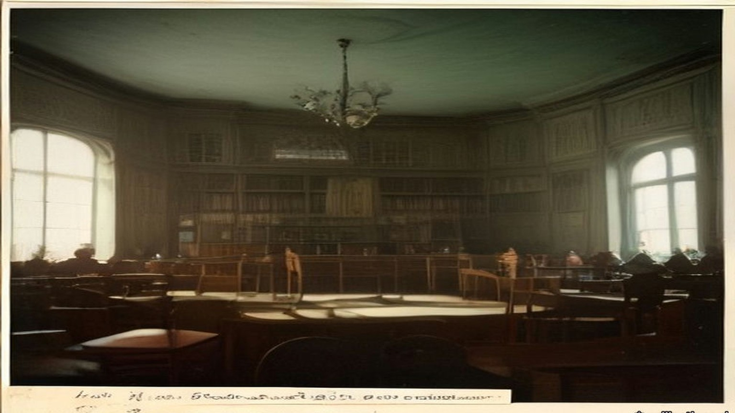
* * *
Athy, county Kildare, Tuesday, 15 September 1903
The circular came to most of the tenants on the Monday. The meeting it called was on the Tuesday. Some tenants never got one at all.
The estate was the Duke of Leinster's, about 45,000 acres, most of it in county Kildare around Maynooth in the north and Athy, Kilkea and Castledermot in the south. The Duke was Maurice FitzGerald, the sixth of the title. He was sixteen, and would come of age on 1 March 1908. The estate was in the hands of two trustees, his uncle Lord Frederick FitzGerald and Lord Kinnaird. That same Tuesday they told the tenants they were willing "to sell the different Leinster estates at 26 years' purchase subject to a reduction of 12½ per cent on first term rents with a view to adjusting them to the second term standard." Twenty-six years' purchase meant a price of twenty-six times the year's rent.
Matthew Minch took the chair in Athy. He held 248 acres from the Duke, and he was a maltster. Five years before, when the Leinster Leader went round the industries of Athy, it had called him Mr. M. J. Minch, M.P., and counted his maltings among the important industries of the town. They kept about fifty men in constant employment throughout the year. The member for South Kildare now was Denis Kilbride.
He told the meeting plainly who was in the room. "Of course, our meeting here today does not comprise all the Leinster tenants, inasmuch as the time was short and circulars were only sent out to those whose names we could secure at very short notice."
They talked a long time about price. They settled on an offer of not more than twenty-four years' purchase of the second-term rents. Some in the room thought even that too much. J. B. Deegan, vice-chairman of the Athy Urban District Council, said they would be "erring on the side of generosity on offering 24 years' purchase," and that the meeting would be "unfavourably criticised by the majority of the tenants in Ireland in consequence of their generosity!"
A committee was named to meet the trustees: Minch, R. Anderson, T. Anderson, J. Gannon, R. Wright, P. Barrington, C. Greene and E. Heydon, with A. Reeves and A. K. Pennycook as secretaries. Robert Anderson and Anthony Reeves were names the Leinster Leader had printed before, in 1898, as a director and as the courteous secretary of the Athy brickworks on the Monasterevan road. Forty men worked there all the year round, for ten shillings to twenty shillings a week.
* * *
Dublin, Thursday, 17 September 1903
The committee went up to Dublin two days later and saw the agent of the estate, Charles R. Hamilton. Stephen J. Browne, solicitor, chairman of Kildare County Council, came for the Maynooth tenants and sat through it without taking part.
Hamilton gave them the trustees' answer. They "had made up their minds, after consultation with their London solicitors, not to sell under 26 years' purchase, inasmuch as, being trustees, they had no power to reduce the income of the present duke."
Afterwards Minch said it was unreasonable and unjust to ask every tenant to pay the same standard price, whatever his land and his circumstances. Twenty-four years was the most the tenants could give.
A correspondent of the Freeman's Journal heard other talk on the estate. The sale, people were saying, was "run by the big men and Scotchmen who have got the fat of the land," men with "heaps of money, made in business, and others who have splendid situations." A tenant who signed himself Nemo said what he meant by the Scotchmen. They were the descendants of men "who in the old days were fondled by Hamilton and his master, the then duke of Leinster, and who got their farms at a figure never dreamt of by Irish men."
* * *
The Town Hall, Maynooth, Monday, 21 September 1903
There were something like seventy tenants on the Maynooth Manor, and the net rental of that part of the estate was said to be well over £9,000 a year. The Nationalist and Leinster Times described the land as mostly grazing, "held by some of the leading graziers of Kildare and Meath. There are, however, some portions of the lands under tillage, and this, needless to say, is of the poorer quality, and is let in comparatively small farms."
About fifty of the tenants were there or represented when the meeting assembled shortly after two o'clock. The Leinster Leader's reporter took down the names: the Rev. Mr. Creed, Laurence Ball, J.P., Mr. Shaw, R. McKenna, J.P. and county councillor, Mark Travers, Philip Brady, two McGraths, Patterson, Langan, Captain Murray, T. Byrne, the Mooneys, the Dunnes. Stephen Browne was there again as solicitor for some of them.
Someone proposed Laurence Ball for the chair. Ball demurred, and Shaw took it. The first question, Shaw said, was whether the Press should be represented at all. Ball said the trustees were consulting in private, and the tenants should consult in private too. The meeting agreed. The reporter closed his notebook and went out.
He waited an hour and a half. When the door opened, Ball and Shaw told him what had been decided: a deputation would go to Athy the next day, made up of Shaw, Ball, Langan, Travers, McGrath, Patterson and McKenna, with Mr. Browne. The paper reported that Browne had brought word from the trustees. They would now take twenty-five years' purchase.
The Nationalist and Leinster Times put it more shortly. "The grazier element predominated and took charge of the meeting."
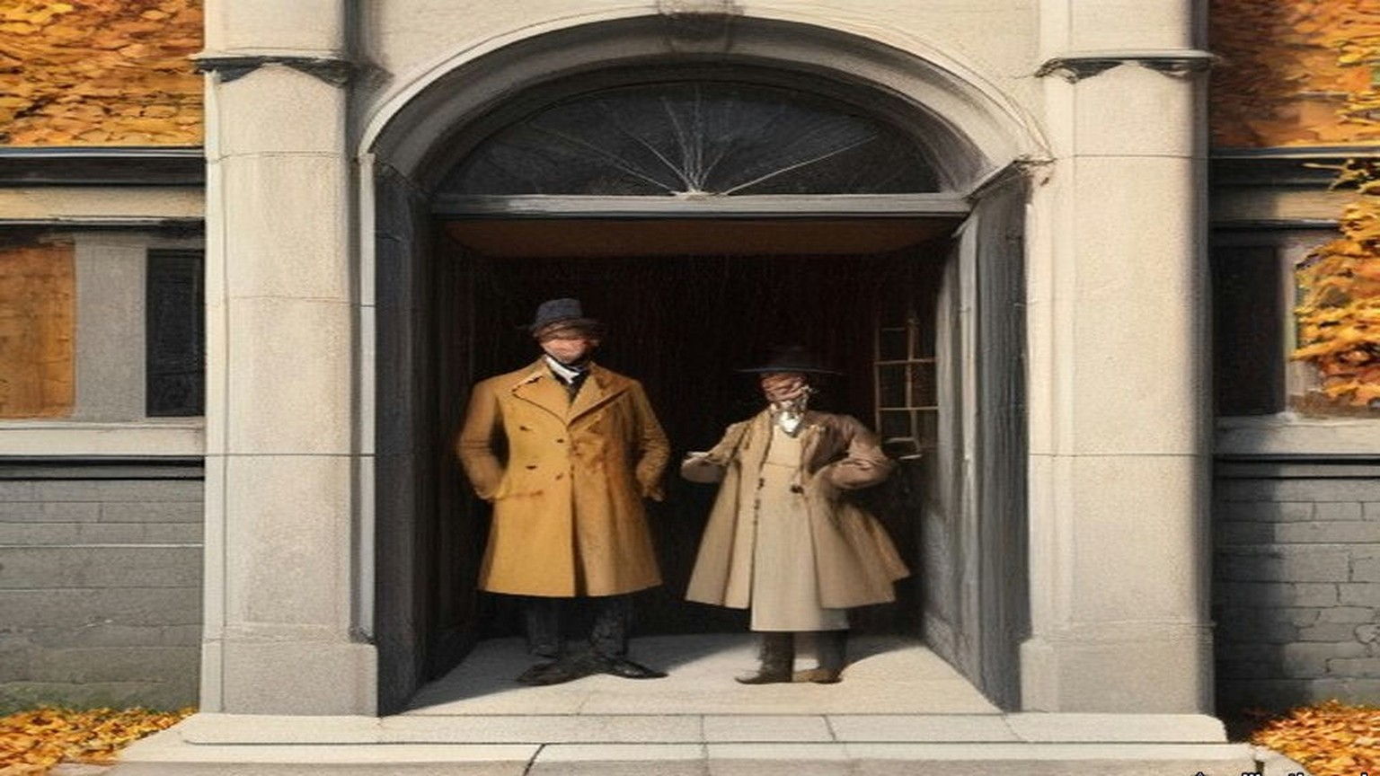
* * *
Athy, Tuesday, 22 September 1903
The general meeting of the whole estate was held in Athy the next day, and the Maynooth men came down for it. The Castledermot tenants did not.
Edward Heydon, county councillor, explained why. They had asked him "to call a meeting for next Sunday for them to consider their own position and I asked them why not come forward on today as there was a meeting in Athy. They told me that the Athy land was not at all on equal grounds." He asked the meeting not to make terms for them.
Then he said it was a serious thing to come to an arrangement with only one tenth of the tenants present. The chairman answered that this was a public meeting. If the tenants came, they would only be too pleased to have them.
J. B. Deegan wanted to know who the committee spoke for.
"By whom was the committee formed, by the tenants?"
"There was a committee appointed on this day week to interview the trustees. You were present yourself."
Deegan asked whether any committee had been formed by the majority of the agricultural tenants on the Leinster estate, for the purpose of making terms on their behalf.
"You have all the information I have."
"Then there has been no committee formed."
"Well it is a matter for our own opinion, I suppose. There was a committee appointed."
Deegan asked whether the member for the district had been asked to attend. The chairman was not aware that he had. Would it not have been well if he had been, Deegan said. Did they not think he was a fit and proper person to be there? Minch said he would only be too pleased if Mr. Kilbride were there.
Heydon spoke for the smaller men. "Twenty-five years' purchase is frightening everybody," he said. The meeting ought to consider it "from the farmers' point of view alone, from the point of view of people with 60 and 50 and 30 acres of land."
The sporting rights took longer than anything. The trustees wanted the shooting kept for the Duke. Some said the rights should go to the Land Commission, some to the tenants, some to the county council. Minch read a resolution: "They didn't object to the sporting rights being retained by the duke of Leinster for his own personal use and that of his family and friends, but they strongly objected to those rights being let out for profit."
In the end they appointed a deputation with power to make terms.
* * *
Dublin, Thursday, 24 September 1903
Lord Frederick FitzGerald received "a joint deputation representing the tenantry of Maynooth and of the Manor of Athy" in Dublin on the Thursday. The Irish Times said the meeting lasted between half an hour and an hour. The press was not admitted. Afterwards it was given the terms.
"1) 25 years purchase. 2) All arrears up to March 1903, to be added to the purchase money. 3) The gale due on September 29th and November 1st to be forgiven. 4) Payment of interest on the purchase money to commence from 29th September, 1903. 5) Sporting rights reserved to the duke."
The shooting was to stay with the Duke until he came of age.
Edward Heydon and Richard Wright had asked for one more thing. They "did their best to get the trustees to forgive all arrears on tillage farms under £50, and they explained that people on these farms were generally harder set, particularly about Castledermot, where the land was colder. They failed to get the trustees to agree to that."
The Return of Advances that Parliament printed in 1907 shows what the men in the room held from the Duke. Richard McKenna of Maynooth, J.P. and county councillor, had 308 acres. James Patterson had 203, William Chamberlain 207, Laurence Ball, J.P., 186, Mark Travers 119, Joseph Langan 46. Thomas Shaw and Stephen Browne held no land on the estate. From Athy and Kilkea, Richard Wright, J.P., had 347 acres at Kilkea and 39 at Castledermot. Edward Heydon had 317 at Kilkea and 59 at Castledermot. Thomas Anderson, J.P., had 313, Robert Anderson 278, John Gannon, J.P., 257, Matthew Minch, J.P., 248, Andrew Pennycook 223, Philip Barrington 201, Charles Greene 149 and Anthony Reeves 80. The eighteen men held about 3,580 acres between them.
The Leinster Leader reported the terms "as accepted by practically the whole of the Leinster tenantry."
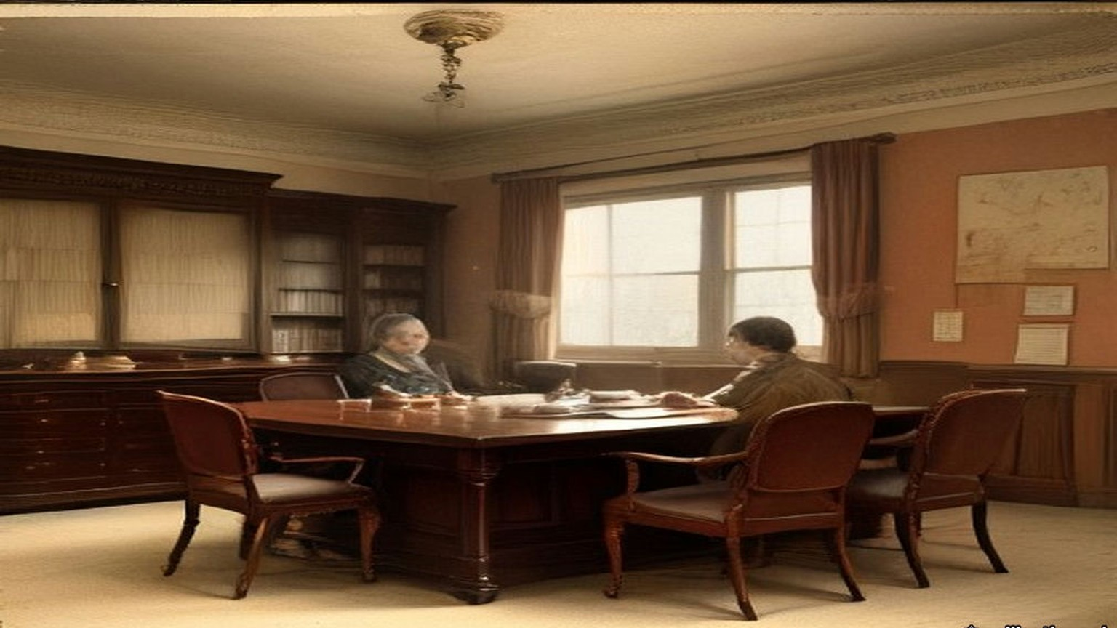
* * *
Castledermot, county Kildare, Sunday, 27 September 1903
The Castledermot tenants met for the first time on the Sunday. The terms had been settled for three days.
The parish priest, the Rev. M. Walsh, took the chair. Edward Heydon told them what had been agreed in Dublin. Nobody in Castledermot had chosen him to go. He told them about the arrears on the small farms, and how the trustees had refused. He spoke of the late Duke.
"He always gave the tenants better terms than other landlords."
"Hear, hear."
A voice said, "He was a good man."
Another voice said, "Better than the government will be."
John Keogh said it out. "It's all very well for the big bugs about Athy to give twenty-five years' purchase, but it's different with us."
John Nolan raised the shooting. There was "some objection to the game rights being given up. We don't want to have gamekeepers coming in on our farms when we have purchased. I would not object to the duke or any of his friends coming on my land to shoot, but I would object to outsiders."
There was the drainage too. The River Lerr ran through the Kilkea and Castledermot lands, and the Board of Works was still owed £14,121 16s. 1d. for draining it, at £363 8s. 9d. every half year. The Duke had always paid it. Heydon said the Duke would go on paying for the maintenance of the Lerr drainage, by investing a sum or mortgaging a piece of property.
A voice said, "We are not paying for it."
They put the motion to accept the terms of the Maynooth and Athy deputations. It was carried with three dissentients.
* * *
A holding near the Lerr, the same day
I never got the paper. A neighbour got one, the Monday, and read it out to a few of us at his gate, and by the time he had it read the meeting in Athy was the next morning. Who'd be going to Athy on a Tuesday, and the oats still out in the stooks? And what would we be doing there, among the Athy men, and it their land and not ours they'd be pricing?
So it was the Sunday, and Father Walsh in the chair.
I stood at the back by the wall. I could smell the wet off the coats, and the pipe smoke, and the cows on the boots of the men either side of me. Heydon was standing up, and he telling us what the big men did in Dublin on the Thursday. I couldn't see him right for the heads in front of me. I could hear him.
Twenty-five years. I heard it and I was counting before I knew I was counting, on the fingers inside my pocket, and I lost the count and started again. Twenty-five years of the rent. Twenty-five times the whole of it, and the arrears put on top. My mouth went dry and I couldn't swallow.
The arrears. He said they tried. He said they told his lordship the land was colder about Castledermot. I know it is colder. I know it in my two hands every February when the water lies in the low field past the Lerr and the ice on it in the morning like the skin on milk, and I breaking it with the heel of my boot to let the cattle drink. There's no man in Athy needs telling the land is colder. They told him and he said no.
Then the old man beside me said the Duke was a good man, and somebody behind said better than the government will be, and I said nothing.
I thought of the government. I never saw the government. I saw the Duke the once, on a horse, and the office every gale day with the book open on the table. You could talk to the office. You could stand there with the cap in your hand and say the potatoes were black, and the man would write it down and say nothing, and it would be in the book the next gale with the rest of what was owing. I didn't know who you'd talk to in the Land Commission. I didn't know was it a man at all.
Keogh said about the big bugs, and my face went hot, and I looked at the floor so no one would see it.
Then a man was on about gamekeepers. I'd have the Duke shoot over me and welcome. It's the strangers I wouldn't want, walking the headlands with the dogs. And then the drainage, and a man shouting we're not paying for it, and I was with him there.
When the priest put it to us, every hand went up around me. Arms in black coats like a fence going up.
I kept mine down. There was two more kept theirs down. I didn't see them. I heard the priest say three. I stood there with my two hands in my pockets and the nails going into the palms.
Then it was done, and we went out into the street, and there was nothing to do only go home.
* * *
Athy and Dublin, October to December 1903
On Sunday, 11 October, Denis Kilbride came to Athy and spoke on the Act. The landlords, he said, would benefit far more than the tenants. Then he spoke about the sale.
"Whatever was said in Athy or Dominick Street has no binding effect on anybody. As long as agreements are not effected the tenants are neither legally or honourably bound by the terms. He had heard that a circular was sent out to the Leinster tenants calling a meeting in Athy. That circular was received in most cases on Monday, and the meeting was called for Tuesday, while several tenants never got a circular at all. How could a tenant imagine that he is bound by an agreement made behind his back."
Stephen Heydon, county councillor, said a headline had been set for south Kildare, and he was afraid it was the wrong one. "It was set generally by those north Kildare men, graziers, who are living within easy access of Dublin, and having prime grassland."
On 25 September the Irish Times had written that "the act will be a complete failure unless it affects the small farmers and poorer agriculturalists." If the big landlords followed the example of the Duke of Leinster's representatives, the five millions the Estates Commissioners could advance in the first year would very quickly be eaten up. "Businesslike and agreeable as is such an agreement as the Leinster tenants have made, we should prefer to see the smaller landlords and poorer tenants coming in for the fruits of this piece of beneficent legislation." On the 30th it wrote, "The twenty-five years' purchase on the Leinster estate cannot rule the sales for Ireland, for Kildare is a choice bit of land with exceptional advantages."
A Maynooth resident who signed himself W. H. wrote to the Freeman's Journal that "a more grievous wrong could hardly be inflicted… on the small tillage tenants than by their inclusion in Mr. Minch's cast-iron mould of uniformity, and this is just the body of tenants least capable of understanding the injustice." The chief support for the terms, he wrote, came "from a swarm of newcomers who represent the wealth of the tenantry and to whom any reduction is quite a god send." He called the uniform price "most mischievous in its results if adopted." A tenant writing as Nemo said he had seen in the negotiations the names of "shop-keepers and business men in a very prominent position, together with the names of a few descendents of those Scotchmen, who in the old days were fondled by Hamilton and his master."
Tenants on the Earl of Dartrey's estate in county Waterford passed a resolution condemning the price. At a League meeting at Redwood in county Wicklow, D. J. Cogan, M.P., said he "was afraid that the wealthier and stronger tenants rushed the sale to the disadvantage of their poorer neighbours." In South Cork, Eugene Crean, M.P., urged tenants "not to repeat the rash and foolish action of the duke of Leinster's tenants."
By late November the terms had a name. On the Samuel Mills estate in Kildare and the Queen's County, the agent said the landlord would sell only on the Leinster terms. On R. H. McDonnell's estate near Athy, the tenants offered twenty-three years' purchase on second-term rents. The landlord refused it and held out for the Leinster terms.
In December Vernon Cochrane wrote in the Irish Times that the Chief Secretary had "used his influence to secure part of the bonus to sell the Leinster estate, which, whatever is its legal aspect, is a crime to the minor." The Chief Secretary was a kinsman of the FitzGeralds.
* * *
The same holding, Michaelmas and after, 1903
The twenty-ninth of September came and I paid nobody.
Every Michaelmas since I was big enough to stand behind my father I saw the money counted out on this table. The half-year. Him wetting his thumb. The coins in a row on the board and the noise of them going into the bag. This year I took the tin down off the dresser and opened it and looked at what was in it and put it back.
The woman said it's like a wake with no corpse.
The first of November the same. Nobody to pay. I went out to the low field and walked the length of the drain and back, and the water was in it already, brown, and the smell of the rotted flags along the bank. Mine, I said. I said it out loud to see what it was like. A crow got up.
But it wasn't mine. It was the Land Commission's, and the interest running on it since the twenty-ninth, Heydon said, in place of the rent. And the arrears in the price. The bad years were in the price now. Out of the book and into the price, and the price stretched out longer than I'll live.
I worked it on the back of the almanac with the stub of a pencil. Three pound five on the hundred. I did it three times and got three answers and then I put the pencil down.
The woman put her hand flat on the paper and held it there.
There's a smell off the Lerr in the back end that I knew all my life and never minded. That winter it came in the door with me every evening.

* * *
Dublin and London, November 1903 to December 1905
The estate was sold in late November 1903. Five hundred and six tenants bought.
The trustees' own accounts, kept in the Leinster papers, show where the money went. The purchase money and interest paid over by the Estates Commissioners came to £674,516. The bonus under section 48 came to £80,108. With £12,021 entered as income, the sale brought in £766,647 11s. 4d.
The expenses of the sale were £22,815. The agent, Charles R. Hamilton, was paid £15,000 for his services. Charges on the estate were paid off to the amount of £78,831 6s. 7d. A statement of December 1905 showed £272,076 of the purchase money bound up in family charges: portions for the Duke's uncles and aunts, Lord Frederick, Lord Walter, Lord Charles, Lord George, Lord Henry and Lady Nesta, and the rest held for the Duke against the day he came of age.
Only £61,706 18s. 7d. went into stocks, some of them Irish: Dublin Corporation, Belfast Corporation, the Bank of Ireland.
Most of the rest went out on mortgage. The trustees lent £298,000 to the Earl of Tankerville at three and a half per cent. They lent £122,500 to Lord Hastings, £82,500 to Mr. Duncombe Shafto, £41,000 to Earl Fitzwilliam and £39,000 to Colonel H. Denison, Hastings at three and a half per cent and the other three at three and three-quarters. The loans came to £603,000. Tankerville was a deputy lieutenant of Northumberland. Denison gave his address as Eaton Hall, Retford, in Nottinghamshire.
The tenants of Castledermot and Maynooth were paying the State three pounds five shillings a year on every hundred pounds they had been lent. The stock the State issued to raise that money paid two and three-quarters per cent.
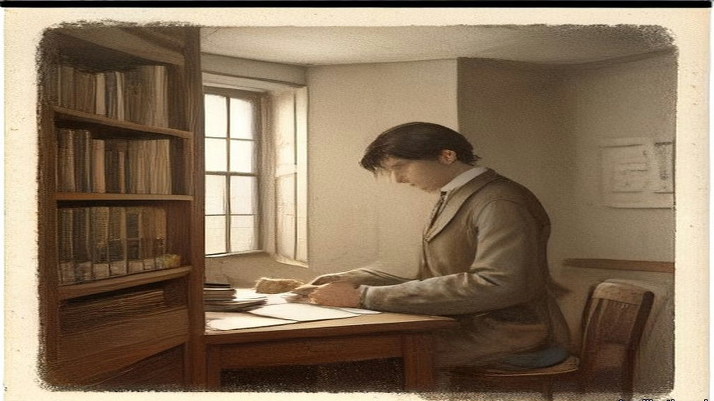
* * *
The House of Lords, Monday, 22 February 1904
Lord Muskerry rose to move that the Land Act of 1903 had failed to settle the Irish land question.
"The last Land Act is already a failure. A mere handful of estates, forced by necessity, have come under its proposals. One great estate, which used to support the highest dignity in the Irish Peerage, has been sacrificed for ready money by the guardians of a minor, with little respect for the future of a title divorced from property and residence."
He went on to complain that for over a third of a century, whenever the Treasury Bench wanted support, it had flung a slice of the Irish landlords' property to "the greedy populace whose votes they thought to buy."
* * *
The House of Commons, Tuesday, 21 March 1905
Denis Kilbride, member for South Kildare, seconded a motion on the working of the Act. Periodic reports had been promised, he said, and they were still groping in the dark. All the Government had told them was the number of tenants whose purchases had been sanctioned, the money advanced and the number of years' purchase paid. They did not know what had been done to reinstate the evicted tenants, or to put back on the grass lands of Connaught the people driven off them in former times. He read out the figures the Government had given the House. The Estates Commissioners had sanctioned advances of £3,567,649. Connaught had got £299,781, something like eight per cent. Leinster, the richest province in Ireland for the natural quality of its land, had absorbed £2,028,548. County Kildare by itself had absorbed £862,068, almost four times as much as the whole province of Connaught.
A member called out, "The Duke of Leinster."
Kilbride said he was not going to say anything against the Duke of Leinster. If the tenants were satisfied to give the Duke exorbitant prices, it did not lie with him to prevent them. "But he said that the Duke of Leinster's estate afforded the best illustration of how the Irish ratepayers were being robbed under the Land Act of 1903."
He took one holding to show it. Before the Act of 1881 it was let at £125. In 1881 the Duke had told his tenants they could go into the court or agree to a valuation, and a valuer brought it down by twenty per cent, to £100. The Duke had not sold the manors of Maynooth and Castledermot when he sold other parts of the estate under the Ashbourne Act. In 1881, Kilbride said, the tenants there had asked for a reduction to match the fall in the price of cattle and sheep, and the Duke had told them he could not give it, because there was a mortgage of over £250,000 on the estates. When the estates were sold, he said, they brought £343,000, and were in that way relieved of the mortgages. After 1887 there was a further reduction of twelve and a half per cent, and the rent stood at £87 10s.
Land of that kind had sold under the Ashbourne Act at eighteen years' purchase. The £100 holding brought £1,800. Under the Act of 1903 the same holding, at twenty-five years' purchase of £87 10s., was sold for £2,187 10s.
"He wished the House to remember that under the Ashbourne Act there was no bonus." If the purchasers ever failed, he said, the Treasury would not go first to the land for its security. It would come down on the Irish Development Fund, and the loss would fall on the general body of the ratepayers of Ireland.
He had another figure for the House. The Act had promised to put the evicted tenants back on the land. Of the £250,000 of Irish money set aside for reinstating evicted persons, £3,500 had been spent. The House had voted £3,000,000 to resettle the Boers.
* * *
Dublin, Saturday, 29 February 1908
On the last day of February the Irish Independent wrote that "the sale of the Leinster estate under the Wyndham Land Act fairly crippled that badly financed measure."
The next day was Sunday, 1 March, and Maurice FitzGerald, sixth Duke of Leinster, was twenty-one.
* * *
The House of Commons, Tuesday, 8 December 1908
The Liberal Government's Irish Land Bill came up for second reading. Harold Cox, member for Preston, said the State was always starting these charitable schemes on behalf of the poor man, "and the rich man dropped in." The Act of 1903 had applied to farms up to £5,000. "The Duke of Leinster, for example, got £80,000 for graciously consenting to sell his land at a price far above the market value."
Charles Craig, member for South Antrim, answered that the Duke was the owner of a particularly large estate, that the bigger the transaction the more tenants were made owners, and that he believed all the tenants were perfectly satisfied with their bargain.
Richard Cherry, the Attorney-General for Ireland, said he had been told that evening by one of the Estates Commissioners that in the five years since the Act was passed, not one single congested estate had been sold. The congested districts clause had been a dead letter. Those who wanted a peasant proprietary in Ireland had become alarmed, he said, at the number of large holdings sold. "A very large portion of the purchase money advanced under the Act of 1903 was advanced to tenants on large holdings, who should not have come under land purchase at all." Then he read figures he had been given that evening.
"On the Carton estate, a very large estate in Kildare owned by the Duke of Leinster, the number of purchasers was only 506, and the total amount of purchase money advanced was £687,417."
Members cried, "Oh, oh!"
That was an enormous sum for a small number of men, Cherry said, "more especially in view of the fact that there were thousands of people with only one or two acres on small uneconomic holdings. In those transactions the Duke of Leinster put into his pocket £80,000. The House would recollect that in the Act power was given to make advances up to £7,000 to a single purchaser, and soon after the Act came into operation this provision was largely taken advantage of by the rich and well-to-do, and really the poor people were shut out. He was speaking of the tenants, and those large tenants of the Duke of Leinster's estate were certainly not the class of people intended to be benefited by the Land Purchase Acts."
Seventy-seven of the holdings had been bought with advances of over £3,000 each. Those seventy-seven came to £381,825, more than half the purchase money for the whole estate.
"The purchase of these large holdings had exhausted the money available, and had left the poor and distressed portions of the country in the West, and South, in North Connaught, Clare, Kerry, and Donegal, in the background."

* * *
The same holding, the winter of 1908
A man read it out of the paper in the forge, and the rest of us standing round the fire. Seventy-seven of them had more than the half of the money. I didn't need telling which seventy-seven.
I got up in the morning same as ever and went down to the low field. The drain was full. I stood on the bank a long time with the cold coming up through my boots, and I thought about the members in London crying oh, oh, and I thought about Keogh and the big bugs, and my own hand down in my pocket that day.
When the half-year came due I paid it, the same as I paid the rent, counting it out on the table. Then I went up to the house for the dinner.
* * *
The House of Commons, Tuesday, 30 March 1909
Augustine Birrell, Chief Secretary, moved the second reading of the new Land Bill. Instead of the bonus of three per cent all round, he said, there would be a bonus graduated inversely according to the price paid for the land. "The lesser the price, the higher the bonus. Everybody will agree that in many cases a bonus of 12 per cent. becomes a most unnecessary burden to be imposed on the Exchequer."
"Therefore, though it is eminently desirable that the Imperial Exchequer should assist in the great agrarian revolution in Ireland, and in bringing about a satisfactory solution yet nobody will say that for a well-managed estate like that of the Duke of Leinster's the Duke should get £80,000 into his breeches pocket for selling at market value an excellent estate upon which there has never been any particular amount of trouble."
He gave the reason for the Bill. Under the Act of 1903, when the guaranteed stock sold below par, the loss on it was met first from the Ireland Development Grant, and after that out of the money that went to Ireland in relief of local rates. In the autumn he had reckoned on 88 5/16. "I am tired of extolling this stock. There is no better in the world; but the more I extol it the lower it falls, and so I think I, at all events, had better leave it alone." He could not safely count on more than 85. At that price, with the agreements already pending and those to come, the excess stock would be £27,000,000, a charge of £877,000 a year for sixty-eight and a half years. After the Development Grant, a balance of £855,000 a year would fall in the end on the Irish ratepayer.
For agreements made since the Treasury's scrutiny of 24 November 1908, he said, the landlord was getting a bonus of three per cent.
The graduated bonus, he told the House, would cost at least £3,000,000 over and above the original £12,000,000, "and I daresay it will be more before we are done."
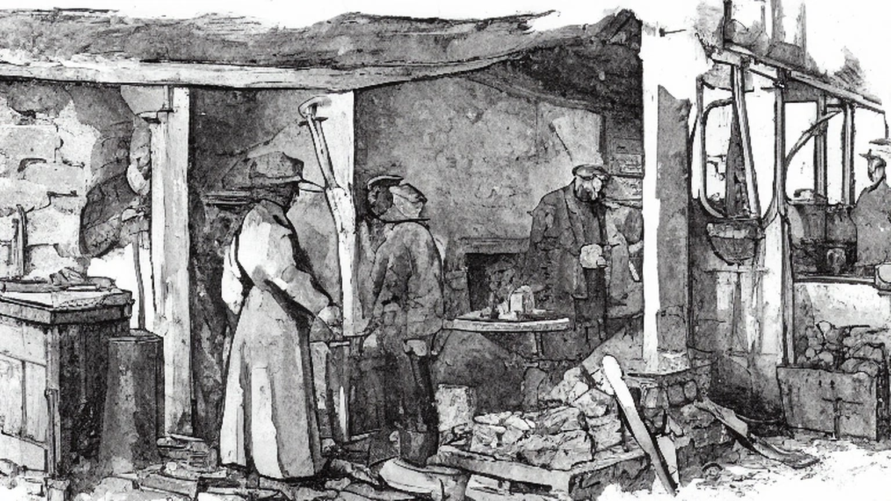
Chapter 14 Appendix of Important Names
• Craig, James (1 mentions in this chapter): Ulster Unionist leader and first Prime Minister of Northern Ireland.
• Hastings, Warren (2 mentions in this chapter): First Governor-General of Bengal, who formalized the East India Company's opium monopoly in 1773.
• Samuel, Herbert (1 mentions in this chapter): British Liberal politician and first High Commissioner for Mandate Palestine (1920–1925).
Sources
• House of Commons Debates, 25 March 1903, "Irish Land Bill," 4th series, vol. 120, cc. 181–240 (Wyndham asking the indulgence of the House; the subject "technical to a degree almost beyond belief"; the two audiences; cash aid "necessary" but "subsidiary," more importance attached to the credit; the instalment lowered from £4 to practically £3 5s., with £2 15s. interest and 10s. sinking fund; the dividend of 2¾ per cent; £100,000,000 as the most sanguine estimate for all the saleable land; the £12,000,000 grant; and in Wyndham's reply at c. 238 the graduated bonus, "15 per cent. on £5,000 and under," 10 per cent at £20,000, 5 per cent at £40,000, rejected a flat rate because "it would press more heavily on the small than on the large properties"). https://api.parliament.uk/historic-hansard/commons/1903/mar/25/irish-land-bill
• Irish Land Act, 1903 (3 Edw. 7, c. 37), as enacted, Irish Statute Book (date of assent, 14 August 1903; s. 1(4), advances up to £7,000 to one purchaser; s. 28, the guaranteed two and three-quarters per cent stock; s. 45, the purchase annuity of £3 5s. per £100; s. 48, the bonus of "twelve per cent. on the amount of the purchase money advanced"). https://www.irishstatutebook.ie/eli/1903/act/37/enacted/en/print.html
• Leinster Leader, 26 March 1898, on the industries of Athy, transcribed by Kildare Library Services, Kildare eHistory (the maltings of "Mr. M. J. Minch, M.P.," keeping about fifty men in constant employment; the brickworks on the Monasterevan road, Robert Anderson a director, Anthony Reeves the "courteous secretary," about forty men employed all the year at 10s. to 20s. a week). https://kildarelibraries.ie/ehistory/athy-newspaper-article-on-the-industries-in-athy-in-1898/
• Leinster Leader, Saturday, 26 September 1903, "Meeting at Maynooth," transcribed by Kildare Library Services, Kildare eHistory (about seventy tenants of the Maynooth Manor; net rental well over £9,000; about fifty present or represented; the names; Browne as solicitor; the meeting shortly after two o'clock; Ball's demurral and Shaw in the chair; consulting in private; the press representative withdrawing; the meeting lasting an hour and a half; the deputation). The transcription prints the date as "Saturday September 25"; the Saturday was the 26th, the date Cosgrove cites. https://kildarelibraries.ie/ehistory/land-purchase-the-leinster-estate-meeting-at-maynooth-1903/
• Contemporary newspaper reports of the negotiations, quoted from the transcriptions and notes in Patrick J. Cosgrove, "The sale of the Leinster estate under the Wyndham Land Act, 1903," Lord Walter Fitzgerald Prize Essay 2009, Journal of the County Kildare Archaeological Society (https://www.kildarearchsoc.ie/wp-content/uploads/2013/04/Lord-Walter-Prize-2009.pdf), and in the same author's NUI Maynooth PhD thesis, "The Wyndham Land Act, 1903: the final solution to the Irish land question?" I could not get to the newspaper files themselves; every quotation from them below is given as Cosgrove printed it, with his citation. The Times, 19 September 1903 (the trustees' offer of 26 years' purchase less 12½ per cent on first-term rents). Leinster Leader, 19 September 1903 (Athy, 15 September: Minch's admission about the circulars; 24 years' purchase; Deegan's "erring on the side of generosity"; the committee and secretaries). Nationalist and Leinster Times, 19 September 1903 (Hamilton's answer of 17 September; Minch on a uniform price; the Freeman's Journal correspondent's "big men and Scotchmen" and "heaps of money"). Nationalist and Leinster Times, cited by Cosgrove as 20 September 1903, the day before the meeting it reports, so the date is a slip (the Maynooth land "mostly made up of grazing lands"; "the grazier element predominated"). Leinster Leader, 26 September 1903 (Athy, 22 September: Heydon on the Castledermot tenants and "one tenth"; Deegan's questions on the committee and on Kilbride; "25 years' purchase is frightening everybody"; the sporting-rights debate and Minch's resolution; the terms "as accepted by practically the whole of the Leinster tenantry"). Irish Times, 25 September 1903 (Lord Frederick and the joint deputation on 24 September; the length of the meeting; the five terms; the leading article on "the small farmers and poorer agriculturalists"). Nationalist and Leinster Times, 3 October 1903 (Castledermot, 27 September: Rev. M. Walsh in the chair; Heydon on the arrears of tillage farms under £50 and the colder land; the late Duke, "Hear, hear," "He was a good man," "Better than the government will be"; Keogh's "big bugs"; Nolan on gamekeepers; the Lerr drainage and "We are not paying for it"; three dissentients). The thesis places the drainage exchange at "the Athy meeting of 27 September"; the only meeting that day was at Castledermot, and the chapter places it there. Nationalist and Leinster Times, 17 October 1903 (Kilbride at Athy, 11 October; Stephen Heydon's "wrong headline"). Irish Times, 30 September 1903 ("a choice bit of land"; the Dartrey tenants). Freeman's Journal, 10 October 1903 (W. H.; Nemo). Freeman's Journal, 6 October 1903 (Cogan at Redwood, as Cosgrove's thesis cites it; the prize essay says the Times). The Times, 1 October 1903 (Crean). Freeman's Journal, 25 and 27 November 1903 (the Mills and McDonnell estates). Irish Times, 14 December 1903 (Cochrane). Irish Independent, 29 February 1908 ("fairly crippled that badly financed measure"; the Duke's coming of age on 1 March 1908).
• Return of advances made under the Irish Land Act, 1903, during the period from 1st November, 1903, to 31st December, 1905, vol. I, parts i–iii [Cd. 3447, Cd. 3560, Cd. 3547], H.C. 1907, lxx, 1, as tabulated in Cosgrove's Appendix I (the acreages of the eighteen men of the deputation, 3,580 acres in all; William Chamberlain replacing McGrath). The prize essay gives Richard Wright 39 acres at Castledermot; the thesis gives 24. The chapter follows the essay's table.
• Leinster papers, Public Record Office of Northern Ireland, D3078/2/15/4, D3078/2/15/5 and D3078/2/15/16/3, as printed and cited by Cosgrove: "Statement of applications of sums received on the sale of the Leinster Estates in Ireland," July 1904 (£674,516 purchase money and interest; £80,108 bonus; £12,021 income; £766,647 11s. 4d. in all; expenses £22,815; charges redeemed £78,831 6s. 7d.; the mortgages to Tankerville, Hastings, Shafto, Fitzwilliam and Denison and their rates, £603,000; £61,706 18s. 7d. in stocks including Dublin Corporation, Belfast Corporation and the Bank of Ireland); "Statement of monies realised" (the Lerr drainage charge of £14,121 16s. 1d. at £363 8s. 9d. a half-year); "Leinster estate sale" (Hamilton's £15,000); "Statement as to the legal and beneficial ownership of the purchase moneys," December 1905 (£272,076 18s. 5½d. in family charges and the beneficiaries). Who's Who 1911, as cited by Cosgrove (Tankerville a deputy lieutenant of Northumberland; Denison at Eaton Hall, Retford).
• Nationalist and Leinster Times, obituary of Lord Walter FitzGerald, transcribed by Kildare Library Services, Kildare eHistory (George Wyndham "a collateral kinsman" of the FitzGeralds). https://kildarelibraries.ie/ehistory/obituary-lord-walter-fitzgerald/
• House of Lords Debates, 22 February 1904, "The Irish Land Act," 4th series, vol. 130, cc. 518–28 (Lord Muskerry's motion; at c. 521 "One great estate ... sacrificed for ready money by the guardians of a minor"; "the greedy populace whose votes they thought to buy"). https://api.parliament.uk/historic-hansard/lords/1904/feb/22/the-irish-land-act
• House of Commons Debates, 21 March 1905, "Irish Land Act, 1903," 4th series, vol. 143, cc. 748–76, Kilbride at cc. 753–6 (advances of £3,567,649; Connaught £299,781; Leinster £2,028,548; Kildare £862,068; the interjection "The Duke of Leinster"; "robbed under the Land Act of 1903"; the holding at £125, £100, £87 10s.; 1881 valuation and 20 per cent; the mortgage of over £250,000; £343,000; eighteen years' purchase and £1,800 against £2,187 10s.; "under the Ashbourne Act there was no bonus"; the Irish Development Fund; £3,500 of £250,000 for evicted tenants against £3,000,000 for the Boers). https://api.parliament.uk/historic-hansard/commons/1905/mar/21/irish-land-act-1903
• House of Commons Debates, 8 December 1908, "Irish Land Bill," 4th series, vol. 198, cc. 265–395 (Harold Cox at cc. 305–6, "the rich man dropped in" and the Duke's £80,000; Charles Craig at c. 330; Cherry at cc. 342–4: no congested estate sold, the Carton estate, 506 purchasers and £687,417, "Oh, oh!", "put into his pocket £80,000," the £7,000 advances "largely taken advantage of by the rich and well-to-do," 77 advances over £3,000 totalling £381,825, the West, North Connaught, Clare, Kerry and Donegal "in the background"). In the same passage Cherry gives the total of purchasers as 508; the chapter follows his first figure, 506, which agrees with Cosgrove. https://api.parliament.uk/historic-hansard/commons/1908/dec/08/irish-land-bill
• House of Commons Debates, 30 March 1909, "Irish Land Bill," 5th series, vol. 3, cc. 188–257, Birrell at cc. 193–5 (the Ireland Development Grant and the loss on excess stock; 88 5/16 and 85; "I am tired of extolling this stock"; £27,000,000 and £877,000 a year for 68½ years; £855,000 on the Irish ratepayer; the 3 per cent bonus on agreements after 24 November; the graduated bonus, "The lesser the price, the higher the bonus"; "into his breeches pocket"; at least £3,000,000 above the £12,000,000). https://api.parliament.uk/historic-hansard/commons/1909/mar/30/irish-land-bill

Chapter 15
Banana Skins at the Metal Bridge, 1913–1915
Belfast, Westminster, Larne, Hamburg, Howth, Clontarf and Dublin, 1913 to 1915
On 24 September 1913 the Ulster Unionist Council, meeting in Belfast, set up a fund to pay for the injuries of the Ulster Volunteer Force before any of them happened. The form of "Indemnity Guarantee" promised a man hurt in the service of Ulster, or the widow of a man killed in it, sums "not less than they would have been entitled to under the Fatal Accidents Act, the Employers' Liability Act, and the Workman's Compensation Act." Sir Edward Carson, Lord Londonderry, Captain James Craig, Sir John Lonsdale, Sir George Clark and Lord Dunleath put their names down for £10,000 each, and six more men matched them. A quarter of a million was guaranteed before the Council left the room. By the end of the week it was £387,000. Before the first of January 1914 it stood at £1,043,816.
On 4 December 1913 the King signed two Proclamations. They were made under section 43 of the Customs Consolidation Act of 1876 and section 8 of the Customs and Inland Revenue Act of 1879, and they forbade the importation of arms and ammunition into Ireland.
In a free-trading kingdom a rifle was goods, like tea or timber. It could come in at any port unless the Crown said otherwise, and now the Crown had said otherwise. The penalty sat in section 186 of the Act of 1876. A man who imported prohibited goods, or knowingly kept or hid them, forfeited "either treble the value of the goods or the sum of £100," at the choice of the Commissioners of Customs. Where three or more persons assembled to do it, the Act of 1879 raised the sum to £500. Section 202 named who could seize such goods: officers of Customs, and persons "duly employed for the prevention of smuggling."
In May 1914 the Financial Secretary to the Treasury told the House of Commons what the Customs paid. An established officer could rise to £300 a year. A watcher, the man who stood on the quay, could rise to 24 shillings a week, with two shillings more for good conduct after ten years.
* * *
The House of Commons, Wednesday, 25 March 1914
Colonel John Seely, Secretary of State for War, rose on the second reading of the Consolidated Fund Bill and asked the indulgence of the House. He said he hoped to conceal nothing.
He went through the papers presented to the House that day. In March, on information received, he had ordered troops to guard the depots at Omagh, Armagh, Enniskillen and Carrickfergus. Sir Arthur Paget, commanding in Ireland, had come over to discuss the moves and had gone back to Dublin. On the evening of 20 March a telegram reached Seely from Paget. The officer commanding the 5th Lancers reported "All officers except two, and one doubtful, are resigning their commissions to-day. I much fear same conditions in 16th Lancers. Fear men will refuse to move."
Bonar Law had read out a letter, said to come from an officer who was there, that put the words "in a blaze" into what Paget told his officers at the Curragh. Seely gave Paget's own account of the phrase. Paget said there might be a blaze, "certainly a blaze in the Press."
Brigadier-General Hubert Gough had come to London with his colonels. Seely had seen him in his own room, with Paget, the Chief of the Imperial General Staff and the Adjutant-General present. Gough said he was prepared to obey all lawful orders. He said the trouble arose "Because we thought we were going to be asked to coerce Ulster." He asked for it in writing. Seely gave him a paper. The Cabinet had discussed a draft while Seely was at the Palace, and afterwards he added two paragraphs of his own, in the sense of what he had told Gough: that the Government had no intention of using the right to protect the civil power "in order to crush political opposition." Sir John French and Sir John Spencer Ewart signed it.
Seely told the House he had made an error of judgment and had handed his resignation to the Prime Minister.
Later in the debate Asquith said, "I am not going to accept his resignation," though he agreed with Seely that it had been an error of judgment. The Government did not associate itself with the two paragraphs. Ramsay MacDonald answered that the paper was now an undertaking "minus the two paragraphs, but minus the two paragraphs it is no undertaking at all."
* * *
Larne, county Antrim, Friday, 24 April 1914
Fred Crawford had bought the rifles in Hamburg. The dealer offered him three lots. He took the dearest, fifteen thousand new Austrian rifles and five thousand German, because ammunition for them could be had in the United Kingdom or America. It was double the price of the first offer and nearly treble the second. In London Carson heard him out and stood up and shook his fist in his face, by Crawford's own account, and said, "Crawford, I'll see you through this business, if I should have to go to prison for it." Craig, who held the fund set aside for arms, agreed to the price.
Crawford had the rifles packed five to a parcel, with their bayonets and a hundred rounds for each rifle, about 75 lbs a parcel, so that nothing would have to be sorted out and put together again at the far end. The packing alone cost about £2,000. Off the Danish island of Langeland, a Danish officer carried away the ship's papers, and Crawford lay awake all night. His cargo, McNeill wrote from Crawford's manuscript, "represented about £70,000 of their money." The papers came back in the morning.
Now he stood on the Clydevalley, a Belfast Lough collier bought in Glasgow, in the Irish Sea. Canvas strips had been cut six feet long and painted with white letters on a black ground and fixed over her name at bow and stern. They read Mountjoy II, for the ship that broke the boom across the Foyle at Derry in 1689. Off Copeland Island a tender came out shouting that it had new orders. Crawford shouted back that if they were not signed by Sir Edward Carson they could take them back where they came from. They were signed. The bulk of the cargo was to go to Larne, the rest to Bangor and Donaghadee.
At 10.30 that night she came alongside the landing-stage at Larne. A triple cordon of Volunteers closed the town and harbour. About five hundred motor cars and lorries had been waiting more than two hours in drizzling rain, the drivers told only at the harbour what they had come for. Women stood at their doors and ran canteens. The men at the cross-roads across nine counties had done a full day's work first. They had orders not to go home till daybreak, and they were "not to receive a sixpence for their night's job."
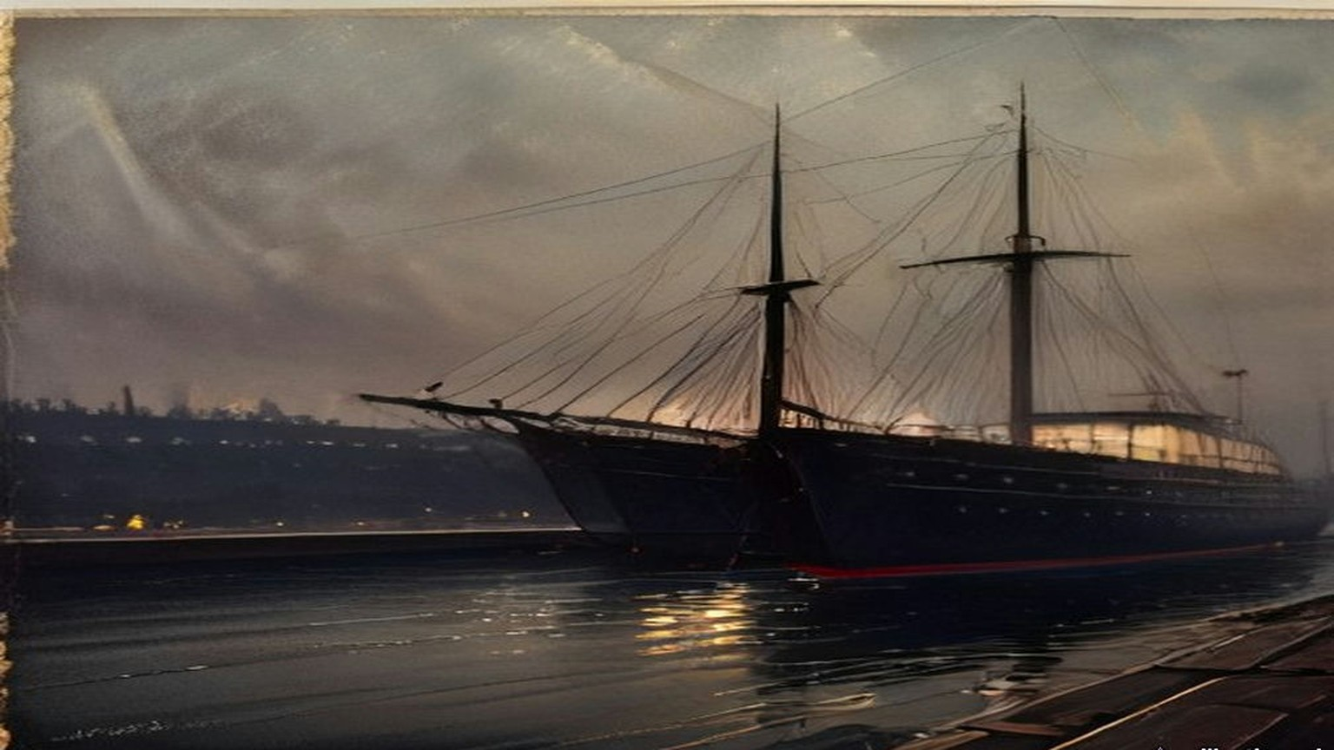
Twenty miles away, a tramp steamer came furtively up the Musgrave Channel in Belfast, and the Customs men spent hours on her. Her cargo was coal. The telephone and telegraph wires out of the three ports had been "earthed." The police and coastguards were shut in their barracks under guard. At Donaghadee a coastguardsman died of heart disease.
Crawford counted 20,000 modern rifles in the cargo, 10,000 older Italian ones and upwards of 3,000,000 rounds. The Clydevalley left Larne at five in the morning to land the last of it at Bangor in daylight.
* * *
The House of Commons, Monday, 27 April 1914, and after
On the Monday the Prime Minister told the House that "in view of this grave and unprecedented outrage, the House may be assured that His Majesty's Government will take, without delay, appropriate steps to vindicate the authority of the law." Philip Morrell asked, "Is it a fact that a coastguardsman died in the performance of his duty?" The Prime Minister assented.
On 30 April Edwin Montagu, for the Treasury, was asked by how many men the Customs staff in Ireland had been increased since 4 December, and on which coasts, and how many military guns had been detained. "It would not be in the public interest to give the information which the hon. Member desires."
On 11 May Leo Amery asked when the appropriate steps would be taken. Asquith answered: "The Government have decided not to take criminal proceedings against the persons concerned in the recent incidents referred to. Other steps are being taken which I do not think it desirable for the present to make public." Keir Hardie asked whether he would advise the Home Secretary "to take a similar course with regard to women in this country."
On 18 May Birrell, answering for the Prime Minister, was asked whether any indictments had been drawn. "The reply is in the negative." On 20 May Earl Winterton asked whether the Proclamation against importing arms into Ireland would now be withdrawn. "No, Sir."
* * *
Hamburg and the North Sea, May to July 1914
In London, in the spring, Darrell Figgis had a sample rifle and the few hundred pounds that could be collected at short notice. The Irish Volunteers in Dublin had enrolled more than a hundred thousand men and had almost no arms and very little money. Roger Casement had got friends to advance £1,500 to buy rifles, sell them to the Volunteers and pay themselves back. Alice Stopford Green put up about half of it. Under her, Figgis wrote later, a number of wage-earners each guaranteed "a limited share of that liability until the final sale to the Volunteers, risking that much of absolute loss if the enterprise failed."
Figgis and Erskine Childers had tried the gunmakers of Liège first. Their rifles were too dear. On the morning of Friday, 29 May, the two men walked a few hundred yards from their hotel opposite the Hamburg railway station to the firm of Michael Magnus, Junior. The brothers Michael and Moritz Magnus sat them in an upholstered room among shell-cases and pistols and kept leaving to consult. Figgis did not know then that the German Government had warned dealers off selling arms to Ireland since Larne. He let slip that the rifles were for Mexico. The brothers looked at each other and went out again. When they came back the tone had changed.
They had come in at 9.20. It was after 12.30 when they had bought a thousand old single-shot Mauser rifles, with an option on five hundred more. Figgis signed the agreement as Edmund Farwell. Childers, under another name, sat up that night going over it clause by clause, though no money would be released until a mate's receipt was given for the cargo. Next day a shipping-house asked £300 for a tug down the river. They tried three houses in Antwerp the following week. All three asked £300.
At the start of July Figgis was in Liège again with a considerable sum of money in his pocket, to pay for the other five hundred rifles and 45,000 rounds. Every rifle had to be inspected, lock, stock and barrel. He got a staff of old men and women through the trade-union officials, and they wrapped the rifles in straw and tied them in canvas, twenty to a bundle, working stripped to the waist in the heat. In Hamburg the ammunition reached the quayside only at seven on the evening of Friday, 10 July. Figgis opened a box in the hold. The rounds were dum-dum.
The port's rules required a Customs officer to pass the cargo. A pilot could act as one. In the chart-room of the tug Figgis paid the pilot his fee and took his receipt, and then passed him three English bank-notes. The pilot went down into the hold, came up, and looked at Figgis once as he went by. The tug cast off.
On Sunday, 12 July, in a windless golden mist near the lightship at the mouth of the Scheldt, she met Conor O'Brien's black yacht, and after it Childers's white Asgard. On board the Asgard were Childers, Mrs. Childers, Mary Spring Rice, two Donegal fishermen and a young friend of Childers. The tug's crew slit the canvas bundles and the rifles went down loose into the cabin, from half past eight at night until half past one in the morning. Afterwards there was nowhere aboard to eat or sleep except on rifles or on cartridge-boxes.
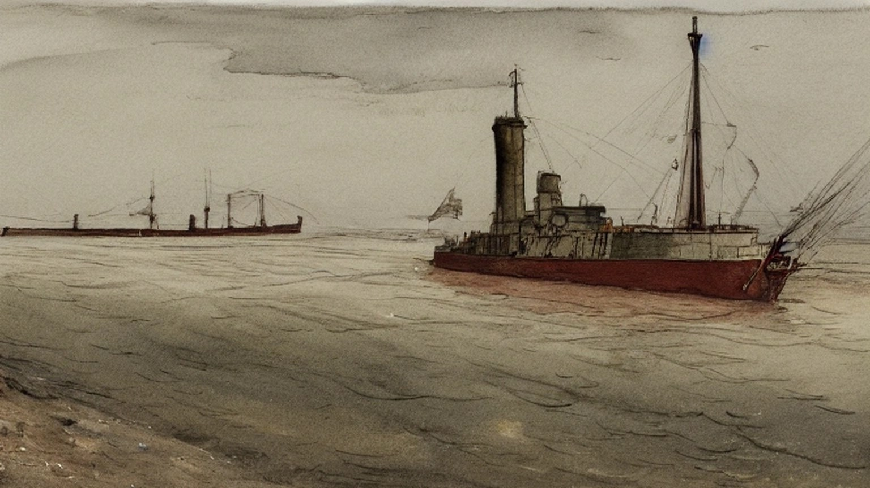
* * *
Howth, county Dublin, Sunday, 26 July 1914
They had us out at Father Mathew Park in Fairview, and there was talk all along the ranks that this was it and we were going for the guns. Sunday after Sunday they'd marched us out and marched us home again. We moved off some time around ten. The police that came after us the first Sunday weren't there at all now.
They kept the pace up the whole way. Fellows in front were shouting back that it was too fast and the column kept going the same. By Sutton the sweat was running down inside my collar and the soles of my feet were burning in the boots. Seven miles and more and not a halt.
Coming round by the harbour you could see a white yacht beyond the pier, under sail, and she going against the wind. A woman was at the tiller of her in a red jersey. Somebody let a cheer and the officers stopped it. Then the word came to double, and we doubled the length of the pier with the boots ringing on the stone.
There was a line of our own lads across the pier already and men on the deck of her taking the covers off. The first box they had open was full of sticks. Oak sticks, the length of your arm. My heart went down into my stomach. I thought, is it for this we came?
Then the rifles came up out of her. They came along from hand to hand down the pier, and when one came to me it was heavier than I thought a rifle would be, a big awkward thing. The order was to pass each one on to the end of the column, and I passed mine on, and there was a man beside me with tears running down into his moustache and he not able to stop them. Some of them put a foot on the rifle they had and passed the next one along.
A boat came round under the other yachts with the coastguards in it. A row of our lads lined along the yacht with the rifles trained on them, and the coastguards turned and pulled away. There wasn't a round in one of those rifles. The boxes of cartridges went off in motors and on the Fianna's trek-cart.
Before we marched off the officer came down the line taking the name and address of every man that had a rifle. Next week at the company you could hand it in, he said, or you could keep it and pay it off weekly. I gave him my name.
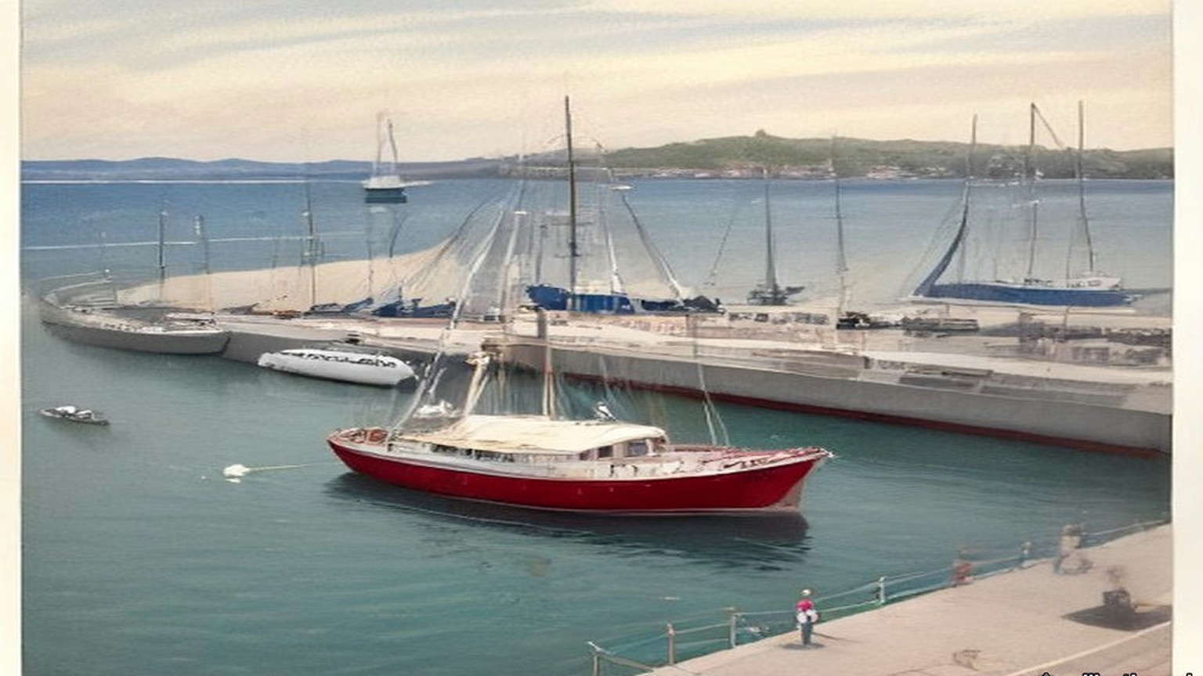
The crowd at the top of the pier went wild when they saw us coming with the rifles up on our shoulders. There was an old white-haired priest among them with his hat off, waving it.
* * *
The Malahide Road, Clontarf, the same afternoon
Constable Michael Gleeson of the Dublin Metropolitan Police had been at his dinner in Green Street barracks at about two o'clock when the man in charge told him to finish it as quick as he could and take a tram to Howth. He went out to Howth on the tram and came back on another as far as the bottom of the Howth Road, at Clontarf.
The DMP men stood in two ranks across the Howth Road. On the trams behind them came soldiers, the King's Own Scottish Borderers, in khaki, with fixed bayonets. The first hundred had left the Royal Barracks at 3.35 with a hundred rounds of ball cartridge to every man.
Gleeson saw the column come down the road towards him. Before it reached the police it wheeled off to the right, into a side road. The police were given the double, and they ran across to the Malahide Road and were put across that road in two ranks. Gleeson was in the front rank. Behind the police the Borderers formed up across the road, two deep.
The column halted in front of them. Gleeson saw the Assistant Commissioner, Mr. Harrel, step forward in his civilian clothes and talk to the officer in charge of the Volunteers. He could not hear what passed between them.
Then a voice said: "Seize the rifles."
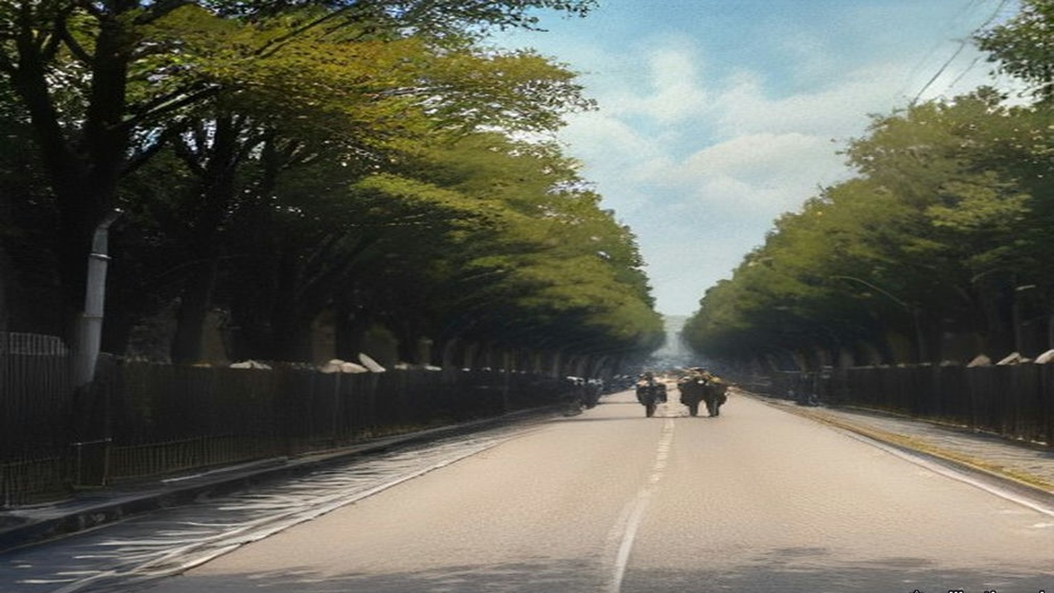
He did not know whose voice it was. He turned round. He did not go forward. He walked away down the Malahide Road. About eighteen of the police refused with him.
The rest went in. Behind his back he heard the rush and the shouting, the crack of wood on wood, the boots. The Volunteers swung their rifles by the barrels. The soldiers came up and went in with the bayonet. Somewhere near the road two revolver shots went off, and two soldiers were hit. When it was over the police had nineteen rifles, all broken in the struggle, and the men behind were going over the walls and through the hedges into the fields of Marino.
Afterwards Mr. Harrel came along the police and asked whether any of them had refused to disarm the Volunteers. Constable O'Neill said, "Here is one." Gleeson said, "Here is another." Harrel said, on the moment, "I suspend these two men. Take them home, Sergeant Dowling."
Sergeant Dowling took them back to the barracks. Gleeson did not know whether he was under arrest. He had three and a half years in the force and he had never once been reported. The next day he was dismissed.
* * *
Fingal Terrace, Howth Road, the same afternoon
Mary Burke Dowling lived with her mother at 1 Fingal Terrace, with a garden between the house and the Howth Road. When she heard the Volunteers had gone out from the city she went down to the gate. A passer-by told her guns had been got in at Howth, and that one half of the police were under arrest by the other half.
She saw the soldiers get down off the trams and run up the road to the Crescent. She was afraid there would be a fight and suggested that some of the women standing there should get in between them. The head of the column turned off before it reached them. She went up to the Volunteers at Charlemont Road and told them the soldiers had gone round to stop them on the Malahide Road. Some of them said they were allowed to do it in Belfast, and why should they not be allowed to do it.
She heard shouting from the Malahide Road and then shots. On the Howth Road the Borderers who stayed behind were drawn across the road, the front line on their knees and the back line standing, and they looked up and down the road as if taking the measure of it. She took her mother with her and went down to them.
"Do you intend to shoot these men?" she asked, meaning the Volunteers, if they came back that way.
"Yes, we do," they said. Several of them told her to get out of the way if she did not want to get shot herself. She told them they were a pack of cowards. A tall officer came out in front and said to her, "They will shoot if they get the order." She told him that she was an Irishwoman, and was no more afraid than were Irishmen.
When no Volunteers came back she went home through the empty house next door. There were young men in among the houses hiding rifles. Somebody pointed out a man to her who had a bayonet stab and was afraid to go to hospital in case he would be arrested.
* * *
Marino and Fairview, that evening
We went over the wall of the O'Brien Institute and down across the fields with the rifle held out in front of me through the hedge. My shoulder was raw from it. Where the ditches were, there were rifles lying in them that lads had dropped running, and we gathered them up as we went. A man came past me with eight of them on him, and he shouted, "You'll find four more in that ditch, I cannot carry any more."
We left them in houses and cottages, wherever there was a door open to us.
Word came over the fields not to go down to Fairview. Up at the road you could see the police yet, and Mr. Harrel standing with them, waiting on somebody to come down with a rifle.
* * *
Bachelor's Walk, Dublin, about half past six
Alfred Byrne, alderman of the Dublin Corporation, took his bicycle when he heard the rumours and went down into Talbot Street, where it crosses Gardiner Street. The soldiers were marching back into the city. Behind them came a crowd of children, singing, jeering and jagging at them, a good many of them from his own neighbourhood. He got off and walked the bicycle in between the children and the soldiers and tried to turn the children back.
In Earl Street somebody threw a bundle of bananas. Whole bananas, and banana skins. The streets were asphalt or wood blocks or stone setts, the side streets all paved. The only loose stones he knew of were in Portland Row, a mile behind.
In O'Connell Street the rear rank broke away and made thrusts at the people with their bayonets. He heard an officer shout "Halt," and run after them, and call, "Come back, you So-and-so." Byrne tried to speak to the officer and the officer brushed him aside.
He kept ten yards behind the rear rank, the children twenty yards behind him. At O'Connell Bridge two trams had come in together from the Phoenix Park and were letting down their people at the terminus. The footway along the river was packed with men and women coming from the Park or going to it. They stood and looked.
The soldiers marched on up the quay to the Metal Bridge. At the corner of Liffey Street, by Kaiteher's shop, without a word of warning, they turned round, and in the space of a second the front men were down on one knee with their rifles pointed back along the quay. Byrne had just time to jump off the bicycle and throw it against the railings of the bridge.
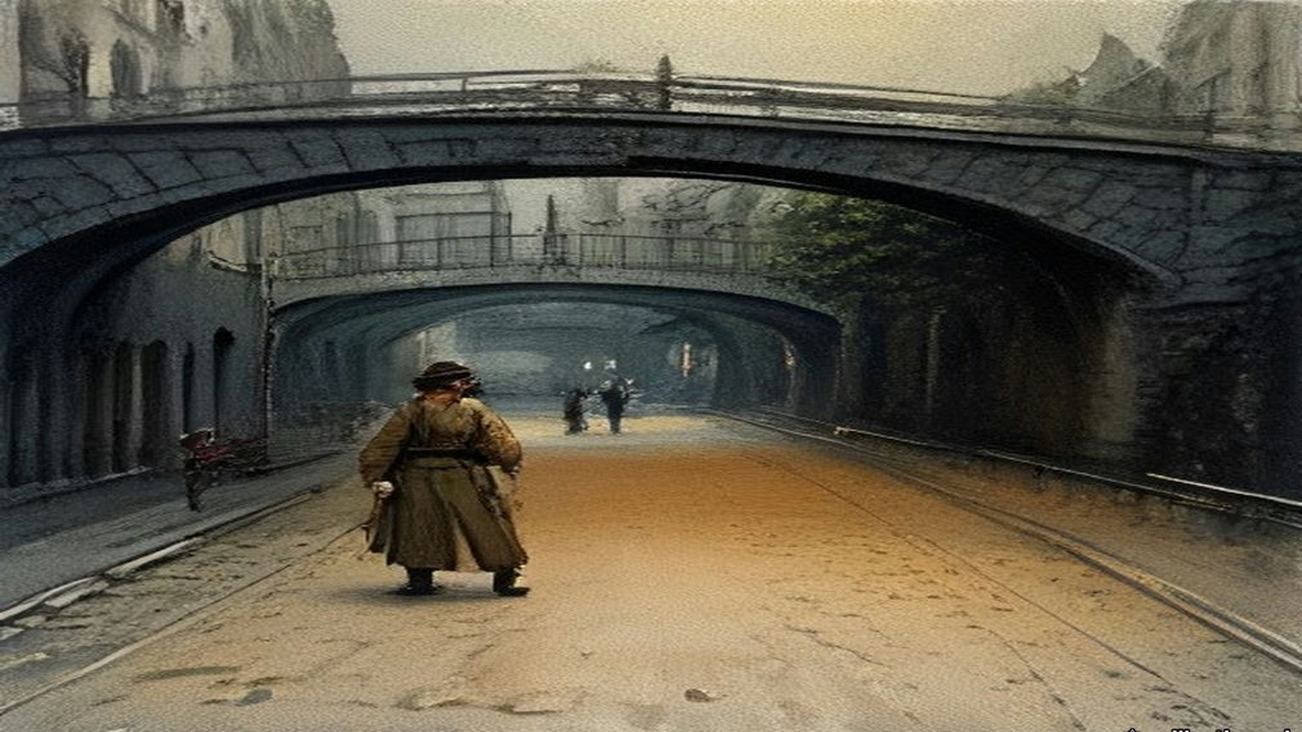
A motor car was behind him. It stopped for a second. Some words passed between the chauffeur and an officer, and the kneeling men stood up and let it through. As soon as it was past they went down on the knee again.
He heard one shot. Then two or three. Then a volley.
He was standing on the step of the bridge. Across the corner a woman was sitting on the ledge of the shop window with her back against the glass. It was Mrs. Mary Duffy, who lived at 20 Lower Liffey Street, a few doors round the corner. When the firing stopped he saw her take one step out from the window, as if to pass by the soldiers.
He thought it was blank cartridge. Even with blank she was too near, for the nearest rifle was not three yards from her. He ran across the corner to pull her round out of the way.
He had her by the arm when the next volley went.
She threw up her hands. Her knees went from under her and she was down on them on the flags with her weight hanging off his arms, and he was down on his own knees beside her trying to keep her up. Two men came running from the far corner of Liffey Street, from O'Brien's corner, to help him. Two soldiers went for them with the butts of their rifles. A rifle butt came round over Byrne's shoulder. It missed him. He almost got it.
Then the firing stopped.
He shouted for help. He and two other men lifted Mrs. Duffy between them and carried her along Liffey Street towards Jervis Street Hospital. It was not much more than five minutes' walk. His bicycle lay where he had left it, out on the road. Behind him came eighteen or twenty more people, carried or walking, to the same door.
Twenty-one soldiers had fired twenty-nine rounds into the people at short range. Byrne had seen no mob. He had seen forty or fifty children of eight to sixteen and the Sunday crowd off the trams. There was not a policeman on the quay.
* * *
Jervis Street Hospital, that evening
James Lanigan, house surgeon, had them coming in at the door from seven o'clock. Patrick Quinn of 1 Gardiner's Lane was brought in about seven. He was dead. There was a small hole in the back of his right thigh and a larger one in the front. One bullet had gone through it and cut the femoral artery.
Mrs. Duffy was dead when they laid her down. His colleague Frank Byrne found later a small wound in her belly on the left side, low, near the point of the hip bone, and a large torn wound two and a half inches square low in her back where the bullet had come out. It had cut the iliac artery and broken the sacrum.
James Brennan of 7 Lower Buckingham Street came in about half past seven. He was eighteen. There was a clean puncture in the front of his right thigh five inches above the knee, a cut six inches long down the back of the thigh, and a smaller wound under the buttock. The front wound ran through into the middle of the long cut behind. A bullet had made the one and a bayonet the other. The femoral artery was severed. He was in a state of collapse. He lived about an hour, and at half past eight he died.
They kept fifteen of the wounded in the wards. The names went into the book. Luke Kelly, aged ten, schoolboy, of Marlborough Street, bullet wound in the back. John Conrad, eleven, schoolboy, of Lower Abbey Street, bullet wound in the leg. Peter MacDowell, fifteen, messenger. Christie Maher, fifteen, paper-boy, bullet wound in the right foot. Mary Rowan, sixteen, of Addison Road, Fairview, bullet wounds in both legs. Mollie Dillon, eighteen, of the North Strand. Mrs. Scully of Chatham Row, a bayonet wound. Sebastian Pidgeon, as the list had him, forty, printer, of the Coombe, a bullet wound front and back of the right leg.
Patrick Farrell, going on sixteen, a gardener from Ballsbridge, had been to the Volta picture house in Mary Street with another boy, Jack Connor. They came out between twenty and twenty-five past six, and in a shop at the corner of Liffey Street Connor bought two halfpenny cakes. They ran down to look at the crowd, and Farrell lost him. He went in among the people to find him. When the soldiers turned at the Metal Bridge he was making for a hall door. He heard one shot, and the bullet caught him in the arm.
A man he did not know took him up on his shoulders and carried him to the hospital. They dressed the arm and sent him home. The man paid his tram fare to Ballsbridge.
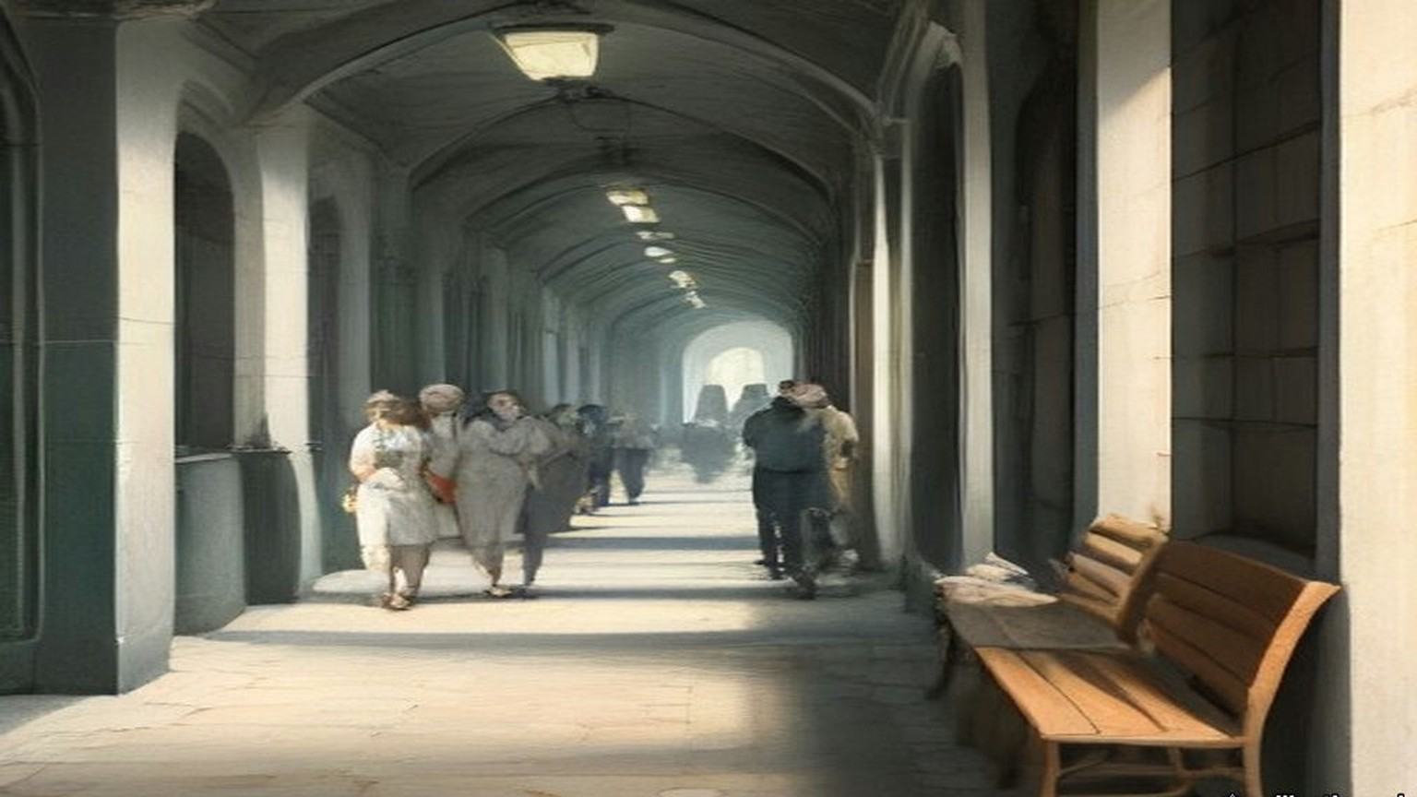
* * *
The House of Commons, Monday, 27 July 1914
Augustine Birrell, Chief Secretary for Ireland, had four questions on land purchase on the paper that day. The maps for the Sugrue estate at Ballinskelligs had not yet been lodged with the Congested Districts Board. The Board would not inquire into the losses of the tenants at Keel, county Kerry, who said they had lost land and cattle for six years through the landlord's neglect of the sea banks. The Board's offer for James Foy's estate in West Mayo had been accepted, and its offer for Mark Foy's had not.
Then John Redmond rose with a private notice question about the shocking occurrences in Dublin.
Birrell read out the times. The Assistant Commissioner had telephoned the Under-Secretary about two o'clock. The Under-Secretary reached the Castle about a quarter to three and sent for him, and he did not come. Birrell read the Under-Secretary's minute, which said "forcible disarmament of the men now marching into Dublin with these arms should not in all the circumstances be attempted." It was dated the 27th. The military had been requisitioned by the Assistant Commissioner entirely on his own responsibility. "Thirty-one rounds in all were fired almost simultaneously." There were three killed and thirty-two injured. "The Assistant Commissioner has been suspended pending an inquiry."
"He ought to be hanged!" said Willie Redmond.
"Ministers ought to be hanged," said Lord Robert Cecil.
"They are the murderers," said a member whom the reporters did not name.
Joseph Devlin asked whether 5,000 armed men with five machine guns had marched through the main streets of Belfast on the Saturday. Birrell said it was the fact, and that "No orders of any kind were given to the police to hold up the Volunteers or to demand the surrender of their rifles and machine guns." The next business on the paper was headed "Austria and Servia."
In the evening Redmond moved the adjournment. He said he had himself been against prosecuting the Larne gun-runners. He read the letter he had written to Birrell on 30 June against the Proclamation. "The police in the South and West might not be so passive as they were in the recent affair at Larne, and there might be serious conflicts, and even loss of life." He read the Irish papers' account of Harrel at the Malahide Road: "I must have these guns," and "The military with me have ball cartridge, and we intend, if necessary, to use it." He held up a London morning paper with a picture of the Ulster Volunteers marching through Belfast on the Saturday, rifles on their shoulders.
Birrell said Harrel was well known to him, "the son of one of my most intimate friends in Ireland, a colleague of mine on the Congested Districts Board." He had gone against what the Government, rightly or wrongly, had decided in Ulster. "I want to know what difference there is in one road in Belfast, or Monaghan, or Tyrone, and a road that leads from them into Dublin."
Bonar Law said the Under-Secretary's minute was written "to save their own precious skin." Birrell read the Brigadier's report that "Practically all officers and men were hit." Late in the evening Lord Robert Cecil moved that the question be now put. The House divided, 217 for and 249 against. At eleven o'clock the motion for the adjournment lapsed without the question being put.
Two days later Birrell told the House that the minute had been written shortly before five, and that a bicyclist had carried it to Harrel, who received it at about a quarter to six.
* * *
The Four Courts, Dublin, Monday, 10 August 1914
Lord Shaw of Dunfermline, chairman of the Royal Commission, sat with Mr. Justice Andrews and Mr. Justice Molony on the third day of evidence. Britain had been at war with Germany for six days.
Serjeant Sullivan, for the Corporation, had told them that some of his witnesses were army reservists. They had been called to the colours and had left Dublin, and he did not know their addresses. The doctor at Jervis Street who drew up the list of the wounded had volunteered for service in Belgium. The list was read into the record by agreement.
Shaw heard the soldiers. Private Rosewell said he fired at the legs of the crowd. Private Andrew Baird, twenty-one, from Dundee, said he fired from the shoulder, at the people in front.
"Did you fire at human beings in front of you?"
"They were all human beings in front of me."
"What did you fire at?"
"Very low, sir."
He heard Miss Dowling and the boy Farrell, who held up the sleeve of his coat to show the hole over the bandage. He heard Alderman Byrne under cross-examination by Mr. Hanna, K.C. Counsel suggested he had been leading the mob. "There was no mob there," Byrne said. Shaw asked him whether, if there had been a few policemen, the crowd could have been kept in hand. Byrne said that with ten or even six policemen they would have kept the crowd back.
Late in the day Constable Gleeson was sworn. He told them about his dinner, and the tram, and the voice that said "Seize the rifles." He was asked why he had refused.
"I considered it an illegal order," Gleeson said. "I had seen where they were allowed to march in the North of Ireland."
He told them he was not a native of the district, that he had three and a half years' service and had never been reported, and that he was willing to serve loyally again. Shaw said this was a case for consideration by the authorities.
"Thank you, my lord," said Gleeson.
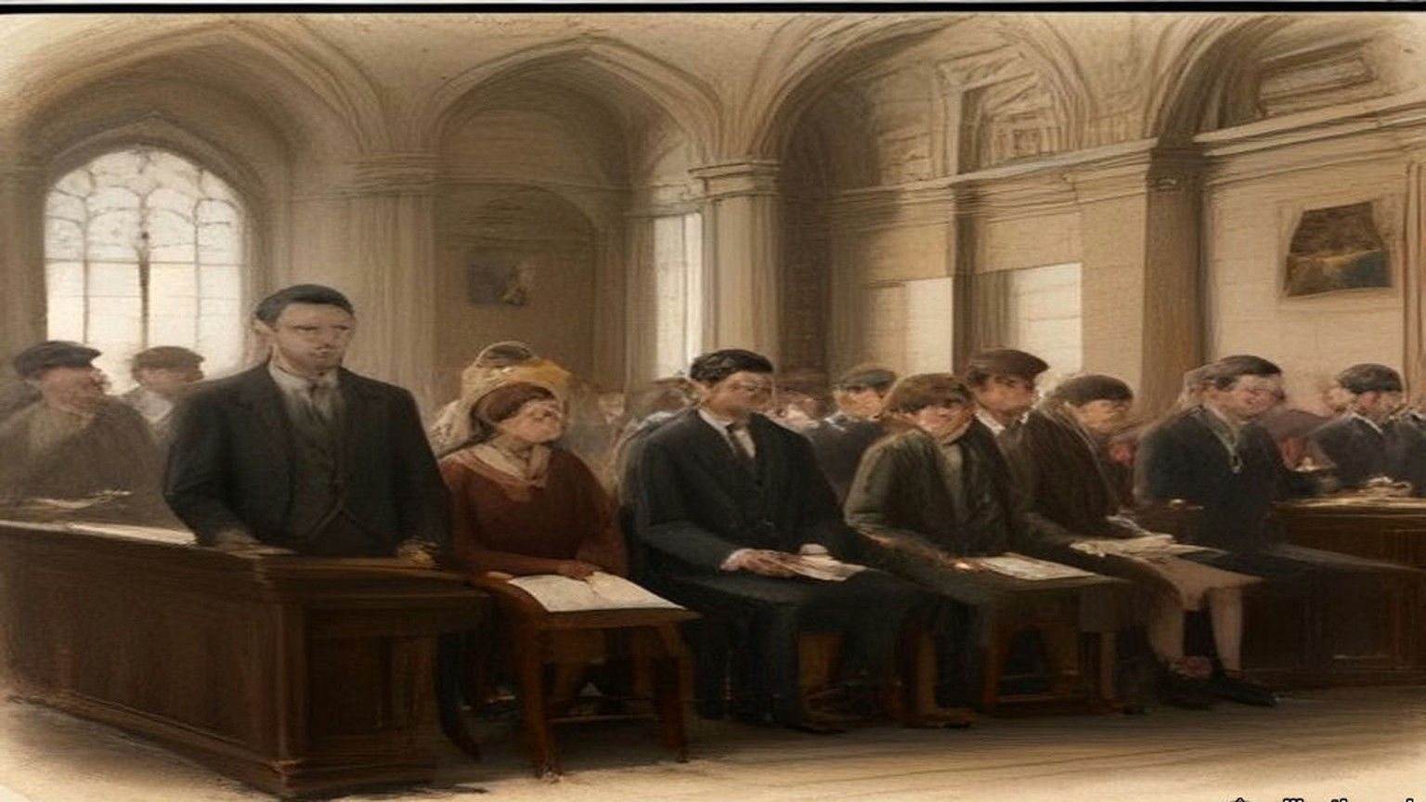
The Commission signed its report on 4 September, and the Stationery Office sold it for twopence.
The rifles, it found, had been landed against the Proclamation. But the Act let only Customs officers, or persons employed to prevent smuggling, seize them, and neither police nor soldiers had been so employed. "The whole transaction was, then, illegal from beginning to end." It found no evidence that the Government had treated one part of Ireland differently from another. What difference there had been came from Harrel alone. It quoted the eighteen constables, who had refused because the disarming "could surely not be legal as it had not been done in Belfast." It found that the soldiers "through great provocation got out of temper and partly out of hand," that a landaulette had passed quietly through troops and crowd, and that some witnesses spoke of no more than the throwing of banana skins. "The firing, in short, was at large, without distinction of age or sex, and was at short range." Many of the victims were "passive spectators or ordinary pedestrians." The Commissioners wrote that "It is not properly in our province to do more than to commend all these cases to the sympathetic consideration of the Lords of the Treasury."
* * *
Dublin and Westminster, September 1914 to February 1915
On 10 September Dr. Esmonde asked whether Constables Gleeson and O'Neill had been reinstated. Birrell said, "I have no doubt that the reinstatement of these men will very shortly take place, but I cannot say more at this moment."
Sylvester Pidgeon, the printer from the Coombe with the bullet through his right leg, died of his wounds on 28 September. He left a widow and five children, the youngest three months old and the eldest eleven. In November a concert was held at the Mansion House in aid of the family.
On 17 November Laurence Ginnell asked why nobody had been tried for the deaths at Bachelor's Walk. T. W. Russell answered for the Irish Office. "In view of the open verdict returned by the Coroner's jury and of all the circumstances set forth in the Report of the Royal Commission appointed to inquire into them, it is not proposed to take any further action in the matter." On compensation, "that question is now before the Treasury."
On 4 February 1915 the Committee of Supply took a Supplementary Estimate of not more than £2,500 for the Dublin Metropolitan Police. Russell explained it. Part was a rise in police pay under an Act of the last session. The rest was "compassionate grants in respect of persons killed and injured in July last." An English member asked whether any of the money went to the tenants of the Corporation buildings whose rooms the police had wrecked in the strike of 1913. Russell said no. "£800 has been paid to those who suffered from the incident at Bachelor's Walk." The Committee agreed to the vote.
Chapter 15 Appendix of Important Names
• Carson, Edward (3 mentions in this chapter): Dublin-born barrister, Solicitor-General, and leader of the Ulster Unionist Council.
• Casement, Roger (1 mentions in this chapter): British consul who exposed atrocities in the Congo and Putumayo, later executed in 1916 for his role in the Irish Easter Rising.
• Craig, James (2 mentions in this chapter): Ulster Unionist leader and first Prime Minister of Northern Ireland.
• O'Connell, Daniel (2 mentions in this chapter): Irish political leader who led the campaigns for Catholic Emancipation and the Repeal of the Union.
• Russell, Lord John (3 mentions in this chapter): British Whig Prime Minister during the height of the Irish Famine (1846–1852).
Sources
• Report of the Royal Commission on the circumstances connected with the landing of arms at Howth on 26th July, 1914 [Cd. 7631], signed 4 September 1914 by Lord Shaw of Dunfermline, W. D. Andrews and T. F. Molony, price 2d., digitised by the University of Southampton Library (the Proclamations of 4 December 1913 under s. 43 of the Customs Consolidation Act 1876 and s. 8 of the Customs and Inland Revenue Act 1879; s. 186, "treble the value of the goods or the sum of £100"; the £500 penalty where three or more assemble; s. 202, "duly employed for the prevention of smuggling"; about 1,000 Volunteers at Howth; Harrel's telephone calls; the fifty Borderers and about seventy police on the Malahide Road; about nineteen rifles seized; bayonet wounds and clubbed rifles; "about two revolver shots were fired, not by the Volunteers, but by some bystanders unknown"; the crowd "of insulting demeanour" in Talbot Street, Earl Street and Sackville Street; "through great provocation got out of temper and partly out of hand"; the bayonet through a shop door; about thirty men lined across at Liffey Street, "four or five men kneeling"; the landaulette and the banana skins; "Twenty-one men discharged their rifles at the crowd. Twenty-nine shots were fired"; three killed, at least thirty-eight injured, fifteen detained; Mary Duffy 50, Patrick Quinn 46, James Brennan 18; "at large, without distinction of age or sex"; "fundamental illegality"; "illegal from beginning to end"; no evidence of discrimination by Government; the eighteen constables and "it had not been done in Belfast"; "passive spectators or ordinary pedestrians"; the commendation to "the Lords of the Treasury"). https://archive.org/details/op1256257-1001
• Royal Commission on the landing of arms at Howth, Minutes of Evidence [Cd. 7649], 1914, same digitisation (first sitting Friday 7 August at the Four Courts; third sitting Monday 10 August. Serjeant Sullivan's opening: the 100 men leaving the Royal Barracks at 3.35 "with one hundred rounds of ball cartridge per man," "none of His Majesty's troops should be kept back unnecessarily at this particular time," no policeman at Bachelor's Walk. Sullivan on 10 August on reservists "summoned to the colours" and the Jervis Street doctor who "has volunteered for service in Belgium." The Jervis Street list, read by agreement, with names, ages, addresses and wounds, total thirty-eight. Miss Mary Burke Dowling, Q. 1234–58: "one-half of the police were under arrest by the other half," "they are allowed to do it in Belfast," "Do you intend to shoot these men," "Yes, we do," "a pack of cowards," "They will shoot if they get the order," "I was an Irishwoman," the men hiding rifles and the man with the bayonet stab. Alderman Alfred Byrne, Q. 1386–1479: the bicycle, Gardiner Street, "singing, jeering and jagging," "Come back, you So-and-so," the bananas, the paving and Portland Row, the two trams from the Park, Kaiteher's corner, "the front men were on the knee with pointed rifles," the bicycle thrown against the Metal Bridge, the motor car let through, "one shot, then two or three immediately after, and then a complete volley," Mrs. Duffy on the window ledge, "blank cartridge," "the nearest rifle was only three yards away," "she threw up her hands and went down on her knees," the rifle butt "went over my shoulder; I did not get it. I almost got it," "not much more than five minutes' walk," "eighteen or twenty other people," "There was no mob there," children "from eight to sixteen," "ten or even six policemen." The inquest depositions of 28 July before Coroner Louis A. Byrne: James Lanigan on Brennan, brought in about 7.30, "state of collapse," the thigh wounds, femoral artery severed, died about 8.30, bullet and bayonet; Frank M. Byrne on Mary Duffy and on Patrick Quinn. Patrick Farrell, Q. 1577–1603: "Going on 16," Jack Connor, the Volta picture house, "two halfpenny cakes," "the bullet caught me there in the arm," the man who carried him on his shoulders and "paid my tram fare home to Ball's Bridge." Private Herbert Rosewell, Q. 1633: "I fired at the legs of the crowd." Private Andrew Baird, Q. 1683–1716: twenty-one, Dundee, "They were all human beings in front of me," "Very low, sir." Constable Michael Gleeson, Q. 1717–52: dinner at about two at Green Street, the tram to Howth, the two ranks, the double to the Malahide Road, "Seize the rifles," about eighteen refused, "Here is one," "Here is another," "I suspend these two men. Take them home, Sergeant Dowling," suspended that evening and dismissed the next day, "I considered it an illegal order. I had seen where they were allowed to march in the North of Ireland," three and a half years unreported, the Chairman's "a case for consideration by the authorities," "Thank you, my lord"). The OCR text drops part of Gleeson's evidence; those answers were read from the page image (printed p. 53, p. 57 of the PDF). https://archive.org/details/op1256258-1001
• Ronald McNeill, Ulster's Stand for Union (London, 1922), chapters XVII to XIX, which print and paraphrase Colonel F. H. Crawford's manuscript narrative. The chapter relies on McNeill's transcription for every Crawford quotation (the Indemnity Guarantee of 24 September 1913, the Fatal Accidents Act wording, the £10,000 subscribers, £387,000 in a week, £1,043,816 before 1 January 1914; the three Hamburg offers and "double the price of the first and nearly treble that of the second"; Craig "in control of the fund ear-marked for the purchase of arms"; "Crawford, I'll see you through this business, if I should have to go to prison for it"; parcels of five rifles and 100 rounds a rifle, about 75 lbs, packing about £2,000; Langeland and "about £70,000 of their money"; the Clydevalley, a Belfast Lough collier bought in Glasgow; the canvas strips; the tender off Copeland and the signed orders; alongside at Larne at 10.30 on 24 April; the triple cordon, about five hundred vehicles, drizzling rain, the women's canteens, "not to receive a sixpence for their night's job"; the coal steamer in the Musgrave Channel; the wires "earthed"; the coastguardsman's death from heart disease at Donaghadee; 20,000 modern rifles, 10,000 Italian, upwards of 3,000,000 rounds; leaving Larne at 5 a.m. for Bangor). https://archive.org/details/ulstersstandforu00mcneuoft
• Darrell Figgis, Recollections of the Irish War (London, 1927), chapters II and III (Carson "where rich men filled his coffers we had to fare by our wits"; "Only a few hundred pounds could be collected"; Mrs. Green as treasurer and the wage-earners' guarantee "until the final sale to the Volunteers"; Liège too dear; Michael and Moritz Magnus; Mexico; 9.20 to after 12.30; "Edmund Farwell"; the mate's receipt; a thousand rifles with the option of five hundred; the £300 tug in Hamburg and Antwerp; Liège at the end of June, 45,000 rounds, the trade-union staff, straw and canvas, twenty apiece; the ammunition at the quay near seven on the Friday, "dum-dum"; the pilot and "three English bank-notes"; Sunday 12 July, the mist, O'Brien's black yacht and Childers's white one, the crew, the bags slit, 8.30 to 1.30, nowhere to sleep "except on rifles or on cartridge-boxes"; Mrs. Childers in a red jersey at the helm; men in tears and the foot on the rifle; the coastguard boat; Harrel "in civilian attire"). https://archive.org/details/recollectionsofi00figg
• Bureau of Military History, Witness Statement 53, Bulmer Hobson, 5 November 1947, "The Gun-running at Howth and Kilcoole" (membership of 100,000 to 150,000 and "very little funds"; Casement's friends advanced 1,500, the OCR drops the currency sign; Mrs. Green "about half"; arms to be sold to the Volunteers "to reimburse the subscribers"; the Sunday route marches; the police absent on 26 July; about eight hundred men at Father Mathew Park; the two hundred oak batons; the fast pace, seven or eight miles without a stop; 900 rifles and 26,000 rounds; the officers to note names and addresses, with the option of handing the rifles in "or of retaining them and paying for them by small weekly instalments"; the two-deep line of soldiers and about eighty police; the dispersal through the Christian Brothers' grounds at Marino; Harrel at Fairview; nineteen rifles; £1,000 from America the day after). Read through the Wayback Machine copy of the Military Archives file, as the live site redirected. https://web.archive.org/web/2022/https://www.militaryarchives.ie/collections/online-collections/bureau-of-military-history-1913-1921/reels/bmh/BMH.WS0053.pdf
• Bureau of Military History, WS 360, Seamus Daly (the route marches "always out to the coast"; moving off around ten; the yacht against the wind; the cheer stopped; doubling down the pier; "to our dismay ... large wooden batons"; the crowd and the white-haired priest waving his hat; the police lining the road at Raheny; the wall of the O'Brien Institute; rifles in ditches; "You'll find four more in that ditch, I cannot carry any more"; rifles dumped "in various houses and cottages"). WS 157, Joseph O'Connor (rifles passed man to man; the Malahide Road). WS 1670, Seumas Kavanagh (the Fianna trek-cart; batons about eighteen inches long). WS 267, Seamus Pounch, and WS 327, Patrick Egan, consulted. Same Wayback route, files BMH.WS0360, WS0157, WS1670, WS0267, WS0327.
• House of Commons Debates, 25 March 1914, "Colonel Seely and the Cabinet," 5th series, vol. 60, cc. 392–458 (Seely's statement; the depots; Paget's telegram, "All officers except two, and one doubtful"; "a blaze, certainly a blaze in the Press"; Gough "prepared to obey all lawful orders," "Because we thought we were going to be asked to coerce Ulster"; "in order to crush political opposition"; the draft discussed by the Cabinet while Seely was at the Palace and the two paragraphs he added; French and Ewart signing; Seely's resignation; Asquith, "I am not going to accept his resignation"; Ramsay MacDonald, "minus the two paragraphs it is no undertaking at all"). https://api.parliament.uk/historic-hansard/commons/1914/mar/25/colonel-seely-and-the-cabinet
• House of Commons Debates, 27 April 1914, "Landing of Arms and Ammunition," vol. 61, cc. 1347–8 (Asquith's "grave and unprecedented outrage"; Morrell and the coastguardsman). https://api.parliament.uk/historic-hansard/commons/1914/apr/27/landing-of-arms-and-ammunition ; 30 April 1914, "Customs (Ireland)," vol. 61, cc. 1861–2 (Montagu, "not be in the public interest"). https://api.parliament.uk/historic-hansard/commons/1914/apr/30/customs-ireland ; 11 May 1914, "Gun-running (Ulster)," vol. 62, cc. 710–1 ("decided not to take criminal proceedings"; Keir Hardie). https://api.parliament.uk/historic-hansard/commons/1914/may/11/gun-running-ulster ; 18 May 1914, "Importation of Arms," vol. 62, cc. 1573–4 ("The reply is in the negative"). https://api.parliament.uk/historic-hansard/commons/1914/may/18/importation-of-arms ; 18 May 1914, "Customs Officers and Watchers," vol. 62, c. 1584 (£300 a year; watchers to 24s. a week and 2s. good conduct pay after ten years). https://api.parliament.uk/historic-hansard/commons/1914/may/18/customs-officers-and-watchers ; 20 May 1914, "Importation of Arms," vol. 62, c. 1934 (Winterton; "No, Sir"). https://api.parliament.uk/historic-hansard/commons/1914/may/20/importation-of-arms
• House of Commons Debates, 27 July 1914, vol. 65: "Land Purchase (Ireland)," cc. 929–30 (Sugrue, Rae and Foy estates) https://api.parliament.uk/historic-hansard/commons/1914/jul/27/land-purchase-ireland ; "Assistant Police Commissioner Suspended," cc. 934–6 (Birrell's times and the minute dated 27.7.14; "Thirty-one rounds"; three killed and thirty-two injured; the suspension; William Redmond, Lord Robert Cecil and "They are the murderers") https://api.parliament.uk/historic-hansard/commons/1914/jul/27/assistant-police-commissioner-suspended ; "Volunteer Forces," c. 936 (Devlin; "No orders of any kind were given"; next item "Austria and Servia") https://api.parliament.uk/historic-hansard/commons/1914/jul/27/volunteer-forces ; "Motion for Adjournment," cc. 1022–66 (Redmond against prosecuting the Larne men; his letter of 30 June; "I must have these guns," "ball cartridge"; the Belfast photograph; Birrell on Harrel, "the son of one of my most intimate friends," "one road in Belfast"; the Brigadier's report read by Birrell; Bonar Law, "to save their own precious skin"; Cecil's closure, Ayes 217, Noes 249; the motion lapsing after eleven "without Question put"). https://api.parliament.uk/historic-hansard/commons/1914/jul/27/motion-for-adjournment-1
• House of Commons Debates, 29 July 1914, "Dublin Disturbances," vol. 65, cc. 1324–8 (the minute prepared "shortly before five," sent by bicyclist, received about 5.45). https://api.parliament.uk/historic-hansard/commons/1914/jul/29/dublin-disturbances ; 10 September 1914, vol. 66, c. 655 (Esmonde; "very shortly take place") https://api.parliament.uk/historic-hansard/commons/1914/sep/10/dublin-metropolitan-police ; 17 November 1914, vol. 68, cc. 331–2 (Ginnell; Russell, "not proposed to take any further action"; "before the Treasury") https://api.parliament.uk/historic-hansard/commons/1914/nov/17/dublin-disturbances ; 4 February 1915, vol. 69, cc. 180–2 (the Supplementary Estimate "not exceeding £2,500"; Booth and the Corporation tenements; "compassionate grants"; "£800 has been paid to those who suffered from the incident at Bachelor's Walk"; "Question put, and agreed to"). https://api.parliament.uk/historic-hansard/commons/1915/feb/04/dublin-metropolitan-police-class-iii
• Irish Capuchin Archives, IE CA CP/3/5/1/4/12, flier for a Mansion House concert, November 1914, catalogue description (Sylvester Pidgeon, printer, died 28 September 1914 of his wounds; widow and five children from three months to eleven). I saw the catalogue entry, not the image of the flier. https://catholicarchives.ie/index.php/flier-for-mansion-house-concert

Chapter 16
Fifty Proxies at Dundalk, 1892–1915
Dublin, Dollymount, Westminster, Ennistymon, Belfast, Rockcorry, Inns Quay and Dundalk, 1892 to 1915
On Friday, 25 November 1892, Douglas Hyde stood up before the Irish National Literary Society in Dublin to read a paper with a long title, "The Necessity for De-Anglicising the Irish Nation." He had come up to Dublin years before to go to college, knowing nobody in the city. He went to a meeting of the Society for the Preservation of the Irish Language, and the first stranger he got to know in Dublin was there, O'Neill Russell, a big man of six foot two or three who was delighted to hear him speaking Irish. Russell sold whiskey in America as a commercial traveller. He told Hyde he had once given his last dollar to James Stephens, in a New York hall, when the Fenian leader swore before an enormous crowd that there would be a rising in Ireland before the month was out. Stephens never went to Ireland. Sometimes only three or four people turned up to the Society's meetings. Its secretary, who was also secretary to the Royal Irish Academy, was paid forty pounds a year for his services.
He began by saying what he did not mean. He did not mean a protest against imitating what was best in the English people, "for that would be absurd." He meant "to show the folly of neglecting what is Irish, and hastening to adopt, pell-mell, and indiscriminately, everything that is English, simply because it is English." The question, he said, "ought also to claim the sympathies of every intelligent Unionist, and which, as I know, does claim the sympathy of many."
Then he put a price on it. He asked the room to suppose a hundred years of good English government, "making Ireland a land of wealth and factories," which left the country at the end "fat, wealthy, and populous, but with all our characteristics gone." The O's and the Macs dropped, the language extinct, the names of the rebels and martyrs blotted out. "How many Irishmen are there who would purchase material prosperity at such a price?"
He said he had known fifteen Irish workmen in a haggard in England who gave up talking Irish among themselves because the English farmer laughed at them.
He ended by appealing "to every one whatever his politics, for this is no political matter."
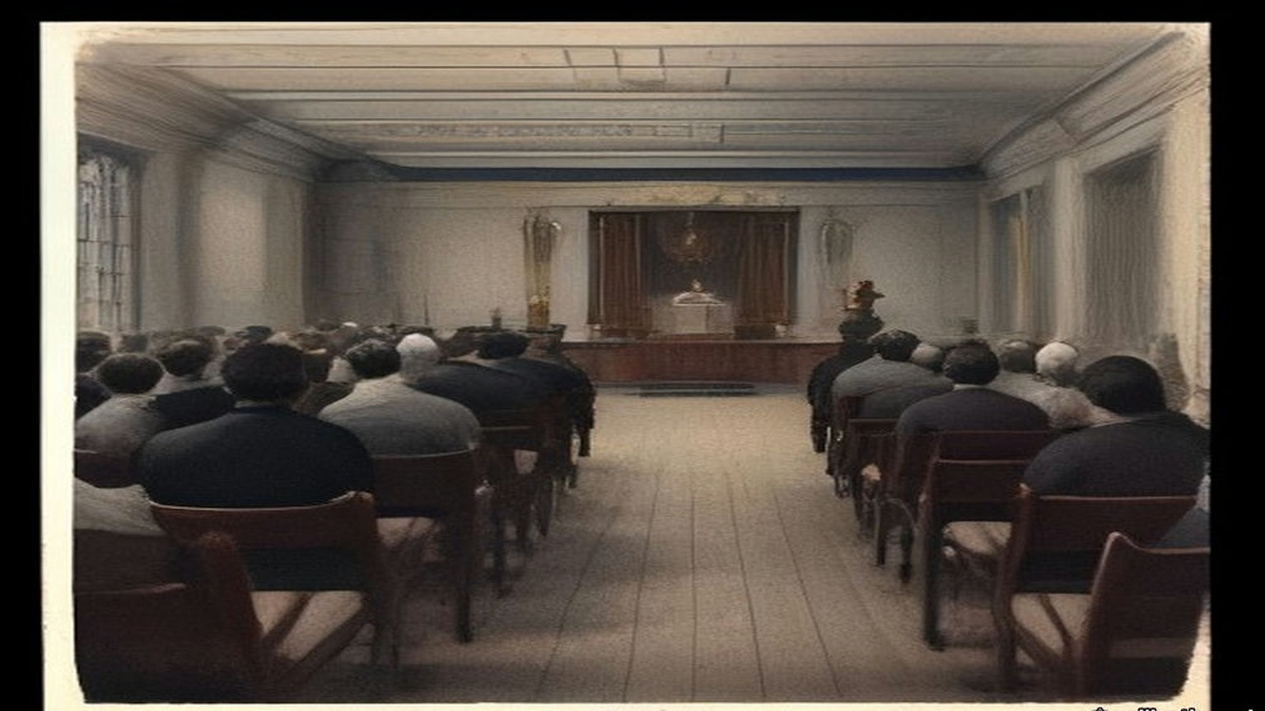
The Gaelic League came out of that paper the following summer. Hyde was its president. In its first years it was so poor that a gift of £300 could keep it going, and Hyde got one by staying out of politics. Patrick Forde of the Irish World, the New York paper that stood behind the Irish Parliamentary Party in America, wrote to him privately and asked why he did not take up politics and make the League an adjunct to the Party. Hyde wrote back at length. Most of the branches, he told Forde, were run by National Teachers and Customs and Excise officers, men barred by rigid rules from taking part in anything political, and many of them full of national feeling with nowhere to put it. The League gave them somewhere. He thought it the best paper he ever wrote. Forde raised £300 in his paper for the League, "at a time when even that small sum meant everything to us." Hyde kept a copy of his letter in a drawer. Years afterwards he went to look for it. The mice had bored a hole into the drawer and eaten that letter and no other paper in it.
Sir Horace Plunkett said kind things about the League too. Hyde reckoned that those words "were worth any money to the League," because with Plunkett on side and every other party agreed, "it became impossible for the Irish Government to send out the 'hard word' to the Intermediate Nat[l] Boards."
* * *
Dublin, March 1905 to 1907
Ernest Blythe came down from the north in March 1905 to be a Boy Clerk in the Department of Agriculture. He was a week or two short of sixteen. His father had a farm about twelve miles outside Belfast, and the family were Protestants.
He had always wanted to learn Irish. He had been in the city about an hour when he heard three people speaking it outside the Gaelic League Book-shop. He stopped at the window. He looked at the books and listened to the sound of it, a language he could not follow a word of, and he stood there as long as the three of them talked. When they went their ways he went in and bought the first book of O'Growney's Easy Lessons.
That night he went to the Queen's Theatre. The play was a melodrama called The Lights of London, the first play he had ever seen. In the intervals, with the lights up and the crowd talking round him, he opened O'Growney on his knee and started.
He did not join the League. For months he was afraid to. He believed that if it were found out that he was a Protestant he would be put out. He sat in his lodgings with the book and got as far as a man can get with a book alone, and then he was stuck.
In November Douglas Hyde set out for America. There was a demonstration for him in O'Connell Street. Blythe plucked up his courage that week and joined the Central Branch. His first teacher was Sinéad Ní Fhlannagáin. For four or five months he kept himself to himself in the class. Then he began to talk to the man beside him, George Irvine, and Irvine told him about Griffith's paper, the United Irishman. Blythe sat up the whole of one night reading his first copy.
He joined the branch hurling club. So did Seán O'Casey. They were both very bad hurlers and never got on the team, and every Saturday they practised in the Phoenix Park anyway, and went together to watch the club play. After some months O'Casey began to talk about the Fenians.
One Saturday evening, coming home on the tram from the Park, O'Casey said it was a great pity the Fenian organisation had not survived. Blythe agreed. At the end of Blessington Street O'Casey asked him to get off the tram, because he wanted to talk to him. They walked up Hardwicke Street together in the dusk. O'Casey told him the Fenian organisation was still alive, and was recruiting young men again, and asked him to join.
Blythe had read about the Invincibles and the Phoenix Park murders. He said he did not favour assassination and would have nothing to do with an organisation that countenanced it. O'Casey said the Fenians were completely against assassination. Their policy was to prepare to make open war on England. Blythe said he would give his answer the following week. Within a couple of days he knew what it would be.
When he told O'Casey he was willing, O'Casey said that he was a stranger to Dublin and unknown to the people with authority, and he would have to be kept under observation for some months. It was a long few months. Blythe found out later that O'Casey had asked him on impulse, without authority, and the observation was the time it took O'Casey to get leave to have asked.
At last O'Casey met him in O'Connell Street and took him to a house on the western side of Parnell Square. People were going up the stairs ahead of them. On the landing he was introduced to Mícheál Mac Amhlaidh, who took him into a back room and gave him the Oath. Then he went into the front room with O'Casey while the other new men were sworn. The room was packed, over a hundred people standing in it. At one point the new members were asked to stand up and let themselves be seen. Blythe got to his feet with four or five others and stood there with the whole room looking at him.
The circle's name to the world was the Bartholomew Teeling Literary and Debating Society. Seán T. O'Kelly was in it, and Cathal Brugha, and Thomas Cuffe, a great friend of Griffith's, and many people who were prominent in the Gaelic League. Blythe was just eighteen.
Some time after, he was mobilised suddenly one Sunday afternoon for a meeting that night in Clontarf Town Hall. Members had been mentioning the organisation in Confession, and the priests had told them to get out of it. A priest who was himself a member was to speak. In the hall Blythe saw men he would never have suspected, among them Jack Shouldice, who was over him in the Department of Agriculture. The priest was a Father O'Sullivan, on the Mission in America. Blythe waited to hear him explain why the Brotherhood was not a condemned secret society. The priest never touched the point. He said he was a member, that he had no conscientious troubles, and he made a patriotic speech. For a good while after that no one else left.
A Boy Clerk's service ended at twenty. As the date came near Blythe looked for work as a reporter, and a month before his twentieth birthday the proprietor of the North Down Herald in Bangor took him on. In Belfast he joined a circle of about fifteen that met in the workshop behind Denis McCullough's premises. The Dublin men had started a rifle fund after he left. The Belfast circle started an arms fund of its own in imitation, but there were so few of them and the collections came in so slowly that they bought only automatic pistols. In Blythe's time they raised the price of five or six. The pistols were shared out among the members by lot.

* * *
The Colonel John O'Mahony Hurling Club, Dollymount, 1907
Patrick O'Daly was nineteen in 1907. His two older brothers, Seamus and Frank, were in the organisation already.
The club was a hurling club, the Colonel John O'Mahony, and it had a clubroom. In the evenings there were Irish classes in it, and debates, and Irish dancing. Seán O'Byrne came to some of the debates, and the Ingoldsbys, and Tom Wheatley. The talk ran to Irish history, and warfare, and other military subjects. Paddy Ingoldsby swore O'Daly in some time that year. Most of the hurlers in the club were members already.
His circle was the Fintan Lalor. Ingoldsby was the Centre and Bulmer Hobson the secretary. Seán Mac Diarmada was in it, and Patrick and Willie Pearse, and Seán O'Byrne, and Seán O'Casey, and Seamus O'Connor. They met at 41 Parnell Square.
They began to drill long before there were any Volunteers, with Seán Heuston as their training officer. Every man of them bought a rifle. They paid it off, so much a week, into the circle.
In 1909 or 1910 O'Daly was at a meeting in Clontarf Town Hall for every member in Dublin. A Father O'Sullivan from America explained the Church's attitude to secret societies, and to O'Daly's mind he proved that the Brotherhood was not banned. Ernest Blythe heard the same priest in the same hall and remembered that he never touched the point at all.
Seán T. O'Kelly watched the League spread. From 1898 on, he wrote long afterwards, "there was not a village or hamlet in Ireland that did not have its branch of the Gaelic League." Teachers were what the branches lacked. A young man who had got through the first few books of O'Growney was put in front of a class of beginners and told to teach it. That had happened to O'Kelly himself. In March 1903 the Coiste Gnótha, the League's executive, made Patrick Pearse editor of its paper, An Claidheamh Soluis, and at the same meeting made O'Kelly its manager.
* * *
Dublin, November 1913
In August 1913 Pearse wrote about a friend and colleague in the Gaelic League who writes to the press "to point out that you are selling the League to the Liberals and that your reward will be a title." That was not a lie, Pearse wrote. It was the man's way of hinting that you ought to smite a little harder. Then he wrote about Hyde. "I love and honour Douglas Hyde." He had served under him since he was a boy. "I have never failed him. He has never failed me."
In November 1913, by his own account, a group of nationalists he was in touch with had decided to found the Irish Volunteers, and were looking about for a leader who would bring in men less "advanced" than themselves. That month Pearse wrote an essay he called "The Coming Revolution," and he wrote it to Gaelic Leaguers.
"If we do not believe in the divinity of our people we have had no business, or very little, all these years in the Gaelic League." Without that belief, he wrote, they would have made their peace with the devil, who "liberally rewards with attorney-generalships, bank balances, villa residences, and so forth, the great and the little who serve him well." They had turned their backs on all of it. "We did it for the sake of Ireland. In other words, we had one and all of us (at least, I had, and I hope that all you had) an ulterior motive in joining the Gaelic League. We never meant to be Gaelic Leaguers and nothing more than Gaelic Leaguers."
"For this we went to school to the Gaelic League. It was a good school, and we love its name and will champion its fame throughout all the days of our later fighting and striving. But we do not propose to remain schoolboys for ever."
Hyde had promised Forde and Plunkett and the whole country that the League was a language movement and nothing else. Years later he wrote that he had pledged himself "before the country, pledged to the very teeth." The trouble had never been the Parliamentary men. "The trouble was to keep out politics of the Wolfe Tone or Fenian type."
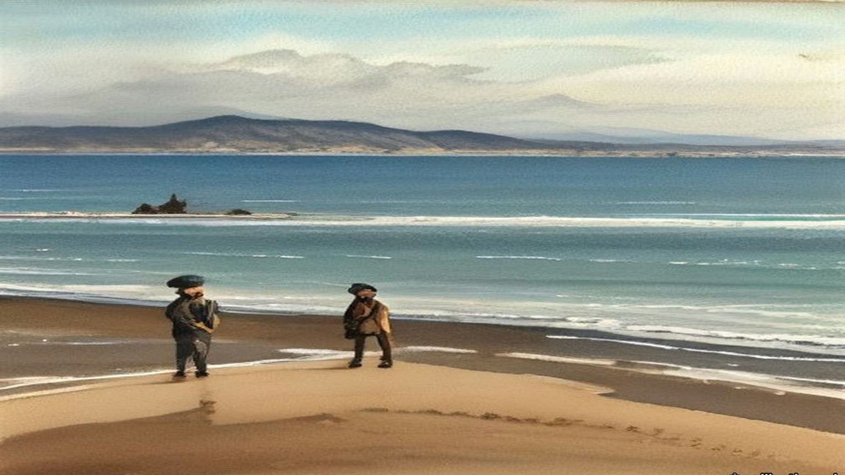
* * *
The House of Commons, February to July 1915
The war was six months old. On 10 February 1915 Philip Morrell asked the Financial Secretary to the War Office about soldiers whose wives had left them. Could the separation allowance go to whoever the man really kept at home, as it would for an unmarried man? H. T. Baker answered that, subject to the Select Committee's report, "the grant of allowances to dependants is confined to married soldiers."
On 28 April Sir Frederick Banbury asked the Under-Secretary for War whether he knew that the rules of the Gaelic Athletic Association shut out of its clubs "all soldiers, sailors of the Royal Navy, miltiamen, or pensioners of the Army and Navy," and that at its annual meeting on the 4th a motion to suspend the rule for the duration of the war had been withdrawn. Harold Tennant said he understood the facts were as stated. "In the circumstances no action is contemplated." James O'Connor asked whether the minister knew that the Association "declines to be regarded as a Nationalist organisation." P. J. Meehan asked whether he knew that most of the reservists and recruits who had joined in Ireland were members of it. Tennant said very little information about that society had reached the War Office.
On 9 June Laurence Ginnell asked where Mr. Shawn MacDermott was. Augustine Birrell, the Chief Secretary, told him. MacDermott had been arrested "on a charge of making statements likely to prejudice the recruiting of His Majesty's Forces contrary to Regulation No. 27." He was being tried that day in Dublin. Eight days later Ginnell asked how MacDermott, "a delicate man," was faring under his heavy sentence. "I can only say that the greatest possible care and attention is being paid to him."
On 21 June Birrell explained why Francis Sheehy Skeffington had been tried without a jury. The competent military authority had determined his case could be adequately dealt with by a Court of Summary Jurisdiction. Asked how many people in Ireland had been prosecuted for statements calculated to prejudice recruiting, Birrell said, "The answer is twenty-seven." Was it alleged that any of them had succeeded in prejudicing recruiting? "I cannot say that they have been successful in their object."
On 19 July Ginnell asked how many students had sat Irish and German before the Intermediate Education Board in 1914, and how many prizes each had won. Birrell gave the candidates: 6,033 in Irish, 1,859 in German. Ginnell pressed him for the prizes.
"How many?"
"I do not know how many, but prizes to the value of £82 were awarded for German, and to the value of £74 for Irish."
A few minutes earlier, by private notice, Arthur Lynch had asked about an order for deportation served on Mr. Ernest Blythe at Ennistymon, West Clare, "on Monday last." Birrell said the question should go to the Under-Secretary for War. Two days later Tennant answered for the orders together. They had been issued "by and on the initiative of the competent military authority," under Article 14 of the Defence of the Realm Regulations, against persons suspected of acting in a manner prejudicial to the public safety.
* * *
Ennistymon, Belfast and Rockcorry, July 1915
Blythe was a Volunteer organiser now, going round county Clare on a bicycle. He was sharing a room in Miss McCormack's hotel in Ennistymon with Eamon Waldron, the local múinteoir taistil, the League's travelling teacher. At about half past eight in the morning the door opened and a District Inspector came in, with a sergeant and a couple of constables behind him.
The Inspector came to the side of the bed. Blythe lay there under the blanket and listened to him read out an order under the Defence of the Realm Act, signed by Major-General Friend, directing him to leave the "following area, namely Ireland," within about a fortnight.
He got up and looked up the trains.
He wired Volunteer Headquarters that he had got the order and was coming to town. He took an early train to Limerick and went on to Dublin. At Headquarters he said he would not obey it. He would not hide either. He would wait to be arrested. He went round to the paper's offices in D'Olier Street and found Arthur Griffith there. Griffith agreed with him. Griffith thought it would be good for the propaganda if he could be arrested in the house of a parish priest. Blythe said every bit of help he had ever got organising Volunteers had come from curates, and he did not know a parish priest who would take him in. Griffith said Father Ó Ciaráin of Rockcorry, in county Monaghan, would be delighted, and he would write to him that night.
Then Blythe went to see Tom Clarke. The news had reached Dublin by then. The same orders had been served on Liam Mellows, Denis McCullough and Herbert Moore Pim.
The night before the order ran out they held a meeting on the Falls Road in Belfast. McCullough spoke, and Pim, and Blythe, and others. There was a big crowd and a great deal of cheering. In the morning Blythe set off for Rockcorry.
He went out bicycling with Father Ó Ciaráin the first afternoon. Then he stayed in the house and waited. For the best part of a week no police came. He did not go out. He sent postcards to people saying where he was. At last they came, early one morning, very apologetic. The priest made the proper protest about the invasion of the parochial house. Blythe was let finish his breakfast.
At the barracks the sergeant kept going out to telegraph. Nobody seemed to know what to do with him. About two o'clock the sergeant's wife sent him in a dinner. Late in the evening a motor car came, and with the sergeant and two constables he was driven to Belfast jail. It was his first drive in a motor car. They put him for the night in one of the half-underground cells for prisoners who came in too late to be received. Lying in the dark he thought how easy it would be for them to forget a prisoner down there and leave him till he starved. In the morning the door opened.
They gave him three months, without hard labour, so he had a mattress from the first night. He was locked in his cell twenty-two hours a day, and he worked hard at mat-making to get through them. He got quick at it. One of the jobs given him was a set of high-pile floor mats for the hall of a Belfast doctor. In the first month there were no library books, only a reader for the second class of a National School once a week, which took five or six minutes, and the Bible, and a bound volume of a magazine called The Quiver. The Quiver had a page of cookery recipes every month. The prison food was plain. He read the recipes over and over.
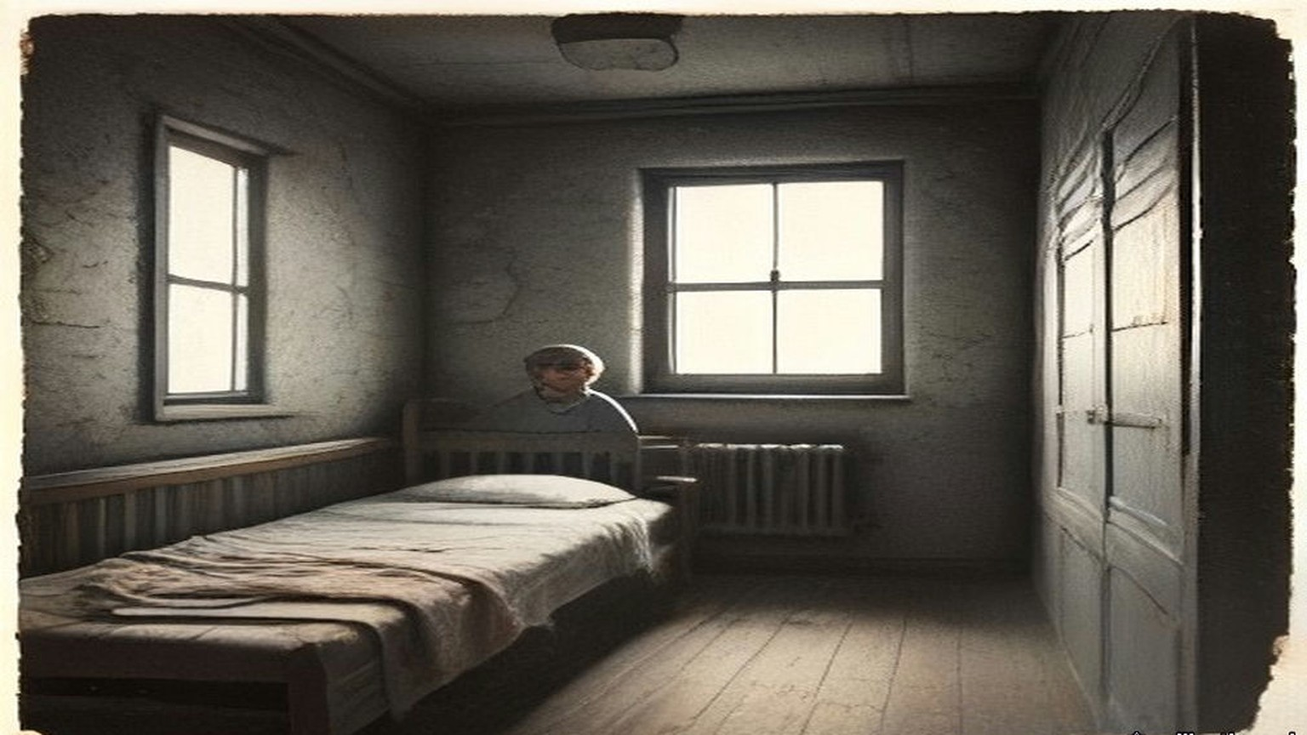
* * *
Inns Quay and Dublin, June and July 1915
Diarmuid Lynch had been State President of the Gaelic League of New York. The Irish World, the same paper whose Patrick Forde had once raised £300 for Hyde, had complained in its "Gaelic Notes" that the League in New York was dominated by the Clan na Gael. Lynch said it was not, though many of its men were in the Clan. When colleagues asked him to join the Clan he refused, so that he could say he was not a member if the Irish World came at them again, and he explained himself to John Devoy, who agreed. He had come home in 1907 and settled in Dublin in 1908, and Seán T. O'Kelly had approached him there and brought him into the Bartholomew Teeling Circle. Since the end of 1911 he had sat on the Supreme Council of the Brotherhood as Divisional Centre for Munster. In law he was an American citizen.
In June 1915 he was ordered to register with the police as a "Friendly Alien," and to report to them every time he left one proclaimed area and entered another. He did not register, and he was summoned before a magistrate at Inns Quay. Tom Clarke wanted him to refuse outright. Deportation to the United States was certain to follow, Clarke said, and that would give the Clan na Gael material for anti-British propaganda. Lynch thought of the fight that was coming and wanted to be in Ireland for it. He registered just before he went into court, and the charge was dismissed.
He had sat on the Coiste Gnótha of the League. His Irish was too slight for him to speak in the debates, or to appeal from the ruling of the chair, as any American delegate would have done at home. At the Ard-Fheis in Galway in 1913 Hyde's rulings seemed to him one-sided from beginning to end, and all Lynch could do was put the one question he had the Irish for: "An tusa an Ard Fheis?" Are you the Ard-Fheis?
By the summer of 1915, he wrote afterwards, "when the stage was secretly set for Insurrection against Britain, the time had come in my opinion when the 'Left Wing' should control the Coiste Gnotha - not to use it for the propagation of Republicanism but to obviate the possibility of tactics contrary thereto."
Well before the date of the Ard-Fheis he wrote to prominent Gaelic Leaguers up and down the country who were also IRB men, urging that delegates "favourable to our political views" should without fail be selected for Dundalk. His colleagues on the Coiste suggested they try to elect men who were in prison: Seán Mac Diarmada, Ernest Blythe, and one other whose name Lynch no longer remembered. Their election would convey "a salutary lesson to all concerned."
* * *
The Ard-Fheis, Dundalk, the last week of July 1915
The Oireachtas of 1915 met in Dundalk with the war a year old. A great number of the delegates were Volunteers. Hyde could feel the politics in the air of the room before anyone stood up. Several items on the agenda were aimed at himself.
He had held the presidency for twenty-one years. He had been getting headaches. The monthly meetings of the Coiste in Dublin dragged on from eight in the evening to three or four in the morning, and they always knocked him up. All through them he kept smiling while his inside was seething with fury, and that was worse for him than the hours. Between meetings he hardly had a day to himself for the League's letters.
He presided for two or three days. Father Maguire and some other priests of the North could not express themselves in Irish, and when the Ard-Fheis refused to hear them in English they got up with their followers and began to walk out of the room. Hyde stopped them at the door. He told them a split of that kind would be the beginning of the end of the Gaelic League. He got leave for Father Maguire to speak in English, and he had to fight the hall for it.
Then came the motion. Pádraig Ó Máille of Oughterard had put down a resolution in the name of a Connemara branch to add a third object to the League's two. The two were to revive the language and to encourage native industries. The third was to make Ireland free of foreign rule. Gall-smacht was the word in it.
Hyde had made up his mind irrevocably. If it passed, he would gather up his papers, vacate the chair and walk out of the Ard-Fheis. He had said in public again and again that the League was non-political and that he would never allow it to be made political while he was president. He had told the Coiste many times that if the League became political he would be the first man to leave it.
Colonel Moore stood up. He had not come near the League for years, and he knew nothing of any of this. He proposed that the words saor ó Ghallsmacht, free from foreign domination, should come out, and the simple word "free" go in.
Hyde pressed him to say what kind of freedom he meant. If they meant freedom from English rule, he said, the resolution was political. He pressed the others too, over and over. Colonel Moore kept saying that Asquith himself had called them a free people, when he spoke in Dublin about "a free gift from a free people." Nobody would define the word. Hyde said that during the year he would interpret it in a non-political sense.
Seán Ó Ceallaigh, who wrote as Sceilg, brought up a long litany of grievances against rulings Hyde had given in the past year, most of which Hyde had forgotten. His remedy was to propose solemnly that the president should not be allowed "to rule out of order anything that was of national importance." When Hyde wrote it down in 1918 he put two exclamation marks after it, and two more after the words "meaning thereby his own political resolutions." Sceilg was soon afterwards elected a Vice-President.
The resolution on the word "free" passed by a large majority. Then the election to the Coiste Gnótha began.
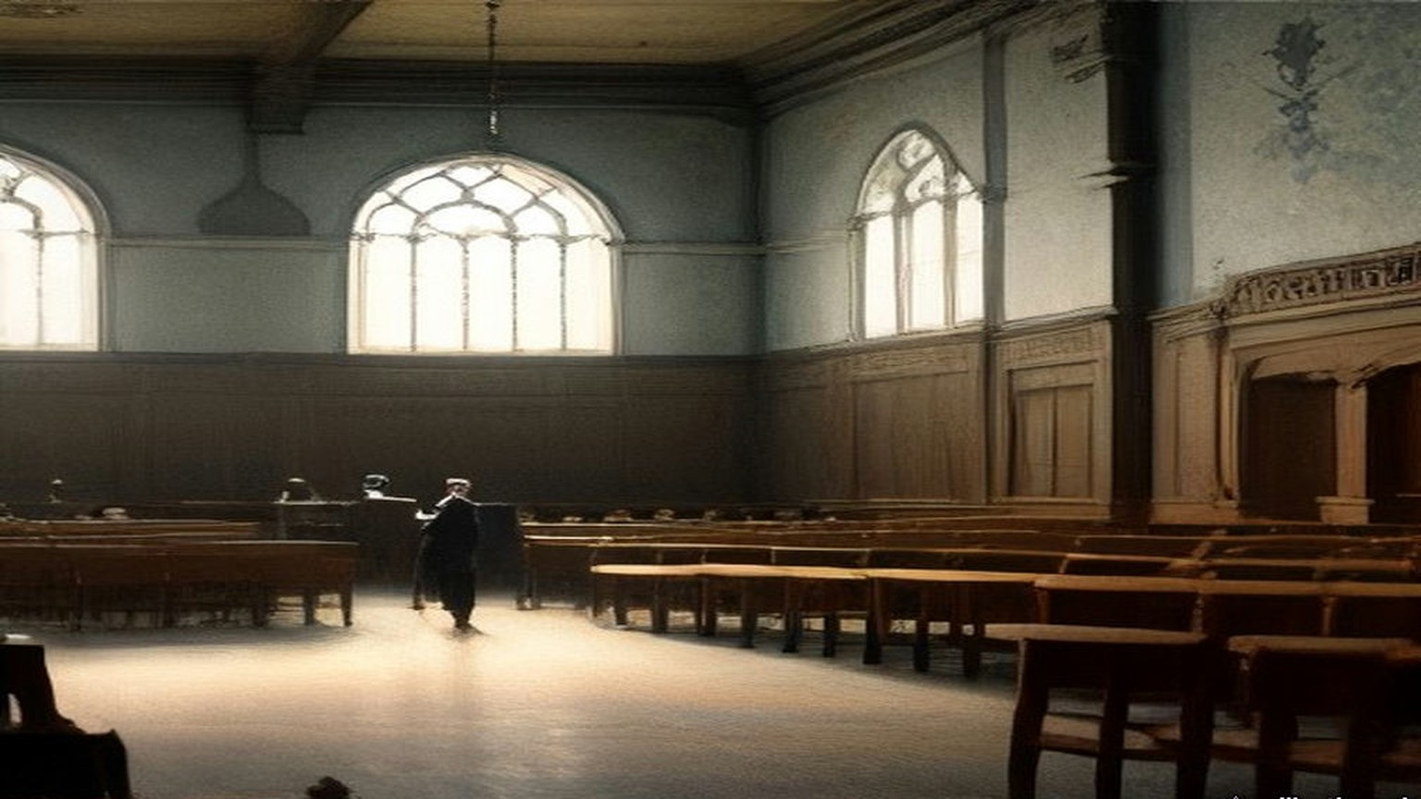
* * *
A delegate's paper, the same day
Hyde was told afterwards, by several people, how fifty of the votes came into the hall. Seán Ó Muirthile had been given fifty proxies to share out among Irish speakers. They told Hyde he had handed them over in one bunch to the secretary of the Sinn Féin society in Dundalk, and the secretary handed them out to fifty Sinn Féiners.
The secretary gave me mine at the door of the rooms, a bit of paper with a name wrote on it that wasn't my name, and the list along with it. Put your mark against them ones, he said, and nothing else, and then you can go home.
I never was in the League. I never was in a branch of it nor a class. I'd say I knew ten words of the Irish, and most of them out of the prayers.
Inside it was full, and hot, and the windows shut. Men in their good suits, and a good many in the green with the leather belts, and the smell of the drink off one or two of them already, and the clergy up near the front. And all of it in Irish. A man would be up on his feet going hard at it and the half of the hall clapping and I didn't know was he for us or against us. I kept my eyes on the man in front of me and clapped when he clapped.
Somebody up at the table was looking down the hall. I went hot from the collar up. I thought any minute now some man will turn and say a word to me in Irish and I'll be stood there like a stook.
Nobody turned.
When it was time I went up with the rest of them and gave in the paper and made my marks where I was told. There was names on that list I knew from the papers. There was one of them in the jail that very day. My hand was steady enough. It was easier than the pictures.
Then I went out the door into the evening. The air was cold and grand after the inside of the hall. I went home for my tea. I never went back.
* * *
Dundalk, about midnight
That night Hyde did some furious thinking. About twelve o'clock he went to Pádraig Ó Dálaigh, the League's secretary for about a dozen years, and found out from him how the count was going. It was far enough on to show him what was coming. There would not be more than a dozen men on the new Coiste Gnótha who would support any consistently non-political line. And at least two men who had been tried or convicted for treason felony were going in high up in the poll.
That decided him. He sat down and wrote a letter to Ó Dálaigh, to be read out next day when the time came to elect the president. In it he declined the honour of re-election, if anyone should propose him, on the grounds of health.
He wrote in 1918 that he had retired "on very real grounds."
Lynch had been at the caucus. The delegates who were his friends at Dundalk, not all of them IRB men, had held a meeting and decided with one exception to run the prisoners, and the nominations were made. He was in the hall when the result was read. He wrote his account of that night for the Bureau of Military History.
"As the result of the ballot was being announced and Sean MacDiarmada's name appeared high on the list, An Craoibhin's uneasiness became apparent. When the election of prisoner was read Dr. Hyde swept his papers from the rostrum and left the Convention Hall. A delegation to him at his hotel brought back word that he had resigned from the presidency. This situation had not been sought or expected by us."
Hyde says he decided at midnight, from Ó Dálaigh's figures, and left a letter. Lynch says he swept his papers off the rostrum when the prisoner's name was read, and that the word came back from the hotel.
Lynch wrote one more thing about it. Had Hyde given his resignation as an ultimatum when the list of nominations was read, they would not have swerved from their plan "at that juncture in national affairs." "The new Coiste was safe from the I.R.B. viewpoint."
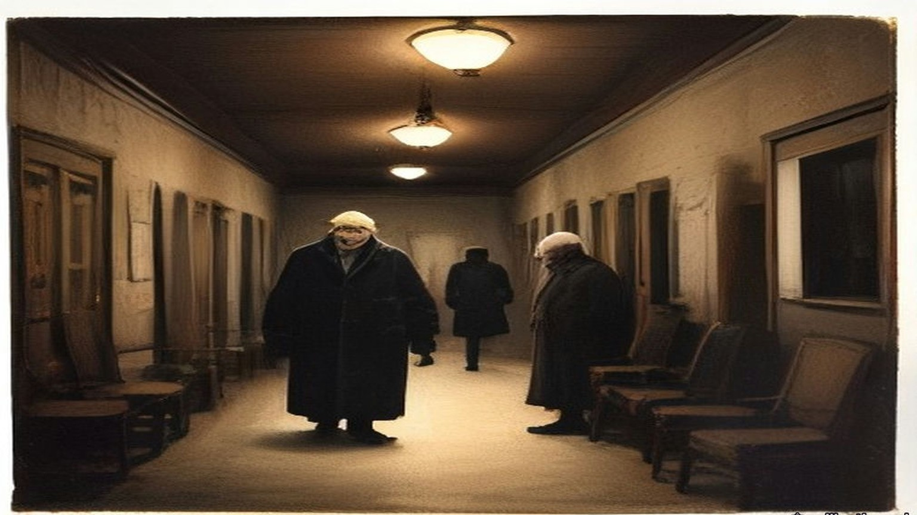
* * *
Dundalk to Dublin, the following day
In the morning Hyde appeared as usual and talked to everybody. He arranged with Peadar Mac Guiley, as the transcription of his manuscript gives the name, to take the chair at two o'clock. About one he slipped away. He got his baggage out of the hotel without anyone noticing, climbed into the hotel bus, and was driven to the station.
The train pulled out for Dublin, and Hyde had a lighter heart than he had known for years.
That same afternoon the Ard-Fheis passed a resolution against conscription. He heard about it afterwards.
Ó Dálaigh resigned as secretary at the same time as Hyde. Hyde had known he was going, and it was a strong part of why he had not stayed on himself. The best organiser the League ever had, Fíonán Mac Coluim, ought to have been the next secretary, Hyde thought, but he was suspected of Parliamentary leanings. They put in Seán T. O'Kelly. Soon after, Dr. Henry of Galway moved at the new Coiste that the League reaffirm its non-political character. The motion was rejected, and Henry resigned, and Father Mac Illenny of Spiddal with him, and Pádraig Brett of Waterford. Henry said they had elected a man from Ballymote, a town where he stayed every year with his people, whose name he had never once heard in connection with the language. The man had been elected "simply because he had distributed guns through the County Sligo."
In a later note Hyde wrote down what had happened to the League as he saw it. Politics of the Wolfe Tone or Fenian type had come on with a rush in 1914 and 1915 "and ended by capturing the League, its officers its machinery and its money."
Lynch was back in Dublin a day or two before Sunday, 1 August. He was on the committee for O'Donovan Rossa's funeral that day, though he had had hardly any hand in the arrangements. He had been busy with the Ard-Fheis at Dundalk.
At a meeting in Dublin that summer the Supreme Council co-opted new members: Tom Clarke, Seán Mac Diarmada, Patrick Pearse and Dr. McCartan.
Towards the end of August Robert Monteith was ready to go to Germany by way of New York. Clarke and Lynch decided to give him £100 for his expenses. The money was handed to him in Tom's shop.
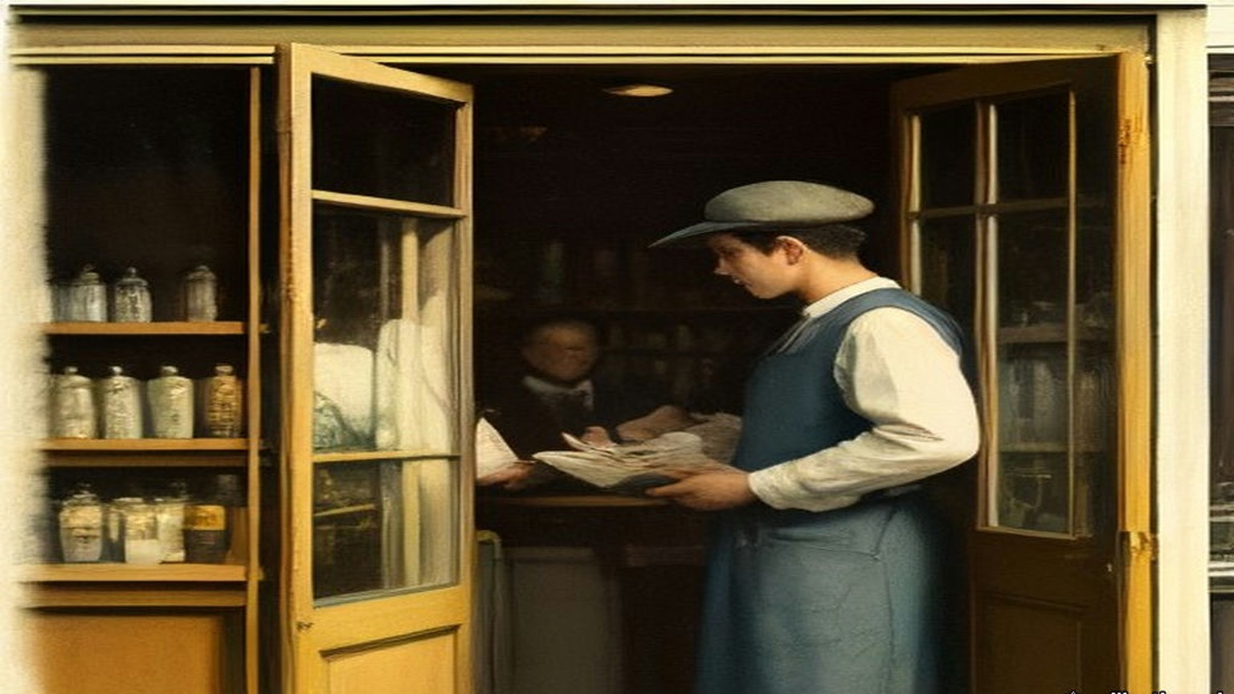
Chapter 16 Appendix of Important Names
• Griffith, Arthur (6 mentions in this chapter): Founder of Sinn Féin and signatory of the 1921 Anglo-Irish Treaty.
• O'Connell, Daniel (2 mentions in this chapter): Irish political leader who led the campaigns for Catholic Emancipation and the Repeal of the Union.
• Parnell, Charles Stewart (2 mentions in this chapter): Leader of the Irish Parliamentary Party and president of the Irish National Land League.
• Parnell, Henry (2 mentions in this chapter): Irish MP and financial reformer who advocated the repeal of the 1800 Union protective duties.
• Plunkett, Horace (3 mentions in this chapter): Irish agricultural reformer and founder of the cooperative creamery movement.
• Russell, Lord John (2 mentions in this chapter): British Whig Prime Minister during the height of the Irish Famine (1846–1852).
Sources
• Douglas Hyde, "The Necessity for De-Anglicising the Irish Nation," address to the Irish National Literary Society, Dublin, 25 November 1892. Read in the user's first-edition source pack (file chapter_12/deanglicising_ireland_hyde.html), a transcription with abridgements marked by ellipses, published by gaeilge.org (https://www.gaeilge.org/deanglicising.html). The full printed text is in The Revival of Irish Literature (London, 1894), which I did not open. Quoted: "for that would be absurd"; "to show the folly of neglecting what is Irish..."; "every intelligent Unionist"; "making Ireland a land of wealth and factories"; "fat, wealthy, and populous, but with all our characteristics gone"; "How many Irishmen are there who would purchase material prosperity at such a price?"; the fifteen workmen in a haggard; "for this is no political matter." The transcription sets that phrase between dashes; the dashes are dropped here and the words are unchanged.
• Douglas Hyde, untitled memoir manuscripts, Luke Wadding Collection, UCD Digital Library (https://digital.ucd.ie/view/ivrla:18726), read in the FromThePage transcription by Rachel Daly. (a) The account of the Dundalk Oireachtas, headed "Scríofa agus mé i mo leaba, aibreán 1918. Baile Átha Cliath," leaves 1–20: the war "raging for a year"; "a great number of the delegates were volunteers"; items "levelled against myself personally"; presiding "two or three days"; Father Maguire and the northern priests, the walk-out stopped, leave "with extreme difficulty" to speak English; Pádraig Ó Máille's Connemara resolution and "Gall-smacht"; the two aims; "I would gather up my papers, vacate the chair, and walk out"; Colonel Moore, "saor ó Ghallsmacht," the word "free," Asquith's "a free gift from a free people"; "Nobody would define the word free"; "passed by a large majority"; Seán Ó Muirthile (Hyde writes "O Murthuile") and the fifty proxies, "handed over in one bunch to the secretary of the Sinn Fein society in Dundalk," men who "did not know Irish ... had never even joined a branch," walked in, voted "a pre-arranged ticket" and "were never seen again"; "furious thinking"; about 12 o'clock and Ó Dálaigh; "not more than a dozen men"; "at least two men who were tried or convicted for treason felony"; the letter to Ó Dálaigh declining re-election "on grounds of health"; the presidency "held for 21 years"; "on very real grounds"; the Coiste meetings from 8 p.m. to 3 or 4 a.m., the headaches, "keep smiling while my inside was seething with fury"; the correspondence; Sceilg's motion; slipping away at about 1 p.m. "after appearing as usual and talking to everybody"; Peadar Mc Guiley in the chair at 2; the baggage, the hotel bus, the train, "a lighter heart than I had known for years"; the conscription resolution; Dr. Henry, Father Mc Illenny of Spiddal, Pádraig Brett, the Ballymote man "elected by a political vote simply because he had distributed guns through the County Sligo"; Ó Dálaigh's resignation and secretaryship of "about a dozen years"; Fíonán Mac Coluim; Seán T. O'Kelly. (b) The undated account of the League's non-political policy, leaves 1–9: Forde of the Irish World, the private letter, the branches run by National Teachers and Customs and Excise officers barred by rigid rules from politics, "Forde raised £300 in his paper for the League, at a time when even that small sum meant everything to us," the copy eaten by mice; Plunkett's words "worth any money to the League" and the "hard word" to the Intermediate and National Boards; "The trouble was to keep out politics of the Wolfe Tone or Fenian type"; "came on with a rush in 1914 and 1915 and ended by capturing the League, its officers its machinery and its money"; "pledged before the country, pledged to the very teeth." The clean reading is followed; Hyde's crossings-out are left out. (c) The memoir of O'Neill Russell, headed "Scríofa agus mé i mo leaba, Samhain 1919," leaves 4–8: coming to Dublin for college knowing nobody; the Society for the Preservation of the Irish Language; Russell "the first stranger whose acquaintance I made in Dublin," "six feet two or three," a commercial traveller for a whiskey firm; "his last dollar to James Stephens" in a New York hall; "Sometimes only three or four turned up"; the secretary, also secretary to the Royal Irish Academy, "paid 40 a year," the OCR dropping the currency sign. Sceilg's later election as Vice-President is in (a), leaf 8.
• Bureau of Military History, WS 939, Ernest Blythe (Earnán de Blaghd), file S.66, read from the PDF and OCR text in research/ch12/bmh: Boy Clerk in March 1905, "a week or two before I was sixteen"; three people speaking Irish outside the Gaelic League Book-shop; O'Growney's Easy Lessons; the Queen's Theatre and "The Lights of London," "the first play I had ever seen"; the fear of being put out as a Protestant; joining the Central Branch when Hyde set out for America in November; Sinéad Ní Fhlannagáin; George Irvine and the United Irishman; the Central Branch hurling club and O'Casey, "very bad hurlers," the Phoenix Park on Saturdays; the tram, Blessington Street, Hardwicke Street; the Invincibles, "open war on England"; the observation and O'Casey's want of authority; the house on the western side of Parnell Square, Mícheál Mac Amhlaidh, the back room, "over a hundred people," four or five standing; the Bartholomew Teeling Literary and Debating Society and its members; "I was just eighteen when I joined the I.R.B."; the Clontarf Town Hall meeting, Jack Shouldice, Father O'Sullivan; service ending at twenty and the North Down Herald; the order at Miss McCormack's hotel in Ennistymon on "I think, 11th July, 1915," Eamon Waldron, the District Inspector, "following area, namely Ireland," "within about a fortnight"; the trains, the wire, Limerick, Mac Diarmada and Griffith at the paper's offices, Father Ó Ciaráin of Rockcorry; Clarke and the orders on Mellows, McCullough and Pim; the Falls Road meeting; the week at Rockcorry, the postcards, the arrest, breakfast, the sergeant telegraphing, the dinner at two, "my first motor drive," the semi-underground cell and "how easy it would be to forget a prisoner"; mat-making, the doctor's mats, "twenty-two hours a day," the school reader, the Bible, The Quiver and its recipes; "the three months we were incarcerated." His father's house "about twelve miles outside Belfast." The Belfast circle of "about fifteen members," McCullough's workshop, the small arms fund "in imitation of the rifle fund which had been started by the I.R.B. in Dublin shortly after I left," "only automatic pistols," "five or six of them," "distributed amongst the members by lot." Not given hard labour, "I had a mattress from the beginning." Blythe's statement does not say when he was sentenced; the three months is his own figure.
• Bureau of Military History, WS 220, Patrick O'Daly, 41 Naas Road, Inchicore, file S.1286, p. 1: "I joined the I.R.B. in 1907. I was then 19 years of age"; Seamus and Frank; the Colonel John O'Mahony Club, Dollymount, the clubroom, Irish classes, debates and dancing; O'Byrne, the Ingoldsbys, Wheatley; "Paddy Ingoldsby swore me in ... most of the members of the Hurling Club were members of the I.R.B."; the Fintan Lalor Circle, Ingoldsby Centre, Hobson secretary, the members named; "We used to meet at 41 Parnell Square"; drilling before the Volunteers, Heuston as training officer; "We all bought a rifle each and used to pay in a certain amount every week to pay for these rifles"; debates on history and warfare; the Clontarf Town Hall meeting of 1909 or 1910 and Father O'Sullivan, who "proved to us that the I.R.B. was not banned by the Church."
• Bureau of Military History, WS 1765, Seán T. O'Kelly, part 1, dated 1951: from 1898 "not a village or hamlet in Ireland that did not have its branch of the Gaelic League"; beginners who had studied "the first few books of O'Growney" conscripted to teach; March 1903, Pearse editor and O'Kelly manager of An Claidheamh Soluis.
• Bureau of Military History, WS 4, Diarmuid Lynch, "The I.R.B.: Some Recollections and Comments," Part 1, pp. 1–6, read from the PDF and OCR text in research/starter: State President of the Gaelic League of New York; return in 1907, Dublin 1908, O'Kelly and the Bartholomew Teeling Circle; Divisional Centre for Munster from the end of 1911; the "Friendly Alien" order of June 1915, Inns Quay, Clarke's advice, the Clan, registering "just before appearing in court," the charge dismissed; under "Gaelic League Ard Fheis - Dundalk, July 1915": the non-political plank "always respected by the I.R.B.," Right and Left Wing, Galway 1913 and "An tusa an Ard Fheis"?, the passage quoted on the Left Wing, the letters urging delegates "favourable to our political views," the prisoners "Sean MacDiarmada, Earnan de Blaghd and one other I think," "a salutary lesson to all concerned," the caucus "unanimous with one exception," the paragraph quoted on the ballot, Hyde's papers and the hotel, "not been sought or expected by us," the ultimatum, "The new Coiste was safe from the I.R.B. viewpoint"; the Rossa funeral and the return "a day or two prior to Sunday, August 1st"; the Supreme Council meeting "either about the middle of July, 1915 ... or about the middle of August," with the co-options of Clarke, Mac Diarmada, Pearse and McCartan; Monteith "Towards the end of August," "L100 for his expenses," "handed to him in Tom's shop." The OCR reads the currency sign as "L." Lynch's being an American citizen is in his account of the Friendly Alien order. The Irish World's "Gaelic Notes," the Clan na Gael invitation declined and Devoy's agreement are on p. 1.
• Collected Works of Padraic H. Pearse: Political Writings and Speeches (Dublin: Phoenix Publishing Co., n.d.), "The Coming Revolution," dated in the contents "Nov., 1913," pp. 91–93, read in the OCR text at research/ch12/pearse_pol.txt. The full stop after "striving" is missing in the OCR and is restored here. The same volume, "From a Hermitage," the article for August 1913, pp. 157–9 (the colleague who writes "that you are selling the League to the Liberals and that your reward will be a title"; "I love and honour Douglas Hyde"; "I have never failed him. He has never failed me"; the line about serving under Hyde since boyhood is paraphrased because the OCR damages it), and Pearse's preface to that series, p. 141 ("When I wrote the article for November 1913 a group of Nationalists with whom I was in touch had decided to found the Irish Volunteers," and the leader "who would command the adhesion of men less 'advanced' than we were known to be").
• House of Commons Debates, 5th series: 10 February 1915, vol. 69, c. 572, "Separation Allowances" (Morrell; Baker, "confined to married soldiers"); 28 April 1915, vol. 71, cc. 704–5, "Gaelic Athletic Association" (Banbury's question including "miltiamen," the meeting of the 4th; Tennant, "no action is contemplated," "Very little information"; O'Connor; Meehan); 9 June 1915, vol. 72, c. 242, "Mr. Shawn MacDermott's Arrest" (Regulation No. 27; the hearing that day); 17 June 1915, vol. 72, c. 774, "Defence of the Realm Act (Irish Prisoners)" ("a delicate man," "heavy sentence," "the greatest possible care and attention"); 21 June 1915, vol. 72, cc. 929–31, "Arrest of Mr. Sheehy Skeffington" (the Summary Court; "The answer is twenty-seven"; "I cannot say that they have been successful in their object"); 19 July 1915, vol. 73, cc. 1166–8, "Defence of the Realm Act (Expulsion, Ireland)" (Arthur Lynch on Blythe at Ennistymon "on Monday last"); 19 July 1915, vol. 73, cc. 1186–7, "German and Irish Languages" (6,033 and 1,859; "How many?"; £82 and £74); 21 July 1915, vol. 73, cc. 1473–6, "Defence of the Realm Act (Expulsions, Ireland)" (Tennant on Article 14 and "by and on the initiative of the competent military authority"). Fetched from api.parliament.uk/historic-hansard and saved at research/ch12/hans.

Chapter 17
Second Volley at Portobello, 1915–1916
Westminster, Dublin Castle, Westmoreland Street, Portobello Bridge, the Rathmines Road, Grosvenor Place, Downing Street and the Four Courts, 1915 to 1916
On Monday, 21 June 1915, Arthur Lynch asked the Chief Secretary for Ireland whether Mr. Sheehy Skeffington, "who was recently sentenced under the Defence of the Realm Act," had applied to be tried by a jury, "and, if so, why this right was denied him?"
Augustine Birrell explained the regulation. A man charged under it could choose a civil court and a jury only when the competent military authority decided that his case "cannot adequately be dealt with by a Court of Summary Jurisdiction." Sheehy Skeffington's case had not been decided to be such a case. A summary court had tried him, and no other court had jurisdiction.
Lynch asked who had started the prosecutions of the journalists, Milroy, MacDermott and the others. The cases had been reported to the competent military authority, Birrell said, and that authority had decided they should go ahead.
"Is the right hon. Gentleman consulted beforehand in regard to these matters?"
"Yes, in almost every case, I am."
Kellaway asked how many people had been prosecuted in Ireland for making statements calculated to prejudice recruiting.
"The answer is twenty-seven."
Lynch put a last question to the War Office: had the prosecutions of Sheehy Skeffington, Milroy and MacDermott encouraged recruiting in Ireland, or the contrary? Tennant answered that "there is room for considerable difference of opinion as to what will or will not affect recruiting adversely or favourably."
* * *
Dublin Castle and Westmoreland Street, Monday and Tuesday, 24 and 25 April 1916
The insurrection broke out early on Easter Monday, and by noon the rebels held many buildings and places in the city. During the attack on the Castle word went round that a British officer, Captain Pinfield, was lying near the gate of Dublin Castle, badly hit and bleeding, with firing going across the open ground in front of it. Nobody would go out to him.
Francis Sheehy Skeffington was in town. He persuaded a chemist to come with him, and the two of them went across the square under the fire. When they reached the gate the officer was gone. Some of his own people had got him in through the gate. There was a pool of blood on the ground where he had been.
That night his wife remonstrated with him for the risk.
"I could not let anyone bleed to death while I could help."
Hanna Sheehy Skeffington was a teacher of languages. Her husband edited a paper called the Irish Citizen. He wore a "Votes for Women" badge. He was opposed to the use of physical force. The Commission later found that he had no connection with the Rebellion. There were no police in the streets now. All Monday and Tuesday he went round the shops that were being looted and tried to save them. He talked to the crowds and held them back. He posted men as civic guards. He got priests and other civilians to help him. On the Tuesday he had a form printed for joining a civic organisation to check looting, and he called a meeting that evening to set up a civic police. By Tuesday evening, his wife said, everyone was afraid.
She met him at about half past five. They had tea together. She was anxious about their boy, who was seven, and she went home to Rathmines by roundabout ways to keep out of the firing. The last place she saw him was Westmoreland Street.
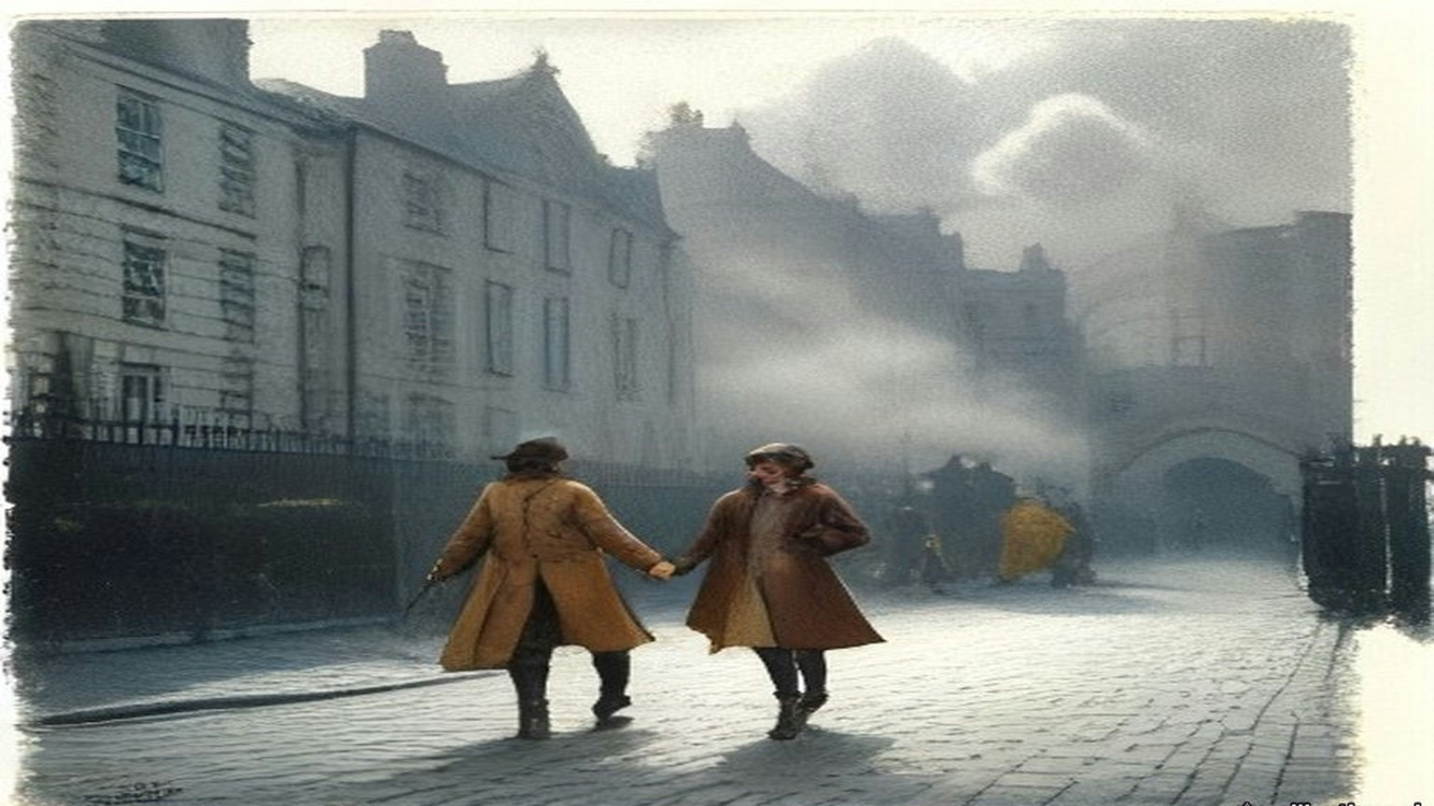
* * *
Portobello Bridge and the guard-room, Tuesday evening, 25 April
Lieutenant M. C. Morris of the 3rd Battalion, Royal Irish Rifles, had taken over the picket at Portobello Bridge an hour before. His men were in Davy's public house on the corner, where the Rathmines Road came over the Grand Canal. His orders were to do his utmost to avoid conflict, and to keep the roadway clear as far as he could. His picket had been fired at from time to time out of the houses close by. It was about dusk. The disturbances had been going on for some thirty hours.
A man came along the road from the city, walking by himself in the middle of it with a stick in his hand. A crowd followed him, and some of them were shouting out his name. Morris heard the name. He decided to detain him and send him to the barracks. He had done the same with one or two others who seemed likely to gather a crowd. There were no police to do it.
Sheehy Skeffington went quite willingly. Two soldiers walked him up the road, and about 350 yards past the bridge they turned in towards the main gate of Portobello Barracks. Morris stayed at his post.
The barracks covered about forty acres, between the canal on the north and the suburb of Rathmines on the south. They had been built for two battalions. That week there were not more than six hundred men in them, and half of those were out on duty. Officers and soldiers who had been home on leave when the fighting began had come in to the nearest barracks and reported, and the place was full of men who did not know one another. Lieutenant-Colonel McCammond, who commanded, was on sick leave. Major Rosborough had the command in his place. Rumours kept coming in of an attack on the barracks and of rebel successes in the city.
In the main guard-room three second lieutenants were sharing the duty, Dobbin, Tooley and Alexander Wilson. Dobbin was the senior of them. He was eighteen. He had left school the year before and had held his commission a few months, and he had seen nothing of fighting.
Sergeant Maxwell took the prisoner across to the orderly-room, where the Adjutant, Lieutenant Morgan, questioned him. Sheehy Skeffington said he was not a Sinn Féiner. He said he was in favour of passive resistance and opposed to militarism. There was no charge of any kind against him, and Morgan telephoned the Garrison Adjutant to ask whether he should go on holding him. The order came back to detain him for further inquiries. The others brought in that evening with no charge against them were to be let go. Against his name, on the charge sheet, someone wrote "no charge."
He asked for his wife to be told where he was. They refused.
He was taken back to the guard-room and searched by Captain J. C. Bowen-Colthurst of the Royal Irish Rifles, an officer of sixteen years' service and a man of exceptional height. He had been seriously wounded at the front and sent home. At about nine Bowen-Colthurst handed what he had found to the Adjutant. Morgan copied each paper. There were very few. None had anything to do with the disturbances except the draft form of membership for a civic guard.
* * *
The Rathmines Road, about eleven at night
Later that evening Bowen-Colthurst was ordered to take a party out and occupy premises at the corner of Camden Street and Harrington Street, the tobacco shop of Alderman James Kelly. Kelly was a Justice of the Peace and had lately been High Sheriff of the city. He was under suspicion through a misunderstanding. He had nothing whatever to do with the outbreak.
Second Lieutenant Leslie Wilson was the junior officer of the party. There were about forty men. Before they left, Bowen-Colthurst went to the guard and took Sheehy Skeffington out of it. He asked no one's leave. He was taking him as a hostage.
Wilson watched them tie the prisoner's hands behind his back. Then Bowen-Colthurst called on him to say his prayers. Sheehy Skeffington refused. Bowen-Colthurst ordered the men to take their caps off. Forty men stood bareheaded in the dark of the barrack square, and the captain prayed aloud over the man with the tied hands.
"O Lord God, if it shall please thee to take away the life of this man forgive him for Christ's sake."
They went out by the main gate and down the lane to the Rathmines Road. As the column came along the road the soldiers fired, to keep people away from the windows, Wilson said. Two young men were standing in the road, J. J. Coade and his friend Laurence Byrne. Coade had been at a meeting of the religious sodality at the Rathmines church that evening. Bowen-Colthurst asked them what business they had to be in the road at that hour, and warned them that martial law had been proclaimed.
Neither of them offered any violence. Bowen-Colthurst shot Coade. Coade fell, mortally wounded.
Wilson said afterwards that the captain fired a rifle. Two civilians who saw it said he brandished a revolver and fired that. Hanna Sheehy Skeffington was told that Bowen-Colthurst said "Bash him," that a soldier broke the boy's jaw with a rifle butt, and that Bowen-Colthurst shot him as he lay. Coade was seventeen, by her account. The ambulance took him to the hospital in the barracks.
The party went on to Portobello Bridge. There Bowen-Colthurst divided it. He left half the men with Wilson at the bridge, and he left Sheehy Skeffington there too. If he and his men were "knocked out," Wilson was to take command. If they were fired on, Wilson was to shoot Sheehy Skeffington.
Then the captain went on with the rest towards Kelly's shop, three hundred yards off.
Wilson stood at the bridge with his half of the party and the prisoner, his hands still tied. Later he told the Commission he saw nothing "strange" in the order.
Back at the barracks, Sergeant Maxwell told the Adjutant that the prisoner had been taken out. Morgan put the time at about twenty past ten. He went to Dobbin and asked him for a written report.
"April 25th, 11.10 p.m.
"An armed party under Captain J. C. Bowen-Colthurst has just passed through my guard, demanding and taking with him the last captured prisoner, Sheehy Skeffington."
Dobbin did not write the word hostage. He told the Commission he did not know what the captain wanted the prisoner for.
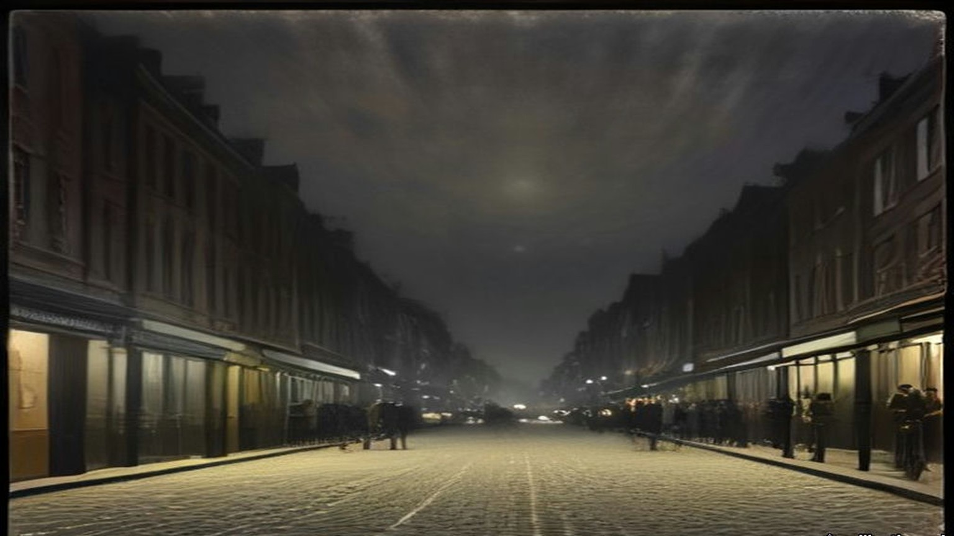
* * *
Alderman Kelly's shop, the same night
Miss Kelly was in her brother's shop when the soldiers came. The Alderman was not there. A friend of his, Patrick McIntyre, had been on the premises some time. Thomas Dickson lived close by in Harrington Street, and when he heard the soldiers firing as they came up the road he ran into the shop to take refuge.
They threw a bomb into the shop. Nobody resisted them. Then Bowen-Colthurst was inside, very tall, in a state of great excitement. Miss Kelly heard him tell everyone there that "as martial law had been proclaimed" he could shoot them as he had shot someone in the street.
The soldiers took four men. Two were let go soon after. The other two were Dickson and McIntyre. Dickson was the editor of a paper called the Eye-Opener. McIntyre edited one called the Searchlight. Dickson was a Scotchman, and he was deformed. Neither of them had any connection with Sinn Féin. Their only offence was being found on Kelly's premises.
The advance party had been gone about twenty minutes. On the way back Bowen-Colthurst picked up Wilson's half at the bridge, and Sheehy Skeffington with it, alive.
In the barracks Bowen-Colthurst made a verbal report to Major Rosborough with the Adjutant present. He said he had taken Sheehy Skeffington with him and arrested Dickson and McIntyre. He said nothing about Coade. Rosborough was working at great pressure that night, and afterwards he had no memory of the interview at all. Nobody gave Bowen-Colthurst a reprimand that anyone remembered.
Dickson and McIntyre were searched. Nothing material was found on them. They spent the night in the detention room with the other civilians. Sheehy Skeffington, "as being of a superior social position," was put in a separate cell by himself and made as comfortable as possible.
Bowen-Colthurst wrote afterwards that he was busy that night until about three in the morning going through their papers.
* * *
The detention room, Wednesday morning, 26 April
We were in that room all night, a dozen of us or more, and none of us charged with a thing. I was brought in off the street the same as the rest. You sat on the floor with your back to the wall and your knees up, and whenever you shut your eyes a door would bang somewhere or a man would shout and you'd be awake again.
The two editors were in with us. The little Scotch fellow, Dickson, with the crooked back. He hardly said a word the whole night. McIntyre talked a while and then he stopped.
Skeffington we didn't see. They had him in a cell on his own.
In the morning there were boots in the passage and voices, and they called the two of them out. Then they called Skeffington. We heard the door of his cell. We heard them go out the few steps into the yard.
Nobody said anything. Not a word out of the three of them.
Then the volley.
It came through the wall into the room like a blow on the chest. A man near me got up on his knees and I could hear him breathing. Somebody said, "Another poor fellow gone."
I thought, we're next. I thought it as plain as that.
There was talking in the yard. Then a while, a minute, two minutes. I couldn't tell you. Then four more shots together.
After that, for a long time, the sound of water being thrown down, and a brush going on stone.
* * *
The guard-room yard, Portobello Barracks, Wednesday, 26 April, shortly after ten
Sergeant John W. Aldridge of the 10th Royal Dublin Fusiliers had been on leave when the rebellion started. When he got back to Dublin he reported at the nearest barracks, like many other soldiers that week, and he was new to Portobello. He did not know the officers by sight. He mounted guard at nine on Wednesday morning.
The three subalterns were the same as the night before. Dobbin was standing out in the barrack square near the guard-room entrance.
Shortly after ten a captain came in. He walked past Dobbin without a word, came straight into the guard-room and gave his orders to the sergeant. He wanted the three prisoners, Skeffington, Dickson and McIntyre, in the yard. He wanted to speak to them.
Aldridge had never seen him. He could see from the uniform that he was a captain. He did not know who the officers of the guard were. A captain giving orders in a guard-room was nothing out of the way to him. He carried them out. Sheehy Skeffington was called out of his cell, and Dickson and McIntyre out of the detention room, and the three of them were ordered out into the yard.
The yard lay inside the guard-room block, at the end of a short passage. It was less than forty feet long and some fifteen feet wide. There were high brick walls all round it.
While the prisoners were being called, the captain stepped back out to Dobbin. He told him he was taking the three prisoners out to shoot them. He thought "it was the best thing to do." Then he went back inside.
Dobbin called Lieutenant Alexander Wilson, who had his bicycle with him, and sent him with an urgent message to the Adjutant. The orderly-room was some five hundred yards away. Wilson rode off across the square.
Inside, Bowen-Colthurst ordered some of the guard out into the yard with their rifles. Every man on duty had a full magazine. Seven went, the seven who happened to be standing nearest the passage. Aldridge went out with them.
The three prisoners had gone out ahead. The captain ordered them to walk to the wall at the far end. It was only a few yards. As they walked, the seven soldiers came out of the passage behind them and fell into line along the wall by the entrance. The three men reached the end wall. They turned round to face the soldiers.
The captain gave the order to fire.
Seven rifles went off together between the high walls.
All three men fell.
No one had said anything. None of the three had made a sound.
Bowen-Colthurst left the yard. The firing party began to file out past the sergeant.
Wilson was back on his bicycle by then. He was outside the guard-room, giving Dobbin the Adjutant's answer, when the volley went off in the yard beside them. The Adjutant's answer was that Major Rosborough was out, that the Adjutant could give no authority for any prisoners to be taken out of the guard-room, and that if Captain Bowen-Colthurst took them out he would be acting on his own responsibility.
Dobbin ran through the guard-room and into the yard. He looked at the bodies. One of Sheehy Skeffington's legs moved.
"Sergeant, that man is not dead."
Aldridge had been a soldier a long time. He thought death had been instantaneous in all three, and that what the young officer saw was a contraction of the muscles of the leg. Dobbin did not wait to be told it. He sent Lieutenant Tooley to the orderly-room to report and to get instructions. At or near the orderly-room Tooley met Bowen-Colthurst. The captain gave him an order to "fire again."
Tooley came back with it. Dobbin ordered four soldiers of the guard into the yard. Not all of them had been in the first party. On Dobbin's directions they fired a second volley into the body of Mr. Sheehy Skeffington.
From the arrival of the captain at the guard-room to the end, the whole of it took a very few minutes. The guard-room, the detention room, the cells and the yard were all in the one block, a few steps apart.
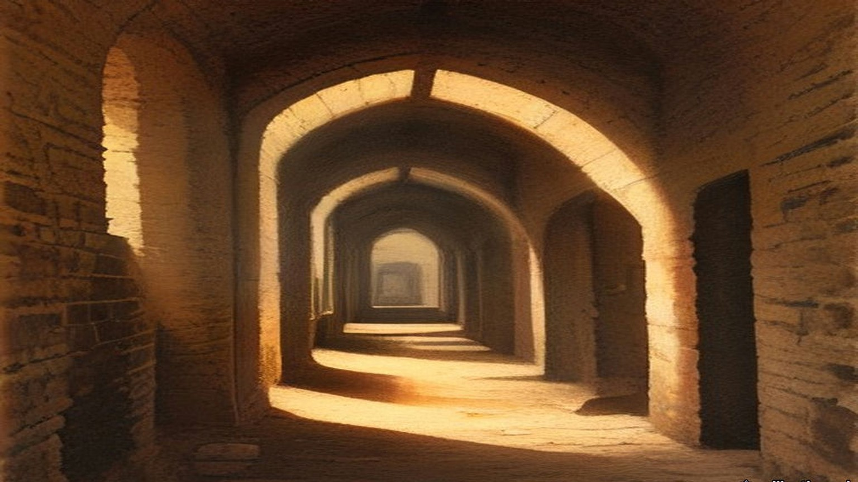
Before half past ten Bowen-Colthurst told the Adjutant in the orderly-room that he had shot Mr. Sheehy Skeffington and the editors of the Eye-Opener and the Searchlight. He said he had been afraid they would escape, or be rescued by armed force. At about the same time he reported it to Major Rosborough. He said he had shot the three prisoners on his own responsibility, and "that he possibly might be hanged for it." Rosborough told him to put it in writing, and told the Adjutant to report the matter to the Garrison Adjutant at Dublin Castle.
Morgan went over to the guard-room and saw the three bodies carried out. Then he telephoned the Garrison Adjutant, Captain Burton. Because of the seriousness of it he also telephoned Headquarters, Irish Command, direct. Rosborough ordered that Bowen-Colthurst was not to be detailed for duty outside the barracks. No more was done about him until 6 May.
Later in the day Morgan telephoned again to ask what to do with the bodies, which were lying in the mortuary. He was told to bury them in the barrack yard that evening. With the Medical Officer, Major Balch, and the Engineer Officer, he had them wrapped in sheets and buried in the barrack square. There were no coffins to be had. Father O'Loughlin, the barracks chaplain, read the rites over all three.
Rosborough kept asking Bowen-Colthurst for his written report all that day. It came in late in the afternoon.
He wrote that he had been up until about three "examining documents found on these three men," and that he had recognised from them "that these 3 men were all very dangerous characters." He wrote that he had gone to the guard-room to examine them and sent them into the yard because the guard-room was full. "I regret now that I did not have these three men handcuffed and surrounded, as the yard was a place from which they might have escaped." The guard had been some distance off. "I called upon the guard to fire upon them, which they did with effect, the 3 men being killed."
The Commission found the account of the Wednesday morning "entirely untrue." "There was no possibility of the prisoners making their escape from the yard, a fact which is obvious to anyone who has seen it." Any documents found on them "could be thoroughly examined in a few minutes."
* * *
Portobello Barracks and 11 Grosvenor Place, Friday, 28 April
By Friday Hanna Sheehy Skeffington still had no word. Rumours came from every side. He was wounded and in a hospital. A looter had shot him. The police had arrested him. Someone told her he had been executed. She would not believe it. Even if he had been condemned, she thought, he would have been tried first, and she would have been told. She tried to see a doctor who was attached to the barracks, and the police stopped her.
On Friday morning her two sisters, Mrs. Culhane and Mrs. Kettle, went to Rathmines police station to ask. The police had nothing to tell them and suggested they try the barracks. Their brother, Lieutenant Sheehy of the Dublin Fusiliers, was fighting in the city that week. Mrs. Kettle's husband, Lieutenant T. M. Kettle, was with his battalion. Mrs. Culhane's husband, lately dead, had been a high official in the Irish Courts of Justice.
They reached Portobello at about one. A young officer, Lieutenant Beattie, came to ask their business. They asked first after their brother, and he answered them courteously. Then they asked after their brother-in-law, Mr. Sheehy Skeffington. The young man became confused, asked them to excuse him, and went away to consult some other officers. When he came back he told them he regretted he would have to put them under arrest. They were Sinn Féiners, he said, and had been seen speaking to Sinn Féiners.
Soldiers marched them across the square to the orderly-room and stood round them there. After some minutes a very tall captain came out of the guard-room and questioned them. They asked again about their brother and their brother-in-law.
"I know nothing whatever about Mr. Sheehy Skeffington."
Mrs. Culhane mentioned some of the rumours. Beattie said something to the captain in an undertone.
"I have no information concerning Mr. Skeffington that is available, and the sooner you leave the barracks the better."
He ordered them taken back, and that they were not to speak to one another. At the gate the guard was dismissed, and Beattie walked them to the tram line.
At about four o'clock, after her sisters came home, Hanna found the father of the boy Coade. Father O'Loughlin had known young Coade from the sodality and had told the father, and the father had been let in to see his son's body in the barracks mortuary. Lying beside his son he saw the body of Mr. Sheehy Skeffington. He told her so. She went straight to Father O'Loughlin. The priest told her that her husband was dead and already buried.
She went home a little after six.
At seven she was upstairs putting Owen to bed. The maid saw soldiers lining up outside the house, panicked, and ran out the back door with the boy. Hanna went after them to call them back. The house would be watched front and back. A child seen running would be shot.
She was at the foot of the stairs when a volley was fired into the front windows.
The glass came in. Rifle butts smashed what was left. They were breaking in all over the house at once, at the front door, at the back, some of them up on the roof. No one had knocked. No one had asked for the door to be opened. Then Bowen-Colthurst was in the hall with a squad behind him and the bayonets fixed, coming at the three of them, the maid, the child and herself.
"Hands up!"
Owen cried out at the bare steel.
She put her arm round him. "These are the defenders of women and children."
They put up their hands. They were marched into the front room and told they would be shot if they stirred. Soldiers knelt outside the windows with their rifles levelled at the room. Inside, men with bayonets stood over them. Colonel Allett was there, and a Lieutenant Brown, and about forty men.
For over three hours she sat in the front room with her arm round her son and listened to them go through her house. She could hear the officers jeering as they turned over her things. Bowen-Colthurst had her husband's keys, taken off his body, and he opened the study that Frank always kept locked. They took the books, many of them her own German textbooks, and his papers and pamphlets. They took the letters he had written her before they were married, his articles and a play in manuscript. They wrapped them in the household linen and carried them out to a motor car they had stopped in the road.
One of the soldiers was a Belfast man. "I didn't enlist for this," he said. "They are taking the whole bloomin' house with them."
They left at a quarter past ten.
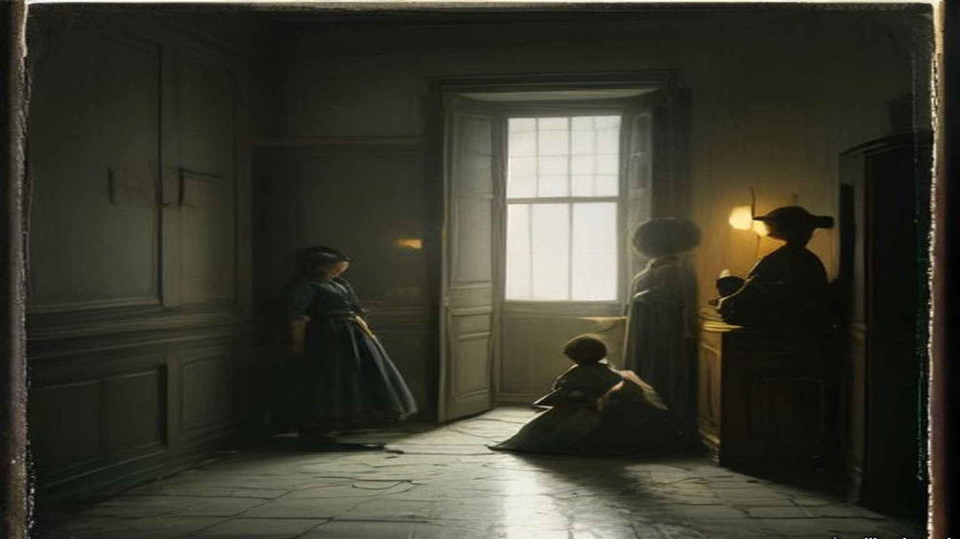
Some time later Bowen-Colthurst produced a printed pamphlet called "Secret Orders Issued to the Military," with a note attached to it in red ink, in his writing: "I certify that I found this document on the person of F. Sheehy Skeffington." It was signed and dated 25/4/16. Lieutenant Morgan, who had copied every paper taken from the prisoner on the Tuesday night, satisfied the Commission that it had not been among them. The Commission found the certificate untrue.
* * *
Dublin and Westminster, May 1916
On Monday, 1 May, two soldiers under a Sergeant Claxton came to the house while Hanna and Owen were out. Bowen-Colthurst had nothing to do with this visit. The maid of the Friday had been terrified and had left. The new one, a temporary girl named Margaret Farrelly, nineteen or twenty years old, was arrested and taken to Rathmines police station. She was kept there until the Saturday, when Hanna got her released.
Major Sir Francis Vane was one of the officers who had reported at Portobello when the fighting began. He was not an officer of the regiment there and had no responsibility for anything that happened. He tried to get Bowen-Colthurst arrested in Dublin and got nowhere. He crossed to London and went to the military authorities there. Hanna was told he saw Lord Kitchener on 3 May.
The Royal Commission found that "as a result of a communication to the military authorities in London, made by Major Sir Francis Vane," Bowen-Colthurst was put under open arrest on 6 May, and under close arrest on 11 May. In December the War Office told the Commons that the date of the arrest was 5 May, "and not 6th May, as erroneously stated in the Report," that it followed Sir John Maxwell's receipt of the report of the shooting, and that no telegram from Kitchener had ever been received in Ireland.
On Sunday, 7 May, Hanna said, bricklayers were brought into the yard by Colonel McCammond's order. They took out the bloodstained bricks and put new ones in. On 8 May her husband's body was taken up and reburied in Glasnevin, and she was not told. The bodies were exhumed by Maxwell's permission, and Mr. Sheehy Skeffington's father was present.
On Thursday, 11 May, John Dillon moved the adjournment of the House on the executions in Ireland. The Under-Secretary for War had told the House that day that fourteen had been executed. Dillon had thought it twelve. The Prime Minister said the true number was thirteen, because one case had been counted twice.
Dillon told the House that thousands of people in Dublin who ten days before had been bitterly opposed to the rebellion "are now becoming infuriated against the Government on account of these executions." He spoke of himself and his party. "We have risked our lives a hundred times to bring about this result," he said, "and now you are washing out our whole life work in a sea of blood."
Then he came to Portobello. The military authorities in Dublin, he said, had told the Prime Minister that Mr. Skeffington was shot "without the knowledge of the military authorities," and that the officer had been under arrest since 6 May. Dillon read out the statement Hanna had given him.
Asquith answered him. A statement of that kind, "which reflected very severely on the subsequent conduct at her own house of British officers and soldiers, I confess I cannot believe and I do not believe." He said it should be examined.
"Public?" said Dillon.
"Yes, certainly, a public examination."
The same day Alfie Byrne asked for a sworn inquiry into the deaths of Sheehy Skeffington and of James M'Cartney, the Lord Mayor's manager, killed with three others at 27 North King Street, and whether the Government would compensate their widows. Herbert Samuel answered. "I am not in a position to make any statement at present as to compensation."
On 24 May T. M. Healy and Joseph Devlin asked when the promised public inquiry would be held. Asquith said it could not take place "until the conclusion of the court-martial."
On 6 and 7 June Bowen-Colthurst was tried by court-martial in Dublin for the murder of the three men. Lord Cheylesmore presided. Hanna was not allowed to give evidence, and Vane was not called. The court found Bowen-Colthurst guilty but insane at the time of the crime, and he was sent to Broadmoor Criminal Lunatic Asylum. Hanna wrote that he kept his rank of captain and drew half pay for several months.
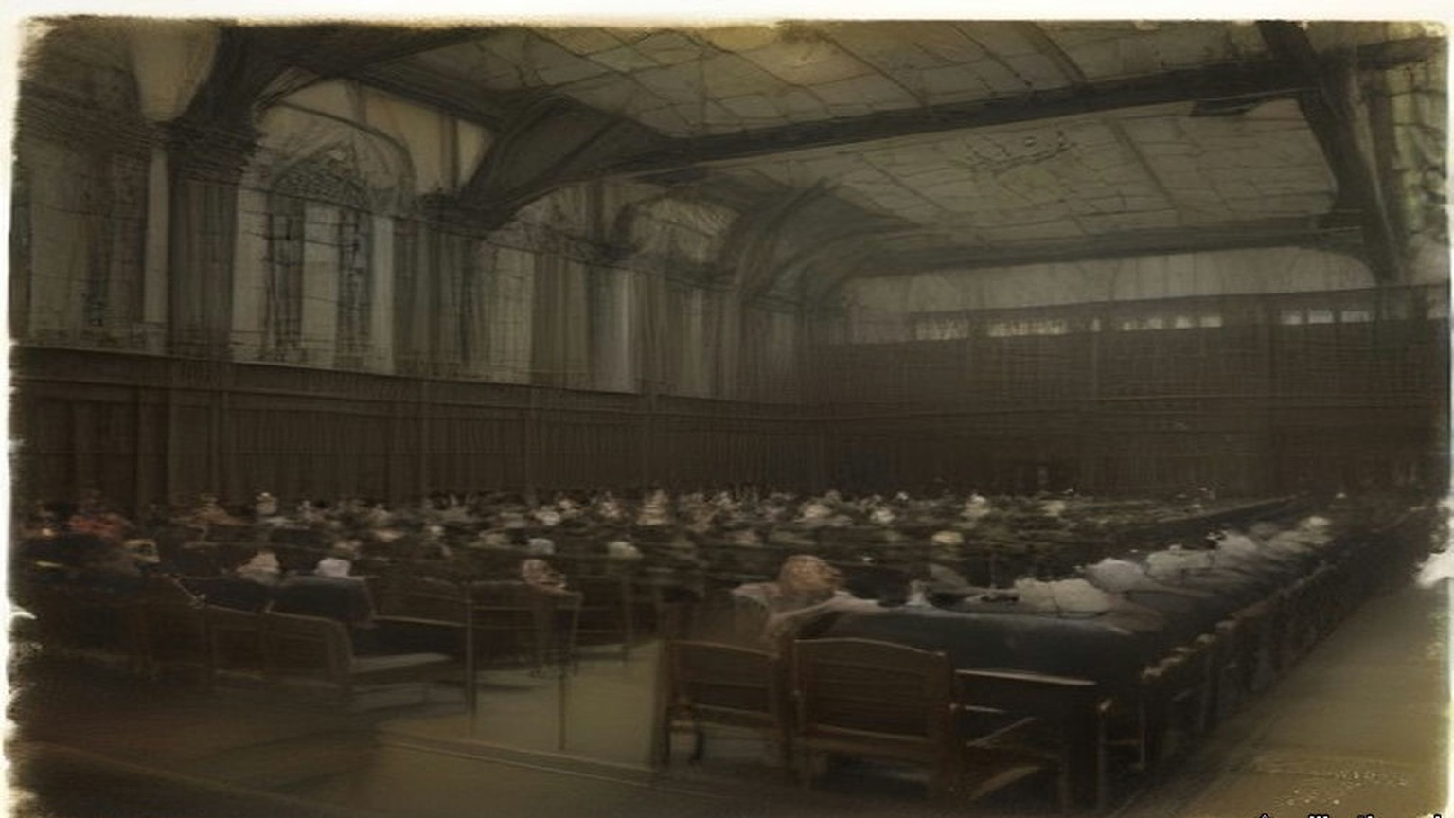
* * *
The Cabinet room, Downing Street, Wednesday, 19 July 1916
In July Hanna went to London to see editors and members of Parliament. On 19 July the Prime Minister sent for her. She brought a witness with her, the suffragist Muriel Matters.
Asquith saw them in the room where the Cabinet met. He sat at the middle of the green baize table with his secretary, and the two women sat at the end of it. He never looked her straight in the face. He glanced at her sideways and tapped his fingers on the baize.
He explained the difficulties in the way of keeping his promise. The House, he said, would refuse a sworn inquiry, and nothing else would be satisfactory. Would she be satisfied with an inadequate inquiry, which was the best they could do? She said she would not be satisfied with any inquiry that he told her in advance would be inadequate.
Then he came round to compensation. She had been sounded before, unofficially and from several quarters, with her boy's future put to her. She had been told that the military would not allow an inquiry, but that compensation "adequate and even generous" would be assured. Now Asquith put it to her himself, very delicately. The other injured people were asking for compensation. Would she not consider it too? Nothing could undo the past.
She told him the only compensation she would ask or take was the one he had promised: a full public inquiry into her husband's murder.
"Were the military blocking him?"
"No, no."
"In that case, Mr. Asquith, will you say yes or no? It is time that I had an answer."
He said he would answer Mr. Dillon on the Thursday.
* * *
The Four Courts, Dublin, Wednesday, 23 August 1916, and after
The Royal Commission was dated 17 August. Sir John Simon was its chairman, with Mr. Justice Molony and Denis Henry, K.C. It held its first sitting at eleven o'clock on the morning of Wednesday, 23 August, at the Four Courts. The Attorney-General appeared for the Government. T. M. Healy, K.C., appeared for the families of Sheehy Skeffington and of Dickson, and a solicitor, Mr. Brennan, for the family of McIntyre. Counsel appeared for the military, for Major Rosborough and Lieutenant Morgan, and for Alderman Kelly.
It sat for six days and heard thirty-eight witnesses. It did not hear Bowen-Colthurst. He was in Broadmoor, and the Commissioners held themselves debarred from taking his evidence.
Miss Kelly told them what the captain had said in the shop about martial law. Lieutenant Leslie Wilson told them about the prayer and the bridge. Dobbin's note of 11.10 p.m. was produced. Mrs. Kettle described the Friday, and the military did not dispute a word of it. Lieutenant Beattie was in court and was not called, because his evidence would in no way contradict hers. The Commission found that the part he had been made to play was extremely distasteful to him.
Their report was signed on 29 September.
The Commissioners wrote that a proclamation of martial law "does not, in itself, confer upon officers or soldiers any new powers." "The shooting of unarmed and unresisting civilians without trial constitutes the offence of murder, whether martial law has been proclaimed or not." Of Bowen-Colthurst they wrote, "Apart from the defence of insanity, there can be no excuse or palliation for his conduct from first to last." They found it "highly regrettable and most surprising" that after the Wednesday he had been free to go out with a body of soldiers, as he did on the Friday.
On 15 November Swift MacNeill asked the War Office why Vane, "commended for his conduct during the rebellion," had been ordered by Maxwell on 26 May to leave Ireland and on 30 June "relegated to unemployment." Henry Forster told him Vane had been at headquarters on 1 May on another matter, "but made no report on the Skeffington case."
On 14 December Hugh Law asked how, if Bowen-Colthurst had been under the personal supervision of his commanding officer from 26 April, he had been able two days later to go out into the street and attack Mrs. Sheehy Skeffington's house. Forster gave no answer to that. Law asked why Vane had been relegated to unemployment. Forster referred him to an answer given on 3 August.
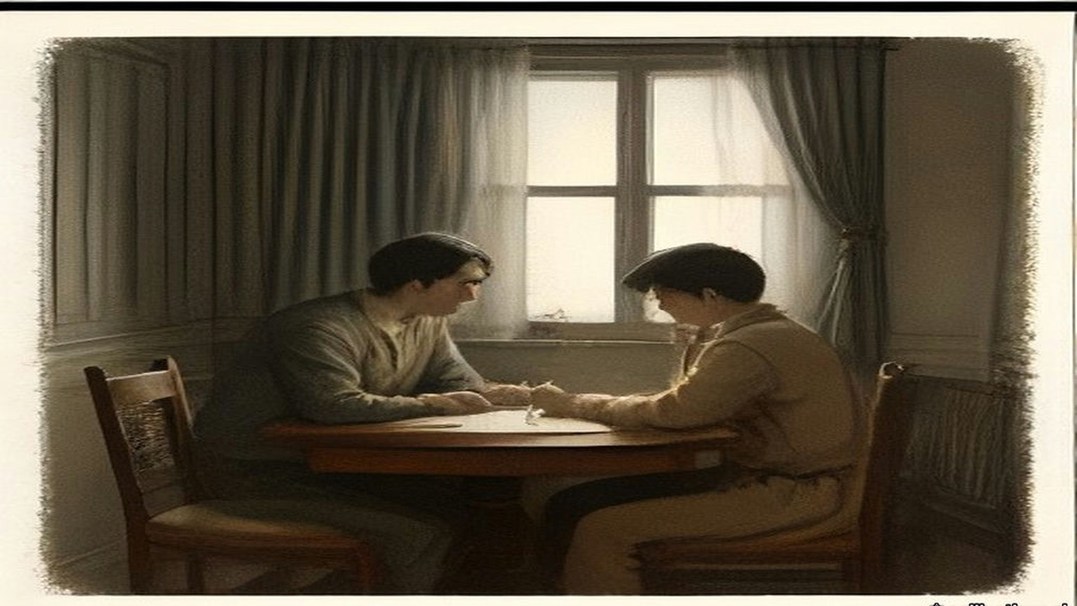
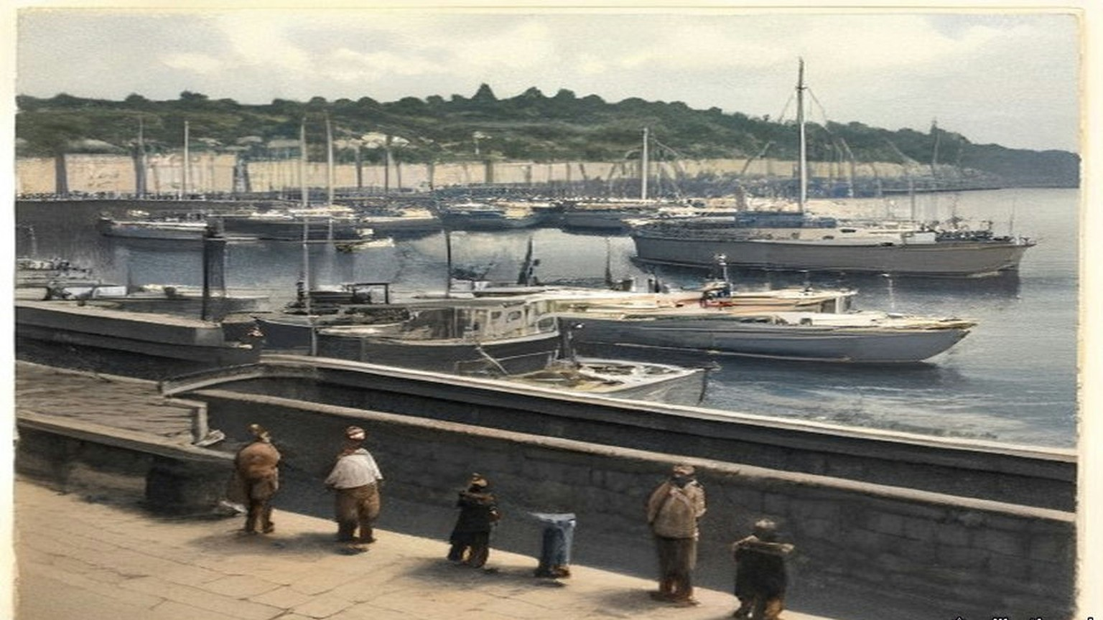
Chapter 17 Appendix of Important Names
• Samuel, Herbert (1 mentions in this chapter): British Liberal politician and first High Commissioner for Mandate Palestine (1920–1925).
Sources
• Report of the Royal Commission on the arrest and subsequent treatment of Mr. Francis Sheehy Skeffington, Mr. Thomas Dickson and Mr. Patrick James McIntyre [Cd. 8376], 1916, signed 29 September 1916 by John Simon, Thomas F. Molony and Denis S. Henry. Digitised by the University of Southampton Library (https://archive.org/details/op1256532-1001). Read in the OCR text, with paragraphs 34 to 39, 45 to 48 and 52 to 53 read from the page images, where the OCR is damaged. Used for: the Commission of 17 August and the first sitting at 11 o'clock on 23 August at the Four Courts (paras 1–2); counsel (3); six days and thirty-eight witnesses (4); McCammond on sick leave, Rosborough in command (5); the rising at noon on the 24th and officers on leave reporting (6); the barracks, about 40 acres, not more than 600 men, half on duty outside, the rumours (7); "a well-known figure," shortly before 8 p.m., 11 Grosvenor Place, about 350 yards (9); no connection with the Rebellion, "opposed to the use of physical force," the appeal against looting, the form of membership, the crowd shouting his name (10); about dusk, some thirty hours, Lieutenant M. C. Morris, the picket at Davy's public house, his orders, the escort of two men (11); fired at from houses, no police, "he went quite willingly" (12); Dobbin, Tooley and Alexander Wilson, Dobbin eighteen, Sergeant Maxwell, Morgan's questioning, "not a Sinn Feiner ... passive resistance and opposed to militarism," the telephone, "detained for further inquiries" (13); Bowen-Colthurst's sixteen years, his wound, the search about 9 o'clock, "a draft form of membership for a civic guard" (14); Alderman James Kelly, Camden Street and Harrington Street, J.P. and lately High Sheriff, "quite innocent," the route (15); the hostage, "extraordinary, and indeed almost meaningless," Second Lieutenant Leslie Wilson and about forty men, the hands tied, the prayers refused, "hats off," and the prayer (16); Coade and Laurence Byrne, martial law, Coade shot and "mortally wounded," the ambulance, rifle against revolver, Bowen-Colthurst "a man of exceptional stature," the firing at the windows (17); "None of the evidence offered to us afforded any justification" (18); the division at the bridge, "knocked out," the order to shoot (19); about twenty minutes, the bomb, no resistance, McIntyre and Dickson, Miss Kelly's account, "a state of great excitement," four taken and two released (20); about 10.20 p.m. and Dobbin's note of 11.10 p.m. (21); the verbal report to Rosborough, nothing said of Coade (22); no reprimand (23); the detention room and the separate cell, "as being of a superior social position" (24); the Eye-Opener and the Searchlight, "a Scotchman, and deformed," no connection with Sinn Féin (25); Sergeant John W. Aldridge of the 10th Royal Dublin Fusiliers, guard mounted at 9 a.m. (26); shortly after 10 a.m., the orders to the sergeant, the yard "less than 40 ft. in length and some 15 ft. in width ... surrounded by high brick walls" (27); Aldridge not knowing him (28); "it was the best thing to do," Wilson's bicycle, 500 yards (29); the Adjutant's answer (31); full magazines, seven men, "no sound was uttered by any of the three" (32); the walk to the wall, the turn, the order, "All three fell" (33); "Sergeant, that man is not dead," Aldridge's view, Tooley, "fire again," four soldiers, the second volley (34); the shot heard in the detention room (35); "a very few minutes" (36); before 10.30 a.m., "escape or might be rescued by armed force," "possibly might be hanged for it" (37); Captain Burton, the telephone to Headquarters, Irish Command, the order not to be detailed outside, no further action until 6 May (38); burial in sheets in the barrack square, Major Balch, Father O'Loughlin, the exhumation with Maxwell's permission and Mr. Sheehy Skeffington senior (39); the written report and the passages quoted from it (40); "entirely untrue" and "no possibility of the prisoners making their escape" (41); Broadmoor and the court-martial's finding (43); Friday and Westmoreland Street (44); the sisters and their families (45); about one p.m., Lieutenant Beattie, the arrest, "I know nothing whatever about Mr. Sheehy Skeffington," "the sooner you leave the barracks the better," the tram line (46); Beattie's part "extremely distasteful" (47); about four o'clock, Coade's father, the sodality, the mortuary, "dead and already buried" (48); 7 p.m., the boy aged seven, the volley through the windows, the bayonets, no request to open the door, the front room, German textbooks, the household linen and the motor car, a quarter past ten (49); 1 May and Margaret Farrelly (50); the "Secret Orders" pamphlet and the red-ink certificate (52); Vane's communication, open arrest on 6 May and close arrest on 11 May, the court-martial of 6 and 7 June, "guilty but insane" (53); "no excuse or palliation" (54); "does not, in itself, confer ... any new powers," the order seen as nothing "strange," "highly regrettable and most surprising," "constitutes the offence of murder" (55).
• Hanna Sheehy Skeffington, "British Militarism As I Have Known It," in A Forgotten Small Nationality: Ireland and the War (New York, 1917), a digest of her American lecture. Read in the proofread Wikisource transcription of the printed pamphlet, pp. 17–32 (https://en.wikisource.org/wiki/A_forgotten_small_nationality/British_Militarism_As_I_Have_Known_It). Used for: Captain Pinfield, the chemist, the pool of blood, "I could not let anyone bleed to death while I could help"; the looting, civic guards, priests, "by Tuesday evening everyone was afraid"; tea at about 5.30 and the roundabout way home; the walking stick, alone in the middle of the road; the charge sheet marked "no charge" and the refusal to tell her; "Bash him," the jaw, Coade aged seventeen; the rumours and her refusal to believe the execution; the doctor and the police; the maid running with Owen, the volley, the rifle butts, the roof, "Hands up!", "These are the defenders of women and children," Allett, Lieutenant Brown, about forty men, kneeling soldiers outside, over three hours, the jeering, the keys and the locked study, the letters and the play, "I didn't enlist for this. They are taking the whole bloomin' house with them"; Vane and Kitchener on 3 May; the bricks on Sunday 7 May "by order of Colonel McCammond"; Cheylesmore; her exclusion from the court-martial and Vane not being called; the half pay; London in July, 19 July, Muriel Matters, the Cabinet room, the green baize, the sideways glance, the inquiry and compensation "adequate and even generous," "Were the military blocking him?", "No, no," "will you say yes or no? It is time that I had an answer," the Thursday answer to Dillon. The "Votes for Women" badge is in her account of what was taken from his body.
• House of Commons Debates, 21 June 1915, vol. 72, cc. 929–31, "Arrest of Mr. Sheehy Skeffington" (Lynch's questions; Regulation 56 (3); "cannot adequately be dealt with by a Court of Summary Jurisdiction"; Regulation 55 (3); "Yes, in almost every case, I am"; twenty-seven). Saved at research/ch12/hans.
• House of Commons Debates, 11 May 1916, vol. 82: "Civilians Shot," cc. 884–5 (Byrne on compensation; Samuel, "I am not in a position to make any statement at present as to compensation"); "Continuance of Martial Law," cc. 935–70 (Dillon on fourteen and twelve executions; Asquith on thirteen; "now becoming infuriated against the Government on account of these executions"; "washing out our whole life work in a sea of blood"; the telegram, "without the knowledge of the military authorities," arrest since 6 May; the widow's statement read out; Asquith, "I confess I cannot believe and I do not believe"; "Public?", "Yes, certainly, a public examination"). https://api.parliament.uk/historic-hansard/commons/1916/may/11/continuance-of-martial-law
• House of Commons Debates, 24 May 1916, vol. 82, c. 2082 (Healy and Devlin; the inquiry to follow "the conclusion of the court-martial"); 15 November 1916, vol. 87, cc. 771–2, "Captain Colthurst" (MacNeill on Vane, Kitchener, 26 May and 30 June, "relegated to unemployment"; Forster, arrest on 5 May, "no telegram or letter," "made no report on the Skeffington case"); 14 December 1916, vol. 88, cc. 833–5 (Law; Forster on 5 May "and not 6th May, as erroneously stated in the Report," "no such telegram was ever received in Ireland"; Law's question on the Friday raid; the reference to 3 August). https://api.parliament.uk/historic-hansard/commons/1916/dec/14/shooting-of-me-sheehy-skeffinston

Chapter 18
Candles from the Staff Sergeant's Store, 1911–1921
The DMP Depot, Exchange Court, Great Brunswick Street, Phibsborough, the Mansion House, Soloheadbeg, Drumcondra and Arbour Hill, 1911 to 1921
Éamon Broy was born and reared at Ballinure, near Rathangan in county Kildare, on the Offaly border, beside the Bog of Allen. His people were farmers. The British Army was near at hand at the Curragh. In January 1911 he joined the Depot of the Dublin Metropolitan Police.
The half year in the Depot did not count as service in the force. Service began only when training was over, so nobody administered an oath to the recruits when they came in. Inspector Denis Carey had charge of their training. He was a world-famous athlete, and he made a most dashing figure in uniform. When he gave instruction in police duties the recruits found they could not attend to a word of it. They could only look at him and remember what he had thrown.
Among the men who joined with Broy was Michael Navin, an athlete himself and a living encyclopaedia of Munster athletics. While they were in the Depot a stranger came to stay as Carey's guest. He was about forty, stout and prosperous and American in appearance, well over eighteen stone and under six feet, and very neat on his feet for it. Navin went through the photographs in the athletic papers and decided that he was John Flanagan, the triple Olympic hammer champion. He was.
Broy was training at the Ballsbridge grounds at the time. Carey told him to take a 16 lb. hammer out there for Mr. Flanagan, and handed him a small leather case. It was heavy enough. It was nowhere near long enough. Broy's textbook on athletics, some years old, showed the hammer as a rigid four-foot sledge, and practical jokes in the Depot were common. He was sure Carey was pulling his leg to give Flanagan a laugh. When he was out of sight of the Depot he opened the case. Inside was the modern hammer, the handle of flexible piano wire with a steel grip, the head a leather centre covered with a sphere of brass.
He felt as proud carrying it as a man carrying a sword to Wolfe Tone.
That day he saw Flanagan throw, a heavy man spinning in the circle and throwing up the dust like what the country people called a "fairy blast." Flanagan told him about athletics in America and gave him an autographed photograph of himself in action. Broy ran to tell Navin and make him green with envy. Navin knew all about the modern hammer. Flanagan had invented and patented it years before.
Later Broy watched the two men practise at Ballsbridge. Carey passed 160 feet with a couple of throws. Coming in off the field he winked at Broy.
"If I get in a couple of throws like that at the sports I'll give John here a fright."
"Ah, Dinny," said Flanagan, "I've won by inches in my time."
At the D.M.P. sports Flanagan won at about 170 feet, with Carey some ten feet behind him. Then Flanagan went home to Kilmallock to farm. He told them he hoped to be there in time to sow his turnips.
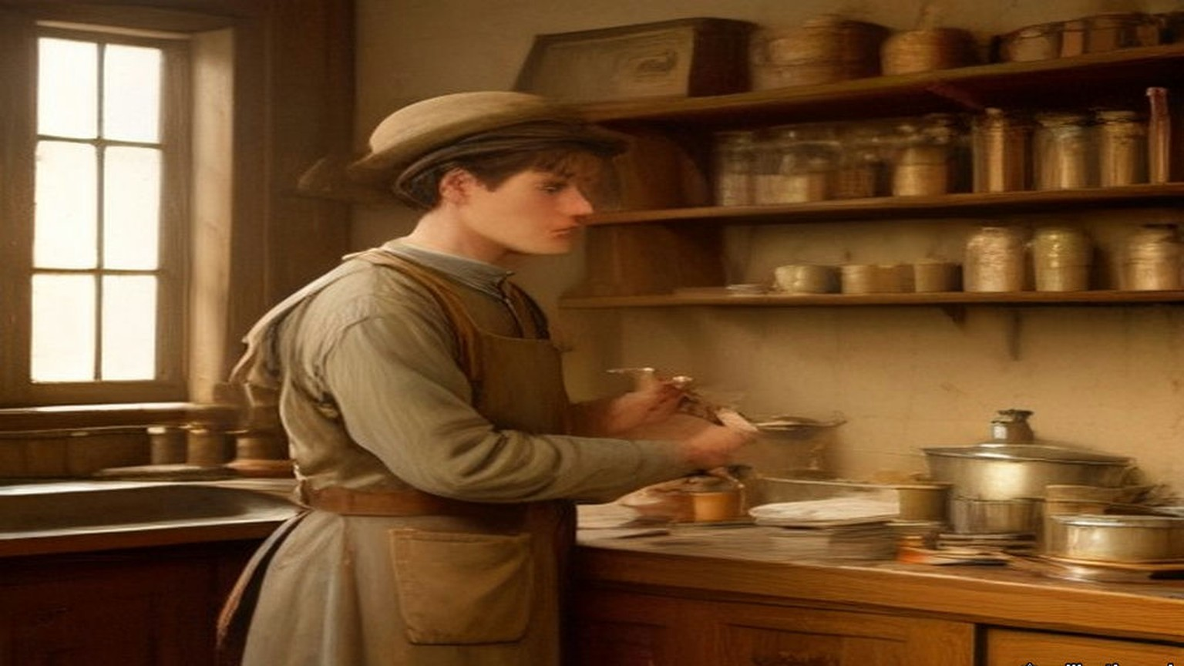
* * *
The Depot and Exchange Court, 1911 to 1915
Andy O'Neill and Michael Gleeson were in the Depot in Broy's time. O'Neill was from the Wexford-Carlow border, a weight-thrower and boxer of fifteen and a half stone who neither drank nor smoked. Gleeson was a Tipperary man. In July 1914, on the Howth Road, they were the first two constables ordered to disarm the Volunteers coming back from the landing of rifles at Howth, and they refused. None of the men who had known them in the Depot was in the least surprised.
The recruits discussed the national question openly in the Depot. It was the first place Broy heard "The Men of the West" sung. One recruit with anti-national views said in front of O'Neill that he would oppose the coming of Home Rule.
"Just imagine a like you trying to prevent Home Rule coming," O'Neill said. "You would be torn into small pieces."
They were taught what the oath would be. It bound them to serve without fear or favour, and there was a proviso: "I swear that I do not now belong to, and that whilst serving I shall not belong to, any secret society whatsoever, the Society of Freemasons excepted." They thought it a great piece of presumption to put that in an oath in Ireland in the twentieth century. The recruits were sworn in batches of about twenty. Several of them neither touched the Bible nor repeated the words.
The force was about 1,200 strong. The constables carried batons. They were trained on the revolver but not the rifle, and a city policeman practically had to be fired on before he was free to shoot. "You would need to make a dying declaration before firing in order to be legally safe," some of them said. The Chief Commissioner was Sir John Ross of Bladensburg. The Assistant Commissioner was William Vesey Harrel, who in July 1914 led the attempt to disarm the Volunteers on the Howth Road.
Broy was posted to E Division, the uniformed men between the Grand Canal and the Dodder, where there were plenty of sports grounds. Between 1911 and 1914 he won sprints and high jumps in Dublin and England. When the Curragh officers refused to move against Ulster in March 1914, some of the senior men in the force gravely shook their heads. One of the younger men said, "By God, two parties can play at that game."
The detectives were the G Division, about forty of them, chosen from men with three years in uniform who passed an examination in English composition, arithmetic, handwriting and a knowledge of the streets. The political section watched the people it called Suspects, always with the capital S, always the word before the name: Suspect Lord Ashbourne, Suspect Sir Roger Casement. Men at the railway stations and the boats noted which Suspects left the city and for where, and sent cipher wires ahead. Others went round the town day and night and wrote down who met whom. Each detective kept his own book. Every day the entries were copied by hand into one very large central book.
In March 1915 Broy, with very little service, was put into the clerical section of political duty at Exchange Court, beside the Castle. The authorities wanted typewriters and card indexes. Before his time the reports to the Government had been written by hand. Now he typed the daily, weekly and monthly reports on the Suspects, in several copies. One went to the Commissioner, Colonel Edgeworth-Johnstone. One went to the Director of Military Intelligence, Major Price. One went to what was called "the Government." Towards the end of 1915 the G Division left Exchange Court for the new building at No. 1 Great Brunswick Street, at the end nearer D'Olier Street.
* * *
No. 1 Great Brunswick Street, Easter Week, 1916
The first word reached the Detective Office a couple of minutes after midday on Easter Monday, by telephone from the Central Police Telephone Office in the Castle. A party of Volunteers, with an ambulance corps and stretchers, had broken into some buildings in Marrowbone Lane and were barricading them. Then came the General Post Office, Jacob's, the Four Courts, Boland's Mills. The detectives who had followed the marching parties as usual came back one after another with the same story. The Volunteers had broken into such and such a building.
The Chief Commissioner ordered every member of the force off the streets. The detectives sat round the dining-room and compared notes. A message came about Constable O'Brien, shot at the gate of the Upper Castle Yard, and later one about the retaking of the Evening Mail office, which ended, "they are now carrying out the dead." The trains kept running up and down Great Brunswick Street for over an hour, their noise mixed with the rifle fire. The detectives meant to defend the building with their .32 automatic pistols. Broy and the other junior men had never been issued with any firearm at all.
Dublin soldiers home on leave drifted into the office, some with rifles, some without. Headquarters wanted lists of them several times a day, by regiment, then by rank, then in some other form. Joe Kavanagh, the detective officer who made out the lists, suggested to the Chief Inspector that they measure the soldiers for height, since sooner or later some brass hat would think of that too.
One morning in the middle of the week a field gun was set up outside the barrack on the Trinity College side. A crowd gathered to watch, men in mufflers with big moustaches advising the gunners how to lift the stone sets for the trail. The detectives got tired of waiting at the windows and went back to their cards. Then there was a swishing sound in the street and the crowd scattered. When they looked out one of the artillerymen was lying in the road, killed by a bullet from the corner building of Bachelor's Walk.
When the Rising was over the senior political men went to Richmond Barracks to pick out the leaders for trial by court-martial. The record books went to the Castle. An entry that Michael O'Hanrahan had met Thomas MacDonagh in Grafton Street three months before and talked for some minutes had not looked like much when it was written. At O'Hanrahan's trial it was brought forward as proof of his general activities against the British. Then the executions began, day after day.
Some time afterwards Broy met a United Irish League organiser who lived near Kilmainham Jail and had no good word to say for Sinn Féin. Broy asked him whether he had heard the firing.
"My God," the man said, "it was terrible waiting, and the volleys sounded in the morning like a clap of thunder."
On Easter Monday Kavanagh had been in the office in the Castle, where the D.M.P. headquarters store held about a hundred Webley and Scott .32 automatic pistols with ammunition. The storekeeper was away for the day. Kavanagh suggested to some of the others that they break in and take them, and kept about half a dozen for himself. After Easter Week he gave one to Broy.
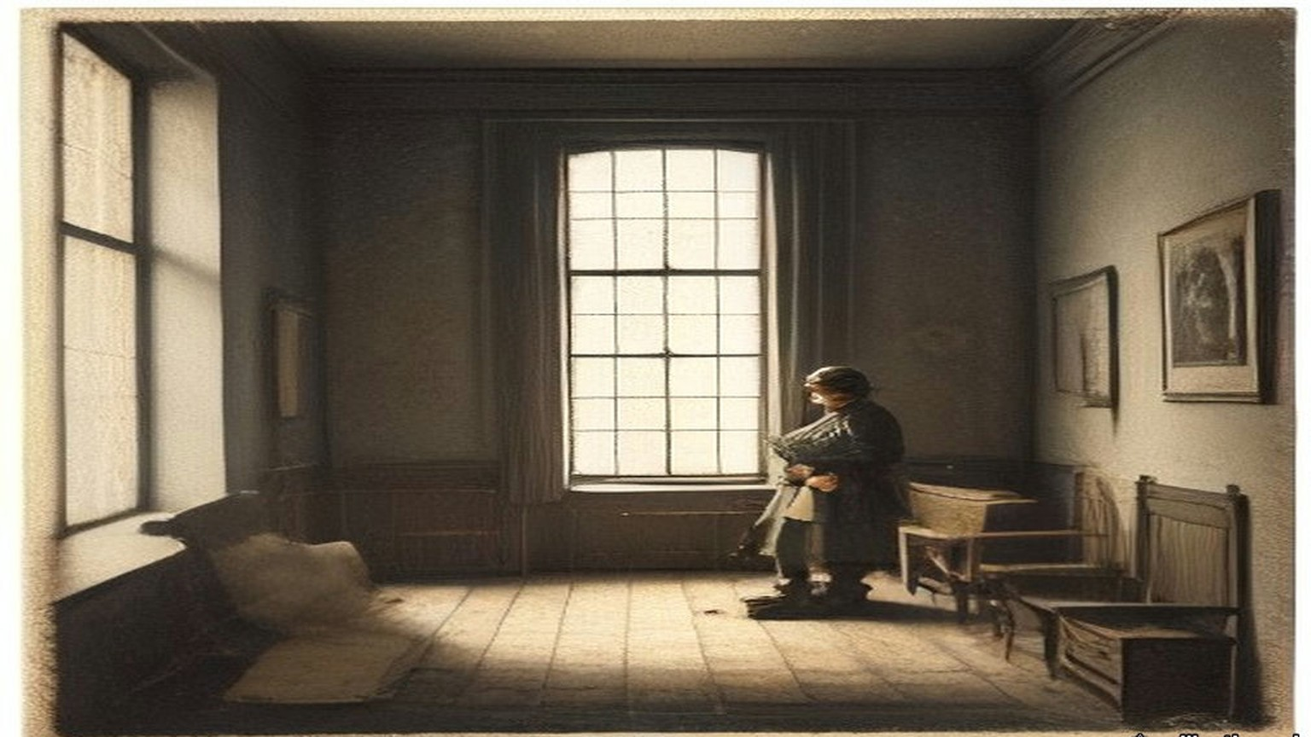
* * *
Phibsborough, 14 August 1917
After the Rising there were so many pensions, transfers and promotions in the force that from about March 1917 Broy found himself alone in the office in Great Brunswick Street from eleven in the morning for the rest of the day. The documents captured in 1916 were kept there. He had been studying the history of Irish risings and why they failed. He had invitations to go to America and no intention of staying in the police. Next to Superintendent Owen Brien, who could have rewritten the record books from memory, he knew more about the Suspects than any man in the force. He began to ask himself what the men he knew as the Sinn Féiners could do with it.
He listed the dangers to them. Traitors. Spies from outside. Drink and boasting. The respectable man who wanted to be arrested and be a hero. Papers found on arrest. Coincidence: the Orangeman in the insurance office who visits a girl in the same street every week and sees two Sinn Féiners meet there every week. Volunteers newly served out with revolvers, who could not resist having a shot at something. He made up his mind to help them, regardless of the consequences.
On the evening he dated as 14 August 1917 a warrant reached the office at about six for the arrest of de Valera, said to be living at 34 Munster Street, Phibsborough. Detective Sergeant Fagan and Broy were the only men there, so they were sent. They were not to inquire at the house. They were to watch for him.
Fagan had a grievance. He was not on the political staff, and he had done a day's work in the office already. Broy encouraged the grievance as far as he safely could, and they agreed to keep away from Phibsborough until the political men came on at seven. Peadar Healy, a Volunteer who had been out in 1916, lived at 86 Phibsborough Road. Broy noted where No. 86 was. Near Mountjoy police station Fagan went in to telephone Superintendent Brien that they had not seen "that man," and invited Broy in for a drink. Broy said he was a teetotaller and would wait outside.
O'Hanrahan's shop, kept by the executed man's brother and sisters, was close by. He did not dare go in. Too many policemen lived round there, and he was known as an athlete. He sprinted to Healy's. Healy was out, but his brother was in. Broy told him who and what he was, and that de Valera was about to be arrested. Then he sprinted back.
Turning into the North Circular Road he ran into Detective Sergeant Revell from the political office in the Castle, a loyalist who lived in the district. Broy told him they were "looking for" de Valera and that Fagan was in the station. Revell went back with him, took Fagan's side, and agreed that the arrest should be left to the political men.
For a week the pressmen rang the Castle to ask whether there was a warrant out. The Superintendent would not comment. The detectives could not find de Valera anywhere, and remarked how odd that was, since he could be seen every day before the warrant was issued. A uniformed man, an athlete, stopped Broy in the street as two detectives went past, Hoey and Smith.
"Look at these two ......s, out looking for de Valera. It would come to a low day for a man like de Valera to be arrested by two ......s like them!"
On the Saturday morning Brien received the press at the Castle, rubbing his hands. "To be quite frank with you, there never was any warrant issued for the arrest of de Valera."
Some time afterwards Broy met Healy, who told him the warning had been checked and that de Valera asked him to thank Broy for it.
* * *
Benburb Street, Greystones and 5 Cabra Road, 1918
Broy could not go into O'Hanrahan's, so he found a go-between. Patrick Tracy was a clerk at Kingsbridge railway terminus, married to a first cousin of his, and a Sinn Féiner. Tracy agreed to carry whatever Broy gave him to the shop. Broy told him to tell O'Hanrahan that no information was ever to come back. From then on every secret document and police code that came into Broy's hands went to Volunteer headquarters by that road, papers from a slip to a hundred pages. He did not know who received them. He had never heard of Michael Collins.
In May 1918 the list for what the newspapers called the German Plot arrests came into his hands, with all the names and addresses for Dublin. He met Tracy in a public-house in Benburb Street on the Wednesday, forty-eight hours before the raid, and gave him a copy of the complete list. Tracy copied it in his own hand, and Broy destroyed his there and then. On the day of the raid, a Friday as he remembered, he met Tracy again.
"To-night's the night. Tell O'Hanrahan to tell the wanted men not to stay in their usual place of abode and to keep their heads."
Brien kept him in the Castle that night for telephone duty. "You will be much more comfortable here," he said. The messages came in one after another, every party reporting that it had its man. A Detective Sergeant at Harcourt Street station rang. "That man has just left."
"That man will get the suck-in of his life," said Brien, and rang the R.I.C.
About an hour later the R.I.C. at Greystones telephoned. "That man has been arrested."
A few days afterwards Brien looked hard at Broy. "The Shin Féiners boasted that their most important men had escaped arrest."
"When you have got de Valera, surely you have got enough."
Later that year Greg Murphy met him at Tracy's house in Millmount Avenue, Drumcondra, thanked him for the information, the like of which they had never had before, turned his mouth conspiratorially sideways and asked whether he would ever mind meeting Mick Collins. Broy looked Collins up in the record book. A six-footer, a Corkman, very intelligent, young and powerful. There was no photograph.
At 5 Cabra Road, in the Foleys' kitchen, Collins came in at the door in black leggings, green breeches and a trenchcoat with all the buttons, belts and rings, and before he had crossed the floor to shake hands Broy knew he was the man. They talked from about eight until midnight. Collins said de Valera had looked at his watch a few minutes before train-time that night and announced that he was going home, arrests or no arrests, and nobody could stop him. Broy asked why they had let him. Collins looked at Greg Murphy, Murphy looked at Collins, and they both smiled.
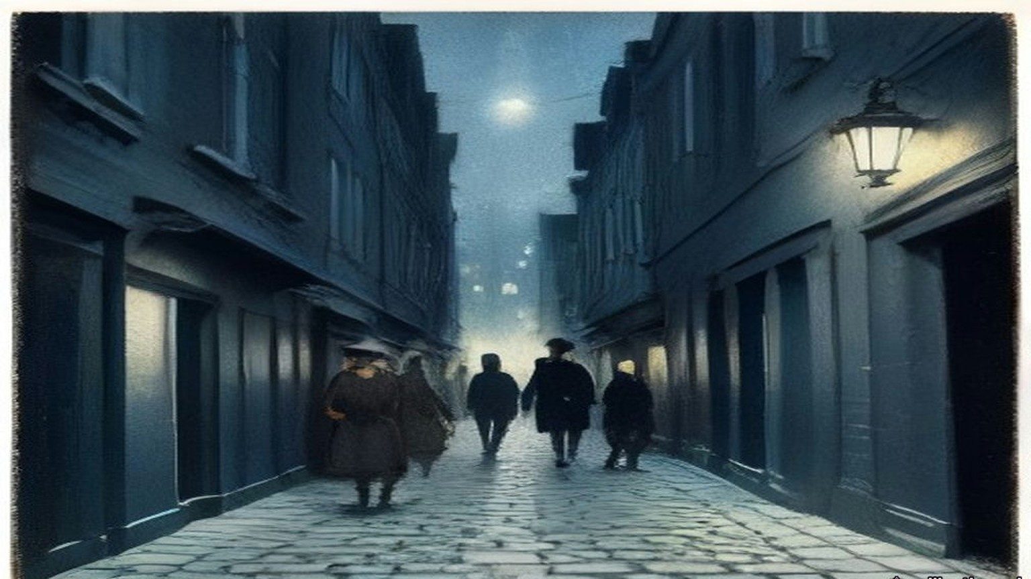
* * *
The Mansion House, Dublin, Tuesday, 21 January 1919
Seán Nunan had been born in London, drilled with the Volunteers in the German Gymnasium at King's Cross, fought in the Post Office in 1916 and done hard labour in an English prison for refusing to serve in the British Army. Now he was one of four clerks to Dáil Éireann. Cathal Brugha took the chair and proposed the four of them, Diarmuid Ó hÉigeartaigh, Riseárd Ó Foghludha, Seán Ó Núnáin and Pádraig Ó Síothcháin, and the House agreed.
Brugha told the public in Irish that they were there only to listen, and then said a few words in English for those who had no Irish. "We desire that there shall be no cheering whatever."
He read the roll. Antrim East, Lieutenant-Colonel McCalmont: as láthair, absent. Carson: absent. Joseph Devlin: absent. Denis Henry, South Derry: absent. Eoin MacNeill: present. Where the member was in jail it was Nunan's duty to answer for him, and he gave the same words each time.
"Fé ghlas ag Gallaibh." Locked up by the foreigners.
Arthur Griffith, twice. Éamon de Valera, for East Clare and again for East Mayo. Terence MacSwiney. Ernest Blythe, North Monaghan. For South Cork the Ceann Comhairle read Micheál Ó Coileáin, and the answer was as láthair. Countess Markievicz was in prison in England.
The Declaration of Independence was read in Irish, then in French, then in English by Eamonn Duggan, the member for South Meath.
"Now, therefore, we, the elected Representatives of the ancient Irish people in National Parliament assembled, do, in the name of the Irish nation, ratify the establishment of the Irish Republic and pledge ourselves and our people to make this declaration effective by every means at our command."
"We solemnly declare foreign government in Ireland to be an invasion of our national right which we will never tolerate, and we demand the evacuation of our country by the English Garrison."
The members stood and took the pledge after Piaras Béaslaí.
* * *
Soloheadbeg, county Tipperary, the same morning
Dan Breen and Seán Treacy had information that explosives were coming to the quarry at Soloheadbeg under an armed police escort. They expected it on 16 January. It came five days later. For five days they lay up behind the ditches above the by-road from Tipperary town, from before daybreak until two in the afternoon. After three days they kept eight men and sent the rest home, because they had no money to feed more. They slept at Breen's home, and his mother got them their breakfast at four every morning. On the fifth morning she said, "If you don't do something today, you can get your own breakfast tomorrow."
On 21 January the scout ran in. "They're coming, they're coming!"
They heard the horse's hooves first in the cold air, and the rumbling of a heavy cart. The driver, James Godfrey, and Patrick Flynn of the County Council, who was to take delivery, walked beside the horse. Two uniformed policemen with rifles followed a little way behind. Breen's pulse was racing until he saw them close. Then the nervousness went.
"Hands up!"
The policemen brought their rifles up to the ready. The call was made again. They did not give way.
"We took aim," Breen wrote. "The two policemen fell, mortally wounded."
They took the rifles and equipment and drove the cart off with more than a hundredweight of gelignite in it, Hogan on the reins and Treacy and Breen behind, on a farm cart without springs over a road of loose stones. Treacy reminded Breen that the book said explosives were dangerous when jolted. Afterwards they read in the newspapers the names of the dead men, Constables James McDonnell and Patrick O'Connell. A reward of £1,000 was offered for their capture. A few months later it was £10,000.
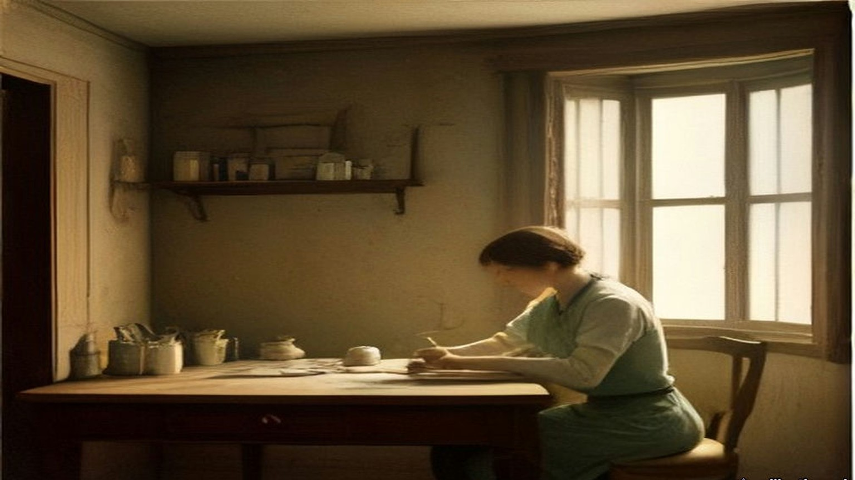
* * *
No. 1 Great Brunswick Street, one night in April 1919
In the early days at the Foleys', Collins called the papers he had been getting for two years their "correspondence course." Broy could see that he still did not understand the organisation behind them. They agreed that he would have to go into the office and read the books himself.
From ten at night until six in the morning one man was on duty in the Detective Office with the cipher, in case telegrams came. When the man on a week of nights had to go to court, someone covered him for a single night, and Broy was often chosen. Meeting Collins one night in April 1919, he was able to tell him he would be on duty the next night. Collins was to ring at twelve, to make sure there had been no last-minute change. He would be "Field." Broy would be "Long."
He went on at ten. The unmarried detectives went up to bed about eleven. From eleven, reports began to come in of shootings in Store Street and other places, and he wondered whether fate was going to take a hand. The inspector on night duty in the uniformed B Division next door was Daniel Barrett. Most uniformed officers gave the G Division a wide berth. Barrett was an ignorant, presumptuous man, quite capable of reporting a light in the office at night.
The secret office was on the first floor. It was semicircular, with many windows and blinds only on the bottom ones, and Broy saw he could not switch on the electric light there. The small secret room that held the books had no electric light at all. There would have to be candles.
Sergeant Kerr of the Carriage Office, a single man who slept in the building, was in the office talking to him, as he often was. At nearly half past eleven Broy tried to break the conversation off. At about a quarter to twelve Kerr said he would stay up and give him a hand, with all these messages coming in. They almost had a row. At about ten to twelve Kerr went to bed.
At twelve the telephone rang.
"Field here. Is that Long?"
"Yes. Bring a candle."
The new building had a brand-new set of keys and a master key in case any were lost. Broy had made himself another master key by filing one of the ordinary ones.
At about a quarter past twelve Collins arrived with Seán Nunan. Broy had told them to come armed and carrying sticks, because nobody could know what would go wrong. He let them in and showed them the back way and the yard door to Townsend Street in case anything happened.
A stone came through the window.
He looked at them. They looked at him. He sent them into a dark passage near the back door, to wait in the shadow, and went to look out on Great Brunswick Street. A policeman had a British soldier in custody on the pavement. Broy opened the door and asked what was wrong.
"This fellow is drunk and he is after throwing a stone in through the window."
The constable took the soldier into the station next door.
Broy went back and asked Collins for the candle. Collins had not brought one. He had thought Broy was having a joke at his expense.
Every D.M.P. station had a Staff Sergeant, the equivalent of an army quartermaster sergeant, who kept a store on the premises. A Staff Sergeant knew that he was always safe if he had too much of anything left over, and in trouble if he had too little, so the store was packed. Broy thought of his precious key. He opened the store and found plenty of candles, boxes of matches and soap. He took a couple of candles and a couple of boxes of matches and brought Collins upstairs.
With the same key he locked the main doors of the dormitories on the top floor, where the detectives were asleep. The same key opened the political office, and the secret small room built into the wall that held the records. He gave Collins and Nunan the candles, got them to close the door fairly tight, and went down.
As soon as he was downstairs there was a heavy knock at the door. It was the same constable, back to ask the value of the broken glass. Broy gave him a rough estimate, and the constable went away. Broy went up and told the boys what the noise had been, and came down again to mind the telephones.
Collins stayed from about a quarter past twelve until about five. He wanted the background of the correspondence. He wanted to know exactly how much the British knew about the Volunteers and Sinn Féin, which of their people were known, and, more important, which were not. "He wanted to try to gauge the mentality behind the records, and then to use the police secret organisation as a model, with suitable improvements and modifications, for Volunteer requirements." He took away with him the bound volume of every telephone message the G Division had received during Easter Week.
Nunan, nearly forty years later, remembered the night his own way. Collins kept him back at Vaughan's Hotel after the others had gone, and at about half past twelve suggested a walk. They walked round the city and came to the police station, where Sergeant Ned Broy was alone on night duty. Broy took them up to Inspector McFeeley's office and opened a large steel safe, and they stayed in it listing the detectives on political work until about four in the morning. Then they walked home, Collins to Mountjoy Street and Nunan to Botanic Road.
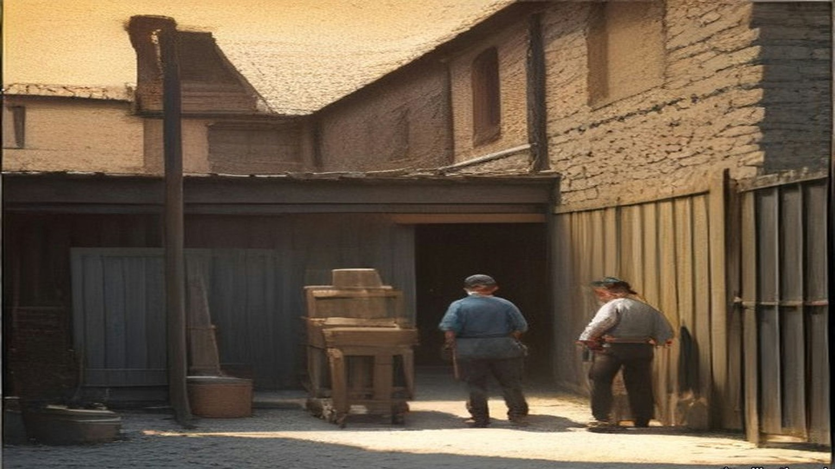
* * *
St. Stephen's Green and Millmount Avenue, 1919
One evening Broy and Joe Kavanagh were walking in St. Stephen's Green, and each found out that the other was in touch with Collins. Broy told him about the night at No. 1 Great Brunswick Street. Kavanagh knew the mentality of the G Division office and he knew Mick, and he nearly fell down laughing. He made Broy tell it a second time. He laughed so much that people looked at him as if he were drunk or mad. He asked what Mick had looked like in the office.
"He looked like a big plain-clothes man going out on duty, with a stick."
At their first meeting Broy and Collins had agreed that the uniformed men were to be let alone, and that no G man who was not active on political duty was to be touched. A G man who stayed hostile was to be warned first, by tying him to a railing. Detective Officer Denis O'Brien, a Kanturk man who had made a particular set against the Munstermen, was the first. When he was let go and taken to the Castle, the Superintendent asked him why he had let himself be tied up. "I would like to know what anyone else would do in the same circumstances," O'Brien said. To some of the others he said afterwards, "They were damned decent men not to shoot me, and I am not doing any more against them."
About a fortnight before the end of July, Jim Slattery was called to a house in North Great George's Street, where Dick McKee and Mick McDonnell asked a roomful of Volunteers whether they had any objection to shooting enemy agents. Most of them objected. Slattery said he was prepared to obey orders. McDonnell told him that Detective Sergeant Smith lived in Millmount Avenue, came home by tram, got off at Botanic Avenue and walked across Drumcondra Bridge. Slattery was to wait at the bridge with Tom Keogh, Tom Ennis and Mick Kennedy, who knew Smith by sight.
They waited about five nights. One night a man came across the bridge and Kennedy said he thought it was Smith, but he could not be sure. "If this man turns into Millmount Avenue we will shoot him," Slattery said. The man walked past the Avenue and went down a lane along the backs of the houses. Slattery nearly dropped to his knees, thinking he had nearly shot an innocent man. Then they knew it was Smith, and he was out of range.
About a week later they shot him. They had .38 revolvers. Slattery thought he would fall the moment they fired, but when they hit him he ran. All four fired. Slattery and Keogh ran after him to his own door. He got into the house.
In the morning McDonnell told Slattery they had made a right mess of the job. "I can assure you that I was more worried until Smith died than Mick was," Slattery said. After that they used .45s.
After the shooting of Smith there was no more shooting for some time. Collins wanted to see how the public and the Volunteers took it.
On 22 June 1920 Colonel Ashley read the House of Commons a list of what had happened in Dublin in twelve months, beginning: "31st July, last year, Detective Sergeant Smith shot and died in hospital. 20th October, Constable Downing brutally shot by three armed men in High Street, Dublin. 11th November, outrage in Dublin, Detective Inspector Wharton shot dead in St. Stephen's Green." The Attorney-General for Ireland, Denis Henry, answered him. The courts had awarded compensation to the widows and children of murdered policemen, and county councils were trying to evade paying it. The Government would bring in a measure to take the money out of the grants to the counties, and would advance "at least a substantial portion of it" to the widows in the meantime.
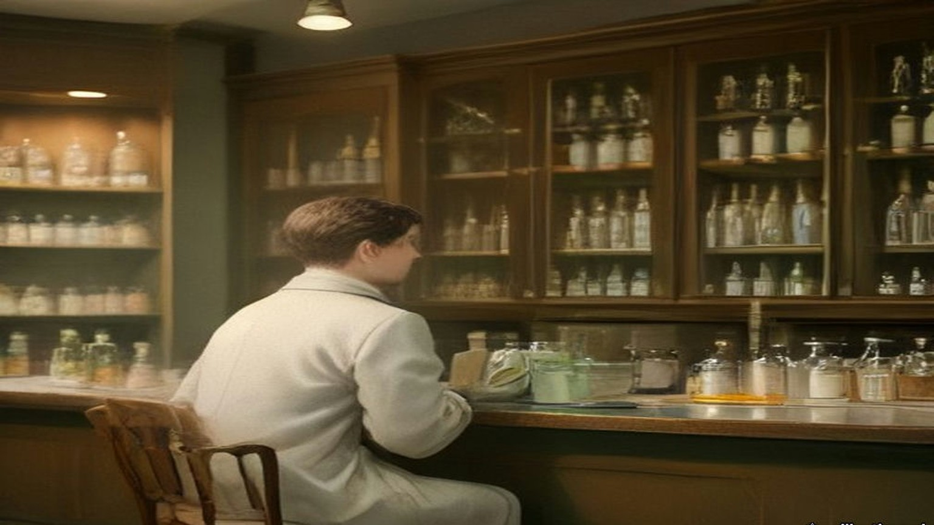
* * *
Dublin Castle and Arbour Hill, 1921
On the night of 31 December 1920 the Auxiliaries raided Eileen McGrane's flat at 21 Dawson Street and found part of Tom Cullen's dump of documents. Among them were copies of secret reports of the political section that Broy had given Collins, every one more than a year old. Joe Kavanagh was dead by then, of a blood clot after an operation for appendicitis in Jervis Street hospital in September 1920.
In January 1921 a Detective Sergeant pinned Broy down to having typed two of the reports in his presence. The captured copies of those two were typed twelve letters to the inch. Every machine in the police offices typed ten. Broy pointed that out. The Sergeant had stood beside him while he typed, and Broy had not dared make an extra copy, so he had put in new carbon sheets and given the carbons to Collins afterwards. Collins had had Miss Moran copy them on a portable typewriter, twelve to the inch. The Commissioner was puzzled.
In the third week of February Superintendent Purcell took him to the Commissioner's office in the Castle. Purcell came out trembling, his face as white as a sheet, and told him in a quavering voice that he was to be arrested for giving out the documents to the Sinn Féiners. For a matter of seconds Broy had the choice of knocking out the two officers and trying to shoot his way past the Auxiliary sentries at the gate with the small official .32. He had made up his mind long before not to try.
They searched him and took the pistol. A D.M.P. van with eight men and an inspector drove him to Arbour Hill Military Prison. On the way he put his hand in his pocket and found the master key.
The search at the Castle had missed it in a corner of the pocket. At Arbour Hill he was put in a cell and searched again by a military warder, who missed it too. The D.M.P. inspector was saying good-bye to him in front of the soldiers when the key fell out on the cell floor with a loud bang.
The inspector asked was that his key.
Broy said it was a key of the Detective Office, and that Superintendent Purcell would need it in the morning. He asked the inspector to get it to the Superintendent without delay. The inspector was a uniformed man and stood in awe of the detectives and of a Superintendent. He hurried off with it. To him it looked like an official key. Purcell had been only a few months in charge of the G Division, and when it came back to him from the prison he took it for one too.
His cell was at the corner nearest the commandant's office, with an iron gate and an iron door. That night he had the best sleep he had had in three months.
The warders were nearly all long-service men of the Royal Garrison Artillery, mostly from Kent. He found them decent, straightforward Englishmen. Philip O'Reilly came to act as his solicitor, far too fashionably dressed to be a good Irishman of the period, and Broy had the prison chaplain find out whether he was all right. O'Reilly told him that headquarters had considered a rescue: Volunteers in khaki on a lorry with faked papers, to take him into "custody," with Collins himself in the party. Broy would not hear of Collins taking part.
The court-martial never sat. The Truce came on 11 July. Immediately afterwards O'Reilly told him he would be out in a couple of days, because Collins was getting him out. A military lorry took him to the Bridewell. Coming out of the prison, the first thing he noticed was the green of the trees and gardens and the great beauty of red bricks.
At the Bridewell Purcell told him he must give bail from two persons, £1,000 each. Collins had arranged for two publicans to stand it. Both of them backed out, though they had posed for years as sympathisers. It was Saturday morning. Broy's brother came forward as one bail, though Collins did not like to bring his brother's house to notice. It was nearly one o'clock before the second was found, Peter Murray, a publican, got by D.M.P. men in the Bridewell at very short notice.
Purcell brought him before Edgeworth-Johnstone. The Chief Commissioner told him he was suspending him from the force, which should have been done on his arrest and had been forgotten. The prison commandant had refused to let the formality be completed while Broy was in Arbour Hill, so he would have to be paid in full up to that day. Then the Commissioner told him that by superior orders he had to dismiss him on the spot, which he personally regretted.
Broy walked with Purcell to Great Brunswick Street to be paid off. The man who had got the office job on his arrest was now the pay officer, a loyalist, and he paid out the money with the greatest reluctance. In the ordinary way a deduction was made for barrack accommodation. Broy had been accommodated in Arbour Hill, so none could be made.
Broy watched how badly he was taking it and asked him whether he would not charge him for his lodging in Arbour Hill.
That evening he was taken to Liam Devlin's public-house at 69 Parnell Street. Collins was there, and marked the reunion by demanding a wrestling bout.
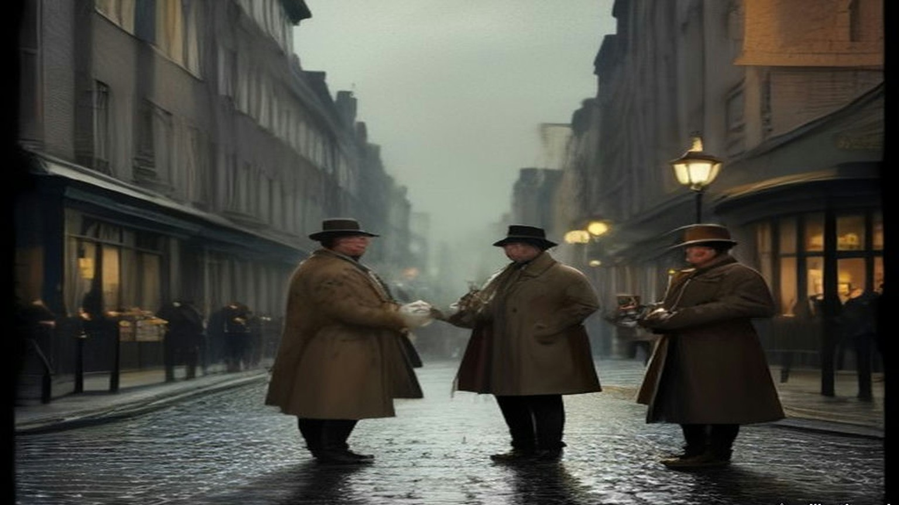
Chapter 18 Appendix of Important Names
• Carson, Edward (1 mentions in this chapter): Dublin-born barrister, Solicitor-General, and leader of the Ulster Unionist Council.
• Casement, Roger (1 mentions in this chapter): British consul who exposed atrocities in the Congo and Putumayo, later executed in 1916 for his role in the Irish Easter Rising.
• Collins, Michael (30 mentions in this chapter): Director of Intelligence for the IRA, signatory of the 1921 Anglo-Irish Treaty, and Chairman of the Provisional Government.
• De Valera, Eamon (11 mentions in this chapter): Surviving commandant of the 1916 Easter Rising, President of Dáil Éireann, and later Taoiseach and President of Ireland.
• Griffith, Arthur (1 mentions in this chapter): Founder of Sinn Féin and signatory of the 1921 Anglo-Irish Treaty.
• Murphy, William Martin (3 mentions in this chapter): Irish businessman, tramway owner, newspaper proprietor, and leader of the Dublin employers during the 1913 Lockout.
• O'Connell, Daniel (1 mentions in this chapter): Irish political leader who led the campaigns for Catholic Emancipation and the Repeal of the Union.
• Parnell, Charles Stewart (1 mentions in this chapter): Leader of the Irish Parliamentary Party and president of the Irish National Land League.
• Parnell, Henry (1 mentions in this chapter): Irish MP and financial reformer who advocated the repeal of the 1800 Union protective duties.
Sources
• Bureau of Military History, WS 1,280, Colonel Éamon Broy, statement in typescript with appendices (militaryarchives.ie, BMH.WS1280.pdf; local copy research/starter/WS1280.pdf and WS1280.txt). Page numbers are the statement's own. Used for: Ballinure, Rathangan, the Bog of Allen, the Curragh (p. 1); January 1911, the half year not counting, no oath in the Depot, Carey "a most dashing figure," Navin (p. 16); Flanagan, the hammer case, the piano wire and brass, "a sword to Wolfe Tone" (pp. 17–18); the "fairy blast," the photograph, 160 feet, "If I get in a couple of throws like that," "Ah, Dinny, I've won by inches in my time," 170 feet, the turnips (p. 18); Gleeson and O'Neill and Howth Road, fifteen and a half stone, "The Men of the West," "Just imagine a like you" (p. 19); the oath and the Freemasons proviso, batches of about 20, Ross of Bladensburg, Harrel (pp. 20–21); 1,200 men, batons, the "dying declaration" (pp. 21–22); E Division and the sprints, "By God, two parties can play at that game" (pp. 22–23); the G Division, Suspects with a capital S, the books (pp. 23–25); March 1915, Exchange Court, typewriters, copies to Edgeworth-Johnstone and Major Price, Owen Brien (pp. 24–26); the move to No. 1 Great Brunswick Street at the end of 1915 (p. 27); the telephone a couple of minutes after midday, Marrowbone Lane (p. 46); Constable O'Brien, "they are now carrying out the dead," the trains, the .32s (pp. 47–48); the soldiers' lists and Joe Cavanagh (p. 48); the field gun and the artilleryman killed from Bachelor's Walk (p. 49); Richmond Barracks, the record books and O'Hanrahan (pp. 50–51); the Kilmainham neighbour, "the volleys sounded in the morning like a clap of thunder" (p. 52); alone in the office from 11 a.m. from March 1917, America (pp. 66–67); the dangers (pp. 67–69); 14 August 1917, Fagan, 34 Munster Street, Peadar Healy at 86 Phibsborough Road, the teetotaller, the sprint, Revell, Hoey and Smith, Brien's "To be quite frank with you," de Valera's thanks (pp. 53–56); Patrick Tracy and O'Hanrahan's (pp. 69–70); the German Plot list, Benburb Street, "To-night's the night," "You will be much more comfortable here," "That man has just left," "the suck-in of his life," Greystones, "When you have got de Valera, surely you have got enough" (pp. 71–73); Greg Murphy, Millmount Avenue, the record book, 5 Cabra Road, the leggings and trenchcoat, 8 p.m. to midnight, de Valera's watch, the smile (pp. 74–76); the policy on the uniformed men and the railing (pp. 77–79); Denis O'Brien, "They were damned decent men not to shoot me," "After the shooting of Detective Sergeant Smith" (p. 80); the "correspondence course," the night duty, "Field" and "Long," Store Street, Barrett, the semicircular office, Kerr, "Field here. Is that Long?" "Yes. Bring a candle," the filed master key, 12.15, Nunan, the sticks, the yard door to Townsend Street (pp. 97–98); the stone, the drunk soldier, the Staff Sergeant's store, the dormitories locked, the secret room built into the wall, the constable and the glass, "a rough stimate," 12.15 to about 5 a.m., the reasons for the visit (pp. 99–100); Kavanagh, the Castle store pistols, St. Stephen's Green, "He looked like a big plain-clothes man going out on duty, with a stick" (pp. 100–101); the Easter Week telephone volume taken away that night (pp. 104–105); 21 Dawson Street, 31 December 1920 (p. 104); twelve letters to the inch, the carbons, Miss Moran (p. 109); Kavanagh's death in September 1920; the third week of February 1921, Purcell, the choice at the gate (pp. 111–112); the search, the van with eight men and an inspector, the key, the cell, the best sleep, the Kent warders (pp. 112–114); Philip O'Reilly and the rescue plan (pp. 115–116); the Truce of 11 July (p. 126); release, the Bridewell, the red bricks (pp. 127–129); bail of £1,000 each, the publicans, his brother, Peter Murray, the suspension and dismissal, full pay (pp. 130–131); the pay officer and the barrack accommodation (p. 132); Liam Devlin's at 69 Parnell Street, the "wrastling" bout (p. 134). Broy spells the detective officer Joe Kavanagh on p. 100 and Joe Cavanagh on pp. 48 and 111; the chapter uses Kavanagh throughout.
• Bureau of Military History, WS 1,744, Seán Nunan, signed 24 November 1958 (militaryarchives.ie, BMH.WS1744.pdf, via the Internet Archive). Used for: born in London in May 1890; the German Gymnasium; the G.P.O.; hard labour for refusing to serve; Vaughan's Hotel, about 12.30 a.m., the walk, Sergeant Ned Broy alone on night duty, Inspector McFeeley's office, "a large, steel safe," until about 4 a.m., Mountjoy Street and Botanic Road; Clerk of the Dáil and the roll-call, "Fé Glas ag gallaibh."
• Dáil Éireann, Official Report, 21 January 1919, item 2 (the clerks; "We desire that there shall be no cheering whatever"), item 3 (An Rolla: the absent members, "fé ghlas ag Gallaibh," Micheál Ó Coileáin "as láthair"), and the Declaration pages (the French text, the call for the member for South Meath to read it in English, the English text, Béaslaí and the pledge). https://www.oireachtas.ie/en/debates/debate/dail/1919-01-21/ pages 3, 4, 7 and 8 (the site refuses direct download; text read on the page and the passages used saved to sources/0018_sources).
• Dan Breen, My Fight for Irish Freedom (Dublin, 1924), ch. 4, "Soloheadbeg," read in the Internet Archive text of the Mercier Press edition (archive.org, my-fight-for-irish-freedom-by-dan-breen-1924). Used for: the explosives and escort; 16 January and five days' wait; the men sent home "because we had not funds for the purchase of provisions"; breakfast at four and "If you don't do something today, you can get your own breakfast tomorrow"; "They're coming, they're coming!"; the hooves and the cart; Godfrey and Flynn; "Hands up!"; "The two policemen fell, mortally wounded"; more than a hundredweight of gelignite; Treacy on jolted explosives; Constables James McDonnell and Patrick O'Connell; £1,000 raised to £10,000.
• Bureau of Military History, WS 445, Colonel James J. Slattery (militaryarchives.ie, BMH.WS0445.pdf, via the Internet Archive). Used for: the meeting in North Great George's Street about a fortnight before "the shooting of Detective Smith (30th July, 1919)"; McKee and McDonnell; Keogh, Ennis and Kennedy; about five nights at Drumcondra Bridge; "If this man turns into Millmount Avenue we will shoot him"; the .38s; "a right mess of the job"; "I was more worried until Smith died than Mick was"; .45s after.
• House of Commons Debates, 22 June 1920, vol. 130, "Maintenance of Law and Order" (Colonel Ashley's list; Denis Henry on the widows' awards and the advances). https://hansard.parliament.uk/commons/1920-06-22/debates/9a050c99-01bb-420f-a78e-e0f180a653de/MAINTENANCEOFLAWANDORDER

Chapter 19
Thirty Revolvers on the Field, 1920
Fingal, Balbriggan, Westminster, Upper Pembroke Street, Croke Park and Cork, September to December 1920
Joseph Lawless farmed at Saucerstown, near Swords, in the part of north county Dublin that its people called Fingal. In the summer of 1920 he was an officer in the Fingal Brigade, and he spent the season watching lorries. The Black and Tans had their depot at Gormanston Camp, and their convoys went to and fro on the roads past his fields every day. The British military from Collinstown Aerodrome had put a post into Swords House, the big empty residence in the town. Nothing was done about any of it.
The Brigade Commander, Michael Lynch, was a city man. He had taken on the reorganising of Fingal in 1917, he still lived in Dublin, and he came out to preside at Brigade Council meetings that were few and formal. When the officers raised their own idleness at one of them, Lynch told the meeting that Collins had instructed him that no active operation was to be undertaken in Fingal without Collins's specific sanction. Some of them did not believe it. Years afterwards Dan Brophy told Lawless that he had been in Collins's office with dispatches about then, and had passed on the officers' grumbling. Collins said he did not want the British to declare north county Dublin a military area. It would cut the city, and General Headquarters with it, off from the north and west. He wanted the country behind the city quiet, a place where hard-pressed men from the city units could go to rest or get away from pursuit.
Lawless found it galling all the same. Peter White, the Company Commander in Ballyboughal, felt as he did and was less constrained by notions of discipline. One night in the middle of September White went into Balbriggan with a couple of his men, and they shot dead Burke of the R.I.C. and wounded a sergeant.
Balbriggan was about three miles from Gormanston. It was the district headquarters of the R.I.C., and Tans on local pass from the camp came into its public-houses. Later that night, 20 September 1920, lorry loads of them came down on the town and set fire to it. The stocking factory, the town's chief industry, burned to the ground. So did about thirty shops and dwelling houses. The Tans went round firing shots at random, and the people were terrified. A queer individual was seen leading an R.I.C. party to certain houses, among them the houses of James Lawless and John Gibbon. The two men were taken out and shot dead on the spot.
Lawless knew of no special reason why those two had been chosen. The only reason he could think of was the name. A Lawless in Balbriggan could be taken for one of his own family. The man who had walked in front of the police party had been seen before on the roads round Fingal, on foot, dressed as a beggar. The beggars who went round selling studs and bootlaces, or collecting mushrooms and crab apples in season, were known to the country people one by one. This one had turned up suddenly and gave no account of himself that anyone believed. The people called him Jack Straw. After the sack of Balbriggan the story of his walking with the R.I.C. went round, and the Volunteer intelligence officers began to look for him.
On 6 October a woman in Balbriggan sat down to write to a trade union official she knew. "Just a line to let you know we are still alive, but don't know the minute," she wrote. "I would have written before, only we are expecting a raid every night, and you cannot settle yourself to do anything." The Tans had been back. They had pasted bills on the doors and turned people out into the fields for a night. "They are even shooting the dogs in the street. I wonder how it will all end. There comes quite a crowd from all parts to see the ruins."
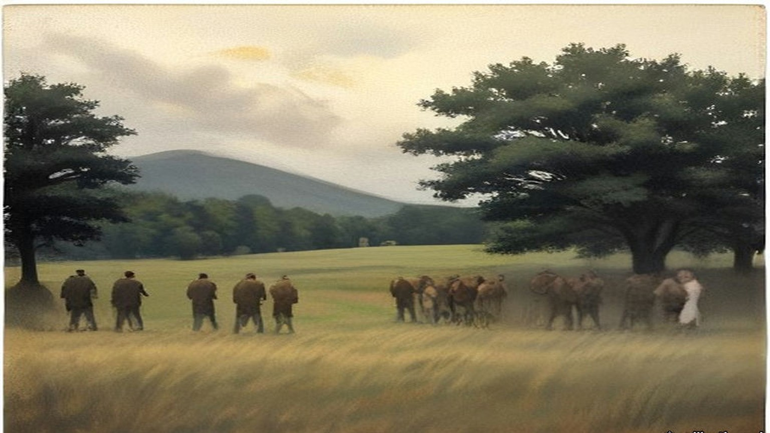
* * *
House of Commons, Wednesday, 20 October 1920
Arthur Henderson, the member for Widnes, rose for the Labour Party and moved the motion standing in his name:
"That this House regrets the present state of lawlessness in Ireland and the lack of discipline in the armed forces of the Crown, resulting in the death or injury of innocent citizens and the destruction of property; and is of opinion that an independent investigation should at once be instituted into the causes, nature, and extent of reprisals on the part of those whose duty is the maintenance of law and order."
It was a vote of censure, and it held up the Government of Ireland Bill for a few hours. Henderson read figures. In 1917, 349 arrests for political offences; in 1918, 1,107. In the two years together, as far as he could learn, one policeman killed. In 1919, 14,000 armed raids on private dwellings and 25 newspapers suppressed. He had spent a couple of weeks in Ireland early in the year with some of his colleagues. They had reached Thurles one morning after a policeman had been shot there in the night, and the first man they met at the station was a policeman, who told them what had happened and then volunteered that he was going to have a little of his own back that night. The cheers that came when Henderson spoke of the provocation offered by the other side were, he said, about the first cheer since he had risen.
The Chief Secretary for Ireland, Sir Hamar Greenwood, answered him. He came to the forces of the Crown. The Army wore badges of valour from the war. The police had been reinforced from two sources: ex-soldiers who enlisted as ordinary constables, and were coming in at over 300 a week, and ex-officers. "This is called the auxiliary division and is composed entirely of ex-officers, ranking from Brigadier-Generals to subalterns," he said, "and I have yet to find one authenticated case of a member of this auxiliary division being accused of anything but the highest conduct characteristic of them."
He gave cases. One was Ennistymon and Lahinch in county Clare, where four policemen had been killed in an ambush and a fifth hunted down on the road, and where soldiers and police, coming on the bodies within ten minutes, went into the two villages and damaged or destroyed sixteen houses and shops. "I am admitting what is called a reprisal," Greenwood said. A member called out, "And justifying it!" Greenwood said the people of those villages had known of the ambush. "The Irish Republican Army is particularly strong in that area. We have lists of the members. We have the muster roll in that area."
Somebody called "Take Balbriggan?" and he took it. Asquith, the member for Paisley, had compared Balbriggan with a Belgian town in the war. "Has he seen Balbriggan?"
"No," said Asquith.
"I have. I claim to be an authority on Balbriggan." He admitted at the start that the case was one he had every right to regret, "because it did mean a certain break in the splendid discipline of the Irish police." Head Constable Burke had lately been decorated for his gallant defence of a barracks. He and his brother, Sergeant Burke, had gone into a public-house, both unarmed, and had been surrounded by men Greenwood could only call assassins. The Head Constable was shot dead, the sergeant dangerously wounded. Men from two depots miles away heard of it and came in lorries. When they saw the bodies, "they saw red." That night, he said, nineteen houses of Sinn Féiners were destroyed or damaged, four public-houses were destroyed, and one hosiery factory employing 200 hands.
"Two men were also killed," said Lieutenant-Commander Kenworthy, the member for Central Hull.
"And two men were killed."
"Murdered!" said Asquith.
"If the right hon. Gentleman the Member for Paisley gets any satisfaction out of it, I will say 'murdered.'" Greenwood had held the fullest inquiry. "I found that from 100 to 150 men went to Balbriggan determined to revenge the death of a popular comrade shot at and murdered in cold blood. I find it is impossible out of that 150 to find the men who did the deed, who did the burning." He had laid down a still stricter code of discipline and addressed a parade. "But I cannot in my heart of hearts," he said, "condemn in the same way those policemen who lost their heads as I condemn the assassins who provoked this outrage."
On the creameries he gave numbers. Kenworthy had said a hundred were burned. There were 710 in Ireland, Greenwood said, and sixteen had been destroyed and eleven partly destroyed. He had never seen a tittle of evidence that servants of the Crown had done it. As for the economy, the Exchequer's estimated revenue from Ireland for the first six months of the financial year had been very nearly equalled by the actual receipts.
Kenworthy had his own report. In some places, he said, soldiers were acting under officers who told them they had orders to burn certain houses. "In some cases the officers apologise to the inmates, who are usually women, and the soldiers have actually assisted in getting the furniture out of the houses."
Asquith closed for the motion. His information on Balbriggan, he said, came from friends who had been there, not from any Sinn Féin source. A couple of hours after the shooting the Black and Tans had come into the town, taken two men to the police barracks, and then set about arson and looting. In one of the main streets a whole row of poor houses was destroyed. Across the street five cottages lately built by the local authority were burned. "In all, 35 houses were destroyed."
"No, no!" said members.
"Let us have an inquiry." The fires went so fast, he had been told, that women and children barely had time to get out half-clad to the fields. Of the two men taken to the barracks there was not a shadow or tittle of evidence connecting either of them with the shooting of the police. They were taken out while the burning went on and shot in cold blood.
T. P. O'Connor, the member for the Scotland division of Liverpool, added what Greenwood had left out. Some of the men in the raid had been woken out of their beds at half-past ten, hours after the shooting. They had come supplied with lorries and petrol, and O'Connor asked how they could have got them except with the help of officers. The first place they visited in Balbriggan was a public-house, and they got drunk before they went out again. And the two men, he said, by the account he had found in the papers, "were prodded with bayonets before they were murdered."
The House divided. Ayes, 79. Noes, 346. There would be no independent inquiry.
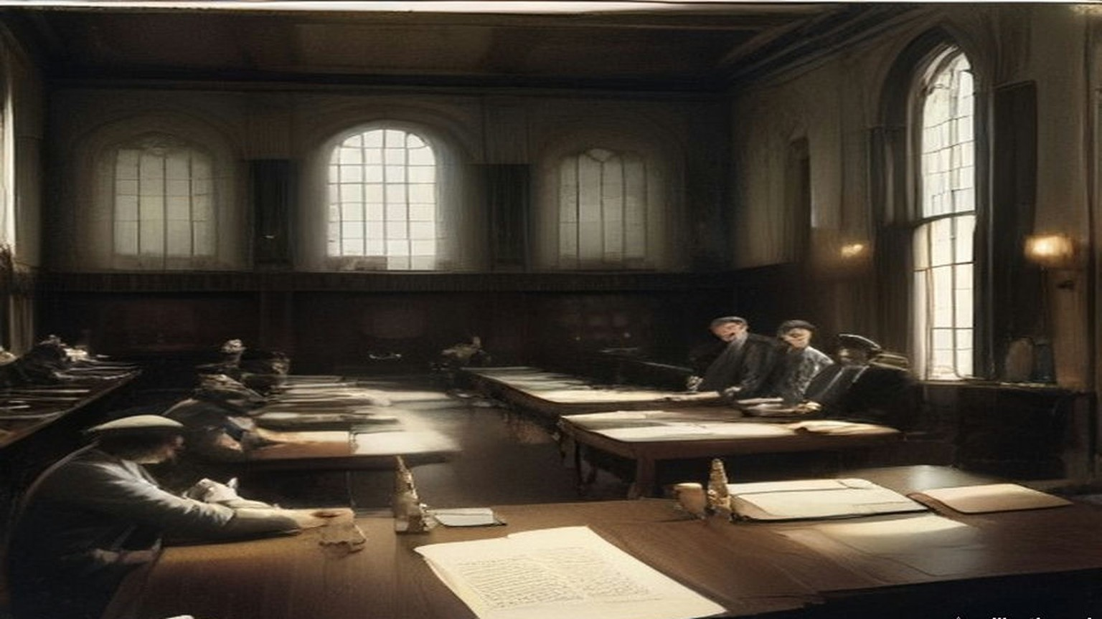
* * *
From Ballybrophy to Phil Shanahan's, Saturday, 20 November 1920
Thomas Ryan was in the Tipperary football team that went up to Dublin on Saturday the 20th to play Dublin at Croke Park the next afternoon. The team was picked from all over the county and came together on the train, and it was not until Ballybrophy that the full complement was aboard. There the Kilkenny train brought in four more of them: Mick Hogan, Jerry Shelly, Dick Lanigan and Seán Brett.
Shortly after the train left Ballybrophy a crowd of soldiers of the Lincolnshire Regiment got on. Some of them went into the carriage where Jacky Brett, another of the players, was sitting with a Father Delahunty from Kilkenny, and passed unseemly remarks. Brett went for them and was knocked down. The priest called out for help. Ryan and the others were in the middle of a penny twenty-five card game and had noticed nothing. They rushed to the carriage, saw what had happened, and saw red. Ryan and Jim Ryan enjoyed themselves immensely playing handball with half a dozen of the soldiers. When they had them all down for the count they picked two of them up and pitched them out through the carriage window.
The whole train was wild for a while, then it calmed. Thinking it over, the players fully expected to be met at Kingsbridge by military and police and arrested. Nobody was waiting. They scattered anyway. The team was booked into Barry's Hotel in Gardiner Place, and instead they divided themselves up among several other hotels.
Hogan and Ryan were the only two Volunteer officers on the team, and they went to Phil Shanahan's. At about nine o'clock that night they heard there was a big job coming off in the morning, and nothing more. D. P. Walsh came in on a mission to collect arms. He took Ryan down to Shanahan's cellar, where there were revolvers and .45 ammunition stored in porter bottles, and asked him to help carry some of it up to Fleming's Hotel in Gardiner Place. They walked one on either side of the street, so that if either was stopped or fired on, the other could fire on the attacker. It was Ryan's first taste of the war in the city. They got there without trouble, and when they came back Ryan volunteered to take part in the morning's work, whatever it was. In between they had gone to confession, and felt fully prepared for whatever turned up.
Somebody in Shanahan's grew uneasy that the two countrymen knew so much. A hush came over the place, and they were told the whole thing was called off or postponed. They went back to their lodgings and went to bed.
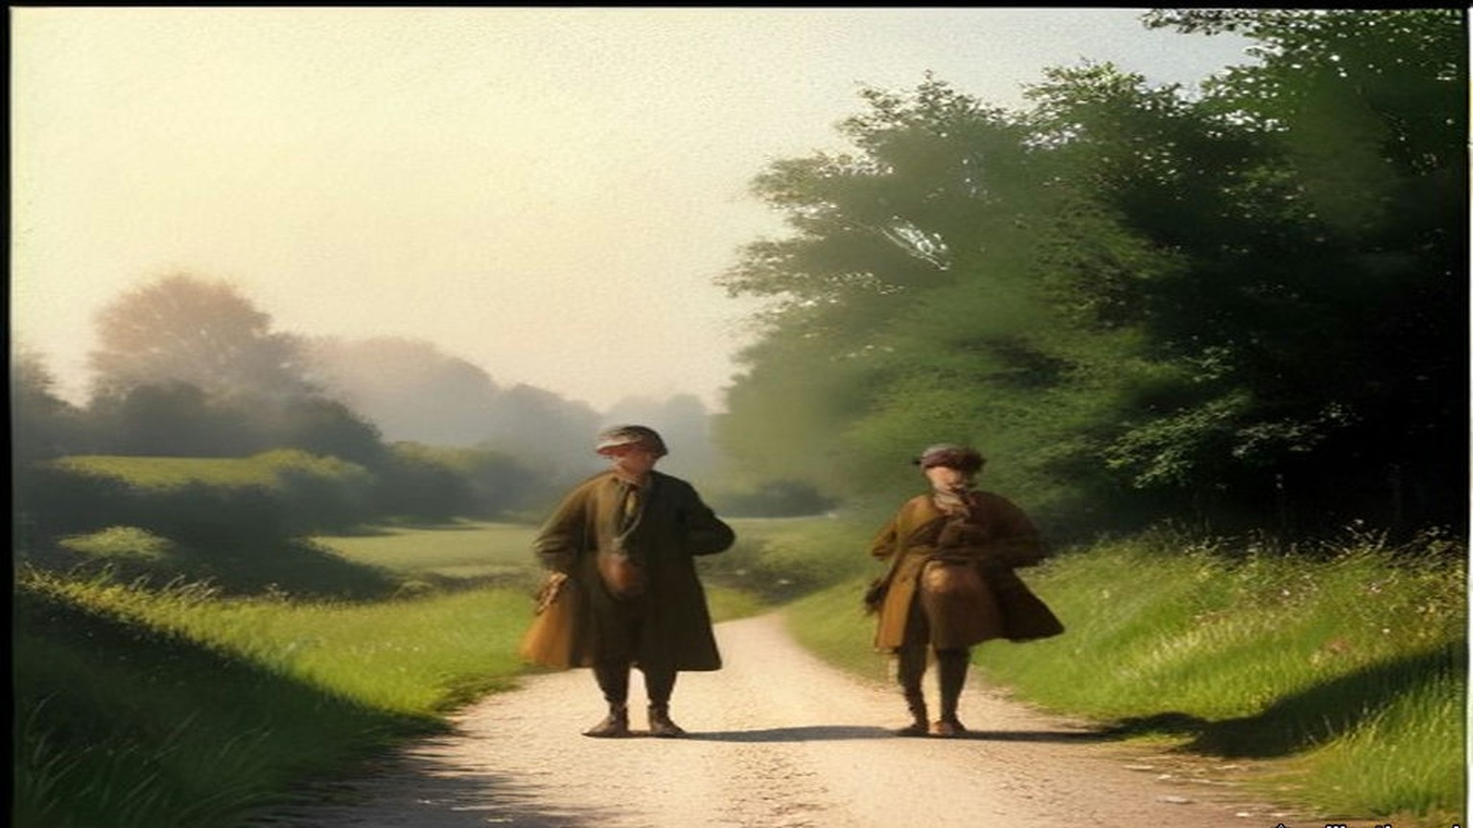
* * *
28 Upper Pembroke Street, Sunday, 21 November 1920, nine o'clock
Charles Dalton had been sent to meet a girl who had told a Volunteer about some strange residents in the block of flats where she was a maid. He met her in the Volunteer's home over a shop in Talbot Street. Her name was Maudie. The residents, she said, followed no regular occupation, but did a lot of office work in their flats. Dalton arranged for her to bring him the contents of their waste-paper baskets. In the torn-up papers were notes on the movements of wanted Volunteers, and photographs of wanted men.
He met Maudie for the last time on Saturday evening, the 20th, at their rendezvous. All her boarders were at home, she said, except two who were moving that night to Upper Mount Street. Dalton reported it to Dick McKee at Brigade headquarters. McKee had already briefed every party for the morning, and he made up a patch unit for Upper Mount Street. Before curfew Dalton went to Harcourt Street to meet the officer who would go with him to 28 and 29 Upper Pembroke Street. It was Paddy Flanagan of the 3rd Battalion. They fixed a place to meet. Dalton slept that night where he always slept while on the run, in the dugout in the unoccupied part of Summerhill Dispensary, and there were several other men there who were going into action in the morning.
At Upper Pembroke Street he found Flanagan and a few others. They had no keys to the hall doors, and they went over the arrangements again. At nine o'clock, the hour fixed, the hall door was open and the porter was on the steps shaking mats.
It was a double house, with a separate staircase on each side, and a party went up each. Dalton went with Flanagan and two others to a room at the top of the house where two officers lived, one of them Lieutenant Dowling. They knocked and pushed the door open. The two men were awake in bed. They were told to stand up, and they were shot. Dalton said he wanted to search the room.
"Search be damned! Get out of here."
They went down to the hall. A number of officers had been brought out of their rooms and lined up against the side of the staircase that led toward the basement. The party's arrival at that level was the signal for a volley. Six or seven men lived at the address, Dalton said afterwards, all holding British commissions, and all were shot. A few lived. The papers taken that morning went to Mrs. Byrne's house in North Richmond Street, and Dalton carried them on to the intelligence office in Crow Street.
Detective McNamara of the Castle told him afterwards what he had seen there. Cabs and side-cars and every kind of conveyance had brought people into the Castle yard, men who had been working quietly against the I.R.A. and who now came in for protection.
On Monday the Chief Secretary read the House of Commons the telegrams from Dublin "just as I have received them." The sixth of them was Case F.
"Residence of Mrs. Gray was raided at nine this morning by about 20 men, some of whom came on bicycles. The house consists of several flats." Mrs. Gray and her maid had gone from room to room afterwards. Major Dowling of the Grenadier Guards was dead at his bedroom door. Captain Price of the Royal Engineers was dead in the room next door. Captain Kenlyside's wife had struggled with the men, and he was wounded in the arm. Colonel Woodcock, Colonel Montgomery and Mr. Murray of the Royal Scots were wounded. "A lady resident in the house went from room to room seeking help, and in every room found only dead, dying, or wounded men."
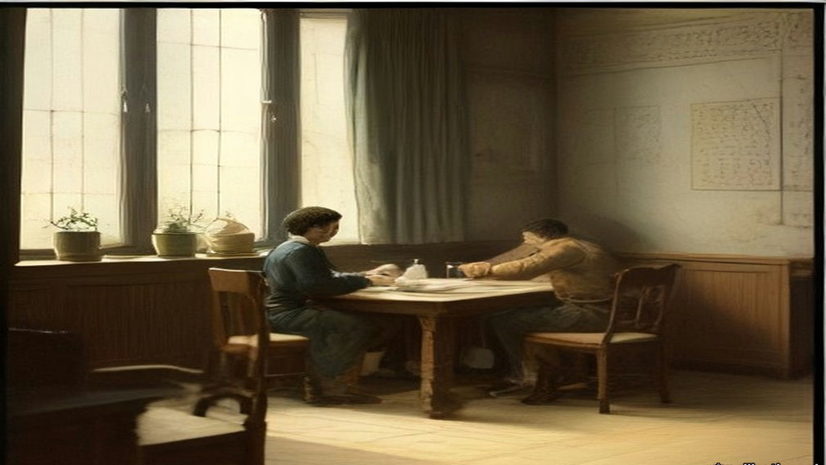
* * *
Croke Park, Sunday afternoon, 21 November 1920
Phil Shanahan called at the lodgings in the morning and told them. Ryan and Hogan walked across the town and went round Mount Street and the other places where the shooting had been. There was nothing to see. About eleven a message came from Dan Breen, who was staying somewhere in Phibsborough. Breen was going back to Tipperary soon and would be glad of Ryan's company. He also thought it very inadvisable for Ryan to show himself at Croke Park that day. Ryan went to Croke Park and took his place in the team.
The match had been going about ten minutes. Play was round the Dublin goal. A penalty was given against Dublin, and Ryan was about to take the free kick. An aeroplane flew over and fired a Verey light. Then came a burst of machine-gun and rifle fire.
The crowd broke at once. The players ran off the field in among the spectators on the sideline, all but six of them, who threw themselves flat on the grass. Hogan and Ryan were two of the six. The other four were Dublin men, Volunteers too, as far as Ryan knew, and he put it down to their training that they lay down instead of running. From where they lay they could see sparks flying off the railway embankment wall where the bullets struck it, and people rolling down the embankment who had been hit.
Two of the six got up and ran for the paling round the pitch on the Hill Sixty side, which was nearest. The others followed one by one. Hogan was hit while running from the field to the paling. Ryan and Josie Sinnott were the last off. Ryan went to Hogan and tried to lift him. The blood was spurting from a wound in his back.
"Jesus, Mary and Joseph! I am done!"
He died there. Ryan's hands and jersey were covered with his blood.
The Auxiliaries had not come onto the pitch. They were all round the ground, herding people into groups with their hands up and searching them, and here and there one of them kept firing in every direction. As Ryan reached the paling he saw an Auxiliary push a round into the breech of his rifle and look his way. He dropped. A youngster near him fell. He jumped the paling into the crowd.
He was the only man on the Tipperary team who wore the tricolour on his stockings and knickers, and he knew it marked him. He ran across Hill Sixty and got out over the wall, and into a house on Clonliffe Road. The house was soon surrounded, and the door forced in. An old man in the hall said something to them and was knocked down with the butt of a revolver. One of them saw Ryan.
"There is one of the Tipperary assassins! Take him out and shoot him!"
Two of them had bayonets drawn. They knocked him down and ripped his stockings and knickers off him with the bayonets until he was naked. An officer came and told them to bring him back to Croke Park, where he would be shot with the rest of the team. Ryan did not take it for mercy. He thought the officer wanted to be tidy and have all the shooting done in one place.
They marched him back along the road with nothing on. People were still jumping from the wall. One man had come down on the spikes of an iron railing. A spike was through his thigh, and others were climbing over the railing on his body. A man standing with his girl, his hands up, took pity on Ryan's nakedness and threw him a coat, and got the butt of a rifle for it. Ryan was not let keep the coat. Inside the gate a priest was ministering to the wounded and dying, holding the Blessed Sacrament aloft, and a drunken Tan came up behind and knocked him flat with a revolver butt.
The people in the ground had had their hands up for about twenty minutes by then, and some were falling down from the strain. Ryan was put against the railway wall with the rest of the team, and a firing party stood in front of them while the crowd was searched. A military officer told them that if there was any shooting or resistance during the search, he had orders to shoot two of them for each incident. Their clothes in the dressing-room were searched for documents and arms. Nothing was found. The searchers took every penny that was in their pockets.
That night an ex-officer of the British Army, Jack Kavanagh of Seville Place, divided £50 among the team so that they could live and get home. The Dublin players took them into their own houses round Seville Place and O'Toole's parish. Ryan stayed with Stephen Sinnott. In the night there was a raid a few doors away and a man was taken out and shot. Ryan, Tommy O'Connor and Sinnott went out into the yard and buried themselves in a heap of manure until the noise had died away. The raiders never came to Sinnott's door. The papers next day mentioned a naked player. That had been Ryan.
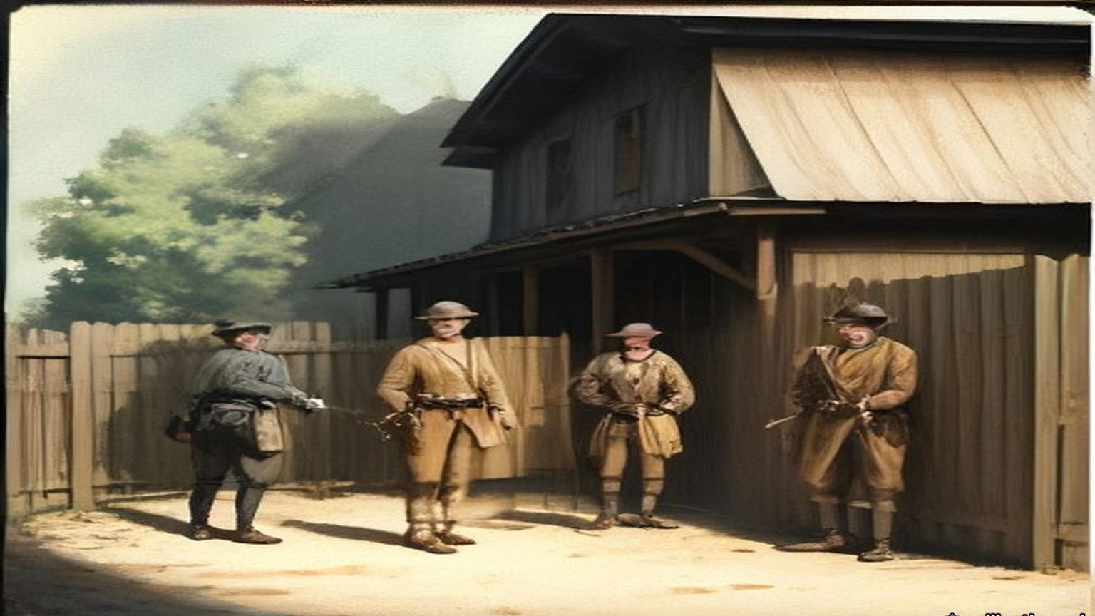
* * *
House of Commons, Monday 22 November to Thursday 9 December 1920
Joseph Devlin, the member for the Falls division of Belfast, sat through the Chief Secretary's telegrams on Monday afternoon. Greenwood had begun by saying, "We are fighting an organised band of paid assassins," and he read the details of the morning in Dublin, house by house, from Case A in Lower Baggot Street to Case H in the Gresham Hotel. "There have been fourteen deaths." Then the Prime Minister answered a question about stronger powers.
Devlin got up. He wanted to know why, when the Prime Minister and the Chief Secretary were asked to recite everything that had happened in Dublin on Sunday, the House had heard nothing about soldiers at a football match. "At which ten people were killed."
"Sit down!"
"I will not sit down." He wanted to know why the House had not been told of the rush of soldiers onto a football field with 15,000 people on it, the indiscriminate shooting, and ten men killed.
Greenwood said he had never been asked. Devlin rose again to put more questions, against loud shouts of "Sit down!" Grave disorder broke out. The Speaker suspended the sitting at five minutes past four, and the public galleries were closed.
When the Speaker came back at twenty past four, Major Molson rose first. "I wish to apologise to the hon. Member for the Falls Division," he said, "to you Mr. Speaker, and to the House. I am afraid that I allowed my feelings to get the better of myself, and I forgot myself." Devlin accepted it and said he had no personal feeling in the matter. His complaint, he said, was with members who took order out of the Speaker's hands and howled down a minority. T. P. O'Connor had sent the Chief Secretary notice on Sunday that he would ask for everything that had happened in Ireland over the week-end. Devlin asked again for the whole story.
Greenwood now read the answer from Dublin. "The authorities had reason to believe that Sinn Fein gunmen came into Dublin on Sunday under the guise of attending a hurling match between Dublin and Tipperary, but really to carry out the Sunday morning's murders." A mixed force of military, R.I.C. and police had surrounded the playing fields to search for arms. "This force was fired upon and they fired back, killing 10 and wounding others. About 3,000 men were searched. Thirty revolvers and other firearms were found on the field. I regret to say that a woman and a man were crushed to death in the crowd."
"Is that the total casualty list?" asked Kenworthy.
"Ten killed, a number wounded and a man and woman crushed to death in the crowd."
Devlin asked whether a single incriminating document had been found on any of the 3,000. Members shouted, "Revolvers!" Before the exchange ended Jeremiah MacVeagh had called out "Begin with Carson," and then "he began," and Sir Edward Carson had answered him across the floor, "You are a liar!" The Speaker said he had not heard it.
On Tuesday Kenworthy asked by private notice about the killing and wounding of some eighty civilians at Croke Park, how many volleys had been fired, for how long, and whether there would be an inquiry. Greenwood read a fuller account, "compiled from report made by police and military, after very careful investigation."
The round-up had been carried out "according to a preconcerted plan." Once the military had surrounded the field, an officer was to tell the crowd "through a megaphone" that a search was to be made by the police "and that no anxiety need be felt by innocent persons." Before the cordon was complete, civilians posted to watch the approaches saw the police coming. The police were fired on from two corners of the field. Men in the grandstand rose and "fired three quick shots with revolvers into the air. Of this there is indisputable evidence." The crowd stampeded, "mostly to one side of the field, where a corrugated iron railing was the only barrier to be surmounted. Through its fall a number of people were crushed." Armed pickets outside kept up a fire on the police, who returned it. "The firing lasted not more than three minutes. About 30 revolvers, thrown away by men who had formed part of the spectators, were picked up on the ground. Twelve persons lost their lives, 11 were injured seriously enough to warrant their detention in hospital, and about 50 persons sustained slight hurt." The responsibility rested "entirely upon those assassins."
Kenworthy asked whether Greenwood knew that many eye-witnesses were ready to swear that no shots had been fired at the police, and that the so-called pickets were men selling tickets outside the field. Mr. E. Kelly asked at what stage it had become necessary to turn a machine gun on the people, and how a little boy of ten came to be bayoneted to death. Greenwood was not aware that any machine guns were used, nor did he believe that a boy of ten was bayoneted. Devlin asked why, if revolvers had been taken from people at Croke Park, nobody in possession of one had been arrested. MacVeagh asked whether any shots had been fired from the aeroplane that was hovering over the ground. Greenwood asked them to put those questions down.
On 2 December Mr. Pennefather asked about the pastoral letter of Cardinal Logue, which said that "a general indiscriminate massacre of innocent and inoffensive victims was perpetrated at Croke Park, Dublin, last Sunday week by forces of the Crown." Denis Henry, the Attorney-General for Ireland, said the passage represented "a complete misunderstanding of what took place." MacVeagh asked if he was aware that "English and American newspaper correspondents who were present flatly contradict the statement." On 9 December, in a written answer, Greenwood agreed that his attention had been drawn to an observer's statement that the attack, in which fifteen people were killed, was made without provocation or warning.
Between Monday and Tuesday the number killed at Croke Park had gone, in the Chief Secretary's own answers, from ten shot and two crushed to twelve.
* * *
Balbriggan and Croke Park, December 1920
William Lunn, a Labour member of the Commons, crossed to Dublin on Tuesday, 30 November, with the Labour Party's Commission to Ireland. The Commons had refused an independent inquiry, so the party had set up its own. Henderson was its chairman. With him and Lunn went J. Lawson, the party's chairman A. G. Cameron, F. W. Jowett, J. Bromley and W. Adamson, with Brigadier-General C. B. Thomson as military adviser and Captain C. W. Kendall as legal adviser. Greenwood gave them every help. They were issued permits to travel by motor anywhere at any hour.
They took evidence at the Shelbourne Hotel. They went out to Balbriggan and saw the shell of the hosiery works of Deedes, Templer and Company, which belonged to an entirely English firm and had employed 109 people inside and at least 120 outworkers. Smith and Company's factory, the other hosiery works in the town, had been saved only because a local man appealed to the policemen who said they were going to burn it. In one long street almost every house was burnt or had its windows broken. On the other side were the newer houses put up by the local authority, now in ruins. Witnesses told them in the Town Hall that the men had waved their caps and cheered at the fires, and had looted drink, and that a local policeman who said it was "going too far" was sworn at when he asked them to stop.
The Commission wrote down what else the fields had cost. Besides the two men shot, two women had died from the effects of exposure, two women had miscarried as a result of the night, and four babies who were sick with measles had been carried out to the fields and had died of it. For days afterwards the town emptied at nightfall, because the people were afraid of another attack.
At Croke Park they reconstructed the scene of 21 November and took evidence on the ground. Not one witness supported Greenwood's statement that the police had been fired on from two corners of the field. The evidence was that the police began firing almost as soon as their lorries stopped. Rifle fire went down Russell Street, the way the lorries had come, and over the turnstile entrance at the spectators inside. A man was mortally wounded about half way down Russell Street. A young woman was shot dead beside her fiancé near the centre line of the field. A small boy who had climbed a tree just inside the turnstiles was brought down wounded. The Commission could neither confirm nor disprove the signal shots from the stand. It asked why, if pickets and gunmen had kept up a fire on the police, there had been no casualties among the police, and no armed prisoners taken. By the evidence given to it, the R.I.C. and Auxiliaries had done the shooting, and the soldiers had taken no part.
The Commission's report was printed in London in 1921 and sold at two shillings, or two and threepence post free. It gave its verdict on Croke Park as "a ghastly tragedy resulting from official errors of judgment and incompetence," and Balbriggan as "a clear example of a 'reprisal' where men wearing the uniform of the British Crown broke out of control and took a savage revenge upon the whole population of the town."
On 29 December Lunn spoke at the special Labour Party conference on Ireland. He told the delegates how Greenwood, in the Commons, had pointed across at Asquith and asked whether he had been to Balbriggan. Lunn had it, he said, on the best authority that Sir Hamar Greenwood had gone through Balbriggan at more than twenty miles an hour in a motor, on his way to address recruits three miles away.

* * *
Cork, Saturday night, 11 December 1920
Captain Alfred Hutson, superintendent of the Cork fire brigade, had come on duty at seven on Saturday morning. At about ten that night a call came in about a fire at Dillon's Cross, where there had been an ambush that day. At half past ten he got the call to A. Grant and Company in Patrick Street. The fire had taken hold when he reached it, and the flames were coming through the roof. He got three lines of hose to work, one in Mutton Lane and two in Market Lane, the passages on either side. With a good supply of water they kept the fire to Grant's, and saved Hackett's and Haynes's, the jewellers next door, with slight damage. Behind Grant's was the Market, a building mostly of timber. If it caught he would have a conflagration on his hands. Apart from a few small outbreaks in its roof, they saved it.
At about half past eleven the Town Clerk sent word that the Munster Arcade was on fire. Hutson sent every man and appliance he could spare. Soon after came word of Cash's. He shortened the hose at Mutton Lane and sent all the stand-pipes, hose and men he had. He found the Munster Arcade and Cash's both alight from end to end, beyond saving, and the fire running into the next buildings. They brought every hydrant and main they could reach to bear, chose the points where the fire could be checked, and fought there. The General Post Office brought out its own fire appliances, which did good work around Winthrop Street and Robert Street. Then he found that the new hose had been cut in several places in the street and was no further use.
About four in the morning he was told that the Municipal Buildings were on fire. There was a practical man in charge there, with half a dozen men, who had put out fires in the City Hall three times already, and Hutson trusted him to do it again. The incendiaries drove his men out of the building, and out of the Carnegie Free Library beside it.
When he got the Dillon's Cross call, Hutson had telephoned Victoria Barracks and asked the military to bring their hose reel and stand-pipes down to the barrack gate, because he was called away to Grant's. They took no notice. At Patrick Street the military brought no fire appliances at all, though they had done so at nearly every fire until the last few months, and before these incendiary fires had often been a real help. By eight on Sunday morning the fires were partly under control, and he kept at it in the streets off Patrick Street until half past ten. He had been on duty since seven the morning before.
He wrote his report to the Lord Mayor. He had no hesitation in saying that every one of the fires was an incendiary fire, and that petrol, or some such spirit, had been used in all of them, and explosives in some. People had been seen going in and out of buildings after breaking an entrance. At some fires he attended, the people had been brought out of their houses and held in the by-lanes until the fire had a good hold. "I have some of the petrol tins left behind in my possession."
On Monday the 13th Greenwood told the Commons that "the best inquiry and the most impartial" would be the one "made by the General Officer Commanding on the spot." Answering Kenworthy, he said: "There is no evidence of hoses being cut or of the forces of the Crown being responsible for these outrages at all." General Strickland announced his military court of inquiry on the 16th, for the 18th. Maurice Healy, solicitor for the Cork Chamber of Commerce and Shipping and the Cork Employers' Federation, asked to attend and offer evidence, and was told that lawyers would not be admitted and that the inquiry was private. When he asked for that in writing, the answer came on the 21st: "As the court of inquiry has now closed, your question does not arise." The Chamber of Commerce telegraphed the Chief Secretary its demand that all the damage be made good out of Government funds.
On 16 February 1921, T. P. O'Connor asked whether the Strickland Report would be produced. Greenwood said it would not. It was not the usual course to publish confidential reports of that kind. Kenworthy asked about the English insurance companies, with their big liabilities in Cork, and about the people whose property was gone and who had no insurance. "There is no foundation," Greenwood said, "for the statement that £3,000,000 or anything like that sum represents the amount of damage done." The damage would be assessed in the usual way, under the Criminal Injuries Act, by the county court judge in Cork.
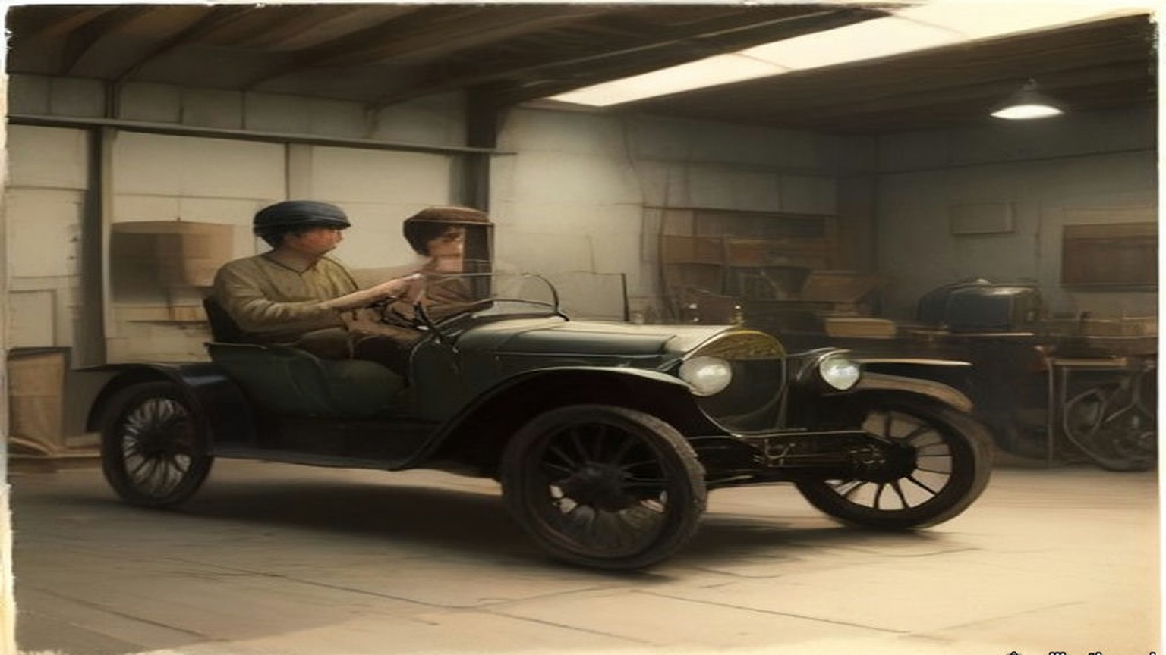
Chapter 19 Mini-Glossary
• Sinn Fein (1 occurrences in this chapter): Irish nationalist movement founded by Arthur Griffith in 1905 ('Ourselves Alone'), cited by Gandhi in 1907 as a parallel to Indian Swadeshi.
Chapter 19 Appendix of Important Names
• Begin, Menachem (1 mentions in this chapter): Commander of the revisionist Zionist underground organization Irgun Zvai Leumi in Mandate Palestine.
• Carson, Edward (2 mentions in this chapter): Dublin-born barrister, Solicitor-General, and leader of the Ulster Unionist Council.
• Collins, Michael (4 mentions in this chapter): Director of Intelligence for the IRA, signatory of the 1921 Anglo-Irish Treaty, and Chairman of the Provisional Government.
• Russell, Lord John (2 mentions in this chapter): British Whig Prime Minister during the height of the Irish Famine (1846–1852).
Sources
• Bureau of Military History, WS 1,043, Joseph V. Lawless (militaryarchives.ie, BMH.WS1043.pdf, via the Internet Archive). Statement pp. 317 to 319. Used for: Michael Lynch; Collins's instruction that nothing be done in Fingal without his sanction, and Dan Brophy's later account of why; Gormanston convoys and the post at Swords House; Peter White, Company Commander in Ballyboughal, and the shooting in Balbriggan "in the middle of September" of "District Inspector Burke" and a sergeant; 20 September 1920; the stocking factory and "about thirty shops and dwelling houses"; James Lawless and John Gibbon; Lawless's thought about the name; "Jack Straw."
• Report of the Labour Commission to Ireland (London: The Labour Party, 1921; Caledonian Press; price 2s., post free 2s. 3d.), Internet Archive, reportoflabourco00labouoft (PDF and text). Used for: the members and advisers; departure on Tuesday 30 November; permits from the Chief Secretary; evidence at the Shelbourne; the visits to Balbriggan and Croke Park (p. 6); the Balbriggan hosiery works, "entirely English company," 109 employees and at least 120 outworkers, the second factory saved (p. 17); Balbriggan, caps waved, looted drink, "going too far," the deaths of women and babies, "a clear example of a 'reprisal'" (pp. 38 to 39); Croke Park, the evidence on Russell Street, the turnstiles, the young woman at her fiancé's side, the boy in the tree, the signal shots, R.I.C. and Auxiliaries, "a ghastly tragedy" (pp. 40 to 42); Cork (pp. 35 to 38, used only for the date of the fires); the letter from a worker's wife in Balbriggan, dated October 6, 1920 (appendix, p. 87); Lunn's speech at the Special Labour Party Conference of 29 December 1920 (p. 112).
• Bureau of Military History, WS 783, Lieutenant-Colonel Thomas Ryan (militaryarchives.ie, BMH.WS0783.pdf, via the Internet Archive). Statement pp. 30 to 38. Used for the train, Ballybrophy, the Lincolnshire Regiment, Barry's Hotel, Phil Shanahan's, D. P. Walsh and the porter bottles, Fleming's Hotel, confession, Breen's message, the match, the aeroplane and "a Verey light signal," the six on the ground, Hogan's death and words, Clonliffe Road, the bayonets, the man on the railing, the priest, the railway wall, the money taken, Jack Kavanagh's £50, Stephen Sinnott's yard, "a naked player."
• Bureau of Military History, WS 434, Charles Dalton (militaryarchives.ie, BMH.WS0434.pdf, via the Internet Archive). Statement pp. 18 to 21. Used for Maudie, the waste-paper baskets, Upper Mount Street, McKee's patch unit, Summerhill Dispensary, Paddy Flanagan, the porter shaking mats, the top room, "Search be damned! Get out of here," the volley in the hall, Mrs. Byrne's and Crow Street, McNamara's account of the Castle.
• House of Commons Debates, 20 October 1920, vol. 133, cc925–1039, "Vote of Censure Proposed": Henderson (cc925–928), Greenwood (cc936–950), Kenworthy, Asquith (cc977–979), O'Connor (cc1013–1015), division 79 to 346. https://api.parliament.uk/historic-hansard/commons/1920/oct/20/vote-of-censure-proposed
• House of Commons Debates, 22 November 1920, vol. 135, cc34–8, "Murder of Officers, Dublin" (the telegrams, Case F) and cc38–43, "Murder Conspiracy" (Devlin, the suspension, Molson, the Dublin answer on Croke Park, Carson and MacVeagh). https://api.parliament.uk/historic-hansard/commons/1920/nov/22/murder-of-officers-dublin and /murder-conspiracy
• House of Commons Debates, 23 November 1920, vol. 135, cc199–202, "Croke Park, Dublin." https://api.parliament.uk/historic-hansard/commons/1920/nov/23/croke-park-dublin
• House of Commons Debates, 2 December 1920, vol. 135, cc1419–20, "Croke Park, Dublin (Shooting)," and Written Answers, 9 December 1920, vol. 135, c2447W, "Croke Park, Dublin." https://api.parliament.uk/historic-hansard/commons/1920/dec/02/croke-park-dublin-shooting and https://api.parliament.uk/historic-hansard/written_answers/1920/dec/09/croke-park-dublin
• Who Burnt Cork City? (Dublin: Irish Labour Party and Trade Union Congress, January 1921; price sixpence), Internet Archive, whoburntcorkcity00dubl (PDF and text). Used for Captain Alfred J. Hutson's report to the Lord Mayor (pp. 29 to 30); Greenwood's words of 13 December on the inquiry, and his answer to Kenworthy on the hoses, as quoted there; the military inquiry, Maurice Healy, and "As the court of inquiry has now closed" (p. 10); the Chamber of Commerce telegram.
• House of Commons Debates, 16 February 1921, vol. 138, cc90–2, "Burnings, Cork." https://api.parliament.uk/historic-hansard/commons/1921/feb/16/burnings-cork

Chapter 20
Two Letters for Craig, 1921–1922
10 Downing Street, 22 Hans Place, and the Council Chamber of University College, Dublin, December 1921 to September 1922
10 Downing Street, Monday, 5 December 1921, three o'clock
Robert Barton kept notes. He was the Minister for Economic Affairs in the Dáil cabinet and one of five plenipotentiaries sent to London in October, and on the afternoon of Monday, 5 December, he was one of three of them at the table in Downing Street. Arthur Griffith sat for the delegation as its chairman. Michael Collins sat beside him. Across the table were four men: the Prime Minister, David Lloyd George; Austen Chamberlain; Lord Birkenhead, the Lord Chancellor; and Winston Churchill. Eamonn Duggan and George Gavan Duffy were not there. They waited at the delegation's house at 22 Hans Place, in Knightsbridge.
The conference had broken down the day before, on the Sunday. An intermediary had put the two sides back in touch on the Monday morning. At three o'clock Lloyd George opened by saying that he must know once and for all exactly where the Irish stood on the Ulster proposals. The proposals in the document on the table, he said, were exactly those Griffith had agreed to, and on which Griffith had undertaken not to let him down.
Griffith said he had not let him down and did not intend to. But before he gave a decision on the earlier articles he must have a reply from Sir James Craig, the Prime Minister of Northern Ireland, accepting or refusing the unity of Ireland. Chamberlain and Lloyd George called that "inadmissible, unreasonable and contrary to the undertaking." Chamberlain said that his colleagues and he had trusted that undertaking when they took the line they did at the Liverpool meeting, and had staked their political future on it.
Then Collins spoke. To agree to any conditions for the future relations of the two countries before Craig assented to Irish unity was impossible, he said, and Barton took down his reason: "that to do so would be to surrender our whole fighting position." Every document the Irish had ever sent made association with the Commonwealth conditional on unity. If Craig refused, they would have given up their position and not even secured the one thing it was meant to buy.
Barton wrote down what happened next in a single line. "LLOYD GEORGE got excited." He shook his papers in the air. He said the Irish were trying deliberately to bring about a break on Ulster because their people at home had refused to come within the Empire, and that Griffith was letting him down where he had promised not to. He took a paper out of an envelope. He said he had shown it to Griffith at a house in London and that Griffith had agreed to its contents. He called it a letter. Barton could remember no letter on the subject except the one Griffith had written to Lloyd George on 2 November, after consulting the rest of the delegation, and he looked across at Collins and saw that Collins could not place it either. The paper came over the table. It was a memorandum, not a letter. If Ulster would not come into a Parliament for all Ireland, it said, she could stay out, "In this case, however, it would be necessary to revise the boundary of Northern Ireland. This might be done by a Boundary Commission which would be directed to adjust the line both by inclusion and exclusion so as to make the Boundary conform as closely as possible to the wishes of the population."
Griffith said he stood by his undertaking. He still thought it not unreasonable that Craig should reply first. Lloyd George said that to ask for Craig's reply before accepting or refusing was itself letting him down, because the only alternative to Craig's acceptance was the Boundary Commission, and his Government would carry the Commission into effect "with strict fidelity." Before the British withdrew to talk among themselves he wanted the Irish objections. The first three Clauses, he said, were absolutely essential. There could be no discussion about them.
The rest of the afternoon went clause by clause. Birkenhead produced a form of oath that Collins had handed him that morning, with Birkenhead's own alterations written in. The Irish objected to its last words, "British Empire," and asked for "British Commonwealth of Nations." Clause 5 was the money. It said the Irish Free State "shall contribute" towards the public debt of the United Kingdom and the war pensions. The Irish wanted the words "if any" put in after "such sums," and in other places, so that the sum owed could be nothing. Chamberlain said these were matters of wording only.
Clause 6 took longer. It said the defence by sea of Great Britain and Ireland would be undertaken exclusively by British forces. Barton argued with Collins and Churchill over the word "exclusively" for a long time. It shut Ireland out of building a single vessel or preparing in any way to take over her own coastal defence, and nothing bound the British ever to hold the conference that was promised to review it in five years. Churchill said that if Ireland were allowed any navy it would be impossible to get the Treaty through Parliament. The English people would believe the Irish meant to build submarines or mine-layers to attack their food ships. The word "exclusively" came out, grudgingly. Barton then asked that Ireland be required to build one or more ships for her own coastal protection. That was refused outright, except for revenue and fishery protection. Churchill said that he would definitely oppose any provision for an Irish navy, and "would even oppose it five years hence if he had the opportunity."
When the British came back Churchill agreed to fix the review conference for a date five years off, and refused to touch the clause on facilities in time of war. He would not take Queenstown out of the Annex. Barton asked what "care and maintenance parties" meant in the forts. Churchill told him: gunners and trained men from the Royal Garrison Artillery and the Royal Engineers, "numbering 1,060 men and 69 officers or thereabouts." On trade, Lloyd George agreed provisionally to freedom on both sides to put on any tariffs either liked.
Then they went back to Ulster. Griffith said that he personally would sign whether Craig accepted or not. His colleagues were in a different position, he said, because they had never made the promise not to let Lloyd George down, and it was not fair to demand their answer before Craig replied. Barton watched him make repeated efforts to keep the question from being put to Collins and to Barton himself.
Lloyd George would not have it. He had always taken it that Griffith spoke for the delegation, he said. They were all plenipotentiaries. It was now a matter of peace or war and each of them must make up his mind. He required that every delegate should sign the document and recommend it, or there was no agreement. The British had hazarded their political future and the Irish must do the same. Then he spoke to Barton directly. "At one time he particularly addressed himself to me," Barton wrote, "and said very solemnly that those who were not for peace must take full responsibility for the war that would immediately follow refusal by any Delegate to sign the Articles of Agreement."
He had two letters ready. One was a covering letter to Craig with the British proposals, saying the Irish delegation had agreed to recommend them for acceptance by Dáil Éireann. The other said the delegation had failed to come to an agreement, and that he therefore had no proposals to send to Craig. One of them, he said, must go to Craig that night. He would have to have their agreement or refusal by ten o'clock. A special train and a destroyer were ready to carry one letter or the other to Belfast.
The Irish fought one more point before they left. The draft gave Craig twelve months to decide whether Northern Ireland came in. For twelve months, Barton argued, they would not know whether there was to be unity or not, and life could be made intolerable for their people in Ulster. Collins spoke of the recent seizure of the Tyrone County Council's books, and the support the Ulster Government had had from English troops. Lloyd George said that was a matter for the Northern Government under the Act of 1920. The British left the room again. The Irish decided on one month, rang for them to come back, and told them. Lloyd George said a month was ill advised. Craig was going to refuse the terms, he said, and he knew it for certain. But he accepted the change and said he would have the clauses redrafted. They were to come back at ten with their answer.
When Barton came to tell the Dáil about it a fortnight later, he said it was then about half-past eight.
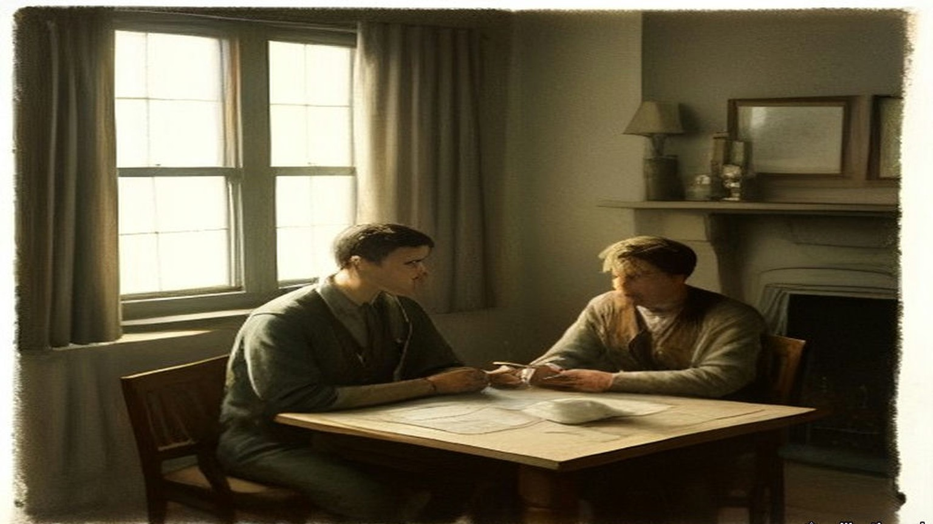
* * *
22 Hans Place, Knightsbridge, the same evening
The two who had stayed behind at the house were waiting for them. Gavan Duffy later said what the three brought back through the door. After four and a half hours of discussion, "our delegates returned to us to inform us that four times they had all but broken and that the fate of Ireland must be decided that night."
Gavan Duffy gave the Dáil the ultimatum as it reached him in that room, in the words he carried away from it. "It must now be peace or war. My messenger goes to-night to Belfast. I have here two answers, one enclosing the Treaty, the other declaring a rupture, and, if it be a rupture, you shall have immediate war, and the only way to avert that immediate war is to bring me the undertaking to sign of every one of the plenipotentiaries, with a further undertaking to recommend the Treaty to Dáil Eireann and to bring me that by 10 o'clock. Take your choice."
The question in front of them was the one Barton put to the Dáil afterwards. They could stand behind their own proposals for external association, face war and maintain the Republic. Or they could accept inclusion in the British Empire and take peace.
Griffith was for acceptance. So was Collins, and so was Duggan. Barton and Gavan Duffy were for refusal, "war or no war." Barton had heard the words across the table and Gavan Duffy had heard them only at second hand, and both came to the same conclusion. An answer that was not unanimous meant immediate war. The responsibility for it would rest on the two who refused.
"For myself, I preferred war," Barton told the Dáil. "I told my colleagues so, but for the nation, without consultation, I dared not accept that responsibility." He had taken an oath to the Republic and still called it the most sacred bond on earth. In that room he judged breaking it to be the lesser of the two outrages in front of him. "So that I myself, and of my own choice, must commit my nation to immediate war, without you, Mr. President, or the Members of the Dáil, or the nation having an opportunity to examine the terms upon which war could be avoided."
"I shall not forget the anguish of that night," Gavan Duffy said, "torn as one was between conflicting duties." He knew the ultimatum could be bluff. "Again this ultimatum might have been bluff, but every one of those who had heard the British Prime Minister believed beyond all reasonable doubt that this time he was not play acting, and that he meant what he said."
The ten o'clock deadline passed with the five of them still in the house. Barton's notes put the discussion at Hans Place from nine o'clock until a quarter past eleven, and say only that "a decision was eventually reached to recommend the Treaty to the Dail."
Nine months later, after Griffith and Collins were both dead, W. T. Cosgrave told the Dáil two things Griffith had told him in London that summer. One was that Barton had said to Collins on the way to Downing Street, "I will never let you down, Mick." The other was that before he signed, Barton went out of the room to talk to his cousin, Erskine Childers, the delegation's secretary, came back in five minutes, and said that he would sign. Barton was not in the Dáil to answer it. His own account of the evening has no Childers in it.
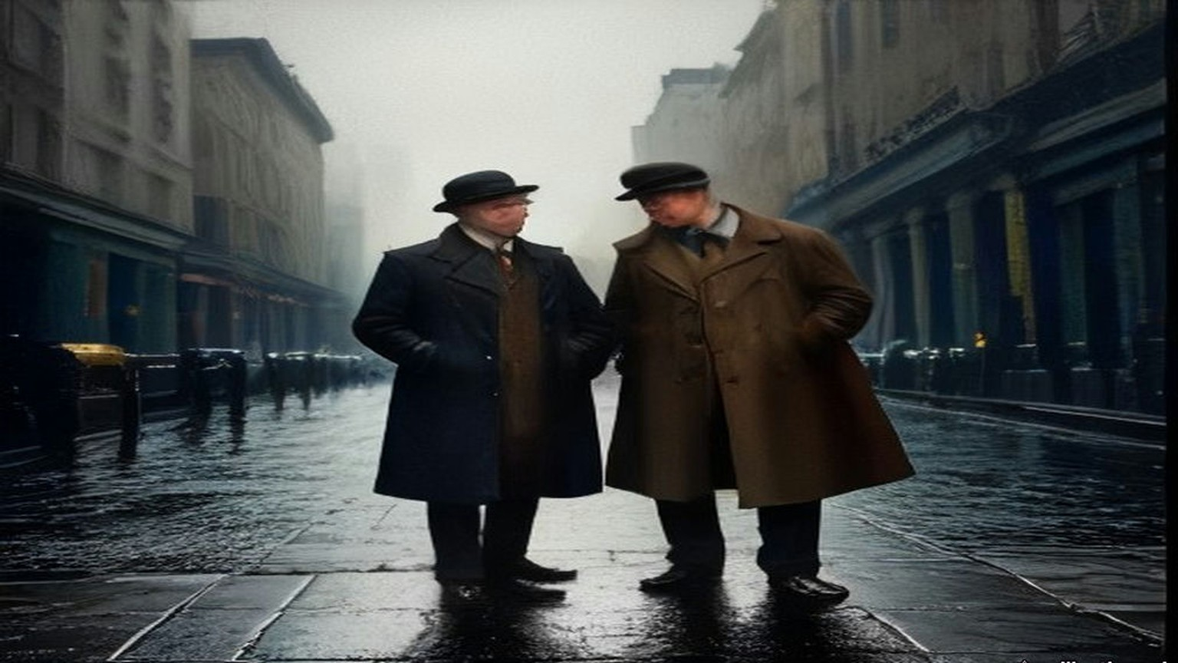
* * *
10 Downing Street, 11.30 p.m. to 2.20 a.m.
Griffith, Collins and Barton were back in Downing Street at half-past eleven, and attacked the document again.
They tried to get Clause 3, the representative of the Crown, taken out altogether, and failed. They got the words "Governor-General" removed, with the choice of a title left to them. Chamberlain said that "President" was inadmissible. Collins demanded the removal of the word "local" in front of the Irish Free State's military defence force, and got it. Clause 14(e), on an Ulster army, came out on his demand, with its substance moved into the safeguards for Ulster.
On Clause 5 the British agreed to the verbal changes. Chamberlain would not have the "if anys." It was too late to quibble over such small points, he said. The clause as signed that night says that the Irish Free State "shall assume liability for the service of the Public Debt of the United Kingdom as existing at the date hereof and towards the payment of War Pensions as existing at that date in such proportion as may be fair and equitable, having regard to any just claim on the part of Ireland by way of set-off or counter-claim." The amount was to be settled, failing agreement, "by the arbitration of one or more independent persons being citizens of the British Empire." It held no "if any." The Irish counter-claim was there, and so was the debt.
Collins asked about the clauses that spoke of summoning the Parliament of Southern Ireland. Birkenhead wrote a memorandum on the spot. The functions in Clauses 15 and 17 were to be carried out by a Provisional Government of Southern Ireland, which would take over the government "immediately" on ratification.
Then Lloyd George asked whether they, as a delegation, were prepared to accept these Articles of Agreement and to stand by them in their Parliament as the British delegation would stand by them in theirs.
Barton wrote down Griffith's answer in full. It was two words. "We do."
While they waited for the clean copy they talked about the release of the prisoners and the procedure for ratification. The final draft was read over, agreed to and signed, and the Annex with it. The British signed as D. Lloyd George, Austen Chamberlain, Birkenhead, Winston S. Churchill, L. Worthington-Evans, Hamar Greenwood and Gordon Hewart. The Irish signed in Irish: Art Ó Griobhtha, Micheál Ó Coileain, Riobárd Bartún, E. S. Ó Dugain, Seórsa Ghabháin Uí Dhubhthaigh.
Duggan was not in Downing Street that night. He told the Dáil so. "I was not threatened by Lloyd George. He did not shake papers in my face. I signed the Treaty in the quiet seclusion of 22, Hans Place."
The British delegation lined up to shake hands and say good-bye. Barton noted the time. The conference ended at 2.20 a.m. on 6 December.
Article 10 was in the document they carried away. The Free State would pay fair compensation to judges, officials, police and other public servants discharged by it or retiring because of the change of government. "Provided that this agreement shall not apply to members of the Auxiliary Police Force or to persons recruited in Great Britain for the Royal Irish Constabulary during the two years next preceding the date hereof. The British Government will assume responsibility for such compensation or pensions as may be payable to any of these excepted persons."
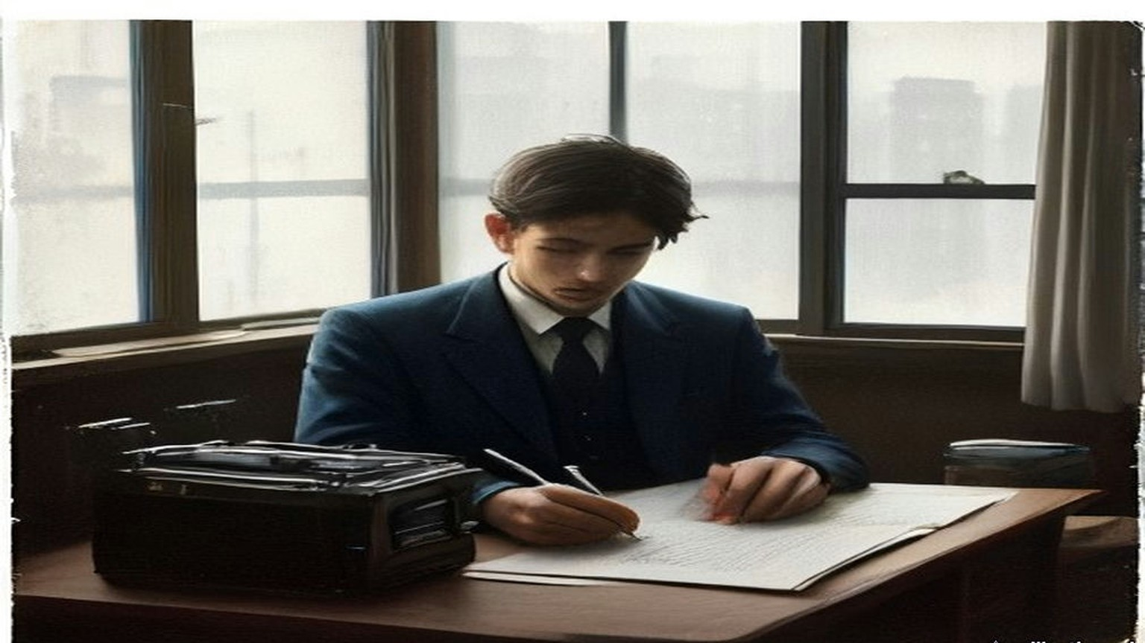
* * *
Council Chamber, University College, Dublin, Monday, 19 December 1921
The Dáil met to deal with the Treaty in the Council Chamber of University College, Dublin, from 14 December. For the first days it sat in private session. On the morning of 19 December it sat in public, with the press in, and Griffith moved "That Dáil Eireann approves of the Treaty between Great Britain and Ireland, signed in London on December 6th, 1921."
Michael Collins was Minister for Finance. He listened to Griffith read a letter Lloyd George had written him on 13 December to settle "doubts" in Dublin. Part of it was about the money. "The second question is as to the scope of the Arbitration contemplated in Article V. regarding Ireland's liability for a share of War Pensions and the Public Debt," Lloyd George wrote. The British Government would submit its claim, and the Free State "should submit any counter-claim to which it thought Ireland entitled." The arbitrators' decision would be final and binding on both. They would be men "as to whose impartiality both the British Government and the Government of the Irish Free State are satisfied." At the end of the letter Lloyd George added a sentence of his own. "I may add that we propose to begin withdrawing the Military and Auxiliary Forces of the Crown in Southern Ireland when the Articles of Agreement are ratified."
The House rose at one o'clock so that de Valera could be installed as Chancellor of the National University, and came back at a quarter to four. Collins spoke first in the afternoon.
He spoke as one of the signatories. He did not recommend the Treaty for more than it was, he said, and he did not recommend it for less. "In my opinion it gives us freedom, not the ultimate freedom that all nations desire and develop to, but the freedom to achieve it." The House applauded. He talked about the bargain as a Minister for Finance. "Rightly or wrongly when you make a bargain you cannot alter it, you cannot go back and get sorry for it and say 'I ought to have made a better bargain.' Business cannot be done on those bases."
He said the Treaty was not signed under personal intimidation. If it had been tried, no member of the delegation would have signed. He told the Dáil what he took the long struggle to have been about. It had been a story of "slow, steady, economic encroach by England," he said, and the encroachment was still going on in front of them. "Every day our Banks become incorporated or allied to British interests, every day our Steamship Companies go into English hands, every day some other business concern in this city is taken over by an English concern and becomes a little oasis of English customs and manners."
He told them about the money from America. As things in London were coming to a close, he had received cablegrams. He knew what saying so would cost him over there, and he said it anyway. "I received a cablegram from San Francisco, saying, 'Stand fast, we will send you a million dollars a month.' Well, my reply to that is, 'Send us half-a-million and send us a thousand men fully equipped.'" Another came from a branch of the American Association for the Recognition of the Irish Republic: "Don't weaken now, stand with de Valera." He told the House to let that branch come over and stand with them both. He was not going on with the fight, he said, without referring it to the Irish people, "for the sake of propaganda in America."
He finished on the living. Deputies had asked whether the dead would approve, and the unborn, and few had asked whether the living approved. "Let us take that responsibility ourselves and let us in God's name abide by the decision."
Erskine Childers followed him, from the other side. He had been secretary to the delegation, and he told the House that the Irish counter-proposals had stood before the British government until the end, "except that last terrible hour." O'Higgins, the Assistant Minister for Local Government, quoted the ultimatum as he had it, in the Prime Minister's words. "The man who is against peace," said the English Premier in presenting his ultimatum, "must bear now and for ever the responsibility for terrible and immediate war."
It was late in the day when Barton rose, the last speaker before the adjournment. Collins had just told the House that no one had intimidated him. Barton said he would make plain the circumstances under which he found himself in honour bound to recommend the Treaty. He did not seek to shield himself from the charge of having broken his oath to the Republic. "My signature is proof of that fact." He told the House about Monday at three o'clock, about Griffith's efforts to refer the decision back to them, and about Lloyd George's answer, given "with all the solemnity and the power of conviction that he alone, of all men I met, can impart by word and gesture." The Prime Minister had declared, Barton said, "that the signature and recommendation of every member of our delegation was necessary or war would follow immediately."
He sat down to applause. Collins moved the adjournment until eleven the next morning.
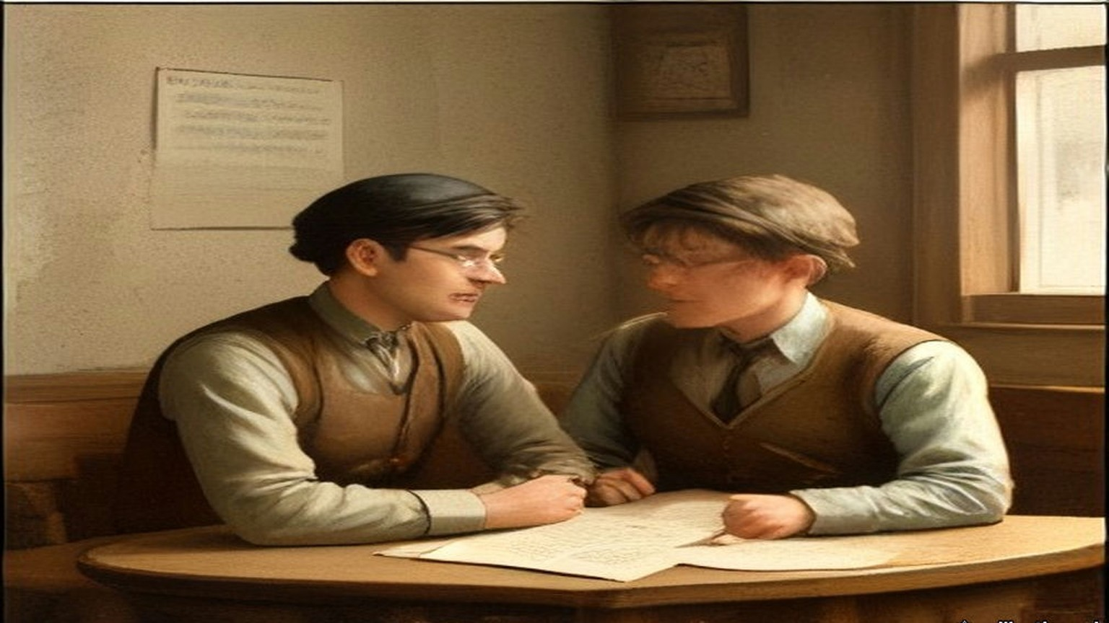
* * *
Council Chamber, University College, Dublin, Wednesday, 4 January 1922
Margaret Pearse was the mother of Pádraig and Willie Pearse, both dead since 1916. Pádraig had been executed in Kilmainham. Since the debate began on 14 December, deputies on the Treaty side had said more than once that Pádraig Pearse would have taken this settlement, and she had sat in the room and heard it. On 4 January she followed Alasdair MacCabe of Sligo, who had told the House that he would take Dominion Home Rule or Repeal of the Union or anything else before a Central American Republic.
"I rise to support the motion of our President for the rejection of this Treaty," she said. Her first reason was her sons. "It has been said here on several occasions that Pádraig Pearse would have accepted this Treaty. I deny it. As his mother I deny it, and on his account I will not accept it. Neither would his brother Willie accept it, because his brother was part and parcel of him."
Her second reason was fear. She had said this already at the private meeting and now she said it in public. From 1916, she said, she had had comfortable, happy nights and happy days, "because I knew my boys had done right, and I knew I had done right in giving them freely for their country." Then the Black and Tans came to her house. "But when the Black-and-Tans came," she said. "Then no nights, no days of rest had I. Always we had to be on the alert." And the Tans were not the worst thing she could think of. "But even the Black-and-Tans alone would not frighten me as much as if I accepted that Treaty; because I feel in my heart," she said, and stopped herself to say she would not say it if she did not feel it, "that the ghosts of my sons would haunt me."
She told the House about a day in 1915 or 1916. Pádraig had sent her into the city on an urgent message. In Westmoreland Street she saw the placards: "Home Rule Bill Passed." She jumped off her tram, got into another, and went back up to Rathfarnham as fast as she could. He was writing, as he usually was. He asked her if she was back so quickly. She told him the Home Rule Bill was passed. The tears came into his eyes. He got up and put his arms round her. "Little mother, this is not the Home Rule Bill we want, but perhaps in a short time you will see what we intend to do and what freedom we intend to fight for." She had forgotten the errand. He told her he would do it himself tomorrow, and to go and get something to eat.
She came to the women of the country. She had been through Ireland in the past few years, she said, and had studied the wives of Ireland, and no one should say those women accepted the Treaty from their hearts. "They say it through fear; they say it through fear of the aeroplanes and all that has been said to them." And she came to the map. In the autumn of 1915 her son had inspected Volunteers at Vinegar Hill and told them they were formed for the whole of Ireland. "Therefore Pádraig Pearse would not have accepted a Treaty like this with only two-thirds of his country in it."
A deputy had spoken of rattling the bones of the dead. "I only wish we could recall them," she said. She sat down to applause. Eoin O'Duffy rose after her.
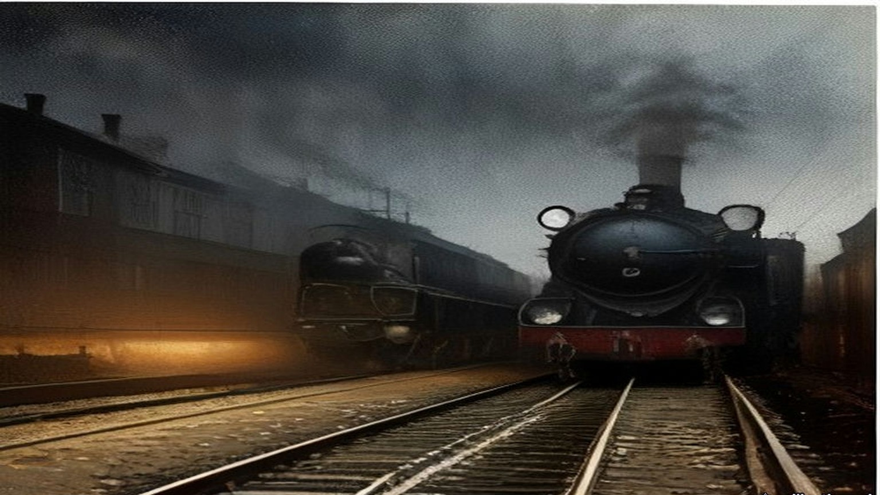
* * *
Council Chamber, University College, Dublin, Saturday, 7 January 1922
Harry Boland had spent most of his time as a deputy in another country. He had been sent to America, he told the House, to secure international recognition from the government of the United States and the support of the American people. The Dáil resumed at twenty past eleven on the Saturday morning with the Speaker, Eoin MacNeill, in the Chair, and Boland spoke early.
He wanted to thank the American people for their support, he said, because the Minister for Finance had made a statement in the House a few weeks before that put the Irish in America in a very embarrassing position. Collins called across, "And which every true American appreciates."
Boland went on. They had been sent back to America to strengthen the hands of the plenipotentiaries in London, to show Britain that if the fight were renewed they were ready to carry it on, and to float a Bond Loan of the Irish Republic. Because negotiations were going on they had confined the loan to two places, the District of Columbia and Illinois. The Great Nations of the World were meeting in Washington. The figures were the point. In 1919, in the first Bond Drive in Illinois, "we collected three hundred and ninety-seven thousand dollars in twelve months at a cost of eighteen thousand dollars." This year, "in three weeks in the State of Illinois they subscribed five hundred and fifty-two thousand dollars at a cost of eighteen thousand dollars." There was a cheer.
The great public opinion of America was on the side of the Treaty, he said, and the American press with it. He would be false to his position if he did not say so. But the subscribers were another matter. "The people who subscribed the money to enable us to carry on look upon this as a betrayal; and it was only out of love for Ireland that an order of restraint was not taken out against us." He meant an injunction against raising money in the name of the Irish Republic. He would vote, he said, prepared for war.
P. O'Keeffe followed with different figures. While the soldiers were fighting, he said, the men and women on the civil side had been helping the enemy. There were cries of "No! no!" He did not take it back. "You were trading with the enemy; and during that time you gave that enemy one hundred and thirty-two million pounds for goods that could be purchased and produced in this country." If the people had been Republicans since 1916, they should have kept their own money in the Republic. The Banks of Ireland, he said, had lent to the British Empire during the war "to win the war," and the sum was "fifty-and-a half million pounds."
The House adjourned at twenty to two. It came back at ten past four. At the Speaker's request the Secretary, Diarmuid O'Hegarty, called the roll, and 122 members answered.
The speeches that afternoon were short. Daniel Corkery of Mid-Cork stood to vote against. "We have heard a lot here of the alternative to this Treaty," he said, "terrible and immediate war." His constituency had started the guerrilla war, he said, and had attacked the first lorry, and its people did not want war but were not half as much afraid of it as people in counties that had not fired a shot. Joseph MacGuinness said that was the shortest speech yet.
It was evening before the roll was called for the vote. De Valera rose before it to enter his last protest. The document, he said, would rise in judgment against the men who said there was only a shadow of difference. "I suppose the Irish Volunteers are to be disbanded next." Collins answered him. "Let the Irish nation judge us now and for future years."
The Clerk called the constituencies. Deputies who sat for two constituencies could vote once, the Speaker ruled, and Griffith registered his protest that five constituencies were disfranchised by it. Sean Milroy protested for Tyrone. Boland heard his own name called and answered against.
The Speaker gave the result. "The result of the poll is sixty-four for approval and fifty-seven against. That is a majority of seven in favour of approval of the Treaty."
The list printed afterwards puts the names in Irish. Riobárd Bartún is among the sixty-four, and Eamon O Dúgáin, and S. Ghabháin Uí Dhubhthaigh. Six women are among the fifty-seven: Bean an Phiarsaigh, Margaret Pearse; Bean Mhíchíl Uí Cheallacháin, Kate O'Callaghan; Bean an Chléirigh, Kathleen Clarke; Constans de Markievicz; Máire Nic Shuibhne, Mary MacSwiney; and Dr. Eithne Inglis, Ada English.
De Valera said it would be his duty to resign his office as Chief Executive. The Republic could only be disestablished by the Irish people, he said, and until it was, the Republic went on. Collins asked to speak. "I do not regard the passing of this thing as being any kind of triumph over the other side." He proposed some kind of joint committee to keep the public safety. "The President knows how I tried to do my best for him." De Valera said, "Hear, hear." Collins said that de Valera had exactly the same place in his heart as he always had.
Mary MacSwiney claimed her right to register her protest. "I maintain here now that this is the grossest act of betrayal that Ireland ever endured." She looked at the majority and said that half of them were looking for a gun.
De Valera rose for the last time that night. "I would like my last word here to be this: we have had a glorious record for four years; it has been four years of magnificent discipline in our nation. The world is looking at us now." He did not finish. The Official Report has one line in brackets where the rest of the sentence would be: "The President here breaks down."
Cathal Brugha, the Minister for Defence, spoke into the silence. "So far as I am concerned I will see, at any rate, that discipline is kept in the army." The House adjourned at ten minutes to nine, until eleven o'clock on Monday.
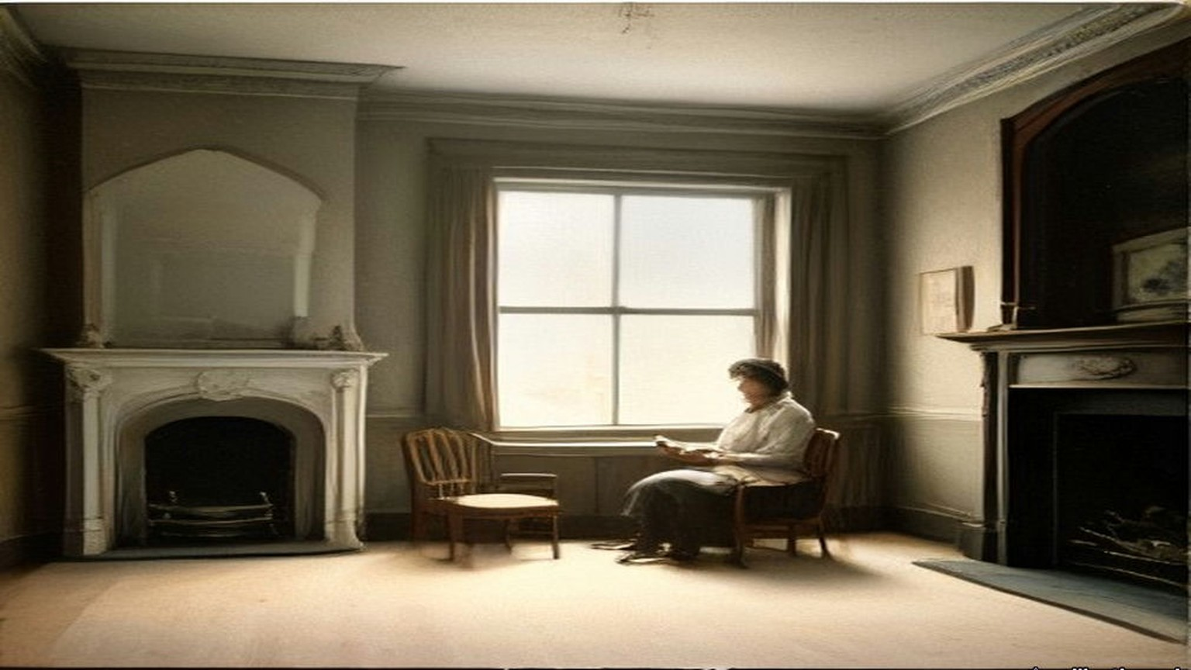
* * *
Council Chamber, University College, Dublin, Tuesday, 10 January 1922
De Valera had resigned. On the Tuesday the motion was that Arthur Griffith be appointed President of Dáil Éireann. Collins watched de Valera get up.
"As a protest against the election as President of the Irish Republic of the Chairman of the Delegation," de Valera said, "who is bound by the Treaty conditions to set up a State which is to subvert the Republic," he would leave the House while the vote was being taken. The Official Report says that he then rose and left the House, "followed by the entire body of his supporters."
Collins shouted after them. "Deserters all! We will now call on the Irish people to rally to us. Deserters all!" David Ceannt shouted "Up the Republic!" Collins went on. "Deserters all to the Irish nation in her hour of trial. We will stand by her." Markievicz answered him. "Oath breakers and cowards." "Foreigners," Collins called back. "Americans. English." "Lloyd Georgeites," said Markievicz.
The Speaker waited until all those who wished to leave had left. The motion was put and carried unanimously by those who were still in the room. Griffith, speaking as Premier, proposed his ministers. The first was "Finance Minister: Mr. Michael Collins."
The Treaty now had to be carried out, and Article 10 was part of it. The policemen who had been recruited in Britain in the two years before 6 December 1921, and the whole of the Auxiliary Division, were to be paid off by the British Treasury and not by Dublin. Lloyd George had promised to begin withdrawing the Auxiliary forces once the Articles were ratified. The cost of their compensation and pensions was to go with them across the water.
* * *
Dáil Éireann, Monday, 11 September 1922
W. T. Cosgrave had been Minister for Local Government in January. By September he was President of Dáil Éireann, elected on the ninth to the chair Griffith had taken on 10 January. On the eleventh he rose to make a statement of the government's policy to the new Dáil.
He began with the credentials of October 1921, and read them into the record: five plenipotentiaries, Arthur Griffith, Chairman; Michael Collins, Minister for Finance; Robert C. Barton; Edmund J. Duggan; George Gavan Duffy. He told the House about the first draft, the one the Cabinet rejected, and Griffith's promise not to sign it, and how Griffith had kept that promise.
He told the House where two of those five were. "There sleeps at present in Glasnevin the late President and the late Commander-in-Chief, earning a rest they were denied on earth."
They had signed on behalf of the nation they represented, he said, "and they died, one with his Ministerial harness on his back, and the other wearing the uniform of the soldiers of the Nation he had laboured so hard for, and for whose honour and existence and for the supremacy of whose Parliament he poured out his blood."
Cosgrave read from the papers left by the late Commander-in-Chief, among them the report of a convention of the army's disaffected section in March, which had looked to a dictatorship that would overthrow four governments in Ireland at once: Dáil Éireann, the Provisional Government, the British Government and the Northern Government. Barton was not in the House. Cosgrave gave Griffith's story of the walk to Downing Street and the five minutes with Childers, and said of Barton, "wherever he is let this message reach him." Then he came to the work of government. "The Castle, for centuries the seat of alien Government in this country, was formally handed over," he said, "and that institution is now entirely and completely in the hands of the people's Government, and under the control of the Executive, and is manned at this moment by Irish troops."
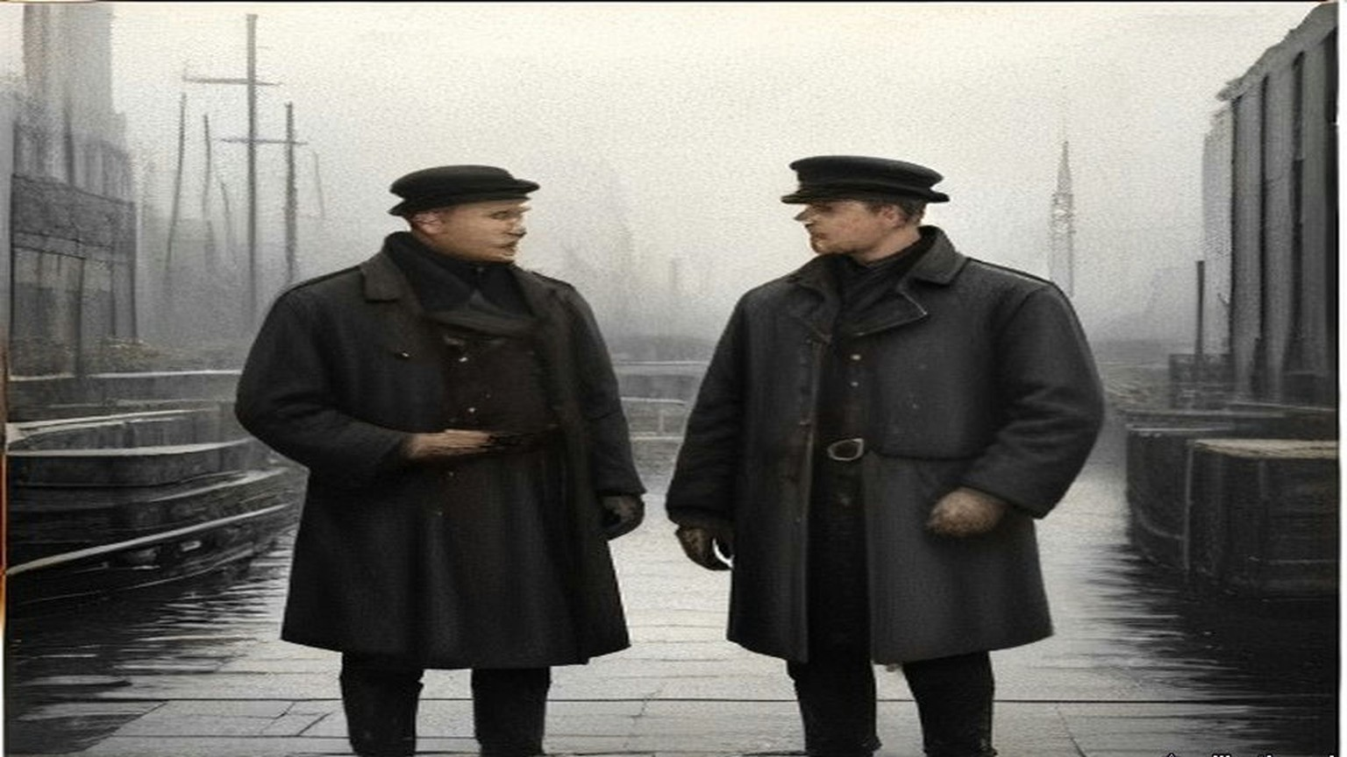
Chapter 20 Appendix of Important Names
• Begin, Menachem (2 mentions in this chapter): Commander of the revisionist Zionist underground organization Irgun Zvai Leumi in Mandate Palestine.
• Churchill, Winston (7 mentions in this chapter): British cabinet minister (Home Secretary, First Lord of the Admiralty, War and Colonial Secretary, and Prime Minister) recurring across the Irish, Middle Eastern, and Indian settlements.
• Collins, Michael (28 mentions in this chapter): Director of Intelligence for the IRA, signatory of the 1921 Anglo-Irish Treaty, and Chairman of the Provisional Government.
• Craig, James (13 mentions in this chapter): Ulster Unionist leader and first Prime Minister of Northern Ireland.
• De Valera, Eamon (10 mentions in this chapter): Surviving commandant of the 1916 Easter Rising, President of Dáil Éireann, and later Taoiseach and President of Ireland.
• Gordon, Lucie Duff (1 mentions in this chapter): English writer resident in Upper Egypt during the 1860s who recorded the impact of the Suez Canal corvée and taxation on the fellahin.
• Griffith, Arthur (27 mentions in this chapter): Founder of Sinn Féin and signatory of the 1921 Anglo-Irish Treaty.
• Lloyd George, David (19 mentions in this chapter): British Prime Minister during the First World War, the post-war Middle Eastern settlements, and the 1921 Anglo-Irish Treaty.
Sources
• Notes by Robert Barton of two sub-conferences held on December 5/6, 1921 at 10 Downing St. National Archives of Ireland, DE 2/304/1. Documents on Irish Foreign Policy, vol. 1, no. 213. https://www.difp.ie/volume-1/1921/notes-by-robert-barton-of-two-sub-conferences-held-on-december-5-6-1921-at-10-downing-st/213/ . Used for: those present; 3 p.m.; Lloyd George's opening; Griffith and Craig's reply; "inadmissible, unreasonable and contrary to the undertaking"; the Liverpool meeting; Collins's "surrender our whole fighting position"; "LLOYD GEORGE got excited," the papers shaken in the air, the envelope, the memorandum and its text on the Boundary Commission, "with strict fidelity"; the first three Clauses; Birkenhead's form of oath; "if any" in Clause 5; "exclusively" in Clause 6, Churchill on submarines and food ships, "even ... five years hence"; Queenstown and "1,060 men and 69 officers or thereabouts"; trade; Griffith's personal undertaking and his efforts for Collins and Barton; Lloyd George's demand and his words to Barton; the two letters; "by 10 p.m.," the special train and destroyer; the twelve months reduced to one; Tyrone; "from 9 to 11.15 at 22, Hans Place"; the second sub-conference, Clause 3, "Governor-General," "President" inadmissible, "local," the "if anys" and "too late to quibble," Clause 14(e), Birkenhead's memorandum on Clauses 15 and 17; "We do."; the prisoners; the signing and the Annex; the handshakes; 2.20 a.m.
• Final text of the Articles of Agreement as signed, London, 6 December 1921. NAI DE 2/304/1. Documents on Irish Foreign Policy, vol. 1, no. 214. Used for Article 5 (verbatim), Article 10 (verbatim), the signatures.
• Dáil Éireann, Official Report, 14 December 1921, Prelude: "the Council Chamber, University College, Dublin." https://data.oireachtas.ie/akn/ie/debateRecord/dail/1921-12-14/debate/mul@/main.xml
• Dáil Éireann, Official Report, 19 December 1921, Debate on Treaty: Griffith's motion and Lloyd George's letter of 13 December 1921; the adjournment at 1 o'clock and resumption at 3.45 p.m.; Collins's speech (the freedom "to achieve it," the bargain, intimidation, "economic encroach," the banks and steamship companies, the cablegrams); Childers ("that last terrible hour," secretary to the delegation); O'Higgins's quotation of the ultimatum; Barton's speech; Collins's motion to adjourn. https://www.oireachtas.ie/en/debates/debate/dail/1921-12-19/2/ (XML: https://data.oireachtas.ie/akn/ie/debateRecord/dail/1921-12-19/debate/mul@/main.xml)
• Dáil Éireann, Official Report, 21 December 1921: Gavan Duffy (the four and a half hours, "four times they had all but broken," the ultimatum as he gave it, "the anguish of that night," bluff); Duggan ("the quiet seclusion of 22, Hans Place"). https://data.oireachtas.ie/akn/ie/debateRecord/dail/1921-12-21/debate/mul@/main.xml
• Dáil Éireann, Official Report, 4 January 1922: MacCabe; Margaret Pearse; O'Duffy following. https://data.oireachtas.ie/akn/ie/debateRecord/dail/1922-01-04/debate/mul@/main.xml
• Dáil Éireann, Official Report, 7 January 1922: resumption at 11.20 a.m.; Boland (the bond loan, Illinois and the District of Columbia, the dollar figures, "betrayal," the order of restraint); Collins's interjection; O'Keeffe (£132,000,000; £50,500,000); adjournment at 1.40 p.m.; resumption at 4.10 p.m.; O'Hegarty's roll of 122; Corkery; MacGuinness; de Valera's last protest; Collins's answer; the roll-call vote and the protests of Griffith and Milroy; 64 to 57 and the names; de Valera, Collins, MacSwiney; "The President here breaks down"; Brugha; adjournment at 8.50 p.m. https://www.oireachtas.ie/en/debates/debate/dail/1922-01-07/2/ (XML: https://data.oireachtas.ie/akn/ie/debateRecord/dail/1922-01-07/debate/mul@/main.xml)
• Dáil Éireann, Official Report, 10 January 1922: de Valera's protest and departure; Collins, Ceannt and Markievicz; the motion carried; Finance: Mr. Michael Collins. https://data.oireachtas.ie/akn/ie/debateRecord/dail/1922-01-10/debate/mul@/main.xml
• Dáil Éireann, Official Report, 9 and 11 September 1922: Cosgrave's election as President (9 September); his statement of 11 September (the credentials, "There sleeps at present in Glasnevin," the "Ministerial harness," Griffith's reports of Barton's words and of Childers, the March convention, the Castle). https://data.oireachtas.ie/akn/ie/debateRecord/dail/1922-09-11/debate/mul@/main.xml

Chapter 21
Ten Shillings a Day for Palestine, 1922
Westminster, Dublin and Carton, February to August 1922
House of Commons, Wednesday, 8 February 1922
Lieutenant-Colonel Martin Archer-Shee had a cheque in his question. It was for £25 10s., drawn on His Majesty's Service on the Bank of Ireland by the Paymaster of the Depot Company, Auxiliary Division, Royal Irish Constabulary, in favour of Mr. L. J. Leipold, late of Z Company. It was Leipold's pay on disbandment, after Income Tax had been taken off it. Leipold had signed a receipt for it at Beggars Bush on 23 January. The Bank of Ireland had dishonoured it.
Archer-Shee put the case to the Chief Secretary for Ireland, Sir Hamar Greenwood, by private notice. He wanted to know whether it would be put right at once, whether there were other cheques out to ex-members of the Division that would not be honoured, and whether Greenwood knew what this did to the men. They had drawn cheques of their own against the money, he said, expecting the Government's to clear, and now their own cheques could bounce.
Greenwood said he regretted it. A number of cheques drawn in favour of members of the Auxiliary Division had, "through an oversight in the demobilisation arrangements," been returned to the payee. Steps had been taken at once to rectify the error.
The next day the House had the terms. Sir Charles Yate asked about the dissatisfaction expressed in the press at the terms on which the ex-officer cadets had been disbanded. Viscount Curzon asked whether disbandment broke the men's contracts, and said many of the Auxiliaries were without any means whatever. Greenwood gave the figures. Men whose contracts ran past 31 March would be paid at the contract rate to the end of the contract. Men whose contracts ran out before 31 March, or had already run out, would be paid to 31 March. Every cadet had received an advance of £30 on demobilisation. No cadet would get less than £70, and those with longer contracts would get more on top. Hansard prints the range of those extra sums with the lower figure missing: "varying from £ to £250." In Committee eleven days later Greenwood gave it again, "amounts ranging from £1 to £250." The total was £210,000. "The average sum per cadet is £140."
Yate said there seemed to be a general complaint that the men who had done least service got most. Greenwood said there was no ground for general complaint. A cadet with a particular complaint knew where to send it.
Kenworthy wanted to know whether the cadets were finally gone. "They have been demobilised," Greenwood said. "Only a few small details are left in Ireland now."
Archer-Shee came back to it a fortnight later with another man, J. C. J. Towner, an Auxiliary cadet in Dr. Steevens' Hospital in Dublin. He had been sent there on 1 October, suffering from the effect of severe chill and lumbago. Towner's pay had been stopped from 11 December. Since 13 January he had been charged 7s. a day in hospital fees. His separation allowance had been stopped. He had a wife and family and was exempt from Income Tax, Archer-Shee said, and £19 10s. had been taken off his pay for it anyway. With the tax and the fees, £64 17s. had been taken from his arrears. He had been demobilised while he lay ill in the hospital. He said the board of investigation had found that his illness was due to service. Greenwood thanked Archer-Shee for bringing the case to his notice, and said he was having immediate inquiry made.
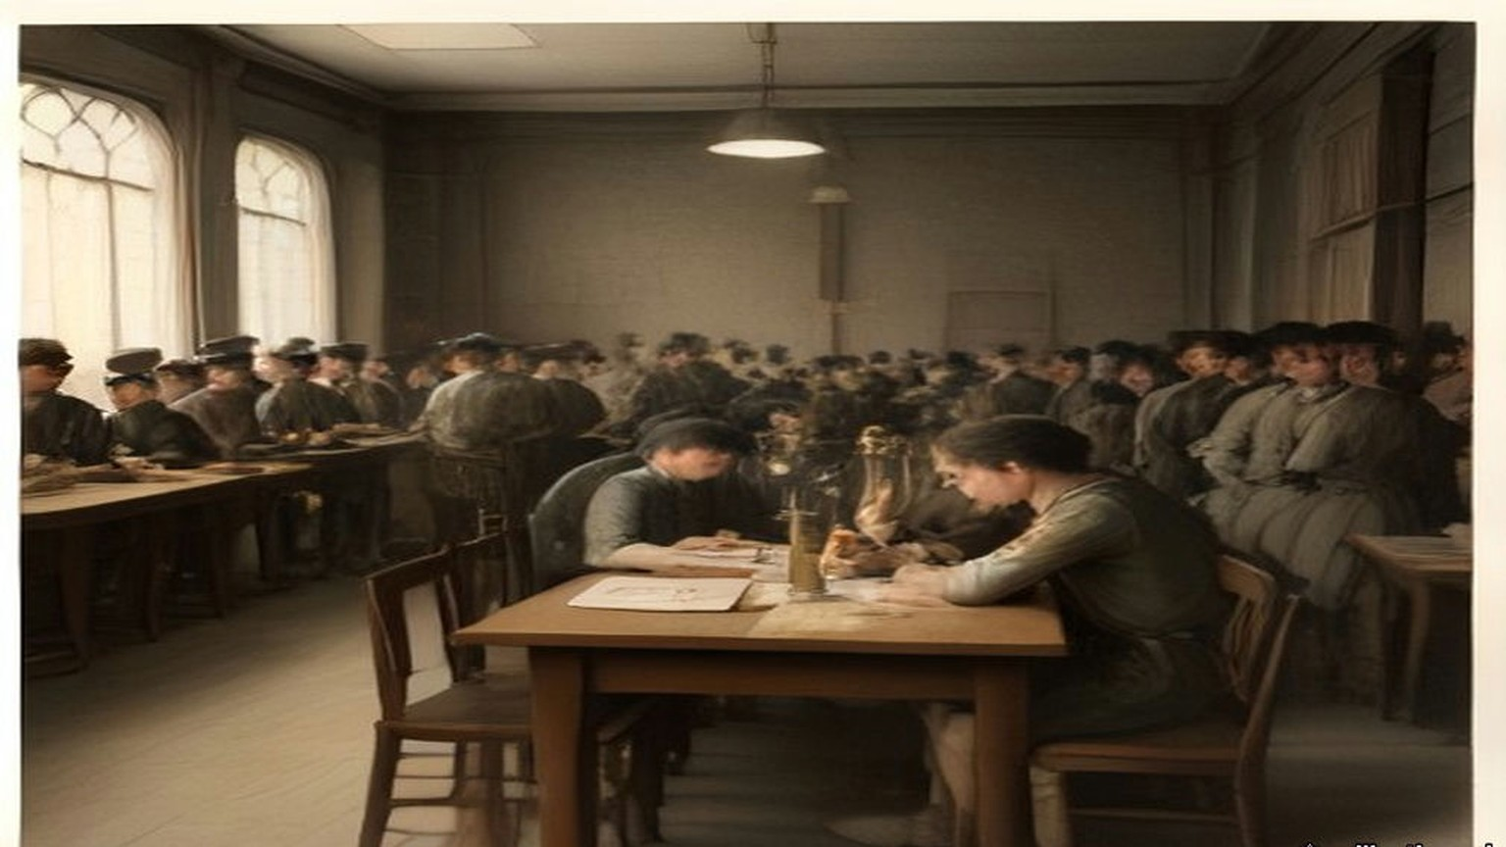
* * *
House of Commons, Thursday, 16 February 1922
Colonel John Newman had two questions down, numbers 55 and 56.
The first was about the cheques. Because they were paid by cheque on the Bank of Ireland, he said, demobilised members of the Auxiliary Division had to wait over a week for the money due to them. Income Tax was being deducted arbitrarily, and refunds were slow and hard to get.
Greenwood answered for the Irish Office. Personal payment was impossible, so payment was by cheque, and since payment was made from Dublin the cheques were drawn on the Bank of Ireland. "The next and final payment is due not later than 31st March, and cheques will be posted in time to enable clearance to be made before that date." Income Tax was assessed and deducted from the pay of these ex-cadets as from the pay of all other public servants. Any complaint about it was promptly investigated. "I am informed, however, that no such case has arisen."
Newman's second question was about a new force. The Inspector-General of the Royal Irish Constabulary, he said, had been able to promise demobilised Auxiliaries preferential treatment in recruiting for the new police force being raised for service in Palestine. But only single men were being taken. If married men agreed to serve without extra pay or emoluments of any sort, would the Government ask the recruiting authorities to give them the same preference?
Winston Churchill, the Colonial Secretary, took it. "The main reason for which it is desired to constitute the force primarily from unmarried men is that there is no accommodation for men's wives in Palestine." And there was the money. "I may add that, if, as the hon. and gallant Member suggests, separation allowance is not to be paid the men would have difficulty in contributing to the support of their absentee wives and families."
"Suppose these men are willing to take the risk?" Newman said. "Why should they not be allowed?"
"I was not aware that any absolute bar had been imposed," Churchill said, "but I think it is important that every one joining the force should know there is no accommodation for women and children out there."
A month later Lieutenant-Colonel Henry Page Croft asked the Secretary of State for War whether married members of the R.I.C. had been told they were not eligible for the Palestine gendarmerie, and whether married men had since been taken anyway. Churchill gave the written answer. "No, Sir." Conditions of service in Palestine were "not regarded as altogether favourable to married life." The recruiting officers had been told to prefer the unmarried, but there had been no absolute bar against married men, "and, indeed, the estimates of the force make provision for a proportion of married personnel."
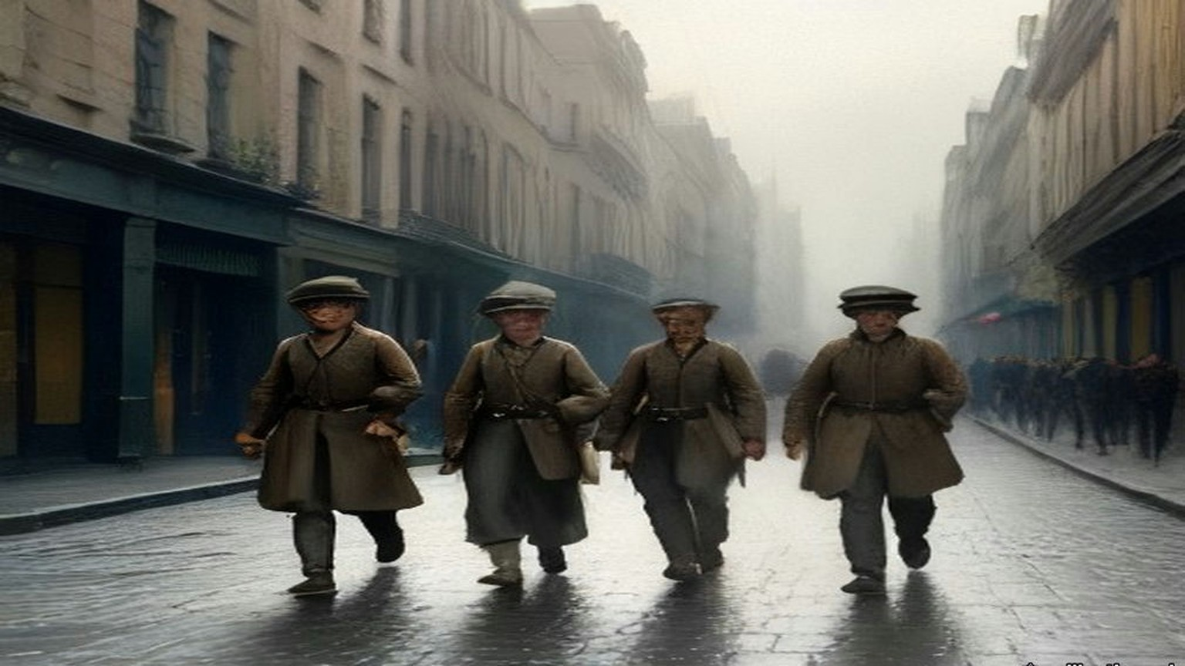
* * *
House of Commons, Committee of Supply, Monday, 20 February 1922
Sir Hamar Greenwood stood up to ask the Committee for a supplementary sum not exceeding £1,474,370 for the Royal Irish Constabulary, for the year ending 31 March 1922.
He said he regretted the need for it, and offered two consolations. The sum was less by many millions than it would have been without the Truce in July and the Treaty in December. And he hoped that, apart from pensions and gratuities, it was the final charge on the taxpayers of Great Britain for the policing of Southern Ireland.
The extra money came from two causes, he said. One was the growth of the force and its transport in the first half of 1921. The other was the terminal charges of the disbandment, after the Treaty, of the Auxiliary Division and the temporary constables. More than 6,000 officers and men recruited in Great Britain had been disbanded since the Treaty was signed and had left Ireland. The regular R.I.C. still in Ireland was "almost entirely Irish and predominantly Catholic": 233 officers and 5,764 other ranks in the South, 50 officers and 2,059 other ranks in the North. Since the Truce twelve of them had been murdered and twenty-seven wounded.
Under Subhead B he wanted £371,443 for the pay of police, and he broke it down. £225,000 was for the ordinary pay and disbandment pay of the Auxiliaries and the temporary constables. "These men were recruited under non-pensionable contracts. This Vote provides the money necessary for the complete discharge of the Government's liabilities under these contracts." He gave the House the £70 again, and the extra sums, "ranging from £1 to £250." The complaints he had received, he said, were not complaints against the Government, but complaints that some comrades, "owing to the accident of the date when they enlisted," were getting more. The representative body of the Division, through its president and delegates, had accepted the terms in an agreement signed on 18 January. There was £66,447 for the Special Constabulary in the North up to 22 November, and £80,000 to pay the purely Irish R.I.C. ahead of 1 April so that the police accounts could be closed by the end of the financial year. "The more expeditious one can make the disbandment, the greater the saving in money."
Then the funerals. The last item of the subhead was public money for the funeral expenses of men murdered or accidentally killed in the discharge of duty. "I regret to say that there were 310 of these funerals payable out of the Supplementary Estimate."
Colonel Josiah Wedgwood said that his side would vote against the whole Estimate "as a protest against wasting our money on dishonourable work, so dishonourable, indeed, that the Government themselves have had to drop it." He asked whether it was really a fact that the Auxiliaries were getting retiring allowances of £250 each. "No, it is not a fact," Archer-Shee said. When Kenworthy came back to the £250 later, Archer-Shee told him: "They do not get a gratuity of £250. That is the money the Government contracted to pay them." Kenworthy asked whether the cadets had in many cases never left Government service at all, "but were at once shipped off to police forces elsewhere, and a great many were offered suitable employment in Palestine." Greenwood had put £40,000 into the Estimate for sending home the men recruited in Great Britain, 6,622 of them. Sir Frederick Banbury made it "about £16 a head." "It seems a large amount for travelling expenses from Ireland, which is not such a very long way off."
Jack Jones broke in. "What about the stuff they ordered and never paid for?"
The next afternoon Jones put it in a question. The Commandant of the Division had appealed to the companies for money to pay what they owed local tradesmen in Ireland, and men who were not in debt had paid for those who were, under the impression that future Government employment depended on it. Greenwood said that considerable sums had been owing by various companies for mess supplies. No one still serving could be held responsible, so the Commandant had appealed for subscriptions. "There was a ready response, and the amount forthcoming represented subscriptions of about 25s. per member." Jones asked whether it was fair that men who had not levied a tribute on the shopkeepers should pay for those who had. "I accept neither the preliminary premises nor the conclusions of the hon. Member," Greenwood said.
The shopkeepers had their own member. Sir Maurice Dockrell told the House on 23 February about G Company at Killaloe, in County Clare. It had opened accounts with the shops there for its mess and canteen when it arrived in November 1920, and left a large sum unpaid when it moved to Corofin in July 1921. On the evening of 2 January 1922 Colonel Guard, second in command of the Division, had offered the shopkeepers part payment and given them until the next morning to accept it in full discharge, or be paid nothing. On 2 March Joseph Hogge, asking in Kenworthy's absence, raised Messrs. James Bourke and Sons, owed £128 1s. 9d. by A Company at Woodstock, County Kilkenny. Greenwood said that if these were private debts, the Government could no more accept responsibility for them than for the private debts of any other branch of His Majesty's Service. If they were public debts, the question would be different, and he was making inquiries. On 29 March Dockrell came back. Greenwood had told him in a letter that £1,000 towards part payment had come from the fines fund of the Division. Messrs. Evans of Limerick had agreed their debt of £460 with the authorities in November and had never been paid. Greenwood said he had nothing to add. The tradesmen had accepted the receipts in full payment at the time.
"Under duress," Dockrell said.
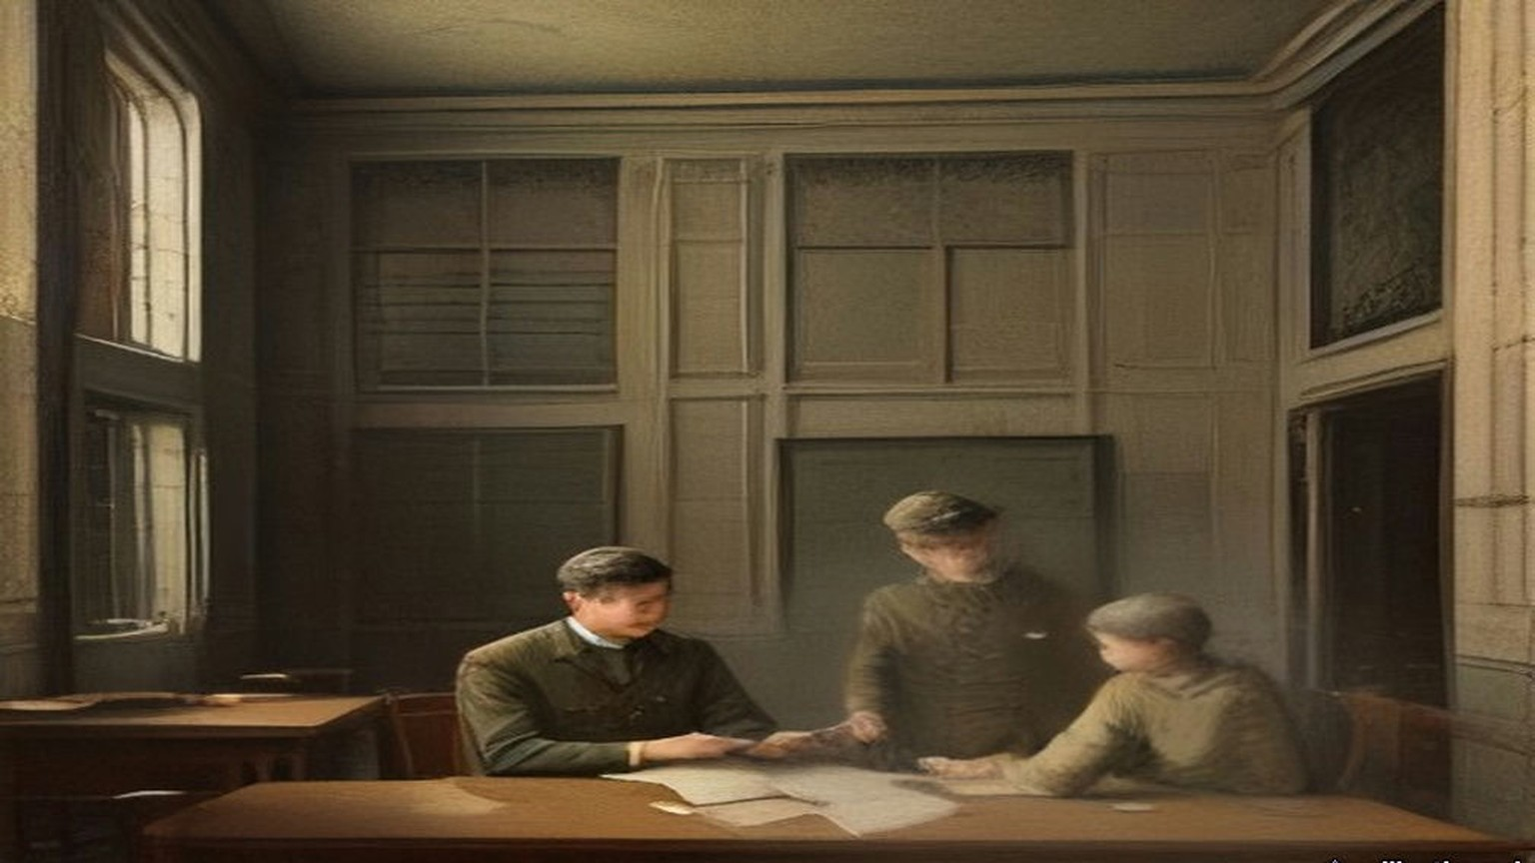
* * *
House of Commons, 28 February to 16 March 1922
Lieutenant-Commander Joseph Kenworthy, the member for Central Hull, had been asking about the new force since February. On 28 February he put down a written question. Was a force of constabulary being raised for the Middle East? How strong? At what cost? For which countries? Who would pay? Would natives of Asia and Africa be enrolled, and aliens?
Churchill answered in writing. "A force of British gendarmerie is being raised at the present time for service in Palestine. Its total strength will be about 700 of all ranks. It is estimated that its recurrent cost will be about £280,000 per annum. The question of the incidence of this expenditure is still under discussion. The personnel will be exclusively British."
On 9 March Allen Parkinson asked the War Office whether the men who had served in Ireland as Black and Tans were being re-engaged for service in Egypt and India at £1 a day, with a gratuity of more than £200 at the end. Churchill gave the written answer. "The answer is in the negative. If the hon. Member is referring to the British section of the Palestine Gendarmerie, which is being largely recruited from ex-members of the various police forces in Ireland, the rate of pay of constables of this force is 10s. a day, with rations and quarters, and a small gratuity if their services are dispensed with before they have earned a pension."
Kenworthy asked again on 14 March, at question time, about pay, horses, motor transport and who would pay. Churchill presumed he meant the British section of the Palestine Gendarmerie, and gave the rates. Constables, 10s. a day. Sergeants, 12s. Head Constables, 15s. Junior Inspectors, 20s. Senior Inspectors, 22s. All of it "with free rations, quarters, arms, equipment, and clothing or an allowance in lieu thereof." There was a commandant "with salary at the rate of £1,000 a year and one or two headquarters officers with pay at appropriate rates." The force would be unmounted. Motor transport would be provided on a scale of "two light lorries and two box cars for each platoon." Kenworthy had asked who would pay. "The incidence of cost is still under consideration," Churchill said.
Kenworthy asked whether this Middle East constabulary was to be employed only in Palestine or elsewhere as well.
"Only in Palestine."
An Auxiliary cadet's average on disbandment, by Greenwood's figure of 9 February, was £140 for the whole of it. A constable in Palestine at 10s. a day would draw £182 10s. in a year, with his rations, quarters and clothes found.
On 3 May Sir John Norton-Griffiths asked Churchill to publish the conditions of service under which ex-members of the R.I.C. had entered the British gendarmerie in Palestine. Edward Wood, the Under-Secretary for the Colonies, answered that "the expense of publication hardly seems justified in the circumstances," but he would be happy to supply a copy of the agreement to any member who asked. The next day Norton-Griffiths wanted to know under what authority the gendarmerie would act at all, since the Treaty of Sèvres, which had authorised the mandate for Palestine, had never been ratified. Wood answered again. "The British gendarmerie exercise their functions under the authority of the Palestine Government. The non-ratification of the Treaty of Sevres does not absolve the Palestine Government from the duty of maintaining order."
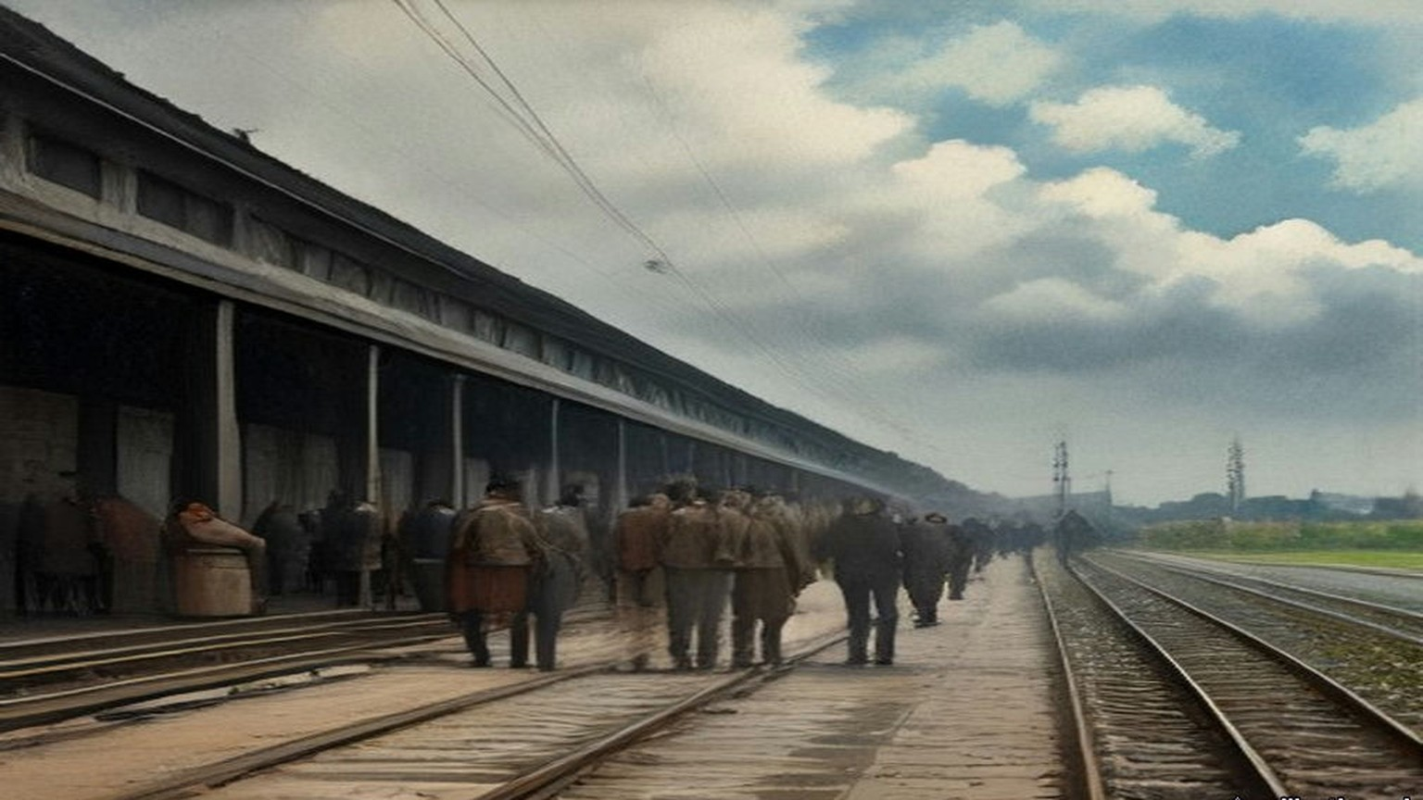
* * *
Ireland and the Commons, March to May 1922
Sir John Butcher sat for York, and from March on he made the disbanding of the R.I.C. his business in the House. Greenwood's terms for the regular men were not the Auxiliaries' terms. On 2 March he gave them to the House: "every man shall receive the pension corresponding to his actual service, with an addition to that service of 12 years," or ten if his pension was reckoned in fiftieths. The pension could be suspended while the pensioner served in any other police force.
The British recruits went first. By 8 March they were the only men of the regular force disbanded, on the terms of the Ninth Schedule to the Act of 1920. On 9 March Greenwood said that the men had been given an advance of £10 at dispersal, "representing, in most cases, over two months' pension." On 11 April Butcher complained that Income Tax not yet assessed was being taken off the pensions of disbanded men. The Financial Secretary to the Treasury, Hilton Young, took the question to mean the British recruits, and said that the arrears for the past year were being taken by monthly instalments of £1, and that the men "were aware, or ought to have been aware, of the approximate amount of their liability."
On 16 March Greenwood said that concentration of the R.I.C. in the South of Ireland, as a preliminary to demobilisation, was complete. On 31 March he said the disbandment of the regular force in the South had begun. On 3 April he told the House that every member of the force, wherever he was serving, would be disbanded by 31 May. It would not be transferred to either Irish Government. A White Paper dated 30 March would give the terms. "When the terms of disbandment are seen," he said, "I am sure that every right hon. and hon. Member will agree that the terms are generous."
Eamon Broy, who had been a sergeant in the Dublin Metropolitan Police and Collins's man inside it, set down the Irish side of that transfer in a single sentence many years later. In 1922 "the Provisional Government took over the D.M.P. but insisted on the immediate disbandment of the R.I.C."
The men were brought in to be paid off. On 17 May Mr. E. Kelly asked about Donegal men brought to the Curragh Camp in Kildare and to Ship Street barracks in Dublin for disbandment, who had asked for the ordinary rates of subsistence and been refused. Greenwood answered that the ordinary rates did not apply to men transferred for disbandment, but that a special allowance of 2s. 6d. a day had been sanctioned for some who had to take their meals out of barracks. It had stopped on 5 April. Officers short of room in barracks got 11s. a night for the first thirty nights. Officers who had to live in hotels in Cork, where the cost of living was "for the moment exceptionally high," got 15s. a night.
On 27 March Greenwood said what a man could have if he was afraid to stay in his own district. He could claim the reasonable cost of moving his home, up to one month's pay if unmarried, two months' if married with fewer than three children, three months' if he had three or more. On 10 April he gave Viscount Curzon numbers, leaving out the men recruited in Great Britain, about 4,400 of them, nearly all already gone. 2,332 regular men had been disbanded. Many who had got warrants to their homes in Ireland had been "deterred by the recent murders from carrying out their intention." 244 had come to Great Britain and 2,055 more meant to. "Four men have been murdered, and one is missing." In the Lords the same day the Earl of Crawford told their Lordships that for the next three months a disbanded man whose home was outside Northern Ireland, who went to Great Britain and left his family in Ireland, would draw separation allowance of 14s. a week, and an officer 28s.
On 3 May Colonel Newman asked about ex-members of the force at Carrick-on-Shannon, compelled under threat of death to leave their homes at once. Greenwood said there had been cases of this kind "not only in Carrick-on-Shannon but in a number of other places in the Irish Free State." The Government would pay the removal expenses of married men and their families to Great Britain or Northern Ireland, and a bureau had been set up at Chester to find them lodgings. On 22 May Sir William Davison put it to the Prime Minister that the separation allowance for a man whose family was still in Ireland was "only 2s. a day for wife and children, or a maximum payment of 14s. a week, whatever the size of the family may be."
Then the count. On 29 May Greenwood said there had been about 10,000 officers and men of the R.I.C. in Southern Ireland before disbandment began. "So far as I am aware, no disbanded member of the force has been offered or has accepted employment under the Provisional Government." Of the 8,000 disbanded so far, at least 5,200 had left Ireland, about 3,200 of them men enlisted in Great Britain, "and about 300 men who have since joined the Palestine Gendarmerie."
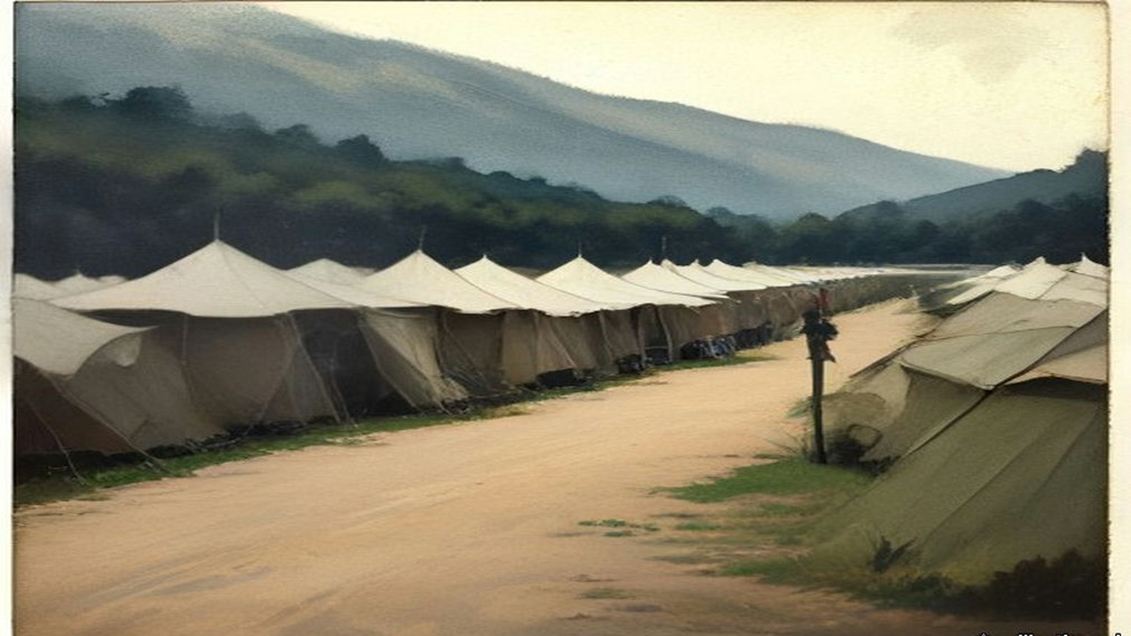
* * *
House of Commons, Wednesday, 10 May 1922
Greenwood moved the Second Reading of the Constabulary (Ireland) Bill, which disbanded the force by law. He moved it, he said, "with profound regret." The force had been founded by Lord Melbourne's Government in 1836, with the support of Daniel O'Connell. At its highest moment, on 11 July 1921, the force had 12,902 regulars and 3,052 temporary police. Disbandment was "urged unanimously by the police force itself," he said, and the men had put their view in a single sentence: "that as an Imperial force they were born, and as an Imperial force they wished to die."
The Auxiliaries, the Veterans and the Transport Division were gone, apart from minor details. The regular force was down to 2,130 in the North and 1,982 in the South, the southern men concentrated in four camps and disbanded day by day. "There are no policemen under the control of this House doing duty in Southern Ireland at the present time." Ronald McNeill asked how many had gone. From memory, Greenwood said: 1,500 Auxiliaries, about 4,000 regular recruits from Great Britain, 500 transport drivers and mechanics, and some 800 old soldiers, the veterans, who had done fatigue, orderly and barrack duties.
He explained the money. A man disbanded since 25 January drew a "compensation allowance," a new term in the vocabulary of pensions. "The policy of disbandment was contemplated and provided for by Article 10 of the Treaty," he said. Under that Article the Free State would ultimately pay the pensions of the Irish R.I.C. But His Majesty's Government had guaranteed every payment, and had taken over the administration of all of them, so that the men would have "a strict and immediate payment of that which is due to them." He gave the House a worked case. The smallest allowance, for a man with under six months' service, was £46 16s. a year, "less than £1 a week." By augmenting it the man could draw £106 12s. a year for two years, and £37 16s. after that, until the difference was paid back.
Colonel Newman spoke later in the afternoon. He asked how the Free State's share would be settled. Greenwood told him that under Article 10, "the Southern Irish Government pledges itself to recoup the Government for the pensions and so on of the permanent Royal Irish Constabulary, except in cases of men recruited during the last two years." "Is that a lump sum?" Newman asked. He took it to mean one final settlement after arbitration. Then he spoke of the men. There were something like 8,000 of them, he said, and half of them married men with families. Could they not be held together, or some of them? "A large number of the special division of the Royal Irish Constabulary," he said, meaning the Englishmen specially recruited, "are about to go to Palestine under General Tudor for service as special constabulary there." Why not the younger unmarried men of the R.I.C. as well? "How valuable would be a force of 2,000 of the Royal Irish Constabulary, say, in Constantinople to-day, to keep law and order."
On 25 May Greenwood circulated in the Official Report what the Bill would cost by the man. About 300 officers and about 12,300 non-commissioned officers and men would be disbanded and receive compensation allowances. About 2,000 of the men had under one year's service, 3,500 under two, 720 under three. A constable with under a year's service would have at least £46 16s. a year; one with two and a half to three and a half years, £58 10s.
The Bill passed its Third Reading on 14 June. Butcher said the Chief Secretary had met their amendments in Committee as far as he could, "subject to the Treasury." "I wish the Treasury could have seen their way to provide more money in the case of the men who were driven out of Ireland and had to come to England or elsewhere for refuge." A week later, on 20 June, he asked Churchill whether an R.I.C. pensioner who took a post in the Colonial or Indian police would have his pension cut. Churchill sent him to Clause 1 (3) of the Bill, which provided "that if any officer or constable to whom a compensation allowance has been awarded takes service in any police force, the allowance may be suspended in whole or in part so long as he remains in such force." He was in communication with the Treasury, he said, as to the scope of that provision. Butcher asked whether he would consult the Law Officers on whether the Indian and Colonial police forces were police forces within the meaning of the clause.
The same day Greenwood told the House in writing that all pensions of retired or disbanded R.I.C. men "will continue to be paid from Imperial funds."
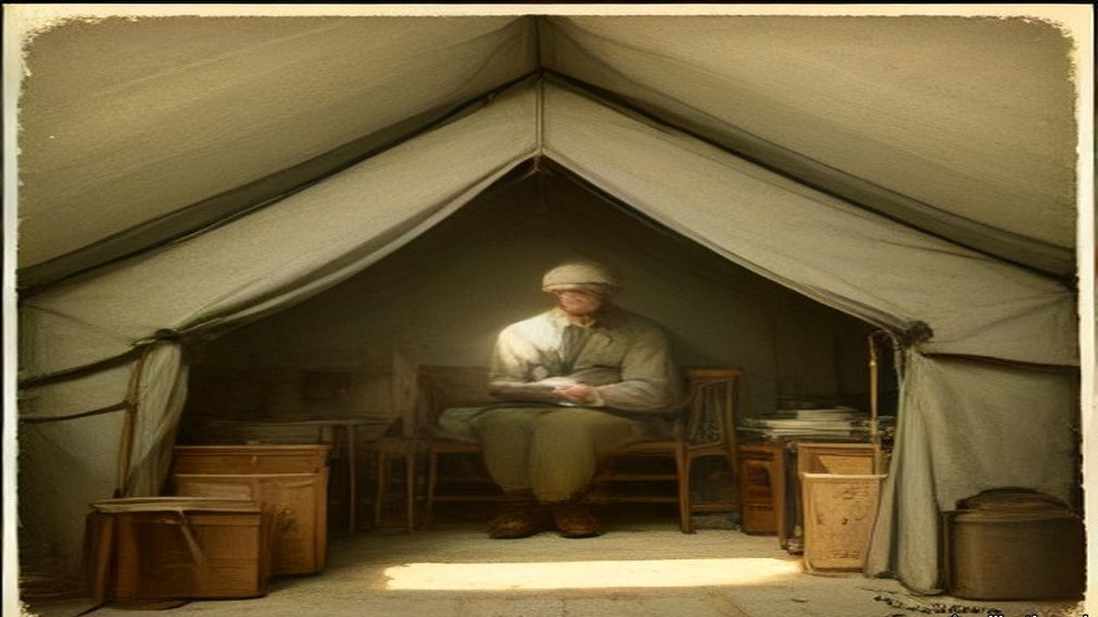
* * *
Carton, County Kildare, June 1922
Lord Frederick FitzGerald had charge of Carton, at Maynooth, with his sister. They were the uncle and aunt of the Duke of Leinster. Nineteen years before, he had been one of the two trustees who offered the Leinster estates to their tenants at Athy. In June 1922 the papers came to Carton.
The Leinster Leader of 17 June had it under "Sale to English Purchaser." The Leinster estate, "embracing the greater part of Kildare, Kilkea Castle and the principal towns of the county," had "now passed into the proprietorship of an English Baronet, Sir Harry Mallaby-Deeley." The present Duke, Lord Frederick's nephew Edward, had sold his reversionary interest when he was Lord Edward FitzGerald, with his two elder brothers still alive and "little prospect of his succeeding to the title," "for, it is stated a relatively small sum." Then Lord Desmond had been killed in the war, and the sixth Duke, Maurice, had died "a few moths ago," as the transcription has it. The title came to Edward. The estate came to the man who had bought the reversion.
The paper gave the Daily Express's Dublin correspondent's figure for the land money. Part of the Duke's Irish estates had been sold to the tenants under the Wyndham Act, "and the proceeds amounting to nearly £1,000,000 invested in London ground rents." The life interest in those investments, it was presumed, would now go to Mallaby-Deeley. Twelve or more workmen on the demesne had been dismissed the week before to cut down expenses.
Mallaby-Deeley told the Daily Mail that he had been asked to buy the reversion four or five years before, and refused, and that when the offer was made again a year later he had named a price that his expert advisers called "perfectly ridiculous," meaning too high. "As far as I know the estate is being run as usual. I am bearing the whole expenses of the estate, and my agreement with the Duke is that everything should be carried on exactly as it has been in the past." The Duke's private secretary gave a London paper the other side's numbers. The Duke had an option to buy back. "The cost for re-purchase is £350,000 and not £400,000 as has been stated. The estate of the Duke of Leinster is worth more than £2,500,000, and, in addition, the heirlooms are valued by him at the best part of £2,000,000. The Castle costs £8,000 a year to maintain, and the annual income from the estates is more than £45,000."
Lord Frederick corrected the land money. The part of the estate sold under the Wyndham Act had reached "over half a million," he said, "not nearly a million as stated in the 'Sunday Express,'" and it was an error to say it had been invested in London ground rents. Expenses had been cut down. "Some labourers having regretfully been discharged owing to the enormous death duties."
A week later, on 24 June, the Leinster Leader printed what he told a Daily Express man at Carton House, where he was in charge of the estate in the absence of the owner. Mallaby-Deeley had repudiated any instructions to dismiss servants. "Certainly," Lord Frederick said. "I received instructions to reduce the staff of the estate. They came from the firm of Messrs. Freshfields," Sir Harry's solicitors. He had written to Sir Harry to ask whether, in view of the repudiation, the dismissed men could be taken back.
The paper set down what the county would lose with the family. The land had been largely sold to the tenants, but the FitzGeralds still held the ground rents and many of the buildings in practically all the towns. "Very extensive employment is given on the demesnes, tillage being intensive and a splendid class of livestock bred." The employees were "comfortably housed and well treated." "Being a resident family a very deep interest was taken in the welfare of the employees." The new owner, it said, was best known for his campaign against the profiteers in the clothing business. He had opened an establishment in London and "sold suits at a figure which broke the prices." "It is not likely that he will come to live at Carton."
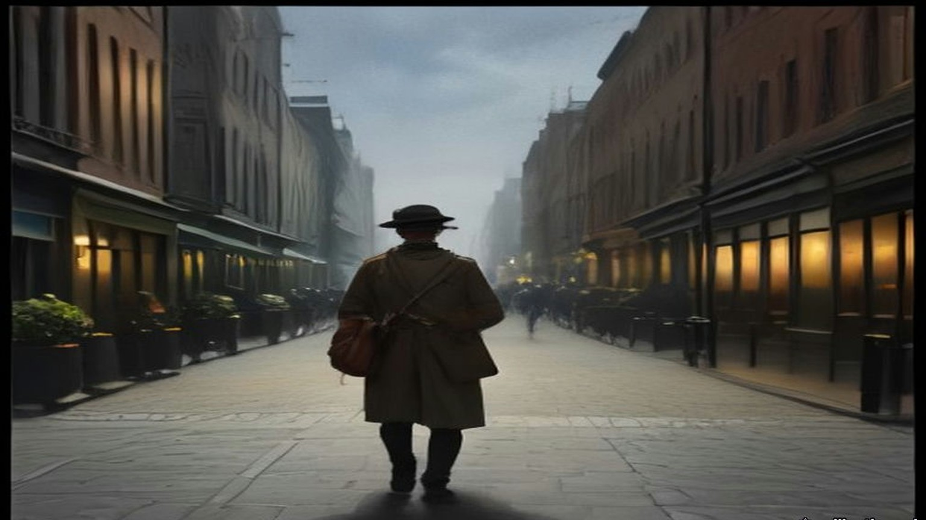
* * *
House of Commons, Tuesday, 1 August 1922
The Bill came back to the Commons from the Lords with amendments. One of them struck out the sub-section that let a man's compensation allowance be suspended if he joined another police force. Sir John Butcher had pressed the point since June.
There were men still waiting for the money the Bill was about. On 24 July Captain Charles Craig asked about ex-Sergeant John Freeman, disbanded in April, paid two months' pension for April and May, told that his June pension would come on 1 June, and paid nothing since. Greenwood answered that a draft for June had been issued on 10 June, but Freeman had changed his address about then and it had not reached him. Duplicates for June and July had gone out. Two days later Craig asked about ex-Head Constable George Fails, who had been put to considerable expense in moving his home from his old station and had nothing for June or July. Greenwood said Fails had been paid for June on 10 June through the Northern Banking Company, Belfast, and that a draft for July had gone to him on the 5th.
On 1 August the Commons took the Lords' amendments. The first moved the last day of disbandment from 31 July to 31 August. Colonel Ashley asked whether Greenwood was sure the 31st of August was late enough. "That is what I hope," Greenwood said. The Speaker pointed out that it would extend by a month the time during which the men had to be paid.
Then the Lords amendment to leave out Sub-section (3). Greenwood moved that the House disagree with it. It was a question of the compensation of disbanded police who joined another police force, and he opposed it on the merits.
Speaker after speaker took the Lords' side. Harry Betterton said the allowances were "really in the nature of damages for breach of contract." The men had served on a contract that promised them pensions, and Parliament had broken it for its own convenience. "We, however, propose to say to these men, 'Because we give you this compensation you shall be precluded, except at your own cost, from taking up the work for which you have been specially trained and for which you are best suited.'" Frederick Macquisten said he had never heard of anything so hare-brained as telling a man who had been a policeman all his life that if he ever became one again a lot of money would be taken from him. "Why, the very thing we ought to say to these men is, 'Go and be policemen.'" And he said where some of them had gone already. "I understand we have already sent a lot of them out to the new Ulster we are making in Palestine. We have sent a number of the Black and Tans out there."
Sir William Joynson-Hicks said the pensions were earned. "He has no right to ask us to give a generous pension out of public money, but only to give what is fair and right, and he has no right to come down here and Prevent these men from earning their living in the way they can best do it in their own interests, and in the interests of the country, by penalising them if they attempt to do it."
The Question was put, that the House disagree with the Lords. The House divided at ten to six. Ayes, 169; Noes, 122. Butcher was a teller for the Noes.
Lieutenant-Colonel Walter Guinness then moved words of his own at the end of the sub-section. The suspension would apply only to a police force "the expenses of which are defrayed in whole or in part out of moneys provided by Parliament, or by any Parliament in Ireland, or out of funds assisted by the Exchequer or by any Exchequer in Ireland." It was a form the Lords' own Select Committee had drafted. "The effect of this compromise would be to leave men free to carry on their work as policemen in any of the great Dominion or Colonial forces to which they might be tempted to go." Sir Samuel Hoare seconded it. The amendment was agreed to.
Chapter 21 Appendix of Important Names
• Churchill, Winston (10 mentions in this chapter): British cabinet minister (Home Secretary, First Lord of the Admiralty, War and Colonial Secretary, and Prime Minister) recurring across the Irish, Middle Eastern, and Indian settlements.
• Collins, Michael (1 mentions in this chapter): Director of Intelligence for the IRA, signatory of the 1921 Anglo-Irish Treaty, and Chairman of the Provisional Government.
• Craig, James (2 mentions in this chapter): Ulster Unionist leader and first Prime Minister of Northern Ireland.
• O'Connell, Daniel (1 mentions in this chapter): Irish political leader who led the campaigns for Catholic Emancipation and the Repeal of the Union.
• Samuel, Herbert (1 mentions in this chapter): British Liberal politician and first High Commissioner for Mandate Palestine (1920–1925).
• Tudor, Hugh (1 mentions in this chapter): British Major-General appointed Police Adviser in Ireland in 1920 and subsequently Inspector-General of Police and Gendarmerie in Mandate Palestine.
Sources
• House of Commons Debates, 8 February 1922, vol. 150, c134, "Auxiliary Division (Pay)" (Archer-Shee; Leipold's cheque; Greenwood). https://api.parliament.uk/historic-hansard/commons/1922/feb/08/auxiliary-division-pay
• HC Deb 9 February 1922, vol. 150, cc270–1, "Royal Irish Constabulary, Auxiliary Division" (Yate, Curzon, Greenwood's terms, Kenworthy). https://api.parliament.uk/historic-hansard/commons/1922/feb/09/royal-irish-constabulary-auxiliary
• HC Deb 23 February 1922, vol. 150, cc2078–9, "Auxiliary Cadet (Mr. J. C. J. Towner)" (printed in Hansard's heading as "T00mer"); cc2079–80, "Auxiliary, Cadets (Tradesmen's Accounts)" (Dockrell, Killaloe, Colonel Guard). https://api.parliament.uk/historic-hansard/commons/1922/feb/23/auxiliary-cadet-mr-j-c-j-t00mer and /auxiliary-cadets-tradesmens-accounts
• HC Deb 16 February 1922, vol. 150, cc1197–8, "Auxiliary Police" (Newman; Greenwood; Churchill). https://api.parliament.uk/historic-hansard/commons/1922/feb/16/auxiliary-police
• HC Deb 16 March 1922, vol. 151, c2392W, "Palestine Gendarmerie (Recruiting)" (Croft; Churchill on married men). https://api.parliament.uk/historic-hansard/written_answers/1922/mar/16/palestine-gendarmerie-recruiting
• HC Deb 20 February 1922, vol. 150, cc1559–663, Supply, Class III, "Royal Irish Constabulary" (Greenwood's supplementary estimate of £1,474,370; Subhead B, £371,443, £225,000, £66,447, £80,000; the 18 January agreement; the 310 funerals; Wedgwood; Archer-Shee; Banbury; Jones). https://api.parliament.uk/historic-hansard/commons/1922/feb/20/royal-irish-constabulary
• HC Deb 21 February 1922, vol. 150, c1727, "Auxiliary Police (Debts)" (Jones; 25s. per member). https://api.parliament.uk/historic-hansard/commons/1922/feb/21/auxiliary-police-debts
• HC Deb 2 March 1922, vol. 151, c549, "Royal Irish Constabulary (Disbandment)," and c550, "Auxiliary Police (Debts)" (Hogge, Bourke and Sons, Woodstock). https://api.parliament.uk/historic-hansard/commons/1922/mar/02/royal-irish-constabulary-disbandment and /auxiliary-police-debts
• HC Deb 29 March 1922, vol. 152, cc1331–2, "Auxiliary Police (Debts)" (Dockrell; the fines fund; Evans of Limerick; "Under duress"). https://api.parliament.uk/historic-hansard/commons/1922/mar/29/auxiliary-police-debts
• HC Deb 28 February 1922, vol. 151, cc287–8W, "Middle East (British Gendarmerie)." https://api.parliament.uk/historic-hansard/written_answers/1922/feb/28/middle-eastbritish-gendarmerie
• HC Deb 9 March 1922, vol. 151, c1519W, "Palestine Gendarmerie (Recruiting)" (Parkinson; Churchill). https://api.parliament.uk/historic-hansard/written_answers/1922/mar/09/palestine-gendarmerie-recruiting
• HC Deb 14 March 1922, vol. 151, cc1947–8, "Constabulary" (Palestine; Kenworthy; Churchill's rates). https://api.parliament.uk/historic-hansard/commons/1922/mar/14/constabulary
• HC Deb 3 May 1922, vol. 153, c1337, "Palestine (Gendarmerie)," and 4 May 1922, vol. 153, cc1540–1, "British Gendarmerie" (Norton-Griffiths; Wood). https://api.parliament.uk/historic-hansard/commons/1922/may/03/palestine-gendarmerie and https://api.parliament.uk/historic-hansard/commons/1922/may/04/british-gendarmerie
• Royal Irish Constabulary answers, 1922: HC Deb 8 March, c1272; 9 March, cc1459–60; 16 March, cc2390–1W; 27 March, c976W; 31 March, c1697W; 3 April, cc1844–5; 10 April, cc25–6; 11 April, cc207–9; 3 May, cc1338–40 ("Ex-Constables (Threats)"); 17 May, cc389–90W; 22 May, cc796–9 ("Royal Irish Constabulary Refugees"); 23 May, cc1025–7W; 25 May, cc1389–90; 29 May, cc1715–6W; 20 June, cc1056–7W and c1016; 24 July, c29 ("Royal Irish Constabulary (J. Freeman)"); 26 July, c447. All at https://api.parliament.uk/historic-hansard/ under the dates given.
• House of Lords Debates, 10 April 1922, vol. 50, cc131–3, "R.I.C. Pensions and Gratuities" (Crawford; Cmd. 1618; separation allowance of 14s. and 28s.). https://api.parliament.uk/historic-hansard/lords/1922/apr/10/ricpensions-and-gratuities
• HC Deb 10 May 1922, vol. 153, cc2229–89, "Constabulary (Ireland) Bill," Second Reading (Greenwood; McNeill; Newman). https://api.parliament.uk/historic-hansard/commons/1922/may/10/constabulary-ireland-bill
• HC Deb 14 June 1922, vol. 155, cc464–5, "Constabulary (Ireland) Bill," Third Reading (Butcher). https://api.parliament.uk/historic-hansard/commons/1922/jun/14/constabulary-ireland-bill
• HC Deb 1 August 1922, vol. 157, cc1301–34, "Clause 1 (Disbandment of the Royal Irish Constabulary)," Lords Amendments (Greenwood; Ashley; the Speaker; Betterton; Macquisten; Joynson-Hicks; Division No. 270, 169 to 122, tellers; Guinness; Hoare). https://api.parliament.uk/historic-hansard/commons/1922/aug/01/clause-1-disbandment-of-the-royal-irish
• Bureau of Military History, WS 1,280, Eamon Broy (militaryarchives.ie, BMH.WS1280.pdf, via the Internet Archive). Statement p. 16 ("the Provisional Government took over the D.M.P. but insisted on the immediate disbandment of the R.I.C.").
• Leinster Leader, 17 June 1922, "Sale to English Purchaser: Historic Co. Kildare Estate," and 24 June 1922, "The Carton Estate Sale," transcribed by Kildare Library Services, Kildare eHistory, "Sale of Leinster Estates." The Leinster Leader quotes the Daily Express, the Daily Mail and a London paper; each quotation is given as the paper printed it. https://kildarelibraries.ie/ehistory/sale-of-leinster-estates/

Part III

Chapter 22
Ledger and Mob, Galilee, 1831–1840
Jerusalem, the hills of Nablus and Hebron, and Safed in the Galilee
In the autumn of 1831 an Egyptian army came up the coast road out of Sinai. At its head rode Ibrahim Pasha, eldest son of Muhammad ʿAli Pasha, the governor of Egypt, who was still in theory a servant of the Ottoman sultan and in practice nobody's servant at all. Muhammad ʿAli gave a reason for the invasion that sounds almost like a clerk's complaint. Egyptian peasants had been running north into Syria for years to escape his draft, and he wanted them back. Judith Mendelsohn Rood, who has spent a career inside the Jerusalem court registers, calls that reason a ruse. By the following year Ibrahim held Acre, Damascus, and everything between them and the Egyptian border.
Most of the people he now governed did not mourn the change at first. Rood records that they were glad to be rid of ʿAbdullah Pasha, the Ottoman governor at Acre, whose rule they remembered as tyranny. For decades the Porte in Istanbul had run this coast through strongmen. Ahmad al-Jazzar had held Acre with his own soldiers and his own tax arrangements until he died in 1804. Muhammad Abu Nabbut held Jaffa in the years after. Such men answered to the sultan when the sultan was looking, and sent money when money could not be avoided.
Ibrahim brought something the strongmen never had. His troops were the نظام nizam, the new order, peasant conscripts drilled in European fashion, in short jackets, armed with muskets loaded from paper cartridges. Behind the troops came a bureaucracy that answered to Cairo, and a ledger that reached into the village.
Rood reads the change through the سجلات sijillat, the registers of the Islamic court in Jerusalem, and what she finds there is a contract being broken. Under the Ottomans the courts spoke of "repose and tranquility." A just ruler kept order and took just taxes, and a ruler who failed to protect his subjects from disorder and arbitrary taxation lost the right to rule. Inside that frame every class had its place. The Muslim scholars and administrators of Jerusalem, the ʿulama, paid no taxes at all. The Bedouin guarded the roads and the pilgrim traffic and were paid portage and toll fees for it, and so was the Abu Ghosh family in the hills west of the city. Christians and Jews paid the jizya and were spared military service. The fallahin farmed and paid and, when trouble came over the hill, picked up the family musket and went out with their sheikh for a day or a week, and then came home to the harvest.
Muhammad ʿAli's government pulled at every corner of that arrangement at once. Across Syria the religious endowments, the waqfs, were reorganized, and Cairo took control of the revenues of the Waqf al-Haramayn, the endowment for the holy cities of Mecca and Medina. The ʿulama lost powers they had held under the sultan, and Jerusalem's Muslim administrative class, men who had never paid a tax, were handed a new one. The Bedouin and the Abu Ghosh family lost their tolls on the roads. On top of everything came the فردة farda, a head tax. The jizya from Christians and Jews went on being collected as before.
In April 1834 Ibrahim summoned the leaders of Jerusalem and Nablus to Jerusalem and told them what he wanted next.
* * *
Jerusalem, April 25, 1834
Cold, the stone of that hall, and the carpets under-us thin. Came-up-we from the hills of Nablus two days on the mule, I and the son of the uncle of my wife, and the dust of the road still in our beards. In the front of the room sat the great-ones of the city. The mufti, Tahir Afandi al-Husayni, and beside-him ʿUmar Afandi al-Husayni, the naqib of the descendants of the Prophet, and the bashkatib of the court, Muhammad ʿAli al-Khalidi, the man who writes the judgments. Behind-them the sheikhs of the country. Qasim al-Ahmad of Jabal Nablus, a man the whole mountain knows his voice. ʿIsa al-Amr from the side of Hebron. And behind-them, men like-me, sheikhs of villages that the pasha knows-not their names.
Small, my village. Forty houses and a spring of water, and trees of olive that the grandfather of my grandfather planted-them. Why called-they-me to Jerusalem, wallah, knew-I-not. After-that knew-I.
Came-in the pasha. Not old in the years, Ibrahim, and thick in the body, and his eye turning over-us the way a buyer turns his eye over the sheep in the market of Nablus. Sat-he, and wasted-not the time.
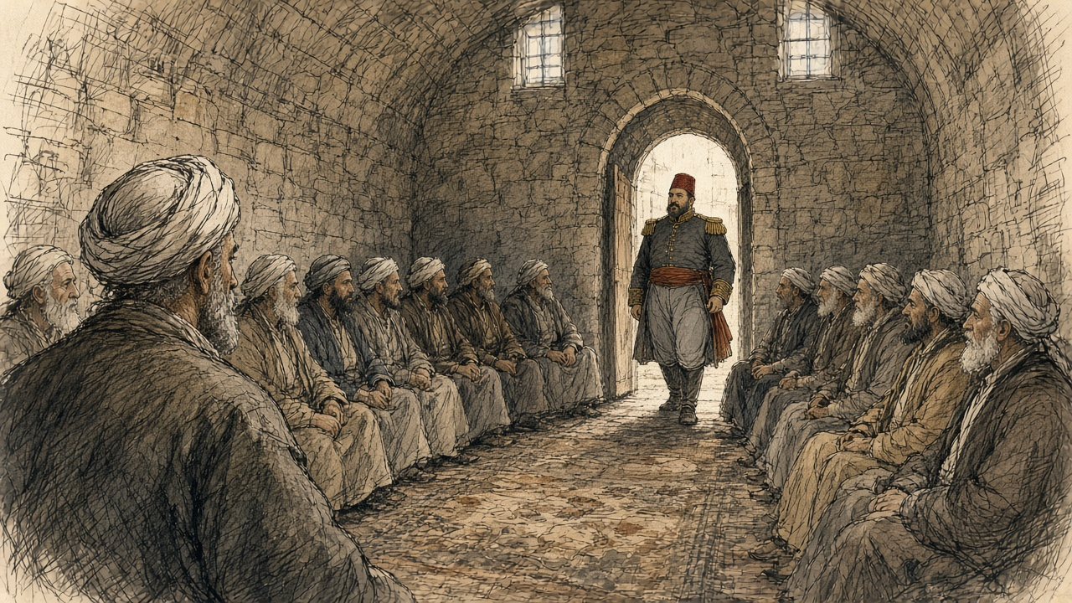
"As we, Muslims, to-us are enemies perpetual from the nations of the Nazarenes, necessary or not necessary is-it that to-us be an army standing great?"
What say-you in this? The great-ones said yes. Without doubt necessary. After-that asked-he-them from whom shall-be-taken the army, from the Christians or from the Muslims, and said-they, from the Muslims, assuredly. And understood-I then that walked-he-us into a room and shut its door behind-us, and that the door, opens-it only from his side.
Wants-he the young-men. Two hundred from the city of Jerusalem first thing. Three thousand and five hundred from the districts of Jerusalem and Nablus. Five hundred from Hebron. A man from every five, said the men who heard-it better than-me. They-learn the craft of the war from their youth, said-he, and be ready.
Fell a silence on the room. Long, that silence. Counted-I my breath, and thought-I in the boys of my village, and their names passed through-me one after one like beads of the misbaha between the fingers. After-that the great-ones answered, and their answer was soft in its beginning and hard in its end.
"Your order upon our heads," said-they. "There-is-not need that we-hand-over our boys and our young-men for the war. When the enemy of our religion enters our land, all-of-us, young and old, go-out and fight and give our blood willingly…"
This the truth that knew-we-it. Thus fought our fathers. Thus fought the grandfathers of our fathers against the French, when the Franks came-up to Acre in the time of al-Jazzar. The man takes his musket from the wall and goes, and fights beside his brother and the son of his uncle, thumma returns-he to his house. To the land of the Arabs goes-he-not, nor to the Yemen, and never forever.
Asked the pasha how want-we we-make war if know-not-we its craft. Told-they to-him that this craft our grandfathers knew-it, and we know-it. And said the pasha a word that carried-I-it with-me on the mule like a stone in the saddlebag.
"The war is not a place for a herd of men useless: craft and skill are required. This order want-I it carried-out without delay, and from here from Jerusalem we-begin."
A herd. Sheep, his meaning. Thus looked-he in-us, thus named-he-us.
The great-ones bowed and asked the permission they-return to their districts they-carry-out the order. Bowed-I with-them. Ya rabb, and what other-than this? And on the road of the return the son of my uncle spoke-not one word until saw-we the lights of Nablus, and in-that-hour said-he, "Will-take-they Hasan. Will-take-they the son of your sister. Will-take-they every one that not-yet his beard has-come-out."
* * *
Jerusalem and the hill villages, spring 1834
Ibrahim left Jerusalem for Jaffa three days after the meeting, on April 28. Behind him the order moved out into the villages faster than he did.
The men who heard it knew what the nizam meant. Rood is plain about it: Muhammad ʿAli's conscripts were inducted for life, with no hope of return, and in 1834 they were being sent to fight in Arabia and in the Yemen. A son taken for the army was a son lost to the plough and the olive press, and to his mother, for good. When the Nablus men talked among themselves about what to do, the chronicle Spyridon published records the sentence that came out of those talks. It was better, they said, to die with their arms than to give their children to everlasting slavery without the hope of ever seeing them again.
An American missionary named William Thomson, posted in Jerusalem that spring, wrote on May 19 that he had "met many fellaheens, armed and equipped for war." He asked one of them, a man come down from the hills, whether he was out shooting birds. The answer went into Thomson's letter word for word. "With a bitter smile, he said, my birds are in Jaffa, and my lead is for the Pasha."
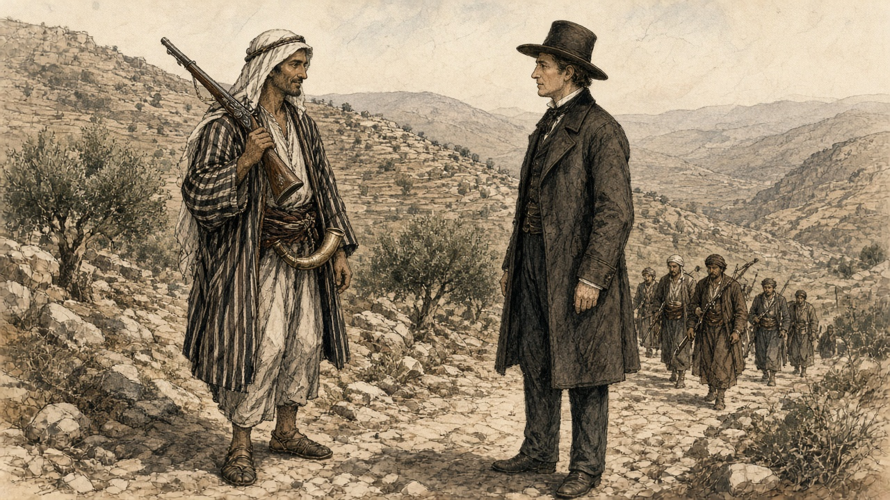
Thomson also wrote down a grievance he called "ridiculous enough," though he admitted it said something about the people. The pasha's recruiters shaved off the conscripts' long beards and put them in the nizam dress, "very much like the Frank," and those two things, Thomson wrote, were "an abomination in the eyes of the people." One poor woman complained to him bitterly that the pasha "made them all become young again."
Some families did not wait for the recruiters. In Egypt, where Muhammad ʿAli's draft had been running for a decade, the historian Khaled Fahmy found young men in the archives of the army who had made their own bodies useless to it. A musket has to be aimed, and so they put caustic lime or needles into an eye. A trigger is pulled by the index finger of the right hand, and so they cut that finger off. A paper cartridge has to be bitten open to pour the powder down the barrel, and so they pulled out their front teeth. Rood found the same desperation reported in Syria: men blinding themselves in one eye, cutting off a hand.
* * *
A village in the hills between Nablus and Jerusalem, the end of April 1834
The morning the cold, and the smoke of the ovens of the bread low over the roofs. Under the tree of the lemon in the courtyard of my father, sat Hasan on the stone of the threshing, and his hand the right laid flat on the block of wood of the olive that we-split on-it the firewood. Hasan, habibi. Since the day were-we boys grazed-we the goats together, and together ate-we the beating with the stick of the same uncle.
At the doorway stood my mother, her-two-hands inside her sleeves. Spoke-not-she. Not-one spoke. The sheikh had-returned from Jerusalem before two days, and since that-day the village all-of-it speaks-not except in the whisper, the way the people speak in a house that in-it someone dying.
Beside-me on the wall-stones, the pot the small of the lime. White, the lime, the lime of the kiln that we-burn-it for the plaster of the roofs. Wet-it with the water, and boils-it by-itself. My grandmother used to say to-us when we small, put-not your hand in the lime, it eats. Now knew-I what it eats.
Zahra, the wife of Hasan, came-she and knelt behind-him and put her-two-hands on his shoulders. Young, Zahra, married-to-him one winter only. Her face white like the lime.
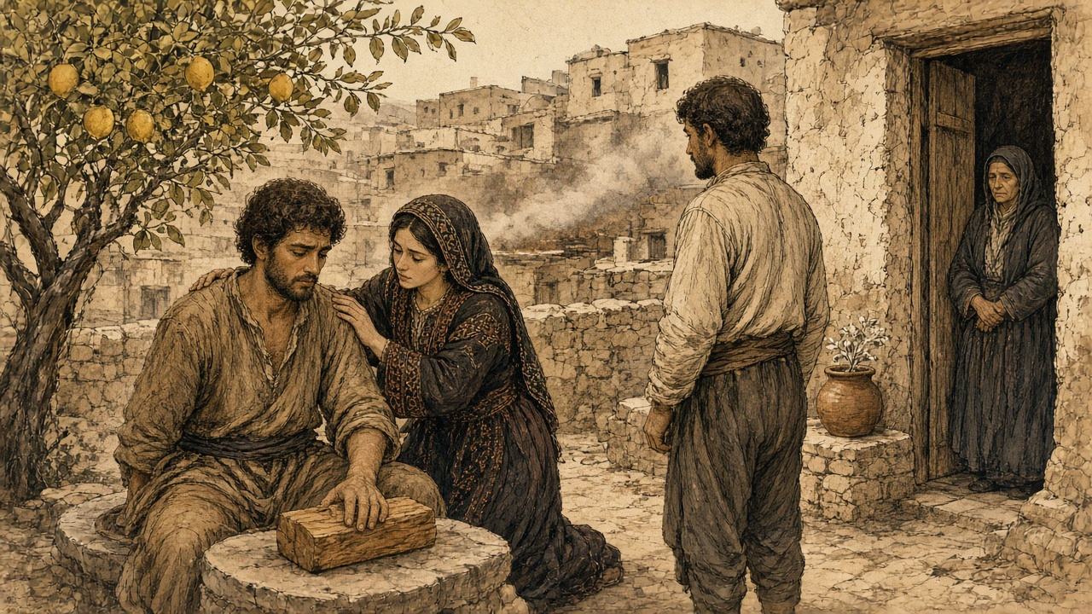
"Bismillah," said Hasan.
Said-he-it the way the man says-it before he-lifts a stone heavy, and the son of his uncle came-down with the hatchet. Its sound, will-tell-I-it-not. Only that it-was short, and that Hasan made in his chest a groaning like a dog held by his neck and wants-not he-howl, and that Zahra had-ready the rag, the rag that tore-she-it from her head-cloth, and wrapped-she his hand and pressed-it against her chest, and spoke-she in his ear the words that the woman speaks-them to a child on-him fever. Ya habibi. Ya habibi. Al-hamdu lillah, it-finished. It-finished.
After-that looked-they in-me.
My eye, hung-it on Amina, core of my heart. Stood-she at the bread-oven and the flour still on her arms, and turned-not-she her face, because I had-asked from-her this that night. Let the last thing sees-it this eye, be you. Her face a moon. Her beauty sufficed-me it-give-me strength, al-hamdu lillah, for my sight going after-him. Scarcely perceived-I the groan of habibi holding-in his pain, knowing that Zahra beside-him comforting-him. And was-she at-there steadying-him.
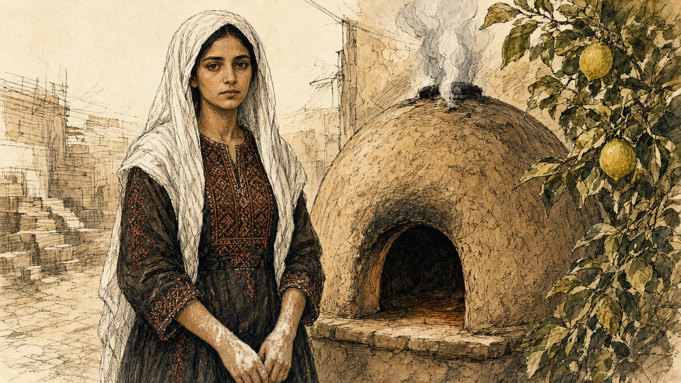
Wetted-I my fingers in the water of the jar. Took-I the lime. Named-I with the name of God, and held-I my eye the left open with my hand the left, and put-I-it in-it.
Burned-away the sight.
What remember-I after-it: its fire, and a smell like smell of a wall after the rain, and my voice that knew-I-it-not, and my mother who came-out in-that-hour, at-the-last, from the doorway, and poured water and water and water over my face from the jar, and wept a weeping that hear-I-it still. The hand of Amina on my wrist. Hasan laughing, wallah, laughing and weeping together, saying, now became-we brothers twice, ya akhi, now became-we brothers twice.
Five days the eye wept. On the sixth untied-I the cloth, and on that side was-not except light, a whiteness like the morning before the sun, and inside-it nothing.
After-that came the day. Came the sheikh to the square with-him the paper, the same sheikh that went to Jerusalem, and with-him two-men from the nizam in their jackets the short, and the young-men stood a line beside the wall of the mosque. Read-he the names, and lifted-not his eye from the paper while he reading-them. His voice the voice of a man reading his grave.
Called-they my name.
Stepped-out-I to-front. The soldier took my chin in his hand and turned my face to the sun and looked into the eye, the burned-one, and after-that into the second, and feared-I a fear great that the eye the sound betray-me. Said-he something in the speech of Egypt to his fellow, and his fellow laughed, and pushed-he-me back against the wall. After-that the name of Hasan, and Hasan held-up his hand the right in the rag of Zahra, and the soldier unwrapped-it-not even, bal waved-he to-him he-go-back with two-fingers like a man brushing-off a fly.
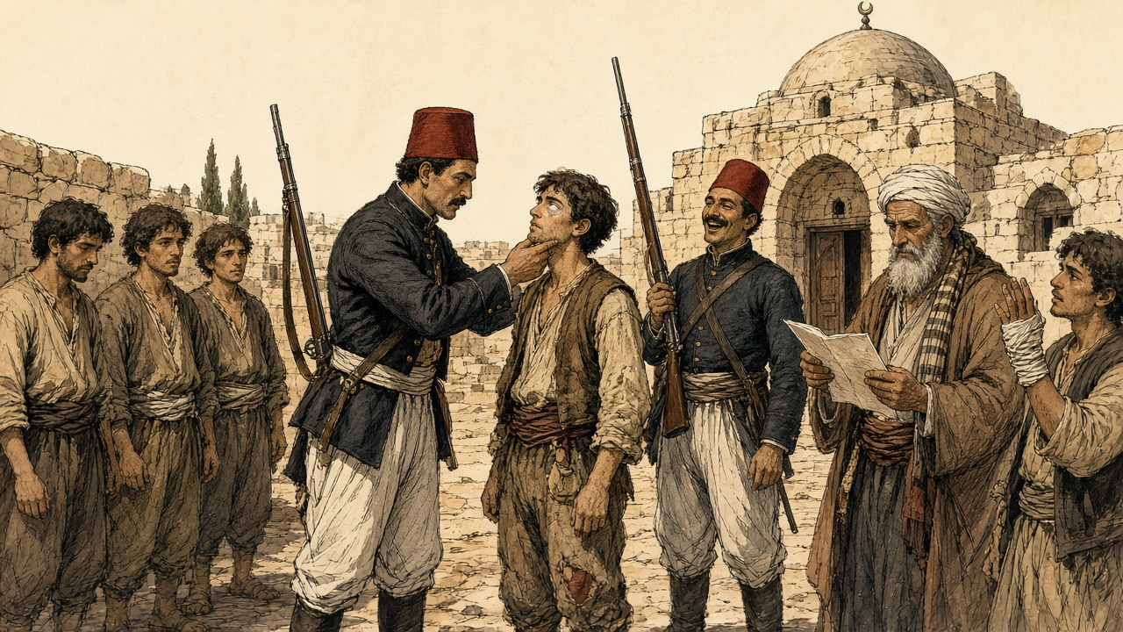
Eleven names, the paper of the sheikh. Nine from-them whole. Eleven mothers know-I their faces. That night the nine took the guns from the walls of their fathers and went-up into the mountain, and among-them the son of my aunt, and not-one in the village saw-them going-up, wallah, not-one.
Smell-I the lemon. Even now, with the eye the one, at end of the day, while I sitting under the tree of the lemon of my father, smell-I-it, and see-I Amina at the bread-oven and the flour on her arms, and that the last picture at the eye the left, and keeps-it-she.
* * *
Jerusalem, May 1834
By the middle of May the villages were done with whispering. The rising began in the east, at Salt across the Jordan, where peasants and Bedouin joined against the Egyptian garrison, and then the Taʿamira Bedouin of the Bethlehem country joined the villagers of Saʿir in the Hebron hills and beat the troops of the Egyptian governor of that district. On May 8, by Rood's chronology, armed villagers surrounded Jerusalem and barred its gates, ten thousand men from Nablus, Hebron, Jerusalem, and Gaza. Soldiers on the walls drove back their first assault. Five days later the ground shook. A report Rood quotes says Jerusalem's Muslims believed the earthquake had been "caused by Ibrahim Pasha's attempt to take soldiers from that sacred city—a thing never attempted before."
The fighting stopped for five days. On May 19 people from Silwan, the village on the slope below the southern wall, showed the rebel leaders an abandoned sewer that ran from near the Dung Gate, باب المغاربة Bab al-Maghariba, into a mill inside the city. The next day thirty-six peasants and Jerusalemites crawled through it, came up within the walls, went to the gate, and threw it open from the inside. The commander of the garrison, Rashid Bey, pulled his troops back into the قلعة qalʿa, the citadel by the Jaffa Gate. On May 21 he arrested the mufti Tahir Afandi, the naqib ʿUmar Afandi, and the bashkatib Muhammad ʿAli al-Khalidi, the same men who had sat across from Ibrahim less than four weeks before. When townspeople opened the Damascus Gate to two thousand fighters from Nablus, the city was lost to him.
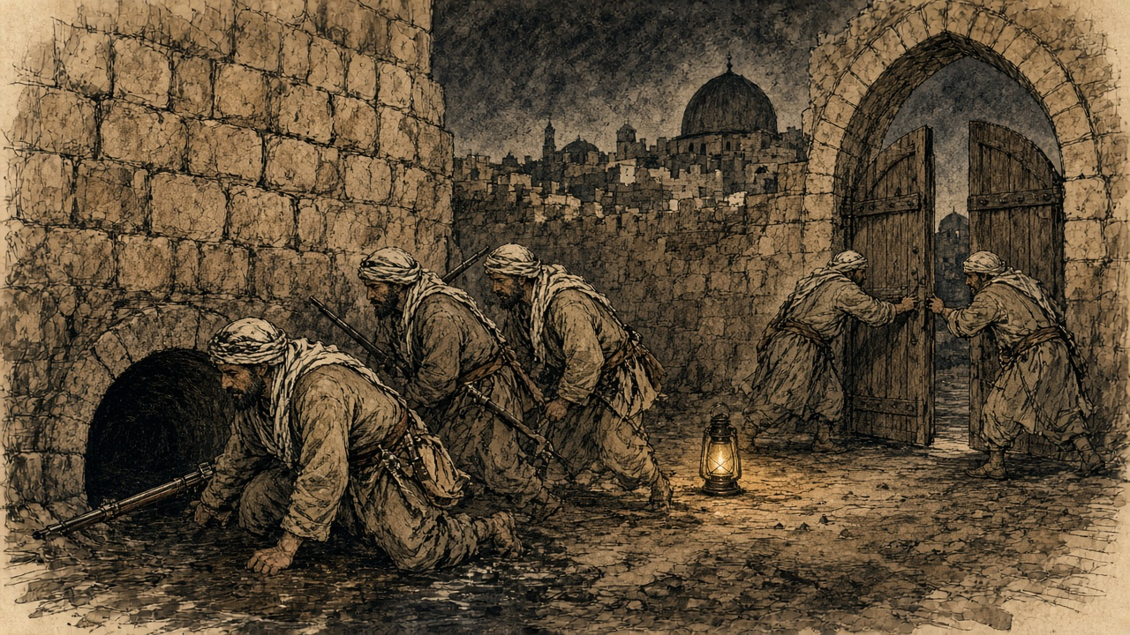
The Greek Orthodox monk Neophytus watched the looting that followed, and his description runs long, the way an eyewitness account runs when the witness is still angry. The crowd stripped the officers' houses first, then the Jewish houses, and then, at night, "the fellaheen, with some low-class bandits of Jerusalem began to loot the shops of the Jews, the Christians, the Franks, and then the Muslims. The grocers, the shoemakers and every other dealer suffered alike." Mattresses were slit open in search of coins. Shop floors were dug up for hidden silver. "Within two or three days there was not one shop intact in the market." When looters turned to the houses of the Orthodox, the Franks, and the Armenians, the leaders of the fellahin and the sheikhs stopped them, warning that if they harmed the riʿaya, the Christian and Jewish subjects, "they would incur the displeasure of the Royal powers." Then Neophytus adds: "In spite of this, they continued to loot the uninhabited houses every night."
People in Jerusalem called those days "the time the peasants entered Jerusalem."
The rising was not one army. In Jabal Nablus it belonged to Qasim al-Ahmad, the sheikh whom the Egyptians had made governor and then removed, with his sons Yusuf and Muhammad and his allies ʿAbdullah Jarrar of Sanur and ʿIsa al-Barqawi. In the Hebron hills it belonged to the ʿAmr clan under ʿIsa al-Amr. In the Galilee the Hawwara aghas fought alongside what was left of Safed's leadership, and around Haifa the al-Madi family led. Khaled Safi, writing about the revolt from the Egyptian royal archives, finds letters passing between Safed and Nablus and no single command over any of it.
The rebels held the mountains, and for some weeks that was enough to beat the nizam on the roads. Ibrahim marched up from Jaffa and lost fifteen hundred of his nine thousand men on a road his column needed two days and two nights to cover, a distance of five hours in peacetime. On the plain of Esdraelon villagers broke the Egyptian Nineteenth Regiment; of twelve hundred men, three hundred reached Haifa, naked and exhausted. On June 4, near the Pools of Solomon south of Bethlehem, rebels caught fifteen hundred troops under Rashid Bey, the citadel commander. Rashid Bey was killed, and eight hundred of his men were killed or captured. Egyptian soldiers were capable of their own violence against people who had not risen. A few days earlier troops had attacked the Christian village of Bayt Jala and killed thirty-three men and women on suspicion of looting, until Ibrahim stopped them.
By the end of June, Safi writes, nearly the whole country except Gaza, Jerusalem, Jaffa, and Acre was in rebel hands.
* * *
Safed, June 15, 1834
Safed sits on a cone of hill above the Sea of Galilee, a town stacked in terraces, its Jewish quarter on the western slope. It had Muslim and Jewish quarters and a Jewish community of scholars and poor pious immigrants, many of them supported by charity from Europe. One of those immigrant households had come from Oshmiany, near Vilna, in 1832. The father had died the year after they arrived. The boy of that house, Jacob Saphir, was twelve years old in the summer of 1834.
Safed's own government had already dissolved. Safi describes its leadership in the revolt as collective, religious scholars and a few military men, with no single family in charge. Into that vacuum stepped a man the British traveler Alexander Kinglake heard about when he passed through the region a few years later. Kinglake's informants told him that early in 1834 "a highly religious Mussulman called Mohammed Damoor went forth into the market-place, crying with a loud voice, and prophesying that on the fifteenth of the following June the true Believers would rise up in just wrath against the Jews, and despoil them of their gold and their silver and their jewels."
The prophecy had a date, and the town waited for it. June 15 fell on a Sunday, in the Hebrew month of Sivan, two days after the festival of Shavuot. "When that day dawned," Kinglake wrote, "the whole Mussulman population of the place assembled in the streets that they might see the result of the prophecy. Suddenly Mohammed Damoor rushed furious into the crowd, and the fierce shout of the prophet soon ensured the fulfilment of his prophecy."
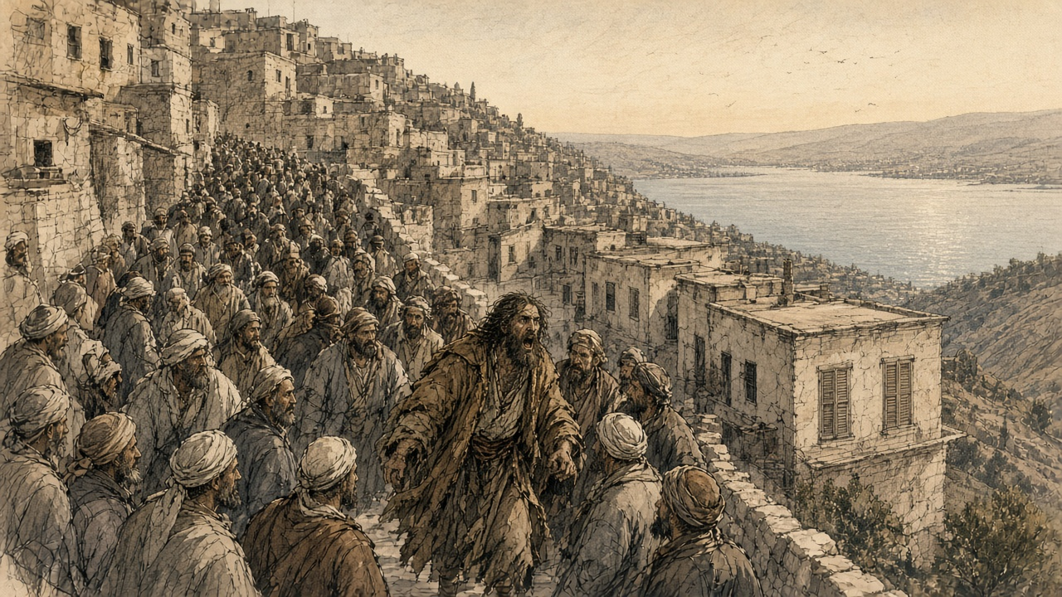
The plunder lasted thirty-three days, until July 17. Kinglake's sources told him that Jews who fled and Jews who stayed lost their property alike, and that women were searched for gold and silver hidden in their clothes. Isaac Farhi, a Safed scholar who lived through it and died in 1853, wrote of people robbed of the clothes they wore. The Hebrew printing press of Israel Bak, set up in Safed only a few years earlier, was wrecked. Yisrael ben Shmuel of Shklov, the head of the Ashkenazi community, wrote to the European consuls in Beirut asking for help.
Help came by way of the Lebanon. Muhammad ʿAli ordered his ally the emir Bashir Shihab II to move on Safed, and the emir came down to the northern edge of the Galilee with a few thousand men and sent proclamations into the town. The notables of Safed sent a sheikh, Salih al-Tarshihi, to negotiate, then rode to meet the emir at Bint Jubayl and offered their submission. Kinglake was told later that some of the plunderers were punished, mostly the ones who had gained nothing they could use to buy their way out. "None of the booty was restored."
* * *
Ein al-Zeitun, below Safed, summer 1834
The village of Ein al-Zeitun lies a short walk north of Safed, down among olive terraces and a spring. When the plunder began, Jewish families ran down the slope to it, and twelve-year-old Jacob Saphir was among them.
What Saphir remembered, and wrote down as a grown man, was hunger first. For the first three days they had nothing to eat. A sheikh of the village took the refugees under his protection. Saphir did not record his name, and no other account in this chapter's sources supplies it. The boy stayed in the village forty days. "We stayed there for forty days," he wrote, "in mortal fear in the hands of the robbers, our possessions before our eyes in the hands of strangers. We could not even be sure of our lives. They stripped us naked, for they took even our clothes from us and emptied our home of everything."
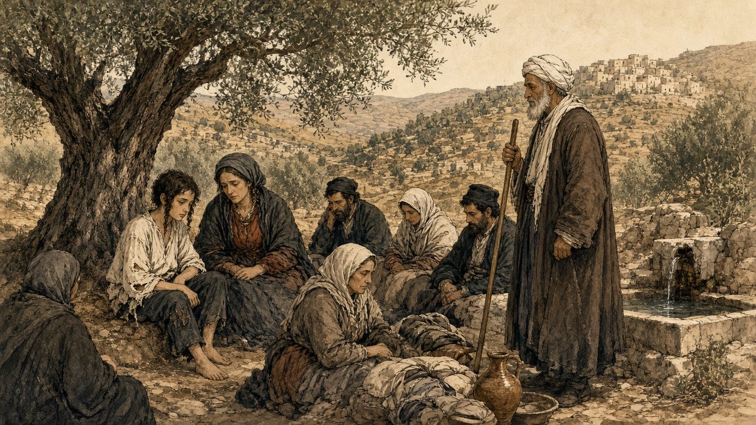
His account is a list of what was taken, and the refugees are alive at the end of it. When they climbed back up to Safed they found their houses stripped so completely that, in Saphir's words, not even small jugs, doors or windows had been left behind.
His mother died not long after. The rabbis of the community took the boy in, and in 1836 he moved to Jerusalem. Decades later, in a book called Even Sapir, the orphan from Oshmiany became a traveler who wrote about Jewish communities from Yemen to India. The sheikh who sheltered him in the summer of 1834 stays without a name.
* * *
Jaffa, June 30, 1834
In the hills, Qasim al-Ahmad had already made and broken a peace. The notables of Jerusalem, through the mufti Tahir Afandi, tried to arrange a truce, and ʿIsa al-Amr of Hebron set its terms: a general amnesty, an end to conscription in exchange for a payment of a thousand piastres a man, and the abolition of illegal taxes. Ibrahim rejected the terms and kept talking. Qasim asked for a pardon, received a safe-conduct with the mufti and Husayn ʿAbd al-Hadi as his guarantors, and came to the pasha's camp. Ibrahim rebuked him. Qasim said he had been forced into the rising and apologized. Ibrahim dressed him in a robe of honor and named him governor of Nablus and Jerusalem.
On June 23, by Rood's dating, Qasim repudiated the truce and called the men of Nablus to arms again. His letter to the notables of the Jerusalem and Hebron districts, preserved by Neophytus, called the peace a trick by which Ibrahim had escaped while he was at the rebels' mercy. Then came the line that every account of the revolt quotes: "Fight bravely for your homes and your honour, for your rights and especially for your beloved children."
A week later Muhammad ʿAli came himself. Thomson was at Jaffa and wrote the scene down. The waterfront street was lined from the landing to the viceroy's quarters with "the finest troops in the army," a military band in the middle. Two corvettes fired a salute at one in the afternoon, and the fleet and the shore batteries answered. "At four o'clock the yards were manned, and with the roar of cannon from the fleet and forts his highness disembarked." Thomson found himself admiring the man. He described a white beard and plain Turkish dress rather than the nizam uniform, and a ruler who bowed to the crowd on both sides as he rode past. Safi counts the troops who came with him at more than fifteen thousand.
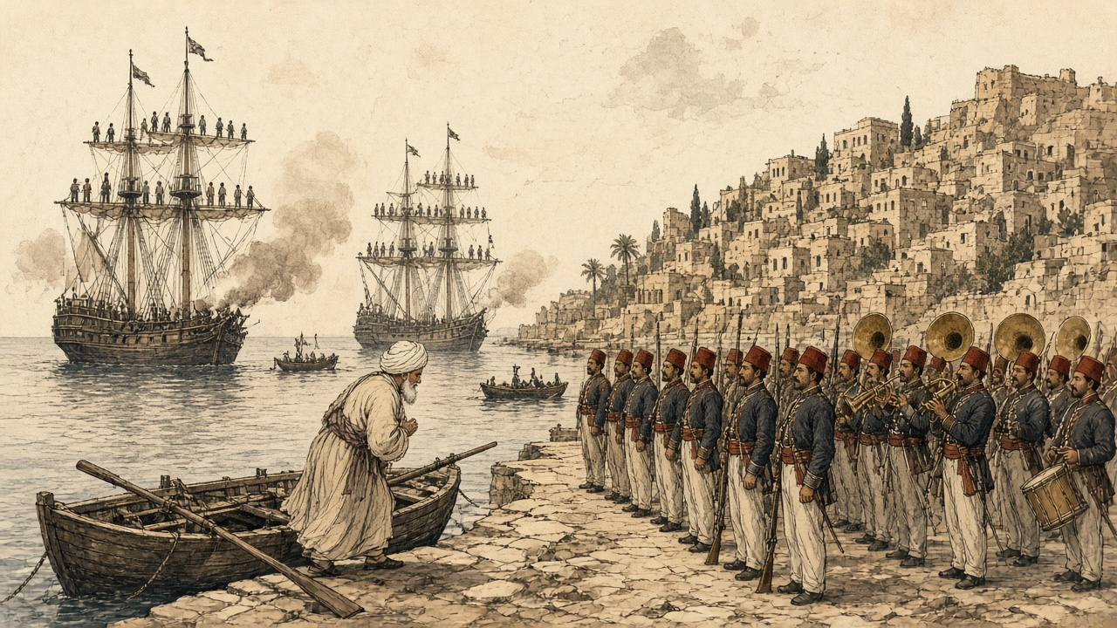
Two days later the old pasha met his son at Ramla. Spyridon's chronicle records that Muhammad ʿAli asked about some men "standing by in great fear," and Ibrahim told him they were the rulers and notables of Jerusalem. "The old man frowned, looked at them from tip to toe for a while, and then, shaking his head, he sighed, but said nothing."
Soon after, the mufti Tahir Afandi, the naqib ʿUmar Afandi, the bashkatib Muhammad ʿAli al-Khalidi, the scholar Shaykh ʿAbdullah Budayri, and Muhammad Abu Saud, a former naqib, were sent into exile and prison in Egypt. Masʿud al-Madi, once chief adviser to ʿAbdullah Pasha at Acre, was beheaded with his son ʿIsa, the governor of Safed. Muhammad ʿAli had Jabr Abu Ghosh released from prison after the man was persuaded to come over to the Egyptian side, and Jabr was made مُتسلّم mutasallim, governor, of Jerusalem. In the month after the landing, Rood records, he ran the disarming of the district. Men found with muskets or knives were executed.
Ibrahim left Jaffa on July 11 with a reinforced army and went up into Jabal Nablus. He beat the Qasim, Jarrar, Jayyusi, and Barqawi clans, rested at ʿArraba with his allies the ʿAbd al-Hadi family, whose fighters rode with him, took the Jarrar fortress at Sanur, and entered Nablus on July 16 without a fight. Safi has him spending twenty days there collecting the villagers' guns and the young men of the levy. Spyridon's chronicle records his warning: from now on, any man found with a gun, a sword, or a dagger would be put to death. Qasim, his sons, and the last of the rebel leaders went south to Hebron and agreed with its sheikhs to keep fighting.
* * *
Hebron, summer 1834
Hebron held out longest. Rood dates the start of the siege to July 24. Safi, working from Egyptian documents, puts the battle at the beginning of August: a short clash an hour outside the town, then fighting street by street, with the defenders taking heavy losses from Ibrahim's artillery. The Egyptians retook the city at a cost of 260 casualties of their own, among them three commanders and seven captains. The inhabitants were massacred, Rood writes, except those who took refuge at the Tomb of Abraham, Isaac and Jacob. Six hundred and thirty young men were taken and sent to Egypt for the army.
Hebron's Jews had taken no part in the revolt. The Jews of Jerusalem had petitioned Ibrahim to protect them, and he had promised to. It made no difference once the soldiers were in the streets. Hyam Zvee Sneersohn, writing in 1872, reported that five Jews "were purposely murdered" and that all the community's property "which had not been buried under ground was either stolen or destroyed." Ibrahim posted a guard around the Jewish quarter afterward. When the community asked for its goods back, Sneersohn wrote, the answer was that what the soldiers already held "cannot be demanded back again of them." Hebron's Jews called that summer Yagma el Gabireh, the Great Destruction.
The violence in Hebron and the violence in Safed are easy to file together and they worked differently. In Safed a crowd of neighbors, given a date by a preacher, went after one community's property while the government had disappeared. In Hebron the government was the army, and it was punishing a rebel city, and everyone inside the walls, Muslim and Jewish, was treated as the enemy.
Qasim al-Ahmad got out before the end. With his sons and ʿIsa al-Barqawi he crossed the Jordan to the fortress town of al-Karak. Ibrahim left Hebron on August 14 with four thousand infantry and two thousand cavalry and went after him. Al-Karak was taken, the town wrecked, its orchards and fields destroyed to punish the people who had sheltered him. Qasim and Barqawi fled again, to the ʿAnaza Bedouin, and the ʿAnaza chief, Duwaikhi al-Samir, afraid of what the pasha would do to his own people, handed them over. Qasim was beheaded in Damascus. With him died ʿIsa al-Barqawi and Arsab al-Kahol, one of his lieutenants. His sons Yusuf and Muhammad were taken to Acre and beheaded there.
* * *
The same village between Nablus and Jerusalem, autumn 1834
After the harvest, came the soldiers another time. Not the two who with-them the paper. Many, this time, and with-them a rope.
The men that went-up to the mountain in May, some-of-them returned, and the soldiers took-them from the threshing-floors. Some-of-them returned-not, and the soldiers cut their trees of the olive and pulled-down the house of their father, so-that the mother of Yusuf the potter slept that winter in the house of her brother and her children around-her like the chicks. The guns, all-of-them, took-they-them. Guns old, guns of the grandfathers, the barrel of one from-them tied with wire. Took-they-them and counted-them and demanded others, and place-where was-not in-it others, the men bought guns in Nablus with the money of the oil to-hand-them-over, so-that be-satisfied the paper of the soldiers.
Tied-they the young-ones one to one, the rope from neck to neck, and walked-they-them going-out by the road of the spring. In the line, the son of my aunt, that went-up to the mountain in May with the gun of his father. This time, there-is-not a mountain. His mother walked beside the line until the soldier pushed-her fell-she in the dust, and sat-she in the dust and threw the dust on her head, and we, the men that the pasha wanted-them-not, I with-my-eye and Hasan with-his-hand, stood-we beside the wall of the mosque and did-not-we a thing, because nothing was what in the hand is-done.
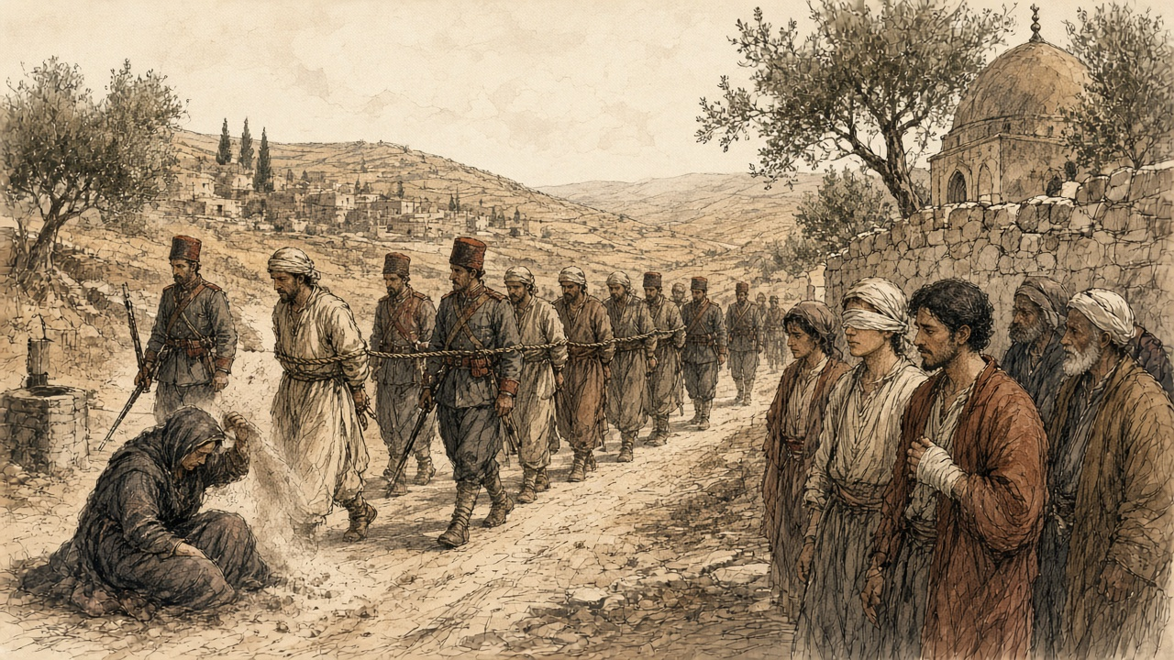
Silent, the village after-it. The press of the oil, turned-it slow that year, and the old-men pushing-it.
* * *
Jerusalem, November 1834
On November 17, 1834, two American missionaries, Dodge and Whiting, wrote home about the country around Jerusalem. They had been struck, they said, by "the depressed and wretched state of the whole country around, in consequence of the very rigorous policy adopted by the government since the late rebellion." Leaders had been beaten on the soles of the feet, imprisoned, or beheaded. The olive and fig trees of men who had fled were cut down and their houses demolished. The thing the people seemed to feel most, the missionaries wrote, the dread that had started the rebellion in the first place, was that "from various towns and villages in the mountains of Judea, Nablous, and Hebron, several thousands of men and boys, we understand, have been gathered and forced into the service, either to be trained as soldiers, or employed on the public works." Safi, counting from the Egyptian archives, puts the number captured and conscripted after the revolt at more than nine thousand.
The new order in the hills belonged to the families who had chosen Cairo. Jabr Abu Ghosh, whose clan had lost its road tolls to the Egyptians three years before, held Jerusalem for them. The ʿAbd al-Hadi family of ʿArraba, which had fought on Ibrahim's side, rose over Nablus and was allowed to keep its own armed men. Conscription went on, but it fell unevenly, on peasants and artisans more than on the sons of sheikhs.
On January 1, 1837, an earthquake brought most of Safed down. The town that Jacob Saphir had left the year before was rubble on its hill. Three years after that, in 1840, a British, Austrian, and Ottoman force on the coast pushed Ibrahim out of Syria, and the sultan's governors came back.
When they did, the sheikhs of Nablus sent a petition to the Ottoman commander, Izzet Pasha. Their governor at the time was Sulayman ʿAbd al-Hadi, of the family that had ridden with Ibrahim. Rood quotes it in an English copy. The sheikhs asked "that the appointment of Suleiman Abdul Hadi [as the mutasallim of their town] may be revoked in favor of Sheik Mahmoud-el-Kassim ibn [the son of] Kasim al-Ahmed," a son of the man beheaded in Damascus in 1834.
Chapter 22 Appendix of Important Names
• Ibrahim Pasha (2 mentions in this chapter): General and son of Muhammad Ali of Egypt who governed Syria and Palestine between 1831 and 1840.
Sources
• Rood, Judith Mendelsohn. "The Time the Peasants Entered Jerusalem: The Revolt against Ibrahim Pasha in the Islamic Court Sources." Jerusalem Quarterly, Issue 27 (Summer 2006) — primary account drawn from the Jerusalem Islamic court registers (sijillat), Spyridon's chronicle, and the Greek Orthodox monk Neophytus's eyewitness record.
• Fahmy, Khaled M. "The Nation and Its Deserters: Conscription in Mehmed Ali's Egypt." International Review of Social History 43 (1998): 421-436 — documents self-mutilation as draft evasion, including removing teeth and blinding, across Mehmed Ali's conscription system more broadly.
• Rood, Judith Mendelsohn. Sacred Law in the Holy City: The Khedival Challenge to the Ottomans as Seen from Jerusalem, 1829–1841. Leiden: Brill, 2004.
• Fahmy, Khaled. All the Pasha's Men: Mehmed Ali, His Army and the Making of Modern Egypt. Cambridge: Cambridge University Press, 1997.
• Spyridon, S. N., ed. "Annals of Palestine, 1821–1841." Journal of the Palestine Oriental Society 18 (1938). Manuscript chronicle of the monk Neophytus of Cyprus.
• Safi, Khaled M. "Territorial Awareness in the 1834 Palestinian Revolt." In Of Times and Spaces in Palestine: The Flows and Resistances of Identity, edited by Roger Heacock, 43–54. Beirut: Presses de l'Ifpo, 2008. Draws on Asad Rustum's calendar of the Egyptian royal archives; source for the Nineteenth Regiment, Muhammad ʿAli's troop strength, the Nablus campaign of July 1834, Hebron casualties, al-Karak, the post-revolt conscription total, and Bashir Shihab II at Safed.
• Kinglake, Alexander William. Eothen. London, 1844. Chapter XXVI, "The Prophet Damoor."
• Saphir, Jacob. Even Sapir. Vol. 1. Lyck, 1866. His recollection of Ein al-Zeitun as translated in "Rabbi Jacob Sapir," Timelines (timelines.co.il); biographical dates also from Isidore Singer and Schulim Ochser, "Saphir, Jacob," Jewish Encyclopedia (1906).
• Sneersohn, Hyam Zvee. Palestine and Roumania. New York, 1872. Account of the 1834 sack of Hebron and the name Yagma el Gabireh.
• Thomson, William, and the American missionaries Dodge and Whiting: letters of May 19, May 24, June 30, and November 17, 1834, as quoted in Rood, "The Time the Peasants Entered Jerusalem."

Chapter 23
Gaslight at Dolmabahçe, 1855–1873
Constantinople, Garvagh and Cavan, Jabal Nablus and the Marj Ibn ʿĀmir, 1855 to 1873
Marseilles to Therapia, September 1855
Edmund Hornby was in Bridport, recovering from a touch of the old fever, when the Foreign Secretary summoned him up to town. There was a loan of five millions which France and England had granted to the Turks to carry on the war in the Crimea, and someone had to go out to Constantinople and manage it. He accepted. Then he waited on the Foreign Secretary for his instructions and was told, blandly, that there were none to give, and was sent on to the Chancellor of the Exchequer.
Sir George Cornewall Lewis had none either. He told Hornby that the money was lying in the Bank of England, that it was to go out to Turkey as it was wanted and by the cheapest means, that the accounts were to be kept accurately, and, above all, that he was "to see that it went to the troops and was not spent on palaces, harems, and bacsheesh."
"Thus fully accoutred," Hornby wrote seventy years later, "I sallied forth like a knight of finance."
The appointment was dated 30 August 1855. His wife came with him; the baby stayed behind with its grandmother. At Paris Lord Cowley told him that his French colleague had already started. At Marseilles they went aboard a Messageries steamer carrying some three hundred French troops to the war, and every evening on the passage his wife sang to them, the rank and file included, any number of French songs, and every evening she wound up with "Partant pour la Syrie."
At Constantinople he went straight to report to the Ambassador. Lord Stratford de Redcliffe received him at the summer embassy at Therapia, up the Bosphorus, in his study, in a grey dressing gown. He did not offer to shake hands. Hornby had hardly finished his bow before the old man let fly at the Government for not appointing the man he had nominated himself, a Greek, a competent financier, a man who had his confidence. He abused the Foreign Office to his heart's content. He wished them joy of their nominee.
Hornby was thunderstruck. He kept a civil tongue in his head and let the old man finish without a word, his face hot, his hands still at his sides. Stratford turned for his dressing room. Hornby said, placidly, "Good morning, my Lord," and added that since it was his Lordship's intention not to assist him, it was his own intention to telegraph to the Foreign Office begging to be relieved, and he left the room without another word. On the stairs a lady he had never seen put out her hand. "Mr. Hornby, I think," said Lady Stratford. She was afraid her husband had not been quite himself that morning. She hoped he would not take to heart anything that had been said, as, with this terrible war going on, "he is sadly harassed and overworked." There was a worn, anxious look in her eyes, and Hornby found he could not vent his anger on her.
He dined at the Embassy that evening. Lord Napier was at the table, and Alison, the Oriental Secretary, and Count Pisani, the Chancelier, and Colonel Mansfield, and Lord and Lady George Paget. Before them all the Ambassador turned to the new commissioner and said he was afraid, "nay indeed I am certain," that he had been "most unjustly rude" to him that morning.
"Will you accept an old man's apology who has much to trouble him?"
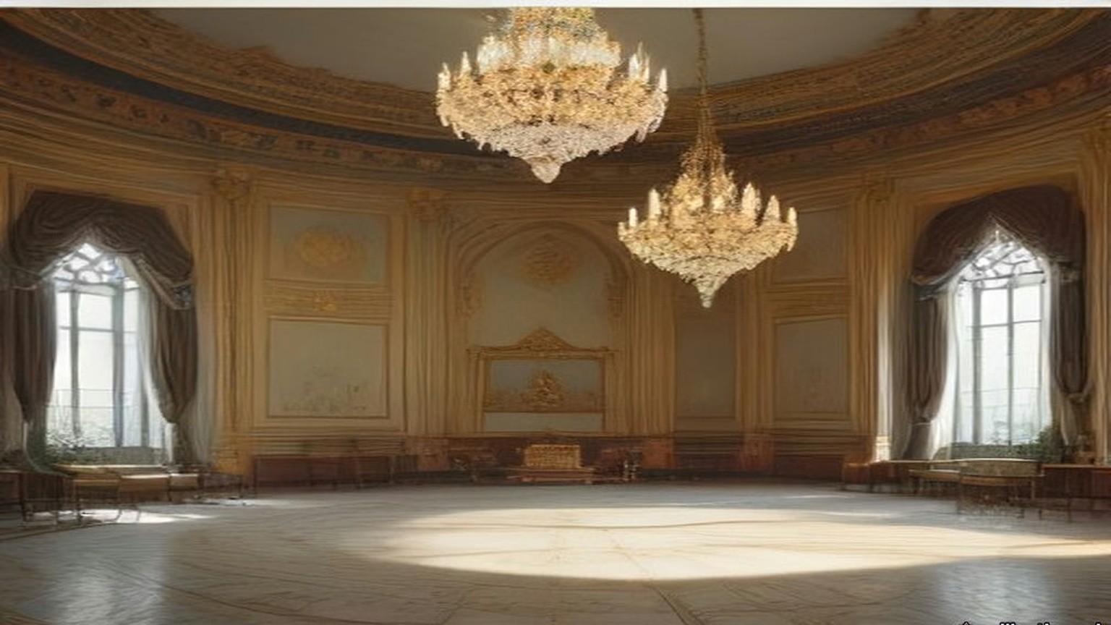
When Stratford took him to be presented to the Sultan and the Ministers, he gave him a lesson in the Porte on the way. Keep your temper; insist on being treated as an equal, even by the Grand Vizier. Easterns never granted anything without demur. Listen to excuses; never give in to them. "Ask him for a million, and he will readily promise it; ask him for £100 which he can easily find, and he will spend months, if you let him, in proving to you that he cannot get it." He was not to assume that men like Reşid, Âli or Fuad Pashas were trying to cheat him. He was to assume that everyone below their stamp was trying to cheat him, and was actually doing so.
Old Reşid Pasha gave Hornby the other side of it one day. The Ambassador was often overbearing, he said, "but we know he is a true friend to Turkey and has more pluck in his little finger than the whole Divan put together."
* * *
Therapia and Orta-kioy, November and December 1855
Emilia Hornby wrote her letters home at the window. From Therapia in November she could see the ships moving up between the dark green shores and the sky tinted rose, and she could see very little of her husband.
He came back from the Porte grey in the face. He sat, he told her, day after day on a divan, smoking an immense chibouque, while the Ministers dragged out a few words of business in a dreamy kind of way at intervals of about half an hour. After weeks of it he and his French colleague felt that they had gained nothing and had only been finessed with. "What must not Lord Stratford have borne in all the years he has been here!" she wrote on 10 November.
The Commission was resolved to be firm, she wrote, "and to do their best to prevent the money of the loan being spent on diamond necklaces or new slaves." It was said in Therapia that before the gold had even arrived, "certain members of the Turkish ministry had obtained advances from their Saraffs at high interest, in anticipation of their share of the plunder." "A Greek banker, supposed to be one of the lenders, himself told us so, besides one or two other persons."
The Sultan was deeply in debt, even at the bazaars, for the dress and jewels of his women, "yet he still persists in spending vast sums in building new palaces and making presents." At the Porte Edmund heard that Omar Pasha had written to the Seraskier complaining that his troops had received no pay for months. Inquiry found that a large sum had been sent, that Omar had never received it, and that the receipt in his handwriting was forged. No inquiry was made into who had forged it.
By December the Hornbys were in a cottage at Orta-kioy, on the European shore. A merchant told her that twenty years before there had been home manufactures the people wore, and that they had gone, because when a Pasha found a manufactory flourishing in his district he taxed and robbed its owner until he fled or starved. The village Cadi fixed the price of bread and meat; the bakers and butchers paid him so many piastres a week to keep the price above what it should be. "The 'Government' have pretty well succeeded in killing the goose for its golden eggs," she wrote on 3 December. Then she set two buildings side by side for a reader in England. The condition of the people, "and that of the Pashas, is perfectly illustrated by the beautiful white marble palace and a more wretched hovel than Ireland ever produced."
The Sultan's new palace was going up in white marble on the shore at Dolma Batche, below the hill of Pera.
* * *
The Treasury, Stamboul, 1855 to 1857
The loan came out in sovereigns. Hornby and his French colleague, M. de Cadrossi, Inspector-General of Finance, kept the cash deposit in bags at the Turkish Treasury, and from time to time they went to inspect and verify it.
On one of those days they cut open a bag that ought to have held £20,000 in gold. It was full of copper coins.
Cadrossi went purple. He went for old Kiani, one of the Ministers, as if to strangle him, and Hornby had to pull him off. They never found the thief. Hornby was certain it was not Kiani; with the Ministers, he wrote, he got on well enough, "especially Fuad, Ali, old Mehemet, and Kiani."
Another time scurvy broke out among the Turkish troops, at Eupatoria, he thought, and the commissioners bought fresh vegetables, filled two large ships and sent them off. Two or three weeks later, at the table d'hôte, Hornby overheard French officers congratulating each other that their regiments had been saved from scurvy by the lucky arrival of two Turkish transports full of vegetables, which their commissariat had bought from the Pasha in command. The Turkish officers had bagged the cash. Hornby went up himself, brought half a dozen of them back to Constantinople, and had them cashiered. Whether they were made to disgorge, he never learned.
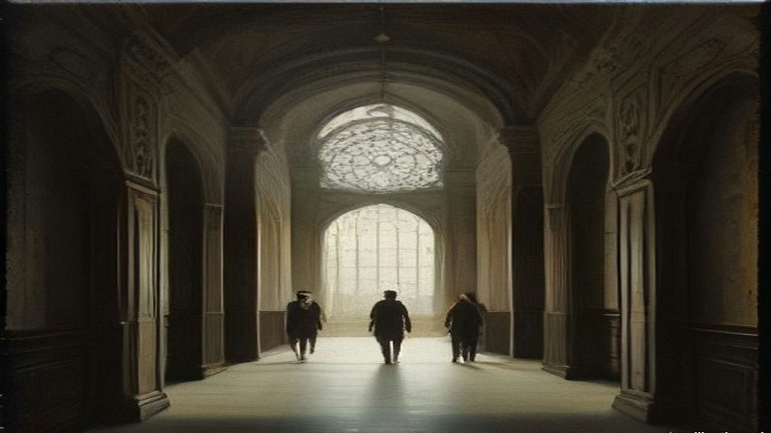
When the five millions were spent the two commissioners went to wind up their accounts with their banker, an Armenian named Theodore Batazzi. He wished them good morning and handed each of them an envelope. Hornby opened his before Cadrossi could open his own. Inside was a cheque for £1,250. He closed it, held out his hand for Cadrossi's envelope, and gave both back. They were salaried servants of their Governments, he told Batazzi in English. Batazzi said it was their lawful due, that they had brought him the business, that a commission was customary all over the world, and that if they refused they were making him a present.
All they had needed to do, Hornby wrote, was to shut their eyes a little to what the real owners of the money wanted done with it. He reckoned the loss to the loan at the end. "I do not believe that more than half a million was misapplied."
* * *
Palais d'Angleterre, Pera, January and February 1856
A year before, on 26 January 1855, the Earl of Clarendon had sent Stratford an instruction about Syria. Consul-General Moore, in Syria, had written of the advantage that would come from developing the agricultural resources of the province. It was not for London to say whether the first step should be to let Christians acquire landed property or to hold out inducements to foreign capitalists to invest their money there. But it was unquestionable, Clarendon wrote, that if the Turkish Government "could be induced to modify its laws in regard to the tenour of landed property," the strength and resources of the Empire would be very decidedly improved. "Your Excellency will press these considerations upon the Porte on all suitable occasions."
By January 1856 Sevastopol had fallen, the powers were going to Paris to make the peace, and the Porte was drafting the reforms it would lay before them. Stratford sat at his desk in the embassy at Pera with information from what he called a sure, though private, source. The Ottoman Ministers had been startled by their colleagues in the Council. They were hesitating. The points from which they were most inclined to recede were three: religious persecution, equal admissibility to office, "and the possession of landed property by foreigners."
It was no longer a time, he wrote to Clarendon, for recurring to arguments already exhausted. He wrote instead to his dragoman, in French, on 25 January, and told Pisani to read the papers to the Grand Vizier and then put them in the hands of Fuad Pasha. One sentence was about himself. He had heard it said that he attached less importance than his French and Austrian colleagues to letting foreigners own land in Turkey. The supposition was entirely mistaken. He was convinced, on the contrary, that the cordial drawing together of Turkey and Europe was essential to the Ottoman Empire, "et que la mesure la plus efficace dans ce sens ne serait autre que la faculté accordée aux étrangers d'y posséder des immeubles de toute espèce": that the most effective measure to that end would be nothing other than the power granted to foreigners to own real property of every kind.
On 13 February Clarendon wrote back approving. As to the privilege of holding land, Her Majesty's Government considered it "of vast importance to Turkey, as there is reason to believe that a large amount of capital is ready for investment in land, upon proper guarantees as to tenure, whenever peace is restored."
The Sultan's charter of reform came out that February. Stratford's biographer, Stanley Lane-Poole, who had his papers, wrote that his hand was traceable in every line. Its fifteenth point, as an English visitor summarised it the next year, said that all foreigners could possess landed property, obeying the laws and paying the taxes, and that arrangements would be made for this with the foreign powers. Its sixteenth said that the abuses in the exaction of taxes, "particularly of the tithes, shall be reformed," and that direct payment into the exchequer would be put in place of the system of farms. Its seventeenth said that while the farms existed they would be let publicly to the highest bidder.
Stratford wrote that its acceptance was "little short of a miracle."
* * *
Prinkipo and Dolma Batche, July 1856
The Sultan gave his dinner for the allies at the new palace in July. Emilia Hornby was on the island of Prinkipo, and at about seven o'clock she sat at her window alone and watched a thunderstorm come down over Constantinople out of the Black Sea, the lightning zigzagging over the water and the rain one dense purple mass from sky to earth. She thought of the guests on the water. The principal guest, the English commander-in-chief, Sir William Codrington, could not land at all, she heard; he battled with the storm, dropped anchor almost within sight of the palace, and was seen for a moment from the shore with his staff in full dress.
Edmund got there. He rowed to the white marble steps and gate of Dolma Batche with Lord Stratford and the staff, in the state caique, and came back and told her all of it.
Fuad Pasha and Âli Pasha, now Grand Vizier, received them and led them through a white marble hall to a plain room with plain white columns, where the Sultan sat on a divan in his usual military frockcoat and fez. His collar, cuffs and sword were covered with brilliants, and he looked shy and uncomfortable, as he generally did before strangers. Stratford presented the English and M. de Thouvenel the French, and Count Stefano Pisani translated the courtly speeches about alliances in the most courtly manner. Then the Sultan withdrew, because it was not etiquette for him to dine with anyone.
The great hall had a dome of glass. In the middle of it hung a chandelier of great size that had cost, her letter said, an immense sum of money, and that the Sultan was very proud of. "It burns four hundred jets of gas." About two hundred wax candles lit the flowers and the gold and silver plate on the table. The walls were lined with soldiers in the dress of the old Sultan's Guard, plumes and all, slouching. The dinner was French dishes and Turkish ones by turns, pilaf among them, cold and ill-served by European waiters who did not know their work, and "the pashas did eat of every thing."
Edmund, by his own account, sat between the two commanders of the war, Pélissier of France, short and fat and one blaze of gold and orders, and Codrington in a scarlet coatee without a single ribbon, looking like an English country gentleman. A minute or two after the Sultan had gone there were two frightful claps of thunder, then wind and hail. The whole building seemed to shake. The gas went out, and the hall under the glass dome was dark. The band at the end of the hall dropped its instruments with a clash and fled. In his wife's telling the musicians left a large door open behind them, and the draught blew out half the candles.
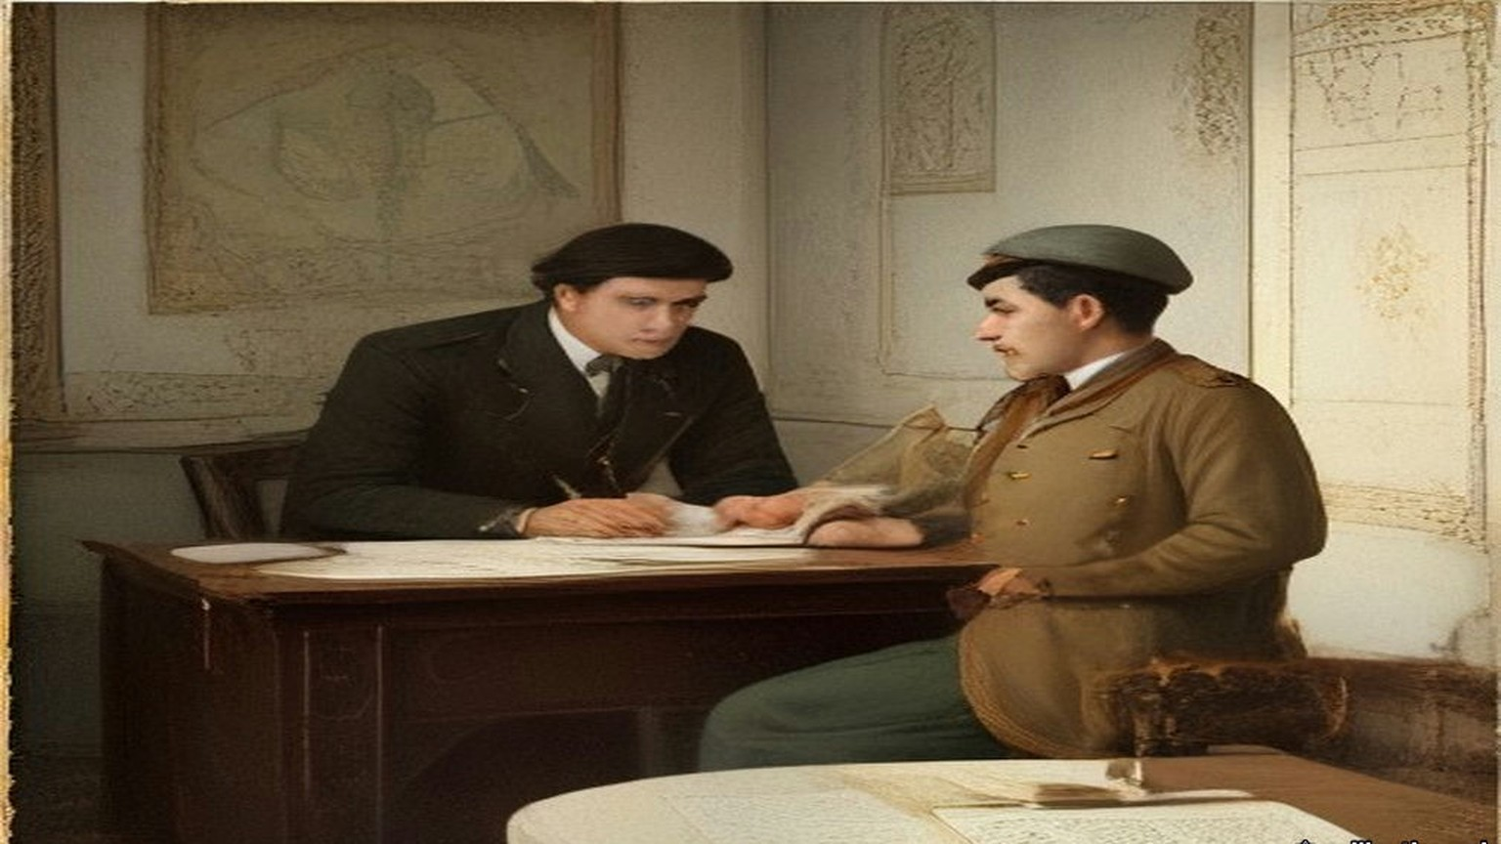
For some moments nobody spoke. Then a thin, shrill voice in French, the Belgian Minister's, said it wanted only the handwriting on the wall and the words "Mene, Mene, Tekel, Upharsin" to make it a second feast of Belshazzar.
Foreign orderlies and the Grand Vizier routed out palace servants who came running with all the candelabra they could find, and the guests went on with their wine. Lightning had struck the palace gasworks, which, Hornby wrote, "Turkish fashion, were planted on the highest piece of ground in the gardens." His wife wrote that the dessert "was demolished almost in the dark by Turk and Christian," and that the Christians at that table were "the first whom the world ever saw assembled in the palace of a Sultan."
Her letter of 23 July began with something else. Edmund had received the Order of the Medjidie, a silver star with a green and crimson ribbon, the patent in a white satin bag with a silver tassel. "It is a great pleasure to know that the Sultan is satisfied with the course which the Commissioners have pursued with regard to the English Loan."
* * *
Stenia, on the Bosphorus, 6 October 1857
Nassau William Senior, the economist, came out in the autumn of 1857 and kept a journal of every conversation he could get. On the fifth of October the Embassy's despatch boat lay all morning with steam up, waiting on a warrant from the Sultan to let British troops cross Egypt for India. The Sultan, Senior heard, had been drunk when it reached him.
On the sixth Senior went by water with Mr. Sarell, the second dragoman, to dine with Reşid Pasha at his palace between Stenia and Rumeli Hisar. The house was a long range of buildings two stories high rising from the water, with fifteen acres of garden running up the hill and a kiosk at the top. Reşid was a short man, about sixty, with mild, kind manners. They walked an hour in his gardens with him and smoked half an hour while he dressed.
Ten sat down at sunset. On Reşid's right was Abdallah Pasha, "the son and the probable successor of the Sheriffe of Mecca," a handsome grave man of about thirty. Senior asked why, being a sharif, he did not wear the green turban. "I wear it sometimes," Abdallah said, "but our pedigree is too well known to need a badge." Reşid whispered to him, asking leave to give the Englishmen wine, and Senior and Sarell and the physician drank a bottle of good Bordeaux that nobody else touched.
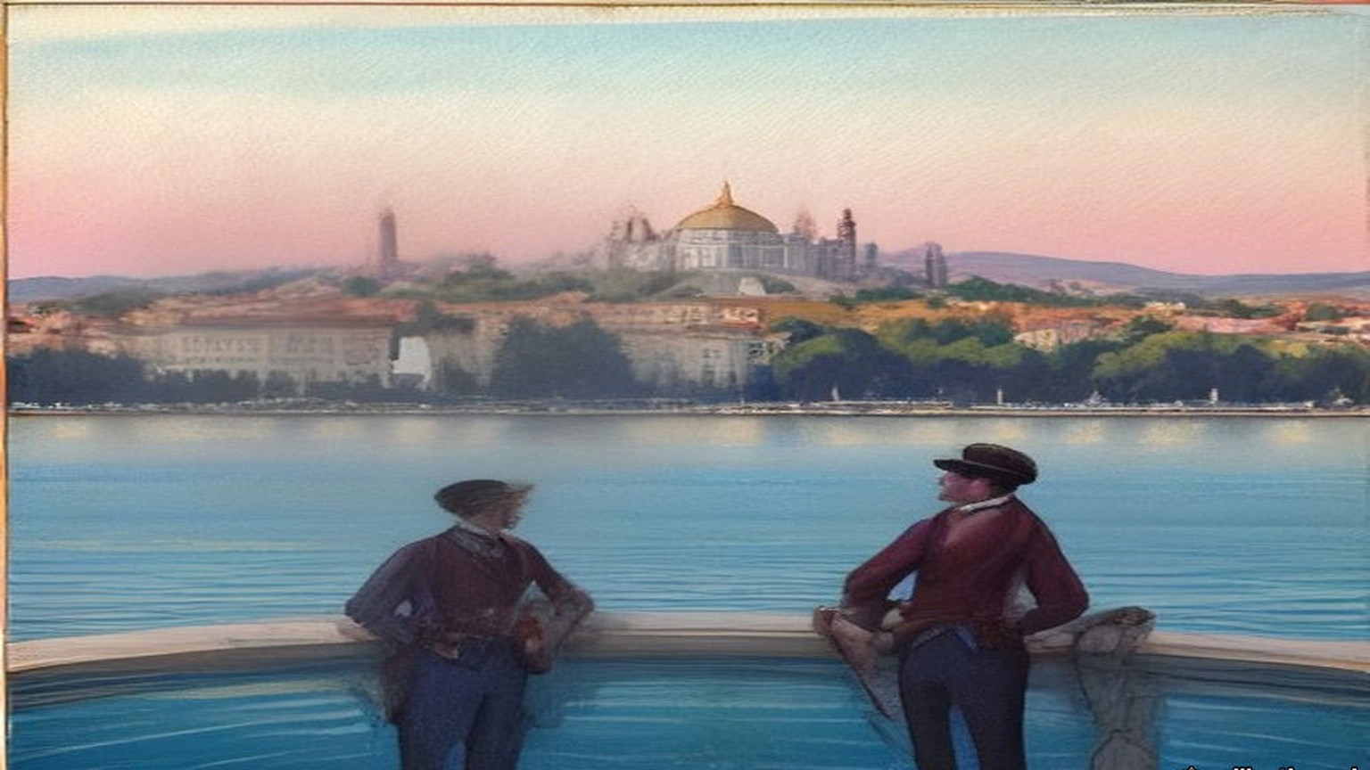
The moon was full when they rose to go. Reşid offered his caique, or horses. If they walked by the shore villages, he said, the dogs would have them in the unlighted lanes, and nobody crossed the hills at night except in a strong party, armed. They walked over the hills in an hour and a half and met no one.
Senior had been asking everyone about land. A European resident he called A. B. told him that foreigners were not allowed to buy,. "The Hatt-i-Humáyoon," Senior said, "declares that foreigners may purchase land and houses." "Yes," A. B. said, "but with this reserve, that the details are to be arranged between the Sultan and the foreign governments." That meant giving up the capitulations, the consular courts. He would not pay that price for land if nothing else were asked. Senior said he saw Englishmen holding land: Mr. Hanson had a property at Candilli. Such transactions, A. B. said, were fraudulent and illegal. Mr. Hanson's agent, keeping his name carefully out of sight, had bought it in the name of his wife, describing her by her Christian name of Marian, "a Christian rajah."
Another man, C. D., told him in his garden on 28 October what a strong sultan would have to do. Fund the floating debt. Restore the currency. Put an end "to the madness of palace-building," and put direct collection of the revenue in place of the farms. "I have no doubt that the revenue, if honestly and directly collected, could be doubled."
* * *
Orta-kioy, January and February 1858
That winter the snow came down off the Black Sea for six weeks. Emilia Hornby lay awake in a thin wooden house on top of the hill at Orta-kioy, waiting for the windows to blow in. Snow drifted onto her table in the middle of the room, and water stood in solid ice in every room of the house. Part of the Golden Horn froze over and many hundreds of people crossed it on foot. Wolves and foxes came down from the mountains; their tracks were in the vineyard by the house, and a charcoal burner from a village nearby was killed by the wolves.
After three days of storm the front of the kiosk was walled up in a drift, and the drawing room went dark at noon. The men cut their way out through the street door. White bread came only from Bebek, and she put everyone on rations. In the autumn, she wrote, the authorities had ordered the boatloads of firewood coming in to sell at a fixed price, filling their own stores at that price; the traders lost by it and brought no more, and by the storm she was burning packing cases. That night the sheep of many villages froze to death, and hundreds of oxen.
"The death of Redshid Pasha has caused much real regret here," she wrote to Mrs. Austin on 5 February. "His friends strongly suspect that bronchitis had but little to do with it; but no inquiries were made, and he was buried before we, living in front of his house, had heard of his death."
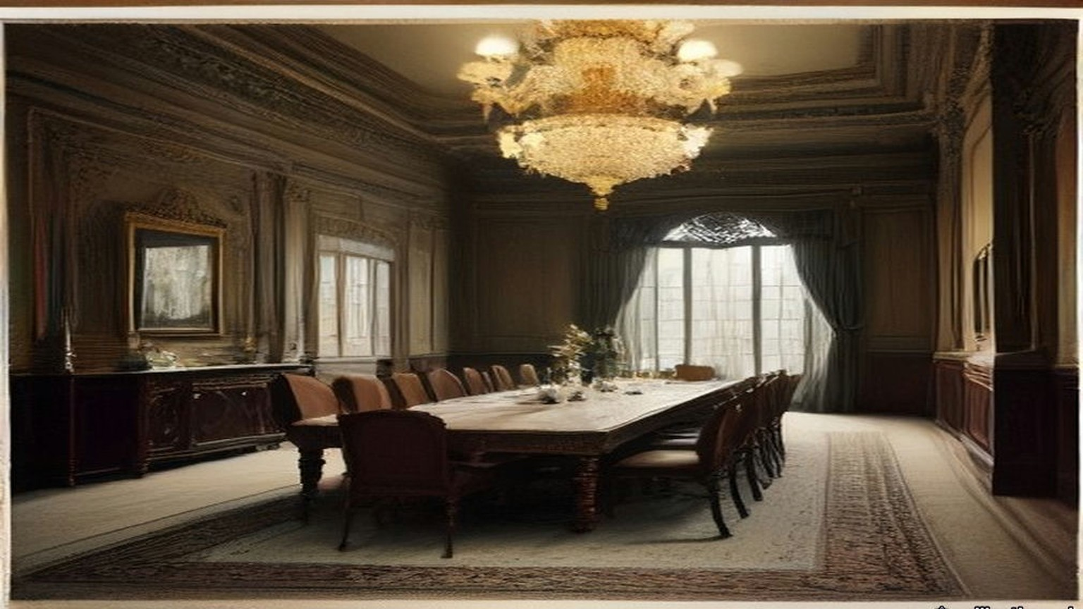
Stratford was gone by then. He had left Constantinople at the turn of the year, meaning to come back, and the news overtook him at Calais. "Alas! poor Reshid!" he wrote to Alison on 14 January. He had left him, to all appearance, well. "The Sultan has lost his best man." On 20 February Palmerston's government fell, and Stratford, out of regard for Palmerston, sent in his resignation rather than serve under Lord Derby. On 28 February the new Foreign Secretary, Lord Malmesbury, wrote that he had sent it to the Queen: "I don't know how to replace you." By 3 March her acceptance was known. "The curtain has at last dropped on my Eastern drama," he wrote to Alison on 4 March.
He was in England when the Land Law was promulgated in Constantinople, on 7 Ramazan 1274, which was 21 April 1858.
* * *
Constantinople, 21 April 1858 to 28 December 1871
The Land Law begins by dividing the soil of the Empire into five. Land held in full property. Land of the state, arazi-i mîrîye, the Crown lands, belonging to the treasury. Land in mortmain. Land left for public use. Dead land. The village ploughland of Palestine, Conder was told in the 1870s, was of the second kind.
Article 3 says what the deed is. A title-deed "with the Tughra at the top is given to the owner." The tapu is the payment made in exchange for the right to possess, "and is collected by the official for the Government."
Article 8: "The whole of the lands of a town or village cannot be granted en bloc to the whole of the inhabitants nor by choice to one, two, or three of them. Different pieces of land are given to each inhabitant, and title-deeds (Tapu sened) showing their possession are delivered to them."
Article 9: the land is not to be left fallow without a valid excuse. Article 20: ten years' possession without dispute stands for a deed. Article 115: "The creditor cannot seize the land owned by a debtor in exchange for his debt," nor force the debtor to sell it.
The Tapu Law that followed in January 1859 fixed the deed's form. It was to be printed, with the Tughra, and to state "the Kaza and village in which the land is situate, and its boundaries and number of donums." Instructions of 15 Shaban 1276 set out the columns of the registers and the fees, and ordered the counterfoils sent to the Imperial Defter Khane in the capital.
The Law on the Registration of Census and of Properties, of 14 Jemazi ul evel 1277, the end of November 1860, gave a province twenty-two registrars under a chief, and paid assessors, to write down people and property together. In each village they reached, an assessing committee of not more than six persons was to be formed "from among the notables and trustworthy inhabitants" of that and the neighbouring villages, and the paid assessors were to sit with it while it valued every property and entered the value in the rough list.
In the late summer of 1862 an imperial irade on debtors left a man his cheapest house and enough of his Crown land to keep it, and sold the rest at auction. Crown land could not be sold for debt under the Land Law, it said, but that exemption did not apply against the Government Treasury. Sums due to the Treasury could be collected from the land.
In the autumn of 1867, eleven years after Stratford's note to Pisani and nine after he left, came the law on the Acquisition of Property by Foreigners. "The subjects of foreign Governments are allowed to take advantage of the rights to possess property within or without towns in every part of the Imperial Dominions, with the exception of the Hejaz, in the same way as Ottoman subjects," on condition that they obeyed Ottoman law, paid Ottoman taxes and went to Ottoman courts in all matters of their property.
Then came a law on the sale of immovable property for debt, which the Code's English translators print with the date 15 Sheval 1288, the end of December 1871, and which set aside Article 115. Crown land "can be sold like movables for a judgment debt without the consent of the debtor." One house appropriate to his station would be left him. If he was a farmer, enough land to keep the house would be left him too, unless he had mortgaged it. The creditor sent a notice; after thirty-one days he could ask for the land to be seized. The seizure paper was to give the kaza and the village, the approximate number of donums, and the number and kind of the trees.
* * *
House of Lords, 14 June 1869
Lord Stratford de Redcliffe was eighty-two and had been out of the Embassy for eleven years when he rose in the Lords on the second reading of the Irish Church Bill. He spoke of the English Government's long efforts to raise the condition of the Irish provinces and called the policy "so changeable, so ill-directed, and sometimes so violent in its prosecution" that little good came of looking back at it. "To the ignorance in which we have been kept on the very important question of land tenure," he said, "may be traced those mischiefs which are not only apprehended, but which in part have actually arisen."
His family were Irish landlords on one side. George Canning, of a Wiltshire and Bristol family, had the manor of Garvagh in County Londonderry, and a lease of the Ironmongers' Company's estate of Agivey; the Cannings of Garvagh were attainted under James II and restored. A Stratford Canning of Garvagh married Letitia Newburgh, heiress of Ballyhaise in County Cavan, in 1734. That Stratford's son, the Ambassador's father, was disinherited, married Mehitabel Patrick, daughter of a Dublin merchant, and went to London to be a merchant and banker. Garvagh went down another line of the family. In 1869 the head of it was the second Baron Garvagh.
Fourteen years later John Bateman printed the estate in his Great Landowners of Great Britain and Ireland: 8,427 acres in County Londonderry at a valuation of £4,459 a year; 5,803 acres in Cavan at £2,804; 1,176 acres in Down at £1,462. In all, 15,406 acres and £8,725. "CHARLOTTE, Dow. LADY G., owns most of this property."
* * *
Jeb'a and Sânûr, Jabal Nablus, August 1872
Lieutenant Claude Conder of the Royal Engineers had just taken command of the Survey of Western Palestine. On 16 August 1872 the camp moved north from Nablus to the village of Jeb'a, in the hills called the Eastern District of the Jarrar after the family of native chiefs who had once governed everything from the Great Plain to Nablus. The villages were large, the houses of good stone, the olives and corn very fine. East of Jeb'a, on its own hill, stood the fortified village of Sânûr, where the head of the Jarrar lived. His nephew was sheikh of Jeb'a.
The Jeb'a family asked the officers to dinner. About six in the evening a man came to fetch them, and they walked up through the village to the highest house. The men of Jeb'a were wonderfully fine men, Conder thought. In 1868, after a riot, the Government had come down on them, killed some thirty or forty, fined the village heavily and taken most of the young men for soldiers.
The sheikh came in a white robe and a yellow silk kufiyya bound with a black cord, slipped off his red slippers, and stepped onto the dais. He touched their hands and then his own breast, lips and head. Elders came in, and the sheikh's son, and each time the room rose and the greetings went round again. Then a low round table, a brass basin and ewer, towels, and a dozen dishes: lentils, stuffed marrows, tomatoes, bowls of leben, three wooden platters of rice piled in cones with meat in them, and a kid dressed whole, its head and legs on. Conder, with no Arabic yet, sat silent while Drake talked of London and the railways. The sheikh thought they were hunting for crosses cut on the ruins, so that they could claim the places afterwards.
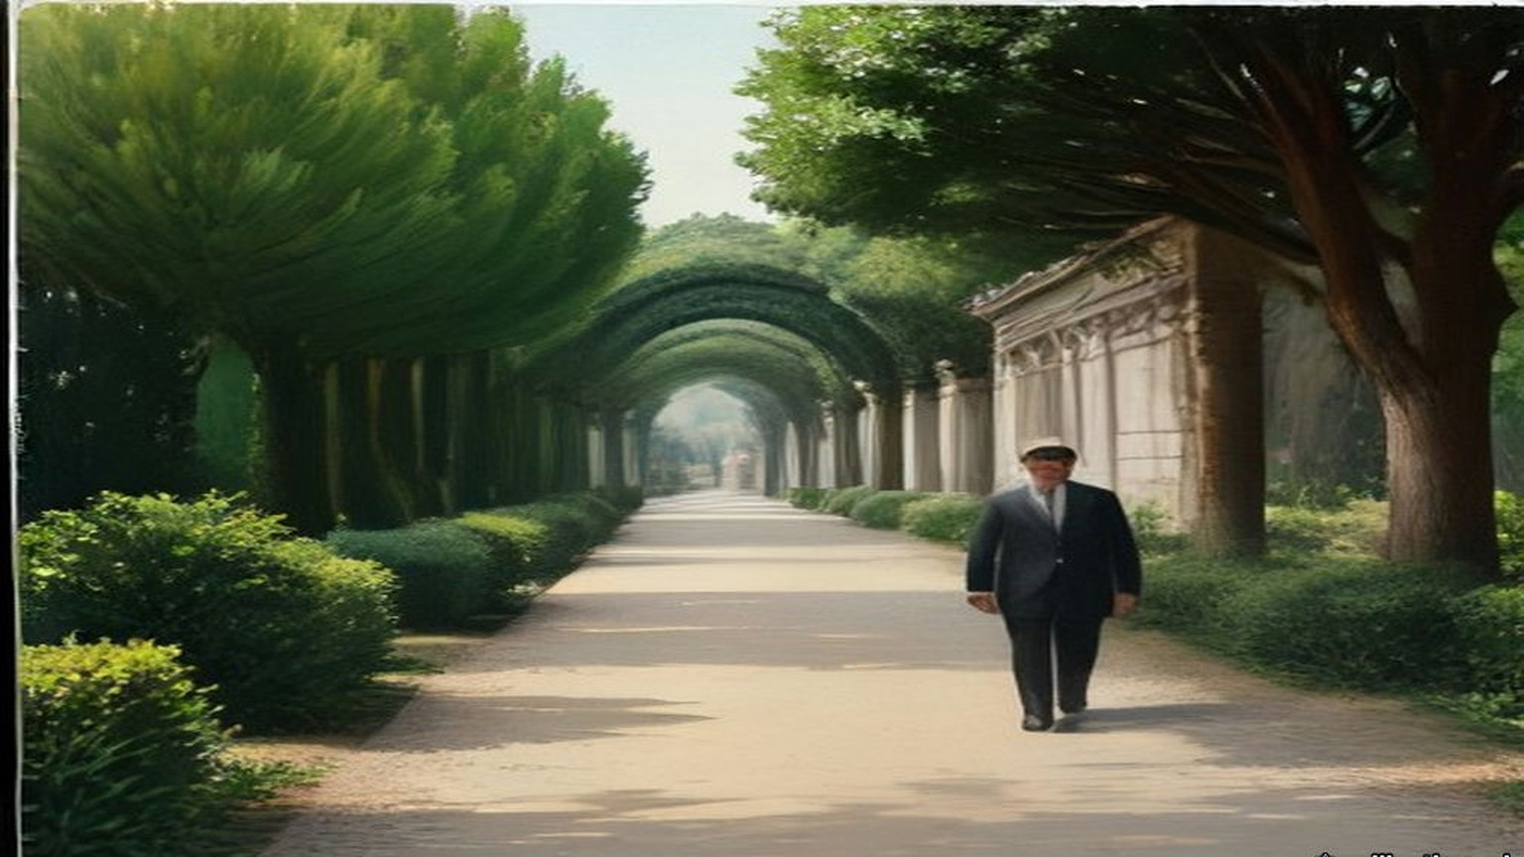
Some days later they dined at Sânûr. The village had once held out for days against regular troops and given in only when the Pasha's guns came up. An old man remembered a cannonball coming into a room where cotton was stored and rolling the soft heap round itself. The host was an unwieldy man in a black cloak. The old sheikh, once governor of the district, spoke bitterly against the Turks. "They rob and impoverish me," he said. "Are my women to carry wood and fetch water? Are my sons to plough the ground?"
Earlier that month, near Nablus, a sheikh riding back with the survey party had been glad of the escort. He was carrying the taxes to Nablus. As they rode he asked Conder how soon the English were coming to take the country and "build it up again."
They left Jeb'a on Friday, 30 August, for Jenin and the plain.
* * *
Nazareth and the Great Plain, autumn 1872
That autumn the survey worked the Nazareth district and the northern edge of the Great Plain, Marj Ibn ʿĀmir, which the English called Esdraelon. After Sergeant Black was shot at near el-Harithiyeh, the Lieutenant-Governor of Nazareth, Faris Effendi, came down to the camp to make friends: a purple flannel shirt, a bright brown jacket, greenish trousers with broad black stripes, a cotton handkerchief under a shabby red fez, huge blue goggles. His salary, the Protestant clergyman Mr. Zeller told Conder, was a mere pittance he could not live on, and he had his ways of increasing his income. In that district Conder learned something about the plain itself.
"A Greek banker named Sursuk," he wrote, "to whom the Government was under obligations, was allowed to buy the northern half of the Great Plain and some of the Nazareth villages for the ridiculously small sum of £20,000 for an extent of seventy square miles." The taxes of the twenty villages came to £4,000 a year, "so that the average income could not be stated at less than £12,000, taking good and bad years together." Cultivation had improved under him. The property would be immensely valuable, Conder added, if the title could be thought secure. The peasants put the sale down to Russian intrigue.
He set down the rules of tenure as the country explained them to him. Crown land, glebe and freehold. "The taxes of the first two kinds are farmed to the highest bidder." The village lands belonged in reality to the Crown; they passed to all the sons equally; if left uncultivated they went back to the Crown; their limits were the valleys, the ridges and the boundary stones. The crop was assessed standing, before the reaping, and the men whose duty it was to assess it put it off to the last moment, so that the peasant often had to give half of it as a bribe to have it assessed at all. He wrote down three villages from his notes: one had 4,000 acres and paid £140, one 6,000 acres and paid £65, one 3,000 acres and paid £320. The peasantry, he wrote, "are eaten up by usury; their very clothes are bought with money borrowed at forty or fifty per cent."
* * *
Kurâwa, Jabal Nablus, 1873
Of the zayt, the oil, I speak first, because of it all the rest.
Bad, the olives that year. Small and few. My father said to me, ya ibni, some years the tree rests, and Allah gives again. Bal, the tax rests not. The tax, it is written in the daftar, الدفتر ad-daftar, in Nablus, and the daftar knows not the wind.
Came the Franks in that year to our hills with their tents and their brass things on three legs, and they asked the name of each valley and the names of the ruins. Said the old men, they look for the crosses on the old stones, to take the places after. I said nothing. Who am I to say.
The land of Kurâwa, it is of the sultan, al-mīrī, الميري. So my grandfather said and his grandfather. We plough it and we sow it and our sons after us, all the sons the same, and if a man leaves it and ploughs it not, it returns. Its borders, the valley on that side and the ridge on this side, and the stones that our fathers set them. There is a paper now in the town also, aṭ-ṭābū, الطابو, with the seal of the sultan at its head, and the afandī says each man should have his piece in it, written with its donums. Wallāh, I have not seen this paper with my eyes. The afandī has seen it.
The tax of the tenth, al-ʿushr, العشر, they sell it. A man of the town buys it from the government, al-multazim, الملتزم, and then it is his, the tenth of us. Came his men at the time of the harvest, and the soldiers with them, the bāshī-bazuq with their guns on their shoulders. They looked at the trees and they did not count. Thumma they went. Said they, after, after, we will come and count. And the olives on the tree and on the ground, and we could not take them in, because if the count is not made the olive is not yours to press, and every day the worm and the birds and the rain. Ya rabb. Came they at the last, when the olive was nearly black on the earth. And to have the count made at all, ibn ʿammī gave a share, and his neighbour gave a share, and what they wrote after, Allah knows it.
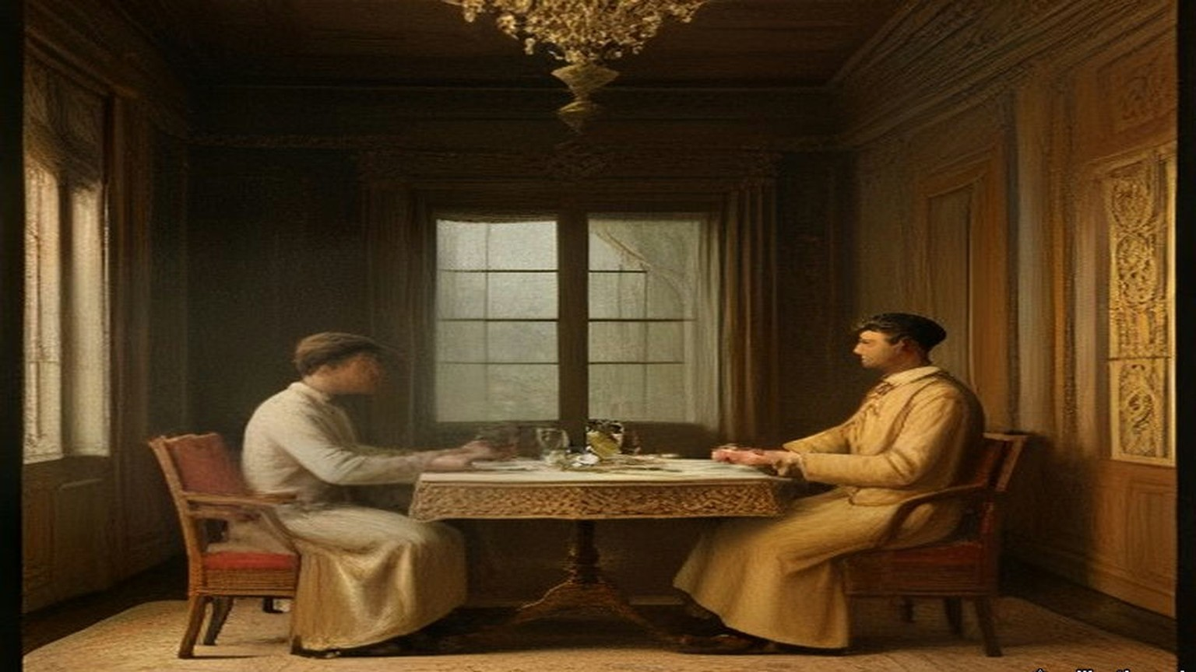
When the qāʾimmaqām came he slept in the guest-house of the village and we fed him and his horses and his men, and that was from us also.
When they counted all of it together, the oil of Kurâwa, all of it, was not as much as the tax.
My shirt that I stand in, I bought it with money from the man of Nablus, and for every ten that I took, at the year's end fourteen, fifteen. My brother's son they took him for the soldiers, he and four others, and put the irons on them going down the road to the sea, and the women went after them crying to the last olive tree and then stood. From the soldiers, who comes back? My grandfather's brother went with the nizam of Ibrāhīm Pasha, and he came not.
And so when the Frank officer came that year to our village and sat with the men, I was with them. And they told him. The olive crop so poor, they said to him, that all its price is not as much as the tax that they will take. And the men were weeping, ya akhī, grown men with beards, and he wrote it down in his book.
What use, the writing of a Frank. But he wrote it.
* * *
Haifa and the Plain of Esdraelon, the 1880s
Laurence Oliphant settled at Haifa and wrote letters about the country for the New York Sun. He rode across Marj Ibn ʿĀmir unarmed. Almost every acre of it was in the highest cultivation, he wrote; it looked like a huge green lake of wheat with the mounds of the villages rising out of it like islands. The Bedouin whose tents were left on the southern edge of it were "subject to inexorable landlords, who charge them exorbitantly for the land which they occupy, and for which they pay in hard cash, under penalty of instant ejection, which is ruthlessly enforced."
Nearly the whole plain, he wrote, was divided between two great proprietors. One was the Sultan, who had lately bought a great part of the eastern end. The other was "the Sursocks, the richest bankers in Syria, who are resident in Beyrout, and who own nearly all the villages extending from the foot of the Nazareth hills to the sea."
They drew "an annual income of about $200,000 a year" from the plain, he wrote in another letter, and "They own practically about five thousand human beings as well, who form the population of thirty villages." When he wanted the villagers to let him into a sealed tomb, he found "no more potent talisman" than the name of Sursuk. The peasants, he wrote, were in the hands of "the money-lenders who now make their profit by sucking their very life-blood."
Mr. Sursock told Oliphant himself that carrying the previous year's crop from the plain down to Haifa and Acre had cost him $50,000. He said it to show why the plain needed a railway. A concession for one had lately been granted to these Beirut capitalists, Oliphant wrote, from the Bay of Acre across the middle of Esdraelon to the Hauran, and as he wrote the engineers were starting out to survey the line.
Chapter 23 Mini-Glossary
• Dragoman (2 occurrences in this chapter): Official interpreter and diplomatic intermediary between European embassies or consulates and Ottoman or Arab authorities.
Chapter 23 Appendix of Important Names
• Palmerston, Lord (Henry John Temple) (2 mentions in this chapter): British Foreign Secretary and Prime Minister who directed British policy in the First Opium War and the 1840 Levant crisis.
Sources
• Hornby, Sir Edmund. Sir Edmund Hornby: An Autobiography. London: Constable, 1929. Book II, ch. I, pp. 67–83: the summons; Cornewall Lewis's instructions and "knight of finance" (p. 67, with the footnote date 30 August 1855); the Messageries steamer and "Partant pour la Syrie" (pp. 67–68); the Therapia interview, Lady Stratford, the dinner and the apology (pp. 68–69); Reşid on Stratford and Stratford's advice (pp. 72–74); the Ministers, Kiani, the copper bag, the scurvy ships, "half a million" (pp. 76–77); Batazzi's cheque (p. 78); the peace banquet, the gas, the Belgian Minister (pp. 82–83). Internet Archive, in.ernet.dli.2015.206554.
• Hornby, Lady (Emilia Bithynia Hornby). In and Around Stamboul. Philadelphia: James Challen, 1858. Letter of 10 November 1855, Therapia, pp. 104–106; letter of 3 December 1855, Orta-kioy, pp. 141–143; letter of 23 July 1856, Prinkipo, pp. 402–406. Internet Archive, inaroundstamboul00hornrich.
• Hornby, Lady. Constantinople during the Crimean War. London: Richard Bentley, 1863. Letter to Mrs. Austin of 5 February 1858, Orta-kioy, pp. 496–500 (the winter; Reşid's death). Internet Archive, constantinopled00unkngoog.
• Foreign Office confidential print, FO 424 (Correspondence respecting Turkey, 1855–1856), as scanned locally: Clarendon to Stratford, 26 January 1855, no. 134; Stratford to Clarendon, no. 100, Constantinople, 28 January 1856, with inclosure, Stratford to Pisani, Palais d'Angleterre, 25 January 1856 (French); Clarendon to Stratford, no. 174, 13 February 1856. The French is quoted from the print and translated in the text.
• Lane-Poole, Stanley. The Life of the Right Honourable Stratford Canning, Viscount Stratford de Redcliffe. 2 vols. London: Longmans, 1888. Vol. i, pp. 3–5 (Garvagh; the disinheritance; Mehitabel Patrick); vol. ii, pp. 440–442 (the Hatt-ı Hümayun; "little short of a miracle"), pp. 446–448 (Reşid's death; resignation; letters to Alison of 14 January and 4 March 1858). Stratford's letters are quoted as Lane-Poole prints them.
• Senior, Nassau William. A Journal Kept in Turkey and Greece in the Autumn of 1857 and the Beginning of 1858. London: Longman, 1859. Pp. 22–24 (A. B. on land; "but with this reserve"; Hanson at Candilli), pp. 53–58 (5 and 6 October 1857; dinner with Reşid; Abdallah Pasha), pp. 147–148 (C. D., 28 October), and his summary of the Hatt-ı Hümayun, points 15–17.
• The Ottoman Land Code, translated by F. Ongley, revised by Horace E. Miller. London: William Clowes, 1892. Land Law of 7 Ramazan 1274, preface and Arts. 1, 3, 8, 9, 20, 115 and the note to Art. 115; Tapu Law of 8 Jemazi ul akhir 1275, Art. 14; Instructions regarding Tapu Seneds, 15 Shaban 1276; Law on the Registration of Census and of Properties, 14 Jemazi ul evel 1277, chs. 1–2; Law concerning the Sale of Land of Certain Debtors, Rebi ul evel 1279; Acquisition of Property by Foreigners, end of Jemazi ul evel 1284, Arts. 1–2; Law concerning the Sale of Immovable Property for Debt, 15 Sheval 1288, Arts. 1, 5–7. Internet Archive, ottomanlandcode00turkuoft. Hijri dates converted with the tabular Islamic calendar; the Code's own note gives 21 April 1858 for 7 Ramazan 1274.
• House of Lords Debates, 14 June 1869, vol. 196, Irish Church Bill, Second Reading, Viscount Stratford de Redcliffe, cc. 1695–1700. https://api.parliament.uk/historic-hansard/lords/1869/jun/14/second-reading-first-night
• Burke, Sir Bernard. A Genealogical and Heraldic Dictionary of the Peerage and Baronetage. 31st ed. London, 1869. "Garvagh" (the 2nd Baron; George Canning of Garvagh; Agivey; Letitia Newburgh of Ballyhaise).
• Bateman, John. The Great Landowners of Great Britain and Ireland. 4th ed. London, 1883, p. 181, "Garvagh, Lord."
• Conder, Claude Reignier. Tent Work in Palestine. 2 vols. London: Richard Bentley, 1878, vol. i, pp. 165–166 (Sursuk). Internet Archive, tentworkinpales00condgoog. And the new edition in one volume, London: Richard Bentley, 1887 (Project Gutenberg 46641): the preface (dates of the Survey); Jeb'a, Sânûr and the Jarrar, 16–30 August 1872; Nazareth and Faris Effendi; the chapter on the Fellahin (tenure, taxes, assessment, the three villages, Kurâwa in 1873, usury, conscription).
• Oliphant, Laurence. Haifa, or Life in Modern Palestine. 2nd ed. Edinburgh and London: Blackwood, 1887. Preface (letters to the New York Sun over three years); p. 42 (the Sursuk income and villages; checked against the page image); pp. 59–61 (the two proprietors; the Bedouin; Mr. Sursock's $50,000; the railway concession). Internet Archive, haifaorlifeinmod00olipuoft.

Chapter 24
Fifty Thousand Pounds in Gold for Mecca, 1915–1917
Cairo, Mecca, the Hejaz coast, London, Rome and Westminster, April 1914 to December 1917
Abdin Palace and the British Agency, Cairo, April 1914 to July 1915
The Amir Abdallah, second son of the Grand Sharif of Mecca, came through Cairo from Constantinople in April 1914 as the guest of the Khedive. Lord Kitchener received him. Abdallah appeared to have something to say and did not reach the point of saying it. Then word came from Constantinople that such audiences displeased the Sublime Porte, and Kitchener received him no more. Before long Abdallah asked Ronald Storrs, the Oriental Secretary at the British Agency, to call.
Storrs sat two hours with him in the Abdin Palace. Abdallah intoned for him whole episodes of the Seven Suspended Odes of the poets before Islam, and the Glories and the Lament of Antar ibn Shaddad, and between them they drank, Storrs reckoned, whole quarts of the rich Khedivial coffee. By a series of delicately inclined planes the talk came down from the warrior past to the defenceless Arab present. Would Great Britain present the Grand Sharif with a dozen machine guns, or even half a dozen? Storrs asked what their purpose could be. For defence, Abdallah said. Pressed, he said the defence would be against attack from the Turks.
Storrs needed no instructions for that answer. Britain could never entertain the idea of supplying arms to be used against a friendly Power. They parted on the best of terms. On 26 April Kitchener wrote privately to Sir William Tyrrell in London that Storrs, under his instructions, had told Abdallah that "the Arabs of the Hejaz could expect no encouragement from us and that our only interest in Arabia was the safety and comfort of Indian pilgrims." The Sharif's son, Kitchener added, had been disappointed by the Turkish determination to push the railway on to Mecca, "which he saw would mean the economic death of the camel-owning population of Arabia."
In October Turkey was going to war. Storrs prepared a letter for Abdallah and a suitable gift, and chose as secret messenger the father-in-law of his little Persian agent, Ruhi. The man went down the Red Sea from Suez on 5 October and was in Jeddah in three days. The customs search there was perfunctory. For one or at most two piastres, he reported, quite large packages could be brought in. He hired a donkey for two pounds, rode all night and reached Mecca at nine the next morning, and paid eight pounds for a room by the Bab al-Salam during his pilgrimage. Every man he met was armed to the teeth, cabman, donkey-boy or mule-driver.
When the Grand Sharif Husain came back to Mecca from Taif, the messenger kissed the hem of his garment with the first of the visitors. Later a servant took him to a room at the very top of the palace, and there the Sharif was sitting alone. "My son," the Sharif said, "though I am as one uninvited in this matter I will yet speak." He walked up and down the room as he spoke and made the messenger stay seated. "The Ottoman Empire has rights over us and we have rights upon her. She has made war upon our rights, and I am not responsible before God if she has made war upon our rights; nor am I responsible before God if we have therefore made war upon hers." He threw back the long sleeve of his robe. "My heart is open to S. even as this," he said, and, with a gesture: "Stretch forth to us a helping hand and we shall never at all help these oppressors."
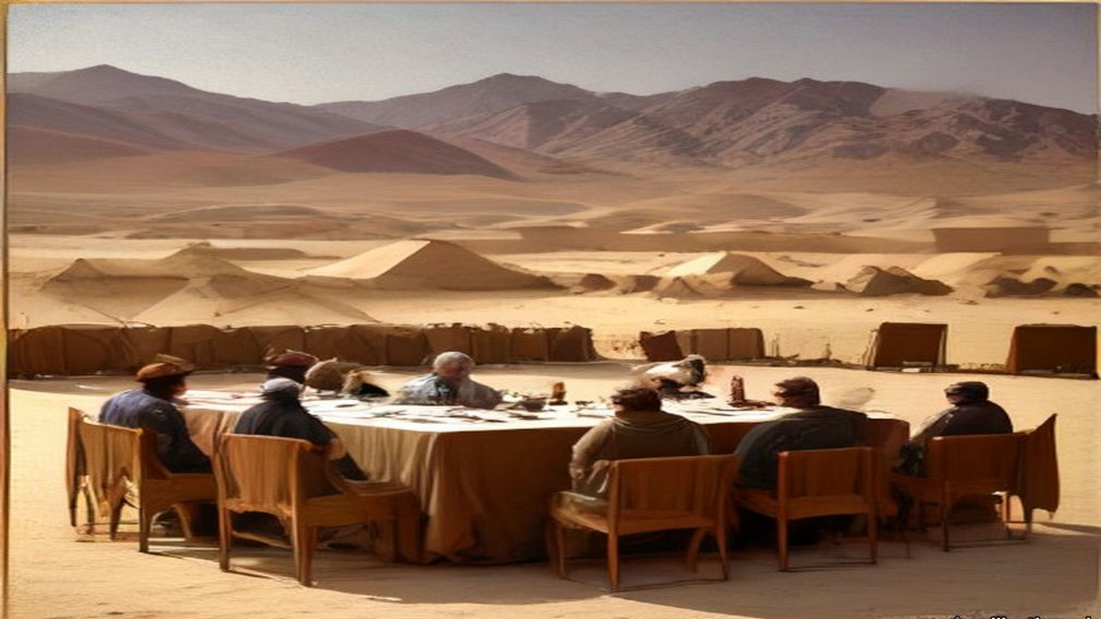
The messenger came back to Cairo and told it all, and Storrs turned it into English for a stenographer as he spoke. On 31 October Kitchener cabled his salaams to Abdallah. "If Arab nation assist England in this war England will guarantee that no intervention takes place in Arabia and will give Arabs every assistance against external foreign aggression."
The first definite proposals reached the High Commissioner, Sir Henry McMahon, in July 1915, enclosed in a personal letter to Storrs, unsigned. Storrs sat with it at his desk. The hand was difficult and the Arabic more difficult still, and as he worked down the page he found himself murmuring an old rhyme:
In matters of commerce the fault of the Dutch
Is offering too little and asking too much.
The Arab nation asked England to acknowledge "the independence of the Arab countries, bounded on the north by Mersina and Adana up to the 37° of latitude, on which degree fall Birijik, Urfa, Mardin, Midiat, Jezirat (Ibn 'Umar), Amadia, up to the border of Persia; on the east by the borders of Persia up to the Gulf of Basra; on the south by the Indian Ocean, with the exception of the position of Aden to remain as it is; on the west by the Red Sea, the Mediterranean Sea up to Mersina." England was "to approve of the proclamation of an Arab Khalifate of Islam." In return the Sharif's Arab Government would give England preference in all economic enterprises in the Arab countries, other things being equal. England was to acknowledge the abolition of foreign privileges. The Arab nation begged for an answer, yes or no, "in a period of thirty days," after which "they reserve to themselves complete freedom of action."
"With the exception of Aden," Storrs wrote later, the Sharif "demanded the whole of Arabic-speaking South-West Asia." He thought then, and he thought twenty years afterwards, "that the Sharif opened his mouth and the British Government their purse a good deal too wide."
* * *
The Residency, Cairo, 30 August to 24 October 1915
McMahon's first answer went on 30 August. It confirmed the terms of Kitchener's message, with its "approval of the Arab Khalifate when it should be proclaimed." On "limits and boundaries" it said that "it would appear to be premature to consume our time in discussing such details in the heat of war," while the Turk was still in effective occupation of much of the ground. It offered something closer to hand: "we are ready to send your Highness for the Holy Cities and the noble Arabs the charitable offerings of Egypt so soon as your Highness shall inform us how and where they should be delivered."
The Sharif's reply was dated 29 Shawwal 1333, 9 September. He had received McMahon's letter "with great cheerfulness and delight," he wrote, "in spite of the impression I received from it of ambiguity and its tone of coldness and hesitation with regard to our essential point." The limits were not his. "I am confident that your Excellency will not doubt that it is not I personally who am demanding of these limits which include only our race, but that they are all proposals of the people." Within them, he wrote, they had not included places inhabited by a foreign race.
Then he turned to the grain and the money. The grain for the people of the Hejaz, and the moneys called surras known to the Ministry of Wakfs, came from pious endowments, "and has nothing to do with politics." Let the grain of the two years go to Jedda "in a special steamer," officially, in the name of the people as usual. The captain or the official sent with it was to accept no receipt but one signed by the grain official of Jedda himself. If he found anything contrary to that arrangement, he was to say he would sail home with the cargo.
McMahon's letters went to Mecca in Arabic. "Our Arabic correspondence with Mecca," Storrs wrote, "was prepared by Ruhi, a fair though not a profound Arabist (and a better agent than scholar); and checked, often under high pressure, by myself." Storrs had no deputy, no staff and no office of his own. The Sharif's letters came back "in an obscure and tortuous prose in which the purity of the Hejaz Arabic was overlaid and tainted with Turkish idioms and syntax." Every sentence passed through Ruhi's pen and Storrs's eye in Cairo before it reached Mecca, and through a translator before it reached London.
The English draft that went to Ruhi in October answered the complaint first. McMahon regretted the impression of coldness and hesitation. "Such was not the case," but it had appeared to him "that the moment had not yet arrived when they could be most profitably discussed." Then it came to the boundaries:
"The districts of Mersina and Alexandretta and the portions of Syria lying to the west of the districts of Damascus, Homs, Hama and Aleppo cannot be said to be purely Arab, and should be excluded from the proposed limits and boundaries. With the above modification, and without prejudice to our existing treaties with Arab chiefs, we accept these limits and boundaries, and, in regard to those portions of the territories therein in which Great Britain is free to act without detriment to the interests of her ally, France, I am empowered, in the name of the Government of Great Britain, to give you the following assurances and make the following reply to your letter."
Great Britain was prepared to recognise and support the independence of the Arabs within the limits the Sharif proposed, subject to the modification. It would guarantee the Holy Places against all external aggression. When the situation admitted, it would help the Arabs to establish suitable forms of government. The Arabs would seek the advice and guidance of Great Britain only, and such European advisers and officials as they needed would be British. In the vilayets of Baghdad and Basra, the Arabs would recognise that "the established position and interests of Great Britain" required "special measures of administrative control in order to secure these territories from foreign aggression, to promote the welfare of the local populations and to safeguard our mutual economic interests."
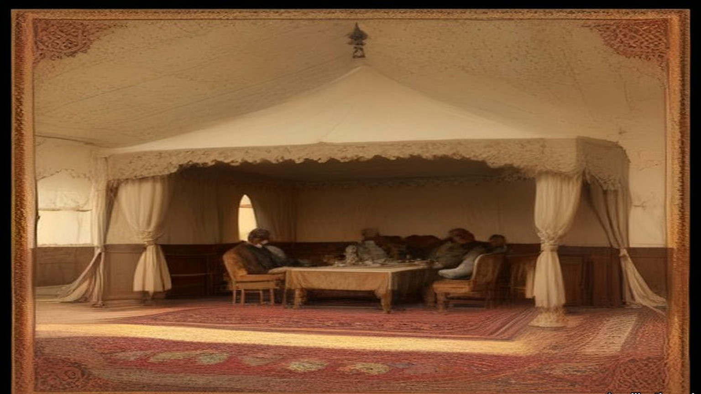
McMahon signed it on 24 October 1915. At the end he wrote of his relief at the safe arrival of the Holy Carpet "and the accompanying offerings," landed without mishap in spite of the war. He sent the letter "by the hand of your trusted and excellent messenger, Sheikh Mohammed Ibn Arif Ibn Uraifan."
Twenty-four years later, in 1939, the Foreign Office printed the exchange as a Command Paper, Cmd. 5957. Its explanatory note said the correspondence had been "exchanged in Arabic," and that the English of some drafts had been modified "where the language has been criticised on the ground that it does not reproduce accurately the Arabic of the actual correspondence and the criticism has been found on examination to be justified." The revised sentence ran: "The two districts of Mersina and Alexandretta and portions of Syria lying to the west of the districts of Damascus, Homs, Hama and Aleppo cannot be said to be purely Arab, and should be excluded from the limits demanded." "Special measures of administrative control" became "special administrative arrangements." "Her traditional friends the Arabs" became "her friends the Arabs." The words of 1915 went into the footnotes, each one marked "Former reading."
* * *
Mecca, Dhu al-Hijja 1333 to Rabiʿ al-Akhir 1334
Of the letters I speak, because the writing of them, it was my work.
Sits our master the Sharif by the window, and I below him with the board on my knee, and he speaks and I write. And when he has finished he speaks it again in another way, and I write that also. Long, the speech of our master, ya akhī. And in it the Turkish, the Turkish of the Dawla, its turns and its words, and the Arabic of al-Ḥijāz underneath like water under oil. Thumma he says to me, read, and I read, and he takes back a word and gives another word in its place.
Came the letter of al-Inglīz, الإنكليز, in the month of Dhu al-Hijja, from the big man of Maṣr. And our master said, write. "We renounce our insistence on the inclusion of the vilayets of Mersina and Adana in the Arab Kingdom." Then he stopped, and I waited with the pen over the paper, and he said: "But the two vilayets of Aleppo and Beirut and their sea coasts are purely Arab vilayets, and there is no difference between a Moslem and a Christian Arab: they are both descendants of one forefather."
And of ʿUmar ibn al-Khaṭṭāb, raḍiya Allāhu ʿanhu, he spoke, who said of the Christians, "They will have the same privileges and submit to the same duties as ourselves." And of al-ʿIrāq he spoke, the seat of the Khalifate in the time of ʿAlī ibn Abī Ṭālib, karrama Allāhu wajhahu. That the English keep it "for a short time," those districts which their soldiers hold, "against a suitable sum paid as compensation to the Arab Kingdom for the period of occupation, in order to meet the expenses which every new kingdom is bound to support." A sum, wallāhi. Every new kingdom has its expenses. I wrote it and I put the sand on it.
And at the end a thing I remember for the sound of it more than for its sense. "Had it not been for the determination which I see in the Arabs for the attainment of their objects, I would have preferred to seclude myself on one of the heights of a mountain." I wrote it, and I did not lift my head.
Came their answer in Safar. Fully understood, they wrote, Aleppo and Beirut, and taken careful note; but France, their ally, is in them both, and the question will require careful consideration. And at the bottom: "As an earnest of our intentions, and in order to aid you in your efforts in our joint cause, I am sending you by your trustworthy messenger a sum of twenty thousand pounds."
Twenty thousand, ya rabb. I have seen gold. In the season of the Ḥajj I have seen it in the hand of the ṣarrāf in the sūq, a little gold, so. Not this. Heavy, the gold, so that one man alone could not lift the whole of it, al-junayh al-inglīzī, الجنيه الإنكليزي, every coin with the head of their king. Our master looked at it. He said nothing to me of it, and I said nothing.
Then our master wrote to them again, the twenty-fifth of Safar. That their letter "removed that which had made me uneasy." That the amount for al-ʿIrāq he leaves "to the perception of her wisdom and justice." And of the north, of France, he said, write: "at the first opportunity after this war is finished, we shall ask you (what we avert our eyes from to-day) for what we now leave to France in Beirut and its coasts." And after: "it is impossible to allow any derogation that gives France, or any other Power, a span of land in those regions." A span, شبر, shibr, the breadth of a man's hand spread open. And he wrote that they stood firm on "our resolution which Storrs learnt from us two years ago."
In Rabīʿ al-Ākhir he gave me the list. One of his sons had gone to al-Shām. Guards had been raised from the people of al-Ḥijāz, from them only. And now, write. First, "The amount of £50,000 in gold for the monthly pay of the troops levied, and other things the necessity of which needs no explanation. We beg you to send it with all possible haste." Secondly, of rice twenty thousand sacks, and of flour fifteen thousand, and of barley eight thousand, and of coffee a hundred and fifty, and of sugar a hundred and fifty, and five thousand rifles "of the modern pattern," with their ammunition, and cartridges of the Martini-Henry and of the rifles of the factory of St. Étienne in France, for the two kinds of rifles our tribes carry. The place of all of it, Port Sudan.
Then the man who would come for the money. Him, they should not put on a steamer, nor treat in any way out of the ordinary. He would carry a letter to "Al Khawaga Elias Effendi, saying that he (Elias) will pay him, in accordance with the letter, the rent of our properties." The rent of our properties. I wrote it, and our master looked at the line a long time, and then he said, good.
And the eighth thing on that paper. "Let the British Government consider this military expenditure in accordance with the books which will be furnished it, explaining how the money has been spent." The fourteenth of Rabīʿ al-Ākhir, 1334. I folded it.
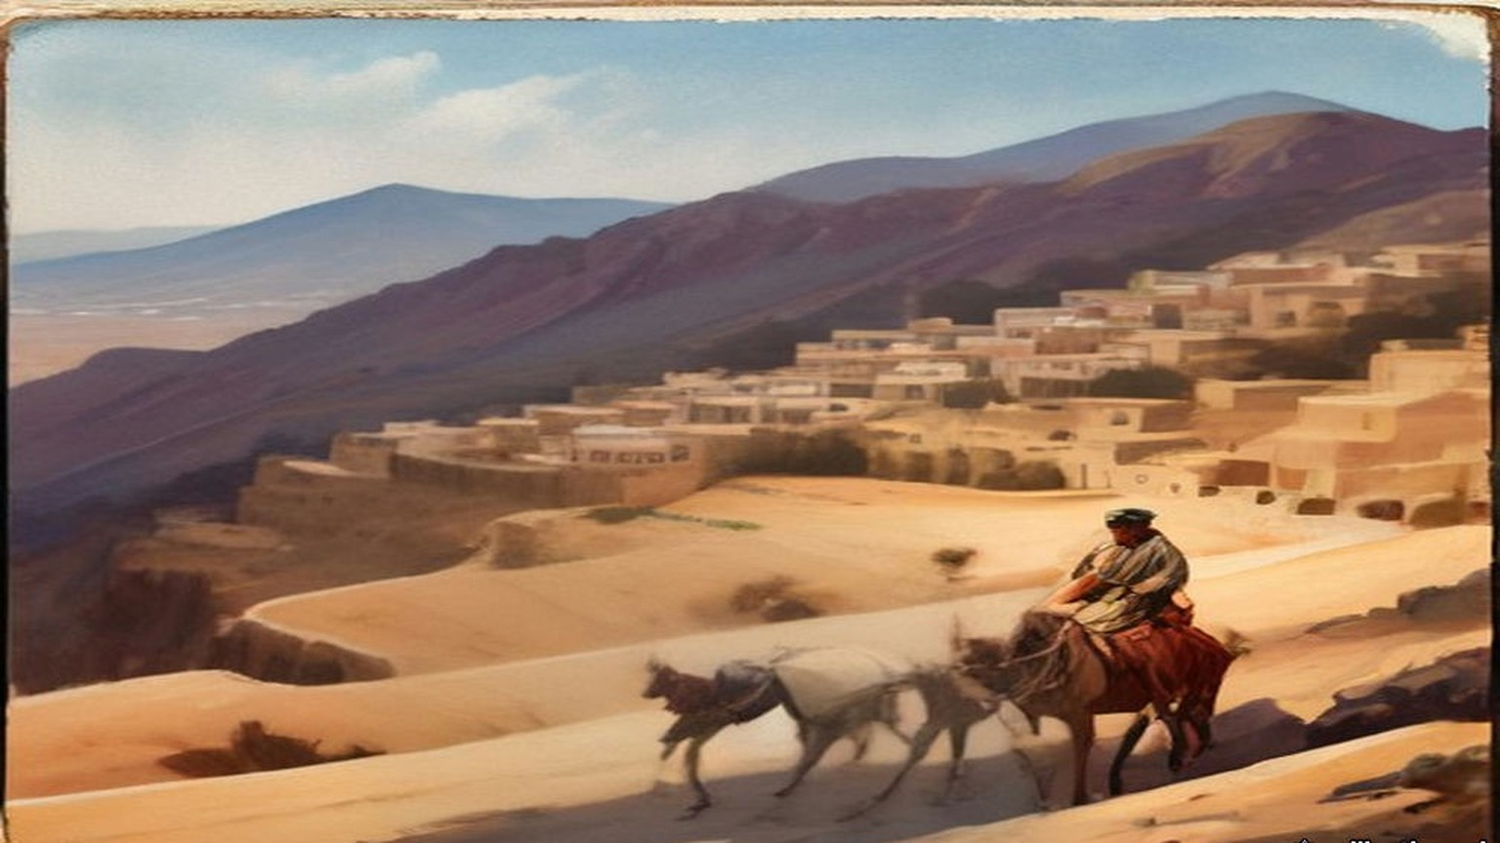
* * *
The Residency, Cairo, and the Foreign Office, London, March to May 1916
McMahon answered on 10 March 1916. The Sharif's requests had been approved, and "that which you asked to be sent with all haste is being despatched with your messenger, who is also the bearer of this letter." The rest would be collected and held at Port Sudan until the Sharif sent word officially that the movement had begun. The Governor at Port Sudan had his instructions. In his letter of 25 January McMahon had told the Sharif that the friendship of Great Britain and France, once the war was won, would be "yet more firm and enduring, cemented by the blood of Englishmen and Frenchmen who have died side by side."
Eight weeks after the March letter, on 16 May 1916, Sir Edward Grey wrote from the Foreign Office to the French Ambassador, Paul Cambon. He acknowledged Cambon's note of the 9th, which accepted "the limits of a future Arab State, or Confederation of States, and of those parts of Syria where French interests predominate," as they resulted "from recent discussions in London and Petrograd." The British negotiator in those discussions was Sir Mark Sykes, the French one Georges Picot. Grey wrote that acceptance of the whole project "will involve the abdication of considerable British interests," but that the Government were ready to accept the arrangement, "provided that the co-operation of the Arabs is secured, and that the Arabs fulfil the conditions and obtain the towns of Homs, Hama, Damascus, and Aleppo."
The note ran to twelve articles and a coloured map. France and Britain would "recognize and protect an independent Arab State or a Confederation of Arab States in the areas (A) and (B) marked on the annexed map, under the suzerainty of an Arab chief." In area (A) France, and in area (B) Britain, would have "priority of right of enterprise and local loans," and would alone supply advisers. In the blue area France, and in the red area Britain, could establish "such direct or indirect administration or control as they desire." In the brown area there would be an international administration, its form to be decided after consultation with Russia, the other Allies, "and the representatives of the Shereef of Mecca."
Britain was to have the ports of Haifa and Acre, and the right "to build, administer, and be sole owner of a railway connecting Haifa with area (B)," with "a perpetual right to transport troops along such a line at all times." Haifa would be a free port for French trade. Alexandretta would be a free port for British trade. Britain would never negotiate the cession of Cyprus to a third Power without French consent. For twenty years the existing Turkish customs tariff would stay in force in every area. The eleventh article said that the negotiations with the Arabs as to boundaries "shall be continued through the same channel as heretofore on behalf of the two Powers."
The channel ran through Storrs's desk. "Until Mark Sykes appeared in Cairo in 1916," he wrote, "we had but the slightest and vaguest information about the Sykes-Picot negotiations for the tripartite division of non-Turkish Turkey between France, Russia and England."
* * *
Samima, near Jeddah, 6 June 1916
On 23 May a telegram reached McMahon from Port Sudan. The Sharif's son Abdallah wanted Storrs on the Arabian coast urgently. Storrs left Cairo at a quarter past six in the evening of 28 May with David Hogarth and Captain Kinahan Cornwallis, and with £10,000 in gold, which two N.C.O.s guarded as far as Suez. From there they went down the Red Sea in the Dufferin. At about nine on the morning of 2 June a wireless came: "Foreign Office has approved payment of £10,000 to Abdallah and £50,000 to Sharif of Mecca. But this latter payment only in return for definite action and if a reliable rising takes place."
Off Jeddah on the 5th the Sharif's agent Oraifan came aboard with a letter for Storrs signed in full, "Husain, Amir of Noble Mecca," and in Abdallah's handwriting except for the signature. Abdallah could not come. He was leaving for Taif to besiege the Turkish governor there, because the rising had been moved forward to Saturday, 10 June. His young brother Zaid would come in his place, with their cousin Sharif Shakir.
At half past five the next morning Storrs left the Dufferin two miles out, in the gig, with the cutter in tow behind a steam launch. Hogarth and Cornwallis were with him, and Oraifan and Ruhi, the £10,000, and two sacks of al-Haqiqa, the Arab Bureau's propaganda newspaper. The cutter hit the outer reef hard and broke her rudder. A canoe led them through to a dhow half full of sacks of maize. They tied up to it and sat for over an hour while the sailors hauled a sail across for an awning and spread their shawls over the sacks.
At length ten camels came over the skyline and down to the shore. Oraifan paddled back to say that Zaid wished to see Storrs alone. Storrs went in the cutter to within eighty yards of the beach and then stepped into Oraifan's canoe, which had so much water in it that he stood up the whole way. Two slaves carried him the last ten yards and soaked him well above the knee. Without looking up, he saw Zaid and Shakir coming slowly towards him. He went on arranging his clothes. He meant them to come down past their guard to meet him on the sand, since he was, after all, there for the High Commissioner. They came, and shook him warmly by the hand.

In the tent there were two small divans, each with two new, poor Shirwan rugs, and kilims underfoot. Zaid was about twenty, fair, with fine eyes and a round face, and was trying to grow a backward beard. Shakir was two inches taller and some ten years older, his face badly pitted by smallpox, his hair plaited in seven or eight long thin tails. Both wore kaftans of rich Egyptian silk. Zaid had a black cloak and an embroidered yellow kuffiya, Shakir a brown camel-hair cloak and a small check kuffiya, and both wore Mecca sandals and large, bright gold aqals. They were so faultless that Storrs was sure they had stopped and changed just before they arrived.
Storrs glanced at his gold bracelet watch to see how the time stood, and when he looked up Zaid was gazing at it. He had brought Zaid no present. The cash was for his brother. He drew the watch off, showed him how to wind it, set it to Arab time by a swift calculation, and fastened it on Zaid's wrist.
Zaid handed him papers. Running his eye down the list of requests in the first, Storrs saw £50,000 with £20,000 more, £70,000 in all. He explained that the first sum would come as soon as there was certain news the rising had begun. "I am then happy to be able to announce to you," Zaid said, "that it began yesterday at Medina." Storrs asked what results he had heard of. By "begun," Zaid explained, he had meant "was timed to begin." Storrs put a question to him. If he were helping a partner with money in a common cause, would he not want some practical result before he went on with it indefinitely? Zaid agreed that he would, and his father more. Was he not aware, Storrs went on, that Britain was already advancing some millions a day to those who had proved themselves its friends?
The Turks had 80,000 men with guns in Syria, Zaid said. Would they not come down on the Hejaz and take a terrible vengeance? Storrs disputed the number. Munitions, money and supplies would follow once the revolt had begun, he said, but these things were not to be plucked like dates from palm trees. Zaid told him the new flag of Arab independence would be crimson, without device, as a slave in white and silver brought coffee in large cups.
On board the Dufferin Cornwallis gave Zaid the British figure for the Turks in Syria, 30,000. Zaid refused it outright. The two sharifs were shown the wireless, which fascinated them, the guns, and the captain's bathroom. A gazelle walked about the deck eating cigarettes off the mess table. At half past twelve the steam launch took them back to their dhow, carrying, rather to the alarm of the Englishmen, the £10,000 and the two bundles of al-Haqiqa. Storrs sent a thousand cigarettes after them for Faisal and Ali at Medina, the only smokers in the family.
When they had gone, Oraifan repeated to Storrs something Shakir had said. "Do the English not see that if the Sharif is not able to redeem his money promises to the Arabs, he will be a liar and lose his honour before them? Then where will be success?"
* * *
Jeddah, 13 to 17 October 1916
The rising began on the 10th. From 8 August 1916, Storrs recorded, Husain received £125,000 a month. In October Lawrence wrote that "the coast towns are glutted with Gold and the Rupee is only 10-12 to the sovereign."
Storrs went down again that month with Lawrence in the Lama, a converted steamer of two thousand tons. Two young veterinary officers were aboard, going to Jeddah to buy £10,000 worth of camels as a first consignment, and Lawrence shared a cabin with one of them. Storrs found the ship loaded with coal and ammunition more than two feet above her safety line, which in peacetime would have meant a fine of some £500. Two boiler tubes burst on the way.
In Jeddah Storrs walked the town with his Kodak and took notes. "Money current Turkish, Egyptian and Indian silver. English gold. Loss on exchange, except of Indian money." Shops were small and kept by Meccans, Indians, Yemenis or Javanese. Twenty thousand people had made the pilgrimage, more than the Sharif had expected. Ruhi, to keep up his name for piety, had drunk so much holy Zamzam water that he had been locked in misery ever since.
On the 17th, at about twelve, the Sharif began ringing them up at the Consulate and went on without a pause until half past one. He repeated himself to Storrs ten or eleven times, asking for a brigade and for aeroplanes, until Storrs reminded him that they did not, unfortunately, have the British Army drawn up in the Consulate back garden.
Abdallah came at six. Storrs took him up to the top north balcony, over the city wall and the desert. The situation at Rabigh, Abdallah began, dwarfed every other question. He was deeply disappointed that Storrs had not brought the £10,000 he had asked for by telegram. Storrs told him without any softening that the subsidy to his father was meant to cover the operations of the sons as well. His father was doing all he could, Abdallah said, and he himself had spent a large sum from his private fortune on the reduction of Taif. He needed every piastre they could send.
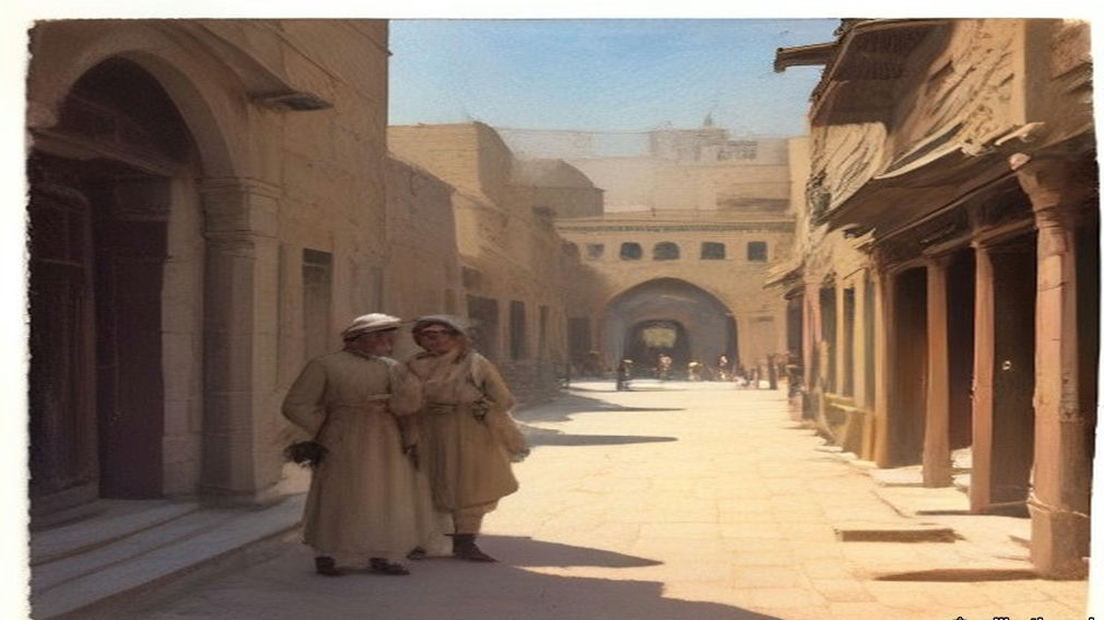
Then he moved to the title. Majesty, Jalala, and King, Malik, of the Arab Nation. It seemed hard that Montenegro should take that style and the Sharif of Mecca not. Storrs reminded him that when Nicholas proclaimed himself king he at least held the whole of his Black Mountain. With these alarms at Rabigh and Medina, could the Sharif say as much? Abdallah seemed to agree. He promised Storrs an advance copy of the first Hejaz Budget.
Storrs gave the total twenty years later. The Revolt in the Desert had cost the British taxpayer £11,000,000. The gold sent to Husain, the sums Storrs had carried and the £125,000 a month, came to "less than one million sterling. The remaining ten millions represent military operations and supplies from Great Britain."
* * *
Foreign Office, London, 2 November 1917
The letter was headed "Foreign Office, November 2nd, 1917," and began "Dear Lord Rothschild." The Foreign Secretary, Arthur James Balfour, had "much pleasure in conveying to you, on behalf of His Majesty's Government, the following declaration of sympathy with Jewish Zionist aspirations which has been submitted to, and approved by, the Cabinet."
"His Majesty's Government view with favour the establishment in Palestine of a national home for the Jewish people, and will use their best endeavours to facilitate the achievement of this object, it being clearly understood that nothing shall be done which may prejudice the civil and religious rights of existing non-Jewish communities in Palestine, or the rights and political status enjoyed by Jews in any other country."
The declaration inside the quotation marks ran to sixty-seven words. Balfour asked Lord Rothschild to bring it "to the knowledge of the Zionist Federation," and signed himself "Yours sincerely, Arthur James Balfour."
* * *
London to Taranto, 7 to 13 November 1917
Five days later Storrs left Charing Cross at twenty past one, seen off by his father and his brother Francis. He was going back to Cairo, and from there it was proposed he should go into Arabia to reconcile the Sharif and Ibn Saud. He was doubtful of it at heart, knowing what he called Husain's "genius for the scientific organization of delay." Sykes had arranged for him to join Georges Picot in Rome and travel on with him under French auspices, and at the Foreign Office Harold Nicolson "immediately provided me with the necessary gold."
From Folkestone the boat zigzagged all the way across. It was filthy cold, and everyone wore their cork life-jackets the whole crossing. At Modane on the 9th there was snow, the first Storrs had seen since the winter of 1903, and crowds of Italian troops. He changed 69 lire for 50 francs and noted that their hosts had coined money out of them. In Rome he was told that the Sharif was making heavy weather of his safe-conduct through the Hejaz, and hinting that he had better go round by the Gulf or Basra. People in Rome said the strikes and riots at Turin had been financed from Berlin, and that sums of up to 300 lire had been found in the pockets of "starving and penniless" workmen. On the 11th Picot came to say they would leave for Taranto on the night of the 12th. On the 12th a cable from Cairo said the Sharif had guaranteed his safe-conduct.
He had two berths to himself on the night train and had gone luxuriously to bed when the conductor came to say there had been an accident ahead. Seven people were dead. They must get up and out within half an hour and change trains. It was blowing hard and pouring with rain. At two in the morning Storrs stumbled along the line with his rug and three boxes, past men with torches guarding a coach thrown on its back with its wheels in the air like a turtle, through the reek of burning, to a little train of two carriages. They went on almost at once, without Picot's heavy luggage.

At Caserta, on the morning of the 13th, Picot was firmly decided not to go on without his trunk, and Storrs would not go on without Picot. "We were rattled by the good news from Palestine," he wrote, "and dreaded lest Jerusalem might be taken before we arrived in Egypt." At Bari, for three lire each, they bought paper bags holding a good meal. At Taranto, at half past four, their boat had gone.
* * *
House of Commons, Westminster, 28 November and 3 December 1917
In Petrograd the new Bolshevik government was publishing the secret papers of the Russian Foreign Ministry. On 28 November Mr. Outhwaite asked the Foreign Office in the Commons whether the secret treaties published by the new Russian Government did not reveal "that the Allies were committed to aims of vast territorial aggrandisement." Lord Robert Cecil answered: "I cannot accept as accurate the suggestion in the first part of the question."
Outhwaite asked next about another Petrograd paper, which said that a director of a British bank had been at a conference of international financiers at Berne in September. Ramsay MacDonald asked whether passports had been issued for it, and whether war aims were discussed. If any such meeting took place, Cecil said, no British subject, so far as he knew, had taken part, and certainly no passport had been issued for the purpose. Mr. Pringle asked whether a passport had in fact been issued to a director of a British bank at about that time. "I should like notice of that question," Cecil said.
On 3 December Mr. Richard Lambert asked whether, under "the Anglo-French-Russian Agreement of 21st February, 1917," France was to receive "the seaboard of Syria, the Adana vilayet, and part of Lesser Armenia," and whether "the Memorandum of Agreement, recently published in the Press," was still binding, and whether Russia was to have "the Erzerum, Trebizond, Bitlis, and Van vilayets, and Kurdistan down to the Persian frontier."
"No agreement of the nature mentioned was come to in the early part of this year," Cecil said. "Such understandings with respect to Asia Minor as were come to between the Powers named did not involve annexations."
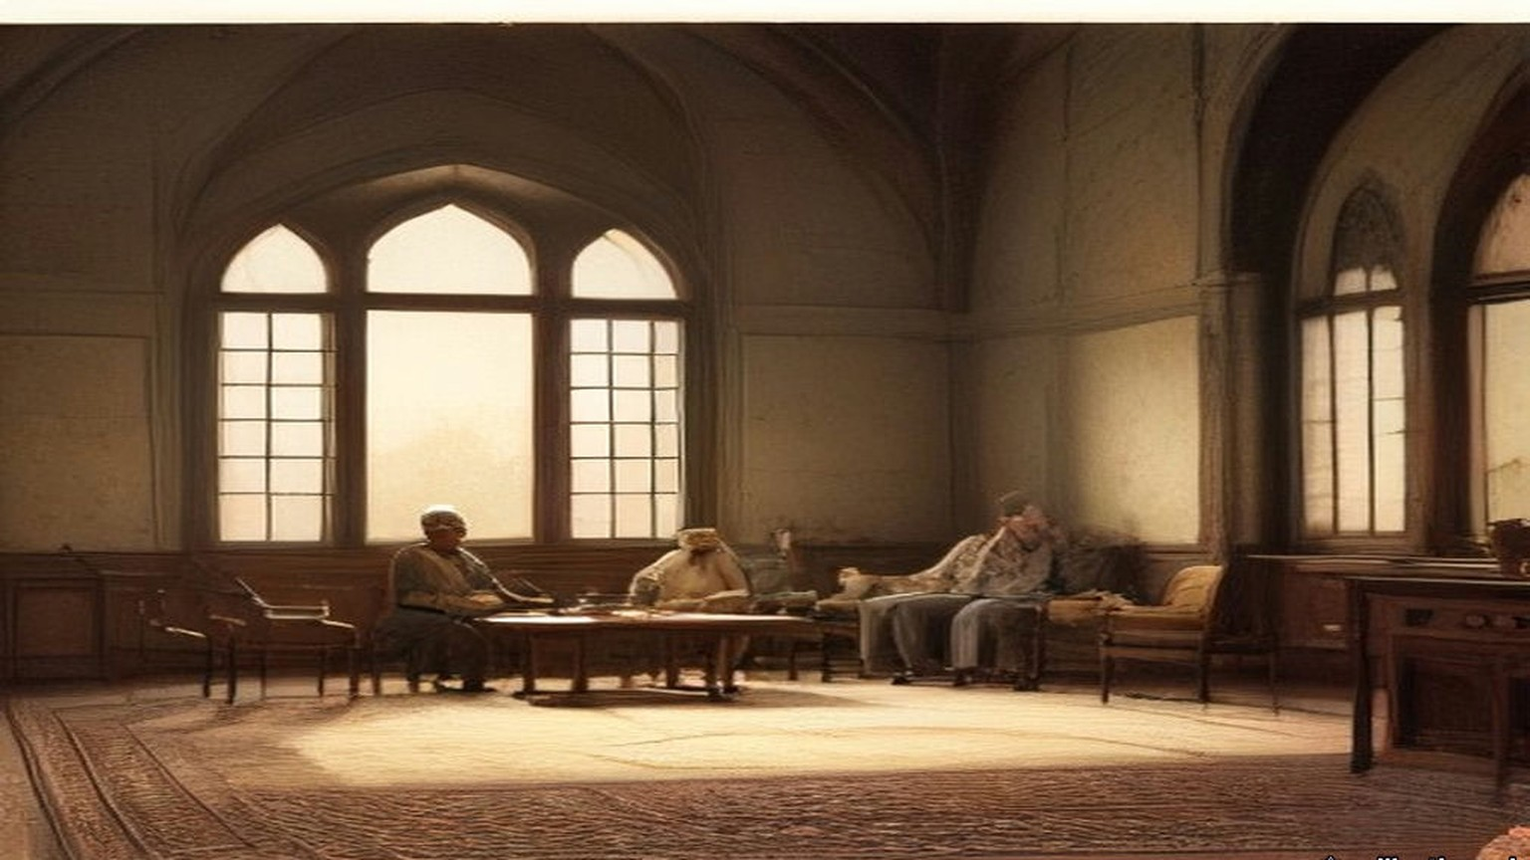
Outhwaite asked about another document from Petrograd, a dispatch of 9 October from Tereshchenko, then Russian Foreign Minister. It said the British, French and Italian Ambassadors had warned Kerensky that their countries would demand an exact account of the material help they had given Russia. Was that so? "Yes, Sir," Cecil said. The Ambassador had been instructed "to point out that the supply of munitions was not unlimited and must be made with regard to the method and value of the employment given to them." On the bankers at Berne he had nothing to add. "As far as I can learn, the whole story is a misapprehension or an invention."
Mr. King asked whether the Foreign Office had received any copy of the secret documents of the Russian Foreign Ministry recently published in Petrograd, and if not, whether it would get them through the Ambassador. "The answer to the first part of the question is in the negative," Cecil said. "As regards the second part, there is no reason to doubt that Sir G. Buchanan will send home copies of these publications in the ordinary course."
Chapter 24 Mini-Glossary
• Abdin (2 occurrences in this chapter): Palace and square in Cairo where Colonel Ahmed Urabi and the Egyptian army confronted Khedive Tewfik on 9 September 1881.
• Khedive (1 occurrences in this chapter): Title of the autonomous Ottoman viceroys of Egypt, formally granted by the Sultan to Ismail Pasha in 1867 and held by his successors until 1914.
• Wakf (1 occurrences in this chapter): In Islamic law, an inalienable charitable or religious endowment of property.
Chapter 24 Appendix of Important Names
• Balfour, Arthur James (3 mentions in this chapter): British Conservative Prime Minister, Chief Secretary for Ireland, and Foreign Secretary who issued the 1917 Balfour Declaration.
• Begin, Menachem (1 mentions in this chapter): Commander of the revisionist Zionist underground organization Irgun Zvai Leumi in Mandate Palestine.
• McMahon, Henry (9 mentions in this chapter): British High Commissioner in Egypt who exchanged the 1915–1916 correspondence with Sharif Hussein of Mecca.
• Rothschild, Lionel de (2 mentions in this chapter): Head of N. M. Rothschild & Sons in London who advanced the £4,000,000 for the British government's purchase of the Suez Canal shares in 1875.
Sources
• Correspondence between Sir Henry McMahon, G.C.M.G., G.C.V.O., K.C.I.E., C.S.I., His Majesty's High Commissioner at Cairo and the Sherif Hussein of Mecca, July 1915–March 1916 (with map). Miscellaneous No. 3 (1939), Cmd. 5957. London: HMSO, 1939. Explanatory note; letters Nos. 1–10 with their footnotes ("Former reading"). Read from the Internet Archive scan (mcmahon5957); OCR text checked against the PDF.
• Storrs, Sir Ronald. Orientations. London: Ivor Nicholson and Watson, 1937. Pp. 142–143 (Abdallah in Cairo, April 1914; Kitchener to Tyrrell, 26 April 1914, footnote); pp. 173–177 (the messenger X and his report of 30 October 1914; Kitchener's cable of 31 October; the July 1915 proposals; "opened his mouth"; the footnote on the cost of the Revolt, checked against the page image of p. 177); p. 179 (Ruhi; Husain's prose; Sykes); pp. 180–188 (the report on the mission of 28 May to 7 June 1916, Samima and the Dufferin); pp. 200–207 (diary, 13–17 October 1916, the Lama and Jeddah); pp. 305–310 (diary, 7–13 November 1917). Internet Archive, in.ernet.dli.2015.174934.
• Sir Edward Grey to Paul Cambon, 15 and 16 May 1916 (the Sykes–Picot Agreement), transcribed by the World War I Document Archive, Brigham Young University Library. https://wwi.lib.byu.edu/index.php/Sykes-Picot_Agreement
• A. J. Balfour to Lord Rothschild, 2 November 1917, transcribed by the World War I Document Archive. https://wwi.lib.byu.edu/index.php/The_Balfour_Declaration
• House of Commons Debates, 28 November 1917, vol. 99, cc. 1986–8, "Russia" (Chapple, Outhwaite, MacDonald, Pringle, Wedgwood; Lord R. Cecil). https://api.parliament.uk/historic-hansard/commons/1917/nov/28/russia
• House of Commons Debates, 3 December 1917, vol. 100, "Russia" (King, Lambert, Outhwaite, Richardson; Lord R. Cecil). https://hansard.parliament.uk/debates/GetDebateAsText/c7a231a5-92f3-48fa-ba1a-a30a27564cef

Chapter 25
Screen at the Wailing Wall, 1922–1938
Haifa, Jerusalem, the hills of Carmel, Acre and Westminster, April 1922 to October 1938
The jetty near Haifa Railway Yards, end of April 1922
They came ashore on a Sunday morning at the end of April 1922, 650 British gendarmes, onto a dusty little jetty near the railway yards at Haifa. Douglas V. Duff was one of the youngest of them. He was not quite twenty-one. He would write later that the Gendarmerie were the first Westerners embodied for service in Palestine and nowhere else to land since Acre fell in 1291, and he liked the thought of the Knights Templar slipping away from Castle Pilgrim in the dark a few weeks after. He wrote that at the end of a long life of soldiering for pay, and the Templars stayed with him the whole way.
He had already been a cadet in the school-ship Conway, and before he was sixteen he was the sole survivor of the Thracia, torpedoed in the Bay of Biscay in March 1917. He spent twenty-six hours on the bottom half of the starboard lifeboat, blown out of its davit-falls, and made a compact there with God that if he lived he would serve Him in the cloister. He was sunk again in 1918. He saw South Russia. He entered the noviciate of a teaching Order in England and stayed twenty months, and on the eve of his temporary vows of Poverty, Chastity and Obedience found he could go no further. He left on a Monday with a railway ticket to London and three-and-sixpence in his pocket. On the Friday of that same week he was in a Royal Irish Constabulary patrol ambushed in Grafton Street, Dublin. A bomb was thrown at the motor-tender. Two men were hurt.
Most of his Irish service was in Galway City, with fights in the bogs and on the mountain-sides of Connemara. When the R.I.C. was disbanded he was given a pension as a "regular," and he still found it useful at Christmas thirty years on. Before he left Ireland he put his name on the list for the new Force. He had decided, he said, "sanely and coolly, that the only trade open to me was that of the Free Companion, of the mercenary soldier who is ready to fight for any side not engaged in warfare against his own country, so long as he is well paid."
The first-year men were well paid. The Colonial Office afterwards signed on a batch of discharged short-service ex-Guardsmen "at a cut rate, three shillings a day less than they paid us." Duff called them the "seven shillings a day" men. The first-year gendarme drew ten.
From the jetty the companies went south to the camp at Sarafand in thick serge, in a Palestine spring. They carried Smith and Wesson .45 revolvers in what Duff called absurd cowboy holsters and wore Stetson hats.
* * *
The marshalling yard at Haifa, 1922
Duff's platoon was moved north again by rail, its gear loaded into a dozen steel box-wagons, with an escort of four for the baggage. There was Taffy, there was Jock, there was Duff, and there was a gendarme from the American South whom they called Kentucky, a man Duff described as hewn in the rough from a block of rather coarse-grained teak. They rigged four folding iron beds in an empty wagon, uncoupled it from another train and coupled it quietly onto their own, and played poker up the Plain of Sharon. It took three days and four nights to cover fifty miles to Haifa. By the end Kentucky owned their money, and the mosquitoes had bitten them so hard that he moaned they would all have malaria before the week was out.
At Haifa they halted in the marshalling yard by the level-crossing on the Acre road. A high wall ten feet away blocked all view. A short reconnaissance towards the station turned up a dozen bottles of German beer at a small Arab café blazing under hissing paraffin arc-lamps. They kept watches through the night. At half past one Kentucky climbed into the wagon to wake Taffy for his turn, and Taffy found his boots gone. So were everyone's, all but the American's. Their other kit was sealed in the locked cars. A famous and much-publicised Gendarmerie robbed of its boots by a sneak-thief was more than any of them could face.
Kentucky went out to look and came back within minutes. The town brothels lay a few yards beyond the wall. Taffy stayed with the baggage. Duff and Jock went in their socks, with Kentucky in front looking for broken glass in the sand and cinders. The brothels were sagging lean-tos against the walls of a compound on the lower slopes of Carmel, with paraffin lamps glowing amber in a few of them and a reek, Duff wrote, of cheap cosmetics, sewage and oily garlic.
They knocked at the matchboard door of the only stone house. "A large, very fat, one-eyed woman" heaved herself up from a creaking brass double bed. She began to curse, then saw three uniforms and stopped. "In fairly good English she asked us if we wanted one of her girls." Jock told her to sit down and listen. She did.
The three of them stood there, revolvers on their hips, Stetsons on their heads. Duff never forgot what she asked next. "She asked, tremblingly, if we belonged to the new Police which she had heard had been sent to Palestine because of the murders we had committed in some land from which the English had been driven because of our brutalities." Kentucky told her that they were, and that they were ready for even more awful tyrannies if she did not find their boots. Duff added that the local police would be no use to her, since this was a superior kind of police. She remembered the Turkish Gendarmerie, he thought, and took the point.
There was shouting, and a blow to one of the younger women, and three pairs of ammunition boots came back. The thief had taken them straight to the bedside of the woman he was visiting and offered them as her fee. "We sweetened the deal by giving the lady five piastres." She brought out a bottle of arak. They declined her other offer and walked back over the cinders shod.
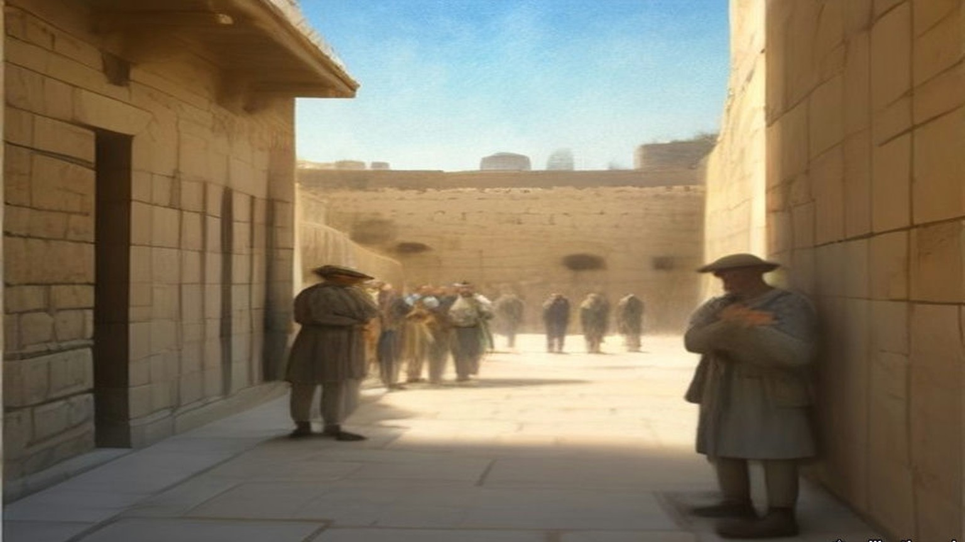
* * *
Jerusalem, 1923 to 1928
The Gendarmerie did not last. Newspapers in Britain demanded retrenchment, and Plumer's administration cut the armed forces first. In 1926 the Gendarmerie, British and Palestinian, was abolished, and 5 officers and 212 other ranks of its British Section went over to the civil police. The Royal Commission of 1937 counted the whole Palestine Police that year at 125 officers and 1,627 other ranks. Of all ranks, 245 were British. Duff stayed and rose. By 1928 he was an officer in Jerusalem, based at the Citadel, carrying a .450 Colt in a belt-holster and an old Irish blackthorn shillelagh.
He also carried a whip. He called it his kurlaj, a Turkish hide whip, and elsewhere by its Arabic name, the kurbaj. He used it on a gang leader behind the Armenian Patriarchate stables, giving the man "the best thrashing he had ever had." After the earthquake of 11 July 1927 brought the new tourist hotel at Jericho down on its guests, he used it on the Jericho men and Bedouin who would not dig until a retired Indian judge had paid them every sovereign in his satchel, and who scrambled for the coins with daggers out when he threw some on the rubble. He had his sergeant trice one Bedouin to the wire of the hotel tennis court and lay on a dozen lashes. He set these down without apology.
In the Wadi Haramiyeh, on the Jerusalem to Nablus road near the twenty-ninth kilometre stone, three highwaymen in hill-country clothes put a stone barrier across the road and stopped several cars. Among the travellers was Dr. MacInnes, the Anglican Bishop in Jerusalem, who faced them down. When they fled, the Bishop's chauffeur lay dead and an American woman, Mrs. Pettit, had been shot through the throat. The police went into the hill villages.
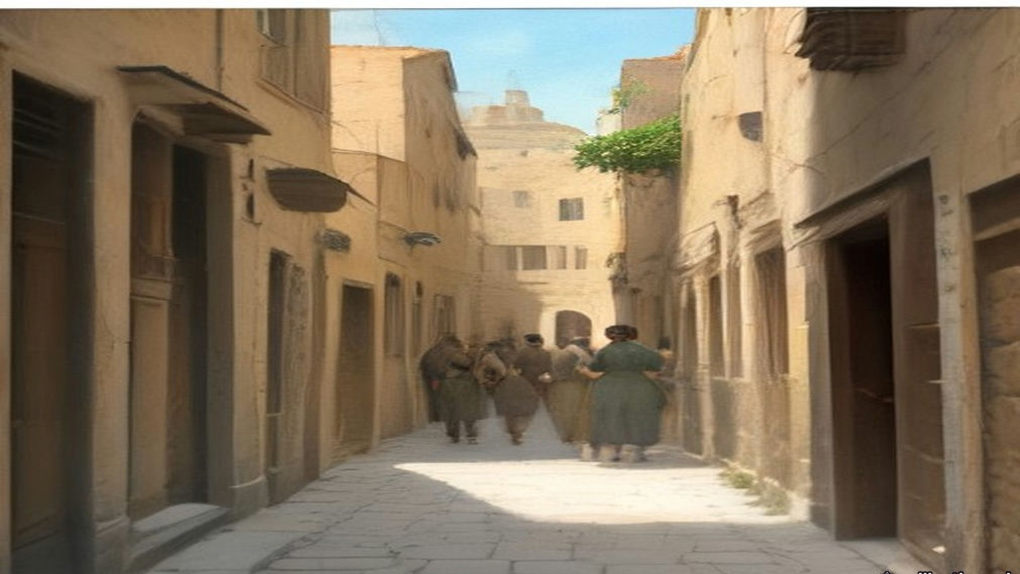
Duff wrote about what followed in plain words, and they are his.
"I, personally, saw a deal of the beating and 'third degree' that was endured by many dozens of people in the hill villages near the scene of the crime, and I am not holding up my hands in shocked protest, for I witnessed hundreds of bastinadoings during my years in the Palestine police and many scores of cases where the 'Hoist', or the 'water-can', was employed."
The water-can left nothing for a doctor to find. The man was held down flat on his back. A thin-spouted coffee-pot poured a trickle of water up his nose. His head was clamped between cushions, so there were no bruises. "Usually, we British officers remained discreetly in the background, not wishing to have the skirts of our garments soiled, but we were ready to benefit by information wrung by our subordinates from the wretched suspects or criminals."
Three men from the hill-top village above the scene were tried and sentenced to death. Most of the British police officers, Duff wrote, believed them innocent, because no Arab robber he knew worked so close to his own village, with the collective fines that followed. The three were hanged in Jerusalem Central Prison. A week later some of the loot from the hold-up was found on known ruffians of Abu Dis, miles away.
* * *
The window of the Mahkama Sharʿiyya, the afternoon and evening of 23 September 1928
On the eve of Yom Kippur Duff met the District Commissioner near the Holy Sepulchre. The Commissioner was going down to the Temple area to call on some of the religious sheikhs and asked him along. They walked down David Street from the Jaffa Gate, across the filled-in valley, towards the Gate of the Chain. Just to the right of the gate stood the Mahkama Sharʿiyya, the Muslim religious court, where dowries, wills, endowments and divorces were heard. Several elderly sheikhs met them there in black cassock-like robes, red fezzes wound with white turbans.
From a tall window of the court the Commissioner looked down on the pavement before the Wall a few yards below. It was full of worshippers coming and going. Duff gave the hour as about four in the afternoon. The fast began at sunset.
Duff had been past the Wall earlier that day and had noticed a screen about a third of the way along the flagstones, an ordinary bedroom screen of light wooden battens and thin cloth panels that folded in four. He had thought nothing of it. The Commissioner saw it now and said he had never seen such a thing at a festival at the Wall before.
Duff was sure the sheikhs had paid it no attention until that moment. They spoke all at once. It was a barefaced Jewish attempt on the Mosque of al-Aqsa and the Dome of the Rock, they said, the thin end of a wedge. The Wall was where the Prophet's steed al-Buraq had stood before the Night Journey. If the Commissioner did nothing, a holy war would be on his head alone, and he would be a false servant to the King of England. And look, they said. Were the women not on one side of the screen and the men on the other, as in a synagogue? Was it not the custom for Jews at the Wall to stand where they chose? Duff looked down. The women were on one side and the men on the other.
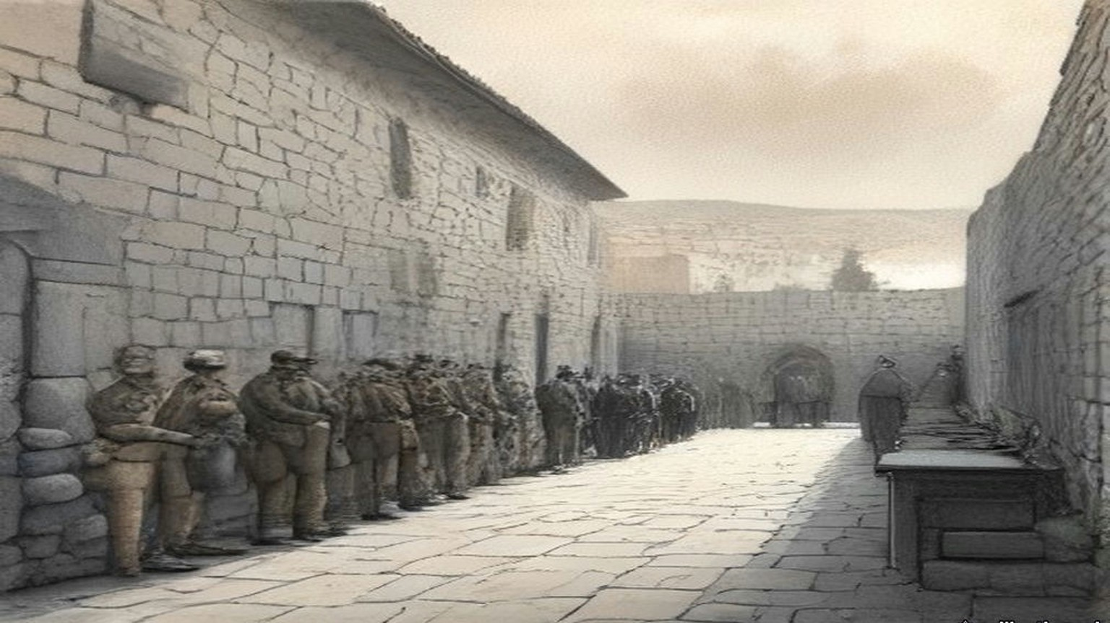
The Commissioner kept calm, made a joke, and said he would go down himself and speak to the beadle of the Wall, whom Duff calls Rabbi Noah. The beadle said the screen meant nothing; it was there to give the women a little privacy. The Commissioner let it stand until the end of the service, on condition that it was then taken quietly away, and explained that the Muslims had objected. Rabbi Noah promised. Duff and the Commissioner walked on to the Hurvah Synagogue in the Jewish quarter to pay a courtesy call on the festival eve.
After about an hour of the service Duff grew restless, whispered that he wanted to check the screen, and went back down. It was still standing. Rabbi Noah told him, in tears, that it was already sunset of the holiest day, that no Jew would touch it now because that would be servile work, and that he would find a couple of Christian workmen during the evening to move it.
Duff went to find the Commissioner at the Hurvah and found him gone, back to the Residency, a Greek Patriarchate building inside the walls between the Jaffa and New Gates. There were guests. The Commissioner gave Duff a whisky-and-soda and told him to make sure, without offending the Jews too much, that the screen was gone by morning.
Duff had been taught as a young gendarme by a major who left the civil authorities no way out when a Court of Inquiry sat. He took out his notebook and wrote an order to himself, setting down the Commissioner's instruction to remove the screen by morning and calling it urgent. Then he got near his host again and held out the notebook and a pencil. The Commissioner glanced at it and signed. Duff took it down the corridor to the old Greek Christian who was chief clerk and had him press the official stamp on it.
That is Duff's account, written a quarter of a century later. The Palestine Government's communiqué of 26 September 1928, printed by the Colonial Office that November, tells it this way. On the evening of the 23rd the Mutawali of the Abu Madian Waqf, in which the pavement was vested, complained to the Deputy District Commissioner "that a dividing screen had been affixed to the pavement adjoining the Wall, and that other innovations had been made in the established practice, such as the introduction of additional petrol lamps, a number of mats, and a tabernacle or ark much larger than was customary." The Deputy District Commissioner visited the Wall during the evening service and decided that the screen had to go before the next day's service. The beadle undertook to remove it and was given until early morning. The British police officer on duty was told that if the beadle did not keep his word, the screen was to be removed.
Duff's officer is the District Commissioner and his hour is four in the afternoon. The communiqué's officer is the Deputy District Commissioner, and its complaint comes from the Mutawali in the evening.
* * *
Behind the screen, the morning of 24 September 1928
Through all of that night she did not sit. On her feet she stood in the women's part, the white kerchief of the festival bound over her hair, the stones of the Wall still cold from the dark. Her mouth was dry from the fast. Twice in the night came the young English officer with the cap, and spoke with the shammash, the beadle, and went away.
כָּל נִדְרֵי, Kol Nidre, they had sung at evening, all the vows. Now was morning. Good, the morning: from the women's side of the screen she could not see the men and the men could not see her, and so it was fitting, so it was in every synagogue of Israel. A screen of cloth only. Four leaves it had. Ribbono shel olam, רִבּוֹנוֹ שֶׁל עוֹלָם, Master of the world, for a screen of cloth what would they do?
Came an Arab officer with a few policemen, not long before nine. Went up the women against him. She felt it in the backs of her knees before she saw it, the press of the bodies moving, and the screaming, and then he was going back the way he had come, his tunic torn.
Duff was at his desk when the Arab inspector came in. At half past six that morning, over breakfast, he had been handed a note from the District Commissioner, brought by the beadle himself: the beadle had found no non-Jewish labour, and the Commissioner gave him until nine. Rabbi Noah kept the note to show any policeman at the Wall. At ten to nine Duff sent the inspector down with a few men to see the screen was gone. A quarter of an hour later the inspector was back "with his tunic in shreds, his face scratched," and the start of two black eyes. A crowd of Jews, mostly women, had gone at his party. The screen was still up, and now it was fixed to the flagstones with iron strappings. And Arabs were gathering in the bazaars.
His two seniors were out of barracks. Duff telephoned Mount Scopus for ten British constables in battle order, put on his steel helmet and walked down to the Jaffa Gate to meet them. Four of the ten were old first-year ex-British gendarmes, and he was glad to see them. They had insisted on coming, they told him later, because there was sure to be action if Duff had sent for them. They went down David Street at the double. Arabs were pouring towards the Gate of the Chain with daggers in their belts and nabbut clubs in their hands.
Then came the English. Ten of them, more, in the round steel hats, and the officer in front. She saw them come round the corner into the narrow place and the women went quiet, all of them, for a moment only. Over the Wall, from the other side, from the Arabs, she heard men roaring. Duff heard a single voice above the rest and gave it in English: "Kill the Jewish dogs! Islam is endangered. Strike!"
He took hold of Rabbi Noah and asked him why the screen was still there. The old man could not answer. He sagged in Duff's hands.
"Tear it down, Sergeant!"
They pushed in close together through the women. Umbrellas and sticks came down on their helmets. One old woman beat at Duff's back until her parasol broke. Fingers raked at them. Duff reached the screen first. A man in a long caftan and a fur-trimmed hat with a wide brim took hold of it and shouted in English that he would die where he stood and they would have to take him with it.
Hers was not an umbrella. Hers were her two hands, and she struck the wool of a back that was broad as a door, and it did not turn. Gevalt. They lifted the screen, and the man in the shtreimel on it hanging, and carried it out from among the women, all of it, the man also, and the screaming going after them up the lane.
Duff's party carried the wreckage of the screen out in their midst, the man still clinging to it. Where the lane to the Dung Gate opened onto the cactus slope of the valley, Duff halted his men and turned them about, and ordered the sergeant to throw the shreds of the screen into the valley, "and when the Rabbi refused to loosen his grip, he went down the twenty-foot-steep slope with it." The constables took a position in a deep archway where they could be attacked only from the front. The women saw they could not get at them, and ran uphill towards David Street. Duff took his men out among them in tight order, afraid of what would happen when the women met the Arab crowd in the main street, and put three constables at the junction of the covered bazaars to hold the Arabs off and block the way into the Jewish quarter.
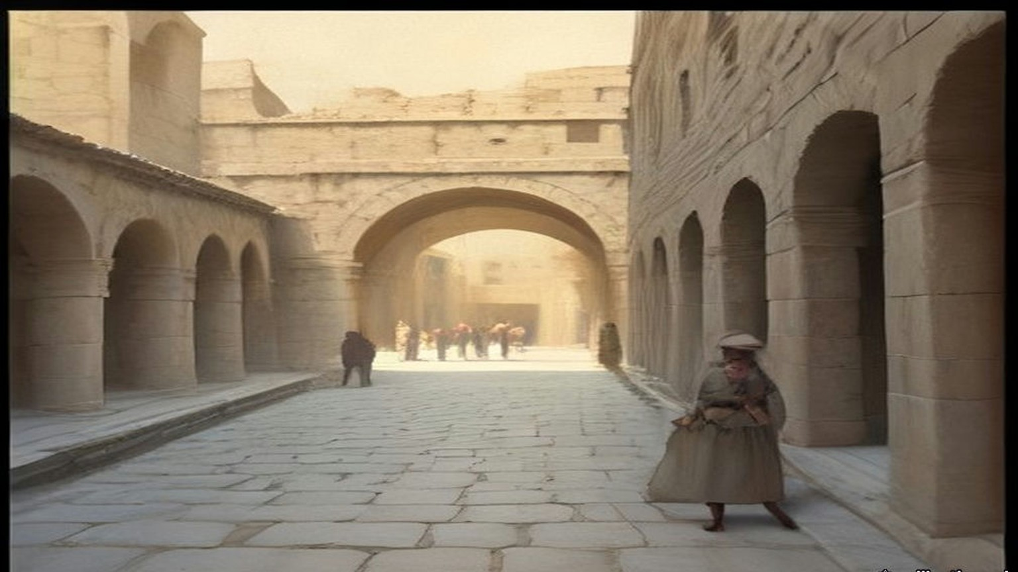
"I still maintain that that day we prevented a general massacre of Jews in those cobbled, sun-drenched narrow streets," Duff wrote. "Not a single Jew was seriously injured; even the Rabbi, who had clung to the screen, sustained only a few abrasions and bruises." A few Arabs who went for the fleeing Jews had their heads cracked with rifle-butts.
The Colonial Office's own words, two months later, were that the removal "was in fact effected without casualties of any but a light nature." The communiqué gave the morning in four sentences. The officer found the screen still there and asked the congregation to take it away; "they replied that they were unable to move it because of the holiness of the day. The Police therefore removed the screen themselves." Worshippers who knew nothing of the night before saw only police removing the screen that divided the men from the women, "and some of them endeavoured by force to prevent the screen being taken away."
* * *
Jerusalem, autumn 1928
The Inspector-General came first, at the head of a posse, angry until he heard Duff's report. Then came a senior man from the Legal department who accused Duff of the most brutal methods against the worshippers and asked how many the police had killed. Duff told him to go and look for any dead or wounded he could find, and if he found none, to come back and apologise. Back in barracks his own senior officer and the Inspector-General said he had acted rashly and should have gone to higher authority. He told them he had taken no initiative at all, and produced the notebook with the Commissioner's signature under the order. That ended it, for him. Some senior officials suggested his transfer to another Colonial police force, on promotion. He refused to be kicked upstairs.
The Arabs cheered him in the streets of the Muslim quarters as the saviour of the shrines. Jews booed him where they were numerous enough. He went to break up a large Jewish demonstration at Mustashfa, then the outer suburb on the Jaffa road. The crowd stopped his two tenders and drove his party into the police outpost. Stones came in, and a shot or two. The tyres were cut and the telephone wires, and one tender was turned on its side. The District Superintendent fought his way through to the door with a dozen troopers. Outside the crowd chanted "Death to Duff" and "Turn Duff out and we will drink his blood."
The Superintendent ordered him to stay out of sight. Duff pulled back the steel bar and stood in the door. The front rank fell back when they saw his face. He shouted at them to come and do it, and "before five seconds had passed my sanity slipped. Once again I experienced that strange and utterly sublime ecstasy of 'going berserk', as my barbarian forefathers had done." He went into them with the hide whip swinging and his boots kicking, and in half a minute the road was empty. The Superintendent led a counter-charge behind him. Within half an hour Duff was back in his quarters under open arrest for insolence and mutiny. The charges were dropped when he apologised.
Then, by his account, three attempts on his life. After midnight, on his rounds near the half-built Nathan Straus building in the New City, a young man asked him for a light and then jumped back, and Duff jumped back too, and a block of stone he put at five or six hundredweight came down from the coping where he had been standing. He wrote that twenty-two years later, in London, he spent a convivial evening with the man who dropped it. A week later in Meah Shearim pistol bullets came at him up an alley. He fired back into the dark, reloaded, fired again, and wrote that he found "two young men lying dead and another one with a severe wound in the lungs." He ran for a patrol. Ten minutes later there was blood on the stones and no one at all. About ten days after that, on St. Paul's Road, a car came at him twice. He put two bullets through the windscreen and four more into the bodywork as it drove off. Next day every garage in Palestine was searched for a car with a shattered windscreen. There was none.
Duff's three attempts and his two dead men rest on Duff alone. He wrote that afterwards the Hebrew and Yiddish newspapers turned on the District Commissioner instead, and that he was grateful.
The leaders on both sides had already understood what the screen could become. The Zionist Organisation protested to the League of Nations against its removal, repudiating any wish "to menace the inviolability of the Moslem Holy Place." The Vaʿad Leumi, the Jewish National Council, wrote an open letter to the Muslims of Palestine declaring "emphatically and sincerely that no Jew has ever thought of encroaching upon the rights of Moslems over their own Holy Places." Hajj Amin al-Husseini, Mufti of Jerusalem and President of the Supreme Moslem Council, told the officer acting for the absent High Commissioner of the Muslim belief "that the Jews' aim is to take possession of the Mosque of Al-Aqsa gradually." On 1 November a General Moslem Conference met under the Mufti and resolved to found a Society for the Protection of the Moslem Holy Places.
* * *
The House of Commons, 12 and 26 November 1928
Mr. Fenby asked the Colonial Secretary whether he was aware that on 24 September, "being the Jewish Day of Atonement, British police, acting on the instructions of the deputy district commissioner for Jerusalem, broke through the Jewish worshippers at the Kotel Maaravi, generally known as the Wailing Wall, and forcibly removed a portable screen which had been placed there on the previous evening." Sir Frank Sanderson, the Member for Darwen, asked the question the other way round, whether the Government would protect the Wall "from acts of aggression."
Leopold Amery answered both. A White Paper was coming. The concern of the two Governments was "to maintain the satus quo as between Jews and Moslems in strict accordance with Article 13 of the Mandate," as Hansard printed it. "At the same time His Majesty's Government deeply deplore the shock which was caused to large numbers of worshippers on a day so holy to Jews." To Darwen: "The hon. Member for Darwen is, I think unnecessarily apprehensive on behalf of the Moslems." It was not contested that those in charge of the service, "acting in defiance of Government instructions, introduced certain innovations." And he gave an absolute assurance that the Jews raised no question of the ownership of the Wall.
Lieutenant-Commander Kenworthy had opened the exchange with a different complaint. The Muslims, he said, were building masonry on top of the Wall, while the authorities forced Jews to take down temporary screens. Now he asked whether the White Paper would report "the alleged brutality that took place among the worshippers." Amery: "I think that the hon. and gallant Member will find that the White Paper gives a very full account." Sanderson asked if there had been rioting in Jerusalem. "No, Sir; there has been no rioting in Jerusalem." Had the Government evidence of widespread feeling among the Muslims? "Yes, there is considerable excitement among all sections of the population."
The White Paper, Cmd. 3229, said that the Wall was "legally the absolute property of the Moslem community," and the pavement Waqf property, and that the Jews had "an undoubted right of access" to it for their devotions. It said that the beadle "has been dealt with by the Jewish authorities." It said that no Jewish police officer was at the Wall that morning, "owing to all Jewish officers in Jerusalem having been excused duty for the Day of Atonement," at the request of the Chief Rabbinate, and that the police who did the work "did not include any Jews." It ended the communiqué on one sentence: "In conclusion, Government consider that the removal of the screen was necessary, but regret all the circumstances attending that removal." It did not name the officer.
Two weeks later Kenworthy was back with a hospice beside the Wall and a muezzin on a nearby roof calling the prayer five times on Saturdays over the corner where the Ark of the Scrolls stood. "No, Sir, I am not aware of any such incidents." Colonel Wedgwood asked whether Amery was satisfied with the Governor, and whether the inquiry was into the police or into a superior officer. "I have full confidence in the Acting High Commissioner."
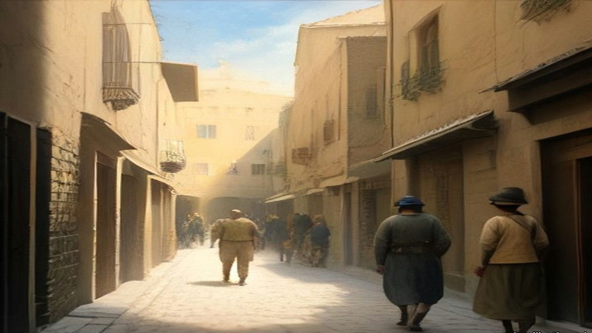
* * *
Palestine, August 1929, and the bill
By the early summer of 1929, Duff wrote, the money had run so thin that "In all the Holy Land of 1929 the Government had only about 30 British police officers and 120-odd constables in the British Section." Some 1,800 Palestinians, nearly all Muslim, made up the rest. There was no British soldier in garrison between Dan and Aqaba; the single R.A.F. squadron was across the Jordan guarding the desert. In summer, with home leave, not more than ninety British police of all ranks were in the country.
His own command of the Jerusalem division ended at the festival of Simon the Just at the tomb in the upper Kidron valley, when a fight between Muslim and Jewish children drew in their mothers and then the men. Duff led a charge of mounted police that killed one rioter. Jews talked of suing him for manslaughter. He announced that he would resign, and then stayed, and was sent to command a penal settlement building a road across the Plain of Esdraelon to Jenin.
On 15 August 1929 Jews marched in procession to the Wall. On the 16th the Arabs did the same. From the 23rd to the 29th Jews were attacked across the country. At Hebron, the Royal Commission recorded, "over 60 Jews were killed, including women and children, and more than 50 injured," and "Only the courage of the one British police officer in the town prevented the outbreak from developing into a general massacre." At Safad 45 Jews were killed or wounded. When troops brought up from Egypt had restored order, "it was reckoned that 133 Jews had been killed and 339 wounded. Of the Arabs, as far as could be ascertained, 116 had been killed and 232 wounded. As in 1921, the majority of Arab casualties were inflicted by the troops or police." Twenty-seven death sentences for murder were confirmed, one of them on a Jew. Three Arabs were hanged.
The Collective Punishments Ordinance of 1926 was applied to the towns and villages whose people had joined attacks on Jews, and fines of £17,840 were laid on them. Nearly 1,300 people were brought to trial. In 1930 the Palestine Government paid £101,135 for damage done in the riots, and its spending on internal security that year reached £918,741. The Shaw Commission found that the policy of cutting the garrison had gone too far, and that "The conduct of the British Police deserved the highest commendation." By 1930 the force stood at 152 officers and 2,568 other ranks, 631 of them in the British Police. Spending on public security, which had been £265,000 in 1923, was £774,000 in 1931.
Duff moved to Tulkarm. He held it, he wrote, with one Palestinian officer, a corporal, four British mounted constables and eighteen Palestinian troopers. When an Arab sergeant of his was "severe with certain associates of the brigands" to make them talk, and the brigands were run down in a fight that lasted until sunset one wet January day, Duff refused to discipline the sergeant, told the new Inspector-General what he thought of his methods, and repeated it to the new High Commissioner, Sir Arthur Wauchope. He left Palestine, sick with malaria, to marry a Scots nurse named Janet.
* * *
The hills of Carmel and Acre, 1937 and 1938
He came back with a pen. In 1938 Blackie published his Palestine Unveiled, told as the journey of a West Dorset farmer and his wife Janet on a holiday they could at last afford in 1937. Duff had married a Janet and was by then a West Dorset farmer himself. He dedicated the book to Sarah Aaronsohn.
His farmer went with a patrol and its police dogs after the men who had ambushed a car and shot an officer and two women. The trail went up into the hills near Haifa and stopped close to the village of Ijzim. The police officer gave the orders aloud: surround the place, challenge anyone leaving, "and shoot to kill if they refuse to halt." A man ran from the houses for the scrub. A dozen voices yelled at him to halt, British and Arab police together. Two or three rifles fired. He fell, got up, ran, and was shot again, and lay still. A constable turned him over and searched him and found no gun and no dagger, only two empty brass cartridge-cases. "'Ere y'are, sir," the constable said, "hexpended cartridges."
The dogs led to two houses. Their owners were not at home. More troops and police came out from Haifa, and then a party of Royal Engineers, and the two houses went up. The whole village was fined, and when the villagers could not pay, their flocks and herds were seized and driven off to be sold.
The farmer asked a senior police officer what good it did. "Arabs only understand brute force," the officer said. "We've tried being decent to 'em, and they took our goodness for weakness, now they are being taught a lesson." The farmer said there was no proof the village had anything to do with the ambush. "Good Lord, man," the officer said, "didn't the dogs lead us here?"
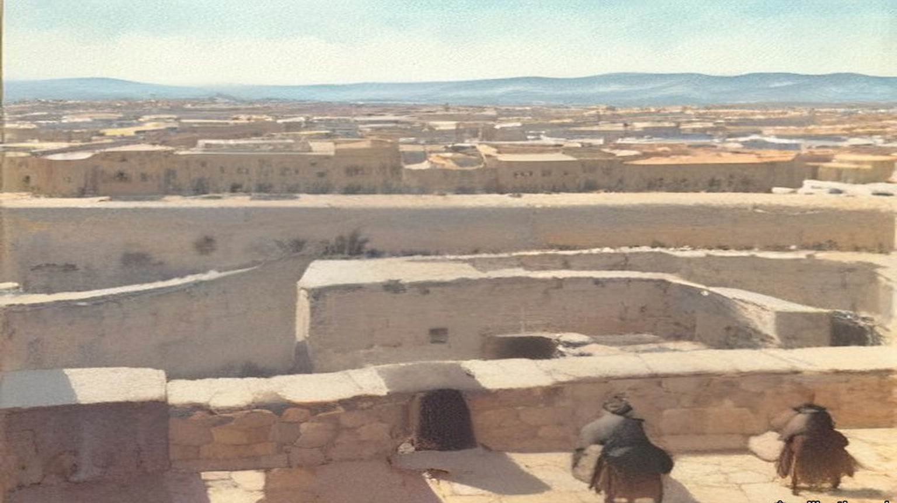
At Acre prison a British inspector showed him round, through the workshops where convicts made carpets from wool unravelled from worn-out army socks, and then to the gallows. The condemned cells were two cages in the vestibule of the execution chamber. When two men were to hang on one morning, the second waited in his cage and heard the first. The inspector said there had been three executions on one morning, the morning the three men of 1929 were hanged. British officers in Palestine acted as executioners themselves, he said, and he would give anything to be really sick on an execution morning. "I suppose that you served in the Royal Irish Constabulary, didn't you?" the farmer asked. "Most of the officers of the Palestine Police seem to have done so."
"I did," the inspector said, "and it was a far better and safer job than this one."
The farmer said that some of the men hanged in Ireland in 1920 and 1921 had been condemned as criminals too, Kevin Barry and the rest. "That was different, they were white men," the inspector said.
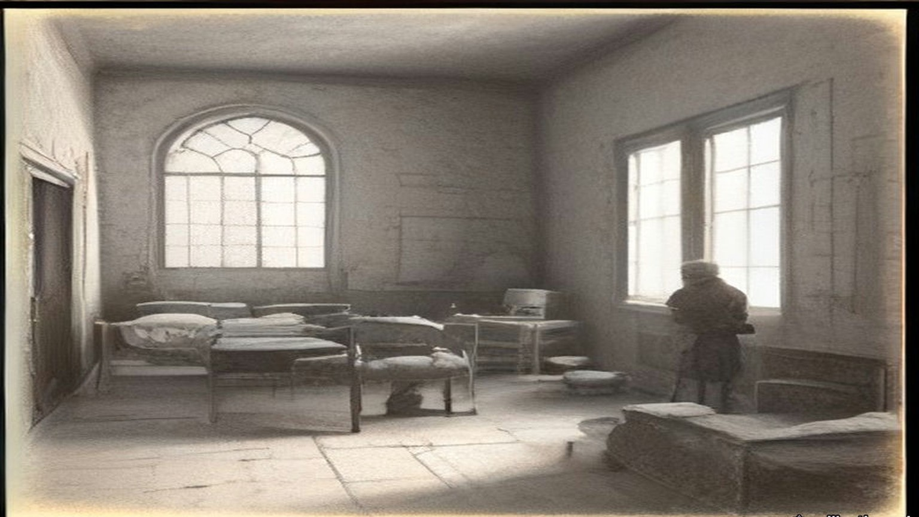
At the end of 1936 the Palestine Police had 59 superior officers, 125 inspectors and 3,132 other ranks. Its public security budget had passed £862,000 in 1935–36. On 14 October 1938 H. G. Wood wrote in The Spectator that the position in Palestine bore "a sinister resemblance to the position in Ireland in 1920 and 1921," that the rebels were adopting "the methods of Irish gunmen," and that "The authorities in the struggle to repress disorder are indulging in reprisals reminiscent of the black-and-tans." Villagers who sheltered rebels at night, he wrote, found "their houses razed to the ground" the next day, and money was being extorted from reluctant supporters of the rebellion under threat of assassination. Nearly six weeks before, on 5 September, the High Commissioner had telegraphed the Colonial Secretary in secret: "I have been much concerned lately by occasional emergence of black-and-tan tendencies."
Duff went back to Palestine as a writer more than once, the last time before the war in 1938. In Bailing with a Teaspoon he set down the names of those he thought had understood and loved the country, and among them, a few words apart, are Moshe Shertok, Ben-Gurion and Hajj Amin al-Husseini, Mufti of Jerusalem. Of those return visits he wrote that the police had grown beyond recognition, that the prisons were jammed, and that he saw "the barbed-wire fences of shameful concentration camps where people suspected, but not convicted, of political offences rotted in confinement."
Chapter 25 Appendix of Important Names
• Ben-Gurion, David (1 mentions in this chapter): Leader of the Jewish Agency and first Prime Minister of Israel.
• Duff, Douglas V. (55 mentions in this chapter): Former Black and Tan in Ireland who served as an officer in the British Gendarmerie and Palestine Police in Jerusalem.
Sources
• Duff, Douglas V. Bailing with a Teaspoon. London: John Long, 1953 (the Internet Archive record gives 1959). Ch. I (landing at Haifa, end of April 1922; Thracia; noviciate; Grafton Street; Galway; R.I.C. pension; "Free Companion"); the Haifa marshalling yard and the brothel; the "seven shillings a day" men and "three shillings a day less than they paid us"; the disbandment for retrenchment; the kurlaj/kurbaj and the blackthorn; the Wadi Haramiyeh hold-up and the "water-can"; the Wailing Wall incident, 23–24 September 1928, pp. 169–176; Mustashfa and the three attempts, pp. 176–179; 1929 numbers, Simon the Just, Tulkarm and leaving, pp. 187–210; 1938 return, pp. 210–211. Internet Archive, bailingwithateas012270mbp (OCR).
• Duff, Douglas V. Palestine Unveiled. London and Glasgow: Blackie, 1938. Foreword and ch. I (the Dorset farmer, Janet, 1937; dedication to Sarah Aaronsohn); pp. 56–61 (Ijzim); pp. 71–74 (Acre prison). Internet Archive, in.ernet.dli.2015.176210 (OCR).
• The Western or Wailing Wall in Jerusalem: Memorandum by the Secretary of State for the Colonies. Cmd. 3229. London: HMSO, November 1928. Includes the Palestine Government communiqué of 26 September 1928. Read in the bilingual transcription at monbalagan.com; the communiqué text checked against the India Office copy in the Qatar Digital Library (IOR file, f. 5r).
• House of Commons Debates, 12 November 1928, vol. 222, cc. 471–3, "Wailing Wall, Jerusalem" (Kenworthy, Fenby, Sanderson, Amery, Beckett). https://api.parliament.uk/historic-hansard/commons/1928/nov/12/wailing-wall-jerusalem
• House of Commons Debates, 26 November 1928, vol. 223, cc. 10–11, "Wailing Wall, Jerusalem" (Kenworthy, Amery, Wedgwood). https://api.parliament.uk/historic-hansard/commons/1928/nov/26/wailing-wall-jerusalem
• Palestine Royal Commission Report. Cmd. 5479. London: HMSO, July 1937. Ch. III §§46–51 (the screen; the Zionist protest, the Vaʿad Leumi letter, the Mufti, the General Moslem Conference; August 1929; casualties; death sentences); ch. VII §§8, 11–16, 22, 25 (police strength 1926, 1930, 1936; £101,135 and £918,741; £17,840 and the 1,300 tried; the Shaw Commission's findings; public security spending 1923–1935/6). Internet Archive, palestine-royal-commission-report (ProQuest scan, OCR).
• Wood, H. G. "Anarchy in Palestine." The Spectator, 14 October 1938, p. 8. https://archive.spectator.co.uk/article/14th-october-1938/9/anarchy-in-palestine
• High Commissioner for Palestine to the Secretary of State for the Colonies, secret telegram, 5 September 1938, as quoted in "The Image of 'Black and Tans' in late Mandate Palestine," Jerusalem Quarterly 40, Institute for Palestine Studies. https://www.palestine-studies.org/en/node/78336.

Chapter 26
Milk Cans at the King David, 1935–1947
Jaffa, the hills west of Jenin, Haifa, Tel Aviv, Jerusalem and Westminster, October 1935 to February 1947
Jaffa port, October 1935
Came the ship from Belgium and lay off in the roads, for at Jaffa the ships do not come in to the quay; the lighters go out to the ships. In the boat with him were six men and the oars, and the sea that morning, al-ḥamdu lillāh, was quiet.
Cement, said the manifest. Casks of cement from Belgium. Heavy, the casks, and they swung them down from the ship's side on the derrick into the lighter, and the lighter went low in the water, and they rowed her in to the customs quay. Wallāhi, وَاللهِ, never a cask of cement like that one, the one that split on the stones. Out of the grey came no grey. Came out oiled paper, and in the paper, iron.
The Government's report to the League of Nations for 1935 put it in one sentence. "A large quantity of arms and ammunition smuggled in a consignment of cement from Belgium was discovered in the course of removal from Jaffa Port in October." The consignee disappeared. Arabs in general, the report said, took it, "in view of the name of the consignee," that "Palestinian Jewry was extensively arming itself." The Arab press campaigned against the Government and the Jews. On 26 October there was a one-day strike of protest across the country. At Jaffa the feeling ran high, and a clash between Arabs and Jews was narrowly averted on the boundary between Jaffa and Tel Aviv.
That year the Government registered 61,854 Jewish immigrants, 27,729 of them under the Labour Schedule. Jaffa port handled 402,524 tons of imports, Haifa 787,307.
On the King's birthday that year the High Commissioner had shown clemency. Fourteen prisoners convicted for the disorders of 1929 were released at once, and twenty-two whose death sentences had been commuted to life were to go free in 1936.
* * *
The hills west of Jenin, 7 to 20 November 1935
On 7 November a police sergeant following up a theft in the hills of the Nazareth sub-district was shot dead by men nobody saw. The search that followed found, in that neighbourhood, an armed band under Sheikh ʿIzz al-Dīn al-Qassām, whom the report described as "a political refugee from Syria, possessing no little reputation as a man of religion, and already strongly suspected of being concerned in terroristic acts a few years ago." A few days later a patrol met one of the band and killed him in an exchange of shots.
Said the people of the village that ash-Shaykh, الشَّيْخ, had come into the hills. Ash-Shaykh from Haifa, they said, the preacher, the man of religion. Yā ḥājj, said his neighbour to him at the press, what is it to us? And he said nothing, and the olives went on to the stone.
Came the police up the wadi on the twentieth, many of them, in the khaki, the English and the Arabs together, and they went across the hillside in a line. Then one shot. From where, nobody saw. Then all the hillside shooting, and he lay in the terrace wall behind the old fig with his face in the earth and his hands over the back of his head, and the shooting went on, and on. Yā rabb, يا رَبّ. His heart went in his chest like a goat on a rope. Thirsty he was, and the water in the jar at the house, and the house a long way down the hill, and he did not lift his head. Once a bullet went into the fig above him and a leaf came down onto his neck, and he did not move it.
The report: "On 20th November a sudden shot fired at a post of police searching the hills a few miles west of Jenin led to the discovery of the main band; in the ensuing fight four of them were killed and five captured, another being arrested some days later. One British constable was shot dead and another wounded. The band was well supplied with arms and ammunition." The Royal Commission, two years later, said the same in fewer words: "four of its members killed, including Sheikh Izzed Din."
When it was dark he went home by the goat path, not by the road, and sat in the house with the lamp not lit, and his wife asked him nothing.
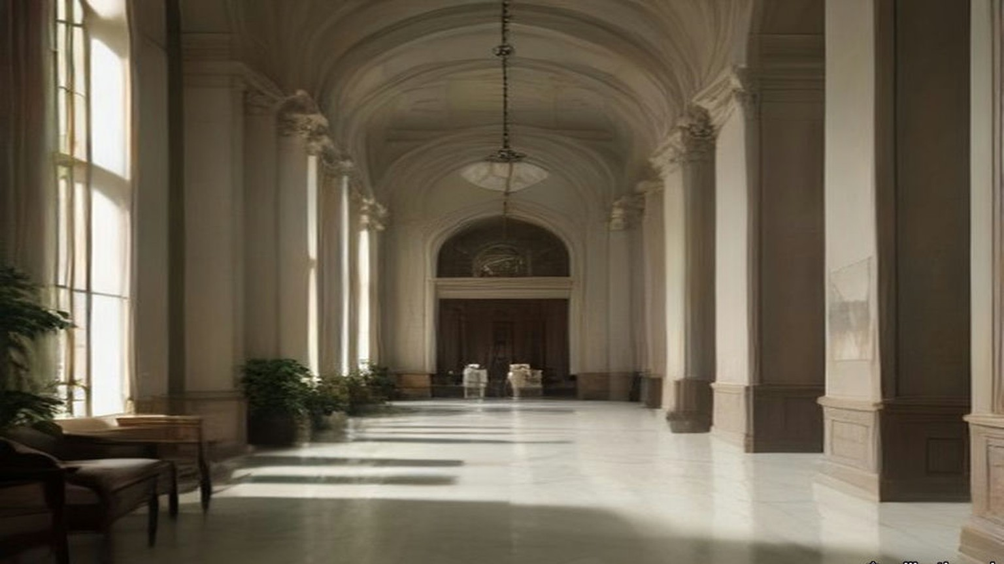
* * *
Haifa, November 1935
They buried him in Haifa. The funeral "was attended by a very large concourse," the report said, "and in spite of the efforts of leading Moslems there to maintain order a certain amount of demonstration and stone-throwing occurred." The death "sent a strong wave of sentiment through political and other circles in the country, and the Arabic press united to pay him the tributes of a martyr in articles charged with patriotic emotion."
The Royal Commission quoted one of those articles. "Dear friend and martyr," it said, "I have heard you preach from a platform resting on a sword. To-day . . . you are, by God, a greater preacher than alive you ever were." In Arabic the oath is wallāhi.
A shorter and less general strike had been called on 13 November, over incomplete and misleading reports of speeches made in London a few days before by the Secretary of State and the High Commissioner. Five days after the fight, on 25 November, the leaders of the five Arab parties went to the High Commissioner together with three demands: democratic government, a ban on the transfer of Arab land to Jews, and an immediate stop to Jewish immigration, with a committee to fix what the country's "absorptive capacity" was.
* * *
Jaffa and Jerusalem, April to July 1936
The trouble began on the night of 15 April 1936, when Arab bandits murdered two Jews on the Tulkarm to Nablus road. The next night two Arabs were murdered near Petah Tikva, and Arabs believed it a Jewish reprisal. The funeral of one of the murdered Jews in Tel Aviv on the 17th ended in angry demonstrations and assaults on Arabs in the streets. On the 19th false rumours went round Jaffa that Arabs had been killed, and Arab crowds there killed three Jews. Curfew came down on Jaffa and Tel Aviv. The Emergency Regulations came into force for all Palestine.
On the 20th a National Committee formed at Nablus and called a general strike until the Arab demands of the previous November were met. The five parties joined on the 21st. On the 25th they formed a Supreme Arab Committee, which became the Arab Higher Committee, with Hajj Amin al-Husseini, Mufti of Jerusalem, as President, Awni Abd al-Hadi as Secretary, and as Treasurer Ahmad Hilmi Pasha, manager of the Arab Bank. It resolved "to continue the general strike until the British Government changes its present policy in a fundamental manner, the beginning of which is the stoppage of Jewish immigration." On 8 May a conference of the National Committees in Jerusalem added that Arabs should stop paying taxes. On 18 May the Government approved a Labour Schedule of 4,500 Jewish immigrants for the next six months.
By 2 May, the Royal Commission recorded, "Arab work and trade were virtually at a standstill. Jaffa port was out of action." Only at Haifa port, and in part on the railways, was Arab labour still to be had.
Through May and June the strike hardened. Five Jews, two Arabs and one British policeman were murdered. Two trains were derailed and a bridge was blown up, roads were barricaded and telephone wires cut, and bands of armed Arabs appeared in the hills, among them volunteers from Syria and Iraq. Troops came from Egypt and Malta. On 23 May sixty-one Arab agitators were arrested and most of them sent to live under police supervision away from their home towns. In June some of the leaders, Awni Abd al-Hadi among them, were interned in what the Royal Commission called, in its own quotation marks, a "concentration camp" at Sarafand. In July the Qadis of the Muslim religious courts sent the High Commissioner a memorandum calling the Government's policy "detestable," charging police and military with "unimaginable acts," and warning "the British authorities of the revenge of God the Almighty."
Sat they on the sand by the boats, the lightermen, and the ships lay out in the roads and nobody went out to them. Who works, a traitor. So said the young men of the committee, and they walked along the quay in the mornings and looked at every man. Five weeks, six weeks. The money in the tin went down and then the tin was empty. His wife sold the bracelet. Went he to his cousin in the orange grove and came back with nothing, for the grove also stood still, the fruit green on the trees and no ships to take it when it ripened. Wallāhi, never in his life a summer like this one, the sea flat and the boats on the sand. In the night he lay with his eyes open and counted: the rent, the bread, the oil for the lamp. Always the counting came out the same.
Came the soldiers in June to the old city, to the houses above the port where the lanes go up in steps. Came the police first, to every door: Out. Out, all of you, now. Twice they came. He carried the mattress on his back and his wife the pots, and the children the lamp, and they went out with the others and stood far off on the road. Then the noise. He felt it come up through the soles of his feet before he heard it, and the dust went up white over the roofs, and where his father's house had been was the sky.
On 24 June Mr. Gallacher, the Member for West Fife, asked the Colonial Secretary whether he knew that the old city of Jaffa had been destroyed without warning, that holy places had been destroyed, and that "dynamite was used, to the terror of the women and children." The Colonial Secretary, Mr. Ormsby-Gore, answered. "It is not the case that the old city of Jaffa has been destroyed. What has happened is that it has been considered necessary to demolish a certain limited number of houses to enable two new roads to the port to be constructed through the labryinth of the old city." The Royal Engineers had done the work after due warning. "Families who have been obliged to evacuate their houses in the old city are being paid for one week a special compensatory allowance. I am glad to say there were no casualties."
Gallacher asked how there could be no danger when dynamite was used and the houses round about were shaken. Full warning had been given on two occasions, Ormsby-Gore said; the police moved the people out of the first house before anything began, and no dynamite was used until the police and the military were satisfied that everyone was clear. "When they were satisfied that all was clear then the dynamite was used and the houses were cleared away." Were the police and military to be congratulated on getting the people out before the houses were dynamited? "Certainly; that was the whole object."
On 1 July Mr. Creech Jones asked whether alternative housing had been found for "the 6,000 inhabitants likely to be displaced." Ormsby-Gore said the works were "considered necessary in the interests of public security." On 16 December he told Colonel Wedgwood that the Palestine Government had been authorised to spend £15,000, out of Palestine revenues, on houses "for which a suitable rent will be charged, to accommodate 100 Arab families rendered homeless by the special demolitions in Jaffa." He would not accept that they were refugees. "In the military interests, and in the interests of peace and order in Jaffa, it was decided to dynamite two lines through the town. The Royal Engineers blew up the houses."
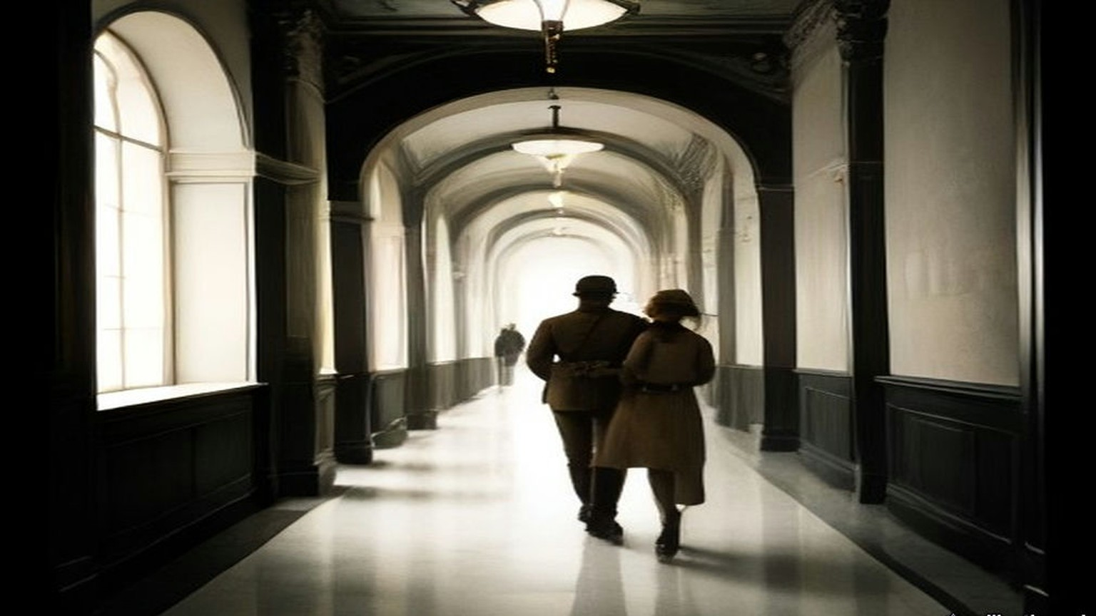
* * *
Tel Aviv, 1936
In the same answer Ormsby-Gore said the Palestine Government would give "about £5,000 towards the cost of maintenance and rehabilitation of Jewish refugees in Tel-Aviv from Jaffa and elsewhere." Wedgwood said the Jewish refugees from Jaffa outnumbered the Arab ones about twenty to one. Ormsby-Gore did not accept his figures.
Twenty years in Yafo lived my father, and I born there. The shop of my father, tin and lamps, in Yafo, and Arabs came and bought, and ya'ani, so it was, a word of theirs we had in our mouth like our own. Now we are in Tel Aviv in one room by the sea, six persons, the bedding on the floor. Baruch Hashem, בָּרוּךְ הַשֵּׁם, alive. There is not shop. There is not work. My father sits by the window all the day and his hands on his knees, the hands which were never still. In the night I hear him, he says the Shema, and again the Shema. The key of the shop he has still, on the string, around the neck. Says my mother: when it is quiet we go back. Says my father nothing. Be'ezrat Hashem, בְּעֶזְרַת הַשֵּׁם, with the help of God, says my mother, and puts the bread on the table, the half loaf for six.
The Royal Commission set the losses side by side. "The official list of 'casualties' gives 195 Arabs killed or died of wounds and 804 wounded," it reported, but the full Arab loss "has been credibly estimated at 1,000 killed, mostly in fighting." The official list on the Jewish side gave 80 Jews killed or died of wounds and 308 wounded; the Jewish Agency counted "82 Jews murdered, apart from nine further deaths," and 369 wounded. The Agency reported 80,000 citrus trees destroyed, 62,000 other fruit trees, 64,000 forest trees and 16,500 dunams of crops, and put the damage to Jewish property at about £250,000, £100,000 of it to commercial and industrial premises in Jaffa. Of the Palestine Police and the Trans-Jordan Frontier Force, one officer and fifteen other ranks were killed. Of the British forces, two officers and nineteen other ranks.
The port told the same story in tons. Jaffa's imports fell from 402,524 tons in 1935 to 163,134 in 1936. Haifa's held at 750,722. Afraid the strike would run into the citrus season, the Jewish traders of Tel Aviv formed a Harbour and Communications Council, raised money by private subscription, and built a jetty and lighter basin of their own on the Tel Aviv beach about four miles north of Jaffa. The Government approved it on condition that no municipal money went into it, and it worked as a private port that winter. The Mayor of Tel Aviv told the Royal Commission that after 1936 dependence on Jaffa was "unthinkable" to the Jews.
* * *
Palestine, September 1936 to May 1939
Towards the end of August trained guerrilla leaders came in from outside. One was Fawzi al-Qawuqji, a Syrian who had served in the Turkish army in the war, won the Légion d'honneur in French intelligence work, joined the Druze revolt of 1925, been sentenced to death, escaped to the Hejaz, advised Ibn Saud, and resigned his commission in the Iraqi army in 1936. In Palestine he named himself "generalissimo" and drilled the bands in trench warfare. The oil pipeline across the Plain of Esdraelon was repeatedly punctured. Roads were mined. On 7 September the Colonial Office called the situation "a direct challenge to the authority of the British Government in Palestine" and sent a further division.
By the end of September 1936, after Lieutenant-General Dill took command, there were about 20,000 British troops in the country. An Order in Council allowed the High Commissioner to apply martial law. In October the Arab Higher Committee published identical appeals from King Ibn Saud, King Ghazi of Iraq and the Amir Abdullah of Transjordan, addressed to "our sons the Arabs of Palestine," asking them to resolve for peace, and called on "the noble Arab nation in Palestine to resort to quietness and to put an end to the strike and disorders." Work went back on the 12th. The orange season opened in November, and the Commission noted that many Arabs had not wanted to lose it.
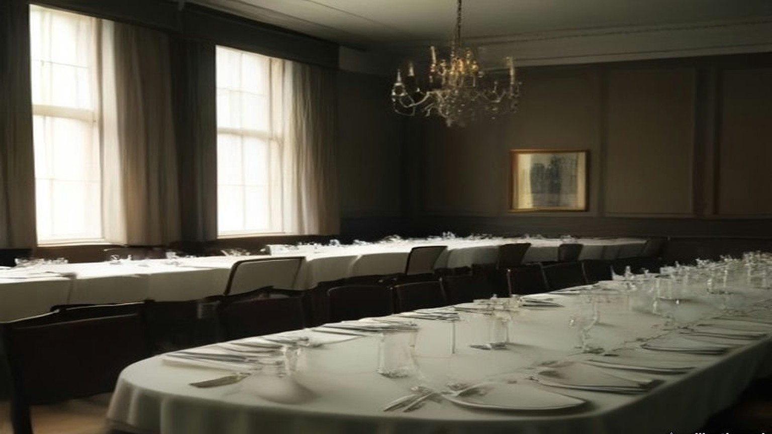
The Commission totted up the bill. The direct cost of the disturbances to the Palestine Treasury in 1936–37 was more than £1,500,000, of which £1,186,000 was for additional troops, £144,000 for extra police and prisons, and about £35,000 for roads, railway bridges and rolling stock. The loss of revenue that year was put at £900,000, and the estimate for the next year at £750,000. The cost of the troops was charged to Palestine's own taxpayers. Losses to the two communities beyond that, the Commission wrote, "must have run into millions of pounds."
In the middle of the strike 137 Arab senior officials and judges of the Palestine Government, and some weeks later 1,200 Arab officials of the Second Division, had signed memoranda to the High Commissioner. The senior officials wrote that the disturbances came from a feeling of despair caused by "loss of faith in the value of official pledges and assurances for the future," and that "We have no hesitation in recommending the stoppage of immigration as the only fair, humane, and honourable solution of the deadlock." "We must conscientiously raise a protest against the present policy of repression." Only the police officials did not sign.
The Royal Commission arrived in Jerusalem on 11 November 1936. Six days earlier the Colonial Secretary had told the Commons that suspending immigration while it sat "would not be justifiable on economic or on other grounds." The Arab Higher Committee called that statement "a strong insult to the Arabs and hostile to their interests," and boycotted the Commission at first and, at the instance of King Ibn Saud and King Ghazi, gave evidence in the end. Its members said "that their quarrel is with the existence of the Mandate itself." They did not accept the Government's reading of the McMahon letter. They denied the validity of the Balfour Declaration. Palestine west of the Jordan, they said, had never been meant to be left out of the McMahon pledge, and the volunteers from Palestine had joined King Hussein's revolt for a single end, the independence of the Arab lands, Palestine included.
The Commission's answer, in July 1937, was partition. "Manifestly the problem cannot be solved by giving either the Arabs or the Jews all they want. The answer to the question 'Which of them in the end will govern Palestine?' must surely be 'Neither'." Britain could not hand over to Arab rule "400,000 Jews, whose entry into Palestine has been for the most part facilitated by the British Government and approved by the League of Nations," nor, if the Jews became a majority, "a million or so of Arabs" to theirs. "But, while neither race can justly rule all Palestine, we see no reason why, if it were practicable, each race should not rule part of it."
In May 1939 the Government laid its new policy before Parliament as Cmd. 6019. "His Majesty's Government therefore now declare unequivocally that it is not part of their policy that Palestine should become a Jewish State." Jewish immigration over the next five years would be "some 75,000," in quotas of 10,000 a year, with 25,000 refugees on top. "After the period of five years, no further Jewish immigration will be permitted unless the Arabs of Palestine are prepared to acquiesce in it." On land, the paper said that in certain areas there was "no room for further transfers of Arab land," and "the High Commissioner will be given general powers to prohibit and regulate transfers of land." The objective was "the establishment within 10 years of an independent Palestine State in such treaty relations with the United Kingdom as will provide satisfactorily for the commercial and strategic requirements of both countries in the future."
* * *
The King David Hotel, Jerusalem, 22 July 1946
Seven years later part of the King David Hotel in Jerusalem held Government offices and what Anthony Eden would call, in the Commons, the British Headquarters in Jerusalem. The rest was still a hotel, with its kitchens and its tradesmen's entrance.
It was the heat of the day in the kitchen. Peeled he the potatoes at the long table, his sleeves to the elbow and the water grey in the basin. Outside, in the street, a bang, not big. Shū hāda, what is this? Lifted the cook his head and then went back to his pot. In Jerusalem that summer every day a bang. The pans hung on their hooks over the stove, and the steam went up from the big pot, and from the other room came the clatter of the plates for the dining room, and the sweat ran into his eyes and he wiped it with the back of his wrist.
Came the lorry to the tradesmen's door, and the men got down from it, and they were not the men of the milk. Pistols. Up, said they, the hands up, all of you, against the wall. He put the knife down on the table very slowly, so slowly, and the potato beside it, and stood with his back to the tiles and his palms flat on the cold of them, and his knees had no bone in them. In they carried the cans, milk cans, big ones, one man to each, heavy, so the men carrying them leaned. Somewhere in the passage a shot, and then nothing.
The official report from Jerusalem, read in the Commons the next day, gave it in this order. After exploding "a small bomb in the street, presumably as a diversionary measure," which "did virtually no damage," "a lorry drove up to the tradesmen's entrance of the King David Hotel and the occupants, after holding up the staff at pistol point, entered the kitchen premises carrying a number of milk cans. At some stage of the proceedings, they shot and seriously wounded a British soldier who attempted to interfere with them. All available information so far is to the effect that they were Jews. Somewhere in the basement of the hotel they planted bombs which went off shortly afterwards. They appear to have made good their escape."
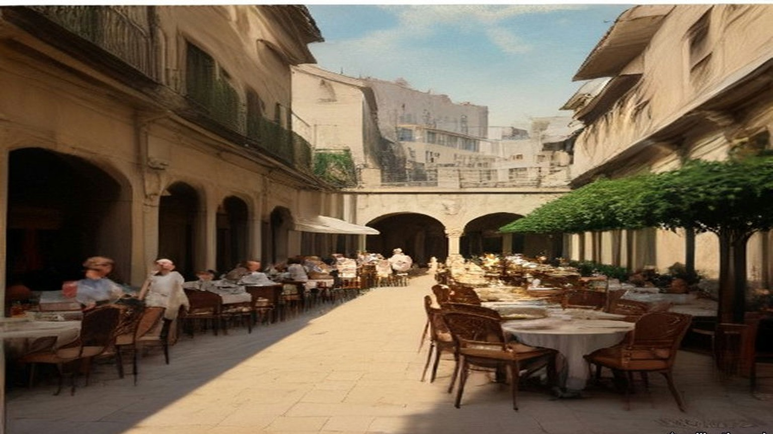
Then the men went out, and the lorry went, and somebody said run, and he ran. Out into the light, and he did not stop, and he was across the road when the ground came up under him. The noise was not a noise. It was a hand that struck him flat in the back, and then the dust, white, so thick he could not see his hand, and in his mouth the taste of lime. Something was in his ear, a ringing, high, that did not stop. People were running, past him and towards, and their mouths were open and he could not hear them. When he could stand he turned round. Where the offices of the Government had been, at the end of the hotel, was a hill of stone.
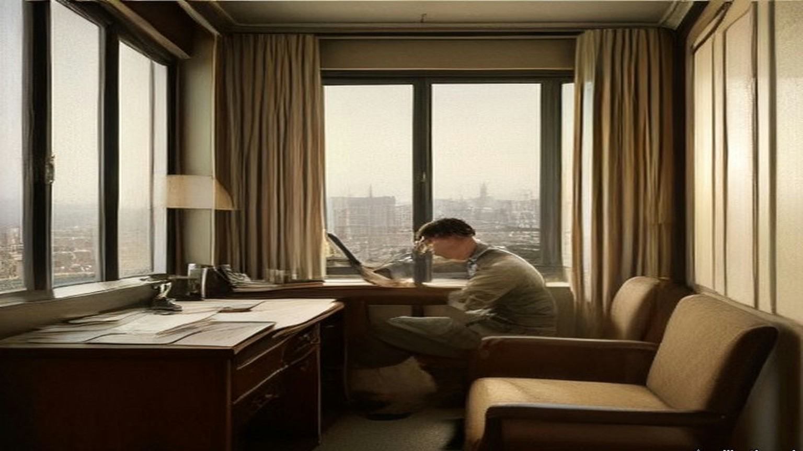
* * *
The House of Commons, 23 July 1946
Anthony Eden asked the Prime Minister by Private Notice for a statement. Clement Attlee rose. "Hon. Members will have learned with horror of the brutal and murderous crime committed yesterday in Jerusalem. Of all the outrages which have occurred in Palestine, and they have been many and horrible in the last few months, this is the worst. By this insane act of terrorism 93 innocent people have been killed or are missing in the ruins. The latest figures of casualties are 41 dead, 52 missing and 53 injured."
He read the official report. He said the rescue work still went on and that the next-of-kin were being told by telegram as soon as accurate information came in. "The High Commissioner, Sir Alan Cunningham, has returned to Palestine by air." The Government were consulting the United States on proposals for a settlement and "will not be diverted by acts of violence from their search for a just and final solution of this problem."
Eden associated the Opposition with "the Prime Minister's expressions of horror at this dastardly and inexcusable outrage." Mr. Lipson asked what Jews in Britain could do, "who are shocked by this murderous and senseless outrage, which brings dishonour and shame to the name of Jew," and whether the Prime Minister would call on their religious and lay leaders, the Zionists among them, to condemn it publicly. Sydney Silverman associated himself "with every word" about "the criminal insanity of this outrage," and then asked whether there was any credible or direct evidence yet that the perpetrators were Jews, and whether the detention without trial of the moderate leaders did not leave the field free to the terrorists. Attlee: "It would be quite improper for me to try to make any conjecture beyond what I have got from the official report."
Mr. Gallacher asked the Government to consider "the necessity of bringing about an independent Palestinian State where Arabs and Jews will have to co-operate together." Attlee said the talks with the Americans were making great progress. Colonel Hutchison offered the hundreds of men in Britain trained with the wartime resistance movements, to put down such organisations, "whether Arab or Jewish." Mr. H. Hynd asked the Prime Minister to be careful, in considering it, "not to set up anything like the 'Black and Tans'." Earl Winterton asked for pensions for the Palestine Police dead the same as if they had been killed in action, since they were fighting "as vile and treacherous a foe as the Nazis." Attlee understood that was the position and asked for the question to be put down for the Colonial Secretary. Major Legge-Bourke said General Barker had wanted for some time to take over the whole of the hotel and had not been allowed to. Attlee said he was having an inquiry made "into the position with regard to the King David Hotel." Mr. Janner said the Jewish Agency Executive and the National Council of Palestine Jewry had condemned the act and wanted those responsible suppressed. "I have noted that statement and welcomed it."
Earlier in the same sitting, among the questions on national finance, Mr. Keeling had asked the Chancellor of the Exchequer what his department had spent in Palestine in the latest six months for which figures existed. Hugh Dalton: "£17¾ million for the six months to 31st March, 1946."
* * *
The House of Commons, 31 July 1946
Attlee had gone to the Peace Conference in Paris, so Herbert Morrison opened the debate on Palestine. "In the destruction of the Government offices at the King David Hotel in Jerusalem, 84 men and women," he said, Arabs, Jews and British, "were killed, and 46 injured, while 22 are still missing. These were people innocent of any crime, members of the public going about their ordinary business, and many loyal and single-hearted servants of the community." Police and military, he said, had moved after every act of terrorism to track down those responsible. "The greatest obstacle to success in these operations has been the refusal of the Jewish population in Palestine to cooperate with the forces of law and order." On 29 June there had been widespread arrests and searches. Since the outrage 446 Jews whose records showed association with the terrorist organisations had been arrested, and on 30 July the army had gone into Tel Aviv.
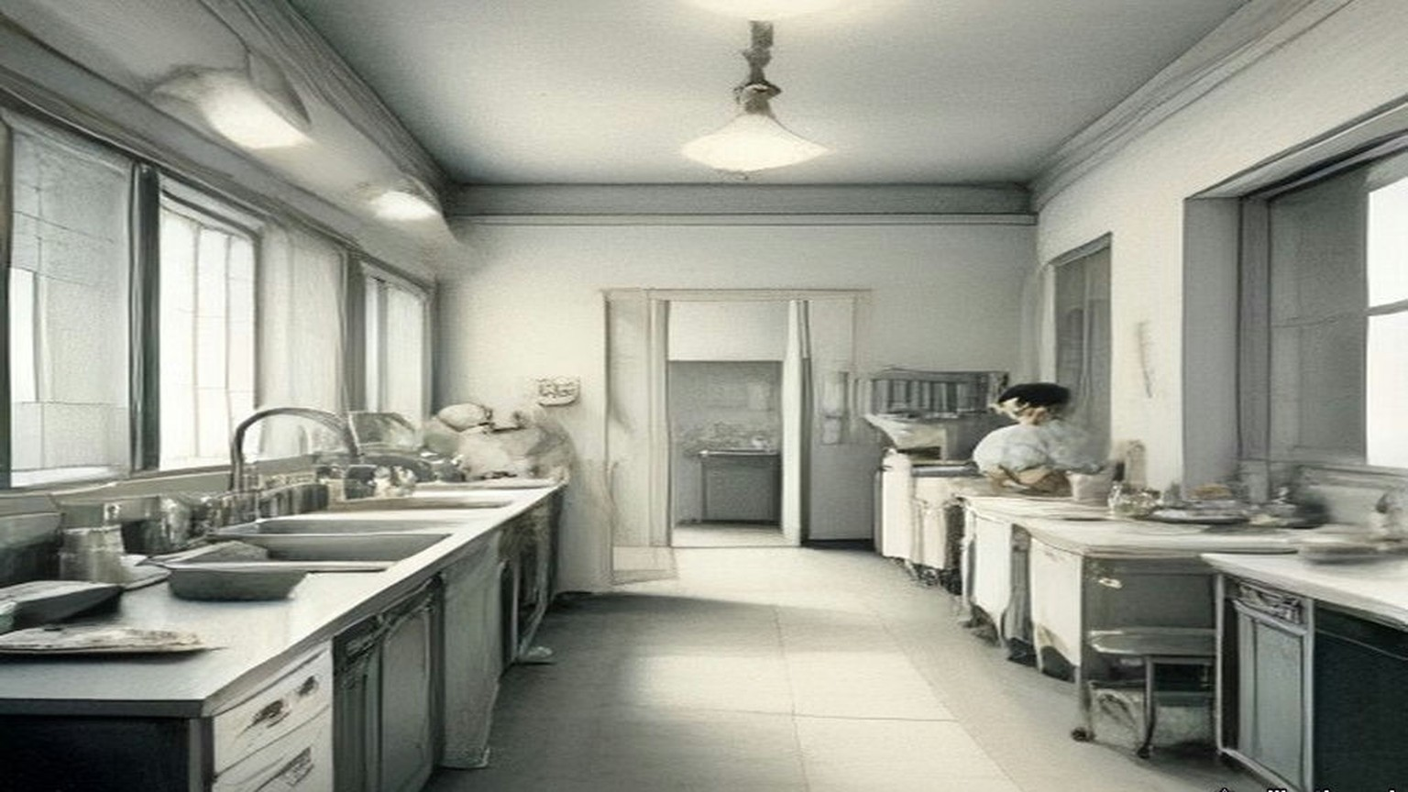
General Barker had written to his officers, by the newspaper reports Morrison cited, forbidding British soldiers "relationships of a social character with Jews" and ordering that any association in the way of duty be "as brief as possible." The Government, Morrison said, must "dissociate themselves from the actual terms in which the letter is couched." Families of British and Palestinian civil servants and police were provided for by legislation in force "since 1935," dealing with pensions and compensation arising out of acts of terrorism.
Then he set out the plan the British and American experts had drawn up, provincial autonomy, an Arab province and a Jewish province under a central government. If it went ahead, 100,000 Jews would be brought from Europe within twelve months. "Under this plan, the United States Government would be asked to undertake sole responsibility for the sea transportation of those Jewish refugees, to whom I have referred, from Europe to Palestine. They would provide the ships and would defray the whole cost of sea transportation." They would feed the immigrants for their first two months. The Jewish organisations would pay for settling them. The United States would be asked for a substantial grant for Arab development, "while this country should be asked to take ultimate responsibility for meeting Palestine's annual budgetary deficit up to the time when increased revenues made this unnecessary."
Mr. Crossman, the Member for East Coventry, had sat on the Anglo-American Committee and still believed, he said, that if "our Report had been acted on immediately, a great chance might have come off." He told the House what he had been told in Palestine. On three occasions, he said, Hagana intelligence had warned British security that the King David "would, one day, have an assault from the inside, and that better security should be employed by the police and military there." No further security was imposed. "The kitchens and night club were left inadequately guarded." He was careful how he said it. "I am putting these things forward for check. I do not know whether they are wholly true."
The same day Mr. Gallacher asked George Hall, the Colonial Secretary, about the recruiting poster for the Palestine Police, which advertised the work as "a man's job." Would the Minister assure the House "that this is not an attempt to reorganise the Black and Tans?" Hall answered that the police forces were apart from the defence forces in Palestine.
* * *
The House of Commons, 18 February 1947
On 18 February 1947 Ernest Bevin, the Foreign Secretary, told the House that "Ever since they took office the Government have laboured incessantly to find a solution of the Palestine problem," and that the London conference with the Arabs and the talks with the Zionist Organisation had come to an end. "There are in Palestine about 1,200,000 Arabs and 600,000 Jews. For the Jews the essential point of principle is the creation of a sovereign Jewish State. For the Arabs, the essential point of principle is to resist to the last the establishment of Jewish sovereignty in any part of Palestine." His Majesty's Government had no power under the Mandate "to award the country either to the Arabs or to the Jews, or even to partition it between them."
"We have, therefore, reached the conclusion that the only course now open to us is to submit the problem to the judgment of the United Nations." They would explain "that the Mandate has proved to be unworkable in practice, and that the obligations undertaken to the two communities in Palestine have been shown to be irreconcilable." They would ask the United Nations to recommend a settlement. "We do not intend ourselves to recommend any particular solution." The General Assembly would not meet before September.
He gave the numbers on immigration. Since July 1945, 29,000 Jews had been admitted. The Government's last proposals, which both sides had rejected outright even as a basis for discussion, would have let in 4,000 a month for two years, inside a unitary State with Arab and Jewish areas and five years of trusteeship.
Winston Churchill asked whether Britain was to go on carrying the whole burden of law and order and administration until the United Nations had solved the problem. "How does he justify keeping 100,000 British soldiers in Palestine, who are needed here, and spending £30 million to £40 million a year from our diminishing resources upon this vast apparatus of protraction and delay?" "I very much regret this rhetorical display about protracted delay," Bevin answered. He said that fifteen hundred Jewish immigrants a month would go on being admitted in the meantime. "At least 1,500?" asked Mr. Boyd-Carpenter. "Fifteen hundred a month will go." "Or more?" Bevin understood the point. "Fifteen hundred, guaranteed during the interim period, will continue to go in." Mr. Keeling asked: "No more?"
In the same sitting Colonel Crosthwaite-Eyre asked the Chancellor what had been claimed from the Palestine Government towards Britain's cost of defending Palestine. Dalton answered. "The Government of Palestine contributes £42,797 a year towards the cost of the Transjordan Frontier Forces. It also meets the cost of the Palestine Police, the cost of the Cyprus camps for illegal immigrants, and expenditure on making good property and compensating individuals in connection with terrorist outrages." Major Legge-Bourke asked whether "property" included railways.
"I should expect so," Dalton said, "but perhaps the hon. and gallant Gentleman will let me look it up."
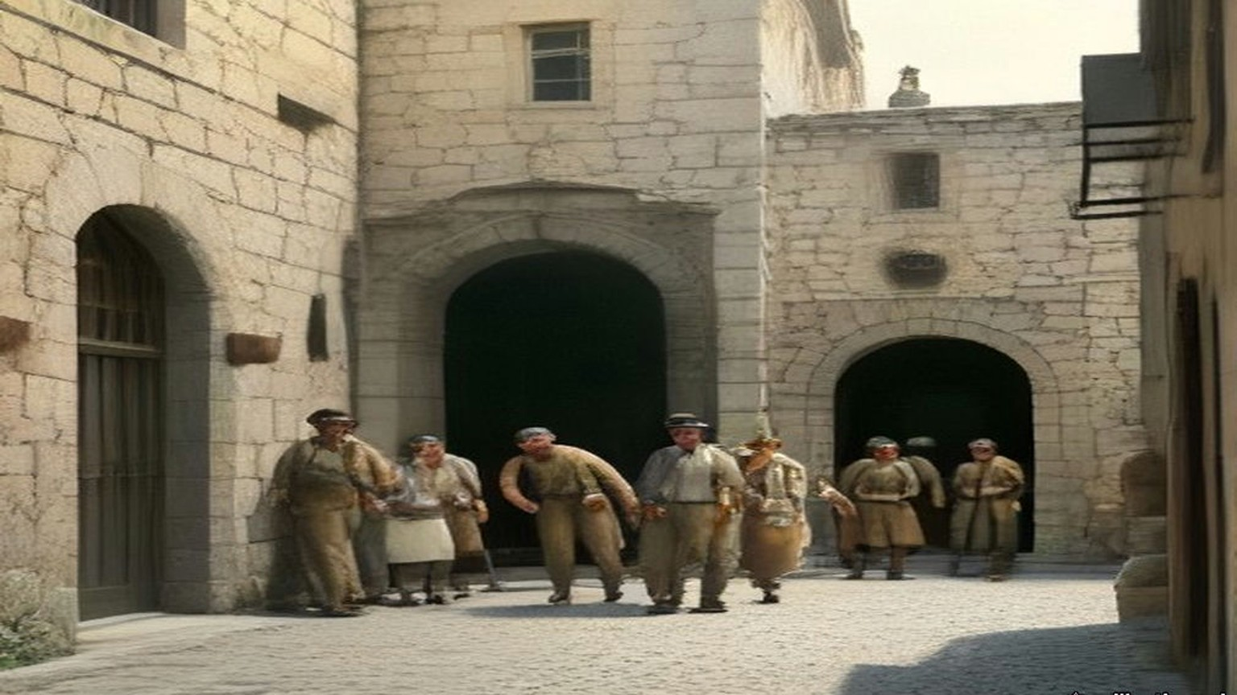
Chapter 26 Appendix of Important Names
• Balfour, Arthur James (1 mentions in this chapter): British Conservative Prime Minister, Chief Secretary for Ireland, and Foreign Secretary who issued the 1917 Balfour Declaration.
• Churchill, Winston (1 mentions in this chapter): British cabinet minister (Home Secretary, First Lord of the Admiralty, War and Colonial Secretary, and Prime Minister) recurring across the Irish, Middle Eastern, and Indian settlements.
• McMahon, Henry (2 mentions in this chapter): British High Commissioner in Egypt who exchanged the 1915–1916 correspondence with Sharif Hussein of Mecca.
Sources
• Report by His Majesty's Government in the United Kingdom of Great Britain and Northern Ireland to the Council of the League of Nations on the Administration of Palestine and Trans-Jordan for the Year 1935 (Colonial No. 112). §§12–13 (the Jaffa cement consignment; the strikes of 26 October and 13 November; the band, 7 and 20 November; the Haifa funeral; the press); §24 (61,854 Jewish immigrants). Read in the retyped transcription hosted by israeled.org (Emory University file). https://israeled.org/wp-content/uploads/2014/10/1935-LON-Transjordan.pdf
• Palestine Royal Commission Report. Cmd. 5479. London: HMSO, July 1937. Ch. III §§87–90 (the King's birthday clemency of 1935; the arms in cement; al-Qassam; the press quotation; the demands of 25 November 1935); ch. IV §§2–35 (the 1936 disturbances; strike; the Arab Higher Committee; taxes; the Labour Schedule; Jaffa port; the officials' memoranda; Dill and 20,000 troops; the Kings' appeal; the boycott and evidence of the Arab Higher Committee; casualties; losses; cost); ch. VI §§64–66 (Jaffa and Haifa tonnage, 1932–1936; the Tel Aviv lighter basin); ch. XX §19 (partition). Internet Archive, palestine-royal-commission-report (ProQuest scan, OCR).
• House of Commons Debates, 24 June 1936, vol. 313, cc. 1747–8, "Jaffa (Demolition of Houses)" (Gallacher, Ormsby-Gore). https://api.parliament.uk/historic-hansard/commons/1936/jun/24/jaffa-demolition-of-houses
• House of Commons Debates, 1 July 1936, vol. 314, cc. 386–7, "Jaffa (Demolition of Houses)" (Creech Jones, Ormsby-Gore, Gallacher). https://api.parliament.uk/historic-hansard/commons/1936/jul/01/jaffa-demolition-of-houses
• House of Commons Debates, 16 December 1936, vol. 318, cc. 2436–8, "Demolitions, Jaffa (Re-housing)" (Wedgwood, Ormsby-Gore, Wilkinson). https://api.parliament.uk/historic-hansard/commons/1936/dec/16/demolitions-jaffa-re-housing
• Palestine: Statement of Policy. Cmd. 6019. London: HMSO, May 1939. Read in the Avalon Project transcription, Yale Law School (first-edition source file macdonald_white_paper_1939.html). The month is fixed by HC Deb 22 May 1939, vol. 347, c. 1895, which refers to "Command Paper 6019." https://api.parliament.uk/historic-hansard/commons/1939/may/22/palestine
• House of Commons Debates, 23 July 1946, vol. 425, cc. 1877–81, "Terrorist Outrage, Jerusalem" (Eden, Attlee, Lipson, Silverman, Hutchison, Winterton, Hynd, Gallacher, Legge-Bourke, Janner). https://api.parliament.uk/historic-hansard/commons/1946/jul/23/terrorist-outrage-jerusalem
• House of Commons Debates, 23 July 1946, vol. 425, c. 1871, "Palestine (Expenditure)" (Keeling, Dalton). https://api.parliament.uk/historic-hansard/commons/1946/jul/23/palestine-expenditure
• House of Commons Debates, 31 July 1946, vol. 426, "Palestine" (Morrison, cc. 957–60; Crossman, cc. 1008–10). https://api.parliament.uk/historic-hansard/commons/1946/jul/31/palestine-1
• House of Commons Debates, 31 July 1946, vol. 426, cc. 934–5, "Police Recruiting Poster" (Gallacher, Hall, Stephen). https://api.parliament.uk/historic-hansard/commons/1946/jul/31/police-recruiting-poster
• House of Commons Debates, 18 February 1947, vol. 433, cc. 985–90, "Palestine Conference (Government Policy)" (Bevin, Churchill, Boyd-Carpenter, Keeling). https://api.parliament.uk/historic-hansard/commons/1947/feb/18/palestine-conference-government-policy
• House of Commons Debates, 18 February 1947, vol. 433, cc. 973–4, "Palestine (Defence Expenditure)" (Crosthwaite-Eyre, Dalton, Legge-Bourke). https://api.parliament.uk/historic-hansard/commons/1947/feb/18/palestine-defence-expenditure

Chapter 27
A Pinch of Salt at Dandi, 1907–1938
Phoenix in Natal, the Kildonan Castle, Sabarmati, Dandi, Dharasana, Westminster, Lancashire and Dublin, September 1907 to April 1938
The press room of Indian Opinion, Phoenix, Natal, September 1907
Bhai, the type for Gujarati is small, small. You pick it with the fingertips from the case, one letter, one letter, and the case is in the shed with the tin roof, and in September already the tin is ticking from the sun by ten o'clock. Ink on the fingers, ink in the nails. My wife says, you are eating ink also with the rotli. What to do? The paper must go out Saturday.
The editor's copy comes from Johannesburg in his own hand, the Gujarati running fast, fast, as if the pen is late for a train. This week one article is about Ireland. Ireland, I am saying to myself, where is Ireland? Near England only, the foreman says, a small island, and the people there also are under the English.
I set it line by line. Nowadays the people of Ireland are striving hard for their rights. The editor writes that the Irish count for nothing in their own land, and that once they go out of Ireland they enjoy rights quite like those of Englishmen. Same like us, I am thinking, only the other way round. Our people go out of India and then only the trouble starts.
Then the new word. Sinn Fein. He has written it in our letters, and next to it he has written what it means, and the foreman reads it over my shoulder and laughs one short laugh through the nose. In the English translation of that page, later, in the big book, it says the movement "is called Sinn Fein, which, literally translated into Gujarati, means exactly our Swadeshi movement."
Swadeshi. Our own things. Our own cloth.
The editor's line goes on: "Till now, Irishmen favoured violent action." The tenants, he writes, often used violence against the foreign landlords. Now the Irish leaders want the Irish members to walk out of the British Parliament, the Irish to stop taking their quarrels to the English courts, "and boycotting British goods even at the cost of hardship to themselves." So that "without any violent struggle taking place the British would ultimately be obliged, or might agree, to grant Home Rule to Ireland, or would quit Ireland."
Then something about Hungary, and a man called Dick who told the Hungarians not to pay taxes to Austria. Then the Transvaal. None can imprison thousands of men or deport them. I set that line and my hand is stopping a moment over the case, because my cousin in Johannesburg is one who has not taken the permit, and the registration office there sits empty, and every week someone says, now they will come for him.
The issue is dated the seventh of September. I lock the forme. Tight, tight, the quoins, so that no letter falls when the press comes down. Ireland goes into the press with the advertisements for rice and for ghee, and comes out the other side wet.
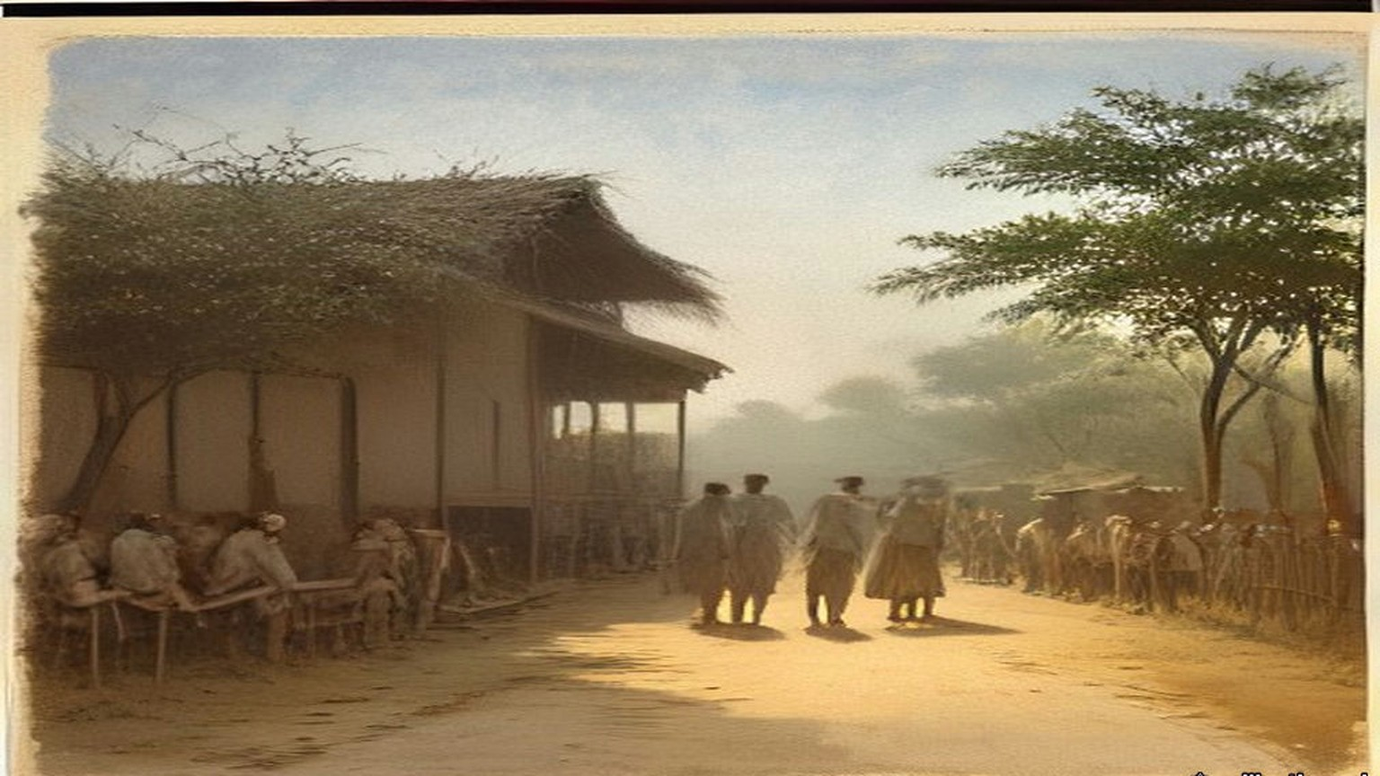
* * *
The Kildonan Castle, the Atlantic, south of Madeira, November 1909
Gandhi had spent four months in London with the Transvaal Indian deputation. "I have read much, I have pondered much," he wrote afterwards, "I discussed things with as many of my countrymen as I could. I met, too, as many Englishmen as it was possible for me to meet." On the voyage home he wrote it down. He wrote in Gujarati, a dialogue between a Reader who wanted Home Rule and an Editor who kept asking him what he meant by it. Some of the manuscript he wrote with his left hand. A page of the ninth chapter survives in it.
The Reader says that India must have its own navy and army, its own flag. "As is Japan, so must India be." The Editor answers him: "In effect it means this: that we want English rule without the Englishman. You want the tiger's nature, but not the tiger."
In the seventh chapter the Reader asks why India was lost. The Editor turns the question round. "The English have not taken India; we have given it to them. They are not in India because of their strength, but because we keep them." He goes back to the Company. "Who assisted the Company's officers? Who was tempted at the sight of their silver? Who bought their goods?" And then, of the men who said India was held by the sword: "The sword is entirely useless for holding India. We alone keep them." Napoleon, he wrote, is said to have called the English a nation of shopkeepers. "They hold whatever dominions they have for the sake of their commerce. Their army and their navy are intended to protect it."
The nineteenth chapter is about machinery. "When I read Mr. Dutt's Economic History of India, I wept," the Editor says. "It is difficult to measure the harm that Manchester has done to us. It is due to Manchester that Indian handicraft has all but disappeared." Then he stops himself. "But I make a mistake. How can Manchester be blamed? We wore Manchester cloth and this is why Manchester wove it."
The foreword is dated 22 November 1909, on board. The first twelve chapters ran in Indian Opinion on 11 December, the rest a week later, and the type was set at Phoenix. In January 1910 the dialogue came out as a booklet. On 24 March the Government of Bombay proscribed it.
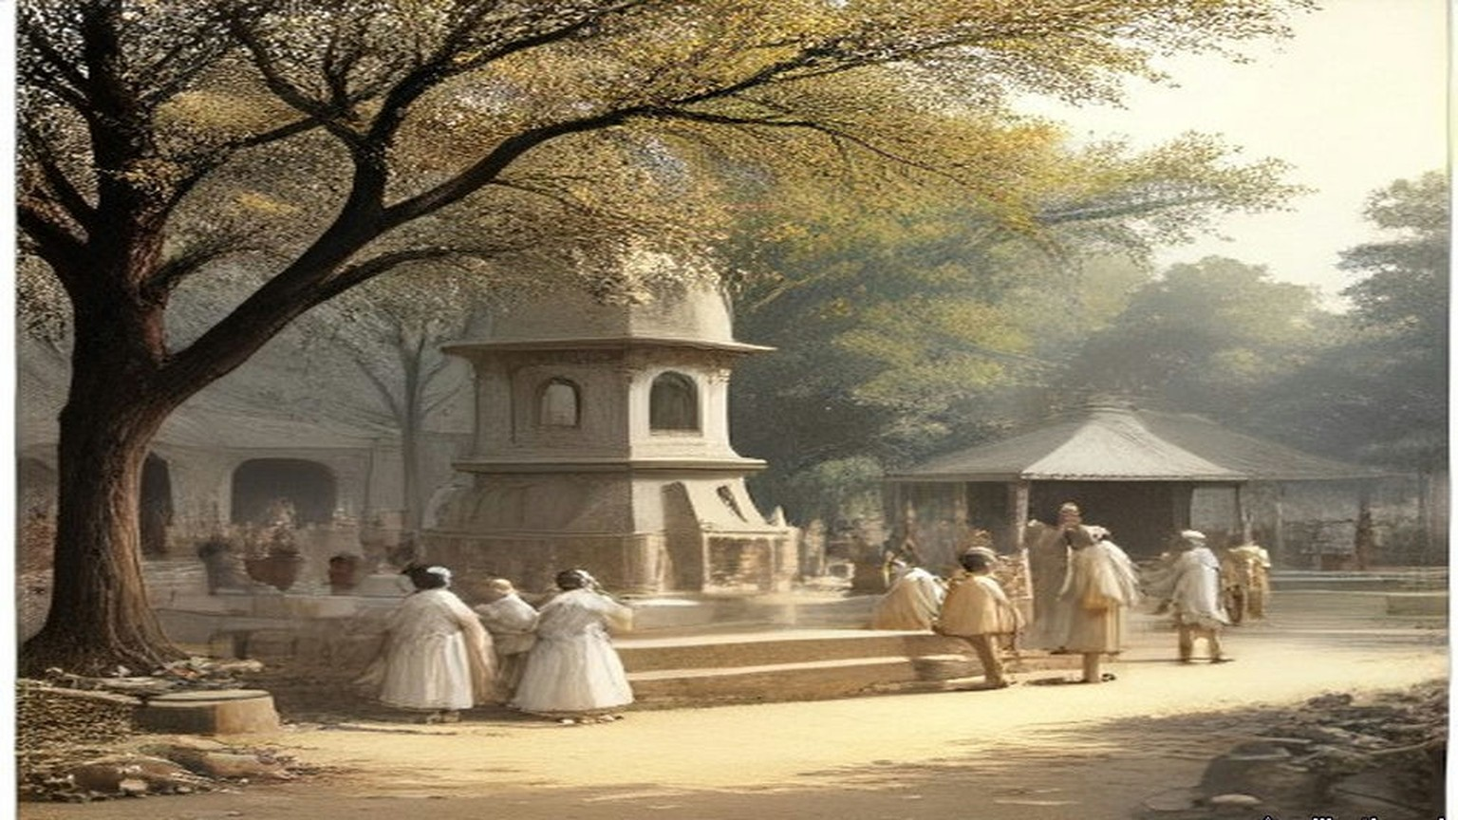
* * *
Westminster, the India Office figures, 1913 to 1930
The cloth Gandhi wrote about can be counted in the India Office's own returns. In the financial year 1913–14 India imported 3,104,311,465 yards of cotton piece goods from the United Kingdom and 8,900,578 yards from Japan. William Wedgwood Benn, Secretary of State for India, put the figures in the Official Report on 4 May 1931, in a table under a question from Mr. Remer.
Salt was the other line, and it had been in the House for a long time. On 7 August 1913, in the debate on the Indian Budget in which Edwin Montagu announced the end of the opium revenue from China, Theodore Taylor, the member for the Radcliffe Division, spoke later in the debate. "My contention is that we have never had any moral right to inflict this drug upon China in order to make money for ourselves or for India," he said. "Personally, I can never forget that there is a salt tax in India, and by it we are taxing a very large number of very poor people, and so long as we do that there is every reason for economy in our military expenditure in India." He went on: "The people in India are very poor and we are their trustees, but our trusteeship for their welfare does not demand from us that we should inflict a wrong upon any other nation."
On 19 May 1930 Benn circulated the revenue of the Salt Department for three years. Rs. 6,69,81,053 in 1926–27. Rs. 6,63,17,979 in 1927–28. Rs. 7,59,92,742 in 1928–29. The department's whole expense, manufacture and the preventive service together, ran at a little over a crore and a quarter of rupees a year. Asked for the incidence of the salt tax on each head of the population, he answered in one line: "Between 4d. and 4½d." On 5 June he added that imported salt had been worth 146¾ lakhs of rupees in 1928–29, from Aden, Egypt, the United Kingdom, Germany, Spain and other places, and Indian production, by Government or by private makers under licence, a little under Rs. 500 lakhs.
Four pence a head is small money in Westminster. The Collectors' offices in Gujarat put it to the villagers in annas. "Adults use five pounds of salt per year, therefore pay three annas per year as tax," one Government notice said. Gandhi copied it out and answered it: "The daily consumption of salt by an adult is three times the amount stated and therefore the poll tax and the salt tax undoubtedly is at least 9 as. per head per year. And this tax is levied from man, woman, child and domestic cattle irrespective of age and health."
* * *
Satyagraha Ashram, Sabarmati, 2 to 12 March 1930
The letter went in the hand of an Englishman. Bapu chose him, Reginald Reynolds, a young Englishman of the Ashram, and he carried it to the Viceroy's House in New Delhi. We are standing by the gate when he goes. Nobody is saying anything much. Bapu wants them to see, the people say, that in this fight there is no hatred for the Englishman, so the letter goes by an Englishman's hand.
Afterwards they read us the copy. Dear Friend. To the Viceroy, Dear Friend, like that. "Before embarking on civil disobedience and taking the risk I have dreaded to take all these years, I would fain approach you and find a way out."
I am listening with my hands in my lap. Calloused, these hands, from the charkha and from the fields at the back. Bapu writes of the land revenue, "the terrific pressure of land revenue," and that the ryot "is a mere tenant at will." My father is a tenant at will. I am feeling it in the stomach, a pulling, to hear it said in a letter to the Viceroy.
He writes the Viceroy's salary. "It is over Rs. 21,000 per month besides many other indirect additions." Over seven hundred rupees a day, "against India's average income of less than two annas per day." Two annas. On a good day in the season my father brings home more than two annas, and on most days less, and in the hot months nothing.
"Thus you are getting much over five thousand times India's average income." Then: "On bended knee I ask you to ponder over this phenomenon."
Someone near me makes a sound, a breath through the teeth. Then he reads the part about force. "It is not a matter of carrying conviction by argument. The matter resolves itself into one of matching forces. Conviction or no conviction, Great Britain would defend her Indian commerce and interests by all the forces at her command." And then: "The conviction is growing deeper and deeper in me that nothing but unadulterated non-violence can check the organized violence of the British Government."
Then the salt. On the eleventh day of the month, if the Viceroy cannot see his way, Bapu will go with such co-workers of the Ashram as he can take "to disregard the provisions of the salt laws. I regard this tax to be the most iniquitous of all from the poor man's standpoint."
An answer comes from Delhi. Bapu does not change the day. We are told to be ready.
Seventy-eight of us. The list is made by name. In the morning of the twelfth, before we start, he speaks to us, and says we have but one capital, which is our vows. "I do ask you to return here only as dead men or as winners of swaraj." Even if the Ashram is on fire, he says, we will not return.
At half past six we go out of the gate. Then I hear it, the crowd. Behind us on the road it is people, people, a whole procession, and the noise of them coming after. Bapu in front, walking fast. I am thinking, at this speed the old man will be finished by Aslali. At Chandola lake, seven miles, half past eight, he says good-bye to the crowd. "Your way at present, however, lies homeward; mine straight on to the sea-coast."
At Aslali, eleven miles and more, they ask him is he tired. "I should not say I am very tired; to be sure, I am tired, but it is ordinary fatigue." My own feet, I am not saying anything about my feet. There he does the salt sum for the village. Population 1,700, so many maunds for the people, so many for 200 bullocks, 1,150 maunds in all. Tax Rs. 1-4 on each pukka maund. "Hence, on 1,150 maunds, which is equal to 575 pukka maunds, you pay a tax of Rs. 720." The village men sitting on the ground, their lips moving, doing it after him. Salt that sells at nine pies a maund in the Punjab, heaps of it on the coast of Kathiawar, "cannot be had by the poor at less than Re. 1-8-0 a maund."
"What curses the Government may not be inviting upon itself from the poor for hiring men to throw this salt into mud!"
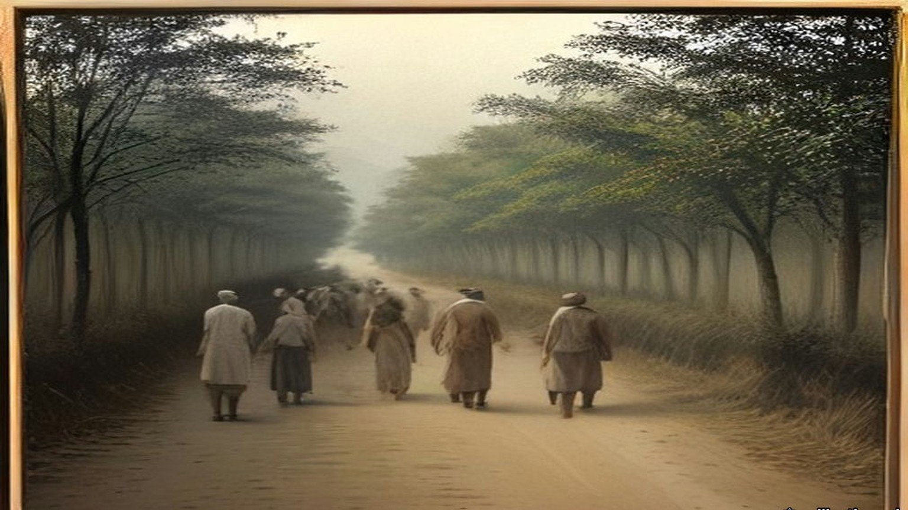
* * *
The shore at Dandi, Surat district, 6 April 1930
Twenty-four days walking. Nadiad, Anand, Broach, Surat, Navsari. Every village, the speeches, the khichdi, the sleeping on the ground in somebody's courtyard with the cows breathing. My feet I wrap in rags at night. Bapu walks. At Broach he tells the meeting that for a long time he had no confidence in himself. "I was straining my ear to listen to the still small voice within. . . . But suddenly, as in a flash, I saw the light in the Ashram."
In London, I learn afterwards, on the seventh of April, the Secretary of State for India tells the House that the march "has caused a certain amount of excitement in the Bombay Presidency, particularly in the districts actually traversed, and a small proportion of village headmen have resigned." Elsewhere, he says, "little general interest appears to have been aroused."
Dandi is a poor place. Sand and mud, salt grass, a few huts, the sea grey and low and very far out when the tide is gone. The morning of the sixth, early, we go down to the water with him, all of us, and people behind us, more people than the village. The mud is cold on the feet and sucks at them. We are looking for the white of the salt in the hollows. There is very little. In the afternoon he tells the meeting that "Government servants had taken timely care to destroy it."
He bends. He picks up a lump. Grey it is, salt and mud together, wet, and he holds it. That is all. An old man in a loincloth holding a lump of dirt by the sea.
My own hand. I put it down into the hollow by my foot and close it on salt and mud and stand up. In my fist it is cold and gritty and it stings in a crack in my thumb. Thief, I am, now. Nine annas a head a year, three annas the Sarkar says. Whatever it is, I am not paying it on this one.
Afterwards he tells the reporter of the Free Press of India that "a technical or ceremonial breach of the salt law has been committed," and that now anyone who takes the risk of prosecution is free to make salt wherever he wishes. "Oh, I shall continue to manufacture illicit salt," he says, when they ask what next. At four in the afternoon, at the meeting, he says he had himself picked up more mud than salt, but after washing and cleaning he got two tolas of pure quality, enough for his day. "Today those who had broken the law had become either thieves or owners."
He tells them also of a raid at Aat, where the police officer confiscated the salt the people made. "What an amount of public money Government had wasted in confiscating that salt!"
He was already turning the march toward cloth. The salt, he told the Free Press, was to go on through the national week, and those engaged in it "should also endeavour to manufacture as much khaddar as possible." Three days later, at Bhimrad, a camp of civil resisters, he gave the women figures, as the Bombay police secret abstracts recorded them. "Rs. 6 crores are nothing for a nation of 30 crores." The Government "would lose Rs. 25 crores income from the sale of liquor." "If you use khaddar 60 crores of rupees will remain in India." In Young India the next day he wrote to the women of India. He wanted them on the picket lines at the liquor shops and the foreign-cloth shops. For them to confine themselves to salt, he said, "would be to change a pound for a penny." "Drink and drugs sap the moral well-being of those who are given to the habit. Foreign cloth undermines the economic foundations of the nation and throws millions out of employment."

* * *
The salt works at Dharasana, Surat district, 21 May 1930
They took him in the night, at a quarter to one on the morning of the fifth of May, at the camp at Karadi: the District Magistrate, the Superintendent of Police and twenty armed constables. The Magistrate went into the hut and woke him. The warrant, signed by the Governor of Bombay, placed him under restraint "under Regulation 25 of 1827," to "suffer imprisonment during the pleasure of the Government." He asked to have it read out. Then: "I am prepared to accompany you, but will you allow me to have a wash and clean my teeth?" The whole camp was up by then. He led the prayers with the police watching, gave his papers to the volunteer he had chosen as captain, and was taken by train and car to Yeravda Central Jail.
He had a letter for the Viceroy drafted on the eve of the arrest, and it went anyway. It said he would go to Dharasana and demand possession of the salt works, and it listed what had been done to the volunteers in five weeks. "Bones have been broken, private parts have been squeezed for the purpose of making volunteers give up, to the Government valueless, to the volunteers precious salt." It said: "the only way to conquer violence is through non-violence pure and undefiled." And it said, to the man who had told him civil disobedience must end in violence: "history will pronounce the verdict that the British Government not bearing because not understanding non-violence, goaded human nature to violence which it could understand and deal with."
So we go without him.
Six in the morning. The salt works lie flat behind the wire, the heaps of salt white in rows, the pans, the posts of the fence, and inside the wire the police, and outside the wire one line of police with lathis, standing. Two thousand six hundred of us, the Government counts afterwards, and spectators behind. We carry ropes to pull down the posts and some have wire cutters. No sticks. Nobody carries a stick.
We walk up to the line. The lathi men do not come at us. They wait.
The magistrate is shouting the order to disperse, again, again. I keep walking because the man in front of me keeps walking. My heart is in the throat, beating there like a bird in the hand. Ten feet. Five. The constable in front of me, a big man, his face shining with the sweat, his eyes not on my eyes, on my hands.
Then the wire, and our hands on it, and then the lathis.
The sound of it. A lathi on a man is a sound like a green coconut on stone, dull, short, and then the man is just not there anymore, he is on the ground. The first one hits me on the shoulder and my arm goes white, no feeling, and I am on my knees and holding the rope still with the other hand because nobody told me to let go. The second on the back. I hear my own breath come out of me like a cough. Someone takes the rope out of my hand. Someone pulls me by the shirt, not police, one of ours, backwards, over the ground, my knees dragging in the salt mud.
At the back, on the ground, our own people. Blood in a man's eyebrow running into his eye and he is blinking it out and blinking. They tie a cloth round my shoulder. Then I see, the next column is already walking up.
For about an hour and a half it goes on like that.
The Bombay Government wired its report the same day, and the Secretary of State circulated it in the House of Commons on 26 May. "Volunteers bore no arms, but had ropes to pull down uprights of fencing, and wire cutters." "When volunteers pushed forward and tried to pull down wire, police beat them off with lathis and took from them as many ropes and cutters as they could seize." "From Congress sources it is estimated that 170 were wounded, more or less, only three or four seriously." "Total police force at Dharasana under 400, of whom nearly half are salt police. Not a single round fired; no weapon except lathis used. Police and all officers dead beat." And: "Salt in pans was not touched."
A company of Hyderabadi infantry arrived by evening. Two companies of Sikhs and a squadron of cavalry were coming from Baroda in the night. On the twenty-second, 1,500 volunteers were put out of their camp by the police, "who had to use force against the recalcitrant."
The Government of India's weekly report, circulated on 2 June, set the salt raids beside the money. In Gujarat "the boycott of public servants accompanied by attempts to coerce them to resign their posts has been more pronounced in several districts, and the campaign against payment of land revenue has shown signs of extending." The Governor-General had promulgated two Ordinances on 30 May. One, the Unlawful Instigation Ordinance, was "intended to strike at the movement in its early stages by bringing within the provisions of the law those who instigate others to withhold the payment of public dues." "The boycott of foreign goods shows signs of becoming more intense and the picketing of shops more widespread."
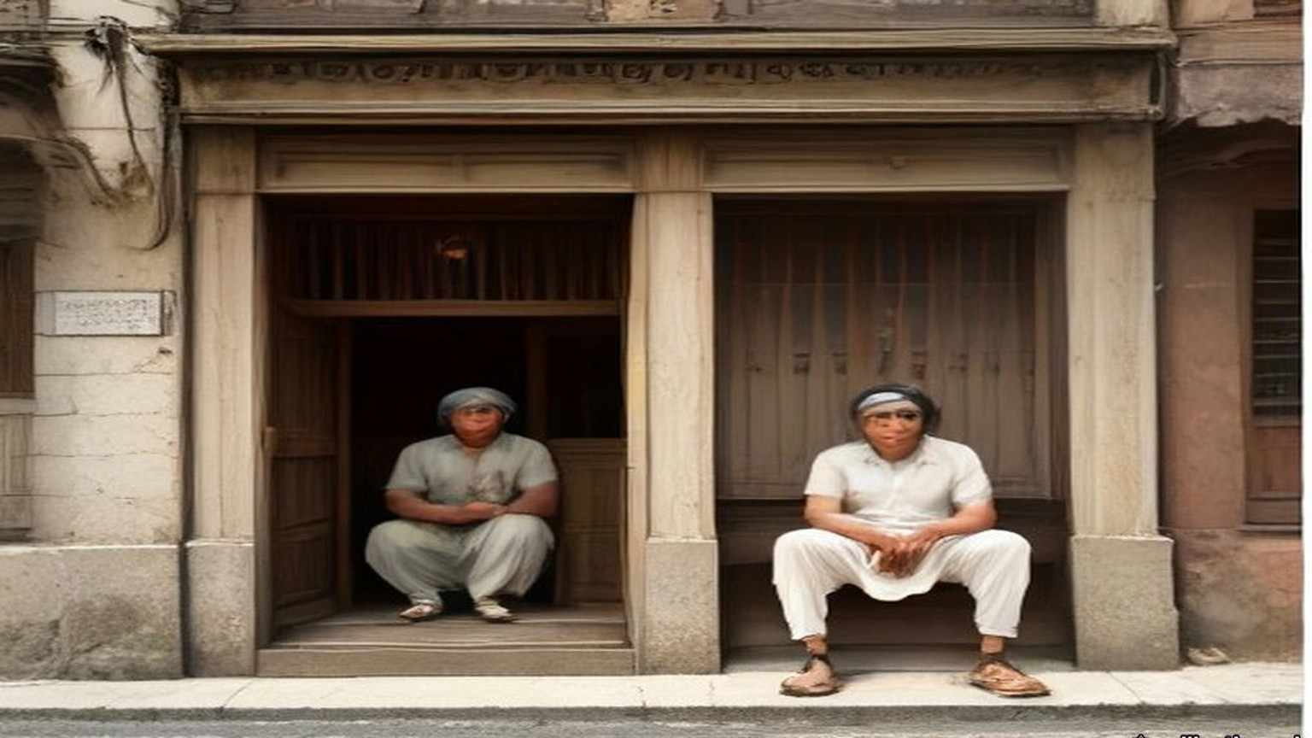
* * *
Westminster and Lancashire, December 1930 to September 1931
Lieut.-Commander Kenworthy asked on 1 December 1930 what the boycott was doing. Benn answered that its strength "has varied greatly in different places and from time to time in the same place. Cotton goods have been much more severely boycotted than other goods." He circulated a table. Exports of cotton piece goods from the United Kingdom to India, by value, against the same month of 1929: March, down 8.2 per cent. April, down 49.97. July, down 57.8. August, 67.9. September, 76.4. October, down 82.5.
On 4 May 1931 the year's figure went beside the 1913 one. In 1930 India took 792,818,786 yards of cotton piece goods from the United Kingdom and 390,393,873 from Japan. On 7 July the Board of Trade circulated the first five months of 1931 against the first five of 1930: 175,626,600 square yards consigned from the United Kingdom to British India against 552,777,100, and in declared value £2,458,644 against £9,832,105.
On 13 May Sir Philip Cunliffe-Lister read the Lancashire figures in Committee. Before the war, exports of cotton goods to India "amounted to 3,000,000,000 yards or more. In 1928 the exports had fallen to 1,500,000,000, and in 1930 they were below the 800,000,000 yards mark." In April 1931, 39,000,000 yards, "against 84,000,000 in 1930, when the boycott was already in operation, and 159,000,000 yards in April, 1929." He quoted figures Sir Herbert Samuel, the member for Darwen, had given for the port of Calcutta in a December of boycott against a December without it: British trade "had fallen from 15,000 to 1,500 bales and the Japanese trade had only fallen from 13,000 to 10,000." In February 1930, he said, non-British cables were 16 per cent. of the imports at Bombay; by February 1931 they were 44 per cent. By far the most important causes of the collapse of the Lancashire trade, he said, "have been the Indian tariff duties and the Indian boycott."
Between those dates the Viceroy and Gandhi had talked. Gandhi was let out in January, and on 5 March 1931 the two men signed a settlement. The boycott of British goods as British goods was dropped. Picketing was to be peaceful. People living near the sea could collect salt for their own use. On 12 March Winston Churchill told the House what he made of it. "The violation of the Salt Law was specially selected by Mr. Gandhi a year ago as the means of defying the Government of India." "His lawless act has now been made lawful. Anyone may now make salt from the sea." The boycott and civil disobedience, he said, "remain suspended over us and can be loosed at any moment by the mere lifting of Mr. Gandhi's little finger." Lieut.-Commander Kenworthy said it would have been better to repeal the salt tax eighteen months before, and that "it is no use hon. Members thinking that 60,000 troops can hold down 300,000,000 people. We cannot do it except by prestige."
In September Gandhi came to Lancashire.
He reached Springvale Garden Village, near Darwen, on Saturday the 26th. To the press that day he said the poverty he had seen distressed him, "and it distresses me further to know that in this unemployment I have a kind of a share." At Darwen, to masters and men the Mayor had brought together, he said: "Pray tell me what I am to do with a fifth of the human race living on the verge of starvation and devoid of all sense of self-respect. It should occupy the attention even of unemployed Lancashire." To a deputation of the unemployed he said there had been no boycott of British cloth, as against other foreign cloth, since the fifth of March. "You must recognize that all the markets of the world are now not open to you." And: "You, surely, will not want me to restrict Indian enterprise for the sake of Lancashire."
Sunday it was, the next day, when they brought us to him at West Bradford, the deputation from the weavers' association at Clitheroe, Mr. Parkinson our president and Mr. Brame the secretary and four of us that was out of work. I had my good suit on. I had been stood in it at the Exchange for months with nobody wanting it.
He was littler than I thought, sat with his legs folded under the sheet and his shins showing, bare, and him not seeming to feel the cold of the room. Spectacles. Big ears. He listened a long while with his head on one side. One of our lads said straight out that he was falling in his own estimation, on the dole, and the old man nodded at him.
Then he talked, and he did not soften it. "I would be untrue to you, I would be a false friend if I were not frank with you." He said Lord Irwin had asked him to give up the boycott for three months as a gesture. "I said I could not give it up for three minutes. You have three million unemployed, but we have nearly three hundred million unemployed for half the year. Your average unemployment dole is 70 shillings. Our average income is 7 shillings and six pence a month." And to the lad: "That operative was right in saying that he was falling in his own estimation. I do believe it is a debasing thing for a human being to remain idle and to live on doles."
Seventy shillings. I sat there doing it. I have a wife and three, and I did not say what the dole came to at our house, because seven and six a month was in my head and would not go out.
Mr. Brame asked him could nothing be done for the suffering in Lancashire and in India both. If he got satisfaction at the Round Table Conference, he said, he would do all he could to stop cloth from Japan and Italy coming into India, and Lancashire could have the first chance of making up what India could not make for itself. He did not wish us to overlook, he said, "the fact that Lancashire's trade with India must ever be a depreciating one."
That morning, at the adult school in the same village, he had gone further, the paper said. India's poverty was the result of British policy, through the overthrowing of India's old cotton industry by the machines of Lancashire more than a hundred years before, and the descendants of those who destroyed the villagers' supplementary means of livelihood "could not now complain if the descendants of the dispossessed tried to rehabilitate themselves." The Clitheroe paper printed it all the following Friday. My wife cut it out.
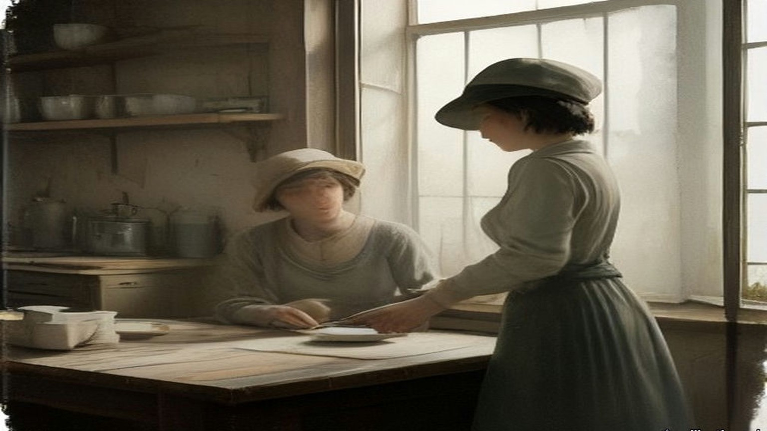
* * *
Westminster and Dublin, July 1932 to April 1938
In March 1932 Éamon de Valera said in Dublin that his government proposed to retain the land annuities. J. H. Thomas, the Dominions Secretary, wrote back on 23 March and set out what they were. "These annuities are payments which the tenants of purchased estates make in order to repay the sums lent to them to buy their land." They ran under the Land Acts of 1891 to 1909, the Wyndham Act of 1903 among them. The money was collected from the tenant-purchasers by the Free State and passed through the National Debt Commissioners to the holders of Irish Land Stock, "held both in Great Britain and in the Irish Free State." The farmers went on paying. The money stayed in Dublin.
On 6 July 1932 J. H. Thomas, the Dominions Secretary, moved the Irish Free State (Special Duties) Bill. "The object of the Bill is to provide the amount of default." The powers asked for, he said, "include everything that is imported into this country from the Irish Free State. It is only fair that I should leave the House in no doubt upon that point. I do not propose to differentiate between the value of one commodity and another. I do not propose to argue the merits of livestock or foodstuffs." One member pointed out that Britain imported £16,000,000 worth of livestock from Ireland a year and that "One hundred per cent. is a long sword with which to fight a fellow-member" of the Commonwealth. Another asked whether the House was "going to make war upon a peasant people, a little nation, with which you have so many connections, and so much trade for a small sum of £3,000,000 a year." Dublin put duties on British goods in answer.
Thomas's duties were laid on what Ireland sent, the cattle with the rest. In the Free State the annuities were halved in 1933 and stayed halved, and the farmer at the fair at Athy with his ash plant and his half-dozen stores was paying the half-gale to the Land Commission in Dublin, and it smaller, and the duty on the beasts to be paid at the other side of the water. Herself counting the notes on the kitchen table after, and the paper from the Commission folded under the clock, and her lips moving.
Six years of it. On 25 April 1938, in London, de Valera, Seán Lemass, Seán MacEntee and Séamas Ó Riain signed three agreements with Neville Chamberlain, Sir John Simon, Sir Samuel Hoare and Malcolm MacDonald. The Financial Agreement was short. Éire would pay £10,000,000 on or before 30 November 1938, and that payment "shall constitute a final settlement of all financial claims of either of the two Governments against the other arising out of matters occurring before the date of this Agreement." The special duties came off on both sides. A list of small matters was left for later, the £250,000 a year for property damage under the agreement of 1925, unredeemed bank notes, trustee savings banks, double taxation, and on a line of its own, "Withdrawal of United Kingdom silver coin from Éire."
On 27 April de Valera moved approval in the Dáil. He read out the British despatch of 1932, which had quoted the 1926 undertaking that the Free State would pay "the full amount of the annuities accruing due from time to time under the Irish Land Acts, 1891 to 1909, without any deduction whatsoever." The British, he said, valued their claim on the land annuities at a capital sum of £78,000,000, with £20,000,000 more for pensions, local loans and the rest. The penal duties by which they had collected it came to "roughly £5,000,000 a year."
"I have repeatedly stated my belief that if we were making agreements on the basis of justice, if sheer equity was to decide these matters, instead of paying money to Britain, whether a big or small sum, the payments should be made the other way." He did not ask the House to call it a good bargain. "We have agreed to this payment, which represents two years' purchase of the sum which the British were collecting by means of these special duties. We are making this Agreement and we are recommending it to the House. You may, if you like, regard it as ransom money."
Ten million against seventy-eight. The Land Acts had sold Irish estates to their tenants at so many years' purchase of the rent. The settlement bought out the claim the same way.
The farmers kept paying the Land Commission. On 24 April 1957 Erskine Childers, Minister for Lands, gave the Dáil the figures: arrears at 31 March 1957 of £142,562, "approximately a quarter of 1 per cent. of the total amount collectable since 1933," annuities "halved in 1933" and still at "a low level." Of 111,000 tenanted holdings vested in the Land Commission since 1923, some 13,000 still waited to pass to the tenants.
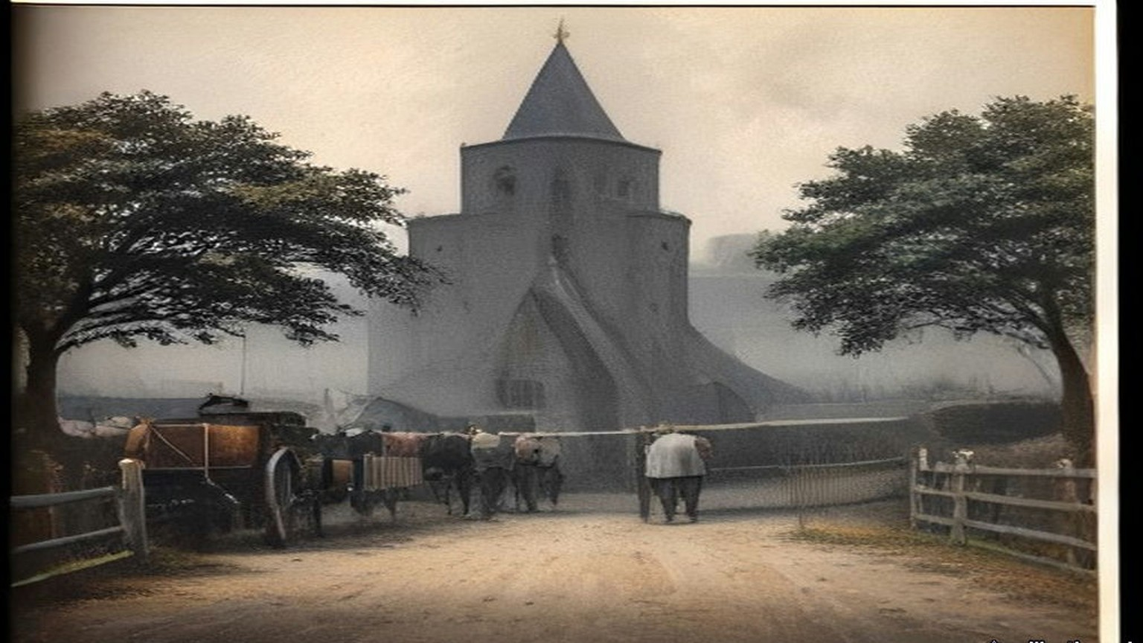
Chapter 27 Mini-Glossary
• Crore (5 occurrences in this chapter): Unit in the Indian numbering system equal to ten million (10,000,000), written as 1,00,00,000 rupees.
• Dandi (2 occurrences in this chapter): Coastal village in Gujarat where Mahatma Gandhi concluded the 240-mile Salt March on 6 April 1930 by picking up natural sea salt in defiance of the salt monopoly.
• Dharasana (3 occurrences in this chapter): Government salt works in Surat district, Gujarat, site of the non-violent Congress raids in May 1930 met by police lathi charges.
• Lakh (2 occurrences in this chapter): Unit in the Indian numbering system equal to one hundred thousand (100,000), written as 1,00,000.
• Lathi (6 occurrences in this chapter): Heavy iron-bound bamboo stave carried by colonial police in British India.
• Maund (7 occurrences in this chapter): Unit of weight in British India; a standard bazaar or factory maund equalled 40 seers (approximately 82.28 pounds avoirdupois).
• Ryot (1 occurrences in this chapter): Indian peasant cultivator or tenant farmer; also applied by British officials with Indian service experience to Irish and Egyptian peasants.
• Satyagraha (1 occurrences in this chapter): Gandhi's doctrine and practice of 'truth-force' or non-violent civil resistance.
• Sinn Fein (2 occurrences in this chapter): Irish nationalist movement founded by Arthur Griffith in 1905 ('Ourselves Alone'), cited by Gandhi in 1907 as a parallel to Indian Swadeshi.
• Swadeshi (2 occurrences in this chapter): Indian movement for economic self-reliance through the use of domestic manufactures and the boycott of British-made goods, especially Lancashire cotton cloth.
• Tola (1 occurrences in this chapter): Indian weight equal to the weight of one silver rupee (approximately 11.66 grams or 0.41 ounces).
Chapter 27 Appendix of Important Names
• Boycott, Charles (10 mentions in this chapter): Land agent in County Mayo for Lord Erne whose ostracism in 1880 gave the English language the word 'boycott'.
• Churchill, Winston (1 mentions in this chapter): British cabinet minister (Home Secretary, First Lord of the Admiralty, War and Colonial Secretary, and Prime Minister) recurring across the Irish, Middle Eastern, and Indian settlements.
• De Valera, Eamon (3 mentions in this chapter): Surviving commandant of the 1916 Easter Rising, President of Dáil Éireann, and later Taoiseach and President of Ireland.
• Gandhi, Mohandas Karamchand (Mahatma) (8 mentions in this chapter): Leader of the Indian independence movement and architect of non-violent satyagraha and the 1930 Salt March to Dandi.
• Samuel, Herbert (2 mentions in this chapter): British Liberal politician and first High Commissioner for Mandate Palestine (1920–1925).
Sources
• The Collected Works of Mahatma Gandhi, vol. VII (June–December 1907). New Delhi: Publications Division. No. 172, "Benefits of Passive Resistance," from the Gujarati, Indian Opinion, 7 September 1907, pp. 213–14; introduction (Sinn Feiners among Gandhi's examples; the idle registration office). Archive.org scan collectedworksof0007unse_h8w4.
• The Collected Works of Mahatma Gandhi, vol. X (November 1909–March 1911). Hind Swaraj, chs. IV, VII and XIX (English text of the Revised New Edition, Navajivan, 1939); editors' note on composition aboard the Kildonan Castle, publication in Indian Opinion on 11 and 18 December 1909, the booklet of January 1910 and the Bombay proscription of 24 March 1910; the facsimile plate "From chapter nine: written with the left hand"; foreword dated 22 November 1909. Archive.org scan collectedworksof0010unse_p6k9.
• The Collected Works of Mahatma Gandhi, vol. XLIII (March–June 1930). Letter to Lord Irwin, 2 March 1930 (no. 3); speech before the march, 12 March, and the editors' note giving seventy-eight marchers; parting message at Chandola and interview with Haridas T. Majumdar at Aslali, 12 March (Bombay Chronicle, 18 March); speech at Aslali, 12 March; interview to the Free Press of India and speech at Dandi, 6 April (Amrita Bazar Patrika, 7 April; Bombay Chronicle, 8 April); speech at Bhimrad, 9 April (Bombay Secret Abstracts, 1930); "To the Women of India," Young India, 10 April; speech at Broach, 26 March; arrest at Karadi, 5 May (Bombay Chronicle, 6 May), and the editors' note on Yeravda; draft letter to Lord Irwin, before 4 May 1930 (pp. 389–93). Archive.org scan dli.ernet.162028. The text of the 2 March letter was also read in The Selected Works of Mahatma Gandhi, vol. IV, Selected Letters, no. 62 (from D. G. Tendulkar, Mahatma, vol. III), and the draft letter of May in no. 63 (from Famous Letters of Mahatma Gandhi), mkgandhi.org; quotations follow the Collected Works where the scan is legible.
• The Collected Works of Mahatma Gandhi, vol. XLVIII (September 1931–January 1932). Nos. 42–46 and 50–51, Lancashire, 26–27 September 1931: statement to the press at Springvale Garden Village (Sunday Observer, 27 September); talks with representatives of the cotton industry at Edgeworth and Darwen and interview to the unemployed workers' deputation (Mahadev Desai, "Gandhiji in Lancashire," Young India, 15 October 1931); speech at the adult school, West Bradford, and interview with the Clitheroe deputation (Clitheroe Advertiser and Times, 2 October 1931). Archive.org scan TheCollectedWorksOfMahatmaGandhiVolXLVIII.
• House of Commons Debates, 7 August 1913, vol. 56, cc. 1780–908, "East India Revenue Accounts" (Theodore Taylor on opium and the salt tax). https://api.parliament.uk/historic-hansard/commons/1913/aug/07/east-india-revenue-accounts-indian-budget
• House of Commons Debates, 2 June 1930, "Situation" (Government of India weekly report; the Ordinances of 30 May). https://api.parliament.uk/historic-hansard/commons/1930/jun/02/situation
• House of Commons Debates, 7 April 1930, vol. 237, cc. 1742–3, "Civil Disobedience Campaign" (Benn). https://api.parliament.uk/historic-hansard/commons/1930/apr/07/civil-disobedience-campaign
• House of Commons Debates, 14 April 1930, vol. 237, cc. 2608–9, "Civil Disobedience Campaign" (Benn). https://api.parliament.uk/historic-hansard/commons/1930/apr/14/civil-disobedience-campaign
• House of Commons Debates, 19 May 1930, vol. 239, cc. 11–12W, "Salt and Customs Departments" (revenue, expenses and incidence). https://api.parliament.uk/historic-hansard/commons/1930/may/19/salt-and-customs-departments
• House of Commons Debates, 26 May 1930, vol. 239, cc. 789–91, "Dharasana Salt Depot" (Grattan-Doyle, Benn; the Bombay Government's report). https://api.parliament.uk/historic-hansard/commons/1930/may/26/dharasana-salt-depot
• House of Commons Debates, 5 June 1930, vol. 239, c. 2394W, "Salt" (Freeman, Benn). https://api.parliament.uk/historic-hansard/written-answers/1930/jun/05/salt
• House of Commons Debates, 23 July 1930, vol. 241, cc. 2146–54, "Salt Works, Dharasana (Raids)" (read for the official account; not quoted). https://api.parliament.uk/historic-hansard/commons/1930/jul/23/salt-works-dharasana-raids
• House of Commons Debates, 1 December 1930, vol. 245, cc. 1764–5, "British Goods (Boycott)" (Kenworthy, Benn; table of percentage decreases). https://api.parliament.uk/historic-hansard/commons/1930/dec/01/british-goods-boycott
• House of Commons Debates, 12 March 1931, vol. 249, cc. 1413–541, "India" (Churchill; Kenworthy). https://api.parliament.uk/historic-hansard/commons/1931/mar/12/india
• House of Commons Debates, 4 May 1931, vol. 252, cc. 4–5, "Cotton Cloth (Imports)" (Remer, Benn; table for 1913–14, 1929–30 and 1930). https://api.parliament.uk/historic-hansard/commons/1931/may/04/cotton-cloth-imports
• House of Commons Debates, 13 May 1931, vol. 252, cc. 1205–332, "India Office" (Cunliffe-Lister). https://api.parliament.uk/historic-hansard/commons/1931/may/13/india-office
• House of Commons Debates, 7 July 1931, vol. 254, cc. 1888–9, "Cotton Exports (India)" (Board of Trade table, January–May 1930 and 1931). https://api.parliament.uk/historic-hansard/commons/1931/jul/07/cotton-exports-india
• Papers relating to the Parliamentary Oath of Allegiance in the Irish Free State and the Land Purchase Annuities (1932): Irish Free State statement of 22 March and J. H. Thomas's despatches of 23 March and after. Read in the Wikisource transcription. https://en.wikisource.org/wiki/Papers_concerning_Irish_Oath_of_Allegiance_and_Land_Annuities_1932
• House of Commons Debates, 6 July 1932, "Irish Free State (Special Duties) Bill" (Thomas; the £16,000,000 livestock trade and the "long sword"; the "peasant people" and the £3,000,000 a year). https://api.parliament.uk/historic-hansard/commons/1932/jul/06/irish-free-state-special-duties-bill
• Agreements between the Government of Éire and the Government of the United Kingdom, London, 25 April 1938, Financial Agreement, articles 1–3. Documents on Irish Foreign Policy, vol. 5, no. 2321. https://www.difp.ie/volume-5/1938/british-irish-tripartite-agreement-on-trade-finance-and-defence/2321/
• Agreement with United Kingdom (Capital Sum) Act, 1938 (No. 13 of 1938). https://www.irishstatutebook.ie/eli/1938/act/13/enacted/en/print.html
• Dáil Éireann Debates, 27 April 1938, Agreements between the Government of Éire and the Government of the United Kingdom: Motion of Approval (de Valera), Oireachtas debate record XML. https://data.oireachtas.ie/akn/ie/debateRecord/dail/1938-04-27/debate/mul@/main.xml
• Dáil Éireann Debates, 24 April 1957, Committee on Finance, Vote 47, Lands (Childers), Oireachtas debate record XML. https://data.oireachtas.ie/akn/ie/debateRecord/dail/1957-04-24/debate/mul@/main.xml

Chapter 28
Full and Final Settlement, 1943–1958
Chungking, Westminster, Nablus, Ismailia, Port Said, Rome, Peking and Canton, January 1943 to July 1958
The Ministry of Foreign Affairs, Chungking, 11 January 1943
The ink stone, this morning, I grind it twice. First time the water too much, the ink grey like the river. Second time good. Section chief says, today no mistakes, today is not an ordinary day, and walks away, and comes back, and says it again.
The English text and our text, two piles, each page I check against the other one, the numbers of the articles, the names. His Excellency Sir Horace James Seymour, Ambassador of the British King. For India, a Mr. Richardson. For us, Minister Sòng, 宋子文, whom the English write Tse Vung Soong, as if from Shanghai the sound comes. Thirty-second year of the Republic, first month, eleventh day.
Article 1 says where the treaty runs, on their side. The United Kingdom, India, all colonies, protectorates, and "all mandated territories in respect of which the mandate is exercised by his Government in the United Kingdom." So many places, one king. On our side, one line. All the territories of the Republic of China.
Article 2. All those provisions of treaties which let the British King or his representatives exercise jurisdiction over his subjects in the territory of the Republic of China, "are hereby abrogated." Their people, from now, under our courts. I copy this one slowly. My grandfather, in Hankow, a British clerk's rickshaw knocked him into the ditch, and the clerk, our magistrate could not touch him. My grandfather told it every New Year. Every New Year the same, the ditch, the clerk, the magistrate, until my grandmother said, enough, eat.
Article 3. The Final Protocol signed at Peking on the seventh day of the ninth month of 1901, after the Boxers, "should be terminated." The diplomatic quarter at Peiping, back to us. Article 4. The International Settlements at Shanghai and at Amoy, back to us. The British Concession at Tientsin, back. "The British Concession at Canton," back.
Canton. The island where the foreign houses were, by the river, where the boats came up from Whampoa. A hundred years, one hundred and one years, my section chief says, since Nanking, since the first treaty. He says it the way you say the date of a funeral.
Article 5 is about land. Titles to real property held by British subjects and companies in China "shall be indefeasible." Cannot be questioned, except for fraud proven in a court. So the houses on the island, the godowns, the land under them, still theirs, on paper. I check the English. Yes. Indefeasible.
Hong Kong, I look for it. Page by page. It is not there.
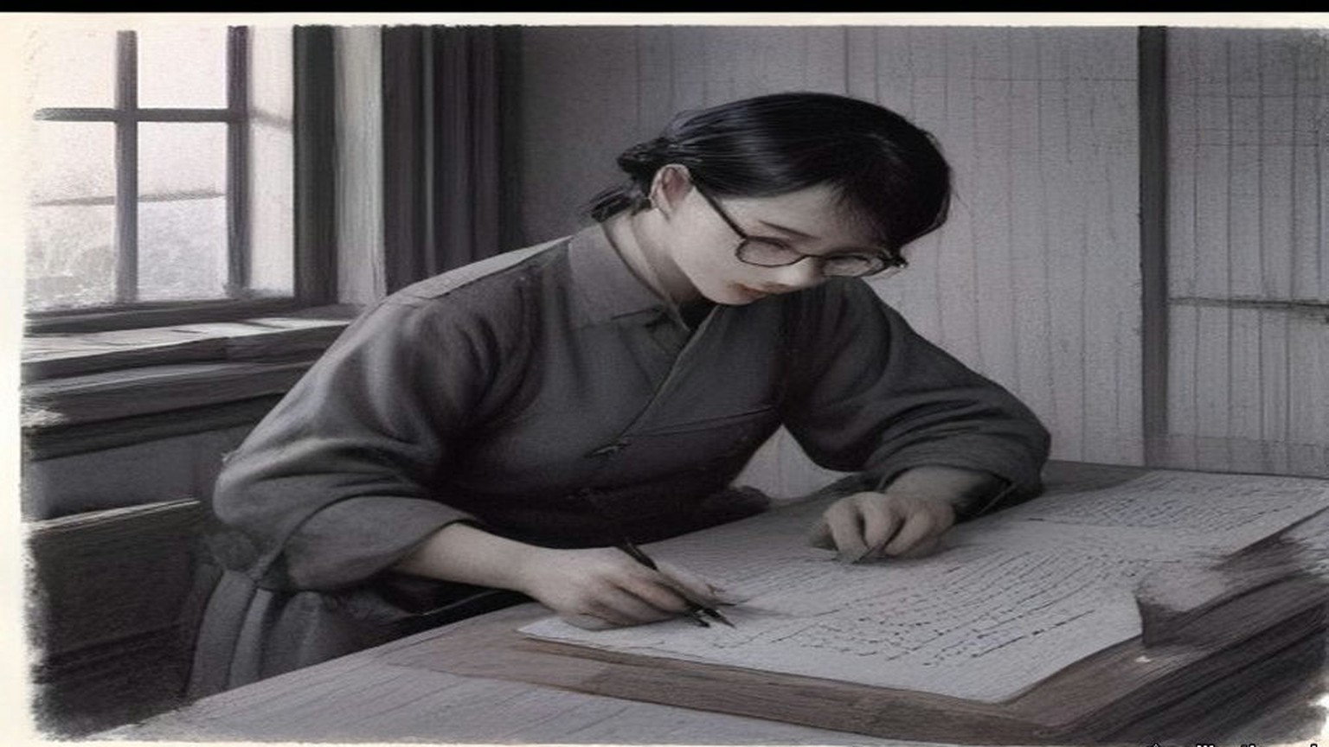
His Majesty's Stationery Office printed the treaty in London as Cmd. 6456, at one shilling and threepence. The opium that had paid for the foreign houses at Canton had stopped being a line in India's accounts thirty years before. On 7 August 1913 Edwin Montagu, Under-Secretary of State for India, had opened the Indian Budget in the Commons. The year just closed had run a surplus over the estimate of nearly £8,000,000, "due mainly to the very large railway receipts and the high prices obtained for opium." Then: "the remarkable feature of the year is that this is the first Budget in which no receipts can be expected from the Indo-Chinese opium traffic." The revenue anticipated from opium was "only £306,000, or £4,250,000 less than last year." The trade the Canton boat people had rowed for, the trade the Imperial Commissioner had sunk into pits of brine and lime in June 1839, had stopped paying the Government of India.
The colonies kept their shops longer. On 13 February 1929 Leopold Amery, then Colonial Secretary, answered a question on Hong Kong in writing. "The Colonial Government has established a legal Government monopoly of the sale of opium with the intention of restricting consumption by charging high prices for Government opium." The monopoly, he said, was not effective, because of "the large quantities of smuggled opium which pour into the colony from China." On 10 November 1943, ten months after the Chungking treaty, Colonel Oliver Stanley, Secretary of State for the Colonies, answered in writing that the Government had decided on "total prohibition of opium smoking in the British and British protected territories in the Far East which are now in enemy occupation," and that "the prepared opium monopolies formerly in operation in these territories will not be re-established on their re-occupation." Hong Kong was one of those territories. On 23 August 1945 the Prime Minister told the House that the Japanese surrender in Hong Kong would "be accepted by a British Force Commander. Plans for re-establishing British Administration in the Colony are fully prepared."
* * *
Westminster and Jerusalem, July 1946 to December 1947
In July 1946 the Colonial Office laid before Parliament a paper of ten pages called Palestine: Statement of Information relating to Acts of Violence. Cmd. 6873, twopence net. It set out, from intercepted telegrams and from the underground press, the Government's case that the Hagana and its striking force the Palmach, the Irgun Zvai Leumi and the Stern Group had worked together in the sabotage of the winter and spring. On the night of 31 October 1945, it said, the Palmach attacked the Palestine railways: "The line was blown in 153 places in all, completely disrupting it." Three police launches were destroyed, two at Haifa and one at Jaffa. The Irgun attacked Lydda station and yards, "causing damage to three locomotives, the destruction of one signal box, and the burning of an engine shed," and one British soldier was killed. "In the first six months of 1946 there were nearly fifty separate incidents involving violence, and in many cases loss of life." It printed telegrams it said were sent from Jerusalem to London. One of 23 September 1945, signed Sneh, the security member of the Jewish Agency Executive, read: "It has also been suggested that we cause one serious incident." Another, of 10 October, set out a code. If the answer from London was to avoid a general conflict but allow isolated cases, the reply should be: "send greetings to Chill for the birth of his daughter." Its conclusion: unless the Government were prepared "to yield to threats of violence and to abandon all hope of establishing law and order," they were bound to take active steps against those responsible.
On 11 December 1947 Arthur Creech Jones, the Colonial Secretary, gave the House the date. The mandatory responsibility "cannot be relinquished piecemeal. The whole complex of governmental responsibilities must be relinquished by the Mandatory Government for the whole of Palestine on an appointed day." Once the military withdrawal was under way, the forces for it would no longer be there. "The Mandate will, therefore, be terminated some time in advance of the completion of the withdrawal, and the date we have in mind for this, subject to negotiation with the United Nations Commission, is 15th May." The troops would be out by 1 August 1948.
On 10 March 1948 he moved the second reading of the Palestine Bill and went through the money. The Government meant to hand over the general assets of the Palestine Government "to the successor authorities on their undertaking to meet liabilities. It may be that we shall be unable to complete satisfactory arrangements until well after 15th May, or possibly not at all." The Bill therefore took power to move "the funds and other movable property of the Palestine Government" to authorities in Britain, to be held against its obligations. Some of those fell due in London: "leave salaries and retirement benefits of British staff," contracts for stores, "amounts due to the Ministry of Food for procurement of food supplies for Palestine." Against them stood "monies invested by the Crown Agents on behalf of the Palestine Government." The British officers had the Government's assurance of their compensation and statutory benefit, "while the local Palestinian staff are similarly guaranteed the payments due to them until such time as successor authorities have emerged capable of taking over this liability." Immovable assets would be left "to the successor authorities in the areas where they are situated."
When it was over, the Colonial Office and the Foreign Office put the account in a pamphlet for public information. The United Nations, it said, had voted on 29 November 1947 for a partition "to be implemented by a Commission of five members unsupported by any police or military forces." The Arabs, it said, had announced that they would resist that plan "by every means within their power." "84,000 troops, who received no co-operation from the Jewish community, had proved insufficient to maintain law and order in the face of a campaign of terrorism waged by highly organised Jewish forces equipped with all the weapons of the modern infantryman. Since the war 338 British subjects had been killed in Palestine, while the military forces there had cost the British taxpayer £100 million." The renewal of Arab violence after the vote, and "the declared intentions of Jewish extremists," showed "that the loss of further British lives was inevitable." In view of the decision not to enforce partition against the declared wishes of the majority of the inhabitants, "the continued presence there of British troops and officials could no longer be justified."
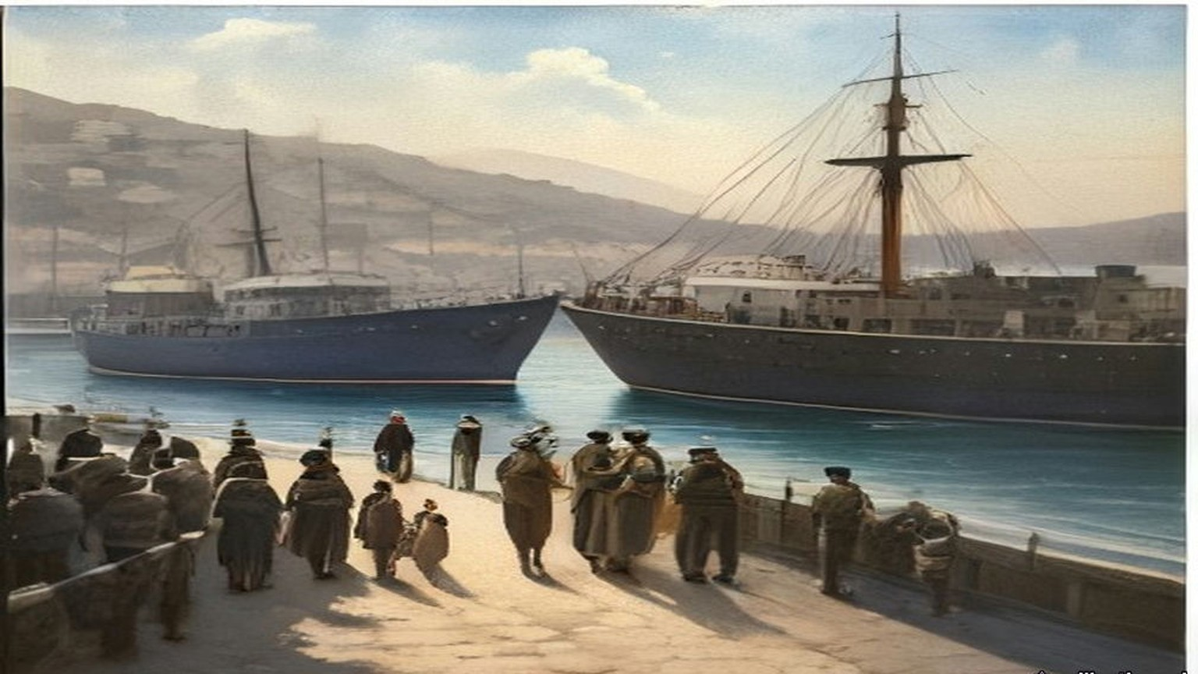
* * *
The municipality, Nablus, April and May 1948
Came the files from Jerusalem in a lorry, wallāhi, in boxes tied with string, and the driver would not wait for tea. Put them, he said, wherever. The Government is finishing.
The hospital, to us. The schools, to us. The taxes, more of them, to us also, the paper says, powers of taxation increased to the municipalities. And the police of the town, a municipal police, to be organised for us, for keeping the order inside the town, because after the fifteenth of the month the Palestine Police are no more. Ya akhī, I said to the clerk from the District Office, and the salaries? Who pays them, the salaries, after the fifteenth? He lifted his shoulders to his ears and let them down.
Licences, also, for the merchants of the town, to bring in themselves the flour and the sugar and the oil, which before the Government brought in all together. The licences in Arabic and in English, signed, stamped. And the post, the telegraph? That one, no. The post, they said, cannot be given to a town. Stays with them until it stops.
Thirty years, my father used to say, since the English came into Jerusalem, and the paper on my table says it also, the ending of thirty years of British rule. Thirty years of forms. Form for the olive tax, form for the tithe, form for the permit to build, form for the permit to travel, form for the son who is in prison. I filed them. Now they are coming back to me in boxes, the forms, and nobody to send them to.
The night of the fourteenth I sat at the table with the lamp. Midnight, the High Commissioner's government no longer responsible for the administration of Palestine. So it was written. At midnight nothing. A dog. The boxes on the floor around my feet like sheep in a pen.
In the morning I opened the office at seven, as every day. Who is the government? the women at the door asked me. I said, al-baladiyya, the municipality. They looked at me. One of them laughed, without any sound.
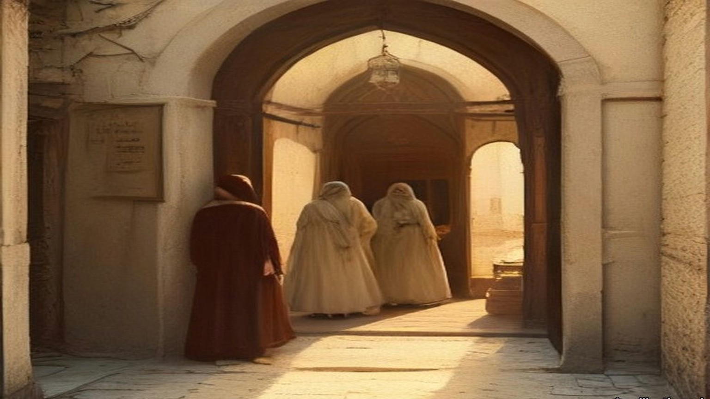
* * *
Westminster, 14 August 1947 to 26 July 1949
The other account was India's. In the Financial Agreement of 14 August 1947, the day before independence, the sterling assets of undivided India were put at £1,160 million. Britain owed it. The money had piled up in London through the war, Indian goods and services bought with sterling that could not be spent.
On 26 July 1949 Mr. Gammans asked how much of it was left. Glenvil Hall, the Financial Secretary to the Treasury, gave the 1947 figure and no other. "I regret that I cannot disclose the size of the balances at other dates." Oliver Stanley, the former Colonial Secretary who had closed the opium shops of the Far East, asked why there must be all this secrecy. "Does the right hon. Gentleman really believe that pre-1939 there ever was a case of balances similar to this?" Mr. Stokes asked about settling the matter "by sending the Indian Government a bill for this amount for saving them from the Japanese." Colonel Haughton asked whether the final settlement lay five or ten years ahead. "Yes, Sir, that is quite likely," said Glenvil Hall. "Are we never to know it?" said Stanley.
* * *
The offices of the Suez Canal Company, Ismailia, 26 and 27 July 1956
Came it in the evening, the news, wallāhi, and by night it was in the whole town, al-sharika itammimat, the company, nationalised. The Company. Ninety years and more the Company, since the digging, since my great-grandfather and the men of his village carried the mud out of the cut in baskets, and now, in one night, ours.
In the morning the French chief of my section came in at eight as every day and sat at his desk and did not open anything. Ya ʿamm, I said to him, sabāḥ al-khēr, and he said bonjour and looked at the window. The law, they told us, says that every employee of the Company must stay in his post. Who leaves, prison. From three years to fifteen. For him also, the Frenchman, for the English pilots, for me. So he sat.
The ledgers in my section are the transit dues. Every ship, its tonnage, its flag, what it paid. The figures I know in my own way. In my hand they are columns. A tanker of so many tons pays so many francs, and the francs go to Paris, and from Paris to the shareholders, and among the shareholders, for eighty years, the English government.
In the afternoon the ships still came. I went out on the quay of the office at the hour of the ʿaṣr to smoke and there was a tanker, very slow, very high in the water, from the south, and on its bridge a pilot, and the pilot was still English. Yā rabb, I said. Who paid this one, and to whom?
The Frenchman stayed at his desk that week and the next. The ships came, the ledger filled, in my hand, as before. Afterwards, the English pilots went away, and many of the foreigners with them, and the men who stayed took the ships through, and the ledger filled again. Ask me whose ledger. Ours, I say. My great-grandfather's basket, I say, and nobody laughs.
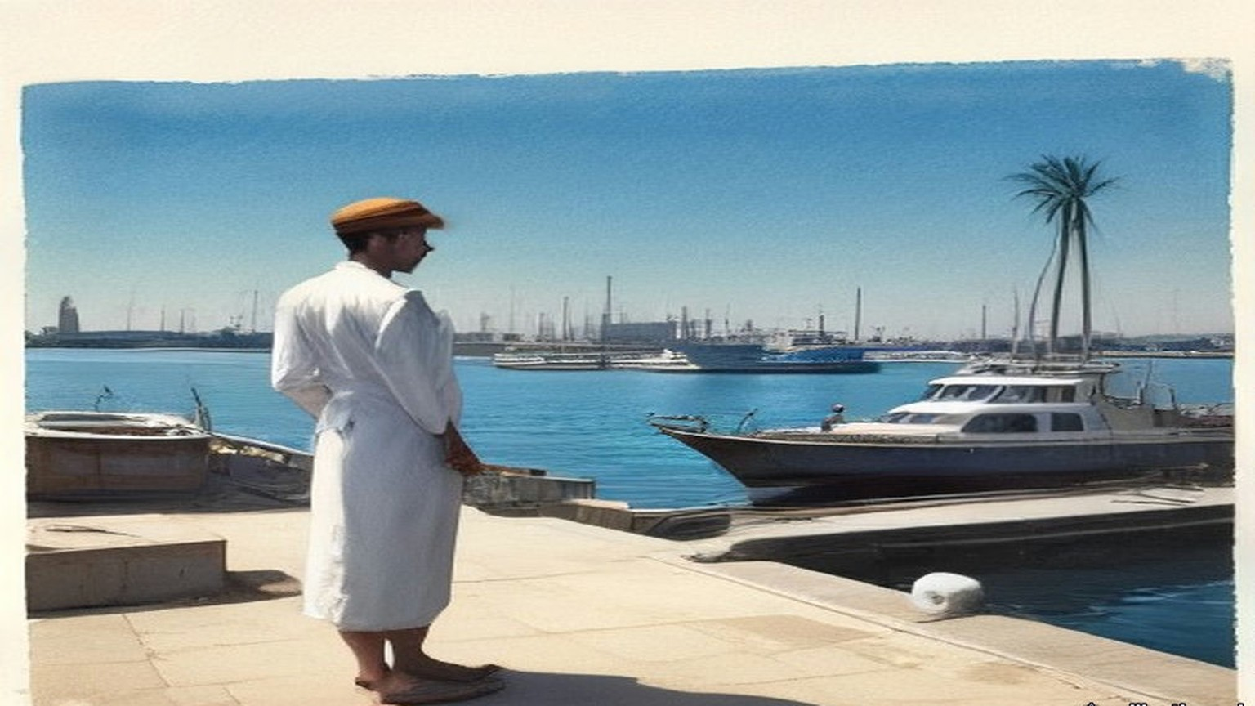
On Friday 27 July Sir Anthony Eden told the House of Commons: "The unilateral decision of the Egyptian Government to expropriate the Suez Canal Company, without notice and in breach of the Concession Agreements, affects the rights and interests of many nations." Hugh Gaitskell, for the Opposition, said, "we deeply deplore this highhanded and totally unjustifiable step," and asked him to bear in mind "the desirability of blocking the sterling balances of the Egyptian Government." On Monday Eden reported what had been done. Ships were still going through the canal, he said. "I am not prepared to say in detail at the moment to whom they are paying their dues." Emrys Hughes asked whether it was true, "as the Press report, that 140 ships seem to have gone through the Suez Canal yesterday, paying dues amounting to £150,000?" John Maclay asked about the law that "employees of the Canal Company must continue with their duties under threat of from three to fifteen years' imprisonment." Eden answered that the Government regarded it "as unacceptable that British subjects should be ordered to stay, or kept as hostages, or under any form of duress." An order under the Exchange Control Act had the effect "of putting Egypt out of the transferable account area and generally making all transactions on Egyptian controlled sterling accounts subject to permission." A direction under the Defence (Finance) Regulations safeguarded "the securities and gold of the Suez Canal Company."
On 2 August he gave the House the figures. "Last year, nearly 70 million tons of oil passed through the Canal, representing about half the oil supplies of Western Europe." Compensation to the shareholders "would cost about £70 million, I am told." "The net annual revenue of the Canal, after providing for taxation and providing for reserves, as is at present done, is only about £10 million." The company's reserves and its revenues from shipping would have paid for widening the canal. "But Colonel Nasser has now announced his intention to divert these revenues from this vital international waterway to build a dam in Egypt."
The British share went back to 1875. In June 1893 Sir William Harcourt, as Chancellor, had told the House that the shares Disraeli bought for £4,000,000 were worth £17,750,000 and that the company's dividend had been 17 per cent for 1890, 21 per cent for 1891 and 18 per cent for 1892, and British ships made up 75 per cent of the tonnage through the canal. In May 1936 the Treasury gave the dividends it had received in sterling: £1,833,273 in 1929, £1,885,094 in 1930, £1,882,945 in 1931, £2,440,251 in 1932, £2,436,816 in 1935. In the same debate of 2 August 1956 Julian Amery said: "For about two generations the Canal was under the management of an international company" and "under the protection of the British Army. In the last few weeks that situation has come to an end. Six weeks ago the last British soldier was withdrawn from the Canal Zone, and one week ago Colonel Nasser grabbed the Company."
* * *
Port Said, 5 and 6 November 1956
From the roof of my uncle's house in al-ʿArab quarter we saw them, the parachutes, white, many, coming down slowly on the far side by the airfield, like washing blown off a line. My uncle said, khalās, it is finished, and went down the stairs, and I stayed. My mother called me from the stairwell, she called me by my full name, which she does only when she is afraid.
In the night I did not sleep. I put my hand on the wall of the room and kept it there, the way you keep a hand on a sick child.
In the morning, the soldiers in the streets, the English and the French, and they went from street to street. The canal, people said, our side had blocked it. Ships sunk in it, in the channel. Which ships, I do not know. The ships that every week of my life lay in the harbour, the big ones, waiting their turn to go south, they were not waiting. Nothing was going south.
In London that day Eden told the House that the Port Said landing "took place successfully and on time. It appears to have been virtually unopposed and no preliminary bombardment of any kind was ordered. Anglo-French troops proceeded to clear Port Said of scattered opposition." Gaitskell said the canal "has now been blocked by eight ships, and with every hour that passes the prospect is that more ships and obstructions will be sunk in it." In a message he read to the House, Eden called the clearing of the obstructions in the canal "in no sense a military operation" and proposed that technicians with the Franco-British force "begin this work at once." Its attacks "on airfields and other military targets," it said, had been "conducted with the most scrupulous care." "Some casualties there must have been." "We deeply regret them. When all fighting has ceased, it will be possible to establish the true figure." His forces would cease fire at midnight.
On 3 December Selwyn Lloyd, the Foreign Secretary, told the House that the French and British Governments had concluded "that the withdrawal of their forces in the Port Said area can now be carried out without delay."
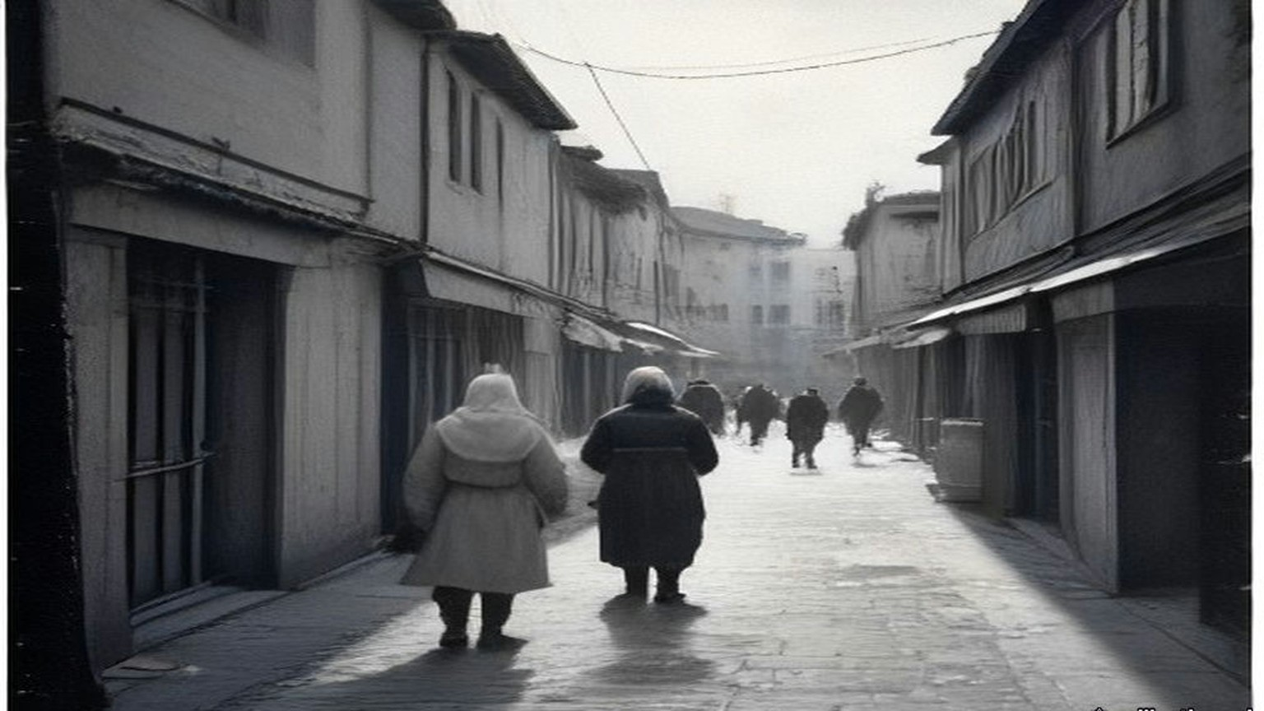
* * *
Westminster, Tuesday 4 December 1956
The Chancellor of the Exchequer, Harold Macmillan, gave the House the reserves the next afternoon. The monthly announcement on the gold and dollar reserves, he said, "is being issued to the Press today and will be circulated in the OFFICIAL REPORT. It shows a fall of 279 million dollars in the reserves to 1,965 million dollars, and a deficit of £24 million in E.P.U."
He went through it in order. "During the first half of this year our gold and dollar reserves rose by 265 million dollars." In the third quarter "the fall was 57 million dollars and would have been about 230 million dollars had it not been for the special receipt from the sale of the Trinidad Oil Company. In October, the fall was 84 million dollars and in November, as I have said, the figure was 279 million dollars."
"These falls in the reserves and the deficit in E.P.U. started after the date of Colonel Nasser's seizure of the Suez Canal and have not been caused by any weakness in our trading position." "First, we will maintain the rate for the £ sterling at its present parity." Then the borrowing. "Each country has a quota in the I.M.F. Ours amounts to 1,300 million dollars." "We are making an immediate approach to the I.M.F. with a view to drawing on part of these resources."
Asked to explain the fall, he said it was hard to tell how much was leads and lags, "how much they result from the desire of the world to change sterling into francs or dollars in a moment of critical situation, and how much of it is the actual payment out, for instance, in the last month, in respect of oil contracts which I have authorised."
* * *
Rome, 29 April 1958, and Westminster, 22 July 1958
The money was settled in Rome. On 29 April 1958 Abdel Galeel El Emary signed Heads of Agreement for the United Arab Republic, and J. Georges-Picot and two others for the stockholders of the company. Lord Hailsham published the text in the House of Lords on 14 May. "As a full and final settlement of the compensation due to shareholders and holders of founders shares as a consequence of the Nationalisation Law No. 285 of 1956," the United Arab Republic would pay the equivalent of £E28.3 million. The company kept its assets outside Egypt. Hailsham told the peers the Government regarded it "as reasonably satisfactory," that the Heads of Agreement appeared "to secure a more advantageous financial settlement to the Company," and that "the Company retains its profitable assets outside Egypt and the payment of instalments is guaranteed in transferable currencies at a fixed rate of exchange." Any special release from Egypt's sterling balances, he said, would arise "only after the present negotiations with Egypt for the settlement of the claims of British citizens have been concluded."
The first £E5.3 million was already in the company's hands: "the retention by the Stockholders of the transit tolls collected in Paris and in London since July 26, 1956." The shipowners had gone on paying the old company, and the old company had kept it. The rest came in six instalments, £E4 million each first day of January from 1959 to 1963, and £E3 million on 1 January 1964. "Not less than 40 per cent. of each instalment shall be payable in Pounds Sterling." If the United Kingdom released Egyptian money from "Egypt's No. 2 Sterling account," the instalments would be paid early out of it. The sterling Eden had frozen in July 1956 was the fund the compensation could be paid from.
On 22 July Gerald Nabarro asked the Chancellor what the Treasury held. Derick Heathcoat Amory answered: "Her Majesty's Government own 353,804 shares in the Suez Finance Company. Their current market value is about £16 million. No decision has been taken about the future of the Government's holding." Mr. Awbery asked whether the Government had a policy "for the pilots and the workmen who left their jobs at the instigation of the Government." The Speaker ruled that a different question.
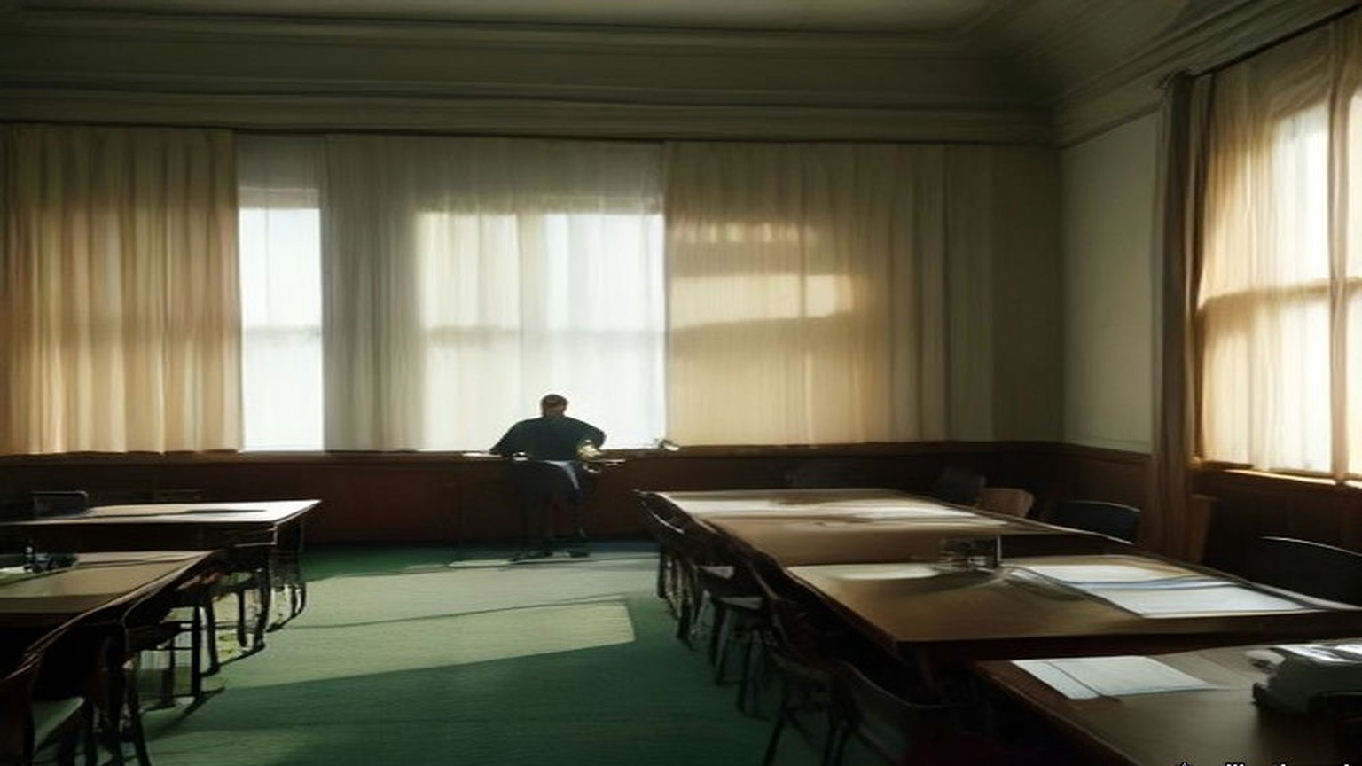
* * *
Peking, September and October 1949
On 21 September 1949 毛泽东 Máo Zédōng opened the Chinese People's Political Consultative Conference in Peking. Six hundred and more delegates. His speech was printed as 中国人民站起来了, The Chinese people have stood up. "一百多年以来，我们的先人以不屈不挠的斗争反对内外压迫者，从来没有停止过": for more than a hundred years our forebears fought without bending against the oppressors within and without, and never stopped. China had fallen behind in modern times, he said, "完全是被外国帝国主义和本国反动政府所压迫和剥削的结果," wholly the result of oppression and exploitation by foreign imperialism and the reactionary government at home. "我们的民族将再也不是一个被人侮辱的民族了": ours will no longer be a nation that others insult.
Then the work ahead. The people's democratic dictatorship, he said, was the state system that guarded the gains of the revolution, "有力的武器，我们必须牢牢地掌握这个武器": a powerful weapon, and we must keep a firm grip on it. China had four hundred and seventy-five million people and nine million five hundred and ninety-seven thousand square kilometres. "我们面前的困难是有的，而且是很多的": the difficulties before us, there are, and they are many.
On 1 October the Central People's Government issued its proclamation. It named Peking the capital and 周恩来 Zhōu Ēnlái premier and foreign minister. It called the new government the sole legal government of all the people of China, and offered relations to any foreign government that would observe 平等、互利及互相尊重领土主权, equality, mutual benefit, and mutual respect for territory and sovereignty.
London accorded it recognition on 6 January 1950. A British chargé d'affaires reached Peking on 13 February. On 17 June he asked whether the Central People's Government wished to exchange ambassadors. In February 1951 the Foreign Office told the Commons: "No reply has been received."
* * *
A registration office of the Public Security Bureau, Canton, spring 1950
The order is pasted on the wall by the door, the big characters, three sheets. 关于严禁鸦片烟毒的通令. Order on the strict prohibition of opium. Everybody reads it standing, moving the lips. I read it two times. The first line, I read three times.
自帝國主義侵略我國，强迫輸入鴉片，爲害我國已百有餘年. Since the imperialists invaded our country and forced opium in on us, the harm to our country, more than a hundred years.
More than a hundred years. My grandmother's grandmother, a boat woman, Tanka, on the river below the city. She fed her husband with chopsticks under the board of the cangue, the story says, in the year the Commissioner came. In our family that story is told only at the cleaning of the graves, and only by the oldest, and the children are sent out first.
The order says more, after. The feudal compradors, the bureaucrats, the warlords, they did not forbid it, they forced the planting. And under Japanese imperialism, 曾有計劃的實行毒化中國, a plan to poison China. Killed the people's lives, used up the people's property, 不可勝數, cannot be counted.
Article 1. The people's governments, together with the people's organisations, wide propaganda against opium, against the poisons, the people to rise up and act all together. Article 2. Committees, from the civil affairs, from the public security, from the people's organisations.
Article 3. From the spring of 1950, where the fighting is finished, no more planting. Where the fighting is not finished, the day it finishes. And watch, before the sowing.
I come to register my husband. The order says it: the people who smoke, register, in the city at the Public Security Bureau, in the village with the people's government, and give it up within the time. Who hides and does not register, who after the time still smokes, when found, punished. The man at the table writes his name, his age, how many years. He does not look up. He has written a hundred names today, his wrist moves like a machine for it.
Article 7. The health organs prepare medicines for giving up, and for the poor smokers, free, or for less. In the cities with much opium, a place for giving up. I have the paper for the place. I have also the pills, in twists of paper, from the clinic. At home I lay them out on the table in a row, and count them, and write the days on a red slip, one fewer each day. Down, down, until none.
Article 4. From the day of the order, no more trading, no more making, no more selling. Who does it, whoever he is, the opium taken, and severe punishment. Article 5. Opium kept among the people, hand it in by the time, and the government, to look after their living, will give something back. Whoever keeps it after the time, punished.
Whoever he is. I read that one again on the way home. On the river the boats are as they always were, the women at the sculls, standing, the babies tied on their backs. Some things the order does not say. It does not say what the Bureau does with the names.
The seventh night my husband sits at the table with his two hands on the edge of it. The eyes running, the nose running, the sweat, and cold, he says, so cold. I take one of his hands off the table and hold it in my two hands. I do not tell him the story of the cangue. I will tell it to our son, when he is old enough, at the graves, after I have sent the children out.

* * *
The argument of this book
This book has followed money from the advance paid to a cultivator in Saran district in 1836 to the Treasury's holding of 353,804 Suez shares in 1958. Its argument can be stated plainly here, once, at the end.
The empire in these pages ran on paper. The opium advance and the Calcutta sale, the receiving ship's chit at Lintin, the canal share bought for £4,000,000, the Irish rent roll and the land annuity, the Ottoman deed and the Mandate's land ordinance, the salt licence, the concession agreement, the sterling account. Each was a claim on someone else's labour, and each was enforced, in the end, by men with weapons. That is the violence of the bureaucracy: quiet, written, collected on a schedule, and backed by the cangue, the gallows and the lathi.
When people answered the paper with guns, the guns behind the paper won. They won hard. The hill villages of Palestine that rose against Ibrahim Pasha's conscription in 1834, Dublin in 1916, the Palestine revolt of 1936 to 1939 are in the record with their dead. Armed revolt gave the administrations a war, and a war was a thing they knew how to fight and how to pay for. Gandhi put it to the Viceroy in May 1930: the Government "goaded human nature to violence which it could understand and deal with."
What the paper could not outlast was refusal that made the account stop balancing. Gandhi read the Irish lesson in Natal in 1907 and called it "exactly our Swadeshi movement." Britain sent India more than three thousand million yards of cotton cloth in 1913–14 and under eight hundred million in 1930, the year of the boycott and the salt. The Irish annuities stayed in Dublin, London took its duties at the ports for six years, and the claim was closed in 1938 for £10,000,000 as a "final settlement." Palestine cost the British taxpayer £100 million and 338 British lives after the war, and the Government told the public that staying "could no longer be justified." In November 1956 the reserves fell by 279 million dollars, and on 3 December the Foreign Secretary told the House the troops at Port Said would be withdrawn "without delay." In none of these cases did the side with the guns lose its battles. Each time the ledger reached a point where staying cost more than going. Each time the empire settled, and wrote the settlement down as full and final, and kept what it could: the profitable assets outside Egypt, the indefeasible titles in China, the Crown Agents' monies, the sterling it had borrowed from India.
Physical violence did not defeat the violence of the paperwork. Economic stalemate did. The people who forced the stalemate paid for it first, in the beatings at Dharasana, in the closed mills of Lancashire and the cattle trade of the economic war, in prison, in hunger.
China is where the money in this book began, at the Lintin anchorage and the Canton factories, and the opium thread ends there. The Indian opium revenue went in 1913. The concessions, the settlements and the foreign courts went in 1943. The colonial opium monopolies were not reopened when the British came back to the Far East. In 1950 the new government in Peking wrote more than a hundred years of opium into the first line of a decree and set about ending the habit with registers, pills and severe punishment, and a woman in Canton counted out cure pills on a red slip as a clerk's wife had counted them below the same city in 1839. What that government did next, to its smokers and to all its other people, and what the next century of money made of China, is the subject of the second book.
Chapter 28 Mini-Glossary
• Cangue (3 occurrences in this chapter): Heavy square wooden collar locked around a prisoner's neck as a public corporal punishment in Qing China.
• Dharasana (1 occurrences in this chapter): Government salt works in Surat district, Gujarat, site of the non-violent Congress raids in May 1930 met by police lathi charges.
• Irgun (2 occurrences in this chapter): Irgun Zvai Leumi (National Military Organization); revisionist Zionist underground group in Mandate Palestine that bombed the King David Hotel in July 1946.
• Lathi (1 occurrences in this chapter): Heavy iron-bound bamboo stave carried by colonial police in British India.
• Lintin (2 occurrences in this chapter): Lingding Island in the outer Pearl River estuary, where foreign receiving hulks anchored year-round to store and transship smuggled Indian opium.
• Swadeshi (1 occurrences in this chapter): Indian movement for economic self-reliance through the use of domestic manufactures and the boycott of British-made goods, especially Lancashire cotton cloth.
• Tanka (1 occurrences in this chapter): Danjia boat-dwelling people of the Pearl River delta in Guangdong, historically barred from living ashore and heavily recruited by both opium boats and Lin Zexu's river forces.
Chapter 28 Appendix of Important Names
• Begin, Menachem (1 mentions in this chapter): Commander of the revisionist Zionist underground organization Irgun Zvai Leumi in Mandate Palestine.
• Boycott, Charles (1 mentions in this chapter): Land agent in County Mayo for Lord Erne whose ostracism in 1880 gave the English language the word 'boycott'.
• Disraeli, Benjamin (1 mentions in this chapter): British Prime Minister who arranged the 1875 purchase of Khedive Ismail's Suez Canal shares with Rothschild financing.
• Gandhi, Mohandas Karamchand (Mahatma) (2 mentions in this chapter): Leader of the Indian independence movement and architect of non-violent satyagraha and the 1930 Salt March to Dandi.
• Ibrahim Pasha (1 mentions in this chapter): General and son of Muhammad Ali of Egypt who governed Syria and Palestine between 1831 and 1840.
• Nasser, Gamal Abdel (3 mentions in this chapter): President of Egypt who nationalized the Suez Canal Company in July 1956.
• Seymour, Beauchamp (1 mentions in this chapter): British admiral who commanded the bombardment of Alexandria on 11 July 1882.
Sources
• China and the opium revenue:
• House of Commons Debates, 7 August 1913, vol. 56. East India Revenue Accounts (Indian Budget); Edwin Montagu on the 1912–13 surplus, the end of receipts from the Indo-Chinese opium traffic, and the 1913–14 opium estimate. https://api.parliament.uk/historic-hansard/commons/1913/aug/07/east-india-revenue-accounts-indian-budget
• House of Commons Written Answers, 13 February 1929, vol. 225, cc. 441–2W. Hong Kong (Opium Traffic); L. S. Amery to Arthur Ponsonby. https://api.parliament.uk/historic-hansard/written_answers/1929/feb/13/hong-kong-opium-traffic
• Treaty between His Majesty in respect of the United Kingdom and India and His Excellency the President of the National Government of the Republic of China for the Relinquishment of Extra-Territorial Rights in China and the Regulation of Related Matters, Chungking, 11 January 1943. Treaty Series No. 2 (1943), Cmd. 6456. London: HMSO, price 1s. 3d. net. Articles 1 to 5 read. https://treaties.fcdo.gov.uk/data/Library2/pdf/1943-TS0002.pdf
• House of Commons Written Answers, 10 November 1943, vol. 393. Opium Smoking, British Far East Territories; Colonel Oliver Stanley. https://api.parliament.uk/historic-hansard/written_answers/1943/nov/10/opium-smoking-british-far-east
• House of Commons Debates, 23 August 1945, vol. 413, cc. 792–3. Hong Kong (British Administration). https://api.parliament.uk/historic-hansard/commons/1945/aug/23/hong-kong-british-administration
• 毛泽东 Mao Zedong, 中国人民站起来了, opening address to the first plenary session of the Chinese People's Political Consultative Conference, 21 September 1949. Text as printed in 《毛泽东选集》第五卷 (Beijing: 人民出版社, 1977), pp. 3–7, transcribed in the Chinese Marxists Internet Archive. https://www.marxists.org/chinese/maozedong/marxist.org-chinese-mao-19490921.htm
• 中华人民共和国中央人民政府公告, 1 October 1949. Text as reprinted from 《新华日报》, Chinese Marxists Internet Archive. https://www.marxists.org/chinese/maozedong/1968/3-001.htm
• House of Commons Debates, 6 March 1950. King's Speech: recognition of the Central People's Government on 6 January. https://api.parliament.uk/historic-hansard/commons/1950/mar/06/kings-speech
• House of Commons Debates, 7 February 1951, vol. 483, cc. 1723–4. China (Diplomatic Relations); Ernest Davies. https://api.parliament.uk/historic-hansard/commons/1951/feb/07/diplomatic-relations
• 中央人民政府政務院, 關於嚴禁鴉片烟毒的通令, 政秘字第一七八號, adopted at the 21st session of the Government Administration Council and issued 24 February 1950, signed 周恩來 Zhou Enlai. Text as transcribed in Chinese Wikisource. https://zh.wikisource.org/wiki/關於嚴禁鴉片烟毒的通令
• Palestine:
• Palestine: Statement of Information relating to Acts of Violence, July 1946. Cmd. 6873. London: HMSO, twopence net. Read in a scanned copy; the two-column layout is badly interleaved in the OCR and only passages that could be read in sequence are quoted.
• House of Commons Debates, 11 December 1947. Palestine; Arthur Creech Jones on the end of the Mandate and the withdrawal. https://api.parliament.uk/historic-hansard/commons/1947/dec/11/palestine
• House of Commons Debates, 10 March 1948. Palestine Bill, second reading; Creech Jones on assets, liabilities, staff and the Crown Agents. https://api.parliament.uk/historic-hansard/commons/1948/mar/10/palestine-bill
• Palestine: Termination of the Mandate, 15th May, 1948. Statement prepared for public information by the Colonial Office and Foreign Office. London: HMSO, 1948. Read in a reprint of the HMSO text.
• India:
• House of Commons Debates, 26 July 1949. Sterling Balances (India and Pakistan); Glenvil Hall, Gammans, Oliver Stanley, Stokes, Haughton. https://api.parliament.uk/historic-hansard/commons/1949/jul/26/sterling-india-and-pakistan
• Suez:
• House of Commons Debates, 19 June 1893, vol. 13, c. 1348. The Suez Canal Shares; Sir William Harcourt. https://api.parliament.uk/historic-hansard/commons/1893/jun/19/the-suez-canal-shares
• House of Commons Written Answers, 7 May 1936, vol. 311, cc. 1899–1900W. Suez Canal (Dividends); W. S. Morrison. https://api.parliament.uk/historic-hansard/written_answers/1936/may/07/suez-canal-dividends
• House of Commons Debates, 27 July 1956, vol. 557. Suez Canal Company (Expropriation); Eden, Gaitskell. https://api.parliament.uk/historic-hansard/commons/1956/jul/27/suez-canal-company-expropriation
• House of Commons Debates, 30 July 1956, vol. 557. Suez Canal; Eden, Maclay, Emrys Hughes. https://api.parliament.uk/historic-hansard/commons/1956/jul/30/suez-canal
• House of Commons Debates, 2 August 1956, vol. 557. Suez Canal; Eden. https://api.parliament.uk/historic-hansard/commons/1956/aug/02/suez-canal
• House of Commons Debates, 2 August 1956, vol. 557. Suez Canal (continued); Julian Amery. https://api.parliament.uk/historic-hansard/commons/1956/aug/02/suez-canal-2
• House of Commons Debates, 6 November 1956. Debate on the Address; Eden, Gaitskell. https://api.parliament.uk/historic-hansard/commons/1956/nov/06/debate-on-the-address
• House of Commons Debates, 3 December 1956, vol. 561. Middle East (Situation); Selwyn Lloyd. https://api.parliament.uk/historic-hansard/commons/1956/dec/03/middle-east-situation
• House of Commons Debates, 4 December 1956. Gold and Dollar Reserves and Economic Situation; Harold Macmillan. https://api.parliament.uk/historic-hansard/commons/1956/dec/04/gold-and-dollar-reserves-and-economic
• House of Lords Debates, 14 May 1958, vol. 209. Suez Canal Compensation Agreement; Viscount Hailsham, with the text of the Heads of Agreement signed at Rome, 29 April 1958. https://api.parliament.uk/historic-hansard/lords/1958/may/14/suez-canal-compensation-agreement
• House of Commons Debates, 22 July 1958, vol. 592. Suez Canal Company (Government Shares); Nabarro, Heathcoat Amory, Awbery, the Speaker. https://api.parliament.uk/historic-hansard/commons/1958/jul/22/suez-canal-company-government-shares
• Earlier chapters drawn on in the closing argument:
• The figures and quotations recapitulated in "The argument of this book" (cloth, the 1907 Indian Opinion article, the May 1930 letter, the 1938 Irish settlement) are sourced in chapter 27. The Saran cultivator, the Lintin trade, the cangue and the cure pills of 1839 are sourced in the opening chapters.

Back Matter: Glossary, Appendix of Important Names & Consolidated Bibliography
1. Historical Glossary
• Abdin (6 occurrences | Chapters: 5, 24): Palace and square in Cairo where Colonel Ahmed Urabi and the Egyptian army confronted Khedive Tewfik on 9 September 1881.
• Ahimsa (0 occurrences | Chapters: —): Sanskrit term for non-injury and non-violence; central principle of Mahatma Gandhi's satyagraha campaigns.
• Ardeb (5 occurrences | Chapters: 4): Standard Egyptian dry measure of grain capacity, approximately equivalent to 5.44 imperial bushels or 198 litres.
• Baojia (0 occurrences | Chapters: —): Qing dynasty neighborhood and village mutual-responsibility registration system used for local policing and opium suppression.
• Bigha (3 occurrences | Chapters: 1): Traditional unit of land area in northern India; in Bihar and Bengal, used by the Opium Department to measure licensed poppy holdings.
• Bisht (0 occurrences | Chapters: —): Traditional dark woollen outer cloak worn over a kaftan or thobe by Arab notables in the Hejaz and Levant.
• Caisse de la Dette (1 occurrences | Chapters: 4): International Commission of the Public Debt established in Egypt in May 1876 to collect assigned state revenues for European bondholders.
• Cangue (7 occurrences | Chapters: 1, 2, 3, 28): Heavy square wooden collar locked around a prisoner's neck as a public corporal punishment in Qing China.
• Cohong (1 occurrences | Chapters: 1): The Gonghang guild of licensed Chinese security merchants at the Thirteen Factories in Canton holding the monopoly on Western trade before 1842.
• Compradore (2 occurrences | Chapters: 1): Chinese treasury manager and intermediary employed by foreign trading houses in Canton and the treaty ports to handle silver, brokers, and local staff.
• Con-acre (8 occurrences | Chapters: 7): Also called 'mock ground' in County Clare; season-only subletting of small patches of manured potato land to landless Irish labourers at high cash or labour rents.
• Corvée (2 occurrences | Chapters: 4): Unpaid or nominally paid compulsory state labour, particularly the mass drafts of Egyptian fellahin used to dig the Suez Canal between 1859 and 1864.
• Couffe (3 occurrences | Chapters: 4): Plaited straw basket carried on the back by Egyptian fellahin to haul sand and wet earth out of the Suez Canal excavations.
• Courbash (3 occurrences | Chapters: 4, 5): Heavy whip of hippopotamus hide used by tax collectors and village officials in 19th-century Egypt to enforce payment and labour.
• Crore (5 occurrences | Chapters: 27): Unit in the Indian numbering system equal to ten million (10,000,000), written as 1,00,00,000 rupees.
• Dandi (2 occurrences | Chapters: 27): Coastal village in Gujarat where Mahatma Gandhi concluded the 240-mile Salt March on 6 April 1930 by picking up natural sea salt in defiance of the salt monopoly.
• Dharasana (4 occurrences | Chapters: 27, 28): Government salt works in Surat district, Gujarat, site of the non-violent Congress raids in May 1930 met by police lathi charges.
• Dragoman (2 occurrences | Chapters: 23): Official interpreter and diplomatic intermediary between European embassies or consulates and Ottoman or Arab authorities.
• Effendina (5 occurrences | Chapters: 5): Honorific Turkish-Arabic title ('Our Lord') used in Egypt to address the Viceroy or Khedive.
• Extraterritoriality (0 occurrences | Chapters: —): Treaty privilege exempting foreign nationals and companies from the jurisdiction of local courts in China and the Ottoman Empire; relinquished by Britain in China in 1943.
• Fast crabs (6 occurrences | Chapters: 2): Kuaixie ('fast crabs') and Palong ('scrambling dragons'); heavily armed, fifty-to-seventy-oar smuggling galleys that ran opium from Lintin into the Pearl River delta.
• Feddan (1 occurrences | Chapters: 5): Egyptian unit of agricultural land area, slightly larger than an English acre (approximately 1.038 acres or 4,200 square metres).
• Fellah (3 occurrences | Chapters: 4, 5): Plural fellahin; Egyptian peasant cultivator or agricultural labourer whose crops and corvée labour underwrote the Khedive's debt and canal works.
• Gomastah (5 occurrences | Chapters: 1): Salaried Indian native agent of the East India Company's Opium Department who distributed cash advances to cultivators and estimated field yields.
• Habere (1 occurrences | Chapters: 7): Writ of habere facias possessionem; legal court order directing the sheriff to evict tenants and deliver physical possession of land to a landlord.
• Haganah (0 occurrences | Chapters: —): Main Jewish paramilitary organization in Mandate Palestine, whose elite strike force (Palmach) coordinated with the Irgun and Lehi in the 1945–1946 sabotage campaign.
• Hoppo (2 occurrences | Chapters: 2): Western name for the Imperial Superintendent of Maritime Customs at Canton, appointed by the Qing court to collect trade duties.
• Humen (1 occurrences | Chapters: 1): The Bogue, at the mouth of the Pearl River, where Imperial Commissioner Lin Zexu destroyed 20,283 chests of surrendered British opium in lime-and-salt trenches in June 1839.
• Irgun (2 occurrences | Chapters: 28): Irgun Zvai Leumi (National Military Organization); revisionist Zionist underground group in Mandate Palestine that bombed the King David Hotel in July 1946.
• Khadi (0 occurrences | Chapters: —): Hand-spun and hand-woven Indian cloth promoted by Mahatma Gandhi and the Swadeshi movement to replace imported Manchester textiles.
• Khedive (41 occurrences | Chapters: 4, 5, 24): Title of the autonomous Ottoman viceroys of Egypt, formally granted by the Sultan to Ismail Pasha in 1867 and held by his successors until 1914.
• Kothi (1 occurrences | Chapters: 1): Rural sub-agency weighing station and treasury house of the Bengal Opium Department where cultivators delivered raw opium pots.
• Lakh (2 occurrences | Chapters: 27): Unit in the Indian numbering system equal to one hundred thousand (100,000), written as 1,00,000.
• Lathi (7 occurrences | Chapters: 27, 28): Heavy iron-bound bamboo stave carried by colonial police in British India.
• Lewa (1 occurrences | Chapters: 1): Thin, sticky liquid opium paste used in the Patna and Ghazipur factories to glue poppy-petal cakes around spherical opium balls.
• Lintin (12 occurrences | Chapters: 1, 2, 28): Lingding Island in the outer Pearl River estuary, where foreign receiving hulks anchored year-round to store and transship smuggled Indian opium.
• Maund (7 occurrences | Chapters: 27): Unit of weight in British India; a standard bazaar or factory maund equalled 40 seers (approximately 82.28 pounds avoirdupois).
• Moukabala (2 occurrences | Chapters: 4, 5): Egyptian tax law of 1872 allowing landholders to redeem half their future land tax in perpetuity by paying six years' tax in advance to the Khedive.
• Mudir (1 occurrences | Chapters: 4): Provincial governor in 19th-century Egypt responsible for tax collection and corvée labour quotas.
• Naboot (2 occurrences | Chapters: 5): Long, heavy quarterstaff of hard wood carried by Egyptian townsmen and watchmen.
• Picul (1 occurrences | Chapters: 1): Traditional East Asian commercial weight (dan) used in the China trade, equal to 100 catties or 133.33 pounds (the weight of one chest of Bengal opium).
• Ryot (4 occurrences | Chapters: 1, 4, 27): Indian peasant cultivator or tenant farmer; also applied by British officials with Indian service experience to Irish and Egyptian peasants.
• Satyagraha (1 occurrences | Chapters: 27): Gandhi's doctrine and practice of 'truth-force' or non-violent civil resistance.
• Seer (2 occurrences | Chapters: 1): Indian unit of weight equal to one-fortieth of a maund (approximately 2.05 pounds).
• Sheikh el-beled (3 occurrences | Chapters: 4, 5): Village headman in Egypt responsible for naming men to the corvée and assisting state tax collectors.
• Shroff (2 occurrences | Chapters: 1): Chinese silver assayer and money-changer who weighed, tested, and stamped Spanish and Mexican silver dollars in Canton and Hong Kong.
• Sicca Rupee (4 occurrences | Chapters: 1): High-purity silver rupee of the Bengal Presidency used in East India Company opium auctions prior to the uniform coinage of 1835.
• Sinn Fein (3 occurrences | Chapters: 19, 27): Irish nationalist movement founded by Arthur Griffith in 1905 ('Ourselves Alone'), cited by Gandhi in 1907 as a parallel to Indian Swadeshi.
• Swadeshi (3 occurrences | Chapters: 27, 28): Indian movement for economic self-reliance through the use of domestic manufactures and the boycott of British-made goods, especially Lancashire cotton cloth.
• Sycee (3 occurrences | Chapters: 1, 2): Fine Chinese silver bullion cast into boat-shaped ingots (yuanbao) and measured by weight in taels; drained outward to pay for imported opium.
• Tael (18 occurrences | Chapters: 1, 2, 3): Chinese ounce of silver (liang), approximately 1.33 ounces avoirdupois (37.8 grams), serving as the standard unit of account in Qing state finance.
• Tanka (7 occurrences | Chapters: 2, 28): Danjia boat-dwelling people of the Pearl River delta in Guangdong, historically barred from living ashore and heavily recruited by both opium boats and Lin Zexu's river forces.
• Tarboush (0 occurrences | Chapters: —): Brimless red felt cap (fez) worn by Ottoman, Egyptian, and Levantine officials and urban notables.
• Tola (1 occurrences | Chapters: 27): Indian weight equal to the weight of one silver rupee (approximately 11.66 grams or 0.41 ounces).
• Tusi (0 occurrences | Chapters: —): Hereditary non-Han native chieftains recognized by the imperial Chinese court to govern frontier districts in Yunnan, Guizhou, and Sichuan.
• Wakf (2 occurrences | Chapters: 5, 24): In Islamic law, an inalienable charitable or religious endowment of property.
• Yamen (11 occurrences | Chapters: 1, 2, 3, 4): The official headquarters, residence, and courtroom of a Chinese mandarin or magistrate.
• Yaokou (0 occurrences | Chapters: —): Literally 'furnace mouths'; wholesale opium brokerage and refining houses in Canton that bought raw opium from foreign ships and distributed it inland.
• Zamindar (5 occurrences | Chapters: 1): Landholder in Bengal and Bihar responsible for paying fixed land revenue to the British colonial state and collecting rent from peasant cultivators.
• Zilladar (2 occurrences | Chapters: 1): Subordinate field officer of the Opium Department in Bihar paid by commission to enforce poppy cultivation quotas.
2. Appendix of Important Names & Entities
• Balfour, Arthur James (4 mentions | Chapters: 24, 26): British Conservative Prime Minister, Chief Secretary for Ireland, and Foreign Secretary who issued the 1917 Balfour Declaration.
• Baring, Evelyn (Lord Cromer) (19 mentions | Chapters: 4, 5, 8): British Commissioner of the Public Debt and long-serving Consul-General in Egypt (1883–1907).
• Begin, Menachem (8 mentions | Chapters: 8, 9, 12, 19, 20, 24, 28): Commander of the revisionist Zionist underground organization Irgun Zvai Leumi in Mandate Palestine.
• Ben-Gurion, David (1 mentions | Chapters: 25): Leader of the Jewish Agency and first Prime Minister of Israel.
• Blunt, Wilfrid Scawen (9 mentions | Chapters: 5): English poet, anti-imperialist writer, and supporter of Ahmed Urabi and Egyptian nationalism.
• Boycott, Charles (41 mentions | Chapters: 13, 27, 28): Land agent in County Mayo for Lord Erne whose ostracism in 1880 gave the English language the word 'boycott'.
• Carson, Edward (6 mentions | Chapters: 15, 18, 19): Dublin-born barrister, Solicitor-General, and leader of the Ulster Unionist Council.
• Casement, Roger (2 mentions | Chapters: 15, 18): British consul who exposed atrocities in the Congo and Putumayo, later executed in 1916 for his role in the Irish Easter Rising.
• Churchill, Winston (20 mentions | Chapters: 5, 20, 21, 26, 27): British cabinet minister (Home Secretary, First Lord of the Admiralty, War and Colonial Secretary, and Prime Minister) recurring across the Irish, Middle Eastern, and Indian settlements.
• Collins, Michael (63 mentions | Chapters: 18, 19, 20, 21): Director of Intelligence for the IRA, signatory of the 1921 Anglo-Irish Treaty, and Chairman of the Provisional Government.
• Colvin, Auckland (4 mentions | Chapters: 5): Indian Civil Service official and British Controller-General in Egypt during the 1881–1882 Urabi confrontation.
• Craig, James (18 mentions | Chapters: 14, 15, 20, 21): Ulster Unionist leader and first Prime Minister of Northern Ireland.
• Davitt, Michael (4 mentions | Chapters: 13): Mayo-born Fenian, convict prisoner, and founder of the Irish National Land League.
• De Valera, Eamon (24 mentions | Chapters: 18, 20, 27): Surviving commandant of the 1916 Easter Rising, President of Dáil Éireann, and later Taoiseach and President of Ireland.
• Deng Tingzhen (3 mentions | Chapters: 2): Viceroy of Liangguang who collaborated with Imperial Commissioner Lin Zexu in the 1838–1839 Canton opium suppression.
• Disraeli, Benjamin (14 mentions | Chapters: 4, 8, 9, 11, 28): British Prime Minister who arranged the 1875 purchase of Khedive Ismail's Suez Canal shares with Rothschild financing.
• Duff, Douglas V. (58 mentions | Chapters: 4, 25): Former Black and Tan in Ireland who served as an officer in the British Gendarmerie and Palestine Police in Jerusalem.
• Elliot, Charles (12 mentions | Chapters: 1, 2, 10): British Chief Superintendent of Trade in China who surrendered the British merchants' opium to Lin Zexu at Humen in 1839.
• Gandhi, Mohandas Karamchand (Mahatma) (10 mentions | Chapters: 27, 28): Leader of the Indian independence movement and architect of non-violent satyagraha and the 1930 Salt March to Dandi.
• Gladstone, William Ewart (7 mentions | Chapters: 1, 4, 5): British Prime Minister and Chancellor of the Exchequer whose career spanned the 1840 Opium War debate, Irish land and Home Rule legislation, and the 1882 occupation of Egypt.
• Gordon, Lucie Duff (5 mentions | Chapters: 4, 9, 20): English writer resident in Upper Egypt during the 1860s who recorded the impact of the Suez Canal corvée and taxation on the fellahin.
• Griffith, Arthur (35 mentions | Chapters: 9, 16, 18, 20): Founder of Sinn Féin and signatory of the 1921 Anglo-Irish Treaty.
• Han Zhaoqing (2 mentions | Chapters: 2): Qing naval officer in Guangdong promoted for staged opium seizures while running protection for the fast-crab smugglers.
• Hastings, Warren (5 mentions | Chapters: 1, 14): First Governor-General of Bengal, who formalized the East India Company's opium monopoly in 1773.
• Houqua (Wu Bingjian) (3 mentions | Chapters: 1): Senior Cohong security merchant of the Yihe Hang in Canton and principal Chinese commercial partner of Western firms.
• Huang Juezi (2 mentions | Chapters: 2, 3): Qing official whose 1838 memorial on silver drain and mandatory capital punishment for opium smokers precipitated Lin Zexu's mission.
• Ibrahim Pasha (3 mentions | Chapters: 22, 28): General and son of Muhammad Ali of Egypt who governed Syria and Palestine between 1831 and 1840.
• Ismail Pasha (Khedive) (2 mentions | Chapters: 5): Ruler of Egypt (1863–1879) whose foreign loans and canal expenditures led to the 1875 sale of Egypt's Suez Canal shares and European financial control.
• Jardine, William (6 mentions | Chapters: 1, 2): Scottish surgeon and co-founder of Jardine, Matheson & Co., who advised Lord Palmerston on the First Opium War.
• Lesseps, Ferdinand de (3 mentions | Chapters: 4): French diplomat and promoter of the Universal Company of the Maritime Canal of Suez.
• Lloyd George, David (19 mentions | Chapters: 20): British Prime Minister during the First World War, the post-war Middle Eastern settlements, and the 1921 Anglo-Irish Treaty.
• Matheson, James (4 mentions | Chapters: 1, 2): Scottish merchant and co-founder of Jardine, Matheson & Co. in Canton.
• McMahon, Henry (12 mentions | Chapters: 10, 24, 26): British High Commissioner in Egypt who exchanged the 1915–1916 correspondence with Sharif Hussein of Mecca.
• Murphy, William Martin (3 mentions | Chapters: 18): Irish businessman, tramway owner, newspaper proprietor, and leader of the Dublin employers during the 1913 Lockout.
• Nasser, Gamal Abdel (3 mentions | Chapters: 28): President of Egypt who nationalized the Suez Canal Company in July 1956.
• Northcote, Stafford (5 mentions | Chapters: 4): British Chancellor of the Exchequer during the 1875–1876 Suez Canal share purchase.
• Nubar Pasha (2 mentions | Chapters: 5): Armenian-Egyptian statesman and three-time Prime Minister of Egypt.
• O'Connell, Daniel (8 mentions | Chapters: 8, 12, 15, 16, 18, 21): Irish political leader who led the campaigns for Catholic Emancipation and the Repeal of the Union.
• Palmerston, Lord (Henry John Temple) (9 mentions | Chapters: 1, 2, 10, 11, 23): British Foreign Secretary and Prime Minister who directed British policy in the First Opium War and the 1840 Levant crisis.
• Parnell, Charles Stewart (14 mentions | Chapters: 6, 13, 16, 18): Leader of the Irish Parliamentary Party and president of the Irish National Land League.
• Parnell, Henry (14 mentions | Chapters: 6, 13, 16, 18): Irish MP and financial reformer who advocated the repeal of the 1800 Union protective duties.
• Peel, Robert (15 mentions | Chapters: 6, 8, 9, 11): British Chief Secretary for Ireland and Prime Minister who repealed the Corn Laws during the Great Famine in 1846.
• Plunkett, Horace (3 mentions | Chapters: 16): Irish agricultural reformer and founder of the cooperative creamery movement.
• Rothschild, Lionel de (12 mentions | Chapters: 4, 5, 24): Head of N. M. Rothschild & Sons in London who advanced the £4,000,000 for the British government's purchase of the Suez Canal shares in 1875.
• Russell, Lord John (13 mentions | Chapters: 8, 9, 11, 15, 16, 19): British Whig Prime Minister during the height of the Irish Famine (1846–1852).
• Said Pasha (2 mentions | Chapters: 4): Viceroy of Egypt (1854–1863) who granted Ferdinand de Lesseps the Suez Canal concessions and the 1856 corvée labour regulation.
• Samuel, Herbert (5 mentions | Chapters: 14, 17, 21, 27): British Liberal politician and first High Commissioner for Mandate Palestine (1920–1925).
• Seymour, Beauchamp (3 mentions | Chapters: 5, 28): British admiral who commanded the bombardment of Alexandria on 11 July 1882.
• Trevelyan, Charles (15 mentions | Chapters: 9, 11): Assistant Secretary to the British Treasury who administered Irish famine relief operations between 1845 and 1847.
• Tudor, Hugh (1 mentions | Chapters: 21): British Major-General appointed Police Adviser in Ireland in 1920 and subsequently Inspector-General of Police and Gendarmerie in Mandate Palestine.
• Urabi, Ahmed (27 mentions | Chapters: 5): Egyptian army colonel and nationalist Minister of War who led the 1881–1882 movement against Khedivial autocracy and European financial control.
• Wei Yuan (3 mentions | Chapters: 2): Qing scholar and historian of the Opium War and maritime geography.
• Wolseley, Garnet (1 mentions | Chapters: 5): British general who commanded the 1882 expeditionary force that defeated Ahmed Urabi's army at Tel el-Kebir.
• Xu Naiji (3 mentions | Chapters: 2, 3): Qing official who proposed legalizing and taxing opium in 1836 and was subsequently demoted.
3. Consolidated Archival Bibliography (Chapters 1–28)
Chapter 01: Opium Auction
• India Office Records, British Library, London. Bengal Opium Proceedings, Opium Department Correspondence, and Patna/Ghazipur Opium Agency Records.
• Jardine Matheson Archive, Cambridge University Library. Canton Correspondence and Opium Consignment Accounts, 1830s-1840.
• Chouban Yiwu Shimo 籌辦夷務始末 [Complete Account of the Management of Barbarian Affairs]. Daoguang chao. Beijing: Palace Museum edition.
• Hansard, House of Commons Debates. 7 April 1840.
• Hunter, W. C. The "Fan Kwae" at Canton Before Treaty Days, 1825-1844. London: Kegan Paul, Trench, & Co., 1882. Source for the smug boats, receiving-ship crews and cumsha, the shroffs and the 717/1000 tael dollar, Houqua and the 1823 compradore deficit, Lin's arrival on 10 March 1839, the 20,283 chests, and Elliot's despatch of 30 March 1839.
• Lin Zexu 林則徐. Lin Zexu ji 林則徐集 [Collected Works of Lin Zexu]. Beijing: Zhonghua Shuju. Memorial of 1838, 钱票无甚关碍宜重禁吃烟以杜弊源片.
• Qing shilu 清實錄 [Veritable Records of the Qing]. Daoguang chao, 1839-1840 entries.
• Fairbank, John King. Trade and Diplomacy on the China Coast: The Opening of the Treaty Ports, 1842-1854. Cambridge, MA: Harvard University Press, 1953.
• Fay, Peter Ward. The Opium War, 1840-1842. Chapel Hill: University of North Carolina Press, 1975.
• Greenberg, Michael. British Trade and the Opening of China, 1800-1842. Cambridge: Cambridge University Press, 1951.
• Lin, Man-houng. China Upside Down: Currency, Silver, and the Opium Trade, 1797-1900. Cambridge, MA: Harvard University Asia Center, 2006.
• Platt, Stephen R. Imperial Twilight: The Opium War and the End of China's Last Golden Age. New York: Alfred A. Knopf, 2018.
• Trocki, Carl A. Opium, Empire and the Global Political Economy. London: Routledge, 1999.
• Zheng Yangwen. The Social Life of Opium in China. Cambridge: Cambridge University Press, 2005.
• Cheong, Weng Eang. The Hong Merchants of Canton: Chinese Merchants in Sino-Western Trade, 1684-1798. Richmond: Curzon Press, 1997.
• Van Dyke, Paul A. Merchants of Canton and Macao: Politics and Strategies in Eighteenth-Century Chinese Trade. Hong Kong: Hong Kong University Press, 2011.
• Hansard, HC Deb 8 April 1840, vol. 53. Gladstone on the China expedition. Division of 9 April 1840: 271 to 262.
• Lin, Man-houng. China Upside Down: Currency, Society, and Ideologies, 1808–1856.
• Farooqui, Amar. Opium City: The Making of Early Victorian Bombay. New Delhi: Three Essays Collective, 2006.
• IOR opium proceedings and Jardine Matheson Canton correspondence: collection level.
• Allen, Nathan. The Opium Trade; Including a Sketch of Its History, Extent, Effects, etc., as Carried on in India and China. Lowell, MA, 1853. Quotes the Chinese Repository (February 1837) on the Bengal agency system; source for the 300-rupee chest cost, the adulterants, the 1846 Calcutta sales, and the medical testimony of James Hill (Lancet, 1841) and G. H. Smith (Medico-Chirurgical Review, April 1842).
• Bauer, Rolf. The Peasant Production of Opium in Nineteenth-Century India. Leiden: Brill, 2019. Advances paid at rent time and passed to landlords; documented coercion; cultivation at a loss.
• Betteridge, Samuel R. "Rethinking the Bengal Connection: Opium Monopoly and Fiscal Capacity in British India, 1862–1908." PhD thesis, London School of Economics, 2021. The 1773 contract monopoly and the 1797 agency system; Royal Commission on Opium evidence (Babu Rasik Lal Ghosh; Poonit Singh, cultivator of Patna district), vol. III.
• Kranton, Rachel, and Anand V. Swamy. "Contracts, Hold-Up, and Exports: Textiles and Opium in Colonial India." American Economic Review 98, no. 3 (2008). Regulation VI of 1799 and payment net of advances and quality deductions.
• Sherwill, Walter S. Illustrations of the Mode of Preparing the Indian Opium Intended for the Chinese Market. London: James Madden, 1851. Plate texts as reprinted in Benjamin Broomhall, The Truth about Opium Smoking (London, 1882), and in Peter C. Perdue, "The First Opium War," MIT Visualizing Cultures.
• Perdue, Peter C. "The First Opium War: The Anglo-Chinese War of 1839–1842." MIT Visualizing Cultures. Source for the Humen trenches, the workforce and duration of the destruction, Lin's prayer to the sea spirit as recorded by Jonathan Spence, and Palmerston's reply to Gladstone.
• The Canton Register and the India Gazette, Asiatic Mirror and other Calcutta and Bombay papers, 1798–1835, as abstracted in Roger Houghton, A Peoples' History 1793–1844 from the Newspapers, "Opium" parts 1 and 2 (houghton.hk). Source for the 1798 burning of 900 chests, Calcutta sale averages of 1800, 1804, and December 1830, the Red Rover's voyages, the 1803 and 1830 Canton treasury bills, the 1811 tea stock, the 1830 edict, the 1832 smoking law, the 1831 yamen fire, Wai Ping's petition, and the 1832–33 Lintin and Macao sales by brand.
• Farooqui, Amar. "The Global Career of Indian Opium and Local Destinies." Almanack 14 (2016). Greenberg's figures of 21,885 chests in 1834–35 and 40,200 in 1838–39.
• "Bulletin on Narcotics" 1956, issue 2 (UNODC): history of the Ghazipur factory, operating since 1789, on its present site from 1820.
• 《钦定严禁鸦片烟条例》 (June 1839), the eighteen-month grace period for smokers, as summarized in 王宏斌, 试论中国禁止鸦片烟毒的经验与教训, 近代中國網.
• 蔡世文 and the 万和行: 乾隆时期广州公行首商蔡世文家族事迹考述——清代广州十三行行商研究之六, 华南师范大学学报 (Journal of South China Normal University).
Chapter 02: Boats at Canton, 1839
• The Chinese Repository 中國叢報. Canton: 1832-1851. Especially the 1837-1839 issues for descriptions of receiving ships, fast crabs, centipede boats, and the Pearl River smuggling routes; vol. VII, no. 8 (December 1838), on the Innes seizure and the attempted execution of 12 December 1838.
• Qing shilu 清實錄 [Veritable Records of the Qing]. Daoguang chao. Entries concerning the opium trade at Lintin and the conduct of Guangdong naval commander Han Zhaoqing 韓肇慶.
• Chouban Yiwu Shimo 籌辦夷務始末 [Complete Account of the Management of Barbarian Affairs]. Daoguang chao. Beijing: Palace Museum edition. Huang Juezi's memorial of 1838 is printed in juan 2.
• Guangdong local gazetteers for Pearl River delta counties. Especially entries on waterways and the Tanka 疍家 boat population; (Yongzheng) Guangdong tongzhi 廣東通志, juan 7 and juan 64, and the Dingli leichao 定例類抄, juan 7, for the edict of the fifth month of Yongzheng 7 (1729), 粤東蛋户准於近水村莊居住.
• Hunter, W. C. The "Fan Kwae" at Canton Before Treaty Days, 1825-1844. London: Kegan Paul, Trench, & Co., 1882. Source for the smug boats ("scrambling dragons" and "fast crabs"), their build, crews, sails, armament and varnished hulls, the brokers' agents, the five-dollar cumsha, magistrates' fees, the river as "a city afloat," the strangling cross, the square riot (misdated by Hunter to February 1839), and the execution of 26 February 1839.
• Antony, Robert J. Unruly People: Crime, Community, and State in Late Imperial South China. Hong Kong: Hong Kong University Press, 2016.
• Brook, Timothy, and Bob Tadashi Wakabayashi, eds. Opium Regimes: China, Britain, and Japan, 1839-1952. Berkeley: University of California Press, 2000.
• Fay, Peter Ward. The Opium War, 1840-1842. Chapel Hill: University of North Carolina Press, 1975.
• Siu, Helen F. Merchants' Daughters: Women, Commerce, and Regional Culture in South China. Hong Kong: Hong Kong University Press, 2010.
• Van Dyke, Paul A. The Canton Trade: Life and Enterprise on the China Coast, 1700-1845. Hong Kong: Hong Kong University Press, 2005.
• Van Dyke, Paul A. Merchants of Canton and Macao: Politics and Strategies in Eighteenth-Century Chinese Trade. Hong Kong: Hong Kong University Press, 2011.
• Murray, Dian H. Pirates of the South China Coast, 1790-1810. Stanford: Stanford University Press, 1987.
• Wakeman, Frederic, Jr. Strangers at the Gate: Social Disorder in South China, 1839-1861. Berkeley: University of California Press, 1966.
• Polachek, James M. The Inner Opium War. Cambridge, MA: Harvard University Press, 1992.
• Chen, Song-Chuan. Merchants of War and Peace: British Knowledge of China in the Making of the Opium War. Hong Kong: Hong Kong University Press, 2017.
• Qing shilu and Chouban yiwu shimo: series-level only until juan/folio confirmed.
• 魏源 Wei Yuan. 夷艘寇海記 (appendix to 聖武記) and 道光洋艘征撫記. Source for Han Zhaoqing's arrangement ("每萬箱許送數百箱與水師報功"), his promotion and peacock feather, the academy students' answers ("皆以水師包庇販私對"), and his dismissal ("終以鄧廷楨所保，不能盡正其罪").
• 防海紀略 Fanghai jilüe (late Qing; Chinese Wikisource text). Follows Wei Yuan; source for the 36,000 taels a month taken by the patrol boats after 1826, Lu Kun's abolition of the patrols in 1832, Deng Tingzhen's restoration in 1837, "水師兵丁，人人充橐," and Lin's recruitment of five thousand men, in a passage on the smugglers, fishermen and 蛋户 the British feared, at six dollars a month plus six for their families.
• 沈渭濱 Shen Weibin. 道光十九年：從禁煙到戰爭. Quotes the memorial of the censor 馮贊勳 on the fast crabs' iron netting, fifty to sixty oars and the name 插翼, and Xu Naiji's 有省城包買戶，謂之窰口.
• 黃爵滋 Huang Juezi. 請嚴塞漏卮以培國本疏, Daoguang 18 (1838), as printed in 中國通史參考資料·近代部分 and in Qing shigao, biography of Huang Juezi. Source for the silver rate of 1,600 cash and more, the scrambling dragons and fast crabs, the year's grace, and the exclusion of smoking officials' sons and grandsons from the examinations.
• 林則徐 Lin Zexu, 鄧廷楨 Deng Tingzhen, 怡良 Yiliang. 會奏續獲人烟槍具摺, in 林文忠公政書, 使粵奏稿 juan 4. Source for "吸食者病於癮而死，興販者罹於法而亦死," the arrest of 1,600 people, 461,526 taels of opium, 42,741 pipes and 212 pans by the end of the third month of 1839, and the later 140 cases and 192 prisoners.
• 林則徐 Lin Zexu. 籌議嚴禁鴉片章程摺 (1838), with the withdrawal prescriptions 忌酸丸 and 補正丸, in 林文忠公政書, 湖廣奏稿 juan 4; the prescriptions as collected by 何其偉 He Qiwei in 救迷良方. Lin's a thousand courses of pills paid from his salary as summarized by 中華文史網 (Qing History Project, historychina.net).
• 茅海建 Mao Haijian. 天朝的崩潰：鴉片戰爭再研究 (Beijing: Sanlian, 1995), ch. 2. Lin's later arrest totals, May 1839 to June 1840.
• "林則徐在高第街的日子," 羊城網 (gznf.net), which also records that Liang Tingnan organized the examination at Lin's request; and 人民周刊, 4 May 2016. The 觀風試 of 645 students from the Yuehua, Yuexiu and Yangcheng academies and its four questions; Lin's couplet at the Yuehua Academy.
• The Canton Register, as abstracted in Roger Houghton, A Peoples' History 1793–1844 from the Newspapers, "Opium" parts 2 and 3 (houghton.hk). Source for the 1832 memorial on 100 to 200 fast crabs, the crabs built at Lintin (December 1832), the fight of June 1833 and the repurchased book, Xu Naiji's description of the boats and the yaokou (1836), Zhu Zun's memorial (8 November 1836), the Shaoguan customs fees (January 1837), Deng Tingzhen's report on the 1837 seizures and the price of a ball, his edict on the foreigners' decked boats (February 1838), the strangling of Kwok Sze Ping at Macao (April 1838), the arrest of Ko Kwan (13 July 1838), the penal code on dealers, the cangue, and the Friend of India editorial of 19 April 1838.
• Eitel, E. J. Europe in China: The History of Hongkong from the Beginning to the Year 1882. London and Hong Kong, 1895, ch. 8. The Innes seizure and the security merchant in the wooden collar, December 1838.
• Merchants and Mandarins: China Trade Era (online flipbuilder edition, pp. 246, 265), citing the Chinese Repository VII, no. 8 (December 1838), the Canton Press Extra, and the consular despatch of P. W. Snow, 6 March 1839, for the dating of the attempted execution to 12 December 1838 and the execution of 26 February 1839; Elliot's address as abstracted in Houghton, "China 1839–1840, part 10" (houghton.hk), gives the same two dates.
• Lin, Man-houng. China Upside Down: Currency, Society, and Ideologies, 1808–1856. Cambridge, MA: Harvard University Asia Center, 2006. Silver-copper exchange rates.
• Greenberg, Michael. British Trade and the Opening of China, 1800-1842. Cambridge: Cambridge University Press, 1951. The agency houses, their London correspondents, and remittance by bills on London.
• "Smith, John Abel (1802–1871)." Oxford Dictionary of National Biography. Magniac, Smith & Co. (1834) as London correspondents of Jardine, Matheson & Co.; Smith's introduction of Jardine to Palmerston.
• Jardine Matheson Archive, Cambridge University Library, MS JM/A5 (Account sales, 1810–1886), the accounts current series (including the London volumes), and the ledgers series A1, as described in the ArchiveSearch catalogue.
• Dickens, Charles ("Boz"). Sketches by Boz. London, 1836. "The Streets—Morning" and "The Streets—Night."
Chapter 03: Poppies Inland, 1839
• Qing shilu 清實錄 [Veritable Records of the Qing]. Daoguang chao. Entry of 丙戌, the last day of the 12th month of Daoguang 20 (22 January 1841), relaying a memorial on the Yongchang opium bands, their red flags and the slogan jiang ben qiu li, she ming qu cai 將本求利，捨命取財, their movement between Shunqing and Ningyuan, the name 芙蓉膏, the Huili confession and the muddled verdict, and the order to Guiliang, Zhang Lizhong and Baoxing; read in the transcription at baike.ytso.com (文脈國學). Entry of 壬寅, 20 December 1838, to Yilibu and Yan Botao on Yunnan cultivation, the tenfold profit over rice, and smokers "十居五六"; same transcription. Daoguang 11, 6th month (juan 191): the reply of 3 August 1831 to Ruan Yuan on Yunnan, the tusi and militia land; the Hunan rules on Su Cheng'e's memorial; the Guangdong rules on Li Hongbin's memorial; read in the transcription at 39017.com.
• Yunnan and Sichuan local gazetteers. Especially entries using the formula fei liang zhong yan 廢糧種煙, "abandon grain, plant smoke."
• Qing administrative records on native-drug likin and local prohibition-office fees. Tuyao li 土藥釐. (Post-1853; not used for 1839.)
• Lin Zexu 林則徐. Lin Zexu ji 林則徐集 [Collected Works of Lin Zexu]. Beijing: Zhonghua Shuju. Especially memorials and letters from 1839-1841 on opium suppression in the interior.
• 林則徐 Lin Zexu. 查挐煙販收繳煙具情形摺 and 錢票無甚關礙宜重禁吃煙以杜弊源片 (Daoguang 18, 1838), in 林文忠公政書, 湖廣奏稿 juan 5 (read at shidianguji.com). Source for the bureaus at Wuchang and Hankou, the thousand courses of pills, Guo Jinchen's seizures from Zhu Yunsheng and the other dealers, the 1,264 pipes split, burned with tung oil and thrown into the river, the ginseng prices, the kneeling women and old people, "是其父子家人平日所不能斷者，皆恃國法有以斷之," "莫不魄悸魂驚," the Hankou and Suzhou merchants and "鴉片煙而已矣," the daily cost of living and of smoking, "嗜鴉片者十之八九," "歷年未聞絞過一人，辦過一案," and the proverb of the shoes and the combs.
• 來新夏 Lai Xinxia. 林則徐年譜, entry for Daoguang 18, 9th month, 10th day (27 October 1838), as given at guoxuedashi.com; and 林則徐全集 vol. 9, 日記, p. 352, as cited there: 1,754 pipes and other implements destroyed on the Wuchang parade ground and 16,768 taels of opium weighed, the Jiangxia lot thrown into the river and the Hanyang lot held in the provincial treasury.
• 許乃濟 Xu Naiji. 鴉片例禁愈嚴流弊愈大亟請變通辦理摺 and 請弛內地民人栽種罌粟之禁片 (Daoguang 16/4/27, 10 June 1836), in 籌辦夷務始末 juan 1 and 鴉片戰爭檔案史料 vol. 1. The reply from Canton allowing poppy on 山頭地角 is in the same juan of 籌辦夷務始末. The edict retiring Xu, Daoguang 18/9/11 (28 October 1838), is in 鴉片戰爭檔案史料 vol. 1, no. 71.
• 朱嶟 Zhu Zun. 申嚴例禁以彰國法而除民害摺 (1836), as quoted in 雲南法制報, "廉吏故事 | 朱嶟：學粹品端 克盡厥職," reprinted by the Baoshan municipal discipline commission, 16 September 2025.
• 中國第一歷史檔案館 summary of the 1838–1839 campaign, "中華文史網 · 檔案利用" (historychina.net, item 352445): provincial totals of 588,179 taels, 39,468 pipes and implements, 4,111 offenders and some 230 mu of poppy uprooted; Baoxing's Sichuan report of March 1839; the Zhejiang report of 230 mu.
• 陸應穀 Lu Yinggu, memorial of Daoguang 19 (1839) on Yunnan cultivation, "昔種豆麥之田今成罌粟之地," as quoted in 中國歷史研究院 (hrczh.cass.cn), February 2025.
• 杜彥士 Du Yanshi, memorial of January 1841; 阮元 Ruan Yuan's 1831 memorial; and 鄂山 E Shan's 1831 report on Huili and Pingwu, as quoted in "晚清民初土藥的自行生產與銷售," 天山醫學院 禁戒毒品 series (tsu.tw, item 12607), which also notes that cultivation remained local and scattered before 1859.
• 《欽定嚴禁鴉片煙條例》 (June 1839), clauses on cultivators, as summarized at historychina.net (清史參考) and tsu.tw (item 12602): strangulation after the assizes for chief offenders, exile to the malarial frontier for accomplices, and the eighteen-month limit.
• 藍鼎元 Lan Dingyuan, on withdrawal ("一日輟飲則面皮頓縮，唇齒齞露，脫神欲斃，復飲乃愈"), as quoted in 近代史研究 2020 no. 6, p. 121; and G. H. Smith, Medico-Chirurgical Review, April 1842, as in chapter 05, for the other signs of withdrawal in the first-person passages.
• 吳其濬 Wu Qijun. 植物名實圖考, juan 26, 罌子粟 ("然其罪不在花也"), Taiyuan, 1848, with the preface by 陸應穀 dated 道光二十八年 from the Taiyuan prefectural office; Naikaku Bunko copy as described at shuge.org (書格), which also gives Wu's offices and Lu's native place of Mengzi.
• Bello, David Anthony. Opium and the Limits of Empire: Drug Prohibition in the Chinese Interior, 1729-1850. Cambridge, MA: Harvard University Asia Center, 2005.
• Dikötter, Frank, Lars Laamann, and Zhou Xun. Narcotic Culture: A History of Drugs in China. Chicago: University of Chicago Press, 2004.
• Li, Xiaoxiong. Poppies and Politics in China: Sichuan Province, 1840s to 1940s. Newark: University of Delaware Press, 2009.
• Schwartz, Benjamin I. In Search of Wealth and Power: Yan Fu and the West. Cambridge, MA: Harvard University Press, 1964. For Yan Fu's translation of Adam Smith and the term mu cai 母財.
• Zheng Yangwen. The Social Life of Opium in China. Cambridge: Cambridge University Press, 2005.
• Baumler, Alan, ed. Modern China and Opium: A Reader. Ann Arbor: University of Michigan Press, 2001.
• Perdue, Peter C. Exhausting the Earth: State and Peasant in Hunan, 1500-1850. Cambridge, MA: Harvard University Press, 1987. For comparison of inland agricultural production and state extraction.
• 徐珂 Xu Ke, comp. 清稗類鈔 (1917), on 籠頭水 and 土皮 (consulted to correct the source chapter; not used in the prose).
Chapter 04: Canal Shares, 1875
• Rothschild Archive, London. Lionel de Rothschild correspondence and loan documents for the £4,000,000 advance, November 1875.
• Hansard, House of Commons Debates and Parliamentary Papers. Suez Canal share purchase, November 1875. Especially HC Deb 14 February 1876, vol. 227 (Supply: The Suez Canal Shares), for Northcote's figures: 176,602 shares, £3,976,582, the 2½ per cent commission of £99,414, the £200,000 a year, the "Hear, hear!", the £5,160,000, the £400,000 of labour and "nearly £10,000,000 of money or money's worth," and the délégations; HC Deb 21 February 1876, vol. 227, cc. 562-661 (Supply: £4,080,000 Suez Canal Shares, adjourned debate), for Gladstone on the "one brass farthing," the 15 per cent and the "Oriental Potentate," and the seven zinc boxes, and for Sir George Campbell on the Khedive's revenue, the poll tax and "the already unhappy ryots of Egypt"; HC Deb 1 June 1876, vol. 229, c. 1521, for "The money has been paid to-day"; HC Deb 19 July 1883 (Childers on the 5 per cent paid by Egypt until 1894 against borrowing at 3½ per cent), consulted for the interest arrangement.
• The Suez Canal (Shares) Act 1876 (39 & 40 Vict. c. 67), legislation.gov.uk, reciting the Agreement of 25 November 1875 between Stanton and Ismail Sadek Pasha and the Commons resolution of 23 February 1876 for £4,080,000.
• Bin Chun 斌椿. Chengcha Biji 乘槎筆記 [Notes from a Raft]. 1866. Collected in Zhong Shuhe 鍾叔河, ed., Zou xiang shijie congshu 走向世界叢書 [The World from Within: Chinese Travel Writing to the West]. Changsha: Yuelu Shushe, 1985. (Consulted for the source chapter's claim; the quoted line could not be verified and is not used.)
• Guo Songtao 郭嵩燾. Shi Xi Jicheng 使西紀程 [Record of a Mission to the West]. 1877. Collected in Zou xiang shijie congshu 走向世界叢書. Read in the National Library of China scan transcribed at zh.wikisource.org: entries for Guangxu 2, 11th month, days 15 to 22 (30 December 1876 to 6 January 1877) on Aden, the Assam tea talk, Suez, the dredges, and the canal telegraph, and the closing list of British possessions. English translation: J. D. Frodsham, trans., The First Chinese Embassy to the West: The Journals of Kuo Sung-tao, Liu Hsi-hung and Chang Te-yi. Oxford: Clarendon Press, 1974.
• He Jinshou 何金壽, memorial of Guangxu 3, 5th month, 6th day (1877) impeaching Shi Xi Jicheng, as summarized by the Hunan Provincial Research Institute of Culture and History (css.hunan.gov.cn) and Hunan Today (hunantoday.cn).
• Monypenny, William Flavelle, and George Earle Buckle. The Life of Benjamin Disraeli, Earl of Beaconsfield. Vol. 5, 1868-1876. London: John Murray, 1920. Chapter 12, for Greenwood's call, the French option and mortgage, Disraeli's letters to the Queen of 18, 19, 20 and 24 November 1875 ("It is just settled: you have it, Madam"), the Queen's replies, Northcote's letters of 22, 24 and 26 November, Corry's grape story and the biographers' caveat, the letters to Lady Bradford, and the Commons speech on "conciliation, compromise, influence."
• Buckle, George Earle, ed. The Letters of Queen Victoria, Second Series. Vol. 2, 1870-1878. London: John Murray, 1926. For the Queen's journal of 24 and 25 November 1875.
• Wei Yuan 魏源. Haiguo Tuzhi 海國圖志 [Illustrated Gazetteer of the Maritime Kingdoms]. 1842. Modern edition: Changsha: Yuelu Shushe. (Consulted; the isthmus appears in juan 24 as 蘇爾士麥, not 苏夷士. Not used in the prose.)
• Règlement pour les ouvriers fellahs qu'emploiera la Compagnie de l'isthme de Suez, Alexandria, 20 July 1856, as printed in Drohojowska, Antoinette-Joséphine-Françoise-Anne. L'Égypte et le canal de Suez. Paris: A. Laporte, 1870, pp. 118-123 (fr.wikisource.org).
• Napoléon III. Sentence arbitrale, Fontainebleau, 6 July 1864, and the Convention of 30 January 1866 between the viceroy and the company, as reproduced by the Fondation Napoléon (napoleon.org, Suez dossier, historique 16 and 17).
• Roussin, Alfred. "L'Isthme de Suez et les travaux du canal maritime." Revue des Deux Mondes, 2e période, tome 70 (1867), pp. 369-405 (fr.wikisource.org). For El-Guisr in September 1862, the twenty thousand fellahs, the month-long contingents, the fresh-water canal reaching Lake Timsah on 10 January 1862, the opening of Lake Timsah to the sea on 18 November 1862, the first blow of the pick on 25 April 1859, the note from Constantinople of 6 April 1863, and the machines.
• Duff Gordon, Lucie. Letters from Egypt, 1863-1865. London: Macmillan, 1865; read in the Project Gutenberg edition (no. 17816). Letters of early December 1862 (the barges), 11 February 1863 ("Forty thousand men"), and late May and 2 June 1864 (the men home from the canal work, the cattle).
• Beardsley, Richard, U.S. Agent and Consul-General at Cairo, to Hamilton Fish, 13 December 1875. Papers Relating to the Foreign Relations of the United States, 1876, no. 322 (history.state.gov).
• Cromer, Evelyn Baring, Earl of. Modern Egypt. Vol. 1. London: Macmillan, 1908. Chapters 2 and 3, for the debt of 1863 and 1876, the suspension of 8 April 1876, the decrees of 2 and 7 May and 18 November 1876, Cave's balance sheet and his words on the Moukabala, Vivian's despatches, the famine and Baird's report, the coupon of 1 May 1878, and the strung coins.
• Blake, Robert. Disraeli. London: Eyre & Spottiswoode, 1966.
• Farnie, D. A. East and West of Suez: The Suez Canal in History, 1854-1956. Oxford: Clarendon Press, 1969.
• Ferguson, Niall. The House of Rothschild: The World's Banker, 1849-1999. New York: Viking, 1998.
• Karabell, Zachary. Parting the Desert: The Creation of the Suez Canal. New York: Alfred A. Knopf, 2003.
• Landes, David S. Bankers and Pashas: International Finance and Economic Imperialism in Egypt. Cambridge, MA: Harvard University Press, 1958.
• Day, Jenny Huangfu. Qing Travelers to the Far West: Diplomacy and the Information Order in Late Imperial China. Cambridge: Cambridge University Press, 2018.
• Leonard, Jane Kate. Wei Yuan and China's Rediscovery of the Maritime World. Cambridge, MA: Council on East Asian Studies, Harvard University, 1984.
• Lubbock, Basil. The China Clippers. Glasgow: Brown, Son & Ferguson, 1914.
• MacGregor, David R. The Tea Clippers: Their History and Development, 1833-1875. London: Conway Maritime Press, 1952.
• The National Archives, Kew. Foreign Office Suez share papers and Rothschild loan correspondence: series cited; piece numbers not assumed.
Chapter 05: Occupation of Egypt, 1882
• Cromer, Evelyn Baring, Earl of. Modern Egypt. Vol. 1. London: Macmillan, 1908. Chapter 5 (Vivian's despatch on the half-pay officers and the riot of 18 February 1879, the Khedive's words, "Death to the dogs of Christians," the shots in the air and the bayonet wounds); chapter 8 (the oath of April 1879, the Sultan's telegram of 26 June 1879, the yacht); chapter 10 (the Controllers' advice from Paris, the coupon of 1 November 1879, the report of 1 January 1880, the rise from 51 to 56, the £1,684,000, the 1880 budget, the repeal of the Moukabala, the poll tax, the register extract, the consuls' reports, the Law of Liquidation of 17 July 1880 and the 66 per cent, the officers' petition, Colvin's appointment); chapter 11 (the petition of January 1881, the court-martial of 1 February, Malet on 9 September, Colvin's account of Abdin, the three demands); chapters 13 and 14 (Colvin's memorandum, the Joint Note of 8 January 1882, Granville's and Malet's telegrams, Gambetta, the consuls' letter to Cherif, the deputation of 2 February); chapter 16 (Malet on the National Debt, Cookson on 30 May, Seymour's report (he was later Lord Alcester), the incendiaries, Gladstone's "grossly disloyal"); chapter 18 (Dufferin's arrangement of the plea, the exile from Suez on 26 December, Suleiman Sami and Lord Randolph Churchill, Granville's circular of 3 January 1883); and the opening of Part III (the Treasury and the unpaid indemnities in September 1883).
• Blunt, Wilfrid Scawen. Secret History of the English Occupation of Egypt. London: T. Fisher Unwin, 1907. For the Rothschild advance and the retrenchments of 1878; the Notables and the "one-half of the revenue"; the notes of 17 January 1882 on the budget as "an international matter"; Sultan Pasha's drum; Rosebery's "views of a bondholder." Appendix I, "Arabi's Account of his Life and of the Events of 1881-1882," told to Blunt in Arabic on 16 March 1903 at Sheykh Obeyd: his birth and land, the riot against Nubar, the disbanded soldiers at Abbassiyeh, the beans sent to Alexandria, the Tewfikieh Canal, Riaz and "muhlik," Abdin and "Nahnu ma abid wa la nurithu ba'd el yom," Cookson's threat, the morning at Tel el-Kebir, his servant Mohammed; and Sheikh Mohammed Abdu's account of his warning before Abdin.
• Broadley, A. M. How We Defended Arábi and His Friends: A Story of Egypt and the Egyptians. London: Chapman and Hall, 1884. For Urabi's written statement of 29 October 1882 on the prison and Ibrahim Agha; "who will own me now?"; the plea and the undertaking to Dufferin of 3 December 1882; the letter to Blunt of late November 1882 and the wakf; the refusal of the letter of thanks; the ceremony at Kasr el-Nil on 25 December 1882 and Captain Elfi; the £30 advances; the Mareotis; the rosary and the prayer carpet; the Khedivial decree of 21 December 1882.
• Royle, Charles. The Egyptian Campaigns, 1882 to 1885. New and revised edition. London: Hurst and Blackett, 1900. For the riot of 11 June 1882 and its casualty figures; the ultimatum of 10 July; the ships and the bombardment of 11 July, the Inflexible's shells, the Egyptian garrisons and losses at Mex, the inner line, Ras el-Tin and Adda, the police chief's figure for citizens, the Moharrem Bey Gate, the mosque in Fort Pharos, Ninet's and Stone's figures and the El Taif account; the carts of dead artillerymen, the wounded, the green flag and the petroleum tins, the Boulevard de Rosette and the native hospital, the fugitives on the Mahmoudieh Canal and the trains; the fire, the petroleum, the women at the gates; Beresford, the floggings, the execution in the Place Mehemet Ali, the proclamation of 20 July and the shootings of the 23rd; Tanta, Benha and Galioub; the Alexandria indemnity awards; Urabi's levy; and Tel el-Kebir: the rations, the cartridges, the hour of the first shots, the bayonet, the trenches, the cavalry, the redoubt, the Egyptian and British losses, and Urabi's statement on his surrender to Drury Lowe.
• Hansard, House of Commons Debates. HC Deb 17 July 1882, vol. 272, cc. 722-4 (Bright's personal explanation and Gladstone's reply); HC Deb 24 July 1882, vol. 272, cc. 1574-619 (Gladstone on the vote of credit, the income tax, the canal "a symptom only," and the war's object; O'Donnell on the riot and the fire); HC Deb 25 July 1882, vol. 272, c. 1682 (the Queen's message on the Army Reserve); HC Deb 31 July 1882, vol. 273, cc. 255-307 (the Indian revenues resolution and division); HC Deb 8 August 1882, vol. 273, c. 1145 (Lawson and Dilke on the Egyptian budget); HC Deb 17 July 1885, vol. 299, c. 1060 (Ruston on the guarantee and the Alexandrian indemnities); HC Deb 30 July 1885 (the Chancellor of the Exchequer on the Rothschild commission); HC Deb 31 July 1885, vol. 300, cc. 670-1 (Bourke on the Convention of 18 March 1885, the £315,000 annuity, and the issue of the loan).
• Matthew, H. C. G., ed. The Gladstone Diaries. Vol. 10, January 1881-June 1883. Oxford: Clarendon Press, 1990. Introduction, for Gladstone's own annual accounts: his holding of Egyptian Tribute loan stock at the end of 1881, its book value, its share of his portfolio, and its prices in 1882.
Chapter 06: Dublin Weavers, 1801–1824
• An Act for the Union of Great Britain and Ireland, 39 & 40 Geo. III c. 67 (1800), original print, Articles Sixth and Seventh and Schedule Number Two ("Ten Pounds per Cent. on the true Value"; the list of manufactures; Old and New Drapery; calicoes and muslins; cotton yarn and twist; the fifteen and two parts).
• Whitelaw, James. An Essay on the Population of Dublin. Being the Result of an Actual Survey Taken in 1798. Dublin, 1805. For the rent of a room, the joint tenancies, the early-morning rooms, the street and house counts for Plunket-street, Weaver's-square, Cork-street and Braithwaite-street, the back-yards, the house in Joseph's-lane and the shoemaker's door, the profit rent, the landlords, and "who will pay me?"
• Warburton, J., J. Whitelaw and R. Walsh. History of the City of Dublin. 2 vols. London, 1818. Vol. 2, the chapters on the cotton, silk and woollen manufactures and the Tenter House: the building of the Liberties after 1688 and the departure of capital after 1699; the cotton looms of 1802, the "feeble protection," the 300 looms of 1816 and the Meath loan weavers; the silk trade's dependence on London, the organzine duty to cease in 1821, the distress of 1816, the Weavers' Hall report of December 1816 and the Carlton House silks; the 170 woollen looms out of 700; the weavers' petitions, the 550 looms and 22,000 dependants, Mr. Pleasants's Tenter House in Brown-street, its furnaces, cost and charges; the people of the Liberties in the streets.
• Hansard, House of Commons Debates. HC Deb 14 June 1820, vol. 1, cc. 1066-72 (Parnell's motion on the Irish ten per cent Union duties; Fitzgerald, the Chancellor of the Exchequer, Shaw, Castlereagh; the division); HC Deb 7 July 1820, vol. 2, cc. 300-3 (the Union Duties Bill in committee; Parnell on brass, apparel, and 1830 against 1840); HC Deb 16 February 1821, vol. 4, cc. 720-3 (the Keswick petition; Hutchinson, Newport on coal, Peel, the Chancellor); HC Deb 3 April 1821, vol. 5, cc. 5-6 (Canning's Liverpool petition and the Dublin chamber of commerce); HC Deb 2 July 1823, vol. 9, cc. 1412-22 (the budget and the repeal of the Union duties); HC Deb 11 May 1824, vol. 11, cc. 654-723 (Parnell on the state of Ireland, the yarn from Manchester and Glasgow, and the commission houses).
• Hansard, House of Lords Debates. HL Deb 14 May 1824, vol. 11, cc. 750-3 (Lauderdale on the Silk Manufacture Bill and the Dublin Society).
• Report from the Select Committee on the Silk Trade, with the Minutes of Evidence. House of Commons, ordered to be printed 2 August 1832. Evidence of Barrett Wadden (the Dublin trade and London fashion, the deputation to the Chancellor of the Irish Exchequer, "a hundred fold") and of Jonathan Sisson (the looms and mills of 1824 and 1832, the Treasury order of November 1825, the auctions, the 15 per cent reduction, 1826 in the Liberties, the hospitals in the fields, the sale of the mills, Fordham's Alley and Skinner's Alley).
• Hand-Loom Weavers. Reports from Assistant Hand-Loom Weavers' Commissioners, Part III. House of Commons, 1840. Report of C. G. Otway on Ireland: the silk trade in 1838, the statement of the committee of silk weavers (1805, the Berlin decrees, enlistment, steam communication, the panic of 1825), Becket and Flood on the power loom and steam, the evidence of the woollen weavers (Hoskins's failure, "walking") and of William Willans (the Hibernian Mills, the duties, coal, 1821 to 1826, the power-loom web).
• Baines, Edward. History of the Cotton Manufacture in Great Britain. London, 1835. For the power looms of 1813, 1820 and 1829, the speculation of 1824 and 1825, and the steam and water power of the cotton factories in 1833.
• Chief Secretary's Office Registered Papers, National Archives of Ireland, CSO/RP/1824/1501 (the letter of the silk weavers of Dublin against the repeal of protective duties, as calendared); CSO/RP/1826 (the Royal Exchange relief fund and the road works, as calendared).
Chapter 07: Crotty's House, 1832
• Evidence taken before Her Majesty's Commissioners of Inquiry into the State of the Law and Practice in respect to the Occupation of Land in Ireland. Part II. Dublin: Alexander Thom for HM Stationery Office, 1845 (HC 1845 [616] XX). Scariff, 20 August 1844: James Molony, No. 579 (mock ground, the price of con-acre, stubble ground, distress and civil bill, wages, 1831, the want of a law for con-acre, medium land at 12s. 6d.). Ennis, 21 August 1844: William Daxon, No. 590 (rents of good land, con-acre at £8 to £12, wages, the agent's two days at Kilrush, keepers, bank credit at six per cent). Kilrush, 23 August 1844: Patrick Slattery, No. 606; Robert Fitzgerald, No. 607; Rev. Malachi Duggan, No. 608 (the parishes, leases and credit, usurers, wages, the widow's arrear and the tumbled house, the Terryalts, Crotty's house, Mr. Westby, absentees and under-agents, fixity of tenure); John Lynch, No. 609; Patrick Crotty, No. 610, examined through an interpreter; Patrick Fitzgerald, No. 611; Francis John Fitzgerald, No. 612. Limerick, 26 August 1844: Daniel Cullen, No. 618 (the 412 persons, the hovels, diet and wages, keepers at 2s. 4d., the £20 to the agent at Quinpool); David John Wilson, No. 625 (usury, rents by grade, leases as "positive bars to improvement").
• Appendix to the same Part II: Appendix B, No. 73, Statement of Marcus Keane, esq., in reply to the evidence of Patrick Crotty (Kiltrellig, Richard and Thomas Pilkington, the lease of 1834, Martin Crotty, the £7, Clohanesevau); No. 74, Statement of Benjamin Finch White, esq., in reply to the evidence of Daniel Cullen; Appendix No. 29, "Cottiers' Cottages," D. J. Wilson's letter to the Farmer's Gazette, December 1843, with the plan, the mason's contract and the cost.
• Hansard, House of Lords Debates. HL Deb 8 March 1832, vol. 10, cc. 1269-305, "Tithes (Ireland)": the Marquis of Lansdown on the first report of the Lords' committee on tithes in Ireland, the tithe on potatoes and flax, the resistance, the evidence of the Archbishop of Dublin ("the point of the bayonet"), and the advance out of the Consolidated Fund.
Chapter 08: Indian Meal at a Penny a Pound, 1845–1846
• The Gardeners' Chronicle and Agricultural Gazette, London, 1845: leading article of 23 August (the "fatal malady," the black spot, the haulm, the "offensive odour," Covent Garden, the cause "traceable to the season"); 13 September ("We stop the Press," the crops about Dublin, "where will Ireland be"); 1 November (the Commissioners Kane, Playfair and Lindley, and their first report, Board Room of the Royal Dublin Society, 24 October 1845, distributed by the constabulary: drying, sorting and layering in turf ashes, potatoes not to be taken into inhabited rooms); 8 November (second report, 29 October 1845: chloride of lime and salt, boiled diseased potatoes, the "disagreeable smell," starch extraction, the animal fed on starch, kiln-drying on corn kilns, lime kilns and hurdles over turf fires).
• Potatoes (Ireland). Copy of the Report of Dr. Playfair and Mr. Lindley on the present state of the Irish Potato Crop, and on the Prospect of Approaching Scarcity, London, 15 November 1845, addressed to Sir James Graham; presented to the House of Commons, February 1846, HC 1846 (28) (the counties visited, "one-half," Skerries and Oldbridge, three-eighths available as food, the habits of the Irish peasantry).
• Memoirs by the Right Honourable Sir Robert Peel, published by the trustees of his papers, Lord Mahon and Edward Cardwell. Part III, The New Government, 1841; Repeal of the Corn Laws, 1845-6. London: John Murray, 1857 (Peel to Graham, 13 October 1845; Graham to Peel, 13 October 1845; Heytesbury to Peel, 24 October and 17 November 1845; Peel's memorandum read to the Cabinet, 31 October 1845, on a vote of credit "for instance, for 100,000l."; the purchase of Indian corn through Barings after 6 November; Russell's Edinburgh letter, 22 November 1845; Peel's resignation at Osborne, 5 December 1845; Lord Stanley; the Queen's words at Windsor and the resumption of office, 20 December 1845; Peel to the Princess Lieven, 26 December 1845).
• Correspondence explanatory of the Measures adopted by Her Majesty's Government for the Relief of Distress arising from the Failure of the Potato Crop in Ireland. Commissariat Series and Board of Works Series. London: HMSO, 1846 (HC 1846 [735] XXXVII). Commissariat: Hewetson to Peel, Southampton, 5 November 1845, and reply, 9 November (p. 1); Treasury to Routh, 27 November 1845; Treasury Minute, 9 December 1845 (Barings, 100,000l., Cork, the Commissariat Chest); Routh, 3 and 20 December 1845 (the hotel; the secret corn); Routh, 1 January 1846 (oats and barley grown for rent); Hewetson, Cork, 12 January 1846 (Haulbowline, weighers' and labourers' wages, the wind); Routh, 15 January 1846, with the resolutions and memorials of the Kilkee meeting of 10 January (pp. 9-13); Treasury instructions to Routh, 26 January 1846; Hewetson on the price and the balance sheet (p. 64); Hewetson, Cork, 24 February 1846 (the Lee Mills, the kilns, the Atlas, the quartern loaf, the strikes, 1,100 sacks of 280 lbs.); Treasury to Routh, 4 March 1846, on the price to be fixed (p. 54); Routh, 6 March 1846 (the price of labour and of meal, the ration, the "craving sensation," p. 56); Routh, 9 March 1846 (the Adirondack's meal at 10s. 6d. per cwt.), with Sligo prices; Treasury Minute, 13 March 1846 (1d. per pound, prompt payment, p. 64); Routh, 2 April 1846 (Limerick, 11s. per cwt., the Indian Corn Pamphlet, p. 88); Routh on Kilkee and Kilrush and the 1,600 men (p. 79) and, 31 March 1846, on the 5,487 men in Clare, Ennis and Colonel Vandeleur (p. 84); Captain Mann, Kilrush, 11 April 1846 (Kilbaha, Carrigaholt, 1s. 3d. per stone, Mr. Burton and Mr. Duggin, the refusals of non-resident landlords, p. 98); Coffin, Limerick, 11 April 1846 (Burke's Thoughts and Details on Scarcity, "starve in the midst of plenty," p. 99); Jones, 18 April 1846 (Tipperary, Carrick-on-Suir, 10d. a day, p. 109); Routh, 17 April 1846 (the Clonmel subscription); Dobree, Waterford, 24 April 1846 (Clonmel, the order to fire, the escorts, p. 122); Captain Perceval, Westport, 19 June 1846 (Cong, Mr. Moore and Mr. Waldron, the enfeebled men, the "cheap diet," pp. 167-8) and 22 June 1846 (the Vulcan, the Eliza and the Killeries, p. 171); Captain Pole, Banagher, 22 June 1846 (pp. 170-1) and 13 July 1846 (the small farmer, the "mighty storehouse," pp. 205-6); Saunders, Flesk, Killarney, 11 July 1846 (p. 204), with the ticket returns for 10 and 11 July; Routh, 5 August 1846 (the price reduced to 9l. a ton); Major Simmonds, Limerick, 4 August 1846; the account of the Indian corn and oatmeal, with the balance of £50,481 5s. 5d.; the Statement of the Total Expenditure for Purposes of Relief in Ireland since November 1845 (p. iv). Board of Works: the Act 9 Vict. c. 1 and the half-grant; returns of men employed for the weeks ended 4, 11, 18 and 25 July 1846 and the county abstract for the week ended 18 July; Treasury Minute of 21 July 1846 (pp. 341-2); Jones to Trevelyan, 21 July 1846.
• Correspondence from July 1846 to January 1847, relating to the Measures adopted for the Relief of the Distress in Ireland. Commissariat Series. London: HMSO, 1847: the Rev. Theobald Mathew to Trevelyan, Cork, 7 August 1846.
• Hansard, House of Commons Debates. HC Deb 15 May 1846, vol. 86, Corn Importation Bill, third reading: Disraeli, Hudson, Peel; division, Ayes 327, Noes 229. HC Deb 25 June 1846, vol. 87, Protection of Life (Ireland) Bill, second reading: Cobden; division, Ayes 219, Noes 292. HC Deb 29 June 1846, vol. 87, Ministerial Explanations: Peel's statement of resignation.
• The Corn Importation Act, 9 & 10 Vict. c. 22 (26 June 1846), schedule of duties.
• Hansard, House of Lords Debates. HL Deb 28 May 1846, vol. 86, Corn Importation Bill, adjourned debate on the second reading: the Duke of Wellington; division, Contents 211, Non-Contents 164. HL Deb 25 June 1846, vol. 87, Corn Importation Bill, third reading.
• Report of the Commissioners appointed to take the Census of Ireland for the year 1841. Dublin: Alexander Thom for HMSO, 1843 (HC 1843 [504] XXIV): total population 8,175,124.
Chapter 09: Twelve O'Clock Precisely, 1846–1847
• National Library of Ireland, Monteagle Papers, Collection List No. 122 (finding aid, with transcriptions): Monteagle to Henry Labouchere, Mount Trenchard, Foynes, 27 September 1846 (copy, MS 13,396/7); Monteagle to Richard Griffith, Mount Trenchard, 30 September 1846 (copy, MS 13,396/8); Monteagle's papers as chairman of the Shanagolden relief sessions (MS 13,396/9, /11); the opening of C. E. Trevelyan to Lord Monteagle, Treasury, 9 October 1846, 35 pp. (MS 13,397/1); Thomas Spring Rice's tenure as Chancellor of the Exchequer, 1835–9.
• C. E. Trevelyan to Lord Monteagle, 9 October 1846: the passages on the functions of government, the nobility and gentry, and the "direct stroke of an all-wise Providence," as given in the verified-quotation file (research/trevelyan-quotes.md), from the transcriptions printed in Noel Kissane, The Irish Famine: A Documentary History (NLI, 1995), p. 51, and Peter Gray, "Ideology and the Famine" (1995), p. 93, citing the NLI manuscript. Wording follows the majority of transcriptions ("unthought of as it is likely to be effectual")
• C. E. Trevelyan to Lieut.-Colonel H. D. Jones, 2 December 1846, Trevelyan's out-letter books (Private Letter Books, vol. X; now Newcastle University Special Collections, CET/1). Wording as in the verified-quotation file
• [C. E. Trevelyan], "The Irish Crisis," Edinburgh Review 87, no. 175 (January 1848), pp. 229–320; reprinted as C. E. Trevelyan, The Irish Crisis (London: Longman, Brown, Green & Longmans, 1848): extraordinary presentment sessions under 9 & 10 Vict. c. 107, roads "presented in the mass" (pp. 56–7); the monthly averages on the Relief Works, 114,000 to 734,000, and the March expenditure of £1,050,772 (pp. 61, 64); the officer "ashamed" of the task work, attendance as proof for wages (p. 63 n.); the announcement at the meeting of Parliament (p. 64); the Temporary Relief Act, the committees, the cooked-food test, personal attendance, the ration and stirabout swelling to three or four pounds, the sour stirabout (pp. 84–8); 3,020,712 rations in July 1847, the end of issues on 15 August and 12 September (pp. 88–9); "The famine was stayed" (p. 89); £1,557,212 (p. 91); the summary of the Poor Relief Acts of 1847, "10 Vic. cap. 31 [Passed 8th June, 1847]," and the quarter-acre rule from 1 November 1847 (pp. 153–4); the closing Providence passage (p. 201, scan-verified).
• Correspondence from July 1846 to January 1847, relating to the Measures adopted for the Relief of the Distress in Ireland. Commissariat Series [First Part]. London: HMSO, 1847: Routh to Trevelyan, 3 September 1846, with Hewetson to Routh, Lee Mills Depot, Cork, 1 September 1846, on Nicholas Cummins, and Treasury Minute of 8 September 1846; N. Cummins to Trevelyan, Cork, 9 October 1846 (oats exported, herrings, the presentment sessions, bere seed, pp. 135–6); N. Cummins to Trevelyan, 12 December 1846; Wynne to Jones, Ennis, 29 December 1846 (pp. 438–9), and Routh to Hewetson, Dublin Castle, 30 December 1846, enclosing it, with the method for soup kitchens in Clare on the Skibbereen precedent, distribution "at twelve o'clock precisely"; N. Cummins to Trevelyan, Cork, 30 December 1846 (p. 439); Hewetson to Trevelyan, Limerick, 30 December 1846; Hugh Parker to Jones, 31 December 1846, enclosed in Trevelyan to Routh, 5 January 1847 (pp. 454–5); Routh to Trevelyan, 7 January 1847 (George and Co., "food is not wanting," the proprietors' incomes, p. 458); Treasury Minute, 8 January 1847, with the Rev. Mr. Caulfield to Sir G. Grey, Creagh Rectory, Skibbereen, dated "January 4, 1846" in print, a misprint for 1847 (p. 459).
• Correspondence from January to March 1847, relating to the Measures adopted for the Relief of the Distress in Ireland. Commissariat Series, Second Part. London: HMSO, 1847: Routh to Trevelyan, 27 January 1847, enclosing Captain Mann to Hewetson, Limerick, 22 January 1847 (the Kilrush soup kitchen from 18 January; Kilkee, 14 January, the bath boilers, p. 53).
• Correspondence from July 1846 to January 1847, relating to the Measures adopted for the Relief of the Distress in Ireland. Board of Works Series [First Part]. London: HMSO, 1847 (HC 1847 [764] L): police report of Sub-Inspector George Pinchin, verdict and evidence of Drs. Daniel Donovan and Patrick Dore at the inquest on Denis M'Kennedy, Caheragh, West Carbery, with the Board's memorandum (p. 252 and contents); Trevelyan to Jones, 4 December 1846 (pp. 300–1); Wynne to the Secretary of the Board of Works, Ennis, 5 December 1846 (Moyarta, Clondegad, the shooting of Hennessy, pp. 308–9); extracts of a private letter of Wynne, Ennis, 7 December 1846 ("900 men are sent adrift," the blasting powder); report of 8 December 1846 and the public notice of 7 December 1846, signed by Edmund Wynne and Samuel Gamble; Wynne to Jones, Ennis, 24 December 1846 (Clare Abbey, the turnip fields, prices, pp. 434–5). The Board's printed correspondence gives 5 December for the shooting ("this evening"); Wynne's private letter of 7 December says "yesterday evening." The chapter follows the official letter.
• Correspondence from January to March 1847 … Board of Works Series, Second Part. London: HMSO, 1847: extract from the Clare Journal, Thursday, 7 January 1847 (the Kilkee deputation to Labouchere, Burton, Martin, Comyn and Duggan, the men staggering on the works, Kilferagh and Killard, oatmeal at 5s. a stone, the pledged clothes); journal of Captain Gordon, West District, County Clare, week ending 6 February 1847 (ling and herrings at Kilkee).
• Treasury Minute, dated 10th March, 1847, and First Report of the Relief Commissioners, constituted under the Act 10th Vic., cap. 7. London: HMSO, 1847 (the February returns, the Board's "weak and even dying creatures," the reduction of 20 per cent. from 20 March, holders of ten acres first; first monthly report, 10 April 1847).
• Fourth Report of the Relief Commissioners, constituted under the Act 10th Vic., cap. 7. London: HMSO, 1847: report of 19 July 1847; accountant's statement of daily rations for Saturday, 3 July 1847 (2,643,128 rations, 3,020,712 persons, cost about 2d., the fall by one-fifth); Kilrush union, 43,317.
• Bill for the temporary Relief of Destitute Persons in Ireland, 28 January 1847; the Act 10 Vict. c. 7.
• Hansard, House of Commons Debates, HC Deb 29 March 1847, vol. 91: "Mortality in Ireland," cc. 571–5 (Lord George Bentinck, the Archbishop of Tuam's letter, Labouchere, Lord John Russell, Disraeli); "Poor Relief (Ireland) Bill," committee (Gregory's clause, cc. 585–92: Gregory, Smith O'Brien, Curteis, Sir G. Grey, Scrope, Sharman Crawford, Gregory's reply; division, Ayes 117, Noes 7).
• Act for the Relief of the Destitute Poor in Ireland, 10 & 11 Vict. c. 31, passed 8 June 1847.
• N. M. Cummins, J.P., Ann Mount, Cork, to the Duke of Wellington, 17 December 1846, published in The Times, 24 December 1846. Text checked against two independent transcriptions (University College Cork, Multitext Project in Irish History; the Southern Star reprint at failteromhat.com), which differ in small points; the chapter follows the Multitext wording ("their wretched legs hanging about, naked above the knees"
Chapter 10: A Fair Face for the Doctor, 1847–1848
• Diary of Stephen E. De Vere, 1847–1848, two volumes, Manuscripts and Archives Research Library, Trinity College Dublin. Cited from the full transcriptions published in the online exhibition "Bearing Witness: Stephen De Vere's Famine Diary (1847–1848)," Irish Famine Stories in Ontario (Canada Ireland Foundation). Vol. 1: the list of the party; Bristol, London and the Birman, 29 April 1847; Gravesend, the powder, dinner with Stephen S. Rice; "Sailed," 1 May; the Banks, 3 June; Cape Breton, 9 June; the squall west of Gaspé, 12 June; the pilot and the corn ships, 13 June; Grosse Isle, 16 June (about forty ships, the tents, the daily mortality about 150, the Sisters of Liverpool, the Jessy, "Water covered with beds," the boats of sick, the separations, the agent's funds, the medical attendance); Quebec, 17–24 June (the O'Connells' lodgings, the complaint against Captain Guthrie before Buchanan, the £10 to the Rev. Mr. McMahon, the men at 5s. a day, 8s. to 10s. for loading infected ships); Hanly's illness and the codicil at Montreal, 4–11 July, and the temperatures; Toronto, Roger Kennedy's fever, 24 July to 2 August, and the birthday entry of 25 July; "Watch wharf," 14–17 September; Bishop Power, 29 September and 1 October; the arrival of Michael, Stephen, Catharine, Biddy and the baby by the Anne, 2 October, and the report that the Anne passed the Jane Black at Kilrush, 20 September; the London cottage, 6 October; the £1,300 become £1,583, 15 July; the fevers of Catharine and Michael, 13–31 October; Dr. Lee and the Board of Health, 5 November; McElderry's death, 6 November; the Mayo family, 20 November; Pat O'Neill and the men, 23–30 November; the dispatch for Elliot, 30 November and 1 December. Vol. 2: Dr. Douglas's four tables for the season of 1847, copied into the diary (98,106 arrived; 8,691 admitted; 3,238 died, by sex and age; the clergy, medical men and attendants; the daily averages by month); 11 and 12 February 1848 (letters to Lord Monteagle and to Vere; the "important disclosure"); 21 February 1848 (the Huron Tract farmer and the £70); 28–29 February and 4 March 1848 (letters to Monteagle).
• Stephen E. De Vere to T. F. Elliot, London, Canada West, 30 November 1847, delivered in by Elliot and printed in First Report from the Select Committee of the House of Lords on Colonization from Ireland; together with the Minutes of Evidence. Session 1848. Ordered to be printed 2 June 1848 (HL 1848 (46-I)), pp. 45–8. Text from the transcription published by Irish Famine Stories in Ontario, checked against the extracts in Hansard (below). The committee transcription reads "for days together"; Hansard prints "for four days together." The chapter quotes each where it is quoted.
• First Report from the Select Committee of the House of Lords on Colonization from Ireland (as above), evidence of T. F. Elliot, Esq., 9 March 1848, Lord Monteagle of Brandon in the chair: Qq. 459–61 (the letter, Lord Grey, the Governor-General), 463–7 (the suggestions that "must lie over," the Act of the last session prohibiting gunpowder, the proposed amendments), 470 (the cost, 15s. or 1l.).
• Papers relative to Emigration to the British Provinces in North America. London: HMSO, 1848 (Canada and New Brunswick): Elgin to Grey, 28 May 1847, enclosing Dr. G. M. Douglas to the Hon. D. Daly, Quarantine Station, 24 May 1847 (the cholera comparison, seventeen vessels, 5,607 passengers, 260 deaths, the Miriam from Limerick), and Douglas's extract of 21 May 1847 (the Jane Black from Limerick, 425 passengers, 13 deaths); A. C. Buchanan to Major Campbell, Quebec, 31 May 1847 (the return of 36 vessels, 12,450 passengers, 662 deaths; the provisions sent down) and 9 June 1847, enclosing Douglas's letter of 8 June ("dragged out the corpse with boat-hooks"); the report of the Colonial Land and Emigration Office, 20 November 1847, signed by T. F. Elliot and others (deaths on the voyage from 5 to 55 in the 1,000); M. H. Perley's report for the quarter ending 30 June 1847, on the Aeolus from Sligo and Sir Robert Gore Booth ("exported," "shovelling out"); Dr. W. S. Harding to the Mayor of St. John, 4 November 1847, and the resolutions of the Common Council of St. John, 10 November 1847; Stewarts and Kincaid to Viscount Palmerston ("the greatest use to your Lordship's estate"); the letter from Roscommon, 27 November 1847, on the Eliza Liddell (3l. 15s. per adult passenger).
• Papers relating to Proceedings for the Relief of the Distress, and State of the Unions and Workhouses in Ireland. Fourth Series, 1847. London: HMSO, 1848: Captain Kennedy, Temporary Inspector, to the Poor Law Commissioners, Kilrush, 11 November 1847 (arrival 9 November; 6,000 notices to quit; the late rate warrant; 21 deaths; the coffin contractor; the hospital beside the house; no out-door relief yet), pp. 155–6; the Commissioners to Kennedy, 15 November 1847; Kennedy to the Commissioners, 18 November 1847 (nearly 200 admissions, fever and small-pox in the crowd, the Guardians, "covered with vermin," 535 coffins in six months, the children, the side gate, the rate collectors, the Westropps, "this most righteous impost," "Provisions are cheap and plentiful"), pp. 156–7; the Poor Law Commissioners to Lieut.-Col. Clarke, 26 November 1847, on surrender of land under 10 Vict. c. 31 and the hardships "foreseen by the legislature."
• Reports (from Captain Kennedy) and Returns relating to Evictions in the Kilrush Union. London: HMSO, 1849: extracts of 25 November 1847, 11 February 1848 (Moyarta, 120 houses "tumbled," the relieving officer; Carrigaholt, 575 families, nearly 200 houses), 16 March, 23 March, 28 March and 30 March 1848 (1,000 cabins, the "small sum of money"); 6 April 1848 (the acre at 15s. let for 3l., 140 days' labour, 4l. 13s.; the cabin and 100 or 120 days; Killard, 23 houses on 27 March); 8 April 1848 (6,000 houses since November); 13 April 1848 ("a paltry consideration of a few shillings"; tenants-at-will); 16 April 1848 (14,292 souls on out-door relief in the week ending 8 April, at 296l. 7s. 11d.). The fivepence a head is the chapter's arithmetic from Kennedy's figures.
• Hansard, House of Commons Debates, HC Deb 21 February 1848, vol. 96, cc. 1024–35, "Passengers' Bill – Emigrant Vessels": Labouchere (the half per cent and the seventeen per cent; twelve feet for ten; food; the Government superintendent; the surgeon not required; the reading of De Vere's letter, cc. 1029–30); Wakley (20l., the Irish fever hospitals); W. Brown ("the cargo carried the ship"); the Bill referred to a select committee.
• Hansard, House of Lords Debates, HL Deb 14 March 1848, vol. 97, cc. 536–7, "Passengers' Bill": Earl Grey (the regulations to be posted; Mr. De Vere and the spirits); Lord Monteagle; the Bill read a second time.
• Aubrey de Vere, Recollections of Aubrey De Vere (London: Edward Arnold, 1897), pp. 252–3 (the cessation of the public works; "those who had been employed on them under his supervision").
• Stephen E. De Vere to Vere E. De Vere, 11 February 1848, Trinity College Dublin MS 5075a, ff. 81–2, quoted from the transcription in the same exhibition (the conversion; "an exile for conscience sake").
Chapter 11: Valid Against the World, 1849–1856
• [C. E. Trevelyan], The Irish Crisis (London: Longman, Brown, Green & Longmans, 1848; first printed in the Edinburgh Review, January 1848), the section on encumbered estates (owners for life, receivers; "The remedy for this state of things is simply the sale"; "the master-key"; "may safely be assumed to be an improver"; the Bill of 1847 and the insurance companies). Text from Project Gutenberg no. 56727.
• Hansard, HC Deb 11 May 1849, vol. 105, cc. 344–61, "Incumbered Estates (Ireland) Bill": the Solicitor-General's motion; Grogan (more estates than purchasers; ten and eleven years' purchase); Sir H. W. Barron (three estates, 60 per cent under value); Colonel Dunne (the small debt, £6,000,000 to absentees, "bought up by speculators"); Sadleir (the Chancery returns, 51 and 69 decrees, 15 and 6 sales, 7 and 1; "economical, speedy, facile"; "summary powers"; "the English capitalist"; poor-rates, three millions, tenants under £15). Second reading.
• Hansard, HL Deb 11 June 1849, vol. 105, cc. 1336–67: Lord Campbell (judgments; Sugden's briefs, "the bombarding of a town"; receivers, £200,000 in 1807, upwards of £2,000,000). HL Deb 26 July 1849, vol. 107, cc. 960–2 (net and gross; "an estate might produce nothing"). HL Deb 28 July 1849, vol. 107, cc. 1071–2, Minutes (Royal Assent: Incumbered Estates (Ireland); Relief of Distress (Ireland) (No. 2); Labouring Poor Act Amendment (Ireland); Advance of Money (Athlone to Galway Railway)). The outline of the Bill (petition by owner or creditor, sale and distribution by the commissioners, the parliamentary title) is taken from Sadleir's speech, the commissioners' report of August 1850 and the 1856 debates below; Hansard prints no text of the Solicitor-General's opening.
• James Caird, The Plantation Scheme; or, The West of Ireland as a Field for Investment (Edinburgh and London: Blackwood, 1850), preface dated Baldoon, Wigtown, January 1850 (Peel's scheme; rents in Scotland; the introduction from Peel; the Lord Lieutenant), pp. 1–2; p. 3 (Dublin, 4 October); pp. 47–53 (the Clifden mail, 17 October; the wet day; no stock; deserted patches; Ballynahinch; five miles of hills; lots 83–86 and 80–81 at Cleggan; the salmon; the bridges and the tide; Derrygimlagh, lot 65, 2,700 acres, "not fewer than eight hundred persons"; drenched; 19 October, lots 35, 36, 38, 39 on Lough Corrib; "Care must be taken"; the farmer's house, "the dirt and confusion"); p. 70 (Kilrush "noted for its evictions and its poverty"; "persons in quest of land"); p. 122 ("welcomed as a benefactor"; "plenty of land in the country unoccupied"). Text from the Internet Archive copy plantationscheme00cairrich.
• Report of the Commissioners for the Sale of Encumbered Estates in Ireland, as to their Progress, &c., S. Woulfe Flanagan to T. N. Redington, 5 August 1850, presented to Parliament 1850: first meeting 28 August 1849; court opened 25 October; first sale by auction 21 January 1850; 87 estates, 257 lots, 77 under £1,000; 64,802 acres; encumbrances in petitions £12,400,348.
• Papers relating to the Removal of the Offices of the Incumbered Estates Court from Henrietta-street to the Four Courts, HC 1854 (184): memorandum of J. Owen, Architect's Office, 30 June 1853 (No. 14 room by room; the stable and coach-house converted into a court for sales, 30 by 29 feet; passages; No. 4 opposite; the fireproof basement for title deeds; "the number of vehicles constantly attending"); Treasury minute of 21 March 1854 (the commission to terminate about August 1858).
• Return from the Incumbered Estates Court to 1 April 1853, HC 1853 (390): produce of sales by county (Galway £1,004,535 11s. 8d.; Clare £149,710; total £8,790,917 17s. 8d.); staff and salaries, signed Henry Carey, 19 April 1853.
• Ireland: Observations on the People, the Land, and the Law, in 1851, with especial reference to the Incumbered Estates Court, 3rd edn (Dublin: Hodges & Smith, 1852), pp. 67–8 (sales to 31 January 1852: 559 estates, 2,698 lots, 1,640 purchasers; 67 from England, one each from Scotland, the Isle of Man and India). The author is anonymous on the title page.
• Hansard, HC Deb 7 March 1850, vol. 109, cc. 465–96, "Kilrush Union": Poulett Scrope (£110,000 in six months; the motion; "As to the Incumbered Estates Bill"); Horsman (the single week; "rights of humanity"; "die in hundreds"); Lord John Russell ("If the operations of that Act were to extend to the Kilrush union"; "must be greatly improved"); Sir G. Grey ("a transfer of property"); H. A. Herbert reading the letter on the Clifden union (the Martin estate, the Law Life Insurance Company); division, 63 to 76.
• Return of Purchases made in the Incumbered Estates Court by the late John Sadleir, HC 1856, signed Henry Carey, 23 April 1856: the Glengall lots and the £30,000 lot; £67,970; the orders of Mr. Commissioner Hargreave of 20 December 1853, 18 January, 11 February and 9 March 1854; the declarations of trust by or for him (7, 22, 9, 8, 2 and 2, fifty in all); twenty conveyances. Hansard, HC Deb 4 April 1856, vol. 141, cc. 543–7 (Deasy; "a good customer to the Court"; "land jobbing").
• The Annual Register ... of the Year 1856 (London, 1857), Chronicle, 17 February, "Suicide of Mr. John Sadleir, M.P." (the career; the inquest; the evidence of the butler as summarised; the deposition of Anthony Norris quoted in the first person; the evidence of Josiah Wilkinson; the forged deed and the transferred seal; the letters to Keating and the unaddressed letter; the balance sheet of 1 February; the overdraft and deficit; the depositors; the verdict). Hansard's people index (Mr John Sadleir, 1813–1856) gives his seats: Carlow, 29 July 1847 to 20 January 1853; Sligo, 8 July 1853 to 17 February 1856.
• Hansard, HC Deb 29 April 1856, vol. 141, cc. 1707–18, "Constabulary Force (Ireland)—Evictions in Galway": M'Mahon (the petition of Kilbegnet and Ballynakill, presented 25 March 1855; 7,414 acres, 500 tenants, 2,500 souls; the police; the processes nailed to doors; Pollok's brother's statement; poor-rate and police; Horsman quoted); Bellew ("misconceived passion for evictions"; "even to the poultry"; the wives and mothers); Palmerston; Ellice; Disraeli; Shaw Stewart; Maguire; the motion withdrawn.
• Hansard, HC Deb 27 May 1856, vol. 142, cc. 697–712, "Alleged Evictions in Ireland—Case of Mr. Pollok": Shaw Stewart (Pollok's petition; the West estate; the nine evicted and replaced as caretakers; the advertisement, "no leases"; the informalities; 1,200 to 1,500 souls; the memorial of 742; the farm buildings; the Renfrewshire estate); M'Mahon (Father Derry's letter; 246 tenants; 1,200 acres, 200 on leases for lives; two-thirds of the houses levelled; nine farmsteadings, twenty cottages, a corn-mill, a mansion-house; no tenants to the poorhouse; December 1853 and the spring of 1854; "wanted the land and not the rent"); Hastie (Kelly's report, as receiver of the Court of Chancery); Drummond; Pakington; Palmerston; Maguire (12,000 acres, 240 tenants; the day-labourer; £17,000,000 and £2,000,000 or £3,000,000); Moore; Bellew (177 tenants; "this day fortnight"); the adjournment.
• Hansard, HC Deb 16 June 1856, vol. 142, c. 1495 (Higgins; Horsman, "a title good and valid against the world"); HC Deb 4 July 1856, vol. 143, cc. 374–80, "Incumbered Estates (Ireland) Bill" (Graham: about 5,000 sales, the old deeds, Longfield's recommendation, the cellar and the Liffey; second reading).
Chapter 12: Church Wells, 1850–1878
• H. D. Inglis, Ireland in 1834. A Journey throughout Ireland, during the Spring, Summer, and Autumn of 1834, 2 vols (London, 1834), vol. I, pp. 318–20, "Castle Connell": the holy well of St. Senanus; the wooden vessels; the shreds of gowns, handkerchiefs and petticoats; beads and locks of hair; "the title-deeds to certain exemptions"; the inn and the £10 asked for a small house; the boat to Killaloe in hay season. Internet Archive copy irelandin1834jou001ingl.
• Decreta Synodi Plenariae Episcoporum Hiberniae apud Thurles habitae, anno MDCCCL (Dublin, 1851). Internet Archive copy decretasynodiple00cath. The letters of convocation, Drogheda, 30 May 1850 (Corpus Christi; "in aedibus Seminarii"; 15 August) and 6 August 1850 ("ob graves causas"; 22 August); the rescript of Propaganda, Rome, 23 May 1851 (general meeting 28 April; papal confirmation 4 May; emendations in italics); Decretum de aperienda Synodo (22 August); De Sacramentis, arts. 5 (no sacrament refused for want of offerings), 7 (baptism in private houses introduced "ob praeteritorum temporum calamitates"; to be in churches; exceptions for danger of death and distance), 8 (fonts in parish churches), 12 (baptismal offerings retained; no bargaining; suspension latae sententiae), 23 (the Eucharist kept for the sick), 46 and 48 (weekly confessions in the church; stations in the parish church twice a year besides the customary stations), 52 (no offering at extreme unction), 57 (marriages always in the church; offerings removed or limited); De Fidei Periculis (proselytism "pecunia, elargitionibus"; "apostatas, hypocritas, et filios gehennae"); De Vita et Honestate Clericorum, arts. 4–9 (intemperance; public dances; horse races; noisy hunting; theatres; cards); De Parochis (feast-day Mass; "Nundinae ... impediri non possunt"; the poor and their oppressors); De Bonis Ecclesiasticis, arts. 1–7 ("vota fidelium, et patrimonia pauperum"; inventories; engraved vessels; titles "juxta legem civilem" in the names of three or four trustees; wills; loss of suffrages); the Elenchus Decretorum and the signatures, beginning with Cullen and including Michael, Archbishop of Cashel.
• The Illustrated London News, 24 August 1850, "Ireland": "Roman Catholic Synod" (barns turned to lodgings; strangers; the hierarchy of four archbishops and twenty-three bishops; secrecy; the opening on Thursday) and "Evictions" (Ballagh, near Clonoulty, nineteen houses, 148 persons, from the Limerick Reporter). 7 September 1850 ("Austrian Subscription for the Irish Poor," from the Evening Post: £3,200; the division by provinces). 14 September 1850, "The National Synod at Thurles," with engravings (the six hundred applicants for beds and the prices; the College and the hall; Bianconi's pictures and the busts of O'Connell; the procession of 22 August, the police, the bell and the litany; the order of the procession and the three hundred clergy; the vestments; the description of Cullen; the throne; the Mass and the Gospel; the allocution, the opening decree and the profession of faith; the second session of 29 August and MacHale's sermon; the requiem; the third session of 9 September, the secretaries O'Brien, Cooper and Leahy, the signing, and the Freeman's Journal on the procession leaving first); the same issue, "The Queen's Colleges" (Slattery's letter, Thurles College, 7 September 1850) and "New Roman Catholic University" (the Cork Examiner's Thurles correspondent; two per cent of clerical incomes).
• The Catholic Layman (Dublin), vol. IV, 17 November 1855, "Holy Wells," letter signed Humphrey Leary (Tobar na mult near Tralee and Ardfert; the wall, the lock, the sixpence, the steps; the stream "gratis"; the trout; the eager drinking and the naked bathers; the old tree and the cabin; counting from the little finger of the left hand; the mound and altar; three rounds on bare knees; the three sweating stone pictures kissed and rubbed nine times; the tents, pipes, fiddle and dance). Vol. V, 15 March 1856, "St. John's Well," signed "An Eye Witness" (the damming of the stream; "Is it eat holy fish?"), and "Popular Superstitions" (bottles of well water for the sick; stations "enjoined by the priest by way of penance"; the well on Inishglora). Vol. V, 15 August 1856, "Connemara Holy Wells" (Tobar Caileen in Errismore, 12 November; the sails; barefoot and fasting; seven rounds; the tents and drink; the fights, "bloody noses, cut heads, broken limbs, and bruised bodies"; butter in St. Kieran's well and the halfpenny, bad penny, button or stone; the priest found dead on the mountains of Rosmuc). Vol. VI, 17 September 1857, "Holy Wells of Arran," signed "A Member of the British Association" (dry wells; the rags at St. Eney's and St. Brecan's; the bramble carried away), and "Images" (Barff and Co.'s advertisement from the Tablet of 29 August 1857, quoted with its prices). JSTOR Early Journal Content, via the Internet Archive (jstor-30066040, 30065897, 30065925, 30066699).
• The Illustrated London News, 1 March 1856 (the Carlow branch of the Tipperary Bank and its cash paid out to three o'clock; "consternation, especially among the agricultural classes"; the inquest on John Sadleir; the telegraph message from James Sadleir, 30 Merrion Square, to John Sadleir, Reform Club, handed to him on the Saturday evening); 8 March 1856, "The Tipperary Joint-Stock Bank" (the Master of the Rolls on the winding-up petition: the report of 1 February 1856, £100,000 and £35,000, £200,000 and £400,000, the six per cent dividend, £3,000 to a reserve of £17,000; "a fraud of so gigantic a character"; dissolution; no solicitor connected with James Sadleir).
• The Annual Register ... of the Year 1856 (London, 1857), Chronicle, February (the depositors "chiefly small farmers and tradesmen"; the shareholders, "widows, spinsters, and half-pay officers"; the suits, insolvencies and flights to the United States). Internet Archive copy s25id13212520.
• Papers relating to Mr. James Sadleir, HC 1857 (Return to an Order of 13 February 1857): Sir Richard Mayne's report of 11 February 1857 and Inspector Whicher; the warrant of H. W. Thompson, Dublin Castle, 4 July 1856; the report of Thomas Kemmis, Crown Solicitor, 12 February 1857; the letter of Samuel M. Gason, sub-sheriff of Tipperary, 6 February 1857 (no residence; goods sold by the official manager); the affidavits in Carroll v. Kennedy and Hickie v. Scully (Sweden or Norway). Internet Archive copy op1248075-1001.
• Hansard, HC Deb 16 February 1857, vol. 144, cc. 702–21, "James Sadleir, a Member of this House. Motion that he be expelled this House": Roebuck ("You have picked the pockets of thousands of poor people"); the expulsion. Hansard's people index gives James Sadleir's seat as Tipperary, 7 July 1852 to 16 February 1857.
• W. Neilson Hancock, "The Depositors in the Tipperary Bank, and the Cost of Proving Wills and distributing small Assets in Ireland," Journal of the Statistical and Social Inquiry Society of Ireland, vol. VIII, part lix (January 1882), pp. 302–9: the advertisement of 12 August 1881; 647 names; £3,000; less than £5 each; nine branches and 53 creditors near Thurles; the deadline of January 1882; the Act of 1867, the Suitors' Fee Fund and the Imperial Exchequer; the twelve towns for proving wills; the cost of administration. Trinity College Dublin repository (TARA).
• The Illustrated London News, 2 November 1878, Obituary, "Cardinal Cullen," with portrait from a photograph by the London Stereoscopic Company (death on 24 October at Eccles Street; birth 29 April 1803, Ballytore; Shackleton's school and Burke; Carlow and Rome; the rector of the Irish College; Armagh in 1849 and the three names; Dublin in 1852 after Murray; cardinal in 1866, St. Peter in Montorio and the earls; "not distinguished either as a preacher or a writer"; the institutions; the Fenian rising; the removal to Marlborough Street; lying in state; the bishops absent; the private burial at Clonliffe in the evening).
Chapter 13: A Shilling a Turnip, 1879–1880
• The Freeman's Journal, 18 August 1879, "Land League Convention at Castlebar" (Daly's Hotel, Saturday 16 August 1879; "the first convention of tenant-farmers held in Ireland since the repeal of the Convention Act"; Daly, Judge and Louden; Davitt's declaration of principles: "The land of Ireland belongs to the people of Ireland"; six million acres and fewer than three hundred owners; twelve owners and 1,297,888 acres; five millions owning not an acre; the semi-military police; twelve to fifteen million pounds a year). The Freeman's Journal, 9 June 1879 (Parnell at Westport, 8 June 1879: "A fair rent is a rent the tenant can reasonably pay"; 1847 and 1848; "a firm grip of your homesteads and lands"). The Freeman's Journal, 22 October 1879 (the meeting at the Imperial Hotel, Dublin, 21 October 1879; the resolution forming the Irish National Land League; its two objects). All three as reprinted in Michael Davitt, The Fall of Feudalism in Ireland (London and New York, 1904), in the chapters on the Irishtown meeting and the Land League of Mayo and at pp. 159–61 and 171. Internet Archive copy falloffeudalismi00daviuoft.
• John MacPhilpin, ed., The Apparitions and Miracles at Knock; also, the Official Depositions of the Eye-Witnesses (Dublin: M. H. Gill & Son, 1880; preface dated Tuam, 25 March 1880). Internet Archive copy TheApparitionsAndMiraclesAtKnock. Ch. II (the multitudes; carts, horseback, side-cars and starting before day; the blind, lame, deaf and paralysed; Thursdays and Mondays; the downpour of 21 August; the cross on the tower; the sacristy gable, the window twelve feet up and the coat of cement; the first account from the Tuam News of 9 January 1880, with the lights of New Year's night and the eve of the Epiphany and the two constables; the cement taken from the wall). Ch. III (Knock in the Claremorris Union; five miles from Claremorris; the car fare of 2s. 6d. from Tuam; two hotels in Claremorris and two in Ballyhaunis and the rivalry). Ch. V, the depositions taken before Archdeacon Cavanagh, Canon Waldron and Canon Bourke, deputed by the Archbishop of Tuam: Patrick Hill, signed 8 October 1879 (the turf and the ass; Dominick Beirne's words; John Durkan and John Curry; the light "going sometimes up high and again not so high"; the people leaning on the wall; "the grand babies"; crossing the wall; the figures "full and round"; the robes, hands, crown and rose; the eyes, "the balls, the pupils, and the iris"; the feet; the old woman who "found nothing in her arms or hands"; St. Joseph's whiskers; the bishop, the mitre and the book, "I saw the lines and the letters"; the altar and the lamb "eight weeks old"; the wings; an hour and a half in the pouring rain; "the rain did not wet the figures"); Mary M'Loughlin (passing at seven; the figures from Dublin "left in the open air"; Mary Beirne; the family sent for; telling the Archdeacon, "He appeared to make nothing of what I said, and consequently he did not go"); Bridget French, aged 75, her evidence given in Irish and translated by Father Corbett (at Mrs. Campbell's; "A hundred thousand thanks to God and to the glorious Virgin that has given us this manifestation"; kissing the feet three times; "nothing in the embrace but the wall"; the south wind and the dry ground; the rosary; thinking the brightness "would continue there always"); Dominick Beirne, aged 20 (tears; going to Mrs. Campbell, "in a dying state"; the vision gone on his return); John Curry, about six ("the fine images and the light"); the fifteen witnesses. Ch. VII, "A Mayo Lourdes," from the London Daily Telegraph (its correspondent on a mission connected with the Irish distress; market day and the asses with oats, potatoes and hay at "the advanced rates now 'ruling'"; the travellers who had kept vigil; the gable boarded half its height and the mortar picked from the stones; the pen of crutches; the kneelers and the sick children; at least two hundred in the chapel and seats for thirty; the floor "full of holes"; the praying by night; the Archdeacon's account of not rising; the cure with mortar in water; the list, including the daughter of R. Walsh of Clifden).
• The Irish Crisis of 1879–80: Proceedings of the Dublin Mansion House Relief Committee, 1880 (Dublin, 1881), Special Reports, J. A. Fox, "Condition of the Peasantry of the County of Mayo during the Famine Crisis of 1880," pp. 104–15 (destitution about Ballyhaunis, Knock and Claremorris, less widespread than about Swinford; Claremorris Union outdoor relief 192 and 588 on 5 June; 1s. 6d. to 3s. 6d. weekly per family; Murneen, 300 families and four; £10,970 applied for and £2,780 issued; Arthur Crean, J.P., "thousands of persons must have died of starvation throughout the Union but for the help afforded by the Relief Committees"). Internet Archive copy irishcrisisof18700dubluoft.
• The Annual Register ... for the Year 1880 (London, 1881), English History, pp. 108–9 (Parnell at Ennis, 19 September 1880: the Land Commission; "Shoot him!"; shunning "as if he were the leper of old"; little attention outside Ireland; the peroration on a strike against rent) and pp. 118–21 (Boycott's letter to the Times dated 14 October; the Ulster offer for £500 and nearly £800 subscribed; Forster's statement to the Dublin press on the Monday evening; fifty men; five hundred troops from Dublin and four hundred from the Curragh; about 900 soldiers at Ballinrobe; the rendezvous at Mullingar and the train to Claremorris on 11 November; 7,000 men in Mayo counting police; boys and girls throwing mud; the anonymous proclamations and false alarms; the return on the 26th; "ostentatious indifference" and the children's "ironical laughter"; Boycott leaving with the expedition, the dinner abandoned and London; Parnell's letter to America: 7,000 men, and every pound of potatoes and every turnip costing the Government a shilling). Internet Archive copy in.ernet.dli.2015.13398.
• C. C. Boycott, letter to the editor, The Times, 18 October 1880, dated Lough Mask House, 14 October (the process-server and seventeen police; "a howling mob of people"; 23 September; the herds; the blacksmith's letter threatening murder; the laundress; the boy of twelve struck on 27 September; the nephew stopped on 2 October; the shopkeepers; the postmistress and the telegraph messenger; "My farm is public property"; the gates, walls and stock). The letter's date and substance are confirmed by the Annual Register for 1880, p. 119.
• James Redpath, Talks about Ireland (New York: P. J. Kennedy, 1881), "An Interview with James Redpath" (the coining of the word at pp. 81–2, as Davitt also cites it; the wage strike, "sixty cents instead of thirty-two cents a day," and Mrs. Boycott going from cabin to cabin; the refusal of abatement; English harvest money, shopkeepers and gombeen men; eighteen constables; three writs served on the women and the law on serving writs for rent; Mrs. Fitzmaurice at the fourth cabin and the signals; the men looking on and the reason; the cheers for Lord Erne and the constables, the groans, and "mud and manure and stones"; the process-server knocked down several times and pursued by "a couple of hundred women and girls" to the parish boundary; the hundred constables and the refusal next day; the strike of herdsmen, car-drivers and servant girls; Mrs. Boycott at the shop, "a dacent woman"; Redpath's ride past the estate; his letter to the Inter-Ocean of 12 October quoting Father John O'Malley on the tenants supported nine months by charity; the coining of the word at the presbytery of the Neale, "How would it do to call it Boycott him?"; the tenants' letter to Lord Erne; Lord Erne heading the subscription anonymously with £10). Internet Archive copy talksaboutirela00redpgoog. Redpath worked for the Land League and is given as what he said.
• Bernard H. Becker, Disturbed Ireland: being the Letters written during the Winter of 1880–81 (London: Macmillan, 1881), reprinting his letters to the Daily News. Internet Archive copy disturbedireland00beckuoft. Letter I, "At Lough Mask," dated Westport, 24 October, pp. 1–17 (Boycott's escort; the route by Galway and Cong; the drive from Westport, the turf at fourpence or fivepence, the cold wind off Nephin and the sunshine; the fresh car at Ballinrobe; the mangolds; the sheep, the shawl, the leather jacket, the bull terrier and the two constables with loaded carbines; Boycott's history; the garrison of ten; one female servant; the laundress, baker and butcher; the young ladies reaping; at least five hundred pounds' worth of root crops; "they 'dare not'"; "I can hardly desert Lord Erne"; the prospect from the steps). Letter VI, "The Relief of Mr. Boycott," dated Ballinrobe, 10, 11, 12 and 13 November, pp. 120–41 (the Lady Eglinton and its passengers; the car-driver at Cong and "would your honour want to set the whole country against him?"; the beaten driver; the 750 military and their units; nearly two hundred constabulary; the tents on the fair green; the Hussars without rations and the cooking pots; the tenants' letter from Kilmore of 10 November and their notice of 11 November, quoted in full; "He will not hear the birds sing in spring"; the train due 2.41 arriving 3.30; perhaps two thousand people; sixty-three officers and men; the drivers' refusal; the walk of about thirteen miles; Hollymount and Ballinrobe; the men kept in barracks; the march of the 12th and its order; Maxwell and Goddard; the steward with his arsenal; the dozen bare-legged girls, "Wad ye dig auld Boycott's pitaties, thin?"; scouts on the hills; the column on the hill; Boycott in shooting-dress with a gun; the slaughtered sheep and Lord Erne's trees; the Cavan and Monaghan quarrel over tents; the storm of the 12th and 13th and the two tents carried away; the potato digging in the gale; the Tiny threshing machine; the herdsman's overcoat and crook; the mutton bones; "There will be a fearful bill for somebody to pay"; the Claremorris blacksmith who dropped his hammer, nails and shoe on learning the horse was from an Ulster cart, and the shoe put on "among the military and police"; no driver at any price; the rain "like a whip"; the Robe at double its size; "the Orangemen are under canvas too").
• Michael Davitt, The Fall of Feudalism in Ireland (1904), "Hold the Harvest!", pp. 273–7 (Father John O'Malley; the League's manifesto to leave the expedition alone and give it no cars or food; the morning of the departure, the houses ordered indoors, the shops shut, the priest with his umbrella before the column; £350 as Boycott's own estimate of the crops lifted and £3,500 as the cost; Boycott leaving Lough Mask on 1 December). Davitt was not at Lough Mask and wrote twenty-four years later; he is given as what he said.
Chapter 14: Big Bugs about Athy, 1903–1909
• House of Commons Debates, 25 March 1903, "Irish Land Bill," 4th series, vol. 120, cc. 181–240 (Wyndham asking the indulgence of the House; the subject "technical to a degree almost beyond belief"; the two audiences; cash aid "necessary" but "subsidiary," more importance attached to the credit; the instalment lowered from £4 to practically £3 5s., with £2 15s. interest and 10s. sinking fund; the dividend of 2¾ per cent; £100,000,000 as the most sanguine estimate for all the saleable land; the £12,000,000 grant; and in Wyndham's reply at c. 238 the graduated bonus, "15 per cent. on £5,000 and under," 10 per cent at £20,000, 5 per cent at £40,000, rejected a flat rate because "it would press more heavily on the small than on the large properties"). https://api.parliament.uk/historic-hansard/commons/1903/mar/25/irish-land-bill
• Irish Land Act, 1903 (3 Edw. 7, c. 37), as enacted, Irish Statute Book (date of assent, 14 August 1903; s. 1(4), advances up to £7,000 to one purchaser; s. 28, the guaranteed two and three-quarters per cent stock; s. 45, the purchase annuity of £3 5s. per £100; s. 48, the bonus of "twelve per cent. on the amount of the purchase money advanced"). https://www.irishstatutebook.ie/eli/1903/act/37/enacted/en/print.html
• Leinster Leader, 26 March 1898, on the industries of Athy, transcribed by Kildare Library Services, Kildare eHistory (the maltings of "Mr. M. J. Minch, M.P.," keeping about fifty men in constant employment; the brickworks on the Monasterevan road, Robert Anderson a director, Anthony Reeves the "courteous secretary," about forty men employed all the year at 10s. to 20s. a week). https://kildarelibraries.ie/ehistory/athy-newspaper-article-on-the-industries-in-athy-in-1898/
• Leinster Leader, Saturday, 26 September 1903, "Meeting at Maynooth," transcribed by Kildare Library Services, Kildare eHistory (about seventy tenants of the Maynooth Manor; net rental well over £9,000; about fifty present or represented; the names; Browne as solicitor; the meeting shortly after two o'clock; Ball's demurral and Shaw in the chair; consulting in private; the press representative withdrawing; the meeting lasting an hour and a half; the deputation). The transcription prints the date as "Saturday September 25"; the Saturday was the 26th, the date Cosgrove cites. https://kildarelibraries.ie/ehistory/land-purchase-the-leinster-estate-meeting-at-maynooth-1903/
• Contemporary newspaper reports of the negotiations, quoted from the transcriptions and notes in Patrick J. Cosgrove, "The sale of the Leinster estate under the Wyndham Land Act, 1903," Lord Walter Fitzgerald Prize Essay 2009, Journal of the County Kildare Archaeological Society (https://www.kildarearchsoc.ie/wp-content/uploads/2013/04/Lord-Walter-Prize-2009.pdf), and in the same author's NUI Maynooth PhD thesis, "The Wyndham Land Act, 1903: the final solution to the Irish land question?" I could not get to the newspaper files themselves; every quotation from them below is given as Cosgrove printed it, with his citation. The Times, 19 September 1903 (the trustees' offer of 26 years' purchase less 12½ per cent on first-term rents). Leinster Leader, 19 September 1903 (Athy, 15 September: Minch's admission about the circulars; 24 years' purchase; Deegan's "erring on the side of generosity"; the committee and secretaries). Nationalist and Leinster Times, 19 September 1903 (Hamilton's answer of 17 September; Minch on a uniform price; the Freeman's Journal correspondent's "big men and Scotchmen" and "heaps of money"). Nationalist and Leinster Times, cited by Cosgrove as 20 September 1903, the day before the meeting it reports, so the date is a slip (the Maynooth land "mostly made up of grazing lands"; "the grazier element predominated"). Leinster Leader, 26 September 1903 (Athy, 22 September: Heydon on the Castledermot tenants and "one tenth"; Deegan's questions on the committee and on Kilbride; "25 years' purchase is frightening everybody"; the sporting-rights debate and Minch's resolution; the terms "as accepted by practically the whole of the Leinster tenantry"). Irish Times, 25 September 1903 (Lord Frederick and the joint deputation on 24 September; the length of the meeting; the five terms; the leading article on "the small farmers and poorer agriculturalists"). Nationalist and Leinster Times, 3 October 1903 (Castledermot, 27 September: Rev. M. Walsh in the chair; Heydon on the arrears of tillage farms under £50 and the colder land; the late Duke, "Hear, hear," "He was a good man," "Better than the government will be"; Keogh's "big bugs"; Nolan on gamekeepers; the Lerr drainage and "We are not paying for it"; three dissentients). The thesis places the drainage exchange at "the Athy meeting of 27 September"; the only meeting that day was at Castledermot, and the chapter places it there. Nationalist and Leinster Times, 17 October 1903 (Kilbride at Athy, 11 October; Stephen Heydon's "wrong headline"). Irish Times, 30 September 1903 ("a choice bit of land"; the Dartrey tenants). Freeman's Journal, 10 October 1903 (W. H.; Nemo). Freeman's Journal, 6 October 1903 (Cogan at Redwood, as Cosgrove's thesis cites it; the prize essay says the Times). The Times, 1 October 1903 (Crean). Freeman's Journal, 25 and 27 November 1903 (the Mills and McDonnell estates). Irish Times, 14 December 1903 (Cochrane). Irish Independent, 29 February 1908 ("fairly crippled that badly financed measure"; the Duke's coming of age on 1 March 1908).
• Return of advances made under the Irish Land Act, 1903, during the period from 1st November, 1903, to 31st December, 1905, vol. I, parts i–iii [Cd. 3447, Cd. 3560, Cd. 3547], H.C. 1907, lxx, 1, as tabulated in Cosgrove's Appendix I (the acreages of the eighteen men of the deputation, 3,580 acres in all; William Chamberlain replacing McGrath). The prize essay gives Richard Wright 39 acres at Castledermot; the thesis gives 24. The chapter follows the essay's table.
• Leinster papers, Public Record Office of Northern Ireland, D3078/2/15/4, D3078/2/15/5 and D3078/2/15/16/3, as printed and cited by Cosgrove: "Statement of applications of sums received on the sale of the Leinster Estates in Ireland," July 1904 (£674,516 purchase money and interest; £80,108 bonus; £12,021 income; £766,647 11s. 4d. in all; expenses £22,815; charges redeemed £78,831 6s. 7d.; the mortgages to Tankerville, Hastings, Shafto, Fitzwilliam and Denison and their rates, £603,000; £61,706 18s. 7d. in stocks including Dublin Corporation, Belfast Corporation and the Bank of Ireland); "Statement of monies realised" (the Lerr drainage charge of £14,121 16s. 1d. at £363 8s. 9d. a half-year); "Leinster estate sale" (Hamilton's £15,000); "Statement as to the legal and beneficial ownership of the purchase moneys," December 1905 (£272,076 18s. 5½d. in family charges and the beneficiaries). Who's Who 1911, as cited by Cosgrove (Tankerville a deputy lieutenant of Northumberland; Denison at Eaton Hall, Retford).
• Nationalist and Leinster Times, obituary of Lord Walter FitzGerald, transcribed by Kildare Library Services, Kildare eHistory (George Wyndham "a collateral kinsman" of the FitzGeralds). https://kildarelibraries.ie/ehistory/obituary-lord-walter-fitzgerald/
• House of Lords Debates, 22 February 1904, "The Irish Land Act," 4th series, vol. 130, cc. 518–28 (Lord Muskerry's motion; at c. 521 "One great estate ... sacrificed for ready money by the guardians of a minor"; "the greedy populace whose votes they thought to buy"). https://api.parliament.uk/historic-hansard/lords/1904/feb/22/the-irish-land-act
• House of Commons Debates, 21 March 1905, "Irish Land Act, 1903," 4th series, vol. 143, cc. 748–76, Kilbride at cc. 753–6 (advances of £3,567,649; Connaught £299,781; Leinster £2,028,548; Kildare £862,068; the interjection "The Duke of Leinster"; "robbed under the Land Act of 1903"; the holding at £125, £100, £87 10s.; 1881 valuation and 20 per cent; the mortgage of over £250,000; £343,000; eighteen years' purchase and £1,800 against £2,187 10s.; "under the Ashbourne Act there was no bonus"; the Irish Development Fund; £3,500 of £250,000 for evicted tenants against £3,000,000 for the Boers). https://api.parliament.uk/historic-hansard/commons/1905/mar/21/irish-land-act-1903
• House of Commons Debates, 8 December 1908, "Irish Land Bill," 4th series, vol. 198, cc. 265–395 (Harold Cox at cc. 305–6, "the rich man dropped in" and the Duke's £80,000; Charles Craig at c. 330; Cherry at cc. 342–4: no congested estate sold, the Carton estate, 506 purchasers and £687,417, "Oh, oh!", "put into his pocket £80,000," the £7,000 advances "largely taken advantage of by the rich and well-to-do," 77 advances over £3,000 totalling £381,825, the West, North Connaught, Clare, Kerry and Donegal "in the background"). In the same passage Cherry gives the total of purchasers as 508; the chapter follows his first figure, 506, which agrees with Cosgrove. https://api.parliament.uk/historic-hansard/commons/1908/dec/08/irish-land-bill
• House of Commons Debates, 30 March 1909, "Irish Land Bill," 5th series, vol. 3, cc. 188–257, Birrell at cc. 193–5 (the Ireland Development Grant and the loss on excess stock; 88 5/16 and 85; "I am tired of extolling this stock"; £27,000,000 and £877,000 a year for 68½ years; £855,000 on the Irish ratepayer; the 3 per cent bonus on agreements after 24 November; the graduated bonus, "The lesser the price, the higher the bonus"; "into his breeches pocket"; at least £3,000,000 above the £12,000,000). https://api.parliament.uk/historic-hansard/commons/1909/mar/30/irish-land-bill
Chapter 15: Banana Skins at the Metal Bridge, 1913–1915
• Report of the Royal Commission on the circumstances connected with the landing of arms at Howth on 26th July, 1914 [Cd. 7631], signed 4 September 1914 by Lord Shaw of Dunfermline, W. D. Andrews and T. F. Molony, price 2d., digitised by the University of Southampton Library (the Proclamations of 4 December 1913 under s. 43 of the Customs Consolidation Act 1876 and s. 8 of the Customs and Inland Revenue Act 1879; s. 186, "treble the value of the goods or the sum of £100"; the £500 penalty where three or more assemble; s. 202, "duly employed for the prevention of smuggling"; about 1,000 Volunteers at Howth; Harrel's telephone calls; the fifty Borderers and about seventy police on the Malahide Road; about nineteen rifles seized; bayonet wounds and clubbed rifles; "about two revolver shots were fired, not by the Volunteers, but by some bystanders unknown"; the crowd "of insulting demeanour" in Talbot Street, Earl Street and Sackville Street; "through great provocation got out of temper and partly out of hand"; the bayonet through a shop door; about thirty men lined across at Liffey Street, "four or five men kneeling"; the landaulette and the banana skins; "Twenty-one men discharged their rifles at the crowd. Twenty-nine shots were fired"; three killed, at least thirty-eight injured, fifteen detained; Mary Duffy 50, Patrick Quinn 46, James Brennan 18; "at large, without distinction of age or sex"; "fundamental illegality"; "illegal from beginning to end"; no evidence of discrimination by Government; the eighteen constables and "it had not been done in Belfast"; "passive spectators or ordinary pedestrians"; the commendation to "the Lords of the Treasury"). https://archive.org/details/op1256257-1001
• Royal Commission on the landing of arms at Howth, Minutes of Evidence [Cd. 7649], 1914, same digitisation (first sitting Friday 7 August at the Four Courts; third sitting Monday 10 August. Serjeant Sullivan's opening: the 100 men leaving the Royal Barracks at 3.35 "with one hundred rounds of ball cartridge per man," "none of His Majesty's troops should be kept back unnecessarily at this particular time," no policeman at Bachelor's Walk. Sullivan on 10 August on reservists "summoned to the colours" and the Jervis Street doctor who "has volunteered for service in Belgium." The Jervis Street list, read by agreement, with names, ages, addresses and wounds, total thirty-eight. Miss Mary Burke Dowling, Q. 1234–58: "one-half of the police were under arrest by the other half," "they are allowed to do it in Belfast," "Do you intend to shoot these men," "Yes, we do," "a pack of cowards," "They will shoot if they get the order," "I was an Irishwoman," the men hiding rifles and the man with the bayonet stab. Alderman Alfred Byrne, Q. 1386–1479: the bicycle, Gardiner Street, "singing, jeering and jagging," "Come back, you So-and-so," the bananas, the paving and Portland Row, the two trams from the Park, Kaiteher's corner, "the front men were on the knee with pointed rifles," the bicycle thrown against the Metal Bridge, the motor car let through, "one shot, then two or three immediately after, and then a complete volley," Mrs. Duffy on the window ledge, "blank cartridge," "the nearest rifle was only three yards away," "she threw up her hands and went down on her knees," the rifle butt "went over my shoulder; I did not get it. I almost got it," "not much more than five minutes' walk," "eighteen or twenty other people," "There was no mob there," children "from eight to sixteen," "ten or even six policemen." The inquest depositions of 28 July before Coroner Louis A. Byrne: James Lanigan on Brennan, brought in about 7.30, "state of collapse," the thigh wounds, femoral artery severed, died about 8.30, bullet and bayonet; Frank M. Byrne on Mary Duffy and on Patrick Quinn. Patrick Farrell, Q. 1577–1603: "Going on 16," Jack Connor, the Volta picture house, "two halfpenny cakes," "the bullet caught me there in the arm," the man who carried him on his shoulders and "paid my tram fare home to Ball's Bridge." Private Herbert Rosewell, Q. 1633: "I fired at the legs of the crowd." Private Andrew Baird, Q. 1683–1716: twenty-one, Dundee, "They were all human beings in front of me," "Very low, sir." Constable Michael Gleeson, Q. 1717–52: dinner at about two at Green Street, the tram to Howth, the two ranks, the double to the Malahide Road, "Seize the rifles," about eighteen refused, "Here is one," "Here is another," "I suspend these two men. Take them home, Sergeant Dowling," suspended that evening and dismissed the next day, "I considered it an illegal order. I had seen where they were allowed to march in the North of Ireland," three and a half years unreported, the Chairman's "a case for consideration by the authorities," "Thank you, my lord"). The OCR text drops part of Gleeson's evidence; those answers were read from the page image (printed p. 53, p. 57 of the PDF). https://archive.org/details/op1256258-1001
• Ronald McNeill, Ulster's Stand for Union (London, 1922), chapters XVII to XIX, which print and paraphrase Colonel F. H. Crawford's manuscript narrative. The chapter relies on McNeill's transcription for every Crawford quotation (the Indemnity Guarantee of 24 September 1913, the Fatal Accidents Act wording, the £10,000 subscribers, £387,000 in a week, £1,043,816 before 1 January 1914; the three Hamburg offers and "double the price of the first and nearly treble that of the second"; Craig "in control of the fund ear-marked for the purchase of arms"; "Crawford, I'll see you through this business, if I should have to go to prison for it"; parcels of five rifles and 100 rounds a rifle, about 75 lbs, packing about £2,000; Langeland and "about £70,000 of their money"; the Clydevalley, a Belfast Lough collier bought in Glasgow; the canvas strips; the tender off Copeland and the signed orders; alongside at Larne at 10.30 on 24 April; the triple cordon, about five hundred vehicles, drizzling rain, the women's canteens, "not to receive a sixpence for their night's job"; the coal steamer in the Musgrave Channel; the wires "earthed"; the coastguardsman's death from heart disease at Donaghadee; 20,000 modern rifles, 10,000 Italian, upwards of 3,000,000 rounds; leaving Larne at 5 a.m. for Bangor). https://archive.org/details/ulstersstandforu00mcneuoft
• Darrell Figgis, Recollections of the Irish War (London, 1927), chapters II and III (Carson "where rich men filled his coffers we had to fare by our wits"; "Only a few hundred pounds could be collected"; Mrs. Green as treasurer and the wage-earners' guarantee "until the final sale to the Volunteers"; Liège too dear; Michael and Moritz Magnus; Mexico; 9.20 to after 12.30; "Edmund Farwell"; the mate's receipt; a thousand rifles with the option of five hundred; the £300 tug in Hamburg and Antwerp; Liège at the end of June, 45,000 rounds, the trade-union staff, straw and canvas, twenty apiece; the ammunition at the quay near seven on the Friday, "dum-dum"; the pilot and "three English bank-notes"; Sunday 12 July, the mist, O'Brien's black yacht and Childers's white one, the crew, the bags slit, 8.30 to 1.30, nowhere to sleep "except on rifles or on cartridge-boxes"; Mrs. Childers in a red jersey at the helm; men in tears and the foot on the rifle; the coastguard boat; Harrel "in civilian attire"). https://archive.org/details/recollectionsofi00figg
• Bureau of Military History, Witness Statement 53, Bulmer Hobson, 5 November 1947, "The Gun-running at Howth and Kilcoole" (membership of 100,000 to 150,000 and "very little funds"; Casement's friends advanced 1,500, the OCR drops the currency sign; Mrs. Green "about half"; arms to be sold to the Volunteers "to reimburse the subscribers"; the Sunday route marches; the police absent on 26 July; about eight hundred men at Father Mathew Park; the two hundred oak batons; the fast pace, seven or eight miles without a stop; 900 rifles and 26,000 rounds; the officers to note names and addresses, with the option of handing the rifles in "or of retaining them and paying for them by small weekly instalments"; the two-deep line of soldiers and about eighty police; the dispersal through the Christian Brothers' grounds at Marino; Harrel at Fairview; nineteen rifles; £1,000 from America the day after). Read through the Wayback Machine copy of the Military Archives file, as the live site redirected. https://web.archive.org/web/2022/https://www.militaryarchives.ie/collections/online-collections/bureau-of-military-history-1913-1921/reels/bmh/BMH.WS0053.pdf
• Bureau of Military History, WS 360, Seamus Daly (the route marches "always out to the coast"; moving off around ten; the yacht against the wind; the cheer stopped; doubling down the pier; "to our dismay ... large wooden batons"; the crowd and the white-haired priest waving his hat; the police lining the road at Raheny; the wall of the O'Brien Institute; rifles in ditches; "You'll find four more in that ditch, I cannot carry any more"; rifles dumped "in various houses and cottages"). WS 157, Joseph O'Connor (rifles passed man to man; the Malahide Road). WS 1670, Seumas Kavanagh (the Fianna trek-cart; batons about eighteen inches long). WS 267, Seamus Pounch, and WS 327, Patrick Egan, consulted. Same Wayback route, files BMH.WS0360, WS0157, WS1670, WS0267, WS0327.
• House of Commons Debates, 25 March 1914, "Colonel Seely and the Cabinet," 5th series, vol. 60, cc. 392–458 (Seely's statement; the depots; Paget's telegram, "All officers except two, and one doubtful"; "a blaze, certainly a blaze in the Press"; Gough "prepared to obey all lawful orders," "Because we thought we were going to be asked to coerce Ulster"; "in order to crush political opposition"; the draft discussed by the Cabinet while Seely was at the Palace and the two paragraphs he added; French and Ewart signing; Seely's resignation; Asquith, "I am not going to accept his resignation"; Ramsay MacDonald, "minus the two paragraphs it is no undertaking at all"). https://api.parliament.uk/historic-hansard/commons/1914/mar/25/colonel-seely-and-the-cabinet
• House of Commons Debates, 27 April 1914, "Landing of Arms and Ammunition," vol. 61, cc. 1347–8 (Asquith's "grave and unprecedented outrage"; Morrell and the coastguardsman). https://api.parliament.uk/historic-hansard/commons/1914/apr/27/landing-of-arms-and-ammunition ; 30 April 1914, "Customs (Ireland)," vol. 61, cc. 1861–2 (Montagu, "not be in the public interest"). https://api.parliament.uk/historic-hansard/commons/1914/apr/30/customs-ireland ; 11 May 1914, "Gun-running (Ulster)," vol. 62, cc. 710–1 ("decided not to take criminal proceedings"; Keir Hardie). https://api.parliament.uk/historic-hansard/commons/1914/may/11/gun-running-ulster ; 18 May 1914, "Importation of Arms," vol. 62, cc. 1573–4 ("The reply is in the negative"). https://api.parliament.uk/historic-hansard/commons/1914/may/18/importation-of-arms ; 18 May 1914, "Customs Officers and Watchers," vol. 62, c. 1584 (£300 a year; watchers to 24s. a week and 2s. good conduct pay after ten years). https://api.parliament.uk/historic-hansard/commons/1914/may/18/customs-officers-and-watchers ; 20 May 1914, "Importation of Arms," vol. 62, c. 1934 (Winterton; "No, Sir"). https://api.parliament.uk/historic-hansard/commons/1914/may/20/importation-of-arms
• House of Commons Debates, 27 July 1914, vol. 65: "Land Purchase (Ireland)," cc. 929–30 (Sugrue, Rae and Foy estates) https://api.parliament.uk/historic-hansard/commons/1914/jul/27/land-purchase-ireland ; "Assistant Police Commissioner Suspended," cc. 934–6 (Birrell's times and the minute dated 27.7.14; "Thirty-one rounds"; three killed and thirty-two injured; the suspension; William Redmond, Lord Robert Cecil and "They are the murderers") https://api.parliament.uk/historic-hansard/commons/1914/jul/27/assistant-police-commissioner-suspended ; "Volunteer Forces," c. 936 (Devlin; "No orders of any kind were given"; next item "Austria and Servia") https://api.parliament.uk/historic-hansard/commons/1914/jul/27/volunteer-forces ; "Motion for Adjournment," cc. 1022–66 (Redmond against prosecuting the Larne men; his letter of 30 June; "I must have these guns," "ball cartridge"; the Belfast photograph; Birrell on Harrel, "the son of one of my most intimate friends," "one road in Belfast"; the Brigadier's report read by Birrell; Bonar Law, "to save their own precious skin"; Cecil's closure, Ayes 217, Noes 249; the motion lapsing after eleven "without Question put"). https://api.parliament.uk/historic-hansard/commons/1914/jul/27/motion-for-adjournment-1
• House of Commons Debates, 29 July 1914, "Dublin Disturbances," vol. 65, cc. 1324–8 (the minute prepared "shortly before five," sent by bicyclist, received about 5.45). https://api.parliament.uk/historic-hansard/commons/1914/jul/29/dublin-disturbances ; 10 September 1914, vol. 66, c. 655 (Esmonde; "very shortly take place") https://api.parliament.uk/historic-hansard/commons/1914/sep/10/dublin-metropolitan-police ; 17 November 1914, vol. 68, cc. 331–2 (Ginnell; Russell, "not proposed to take any further action"; "before the Treasury") https://api.parliament.uk/historic-hansard/commons/1914/nov/17/dublin-disturbances ; 4 February 1915, vol. 69, cc. 180–2 (the Supplementary Estimate "not exceeding £2,500"; Booth and the Corporation tenements; "compassionate grants"; "£800 has been paid to those who suffered from the incident at Bachelor's Walk"; "Question put, and agreed to"). https://api.parliament.uk/historic-hansard/commons/1915/feb/04/dublin-metropolitan-police-class-iii
• Irish Capuchin Archives, IE CA CP/3/5/1/4/12, flier for a Mansion House concert, November 1914, catalogue description (Sylvester Pidgeon, printer, died 28 September 1914 of his wounds; widow and five children from three months to eleven). I saw the catalogue entry, not the image of the flier. https://catholicarchives.ie/index.php/flier-for-mansion-house-concert
Chapter 16: Fifty Proxies at Dundalk, 1892–1915
• Douglas Hyde, "The Necessity for De-Anglicising the Irish Nation," address to the Irish National Literary Society, Dublin, 25 November 1892. Read in the user's first-edition source pack (file chapter_12/deanglicising_ireland_hyde.html), a transcription with abridgements marked by ellipses, published by gaeilge.org (https://www.gaeilge.org/deanglicising.html). The full printed text is in The Revival of Irish Literature (London, 1894), which I did not open. Quoted: "for that would be absurd"; "to show the folly of neglecting what is Irish..."; "every intelligent Unionist"; "making Ireland a land of wealth and factories"; "fat, wealthy, and populous, but with all our characteristics gone"; "How many Irishmen are there who would purchase material prosperity at such a price?"; the fifteen workmen in a haggard; "for this is no political matter." The transcription sets that phrase between dashes; the dashes are dropped here and the words are unchanged.
• Douglas Hyde, untitled memoir manuscripts, Luke Wadding Collection, UCD Digital Library (https://digital.ucd.ie/view/ivrla:18726), read in the FromThePage transcription by Rachel Daly. (a) The account of the Dundalk Oireachtas, headed "Scríofa agus mé i mo leaba, aibreán 1918. Baile Átha Cliath," leaves 1–20: the war "raging for a year"; "a great number of the delegates were volunteers"; items "levelled against myself personally"; presiding "two or three days"; Father Maguire and the northern priests, the walk-out stopped, leave "with extreme difficulty" to speak English; Pádraig Ó Máille's Connemara resolution and "Gall-smacht"; the two aims; "I would gather up my papers, vacate the chair, and walk out"; Colonel Moore, "saor ó Ghallsmacht," the word "free," Asquith's "a free gift from a free people"; "Nobody would define the word free"; "passed by a large majority"; Seán Ó Muirthile (Hyde writes "O Murthuile") and the fifty proxies, "handed over in one bunch to the secretary of the Sinn Fein society in Dundalk," men who "did not know Irish ... had never even joined a branch," walked in, voted "a pre-arranged ticket" and "were never seen again"; "furious thinking"; about 12 o'clock and Ó Dálaigh; "not more than a dozen men"; "at least two men who were tried or convicted for treason felony"; the letter to Ó Dálaigh declining re-election "on grounds of health"; the presidency "held for 21 years"; "on very real grounds"; the Coiste meetings from 8 p.m. to 3 or 4 a.m., the headaches, "keep smiling while my inside was seething with fury"; the correspondence; Sceilg's motion; slipping away at about 1 p.m. "after appearing as usual and talking to everybody"; Peadar Mc Guiley in the chair at 2; the baggage, the hotel bus, the train, "a lighter heart than I had known for years"; the conscription resolution; Dr. Henry, Father Mc Illenny of Spiddal, Pádraig Brett, the Ballymote man "elected by a political vote simply because he had distributed guns through the County Sligo"; Ó Dálaigh's resignation and secretaryship of "about a dozen years"; Fíonán Mac Coluim; Seán T. O'Kelly. (b) The undated account of the League's non-political policy, leaves 1–9: Forde of the Irish World, the private letter, the branches run by National Teachers and Customs and Excise officers barred by rigid rules from politics, "Forde raised £300 in his paper for the League, at a time when even that small sum meant everything to us," the copy eaten by mice; Plunkett's words "worth any money to the League" and the "hard word" to the Intermediate and National Boards; "The trouble was to keep out politics of the Wolfe Tone or Fenian type"; "came on with a rush in 1914 and 1915 and ended by capturing the League, its officers its machinery and its money"; "pledged before the country, pledged to the very teeth." The clean reading is followed; Hyde's crossings-out are left out. (c) The memoir of O'Neill Russell, headed "Scríofa agus mé i mo leaba, Samhain 1919," leaves 4–8: coming to Dublin for college knowing nobody; the Society for the Preservation of the Irish Language; Russell "the first stranger whose acquaintance I made in Dublin," "six feet two or three," a commercial traveller for a whiskey firm; "his last dollar to James Stephens" in a New York hall; "Sometimes only three or four turned up"; the secretary, also secretary to the Royal Irish Academy, "paid 40 a year," the OCR dropping the currency sign. Sceilg's later election as Vice-President is in (a), leaf 8.
• Bureau of Military History, WS 939, Ernest Blythe (Earnán de Blaghd), file S.66, read from the PDF and OCR text in research/ch12/bmh: Boy Clerk in March 1905, "a week or two before I was sixteen"; three people speaking Irish outside the Gaelic League Book-shop; O'Growney's Easy Lessons; the Queen's Theatre and "The Lights of London," "the first play I had ever seen"; the fear of being put out as a Protestant; joining the Central Branch when Hyde set out for America in November; Sinéad Ní Fhlannagáin; George Irvine and the United Irishman; the Central Branch hurling club and O'Casey, "very bad hurlers," the Phoenix Park on Saturdays; the tram, Blessington Street, Hardwicke Street; the Invincibles, "open war on England"; the observation and O'Casey's want of authority; the house on the western side of Parnell Square, Mícheál Mac Amhlaidh, the back room, "over a hundred people," four or five standing; the Bartholomew Teeling Literary and Debating Society and its members; "I was just eighteen when I joined the I.R.B."; the Clontarf Town Hall meeting, Jack Shouldice, Father O'Sullivan; service ending at twenty and the North Down Herald; the order at Miss McCormack's hotel in Ennistymon on "I think, 11th July, 1915," Eamon Waldron, the District Inspector, "following area, namely Ireland," "within about a fortnight"; the trains, the wire, Limerick, Mac Diarmada and Griffith at the paper's offices, Father Ó Ciaráin of Rockcorry; Clarke and the orders on Mellows, McCullough and Pim; the Falls Road meeting; the week at Rockcorry, the postcards, the arrest, breakfast, the sergeant telegraphing, the dinner at two, "my first motor drive," the semi-underground cell and "how easy it would be to forget a prisoner"; mat-making, the doctor's mats, "twenty-two hours a day," the school reader, the Bible, The Quiver and its recipes; "the three months we were incarcerated." His father's house "about twelve miles outside Belfast." The Belfast circle of "about fifteen members," McCullough's workshop, the small arms fund "in imitation of the rifle fund which had been started by the I.R.B. in Dublin shortly after I left," "only automatic pistols," "five or six of them," "distributed amongst the members by lot." Not given hard labour, "I had a mattress from the beginning." Blythe's statement does not say when he was sentenced; the three months is his own figure.
• Bureau of Military History, WS 220, Patrick O'Daly, 41 Naas Road, Inchicore, file S.1286, p. 1: "I joined the I.R.B. in 1907. I was then 19 years of age"; Seamus and Frank; the Colonel John O'Mahony Club, Dollymount, the clubroom, Irish classes, debates and dancing; O'Byrne, the Ingoldsbys, Wheatley; "Paddy Ingoldsby swore me in ... most of the members of the Hurling Club were members of the I.R.B."; the Fintan Lalor Circle, Ingoldsby Centre, Hobson secretary, the members named; "We used to meet at 41 Parnell Square"; drilling before the Volunteers, Heuston as training officer; "We all bought a rifle each and used to pay in a certain amount every week to pay for these rifles"; debates on history and warfare; the Clontarf Town Hall meeting of 1909 or 1910 and Father O'Sullivan, who "proved to us that the I.R.B. was not banned by the Church."
• Bureau of Military History, WS 1765, Seán T. O'Kelly, part 1, dated 1951: from 1898 "not a village or hamlet in Ireland that did not have its branch of the Gaelic League"; beginners who had studied "the first few books of O'Growney" conscripted to teach; March 1903, Pearse editor and O'Kelly manager of An Claidheamh Soluis.
• Bureau of Military History, WS 4, Diarmuid Lynch, "The I.R.B.: Some Recollections and Comments," Part 1, pp. 1–6, read from the PDF and OCR text in research/starter: State President of the Gaelic League of New York; return in 1907, Dublin 1908, O'Kelly and the Bartholomew Teeling Circle; Divisional Centre for Munster from the end of 1911; the "Friendly Alien" order of June 1915, Inns Quay, Clarke's advice, the Clan, registering "just before appearing in court," the charge dismissed; under "Gaelic League Ard Fheis - Dundalk, July 1915": the non-political plank "always respected by the I.R.B.," Right and Left Wing, Galway 1913 and "An tusa an Ard Fheis"?, the passage quoted on the Left Wing, the letters urging delegates "favourable to our political views," the prisoners "Sean MacDiarmada, Earnan de Blaghd and one other I think," "a salutary lesson to all concerned," the caucus "unanimous with one exception," the paragraph quoted on the ballot, Hyde's papers and the hotel, "not been sought or expected by us," the ultimatum, "The new Coiste was safe from the I.R.B. viewpoint"; the Rossa funeral and the return "a day or two prior to Sunday, August 1st"; the Supreme Council meeting "either about the middle of July, 1915 ... or about the middle of August," with the co-options of Clarke, Mac Diarmada, Pearse and McCartan; Monteith "Towards the end of August," "L100 for his expenses," "handed to him in Tom's shop." The OCR reads the currency sign as "L." Lynch's being an American citizen is in his account of the Friendly Alien order. The Irish World's "Gaelic Notes," the Clan na Gael invitation declined and Devoy's agreement are on p. 1.
• Collected Works of Padraic H. Pearse: Political Writings and Speeches (Dublin: Phoenix Publishing Co., n.d.), "The Coming Revolution," dated in the contents "Nov., 1913," pp. 91–93, read in the OCR text at research/ch12/pearse_pol.txt. The full stop after "striving" is missing in the OCR and is restored here. The same volume, "From a Hermitage," the article for August 1913, pp. 157–9 (the colleague who writes "that you are selling the League to the Liberals and that your reward will be a title"; "I love and honour Douglas Hyde"; "I have never failed him. He has never failed me"; the line about serving under Hyde since boyhood is paraphrased because the OCR damages it), and Pearse's preface to that series, p. 141 ("When I wrote the article for November 1913 a group of Nationalists with whom I was in touch had decided to found the Irish Volunteers," and the leader "who would command the adhesion of men less 'advanced' than we were known to be").
• House of Commons Debates, 5th series: 10 February 1915, vol. 69, c. 572, "Separation Allowances" (Morrell; Baker, "confined to married soldiers"); 28 April 1915, vol. 71, cc. 704–5, "Gaelic Athletic Association" (Banbury's question including "miltiamen," the meeting of the 4th; Tennant, "no action is contemplated," "Very little information"; O'Connor; Meehan); 9 June 1915, vol. 72, c. 242, "Mr. Shawn MacDermott's Arrest" (Regulation No. 27; the hearing that day); 17 June 1915, vol. 72, c. 774, "Defence of the Realm Act (Irish Prisoners)" ("a delicate man," "heavy sentence," "the greatest possible care and attention"); 21 June 1915, vol. 72, cc. 929–31, "Arrest of Mr. Sheehy Skeffington" (the Summary Court; "The answer is twenty-seven"; "I cannot say that they have been successful in their object"); 19 July 1915, vol. 73, cc. 1166–8, "Defence of the Realm Act (Expulsion, Ireland)" (Arthur Lynch on Blythe at Ennistymon "on Monday last"); 19 July 1915, vol. 73, cc. 1186–7, "German and Irish Languages" (6,033 and 1,859; "How many?"; £82 and £74); 21 July 1915, vol. 73, cc. 1473–6, "Defence of the Realm Act (Expulsions, Ireland)" (Tennant on Article 14 and "by and on the initiative of the competent military authority"). Fetched from api.parliament.uk/historic-hansard and saved at research/ch12/hans.
Chapter 17: Second Volley at Portobello, 1915–1916
• Report of the Royal Commission on the arrest and subsequent treatment of Mr. Francis Sheehy Skeffington, Mr. Thomas Dickson and Mr. Patrick James McIntyre [Cd. 8376], 1916, signed 29 September 1916 by John Simon, Thomas F. Molony and Denis S. Henry. Digitised by the University of Southampton Library (https://archive.org/details/op1256532-1001). Read in the OCR text, with paragraphs 34 to 39, 45 to 48 and 52 to 53 read from the page images, where the OCR is damaged. Used for: the Commission of 17 August and the first sitting at 11 o'clock on 23 August at the Four Courts (paras 1–2); counsel (3); six days and thirty-eight witnesses (4); McCammond on sick leave, Rosborough in command (5); the rising at noon on the 24th and officers on leave reporting (6); the barracks, about 40 acres, not more than 600 men, half on duty outside, the rumours (7); "a well-known figure," shortly before 8 p.m., 11 Grosvenor Place, about 350 yards (9); no connection with the Rebellion, "opposed to the use of physical force," the appeal against looting, the form of membership, the crowd shouting his name (10); about dusk, some thirty hours, Lieutenant M. C. Morris, the picket at Davy's public house, his orders, the escort of two men (11); fired at from houses, no police, "he went quite willingly" (12); Dobbin, Tooley and Alexander Wilson, Dobbin eighteen, Sergeant Maxwell, Morgan's questioning, "not a Sinn Feiner ... passive resistance and opposed to militarism," the telephone, "detained for further inquiries" (13); Bowen-Colthurst's sixteen years, his wound, the search about 9 o'clock, "a draft form of membership for a civic guard" (14); Alderman James Kelly, Camden Street and Harrington Street, J.P. and lately High Sheriff, "quite innocent," the route (15); the hostage, "extraordinary, and indeed almost meaningless," Second Lieutenant Leslie Wilson and about forty men, the hands tied, the prayers refused, "hats off," and the prayer (16); Coade and Laurence Byrne, martial law, Coade shot and "mortally wounded," the ambulance, rifle against revolver, Bowen-Colthurst "a man of exceptional stature," the firing at the windows (17); "None of the evidence offered to us afforded any justification" (18); the division at the bridge, "knocked out," the order to shoot (19); about twenty minutes, the bomb, no resistance, McIntyre and Dickson, Miss Kelly's account, "a state of great excitement," four taken and two released (20); about 10.20 p.m. and Dobbin's note of 11.10 p.m. (21); the verbal report to Rosborough, nothing said of Coade (22); no reprimand (23); the detention room and the separate cell, "as being of a superior social position" (24); the Eye-Opener and the Searchlight, "a Scotchman, and deformed," no connection with Sinn Féin (25); Sergeant John W. Aldridge of the 10th Royal Dublin Fusiliers, guard mounted at 9 a.m. (26); shortly after 10 a.m., the orders to the sergeant, the yard "less than 40 ft. in length and some 15 ft. in width ... surrounded by high brick walls" (27); Aldridge not knowing him (28); "it was the best thing to do," Wilson's bicycle, 500 yards (29); the Adjutant's answer (31); full magazines, seven men, "no sound was uttered by any of the three" (32); the walk to the wall, the turn, the order, "All three fell" (33); "Sergeant, that man is not dead," Aldridge's view, Tooley, "fire again," four soldiers, the second volley (34); the shot heard in the detention room (35); "a very few minutes" (36); before 10.30 a.m., "escape or might be rescued by armed force," "possibly might be hanged for it" (37); Captain Burton, the telephone to Headquarters, Irish Command, the order not to be detailed outside, no further action until 6 May (38); burial in sheets in the barrack square, Major Balch, Father O'Loughlin, the exhumation with Maxwell's permission and Mr. Sheehy Skeffington senior (39); the written report and the passages quoted from it (40); "entirely untrue" and "no possibility of the prisoners making their escape" (41); Broadmoor and the court-martial's finding (43); Friday and Westmoreland Street (44); the sisters and their families (45); about one p.m., Lieutenant Beattie, the arrest, "I know nothing whatever about Mr. Sheehy Skeffington," "the sooner you leave the barracks the better," the tram line (46); Beattie's part "extremely distasteful" (47); about four o'clock, Coade's father, the sodality, the mortuary, "dead and already buried" (48); 7 p.m., the boy aged seven, the volley through the windows, the bayonets, no request to open the door, the front room, German textbooks, the household linen and the motor car, a quarter past ten (49); 1 May and Margaret Farrelly (50); the "Secret Orders" pamphlet and the red-ink certificate (52); Vane's communication, open arrest on 6 May and close arrest on 11 May, the court-martial of 6 and 7 June, "guilty but insane" (53); "no excuse or palliation" (54); "does not, in itself, confer ... any new powers," the order seen as nothing "strange," "highly regrettable and most surprising," "constitutes the offence of murder" (55).
• Hanna Sheehy Skeffington, "British Militarism As I Have Known It," in A Forgotten Small Nationality: Ireland and the War (New York, 1917), a digest of her American lecture. Read in the proofread Wikisource transcription of the printed pamphlet, pp. 17–32 (https://en.wikisource.org/wiki/A_forgotten_small_nationality/British_Militarism_As_I_Have_Known_It). Used for: Captain Pinfield, the chemist, the pool of blood, "I could not let anyone bleed to death while I could help"; the looting, civic guards, priests, "by Tuesday evening everyone was afraid"; tea at about 5.30 and the roundabout way home; the walking stick, alone in the middle of the road; the charge sheet marked "no charge" and the refusal to tell her; "Bash him," the jaw, Coade aged seventeen; the rumours and her refusal to believe the execution; the doctor and the police; the maid running with Owen, the volley, the rifle butts, the roof, "Hands up!", "These are the defenders of women and children," Allett, Lieutenant Brown, about forty men, kneeling soldiers outside, over three hours, the jeering, the keys and the locked study, the letters and the play, "I didn't enlist for this. They are taking the whole bloomin' house with them"; Vane and Kitchener on 3 May; the bricks on Sunday 7 May "by order of Colonel McCammond"; Cheylesmore; her exclusion from the court-martial and Vane not being called; the half pay; London in July, 19 July, Muriel Matters, the Cabinet room, the green baize, the sideways glance, the inquiry and compensation "adequate and even generous," "Were the military blocking him?", "No, no," "will you say yes or no? It is time that I had an answer," the Thursday answer to Dillon. The "Votes for Women" badge is in her account of what was taken from his body.
• House of Commons Debates, 21 June 1915, vol. 72, cc. 929–31, "Arrest of Mr. Sheehy Skeffington" (Lynch's questions; Regulation 56 (3); "cannot adequately be dealt with by a Court of Summary Jurisdiction"; Regulation 55 (3); "Yes, in almost every case, I am"; twenty-seven). Saved at research/ch12/hans.
• House of Commons Debates, 11 May 1916, vol. 82: "Civilians Shot," cc. 884–5 (Byrne on compensation; Samuel, "I am not in a position to make any statement at present as to compensation"); "Continuance of Martial Law," cc. 935–70 (Dillon on fourteen and twelve executions; Asquith on thirteen; "now becoming infuriated against the Government on account of these executions"; "washing out our whole life work in a sea of blood"; the telegram, "without the knowledge of the military authorities," arrest since 6 May; the widow's statement read out; Asquith, "I confess I cannot believe and I do not believe"; "Public?", "Yes, certainly, a public examination"). https://api.parliament.uk/historic-hansard/commons/1916/may/11/continuance-of-martial-law
• House of Commons Debates, 24 May 1916, vol. 82, c. 2082 (Healy and Devlin; the inquiry to follow "the conclusion of the court-martial"); 15 November 1916, vol. 87, cc. 771–2, "Captain Colthurst" (MacNeill on Vane, Kitchener, 26 May and 30 June, "relegated to unemployment"; Forster, arrest on 5 May, "no telegram or letter," "made no report on the Skeffington case"); 14 December 1916, vol. 88, cc. 833–5 (Law; Forster on 5 May "and not 6th May, as erroneously stated in the Report," "no such telegram was ever received in Ireland"; Law's question on the Friday raid; the reference to 3 August). https://api.parliament.uk/historic-hansard/commons/1916/dec/14/shooting-of-me-sheehy-skeffinston
Chapter 18: Candles from the Staff Sergeant's Store, 1911–1921
• Bureau of Military History, WS 1,280, Colonel Éamon Broy, statement in typescript with appendices (militaryarchives.ie, BMH.WS1280.pdf; local copy research/starter/WS1280.pdf and WS1280.txt). Page numbers are the statement's own. Used for: Ballinure, Rathangan, the Bog of Allen, the Curragh (p. 1); January 1911, the half year not counting, no oath in the Depot, Carey "a most dashing figure," Navin (p. 16); Flanagan, the hammer case, the piano wire and brass, "a sword to Wolfe Tone" (pp. 17–18); the "fairy blast," the photograph, 160 feet, "If I get in a couple of throws like that," "Ah, Dinny, I've won by inches in my time," 170 feet, the turnips (p. 18); Gleeson and O'Neill and Howth Road, fifteen and a half stone, "The Men of the West," "Just imagine a like you" (p. 19); the oath and the Freemasons proviso, batches of about 20, Ross of Bladensburg, Harrel (pp. 20–21); 1,200 men, batons, the "dying declaration" (pp. 21–22); E Division and the sprints, "By God, two parties can play at that game" (pp. 22–23); the G Division, Suspects with a capital S, the books (pp. 23–25); March 1915, Exchange Court, typewriters, copies to Edgeworth-Johnstone and Major Price, Owen Brien (pp. 24–26); the move to No. 1 Great Brunswick Street at the end of 1915 (p. 27); the telephone a couple of minutes after midday, Marrowbone Lane (p. 46); Constable O'Brien, "they are now carrying out the dead," the trains, the .32s (pp. 47–48); the soldiers' lists and Joe Cavanagh (p. 48); the field gun and the artilleryman killed from Bachelor's Walk (p. 49); Richmond Barracks, the record books and O'Hanrahan (pp. 50–51); the Kilmainham neighbour, "the volleys sounded in the morning like a clap of thunder" (p. 52); alone in the office from 11 a.m. from March 1917, America (pp. 66–67); the dangers (pp. 67–69); 14 August 1917, Fagan, 34 Munster Street, Peadar Healy at 86 Phibsborough Road, the teetotaller, the sprint, Revell, Hoey and Smith, Brien's "To be quite frank with you," de Valera's thanks (pp. 53–56); Patrick Tracy and O'Hanrahan's (pp. 69–70); the German Plot list, Benburb Street, "To-night's the night," "You will be much more comfortable here," "That man has just left," "the suck-in of his life," Greystones, "When you have got de Valera, surely you have got enough" (pp. 71–73); Greg Murphy, Millmount Avenue, the record book, 5 Cabra Road, the leggings and trenchcoat, 8 p.m. to midnight, de Valera's watch, the smile (pp. 74–76); the policy on the uniformed men and the railing (pp. 77–79); Denis O'Brien, "They were damned decent men not to shoot me," "After the shooting of Detective Sergeant Smith" (p. 80); the "correspondence course," the night duty, "Field" and "Long," Store Street, Barrett, the semicircular office, Kerr, "Field here. Is that Long?" "Yes. Bring a candle," the filed master key, 12.15, Nunan, the sticks, the yard door to Townsend Street (pp. 97–98); the stone, the drunk soldier, the Staff Sergeant's store, the dormitories locked, the secret room built into the wall, the constable and the glass, "a rough stimate," 12.15 to about 5 a.m., the reasons for the visit (pp. 99–100); Kavanagh, the Castle store pistols, St. Stephen's Green, "He looked like a big plain-clothes man going out on duty, with a stick" (pp. 100–101); the Easter Week telephone volume taken away that night (pp. 104–105); 21 Dawson Street, 31 December 1920 (p. 104); twelve letters to the inch, the carbons, Miss Moran (p. 109); Kavanagh's death in September 1920; the third week of February 1921, Purcell, the choice at the gate (pp. 111–112); the search, the van with eight men and an inspector, the key, the cell, the best sleep, the Kent warders (pp. 112–114); Philip O'Reilly and the rescue plan (pp. 115–116); the Truce of 11 July (p. 126); release, the Bridewell, the red bricks (pp. 127–129); bail of £1,000 each, the publicans, his brother, Peter Murray, the suspension and dismissal, full pay (pp. 130–131); the pay officer and the barrack accommodation (p. 132); Liam Devlin's at 69 Parnell Street, the "wrastling" bout (p. 134). Broy spells the detective officer Joe Kavanagh on p. 100 and Joe Cavanagh on pp. 48 and 111; the chapter uses Kavanagh throughout.
• Bureau of Military History, WS 1,744, Seán Nunan, signed 24 November 1958 (militaryarchives.ie, BMH.WS1744.pdf, via the Internet Archive). Used for: born in London in May 1890; the German Gymnasium; the G.P.O.; hard labour for refusing to serve; Vaughan's Hotel, about 12.30 a.m., the walk, Sergeant Ned Broy alone on night duty, Inspector McFeeley's office, "a large, steel safe," until about 4 a.m., Mountjoy Street and Botanic Road; Clerk of the Dáil and the roll-call, "Fé Glas ag gallaibh."
• Dáil Éireann, Official Report, 21 January 1919, item 2 (the clerks; "We desire that there shall be no cheering whatever"), item 3 (An Rolla: the absent members, "fé ghlas ag Gallaibh," Micheál Ó Coileáin "as láthair"), and the Declaration pages (the French text, the call for the member for South Meath to read it in English, the English text, Béaslaí and the pledge). https://www.oireachtas.ie/en/debates/debate/dail/1919-01-21/ pages 3, 4, 7 and 8 (the site refuses direct download; text read on the page and the passages used saved to sources/0018_sources).
• Dan Breen, My Fight for Irish Freedom (Dublin, 1924), ch. 4, "Soloheadbeg," read in the Internet Archive text of the Mercier Press edition (archive.org, my-fight-for-irish-freedom-by-dan-breen-1924). Used for: the explosives and escort; 16 January and five days' wait; the men sent home "because we had not funds for the purchase of provisions"; breakfast at four and "If you don't do something today, you can get your own breakfast tomorrow"; "They're coming, they're coming!"; the hooves and the cart; Godfrey and Flynn; "Hands up!"; "The two policemen fell, mortally wounded"; more than a hundredweight of gelignite; Treacy on jolted explosives; Constables James McDonnell and Patrick O'Connell; £1,000 raised to £10,000.
• Bureau of Military History, WS 445, Colonel James J. Slattery (militaryarchives.ie, BMH.WS0445.pdf, via the Internet Archive). Used for: the meeting in North Great George's Street about a fortnight before "the shooting of Detective Smith (30th July, 1919)"; McKee and McDonnell; Keogh, Ennis and Kennedy; about five nights at Drumcondra Bridge; "If this man turns into Millmount Avenue we will shoot him"; the .38s; "a right mess of the job"; "I was more worried until Smith died than Mick was"; .45s after.
• House of Commons Debates, 22 June 1920, vol. 130, "Maintenance of Law and Order" (Colonel Ashley's list; Denis Henry on the widows' awards and the advances). https://hansard.parliament.uk/commons/1920-06-22/debates/9a050c99-01bb-420f-a78e-e0f180a653de/MAINTENANCEOFLAWANDORDER
Chapter 19: Thirty Revolvers on the Field, 1920
• Bureau of Military History, WS 1,043, Joseph V. Lawless (militaryarchives.ie, BMH.WS1043.pdf, via the Internet Archive). Statement pp. 317 to 319. Used for: Michael Lynch; Collins's instruction that nothing be done in Fingal without his sanction, and Dan Brophy's later account of why; Gormanston convoys and the post at Swords House; Peter White, Company Commander in Ballyboughal, and the shooting in Balbriggan "in the middle of September" of "District Inspector Burke" and a sergeant; 20 September 1920; the stocking factory and "about thirty shops and dwelling houses"; James Lawless and John Gibbon; Lawless's thought about the name; "Jack Straw."
• Report of the Labour Commission to Ireland (London: The Labour Party, 1921; Caledonian Press; price 2s., post free 2s. 3d.), Internet Archive, reportoflabourco00labouoft (PDF and text). Used for: the members and advisers; departure on Tuesday 30 November; permits from the Chief Secretary; evidence at the Shelbourne; the visits to Balbriggan and Croke Park (p. 6); the Balbriggan hosiery works, "entirely English company," 109 employees and at least 120 outworkers, the second factory saved (p. 17); Balbriggan, caps waved, looted drink, "going too far," the deaths of women and babies, "a clear example of a 'reprisal'" (pp. 38 to 39); Croke Park, the evidence on Russell Street, the turnstiles, the young woman at her fiancé's side, the boy in the tree, the signal shots, R.I.C. and Auxiliaries, "a ghastly tragedy" (pp. 40 to 42); Cork (pp. 35 to 38, used only for the date of the fires); the letter from a worker's wife in Balbriggan, dated October 6, 1920 (appendix, p. 87); Lunn's speech at the Special Labour Party Conference of 29 December 1920 (p. 112).
• Bureau of Military History, WS 783, Lieutenant-Colonel Thomas Ryan (militaryarchives.ie, BMH.WS0783.pdf, via the Internet Archive). Statement pp. 30 to 38. Used for the train, Ballybrophy, the Lincolnshire Regiment, Barry's Hotel, Phil Shanahan's, D. P. Walsh and the porter bottles, Fleming's Hotel, confession, Breen's message, the match, the aeroplane and "a Verey light signal," the six on the ground, Hogan's death and words, Clonliffe Road, the bayonets, the man on the railing, the priest, the railway wall, the money taken, Jack Kavanagh's £50, Stephen Sinnott's yard, "a naked player."
• Bureau of Military History, WS 434, Charles Dalton (militaryarchives.ie, BMH.WS0434.pdf, via the Internet Archive). Statement pp. 18 to 21. Used for Maudie, the waste-paper baskets, Upper Mount Street, McKee's patch unit, Summerhill Dispensary, Paddy Flanagan, the porter shaking mats, the top room, "Search be damned! Get out of here," the volley in the hall, Mrs. Byrne's and Crow Street, McNamara's account of the Castle.
• House of Commons Debates, 20 October 1920, vol. 133, cc925–1039, "Vote of Censure Proposed": Henderson (cc925–928), Greenwood (cc936–950), Kenworthy, Asquith (cc977–979), O'Connor (cc1013–1015), division 79 to 346. https://api.parliament.uk/historic-hansard/commons/1920/oct/20/vote-of-censure-proposed
• House of Commons Debates, 22 November 1920, vol. 135, cc34–8, "Murder of Officers, Dublin" (the telegrams, Case F) and cc38–43, "Murder Conspiracy" (Devlin, the suspension, Molson, the Dublin answer on Croke Park, Carson and MacVeagh). https://api.parliament.uk/historic-hansard/commons/1920/nov/22/murder-of-officers-dublin and /murder-conspiracy
• House of Commons Debates, 23 November 1920, vol. 135, cc199–202, "Croke Park, Dublin." https://api.parliament.uk/historic-hansard/commons/1920/nov/23/croke-park-dublin
• House of Commons Debates, 2 December 1920, vol. 135, cc1419–20, "Croke Park, Dublin (Shooting)," and Written Answers, 9 December 1920, vol. 135, c2447W, "Croke Park, Dublin." https://api.parliament.uk/historic-hansard/commons/1920/dec/02/croke-park-dublin-shooting and https://api.parliament.uk/historic-hansard/written_answers/1920/dec/09/croke-park-dublin
• Who Burnt Cork City? (Dublin: Irish Labour Party and Trade Union Congress, January 1921; price sixpence), Internet Archive, whoburntcorkcity00dubl (PDF and text). Used for Captain Alfred J. Hutson's report to the Lord Mayor (pp. 29 to 30); Greenwood's words of 13 December on the inquiry, and his answer to Kenworthy on the hoses, as quoted there; the military inquiry, Maurice Healy, and "As the court of inquiry has now closed" (p. 10); the Chamber of Commerce telegram.
• House of Commons Debates, 16 February 1921, vol. 138, cc90–2, "Burnings, Cork." https://api.parliament.uk/historic-hansard/commons/1921/feb/16/burnings-cork
Chapter 20: Two Letters for Craig, 1921–1922
• Notes by Robert Barton of two sub-conferences held on December 5/6, 1921 at 10 Downing St. National Archives of Ireland, DE 2/304/1. Documents on Irish Foreign Policy, vol. 1, no. 213. https://www.difp.ie/volume-1/1921/notes-by-robert-barton-of-two-sub-conferences-held-on-december-5-6-1921-at-10-downing-st/213/ . Used for: those present; 3 p.m.; Lloyd George's opening; Griffith and Craig's reply; "inadmissible, unreasonable and contrary to the undertaking"; the Liverpool meeting; Collins's "surrender our whole fighting position"; "LLOYD GEORGE got excited," the papers shaken in the air, the envelope, the memorandum and its text on the Boundary Commission, "with strict fidelity"; the first three Clauses; Birkenhead's form of oath; "if any" in Clause 5; "exclusively" in Clause 6, Churchill on submarines and food ships, "even ... five years hence"; Queenstown and "1,060 men and 69 officers or thereabouts"; trade; Griffith's personal undertaking and his efforts for Collins and Barton; Lloyd George's demand and his words to Barton; the two letters; "by 10 p.m.," the special train and destroyer; the twelve months reduced to one; Tyrone; "from 9 to 11.15 at 22, Hans Place"; the second sub-conference, Clause 3, "Governor-General," "President" inadmissible, "local," the "if anys" and "too late to quibble," Clause 14(e), Birkenhead's memorandum on Clauses 15 and 17; "We do."; the prisoners; the signing and the Annex; the handshakes; 2.20 a.m.
• Final text of the Articles of Agreement as signed, London, 6 December 1921. NAI DE 2/304/1. Documents on Irish Foreign Policy, vol. 1, no. 214. Used for Article 5 (verbatim), Article 10 (verbatim), the signatures.
• Dáil Éireann, Official Report, 14 December 1921, Prelude: "the Council Chamber, University College, Dublin." https://data.oireachtas.ie/akn/ie/debateRecord/dail/1921-12-14/debate/mul@/main.xml
• Dáil Éireann, Official Report, 19 December 1921, Debate on Treaty: Griffith's motion and Lloyd George's letter of 13 December 1921; the adjournment at 1 o'clock and resumption at 3.45 p.m.; Collins's speech (the freedom "to achieve it," the bargain, intimidation, "economic encroach," the banks and steamship companies, the cablegrams); Childers ("that last terrible hour," secretary to the delegation); O'Higgins's quotation of the ultimatum; Barton's speech; Collins's motion to adjourn. https://www.oireachtas.ie/en/debates/debate/dail/1921-12-19/2/ (XML: https://data.oireachtas.ie/akn/ie/debateRecord/dail/1921-12-19/debate/mul@/main.xml)
• Dáil Éireann, Official Report, 21 December 1921: Gavan Duffy (the four and a half hours, "four times they had all but broken," the ultimatum as he gave it, "the anguish of that night," bluff); Duggan ("the quiet seclusion of 22, Hans Place"). https://data.oireachtas.ie/akn/ie/debateRecord/dail/1921-12-21/debate/mul@/main.xml
• Dáil Éireann, Official Report, 4 January 1922: MacCabe; Margaret Pearse; O'Duffy following. https://data.oireachtas.ie/akn/ie/debateRecord/dail/1922-01-04/debate/mul@/main.xml
• Dáil Éireann, Official Report, 7 January 1922: resumption at 11.20 a.m.; Boland (the bond loan, Illinois and the District of Columbia, the dollar figures, "betrayal," the order of restraint); Collins's interjection; O'Keeffe (£132,000,000; £50,500,000); adjournment at 1.40 p.m.; resumption at 4.10 p.m.; O'Hegarty's roll of 122; Corkery; MacGuinness; de Valera's last protest; Collins's answer; the roll-call vote and the protests of Griffith and Milroy; 64 to 57 and the names; de Valera, Collins, MacSwiney; "The President here breaks down"; Brugha; adjournment at 8.50 p.m. https://www.oireachtas.ie/en/debates/debate/dail/1922-01-07/2/ (XML: https://data.oireachtas.ie/akn/ie/debateRecord/dail/1922-01-07/debate/mul@/main.xml)
• Dáil Éireann, Official Report, 10 January 1922: de Valera's protest and departure; Collins, Ceannt and Markievicz; the motion carried; Finance: Mr. Michael Collins. https://data.oireachtas.ie/akn/ie/debateRecord/dail/1922-01-10/debate/mul@/main.xml
• Dáil Éireann, Official Report, 9 and 11 September 1922: Cosgrave's election as President (9 September); his statement of 11 September (the credentials, "There sleeps at present in Glasnevin," the "Ministerial harness," Griffith's reports of Barton's words and of Childers, the March convention, the Castle). https://data.oireachtas.ie/akn/ie/debateRecord/dail/1922-09-11/debate/mul@/main.xml
Chapter 21: Ten Shillings a Day for Palestine, 1922
• House of Commons Debates, 8 February 1922, vol. 150, c134, "Auxiliary Division (Pay)" (Archer-Shee; Leipold's cheque; Greenwood). https://api.parliament.uk/historic-hansard/commons/1922/feb/08/auxiliary-division-pay
• HC Deb 9 February 1922, vol. 150, cc270–1, "Royal Irish Constabulary, Auxiliary Division" (Yate, Curzon, Greenwood's terms, Kenworthy). https://api.parliament.uk/historic-hansard/commons/1922/feb/09/royal-irish-constabulary-auxiliary
• HC Deb 23 February 1922, vol. 150, cc2078–9, "Auxiliary Cadet (Mr. J. C. J. Towner)" (printed in Hansard's heading as "T00mer"); cc2079–80, "Auxiliary, Cadets (Tradesmen's Accounts)" (Dockrell, Killaloe, Colonel Guard). https://api.parliament.uk/historic-hansard/commons/1922/feb/23/auxiliary-cadet-mr-j-c-j-t00mer and /auxiliary-cadets-tradesmens-accounts
• HC Deb 16 February 1922, vol. 150, cc1197–8, "Auxiliary Police" (Newman; Greenwood; Churchill). https://api.parliament.uk/historic-hansard/commons/1922/feb/16/auxiliary-police
• HC Deb 16 March 1922, vol. 151, c2392W, "Palestine Gendarmerie (Recruiting)" (Croft; Churchill on married men). https://api.parliament.uk/historic-hansard/written_answers/1922/mar/16/palestine-gendarmerie-recruiting
• HC Deb 20 February 1922, vol. 150, cc1559–663, Supply, Class III, "Royal Irish Constabulary" (Greenwood's supplementary estimate of £1,474,370; Subhead B, £371,443, £225,000, £66,447, £80,000; the 18 January agreement; the 310 funerals; Wedgwood; Archer-Shee; Banbury; Jones). https://api.parliament.uk/historic-hansard/commons/1922/feb/20/royal-irish-constabulary
• HC Deb 21 February 1922, vol. 150, c1727, "Auxiliary Police (Debts)" (Jones; 25s. per member). https://api.parliament.uk/historic-hansard/commons/1922/feb/21/auxiliary-police-debts
• HC Deb 2 March 1922, vol. 151, c549, "Royal Irish Constabulary (Disbandment)," and c550, "Auxiliary Police (Debts)" (Hogge, Bourke and Sons, Woodstock). https://api.parliament.uk/historic-hansard/commons/1922/mar/02/royal-irish-constabulary-disbandment and /auxiliary-police-debts
• HC Deb 29 March 1922, vol. 152, cc1331–2, "Auxiliary Police (Debts)" (Dockrell; the fines fund; Evans of Limerick; "Under duress"). https://api.parliament.uk/historic-hansard/commons/1922/mar/29/auxiliary-police-debts
• HC Deb 28 February 1922, vol. 151, cc287–8W, "Middle East (British Gendarmerie)." https://api.parliament.uk/historic-hansard/written_answers/1922/feb/28/middle-eastbritish-gendarmerie
• HC Deb 9 March 1922, vol. 151, c1519W, "Palestine Gendarmerie (Recruiting)" (Parkinson; Churchill). https://api.parliament.uk/historic-hansard/written_answers/1922/mar/09/palestine-gendarmerie-recruiting
• HC Deb 14 March 1922, vol. 151, cc1947–8, "Constabulary" (Palestine; Kenworthy; Churchill's rates). https://api.parliament.uk/historic-hansard/commons/1922/mar/14/constabulary
• HC Deb 3 May 1922, vol. 153, c1337, "Palestine (Gendarmerie)," and 4 May 1922, vol. 153, cc1540–1, "British Gendarmerie" (Norton-Griffiths; Wood). https://api.parliament.uk/historic-hansard/commons/1922/may/03/palestine-gendarmerie and https://api.parliament.uk/historic-hansard/commons/1922/may/04/british-gendarmerie
• Royal Irish Constabulary answers, 1922: HC Deb 8 March, c1272; 9 March, cc1459–60; 16 March, cc2390–1W; 27 March, c976W; 31 March, c1697W; 3 April, cc1844–5; 10 April, cc25–6; 11 April, cc207–9; 3 May, cc1338–40 ("Ex-Constables (Threats)"); 17 May, cc389–90W; 22 May, cc796–9 ("Royal Irish Constabulary Refugees"); 23 May, cc1025–7W; 25 May, cc1389–90; 29 May, cc1715–6W; 20 June, cc1056–7W and c1016; 24 July, c29 ("Royal Irish Constabulary (J. Freeman)"); 26 July, c447. All at https://api.parliament.uk/historic-hansard/ under the dates given.
• House of Lords Debates, 10 April 1922, vol. 50, cc131–3, "R.I.C. Pensions and Gratuities" (Crawford; Cmd. 1618; separation allowance of 14s. and 28s.). https://api.parliament.uk/historic-hansard/lords/1922/apr/10/ricpensions-and-gratuities
• HC Deb 10 May 1922, vol. 153, cc2229–89, "Constabulary (Ireland) Bill," Second Reading (Greenwood; McNeill; Newman). https://api.parliament.uk/historic-hansard/commons/1922/may/10/constabulary-ireland-bill
• HC Deb 14 June 1922, vol. 155, cc464–5, "Constabulary (Ireland) Bill," Third Reading (Butcher). https://api.parliament.uk/historic-hansard/commons/1922/jun/14/constabulary-ireland-bill
• HC Deb 1 August 1922, vol. 157, cc1301–34, "Clause 1 (Disbandment of the Royal Irish Constabulary)," Lords Amendments (Greenwood; Ashley; the Speaker; Betterton; Macquisten; Joynson-Hicks; Division No. 270, 169 to 122, tellers; Guinness; Hoare). https://api.parliament.uk/historic-hansard/commons/1922/aug/01/clause-1-disbandment-of-the-royal-irish
• Bureau of Military History, WS 1,280, Eamon Broy (militaryarchives.ie, BMH.WS1280.pdf, via the Internet Archive). Statement p. 16 ("the Provisional Government took over the D.M.P. but insisted on the immediate disbandment of the R.I.C.").
• Leinster Leader, 17 June 1922, "Sale to English Purchaser: Historic Co. Kildare Estate," and 24 June 1922, "The Carton Estate Sale," transcribed by Kildare Library Services, Kildare eHistory, "Sale of Leinster Estates." The Leinster Leader quotes the Daily Express, the Daily Mail and a London paper; each quotation is given as the paper printed it. https://kildarelibraries.ie/ehistory/sale-of-leinster-estates/
Chapter 22: Ledger and Mob, Galilee, 1831–1840
• Rood, Judith Mendelsohn. "The Time the Peasants Entered Jerusalem: The Revolt against Ibrahim Pasha in the Islamic Court Sources." Jerusalem Quarterly, Issue 27 (Summer 2006) — primary account drawn from the Jerusalem Islamic court registers (sijillat), Spyridon's chronicle, and the Greek Orthodox monk Neophytus's eyewitness record.
• Fahmy, Khaled M. "The Nation and Its Deserters: Conscription in Mehmed Ali's Egypt." International Review of Social History 43 (1998): 421-436 — documents self-mutilation as draft evasion, including removing teeth and blinding, across Mehmed Ali's conscription system more broadly.
• Rood, Judith Mendelsohn. Sacred Law in the Holy City: The Khedival Challenge to the Ottomans as Seen from Jerusalem, 1829–1841. Leiden: Brill, 2004.
• Fahmy, Khaled. All the Pasha's Men: Mehmed Ali, His Army and the Making of Modern Egypt. Cambridge: Cambridge University Press, 1997.
• Spyridon, S. N., ed. "Annals of Palestine, 1821–1841." Journal of the Palestine Oriental Society 18 (1938). Manuscript chronicle of the monk Neophytus of Cyprus.
• Safi, Khaled M. "Territorial Awareness in the 1834 Palestinian Revolt." In Of Times and Spaces in Palestine: The Flows and Resistances of Identity, edited by Roger Heacock, 43–54. Beirut: Presses de l'Ifpo, 2008. Draws on Asad Rustum's calendar of the Egyptian royal archives; source for the Nineteenth Regiment, Muhammad ʿAli's troop strength, the Nablus campaign of July 1834, Hebron casualties, al-Karak, the post-revolt conscription total, and Bashir Shihab II at Safed.
• Kinglake, Alexander William. Eothen. London, 1844. Chapter XXVI, "The Prophet Damoor."
• Saphir, Jacob. Even Sapir. Vol. 1. Lyck, 1866. His recollection of Ein al-Zeitun as translated in "Rabbi Jacob Sapir," Timelines (timelines.co.il); biographical dates also from Isidore Singer and Schulim Ochser, "Saphir, Jacob," Jewish Encyclopedia (1906).
• Sneersohn, Hyam Zvee. Palestine and Roumania. New York, 1872. Account of the 1834 sack of Hebron and the name Yagma el Gabireh.
• Thomson, William, and the American missionaries Dodge and Whiting: letters of May 19, May 24, June 30, and November 17, 1834, as quoted in Rood, "The Time the Peasants Entered Jerusalem."
Chapter 23: Gaslight at Dolmabahçe, 1855–1873
• Hornby, Sir Edmund. Sir Edmund Hornby: An Autobiography. London: Constable, 1929. Book II, ch. I, pp. 67–83: the summons; Cornewall Lewis's instructions and "knight of finance" (p. 67, with the footnote date 30 August 1855); the Messageries steamer and "Partant pour la Syrie" (pp. 67–68); the Therapia interview, Lady Stratford, the dinner and the apology (pp. 68–69); Reşid on Stratford and Stratford's advice (pp. 72–74); the Ministers, Kiani, the copper bag, the scurvy ships, "half a million" (pp. 76–77); Batazzi's cheque (p. 78); the peace banquet, the gas, the Belgian Minister (pp. 82–83). Internet Archive, in.ernet.dli.2015.206554.
• Hornby, Lady (Emilia Bithynia Hornby). In and Around Stamboul. Philadelphia: James Challen, 1858. Letter of 10 November 1855, Therapia, pp. 104–106; letter of 3 December 1855, Orta-kioy, pp. 141–143; letter of 23 July 1856, Prinkipo, pp. 402–406. Internet Archive, inaroundstamboul00hornrich.
• Hornby, Lady. Constantinople during the Crimean War. London: Richard Bentley, 1863. Letter to Mrs. Austin of 5 February 1858, Orta-kioy, pp. 496–500 (the winter; Reşid's death). Internet Archive, constantinopled00unkngoog.
• Foreign Office confidential print, FO 424 (Correspondence respecting Turkey, 1855–1856), as scanned locally: Clarendon to Stratford, 26 January 1855, no. 134; Stratford to Clarendon, no. 100, Constantinople, 28 January 1856, with inclosure, Stratford to Pisani, Palais d'Angleterre, 25 January 1856 (French); Clarendon to Stratford, no. 174, 13 February 1856. The French is quoted from the print and translated in the text.
• Lane-Poole, Stanley. The Life of the Right Honourable Stratford Canning, Viscount Stratford de Redcliffe. 2 vols. London: Longmans, 1888. Vol. i, pp. 3–5 (Garvagh; the disinheritance; Mehitabel Patrick); vol. ii, pp. 440–442 (the Hatt-ı Hümayun; "little short of a miracle"), pp. 446–448 (Reşid's death; resignation; letters to Alison of 14 January and 4 March 1858). Stratford's letters are quoted as Lane-Poole prints them.
• Senior, Nassau William. A Journal Kept in Turkey and Greece in the Autumn of 1857 and the Beginning of 1858. London: Longman, 1859. Pp. 22–24 (A. B. on land; "but with this reserve"; Hanson at Candilli), pp. 53–58 (5 and 6 October 1857; dinner with Reşid; Abdallah Pasha), pp. 147–148 (C. D., 28 October), and his summary of the Hatt-ı Hümayun, points 15–17.
• The Ottoman Land Code, translated by F. Ongley, revised by Horace E. Miller. London: William Clowes, 1892. Land Law of 7 Ramazan 1274, preface and Arts. 1, 3, 8, 9, 20, 115 and the note to Art. 115; Tapu Law of 8 Jemazi ul akhir 1275, Art. 14; Instructions regarding Tapu Seneds, 15 Shaban 1276; Law on the Registration of Census and of Properties, 14 Jemazi ul evel 1277, chs. 1–2; Law concerning the Sale of Land of Certain Debtors, Rebi ul evel 1279; Acquisition of Property by Foreigners, end of Jemazi ul evel 1284, Arts. 1–2; Law concerning the Sale of Immovable Property for Debt, 15 Sheval 1288, Arts. 1, 5–7. Internet Archive, ottomanlandcode00turkuoft. Hijri dates converted with the tabular Islamic calendar; the Code's own note gives 21 April 1858 for 7 Ramazan 1274.
• House of Lords Debates, 14 June 1869, vol. 196, Irish Church Bill, Second Reading, Viscount Stratford de Redcliffe, cc. 1695–1700. https://api.parliament.uk/historic-hansard/lords/1869/jun/14/second-reading-first-night
• Burke, Sir Bernard. A Genealogical and Heraldic Dictionary of the Peerage and Baronetage. 31st ed. London, 1869. "Garvagh" (the 2nd Baron; George Canning of Garvagh; Agivey; Letitia Newburgh of Ballyhaise).
• Bateman, John. The Great Landowners of Great Britain and Ireland. 4th ed. London, 1883, p. 181, "Garvagh, Lord."
• Conder, Claude Reignier. Tent Work in Palestine. 2 vols. London: Richard Bentley, 1878, vol. i, pp. 165–166 (Sursuk). Internet Archive, tentworkinpales00condgoog. And the new edition in one volume, London: Richard Bentley, 1887 (Project Gutenberg 46641): the preface (dates of the Survey); Jeb'a, Sânûr and the Jarrar, 16–30 August 1872; Nazareth and Faris Effendi; the chapter on the Fellahin (tenure, taxes, assessment, the three villages, Kurâwa in 1873, usury, conscription).
• Oliphant, Laurence. Haifa, or Life in Modern Palestine. 2nd ed. Edinburgh and London: Blackwood, 1887. Preface (letters to the New York Sun over three years); p. 42 (the Sursuk income and villages; checked against the page image); pp. 59–61 (the two proprietors; the Bedouin; Mr. Sursock's $50,000; the railway concession). Internet Archive, haifaorlifeinmod00olipuoft.
Chapter 24: Fifty Thousand Pounds in Gold for Mecca, 1915–1917
• Correspondence between Sir Henry McMahon, G.C.M.G., G.C.V.O., K.C.I.E., C.S.I., His Majesty's High Commissioner at Cairo and the Sherif Hussein of Mecca, July 1915–March 1916 (with map). Miscellaneous No. 3 (1939), Cmd. 5957. London: HMSO, 1939. Explanatory note; letters Nos. 1–10 with their footnotes ("Former reading"). Read from the Internet Archive scan (mcmahon5957); OCR text checked against the PDF.
• Storrs, Sir Ronald. Orientations. London: Ivor Nicholson and Watson, 1937. Pp. 142–143 (Abdallah in Cairo, April 1914; Kitchener to Tyrrell, 26 April 1914, footnote); pp. 173–177 (the messenger X and his report of 30 October 1914; Kitchener's cable of 31 October; the July 1915 proposals; "opened his mouth"; the footnote on the cost of the Revolt, checked against the page image of p. 177); p. 179 (Ruhi; Husain's prose; Sykes); pp. 180–188 (the report on the mission of 28 May to 7 June 1916, Samima and the Dufferin); pp. 200–207 (diary, 13–17 October 1916, the Lama and Jeddah); pp. 305–310 (diary, 7–13 November 1917). Internet Archive, in.ernet.dli.2015.174934.
• Sir Edward Grey to Paul Cambon, 15 and 16 May 1916 (the Sykes–Picot Agreement), transcribed by the World War I Document Archive, Brigham Young University Library. https://wwi.lib.byu.edu/index.php/Sykes-Picot_Agreement
• A. J. Balfour to Lord Rothschild, 2 November 1917, transcribed by the World War I Document Archive. https://wwi.lib.byu.edu/index.php/The_Balfour_Declaration
• House of Commons Debates, 28 November 1917, vol. 99, cc. 1986–8, "Russia" (Chapple, Outhwaite, MacDonald, Pringle, Wedgwood; Lord R. Cecil). https://api.parliament.uk/historic-hansard/commons/1917/nov/28/russia
• House of Commons Debates, 3 December 1917, vol. 100, "Russia" (King, Lambert, Outhwaite, Richardson; Lord R. Cecil). https://hansard.parliament.uk/debates/GetDebateAsText/c7a231a5-92f3-48fa-ba1a-a30a27564cef
Chapter 25: Screen at the Wailing Wall, 1922–1938
• Duff, Douglas V. Bailing with a Teaspoon. London: John Long, 1953 (the Internet Archive record gives 1959). Ch. I (landing at Haifa, end of April 1922; Thracia; noviciate; Grafton Street; Galway; R.I.C. pension; "Free Companion"); the Haifa marshalling yard and the brothel; the "seven shillings a day" men and "three shillings a day less than they paid us"; the disbandment for retrenchment; the kurlaj/kurbaj and the blackthorn; the Wadi Haramiyeh hold-up and the "water-can"; the Wailing Wall incident, 23–24 September 1928, pp. 169–176; Mustashfa and the three attempts, pp. 176–179; 1929 numbers, Simon the Just, Tulkarm and leaving, pp. 187–210; 1938 return, pp. 210–211. Internet Archive, bailingwithateas012270mbp (OCR).
• Duff, Douglas V. Palestine Unveiled. London and Glasgow: Blackie, 1938. Foreword and ch. I (the Dorset farmer, Janet, 1937; dedication to Sarah Aaronsohn); pp. 56–61 (Ijzim); pp. 71–74 (Acre prison). Internet Archive, in.ernet.dli.2015.176210 (OCR).
• The Western or Wailing Wall in Jerusalem: Memorandum by the Secretary of State for the Colonies. Cmd. 3229. London: HMSO, November 1928. Includes the Palestine Government communiqué of 26 September 1928. Read in the bilingual transcription at monbalagan.com; the communiqué text checked against the India Office copy in the Qatar Digital Library (IOR file, f. 5r).
• House of Commons Debates, 12 November 1928, vol. 222, cc. 471–3, "Wailing Wall, Jerusalem" (Kenworthy, Fenby, Sanderson, Amery, Beckett). https://api.parliament.uk/historic-hansard/commons/1928/nov/12/wailing-wall-jerusalem
• House of Commons Debates, 26 November 1928, vol. 223, cc. 10–11, "Wailing Wall, Jerusalem" (Kenworthy, Amery, Wedgwood). https://api.parliament.uk/historic-hansard/commons/1928/nov/26/wailing-wall-jerusalem
• Palestine Royal Commission Report. Cmd. 5479. London: HMSO, July 1937. Ch. III §§46–51 (the screen; the Zionist protest, the Vaʿad Leumi letter, the Mufti, the General Moslem Conference; August 1929; casualties; death sentences); ch. VII §§8, 11–16, 22, 25 (police strength 1926, 1930, 1936; £101,135 and £918,741; £17,840 and the 1,300 tried; the Shaw Commission's findings; public security spending 1923–1935/6). Internet Archive, palestine-royal-commission-report (ProQuest scan, OCR).
• Wood, H. G. "Anarchy in Palestine." The Spectator, 14 October 1938, p. 8. https://archive.spectator.co.uk/article/14th-october-1938/9/anarchy-in-palestine
• High Commissioner for Palestine to the Secretary of State for the Colonies, secret telegram, 5 September 1938, as quoted in "The Image of 'Black and Tans' in late Mandate Palestine," Jerusalem Quarterly 40, Institute for Palestine Studies. https://www.palestine-studies.org/en/node/78336.
Chapter 26: Milk Cans at the King David, 1935–1947
• Report by His Majesty's Government in the United Kingdom of Great Britain and Northern Ireland to the Council of the League of Nations on the Administration of Palestine and Trans-Jordan for the Year 1935 (Colonial No. 112). §§12–13 (the Jaffa cement consignment; the strikes of 26 October and 13 November; the band, 7 and 20 November; the Haifa funeral; the press); §24 (61,854 Jewish immigrants). Read in the retyped transcription hosted by israeled.org (Emory University file). https://israeled.org/wp-content/uploads/2014/10/1935-LON-Transjordan.pdf
• Palestine Royal Commission Report. Cmd. 5479. London: HMSO, July 1937. Ch. III §§87–90 (the King's birthday clemency of 1935; the arms in cement; al-Qassam; the press quotation; the demands of 25 November 1935); ch. IV §§2–35 (the 1936 disturbances; strike; the Arab Higher Committee; taxes; the Labour Schedule; Jaffa port; the officials' memoranda; Dill and 20,000 troops; the Kings' appeal; the boycott and evidence of the Arab Higher Committee; casualties; losses; cost); ch. VI §§64–66 (Jaffa and Haifa tonnage, 1932–1936; the Tel Aviv lighter basin); ch. XX §19 (partition). Internet Archive, palestine-royal-commission-report (ProQuest scan, OCR).
• House of Commons Debates, 24 June 1936, vol. 313, cc. 1747–8, "Jaffa (Demolition of Houses)" (Gallacher, Ormsby-Gore). https://api.parliament.uk/historic-hansard/commons/1936/jun/24/jaffa-demolition-of-houses
• House of Commons Debates, 1 July 1936, vol. 314, cc. 386–7, "Jaffa (Demolition of Houses)" (Creech Jones, Ormsby-Gore, Gallacher). https://api.parliament.uk/historic-hansard/commons/1936/jul/01/jaffa-demolition-of-houses
• House of Commons Debates, 16 December 1936, vol. 318, cc. 2436–8, "Demolitions, Jaffa (Re-housing)" (Wedgwood, Ormsby-Gore, Wilkinson). https://api.parliament.uk/historic-hansard/commons/1936/dec/16/demolitions-jaffa-re-housing
• Palestine: Statement of Policy. Cmd. 6019. London: HMSO, May 1939. Read in the Avalon Project transcription, Yale Law School (first-edition source file macdonald_white_paper_1939.html). The month is fixed by HC Deb 22 May 1939, vol. 347, c. 1895, which refers to "Command Paper 6019." https://api.parliament.uk/historic-hansard/commons/1939/may/22/palestine
• House of Commons Debates, 23 July 1946, vol. 425, cc. 1877–81, "Terrorist Outrage, Jerusalem" (Eden, Attlee, Lipson, Silverman, Hutchison, Winterton, Hynd, Gallacher, Legge-Bourke, Janner). https://api.parliament.uk/historic-hansard/commons/1946/jul/23/terrorist-outrage-jerusalem
• House of Commons Debates, 23 July 1946, vol. 425, c. 1871, "Palestine (Expenditure)" (Keeling, Dalton). https://api.parliament.uk/historic-hansard/commons/1946/jul/23/palestine-expenditure
• House of Commons Debates, 31 July 1946, vol. 426, "Palestine" (Morrison, cc. 957–60; Crossman, cc. 1008–10). https://api.parliament.uk/historic-hansard/commons/1946/jul/31/palestine-1
• House of Commons Debates, 31 July 1946, vol. 426, cc. 934–5, "Police Recruiting Poster" (Gallacher, Hall, Stephen). https://api.parliament.uk/historic-hansard/commons/1946/jul/31/police-recruiting-poster
• House of Commons Debates, 18 February 1947, vol. 433, cc. 985–90, "Palestine Conference (Government Policy)" (Bevin, Churchill, Boyd-Carpenter, Keeling). https://api.parliament.uk/historic-hansard/commons/1947/feb/18/palestine-conference-government-policy
• House of Commons Debates, 18 February 1947, vol. 433, cc. 973–4, "Palestine (Defence Expenditure)" (Crosthwaite-Eyre, Dalton, Legge-Bourke). https://api.parliament.uk/historic-hansard/commons/1947/feb/18/palestine-defence-expenditure
Chapter 27: A Pinch of Salt at Dandi, 1907–1938
• The Collected Works of Mahatma Gandhi, vol. VII (June–December 1907). New Delhi: Publications Division. No. 172, "Benefits of Passive Resistance," from the Gujarati, Indian Opinion, 7 September 1907, pp. 213–14; introduction (Sinn Feiners among Gandhi's examples; the idle registration office). Archive.org scan collectedworksof0007unse_h8w4.
• The Collected Works of Mahatma Gandhi, vol. X (November 1909–March 1911). Hind Swaraj, chs. IV, VII and XIX (English text of the Revised New Edition, Navajivan, 1939); editors' note on composition aboard the Kildonan Castle, publication in Indian Opinion on 11 and 18 December 1909, the booklet of January 1910 and the Bombay proscription of 24 March 1910; the facsimile plate "From chapter nine: written with the left hand"; foreword dated 22 November 1909. Archive.org scan collectedworksof0010unse_p6k9.
• The Collected Works of Mahatma Gandhi, vol. XLIII (March–June 1930). Letter to Lord Irwin, 2 March 1930 (no. 3); speech before the march, 12 March, and the editors' note giving seventy-eight marchers; parting message at Chandola and interview with Haridas T. Majumdar at Aslali, 12 March (Bombay Chronicle, 18 March); speech at Aslali, 12 March; interview to the Free Press of India and speech at Dandi, 6 April (Amrita Bazar Patrika, 7 April; Bombay Chronicle, 8 April); speech at Bhimrad, 9 April (Bombay Secret Abstracts, 1930); "To the Women of India," Young India, 10 April; speech at Broach, 26 March; arrest at Karadi, 5 May (Bombay Chronicle, 6 May), and the editors' note on Yeravda; draft letter to Lord Irwin, before 4 May 1930 (pp. 389–93). Archive.org scan dli.ernet.162028. The text of the 2 March letter was also read in The Selected Works of Mahatma Gandhi, vol. IV, Selected Letters, no. 62 (from D. G. Tendulkar, Mahatma, vol. III), and the draft letter of May in no. 63 (from Famous Letters of Mahatma Gandhi), mkgandhi.org; quotations follow the Collected Works where the scan is legible.
• The Collected Works of Mahatma Gandhi, vol. XLVIII (September 1931–January 1932). Nos. 42–46 and 50–51, Lancashire, 26–27 September 1931: statement to the press at Springvale Garden Village (Sunday Observer, 27 September); talks with representatives of the cotton industry at Edgeworth and Darwen and interview to the unemployed workers' deputation (Mahadev Desai, "Gandhiji in Lancashire," Young India, 15 October 1931); speech at the adult school, West Bradford, and interview with the Clitheroe deputation (Clitheroe Advertiser and Times, 2 October 1931). Archive.org scan TheCollectedWorksOfMahatmaGandhiVolXLVIII.
• House of Commons Debates, 7 August 1913, vol. 56, cc. 1780–908, "East India Revenue Accounts" (Theodore Taylor on opium and the salt tax). https://api.parliament.uk/historic-hansard/commons/1913/aug/07/east-india-revenue-accounts-indian-budget
• House of Commons Debates, 2 June 1930, "Situation" (Government of India weekly report; the Ordinances of 30 May). https://api.parliament.uk/historic-hansard/commons/1930/jun/02/situation
• House of Commons Debates, 7 April 1930, vol. 237, cc. 1742–3, "Civil Disobedience Campaign" (Benn). https://api.parliament.uk/historic-hansard/commons/1930/apr/07/civil-disobedience-campaign
• House of Commons Debates, 14 April 1930, vol. 237, cc. 2608–9, "Civil Disobedience Campaign" (Benn). https://api.parliament.uk/historic-hansard/commons/1930/apr/14/civil-disobedience-campaign
• House of Commons Debates, 19 May 1930, vol. 239, cc. 11–12W, "Salt and Customs Departments" (revenue, expenses and incidence). https://api.parliament.uk/historic-hansard/commons/1930/may/19/salt-and-customs-departments
• House of Commons Debates, 26 May 1930, vol. 239, cc. 789–91, "Dharasana Salt Depot" (Grattan-Doyle, Benn; the Bombay Government's report). https://api.parliament.uk/historic-hansard/commons/1930/may/26/dharasana-salt-depot
• House of Commons Debates, 5 June 1930, vol. 239, c. 2394W, "Salt" (Freeman, Benn). https://api.parliament.uk/historic-hansard/written-answers/1930/jun/05/salt
• House of Commons Debates, 23 July 1930, vol. 241, cc. 2146–54, "Salt Works, Dharasana (Raids)" (read for the official account; not quoted). https://api.parliament.uk/historic-hansard/commons/1930/jul/23/salt-works-dharasana-raids
• House of Commons Debates, 1 December 1930, vol. 245, cc. 1764–5, "British Goods (Boycott)" (Kenworthy, Benn; table of percentage decreases). https://api.parliament.uk/historic-hansard/commons/1930/dec/01/british-goods-boycott
• House of Commons Debates, 12 March 1931, vol. 249, cc. 1413–541, "India" (Churchill; Kenworthy). https://api.parliament.uk/historic-hansard/commons/1931/mar/12/india
• House of Commons Debates, 4 May 1931, vol. 252, cc. 4–5, "Cotton Cloth (Imports)" (Remer, Benn; table for 1913–14, 1929–30 and 1930). https://api.parliament.uk/historic-hansard/commons/1931/may/04/cotton-cloth-imports
• House of Commons Debates, 13 May 1931, vol. 252, cc. 1205–332, "India Office" (Cunliffe-Lister). https://api.parliament.uk/historic-hansard/commons/1931/may/13/india-office
• House of Commons Debates, 7 July 1931, vol. 254, cc. 1888–9, "Cotton Exports (India)" (Board of Trade table, January–May 1930 and 1931). https://api.parliament.uk/historic-hansard/commons/1931/jul/07/cotton-exports-india
• Papers relating to the Parliamentary Oath of Allegiance in the Irish Free State and the Land Purchase Annuities (1932): Irish Free State statement of 22 March and J. H. Thomas's despatches of 23 March and after. Read in the Wikisource transcription. https://en.wikisource.org/wiki/Papers_concerning_Irish_Oath_of_Allegiance_and_Land_Annuities_1932
• House of Commons Debates, 6 July 1932, "Irish Free State (Special Duties) Bill" (Thomas; the £16,000,000 livestock trade and the "long sword"; the "peasant people" and the £3,000,000 a year). https://api.parliament.uk/historic-hansard/commons/1932/jul/06/irish-free-state-special-duties-bill
• Agreements between the Government of Éire and the Government of the United Kingdom, London, 25 April 1938, Financial Agreement, articles 1–3. Documents on Irish Foreign Policy, vol. 5, no. 2321. https://www.difp.ie/volume-5/1938/british-irish-tripartite-agreement-on-trade-finance-and-defence/2321/
• Agreement with United Kingdom (Capital Sum) Act, 1938 (No. 13 of 1938). https://www.irishstatutebook.ie/eli/1938/act/13/enacted/en/print.html
• Dáil Éireann Debates, 27 April 1938, Agreements between the Government of Éire and the Government of the United Kingdom: Motion of Approval (de Valera), Oireachtas debate record XML. https://data.oireachtas.ie/akn/ie/debateRecord/dail/1938-04-27/debate/mul@/main.xml
• Dáil Éireann Debates, 24 April 1957, Committee on Finance, Vote 47, Lands (Childers), Oireachtas debate record XML. https://data.oireachtas.ie/akn/ie/debateRecord/dail/1957-04-24/debate/mul@/main.xml
Chapter 28: Full and Final Settlement, 1943–1958
• China and the opium revenue:
• House of Commons Debates, 7 August 1913, vol. 56. East India Revenue Accounts (Indian Budget); Edwin Montagu on the 1912–13 surplus, the end of receipts from the Indo-Chinese opium traffic, and the 1913–14 opium estimate. https://api.parliament.uk/historic-hansard/commons/1913/aug/07/east-india-revenue-accounts-indian-budget
• House of Commons Written Answers, 13 February 1929, vol. 225, cc. 441–2W. Hong Kong (Opium Traffic); L. S. Amery to Arthur Ponsonby. https://api.parliament.uk/historic-hansard/written_answers/1929/feb/13/hong-kong-opium-traffic
• Treaty between His Majesty in respect of the United Kingdom and India and His Excellency the President of the National Government of the Republic of China for the Relinquishment of Extra-Territorial Rights in China and the Regulation of Related Matters, Chungking, 11 January 1943. Treaty Series No. 2 (1943), Cmd. 6456. London: HMSO, price 1s. 3d. net. Articles 1 to 5 read. https://treaties.fcdo.gov.uk/data/Library2/pdf/1943-TS0002.pdf
• House of Commons Written Answers, 10 November 1943, vol. 393. Opium Smoking, British Far East Territories; Colonel Oliver Stanley. https://api.parliament.uk/historic-hansard/written_answers/1943/nov/10/opium-smoking-british-far-east
• House of Commons Debates, 23 August 1945, vol. 413, cc. 792–3. Hong Kong (British Administration). https://api.parliament.uk/historic-hansard/commons/1945/aug/23/hong-kong-british-administration
• 毛泽东 Mao Zedong, 中国人民站起来了, opening address to the first plenary session of the Chinese People's Political Consultative Conference, 21 September 1949. Text as printed in 《毛泽东选集》第五卷 (Beijing: 人民出版社, 1977), pp. 3–7, transcribed in the Chinese Marxists Internet Archive. https://www.marxists.org/chinese/maozedong/marxist.org-chinese-mao-19490921.htm
• 中华人民共和国中央人民政府公告, 1 October 1949. Text as reprinted from 《新华日报》, Chinese Marxists Internet Archive. https://www.marxists.org/chinese/maozedong/1968/3-001.htm
• House of Commons Debates, 6 March 1950. King's Speech: recognition of the Central People's Government on 6 January. https://api.parliament.uk/historic-hansard/commons/1950/mar/06/kings-speech
• House of Commons Debates, 7 February 1951, vol. 483, cc. 1723–4. China (Diplomatic Relations); Ernest Davies. https://api.parliament.uk/historic-hansard/commons/1951/feb/07/diplomatic-relations
• 中央人民政府政務院, 關於嚴禁鴉片烟毒的通令, 政秘字第一七八號, adopted at the 21st session of the Government Administration Council and issued 24 February 1950, signed 周恩來 Zhou Enlai. Text as transcribed in Chinese Wikisource. https://zh.wikisource.org/wiki/關於嚴禁鴉片烟毒的通令
• Palestine:
• Palestine: Statement of Information relating to Acts of Violence, July 1946. Cmd. 6873. London: HMSO, twopence net. Read in a scanned copy; the two-column layout is badly interleaved in the OCR and only passages that could be read in sequence are quoted.
• House of Commons Debates, 11 December 1947. Palestine; Arthur Creech Jones on the end of the Mandate and the withdrawal. https://api.parliament.uk/historic-hansard/commons/1947/dec/11/palestine
• House of Commons Debates, 10 March 1948. Palestine Bill, second reading; Creech Jones on assets, liabilities, staff and the Crown Agents. https://api.parliament.uk/historic-hansard/commons/1948/mar/10/palestine-bill
• Palestine: Termination of the Mandate, 15th May, 1948. Statement prepared for public information by the Colonial Office and Foreign Office. London: HMSO, 1948. Read in a reprint of the HMSO text.
• India:
• House of Commons Debates, 26 July 1949. Sterling Balances (India and Pakistan); Glenvil Hall, Gammans, Oliver Stanley, Stokes, Haughton. https://api.parliament.uk/historic-hansard/commons/1949/jul/26/sterling-india-and-pakistan
• Suez:
• House of Commons Debates, 19 June 1893, vol. 13, c. 1348. The Suez Canal Shares; Sir William Harcourt. https://api.parliament.uk/historic-hansard/commons/1893/jun/19/the-suez-canal-shares
• House of Commons Written Answers, 7 May 1936, vol. 311, cc. 1899–1900W. Suez Canal (Dividends); W. S. Morrison. https://api.parliament.uk/historic-hansard/written_answers/1936/may/07/suez-canal-dividends
• House of Commons Debates, 27 July 1956, vol. 557. Suez Canal Company (Expropriation); Eden, Gaitskell. https://api.parliament.uk/historic-hansard/commons/1956/jul/27/suez-canal-company-expropriation
• House of Commons Debates, 30 July 1956, vol. 557. Suez Canal; Eden, Maclay, Emrys Hughes. https://api.parliament.uk/historic-hansard/commons/1956/jul/30/suez-canal
• House of Commons Debates, 2 August 1956, vol. 557. Suez Canal; Eden. https://api.parliament.uk/historic-hansard/commons/1956/aug/02/suez-canal
• House of Commons Debates, 2 August 1956, vol. 557. Suez Canal (continued); Julian Amery. https://api.parliament.uk/historic-hansard/commons/1956/aug/02/suez-canal-2
• House of Commons Debates, 6 November 1956. Debate on the Address; Eden, Gaitskell. https://api.parliament.uk/historic-hansard/commons/1956/nov/06/debate-on-the-address
• House of Commons Debates, 3 December 1956, vol. 561. Middle East (Situation); Selwyn Lloyd. https://api.parliament.uk/historic-hansard/commons/1956/dec/03/middle-east-situation
• House of Commons Debates, 4 December 1956. Gold and Dollar Reserves and Economic Situation; Harold Macmillan. https://api.parliament.uk/historic-hansard/commons/1956/dec/04/gold-and-dollar-reserves-and-economic
• House of Lords Debates, 14 May 1958, vol. 209. Suez Canal Compensation Agreement; Viscount Hailsham, with the text of the Heads of Agreement signed at Rome, 29 April 1958. https://api.parliament.uk/historic-hansard/lords/1958/may/14/suez-canal-compensation-agreement
• House of Commons Debates, 22 July 1958, vol. 592. Suez Canal Company (Government Shares); Nabarro, Heathcoat Amory, Awbery, the Speaker. https://api.parliament.uk/historic-hansard/commons/1958/jul/22/suez-canal-company-government-shares
• Earlier chapters drawn on in the closing argument:
• The figures and quotations recapitulated in "The argument of this book" (cloth, the 1907 Indian Opinion article, the May 1930 letter, the 1938 Irish settlement) are sourced in chapter 27. The Saran cultivator, the Lintin trade, the cangue and the cure pills of 1839 are sourced in the opening chapters.

