Profile:
Yu-Kai Liao
Assistant Professor,
International Degree Program in Climate Change and Sustainable Development,
National Taiwan University
Research Interests: Political Ecology, Economic Geography, Water Research, Science and Technology Studies, and Vietnamese Studies
[Profile photo here]

Publications:
Journal articles
Liao, Yu-Kai (2025) Shrimp Economies and Hydro-Social Lives in the Capricious and Infrastructuralised Vietnamese Mekong Delta. Water Alternatives. 18(2). [PDF]
廖昱凱 (2024) 再訪區域地理：越南研究的知識生產。地理學報。109: 37-67。
Liao, Yu-Kai and Jeremy J. Schmidt. (2023) Hydrosocial Geographies: Cycles, Spaces, and Emerging Spheres of Concern. Progress in Environmental Geography, 2(4): 240-265.
Liao, Yu-Kai (2023) Shrimp in Labs: Biosecurity and Hydro-Social Life. Environment and Planning E: Nature and Space, 7(1): 141-165.
Hong, Dong-Li, Shiuh-Shen Chien and Yu-Kai Liao (2020) Green Developmentalism and Trade-offs between Natural Preservation and Environmental Exploitation in China. Environment and Planning E: Nature and Space, 3(3): 688-705.
廖昱凱、簡旭伸(2019) 地理學中的量體轉向：領土立體化、地球物理政治與環境中的情感氛圍。地理學報 92: 1-29。(TSSCI一級期刊，第一作者)
廖昱凱 (2017) 點石成金－事業電子廢棄物與貴金屬回收的市場化分析。地理學報。85: 47-71。
盧鏡臣、周素卿、廖昱凱 (2015) 落差與接軌？從國際發展看台灣的都市氣候治理與研究。都市與計劃。42(1): 7-38。

Book chapter
Hsu, Jinn-Yuh and Yu-Kai Liao (2017) Path Dependence. In D. Richardson, N. Castree, M. Goodchild, W. Liu, A. Kobayashi & R. Marston (eds) The Wiley-AAG international encyclopedia of geography. Oxford: Wiley-Blackwell.

Book reviews
廖昱凱 (2023) 書評: Underflows: Queer Trans Ecologies and River Justice. Cleo Woelfle Hazard. 2022. Seattle, United States: University of Washington Press。地理學報。 104: 141-151。
廖昱凱 (2021) 書評：Pamela D. McElwee. Forests Are Gold: Trees, People, and Environmental Rule in Vietnam, Seattle, United States: University of Washington Press, 2016。Journal of Viet Nam Hoc. 2: 52-55.
廖昱凱 (2020) 書評：Viral Economies: Bird Flu Experiments in Vietnam. Natalie Porter. 2019. United States: University of Chicago Press。考古人類學刊。92: 125-132。
廖昱凱 (2020) 書評：常態水與全球敘事：美國水資源管理哲學 評Water: Abundance, Scarcity and Security in the Age of Humanity。科技、醫療與社會。30: 225-238。
廖昱凱 (2023) 書評: Underflows: Queer Trans Ecologies and River Justice. Cleo Woelfle Hazard. 2022. Seattle, United States: University of Washington Press。地理學報。 104: 141-151。

Research:
- Shrimp Economies in the Mekong Delta
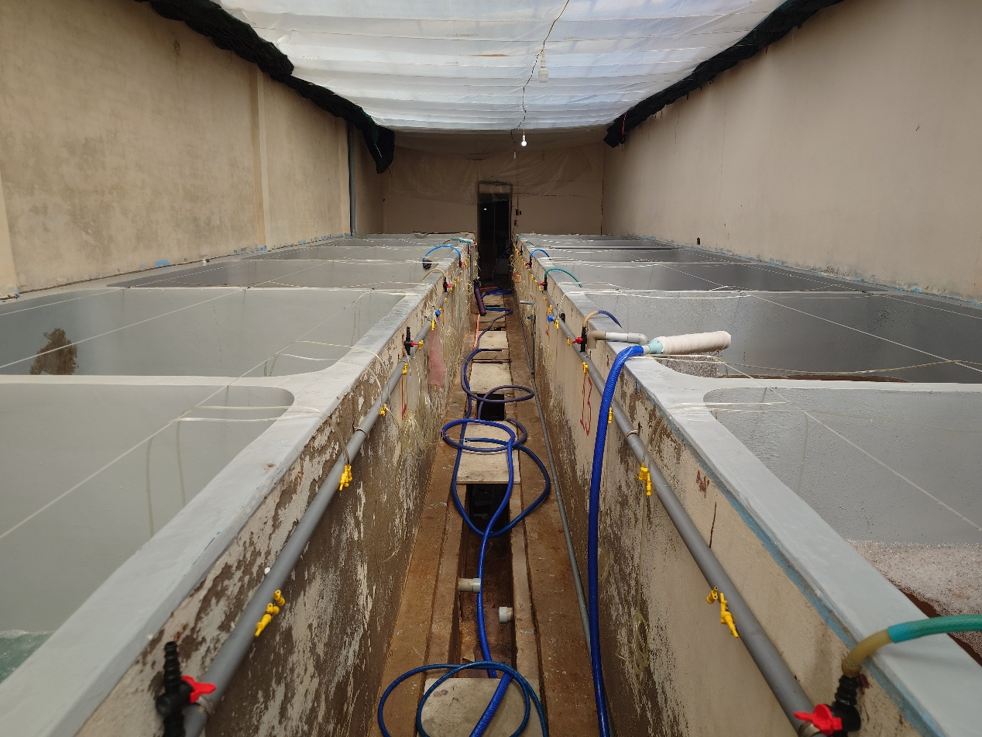
- Climate Services in Vietnam
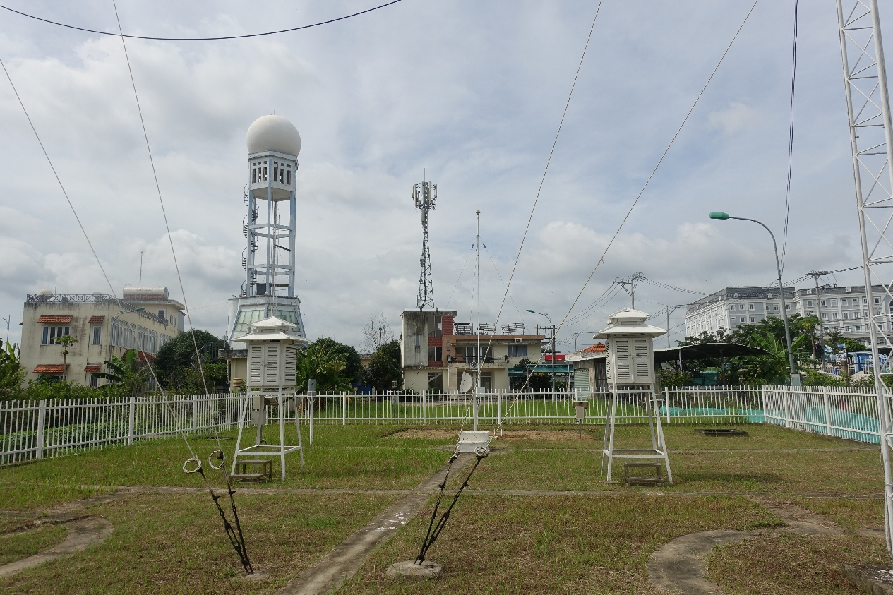
- Climate Smart Agriculture and Coffee Plantation in Vietnam’s Central Highland
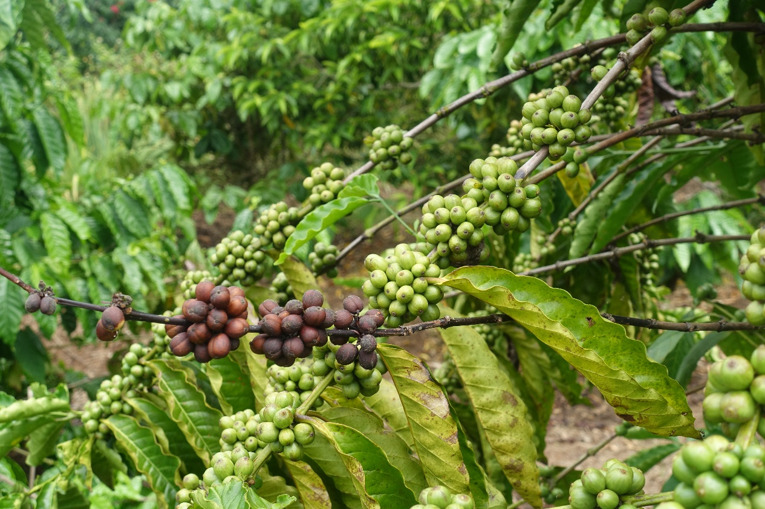
Supervision:
Current Students:
Pin-Han Tsai
Chia-Chien Li
Huỳnh Hà Quốc Việt (Jason)

Alumni
Yan-Ruei Huang
Thesis title: Rethinking Design for Sustainability: A Novel Multi-Objective Optimization Methodology for Sustainable Product Lifecycle Design

Prospective Students: Important Information Before Contacting Me
If you are considering working with me as your supervisor, please read the following guidelines carefully. These points outline my expectations and the preparation required before we arrange a meeting or begin supervision.

1. Develop your own research proposal
I encourage students to formulate their own research ideas. Once you have write a tentative research proposal, I will provide feedback, guidance, and theoretical grounding.

2. Prepare a structured research proposal
Your initial proposal should include research title, research questions, literature review, and methodology.
This does not need to be perfect, but it should demonstrate that you have thought carefully about your topic.

3. Evaluate your timeline
Please assess the time you will need to complete your proposal and ensure that your schedule aligns with your relevant application deadlines. This will help maintain a smooth review process.

4. Read one of my papers
To understand my research orientation, writing style, and theoretical approach, please read at least one of my published papers before contacting me. This allows us to have a more productive conversation and ensures that your proposed topic fits within my areas of expertise.

Contact
Global Change Centre
National Taiwan University
No. 1, Sec. 4, Roosevelt Rd.
Taipei 10617
Taiwan

liaoyk at ntu.edu.tw

個人介紹
廖昱凱
國立臺灣大學氣候變遷與永續發展國際學位學程助理教授
研究興趣：政治生態學、經濟地理、水研究、科技與社會研究、越南研究
[Profile photo here]

研究成果
期刊文章
Liao, Yu-Kai (2025) Shrimp Economies and Hydro-Social Lives in the Capricious and Infrastructuralised Vietnamese Mekong Delta. Water Alternatives. 18(2).
廖昱凱 (2024) 再訪區域地理：越南研究的知識生產。地理學報。109: 37-67。
Liao, Yu-Kai and Jeremy J. Schmidt. (2023) Hydrosocial Geographies: Cycles, Spaces, and Emerging Spheres of Concern. Progress in Environmental Geography, 2(4): 240-265.
Liao, Yu-Kai (2023) Shrimp in Labs: Biosecurity and Hydro-Social Life. Environment and Planning E: Nature and Space, 7(1): 141-165.
Hong, Dong-Li, Shiuh-Shen Chien and Yu-Kai Liao (2020) Green Developmentalism and Trade-offs between Natural Preservation and Environmental Exploitation in China. Environment and Planning E: Nature and Space, 3(3): 688-705.
廖昱凱、簡旭伸(2019) 地理學中的量體轉向：領土立體化、地球物理政治與環境中的情感氛圍。地理學報 92: 1-29。(TSSCI一級期刊，第一作者)
廖昱凱 (2017) 點石成金－事業電子廢棄物與貴金屬回收的市場化分析。地理學報。85: 47-71。
盧鏡臣、周素卿、廖昱凱 (2015) 落差與接軌？從國際發展看台灣的都市氣候治理與研究。都市與計劃。42(1): 7-38。

專書論文
Hsu, Jinn-Yuh and Yu-Kai Liao (2017) Path Dependence. In D. Richardson, N. Castree, M. Goodchild, W. Liu, A. Kobayashi & R. Marston (eds) The Wiley-AAG international encyclopedia of geography. Oxford: Wiley-Blackwell.

書評
廖昱凱 (2023) 書評: Underflows: Queer Trans Ecologies and River Justice. Cleo Woelfle Hazard. 2022. Seattle, United States: University of Washington Press。地理學報。 104: 141-151。
廖昱凱 (2021) 書評：Pamela D. McElwee. Forests Are Gold: Trees, People, and Environmental Rule in Vietnam, Seattle, United States: University of Washington Press, 2016。Journal of Viet Nam Hoc. 2: 52-55.

廖昱凱 (2020) 書評：Viral Economies: Bird Flu Experiments in Vietnam. Natalie Porter. 2019. United States: University of Chicago Press。考古人類學刊。92: 125-132。
廖昱凱 (2020) 書評：常態水與全球敘事：美國水資源管理哲學 評Water: Abundance, Scarcity and Security in the Age of Humanity。科技、醫療與社會。30: 225-238。
廖昱凱 (2016) 書評: Material Politics: Disputes Along the Pipeline. Andrew Barry. 2013. New York, United States: John Wiley & Sons Inc.。地理學報。 80: 81-86。

研究主題:
- 越南湄公河三角洲的蝦子經濟
- 越南氣候服務
- 越南中越高地的氣候智慧型農業與咖啡栽培業
指導學生
目前指導的學生:
蔡秉翰
李家謙
Huỳnh Hà Quốc Việt (Jason)

畢業生:
黃衍瑞
論文題目: 重塑永續產品設計思維： 以多目標最佳化及生命週期評估打造永續產品設計方法學

預計申請碩博士
如果你正在考慮找我指導研究，請先閱讀以下說明。這些內容將幫助你了解我的期待，也能讓我們之後的討論更有效率。

1. 請先自行發展研究構想
我鼓勵學生主動提出自己的研究點子，而不是等待我提供題目。當你完成一份初步的研究計畫後，我會再協助你進一步細化問題、補充理論與方法上的建議。

2. 準備一份基本且有架構的研究計畫
你的初步研究計畫建議包含以下內容：
- 研究題目
- 研究問題
- 相關文獻與背景
- 研究方法
計畫不需非常完整，但應能呈現你已認真思考過自己的研究主題。

3. 請先確認你的時間安排
請評估你需要多少時間來完成研究計畫，並檢查是否能配合相關申請或系所的截止日期。良好的時間規劃有助於後續的討論與審閱。

4. 請先閱讀我至少一篇論文
為了讓你更了解我的研究方向、寫作方式與理論取向，建議在與我聯繫前先讀一篇我已發表的研究。這能讓我們的對話更有焦點，也能幫助你判斷自己的研究是否與我的專長相符。

聯絡方式
10617台北市大安區羅斯福路四段一號全球變遷中心
Email: liaoyk at ntu.edu.tw

