CIVICBIRTH PROJECT DOCUMENTATION
A Production-Ready, Containerized Web Application for Digitizing Birth Registration in Cameroon aligned with UNICEF, World Bank ID4D, and African Union APAI-CRVS standards.

1. README (Project Overview)

1.1 Project Description
CivicBirth is a digital civil registration system designed to enable birth registration in both urban and remote areas of Cameroon. The system supports offline-capable field agents, municipal validation, certificate generation, and international SDG reporting.

1.2 Key Features
- Mobile birth registration
- Offline/online synchronization
- Municipal validation workflow
- QR-code based certificate verification
- Real-time analytics dashboard
- SDG 16.9 reporting

1.3 Installation (Setup Guide)
Backend:
1. git clone https://github.com/your-org/civicbirth
2. cd civicbirth-backend
3. npm install
4. cp .env.example .env
5. npm run dev
Frontend:
1. cd civicbirth-frontend
2. npm install
3. npm run dev
Docker:
docker-compose up --build

1.4 Contribution Guidelines
1. Fork repository
2. Create feature branch
3. Commit changes with clear messages
4. Submit pull request
5. Ensure tests pass before merge

2. API DOCUMENTATION (Swagger Style)

2.1 Authentication
POST /api/auth/login
POST /api/auth/register
GET /api/auth/me

2.2 Birth Registration
POST /api/birth/register - Create birth record
GET /api/birth/{id} - Retrieve record
GET /api/birth/reference/{refNo} - Public lookup

2.3 Validation
GET /api/registrar/pending
POST /api/registrar/validate/{id}
POST /api/registrar/reject/{id}

2.4 Certificates
GET /api/certificate/{id}
GET /api/certificate/verify/{qr}

2.5 Analytics & SDG
GET /api/analytics/dashboard
GET /api/analytics/sdg/16-9

3. USER MANUAL
Field Agents:
- Log in to mobile app
- Register birth using form
- Receive reference number
Parents:
- Enter reference number on portal
- View registration status
Registrars:
- Validate pending records
- Generate certificates
Administrators:
- Manage agents
- View analytics dashboards

4. PROJECT REPORT TEMPLATE
1. Introduction
2. Problem Statement
3. Objectives
4. System Design
5. UML Diagrams
6. Implementation
7. Testing
8. Results
9. Conclusion
10. References

5. UML / USE CASE DIAGRAMS

USE CASE DIAGRAM
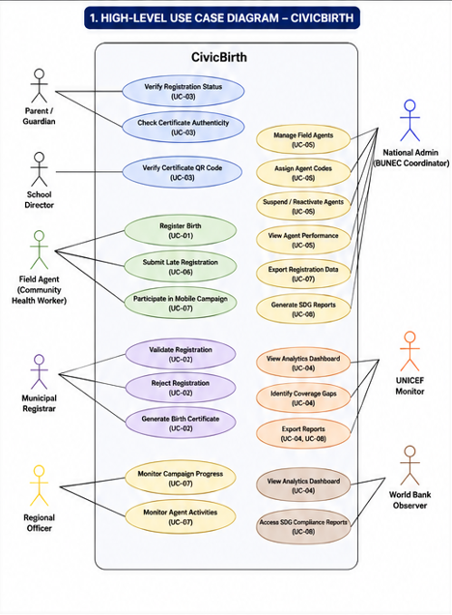

DETAILED USECASE DIAGRAMX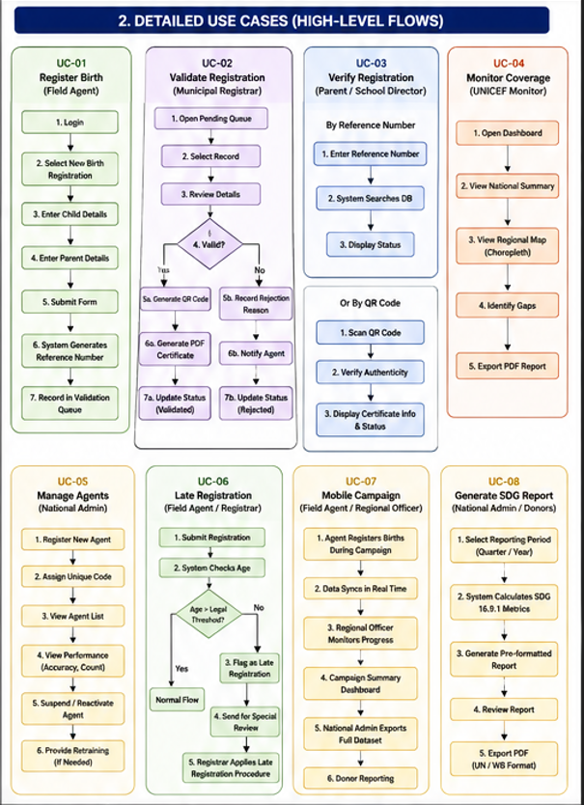

UML CLASS DIAGRAM
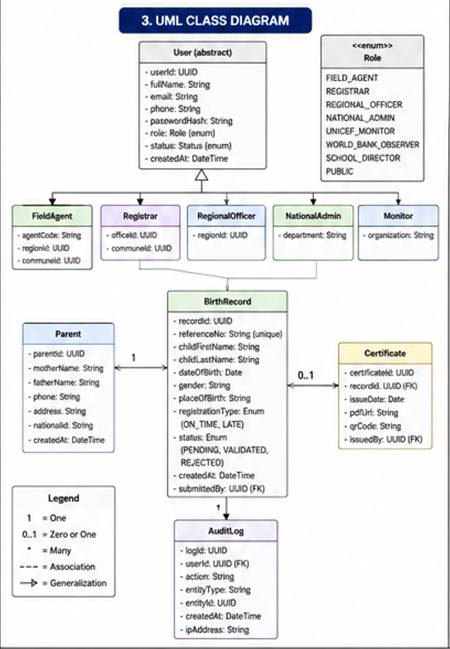

ACTIVITY DIAGRAM
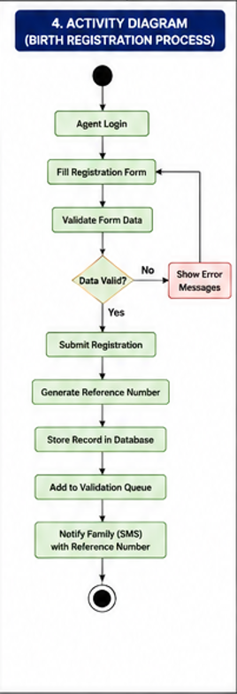

SEQUENCE DIAGRAM
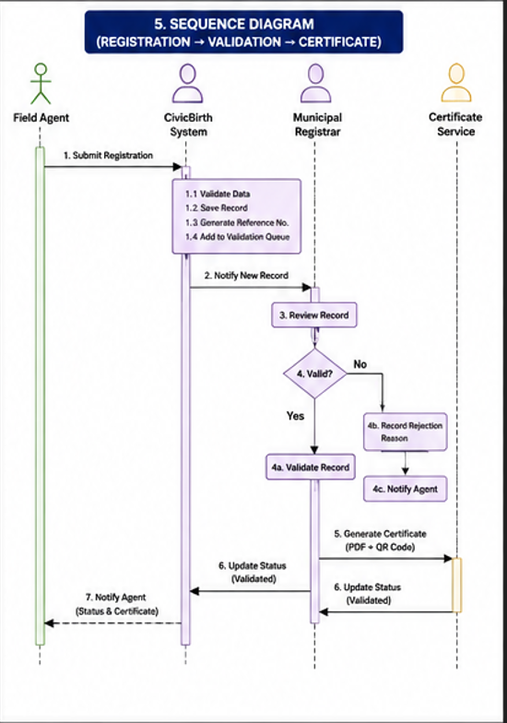

SYSTEM MODULES
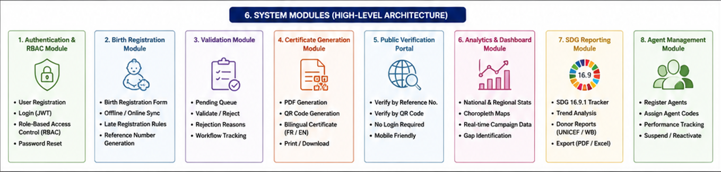

CONCLUSION

CivicBirth represents a comprehensive digital transformation of the civil registration ecosystem in Cameroon. The system successfully addresses the limitations of traditional paper-based registration by introducing a secure, scalable, and interoperable platform.
By integrating mobile data collection, real-time validation, QR-based verification, and automated SDG reporting, the platform significantly enhances efficiency, transparency, and accessibility.
Furthermore, CivicBirth aligns with international development frameworks including UNICEF CRVS standards, World Bank ID4D principles, and African Union APAI-CRVS guidelines. It ensures inclusivity by enabling rural and underserved populations to access legal identity services without geographical or administrative barriers.
In conclusion, CivicBirth is not only a technical solution but also a socio-digital innovation that contributes directly to Sustainable Development Goal 16.9, which aims to provide legal identity for all by 2030. It establishes a strong foundation for a fully digitized, reliable, and future-ready civil registration system in Cameroon.

