An simplified Online Car Rental System

**Introduction**

A simplified on-line business portal (website) for a Car Rental Company: “Hertz-UTS” that develop by using AJAX and XML.

**How to use**

* Install node environment
* Move all files in the root directory to the server, such as Apache, nginx, xampp.
* Open server/config/index.js in the root directory to configure your account, password and SMTP service address, as shown in Fig.1

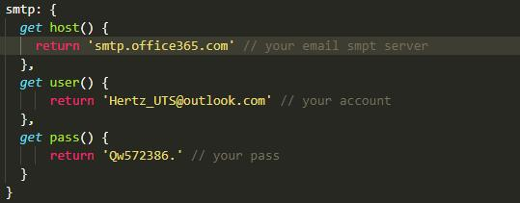

Fig.1 configure your own info

* Open the terminal and enter the server directory under the root directory and use ‘npm run start’ command.

**Implement following Features**

* design data structure using XML schema,“cars.xml”.
* Use AJAX to load the XML file “cars.xml” and extract the data and save it as arrays in your webpage and render the page DOM, as shown in Fig.2

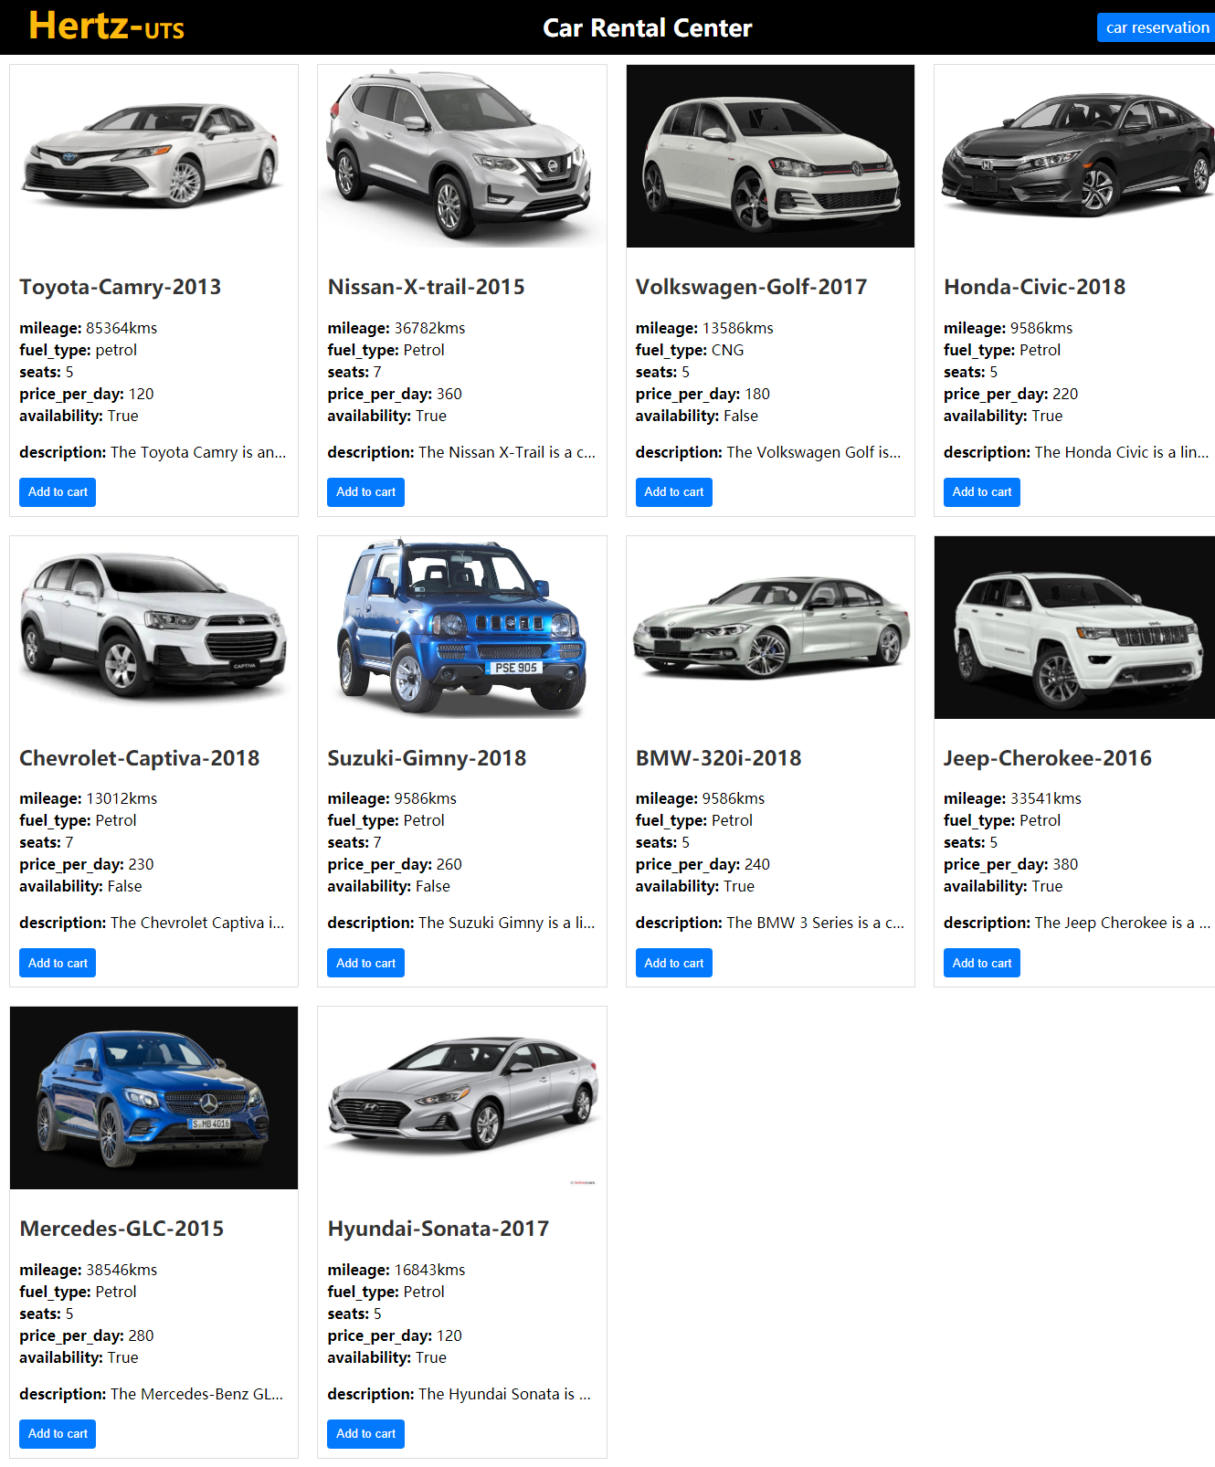

Fig.2. load file and render page

* Use AJAX to check the availability of the car after clicking the “Add to cart” button, as shown in Fig.3

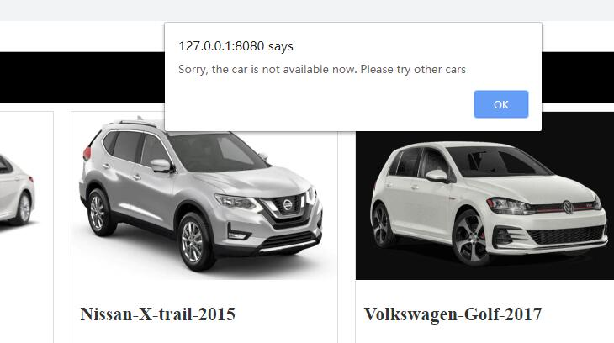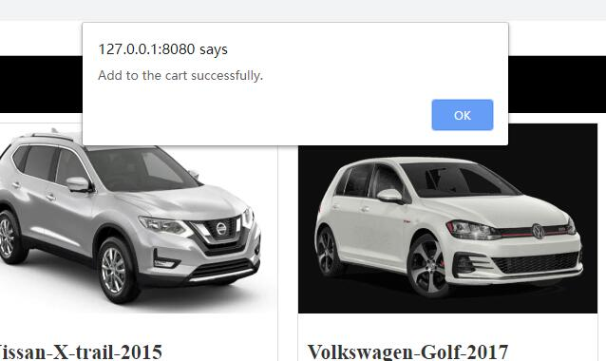

Fig.3

* Click the “car reservation” button to display the cars which have been added into the reservation shopping cart, as shown in Fig.4

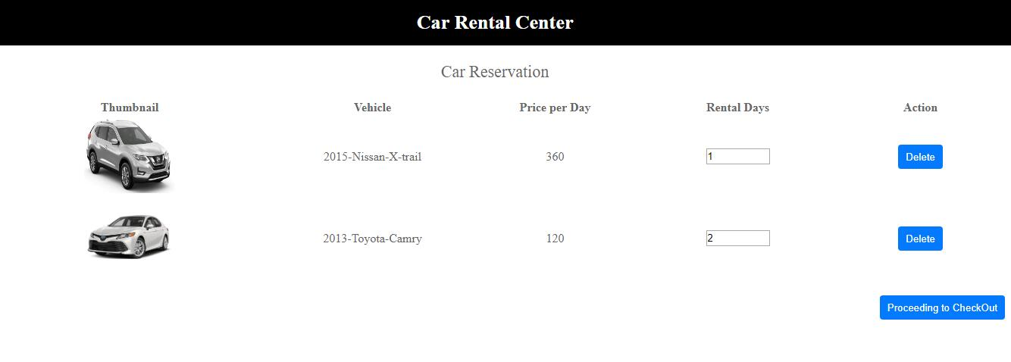

Fig.4

* Users can set the “rent days” or delete cars in the reservation shopping cart
* The “Proceeding to Checkout” button to check if there are cars in the shopping cart, as shown in Fig.5

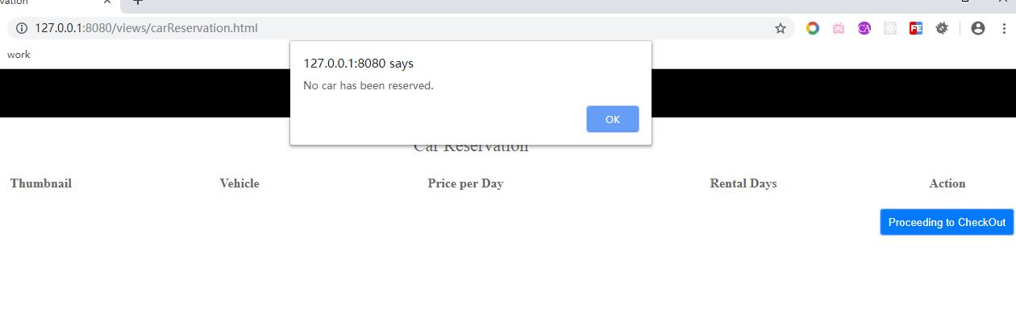

Fig.5

* Design the checkout page which displays a purchase form asking the user to fill in their delivery details, as shown in Fig.6

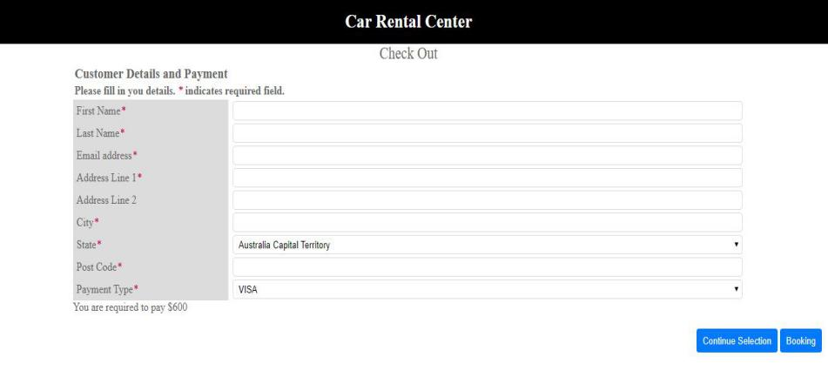

Fig.6

* All these fields must be completed for the order to go ahead, as shown in Fig.7

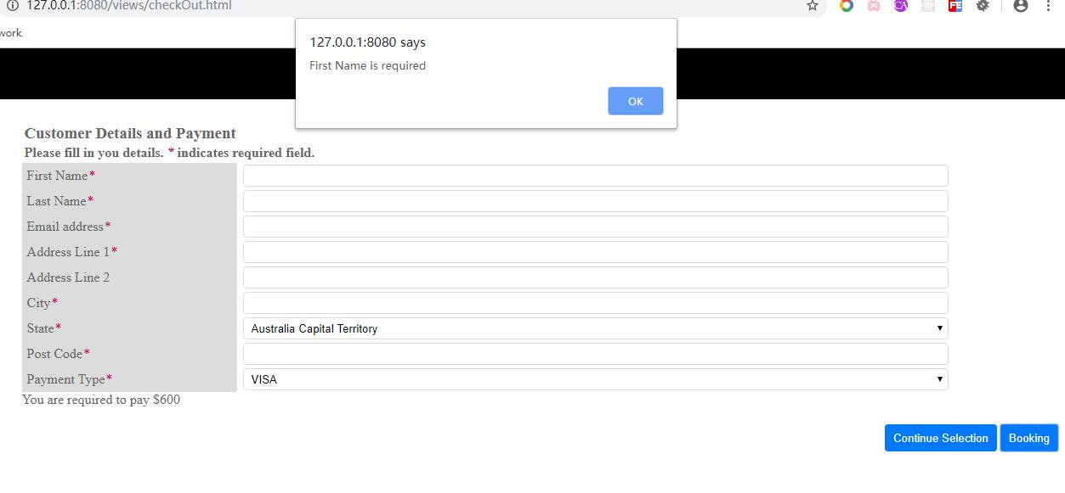

Fig.7

* Validate the format of the email address, as shown in Fig.8

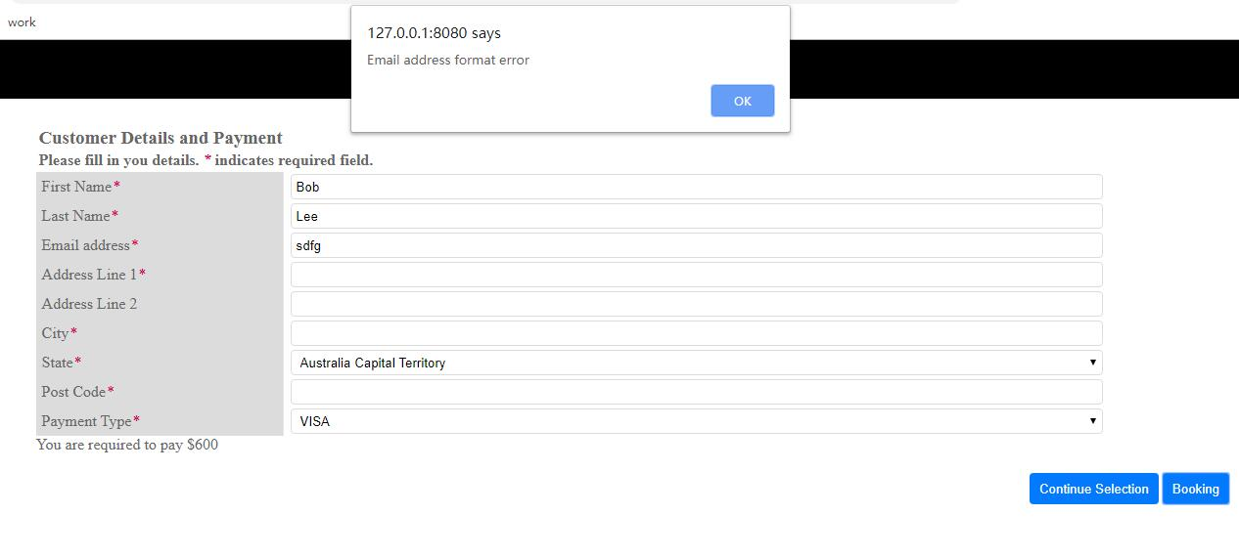

Fig.8

* All details are filled correctly, then send an email to the email address given in the form with the delivery details and the cost, as shown in Fig.9

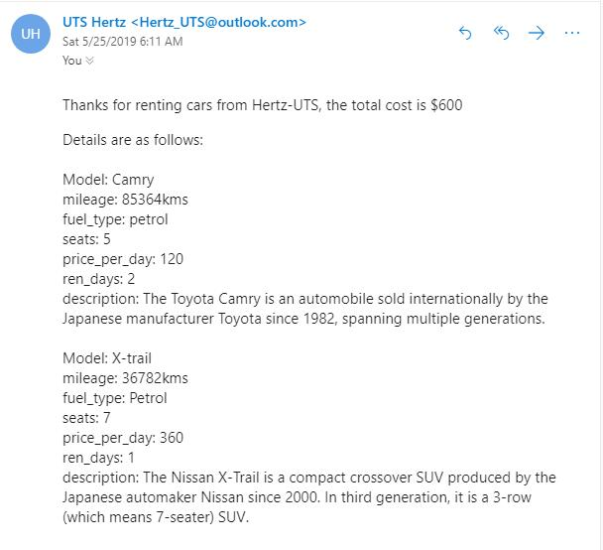

Fig.9