**Payment Receipt** 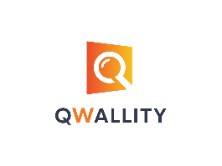

**Company Name Payer**

Qwallity_App {{ username }}

**Phone**

(011) 111 – 1111

|  |  |  |  |
| --- | --- | --- | --- |
| Amount | Date | Payment_Method | Account_Balance |
| {{ amount }} | {{ date }} | {{ payment_method }} | {{ account_balance }} |

*For questions concerning this invoice, please contact*

Qwallity_App - (011) 111-1111