Payment Receipt 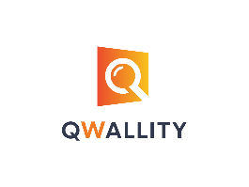
Company Name Payer
Qwallity_App {{ username }}
Phone
(011) 111 – 1111

Amount | Date | Payment_Method | Account_Balance
{{ amount }} | {{ date }} | {{ payment_method }} | {{ account_balance }}

For questions concerning this invoice, please contact
Qwallity_App - (011) 111-1111

