**Clinical Decision Support System:**

A Unique Database Aiding in Physician Decision-Making

By: Brianna Bowman

Kristen Hanten

Summer Peterson

Kaleb Plate

Qianran Wang

Wade Wilhelmi

**Introduction to our Clinical Decision Support System:**

"Clinical Decision Support systems link health observations with health knowledge to influence health choices by clinicians for improved health care” (Hayward, Robert). We have created a Clinical Decision Support System (CDSS) that specifically aides in decision-making for physicians at Birmingham Heart Clinic. As our clinic name suggests, we specialize in diseases and complications of the heart. Physicians of our clinic use the decision support from our system to help diagnose their patients. The majority of the time, physicians use this technology when they are face-to-face with their patient. However, it can also be useful for patient/physician phone calls, which is called telemedicine. Telemedicine requires the patient to describe, in detail, their symptoms so that the physician can use his/her knowledge as well as our database to determine the most-fitting diagnosis/advice. Our support system has the ability to enter up to three symptoms of potential heart complications, click the “search” button, and the system will narrow in on possible diagnoses/diagnosis. CDSS have a number of important benefits, including increased quality of care and enhanced health outcomes, avoidance of errors and adverse events, as well as improved efficiency, cost-benefit, and provider and patient satisfaction. Costs are reduced by improving medical diagnosis and reducing diagnostic errors. Quality is improved by the support system assisting physicians *at the point of care* to aid in analysis and diagnosis of the patient. CDSS provide a platform for integrating evidence-based knowledge into care delivery. Our database is designed to support physicians, not make decisions for them. It is most effectively used in conjunction with doctor expertise.

**As-is and To-be Process Flow Diagrams:**

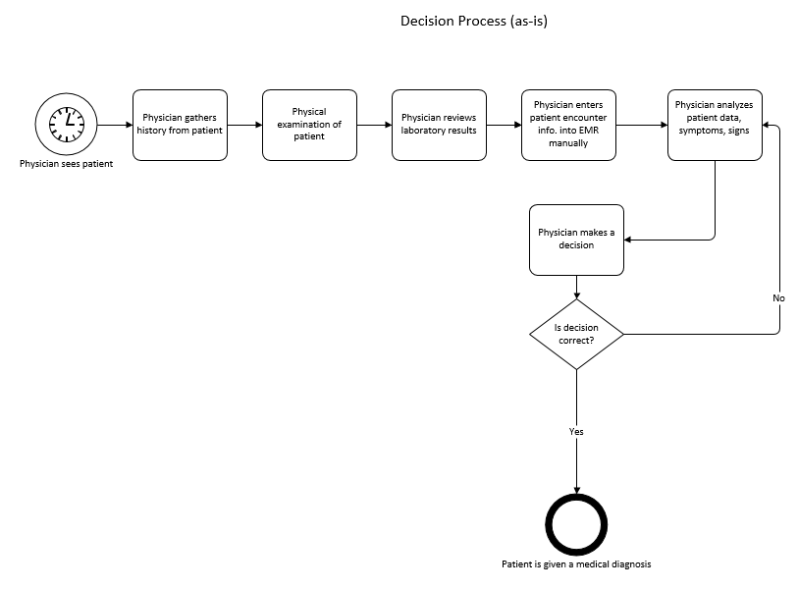

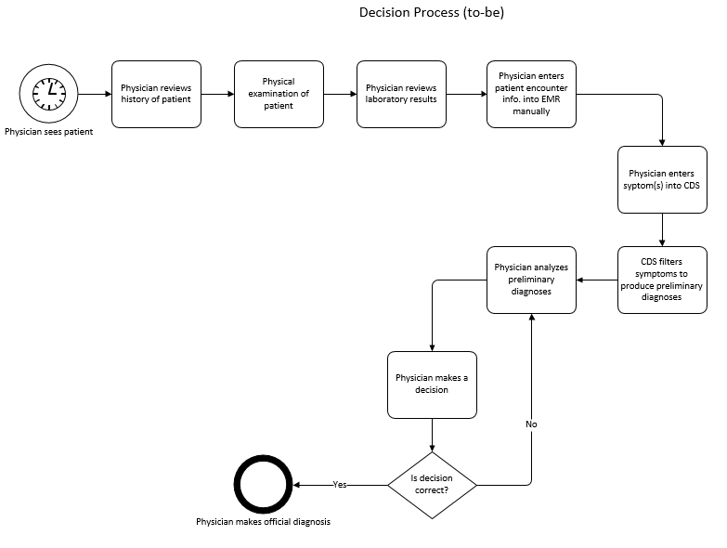

**User Manual**

This database is to be used as part of a heart disease and complications Clinical Decision Support System. The major functions of the CDSS include:

1. Capability of searching for different patients and symptoms in relation to heart disease in order to obtain specified diagnosis;
2. Help to improve and support the accuracy of physician’s diagnosis;
3. Help to coordinate ongoing medical care based on the diagnosis.

**General Information:**

1. Open the database. This will bring you to the main menu with the following buttons: Patient Form, Patient Order Plan, Patient Problem, Encounter Form, View Patient Encounter Form, Physician Form, Search For Patient, Search For Symptoms, and Symptom/Diagnosis Report.
2. Click the desired field (“Search for Symptoms”).
3. Once on the desired page, read the instructions below for the specified form instructions.

Symptoms Search Function (our specialized application):

1. Once inside the Symptoms Search Form, notice there are three symptom search boxes. Here you can enter up to three symptoms that the patient is experiencing.
2. The more symptoms entered, the more specific the diagnosis will be. You can enter these by simply typing one symptom in each specified field (i.e. “Symptom One”).

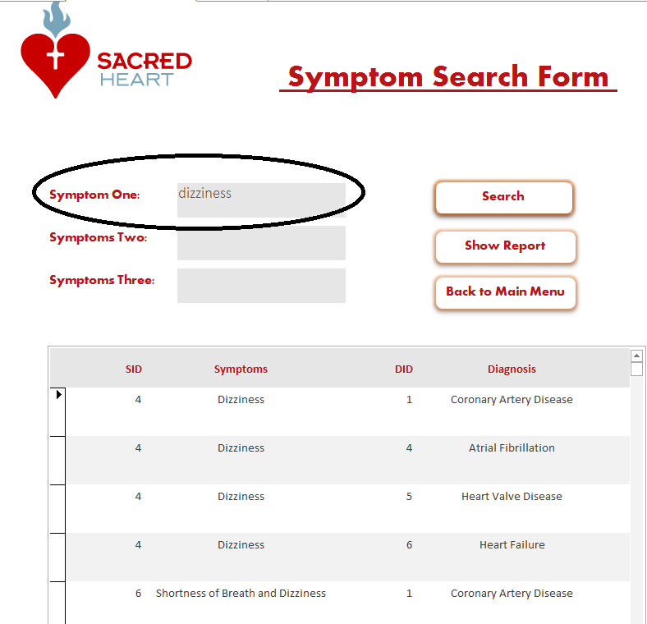

1. Once the diagnoses have been narrowed down, an educated decision can be implemented.
2. If the physician feels that they would like to compare more symptoms to other diagnoses, there is a “Show Report” button available to click on. This will bring up a full list of the systems and diagnoses available for the physician to view.

Symptom/Diagnosis Report:

1. Once inside the Symptom Diagnosis Report, there is a list of symptoms attached to possible diagnoses. From here, it is possible to scroll through and view all them.

Patient Form:

1. Once directed to the patient form, patient information will be listed.
2. From here, there will be different directional buttons which include “previous patient,” “next patient,” “add new patient,” and “delete patient”. Each of these buttons will give you the capability to perform the specified action on the button.

Encounter Form:

1. Once inside the encounter form, encounter information will be available.
2. Users can operate the different directional buttons which include “previous encounter,” “next encounter,” “add new encounter,” and “delete encounter” clicking on them will give the ability to perform the action that is specified on the button.

Patient Search Form

1. This form is ideal for looking up a patient to discover what type of insurance plan he or she is enrolled in.
2. To operate this form, physicians or clerical workers must first enter the first name or last name of a patient in the “Patient First Name” or “Patient Last Name” search boxes.
3. Next, press the “Search” button, which will cause the database to bring up all patient records associated with the name that was entered.
4. Insurance information is retrieved alongside the patient’s picture, helping with filing insurance claims and ensuring the proper patient has been identified.
5. Press the “Show All Patient” button to re-populate the list with all current patients.

Patient Problem Form:

1. Users can utilize the patient problem form to browse through patients and view problem(s) that are associated with each specific patient.
2. In this form, the problem table lists both the ICD code and description for each diagnosis/illness the patient has had. This provides the entire history of illnesses for the patient.

Physician Form:

1. Inside this form, each physician’s information is listed, including their picture, physician ID, first and last name, specialty, and location.
2. The form also allows the user to browse through physicians, add a new physician, delete a physician, and go back to the main menu by clicking on the buttons listed on the bottom of the form.

Patient Order Plan Form:

1. Inside this form, orders relating to each encounter can be found
2. this also includes the patient’s name, their chief complaint, and the specific diagnosis they were given during the encounter. You can cycle through each encounter using the next and previous buttons.

Patient Encounter Form:

1. Within this form, the patients encounter(s) can be seen along with the information pertaining to their encounter(s).
2. You can use the next and previous buttons to cycle through each patient to look at their individual encounter(s).

**Work Distribution Form:**

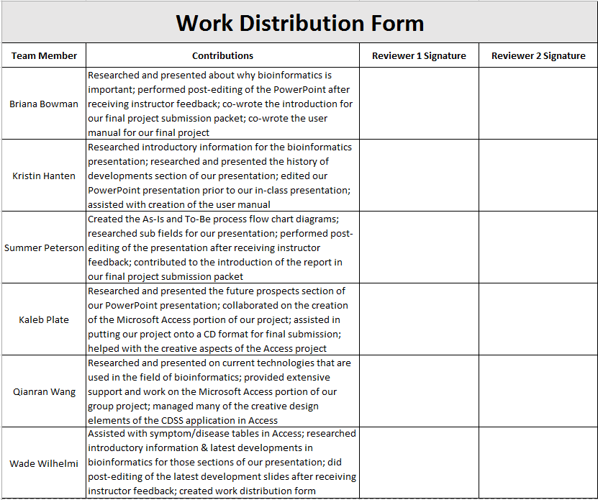



**Symptom Search SQL code:**

**Symptom Search VBA code:**

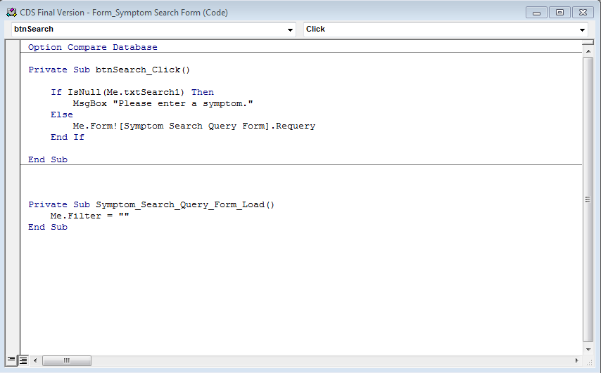

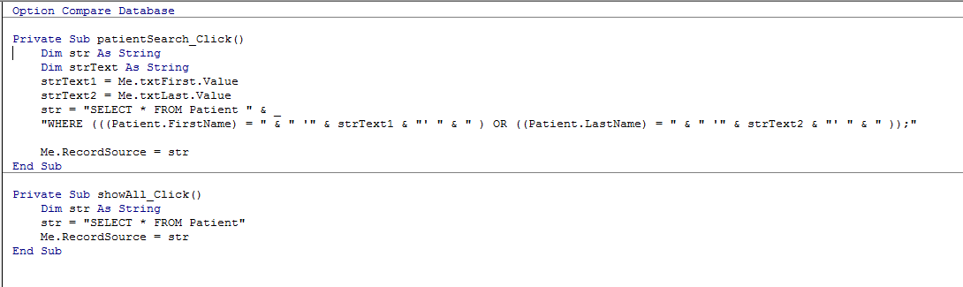**Patient Search VBA code**

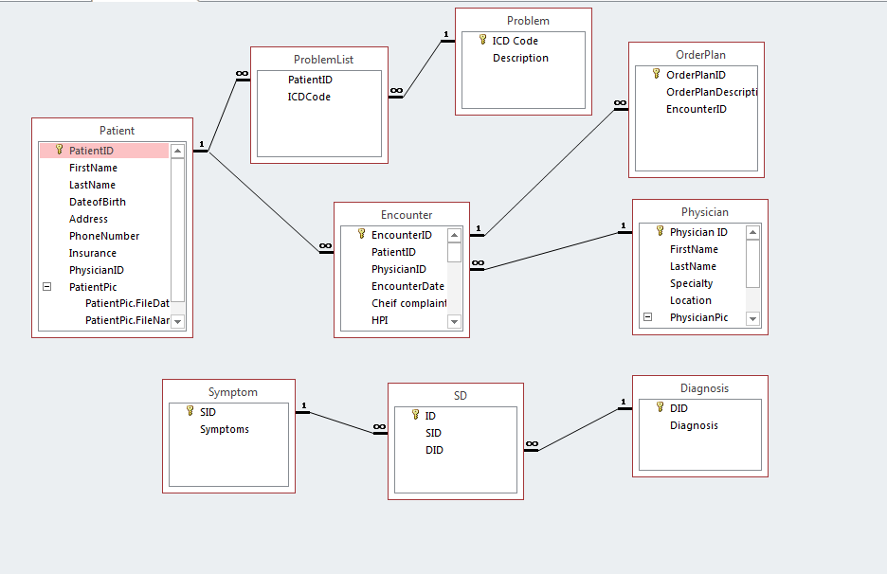**Relationship:**