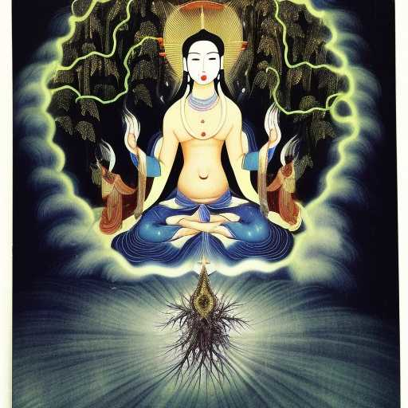
DP

Duōluó Púsà draws me forth from form into the 5th jhana, the great emptiness

She asks me what form of Her
is my Immaculate Conception and She becomes it while blasting through the waterfalls of lightning over the
Eastern horizon of mountaintops

Below... cedars and pines, glowing as a benevolent wisp, as Shakti, forest nymph and angel

