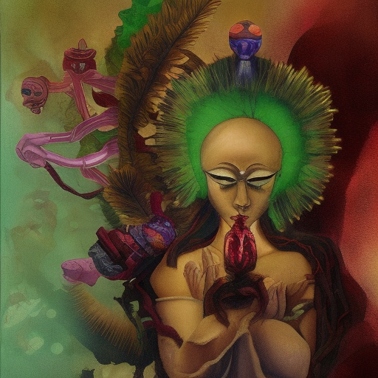
GARUDA

From lungs to mind the breeze of Ruach
Tara smiles
Nyx offers toxic mirths
Sated hedonism, desert penitence
Courage breaks through traps of the sense chase
Half-man, half-bird, the soul longs for ease from duality
Green efforts triumph over envy & jealousy
Beasts at bay with right actions
The generative is comprehended
Double vajra, double work, All-accomplishing

