命令：

dumpsys [service]
Currently running services:
SurfaceFlinger
accessibility
account
activity
alarm
appwidget
audio
…
window

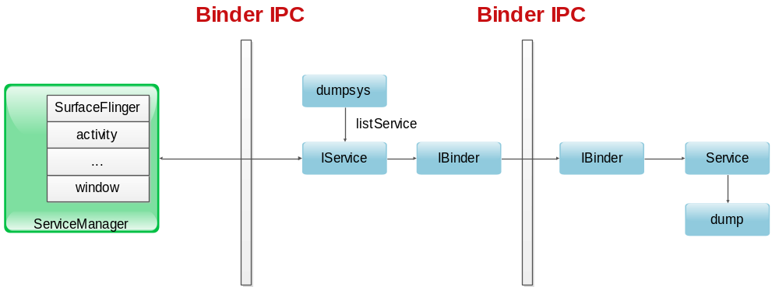
实现方式
dumpsys的代码在mydroid/frameworks/base/cmds/dumpsys/dumpsys.cpp
所有的dump信息都是由重载了Binder中的dump函数的类来完成：
@Override
protected void dump(FileDescriptor fd, PrintWriter pw, String[] args) {
...
}
代码很简单，发现所有dump的信息都是由defaultServiceManager)提供的由系统注册的所有service来提供信息。
以meminfo为例：
它是在mydroid/frameworks/base/services/java/com/android/server/am/ActivityManagerService.java中的setSystemProcess函数处被注册的
SrviceManager.addService("activity", m);
ServiceManager.addService("meminfo", new MemBinder(m));
...
MemBinder->ProcessRecord->各个正在运行状态的ApplicationThread的状态（mydroid/frameworks/base/core/java/android/app/ActivityThread.java），从中得到需要的meminfo信息。

这其中其实牵涉到负责的Android的是如何管理Linux的进程，同时又是如何把Linux的进程管理起来提供各种信息给Java层使用。
总之，关键还是package的管理和它的活动周期的管理问题。值得深入理解。

几个重要信息解析
# dumpsys meminfo
Applications Memory Usage (kB):
Uptime: 55328978 Realtime: 55328249

Total PSS by process:
21652 kB: com.android.systemui (pid 1163)
20865 kB: system (pid 1014)
14615 kB: com.android.launcher (pid 1733)
11652 kB: com.android.soundrecorder (pid 5893)
11617 kB: com.android.settings (pid 1746)
10436 kB: com.google.process.gapps (pid 1193)
9604 kB: com.google.android.gm (pid 1485)
8833 kB: com.google.android.gsf.login (pid 1719)
7474 kB: com.android.phone (pid 1223)
7435 kB: com.android.vending (pid 1380)
7362 kB: android.process.acore (pid 1313)
7026 kB: android.process.media (pid 1258)
6035 kB: com.google.android.talk (pid 1528)
5845 kB: com.android.inputmethod.pinyin (pid 1179)
5411 kB: com.android.providers.calendar (pid 1601)
5397 kB: com.android.calendar (pid 1669)
5006 kB: android:ui (pid 6179)
4923 kB: com.android.gallery3d (pid 1365)
4394 kB: com.android.quicksearchbox (pid 1650)
3792 kB: com.android.provision (pid 1691)
3762 kB: com.android.deskclock (pid 1760)
3538 kB: com.android.smspush (pid 1285)

Total PSS by OOM adjustment:
20865 kB: System
20865 kB: system (pid 1014)
29126 kB: Persistent
21652 kB: com.android.systemui (pid 1163)
7474 kB: com.android.phone (pid 1223)
14615 kB: Foreground
14615 kB: com.android.launcher (pid 1733)
3538 kB: Visible
3538 kB: com.android.smspush (pid 1285)
5845 kB: Perceptible
5845 kB: com.android.inputmethod.pinyin (pid 1179)
11617 kB: Previous
11617 kB: com.android.settings (pid 1746)
101068 kB: Background
11652 kB: com.android.soundrecorder (pid 5893)
10436 kB: com.google.process.gapps (pid 1193)
9604 kB: com.google.android.gm (pid 1485)
8833 kB: com.google.android.gsf.login (pid 1719)
7435 kB: com.android.vending (pid 1380)
7362 kB: android.process.acore (pid 1313)
7026 kB: android.process.media (pid 1258)
6035 kB: com.google.android.talk (pid 1528)
5411 kB: com.android.providers.calendar (pid 1601)
5397 kB: com.android.calendar (pid 1669)
5006 kB: android:ui (pid 6179)
4923 kB: com.android.gallery3d (pid 1365)
4394 kB: com.android.quicksearchbox (pid 1650)
3792 kB: com.android.provision (pid 1691)
3762 kB: com.android.deskclock (pid 1760)

Total PSS by category:
72496 kB: Dalvik
35237 kB: Native
26475 kB: Unknown
23494 kB: .so mmap
19335 kB: .dex mmap
6916 kB: .apk mmap
1655 kB: .ttf mmap
912 kB: Other mmap
88 kB: Other dev
38 kB: Ashmem
16 kB: Cursor
12 kB: .jar mmap
VSS - Virtual Set Size 虚拟耗用内存（包含共享库占用的内存）
RSS - Resident Set Size 实际使用物理内存（包含共享库占用的内存）
PSS - Proportional Set Size 实际使用的物理内存（比例分配共享库占用的内存）
USS - Unique Set Size 进程独自占用的物理内存（不包含共享库占用的内存）
一般来说内存占用大小有如下规律：VSS >= RSS >= PSS >= USS

Total PSS by process 各个进程占用的物理内存，这里主要看的是android进程(java进程)
Total PSS by OOM adjustment OOM 杀进程后，可以要回来的内存
Total PSS by category 按memory使用类型统计内存使用情况

也可以单项看每个进程的memory占比情况。
root@android:/ # dumpsys meminfo 1014
dumpsys meminfo 1014
Applications Memory Usage (kB):
Uptime: 55688807 Realtime: 55688078

** MEMINFO in pid 1014 [system] **
Shared Private Heap Heap Heap
Pss Dirty Dirty Size Alloc Free
------ ------ ------ ------ ------ ------
Native 3176 824 3140 10708 5502 369
Dalvik 8891 6488 8596 11335 10989 346
Cursor 12 0 12
Ashmem 28 24 16
Other dev 4 0 0
.so mmap 2614 1552 868
.jar mmap 0 0 0
.apk mmap 1240 0 0
.ttf mmap 195 0 0
.dex mmap 3155 0 0
Other mmap 94 20 24
Unknown 1512 316 1500
TOTAL 20921 9224 14156 22043 16491 715

Objects
Views: 41 ViewRootImpl: 1
AppContexts: 8 Activities: 0
Assets: 4 AssetManagers: 4
Local Binders: 122 Proxy Binders: 170
Death Recipients: 68
OpenSSL Sockets: 0

SQL
heap: 247 MEMORY_USED: 247
PAGECACHE_OVERFLOW: 52 MALLOC_SIZE: 46

DATABASES
pgsz dbsz Lookaside(b) cache Dbname
1 16 23 2/16/2 accounts.db
1 31 58 215/45/7 settings.db
9/18/6 (pooled # 1) settings.db

Asset Allocations
zip:/system/app/GoogleBackupTransport.apk:/resources.arsc: 14K

每一项的意思
http://stackoverflow.com/questions/2298208/how-to-discover-memory-usage-of-my-application-in-android#2299813

http://source.android.com/tech/input/dumpsys.html

dumpsys diskstats
Latency: 1ms [512B Data Write]
Data-Free: 885180K / 1007896K total = 87% free
Cache-Free: 54800K / 63461K total = 86% free
System-Free: 7108K / 244768K total = 2% free

root@android:/ # dumpsys diskstats
dumpsys diskstats
Latency: 2ms [512B Data Write]
Data-Free: 885040K / 1007896K total = 87% free
Cache-Free: 54800K / 63461K total = 86% free
System-Free: 7108K / 244768K total = 2% free

dumpsys battery
Current Battery Service state:
AC powered: true
USB powered: true
status: 4
health: 2
present: true
level: 100
scale: 100
voltage:4161
temperature: 33
technology: Li-ion

C:\Documents and Settings\shuide.chen>adb shell dumpsys power
Power Manager State:
mIsPowered=true mPowerState=0 mScreenOffTime=50064550 ms
mPartialCount=0
mWakeLockState=
mUserState=
mPowerState=
mLocks.gather=
mNextTimeout=6765736 now=56817946 -50052s from now
mDimScreen=true mStayOnConditions=0 mPreparingForScreenOn=false mSkippedScreenOn=false
mScreenOffReason=3 mUserState=0
mBroadcastQueue={-1,-1,-1}
mBroadcastWhy={0,0,0}
mPokey=0 mPokeAwakeonSet=false
mKeyboardVisible=false mUserActivityAllowed=false
mKeylightDelay=6000 mDimDelay=287000 mScreenOffDelay=7000
mPreventScreenOn=false mScreenBrightnessOverride=-1 mButtonBrightnessOverride=-1
mScreenOffTimeoutSetting=300000 mMaximumScreenOffTimeout=2147483647
mLastScreenOnTime=0
mBroadcastWakeLock=UnsynchronizedWakeLock(mFlags=0x1 mCount=0 mHeld=false)
mStayOnWhilePluggedInScreenDimLock=UnsynchronizedWakeLock(mFlags=0x6 mCount=0 mHeld=false)
mStayOnWhilePluggedInPartialLock=UnsynchronizedWakeLock(mFlags=0x1 mCount=0 mHeld=false)
mPreventScreenOnPartialLock=UnsynchronizedWakeLock(mFlags=0x1 mCount=0 mHeld=false)
mProximityPartialLock=UnsynchronizedWakeLock(mFlags=0x1 mCount=0 mHeld=false)
mProximityWakeLockCount=0
mProximitySensorEnabled=false
mProximitySensorActive=false
mProximityPendingValue=-1
mLastProximityEventTime=0
mLightSensorEnabled=false
mLightSensorValue=-1.0 mLightSensorPendingValue=-1.0
mLightSensorPendingDecrease=false mLightSensorPendingIncrease=false
mLightSensorScreenBrightness=-1 mLightSensorButtonBrightness=-1 mLightSensorKeyboardBrightness=-1
mUseSoftwareAutoBrightness=false
mAutoBrightessEnabled=false
mScreenBrightness: animating=false targetValue=0 curValue=0.0 delta=-10.0

mLocks.size=0:

mPokeLocks.size=0:

不需要打trace了，实时监控关心的关键信息的值，以便debug.
Android的服务基本都有dump信息，debug的利器，效率极高(相比trace和断点调试)
开发、维护人员需要经常使用并熟悉相关的表示
适时扩展dump的输出及格式，方便适时调试。
新增服务及接口，尽量实现此dump功能，以提高debug效率。
常用服务需要掌握调试技巧

