Online Image Description System
Assignment Report

Group project (Group 025) | 7 November 2026

Group members
Name | Student ID
Tang Pok Hin | 58529764
Chan Wing Yam | 60462714
Tang Pok Chun | 60645371

1. Introduction
This report describes the environment setup, running command and testing result of our online image description system. According to the requirements, the system follows a client-server design over one persistent TCP connection, offering functions of file transfer, storage and AI description. It has six available commands {UPLOAD, LIST, DESCRIBE, DOWNLOAD, REMOVE, QUIT}.

2. Runtime environment
Component | Detail
Operating system | Windows 11 (25H2, build 26200), 64-bit
Shell | Windows PowerShell 5.1
Python | 3.11.15 (uv-managed CPython, project-local .venv)
PyTorch | 2.2.2+cpu (CPU wheel backend)
Transformers | 4.49.0
Pillow | 10.4.0
Model | SmolVLM-256M-Instruct, stored locally in models\smolvlm-256m
Environment setup | setup_env.bat (uv 0.10.9, requirements.lock.txt)

The commands used to run the finished system are:
cd image-description-assignment
.\setup_env.bat
.\.venv\Scripts\python.exe ImageDescriptionServer_<student_IDs>.py
# second terminal (same folder):
.\.venv\Scripts\python.exe ImageDescriptionClient_<student_IDs>.py 127.0.0.1 18333

3. Function and command description

3.1 Socket functions
Function | Behaviour implemented
create_listener  (host, port) | Creates an IPv4 (AF_INET) TCP (SOCK_STREAM) socket, enables SO_REUSEADDR, binds to (host, port), listens, and closes the socket again if any step raises OSError before re-raising.
accept_client  (listener) | Blocks until a client connects and returns the pair (conn, address) produced by listener.accept().
receive_message  (conn) | Reads exactly 10 header bytes; returns None when the peer closes the connection between messages. A header that is not 10 ASCII digits raises ValueError('Invalid length header'); a length outside 1..5,242,880 raises ValueError('Message size must be 1 byte to 5 MiB'). The payload is then read with a loop until the declared byte count is reached; if the connection closes first, ConnectionError is raised.
send_message  (conn, payload) | Accepts bytes, bytearray or memoryview only (TypeError otherwise) with a length of 1..5,242,880 bytes (ValueError otherwise). Sends the zero-padded 10-digit ASCII length header followed by the payload with sendall.
close_client  (conn) | Closes the connection socket (no exception on a second close).

3.2 Protocol and storage rules
Messages are framed as a 10-character decimal length header (zero padded) followed by exactly that many bytes. A command message is at most 1024 bytes. File names must be at most 255 characters and must not contain a path separator, a control character, or be '.' or '..'. Accepted images are JPEG or PNG, at most 5 MiB, and at most 20 megapixels; the server stores at most 20 images and 50 MiB in total. Image identifiers are decimal strings (0000, 0001, ...) that are never reused within one run of the server.

3.3 Client commands

Command | Server reply
UPLOAD <filename> + second message with image bytes | OK <id>
LIST | OK, then one line per image: IMAGE ID: <id> | FILE: <name> | TIME: HH:MM:SS | DESCRIPTION: yes|no; or the single line No images
DESCRIBE <id> | OK and a new line with the caption (cached after first use)
DOWNLOAD <id> | OK <filename>, then a second message with the image bytes
REMOVE <id> | OK
QUIT | OK, then the connection is closed
invalid command, id, image, file name or full storage | ERROR - Command not understood | ERROR - Invalid ID | ERROR - Invalid image | ERROR - Invalid filename | ERROR - Image storage is full

4. Test results

The screenshots below were captured on the machine described in Section 2. They show the environment being checked, the server printing its READY line, and a complete interactive session.
Figure 1. The environment check: --check-ai prints a caption for test_images\cat.jpg.
Figure 2. The server window after startup: READY host=0.0.0.0 port=18333.

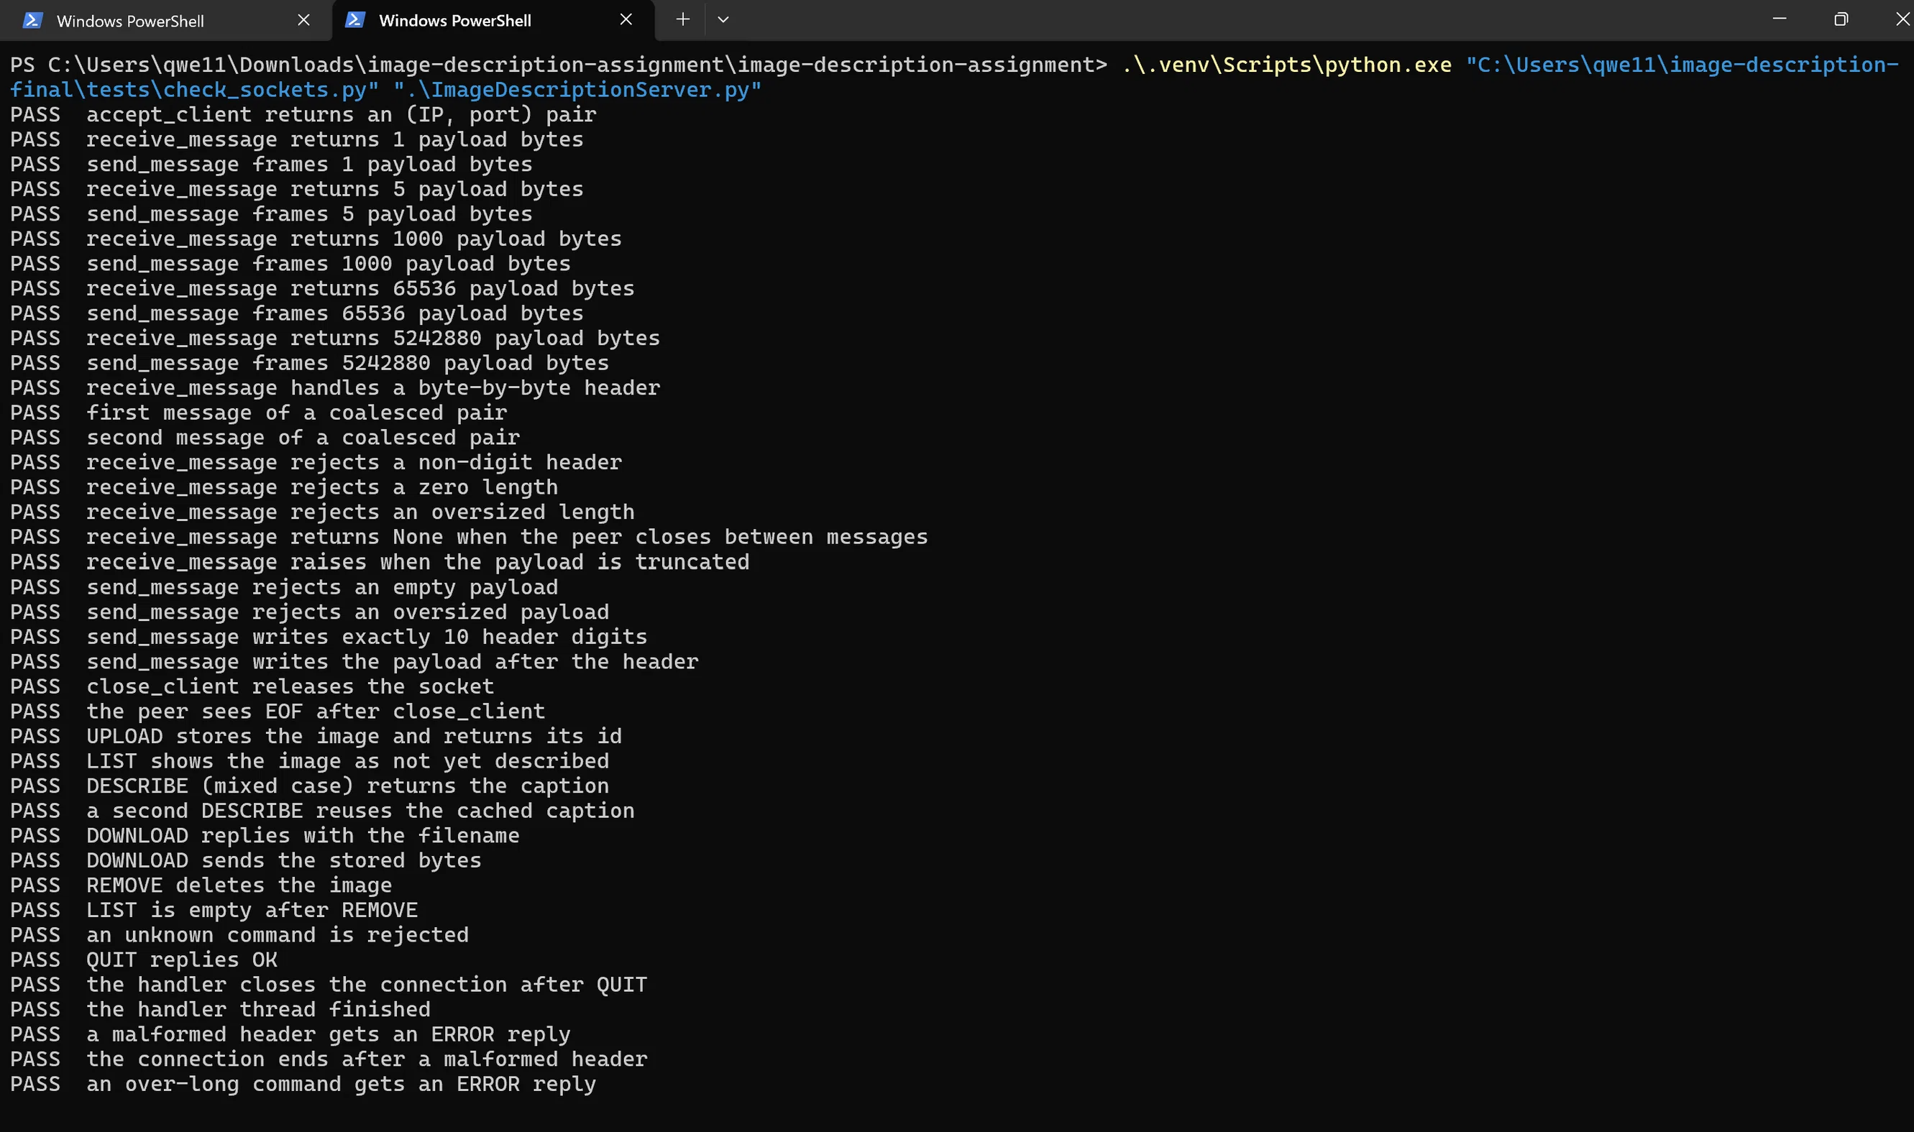
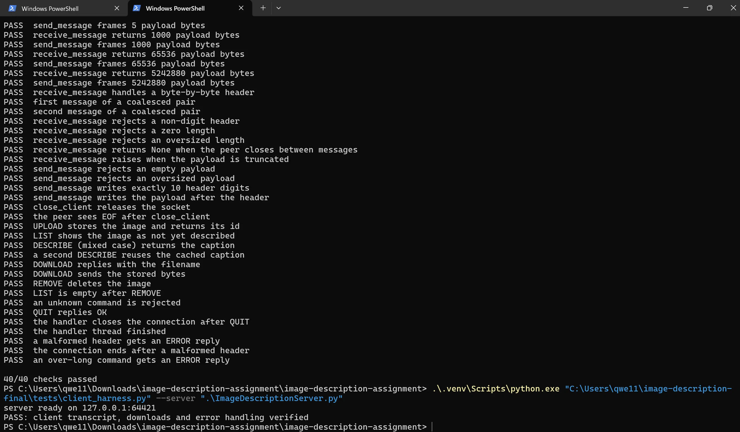
Figure 3.1 and 3.2 test for socket functions
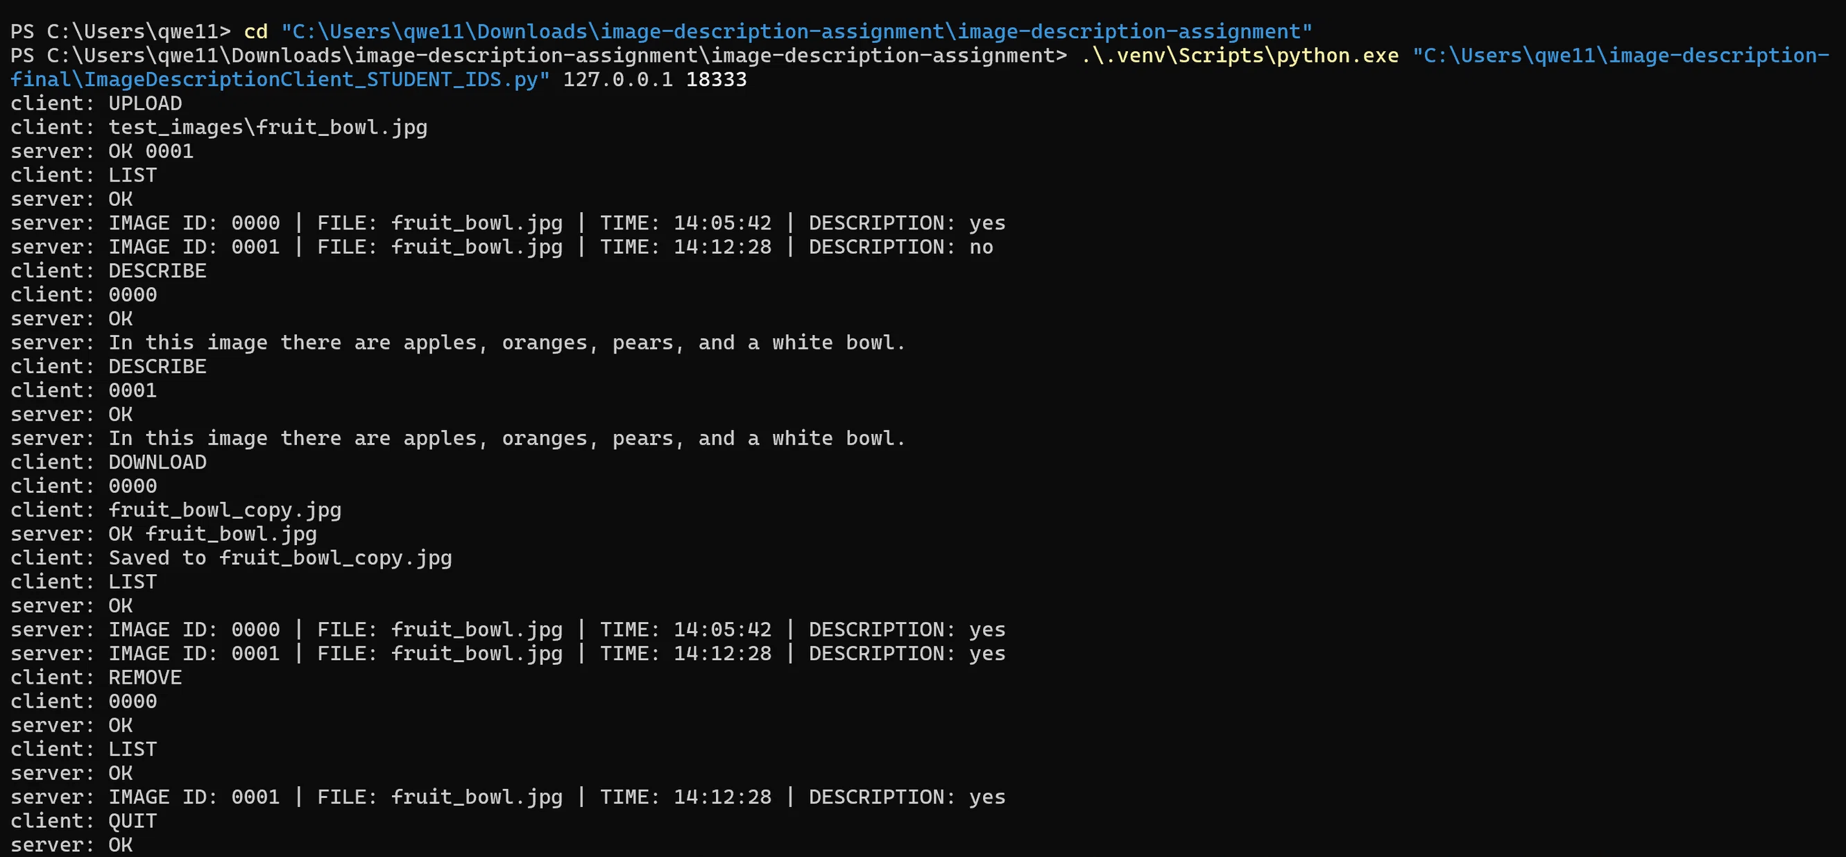
Figure 4 . A complete interactive client session: UPLOAD, LIST, DESCRIBE, DOWNLOAD, REMOVE, QUIT.

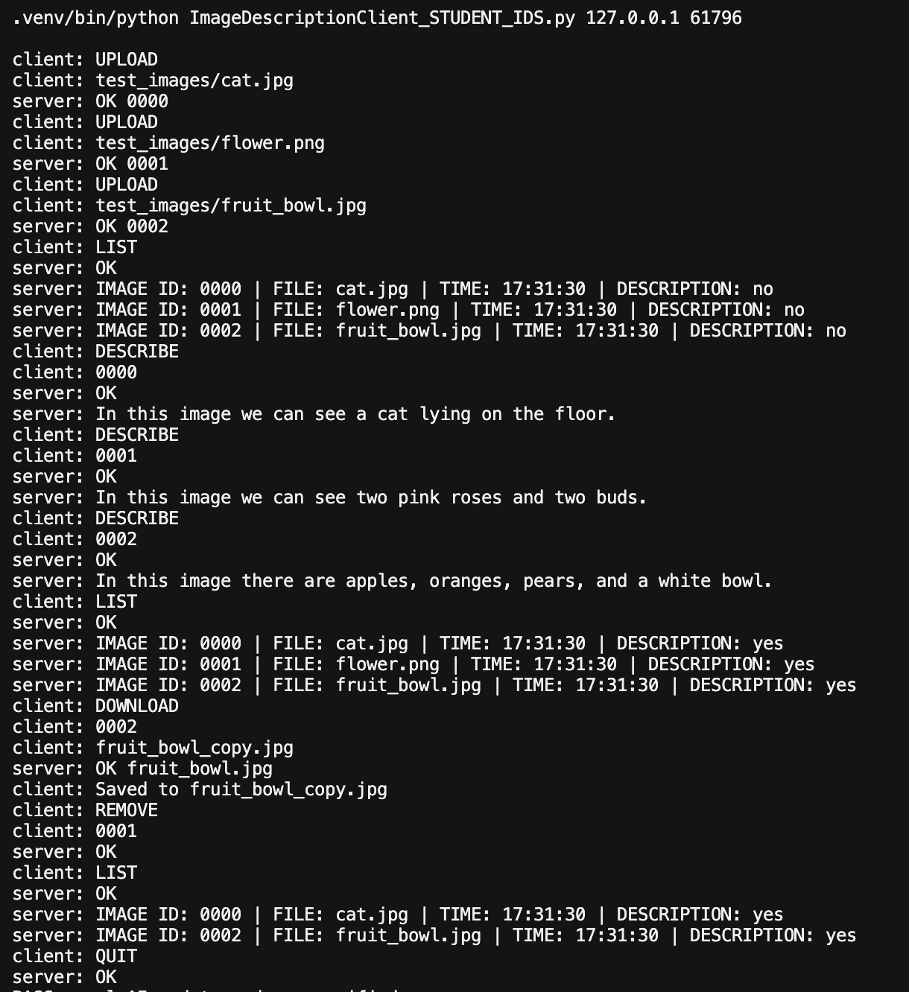
Figure 5. end-to-end run

