**Practical 10**

**Aim: Demonstrate concept of autopost back.**

**Aspx file**

<%@ Page Language="C#" AutoEventWireup="true" CodeBehind="CLOUD.aspx.cs" Inherits="Apple.CLOUD" %>

<!DOCTYPE html>

<html xmlns="http://www.w3.org/1999/xhtml">

<head runat="server">

<title></title>

</head>

<body>

<form id="form1" runat="server">

<div>

&nbsp;&nbsp;&nbsp;&nbsp;&nbsp;&nbsp;&nbsp;&nbsp;&nbsp;&nbsp;&nbsp;&nbsp;&nbsp;&nbsp;&nbsp;&nbsp;

<br />

&nbsp;&nbsp;&nbsp;&nbsp;&nbsp;&nbsp;&nbsp;&nbsp;&nbsp;&nbsp;&nbsp;

<asp:DropDownList ID="ddlFruits" runat="server" AutoPostBack="True" OnSelectedIndexChanged="ddlFruits_SelectedIndexChanged">

<asp:ListItem>Apple</asp:ListItem>

<asp:ListItem>Banana</asp:ListItem>

</asp:DropDownList>

<br />

<br />

<br />

&nbsp;&nbsp;&nbsp;&nbsp;&nbsp;&nbsp;&nbsp;&nbsp;&nbsp;&nbsp;&nbsp;&nbsp;&nbsp;&nbsp;&nbsp;&nbsp;&nbsp;&nbsp;&nbsp;&nbsp;&nbsp;&nbsp;&nbsp;&nbsp;&nbsp;&nbsp;&nbsp;&nbsp;&nbsp;&nbsp;&nbsp;&nbsp;&nbsp;&nbsp;&nbsp;

<asp:Button ID="btnSubmit" runat="server" OnClick="btnSubmit_Click" Text="Submit" />

<br />

<br />

<br />

&nbsp;&nbsp;&nbsp;&nbsp;&nbsp;&nbsp;&nbsp;

<asp:Label ID="lblDisplay" runat="server"></asp:Label>

</div>

</form>

</body>

</html>

**Aspx.cs**

using System;

using System.Collections.Generic;

using System.Linq;

using System.Web;

using System.Web.UI;

using System.Web.UI.WebControls;

namespace Apple

{

public partial class CLOUD : System.Web.UI.Page

{

protected void Page_Load(object sender, EventArgs e)

{

}

protected void btnSubmit_Click(object sender, EventArgs e)

{

}

protected void ddlFruits_SelectedIndexChanged(object sender, EventArgs e)

{

lblDisplay.Text = ddlFruits.SelectedValue;

}

}

}

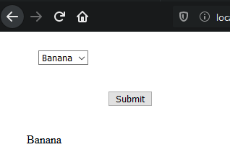

**Practical 11**

**Design ticket enquiry form for a theater. Select location (Mumbai/Pune) using radio button. When user clicks a location, it fills a combo box with names of theaters in that city. When user selects the name of the theatre, the list of films currently shown and their show timings should be displayed in table[Use autopostback].**

**Aspx file**

<%@ Page Language="C#" AutoEventWireup="true" CodeBehind="TicketEnquiry.aspx.cs" Inherits="Apple.TicketEnquiry" %>

<!DOCTYPE html>

<html xmlns="http://www.w3.org/1999/xhtml">

<head runat="server">

<title></title>

</head>

<body>

<form id="form1" runat="server">

<div>

&nbsp;&nbsp;&nbsp;&nbsp;&nbsp;&nbsp;&nbsp;&nbsp;&nbsp;&nbsp;&nbsp;&nbsp;

<asp:RadioButton ID="rdbMumbai" runat="server" AutoPostBack="True" GroupName="a" OnCheckedChanged="rdbMumbai_CheckedChanged" Text="Mumbai" />

&nbsp;&nbsp;&nbsp;&nbsp;&nbsp;&nbsp;&nbsp;&nbsp;&nbsp;&nbsp;&nbsp;&nbsp;&nbsp;&nbsp;&nbsp;&nbsp;&nbsp;&nbsp;

<br />

&nbsp;&nbsp;&nbsp;&nbsp;&nbsp;&nbsp;&nbsp;&nbsp;&nbsp;&nbsp;&nbsp;

<asp:RadioButton ID="rdbPune" runat="server" AutoPostBack="True" GroupName="a" OnCheckedChanged="rdbPune_CheckedChanged" Text="Pune" />

&nbsp;&nbsp;&nbsp;

<br />

<br />

<br />

&nbsp;&nbsp;&nbsp;&nbsp;&nbsp;&nbsp;&nbsp;&nbsp;&nbsp;&nbsp;&nbsp;&nbsp;&nbsp;

<asp:DropDownList ID="ddlTheaters" runat="server" AutoPostBack="True" OnSelectedIndexChanged="ddlTheaters_SelectedIndexChanged">

</asp:DropDownList>

<br />

<br />

&nbsp;&nbsp;&nbsp;&nbsp;&nbsp;&nbsp;&nbsp;&nbsp;&nbsp;&nbsp;&nbsp;&nbsp;

<br />

&nbsp;&nbsp;&nbsp;&nbsp;&nbsp;&nbsp;&nbsp;&nbsp;&nbsp;&nbsp;&nbsp;&nbsp;&nbsp;&nbsp;

<asp:Label ID="lbldisplay" runat="server"></asp:Label>

</div>

</form>

</body>

</html>

**Aspx.cs file**

using System;

using System.Collections.Generic;

using System.Linq;

using System.Web;

using System.Web.UI;

using System.Web.UI.WebControls;

namespace Apple

{

public partial class TicketEnquiry : System.Web.UI.Page

{

protected void Page_Load(object sender, EventArgs e)

{

}

protected void ddlTheaters_SelectedIndexChanged(object sender, EventArgs e)

{

if (ddlTheaters.SelectedValue == "PVR")

{

String str = " ";

str += "<table border=2>";

str += "<tr>";

str += "<td>Movies</td>";

str += "<td>Screen 1</td>";

str += "<td>Screen 2</td>";

str += "</tr>";

str += "<tr>";

str += "<td>Golmaal</td>";

str += "<td>10 to 12</td>";

str += "<td>1 to 3</td>";

str += "</tr>";

str += "</table>";

lbldisplay.Text = str;

}

else if (ddlTheaters.SelectedValue == "Cinemax")

{

String str = "";

str += "<table border=2>";

str += "<tr>";

str += "<td>Movies</td>";

str += "<td>Screen 1</td>";

str += "<td>Screen 2</td>";

str += "</tr>";

str += "<tr>";

str += "<td>Jeene nhi dunga</td>";

str += "<td>10 to 12</td>";

str += "<td>1 to 3</td>";

str += "</tr>";

str += "</table>";

lbldisplay.Text = str;

}

else if (ddlTheaters.SelectedValue == "IMax")

{

String str = "";

str += "<table border=2>";

str += "<tr>";

str += "<td>Movies</td>";

str += "<td>Screen 1</td>";

str += "<td>Screen 2</td>";

str += "</tr>";

str += "<tr>";

str += "<td>Terminator</td>";

str += "<td>10 to 12</td>";

str += "<td>1 to 3</td>";

str += "</tr>";

str += "</table>";

lbldisplay.Text = str;

}

else if(ddlTheaters.SelectedValue=="VRP")

{

String str = "";

str += "<table border=2>";

str += "<tr>";

str += "<td>Movies</td>";

str += "<td>Screen 1</td>";

str += "<td>Screen 2</td>";

str += "</tr>";

str += "<tr>";

str += "<td>Chota Chetan</td>";

str += "<td>10 to 12</td>";

str += "<td>1 to 3</td>";

str += "</tr>";

str += "</table>";

lbldisplay.Text = str;

}

else if (ddlTheaters.SelectedValue == "Growels")

{

String str = "";

str += "<table border=2>";

str += "<tr>";

str += "<td>Movies</td>";

str += "<td>Screen 1</td>";

str += "<td>Screen 2</td>";

str += "</tr>";

str += "<tr>";

str += "<td>Sivaji The Boss</td>";

str += "<td>Kyu Hila Dala Na</td>";

str += "<td>1 to 3</td>";

str += "</tr>";

str += "</table>";

lbldisplay.Text = str;

}

}

protected void rdbMumbai_CheckedChanged(object sender, EventArgs e)

{

ddlTheaters.Items.Clear();

ddlTheaters.Items.Add("PVR");

ddlTheaters.Items.Add("Cinemax");

ddlTheaters.Items.Add("IMax");

ddlTheaters.Items.Add("VRP");

}

protected void rdbPune_CheckedChanged(object sender, EventArgs e)

{

ddlTheaters.Items.Clear();

ddlTheaters.Items.Add("Growels");

ddlTheaters.Items.Add("Cinepolis");

ddlTheaters.Items.Add("Navrang");

ddlTheaters.Items.Add("24 karat");

}

}

}

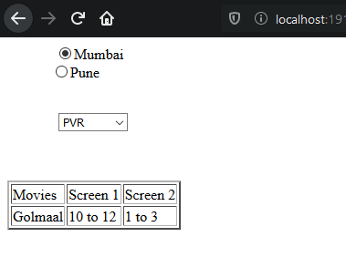

**Practical 12**

**Add validations – name should not be null, age should be within (21 to 100) & Email should be in specific format, password field should not be empty, retype password data should be same as password field.**

**Aspx file**

<%@ Page Language="C#" AutoEventWireup="true" CodeBehind="WebForm2.aspx.cs" Inherits="WebApplication1.WebForm2" %>

<!DOCTYPE html>

<html xmlns="http://www.w3.org/1999/xhtml">

<head runat="server">

<title></title>

</head>

<body>

<form id="form1" runat="server">

<div>

</div>

<asp:Label ID="lblname" runat="server" Text="Name"></asp:Label>

&nbsp;&nbsp;&nbsp;&nbsp;&nbsp;&nbsp;&nbsp;

<asp:TextBox ID="txtName" runat="server" style="margin-left: 20px"></asp:TextBox>

<asp:RequiredFieldValidator ID="RequiredFieldValidator1" runat="server" ControlToValidate="txtName" ErrorMessage="RequiredFieldValidator" ValidationGroup="[a-z A-Z]">name required</asp:RequiredFieldValidator>

<p>

<asp:Label ID="lblage" runat="server" Text="Age"></asp:Label>

&nbsp;&nbsp;&nbsp;&nbsp;&nbsp;&nbsp;&nbsp;

<asp:TextBox ID="txtAge" runat="server" style="margin-left: 31px"></asp:TextBox>

<asp:RangeValidator ID="RangeValidator1" runat="server" ControlToValidate="txtAge" ErrorMessage="Not proper age mentioned" MaximumValue="100" MinimumValue="21" Type="Integer">Age must be within 21-100</asp:RangeValidator>

</p>

<p>

<asp:Label ID="lblid" runat="server" Text="Email-ID"></asp:Label>

&nbsp;&nbsp;&nbsp;&nbsp;&nbsp;&nbsp;&nbsp;

<asp:TextBox ID="txtId" runat="server"></asp:TextBox>

<asp:RegularExpressionValidator ID="RegularExpressionValidator1" runat="server" ControlToValidate="txtId" ErrorMessage="Email is not correct" ValidationExpression="\w+([-+.']\w+)*@\w+([-.]\w+)*\.\w+([-.]\w+)*">Email-id not in correct format</asp:RegularExpressionValidator>

</p>

<asp:Label ID="lblpass" runat="server" Text="Password"></asp:Label>

&nbsp;&nbsp;&nbsp;&nbsp;&nbsp;

<asp:TextBox ID="txtPass" runat="server" TextMode="Password"></asp:TextBox>

<asp:RequiredFieldValidator ID="RequiredFieldValidator2" runat="server" ControlToValidate="txtPass">Password Required</asp:RequiredFieldValidator>

<p>

<asp:Label ID="lblconfirm" runat="server" Text="Confirm"></asp:Label>

&nbsp;&nbsp;&nbsp;

<asp:TextBox ID="txtconfirm" runat="server" style="margin-left: 13px" TextMode="Password"></asp:TextBox>

<asp:CompareValidator ID="CompareValidator1" runat="server" ControlToCompare="txtPass" ControlToValidate="txtconfirm" ErrorMessage="Password is not same">Password does not match</asp:CompareValidator>

</p>

<p style="margin-left: 40px">

<asp:Button ID="btnsubmit" runat="server" Text="SUBMIT" OnClick="btnsubmit_Click" />

</p>

<asp:ValidationSummary ID="ValidationSummary1" runat="server" />

</form>

</body>

</html>

**Aspx.cs file**

using System;

using System.Collections.Generic;

using System.Linq;

using System.Web;

using System.Web.UI;

using System.Web.UI.WebControls;

namespace WebApplication1

{

public partial class WebForm2 : System.Web.UI.Page

{

protected void Page_Load(object sender, EventArgs e)

{

}

protected void btnsubmit_Click(object sender, EventArgs e)

{

}

}

}

**Output:-**

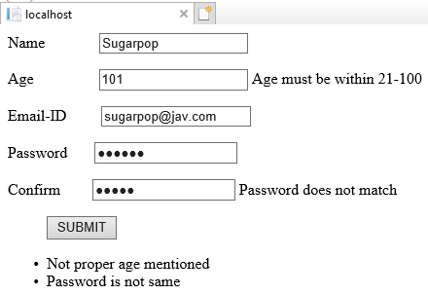

**Practical 13**

**Design ASP.NET page with Rich controls.**

**A. Calendar**

**Aspx file**

<%@ Page Language="C#" AutoEventWireup="true" CodeBehind="RichControls.aspx.cs" Inherits="Vaibhav17.RichControls" %>

<!DOCTYPE html>

<html xmlns="http://www.w3.org/1999/xhtml">

<head runat="server">

<title></title>

</head>

<body>

<form id="form1" runat="server">

<div>

&nbsp;<asp:Calendar ID="Calendar1" runat="server" BackColor="White" BorderColor="Black" BorderStyle="Solid" CellSpacing="1" Font-Names="Verdana" Font-Size="9pt" ForeColor="Black" Height="250px" NextPrevFormat="ShortMonth" OnSelectionChanged="Calendar1_SelectionChanged" Width="330px">

<DayHeaderStyle Font-Bold="True" Font-Size="8pt" ForeColor="#333333" Height="8pt" />

<DayStyle BackColor="#CCCCCC" />

<NextPrevStyle Font-Bold="True" Font-Size="8pt" ForeColor="White" />

<OtherMonthDayStyle ForeColor="#999999" />

<SelectedDayStyle BackColor="#333399" ForeColor="White" />

<TitleStyle BackColor="#333399" BorderStyle="Solid" Font-Bold="True" Font-Size="12pt" ForeColor="White" Height="12pt" />

<TodayDayStyle BackColor="#999999" ForeColor="White" />

</asp:Calendar>

<br />

<asp:Label ID="Label1" runat="server" Text="Label"></asp:Label>

&nbsp;&nbsp;&nbsp;&nbsp;&nbsp;&nbsp;&nbsp;&nbsp;&nbsp;&nbsp;&nbsp;&nbsp;&nbsp;&nbsp;&nbsp;

<asp:Label ID="Label2" runat="server" Text="Label"></asp:Label>

</div>

</form>

</body>

</html>

**Aspx.cs file**

using System;

using System.Collections.Generic;

using System.Linq;

using System.Web;

using System.Web.UI;

using System.Web.UI.WebControls;

namespace Vaibhav17

{

public partial class RichControls : System.Web.UI.Page

{

protected void Page_Load(object sender, EventArgs e)

{

}

protected void Calendar1_SelectionChanged(object sender, EventArgs e)

{

Label1.Text = Calendar1.TodaysDate.ToShortDateString();

Label2.Text = Calendar1.SelectedDate.ToShortDateString();

}

}

}

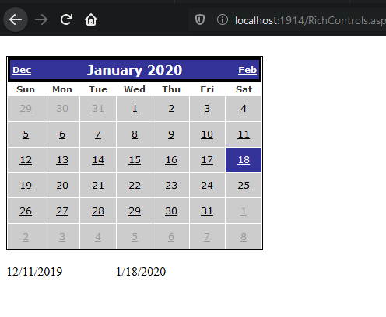

**B).AD Rotator**

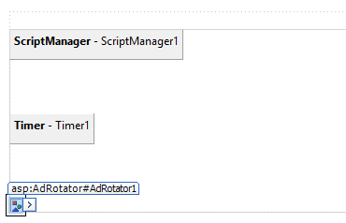

<%@ Page Language="C#" AutoEventWireup="true" CodeBehind="Rotator.aspx.cs" Inherits="Vaibhav17.Rotator" %>

<!DOCTYPE html>

<html xmlns="http://www.w3.org/1999/xhtml">

<head runat="server">

<title></title>

</head>

<body>

<form id="form1" runat="server">

<div>

&nbsp;&nbsp;

<asp:UpdatePanel ID="UpdatePanel1" runat="server">

<ContentTemplate>

<asp:ScriptManager ID="ScriptManager1" runat="server">

</asp:ScriptManager>

<br />

<br />

<br />

<asp:Timer ID="Timer1" runat="server" Interval="600">

</asp:Timer>

<br />

<br />

<br />

<asp:AdRotator ID="AdRotator1" runat="server" AdvertisementFile="~/AddFile1.xml" />

</ContentTemplate>

</asp:UpdatePanel>

</div>

</form>

</body>

</html>

**XML file**

<?xml version="1.0" encoding="utf-8" ?>

<Advertisements>

<Ad>

<ImageUrl>~/Images/1.jpg</ImageUrl>

<AlternateText>img1</AlternateText>

</Ad>

<Ad>

<ImageUrl>~/Images/2.jpg</ImageUrl>

<AlternateText>img2</AlternateText>

</Ad>

<Ad>

<ImageUrl>~/Images/3.jpg</ImageUrl>

<AlternateText>img3</AlternateText>

</Ad>

</Advertisements>

**Output:-**



**Practical 14**

**Design ASP.NET Pages for State Management using**

**A. Cookies**

**Cookie1aspx.cs file**

using System;

using System.Collections.Generic;

using System.Linq;

using System.Web;

using System.Web.UI;

using System.Web.UI.WebControls;

namespace WebApplication1

{

public partial class WebForm3 : System.Web.UI.Page

{

protected void Page_Load(object sender, EventArgs e)

{

}

protected void Button1_Click(object sender, EventArgs e)

{

HttpCookie mycookie = new HttpCookie("studentdata");

mycookie["name"] = TextBox1.Text;

mycookie["rollno"] = TextBox2.Text;

Response.Cookies.Add(mycookie);

lblDisplay.Text = "Cookies Created";

Response.Redirect("cookies2.aspx");

HttpCookie c = Request.Cookies["studentdata"];

if(c!= null)

{

lblDisplay.Text = c["name"].ToString();

}

else

{

lblDisplay.Text = "no !";

}

}

}

}

**Cookie2aspx.cs file**

using System;

using System.Collections.Generic;

using System.Linq;

using System.Web;

using System.Web.UI;

using System.Web.UI.WebControls;

namespace WebApplication1

{

public partial class c : System.Web.UI.Page

{

protected void Page_Load(object sender, EventArgs e)

{

HttpCookie c = Request.Cookies["studentdata"];

if (c != null)

{

Label1.Text = c["name"].ToString();

}

else

{

Label1.Text = "no !";

}

}

}

}

**Output:-**

**a)**

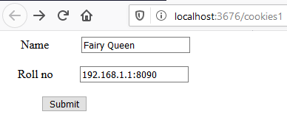

**b)**

