# Practical 19:

# Aim:Design ASP.NET application to query a Database (Build-in/Internal Database). Perform Insert, Update, Delete, Select, Search operations:

# Site1.master

<%@ Master Language="C#" AutoEventWireup="true" CodeBehind="Site1.master.cs" Inherits="WebApplication3.Site1" %>

<!DOCTYPE html>

<html xmlns="http://www.w3.org/1999/xhtml">

<head runat="server">

<title></title>

<asp:ContentPlaceHolder ID="head" runat="server">

</asp:ContentPlaceHolder>

</head>

<body>

<form id="form1" runat="server">

<div>

<asp:ContentPlaceHolder ID="ContentPlaceHolder1" runat="server">

</asp:ContentPlaceHolder>

</div>

<asp:Button ID="Button1" runat="server" PostBackUrl="~/Insert.aspx" Text="Insert" />

&nbsp;&nbsp;&nbsp;&nbsp;&nbsp;&nbsp;&nbsp;

<asp:Button ID="Button2" runat="server" PostBackUrl="~/Display.aspx" Text="Display" />

&nbsp;&nbsp;&nbsp;&nbsp;&nbsp;&nbsp;&nbsp;

<asp:Button ID="Button3" runat="server" PostBackUrl="~/Update.aspx" Text="Update" />

&nbsp;&nbsp;&nbsp;&nbsp;&nbsp;&nbsp;&nbsp;

<asp:Button ID="Button4" runat="server" PostBackUrl="~/Search.aspx" Text="Search" />

&nbsp;&nbsp;&nbsp;&nbsp;&nbsp;&nbsp;&nbsp;

<asp:Button ID="Button5" runat="server" PostBackUrl="~/Delete.aspx" Text="Delete" />

</form>

</body>

</html>

**Insert.aspx**

<%@ Page Title="" Language="C#" MasterPageFile="~/Site1.Master" AutoEventWireup="true" CodeBehind="Insert.aspx.cs" Inherits="WebApplication3.WebForm2" %>

<asp:Content ID="Content1" ContentPlaceHolderID="head" runat="server">

</asp:Content>

<asp:Content ID="Content2" ContentPlaceHolderID="ContentPlaceHolder1" runat="server">

<p>

&nbsp;Roll no : &nbsp;<asp:TextBox ID="txtRollno" runat="server" Height="22px" Width="131px"></asp:TextBox>

</p>

<p>

&nbsp;Name :&nbsp;<asp:TextBox ID="txtName" runat="server"></asp:TextBox>

</p>

<p>

&nbsp;&nbsp;&nbsp;&nbsp;&nbsp;&nbsp;&nbsp;&nbsp;&nbsp;&nbsp;&nbsp;&nbsp; &nbsp;<asp:Button ID="btnSubmit" runat="server" Text="Submit" OnClick="btnSubmit_Click" style="height: 26px" />

</p>

<p>

<asp:Label ID="lblDisplay" runat="server"></asp:Label>

</p>

</asp:Content>

**Insert.aspx.cs**

using System;

using System.Collections.Generic;

using System.Linq;

using System.Web;

using System.Web.UI;

using System.Web.UI.WebControls;

using System.Data.SqlClient;

namespace WebApplication3

{

public partial class WebForm2 : System.Web.UI.Page

{

protected void btnSubmit_Click(object sender, EventArgs e)

{

SqlConnection con = new SqlConnection(@"Data Source=(LocalDB)\MSSQLLocalDB;AttachDbFilename=|DataDirectory|\Mydb.mdf;Integrated Security=True");

con.Open();

String query = "insert into Student values('" + txtRollno.Text + "','" + txtName.Text + "')";

SqlDataAdapter sda = new SqlDataAdapter(query, con);

sda.SelectCommand.ExecuteNonQuery();

con.Close();

lblDisplay.Text = "Record inserted successfuly"; **Output:**

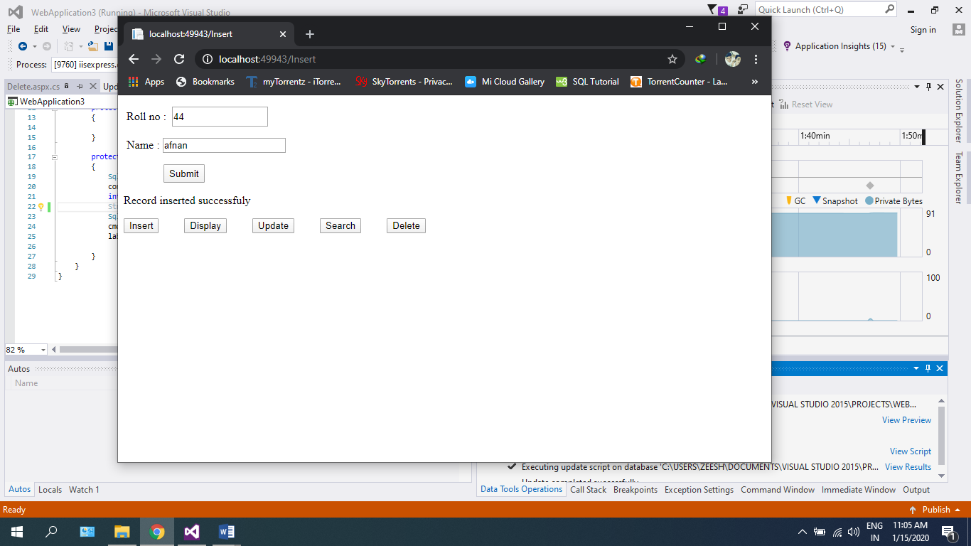

}

}

}

**Display.aspx**

<%@ Page Title="" Language="C#" MasterPageFile="~/Site1.Master" AutoEventWireup="true" CodeBehind="Display.aspx.cs" Inherits="WebApplication3.display" %>

<asp:Content ID="Content1" ContentPlaceHolderID="head" runat="server"></asp:Content>

<asp:Content ID="Content2" ContentPlaceHolderID="ContentPlaceHolder1" runat="server">

<asp:GridView ID="GridView1" runat="server" AutoGenerateColumns="False" DataKeyNames="Id" DataSourceID="SqlDataSource1">

<Columns>

<asp:BoundField DataField="Id" HeaderText="Id" ReadOnly="True" SortExpression="Id" />

<asp:BoundField DataField="name" HeaderText="name" SortExpression="name" />

</Columns>

</asp:GridView>

<asp:SqlDataSource ID="SqlDataSource1" runat="server" ConnectionString="Data Source=(LocalDB)\MSSQLLocalDB;AttachDbFilename=|DataDirectory|\Mydb.mdf;Integrated Security=True" ProviderName="System.Data.SqlClient" SelectCommand="SELECT * FROM [Student]"></asp:SqlDataSource>

</asp:Content>

**Display.aspx.cs**

using System;

using System.Collections.Generic;

using System.Linq;

using System.Web;

using System.Web.UI;

using System.Web.UI.WebControls;

using System.Data.SqlClient;

using System.Data;

using System.Configuration;

namespace WebApplication3

{

public partial class display : System.Web.UI.Page

{

protected void Page_Load(object sender, EventArgs e)

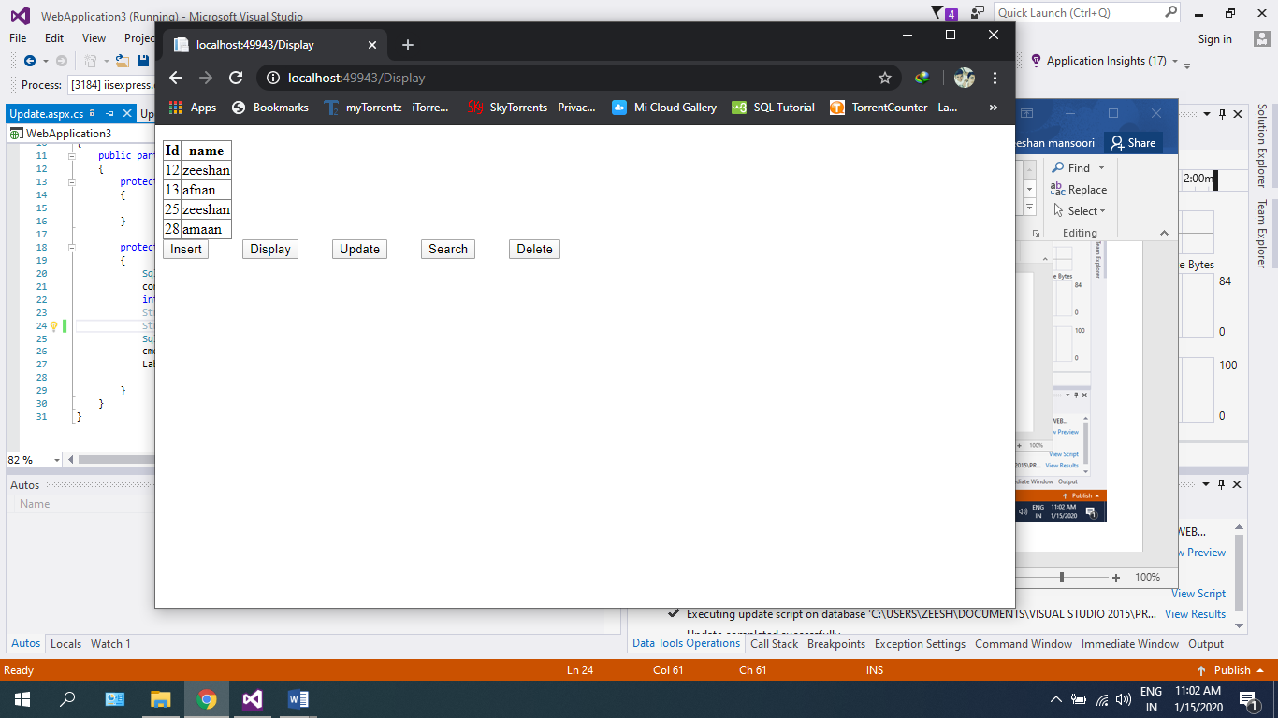 { **Output:**

}

}

}

**Update.aspx**

<%@ Page Title="" Language="C#" MasterPageFile="~/Site1.Master" AutoEventWireup="true" CodeBehind="Update.aspx.cs" Inherits="WebApplication3.search" %>

<asp:Content ID="Content1" ContentPlaceHolderID="head" runat="server">

</asp:Content>

<asp:Content ID="Content2" ContentPlaceHolderID="ContentPlaceHolder1" runat="server">

<p>&nbsp;Roll no : &nbsp;<asp:TextBox ID="txtRollno" runat="server"></asp:TextBox></p>

<p>&nbsp; New Name :&nbsp; <asp:TextBox ID="txtName" runat="server"></asp:TextBox></p>

<p>&nbsp;&nbsp;&nbsp;&nbsp;&nbsp;&nbsp;&nbsp;&nbsp;&nbsp;&nbsp;&nbsp;&nbsp; &nbsp;<asp:Button ID="Button6" runat="server" Text="Submit" OnClick="Button6_Click" /></p>

<asp:Label ID="Label1" runat="server"></asp:Label>

<p&nbsp;&nbsp;&nbsp;&nbsp; &nbsp;</p>

</asp:Content>

**Output:**

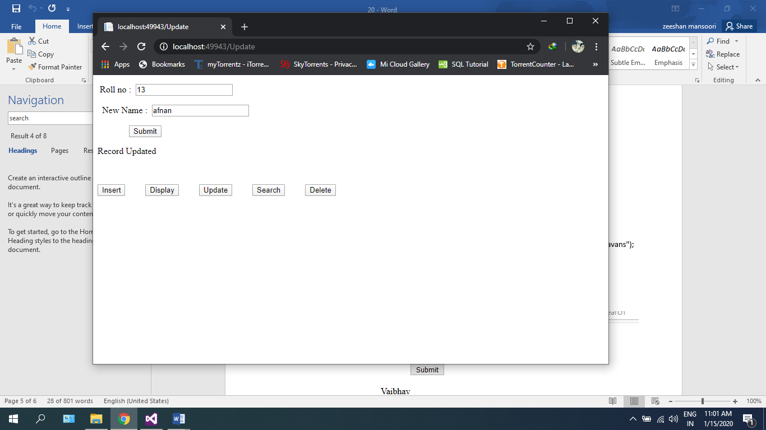**Update.aspx.cs**

using System;

using System.Collections.Generic;

using System.Linq;

using System.Web;

using System.Web.UI;

using System.Web.UI.WebControls;

using System.Data.SqlClient;

namespace WebApplication3

{

public partial class search : System.Web.UI.Page

{

protected void Button6_Click(object sender, EventArgs e)

{

SqlConnection con = new SqlConnection(@"Data Source=(LocalDB)\MSSQLLocalDB;AttachDbFilename=|DataDirectory|\Mydb.mdf;Integrated Security=True");

con.Open();

int rn = Int32.Parse(txtRollno.Text);

String name = txtName.Text;

String query = "update Student set name='"+name+"' where id="+rn+";";

SqlCommand cmd = new SqlCommand(query, con);

cmd.ExecuteNonQuery();

Label1.Text = "Record Updated";

}

}

}

**Delete.aspx**

<%@ Page Title="" Language="C#" MasterPageFile="~/Site1.Master" AutoEventWireup="true" CodeBehind="Delete.aspx.cs" Inherits="WebApplication3.delete" %>

<asp:Content ID="Content1" ContentPlaceHolderID="head" runat="server">

</asp:Content>

<asp:Content ID="Content2" ContentPlaceHolderID="ContentPlaceHolder1" runat="server">

<p>&nbsp;Roll no : &nbsp;<asp:TextBox ID="TextBox1" runat="server"></asp:TextBox></p>

<p>&nbsp;&nbsp;&nbsp;&nbsp;&nbsp;&nbsp;&nbsp;&nbsp;&nbsp;&nbsp;&nbsp;&nbsp; &nbsp;<asp:Button ID="Button6" runat="server" Text="Submit" OnClick="Button6_Click" />

</p>

<p><asp:Label ID="label1" runat="server"></asp:Label></p>

</asp:Content>

**Delete.aspx.cs**

using System;

using System.Collections.Generic;

using System.Linq;

using System.Web;

using System.Web.UI;

using System.Web.UI.WebControls;

using System.Data.SqlClient;

namespace WebApplication3

{

public partial class delete : System.Web.UI.Page

{

protected void Button6_Click(object sender, EventArgs e)

{

SqlConnection con = new SqlConnection(@"Data Source=(LocalDB)\MSSQLLocalDB;AttachDbFilename=|DataDirectory|\Mydb.mdf;Integrated Security=True");

con.Open();

int rn = Int32.Parse(TextBox1.Text);

String query = "delete from Student where id="+rn+";";

SqlCommand cmd = new SqlCommand(query, con); **Output:**

cmd.ExecuteNonQuery();

label1.Text = "Record Deleted";

}

}

