How to Set Up a Mount & Blade: Warband Dedicated Server on CentOS

June 16, 2015 by Michael Douse (9posts) under Cloud Hosting
1 Comment

Verified and Tested 04/27/15

Introduction
In this article, we will go over how to set up a Mount & Blade: Warband dedicated server in a freshly provisioned CentOS 6.5 cloud server.

Prerequisites
-You will need to provision a CentOS 6.5 (64 bit) VPS.
-If you do not have a server, consider a CentOS server from Atlantic.Net. The Recommended plan for this game is the Medium plan.

Install Mount & Blade: Warband dedicated server on CentOS
First we will need to install the EPEL repository:
yum install epel-release -y
Now update system packages and EPEL database:
yum update -y
And finally, all the required packages:
yum install tmux nano wine unzip wget -y
Note: Wine will take several minutes to install so be patient.

Now to open up the require ports in the firewall. The default ports needed for steam and non-steam users are 7240 and 7241. Let us open these up in IPtables:
nano /etc/sysconfig/iptables
Add the following lines before the REJECT rules:
-A INPUT -p tcp --match multiport --dports 7240,7241 -j ACCEPT
-A INPUT -p udp --match multiport --dports 7240,7241 -j ACCEPT
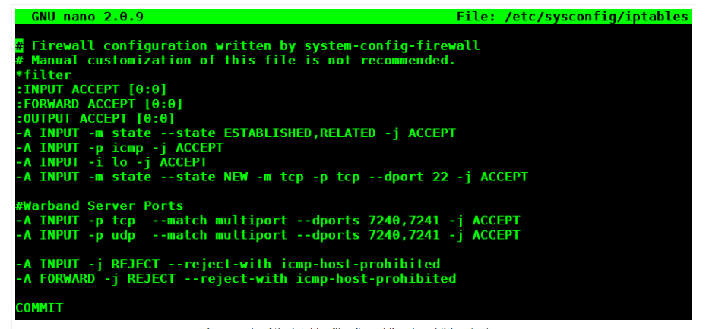
An example of the iptables file after adding the additional rules.
Once you are done, save your changes and exit from nano with CTRL O + Enter, and CTRL X.
Then restart IPtables:
service iptables restart
Verify that the rules are in place:
iptables -L
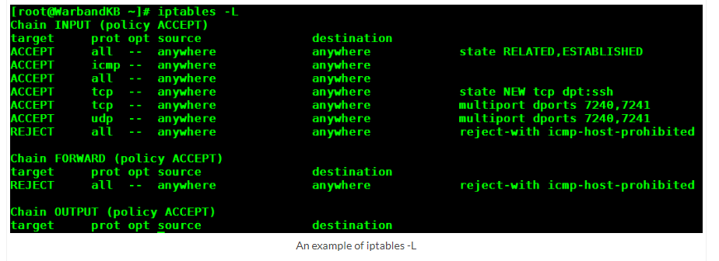
An example of iptables -L
That’s it for the firewall configuration.

Time to create a separate user for the dedicated server. Call this user what ever you wish, but for the sake of this how-to, I will be using “Warband”:
useradd Warband
passwd Warband
Now let’s change to the home folder of the user we just created and make a directory for our server files:
su Warband
cd
mkdir Warband_Server
cd Warband_Server
Download the Warband dedicated server files to the Warband_Server directory we just created. The most recent dedicated server can be found HERE under the “Other Downloads” section.
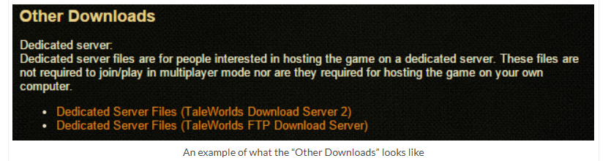
An example of what the “Other Downloads” looks like
We can “wget” the zipped file by right-clicking on the link and selecting “Copy Link Address” (For Chrome) or “Copy Shortcut” (For Internet Explorer):
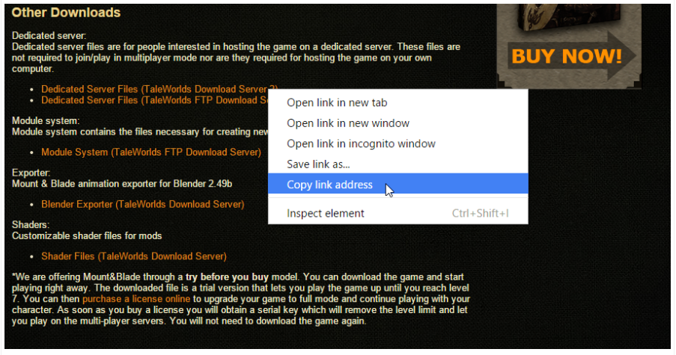
Getting the link to download so that we can wget it on the server.
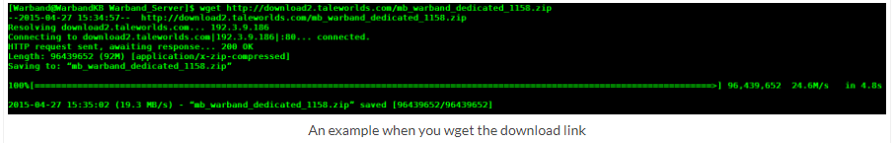
An example when you wget the download link
Now that we have the dedicated server files, we will need to unzip them:
unzip mb_warband_dedicated_1158.zip
Change into the Warband directory you just unzipped. You may need to use TAB to fill out the actual directory name:
cd Mount\&Blade\ Wardband\ Dedicated/
Inside you will find many sample server configuration templates to use. The easiest thing to do is edit one of the pre-existing templates. After deciding what kind of game mode you want to host, open it with nano:
nano Sample_Team_Deathmatch.txt
Review this file for applicable settings. The first changes you will want to make are:
#set_pass_admin ADMINPASS
#set_server_name SERVERNAME
#set_welcome_message WELCOME MESSAGE
Remove the “#” and add the appropriate changes to the admin password, server name, and welcome message. Also, keep in mind that the server name cannot have spaces or special characters in it. If you need to create a space, then use an underscore.
NOTE: You can find additional commands to add to this file from the readme.txt. For instance, I highly recommend adding the following line:
set_control_block_direction 1
If set to 1, blocking will have to be done manually by a mouse. Otherwise, directional blocking will be automatic… and that’s no fun.
One you are done, save your changes and exit from nano with CTRL O + Enter, and CTRL X.

Now let’s take a minute to discuss the TMUX package we installed earlier.
At this point, we are ready to run the dedicated server, but once we start it from the current terminal session, it will stop once we disconnect/exit from the session. This is where TMUX comes in. TMUX allows us to create a “Window” to run other applications in. This allows us to quit our current terminal session while leaving the window open to run whatever service we choose. For a better understanding of TMUX, see HERE.
Note: TMUX is what is referred to as a Terminal Multiplexer. The most popular alternative to TMUX is SCREEN. Both of which have very loyal user bases. It is a matter of preference on which one you decide to use.

Open a new window:
tmux
Now start the dedicated server with Wine. Make sure you are still in the dedicated server files directory when you run this:
wineconsole --backend=curses Sample_Team_Deathmatch_start.bat
Note: Each game mode template has an associated “.bat” file. Run the one that corresponds to the template you edited.
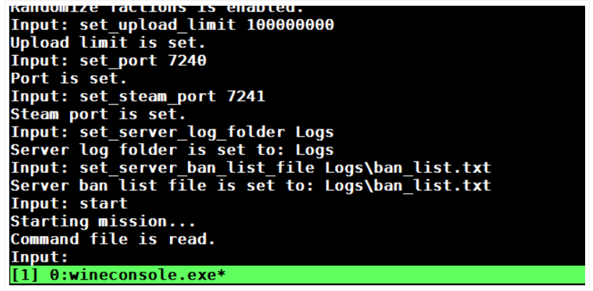
An example of the wineconsole.exe
Once the dedicated server is finished loading, you can close the window with CTRL B + D.
Note: You can re-open any active TMUX sessions with the “tmux attach” command.

Now check to make sure that the server is still running with the “top” command:
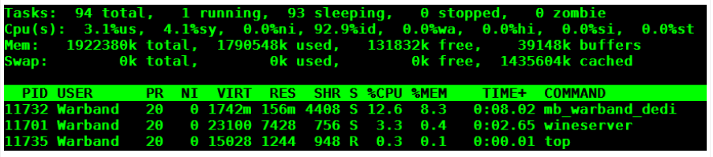
An example of top
Now go join your server!
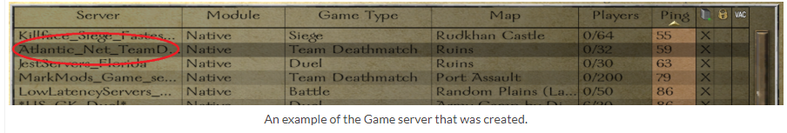
An example of the Game server that was created.

