配置入口函数：
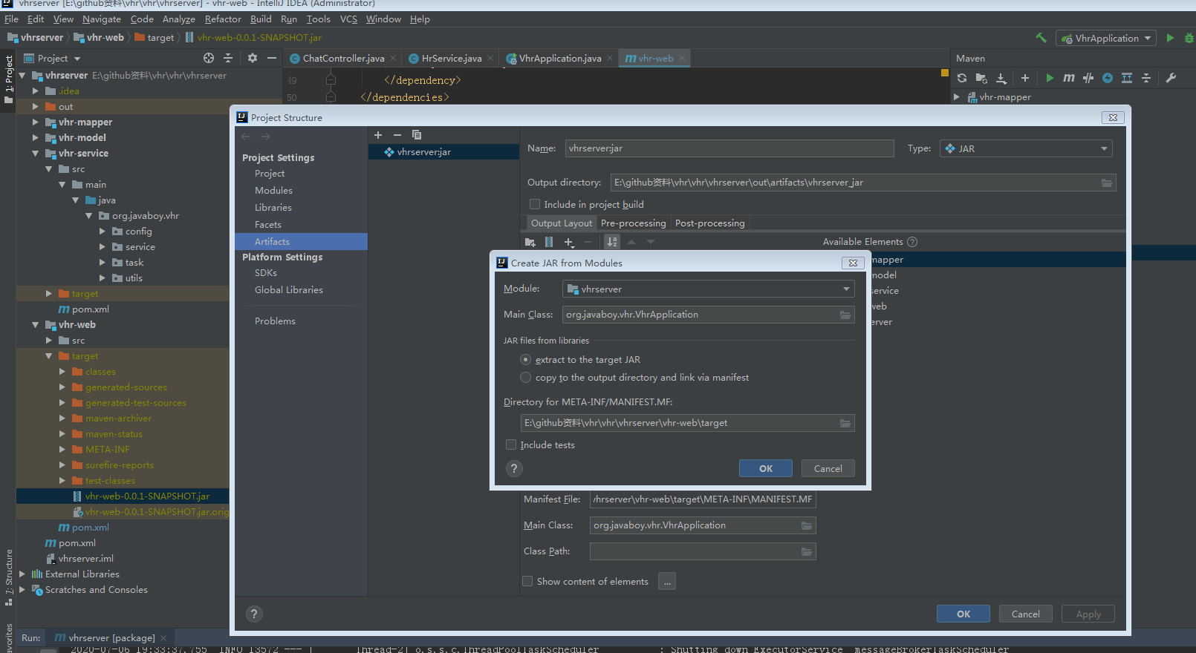

打包并运行：
<plugin>
<groupId>org.springframework.boot</groupId>
<artifactId>spring-boot-maven-plugin</artifactId>
</plugin>

https://blog.csdn.net/zhizhuodewo6/article/details/82178286?utm_medium=distribute.pc_relevant_t0.none-task-blog-BlogCommendFromMachineLearnPai2-1.nonecase&depth_1-utm_source=distribute.pc_relevant_t0.none-task-blog-BlogCommendFromMachineLearnPai2-1.nonecase

Cmd中运行:
Java -jar xxxx

