https://blog.csdn.net/choulie4195/article/details/100746063

遇到的一个问题:
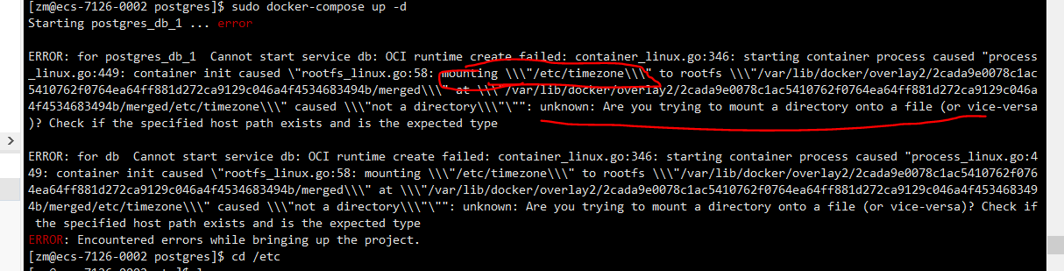

在我的服务器跑着好好地，在公司服务器上却不行，问题出在这里 这个文件是个文件夹，而不是要求的文件

Docker安装PostgresSql

拉取docker镜像

# docker pull postgres:10.10

10.10: Pulling from library/postgres

9fc222b64b0a: Pull complete

38296355136d: Pull complete

2809e135bbdb: Pull complete

77907400401d: Pull complete

1f8ceea7d21e: Pull complete

1ede1f2cb1b8: Pull complete

dcfbc2751885: Pull complete

8379f81b7622: Pull complete

f37258850b74: Pull complete

479386815b9c: Pull complete

2eaacc23d0af: Pull complete

7fa9fcadf751: Pull complete

c174beec495a: Pull complete

c22dfb67db84: Pull complete

Digest: sha256:b993cd394914008833523880072cb848c8ecaca7d80d6b02d9d6645705fa63fa

Status: Downloaded newer image for postgres:10.10

创建目录
程序目录：/data/docker/postgres 数据目录：/data/docker/postgres/data

编写 docker-compose.yml
/data/docker/postgres/docker-compose.yml

version: '3.1'

services:

db:

image: postgres:10.10

restart: always

ports:

- 5432:5432

environment:

POSTGRES_PASSWORD: postsqldev

POSTGRES_USER: postgres

PGDATA: /data/docker/postgres

volumes:

- /data/docker/postgres:/var/lib/postgresql/data

- /etc/localtime:/etc/localtime

- /etc/timezone:/etc/timezone

启动
启动命令

nohup docker-compose up >/dev/null 2>&1 &

#或者

docker-compose up -d

