- pom.xml下填入如下内容:
<?xml version="1.0" encoding="UTF-8"?>
<project xmlns="http://maven.apache.org/POM/4.0.0"
xmlns:xsi="http://www.w3.org/2001/XMLSchema-instance"
xsi:schemaLocation="http://maven.apache.org/POM/4.0.0 http://maven.apache.org/xsd/maven-4.0.0.xsd">
<modelVersion>4.0.0</modelVersion>
<parent>
<groupId>org.springframework.boot</groupId>
<artifactId>spring-boot-starter-parent</artifactId>
<version>2.1.7.RELEASE</version>
<relativePath/> <!-- lookup parent from repository -->
</parent>
<groupId>try.websocket</groupId>
<artifactId>demo</artifactId>
<version>1.0-SNAPSHOT</version>
<properties>
<java.version>1.8</java.version>
</properties>
<dependencies>
<dependency>
<groupId>org.springframework.boot</groupId>
<artifactId>spring-boot-starter-web</artifactId>
</dependency>
<dependency>
<groupId>org.springframework.boot</groupId>
<artifactId>spring-boot-starter-websocket</artifactId>
</dependency>
<dependency>
<groupId>org.webjars</groupId>
<artifactId>sockjs-client</artifactId>
<version>1.1.2</version>
</dependency>
<dependency>
<groupId>org.webjars</groupId>
<artifactId>jquery</artifactId>
<version>3.4.1</version>
</dependency>
<dependency>
<groupId>org.webjars</groupId>
<artifactId>stomp-websocket</artifactId>
<version>2.3.3</version>
</dependency>
<dependency>
<groupId>org.webjars</groupId>
<artifactId>webjars-locator-core</artifactId>
</dependency>
<dependency>
<groupId>org.springframework.boot</groupId>
<artifactId>spring-boot-starter-security</artifactId>
</dependency>
<dependency>
<groupId>org.springframework.boot</groupId>
<artifactId>spring-boot-starter-test</artifactId>
<scope>test</scope>
</dependency>
</dependencies>
<build>
<plugins>
<plugin>
<groupId>org.springframework.boot</groupId>
<artifactId>spring-boot-maven-plugin</artifactId>
</plugin>
</plugins>
</build>
</project>

待项目创建好之后，添加启动文件和controller
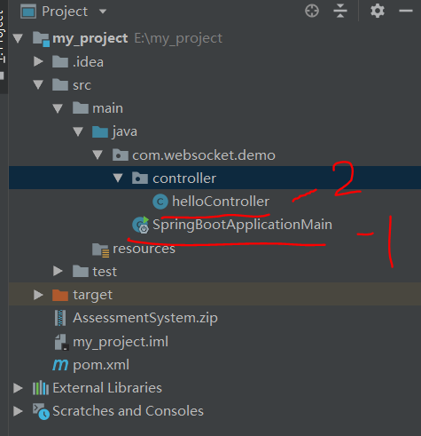

springBootApplication下的内容为:
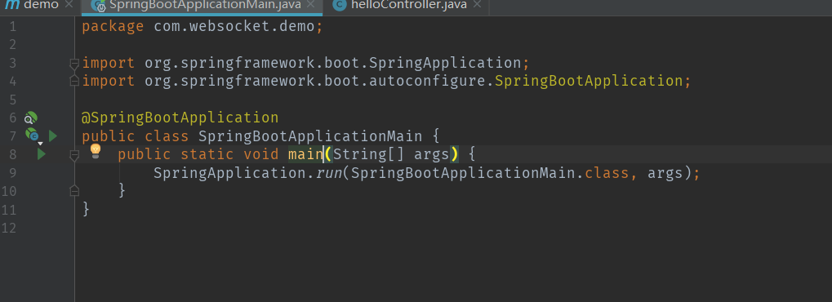

controller下的内容为:
