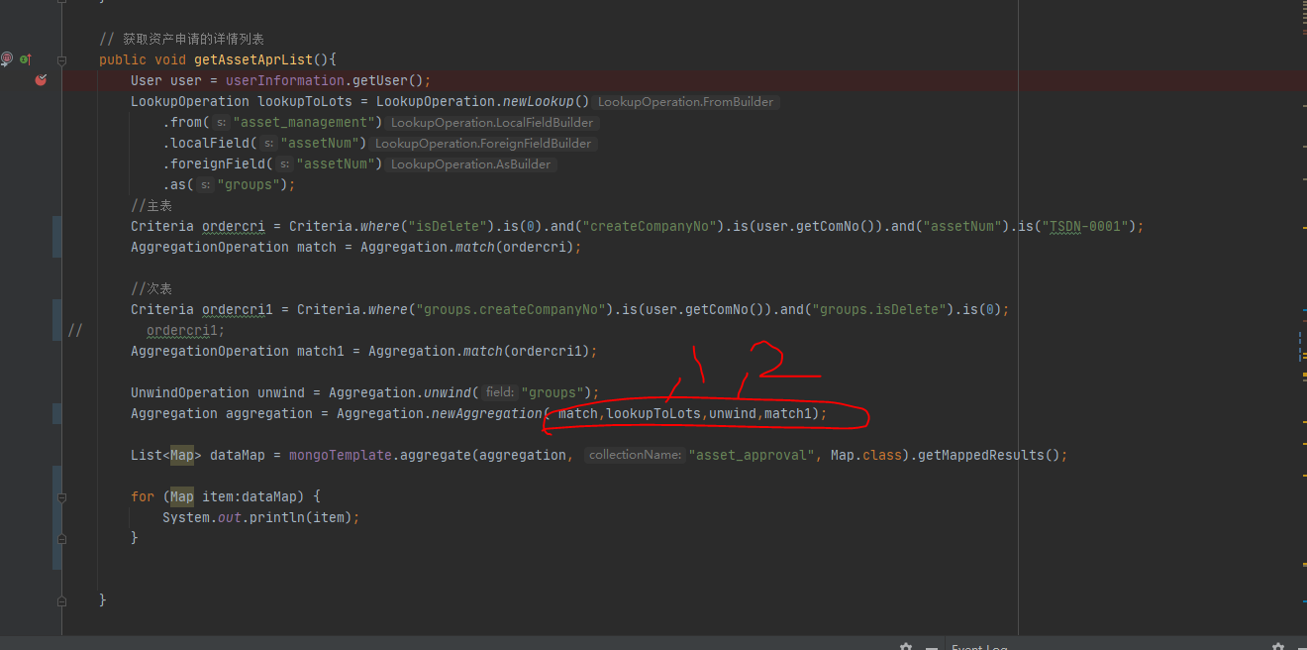
Aggregation.newAggregation( match,lookupToLots,unwind,match1);

注意顺序

