##### Appendix

## Drug Properties

|  |  |  |  |
| --- | --- | --- | --- |
| Absorption | Distribution | Metabolism | Excretion |
| ALOGP  HBA  HBD  PSA  MW_FREEBASE  RO3_PASS  NUM_RO5_VIO-LATIONS | cx_logd  cx_most_apka  cx_most_bpka  full_mwt  activity_id  Molregno  standard_relation  standard_value  standard_units  standard_flag  pchembl_value | enzyme_name  enzyme_tid  mw_freebase  mw_monoisotopic | structure_type  molecule_type  direct_interaction  SMILES sequence |

## Drug Properties

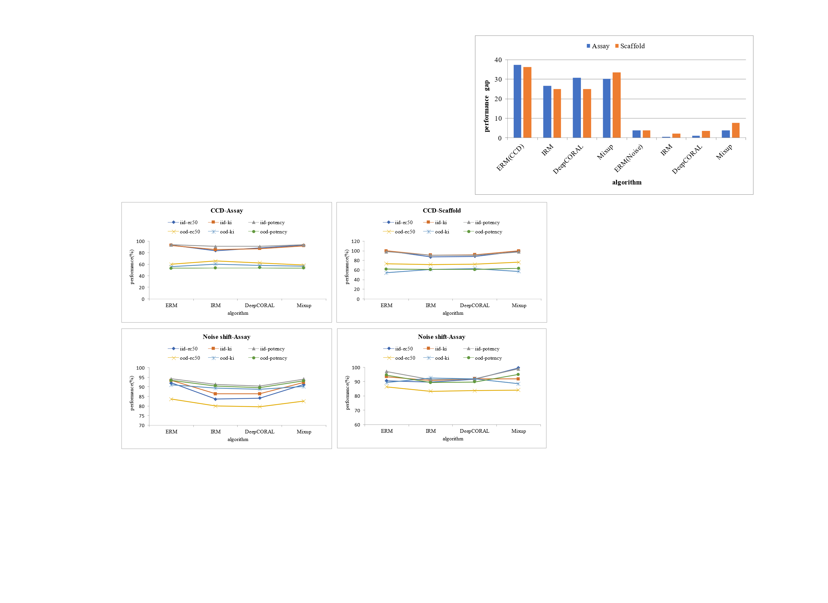

1. All results in the experiment.