Interisland movements and oceanic swimming of woodland caribou in Newfoundland

Quinn M.R. Webber1*, Jack G. Hendrix1, Alec L. Robitaille2, Eric Vander Wal1,2

1Cognitive and Behavioural Ecology Interdisciplinary Program, Memorial University of Newfoundland 2Department of Biology, Memorial University of Newfoundland, Canada

The Fogo Island archipelago, off the coast of Newfoundland, Canada, is home to approximately 300 woodland caribou. During routine fieldwork on May 30, 2017, we observed an unmarked adult male caribou swim between two small islands (Figure 1, see Figure 2 for location), a distance of at least 470 m which took ~9 minutes (~52 m per minute). Residents of Fogo Island confirmed this phenomenon and have also reported regularly observing caribou swimming between islands. This observation prompted us to investigate whether swimming behaviour was common among GPS radio-collared caribou in the population (n = 29, for collaring details see, Peignier et al. 2019). We identified an individual’s swimming events as two consecutive GPS locations (2-hour relocation rates) on different islands. Northeastern Newfoundland typically experiences pack ice during winter and caribou are known locally to travel between islands by walking over the ice. We restricted our GPS data to the ice-free period of the year (April 1 to December 31) and identified 127 swimming events over three years (Figure 2).

In total, 12 of 29 collared female caribou swam between islands in the Fogo Island archipelago. Of the caribou that swam, caribou swam on average approximately 11 (range = 2-34) times per year and remained on each island for approximately 30 (range = 0-724) days before swimming again. Based on GPS data to infer swimming, we separated the population into three apparent groups of individuals: those that swam regularly between islands (n = 3, every ~15 days); those that rarely engaged in swimming events (n = 9, every ~ 42 days); and those that never swam (n = 17).

Caribou (*Rangifer tarandus*) are exceptional swimmers. Ample evidence exists that caribou swim in streams, rivers, and lakes during migration (Leblond et al. 2016), to avoid predators (Bergerud 1985), and to access islands during calving (Bergerud et al. 1990). Even for adept swimmers like caribou, which have hollow hair shafts that aid in flotation, the energetic expenditure of swimming for quadrupedal mammals is significantly higher than walking or running, and drowning is also possible (Miller and Gunn 1985). Despite the abundance of coastal and island caribou herds, only a handful of studies have documented caribou swimming in the ocean, and most of these lack observation, but rather deduce swimming based on presence of caribou on a previously uninhabitated island (e.g. Miller 1995, 2002, Jeffery et al. 2007, Ricca et al. 2012). Caribou may swim between islands in the ocean for similar reasons they swim in freshwater (Leblond et al. 2016), mainly concerning predator avoidance or to access new habitats and foraging opportunities. We propose that one such explanation, the forage limitation hypothesis, is the most likely explanation for oceanic swimming for caribou that live on islands in the Fogo Island archipelago.

Caribou were introduced to Fogo Island (n = 26 animals between 1964–67) and Change Island (n = 5 animals in 1964) from Newfoundland as part of a series of translocations and introductions throughout the province (Bergerud and Mercer 1989). Typical caribou predators such as black bears (*Ursus americanus*) and wolves (*Canis lupus*) are absent from Fogo Island; the dominant predator is coyote (*Canis latrans*), which predate calves but it remains unclear what threat they pose, if any, to adult caribou (Rayl et al. 2014). Given the minimal risk of predation to adults, we propose that forage limitation is more likely to drive movement between islands than predator avoidance. For several decades after their introduction to Fogo Island, the caribou population did not exceed ~100 individuals (Bergerud and Mercer 1989, Newfoundland and Labrador Wildlife Division, unpublished data). During the 1990s, population density reached ~300 animals and anecdotal evidence suggests caribou were first seen on nearby islands during this same period. Increased competition for resources on Fogo Island due to this increase in density could have precipitated movement to other islands.

Forage limitation and over-grazing is a major concern for caribou populations and can lead to reduced female reproductive success (Schaefer et al. 2016). Forage scarcity has been proposed as a potential reason for caribou moving between arctic islands on the sea-ice in winter (Miller et al. 1977). For the Fogo Island population, as the population grew and predation pressure was insufficient to maintain population density, forage depletion could lead caribou to make similar, but riskier and more costly, movements between islands during the ice-free season. Given the small size of other islands near Fogo (Figure 2), over-grazing by newly arrived caribou could rapidly deplete forage on an annual cycle (Bergerud et al. 1990), leading to more frequent movements back and forth between islands rather than permanent relocation.

The trade-off associated with swimming between islands can be understood as density-dependent habitat selection governed by the Ideal Free Distribution (Morris 1987, Bradbury et al. 2015). Ideal Free Distribution theory predicts a fitness equilibrium: when the density in a given habitat patch has exceeded the optimum for fitness within that patch, animals should relocate and settle new habitat patches, so that fitness is equal across all patches (Bradbury et al. 2015). Islands act as discrete habitat patches in this case, but the costs associated with swimming create a trade-off when moving between patches. For caribou in the Fogo Island archipelago, the role of forage limitation in habitat selection patterns remains unknown, but swimming between islands may be at least partially governed by density-dependent habitat selection.

Forage limitation may be the ultimate explanation for caribou swimming between oceanic islands, but a number of proximate mechanisms remain untested. Our observations of caribou swimming in the ocean lead to five questions for future research:

1. How do the energetic cost and risk of swimming differ from walking on sea ice? Walking over solid ice is likely less energetically expensive than swimming, but may pose a greater risk of falling through depending on the thickness and stability of ice. What proportion of inter-island movements are swimming events compared to walking on ice? The presence and extent of sea ice varies annually in our study area and we are unable to determine the exact timing or duration of sea ice from past years. However, we qualitatively delineate the timing of typical sea ice arrival and departure (Figure 2B) and deduce that although the majority of inter-island movements occur between April 1 and December 31, some inter-island movements appear to be caribou walking on sea ice between islands. Future research on the trade-offs of these types of movement should consider both how the costs associated with each differ, but also how the potential benefits - foraging opportunities - may vary seasonally.
2. At which temporal and spatial scales do caribou choose to swim between islands? Does the time of day, weather, season, or availability of food influence swimming?
3. Does reproductive status (presence of a calf-at-heel) or demographic class (age or sex) influence propensity for oceanic swimming? Our initial observation was of an adult male, but all collared individuals were adult females. Are younger caribou more likely to swim if they are unable to compete with older individuals for resources? Are males or females without a calf-at-heel more likely to swim in the summer given they are not restricted based on presence of a calf-at-heel, as females are?
4. If swimming is a function of density-dependent habitat selection, what are the costs of movement between patches? IFD assumes zero-cost movement, but could the risk and energetic costs associated with oceanic swimming be estimated using the potential fitness deficit that caribou are willing to tolerate before swimming to a new island?
5. In relation to all the previous questions: how do individuals vary in their assessment of the costs and benefits of swimming between islands? Why did some caribou regularly engage in swimming events, while more than half of our marked population were never observed swimming in the ocean? The forage limitation hypothesis is thought to apply uniformly across populations, but individual caribou could evaluate the costs and benefits of swimming differently. It is possible that some individuals, in our case ~10%, considered swimming to be less costly or perceived competition or predation more acutely than their conspecifics.

We surmise that for Fogo Island, as competition among conspecifics increased along with population size, density-dependent habitat selection resulted in expansion of the population to nearby islands. Following Ideal Free Distribution theory, caribou should swim to new islands when the average fitness of individuals on the starting island exceeds the density-fitness equilibrium (Morris 1987). While this is an ultimate explanation, our data suggest caribou only remain on smaller islands for a few days at a time, so the fitness equilibrium remains a theoretical construct. More likely, however, is that fine-scale competition, density-dependent habitat selection, and forage depletion drives individuals to periodically swim between islands. Our focal observations add to the evidence that caribou can, and occasionally do, swim in the ocean (e.g. Miller 1995, 2002, Jeffery et al. 2007, Ricca et al. 2012). We suggest that swimming is likely more common than previously thought for caribou living on oceanic islands, and that forage limitation and the associated density-dependent habitat selection is an ultimate explanation for this phenomenon. Although our inference is limited to observations, islands appear to represent discrete foraging patches for terrestrial animals that can influence fitness via increased foraging opportunities. We also present several hypotheses related to the nuances and further variation within the idea that density-dependent habitat selection governs swimming behaviour, and posit that above and beyond these additional factors, individuals can vary in their evaluation of costs and benefits of movement between these habitat patches.

**Acknowledgements** We thank M. Laforge, M. Bonar, C. Hart, and R. Huang for help in the field. Logistical support was provided by L. Bixby. We thank all members of the Wildlife Evolutionary Ecology Lab, including C. Hart, C. Prokopenko, J. Kennah, J.W. Turner, and S. Boyle for their comments on previous versions of this manuscript. Newfoundland Wildlife Division including S. Moores, B. Adams, C. Doucet, W. Barney, and J. Neville for logistical support in the field as well as help with data data collection and management. We thank T. Bergerud and S. Mahoney for their vision in initiating much of the work on caribou in Newfoundland. Funding for this study was provided by the National Sciences and Engineering Research Council (QMRW, JGH, EVW). We respectfully acknowledge the territory in which data were collected and analyzed as the ancestral homelands of the Beothuk, and the island of Newfoundland as the ancestral homelands of the Mi’kmaq and Beothuk.

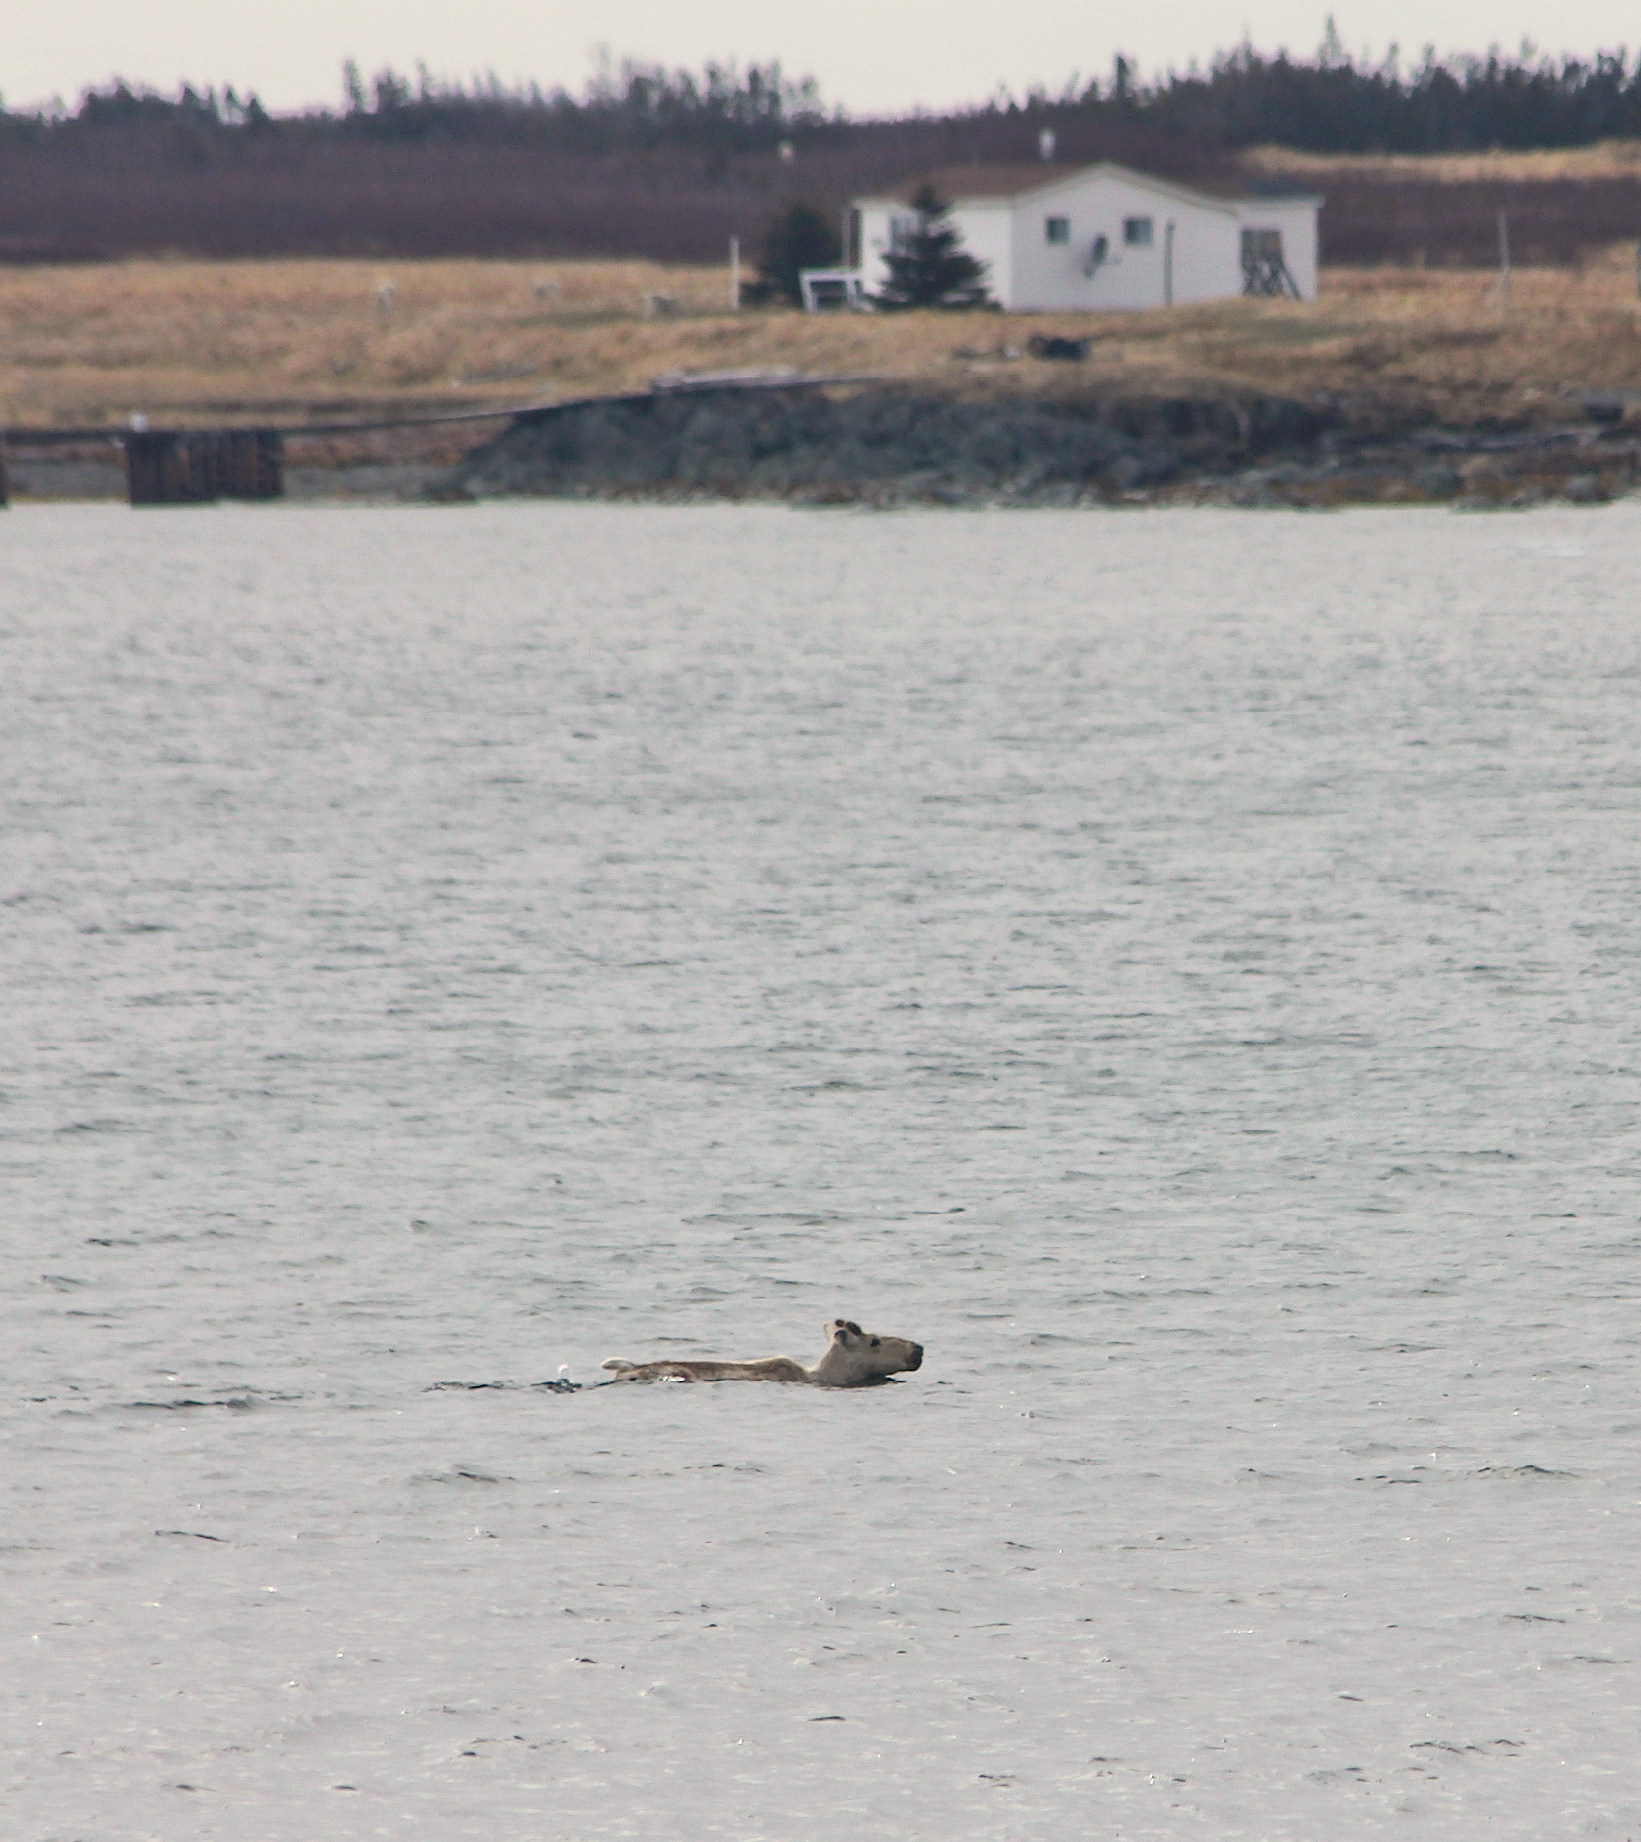

Figure 1: Photograph of swimming unmarked adult male caribou (*Rangifer tarandus*) from Western to Eastern Indian Island taken on 30 May 2017.

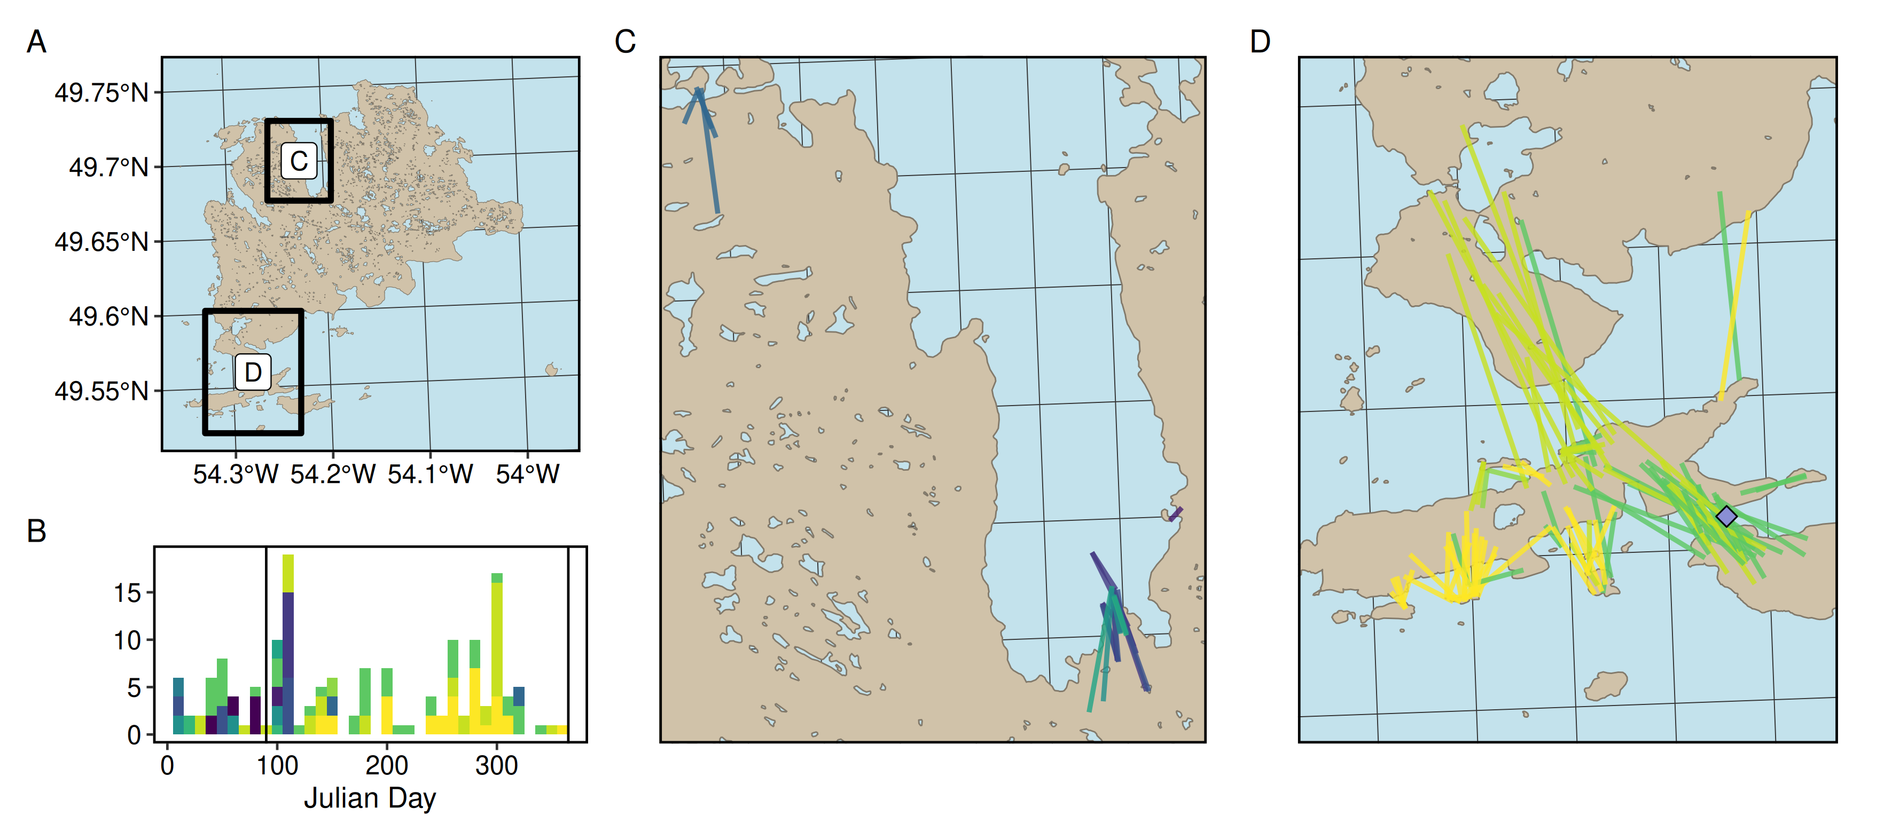

Figure 2: A) Map of the Fogo Island archipelago with swimming events between islands. B) Histogram displaying the frequency of swimming events throughout the year. Note, colours correspond to individual caribou and vertical black bars delineate the ice-free season (April 1 to December 31). C) Inset of swimming events between small islands on the northern coast of Fogo island. D) Inset of swimming events between islands on the southern coast of Fogo island. Note, the grey diamond represents the location we observed an adult male caribou swimming (see Figure 1).

**Literature Cited**

Bergerud, A., R. Ferguson, and H. Butler. 1990. Spring migration and dispersion of woodland caribou at calving. Animal Behaviour 39:360–368.

Bergerud, A., and W. Mercer. 1989. Caribou Introductions in Eastern North America. Wildlife Society Bulletin 17:111–120.

Bergerud, A. T. 1985. Antipredator strategies of caribou: dispersion along shorelines. Canadian Journal of Zoology 63:1324–1329.

Bradbury, J., S. Vehrencamp, and K. Clifton. 2015. The ideal free antelope: foraging dispersions. Behavioral Ecology arv078:1–11.

Jeffery, R. A., R. D. Otto, and F. R. Phillips. 2007. George’s Island, Labrador - A high-density predator-free refuge for a woodland caribou subpopulation? Rangifer:51–56.

Leblond, M., M.-H. St-Laurent, and S. D. Côté. 2016. Caribou, water, and ice – fine-scale movements of a migratory arctic ungulate in the context of climate change. Movement Ecology:4:14.

Miller, F. 1995. Inter-island water crossings by peary caribou, south-central Queen Elizabeth Islands. Arctic 48:8–12.

Miller, F. 2002. Multi-Island Seasonal Home Range Use by Two Peary Caribou, Canadian High Arctic Islands, Nunavut, 1993-94. Arctic 55:133–142.

Miller, F., and A. Gunn. 1985. Observations of Barren-Ground Caribou Travelling on Thin Ice during Autumn Migration. Arctic 39:85–88.

Miller, F., R. Russell, and A. Gunn. 1977. Interisland movements of Peary caribou (*Rangifer tarandus pearyi*) on western Queen Elizabeth Islands, Arctic Canada. Canadian Journal of Zoology 55:1029–1037.

Morris, D. 1987. Tests of density-dependent habitat selection in a patchy environment. Ecological Monographs 57:269–281.

Peignier, M., Q. M. R. Webber, E. L. Koen, M. P. Laforge, A. L. Robitaille, and E. Vander Wal. 2019. Space use and social association in a gregarious ungulate: Testing the conspecific attraction and resource dispersion hypotheses. Ecology & Evolution 9:5133–5145.

Rayl, N., T. Fuller, J. Organ, J. McDonald, S. Mahoney, C. Soulliere, S. Gullage, T. Hodder, F. Norman, T. Porter, G. Bastille-Rousseau, J. Schaefer, and D. Murray. 2014. Mapping the distribution of a prey resource: neonate caribou in Newfoundland. Journal of Mammalogy 95:328–339.

Ricca, M. A., F. W. Weckerly, A. Duarte, and J. C. Williams. 2012. Range expansion of nonindigenous caribou in the Aleutian archipelago of Alaska. Biological Invasions 14:1779–1784.

Schaefer, J., S. Mahoney, J. Weir, J. Luther, and C. Soulliere. 2016. Decades of habitat use reveal food limitation of Newfoundland caribou. Journal of Mammalogy 97:386–393.