On the marginal value of swimming in woodland caribou

Quinn M.R. Webber2, Jack G. Hendrix2, Alec L. Robitaille1, and Eric Vander Wal1,2

1 Department of Biology, Memorial University of Newfoundland, Canada  
2 Cognitive and Behavioural Ecology Interdisciplinary Program, Memorial University of Newfoundland

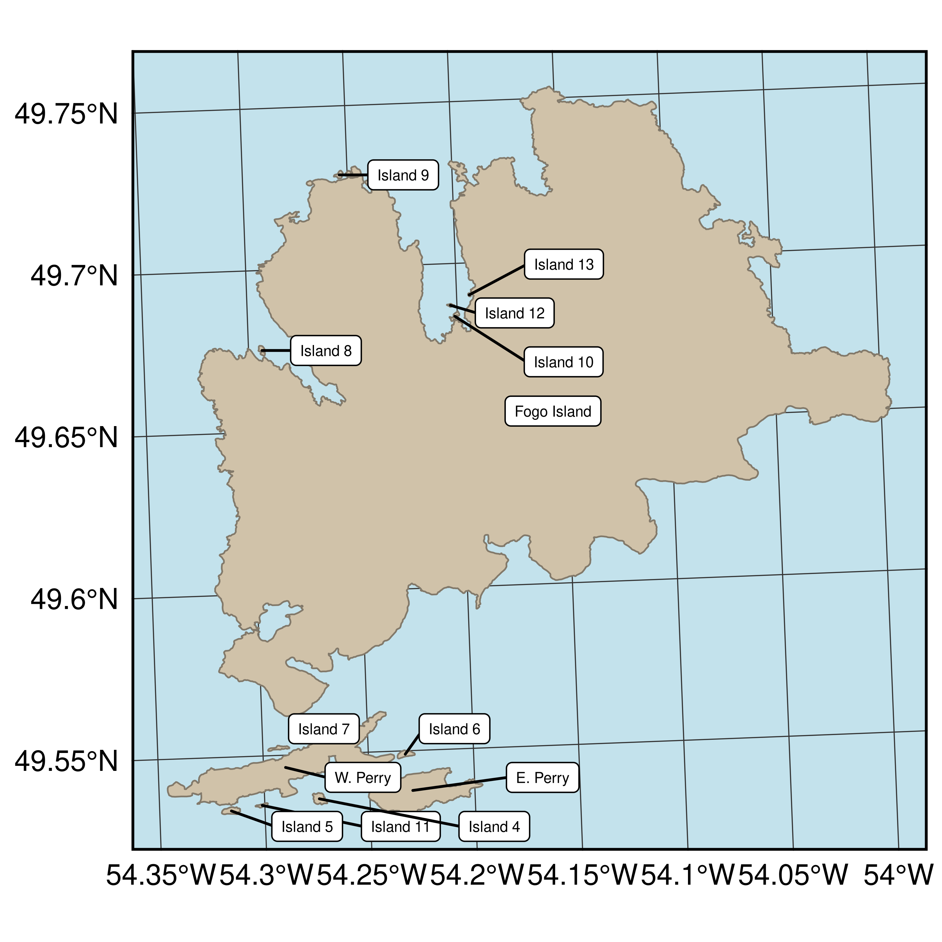

Figure S1: Map of the Fogo Island archipelago. 13 islands are identified and the dominant habitats on these islands are presented in Table S1. Note, islands listed as Island 1–5 correspond to those presented in Panel D in Figure 2 and Islands 6 and 7 correspond to those presented in Panel C in Figure 2. These numbered islands do not have official names and for ease of interpretation we identified them using numbers.

Table 1: Table S1: Summary of primary habitat types for eight islands in the Fogo Island Archipelago. Habitat types were determined using supervised classification of Landsat 7 imagery (Integrated Informatics Inc., 2014). Habitats pooled in the ‘other’ category include broadleaf forest, mixed-wood forest, and anthropogenic habitats and we pooled conifer forest and conifer scrub together as these habitats are similar in their species composition. Descriptions of each habitat type and dominant plant species are presented in Table S2 and the location of each island is presented in Figure S1.

|  |  |  |  |  |  |  |  |
| --- | --- | --- | --- | --- | --- | --- | --- |
| Island | Area (km2) | Lichen | Wetland | Conifer forest | Rocky barrens | Freshwater | Other |
| Fogo Island | 253.144 | 11.73% | 21.24% | 10.44% | 6.74% | 9.17% | 15.81% |
| W. Perry | 7.509 | 3.34% | 48.09% | 6.31% | 3.51% | 24.12% | 0.42% |
| E. Perry | 3.772 | 12.49% | 39.49% | 3.34% | 3.61% | 10.84% | 8.07% |
| Island 4 | 0.134 | 10.00% | 14.00% | 48.00% | 1.33% | 8.00% | 0.00% |
| Island 5 | 0.121 | 0.00% | 10.87% | 1.45% | 26.81% | 60.14% | 0.00% |
| Island 6 | 0.098 | 7.21% | 17.12% | 32.43% | 8.11% | 18.02% | 0.00% |
| Island 7 | 0.062 | 10.29% | 32.35% | 4.41% | 2.94% | 23.53% | 0.00% |
| Island 8 | 0.052 | 26.67% | 6.67% | 0.00% | 31.67% | 31.67% | 1.67% |
| Island 9 | 0.045 | 26.67% | 22.22% | 0.00% | 11.11% | 40.00% | 10.00% |
| Island 10 | 0.044 | 24.49% | 16.33% | 0.00% | 51.02% | 4.08% | 0.00% |
| Island 11 | 0.032 | 0.00% | 28.95% | 7.89% | 5.26% | 18.42% | 2.63% |
| Island 12 | 0.015 | 29.41% | 5.88% | 0.00% | 58.82% | 5.88% | 0.00% |
| Island 13 | 0.006 | 0.00% | 0.00% | 0.00% | 25.00% | 75.00% | 0.00% |

Table 2: Table S2: Summary of common plant species and groups of species in four habitat types on Fogo Island, Newfoundland. Habitat types were determined using supervised classification of Landsat 7 imagery with 30×30m pixels to generate land cover classifications (Integrated Informatics Inc., 2014).

|  |  |  |
| --- | --- | --- |
| **Habitat type** | **Description** | **Common species and groups of species** |
| Lichen | A non-forested shrub-dominated habitat found on hummocky terrain and may have thin soils with exposed bedrock, ericaceous shrubs dominate having relatively high percent cover. Tree species are always stunted and rarely grow above the shrub layer. The herb layer is species-rich, is nearly always dominated by ground lichen. | Caribou lichen (*Cladonia* sp.), Sheep laurel (*Kalmia* sp.) , Dwarf willow (*Salix herbacea*) |
| Wetland | Characterized by open or ponded water. Dominated by aquatic and submergent vegetation such as yellow pond lily and rushes. | Sedges (*Carex* sp.), Rushes (*Juncus* sp.), Mosses |
| Conifer forest | Dominant tree species are typically balsam fir or black spruce with lesser amount of larch, ericaceous shrubs are found in this habitat and sheep laurel. | White spruce (*Picea glauca*), Black spruce (*Picea mariana*), Balsam fir (*Abies balsamea*), Larch (*Larix laricina*) |
| Rocky barrens | Windswept with thin layer that is comprised of bedrock, exposed soil, stone, and boulders. The shrub layer is composed mainly of ericaceous shrubs. Ground cover consists of grasses, lichens, mosses, and smaller berry plants. | Alder (*Alnus* sp.), Sheep laurel (*Kalmia* sp.), Crowberry (*Empetrum nigrum*), *Vaccinium* sp. |

**References**

Integrated Informatics Inc. 2014. Sustainable Development and Strategic Science Branch Land cover classification. Sustainable Development and Strategic Science, Government of Newfoundland and Labrador, St. John’s, NL.